Medicinal Phytodiversity in Cocoa Agroforestry Systems and Well-Being of Local Communities in Department of Daloa (Central West, Côte d’Ivoire)

Abstract
In Côte d’Ivoire, despite their importance for local communities, medicinal plant species are increasingly threatened with extinction due to human activities. In cocoa agroforestry systems (AFS), farmers intentionally preserve plant species with cocoa trees to meet daily needs, including healthcare. However, the relationship between the traditional value of uses given to medicinal species and their actual availability in agroforestry systems allowing for improved efficiency in plant conservation, remain poorly documented. This study aims to show the status distribution of medicinal plants diversity in regard to its traditional value within cocoa agroforestry systems. In the Daloa Department, floristic surveys were conducted in 375 plots of 400 m² established within cocoa-based agroforestry systems (AFS), combined with ethnobotanical surveys involving 500 households. The results revealed that cocoa-based agroforestry systems host 140 medicinal plant species, mainly belonging to the Fabaceae, Euphorbiaceae, Apocynaceae, Asteraceae and Malvaceae families. This flora consists of 61.43% naturally preserved native species, 20% exotic species, and 18.57% deliberately cultivated species. Among these, species with low traditional value are numerous while species with high valur for medicine areless represented. Conservation of species in AFS has to be oriented to enhance the presence of medicinal plants of interest. These findings highlight the need for intensified conservation efforts according to research results.

Keywords
Affections, Cocoa Agroforestry System, Ethnobotany, Medicinal Plant, Daloa

1. Introduction

In their pursuit of well-being and the satisfaction of basic needs, humans rely on plants for food, income, and healthcare [1] [2]. In West Africa, plant-based medicine constitutes the cornerstone of primary healthcare for the majority of the population because of its effectiveness, geographic accessibility, affordability, and cultural relevance [3] [4]. Despite their importance to local communities, these medicinal species face increasing threats of extinction due to the continuous degradation of vegetation cover caused by rapid urbanization, bushfires, and especially agricultural expansion [5] [6].
In Côte d’Ivoire, agricultural activities particularly the expansion and intensification of cocoa cultivation have led to the degradation of nearly 80% of the country’s forest cover within a century [7]. The country’s forest area has declined from approximately 16 million hectares in 1960 to 2.97 million hectares in 2021 [8]. This loss has had severe consequences for the conservation of biological resources, particularly medicinal plants, which remain a vital source of healthcare for most rural populations, including cocoa farmers and their families [9].
To counter the progressive decline of forest cover in Côte d’Ivoire, agroforestry has been recommended as a sustainable alternative capable of reconciling agricultural production with environmental protection [5] [10] [11]. In these farming systems, plant species deliberately retained by farmers serve to multiple purposes, including the provision of healthcare [12] [13] [14]. Cocoa-based agroforestry systems therefore function as “green pharmacies” or key reservoirs of medicinal plant species [9].
However, the relationship between the traditional value of uses given to medicinal species and their actual availability in agroforestry systems allowing for improved efficiency in plant conservation, remain poorly documented. Yet such knowledge could alleviate negative impacts on availability and on the productivity of the agricultural workforce. This study aims to show the status distribution of medicinal plants diversity in regard to its traditional value within cocoa agroforestry systems.

2. Materials and Methods

2.1. Study Area
The study was conducted in five localities Zépréguhé, Séria, Doboua, Bantikro, and Gonaté located around the town of Daloa. The Daloa Department is located in the Haut-Sassandra Region between 6°40′ and 7°20′ N latitude and 6°00′ and 6°40′ W longitude (Figure 1). The regional capital is the city of Daloa, situated approximately 400 km from Abidjan, the economic capital, and 140 km from Yamoussoukro, the political and administrative capital. Covering an area of 5,450 km², the Daloa Department represents approximately 28% of the Haut-Sassandra Region and 2% of the national territory [15]. The area experiences a sub-equatorial rainfall regime characterized by two main seasons: a rainy season and a dry season [16] [17]. The average annual temperature is 26.47 °C and the average annual rainfall is 930.60 mm [18]. Gonaté is situated in a semi-deciduous dense-forest zone characterised by Celtis spp. and Triplochiton scleroxylon in the mesophilic sector [17]. In a heavily forested environment, the Daloa Department offers a wide range of floral, faunal and agricultural resources [19].

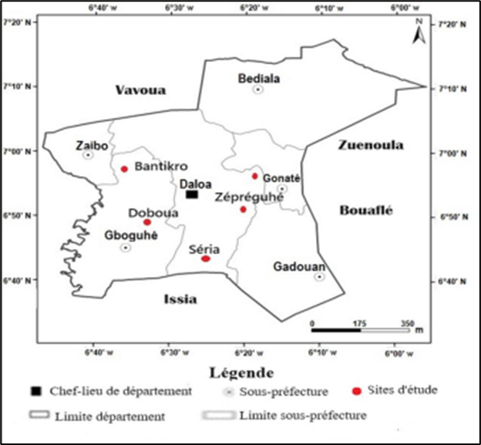

Figure 1 : Location of sites in the study area ([20] modified)

2.2. Data collection
A total of 375 randomly distributed 400 m² plots were established within cocoa agroforestry systems across the study localities, all plant species encountered were recorded and discussed with people aged up to 20 years. In each square plot, medicinal species were identified with farmers and a field guide. Identified species were listed by recording either the local name, trade name or scientific name. Semi-structured interviews were conducted using a pre-designed questionnaire following the botanical surveys. With a translator, questions were asked in french and in local languages for respondents who did not speak french. The information collected from respondents focused on the diseases treated by medicinal plant species which were recorded in the cocoa agroforestry systems.

2.3. Data analysis
Qualitative Diversity Analysis
Taxonomic identification of the recorded medicinal plant samples was performed either in situ or at the Agricultural Production Improvement Laboratory of Jean Lorougnon Guédé University, using collected specimens in herbarium and referring to standard botanical identification guides. Reference was made to the floras and identification keys of [21] [22] [23] [24] and [25]. Following [26] [21] [27] [23], and the fourth version of the Angiosperm classification proposed by the Angiosperm Phylogeny Group [28], the scientific names and botanical families of the identified medicinal plants were updated. Biological life forms were classified according to [29], while chorological types followed the system proposed by [26] [21] [27], as adopted by several authors including [30] [11] and [20].

Socio-Ecological Importance of Medicinal Plants in Cocoa Agroforestry Systems
The cultural and ecological importance of medicinal plant species in cocoa agroforestry systems (AFS) was assessed using several ethnobotanical indicators. These indicators included the ethnobotanical use value (Medicinal Use Value, Med.UVs), the informant agreement ratio (Medicinal Informant Agreement Ratio, Med.IARs), and an analysis of the relationship between medicinal use value and the number of diseases treated. The quantitative assessment of the use of a medicinal plant by a community, referred to Medicinal Use Value (Med.UVs), that was calculated following the method proposed by [31]:
Equation 1
$$Med.UVs=∑Uis/n_{s}$$

where Uis represents the total number of medicinal use citations for species s reported by informant i, and Ns corresponds to the number of informants who cited species s.
Because the Medicinal Use Value (Med.UVs) does not fully reflect the level of agreement among informants, the Medicinal Informant Agreement Ratio (Med.IARs) was additionally calculated to evaluate consensus regarding the use of each medicinal plant species [32]. It is calculated as follows:
Equation 2
$$Med.IARS=\left(Nt-Ns\right)/(Nt-1)$$

where Nt denotes the total number recorded uses citations for species s, and Ns represents the number of diseases treated using that species.
The Med.IARs value ranges from 0 to 1. A value of 0 indicates that the number of treated diseases equals the number of citations, whereas a value of 1 indicates complete agreement among informants regarding the exclusive use of the species. A low Med.IARs value suggests disagreement among informants regarding the use of the mentioned species.
A correlation analysis was performed to examine the relationship between the Medicinal Use Value (Med.UVs) and the number of diseases treated per plant species. This allowed assessment of the local importance of medicinal plants cited by farmers for treating diseases, as well as the importance of ecological abundance of medicinal species by categories encountered.
Correlation coefficients range from −1 to 1, where negative values indicate inverse relationships and positive values indicate direct relationships.
r < 0.5: weak correlation
r > 0.5: strong correlation
r = 1: the two rankings are identical
r = 0: the two rankings are independent
r = –1: the two rankings are opposite
The Pearson correlation coefficient (r) was calculated, and statistical significance was assessed using a p-value threshold of 5%. All analyses were performed using STATISTICA software version 7.1.

3. Results

3.1. Floristic characteristics
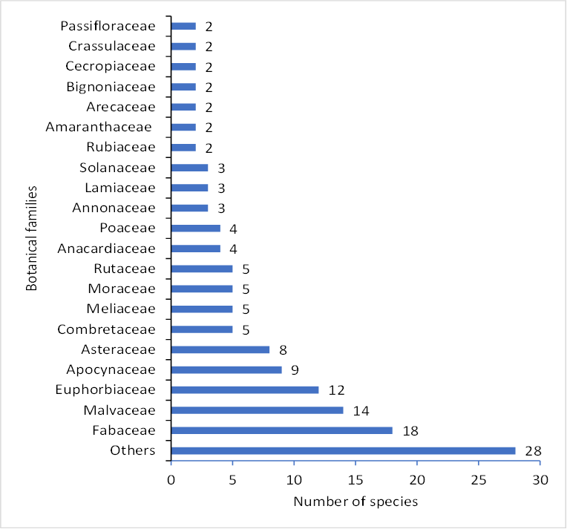

Figure 2 : Distribution of botanical families of medicinal plant species identified in cocoa agroforestry systems

Floristic surveys conducted in cocoa-based agroforestry systems (AFS) across the five study localities identified a total of 140 medicinal plant species belonging to 49 botanical families. The most species-rich families were Fabaceae (18 species), Malvaceae (14 species), Euphorbiaceae (12 species), Apocynaceae (9 species), and Asteraceae (8 species). Figure 2 illustrates the distribution of the most represented botanical families.
The medicinal flora recorded in cocoa-based agroforestry systems is characterized by four morphological types: herbaceous plants (27.86%), lianas (1.43%), shrubs (43.57%), and trees (26.14%) (Figure 3).

Figure 3 : Morphological types of medicinal plant species identified in cocoa-based agroforestry systems

The chorological analysis showed that 35% of the recorded taxa belong to the Guineo-Congolian–Sudano-Zambezian region (GC–SZ), 34.29% to the Guineo-Congolian region (GC), 20.71% are introduced species (I), and 10% belong to the Sudano-Zambezian region (SZ) (Figure 4).

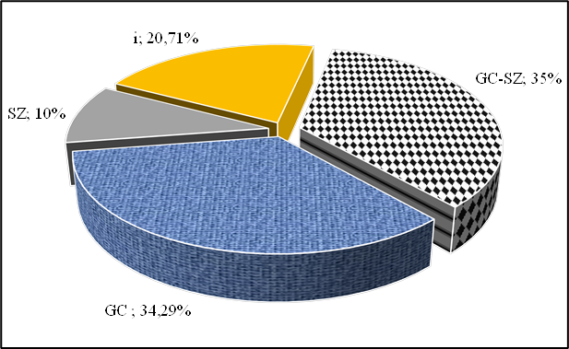

Figure 4 : Chorological distribution of medicinal plant species identified in cocoa agroforestry systems.

The analysis of biogeographical status revealed the presence of naturally occurring native species, deliberately planted native species, and exotic species within cocoa agroforestry systems (Figure 5). Native species dominated the medicinal flora, accounting for 80% of the recorded species, whereas exotic species represented the remaining 20%. Indigenous taxa included Adenia lobata (Jacq.) Engl., Ageratum conyzoides Linn., Alchornea cordifolia (Schum. & Thonn.) Müll.Arg., Alstonia boonei De Wild., Anthocleista procera Lepr. ex Bureau, Antiaris toxicaria var. africana (Engl.) C.C. Berg, and Carapa procera DC. De Wilde. Exotic flora includes Anacardium occidentalis Linn., Azadirachta indica A. Juss., Bambusa vulgaris Schrad. ex J.C.W., Citrus limon Burn. f., Jatropha curcas Linn., Moringa oleifera Lam, and Tectona grandis Linn.f. among native species, those naturally retained by farmers accounted for 61.43%, whereas deliberately planted native species represented 18.57% of the medicinal flora (Figure 5).

Figure 5 : Distribution of medicinal plant species in cocoa farms according to biogeographical status
3.2. Socio-ecological importance

Analysis of the relationship between Medicinal Use Values (Med.UVs) and the number of diseases treated per plant species revealed a strog significant positive correlation between the two variables (r = 0.59, p = 0.0001). This relationship was linear, as illustrated in Figure 6. The variation in the values of Medicinal Use Value (Med.UVs) is expressed in 34% (r²= 0.34924) of cases by the number of citations from respondents. Based on this relationship, four distinct groups of medicinal plant species were identified. Group 1 consisted of species with high medicinal use values that were used to treat a wide range of diseases. This group contains few medicinal species including Alstonia boonei (Albo), Alchornea cordifolia (Alco), Parquetina nigrescens (Pa ni), Rauvolfia vomitoria (Ra vo), Vernoniacolorata (Veco), Morinda lucida (Mo lu), Newbouldia laevis (Ne la), Colanitida (Co ni), Mallotus oppositifolius (Maop), Zanthoxylum Zanthoxyloides (Zanza), and Sterculia tragacantha (Str tran).

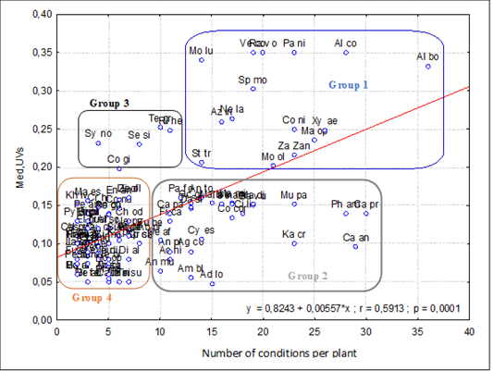

Figure 6 : Correlation between Med.UVs and the number of conditions per cited plant, scatter plot and regression line

Group 2 included species with relatively low use values that were nevertheless used to treat multiple diseases. Few medicinal species are found in this category, like (An m) Annona muricata, (Ch od) Chromolaena odorata, (Py an) Pycnanthus angolensis, (Ad lo) -Adenia lobata, (Pe am)- Persea americana, (Co gi) Cola gigantea, and (Ca pa) Carica papaya. Group 3 comprised medicinal plant species with high use values that were employed to treat a few diseases. These include Synedrella nodiflora (Sy no), Terminalia superba (Tesu), Senna siamea (Se si), Ricinodendron heudelotii (Rihe), and Cola gigantea (Co gi). Group 4 consisted of numerous medicinal plant species characterized by low Med.UVs and a low number of corresponding diseases. Unlike other groups, this one stands out for its abundance of medicinal species such as Pycnanthus angolensis (Py an), Chromolaena odorata (Ch od), Entandrophragma angolense (En an), Elaeis guineensis (El gu), Dioscorea alata (Di al), Cocos nucifera (Co nu), Celtis zenkeri (Ce ze), Combretum micranthum (Co mi), etc. The analysis reveals that Groups 1 and 2 contain the species most frequently medicinal plants used to treat diseases. These species show moderate diversity within cocoa-based agroforestry systems.

4. Discussion

Floristic inventories conducted in cocoa-based agroforestry systems (AFS) identified a total of 140 plant species with medicinal potential. The distribution of these medicinal species among botanical families revealed that Fabaceae, Malvaceae, Euphorbiaceae, Apocynaceae, Asteraceae, and Combretaceae were the most dominant families in cocoa agroforestry systems. The predominance of these families can be explained by the strong representation of their species within the native forest flora of Côte d’Ivoire [26] [30] [5]. Analysis of the morphological structure of medicinal plants in cocoa agroforestry systems showed that shrubs accounted for the highest proportion (44.06%), followed by herbaceous species (27.97%), trees (26.57%), and lianas (1.40%). The dominance of shrubs and herbaceous plants may be attributed to their ability to adapt to the semi-shaded conditions characteristic of cocoa-based agroforestry systems, where the cocoa canopy plays a key role in regulating light availability. The relatively high proportion of trees likely results from farmers’ deliberate decisions to retain woody species that provide ecological, economic, and cultural benefits within their plantations. These findings are consistent with previous studies conducted in the Daloa Department and other cocoa-producing areas of Côte d’Ivoire, which reported a predominance of woody and herbaceous species in cocoa agroforestry systems [33] [34] [14]. The low proportion of lianas in cocoa-based agroforestry systems is likely due to the regular disturbance of these environments caused by cleaning activities. The distribution of medicinal plant species within cocoa agroforestry systems revealed that native phytodiversity retained during plantation establishment and throughout the production cycle was dominant, accounting for 61.43% of the recorded medicinal flora. The high proportion of native species indicates that most of the medicinal flora found in cocoa agroforestry systems is naturally established and has been selectively maintained or conserved by farmers over time.

The commitment of local communities to conserving and introducing various multipurpose plant species based on traditional knowledge contributes to transforming cocoa agroforestry landscapes into more sustainable production systems. These observations are in agreement with previous studies emphasizing that the long-term persistence of plant diversity within cocoa agroforestry systems depends largely on the recognized socioeconomic, cultural, and ecological value of retained species [35] [13] [11] [20]. The observed correlation between medicinal use value which reflects the importance of a species to local communities and their abondance in cocoa agroforestry systems in regard to number of treated diseases is variable. Some species are less known and naturally less used. But for species which treat numerous diseases and present a low abondance it is urgent to do more for their conservation. This situation suggests that the conservation of medicinal plant species has to be reinforced at least identifying a list of interest and their place in cocoa cultivation systems to ensure a global resilient for local community in the cocoa agroforestry regions

5. Conclusion

Cocoa-based agroforestry systems in the Daloa Department are rich in medicinal plant species that are used by local populations to treat a wide range of diseases. The analysis demonstrated that these agroforestry systems contain a diversity of life forms, including lianas, shrubs, herbs, and trees, which are deliberately retained by farmers to meet their healthcare needs. These species, which are both native and exotic, are used differently by different communities. The classification of medicinal plant species resulted in different groups of species with values treating and corresponding treated diseases; The number of medicinal species within each group varied, revealing that species used to treat a greater number of diseases were moderately represented in terms of diversity within cocoa agroforestry systems. This medicinal flora, which is preserved within cocoa agroforestry systems and warrants greater conservation attention, includes species such as Alstonia boonei, Carapa procea, Newbouldia laevis, Zanthoxylum zanthoxyloides, Morinda lucida, Rauvolfia vomitoria.

References

[1] Sadallah, A. & Laidi, R. (2018). Ethnobotanical study of certain medicinal plants in the Ain Bessem and Sour El Ghozlane region (Bouira). Master's Thesis in Biological Sciences, Faculty of Natural Sciences, Akli Mohand Oulhadj University of Bouira, (Bouira, Algeria), 58 p. https://www.theses-algerie.com/document/etude-ethnobotanique-de-certaines-plantes-medicinales-dans-la-region-d-ain-bessem-et-sour-el-ghozlane-bouira
[2] Jean-Pierre, N. (2023). Medicinal plants of Northern Madagascar, Antakarana ethnobotany and scientific information, Jardins du Monde editions, Antsiranana (Madagascar), 151 p. https://www.jardinsdumonde.org/
[3] Koulibaly, A., Monian, M., Ackah, J. A. A. B., Koné, M. W. & Traoré, K. (2016). Ethnobotanical study of medicinal plants: case of the most frequent ailments in an agricultural region of Daloa (Central West, Côte d'Ivoire). Journal of Animal & Plant Sciences, 31(2): 5021-5032. http://www.m.elewa.org/JAPS
[4] Dro, B., Coulibaly, S., Kouassi, K. M. and Salla, M. (2021). Ethnobotanical uses of plants by the populations of the Gonaté Sub-Prefecture (Central-West of Côte d'Ivoire). International Journal of Innovation and Applied Studies, 34(2): 369-379. http://www.ijias.issr-journals.org/abstract.php?article=IJIAS-21-265-02
[5] Koulibaly, A., Goetze, D., Porembski, S. and Traoré D. (2010). Agricultural production and agrobiodiversity in Côte d’Ivoire. In: Konaté S. and Kampmann D., Ed. Biodiversity Atlas of West Africa, Volume III: Côte d'Ivoire. Abidjan and Frankfurt/Main: 350-361. [6] Konan, D., Goetze D., Koulibaly, A., Porembski, S. and Traoré, D., 2011. Comparative study of the woody flora of cocoa plantations according to age and ethnic groups in Central-Western Côte d'Ivoire, Annals of West African Botany, (07), 20. https://www.cari.info/ressources/atlas-de-la-biodiversite-de-lafrique-de-louest-cote-divoire/
[7] REDD+, 2018. National REDD+ Strategy. Report entitled Sustainable cocoa production in Côte d'Ivoire: financing needs and solutions for small producers. 48 p. https://www.un-redd.org/publication/production-durable-de-cacao-en-cote-divoire-besoins-et-solutions-de-financement-pour-les-petits-producteurs
[8] IFFN, 2021. Forest and wildlife inventory of Côte d'Ivoire. Final report, 2 p. https://www.onfinternational.com/projet/inventaire-forestier-et-faunique-national-iffn-de-la-cote-divoire/
[9] Kouadio, N. K. C., Koulibaly, A., N’guessan, K. R., Boko B. B., Dramane, K. B., Diomandé, V. P. A. and Diaby F. (2022). Knowledge of medicinal plants and supply locations of interest: the case of cocoa producers and their families in the locality of Gonaté (Central-West, Côte d'Ivoire). RAMReS, 21(1): 20-32. https://publication.lecames.org/index.php/pharm/issue/view/100
[10] Jagoret, P. (2011). Analysis and evaluation of co mplex agroforestry systems over the long term: Application to cocoa-based cropping systems in Central Cameroon. Doctoral thesis, agronomy, Functioning of Natural and Cultivated Ecosystems, Montpellier, Supagro, 236 p. https://agritrop.cirad.fr/560345/
[11] Boko, B. B. (2022). Implication of the cocoa agroforestry system for the conservation of woody plant diversity and carbon storage (Central-West, Côte d'Ivoire) in the Daloa department. Doctoral thesis, UFR Environment, Jean Lorougnon Guédé University, (Daloa, Côte d'Ivoire), 210 p. [12] Piba, S.C., Koulibaly, A., Goetze, D., Porembski, S. and Traore, D. (2011). Diversity and social importance of medicinal species conserved in cocoa agroecosystems in West-Central Côte d'Ivoire. West African Botanical Annex, 7: 80-96.
[13] Koulibaly, A. (2019). Sustainable agricultural development: phytodiversity as a management tool for cash crop plantations in Côte d'Ivoire. African Agronomy, 8: 138-149.
[14] Diomandé, V. P. A, Koulibaly, A., Voui bi, B. N. B, Boko B. B, Dramane, K. B., Kouadio, N. K. C and Traore, K. (2021). Farmers' strategy for preserving associated woody flora in cocoa plantations in the Djekro cocoa-growing area (West-Central, Côte d'Ivoire). African Agronomy, 33 (1): 29-39. https://hdl.handle.net/2268/258104
[15] OECD (Organisation for Economic Co-operation and Development) (2002). The local economy of the Daloa department. Synthesis report, (2), 41 p.
[16] Declert, C. (1990). Manual of tropical vegetable phytopathology: crops of Côte d'Ivoire. Final report, 333 p https://horizon.documentation.ird.fr/exl-doc/pleins_textes/divers11-05/36393.pdf .
[17] Koffi-bikpo, C. Y. and Kra K. S. (2013). The Upper Sassandra region in the distribution of agricultural food products in Côte d'Ivoire. Tropical Geography and Environment Review, 2: 95-103. https://www.educi.ci/la-region-du-haut-sassandra-dans-la-distribution-des-produits-vivriers-agricoles-en-cote-d-ivoire/
[18] SODEXAM (Airport, Aeronautical and Meteorological Exploitation and Development Company) (2020). Meteorological data from 1991 to 2020 collected at the Daloa meteorological station.
[19] Adiko, A. F. A. E. (2019). Evaluation of supply services provided by the Haut-Sassandra Classified Forest in 2000 and 2019: the case of cocoa and timber production. Master's Thesis, UFR Environment, Jean Lorougnon Guédé University, Daloa (Côte d'Ivoire), 70 p. https://griepe.org/wp-content/uploads/2020/07/2020_Memoire-ADIKO_02072020.pdf
[20] Dramane, K. B. (2023). Typology of cocoa agroforestry systems and their effect on yield in the Daloa department (Central-West, Côte d'Ivoire). Doctoral Thesis, Ecology, Plant Ecology, UFR Environment, Jean Lorougnon Guédé University, (Daloa, Côte d'Ivoire), 171 p. https://www.dicames.org/theses-soutenues
[21] Aké-Assi, L. (2001). Flora of Côte d'Ivoire 1, systematic, biogeographic and ecological catalog. Conservatory and Botanical Garden, Geneva (Switzerland), 396 p. https://www.e-periodica.ch/digbib/volumes?id=boissiera_057
[22] Arbonn Hier, M. (2002). Trees, shrubs and lianas of the dry zones of West Africa. Second edition, 573 p. https://science.mnhn.fr/ref/isbn/2-85653-546-1
[23] Bongers, F., Paren, M. P. E. and Traore, D. (2005). Forest Climbing Plants of West Africa: Diversity, Ecology and Management. CABI Publishing, Cambridge (USA), 273 p. https://www.cabi.org/bookshop/book/9780851999142
[24] WAHO, (2013). West African Pharmacopoeia, 1st edition, Kumasi (Ghana), KS PRINTCRAFT, 268 p. https://www.wahooas.org/wp-content/uploads/2019/07/la-pharmacopee-des-plantes-medicinales-de-lafrique-de-louest.pdf
[25] MSHP, (2018). Ivorian Pharmacopoeia. 1st edition, Abidjan, Côte d’Ivoire, 206 p.
[26] Aké-Assi, L. (1984). Flora of Côte d’Ivoire: descriptive and biogeographical study, with some ethnobotanical notes. Volumes I, II and III. Doctoral Thesis in Natural Sciences, FAST, University of Abidjan (Abidjan, Côte d’Ivoire), 1205 p.
[27] Aké-Assi, L. (2002). Flora of Côte d’Ivoire 2. Systematic, biogeographical and ecological catalog. Conservatory and botanical garden, Geneva (Switzerland), 401 p. https://doi.org/10.5169/seals-790000
[28] APG, IV (2016). An update of the Angiosperm Phylogeny Group classification for the orders and families of flowering plants. APG IV. Botanical Journal of the Linnean Society, 181: 1-20. https://doi.org/10.1111/boj.12385
[29] Raunkiaer, C. (1934). The life forms of plants and statistical plant geography. Oxford University Press, London (UK), 632 p. https://www.cabidigitallibrary.org/doi/10.1079/9780851980021.0000
[30] Bakayoko, A. (2005). Influence of forest fragmentation on floristic composition and plant structure in southwestern Côte d’Ivoire. Doctoral thesis in Natural Sciences, UFR Biosciences, University of Cocody (Abidjan, Ivory Coast), 270 p.
[31] Thomas, E., Vandebroek, I., Sanca S. and Van Damme, P. (2009). Cultural significance of medicinal plant families and species among Quechua farmers in Apillapampa, Bolivia. Journal of Ethnopharmacology, 122: 60-67. https://doi.org/10.1016/j.jep.2008.11.021
[32] Phillips, O. L. (1996). Some quantitative methods for analyzing ethnobotanical knowledge. In: Alexiades M. N. (Ed.). Selected guidelines for ethnobotanical research. New York, USA, the New York Botanical Garden: 171-197.
[33] Boko, B.B., Koulibaly, A., Amon-Anoh, D.E., Dramane, K.B., M’Bo, K.A.A., Porembski, S., 2020. Farmers' Influence on Plant Diversity Conservation in Traditional Cocoa Agroforestry Systems of Côte D’Ivoire. International Journal of Research Studies in Agricultural Sciences (IJRSAS), 6(12): 1-11. https://doi.org/10.20431/2454-6224.0612001
[34] Dramane, K. B., Koulibaly, A., Kouadio, N. K. C., Boko, B. B. and Soro, G. (2021). Effect of different types of traditional agroforestry systems on cocoa yield (Central-West, Côte d'Ivoire). International Journal of Innovation and Applied Studies, 39(3): 1462-1474. http://www.ijias.issr-journals.org/abstract.php?article=IJIAS-23-094-04
[35] Kpangui, K. B., Kouamé, D., Gone, B. Z. B., Vroh, B. T. A., Koffi, A. B. and Adou Yao, C. (2015). Typology of cocoa-based agroforestry systems in a forest-savannah transition zone: case study of Kokoumbo (Central, Côte d'Ivoire). International Journal of Agronomy and Agricultural Research, 6(3): 36-47. https://www.innspub.net/ijaar-v6no3-p36-47/

