Case report
Management of Salter Harris type 1 Radius-ulna fracture using One SSEN in Radius and one SSEN in Ulna: A case report

.
ABSTRACT
A 10month old female German Shepherd weighing 21kg was presented with non-weight bearing lameness on right forelimb after being met with bike accident 1 day ago. The physical examination revealed pain and crepitus on distal 3rd part of radius-ulna. The other physical parameters were normal. The haemato-biochemical parameters including Hb, TLC, Platelets count, BUN, Creatinine, etc were normal. The animal was operated under general anaesthesia and one 2mm SSEN was inserted in radius and one 2mm SSEN in ulna. The limb was additionally supported by bandaging with caudal splint for 2 weeks along with antibiotics and anti-inflammatory drugs. The sutures were removed on 14th day without any suture line infection. The dog was reviewed periodically for radiography and weight bearing. The animal had uneventful recovery without any complications. The implant was not removed.

Keywords: Radius-ulna fracture, Elastic nailing, dog, medullary canal

1. INTRODUCTION

Dogs' forelimbs typically support proportionately more body weight (60.4%) than the hind limbs (Fish et al., 2020); therefore, compared to the pelvic limb, management of forelimb fractures—particularly of the radius and ulna—is often more challenging and complicated. Among various approaches, bone plating has been advocated as one of the most popular techniques for managing canine radial-ulnar fractures However, the use of such rigid fracture fixation procedures is limited in young growing dogs, particularly with distal radius-ulna fractures due to the smaller distal fragment and open physis (Jackson & Pacchiana, 2004). Besides, external coaptation has limited usefulness and is recommended in dogs with minor non-displaced diaphyseal radius-ulna fractures (Harasen, 2003). Elastic nailing, which has now been routinely adopted in medical practice, offers balanced mechanical stability while preserving the biological environment at the fracture site. Controlled flexibility promotes callus formation, whereas less precise, indirect reduction will reduce operative trauma (Perren, 2002).
Fractures of the radius and ulna are the most prevalent in the pectoral limb, occurring in 65.25% of cases, mostly in young puppies up to six months old, accounting for 36.25% (Shiju Simon et al., 2011). Kushwaha et al., (2011) found that dogs under one year had the greatest frequency of long bone fractures, with 50% occurring in dogs under six months old. Spitz had the greatest frequency of fractures (35.14%), followed by unidentified breeds (27.03%), German Shepherds (21.62%), Labradors (5.40%), and other breeds (10.81%). The most common cause discovered was falls from height (43.24%), followed by vehicle traffic accidents (27.03%). The radius-ulna was shown to be the second most broken bone (12.5%), after only the femur (65%). In order to assess the hospital incidence pattern and bone-wise signaling of appendicular fractures in 1242 dogs presented at the Guru Angad Dev Veterinary and Animal Sciences University, Gupta et al., (2024) carried out a three-year retrospective research (2019–2021). Over a three-year period, the total hospital incidence of appendicular fractures was 6.53%. The number of fracture cases showed an upward trend, peaking in 2021 at 46.62%. Male dogs (66.46%) and non-descript dogs (46.49%) were most impacted. The most common causes of fractures were falls from heights and car accidents. Appendicular bone fractures were more common in young pups under a year of age. Of all the cases, the femur was the most often broken long bone (40%). Most fractures were non-comminuted, distal, and closed.
According to Saka et al., (2014), plate fixation is still the most effective treatment for adult forearm diaphyseal fractures. However, recently developed intramedullary nails could provide a better option for these fractures. The union rate of the new IM forearm nails was similar to that of plate fixation. Additionally, the incisions were smaller than those required for plate fixation, and no periosteal stripping was required. Positive functional results are obtained when instant free movement is permitted without further assistance. The research recommended that adult patients with diaphyseal fractures be treated with intramedullary nails in the forearm. Fractures of the radius and ulna in pediatric patients are treated using titanium or stainless-steel elastic nails, with one nail implanted in each bone (Khuntia et al., 2020).
Prabhukumar et al., (2020) treated two nondescript dogs, aged 7 and 12 months, who had a short oblique overriding and transverse overriding fracture of the radius-ulna. The dogs weighed 10.5 and 13.5 kg. A precurved stainless steel elastic intramedullary nail (1.5 mm in the first and 2.0 mm in the second dog) was placed in the radial bone medullary canal, filling 60% of the narrowest medullary canal. In both instances, a plaster cast was inserted for 15 days after surgery to increase stability. Both instances began weight bearing after the first week after surgery and achieved full weight bearing by the sixth and eighth weeks, respectively. This research found that a single stainless steel elastic nail, along with extra external coaptation support, may efficiently handle. This research shown that a single stainless steel elastic nail, along with extra external coaptation support, may successfully treat radius-ulna fractures in young dogs. Kumar et al., (2020) investigated the idea and extent of elastic osteosynthesis in long bone fractures, specifically in young dogs, employing elastic nails implanted in a dynamic intramedullary cross manner. This approach conserved the milieu surrounding the fracture site by avoiding significant soft tissue dissection and periosteal stripping, resulting in faster fracture healing.
2. case presentation

A 10 months old female German Shepherd was presented to Multi Speciality Veterinary Hospital, Guru Angad Dev Veterinary and Animal Sciences University, Ludhiana 1 day after having accident with bike. It had non-weight bearing lameness on its right forelimb. The physical examination and haemato-biochemical parameters were normal except pain and crepitus on distal third part of radius-ulna. Pre operative radiographs were done to assess the size of medullary canal and elastic nail to be inserted in radius and ulna. The narrowest medullary canal in medio-lateral view was 5.8mm and in cranio-caudal view was 7.6mm with distal fragment was of about 9mm. The radiograph revealed Salter Harris Type 1 fracture. As the dog was young, we opted for elastic nailing technique.
The surgery was performed under general anaesthesia. The dog was premedicated with xylazine(1mg/kg) and atropine(0.04mg/kg) intramuscularly, induced on propofol(4mg/kg) intravenously and maintained on isoflurane. The animal was positioned in left lateral recumbency with fractured limb facing up. The lateral approach was used. The surgery was planned to insert two 2mm elastic nails in radius but due to fear of fragmentation in smaller distal fragment(9mm), the decision was changed intraoperatively to insert one elastic nail each in radius and ulna. After stabilisation with elastic nailing subcutaneous sutures were applied using Vicryl 2-0 and skin sutures with staples. Post operatively, the dog was advised cefotaxime(22mg/kg) for 5 days and meloxicam(0.2mg/kg) for 3 days intramuscular. The dog was followed up for any suture site infection. The immediate post operative radiograph revealed satisfactory reduction of fracture fragments. Periodic follow ups were taken along with radiographs whenever the animal was presented. Also required follow ups were given by owner on mobile wherever possible.
Clinical lameness score (0-5) as previously described by Cook et al., (1999) was given at the final follow up examination as follows:
0 - No observable lameness
1 - Intermittent, mild weight-bearing lameness with little if any change in gait
2 - Consistent, mild weight-bearing lameness with little change in gait
3 - Moderate weight-bearing lameness - obvious lameness with noticeable―head bob‖ and change in gait
4 - Severe weight-bearing lameness - toe-touching only
5 - Non-weight-bearing

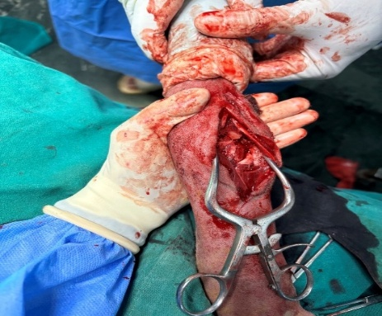
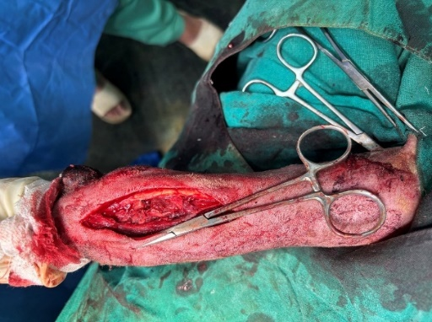
a
b
a: Lateral incision showing fractured radius ulna
b: Reduced fractured fragments after insertion of nails

Fig. 1: Fractured radius ulna and Reduced fractured fragments with inserted nails

3. results and discussion

The dog was presented after 14 days, 30 days and 90 days of surgery. The dogs had toe touching by 7th day of surgery and mild weight bearing by 14th day of surgery. The dog had complete bearing after 30 days of surgery. The sutures were removed on 14th day after surgery. Pre operatively, the flexion angle of carpal joint of healthy limb was 60° and extension angle was 180°. After 3 months of surgery, the flexion angle of carpal joint of fractured limb was 65° and extension angle was 180°. It implies that there was no change in ROM as compared to healthy limb. The lameness score improved with time from 5 to 0 as described above. The dog had mild osteomyelitis near carpal joint due to the small distal fragment and insertion of nail near to the carpal joint. But by follow up at 3 months, there was no osteomyelitis. Sodhi et al., (2024) studied the effectiveness of titanium elastic nailing (TENs) in treating Radis-ulna fractures in ten dogs (7 greyhounds and one each of Crossbred, Pomerenarian, and Siberian Husky). Long-term findings indicated complete (9) and satisfactory (1) functional outcomes. The TENs approach was identified as a simple and less intrusive alternative fixation procedure for distal radius-ulna fractures in young, light-weight dogs.

4. Conclusion

In young animals, elastic nailing can be alternate method for radius-ulna fracture fixation to plating. In rigid method of bone plating, the ROM of carpal joint does not return to normal as before fracture. So, elastic nailing serves as an alternate to plating. Also, due to less muscle mass covering radius ulna, there are increased chances of plate exposure. In addition plate removal demands an equal length of incision on limb which requires additional care and management. The difficulties with bone plate and screw fixation methods were examined by Larsen et al., (1999). It has been suggested that delayed union and nonunion in distal radius and ulna fractures are caused by decreased blood supply to the distal metaphyseal region. There was not enough soft tissue to give extraosseous blood for early vascularization and healing because of the small radial bone diameter and the tension of the digital flexor muscles. It was also difficult to keep the radius-ulna fractures biomechanically stable. The rigid IM pinning in radius such as Steinmann pin is contraindicated in radius due to its shape. So, elastic nailing was opted as an option. But due to fear of break of distal fragment single elastic nail in each radius and ulna was inserted. The dog recovered uneventfully. So, it can be concluded that single 2mm elastic nail in each radius and ulna in a dog of about 20 kgs is good alternate and cheap option to plating.

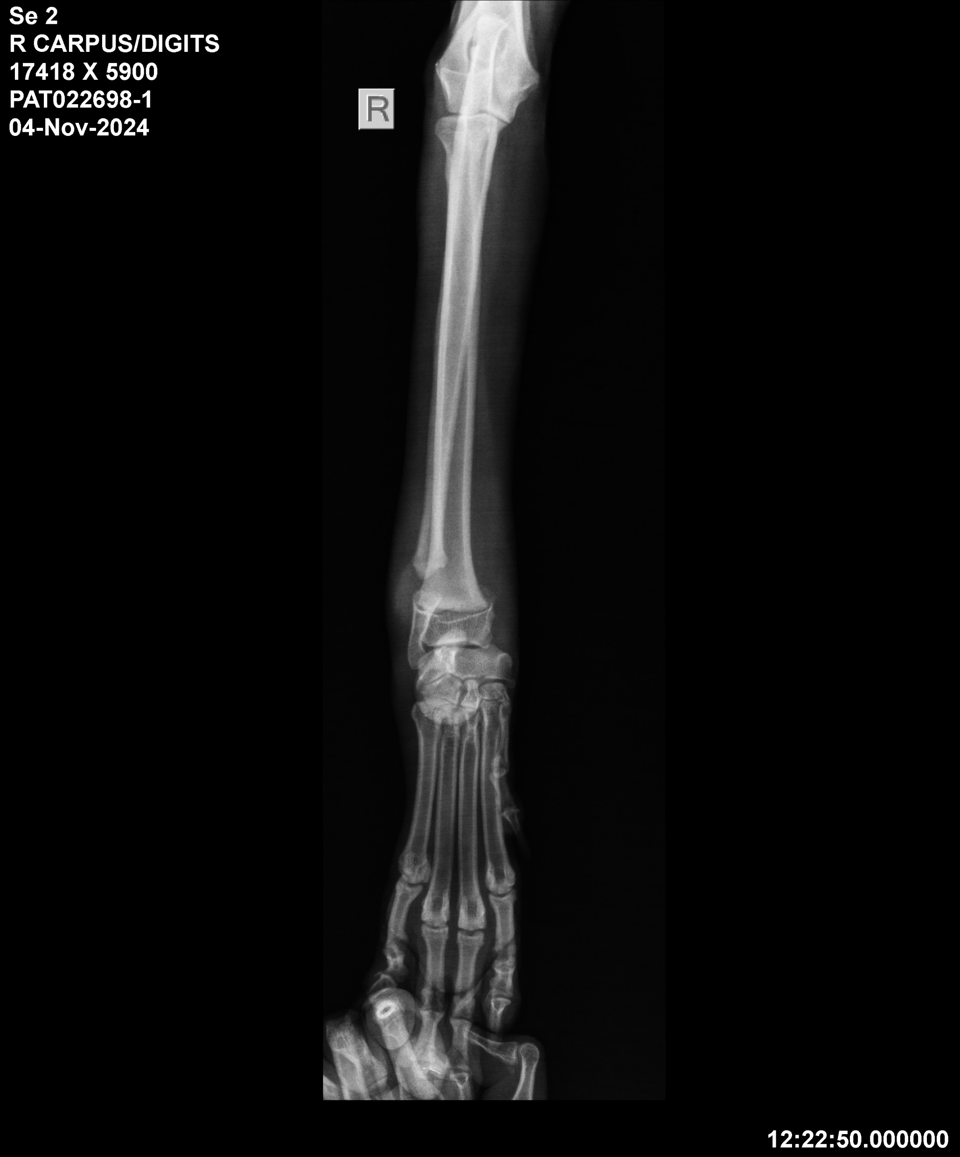
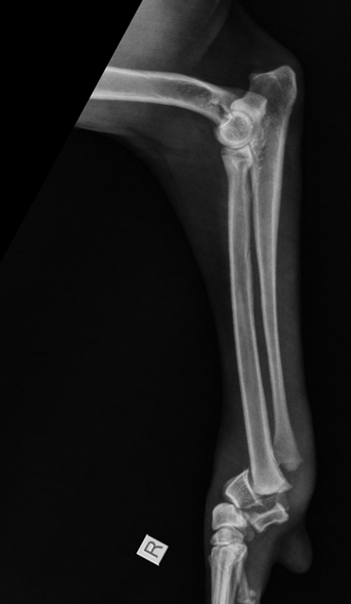
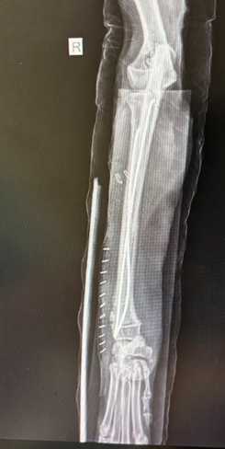
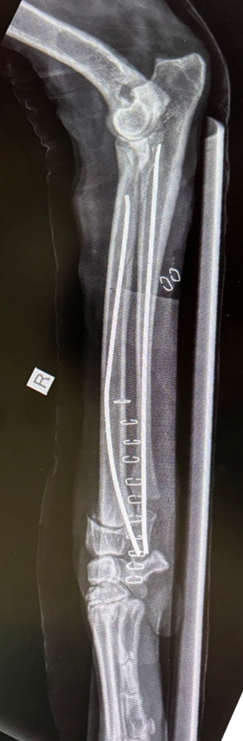
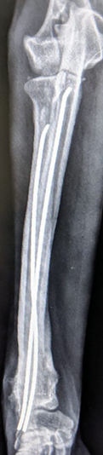
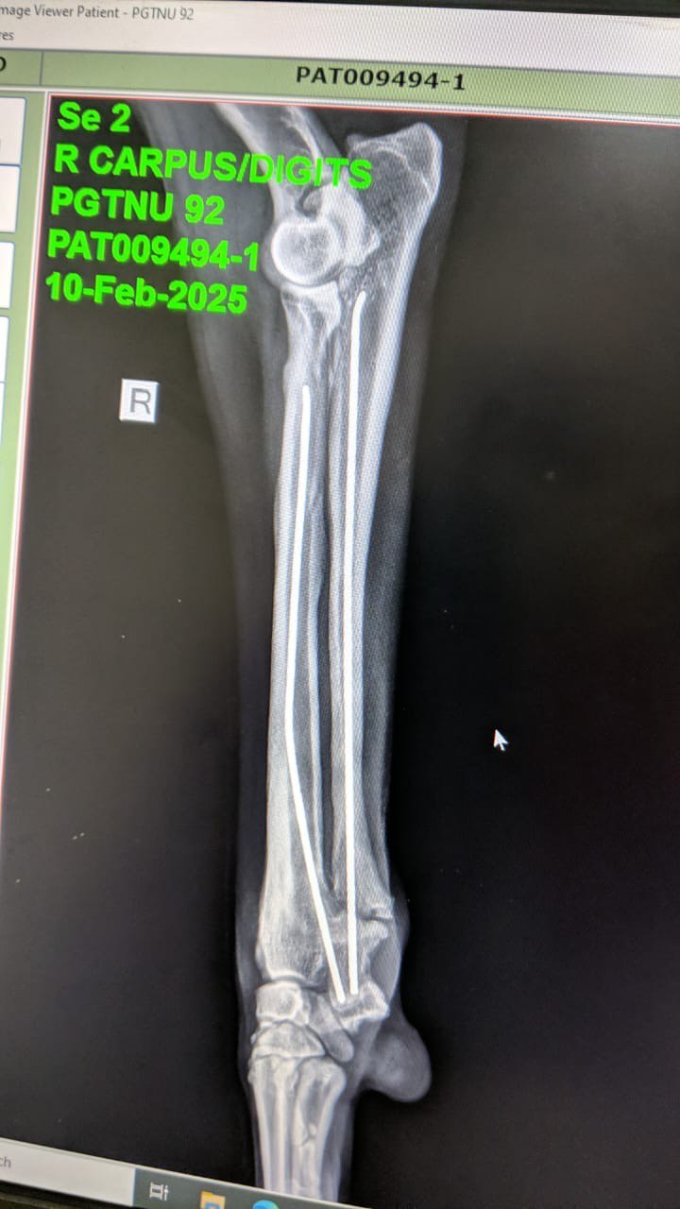
a
b
c
d
e
f
a and b: Pre operative radiographs of right radius ulna
c and d: Immediate post operative radiographs
e and f: 90 days post operative radiographs showing proper callus formation.

Fig 2: radiographic findings

References

Cook, J. L., Tomlinson, J. L., & Reed, A. L. (1999). Fluoroscopically guided closed reduction and internal fixation of fractures of the lateral portion of the humeral condyle: prospective clinical study of the technique and results in ten dogs. Veterinary Surgery, 28(5), 315-321. https://doi.org/10.1111/j.1532-950x.1999.00315.x
Fish, F. E., Sheehan, M. J., Adams, D. S., Tennett, K. A., & Gough, W. T. (2021). A 60:40 split: Differential mass support in dogs. Anatomical Record (Hoboken), 304(1), 78-89. https://doi.org/10.1002/ar.24407
Gupta, N., Kaur, K., Sangwan, V., & Kumar, A. (2024). Hospital Occurrence Pattern Of Appendicular Fractures In Dogs For 3 Consecutive Years (2019–2021). International Journal Of Livestock Research, 14(10), 17-29. http://ijlr.org/ojs_journal/index.php/ijlr/article/view/884
Harasen, G. (2003). External coaptation of distal radius and ulna fractures. The Canadian Veterinary Journal, 44(12), 1010-1011. https://pubmed.ncbi.nlm.nih.gov/14703093/
Jackson, L. C., & Pacchiana, P. D. (2004). Common complications of fracture repair. Clinical Techniques in Small Animal Practice, 19(3), 168-179 https://doi.org/10.1053/j.ctsap.2004.09.008
Khuntia, S., Swaroop, S., Patro, B. P., & Sahu, S. (2020). Paediatric Long Bone Fractures Managed with Elastic Intramedullary Nails: A Retrospective Study of 30 Patients. Cureus. https://doi.org/10.7759/cureus.7847
Kumar, A., Qureshi, B., & Sangwan, V. (2020). Biological Osteosynthesis in Veterinary Practice: A Review. International Journal of Livestock Research, 10(10), 24-31. https://doi.org/10.5455/ijlr.20200718
Kushwaha, R. B., Gupta, A. K., Bhadwal, M. S., Kumar, S., & Tripathi, A. K. (2011). Incidence of Fractures and their Management in Animals: a Clinical Study of 77 Cases. Indian Journal of Veterinary Surgery, 32(1), 54-56.
Larsen, L. J., Roush, J. K., & McLaughlin, R. M. (1999). Bone Plate Fixation of Distal Radius and Ulna Fractures in Small- and Miniature-Breed Dogs. Journal of the American Animal Hospital Association, 35(3), 243-250. https://doi.org/10.5326/15473317-35-3-243
Perren, S. M. (2002). Evolution of the internal fixation of long bone fractures: The scientific basis of biological internal fixation: Choosing a new balance between stability and biology. The Journal of Bone & Joint Surgery British Volume, 84(8), 1093-1110. https://doi.org/10.1302/0301-620x.84b8.13752

Prabhukumar, M. D., Dileepkumar, K. M., Devanand, C. B., Venugopal, S. K., Raj, I. V., Anoop, S., Nair, S. S., & Philip, L. M. (2020). Elastic stable intramedullary nailing for fixation of distal diaphyseal fracture of radius in two dogs. Indian Journal of Veterinary Surgery, 41(2), 134-136. https://www.researchgate.net/publication/352570000_Elastic_stable_intramedullary_nailing_for_fixation_of_distal_diaphyseal_fracture_of_radius_in_two_dogs

Saka, G., Saglam, N., Kurtulmus, T., Avci, C. C., Akpinar, F., Kovaci, H., & Celik, A. (2014). New interlocking intramedullary radius and ulna nails for treating forearm diaphyseal fractures in adults: a retrospective study. Injury, 45, s16-s23. https://doi.org/10.1016/j.injury.2013.10.040

Simon, M. S., Ganesh, R., Ayyappan, S., & Kumar, R. S. (2011). Incidence of pectoral limb fractures in dogs: A survey of 331 cases. Tamilnadu Journal of Veterinary and Animal Sciences, 7(2), 94-96. https://krishikosh.egranth.ac.in/handle/1/58100000000000000000

Sodhi, H. S., Kumar, A., Anand, A., Sangwan, V., & Gupta, D. K. (2024). Titanium elastic nails for distal radius-ulna fractures in young dogs. Indian journal of animal research, 58(4), 642-647. https://doi.org/10.18805/IJAR.B-4509

