Impact of replacing soybean meal with Black Soldier Fly (Hermetia illucens) Larvae Meal on the development of Tibial Bone in Vancobb Broiler Chickens

Abstract
The current study compared the impact of partial soybean meal replacement with Black Soldier Fly Larvae Meal (BSFLM) as a source of protein on the development of tibial bone in Vancob broiler chickens. A total of four dietary regimens were developed: T0 (control; 0% replacement), T1 (40% replacement), T2 (50% replacement) and T3 (60% substitution of soybean meal protein with BSFLM). Tibial length and morphometric parameters including proximal end width, mid-shaft diameter and distal end width were measured at the end of the experimental period. The data showed a steady increase in tibial length and bone thickness in BSFLM-fed groups in a direct comparison with control animals. T3, T1 and T2 have the highest average length of tibial bone (108.6 mm). Studies performed through morphometric evaluation indicated greater bone robustness with BSFLM-based diets that contributed to the progression of skeletal maturation without associated ill effects. The authors concluded from their investigations that BSFLM can safely replace soybean meal protein by 60% in Vancobb broiler diets, which provides positive effects on the evolution of tibial bone.
Keywords: Black soldier fly larvae meal, tibial bone, Vancobb broiler, soybean meal replacement, skeletal development.
Introduction
Rapid genetic improvement in modern broiler chickens has resulted in accelerated growth rate, improved feed efficiency, and high breast muscle yield. However, these genetic advancements have placed disproportionate physiological demands on the skeletal system, which often fails to mature at a rate proportional to muscle accretion. Consequently, skeletal defects, leg weakness, impaired locomotion, and compromised welfare have become major constraints in intensive broiler production systems, leading to substantial economic losses due to increased culling, mortality, and reduced performance (Corr et al., 2003; Alkhtib et al., 2021; Güz et al., 2021).
Skeletal integrity remains a critical limiting factor preventing fast-growing broiler strains from fully expressing their genetic potential. Bone development in poultry is a complex biological process regulated by genetics, nutrition, and environmental factors. Adequate intake of high-quality protein, balanced amino acids, and bioavailable minerals—particularly calcium and phosphorus—is essential for proper endochondral ossification, epiphyseal cartilage maturation, and cortical bone formation (Proszkowiec-Weglarz and Angel, 2013; Rama Rao et al., 2006). Nutrient deficiencies or imbalances adversely affect bone mineralization, resulting in conditions such as tibial dyschondroplasia, reduced bone strength, and increased fracture susceptibility during rapid growth phases (Yan et al., 2005).
Among long bones, the tibia serves as a primary weight-bearing structure and is widely used as a reliable indicator of skeletal health in broilers due to its sensitivity to dietary and nutritional interventions (Charuta et al., 2013; Alkhtib et al., 2021). Soybean meal remains the conventional primary protein source in broiler diets owing to its favorable amino acid profile and digestibility. However, increasing costs, dependence on imports, competition with human food systems, and environmental concerns associated with soybean cultivation have intensified the search for alternative and sustainable protein sources for poultry nutrition (Letourneau-Montminy et al., 2010; Zaid et al., 2023).
In this context, insect-derived protein meals have gained considerable attention, particularly Black Soldier Fly larvae meal (BSFLM), which exhibits high crude protein content, a balanced essential amino acid profile, and substantial calcium and phosphorus concentrations (Vasilopoulos et al., 2024; Keser, 2023). BSFLM can be produced using organic waste substrates, thereby supporting circular bioeconomy principles (Seyedalmoosavi et al., 2023; Siddiqui et al., 2023). The protein quality and digestibility of BSFLM are comparable to conventional protein ingredients, supplying essential amino acids necessary for skeletal matrix synthesis (Maidin et al., 2023; Facey et al., 2024).
The mineral-rich exoskeleton of Black Soldier Fly larvae contributes significantly to dietary calcium and phosphorus, supporting bone mineralization and epiphyseal growth (Seyedalmoosavi et al., 2024). Additionally, BSFLM contains chitin, which may exert prebiotic-like effects, improving gut health and nutrient utilization. Medium-chain fatty acids, particularly lauric acid, may further enhance intestinal integrity and mineral absorption (Zaid et al., 2023). While BSFLM has been extensively evaluated for growth performance, feed efficiency, carcass characteristics, gut health, and meat quality (Pieterse et al., 2019; Ayuningtyas et al., 2023; Facey et al., 2024), information regarding its influence on skeletal development—especially tibial morphometry—remains limited.
Most existing studies have focused on low inclusion levels of insect meal or evaluated performance traits rather than bone traits and have rarely quantified skeletal responses under higher replacement rates using commercial broiler strains (Selaledi et al., 2022; Vasilopoulos et al., 2024). The response of tibial length, epiphyseal width, and mid-shaft diameter to progressive replacement of soybean meal with BSFLM is therefore insufficiently understood, despite the direct relevance of these parameters to bone strength, load-bearing capacity, and resistance to leg disorders (Charuta et al., 2013; Alkhtib et al., 2021).
Therefore, the objective of the present study was to evaluate the effects of partial replacement of soybean meal protein with BSFLM at 40%, 50%, and 60% levels on tibial bone development in Vancob broiler chickens, focusing on tibial length, proximal and distal epiphyseal widths, and mid-shaft diameter as indicators of skeletal growth and strength.
Materials and Methods
Experimental Birds: Design and Experiment.
A collection of 240-day old Vencobb 400 broiler chicks was procured by a local Assam livestock and poultry cooperation Ltd., Panjabari, Khanapara, Guwahati, Assam 78103. For the entire experimental period, chicks were wing banded and raised under deep litter system of management with same standard and uniform management practices. The birds were fed according to the ICAR (2013) feeding schedule. Four dietary treatment groups were randomly allocated to the birds: T0 (0% soybean meal protein replacement), T1 (40% replacement), T2 (50% replacement), and T3 (60% substitute with Black Soldier Fly larvae meal) were all fed to each batch of birds. A total of 60 birds were reared in the treatment and under the same management, feeding, and environmental conditions throughout the experimental period.
Sampling and Tibial Morphometry.
Five birds from each class of treatment (n = 20) were randomly selected and slaughtered humanely in accordance with standard ethical practices on the 45-day final feeding trial. A digital electronic balance was used to record body weight, and the two tibiae were cut carefully. Soft tissue that adhered to the tissue were removed manually to prevent injury of the bone surface. The bone length, proximal end width, mid-shaft diameter and distal end width along with other morphometric features of the tibia were collected with a vernier calliper with millimetre precision (Fig. 1-17).
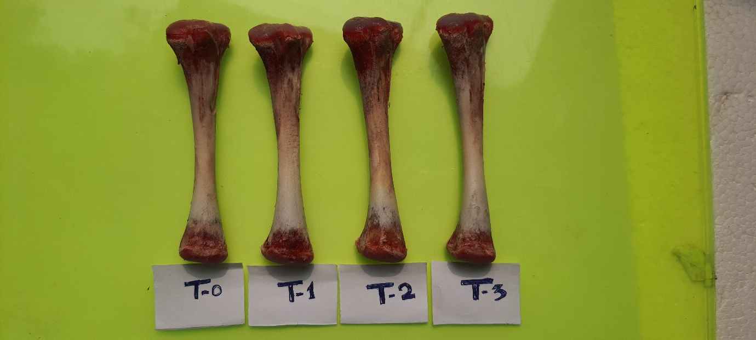
Fig. 1 Comparative image of T0, T1, T2 and T3 Tibial bone
T0 | 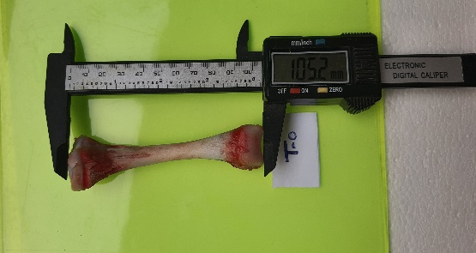 | 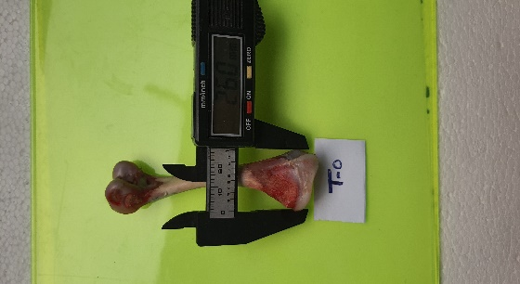 | 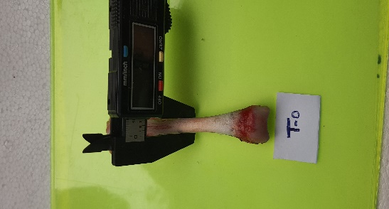 | 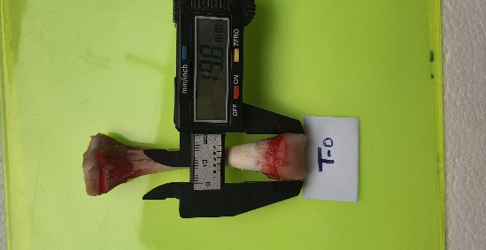
 | Fig.2 T-0 Tibial length | Fig.3 T-0 Proximal end | Fig.4 T-0 Mid-shaft | Fig.5 T-0 Distal end
T1 | 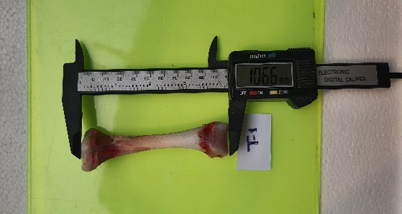 | 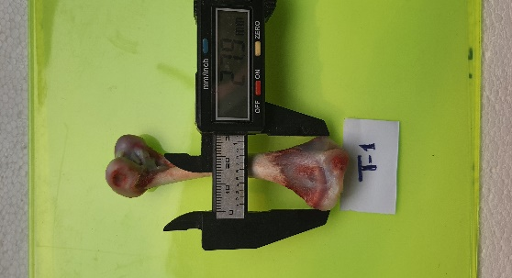 | 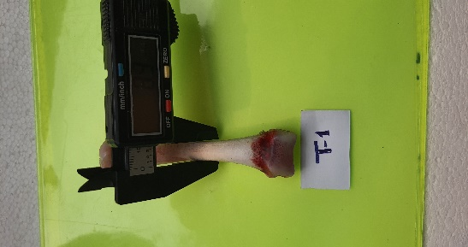 | 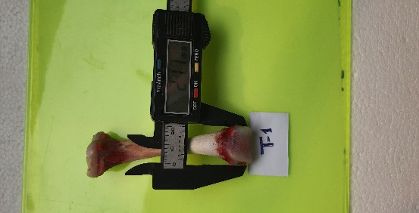
 | Fig.6 T-1 Tibial length | Fig.7 T-1 Proximal end | Fig.8 T-1 Mid-shaft | Fig.9 T-1 Distal end
T2 | 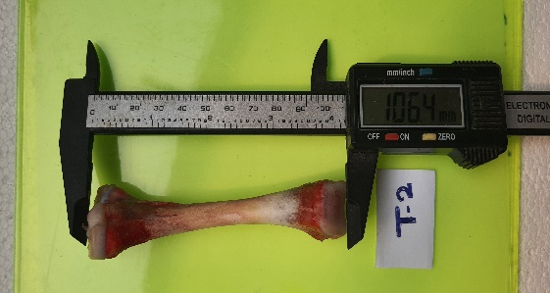 | 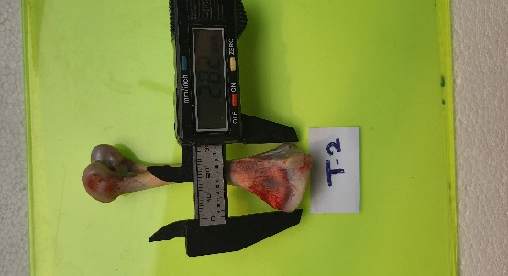 | 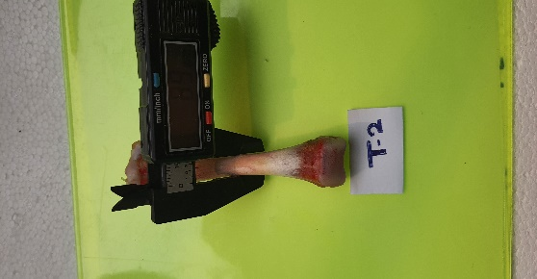 | 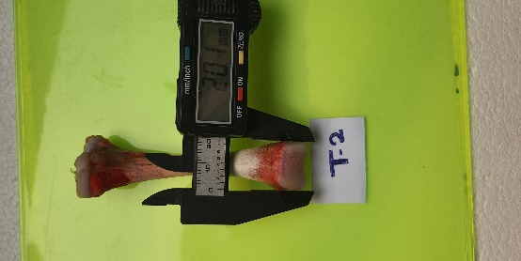
 | Fig.10 T-2 Tibial length | Fig.11 T-2 Proximal end | Fig.12 T-2 Mid-shaft | Fig.13 T-2 Distal end
T3 | 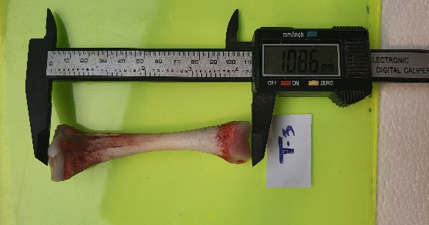 | 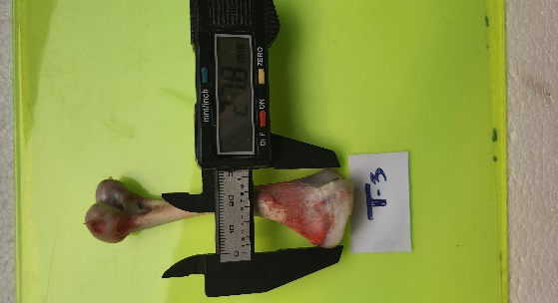 | 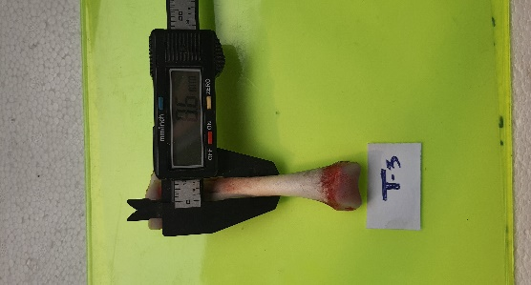 | 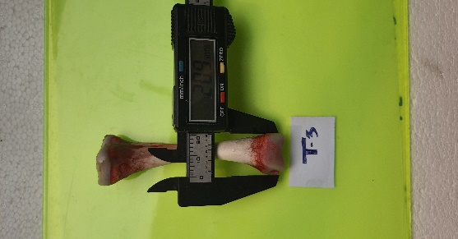
 | Fig.14 T-3 Tibial length | Fig.15 T-3 Proximal end | Fig.16 T-3 Mid-shaft | Fig.17 T-3 Distal end

X-ray analysis of the tibial bone
Abnormally produced tibial bone fragments were examined post-mortem morphobiology for bone and morphologic characteristics with X-ray. Radiographs were obtained in the AP and PA areas at the Veterinary Clinical Complex, College of Veterinary Science, Khanapara, according to the usual diagnostics exposure conditions. Bone continuity, cortical density, and structural uniformity of all treatments were assessed on the radiographs (Fig. 18-19).
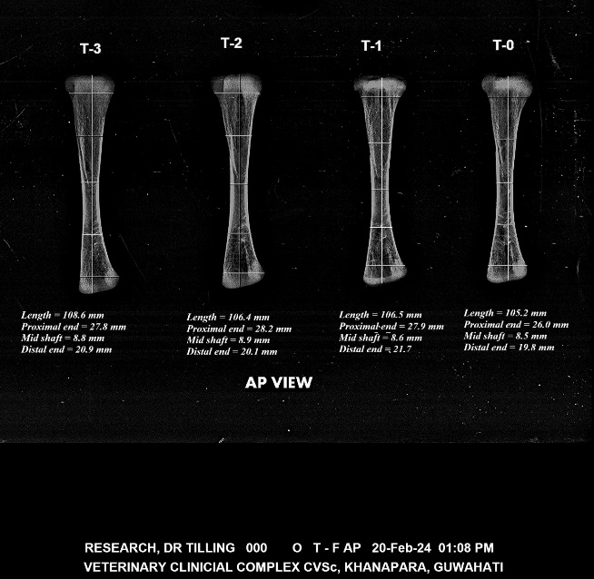 | 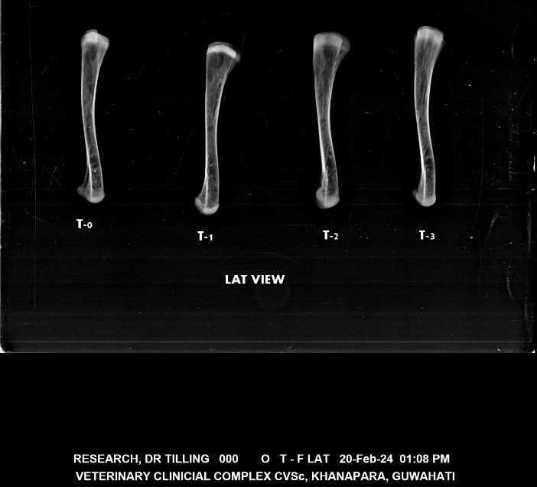
Fig. 18 Anterior Posterior X ray view of Broiler Tibial bone | Fig. 19 Lateral X ray view of Broiler Tibial bone

Presentation and statistical analysis (Mean ± SE)
The tibial bone morphometry data were analyzed using one-way analysis of variance (ANOVA) with dietary treatment as a fixed effect (Snedecor and Cochran 1994). Separation of treatments was examined by mean by using means of Duncan's multiple range test. The P < 0.05 difference was considered statistically significant. Results are reported as mean ± SE, depending on n (n = 10 birds per treatment).
Results
Statistical analysis showed significant trends in tibial bone parameters after dietary supplementation of soybean meal with BSFLM (Table 1).
Table 1. Tibial bone morphometric parameters (Mean ± SE; n = 5)
Treatment | Tibial length (mm) | Proximal end (mm) | Mid shaft (mm) | Distal end (mm)
T0 (0%) | 105.2 ± 0.42ᶜ | 26.0 ± 0.31ᵇ | 8.5 ± 0.09ᵇ | 19.8 ± 0.28ᵇ
T1 (40%) | 106.5 ± 0.38ᵇ | 27.9 ± 0.29ᵃ | 8.6 ± 0.07ᵇ | 21.7 ± 0.34ᵃ
T2 (50%) | 106.4 ± 0.36ᵇ | 28.2 ± 0.33ᵃ | 8.9 ± 0.08ᵃ | 20.1 ± 0.26ᵇ
T3 (60%) | 108.6 ± 0.41ᵃ | 27.8 ± 0.27ᵃ | 8.8 ± 0.06ᵃ | 20.9 ± 0.31ᵃᵇ
a,b,c Means within a column bearing different superscripts differ significantly (P < 0.05).
Discussions:
Skeletal development is a key determinant of productivity, welfare, and economic sustainability in modern broiler production systems. Genetic selection for rapid growth and feed efficiency has increased physiological stress on the musculoskeletal system, often resulting in an imbalance between muscle deposition and bone strength (Corr et al., 2003; Güz et al., 2021). Consequently, leg disorders, restricted mobility, and welfare impairments are common in fast-growing broiler strains.
The present study demonstrated significant improvements in tibial morphometry in broiler chickens when soybean meal protein was partially replaced with BSFLM, indicating that BSFLM may actively promote skeletal development rather than simply acting as a neutral protein substitute.
General Implications of Improved Tibial Morphometry
The tibia is an appropriate representative bone for assessing skeletal development due to its load-bearing role and nutritional sensitivity (Alkhtib et al., 2021). Improvements in tibial length, epiphyseal width, and mid-shaft diameter with increasing levels of BSFLM inclusion—particularly at 50% and 60% replacement—suggest enhanced bone growth dynamics, mineral deposition, and structural integrity. The absence of adverse effects even at the highest replacement level confirms the biological adequacy of BSFLM for broiler skeletal development (Facey et al., 2024).
Tibial Length and Longitudinal Bone Growth
Tibial length reflects growth plate activity and endochondral ossification. The progressive increase in tibial length with higher BSFLM inclusion indicates sufficient availability of amino acids, calcium, and phosphorus to support uninterrupted longitudinal bone growth (Proszkowiec-Weglarz and Angel, 2013; Yan et al., 2005). The absence of growth suppression at higher inclusion levels suggests that BSFLM does not impair mineral homeostasis or nutrient digestibility (Seyedalmoosavi et al., 2024).
Proximal Epiphyseal Width and Epiphyseal Development
The proximal tibial epiphysis is highly sensitive to dietary calcium, phosphorus, and protein supply (Rama Rao et al., 2006; Yan et al., 2004). The observed increase in proximal epiphyseal width in BSFLM-fed birds suggests improved cartilage maturation and mineralization. Improved mineral bioavailability and potential enhancement of gut absorption likely contributed to superior epiphyseal development (Viveros et al., 2002; Powell et al., 2011).
Mid-Shaft Diameter and Cortical Bone Development
Mid-shaft diameter is closely related to cortical thickness and mechanical strength. Broilers fed 50% and 60% BSFLM exhibited significantly greater mid-shaft diameters, suggesting improved periosteal bone apposition and structural reinforcement (Charuta et al., 2013; Alkhtib et al., 2021). Adequate amino acid supply, mineral availability, and efficient phosphorus utilization are critical drivers of this response (Driver et al., 2005; Wilkinson et al., 2011).
Distal Epiphyseal Width and Metaphyseal Maturation
Although changes at the distal epiphysis were less pronounced, improvements suggest balanced metaphyseal maturation and appropriate mineral deposition across the tibia. This pattern aligns with site-specific growth dynamics, where proximal regions respond more rapidly to nutritional modulation than distal regions (Yan et al., 2005; Charuta et al., 2013).
Nutrient Utilization and Bone Metabolism
Low variation in morphometric measurements indicates uniform skeletal responses, desirable for commercial production. Efficient utilization of BSFLM-derived nutrients and potential prebiotic effects of chitin may have improved gut integrity and mineral absorption (Viveros et al., 2002; Seyedalmoosavi et al., 2024; Sarıca et al., 2025).
Mineral Bioavailability and Skeletal Integrity
Animal-derived mineral sources are generally less bound to phytate compared with plant-based ingredients, resulting in improved mineral bioavailability (Letourneau-Montminy et al., 2010; Boling-Frankenbach et al., 2001). The enhanced tibial morphology suggests effective calcium–phosphorus balance and mineral homeostasis, critical for skeletal integrity (Proszkowiec-Weglarz and Angel, 2013).
Broiler Welfare and Production Implications
Improved tibial structure has direct implications for broiler welfare by reducing leg disorders, improving locomotion, and minimizing pain and stress (Güz et al., 2021). From a production standpoint, enhanced skeletal health contributes to improved feed efficiency, reduced mortality, and superior carcass quality (Facey et al., 2024).
Sustainability and Future Perspectives
BSFLM production supports circular bioeconomy principles through upcycling organic waste streams, while reducing reliance on soybean meal associated with environmental degradation (Seyedalmoosavi et al., 2023; Zaid et al., 2023). Future studies should evaluate long-term bone mineral density, biomechanical strength, and interactions with mineral supplementation or phytase strategies (Khattak et al., 2023).
Conclusions:
To conclude, the current study provides strong evidence that partial substitution of soybean meal with BSFLM significantly positively affects the tibial bone morphometric parameters in broiler chickens. Increased tibial length, wide proximal epiphysis, larger mid-shaft, and well-developed distal epiphyseal development all reflect better skeletal growth and strength. These effects may be mediated by the better amino acid availability, increased mineral bioavailability and nutrient efficiency that BSFLM have shown to promote (Elahi et al., 2022; Belhadj et al., 2023). No side effects have been observed even at 60% replacement, further demonstrating nutritional adequacy and safety of BSFLM as an alternative protein source. From the nutritional and sustainability viewpoint, BSFLM represents an attractive feed nutrient and can be beneficial to skeletal integrity, enhanced broiler welfare and promote more sustainable poultry production systems.
References
- Alkhtib, A., Sanni, C. O., Burton, E., & Scholey, D. (2021). What is “normal”? Morphology and mineralization of tibias from healthy, on-farm broilers. Journal of Applied Poultry Research, 30(3), 100190. https://doi.org/10.1016/j.japr.2021.100190
- Ayuningtyas, G., Sembada, P., & Priyambodo, D. (2023). Carcass and meat quality traits of IPB D1 chicken on black soldier fly larvae (BSFL) dietary inclusion. E3S Web of Conferences, 454, 02014. https://doi.org/10.1051/e3sconf/202345402014
- Belhadj Slimen I, Yerou H, Ben Larbi M, M'Hamdi N, Najar T. Insects as an alternative protein source for poultry nutrition: a review. Front Vet Sci. 2023 Aug 17;10:1200031. doi: 10.3389/fvets.2023.1200031.
- Boling-Frankenbach, S. D., Snow, J. L., Parsons, C. M., & Baker, D. H. (2001). The effect of citric acid on the calcium and phosphorus requirements of chicks fed corn–soybean meal diets. Poultry Science, 80, 783–788. https://doi.org/10.1093/ps/80.6.783
- Charuta, A., Dzierzęcka, M., Komosa, M., Kalinowski, Ł., & Pierzchała, M. (2013). Age- and sex-related differences of morphometric, densitometric and geometric parameters of tibiotarsal bone in Ross broiler chickens. Folia Biologica (Kraków), 61(3–4), 211–220.
https://doi.org/10.3409/fb61_3-4.211
- Corr, S. A., Gentle, M. J., McCorquodale, C. C., & Bennett, D. (2003). The effect of morphology on the musculoskeletal system of the modern broiler. Animal Welfare, 12(2), 145–157. https://doi.org/10.1017/S0962728600025604
- Driver, J. P., Pesti, G. M., Bakalli, R. I., & Edwards, H. M., Jr. (2005). Effects of calcium and nonphytate phosphorus concentrations on phytase efficacy in broiler chicks. Poultry Science, 84, 1406–1417. https://doi.org/10.1093/ps/84.9.1406
- Elahi U, Xu CC, Wang J, Lin J, Wu SG, Zhang HJ, Qi GH. Insect meal as a feed ingredient for poultry. Anim Biosci. 2022 Feb;35(2):332-346. doi: 10.5713/ab.21.0435
- Facey, H., Kithama, M., Mohammadigheisar, M., Barbut, S., Huber, L. A., Shoveller, A. K., & Kiarie, E. G. (2024). Complete replacement of soybean meal with black soldier fly larvae meal in feeding programs for broiler chickens: Impact on gastrointestinal, breast, skeletal, plasma, and litter attributes. Canadian Journal of Animal Science, 104(4), 454–465.
https://doi.org/10.1139/cjas-2024-0006
- Güz, B. C., de Jong, I. C., Da Silva, C. S., Veldkamp, F., Kemp, B., Molenaar, R., & van den Brand, H. (2021). Effects of pen enrichment on leg health of fast- and slower-growing broiler chickens. PLoS ONE, 16(12), e0254462. https://doi.org/10.1371/journal.pone.0254462
- Keser, O. (2023). The use of black soldier fly (Hermetia illucens) larvae in poultry nutrition. International Academic Research and Reviews in Health Sciences, 21, 21–63. https://www.seruvenyayinevi.com/Webkontrol/uploads/Fck/marthealth2023.pdf#page=27
- Khattak, F., Jlali, M., Rougier, T., Houdijk, J. G. M., & Hincelin, C. (2023). Bacterial 6-phytase supplementation improves bone mineralisation, phosphorus digestibility and growth performance of broilers fed corn–soybean meal-based diets. Proceedings of the WPSA UK Branch Meeting. https://doi.org/10.1080/17466202.2023.2215131
- Letourneau-Montminy, M. P., Narcy, A., Lescoat, P., Bernier, J. F., Magnin, M., Pomar, C., Nys, Y., Sauvant, D., & Jondreville, C. (2010). Meta-analysis of phosphorus utilisation by broilers receiving corn–soybean meal diets: Influence of dietary calcium and microbial phytase. Animal, 4, 1844–1853. https://doi.org/10.1017/S1751731110001060
- Maidin, M. B. M., Liang, J., McCormack, H. A., Wilson, P. W., Andersson, B., Schmutz, M., & Heritability, I. D. (2023). Insects as animal feed. British Poultry Abstracts, 19(1), 1–27.
https://doi.org/10.1080/17466202.2023.2215131
- Pieterse, E., Erasmus, S. W., Uushona, T., & Hoffman, L. C. (2019). Black soldier fly (Hermetia illucens) pre-pupae meal as a dietary protein source for broiler production. Journal of the Science of Food and Agriculture, 99(2), 893–903.
https://doi.org/10.1002/jsfa.9261
- Powell, S., Bidner, T. D., & Southern, L. L. (2011). Phytase supplementation improved growth performance and bone characteristics in broilers fed varying levels of dietary calcium. Poultry Science, 90, 604–608. https://doi.org/10.3382/ps.2010-01000
- Proszkowiec-Weglarz, M., & Angel, R. (2013). Calcium and phosphorus metabolism in broilers: Effect of homeostatic mechanism on calcium and phosphorus digestibility. Journal of Applied Poultry Research, 22, 609–627. https://doi.org/10.3382/japr.2013-00740
- Rama Rao, S. V., Raju, M. V. L. N., Reddy, M. R., & Pavani, P. (2006). Interaction between dietary calcium and nonphytate phosphorus levels on growth, bone mineralization, and mineral excretion in commercial broilers. Animal Feed Science and Technology, 131, 133–148. https://doi.org/10.1016/j.anifeedsci.2006.02.011
- Sarıca, Ş., Yavuz, M., Sanlı, E. R., Baş-Ekici, H., & Yardım, Z. (2025). Effects of dietary fermented mealworm larvae and stocking density on morphometric characteristics and mineral contents of tibia bone of broilers. Turkish Journal of Agriculture–Food Science and Technology, 13(2), 294–302. https://doi.org/10.24925/turjaf.v13i2.294-302.7019
- Selaledi, L., Sebola, N. A., Mbajiorgu, C., & Mabelebele, M. (2022). Inclusion of yellow mealworm (Tenebrio molitor) in diets for Boschveld indigenous chickens.
https://doi.org/10.2139/ssrn.4301267
- Seyedalmoosavi, M. M., Daş̧, G., Mielenz, M., Maak, S., Wolf, P., & Metges, C. C. (2024). Growth, nutrient uptake, blood metabolites and bone properties in broilers consuming feed with mineral-enriched whole black soldier fly larvae. Journal of Insects as Food and Feed, 10(12), 2071–2083. https://doi.org/10.1163/23524588-00001208
- Seyedalmoosavi, M. M., Mielenz, M., Schleifer, K., Görs, S., Wolf, P., Tränckner, J., Hüther, L., Dänicke, S., Daş, G., & Metges, C. C. (2023). Upcycling of recycled minerals from sewage sludge through black soldier fly larvae (Hermetia illucens). Journal of Environmental Management, 344, 118695. https://doi.org/10.1016/j.jenvman.2023.118695
- Siddiqui, S. A., Fernando, I., Nisa', K., Shah, M. A., Rahayu, T., Rasool, A., & Aidoo, O. F. (2023). Effects of undesired substances and bioaccumulation in black soldier fly larvae. Environmental Monitoring and Assessment, 195, 823. https://doi.org/10.1007/s10661-023-11186-w
- Vasilopoulos, S., Giannenas, I., Athanassiou, C. G., Rumbos, C., Papadopoulos, E., & Fortomaris, P. (2024). Black soldier fly, mealworm and superworm: Chemical composition and comparative effect on broiler growth. World’s Poultry Science Journal, 80(3), 681–710.
https://doi.org/10.1080/00439339.2024.2365919
- Viveros, A., Brenes, A., Arija, I., & Centeno, C. (2002). Effects of microbial phytase supplementation on mineral utilization and serum enzyme activities in broiler chicks. Poultry Science, 81, 1172–1183. https://doi.org/10.1093/ps/81.8.1172
- Wilkinson, S. J., Selle, P. H., Bedford, M. R., & Cowieson, A. J. (2011). Exploiting calcium-specific appetite in poultry nutrition. World’s Poultry Science Journal, 67, 587–598.
https://doi.org/10.1017/S0043933911000699
- Yan, F., Angel, R., Ashwell, C., Mitchell, A., & Christman, M. (2005). Evaluation of the broiler’s ability to adapt to an early moderate deficiency of phosphorus and calcium. Poultry Science, 84, 1232–1241. https://doi.org/10.1093/ps/84.8.1232
- Yan, F., Fritts, C. A., & Waldroup, P. W. (2004). Evaluation of modified dietary phosphorus levels with and without phytase supplementation. Journal of Applied Poultry Research, 13, 394–400. https://doi.org/10.1093/japr/13.3.394
- Zaid, M. Z. A., Ramiah, S. K., Jamein, E. S., Zulkifli, I., Lokman, I. H., Amirul, F. M. A., & Hassim, H. A. (2023). Potential use of black soldier fly larvae in chicken feed as a protein replacer. Journal of Animal Feed Science, 32, 341–353. https://doi.org/10.22358/jafs/162066/2023

