Original Research Article

CLINICAL FEASIBILITY OF HAND-GUIDED BLIND ENDOTRACHEAL INTUBATION IN GOATS UNDER GENERAL ANAESTHESIA

.
ABSTRACT
Aims:
The present study aimed to evaluate the clinical feasibility and safety of hand-guided blind endotracheal intubation as an airway management technique in goats undergoing general anaesthesia for elective surgical procedures.
Study Design:
Prospective clinical feasibility study.
Place and Duration of Study:
The study was conducted at the Teaching Veterinary Clinical Complex, Mannuthy and the University Veterinary Hospital, Kokkalai, Thrissur, Kerala Veterinary and Animal Sciences University, India, between 2020 to 2023.
Methodology:
Twelve clinically healthy goats of either sex were included in the study. Following standardised premedication and induction, general anaesthesia was maintained using balanced anaesthetic protocols, including partial intravenous anaesthesia as clinically indicated. Endotracheal intubation was performed using a digital palpation–guided blind technique without the use of a laryngoscope. All intubations were carried out by a single experienced operator. Correct placement of cuffed endotracheal tubes was confirmed by assessment of airflow, observation of thoracic excursions, and capnographic detection of end-tidal carbon dioxide. Intubation success, airway security, and peri-intubation complications were recorded.
Results:
Hand-guided blind endotracheal intubation was successfully achieved in all animals (12/12), resulting in a 100% success rate. No major airway-related complications were observed. Minor, self-limiting events such as transient resistance at the laryngeal inlet or brief oesophageal intubation occurred in a limited number of cases and were corrected promptly without adverse consequences. No incidences of aspiration, significant airway trauma, or clinically relevant physiological instability were recorded.
Conclusion:
The findings demonstrate that hand-guided blind endotracheal intubation is a reliable, safe, and clinically feasible technique for airway management in goats under general anaesthesia. Owing to its minimal equipment requirements and reliance on tactile anatomical landmarks, this technique represents a practical alternative to laryngoscope-assisted intubation, particularly in field, teaching, and resource-limited veterinary settings.

Keywords: Goats, Endotracheal intubation, Airway management, General anaesthesia, Blind intubation, Small ruminants

1. INTRODUCTION

Safe and effective airway management is a cornerstone of general anaesthesia in goats, particularly due to their unique anatomical and physiological characteristics. Goats possess a narrow oral cavity, limited intermandibular space, copious salivation, and a strong tendency for regurgitation, all of which increase the risk of airway obstruction and aspiration during anaesthesia (Taylor, 1991; Galatos, 2011). Consequently, securing the airway through endotracheal intubation is widely regarded as an essential component of anaesthetic management in small ruminants (White and Taylor, 2000).
Endotracheal intubation in goats, however, can be technically challenging. Visualisation of the glottis using a laryngoscope is often difficult because of the caudal position of the larynx, limited mouth opening, and the presence of soft tissue structures that obscure the vocal folds (Ewing, 1990; Caulkett, 2003). These challenges are particularly evident in field conditions and resource-limited settings, where access to specialised airway equipment and optimal positioning may be restricted. As a result, alternative intubation techniques that do not rely on direct visualisation of the larynx have been advocated in small ruminants.
Hand-guided blind endotracheal intubation, based on digital palpation of the epiglottis and laryngeal inlet, has been described as a practical technique for airway management in goats and sheep (Gray and McDonell, 1986). By relying on tactile anatomical landmarks rather than visual cues, this method may facilitate rapid and reliable tracheal intubation, particularly in situations where laryngoscope-assisted techniques are impractical or unsuccessful. Previous reports have highlighted the feasibility of blind intubation in ruminants, especially when performed by experienced operators (Caulkett, 2003; Abrahamsen, 2008).
The use of cuffed endotracheal tubes is strongly recommended during general anaesthesia in goats to minimise the risk of aspiration of ruminal contents and to ensure effective ventilation (Taylor, 1991; Reid et al., 1993; Fabin, 2017; Dzikiti et al., 2011). Proper placement and inflation of the cuff are critical for maintaining airway patency and preventing peri-anaesthetic complications. Despite the recognised importance of airway protection in goats, there is limited published information evaluating the clinical performance of hand-guided blind endotracheal intubation techniques under routine surgical conditions.
The objective of the present study was to evaluate the feasibility and clinical applicability of hand-guided blind endotracheal intubation in goats undergoing general anaesthesia for elective surgical procedures. By documenting intubation success and airway security under routine clinical conditions, this study aims to contribute practical evidence to support airway management strategies in goats, particularly in field and resource-limited veterinary settings.
2. material and methods

The present study was conducted as a prospective clinical evaluation of a hand-guided blind endotracheal intubation technique in goats undergoing general anaesthesia for elective surgical procedures. All experimental procedures were carried out following approval from the Institutional Faculty Research Committee, and informed consent was obtained from animal owners prior to inclusion in the study. Animals were assessed pre-operatively to rule out any apparent upper airway abnormalities that could interfere with endotracheal intubation. Twelve clinically healthy goats of either sex undergoing routine surgical interventions were included in the study.
Anaesthetic premedication, induction and maintenance protocols were standardised and followed previously described methods using α₂-adrenergic agonist–opioid combinations with tiletamine–zolazepam induction, under total or partial intravenous anaesthesia as clinically indicated (Udharwar et al., 2023a; Udharwar et al., 2023b; Udharwar et al., 2025). Adequate depth of anaesthesia was ensured before attempting endotracheal intubation in all animals.
An intubation attempt was defined as insertion of the endotracheal tube into the oral cavity with the intention of tracheal placement. Endotracheal intubation was performed using a hand-guided blind technique without the use of a laryngoscope. Following induction of anaesthesia, the animal was positioned in sternal recumbency with the head and neck gently extended. The mouth was opened manually, and the non-dominant hand of the operator was introduced into the oral cavity. Using digital palpation, the base of the tongue and epiglottis were identified, and the laryngeal inlet was located manually. A suitably sized, lubricated cuffed endotracheal tube fitted with a malleable stylet was then advanced along the palmar surface of the guiding fingers toward the laryngeal opening. Gentle rotational movements were employed to facilitate passage of the tube through the vocal folds into the trachea. Care was taken to avoid excessive force in order to minimise the risk of mucosal trauma or laryngospasm. All intubations were performed by the same experienced operator to ensure consistency of technique.
Correct placement of the endotracheal tube was confirmed by observation of bilateral chest excursions, detection of airflow through the tube, and capnographic confirmation of end-tidal carbon dioxide. The cuff was inflated only after confirmation of tracheal placement. The following parameters, including successful intubation and occurrence of complications (oesophageal intubation, oral or pharyngeal trauma, bleeding, or laryngospasm).

3. results

Hand-guided blind endotracheal intubation was successfully achieved in all goats included in the study, resulting in a 100% overall success rate (12/12 animals) following induction of adequate general anaesthetic depth. (Figure 1).

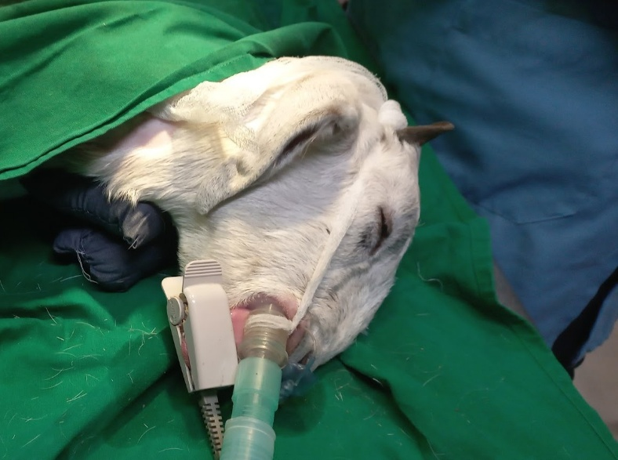

Fig. 1. Endotracheal tube in position (connected to Anaesthesia machine)

Intubation was performed using a digital palpation–guided blind technique without the use of a laryngoscope, relying on manual identification of the epiglottis and laryngeal inlet to facilitate tracheal tube placement. All procedures were carried out by a single experienced operator, ensuring consistency of technique and minimising operator-related variability.
Appropriately sized cuffed Murphy-type endotracheal tubes were selected based on external palpation of the trachea (Figure 2).

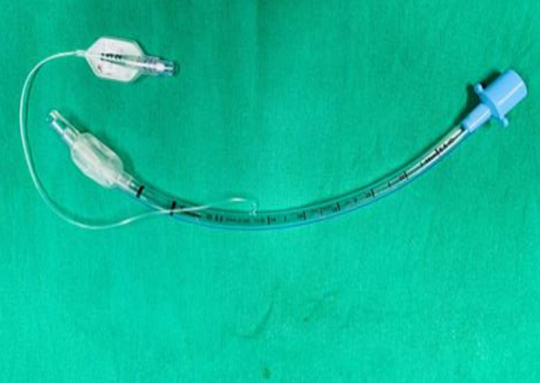

Fig. 2. Cuffed Murphy-type endotracheal tube

Correct tracheal placement was confirmed by unobstructed airflow through the tube, observation of bilateral thoracic excursions, and capnographic detection of end-tidal carbon dioxide. Following confirmation of placement, inflation of the cuff with room air provided an effective airway seal, with no evidence of air leakage during maintenance of anaesthesia. Securing the endotracheal tube behind the horns effectively prevented displacement throughout the surgical procedures (Figure 3).
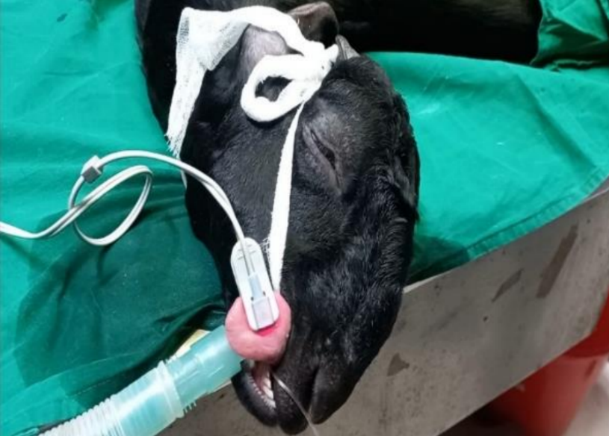

Fig. 3. Securing the endotracheal tube behind the horns (with cotton tape)

No major airway-related complications were observed during intubation or anaesthetic maintenance. Minor, self-limiting events, including brief oesophageal intubation or transient resistance at the level of the laryngeal inlet, were encountered in a limited number of cases and were corrected promptly without adverse clinical consequences. There were no incidences of oral or pharyngeal trauma, significant bleeding, sustained laryngospasm, or aspiration of ruminal contents in any of the animals.
Physiological parameters remained within clinically acceptable limits throughout the peri-intubation and anaesthetic periods, and no additional interventions were required. All goats tolerated the intubation procedure well, and airway patency was effectively maintained until recovery.
.
4. discussion

Securing the airway during general anaesthesia is a critical component of safe anaesthetic management in goats, particularly due to their anatomical characteristics (Patel et al., 2024), copious salivation, and predisposition to regurgitation and aspiration (Abrahamsen, 2008; Galatos, 2011). When general anaesthesia is induced in ruminants, endotracheal intubation with a cuffed tube is generally considered essential (Taylor, 1991) as a critical step in respiratory support and airway protection (Lin, 2015; Niehaus, 2025). In the present study, hand-guided blind endotracheal intubation was successfully performed in all goats following induction of adequate anaesthetic depth, demonstrating that this technique is both feasible and effective under clinical conditions. Endotracheal intubation was accomplished (Vieitez et al., 2017) using a digital palpation-guided blind technique with the animals maintained in lateral recumbency, as described by Gray and McDonell (1986). The technique enabled rapid passage of the endotracheal tube into the trachea without the use of a laryngoscope, which is consistent with previous reports highlighting the practicality of blind intubation (Ewing, 1990; Caulkett, 2003) in small ruminants where visualisation of the glottis may be challenging due to anatomical constraints. Similar approaches have been advocated in goats and sheep, particularly under field conditions where visualisation equipment may not be readily available (Abrahamsen, 2008; Galatos, 2011). Murphy-type cuffed endotracheal tubes were used in the present study, as recommended by Vishnugurubaran et al. (2016), and facilitated effective airway sealing during anaesthesia.
Inflation of the cuff immediately after intubation (Fulton et al., 1994; Reibold, 2007; Lin, 2022) ensured prevention of air leakage and contributed to airway protection throughout the anaesthetic period. Importantly, no aspiration of ruminal contents was observed in any of the intubated goats, corroborating earlier findings that cuffed endotracheal intubation markedly reduces the risk of aspiration in sedated ruminants (Abrahamsen, 2008; Dzikiti et al., 2011) Although cuffed tubes may not eliminate aspiration risk under all circumstances (Mehta, 1972), correct placement and appropriate cuff inflation remain critical in minimising this complication. These observations reinforce the importance of securing the airway during general anaesthesia in goats, particularly during procedures of longer duration or when animals are maintained in lateral recumbency (Galatos, 2011; Lin, 2015). After fixation of the endotracheal tube in the proper position in lateral recumbency, a textile roll support was placed under the cervical region to prevent regurgitation, slightly elevate the neck, and facilitate proper drainage of saliva (Costea et al. 2024). Fixation of the endotracheal tube behind the horns provided additional stability and prevented tube displacement during the surgical procedures. Dislodgement of the endotracheal tube is a recognised concern in goats due to head movement and changes in body position during anaesthesia (Ewing, 1990; Abrahamsen, 2008), and the fixation method employed in this study proved adequate in maintaining tube position until recovery, when coughing and swallowing reflexes returned.
The successful use of hand-guided blind endotracheal intubation without a laryngoscope highlights the clinical utility of this technique, particularly in field conditions and resource-limited settings where specialised airway equipment may not be readily available. The technique relies on tactile anatomical landmarks rather than visualisation and can be performed efficiently once the operator is familiar with the procedure. This is of practical relevance for veterinary practitioners working in rural or ambulatory practice, where rapid and reliable airway management is often required (Caulkett, 2003; Abrahamsen, 2008). The anaesthetic protocols employed in the present study have previously been shown to maintain stable cardiovascular and respiratory parameters in goats, with physiological variables remaining within clinically acceptable limits under both total and partial intravenous anaesthesia (Udharwar et al., 2023a).
A limitation of the present study is that intubation was performed by an experienced operator, and the success of the technique may vary with the skill and familiarity of the clinician. Furthermore, quantitative parameters such as intubation time and number of attempts were not documented, which could have provided additional insight into the efficiency of the technique. The absence of quantitative time and attempt data reflects the primary clinical objective of establishing feasibility and safety under routine conditions rather than procedural optimisation. Future studies may focus on comparing blind digital intubation with laryngoscope-assisted methods, assessing learning curves among operators with varying levels of experience, and evaluating the technique under different anaesthetic protocols, as suggested in previous ruminant anaesthesia studies (Galatos, 2011; Lin, 2015).
Overall, the findings of the present study indicate that hand-guided blind endotracheal intubation is a reliable, safe, and clinically applicable technique for airway management in goats under general anaesthesia. When performed correctly, it provides effective airway protection and may serve as a valuable alternative to visual intubation techniques, especially in settings where equipment availability is limited (Abrahamsen, 2008; Dzikiti et al., 2011).

5. Conclusion

The present study demonstrates that hand-guided blind endotracheal intubation is a reliable, safe, and clinically feasible technique for securing the airway in goats undergoing general anaesthesia. Successful intubation was achieved in all animals following induction of adequate anaesthetic depth, and the use of cuffed endotracheal tubes provided effective airway sealing without evidence of aspiration or clinically significant airway-related complications. The technique was well tolerated, with physiological parameters remaining within acceptable clinical limits throughout the peri-anaesthetic period.
From a practical perspective, hand-guided blind endotracheal intubation offers several advantages, including minimal equipment requirements, consistent airway security, and applicability under both hospital and field conditions. By relying on tactile anatomical landmarks rather than direct visualisation of the larynx, the technique is particularly useful in situations where laryngoscope-assisted intubation is difficult or specialised airway equipment is unavailable. These attributes make it a valuable option for ambulatory practice, teaching environments, and resource-limited veterinary settings.
Although the technique has been described previously in small ruminants, contemporary clinical evidence supporting its use under modern balanced anaesthetic protocols has been limited. The findings of the present study provide updated clinical validation of hand-guided blind endotracheal intubation under routine surgical conditions, supporting its continued relevance in current veterinary anaesthetic practice.
Future investigations should focus on comparative evaluation with visual intubation techniques, assessment of learning curves among operators with varying levels of experience, and quantitative analysis of intubation efficiency. Such studies would further refine airway management strategies and contribute to improved anaesthetic safety in goats.

CONSENT

All authors declare that written informed consent was obtained from the respective owners for publication of this research. A copy of the written consent is available for review by the Editorial office/Chief Editor/Editorial Board members of this journal.

ETHICAL APPROVAL

The research was approved by the XVth Faculty Research Committee (institutional review board) of Kerala Veterinary and Animal Sciences University held on 23.11.2021.

References

- Abrahamsen, E. J. (2008). Ruminant field anesthesia. Veterinary Clinics of North America: Food Animal Practice, 24(3), 429-441. https://doi.org/10.1016/j.cvfa.2008.07.001
- Caulkett, N. (2003). Anesthesia of ruminants. Large Animal Veterinary Rounds, 3(2), 1-6. http://www.larounds.ca/crus/laveng_0203.pdf
- Costea, R., Iancu, T., Duțulescu, A., Nicolae, C., Leau, F. & Pavel, R. (2024). Critical key points for anesthesia in experimental research involving sheep (Ovis aries). Open Veterinary Journal, 14(9):2129-2137. https://doi.org/10.5455/OVJ.2024.v14.i9.2
- Dzikiti, T. B. (2013). Intravenous anaesthesia in goats: A review. Journal of the South African Veterinary Association, 84(1), 1-8. Dzikiti, T. B. (2013). Intravenous anaesthesia in goats: A review. Journal of the South African Veterinary Association. https://doi.org/10.4102/jsava.v84i1.499
- Ewing, K. K. (1990). Anesthesia techniques in sheep and goats. Veterinary Clinics of North America: Food Animal Practice, 6(3), 759-778. https://doi.org/10.1016/S0749-0720(15)30845-8
- Fabin, P. M. (2017). Comparative efficacy of isoflurane and sevoflurane anaesthesia following induction with thiopentone sodium in goats. M. V. Sc thesis, Kerala Veterinary and Animal Sciences University, Pookode. https://www.kvasu.ac.in/faculty/faculty-of-veterinary-and-animal-science
- Fulton, L.K., Clarke, M.S. & Farris, H.E. (1994). The Goat as a Model for Biomedical Research and Teaching, ILAR News,36 (2), 21-29. https://doi.org/10.1093/ilar.36.2.21
- Galatos, A. D. (2011). Anesthesia and analgesia in sheep and goats. Veterinary Clinics of North America-Food Animal Practice, 27(1), 47. https://doi.org/10.1016/j.cvfa.2010.10.007
- Gray, R. R. & MCDonell, W. N. (1986). Anesthesia in goats and sheep. Part II General anesthesia. Compendium on Continuing Education for the Practicing Veterinarian. 8:129-134.
- Lin, H. (2015). Veterinary anesthesia and analgesia. In: Grimm, K. A., Lamont, L. A.,Tranquilli, W. J., Greene, S. A., Robertson, S. A. (Eds), The 5th Edition of Lumb and Jones, John Wiley & Sons, USA. https://doi.org/10.1002/9781119421375.ch38
- Lin, H. (2022). Preanesthetic considerations. In: Lin, H., Passler, T., Clark-Price, S. (Eds), Farm Animal Anesthesia: Cattle, Small Ruminants, Camelids, and Pigs, Wiley Blackwell, USA. https://doi.org/10.1002/9781119672661.ch1
- Mehta, S. (1972). The risk of aspiration in presence of cuffed endotracheal tubes. British Journal of Anaesthesia, 44(6):601-605. https://doi.org/10.1093/bja/44.6.601
- Niehaus, A. J. (2025). General Anesthesia and Sedation. In: Joseph W. Lozier, J. W., Niehaus, A. J. (Eds), Noordsy's Food Animal Surgery, Wiley Blackwell, USA. https://doi.org/10.1002/9781119930372.ch5
- Patel, U. B., Patel, K. P., Kelawala, R. N., & Kelawala, D. N. (2024). Anaesthesia and pain management in goats. In: Rana, T. (Ed), Trends in Clinical Diseases, Production and Management of Goats Vol. 2. Academic Press, USA. https://doi.org/10.1016/B978-0-443-23697-6.00013-5
- Reibold, T. W. (2007). Anesthesia, analgesia and immobilization of selected species and classes of animals: Ruminants, In: Lumb and Jones’ Veterinary Anesthesia and Analgesia. (4th Ed.). Blackwell Publishing, USA.
- Reid, J., Nolan, A.M. & Welsh, E. (1993). Propofol as an induction agent in the goat: A pharmacokinetic study, Journal of Veterinary Pharmacology and Therapeutics, 16, 488-493. http://dx.doi.org/10.1111/j.1365-2885.1993.tb00215.x
- Taylor, P. M. (1991). Anaesthesia in sheep and goats. In Practice, 13(1), 31-36. https://doi.org/10.1136/inpract.13.1.31
- Udharwar, S.V., John Martin, K.D., Zarina, A., Nair, S.S., Anoop, S., Jayakumar, C. et al. (2023a). Studies on electrocardiographic changes in xylazine-butorphanol and dexmedetomidine-butorphanol premedicated goats with tiletamine-zolazepam induction under TIVA and PIVA protocols. Journal of Andaman Science Association 28(2): 158-165.
- Udharwar, S. V., John Martin, K. D., Nair, S. S., Jayakumar, A. C., Zarina, A., Senthilkumar, S., & Venugopal, S. K. (2023). Comparative evaluation of the isoflurane-sparing effects of premedication with dexmedetomidine-butorphanol and xylazine-butorphanol in tiletamine-zolazepam-induced anaesthesia in goats. Journal of Andaman Science Association, 28(2), 166-172.
- Udharwar, S.V., John Martin, K.D., Nair, S.S., Anoop, S., Jayakumar, C., Zarina, A. et al. (2025). Comparative study on the effects of xylazine-butorphanol and dexmedetomidine-butorphanol premedication on the dose-sparing effect of tiletamine-zolazepam in goats. International Journal of Veterinary Sciences and Animal Husbandry 10(3): 01-05.
- Vieitez, V., Álvarez Gómez de Segura, I., López Rámis, V., Santella, M., & Ezquerra, L. J. (2017). Total intravenous anaesthesia in a goat undergoing craniectomy. BMC Veterinary Research, 13(1), 287. https://doi.org/10.1186/s12917-017-1205-2
- Vishnugurubaran D., Kathirvel S., Senthilkumar S., Balasundaram K. & Dharmaceelan S. (2016). Isoflurane sparing effect of diazepam and midazolam to xylazine-ketamine induction and isoflurane maintenance in goats. Indian Journal of Animal Research. 51(4): 762-763. https://doi.org/10.18805/ijar.v0iOF.4567
- White K., Taylor P. Anaesthesia in sheep. Practice. 2000;22(3):126-135.

