Effect of an Indigenous Isolates (Aspergillus niger and Pseudomonas fluorescence) on Microbial Degradation and Detoxification of Distillery Spent Wash

ABSTRACT
An experiment was conducted in 2024–25 at the Soil and Water Management Research Unit, NAU, Navsari to evaluate the effectiveness of microbial inoculants for the degradation of distillery spent wash using FCRD with three treatments (M₀ – no inoculation, M₁ – Aspergillus niger at 1 g/L and M₂ – Pseudomonas fluorescens at 10 mL/L) and five replications. Among the treatments, M₂ consistently demonstrated superior performance in reducing organic pollution, recording the lowest mean values of COD, BOD, TS and TDS. Treatment efficiency was increased with incubation time. The interaction effect M₂D₃ was the most effective, achieved the lowest COD, BOD and TS contents which indicated a strong synergistic effect between microbial inoculation and 30th days of incubation period. M₂ also showed the highest reduction in optical density across all tested DSW concentrations, even at 10th day of incubation. M₁ proved more effective for micronutrient removal, particularly for Fe, Mn, Zn and Cu. The M₁D₁ interaction resulted in the lowest concentrations of these metals. Overall, the findings demonstrated that M₂ with extended incubation was optimal for organic pollution mitigation, whereas M₁ was better suited for micronutrient removal. This integrated microbial approach offers eco-friendly strategy for efficient treatment of DSW.
Keywords: Aspergillus niger, Distillery spent wash, Incubation period, Microbial degradation, Pseudomonas fluorescence.

- INTRODUCTION
Waste management is a major global challenge, as the composition of wastewater varies widely among industries. In recent years, the reuse of wastewater in agriculture has gained attention due to its potential to supply nutrients, improve soil properties and enhance crop yield. Among agro-based industries, the sugarcane (Saccharum officinarum L.) industry plays a significant role in the socio-economic development of many countries. Along with sugar production, this industry generates by-products such as bagasse, press mud and distillery spent wash (DSW).
India ranks second in ethanol production in Asia and fourth globally, contributing nearly 65% of alcohol production in the South-East Asian region. Most Indian distilleries use sugarcane molasses as the primary raw material for ethanol production. Approximately 61% of the world’s ethanol is produced from sugar crops (Berg, 2004; Ogbonna, 2004). During fermentation, carried out for about 50 hours using Saccharomyces cerevisiae, ethanol accumulates up to 8–10%, after which distillation and rectification are performed. The residual liquid waste generated after distillation is known as spent wash (Nandy et al., 2002; Singh et al., 2004).
A typical molasses-based distillery produces about 15 L of spent wash per litre of ethanol and more than 30 billion litres are generated annually from approximately 212 distilleries in India. Distillery spent wash is dark brown, acidic, viscous and foul-smelling. Dark brown colour of spent wash is mainly because of the presence of brown polymeric melanoidin pigments, which are highly recalcitrant. Melanoidin pigments are formed by the non-enzymatic aminocarbonyl reaction i.e. Maillard reaction. The unpleasant odour of the effluent is due to the presence of skatole, indole and other sulphur compounds, which are not effectively decomposed by yeast during distillation (Sharma et al., 2007). Their discharge into aquatic systems reduces light penetration, dissolved oxygen levels and photosynthetic activity, thereby harming aquatic life (Pazouki et al., 2008).
Although several physico-chemical and biological treatment methods have been explored, many require high chemical inputs and generate excessive sludge. In contrast, microbial treatment offers an eco-friendly, cost-effective and sustainable alternative, effectively reducing toxicity and making treated effluents suitable for agricultural reuse without adversely affecting soil health.
2. MATERIAL AND METHODOLOGY
2.1 Collection of spent wash
The distillery spent wash was collected from the Distillery plant of Gandevi Sugar Factory, Ambheta, Gandevi, which is in the Navsari district of Gujarat. It is situated between 20.78405 N Latitude and 72.98555 E Longitude and used for the further studies. The spent wash was collected in the month of October-2024.
2.2 Preparation of 25% Spent Wash
After collecting the spent wash from the Distillery Plant of Gandevi Sugar Factory, 25% spent wash solution was prepared by diluting the raw spent wash with water. This diluted solution was then filled into 2.5-liter amber-colored glass bottles for further analysis.
2.3 Physio-Chemical Characterization of Distillery Spent Wash Sample
The changes in physico-chemical parameters (COD, BOD, OD, TS, TDS and heavy metals like Fe, Mn, Zn and Cu) in distillery spent wash before and after microbial degradation were analyzed as per standard methods (APHA 1999).
2.4 Methodology
Fifteen umber colour bottles of 2.5 L capacity were filled with 25% diluted spent wash collected from the Distillery Plant of Gandevi Sugar Factory, Ambheta, Gandevi. A pure culture of microbial inoculation (Aspergillus niger @ 1 g/l and Pseudomonas fluorescens @ 10 ml/l) were inoculated to M₁ and M₂ treatment, respectively while M₀ was kept as uninoculated as per treatment. Each treatment was incubated at room temperature for 30 days after proper mixing in 2.5 L umber colour bottle. The bottles were shaken daily to get complete mixing and chemical reaction of each treatment under study. For periodic sample analysis, three sets of each treatment replicated five times were arranged and each one set was disturbed for periodic sample analysis of COD, BOD, OD, TS, TDS, Fe, Mn, Zn, Cu of distillery spent wash for periodic analysis on 10th, 20th and 30th days.
Table 1: Properties of raw and 25% spent wash
Sr. No. | Parameters (mg/L) | Method of analysis | Reference | Raw  Spent wash | 25% diluted  Spent wash
1. | COD | Open Reflux method | Franson (1985) | 3,29,840 | 77,280
2. | BOD | Dissolved oxygen (Winkler method) | Franson (1985) | 75,790 | 18,356
3. | Total Solid (TS) | Gravimetric method | Symons and Morey (1941) | 3,88,200 | 94,800
4. | Total Dissolved Solid (TDS) | Gravimetric method | Howard (1933) | 3,33,600 | 83,400
5. | Iron | Atomic Absorption Spectrophoto-metric | Page et al. (1982) | 75.89 | 32.85
6. | Manganese | Atomic Absorption Spectrophoto-metric | Page et al. (1982) | 13.33 | 3.18
7. | Zinc | Atomic Absorption Spectrophoto-metric | Page et al. (1982) | 12.9 | 3.37
8. | Copper | Atomic Absorption Spectrophoto-metric | Page et al. (1982) | 0.94 | 0.19
- RESULT AND DISCUSSION
3.1 Effect of Microbial Inoculation and Incubation Period on COD, BOD and OD of Distillery Spent Wash
The results in Table 2 and Fig. 1 showed that both microbial inoculation (M₀, M₁, M₂) and incubation period (10, 20 and 30 days) significantly influenced the COD of distillery spent wash. The control (M₀) recorded the highest mean COD (74,960.13 mg/L), while inoculation with Pseudomonas fluorescens (M₂) resulted in the lowest mean COD (31,055.47 mg/L), indicating a 58.57% reduction over M₀. M₁ also lowered the COD of spent wash by 48.11%. This decline can be attributed to the enhanced metabolic capability of the inoculated microbes, which break down organic pollutants more efficiently. COD values also decreased significantly with increasing incubation time, with the lowest value (44,998.07 mg/L) on the 30th day, reflecting 15.14% and 4.03% reductions over the 10th and 20th days, respectively. The interaction effect (M×D) was significant, with M₂D₃ showing the minimum COD (28,201.60 mg/L), followed closely by M₂D₂. Reductions under these treatments exceeded 59–63% over their respective controls, highlighting the benefit of combining effective microorganisms with adequate incubation time. Comparable studies, such as those by Shayegan et al. (2005) and Chavan et al. (2006), also reported substantial COD reductions through fungal and bacterial treatments, supporting the effectiveness of microbes for the degradation of distillery spent wash.
Table 2: Effect of microbial inoculation and incubation period on COD (mg/L) of distillery spent wash
Microbial  inoculation | COD (mg/L)
Microbial  inoculation | Incubation period (Day) |  |  | Mean (M)
Microbial  inoculation | 10th (D₁) | 20th (D₂) | 30th (D₃) | Mean (M)
M₀ | 76,748.00 | 75,425.80 | 72,706.60 | 74,960.13
M₁ | 46,489.80 | 36,120.00 | 34,086.00 | 38,898.60
M₂ | 35,844.40 | 29,120.40 | 28,201.60 | 31,055.47
Mean (D) | 53,027.40 | 46,888.73 | 44,998.07 | 48,304.73
Source | S.Em. (±) |  | CD at 5% | CV (%)
M | 394.04 |  | 1,134.78 | 3.15
D | 394.04 |  | 1,134.78 | 3.15
M×D | 682.5 |  | 1,965.49 | 3.15
The data in Table 3 and Fig. 1 exhibited that the highest mean BOD value was recorded in the control (M₀) at 17,366.67 mg/L, while inoculation with Pseudomonas fluorescens (M₂) resulted in the lowest mean BOD (7,883.53 mg/L), reflecting a 54.61% reduction over M₀. Aspergillus niger (M₁) also reduced BOD by 47.02%. The decline in BOD with M₁ and M₂ indicates enhanced microbial degradation of organic matter. Incubation time also played a role, with BOD decreasing from 12,354.87 mg/L on the 10th day to 10,758.00 mg/L on the 30th day, showing that prolonged microbial action gradually lowered the BOD content. The interaction effect (M×D) further confirmed that M₂ at 30 days (M₂D₃) achieved the minimum BOD (7,451.80 mg/L), with reductions exceeding 54–59% over corresponding controls. These findings emphasize that both microbial type and incubation duration are key to efficient BOD removal. Similar reductions in BOD due to microbial treatments have been reported by Choi (2016) and Yadav and Chandra (2012), all highlighted the effectiveness of microbial degradation in lowering BOD levels in industrial wastewaters.
Table 3.: Effect of microbial inoculation and incubation period on BOD (mg/L) of distillery spent wash
Microbial  inoculation | BOD (mg/L)
Microbial  inoculation | Incubation period (Day) |  |  | Mean (M)
Microbial  inoculation | 10th (D₁) | 20th (D₂) | 30th (D₃) | Mean (M)
M₀ | 18,289.20 | 17,420.40 | 16,390.40 | 17,366.67
M₁ | 10,538.60 | 8,631.80 | 8,431.80 | 9,200.73
M₂ | 8,236.80 | 7,962.00 | 7,451.80 | 7,883.53
Mean (D) | 12,354.87 | 11,338.07 | 10,758.00 | 11,483.64
Source | S.Em. (±) |  | CD at 5% | CV (%)
M | 117.46 |  | 338.26 | 3.96
D | 117.46 |  | 338.26 | 3.96
M×D | 203.44 |  | 585.89 | 3.96

Fig. 1 Effect of microbial inoculation and incubation period on reduction of COD and BOD in distillery spent wash
Table 4 presents the decolourization efficiency of distillery spent wash, assessed through reductions in optical density (OD) under different microbial inoculation treatments (M₀, M₁, M₂), incubation periods (10, 20 and 30 days) and spent wash concentrations (1–5%). Initial OD values increased with concentration and served as the baseline. OD decreased across treatments and incubation periods, with the greatest reduction generally observed on the 10th day. Aspergillus niger (M₁) improved decolourization over the control, particularly at higher concentrations, while Pseudomonas fluorescens (M₂) consistently showed the maximum OD reduction at all concentrations. For example, at 1% concentration on the 10th day, M₂ achieved a 44.63% reduction, outperforming M₁ (19.37%) and M₀ (4.42%). Overall, M₂ proved most effective, followed by M₁, indicated that microbial inoculation substantially enhances the breakdown of melanoidins responsible for the dark colour of spent wash. These findings align with earlier reports by Wagh and Nemade (2018) and Chavan et al. (2006), who also observed high decolourization efficiencies using fungal and bacterial isolates. The results highlighted the strong potential of targeted microbial treatments for bioremediation of coloured industrial effluents.

Table 4: Effect of microbial inoculation and incubation period on optical density of distillery spent wash
Treat. | Days | Spent wash 1% |  | Spent wash 2% |  | Spent wash 3% |  | Spent wash 4% |  | Spent wash 5%
Treat. | Days | Mean | % reduction | Mean | % reduction | Mean | % reduction | Mean | % reduction | Mean | % reduction
Treat. | Initial | 0.1244 | 0.00 | 0.2513 | 0.00 | 0.3876 | 0.00 | 0.5206 | 0.00 | 0.6590 | 0.00
M₀ | 10 | 0.1189 | 4.42 | 0.2394 | 4.75 | 0.3785 | 2.36 | 0.5114 | 1.75 | 0.6455 | 2.04
M₀ | 20 | 0.1182 | 5.05 | 0.2364 | 5.94 | 0.3734 | 3.65 | 0.5026 | 3.45 | 0.6388 | 3.07
M₀ | 30 | 0.1164 | 6.49 | 0.2353 | 6.39 | 0.3695 | 4.67 | 0.4976 | 4.41 | 0.6214 | 5.71
M₁ | 10 | 0.1003 | 19.37 | 0.1998 | 20.51 | 0.2540 | 34.46 | 0.3751 | 27.95 | 0.4913 | 25.45
M₁ | 20 | 0.1094 | 12.12 | 0.2094 | 16.69 | 0.3133 | 19.16 | 0.4516 | 13.24 | 0.5623 | 14.67
M₁ | 30 | 0.1129 | 9.24 | 0.2294 | 8.73 | 0.3339 | 13.85 | 0.4726 | 9.22 | 0.6105 | 7.36
M₂ | 10 | 0.0689 | 44.63 | 0.1429 | 43.16 | 0.2218 | 42.77 | 0.3106 | 40.33 | 0.3573 | 45.78
M₂ | 20 | 0.0888 | 28.62 | 0.1721 | 31.53 | 0.2814 | 27.39 | 0.3616 | 30.53 | 0.4893 | 25.75
M₂ | 30 | 0.1012 | 18.66 | 0.2106 | 16.20 | 0.3106 | 19.88 | 0.4316 | 17.09 | 0.5266 | 20.09

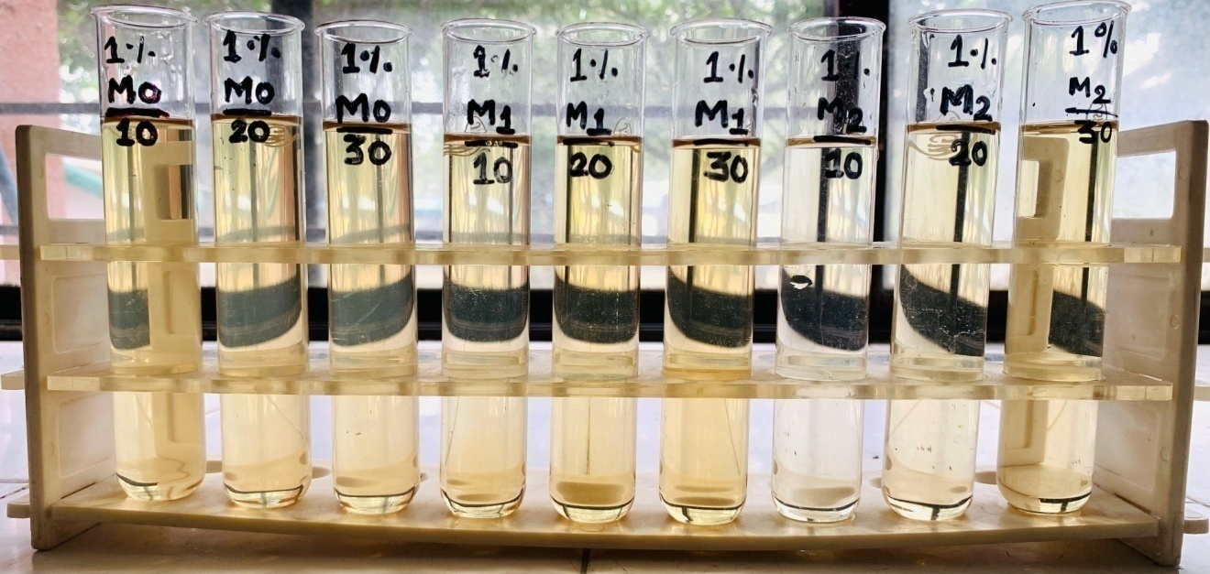
Photo No. 1: Reduction in optical density of distillery spent wash (1%) due to microbial inoculation
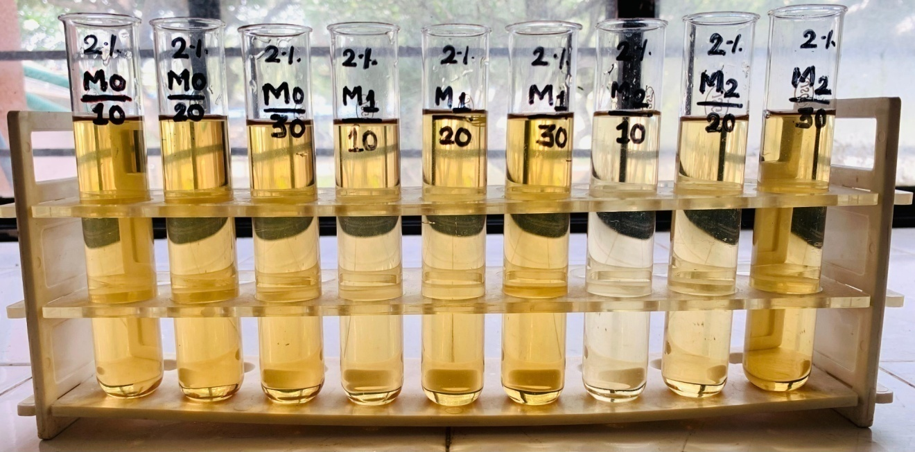 Photo No. 2: Reduction in optical density of distillery spent wash (2%) due to microbial inoculation
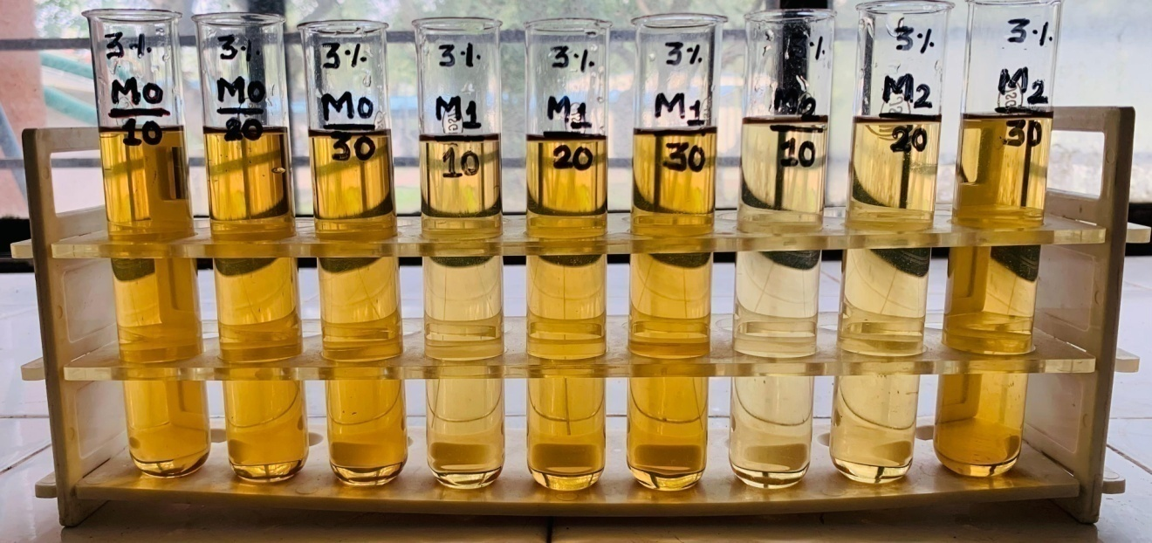
Photo No. 3: Reduction in optical density of distillery spent wash (3%) due to microbial inoculation
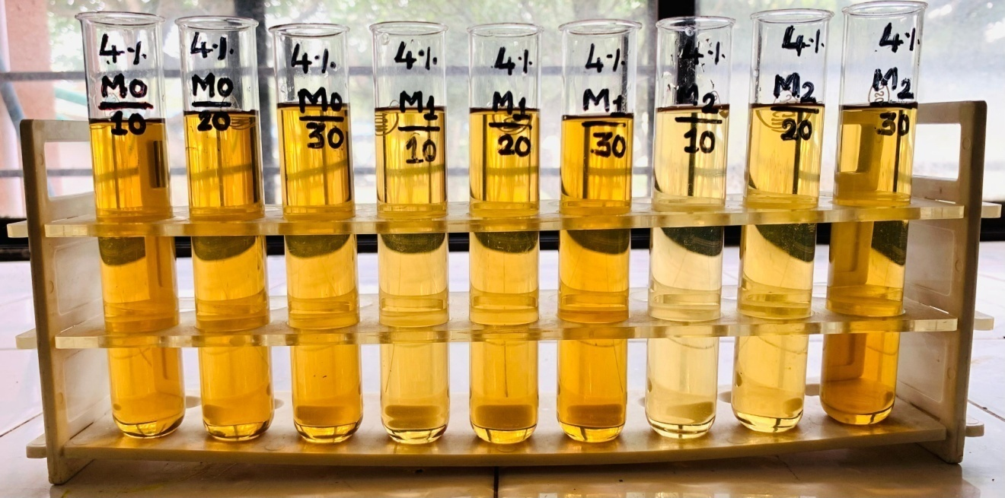Photo No. 4: Reduction in optical density of distillery spent wash (4%) due to microbial inoculation
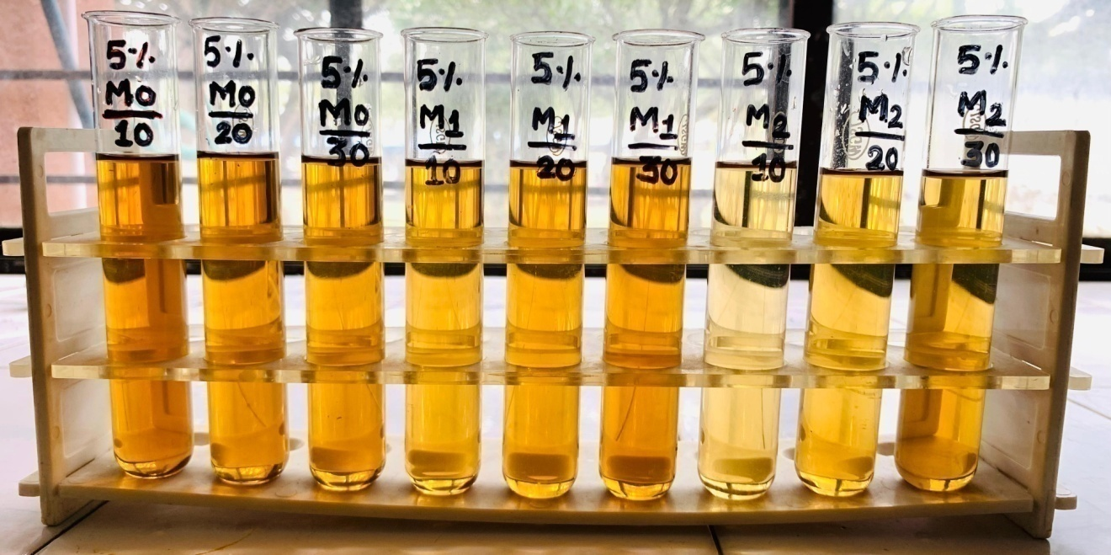Photo No. 5: Reduction in optical density of distillery spent wash (5%) due to microbial inoculation
3.2 Effect of Microbial Inoculation and Incubation Period on TS and TDS of Distillery Spent Wash
Table 5 and Fig. 2 showed that microbial inoculation and incubation time significantly reduced the total solids (TS) content of distillery spent wash. The control (M₀) recorded the highest mean TS (94,025.34 mg/L), whereas Pseudomonas fluorescens (M₂) achieved the lowest (20,064.40 mg/L), reflecting a 78.66% reduction over M₀. Aspergillus niger (M₁) also lowered TS by 67.24%. This decline suggests that inoculated microbes actively degraded and utilized complex organic matter, with M₂ showing greater efficiency due to its stronger metabolic capabilities. TS levels also decreased with longer incubation, with the lowest value (44,455.07 mg/L) observed on the 30th day, indicating that extended microbial activity enhances solids breakdown. The interaction effect (M×D) further confirmed that M₂ at 30 days (M₂D₃) produced the minimum TS (14,875.20 mg/L), achieving more than 83–84% reduction over respective controls. These findings align with earlier reports, such as Ratna and Kumar (2022), who also noted substantial TS reduction in distillery wastewater due to microbial degradation into simpler, soluble components.
Table 5: Effect of microbial inoculation and incubation period on TS (mg/L) of distillery spent wash
Microbial  inoculation | TS (mg/L)
Microbial  inoculation | Incubation period (Day) |  |  | Mean (M)
Microbial  inoculation | 10th (D₁) | 20th (D₂) | 30th (D₃) | Mean (M)
M₀ | 95,710.00 | 93,512.00 | 92,854.00 | 94,025.34
M₁ | 40,582.00 | 26,196.00 | 25,636.00 | 30,804.67
M₂ | 29,834.00 | 15,484.00 | 14,875.20 | 20,064.40
Mean (D) | 55,375.33 | 45,064.00 | 44,455.07 | 48,298.14
Source | S.Em. (±) |  | CD at 5% | CV (%)
M | 86.30 |  | 248.54 | 0.69
D | 86.30 |  | 248.54 | 0.69
M×D | 149.48 |  | 430.48 | 0.69

Fig. 2 Effect of microbial inoculation and incubation period on reduction of TS in distillery spent wash
Table 6and Fig. 3 showed that microbial inoculation significantly reduced the TDS content of distillery spent wash. The control (M₀) recorded the highest mean TDS (83,071.34 mg/L), while Pseudomonas fluorescens (M₂) achieved the lowest value (12,974.67 mg/L), followed by Aspergillus niger (M₁) with 19,206.67 mg/L, corresponding to reductions of 76.88% and 84.38% over M₀. This substantial decline indicates that the inoculated microbes effectively transformed or degraded dissolved solids due to their enzymatic activity and better adaptation to the spent wash environment. Incubation period also influenced TDS levels, with the lowest mean value observed on the 10th day (36,319.33 mg/L). A slight rise on the 20th day followed by a small drop on the 30th day suggests complex microbial dynamics, where early degradation may release soluble compounds before further breakdown occurs later. The interaction effect (M×D) showed that M₂ at the 10th day produced the lowest TDS (12,480.00 mg/L), achieving over 84–85% reduction compared to respective controls. Shugaba et al. (2010) also found that the TDS of tannery wastewater decreased from 9,171 mg/L to 1,138 mg/L after treatment with A. niger, which showed efficiency of reducing TDS content (87.59%) of distillery spent wash.

Table 6: Effect of microbial inoculation and incubation period on TDS (mg/L) of distillery spent wash
Microbial  inoculation | TDS (mg/L)
Microbial  inoculation | Incubation period (Day) |  |  | Mean (M)
Microbial  inoculation | 10th (D₁) | 20th (D₂) | 30th (D₃) | Mean (M)
M₀ | 83,978.00 | 82,752.00 | 82,484.00 | 83,071.34
M₁ | 12,500.00 | 22,800.00 | 22,320.00 | 19,206.67
M₂ | 12,480.00 | 13,494.00 | 12,950.00 | 12,974.67
Mean (D) | 36,319.33 | 39,682.00 | 39,251.33 | 38,417.56
Source | S.Em. (±) |  | CD at 5% | CV (%)
M | 64.53 |  | 185.83 | 0.65
D | 64.53 |  | 185.83 | 0.65
M×D | 111.76 |  | 321.86 | 0.65

Fig. 3 Effect of microbial inoculation and incubation period on reduction of TDS in distillery spent wash
3.3 Effect of Microbial Inoculation and Incubation Period on Fe, Mn, Zn and Cu Content of Distillery Spent Wash
Treatment M₀ (without inoculation) showed significantly the highest mean Fe content (33.36 mg/L), while significantly the lowest Fe content was observed in M₁ (19.50 mg/L) which was statistically at par with M₂. The data further showed that 41.55 and 37.20 per cent Fe content was decreased due to M₁ and M₂ over M₀. In relation with the incubation period significantly lower Fe content (23.43 mg/L) in distillery spent wash was observed at 10th day of incubation period. The data further showed that decrement in Fe content in distillery spent wash due to M₁D₁ was 53.12, 50.58 and 43.23 per cent over M₀D₁, M₀D₂ and M₀D₃, while in case of M₂D₁, decrement in Fe content of spent wash was 52.04, 49.44 and 41.93 per cent over M₀D₁, M₀D₂ and M₀D₃, respectively. Verma et al. (2022) reported that heavy metal concentrations also decreased significantly like Fe content was decreased from 65.02 mg/L to 13.01 mg/L in pulp paper industrial effluent through bacterial treatment. This is because of mechanisms such as biosorption, precipitation or redox conversion of Fe²⁺ to insoluble forms.
Table 7: Effect of microbial inoculation and incubation period on Fe content (mg/L) of distillery spent wash
Microbial  inoculation | Fe (mg/L)
Microbial  inoculation | Incubation period (Day) |  |  | Mean (M)
Microbial  inoculation | 10th (D₁) | 20th (D₂) | 30th (D₃) | Mean (M)
M₀ | 36.07 | 34.22 | 29.79 | 33.36
M₁ | 16.91 | 19.97 | 21.63 | 19.50
M₂ | 17.30 | 21.99 | 23.56 | 20.95
Mean (D) | 23.43 | 25.39 | 25.00 | 24.60
Source | S.Em. (±) |  | CD at 5% | CV (%)
M | 1.12 |  | 3.23 | 17.64
D | 1.12 |  | NS | 17.64
M×D | 1.94 |  | 5.59 | 17.64

Significantly the highest mean Mn content (4.52 mg/L) was found in M₀ treatment (without inoculation) and significantly lower Mn content (2.74 mg/L) was observed in distillery spent wash treated by Aspergillus niger. The observed reduction in Mn content with microbial inoculation, particularly with M₁ and M₂ was 39.38 and 22.79 per cent over M₀, respectively. Significantly the lowest Mn content (1.65 mg/L) was found in distillery spent wash treated by Aspergillus niger at 10th day of incubation. Decrement in Mn content of distillery spent wash due to M₁D₁ was 75.15, 55.88 and 48.11 per cent over M₀D₁, M₀D₂ and M₀D_{3,} respectively. According to Chaturvedi et al. (2006) microbial treatment can reduce Mn through bioaccumulation and enzymatic transformation into less soluble forms because they observed that bacterial inoculated distillery spent wash reduced 98.34% Mn content. Similar findings reported that both bacteria and fungi are capable of oxidizing Mn²⁺ to Mn⁴⁺, leading to precipitation and removal from solution.
Table 8: Effect of microbial inoculation and incubation period on Mn content (mg/L) of distillery spent wash
Microbial  inoculation | Mn (mg/L)
Microbial  inoculation | Incubation period (Day) |  |  | Mean (M)
Microbial  inoculation | 10th (D₁) | 20th (D₂) | 30th (D₃) | Mean (M)
M₀ | 6.64 | 3.74 | 3.18 | 4.52
M₁ | 1.65 | 3.47 | 3.10 | 2.74
M₂ | 3.71 | 3.58 | 3.16 | 3.49
Mean (D) | 4.00 | 3.60 | 3.15 | 3.58
Source | S.Em. (±) |  | CD at 5% | CV (%)
M | 0.17 |  | 0.50 | 18.86
D | 0.17 |  | 0.50 | 18.86
M×D | 0.30 |  | 0.87 | 18.86

M₀ treatment exhibited significantly the highest mean Zn content (5.68 mg/L) in distillery spent wash. With microbial inoculation M₁ and M₂, the mean Zn content significantly decreased to 2.53 mg/L and 2.80 mg/L, respectively. The results further revealed that 55.45 and 50.70 per cent decrement in Zn content of distillery spent wash was observed with M₁ and M₂ over M₀, respectively. Significantly the lowest Zn content in distillery spent wash was observed in M₁D₁ with corresponding value of 1.78 mg/L. The data also revealed that the decrement in Zn content of distillery spent wash due to M₁D₁ was 71.87, 67.58 and 65.77 per cent over M₀D₁, M₀D₂ and M₀D₃, while in case of M₂D₁, decrement in Zn content of spent wash was 50.87, 43.35 and 40.19 per cent over M₀D₁, M₀D₂ and M₀D₃, respectively. Chau et al. (2023) also found similar result that zinc reduced from 8.1±0.35 mg/L to 7.8±0.32 mg/L in tannery effluent treated by Aspergillus niger via biosorption, complexation and cellular uptake. Similarly, it was also found that Zn removal is enhanced through fungal enzymatic activity and chelation.
Table 9: Effect of microbial inoculation and incubation period on Zn content (mg/L) of distillery spent wash
Microbial  inoculation | Zn (mg/L)
Microbial  inoculation | Incubation period (Day) |  |  | Mean (M)
Microbial  inoculation | 10th (D₁) | 20th (D₂) | 30th (D₃) | Mean (M)
M₀ | 6.33 | 5.49 | 5.20 | 5.68
M₁ | 1.78 | 2.81 | 2.98 | 2.53
M₂ | 3.11 | 2.74 | 2.54 | 2.80
Mean (D) | 3.74 | 3.68 | 3.57 | 3.67
Source | S.Em. (±) |  | CD at 5% | CV (%)
M | 0.09 |  | 0.27 | 9.86
D | 0.09 |  | NS | 9.86
M×D | 0.16 |  | 0.47 | 9.86
Significantly the highest mean Cu content (1.81 mg/L) in distillery spent wash was found in M₀ (control). However, 28.18 and 18.78 per cent decrement in Cu content of distillery spent wash was observed due to M₁ and M₂ over M₀. Significantly lower mean Cu content (1.43 mg/L) was found at 20th day of incubation period (D₂) which was statistically at par with the 10th day of incubation period (D₁). Significantly the lowest Cu content (1.16 mg/L) was found in distillery spent wash treated by Aspergillus niger at 10th day of incubation period (M₁D₁) which was statistically at par with M₁D₂, M₂D₁ and M₂D₂. The data also revealed that the decrement in Cu content in distillery spent wash due to M₁D₁ was 40.81, 29.26 and 36.26 per cent over M₀D₁, M₀D₂ and M₀D₃, while in case of M₂D₁, decrement in Cu content of spent wash was 38.77, 26.83 and 34.06 per cent over M₀D₁, M₀D₂ and M₀D₃, respectively. Similar result was found by Agnihotri (2011) that Aspergillus spp. was capable of reducing Cu content from biomethanated distillery effluent as copper declined from 0.097 ppm to 0.0198 ppm (79.59% reduction) because Cu is often sequestered in microbial biomass or transformed into less bioavailable forms during effluent treatment.
Table 10: Effect of microbial inoculation and incubation period on Cu content (mg/L) of distillery spent wash
Microbial  inoculation | Cu (mg/L)
Microbial  inoculation | Incubation period (Day) |  |  | Mean (M)
Microbial  inoculation | 10th (D₁) | 20th (D₂) | 30th (D₃) | Mean (M)
M₀ | 1.96 | 1.64 | 1.82 | 1.81
M₁ | 1.16 | 1.29 | 1.45 | 1.30
M₂ | 1.20 | 1.36 | 1.83 | 1.47
Mean (D) | 1.44 | 1.43 | 1.70 | 1.52
Source | S.Em. (±) |  | CD at 5% | CV (%)
M | 0.06 |  | 0.18 | 15.84
D | 0.06 |  | 0.18 | 15.84
M×D | 0.11 |  | 0.31 | 15.84

Fig. 4 Effect of microbial inoculation and incubation period on reduction of Fe, Mn, Zn and Cu content in distillery spent wash
- CONCLUSION
The present investigation clearly demonstrated that both Aspergillus niger and Pseudomonas fluorescens played an effective roles in the microbial degradation and detoxification of distillery spent wash, though their efficiencies varied across parameters at 10th, 20th and 30th day of incubation period. Pseudomonas fluorescens demonstrated superior performance in reducing Biochemical Oxygen Demand (BOD), Chemical Oxygen Demand (COD), Total Solids (TS), Total Dissolved Solids (TDS) and optical density (OD), indicating its strong capacity for reducing organic load and colour. On the other hand, Aspergillus niger was particularly efficient in reducing heavy metals like iron (Fe), manganese (Mn), zinc (Zn), copper (Cu) at 10th day incubation period and it was also contributed significantly in reductions of BOD, COD and decolourization at 10th day of incubation period over no microbial inoculation. Future studies may focus on optimizing microbial consortia, scaling up the treatment process and evaluating the safe use of treated or diluted distillery spent wash for fertigation or as a nutrient-rich fertilizer in agricultural fields.
- REFERENCES
Agnihotri, S. N. (2011). Bioremediation of biomethanated distillery effluent before discharge to reduce contamination of aquatic sources. WIT Transactions on Ecology and the Environment, 153: 253-261.
American Public Health Association, American Water Works Association, & Water Environment Federation. (1999). Standard methods for the examination of water and wastewater. American Public Health Association.
Berg, C. (2004). World fuel ethanol – analysis and outlook. In *Sugar Trading Manual*. https://doi.org/10.1016/B978-1-85573-457-9.50012-3
Chaturvedi, S., Chandra, R., & Rai, V. (2006). Isolation and characterization of Phragmites australis (L.) rhizosphere bacteria from contaminated site for bioremediation of colored distillery effluent. Ecological Engineering, 27(3), 202-207. https://doi.org/10.1016/j.ecoleng.2006.02.008
Chau, T. P., Bulgariu, L., Saravanan, M., Rajkumar, R., Chinnathambi, A., Salmen, S. H., & Jhanani, G. K. (2023). Bioremediation efficiency of free and immobilized form of Aspergillus niger and Aspergillus tubigenesis biomass on tannery effluent. Environmental Research. https://doi.org/10.1016/j.envres.2023.116275
Chavan, M. N., Kulkarni, M. V., Zope, V. P., & Mahulikar, P. P. (2006). Microbial degradation of melanoidins in distillery spent wash by an indigenous isolate. Indian Journal of Biotechnology, 5(3), 416-421. http://nopr.niscpr.res.in/handle/123456789/38
Choi, H. J. (2016). Parametric study of brewery wastewater effluent treatment using Chlorella vulgaris microalgae. Environmental Engineering Research, 21(4), 401-408. https://doi.org/10.4491/eer.2016.024
Greenberg, A. E., Trussell, R. R., & Clesceri, L. S. (Eds.). (1985). Standard methods for the examination of water and wastewater (16th ed.). American Public Health Association; American Water Works Association; Water Pollution Control Federation.
Howard, C. S. (1933). Determination of Total Dissolved Solids in Water Analysis. Industrial & Engineering Chemistry Analytical Edition, 5(1), 4-6. https://doi.org/10.1021/ac50081a004
Nandy, T., Shastry, S., & Kaul, S. N. (2002). Wastewater management in a cane molasses distillery involving bioresource recovery. Journal of Environmental Management, 65(1), 25-38. https://doi.org/10.1006/jema.2001.0505
Ogbonna, J. C. (2004). Fuel ethanol production from renewable biomass resources. Concise Encyclopedia of Bioresource Technology, Food Products Press, New York, USA, 346-361.
Page, A. L., Miller, R. H., & Keeney, D. R. (Eds.). (1982). *Methods of soil analysis. Part 2. Chemical and microbiological properties*. American Society of Agronomy; Soil Science Society of America. https://doi.org/10.2134/agronmonogr9.2.2ed

Pazouki, M., Shayegan, J., & Afshari, A. (2008). Screening of microorganisms for decolorization of treated distillery wastewater. Iranian Journal of Science and Technology, Transaction B: Engineering, 32(B1), 53-60. https://www.researchgate.net/publication/267370006_Screening_of_microorganisms_for_decolorization_of_treated_distillery_wastewater
Ratna, S. and Kumar, R. (2022). Production of di-rhamnolipid with simultaneous distillery wastewater degradation and detoxification by newly isolated Pseudomonas aeruginosa SRRBL1. Journal of Cleaner Production, 336: 130429.
Sharma, S.; Sharma, A.; Singh, P. K.; Soni, P.; Sharma, S.; Sharma, P. and Sharma, K. P. (2007). Impact of distillery soil leachate on haematology of swiss albino mice (Mus musculus). Bulletin of Environmental Contamination and Toxicology, 79: 273-277.
Shayegan, J., Pazouki, M., & Afshari, A. (2005). Continuous decolorization of anaerobically digested distillery wastewater. Process Biochemistry, 40(3-4), 1323-1329. https://doi.org/10.1007/s11157-005-1246-z
Shugaba, A., Wuyep, P. A., Nok, A. J., Ameh, D. A., & Lori, J. A. (2010). Bioremediation of hexavalent chromium and tannic acid in synthetic tannery wastewater using free and calcium alginate–immobilized spores and mycelia of Aspergillus niger and Aspergillus parasiticus. Bioremediation Journal, 14(3), 142-149. https://doi.org/10.1080/10889868.2010.495661
Singh, P. N.; Robinson, T. and Dalel Singh, D. S. (2004). Treatment of industrial effluents-distillery effluent. Concise Encyclopedia of Bioresource Technology, Food Products Press, New York, USA, 135-142.
Symons, G. E. and Morey, B. (1941). The effect of drying time on the determination of solids in sewage and sewage sludges. Sewage Works Journal, 13(5): 936-939.
Verma, P.; Tripathi, S.; Yadav, S. and Chandra, R. (2022). Degradation and decolourization potential of ligninolytic enzyme producing Bacillus paramycoides BL2 and Micrococcus luteus BL3 for pulp paper industrial effluent and its toxicity evaluation. Archives of Microbiology, 204 (10): 642.
Wagh, M. P., & Nemade, P. D. (2018). Biodegradation of anaerobically treated distillery spent wash by Aspergillus species from a distillery effluent contaminated site. Desalination and Water Treatment. https://doi.org/10.5004/dwt.2018.21838
Yadav, S., & Chandra, R. (2012). Biodegradation of organic compounds of molasses melanoidin (MM) from biomethanated distillery spent wash (BMDS) during the decolourisation by a potential bacterial consortium. Biodegradation, 23(4), 609-620. https://doi.org/10.1007/s10532-012-9537-x

