Review Article
Pulsed electric field Processing for Fish Preservation: A review

Abstract
A promising non-thermal method for preserving and enhancing the value of fish and fisheries products is pulsed electric field (PEF) processing. Despite being successful in guaranteeing safety and prolonging shelf life, conventional preservation techniques frequently result in unfavourable changes in sensory qualities, nutritional deterioration, and high energy consumption. By using brief bursts of high-voltage electric pulses that cause electroporation in biological cell membranes and produce microbial inactivation and improved mass transfer with little thermal damage, PEF technology overcomes majority of these limitations. With a focus on applications in fish and fisheries products, this review critically examines the fundamentals and mechanisms of PEF processing, important process parameters, equipment considerations, benefits, and limitations. Highlighted are the functions of PEF in texture modification, drying, salting, marinating, and the extraction of valuable bioactive compounds from fish byproducts. Furthermore, the synergistic effects of combining PEF with other cutting-edge technologies like cold plasma, enzymatic hydrolysis, high-pressure processing, ultrasound, and accelerated solvent extraction are investigated. Additionally examined is the effect of PEF on physicochemical characteristics, such as protein structure, lipid stability, pigment retention, moisture distribution, and nutritional quality. Lastly, PEF's industrial potential and sustainability aspects are examined, with a focus on how it contributes to environmentally friendly seafood processing, energy efficiency, and by-product valorization. All things considered, PEF is a workable green processing method for creating sustainable, safe, and high-quality fish products.
Keyword: Pulsed electric field, Fish and Fishery products, electroporation, seafood preservation, sustainable.
- Introduction
One of the most significant sources of essential fatty acids, vitamins, minerals, and high-quality animal protein for people around the globe is seafood. However, because of their high moisture content, neutral pH, abundance of unsaturated lipids, and the presence of spoilage microorganisms and endogenous enzymes, fish and fisheries products are among the most perishable food commodities (Badoni et al., 2021). To guarantee safety and increase shelf life, conventional preservation methods like chilling, freezing, drying, salting, smoking, and thermal processing are frequently used (Rabiepour et al., 2024). Despite their effectiveness, these techniques are frequently linked to unfavourable changes in sensory quality, nutritional losses, excessive energy consumption, and decreased consumer acceptance because of the impression of overprocessing (Gavahian, 2024).
The food industry is becoming more interested in new non-thermal technologies in response to consumer demand for minimally processed, fresh-like, and safe seafood products (Arumugam et al., 2025). Among these, Pulsed Electric Field (PEF) processing has drawn a lot of interest as a promising green technology that can maintain nutritional and sensory qualities while enhancing safety and quality. By applying brief bursts of high voltage electric pulses to food materials positioned between electrodes, PEF causes biological cell membranes to electroporate (Khojasteh et al., 2025).
PEF was first created for liquid foods like fruit juices, but it has since progressively spread to applications involving solid and semi-solid matrices, such as fish and meat. PEF is especially important for microbial inactivation, texture modification, improving mass transfer processes, extracting high-value bioactive compounds, and valuing processing byproducts in fish processing (Gao et al., 2025). PEF reduces heat-induced deterioration of proteins, lipids, pigments, and flavour compounds by operating at temperatures close to room temperature when compared to traditional thermal methods (Khalid et al., 2023). The principle, mechanism, benefits, drawbacks, and main uses of PEF in fish and fisheries products are covered in this article, with a focus on sustainable fish resource use, quality improvement, and preservation.
2. Principle and Mechanism of Pulsed Electric Field Processing
2.1 Basic Working Principle
Electric Pulsed Food materials are subjected to brief, high-voltage electrical pulses for microsecond to millisecond durations (Takaki et al., 2021). These pulses usually range from a few hundred volts per centimetre to several tens of kilovolts per centimetre. A pulse generator (Fig. 1) produces controlled electric pulses in accordance with predetermined processing parameters while the food material is placed between two electrodes inside a treatment chamber (Mohamed and Eissa, 2012).
The applied voltage and the distance between the electrodes determine the intensity of the electric field (Kasri et al., 2021). PEF treatments, in contrast to thermal processing, are intended to reduce temperature rise, protecting heat-sensitive components. Although some ohmic heating may occur depending on product conductivity and processing conditions, the main effect of PEF is electrical rather than thermal (Ghoshal, 2023).
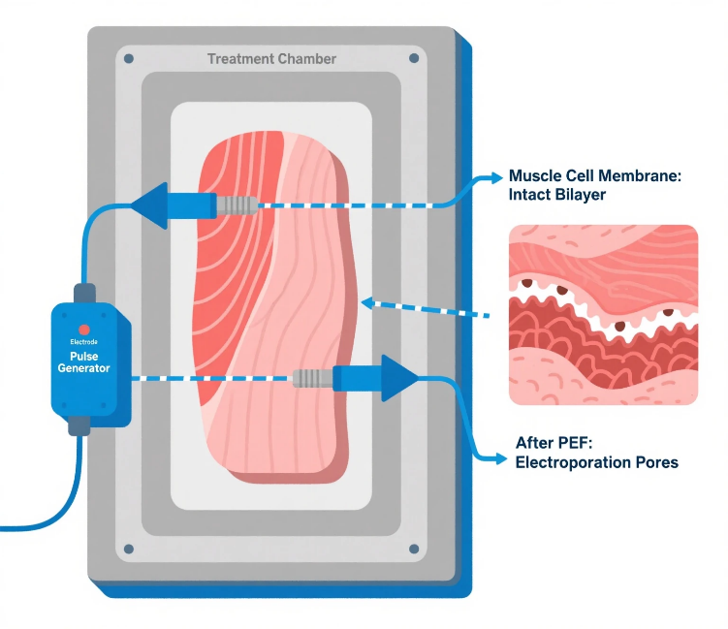
Fig. 1 Working Principle of PEF
2.2 Electroporation Mechanism
Electroporation is the principle behind PEF technology. As a result of a sufficient level of an external electric field, a transmembrane potential is generated in cells (Saulis, 2010). As this potential crosses a certain threshold, changes occur within the lipid bilayer, creating aqueous pores.
Electroporation may be further distinguished into reversible or irreversible electroporation (Martinez et al., 2020). In the case of reversible electroporation, the pores reseal after the electric field has been turned off; temporary enhancement of permeability is possible without permanent damage to the cells. Whereas in irreversible electroporation, the formation of the pores is so extensive that they are permanent, inducing loss of membrane integrity, intracellular component leakage, and ultimate cell death (Weaver and Chizmadzhev, 2018). The type of electroporation depends on electric field strength, pulse duration, number of pulses, temperature, and biological features of the cells (Weaver et al., 2012).
Electroporation in fish tissues affects muscle cells, connective tissues, and microbial cells present on the surface or within the product. This phenomenon is responsible for microbial inactivation, enhanced mass transfer, and the modification of tissue structure (Saulis, 2010).
2.3 Process Parameters Influencing PEF Treatment
Parameters that influence the efficiency of PEF processing include (Fig. 2):
Electric field strength (kV/cm): Stronger electric field strength values will enhance the permeabilization and microbial inactivation effect but may also accentuate heating (Chudasama et al., 2025).
Pulse duration and number of pulses: The more frequent the pulses, the more intense the treatment (Mohamed and Eissa, 2012).
Pulse waveform: The presence of square, exponential decay, bipolar, and oscillatory pulses affects energy distribution and electroporation efficacy (Carullo et al., 2020).
Treatment time and specific energy input: These factors are related to the process severity (Fauster et al., 2018).
Product properties: The electrical conductivity of the material, temperature, composition, and structure of the fish tissue are considered to influence the efficacy (Gómez et al., 2019).
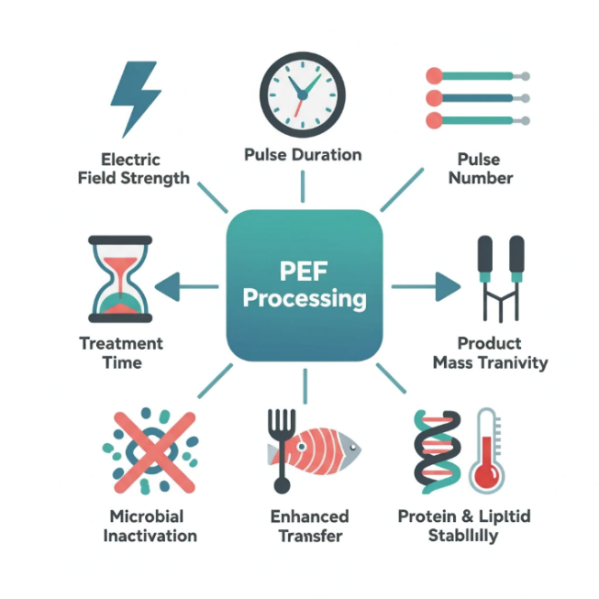
Fig. 2. Process parameters influencing PEF treatment
2.4 Equipment and Safety Considerations
In a conventional PEF system, there are several components, such as a high voltage power supply, pulse generator, capacitor bank, switching device, treatment chamber containing the electrodes, and a monitoring and control unit (Töpfl, 2006). Electrode materials and the design of the treatment chambers significantly affect field distribution to reduce electrolysis or corrosion.
Although PEF technology is regarded as safe, there exist challenges such as dielectric breakdown, localized heating, and metal migration that may be caused by electrodes (Abdollahnejad, 2025). Optimal design of the system is necessary to guarantee product quality and food safety.
3. Advantages and Limitations of PEF in Food Processing
3.1 Advantages
It has several benefits over the normal processing techniques (Mahnič-Kalamiza et al., 2014; Chauhan and Unni, 2015; Gómez et al., 2019):
Non-thermal microbial inactivation: Inactivation of microorganisms of spoilage and pathogenic nature without the need to heat extensively.
Retention of nutritional quality: This includes retention of proteins, omega-3 fatty acids, vitamins, and other biological compounds.
Minimal sensory differences: Enhanced natural color, texture, and flavor of fish products.
Increased mass transfer: Greater diffusion of salt, water, and solutes because of the cell membrane permeabilization.
Energy efficiency and sustainability: Reduced energy and water usage compared to conventional methods.
3.2 Limitations
Although PEF technology is vastly beneficial, there may be certain limitations with PEF (Barba et al., 2015; Chauhan and Unni, 2015; Gómez et al., 2019):
High capital investment: The initial investment cost of equipment is comparatively higher.
Lack of effectiveness against spores and some enzymes: PEF treatment might not be effective in inactivating resistant microbes.
Problems associated with solid foods: It is comparatively harder to handle whole fish or thick fillets compared to liquids.
Scale-up and standardization issues: There are issues related to scale-up and standardization for industrial implementation.
4. Applications of PEF in Fish and Fishery Products
4.1 Fish Preservation and Shelf-Life Extension
PEF has also been researched as a method for fish preservation to increase the shelf life of fresh and lightly processed fish (Gómez et al., 2019). PEF was found to reduce the microorganisms that cause fish spoilage by creating an irreversible electroporation in microorganisms, thus lowering the microorganism counts (Speranza et al., 2021). There has been a reduction in the total viable counts of bacteria found in fish fillets and shrimp (Ekonomou and Boziaris, 2021). Apart from microbial inactivation, PEF also affects enzymatic processes involved in autolysis and deterioration of product characteristics (Abelbaeviсh et al., 2024). When used in conjunction with refrigeration or Modified Atmosphere Packaging, PEF-treated fish products show reduced spoilage, lower odour of off-characteristics, and better micro biological stability (Gómez et al., 2019).
4.2 Texture Modification and Tenderization
Texture is a very important quality attribute which contributes to the acceptance or acceptance/rejection of fish products by the consumer. PEF processing can alter the fish muscle tissue by affecting the cell membrane and the connective tissue (Gómez et al., 2019). This results in increased water mobility inside the cells and reduced muscle fibres (Franco et al., 2020). When compared to mechanical tenderization, the use of PEF is a non-contact and more uniform process which may lead to faster processing and lower energy consumption (Alvarez-Cisneros et al., 2025). This technology is very applicable for value addition in tough and low-value fish species.
4.3 Enhancement of Drying, Salting, and Marination Processes
Mass transfer techniques such as drying, salting, and marination are also employed extensively in the preservation and creation of fishery products. PEF-assisted treatment increases the permeability of fish tissues, which helps to facilitate faster diffusion of salt and other solutes (Ayyasamy et al., 2025). Hence, there have been reductions in the time taken for curing and marination in addition to realizing equal distribution of additives. Water extraction efficiency in assisted drying through PEF was found to improve, and there was a reduction in energy consumption while retaining product quality (Llavata et al., 2024).
4.4 Extraction of Bioactive Compounds and by-Product Valorization
Fish processing yields a considerable amount of by products such as fish heads, skins, visceral portions, and bones that contain a high level of proteins, peptides, collagen, lipids, and antioxidants (Benjakul et al, 2019). PEF treatment has emerged as a promising step for the improved extraction of the aforementioned valuable compounds. By increasing cell permeability, the process enables solvents to better access intracellular substances, leading to increased extraction efficiencies. Protein extraction efficiency up to 80%, with increased antioxidant activity, has been attainable for rainbow trout and sole by-products using the technology (Wang et al., 2021). Shifts in protein molecular weights, evident in electrophoretic studies, suggest the impact of the technology on protein structure or activity. In contrast to traditional extraction techniques and other novel technologies such as ultrasonication or accelerated solvent extraction, PEF provides a gentler and more sustainable process option for by product valorization (Velusamy et al., 2023).
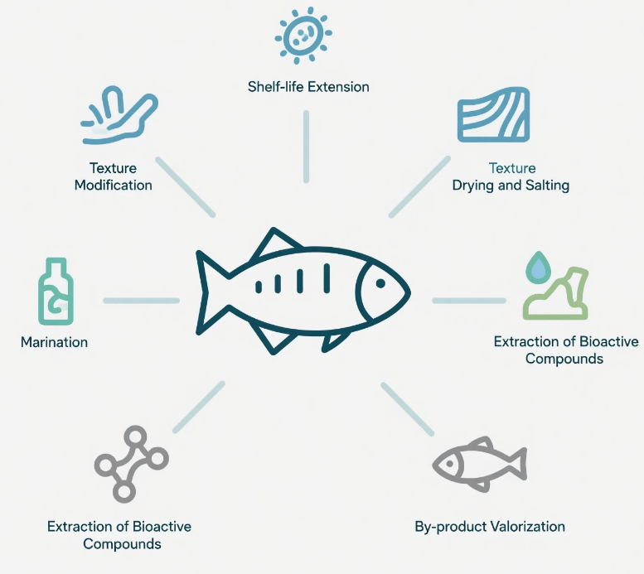
Fig. 3. Applications of PEF in Fish and Fishery Products

4.5 Combination of PEF with Other Technologies
PEF technology as a standalone processing technology has shown immense potential in fish and fishery product processing; however, the full industrial impact of this technology will be realized when PEF is combined with other fish and seafood processing and preservation technologies (Russo et al., 2024). Synergistic combination or hurdle-based strategies are preferred in modern food-processing methodologies due to the ability of multiple modes of action operating at low intensities. Hybrid PEF systems have been one strategic way to improve safety, efficiency in processing, and resource utilisation in a sustainable manner for seafood products, where retention of quality plays a very important role (Getahun et al., 2025).
4.5.1 PEF Combined with Accelerated Solvent Extraction (ASE)
The Accelerated Solvent Extraction method is commonly utilized for the recovery of valuable compounds from food matrices, typically conducted at high temperature and high pressure (Ameer et al., 2017). When integrated with PEF treatment, there is a possibility of improved efficiency of the Accelerated Solvent Extraction method. Electroporation, a biological process induced by PEF, causes damage to the cell membranes of fish tissues and by-products, resulting in improved penetration of solvents, hence higher yields of proteins, lipids, antioxidants, and other beneficial compounds (Ayyasamy et al., 2025). In fish processing, the relevance for the combined process appears in the valorization of fish by-products like skin, head, and viscera. The PEF treatment has effectively impacted the molecular weight distribution of proteins, and the SDS-PAGE analysis has demonstrated an increased liberation of intracellular proteins and peptides (Chian et al., 2019). On the basis of the improved liberation of functional proteins and increased antioxidant activity, the combined process PEF and ASE perform better than the ASE process alone.
4.5.2 PEF and Enzymatic Hydrolysis
Enzymatic hydrolysis can also be widely found in the seafood industry as a production process for fish protein hydrolysates or bioactive peptides (Ishak and Sarbon, 2018). In some cases, the ability of enzymes to reach their target substrate may hinder the process of hydrolysis. The use of PEF as a technology to combine with enzymes can eliminate this challenge due to increased cell membrane permeability (Töpfl, 2006). PEF treatment before enzymatic hydrolysis has been shown to improve the degree of hydrolysis, reaction time, and functional properties of hydrolysates in terms of solubility, emulsifying activity, and antioxidant capacity. PEF treatment of low-value fish and fish processing wastes can be advantageous in that it would make them suitable for production of high-value functional ingredients at lower production and environmental costs (Ghalamara et al., 2024).
4.5.3 PEF Combined with High-Pressure Processing (HPP)
High-pressure processing is well-established as a non-thermal technology to inactivate microorganisms in seafood products. Application of very high levels of pressure, however, produces fewer desirable changes in product texture and protein structure (Ekonomou and Boziaris, 2021). As a pretreatment, PEF increases the susceptibility of microorganisms to pressure, enabling effective inactivation at reduced pressure intensities. The combination of PEF and HPP synergistically enhances microbial safety without compromising the natural texture, color, and nutritional qualities of fish products (Gómez et al., 2019). Electroporation is responsible for the disruption of microbial cell membranes induced by PEF, while pressure further compromises cellular integrity and enzyme activity. This combination looks very promising, especially for ready-to-eat products from fish and minimally processed seafood, where very strict safety standards have to be met without loss in sensory quality.
4.5.4 PEF and Ultrasound-Assisted Processing
The processing of ultrasound utilizes acoustic cavitation to create physical and chemical phenomena that improve mass transfer and tissue disruption (Ekonomou and Boziaris, 2021). The pre-induced membrane permeabilization synergistically benefits ultrasound processing with PEF, achieving more efficient processing results. Fish processing using the combination of PEF and ultrasound has been investigated for its applications in marination, drying, extraction, and enzyme hydrolysis. This combined strategy promotes faster diffusion of salt, minimizes marination times, and optimizes uniform treatment distribution (Sireesha et al., 22). In the context of extraction procedures, the synergistic action of electroporation and cavitation increases the overall production of proteins and value-added bio-compounds with the retention of bio-integrity (Gómez et al., 2019). Furthermore, the use of the PEF-ultrasound device also supports energy conservation and accelerated processing, in coherence with the sustainable processing goal (Grillo et al., 2022).
4.5.5 PEF Combined with Cold Plasma and Refrigeration
The cold plasma technology has been found useful for the surface decontamination of fish products by the generation of reactive species; however, the penetration depth is a limitation for the solo process (Katsigiannis et al., 2022). PEF pre-treatment can increase the susceptibility of bacterial cells to plasma-mediated oxidative stress, which improves the efficiency. Using cold plasma-PEF technology together with cold storage or modified atmosphere packaging (MAP) can provide longer shelf life and improved safety for fresh fish products (Rathod et al., 2022).
In any event, the integration of PEF technology and other approaches offers a considerable improvement over current technologies in seafood processing, and it can be applied to various applications due to economic and practical considerations. The comparison of PEF with the non-thermal processing technologies, when applied individually, if given in Figure 4
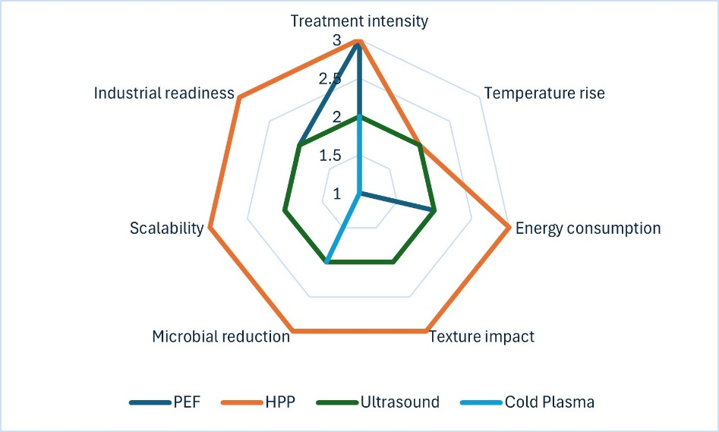
Fig. 4. Radar chart showing a qualitative comparison of non-thermal processing technologies (PEF, HPP, ultrasound, and cold plasma) used in fish processing, based on processing severity, thermal effects, energy demand, quality impact, microbial inactivation, scalability, and industrial adoption.
Note: Values represent qualitative comparisons (Low = 1, Moderate = 2, High = 3) derived from reported literature trends rather than absolute quantitative measurements.
5. Effect of PEF on Physicochemical and Nutritional Properties
5.1 Influence on Protein Structure and Functionality
The role of proteins in the functional and nutritional characteristics of fish products is highly important. The action of PEF on proteins is secondary and takes place through the mechanism of electroporation (Töpfl, 2006). At a moderate processing level, PEF does not cause the denaturation of muscle proteins (Alahakoon et al., 2017). This means that the proteins retain their solubility. However, higher electric field strength and energy inputs can cause some unfolding and aggregation of proteins (Malik et al., 2024). Protein profiles, as evidenced by the results of SDS-PAGE analysis, show changes in molecular weight distribution, especially in PEF-assisted extraction. Such changes can cause increased release of low-molecular-weight peptides with bioactive properties, which can improve antioxidant and functional properties (Chian et al., 2019).
5.2 Pigment Retention and Color Stability
Color is an important integrity attribute that impacts consumer acceptance of fish products. PEF technology has been found to ensure pigment integrity and avoid degradation due to heat treatment (Giancaterino and Jaeger, 2023). When applied to species that have carotenoid or myoglobin-related pigments, the technology maintains intact and prevents discoloration of natural product color (Joshi et al., 2025). There may be slight variations in the color variables because of moisture or structural variations, although these variations are not as extensive as those that may result from thermal procedures.
5.3 Changes in Moisture Content, pH, and Texture
The effect of electroporation induced by PEF treatment affects the distribution of water in fish tissue, often resulting in improved water-holding capacity (Gómez et al., 2019). This may lead to lower drip loss and higher juiciness in fish fillet meats. The value of pH is normally unaffected or unchanged by the treatment, although slight variations may result from ion movement. Textural changes, such as increased tenderness, are associated with muscle fibre softening and weakening of connective tissue. These are associated with a positive effect on both texture and processing ease (Jeong et al., 2024).
5.4 Retention of Nutritional and Bioactive Compounds
Among the major benefits of PEF technology, there is the preservation of nutritional quality. Vitamins, essential amino acids, and omega-3 fatty acids are mostly preserved because of the low thermal impact of the process (Ali et al., 2022). Moreover, antioxidant compounds recovery is enhanced by PEF assisted extraction, improving the nutritional and functional value of the fish-derived ingredients (Ghalamara et al.,2024).
6. Industrial Potential and Sustainability Aspects
6.1 Environmental Benefits
PEF processing has much in common with the basics of sustainable food processing. It is characterized by a lower energy and water supply compared to traditional thermal methods, resulting in fewer greenhouse gas emissions and lower costs of operation (Landi et al, 2025). Moreover, the technology allows for more raw material efficiency through valorization of by-products.
6.2 Economic Feasibility and Scale-Up Challenges
In spite of these advantages, industrial-scale applications of PEF in the seafood sector will be limited until such time that the initial capital investment can be better justified and large-scale systems that are capable of processing solid foods become more readily available (Ahmed et al., 2025). Issues like electrode design, distribution of uniform electric field, and equipment maintenance have to be resolved for reliable operation. However, it is from experience with meat and juice industries that such challenges can be overcome with technological innovation and optimization of the processes (Ghoshal, 2023). With increasing demand for minimally processed seafood, the economic feasibility for PEF will continue to improve.
Conclusion
A major development in the processing of fish and fisheries products, pulsed electric field technology fits in nicely with the rising demand for sustainable, high-quality, minimally processed seafood. PEF allows for efficient microbial inactivation, improved mass transfer, and structural modification of fish tissues while mainly maintaining nutritional and sensory characteristics by taking advantage of the electroporation mechanism. The technology has shown significant promise in increasing shelf life, enhancing the extraction of valuable bioactive compounds from fish and processing by-products, improving texture, and speeding up drying and curing processes. Additionally, PEF offers synergistic benefits when combined with other mild and non-thermal processing technologies, enabling increased safety and efficiency at lower process intensities. Despite these benefits, widespread adoption is still hampered by issues with large-scale industrial standardization, handling solid and heterogeneous matrices, and high initial investment. Successful commercialization requires ongoing research on equipment design, process optimization, and techno-economic viability. PEF is positioned to become a crucial part of next-generation fish processing systems, helping to improve resource efficiency, lessen environmental impact, and improve product quality, thanks to continuous technological advancements and growing emphasis on sustainable seafood processing.
Reference
Abdollahnejad, M. (2025). Evaluating Electrodes in PEF systems: A Systematic Review. Food and Humanity, 100605.
Abelbaeviсh, B. T., Zamzagul, M., Zhaksylykovna, M. B., Zhanabayevna, A. L., Sholpan, T., Yerkin, Y., & Sarsenbayevna, B. A. (2024). Enhancing food safety and quality through high-pressure processing and PEF technologies: Comparative analysis. Caspian Journal of Environmental Sciences, 22(2), 513-520. https://doi.org/10.22124/CJES.2024.7742
Ahmed, M., Ranjan, H., & Roy, S. (2025). Pulsed electric fields for sustainable meat, poultry, and fish processing: Recent advances, prospects, and industry challenges. Innovative Food Science & Emerging Technologies, 104008. https://doi.org/10.1016/j.ifset.2025.104008
Alahakoon, A. U., Oey, I., Silcock, P., & Bremer, P. J. F. R. I. (2017). Understanding the effect of pulsed electric fields on thermostability of connective tissue isolated from beef pectoralis muscle using a model system. Food Research International, 100, 261-267. https://doi.org/10.1016/j.foodres.2017.08.025
Ali, A., Wei, S., Ali, A., Khan, I., Sun, Q., Xia, Q., ... & Liu, S. (2022). Research progress on nutritional value, preservation and processing of fish—A review. Foods, 11(22), 3669. https://doi.org/10.3390/foods11223669
Alvarez-Cisneros, Y. M., de Lourdes Pérez-Chabela, M., & Ponce-Alquicira, E. (2025). New Technologies in Meat Preservation.
Ameer, K., Shahbaz, H. M., & Kwon, J. H. (2017). Green extraction methods for polyphenols from plant matrices and their byproducts: A review. Comprehensive reviews in food science and food safety, 16(2), 295-315. https://doi.org/10.1111/1541-4337.12253
Arumugam, D., Li, S., Rao, M., Peng, R., Liu, H., Huo, B., ... & Wang, J. (2025). Non-thermal technologies for seafood preservation and shelf-life extension: a detailed review. Food Quality and Safety, fyaf046.
Ayyasamy, V., Ravi, H., & Natarajan, V. (2025). Green extraction of marine bioactive compounds and their byproducts using pulsed electric field: mechanisms, applications, and impacts on aquatic foods. Critical Reviews in Food Science and Nutrition, 1-23. https://doi.org/10.1080/10408398.2025.2589457
Badoni, P., Nazir, I., Aier, M., Maity, P. B., Samanta, S., & Das, A. (2021). Significant role of fish nutrients with special emphasis to essential fatty acid in human nutrition. Int. J. Curr. Microbiol. Appl. Sci, 10, 2034-2046. https://doi.org/10.20546/ijcmas.2021.1002.243
Barba, F. J., Parniakov, O., Pereira, S. A., Wiktor, A., Grimi, N., Boussetta, N., ... & Vorobiev, E. (2015). Current applications and new opportunities for the use of pulsed electric fields in food science and industry. Food research international, 77, 773-798. https://doi.org/10.1016/j.foodres.2015.09.015
Benjakul, S., Sae‐leaw, T., & Simpson, B. K. (2019). Byproducts from fish harvesting and processing. Byproducts from agriculture and fisheries: adding value for food, feed, pharma, and fuels, 179-217. https://doi.org/10.1002/9781119383956.ch9
Carullo, D., Pataro, G., Donsì, F., & Ferrari, G. (2020). Pulsed electric fields-assisted extraction of valuable compounds from arthrospira platensis: effect of pulse polarity and mild heating. Frontiers in Bioengineering and Biotechnology, 8, 551272. https://doi.org/10.3389/fbioe.2020.551272
Chauhan, O. P., & Unni, L. E. (2015). Pulsed electric field (PEF) processing of foods and its combination with electron beam processing. Electron beam pasteurization and complementary food processing technologies, 157-184. https://doi.org/10.1533/9781782421085.2.157
Chian, F. M., Kaur, L., Oey, I., Astruc, T., Hodgkinson, S., & Boland, M. (2019). Effect of Pulsed Electric Fields (PEF) on the ultrastructure and in vitro protein digestibility of bovine longissimus thoracis. LWT, 103, 253-259. https://doi.org/10.1016/j.lwt.2019.01.005
Chudasama, M., Singh, D. K., & Pradhan, R. C. (2025). Review on Electroporation Mechanisms for PEF-Assisted Extraction and Microbial Inactivation. Food Engineering Reviews, 1-21. https://doi.org/10.1007/s12393-025-09416-7
Ekonomou, S. I., & Boziaris, I. S. (2021). Non-thermal methods for ensuring the microbiological quality and safety of seafood. Applied Sciences, 11(2), 833. https://doi.org/10.3390/app11020833
Fauster, T., Schlossnikl, D., Rath, F., Ostermeier, R., Teufel, F., Toepfl, S., & Jaeger, H. (2018). Impact of pulsed electric field (PEF) pretreatment on process performance of industrial French fries production. Journal of Food Engineering, 235, 16-22. https://doi.org/10.1016/j.jfoodeng.2018.04.023
Franco, D., Munekata, P. E., Agregán, R., Bermúdez, R., López-Pedrouso, M., Pateiro, M., & Lorenzo, J. M. (2020). Application of pulsed electric fields for obtaining antioxidant extracts from fish residues. Antioxidants, 9(2), 90. https://doi.org/10.3390/antiox9020090
Gao, X., Wang, Z., Sun, G., Zhao, Y., Tang, S., Zhu, H., & Li, Z. (2025). Pulsed Electric Field (PEF) Technology for Preserving Fruits and Vegetables: Applications, Benefits, and Comparisons. Food Reviews International, 1-26. https://doi.org/10.1080/87559129.2025.2489754
Gavahian, M. (2024). Opinion on the prospects of emerging food processing technologies to achieve sustainability in the industry by reduced energy consumption, waste reduction and valorisation, and improved food nutrition. International Journal of Food Science and Technology, 59(11), 8135-8140. https://doi.org/10.1111/ijfs.17525
Getahun, A., Kechero, Y., & Yemane, N. (2025). Review on fish production enhancement and preservation technologies. Veterinary Sciences: Research and Reviews, 11(1), 54-70. https://doi.org/10.17582/journal.vsrr/2025/11.1.54.70
Ghalamara, S., Brazinha, C., Silva, S., & Pintado, M. (2024). Exploring fish processing by-products as an alternative source of bioactive peptides: a review on extraction and food applications. Current Food Science and Technology Reports, 2(4), 377-391. https://doi.org/10.1007/s43555-024-00041-9
Ghoshal, G. (2023). Comprehensive review on pulsed electric field in food preservation: Gaps in current studies for potential future research. Heliyon, 9(6). https://doi.org/10.1016/j.heliyon.2023.e17532
Giancaterino, M., & Jaeger, H. (2023). Impact of pulsed electric fields (PEF) treatment on the peeling ability of tomatoes and kiwi fruits. Frontiers in Food Science and Technology, 3, 1152111. https://doi.org/10.3389/frfst.2023.1152111
Gómez, B., Munekata, P. E., Gavahian, M., Barba, F. J., Martí-Quijal, F. J., Bolumar, T., ... & Lorenzo, J. M. (2019). Application of pulsed electric fields in meat and fish processing industries: An overview. Food research international, 123, 95-105. https://doi.org/10.1016/j.foodres.2019.04.047
Grillo, G., Boffa, L., Calcio Gaudino, E., Binello, A., Rego, D., Pereira, M., ... & Cravotto, G. (2022). Combined ultrasound and pulsed electric fields in continuous-flow industrial olive-oil production. Foods, 11(21), 3419. https://doi.org/10.3390/foods11213419
Ishak, N. H., & Sarbon, N. M. (2018). A review of protein hydrolysates and bioactive peptides deriving from wastes generated by fish processing. Food and Bioprocess Technology, 11(1), 2-16. https://doi.org/10.1007/s11947-017-1940-1
Jeong, S. H., Lee, H. B., & Lee, D. U. (2024). Effects of pulsed electric field on meat tenderization and microbial decontamination: A review. Food science of animal resources, 44(2), 239. https://doi.org/10.5851/kosfa.2023.e82
Joshi, S., Appukuttan, J., Chandrapala, J., & Majzoobi, M. (2025). Impact of Conventional and Advanced Techniques on Stability of Natural Food Colourants. Foods, 14(18), 3187. https://doi.org/10.3390/foods14183187
Kasri, N. F., Piah, M. A. M., Hamzah, A., & Adzis, Z. (2021). Microcontroller‐based pulse signal controller development for compact high voltage pulse generator: Practical development in food treatment technology. Journal of Food Processing and Preservation, 45(6), e15531. https://doi.org/10.1111/jfpp.15531
Katsigiannis, A. S., Bayliss, D. L., & Walsh, J. L. (2022). Cold plasma for the disinfection of industrial food‐contact surfaces: An overview of current status and opportunities. Comprehensive Reviews in Food Science and Food Safety, 21(2), 1086-1124. https://doi.org/10.1111/1541-4337.12885
Khalid, W., Maggiolino, A., Kour, J., Arshad, M. S., Aslam, N., Afzal, M. F., ... & Korma, S. A. (2023). Dynamic alterations in protein, sensory, chemical, and oxidative properties occurring in meat during thermal and non-thermal processing techniques: A comprehensive review. Frontiers in Nutrition, 9, 1057457. https://doi.org/10.3389/fnut.2022.1057457
Khojasteh, S. K., Elmizadeh, A., Sarraf, M., & Dodange, S. (2025). Non-thermal innovations in solid food processing: Eco-friendly alternatives to thermal methods. Applied Food Research, 101256. http://www.sciencedirect.com/science/article/pii/S277250222500561X
Landi, G., Benedetti, M., Sforzini, M., Eslami, E., & Pataro, G. (2025). Comparative Analysis of Cost, Energy Efficiency, and Environmental Impact of Pulsed Electric Fields and Conventional Thermal Treatment with Integrated Heat Recovery for Fruit Juice Pasteurization. Foods, 14(13), 2239. https://doi.org/10.3390/foods14132239
Llavata, B., Collazos-Escobar, G. A., García-Pérez, J. V., & Cárcel, J. A. (2024). PEF pre-treatment and ultrasound-assisted drying at different temperatures as a stabilizing method for the up-cycling of kiwifruit: Effect on drying kinetics and final quality. Innovative Food Science & Emerging Technologies, 92, 103591. https://doi.org/10.1016/j.ifset.2024.103591
Mahnič-Kalamiza, S., Vorobiev, E., & Miklavčič, D. (2014). Electroporation in food processing and biorefinery. The Journal of membrane biology, 247(12), 1279-1304. https://doi.org/10.1007/s00232-014-9737-x
Malik, M. A., Sheikh, M. A., & Mir, N. A. (2024). A review on pulsed electric field modification of proteins: Effect on the functional and structural properties. Food Bioscience, 61, 104636. https://doi.org/10.1016/j.fbio.2024.104636
Martínez, J. M., Delso, C., Álvarez, I., & Raso, J. (2020). Pulsed electric field‐assisted extraction of valuable compounds from microorganisms. Comprehensive Reviews in Food Science and Food Safety, 19(2), 530-552. https://doi.org/10.1111/1541-4337.12512
Mohamed, M. E., & Eissa, A. H. A. (2012). Pulsed electric fields for food processing technology. In Structure and function of food engineering. IntechOpen. https://doi.org/10.5772/48678
Rabiepour, A., Zahmatkesh, F., & Babakhani, A. (2024). Preservation techniques to increase the shelf life of seafood products: An overview. Journal of Food Engineering and Technology, 13(1), 1-24. https://doi.org/10.32732/jfet.2024.13.1.1
Rathod, N. B., Kulawik, P., Ozogul, Y., Ozogul, F., & Bekhit, A. E. D. A. (2022). Recent developments in non-thermal processing for seafood and seafood products: Cold plasma, pulsed electric field and high hydrostatic pressure. International Journal of Food Science and Technology, 57(2), 774-790. https://doi.org/10.1111/ijfs.15392
Russo, G. L., Langellotti, A. L., Torrieri, E., & Masi, P. (2024). Emerging technologies in seafood processing: An overview of innovations reshaping the aquatic food industry. Comprehensive Reviews in Food Science and Food Safety, 23(1), e13281. https://doi.org/10.1111/1541-4337.13281
Saulis, G. (2010). Electroporation of cell membranes: the fundamental effects of pulsed electric fields in food processing. Food Engineering Reviews, 2(2), 52-73. https://doi.org/10.1007/s12393-010-9023-3
Sireesha, T., Gowda, N. N., & Kambhampati, V. (2022). Ultrasonication in seafood processing and preservation: a comprehensive review. Applied Food Research, 2(2), 100208. https://doi.org/10.1016/j.afres.2022.100208
Speranza, B., Racioppo, A., Bevilacqua, A., Buzzo, V., Marigliano, P., Mocerino, E., ... & Sinigaglia, M. (2021). Innovative preservation methods improving the quality and safety of fish products: Beneficial effects and limits. Foods, 10(11), 2854. https://doi.org/10.3390/foods10112854
Takaki, K., Takahashi, K., Hayashi, N., Wang, D., & Ohshima, T. (2021). Pulsed power applications for agriculture and food processing. Reviews of Modern Plasma Physics, 5(1), 12. https://doi.org/10.1007/s41614-021-00059-9
Töpfl, S. (2006). Pulsed Electric Fields (PEF) for Permeabilization of Cell Membranes in Food-and Bioprocessing–Applications, Process and Equipment Design and Cost Analysis.
Velusamy, M., Rajan, A., & Radhakrishnan, M. (2023). Valorisation of food processing wastes using PEF and its economic advances–recent update. International Journal of Food Science & Technology, 58(4), 2021-2041. https://doi.org/10.1111/ijfs.16297
Wang, M., Zhou, J., Collado, M. C., & Barba, F. J. (2021). Accelerated solvent extraction and pulsed electric fields for valorization of rainbow trout (Oncorhynchus mykiss) and sole (Dover sole) by-products: Protein content, molecular weight distribution and antioxidant potential of the extracts. Marine Drugs, 19(4), 207. https://doi.org/10.3390/md19040207
Weaver, J. C., & Chizmadzhev, Y. (2018). Electroporation. In Biological and Medical Aspects of Electromagnetic Fields, Fourth Edition (pp. 243-284). CRC Press. https://doi.org/10.1201/9781315186641
Weaver, J. C., Smith, K. C., Esser, A. T., Son, R. S., & Gowrishankar, T. R. (2012). A brief overview of electroporation pulse strength–duration space: A region where additional intracellular effects are expected. Bioelectrochemistry, 87, 236-243. https://doi.org/10.1016/j.bioelechem.2012.02.007

