Assessment of Floral Phenology and Pollen Quality in Guava (Psidium guajava L.) Genotypes

.
ABSTRACT

Understanding floral biology and pollen behavior is fundamental for improving fruit set and reproductive efficiency in guava, yet genotype-specific variations in these traits remain insufficiently explored. The study aimed to assess floral behavior, pollen characteristics, and reproductive traits among six guava genotypes viz., Lucknow-49, Arka Mridula, Dharwad Local, Kohir Local, Arka Kiran, and Purple Guava grown under uniform conditions. The experiment was laid out in a Randomized Block Design (RBD) with three replications. The duration of floral bud development varied from 37 to 45 days, being longest in Dharwad Local (45 days) and shortest in Kohir Local and Purple Guava (37 days each). Peak anthesis occurred between 5:30–6:30 AM, while maximum anther dehiscence was observed between 7:30–8:30 AM. Arka Kiran exhibited the longest flowering duration (54 days) and full bloom period (32.33 days). Pollen viability ranged from 92.89% (Kohir Local) to 98.45% (Arka Kiran), while pollen germination varied from 81.20% (Kohir Local) to 91.48% (Arka Kiran). Significant genotypic variation was also noted in pollen size, which ranged from 15.77 µm in Dharwad Local to 18.93 µm in Purple Guava. The study revealed distinct inter-genotypic differences in floral and pollen traits, suggesting their influence on reproductive efficiency and potential use in breeding programs aimed at improving fruit set and yield in guava.

Keywords: Anthesis, Floral bud development, Genotypes, Guava, Pollen

1. INTRODUCTION

Guava (Psidium guajava L.) is one of the most widely grown tropical fruit species, recognized for its remarkable adaptability and prolific bearing habit. It is a member of the Myrtaceae family and possesses a diploid chromosome number of 2n = 22 (Morton, 1987). The species is believed to have originated in the neotropical regions of Central and South America, from where it gradually spread to other continents through early trade routes and domestication (Nakasone and Paull, 1998). Over time, guava has become naturalized and commercially cultivated across diverse agro-climatic zones of the tropics and subtropics, owing to its hardy nature, wide ecological tolerance, and high consumer demand.
India is the largest producer of guava, contributing about 45–50% of global production. According to the National Horticultural Board (Anon., 2023), it occupies 3.59 lakh hectares with an annual production of 5.59 million tonnes and an average productivity of 15.9 t/ha. Uttar Pradesh ranks first (21.8%), followed by Madhya Pradesh (17.2%) and Bihar (9.6%), while Andhra Pradesh, Maharashtra, and West Bengal are other major producers.
Botanically, guava is a small tree up to 9 m tall with greenish-brown bark, opposite pubescent leaves, and bisexual white flowers borne singly or in clusters (Braganza, 1990). Flowers arising from middle and basal shoots usually bear higher fruiting potential. The calyx splits into 4–6 hairy sepals, petals are 4–5 in number, and stamens range from 160–400 with bilobed, longitudinally dehiscent anthers (Kwee and Chong, 1990). The ovary is inferior and 4–5 locular with a slender style and capitate stigma. Anthesis generally occurs between 4:00 and 10:00 AM, peaking in early morning hours.
Guava fruits are valued for their nutritional richness and adaptability, containing 9.60–11.10°Brix TSS, 0.28–0.38% acidity, and 167–210 mg/100 g ascorbic acid (Archana and Siddique, 2004; Aulakh, 2004). They are rich in calcium, iron, and vitamin C (80–300 mg/100 g), surpassing citrus fruits, and also contain β-carotene, lycopene, phenolics, and flavonoids (Singh, 2005; Joseph et al., 2014), conferring strong antioxidant and health-promoting properties.
Despite its importance, guava production in India faces several challenges, including variable fruit quality, low yields and low productivity. One of the often-neglected causes of these challenges is the limited understanding of the factors that influence fruit development. With increasing demand for high-quality guava varieties, understanding the factors that influence fruit quality has become essential. Hence, the present study was undertaken to investigate the floral biology and pollen quality of different guava genotypes.
2. material and methods

The field experiment on “Assessment of Floral Phenology and Pollen Quality in Guava (Psidium guajava L.) Genotypes” was carried out during 2024–2025 at the experimental farm of the College of Horticulture, Bengaluru, University of Horticultural Sciences, Bagalkot. The experimental site is situated at 13.09° N latitude, 77.56° E longitude, and an altitude of 924 meters above mean sea level. The soil of the experimental plot was red sandy loam in texture, slightly acidic to neutral in reaction (pH 5.5–7.0), low to medium in organic carbon, and with moderate water-holding capacity. The available nutrient status of the soil was generally low to medium in nitrogen, medium to high in phosphorus, and medium in potassium. The climate of Bengaluru is tropical, characterized by distinct wet and dry seasons with a mean annual temperature ranging from 16.9°C (January) to 32.1°C (April). The rainfall during the experimental period was mainly received from the retreating southwest monsoon (September) and northeast monsoon (October–December), with occasional pre-monsoon showers during May and June.
The experiment was conducted in a Randomized Block Design (RBD) with six treatments (genotypes) and four replications. The plant material comprised eight-year-old, well-established guava trees planted at a spacing of 6 × 6 m in the experimental orchard. The six genotypes evaluated in the study are T₁ – Lucknow-49, T₂ – Arka Mridula, T₃ – Dharwad Local, T₄ – Kohir Local, T₅ – Arka Kiran, and T₆ – Purple Guava. Standard cultural practices were uniformly followed throughout the study period. Pruning was carried out during the last week of September 2024 to induce uniform flowering and synchronized shoot emergence. Observations on floral biology parameters such as flower bud development, anthesis, anther dehiscence, pollen viability, pollen germination, and fruit set percentage were recorded during the flowering and fruiting periods to assess the reproductive behavior of different guava genotypes.

2.1 Duration of Bud Development
The duration of flower bud development in guava genotypes was determined by recording the number of days from bud initiation to anthesis. Twenty flower buds per genotype were tagged immediately after emergence, selecting five buds from each of the four canopy sides. Observations were made daily, and the total period from bud swelling to flower opening was expressed as the duration of bud development in days.
2.2 Anthesis Time
To study the time of anthesis, twenty healthy, fully developed flower buds at calyx break stage were tagged and bagged in the evening prior to anthesis to avoid insect interference. Observations were made at hourly intervals from 5:30 a.m. to 10:30 a.m. The exact time when petals started to separate was recorded as the time of anthesis. The observations were continued for four consecutive days for each genotype during peak flowering.
2.3 Anther Dehiscence
The timing of anther dehiscence was studied by observing twenty freshly opened flowers per genotype at hourly intervals from 5:30 a.m. to 10:30 a.m. for four consecutive days. Dehiscence was considered to have occurred when about 25–50% of the anthers had split, releasing pollen. The onset of dehiscence was indicated by yellowing of anthers and was confirmed using a hand lens. The period with maximum dehisced anthers was recorded as the peak dehiscence time.
2.4 Duration of Flowering
The date of first flowering was recorded when about 50% of the trees in each genotype showed the first open flower. Full bloom was noted when the maximum number of flowers appeared on 50% of trees, and the end of flowering was marked when the last flowers appeared on a similar proportion of trees. The duration of flowering was calculated as the number of days between first and last flowering.
2.5 Pollen Viability Assessment
Pollen viability was assessed using the acetocarmine staining method. Freshly dehisced anthers were collected between 8:00 and 9:00 a.m., and pollen grains were transferred to slides containing 1% acetocarmine solution. After 10 minutes of staining, the slides were examined under a microscope. Well-filled, uniformly stained pollen grains with clear outlines were considered viable, while shriveled or unstained ones were treated as non-viable. Pollen viability percentage was determined by counting viable pollen in 10 random microscopic fields per slide, and four slides were observed per genotype. The percentage of viable pollen was calculated using the formula:
Number of viable pollens
Pollen viability = × 100
Total number of pollens in the microscopic field
2.6 Pollen Germination Study
In vitro pollen germination was studied using the sitting drop technique on cavity slides containing 10% sucrose solution as the germination medium. Freshly dehisced pollen grains collected between 8:00 and 9:00 a.m. were incubated at 28°C in moist chambers for up to three hours. Pollen grains with pollen tubes at least equal to or longer than their diameter were considered germinated. Germination percentage was determined by counting germinated pollen in 10 random microscopic fields per slide, and four slides were observed per genotype. The percentage of pollen germination was determined by the formula:
Number of pollens germinated
Pollen germination % = × 100
Total number of pollens in the microscopic field
2.7 Pollen Size (µm)
Pollen size was determined by measuring two dimensions viz., polar axis and equatorial diameter using Scanning Electron Microscopy (SEM). The average values were expressed in micrometers (µm), and variations among genotypes were noted to assess pollen morphological differences.
3. results and discussion

3.1 Duration of Floral Bud Development
The duration of floral bud development among guava genotypes ranged from 37 to 45 days (Table 1 and Fig. 1). Dharwad Local recorded the maximum duration (45 days), followed by Lucknow-49 (41.33 days), while Kohir Local and Purple Guava showed the shortest (37 days each). The mean time between successive stages gradually decreased with development, from 9 days (stage 1–2) to 1 day (stage 7–8). These results are in agreement with Sharma et al. (2017), who reported that guava floral buds pass through eight distinct stages, requiring 39–41 days in spring and 36–40 days in autumn, with a similar decreasing trend in stage duration. Earlier reports also highlight comparable patterns such as Dasarathy (1951) and Balasubrahmanyam (1959) observed 30–37 days for bud development in Lucknow-49, Allahabad Round, and Chittidar, whereas Sehgal and Singh (1967) recorded 38–42 days in Allahabad Safeda and Lucknow-49, attributing longer duration to environmental factors. The variation observed may be due to genotypic influence and local environmental conditions. The progressive reduction in stage duration indicates accelerated metabolic and hormonal activity towards anthesis, ensuring synchronized flower opening.
Table 1. Number of days required for floral bud development in guava genotypes
Genotypes | No. of days required for passing from one stage to the other |  |  |  |  |  |  | Total No. of days
Genotypes | 1 to 2 | 2 to 3 | 3 to 4 | 4 to 5 | 5 to 6 | 6 to 7 | 7 to 8 | Total No. of days
T₁ ₋ Lucknow 49 | 10.00^{ab} | 9.33 | 5.33^{b} | 5.67^{ab} | 5.00ª | 5.00ª | 1.00 | 41.33^{b}
T₂ - Arka Mridula | 8.33^{cd} | 9.67 | 5.67^{b} | 4.00^{c} | 5.33ª | 4.00^{b} | 1.00 | 38.00^{c}
T₃ - Dharwad Local | 10.67ª | 9.33 | 8.00ª | 6.00ª | 5.33ª | 4.67ª | 1.00 | 45.00ª
T₄ - Kohir Local | 9.00^{bc} | 9.00 | 5.67^{b} | 5.33^{b} | 4.00^{b} | 3.00^{c} | 1.00 | 37.00^{c}
T₅ - Arka Kiran | 8.33^{cd} | 8.33 | 5.33^{b} | 5.33^{b} | 5.00ª | 4.00^{b} | 1.00 | 37.33^{c}
T₆ ₋ Purple Guava | 7.67^{d} | 9.67 | 6.33^{b} | 5.00^{b} | 4.00^{b} | 3.33^{c} | 1.00 | 37.00^{c}
Mean | 9.00 | 9.22 | 6.06 | 5.22 | 4.78 | 4.00 | 1.00 | 39.28
S. Em+ | 0.38 | 0.30 | 0.31 | 0.20 | 0.29 | 0.18 | 0.00 | 0.81
CD at 5 % | 1.20 | NS | 0.98 | 0.64 | 0.92 | 0.58 | NS | 2.54
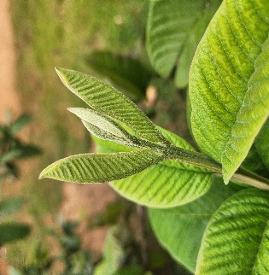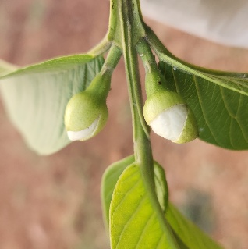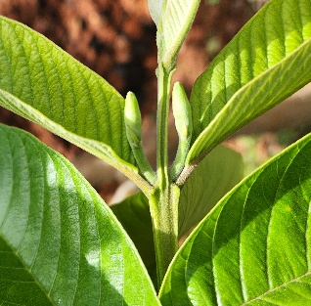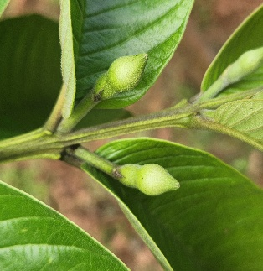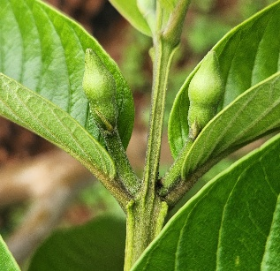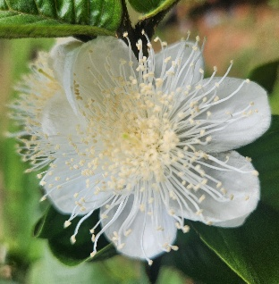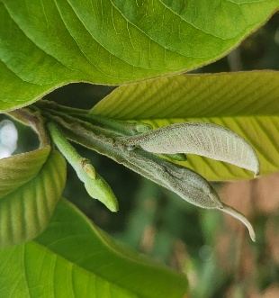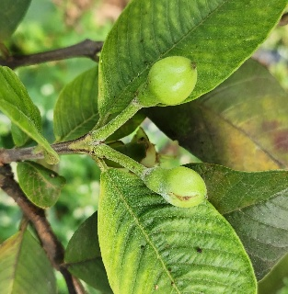3.2 Anthesis
Fig. 1 Stages of floral bud development in guava genotypes
Stage 1
Stage 2
Stage 3
Stage 4
Stage 5
Stage 6
Stage 7
Stage 8
Among the genotypes (Table 2), maximum anthesis occurred between 5:30–6:30 AM (40.74%), declining gradually thereafter. Arka Kiran recorded the highest anthesis between 6:30–7:30 AM (37.78%), followed by Kohir Local (36.67%) and Lucknow-49 (33.33%), while the lowest was in Arka Mridula (22.22%). These results are in line with the findings of Sandhu et al. (2024), who reported a peak anthesis between 5:30–6:30 AM in cv. Lalit (40.00%) and Sardar (36.66%). Similarly, Teaotia (1970) and Srivastava (1974) recorded maximum anthesis between 5:00–7:30 AM in guava cultivars, which corroborates the present findings. On the other hand, Ojha et al. (1986) observed relatively delayed flower opening in the rainy season compared to the spring season, indicating that seasonal variations may also influence anthesis patterns. The variation among genotypes may be attributed to genetic differences in floral physiology, carbohydrate mobilization, and petal expansion, while environmental factors such as temperature and humidity further influence timing.
Table 2. Time of anthesis in selected guava genotypes
Genotypes | Percentage of flowers opened at hourly interval (%)
Genotypes | 5:30 AM to 6:30 AM | 6:30 AM to 7:30 AM | 7:30 AM to 8:30 AM | 8:30 AM to 9:30 AM | 9:30 AM to 10:30AM
T₁ ₋ Lucknow 49 | 35.56 (36.60) | 33.33^{ab} (35.25) | 16.67^{abc} (24.05) | 8.89 (17.29) | 5.56 (13.48)
T₂ - Arka Mridula | 46.67 (43.08) | 22.22^{c} (28.07) | 20.00ª (26.36) | 8.89  (17.11) | 2.22 (4.99)
T₃ - Dharwad Local | 40.00 (39.22) | 33.33^{ab} (35.25) | 17.78^{ab} (24.92) | 5.56 (13.48) | 3.33 (8.49)
T₄ - Kohir Local | 42.22 (40.51) | 36.67ª (37.25) | 11.11^{cd} (19.43) | 6.67 (14.64) | 3.33 (8.49)
T₅ - Arka Kiran | 36.67 (37.25) | 37.78ª (37.91) | 12.22^{bcd} (20.32) | 7.78 (16.12) | 5.56 (13.48)
T₆ ₋ Purple Guava | 43.33 (41.15) | 26.67^{bc} (31.00) | 10.00^{d} (18.44) | 13.33 (21.15) | 6.67 (12.29)
Mean | 40.74 | 31.67 | 14.63 | 8.52 | 4.45
S. Em+ | 1.63 | 1.39 | 1.62 | 1.77 | 4.47
CD at 5 % | NS | 4.38 | 5.11 | NS | NS
*Values in parenthesis are arc sin transformation data
3.3 Anther Dehiscence
Peak anther dehiscence was observed between 7:30–8:30 AM (42.04%) (Table 3). Purple Guava recorded the highest dehiscence at 6:30–7:30 AM (23.33%), while Dharwad Local and Arka Kiran exhibited higher activity at 8:30–9:30 AM. These findings align with the results of Dhaliwal and Singla (2002), who reported that anther dehiscence in guava generally begins around 5:30 AM, approximately 15–20 minutes before or after anthesis and continues until 11:30 AM, with a peak between 6:30 and 8:30 AM. Similarly, Balasubrahmanyam (1959) and Nalawadi et al. (1973) observed that anther dehiscence follows a distinct early-morning pattern, typically commencing soon after anthesis and reaching maximum activity between 6:30 and 8:00 AM. The genotypic differences in dehiscence pattern could be due to variation in anther wall structure, endothecial development, and moisture sensitivity. Environmental factors, particularly temperature and humidity, also play a critical role in regulating anther opening and pollen release.
Genotypes | Percentage of flowers dehisced at hourly interval (%)
Genotypes | 5:30 AM to 6:30 AM | 6:30 AM to 7:30 AM | 7:30 AM to 8:30 AM | 8:30 AM to 9:30 AM | 9:30 AM to 10:30 AM
T₁ ₋ Lucknow 49 | 5.56  (13.48) | 14.44^{bc} (22.31) | 43.33 (41.16) | 26.67^{ab} (31.11) | 10.00 (18.27)
T₂ - Arka Mridula | 6.67  (12.13) | 17.78^{ab} (24.85) | 40.00 (39.20) | 26.67^{ab} (31.11) | 8.89  (17.11)
T₃ - Dharwad Local | 3.33  (8.49) | 10.00^{c} (18.27) | 43.33 (41.16) | 32.22ª (34.60) | 11.11  (19.16)
T₄ - Kohir Local | 6.67  (14.64) | 14.44^{bc} (22.31) | 40.00 (39.22) | 30.00ª (33.23) | 8.89  (16.79)
T₅ - Arka Kiran | 3.33  (8.49) | 10.00^{c} (18.27) | 42.22 (40.51) | 31.11ª (33.92) | 13.33 (21.32)
T₆ ₋ Purple Guava | 6.67  (12.29) | 23.33ª (28.78) | 43.33 (41.15) | 20.00^{b} (26.58) | 6.67  (12.29)
Mean | 5.37 | 15.00 | 42.04 | 27.78 | 9.84
S. Em+ | 2.95 | 1.47 | 1.61 | 1.51 | 3.25
CD at 5 % | NS | 4.61 | NS | 4.75 | NS
Table 3. Time of anther dehiscence in selected guava genotypes
*Values in parenthesis are arc sin transformation data
3.4 Duration of Flowering
Flowering duration varied widely among genotypes (Table 4), ranging from 31.33 days in Purple Guava to 54 days in Arka Kiran. Arka Mridula (50.67 days) and Lucknow-49 (46.33 days) exhibited intermediate durations, while Dharwad Local showed a shorter span (41 days). The full bloom period was longest in Arka Kiran (32.33 days), followed by Arka Mridula (30.67 days). These findings are in line with earlier reports of wide variation in flowering duration among guava cultivars. Sehgal and Singh (1967) noted flowering periods ranging from 27 to 46 days across varieties, with longer durations in autumn compared to spring. Chatterjee et al. (1992) similarly reported variation, with Lucknow-49 showing the shortest duration (34 days) and Allahabad Safeda the longest (38 days). Recent studies by Sharma et al. (2017) recorded flowering durations of 37–41 days in Lucknow-49 and Allahabad Safeda, and up to 45 days in Hisar Surkha. The extended flowering in Arka Kiran and Arka Mridula may be attributed to staggered bud initiation and sustained assimilate supply, whereas concentrated flowering in Purple Guava indicates a more synchronized reproductive pattern influenced by temperature and day length.
Table 4. Time and duration of flowering of selected guava genotypes
Genotypes | Period of flower initiation | Period of flower ending | Duration of flowering (days) | Full bloom period (days)
T₁ ₋ Lucknow 49 | Dec 1st week 2024 | Jan 3rd week 2025 | 46.33^{c} | 28.67^{c}
T₂ - Arka Mridula | Nov 3rd week 2024 | Jan 1st week 2025 | 50.67^{b} | 30.67^{b}
T₃ - Dharwad Local | Nov 4th week 2024 | Jan 2nd week 2025 | 41.00^{d} | 25.33^{d}
T₄ - Kohir Local | Jan 4th week 2025 | Mar 2nd week 2025 | 46.33^{c} | 25.67^{d}
T₅ - Arka Kiran | Dec 1st week 2024 | Jan 4th week 2025 | 54.00ª | 32.33ª
T₆ ₋ Purple Guava | Feb 1st week 2025 | Mar 2nd week 2025 | 31.33e | 20.67e
Mean |  |  | 44.94 | 27.22
S. Em+ |  |  | 0.80 | 0.39
CD at 5 % |  |  | 2.52 | 1.23
3.5 Pollen Viability (%)
Pollen viability ranged from 92.89% in Kohir Local to 98.45% in Arka Kiran (Table 5 and Fig. 2). Arka Mridula (97.98%) and Lucknow-49 (95.65%) also recorded high viability. Earlier, Singh and Sehgal (1968) reported pollen viability ranging from 84.00% to 96.40% in seeded cultivars, while significantly lower values (43.15–45.30%) were observed in seedless types. Similarly, Dhaliwal and Singla (2002) observed higher pollen viability in Sardar compared to Bangalore selections, with seasonal variation influencing fertility. Sangphet et al. (2007) also noted high viability in seedy types (‘Klom Salee’, 92%) and comparatively lower values in seedless cultivars (33–58%). The higher viability in Arka Kiran and Arka Mridula suggests better pollen development, efficient tapetal function, and higher enzymatic and antioxidant activity, while the lower values in Kohir Local and Purple Guava may be due to partial maturation or lower cytoplasmic stability. Environmental conditions during anther maturation also significantly affect pollen fertility.
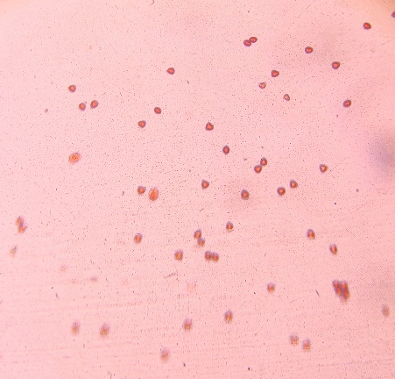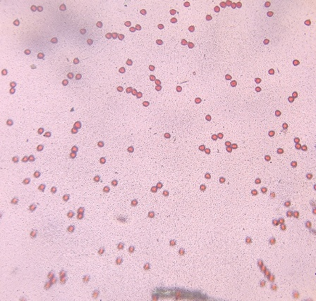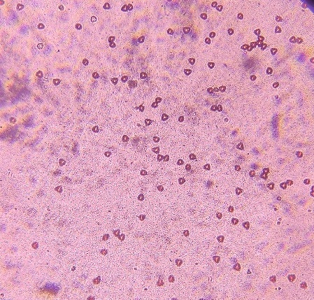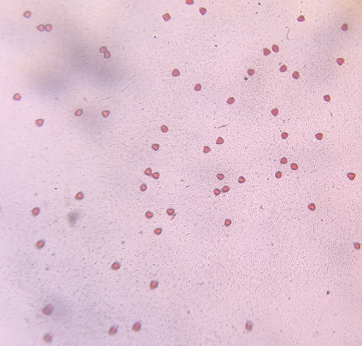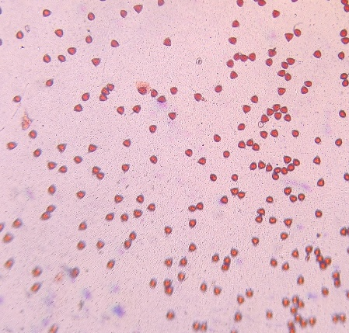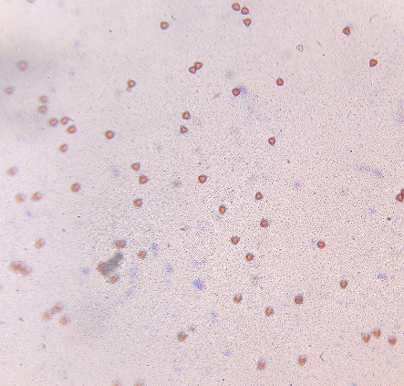
T₁ – Lucknow 49
T₂ – Arka Mridula
T₄ – Kohir Local
T₅ – Arka Kiran
T₃ – Dharwad Local
T₆ – Purple Guava
Fig. 2. Microscopic images of pollen viability test at 10x magnification in selected guava genotypes
3.6 Pollen Germination (%)
Pollen germination varied significantly among genotypes (Table 5 and Fig. 3), ranging from 81.20% in Kohir Local to 91.48% in Arka Kiran. Arka Mridula (87.38%) and Lucknow-49 (86.32%) followed closely, showing statistically similar performance. These results are in accordance with earlier studies reporting considerable variability in pollen germination among guava cultivars. Balasubrahmanyam (1959) demonstrated that pollen from Chittidar and Lucknow-49 germinated effectively in 6 per cent glucose solution, whereas Allahabad Round showed poor germination. Seth (1963) also reported interspecific variation, with germination ranging from 40.23% in P. cattleianum to 80.34% in the cultivated variety Arka Kiran. Sarkar et al. (2018) further confirmed that sucrose and boric acid concentrations play a vital role, recording maximum germination of 87.00 per cent in L-49. Higher germination in Arka Kiran and Arka Mridula indicates strong pollen vigor, efficient nutrient utilization, and enhanced pollen tube growth, while lower germination in Kohir Local reflects weaker enzymatic activity or limited carbohydrate metabolism during pollen development.
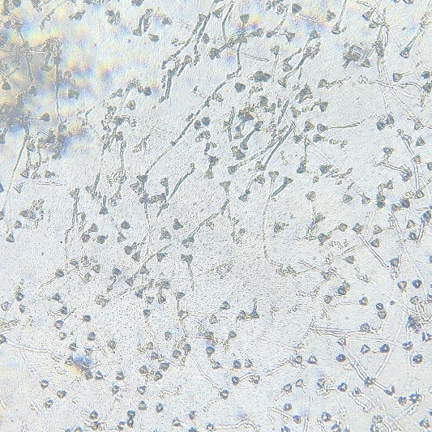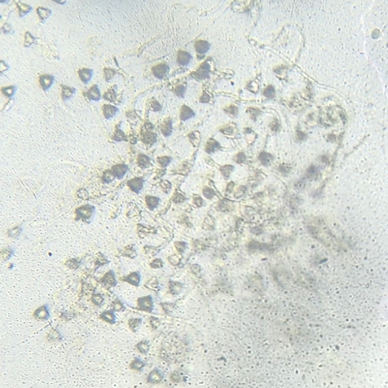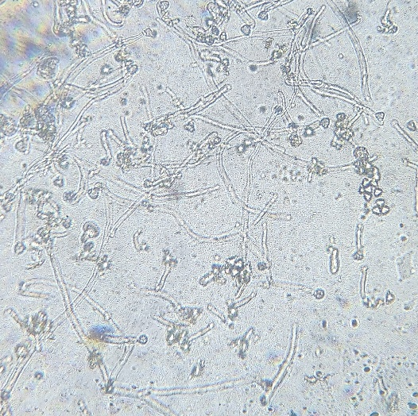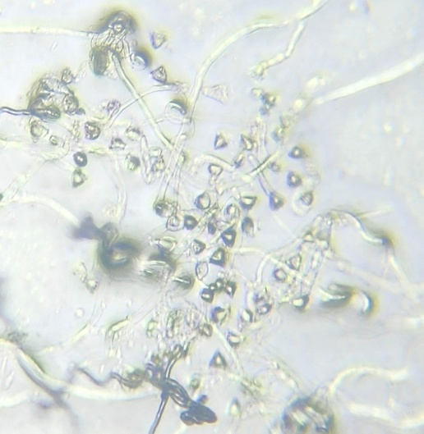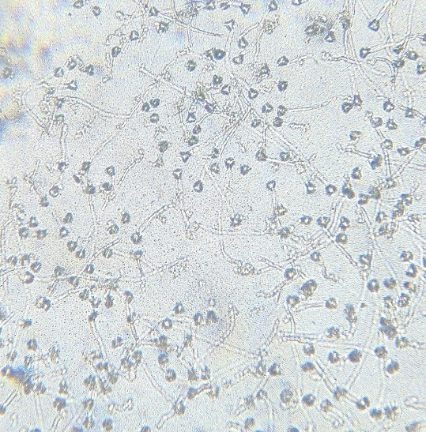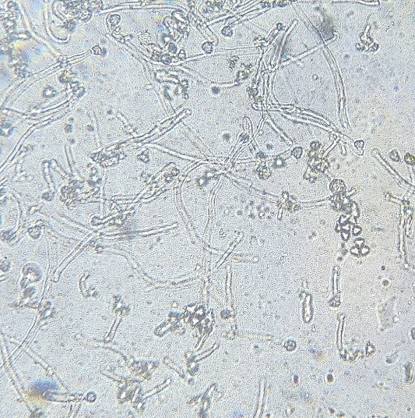3.7 Pollen size (µm)
T₁ – Lucknow 49
T₂ – Arka Mridula
T₄ – Kohir Local
T₅ – Arka Kiran
T₆ – Purple Guava
T₃ – Dharwad Local
Fig. 3. Microscopic images of in-vitro pollen germination test at 10x magnification in selected guava genotypes
Significant variation was observed in pollen size (Table 5 and Fig. 4). The largest pollen grains were recorded in Purple Guava (18.93 µm), followed by Arka Kiran (18.67 µm) and Lucknow-49 (18.60 µm), while the smallest was in Dharwad Local (15.77 µm). For equatorial diameter, Lucknow-49 showed the largest size (16.50 µm), and Arka Kiran the smallest (13.67 µm). These results are in agreement with Singh and Sehgal (1968), who reported pollen size variation ranging from 18.97 to 21.18 µm among cultivars, with larger grains in Lucknow-49 and Seedless. Nalawadi et al. (1973) also noted differences depending on mounting media, with average pollen diameters of 21.50 µm in dry condition, 26.50 µm in water, and 25.50 µm in acetocarmine. Srivastava (1974) recorded maximum pollen size in Red Fleshed (22.27 µm), while Kahlon et al. (1987) observed seasonal variation, with polar lengths of 21.20–22.20 µm and equatorial lengths of 23.10–26.60 µm in Allahabad Safeda and Sardar. Differences in pollen dimensions may result from genetic constitution, ploidy level, and environmental effects during microsporogenesis. Larger pollen in Purple Guava and Lucknow-49 indicates better tapetal nutrition, while smaller size in Dharwad Local may be due to compact structure and limited hydration during development.
Table 5. Pollen viability percentage, pollen germination percentage and pollen size (µm) of selected guava genotypes
Genotypes | Pollen viability (%) | Pollen germination (%) | Polar axis (µm) | Equatorial diameter (µm)
T₁ ₋ Lucknow 49 | 95.65^{b} (78.00) | 86.32^{b} (68.30) | 18.60ª | 16.50ª
T₂ - Arka Mridula | 97.98ª (81.89) | 87.38^{b} (69.20) | 17.63^{ab} | 14.67^{bc}
T₃ - Dharwad Local | 95.59^{b} (77.89) | 84.34^{c} (66.69) | 15.77^{c} | 13.87^{bc}
T₄ - Kohir Local | 92.89^{c} (74.54) | 81.20^{d} (64.30) | 16.53^{bc} | 14.20^{bc}
T₅ - Arka Kiran | 98.45ª (82.87) | 91.48ª (73.05) | 18.67ª | 13.67^{c}
T₆ ₋ Purple Guava | 93.73^{c} (75.51) | 85.82^{bc} (67.88) | 18.93ª | 15.40^{ab}
S. Em+ | 0.58 | 0.43 | 0.79 | 0.65
CD at 5 % | 1.82 | 1.36 | 1.76 | 1.45
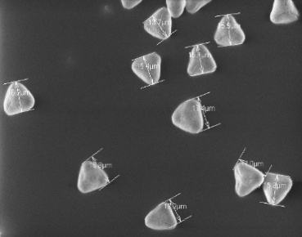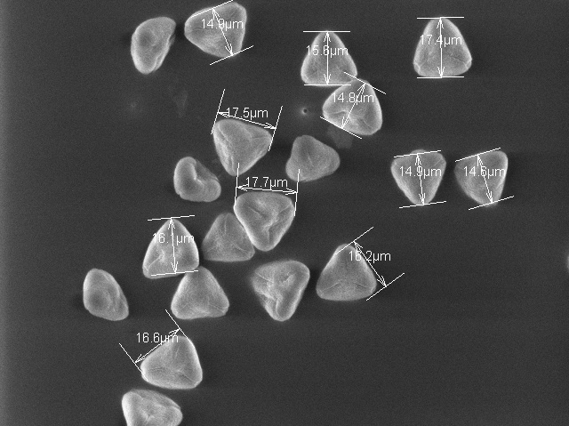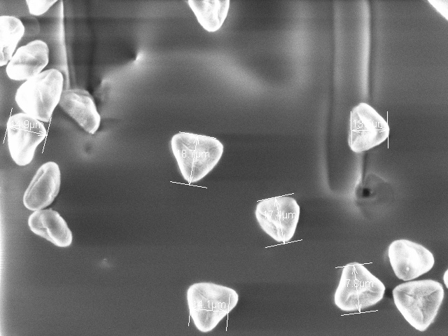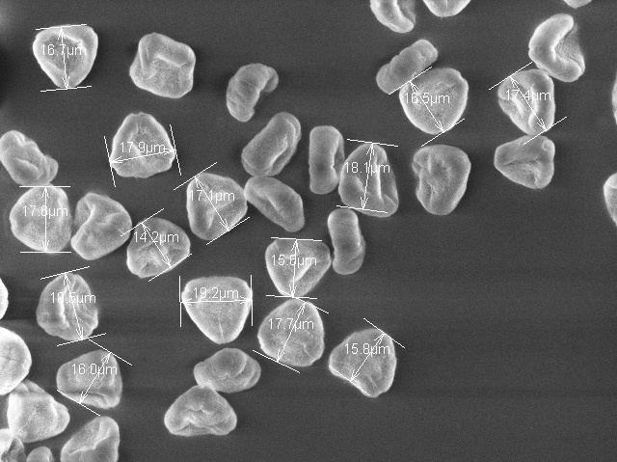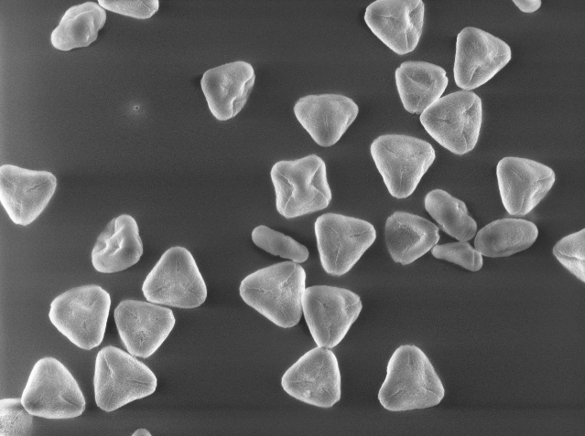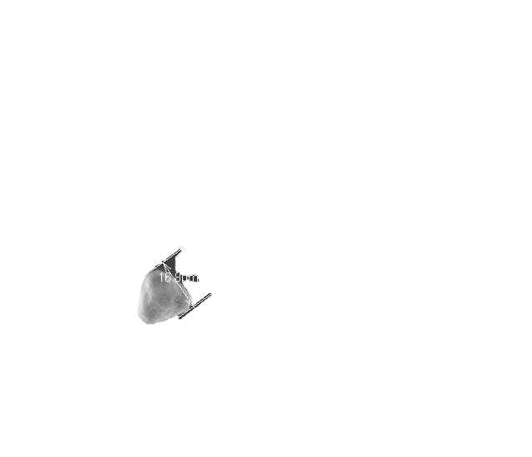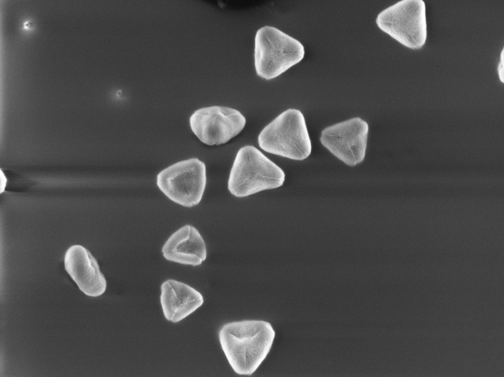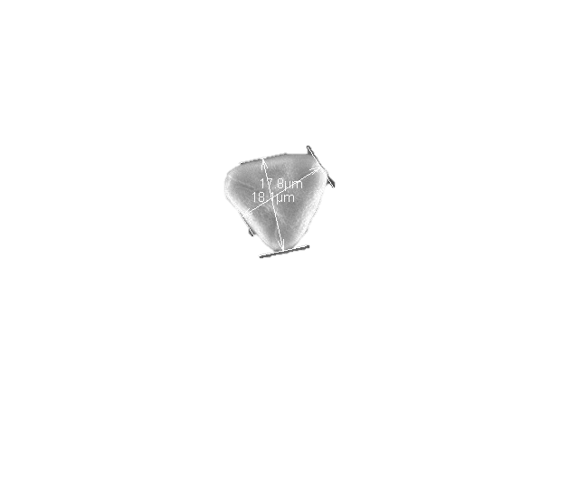*Values in parenthesis are arc sin transformation data
T₁ – Lucknow 49
T₂ – Arka Mridula
T₃ – Dharwad Local
T₄ – Kohir Local
T₅ – Arka Kiran
T₆ – Purple Guava
Fig. 4. SEM micrographs at 1000x magnification depicting pollen morphology and size in selected guava genotypes
4. CONCLUSION
Overall, the study revealed significant differences among guava genotypes in key floral parameters. The synchronization of anthesis and anther dehiscence in the early morning hours suggests favorable conditions for natural cross-pollination under Bengaluru’s climatic conditions. Among the genotypes, Arka Kiran and Arka Mridula showed superior floral and pollen characteristics, making them promising candidates for use as pollinizers or parents in hybridization programmes. Understanding these reproductive traits will aid in improving pollination efficiency, fruit set, and yield potential in guava under similar agro-climatic conditions.
DISCLAIMER (ARTIFICIAL INTELLIGENCE)
Author(s) hereby declares that NO generative AI technologies such as Large Language Models (ChatGPT, COPILOT, etc) and text-to-image generators have been used during writing or editing of this manuscript.

References
Keelery, S. (2023). India: production volume of guava 2023. https://www.statista.com/statistics/1043925/india-production-volume-of-guava/
Archana, A. & Siddique, S. (2004). Biochemical changes in guava fruits under various modified conditions. Journal of Horticultural Sciences. 33, 209-212.
Aulakh, P. S. (2004). Effect of seasonal variation on yield and fruit quality of some promising guava cultivars under Arid irrigated region of Punjab. Haryana Journal of Horticultural Sciences. 33, 170-171.
Balasubrahmanyam, V. R. (1959). Studies on the blossom biology of guava (Psidium guajava L.). Indian Journal of Horticulture. 16, 69-75.
Braganza, M. A. (1990). Floral Biology studies and varietal evaluation in genus Psidium. M. Sc. (Agri.) Thesis. University of Agricultural Sciences, Bangalore (India).
Chatterjee, D., Singh, U. P., Thakur, S. & Kumar, R. (1992). A note on the bearing habit of guava (Psidium guajava L.). Haryana Journal of Horticultural Sciences. 21(1-2), 69-71.
Coser, S. M., Fontes, M. M. P., & Ferreira, M. F. S. (2012). Assessment of pollen viability in guava genotypes. Acta Horticulturae, 959, 141-144. https://doi.org/10.17660/ActaHortic.2012.959.17
Dasarathy, T. B. (1951). The guava (Psidium guajava). Madras Agricultural Journal, 38, 521-527. https://www.madrasagriculturaljournal.in/index.php/maj/article/view/1000
Joseph, S., Chatli, M. K., Biswas, A. K., & Sahoo, J. (2014). Efficacy of pink guava pulp as an antioxidant in raw pork emulsion. Journal of Food Science and Technology, 51(8), 1492-1500. https://doi.org/10.1007/s13197-012-0668-1
Kahlon, P. S., Sharma, P. K. & Rambadi, J. L. (1987). Studies on floral biology of guava (Psidium guajava L.) cultivar Allahabad Safeda and Lucknow-49. Haryana Journal of Horticultural Sciences. 16(1-2), 65-73.
Kwee, L. T. & Chong K. K. (1990). Guava in Malaysia – Production. Pests and Diseases: Botany and Cultivars. Tropical Press, Kuala Lumpur, Malaysia. 21-51.
Morton, J. F. (1987). Guava (Psidium guajava L.). In *Fruits of warm climates* (pp. 356-363). Miami, Florida, USA. http://www.hort.purdue.edu/newcrop/morton/guava.html
Nakasone, H. Y., & Paull, R. E. (1998). Guava. In Tropical Fruits (pp. 247–259). CAB International. https://www.cabidigitallibrary.org/doi/book/10.1079/9780851992549.0000
Nalawadi, U. G., Farooqi, A. A., Narayana Reddy, M. A., Gubbaiah G. & Nalini A. S. (1973). Studies on the floral biology of guava (Psidium guajava L.) variety Lucknow-49 (Sardar). Mysore Journal of Agricultural Sciences. 7, 24-37.
Ojha, A. P., Tewari, J. P. & Mishra, K. K. (1986). Studies on floral biology of guava cultivars under tarai conditions of Uttar Pradesh. Progressive Horticulture. 18, 308-311.
Sandhu, M. S., Kaur, R., & Bal, J. S. (2024). Studies on floral bud development and flowering behaviour of guava (Psidium guajava L.). International Journal of Pharmacy and Pharmaceutical Science, 6(1), 38-43. https://doi.org/10.33545/26647222.2024.v6.i1a.83
Sangphet, P., Boonprakob, U. & Thaipong, K. (2007). Evaluation on viability and germination of seedless and less seed guava pollen. Agricultural Science Journal, 38(5), 389-395.
Sarkar, T., Sarkar, S. K., & Vangaru, S. (2018). Effect of Sucrose and Boric Acid on in-vitro Pollen Germination of Guava (Psidium guajava) Varieties. Advances in Research, 15(1), 1-9. https://doi.org/10.9734/AIR/2018/41145
Sehgal, O. P. & Singh, R. (1967). Studies on blossom biology of guava (Psidium guajava L.) I. Flowering season, flowering habit, floral bud development, anthesis and dehiscence. Indian Journal of Horticulture. 24, 118-26.
Seth, J. N., 1963, Morphological and cross incompatibility studies in some species of Psidium. Agra University Journal of Research. 12, 193-197.
Sharma, S., Sehrawat, S. K., & Sharma, K. D. (2017). Studies on Time and Duration of Flowering, Floral Bud Development and Morphology of Guava (Psidium guajava L.) under Semi-Arid Region of India. International Journal of Current Microbiology and Applied Sciences. https://doi.org/10.20546/ijcmas.2017.612.480
Singh, G. (2005). Strategies for improved production in guava. In Proc. 1st International Guava Symposium, December 2005, CISH, Lucknow, India. 26, 39.
Singh, R. & Sehgal, O. P. (1968). Studies on the blossom-biology of Psidium guajava L. (Guava) II. pollen studies, stigmatal receptivity, pollination and fruit-set. Indian Journal of Horticulture, 25(1-2), 52-59.
Srivastava, O. P. (1974). Studies on flowering habit, blooming period, anthesis, dehiscence and pollen grain of Psidium guajava L. varieties Apple Colour, Chittidar and Red Fleshed. Progressive Horticulture. 6(1), 71-77.
Teaotia, S. S., Phogat K. P. S. & Srivastava V. S. (1970). Blossom biology studies in Psidium sp. Progressive Horticulture. 2(3), 101-112.

