EFFICACY OF Trichoderma harzianum IN REDUCTION OF Aspergillus flavus INFECTION AND AFLATOXIN CONTAMINATION IN GROUNDNUT SEEDS

Abstract:
Aflatoxin produced by the Aspergillus spp. is an important contamination in plant products that is harmful for health of humans as well as the other animals. Aspergillus flavus infect the groundnut seeds in the field due to poor management and abiotic stress like pod damage and drought. Hence, it is important to manage it in field condition by employing the different methodologies. One among is seed treatment and field application of the bioagents that help in reducing the Aspergillus flavus colonization in seeds as well as reducing the soil borne inoculum. The Trichoderma harzianum is one of the potent biocontrol agents used against the Aspergillus flavus as it reduces the infection in this experiment, it not only reduced the colonization of Aspergillus flavus in seeds but also contributed to the good yield helping healthy plant growth and by parasitic nature on the pathogen. The aflatoxin content was also significantly reduced in treatment with biocontrol agents when compared to control and treatments which did not involve biocontrol agents. The seed quality parameters in seeds examined after harvest was superior in seeds treated with T. harzianum. The quantification of this aflatoxin food or feed is an important aspect in knowing the impact of the seed infection it is one of the considerable factors in trade, hence the efficacy of some chemicals and T. harzianum was also revealed in this investigation by indirect competitive ELISA.
Key words: Aspergillus flavus, aflatoxin, groundnut, ELISA, Trichoderma harzianum

Introduction
Arachis hypogaea, a groundnut commonly known as peanut, is an annual herbaceous legume belonging to the family Fabaceae. The origin of groundnut was drawn from evidence by carbon dating of the remnant pericarp from archeological sites in Peru places its agricultural activity between 3700 and 3900 years old (Kochert et al. 1996). that it was cultivated in the Central and South American region earlier but now its cultivation has spread to temperate and tropical regions around the globe. It is one of the high-demand holding oilseed crops with multiple health benefits (Arya et al. 2016). The largest producer of peanuts is China with an overall production of 16.5 million tons, followed by India (6.6 million tons). The main exporters of peanuts include India (exports 541,337 tons) and the United States (exports 250,000 tons) (Annon., 2016). According to preliminary research, peanuts are mostly made up of dietary fiber, minerals, vitamins, lipids, proteins, and carbohydrates (Akhtar et al. 2014) along with small amount of moisture. However, the consumption and nutritional value of oilseeds are limited by antinutritional factors like phytates, condensed tannins, trypsin, and α-amylase inhibitors (Tanwar et al. 2019).
Aspergillus flavus, Aspergillus niger, Macrophomina phaseolina, Rhizoctonia solani, Fusarium oxysporum, and F. solani are among the several species of seed-borne fungi known to be present in groundnut seeds. The majority of these fungi were found in the seed coat, which was heavily infected, followed by the cotyledon and axis s (Rasheed et al., 2004). Species of Aspergillus, Penicillium, Fusarium, Rhizopus and Alternaria are commonly occurring post-harvest moulds in storage conditions (Chavan, 2011). In groundnut post-harvest degradation is primarily caused by the growth of mold, particularly by Aspergillus section Flavi group of fungus. Aspergillus flavus, Aspergillus parasiticus and other members of this genus create aflatoxins, which are secondary metabolites that have immunosuppressive, teratogenic, estrogenic, and carcinogenic properties (Klich et al., 2009). A. flavus is mostly to blame for the decline in groundnut seed quality, rendering the commodity unfit for sale or ingestion. A. flavus is the pathogen responsible for aflaroot infections and seed and seedling degradation in groundnuts. Contamination of groundnut kernels with aflatoxin poses a serious risk to human health, the health of livestock, and global trade. The weather conditions during the grain filling period mainly affect the Afla toxin contamination, Aspergillus contamination is more likely to occur less in adequate rainfall and irrigation but under deficient conditions the infection is most likely high leading to high toxin accumulation in pods (Pitt et al., 2013).
The groundnut pods develop below soil which is the main source of inoculum leading the infection. The primary inoculum of A. flavus and A. parasiticus is stored in the soil. Peanut pods are in direct touch with soil populations of aflatoxigenic fungus (Horn & Pitt, 1997). Toxigenic strains can be divided into S and L types based on their phenotyping. While L strains produce huge sclerotia but fewer aflatoxins, S strains produce high quantities of aflatoxins and numerous sclerotia (average diameter < 400 µm) (Cotty, 1989). Based on their relative mobility on silica gel and fluorescence emission, aflatoxins are classified under AFB1, AFB2, AFG1 and AFG2, which correspond to the difuranocoumarins family of chemicals. AFB1, which is generated by both A. flavus and A. parasiticus, is the most poisonous of them. The sole producer of AFG1 and AFG2 is A. parasiticus. Whereas A. parasiticus infections are more common in the Americas, A. flavus infections are more common in Asia and Africa (Upadhyaya et al., 2000).
These two fungi survive in soil as conidia or sclerotia and also as mycelium within the plant tissue. This sclerotia survives in soil in hard environment conditions and germinates to produce conidia or ascospores (Horn et al., 2019). Contamination of groundnuts by these fungi occurs at both pre-and post-harvest stages, leading to aflatoxin contamination. Since high aflatoxin levels are known to have serious negative effects on health, both the international community and many individual nations have imposed stringent restrictions on permissible aflatoxin levels, which are typically 10–20 parts per billion (ppb). In actuality, these limitations are frequently significantly surpassed, with detrimental impacts on health. High aflatoxin levels in humans weaken the immune system, which can lead to a variety of health issues, including cancer, HIV susceptibility, and stunted growth in young people (Villers, 2017). It has been designated by the International Agency for Research on Cancer as a Class 1 human carcinogen (Annon., 2002). In plant system, afla toxin affects amylase activity in germinating seeds causing inhibition of starch hydrolysis and consequent unavailability of sucrose to the embryonic axis during imbibition. The embryos of aflatoxin-contaminated seeds remain alive with fairly high dehydrogenase activity and are capable of growth in culture when supplemented with sucrose (Chatterjee, 1988).
The greatest ways to lessen aflatoxin contamination are preventive measures including host-plant resistance and cultural practices. Several chemicals and plant products have been found useful in inhibiting A. flavus invasion and aflatoxin contamination during the crop stage hence studies on the management and quantification of aflatoxin using different treatments was carried out.
Materials and methods
A field experiment was conducted during the summer 2021 - 2022 at AICRP- Groundnut, MARS, Dharwad to evaluate the efficacy of integrated management for Aspergillus flavus infection using variety Dh-256, all the treatments were replicated in to three and laid in Randomized complete Block Design (RCBD) with a spacing of 30 X 10 centimeter. Treatments included chemicals, bioagents, soil amendments and their combinations as listed in Table 1.
Table 1. The details of the treatments of field experiment are furnished here under
Sl. No. | Treatment
1 | Seed treatment with carbendazim 50% WP (@ 2 g/kg seeds)
2 | Seed treatment with carboxin + thiram 75 WP (@ 3g/kg seeds)
3 | Seed treatment with Trichoderma harzianum (IOF) (@ 10g/kg seeds)
4 | FYM (@ 2.5t/ha) + seed treatment with carbendazim (@ 2 g/kg seeds)
5 | FYM (@ 2.5t/ha) + seed treatment with carboxin + thiram 75 WP (@ 3g/kg seeds)
6 | FYM (@ 2.5t/ha) + seed treatment with Trichoderma harzianum (IOF) (@ 10g/kg seeds)
7 | Vermicompost (@ 1.0t/ha) + seed treatment with carbendiazim (@ 2 g/kg seeds)
8 | Vermicompost (@ 1.0t/ha) + seed treatment with carboxin + thiram 75 WP (@ 2g/kg seeds)
9 | Vermicompost (@ 1.0t/ha) + seed treatment with Trichoderma harzianum (IOF) (@ 10g/kg seeds)
10 | Control

The Aspergillus flavus isolated from northern parts of Karnataka. Groundnut kernels were surface sterilized with sodium hypochlorite (1%) for one minute and subsequently washed with distilled water for two times. The culture of pathogen obtained by placing the four surface sterilized groundnut kernels (2 kernels were split into halves) equidistantly on potato dextrose agar (PDA) medium in each petri dish under complete aseptic conditions. Plates were incubated at 25±2˚C in a BOD incubator for obtaining fungal growth for 5 to 7 days.
Conidia of the typical A. flavus colonies in seed infection assays were picked up using a sterile needle and placed in petri dishes containing PDA. The inoculated plates were kept in the incubator at 28º C. The pathogen was identified as A. flavus based on its mycelial and conidial characters (Barnett and Hunter, 1972) and further sent to the molecular confirmation. Molecular analysis was carried out to identify the fungus. The fungal culture was sent to National Collection of Industrial Microorganisms (NCIM), CSIR- National Chemical Laboratory (NCL) Pune, India. PCR amplification was conducted by using fungal 16S rRNA gene. Purified amplicons were sequenced by Sanger method and were further analyzed using Basic Local Alignment Search Toyol (BLAST) with closest culture sequence retrieved from the National Center for Biotechnology Information (NCBI) database that finds regions of local similarity between sequences. The one which has the highest similarity was taken as information to be interpreted. Decoding was done to identify fungi to highlight the results
Aspergillus flavus isolate was mass multiplied on organic matrix as recommended by Will et al. (1994) and artificially inoculated to soil at 40 DAS and 60 DAS. The observations were taken on germination, plant height and yield. Then the per cent seed infection by Aspergillus flavus along with other seed quality parameters were assessed by blotter paper method then the aflatoxin in harvested seeds under different treatment was quantified by indirect competitive ELISA. The harvested seeds were also examined for seed quality parameters by paper towel method as prescribed by ISTA and seedling vigor index was calculated by the following formula, given by Abdul Baki and Anderson (1973).
ELISA
Initially the seed extract from the dried groundnut seed was taken by grinding 100 grams of seeds and 20 grams of that was wet grinded with 70 per cent methanol. The mixture was incubated in shaker for 30 minutes at more than 200 rpm. After the incubation time the seed extract was filtered through Whattman 41 filter paper and stored in glass vials. This extract was used further for carrying out indirect competitive ELISA as recommended by Reddy et al., (2001).
Coating was done by loading ELISA plate (all 60 wells) with 150µl/well of AfB1-BSA conjugate and incubating it overnight at 37°C for 1 hour then the plate was washed twice with PBS-T. dilution of healthy groundnut extract (HGN) with 0.2 per cent BSA (10 times) and prepare pure toxin (AfB1) with the above prepared HGN extract was done. Then the 100µl of diluted pure toxin was loaded to first two columns and first two rows. The 100µl of diluted HGN extract to remaining wells of first two rows. The solution was mixed from 3rd well to 20th well (serial dilution) to reduce pure toxin concentration from 50 mg to 0.1 m.
The 90µl of 0.2 per cent BSA to the remaining wells followed by the addition of 10 µl of seed sample extract to wells from 21-60 (in replicates). The 50 µl of antiserum was added to all wells and incubate at 37°C for 1 hour and washed thrice with PBS-T. The washed plates was incubated at with at 37°C for 1 hour after addition of 150 µl goat antirabbit IgG (1:2000 dilution in 0.2% BSA) per well and again washed thrice with PBS-T. the 150 µl of substrate buffer per well (5 mg PNPP per 10ml of 10 per cent diethanolamine) was loaded to all wells simultaneously with substrate alone (10% diethanolamine) to A1 well as blank and incubated at room temperature under dark condition for 1 hour followed by measuring the absorbance at 405 nm in ELISA reader.
Results
Morphological characterization: The seed samples collected from different groundnut growing areas from northern parts of Karnataka were used for isolation of A. flavus. The A. flavus produced whitish mycelial growth on PDA medium with orange color on backside of the petri dish indicating toxin production and was further sub cultured. The colonies of the pathogen on PDA were whitish initially for 2-3 days and turned to yellowish to green as they attained maturity. Confirmation of the fungus was confirmed based on the morphological and cultural characters of the fungus such as conidia, conidiophore and colour of the colony by referring to “A Manual of the Aspergilli” (Thom and Raper, 1945) (Fig 1).
Molecular characterization: Chromosomal DNA was isolated using a spin column kit (such as HiMedia, India or equivalent). The quality of the extracted genomic DNA was checked through gel electrophoresis (as shown in Fig 1a). Amplification of the fungal ITS rRNA gene (~600 bp) was carried out by PCR in a thermal cycler, and the resulting amplicons were purified with Exonuclease I and Shrimp Alkaline Phosphatase (Exo-SAP) (Fig 1b). Sequencing was performed using the Sanger method on an ABI 3500xl genetic analyzer (Life Technologies, USA). The sequence files were processed and edited using CHROMASLITE software (version 1.5), and the sequences were subsequently analyzed with the Basic Local Alignment Search Tool (BLAST). This tool, available from the National Center for Biotechnology Information (NCBI), finds local sequence alignments, compares the isolate's DNA sequence with database entries, and calculates the statistical significance of sequence matches. The analysis with BLAST provided insights into functional and evolutionary relationships by comparing the isolate’s sequence with those in the NCBI database. Based on the obtained sequence comparison was made by constructing the phylogenetic tree using MEGA 11 software. The phylogenetic tree places the "Dharwad Isolate" within a clade primarily composed of Aspergillus flavus strains. This suggests that the Dharwad isolate is likely a strain of Aspergillus flavus. The branch support values are high (mostly 98–97%), providing strong confidence in the tree's branching pattern. The tree also includes other species like Aspergillus sydowii and Aspergillus austwickii, which form distinct clades, showing that they are more distantly related to the Aspergillus flavus cluster. (fig 2)
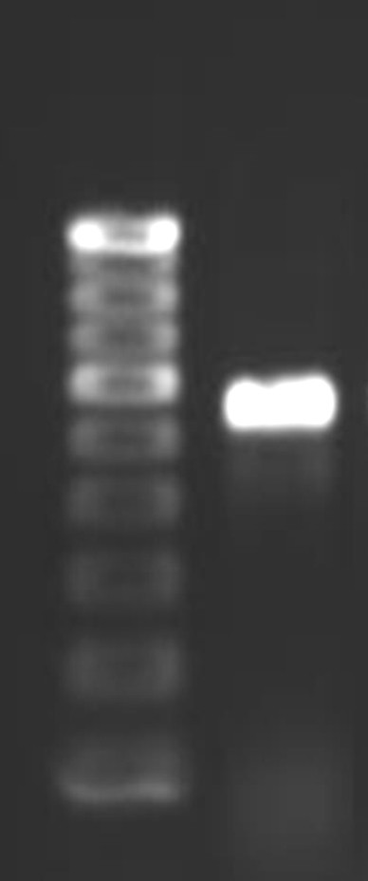
L
1
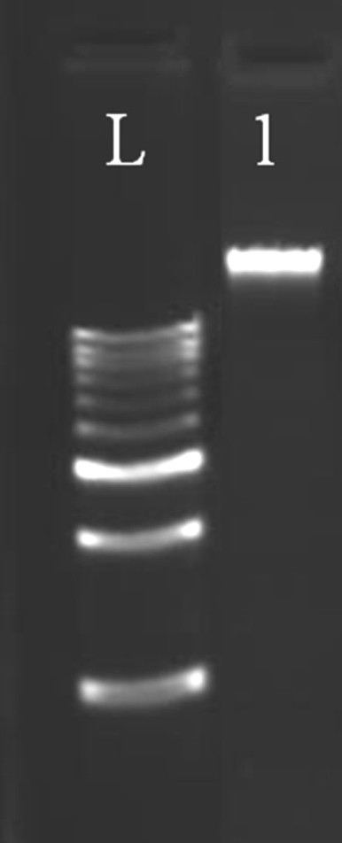
Fig 1: Gel electrophoresis picture indicating the isolated DNA quality and amplified ITS region
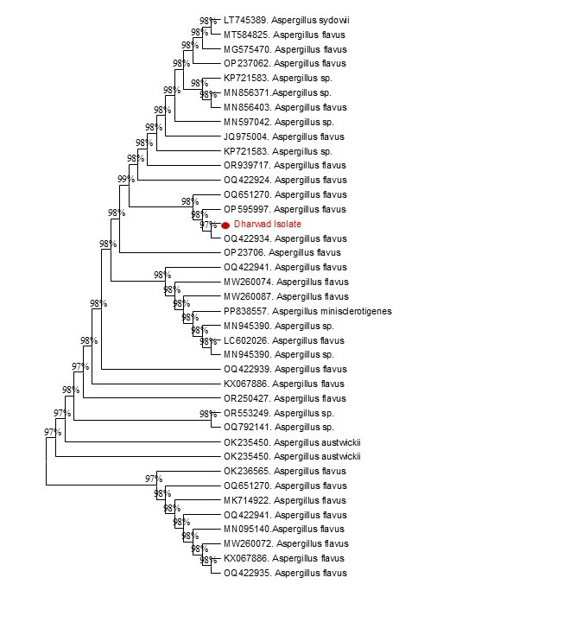
Fig 2: Phylogenetic tree depicting taxonomic position of Aspergillus flavus Dharwad isolate
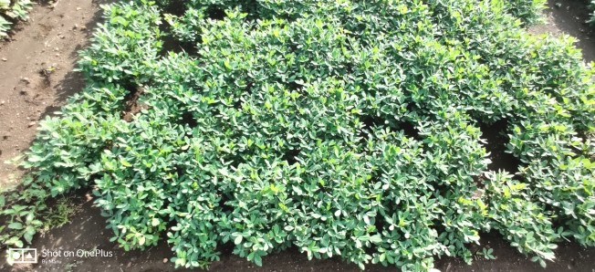
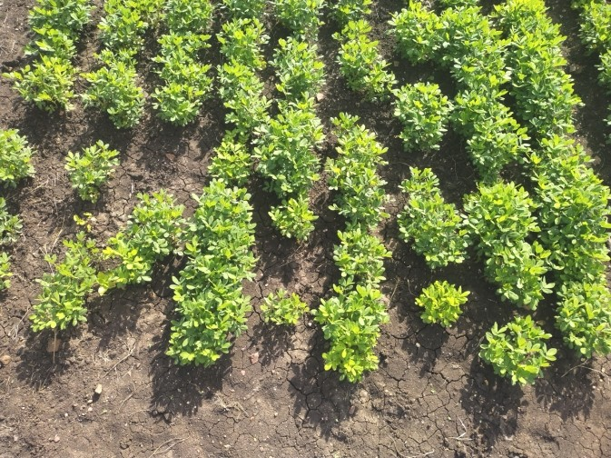
Plant growth and yield factors: Under field condition the plants inoculated with the A. flavus falling under the treatments application of vermicompost @ 1t/ha + seed treatment with T. harzianum having higher plant hight at both 60 and 90 DAS of 34.07 and 34.07 cm respectively. vermicompost @ 1t/ha + seed treatment with T. harzianum recorded highest plant height at of 34.07 and 34.07 cm at 60 and 90 DAS respectively (Table 2) along with the higher yield of 31.02 quintal per hectare (fig 3).
- Control b. FYM 2.5 t/ha + T. harzianum 10 g/kg seed
Fig 3: Field view of integrated management of Aspergillus flavus infection
Determination of aflatoxin: The groundnut seeds harvested from field experiment under all the treatments were tested for aflatoxin B1 levels by direct competitive enzyme-linked immunosorbent assay (ELISA) and absorbance values were determined at 430 nm. No detectible aflatoxin content was recorded in seed treatment with Trichoderma harzianum (IOF) and FYM + seed treatment with Carbendazim 50% WP and in seed treatment with T. harzianum alone. The aflatoxin content was highest in treatment which involved no bioagent in the practice.
In-vitro experiment: The harvested seeds were examined by paper towel method for the seed quality parameters. The seed germination and seed vigour were higher in seed treatment with vermicompost @ 1t/ha + seed treatment with T. harzianum. The vigour was 79.19 per cent increase over control with germination of 96.33 per cent. The infection of A. flavus on harvested seeds was 69.39 and 56.00 per cent decreased over control in seed treatment with vermicompost @ 1t/ha + seed treatment and seed treatment with T. harzianum alone respectively.

Table 2: Integrated management of Aspergillus flavus infection in groundnut under field condition
Treatments | Treatment detail | Plant height 60 DAS  (cm) | Plant height 90 DAS  (cm) | Pod yield  (q/ha) | Aflatoxin  Content (ppb)
T₁ | Seed treatment with carbendazim 50% WP @ 2 g/kg of seeds | 18.37 | 30.2 | 20.83 | 0.80
T₂ | Seed treatment with carboxin 37.5 % + thiram 37.5% WP @ 3g/kg of seeds | 19.03 | 31.53 | 21.76 | 2.50
T₃ | Seed treatment with Trichoderma harzianum (IOF) @ 10g/kg of seeds | 20.40 | 32.83 | 22.69 | 0.00
T₄ | FYM @ 2.5t/ha + seed treatment with carbendazim 50% WP @ 2 g/kg of seeds | 21.47 | 31.67 | 24.54 | 0.00
T₅ | FYM @ 2.5t/ha + seed treatment with carboxin 37.5 % + thiram 37.5% WP @ 3g/kg of seeds | 19.77 | 31.53 | 25.93 | 23.10
T₆ | FYM @ 2.5t/ha + seed treatment with Trichoderma harzianum (IOF) @ 10g/kg of seeds | 21.00 | 33.90 | 26.85 | 12.90
T₇ | Vermicompost @ 1.0t/ha + seed treatment with carbendazim 50% WP @ 2 g/kg of seeds | 20.50 | 31.37 | 27.78 | 9.60
T₈ | Vermicompost @ 1.0t/ha+ seed treatment with carboxin 37.5 % + thiram 37.5% WP @ 3g/kg of seeds | 21.83 | 31.73 | 29.17 | 7.70
T₉ | Vermicompost (@ 1.0t/ha) + seed treatment with Trichoderma harzianum (IOF) @ 10g/kg of seeds | 23.83 | 34.07 | 31.02 | 11.80
T₁₀ | Control | 17.47 | 22.70 | 18.52 | 10.50
 | C.D. @ 1% | 2.89 | 3.30 | 2.78 | 0.82
 | S. Em.± | 0.98 | 1.10 | 0.93 | 0.27
 | C.V. (%) | 8.18 | 6.02 | 6.46 | 3.70

Table 3: Post- harvest in-vitro experimental results on seed quality parameters

Treatment Number | Seed  germination (%) | Seed vigour | Per cent vigour increase over control | Aspergillus flavus infection (%) | Per cent decrease in infection over control
1 | 89.33*  (70.96) | 1045.13 | 20.51 | 11.33* (19.67) | 9.36
2 | 90.67  (72.25) | 1153.45 | 33.00 | 8.33 (16.78) | 33.36
3 | 93  (74.68) | 1266.43 | 46.03 | 5.50 (13.56) | 56
4 | 90.33  (71.92) | 1173.87 | 35.35 | 9.67 (18.11) | 22.64
5 | 92.33  (73.93) | 1209.43 | 39.45 | 6.83 (15.15) | 45.36
6 | 94.33  (76.31) | 1286.07 | 48.29 | 4.83 (12.70) | 61.36
7 | 93.00  (74.68) | 1292.5 | 49.03 | 7.67 (16.07) | 38.64
8 | 94.33  (76.24) | 1329.9 | 53.34 | 6.67 (14.96) | 46.64
9 | 96.33  (78.98) | 1545.33 | 78.19 | 3.83 (11.29) | 69.36
10 | 83.66667  (66.16) | 867.2333 | - | 12.5 (20.70)
C.D. @ 1% | 1.95 | 94.50 |  | 1.353
S. Em.± | 0.93 | 44.98 |  | 0.644
C.V. (%) | 1.55 | 4.53 |  | 4.966

Discussion
One of the most important steps in disease management is to figure out what is the cause. For a better assessment of contamination, it is crucial that the fungi be identified with reliability and accuracy. The widely used technique for isolating and characterizing fungi is morphological characterisation. The fungus was grown and established for observation by the use of culture media. The A. flavus culture on PDA medial showed the cultural characters such as whitish colony at initial days, the mycelium grown radially to cover the entire surface of the media and gradually when organism started to sporulate greenish- yellow conidia were observed, the replaced the white colour of colony with greenish- yellow colour which partly confirms it as A. flavus as described by Thathana et al. (2017). A. flavus microscopic characteristics revealed that the colonies were biseriate, with philiades spreading forth from metulae on globose or sub globose vesicles of varying sizes (Okayo et al., 2020).
Morphological characters alone are not always sufficient for identifying the fungi due to overlapping in morphological characters. Furthermore, Aspergillus sp. has a complicated taxonomy with identical morphological and biochemical traits, making it difficult to identify it morphologically due to intraspecific similarities (Rodrigues et al. 2007). In order to overcome the inadequacy, DNA sequence analysis has been used to characterize the fungi. Consequently, it appears that molecular characterisation, based on PCR, is a reliable method for identifying fungal isolates. Hence the ITS region sequencing was done which is one of the gold standards today confirmed the infectious agent as A. flavus. The full-length fragment size of the isolate determined by PCR using the ITS 1 (5'–CTCCCACCCGTGTTTACT-3') and ITS 4 (5'– TTCCGTAGGGTGAACCTGC-3’) as universal primers for fungi., it was 600 bp, which is consistent with the findings of Krulj et al. (2014). The Dharwad isolate's close relationship with Aspergillus flavus suggests it shares significant genetic similarity with this species, possibly indicating similar ecological roles, pathogenicity, or metabolic capabilities. High branch support values confirm that the phylogenetic clustering is reliable, reinforcing that the Dharwad isolate is accurately grouped. This data can be useful for further studies on the isolate’s behavior, potential for mycotoxin production, and its relevance in agriculture or medical contexts, especially if A. flavus is of concern in the region.
The field experiment was conducted during the summer 2021-22 because aflatoxin producing Aspergillus species typically infect plants in the field, causing aflatoxins to contaminate crops during harvest and subsequent accumulation of aflatoxins during storage if humidity and temperature are not appropriately regulated. The pathogen invasion and toxin accumulation are more severe in climates that stress plants, like extreme heat and drought (Cotty and Jaime-Garcia, 2007).
Organic amendment vermicompost was used along with the T. harzianum to enhance the establishment of the microbes in field condition (Kalavathi et al., 2020) and treating the plants with the bioagents will help in rising the healthier plant that resulting in more yield (Mohamed, 2015). These facts have resulted in the highest plant height and yield in fields experiment. Vermicompost @ 1t/ha + seed treatment with T. harzianum recorded highest plant height at of 34.07 cm at 90 DAS (Table 2) along with the high yield of 31.02 quintal per hectare. The abilities of the Trichoderma species to grow fast and colonies a greater portion of the rhizosphere, is also indicative of their competitive abilities for space and nutrients. It suggested competition for space and nutrients as part of the mode of inhibiting the colonization of A. flavus (Sobowale et al., 2010). Mohammed et al. (2018) affirmed that seed treatment with T. harzianum had significant impact in restricting A. flavus infection and subsequent aflatoxin contaminations in groundnut. All these cumulative antagonistic natures of biocontrol agent resulted in lowest seed infection of 3.83 per cent by A. flavus when tested after harvest.
One of the Ascomycetes fungi that inhabit in the soil is Trichoderma. It is green filamentous fungus that has a potential role as biocontrol agent against the phytopathogens. Trichoderma spp. have the ability to biocontrol plant diseases because of their intricate interactions with them, which can involve parasitization, the secretion of antibiotics, or competition for nutrients and space. Trichoderma spp. induce hydrolytic enzyme production during mycoparasitic interactions, including glucanase, chitinase, and protease. These microbes also activate signaling pathways, the most significant of which are MAP kinase, cAMP pathway, and heterotrimeric G protein. The production of infection structures and the secretion of antifungal metabolites are primarily mediated by G protein and MAPK (Mukhopadhyay and Kumar, 2020). Trichoderma spp. have known to inhibit the growth of soil borne fungal pathogens by its mycoparasitism action. T. harzianum showed the ability to parasitize A. flavus by coiling around A. flavus hyphae then by penetrating and degrading the mycelium of A. flavus (Kifle et al., 2017). All these mentioned moods have resulted in low or undetectable aflatoxin contamination in seeds under treatment seed treatment with Trichoderma harzianum (IOF) @ 10g/kg of seeds and FYM @ 2.5t/ha + seed treatment with carbendazim 50% WP @ 2 g/kg of seeds.
The seed quality parameters like germination, vigor and free from the harmful pathogen is also an important factor to meet the seed certification requirements. Compromise in any of theses will result in the undesirable traits like reduction in plant stand and uniformity in crop. The seed infection by A. flavus will act as the source of inoculum for new field so the seed infection by A. flavus in harvested was accessed by paper towel method reaveled that the seed infection was least in treatment where vermicompost (@ 1.0t/ha) was applied along with seed treatment with Trichoderma harzianum (IOF) @ 10g/kg of seeds as the Trichoderma harzianum acted in antagonistic manner and reduced the A. flavus infection.
Conflict of Interest Statement:
The authors declare that there are no conflicts of interest regarding the publication of this article

Ethics approval
This research does not involve any human participants or animal-related and hence is not applicable.
Data availability
The datasets generated during and/or analysed during the current study are available from the corresponding author on reasonable request.

References:
Abdul-Baki, A. A., & Anderson, J. D. (1973). Vigor determination in soybean seed by multiple criteria. *Crop Science*, *13*, 630–633. https://doi.org/10.2135/cropsci1973.0011183X001300060013X
Akhtar, S., Khalid, N., Ahmed, I., Shahzad, A., & Suleria, H. A. R. (2014). Physicochemical characteristics, functional properties, and nutritional benefits of peanut oil: A review. Critical Reviews in Food Science and Nutrition, 54(12), 1562–1575. https://doi.org/10.1080/10408398.2011.644353
IARC Working Group on the Evaluation of Carcinogenic Risks to Humans. (2002). Some traditional herbal medicines, some mycotoxins, naphthalene and styrene. IARC Monographs on the Evaluation of Carcinogenic Risks to Humans, Vol. 82. https://publications.iarc.fr/Book-And-Report-Series/Iarc-Monographs-On-The-Evaluation-Of-Carcinogenic-Risks-To-Humans/Some-Traditional-Herbal-Medicines-Some-Mycotoxins-Naphthalene-And-Styrene-2002
Food and Agriculture Organization of the United Nations. (2016). FAOSTAT. http://www.fao.org/faostat/en/#data
Arya, S. S., Salve, A. R., & Chauhan, S. (2016). Peanuts as functional food: a review. Journal of Food Science and Technology, 53(1), 31–41. https://doi.org/10.1007/s13197-015-2007-9
Barnett, H. L., & Hunter, B. B. (1972). Illustrated genera of imperfect fungi. Burgess Publishing Company. https://books.google.com/books/about/Illustrated_Genera_of_Imperfect_Fungi.html?id=024_AAAAMAAJ
Chatterjee, D. (1988). Inhibitory effects of aflatoxin B1 on amylase of maize seed. Letters in Applied Microbiology, 7, 9–11. https://doi.org/10.1111/j.1472-765X.1988.tb01241.x
Chavan, A. M. (2011). Nutritional changes in oilseeds due to Aspergillus spp. Journal of Experimental Sciences, 2(4), 29–31. https://updatepublishing.com/journal/index.php/jes/article/view/1831
Cotty, P. J. (1989). Virulence and cultural characteristics of two Aspergillus flavus strains pathogenic on cotton. Phytopathology, 79, 808–814. https://doi.org/10.1094/Phyto-79-808
Cotty, P. J., & Jaime-Garcia, R. (2007). Influences of climate on aflatoxin producing fungi and aflatoxin contamination. International Journal of Food Microbiology, 119(1-2), 109–115. https://doi.org/10.1016/j.ijfoodmicro.2007.07.060
Horn, B. W., Moore, G. G., & Carbone, I. (2009). Sexual reproduction in Aspergillus flavus. Mycologia, 101(3), 423–429. https://doi.org/10.3852/09-011
Horn, B. W., & Pitt, J. I. (1997). Yellow mold and aflatoxin. In N. Kokalis-Burelle, D. M. Porter, R. Rodriguez-Kabana, D. H. Smith, & P. Subrahmanyam (Eds.), Compendium of Peanut Diseases (2nd ed., pp. 40–42). American Phytopathological Society. https://www.apsnet.org/publications/compendia/Pages/PeanutDiseases.aspx
Kalavathi, S., Babu, M., Mathew, J., & Indhuja, S. (2020). Farm level evaluation of Trichoderma enriched organic substrates for improved field establishment and yield enhancement in chillies (Capsicum annuum L.). Current Journal of Applied Science and Technology, 39(19), 30–37. https://doi.org/10.9734/cjast/2020/v39i1930788
Kifle, M. H., Yobo, K. S., & Laing, M. D. (2017). Biocontrol of Aspergillus flavus in groundnut using Trichoderma harzianum strain kd. *Journal of Plant Diseases and Protection*, *124*(1), 51–56. https://doi.org/10.1007/s41348-016-0066-4
Klich, M. A., Tang, S., & Denning, D. W. (2009). Aflatoxin and ochratoxin production by Aspergillus species under ex vivo conditions. Mycopathologia, 168(4), 185–191. https://doi.org/10.1007/s11046-009-9215-7
Kochert, G., Stalker, H. T., Gimenes, M., Galgaro, L., Lopes, C. R., & Moore, K. (1996). RFLP and cytogenetic evidence on the origin and evolution of allotetraploid domesticated peanut, Arachis hypogaea (Leguminosae). American Journal of Botany, 83(10), 1282–1291. https://doi.org/10.2307/2446112
Krulj, J., Curcic, N., Stancic, A. B., Kojic, J., Pezo, L., Tukuljac, L. P., & Solarov, M. B. (2020). Molecular identification and characterisation of Aspergillus flavus isolates originating from Serbian wheat grains. Acta Alimentaria, 49(4), 382–389. https://doi.org/10.1556/066.2020.49.4.3
Mohamed, A. M. (2015). Efficiency of some bioagents and nemastop compound in controlling damping off and root rot diseases on peanut plants. *International Journal of Advanced Research in Biological Sciences*, *2*(11), 77–86. https://www.ijarbs.com/archive/VOL.-2.-ISSUE-%E2%80%93-11-(November-2015).php
Mohammed, A., Chala, A., Ojiewo, C. O., Dejene, M., Fininsa, C., Ayalew, A., Hoisington, D. A., Sobolev, V. S., & Arias, R. S. (2018). Integrated management of Aspergillus species and aflatoxin production in groundnut (Arachis hypogaea L.) through application of farm yard manure and seed treatments with fungicides and Trichoderma species. African Journal of Plant Science, 12(9), 196–207. https://doi.org/10.5897/AJPS2018.1688
Mukhopadhyay, R., & Kumar, D. (2020). Trichoderma: a beneficial antifungal agent and insights into its mechanism of biocontrol potential. Egyptian Journal of Biological Pest Control, 30, 1–8. https://doi.org/10.1186/s41938-020-00333-x
Mukhopadhyay, R., & Kumar, D. (2020). Trichoderma: a beneficial antifungal agent and insights into its mechanism of biocontrol potential. Egyptian Journal of Biological Pest Control, 30, 1–8. https://doi.org/10.1186/s41938-020-00333-x
Pitt, J. I., Taniwaki, M. H., & Cole, M. B. (2013). Mycotoxin production in major crops as influenced by growing, harvesting, storage and processing, with emphasis on the achievement of Food Safety Objectives. Food Control, 32(1), 205–215. https://doi.org/10.1016/j.foodcont.2012.11.023
Rasheed, S., Dawar, S., Ghaffar, A., & Shaukat, S. S. (2004). Seed borne mycoflora of groundnut. Pakistan Journal of Botany, 36, 199–202. https://pjbot.org/Abstract/PJB-2004-20.pdf
Reddy, S. V., Mayi, D. K., Reddy, M. U., Thirumala-Devi, K., & Reddy, D. V. R. (2001). Aflatoxins B1 in different grades of chillies (Capsicum annum L.) in India as determined by indirect competitive-ELISA. Food Additives and Contaminants, 18(6), 553–558. https://doi.org/10.1080/02652030119491
Rodrigues, P., Soares, C., Kozakiewicz, Z., Paterson, R. R. M., Lima, N., & Venâncio, A. (2007). Identification and characterization of Aspergillus flavus and aflatoxins. In A. Méndez-Vilas (Ed.), Communicating Current Research and Educational Topics and Trends in Applied Microbiology (pp. 527–534). Formatex. http://hdl.handle.net/10198/933
Sobowale, A. A., Odebode, A. C., Cardwell, K. F., Bandyopadhyay, R., & Jonathan, S. G. (2010). Antagonistic potential of Trichoderma longibrachiatum and T. hamatum resident on maize (Zea mays) plant against Fusarium verticillioides (Nirenberg) isolated from rotting maize stem. Archives of Phytopathology and Plant Protection, 43(8), 744–753. https://doi.org/10.1080/03235400802175904
Tanwar, B., Modgil, R., & Goyal, A. (2019). Effect of detoxification on biological quality of wild apricot (Prunus armeniaca L.) kernel. Journal of the Science of Food and Agriculture, 99(2), 517–528. https://doi.org/10.1002/jsfa.9209
Thathana, M. G., Murage, H., Abia, A. L. K., & Pillay, M. (2017). Morphological Characterization and Determination of Aflatoxin-Production Potentials of Aspergillus flavus Isolated from Maize and Soil in Kenya. Agriculture, 7(10), 80. https://doi.org/10.3390/agriculture7100080
Thom, C., & Raper, K. B. (1945). A manual of the Aspergilli. The Williams & Wilkins Company. https://doi.org/10.5962/bhl.title.5694
Upadhyaya, H. D., Nigam, S. N., & Thakur, R. P. (2002). Genetic enhancement for resistance to aflatoxin contamination in groundnut. In *Summary Proceedings of the Seventh ICRISAT Regional Groundnut Meeting for Western and Central Africa, Cotonou, Benin, 6–8 December 2000* (pp. 29–36). International Crops Research Institute for the Semi-Arid Tropics. http://oar.icrisat.org/id/eprint/3333
Villers, P. (2017). Food safety and aflatoxin control. Journal of Food Research, 6(2), 38. https://doi.org/10.5539/jfr.v6n2p38
Will, M. E., Holbrook, C. C., & Wilson, D. M. (1994). Evaluation of field inoculation techniques for screening peanut genotypes for reaction to preharvest Aspergillus flavus group infection and aflatoxin contamination. *Peanut Science*, *21*(2), 122–125. https://doi.org/10.3146/i0095-3679-21-2-12

