GENOME-WIDE ANALYSIS OF ZRT/IRT LIKE PROTEIN (ZIP) FAMILY GENES IN CARICA PAPAYA AND EXPRESSION PROFILE ANALYSIS DURING FRUITING STAGE

ABSTRACT

The papaya (Carica papaya) fruit is considered to be a miracle fruit contains zinc (Zn) and iron (Fe) in abundant amount. The zinc and iron regulated transporter like protein (ZIP) in plants are known to be critically involved in uptake, transport and cellular homeostasis of Zn and Fe. However, comprehensive characterization and role of ZIP family in papaya plant is still missing. In the present study, nine members of ZIP transporter were identified in the papaya genome. The genes were named accordingly as CpZIP1 to CpZIP9. Sequence analysis shows that they putatively encode proteins of 343 to 486 amino acid length with six to nine transmembrane (TM) domains. Phylogenetically, the ZIP genes were clustered into four subfamilies similar to the ZIP family in Arabidopsis thaliana. Gene ontology (GO) analysis shows the processes of transmembrane transport, divalent inorganic cation transport, metal ion transport, inorganic molecular entity transmembrane transporter activity are highly enriched among all the Papaya ZIP genes. Gene expression analysis indicates five out of nine ZIP members are sharply up-regulated during the fruiting stage whereas three genes (CpZIP2, CpZIP5 and CpZIP7) exhibited moderate level of expression. Homology modeling revealed amino acid-like isoleucine, histidine, leucine, glycine, valine are highly conserved among ZIP genes. Mutational sensitivity assay indicates the ZIP proteins in papaya are not sensitive to mutation and are highly stable. The result of our study contributes to the first comprehensive information about phylogenetic relationship, putative functional divergence of ZIP family genes in papaya.

Key words- Metal ion homeostasis, homology modeling, phylogenetic analysis, gene ontology

- INTRODUCTION

The Carica papaya is an evergreen plant that originated from Central America and Mexico. India is the world’s largest papaya producer, contributing over 40% of the world’s total papaya production. This wonder fruit is packed with a broad spectrum of phytochemicals, including polysaccharides, vitamins, minerals, enzymes, proteins, glycosides, saponins, flavonoids, and phytosterols. These bioactive compounds in papaya have pharmacological properties and demonstrate its importance as neutraceuticals.
The zinc (Zn) and iron (Fe) are important catalytic elements for many enzymes and also plays role in stabilizing various protein motifs. Several reports suggest that the absorption and homeostasis of Zn and Fe are tightly regulated by Zinc and iron-regulated transporter-like proteins (ZIP). Thus ZIP family proteins play a vital role for the availability of Zn and Fe to the plants. The ZIP transporters also indirectly maintain several metabolic processes and greatly contribute to growth, development, and resistance to abiotic stress (Tina et al. 2017). Fu et al. (2017) reported the complementation of Zn and Fe deficient mutants of yeast with ZIP genes. The ZIP genes are also reported to play a key role in organ development, auxin signaling, embryogenesis, vascular bundle development and trichome formation in plants (Dezar et al. 2011; Hu et al. 2012; Turchi et al. 2013; Krishna et al., 2020). Considering its importance, identification and functional characterization of ZIP family members have been carried out in many plants like Arabidopsis thaliana (Ciarbelli et al. 2008; Lin et al. 2009), Setaria italica (Chai et al. 2018), Zea mays (Javelle et al. 2011), Solanum lycopersicum (Zhang et al. 2014). Though papaya contain high amount of Zn and Fe, charactrisation and biological function of ZIP genes in papaya have not been reported so far. In the present investigation, we identified and characterized the ZIP family genes across the Papaya genome. We also studied their expression pattern during the fruiting stage. Our study will provide a new insight and understanding about the ZIP family genes in C. papaya and will open new avenues in improving quality traits in the fruiting plants.

- material and methods

  - Genome-wide identification of zip gene family in C. papaya

To identify ZIP family members in C. papaya, candidate ZIP genes from A. thaliana and O. sativa were retrieved from the NCBI database. The sequences thus retrieved were again cross-checked with the Arabidopsis Information Resource (https://www.arabidopsis.org) (Berardini et al. 2016) and Rice Genome Annotation Project (http://rice.plantbiology.msu.edu/) (Kawahara et al. 2013). The selected sequences were sorted manually and redundant sequences were removed. The reference ZIP proteins thus obtained were used to run a BLAST search against the C. papaya database (http://plantgdb.org/CpGDB). The results were filtered at a score value of ≥100 and an e value of ≤e⁻¹⁰. The non- redundant and non-overlapped sequences were further analysed for the presence of ZIP domains using the SMART tool (http://smart.embl-heidelberg.de) (Letunic et al. 2004). The sequence lacking the ZIP domain was discarded.

  - Multiple sequence alignment and phylogenetic analysis of zip gene

Multiple sequence analysis of C. papaya ZIP sequences (CpZIP) were performed using T-Coffee alignment tool (http://tcoffee.crg.cat/apps/tcoffee) with default parameters. To gain further insight into the evolutionary relationship, a phylogenetic tree was constructed for the ZIP sequences of C. papaya, A. thaliana, and O. sativa using MEGA 7.0 software (Kumar et al. 2016).
2.3 Exon- intron structure analysis, identification of conserved motifs
To understand gene structure, exon/intron organisation was analysed using full length coding DNA sequences (CDs) and corresponding genomic DNA sequences (GDs). The diagram of exon-intron structures was generated using GSDS software 2.0 (Hu et al. 2015). The motif annotation was carried out using the MEME suite version 4.11.2. The TM segment of the proteins was identified by using TMHMM. Sub-cellular localization for each protein was predicted using the sub-cellular localization predictor tool ProtComp V 9.0 (http://www.softberry.com/). The signal peptides were identified by using the SignalP v4.1 server. The isoelectric point (pI), molecular weight (Mw), amino acid length, and instability index (with >40 as unstable) of each ZIP member were predicted using ExPASy ProtParam tool.
2.4 RNA extraction and Expression analysis of ZIP genes
Total RNA was isolated from the leaf of young and fruiting plants using the Qiagen RNeasy plant mini kit according to the manufacturer’s instruction. The RNA was subjected to cDNAs synthesis using Qiagen QuantiTect reverse transcription kit. The specific primers were designed for CpZIP genes by using the NCBI primer BLAST tool (https://www.ncbi.nlm.nih.gov/tools/primer-blast/) (Supplementary Table S1). ACTIN2 gene was used as a reference gene (GenBank Accession number JQ678785) with Forward primer (5’TTTCCAAGGGTGAGTATGATGAG3’) and Reverse primer (5’ACACAGGACACAAAAGCCAACTA3’). Semi quantitative reverse transcription PCR was performed containing 10µl of iTaq Universal SYBR Green Supermix dye, 2 μL cDNA, 1 μl (1 μM) gene specific primers, 7μl of sterile distilled water in a final volume of 20 μL. The protocol followed was 94°C for 4min, followed by final denaturation at 94°C for 30 s, annealing at 54°C for 1 min, extension at 72◦C for 30 s with 30 cycles, and final extension at 72°C for 6 min.

2.5 Functional annotation of zip genes
2.5.1 Gene Ontology (GO) analysis
The functional information such as molecular function, biological process, the cellular component was predicted by assessing different semantic similarity measures of gene ontology (GO) using high precession software BLAST2GO (Ma et al. 2015). The interproscan (IPS) was used to retrieve the protein domain and motif information.
2.5.2 Homology modeling of Papaya ZIP proteins
Three dimensional structures by homology modeling and secondary structure of papaya ZIP proteins was predicted using the Phyre 2 server. The protein with the top rank model was searched for potential binding site prediction using the 3DLigandSite tool. The functional analysis like conserved amino acid residues, detection of largest pocket, active site of the protein, mutational sensitivity for each papaya ZIP protein was carried out. The suspect tool was used to predict missense mutation in each protein.

- results and discussion

3.1 Identification of ZIP family genes in Papaya
The zinc and iron transporter (ZIP) genes across the papaya genome were identified using the BLAST search of known ZIP proteins as a query sequence from A. thaliana and O. sativa. After the removal of redundant sequences, a total of nine genes encoding ZIP proteins were identified in the Papaya genome and named as CpZIP1 to CpZIP9. The identified papaya ZIP proteins exhibited similar characters as known ZIP proteins. The presence of at least one conserved ZIP domain (pfam: PF2535) in the protein sequences was selected for further characterisation. Six to nine putative transmembrane helices in CpZIP were detected using TMHMM server V 2.0. Similar results were reported in ZIP gene family of trifoliate orange and maize (Li et al. 2013; Fu et al. 2017) The predicted proteins were of 330-486 amino acid length and contain six to nine TM domains (Table S2). The conserved motif of all the Papaya ZIP protein was analysed by using MEME tool (Fig. 1).

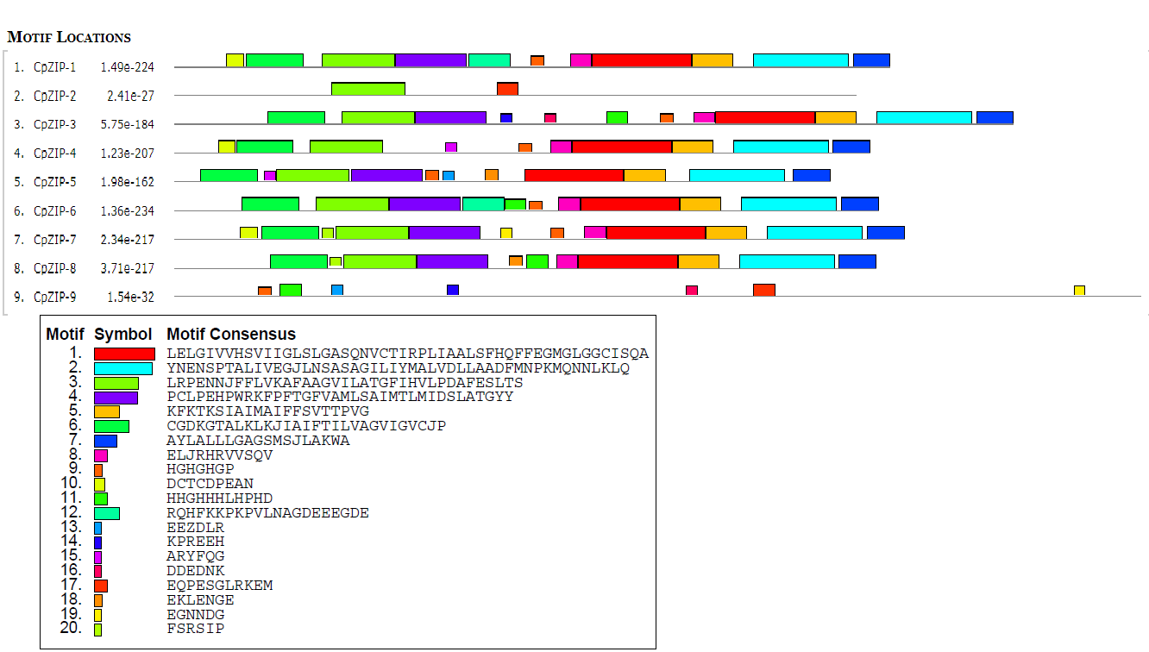

Fig. 1. Distribution of conserved motif in ZIP family proteins of Carica papaya, identified by MEME tools; Different motifs are represented by distinctive colours and numbered 1-20.

Motif1and motif2 were found in all the Papaya ZIP sequences except CpZIP2 and CPZIP9. Motif1 and motif2 encode the ZIP domain. In CpZIP2 the least number of motifs that is only two motifs were detected. Motif 3 which also encodes the ZIP domains found in all the Papaya ZIP genes except CpZIP9. However, some motifs are observed to be clade specific, like motif 17 is found in all ZIP members of Clade II and Clade III. Motif 19 is restricted to CpZIP9, which is the only Papaya ZIP protein in clade II. These clade specific motifs may be contributing to functional divergence among ZIP genes.

3.2 Multiple sequence alignment and phylogenetic analysis
All the deduced amino acid sequence of Papaya ZIP genes showed good alignment with other known ZIP proteins. The ZIP proteins were divided into four different clades. The highest number of CpZIP genes was clustered in clade I where eleven Arabidopsis and Nine Oryza ZIP transporters were also found (Fig. 2). CpZIP9 forms the smallest clade (clade II) with one ZIP member from O. sativa (OS13).

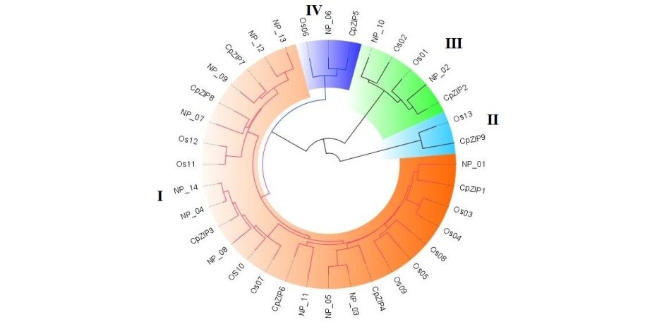

Fig. 2 Phylogenetic analysis of ZIP proteins from Carica papaya. The phylogentic tree was constructed using Mega 7.0 software by neighbor joining method with 1000 bootstrap values. Different clades are colored with distinct colors which indicate different subfamilies of ZIP genes and designated as I, II, III, IV.

3.3 Exon- intron organization and identification of conserved motifs
A total of 20 conserved motifs were detected in nine C. papaya ZIP sequences. The number of exons and introns were varied between 1 to 10 and 1 to 8 respectively. It was also observed that CpZIP2 had no intron whereas CpZIP9 had the highest number of exons (10) and introns (9) (Fig. 3). Interestingly, it was observed that there is great variation in the number of exons and introns among the papaya ZIP transporters even they belong to same subfamily.
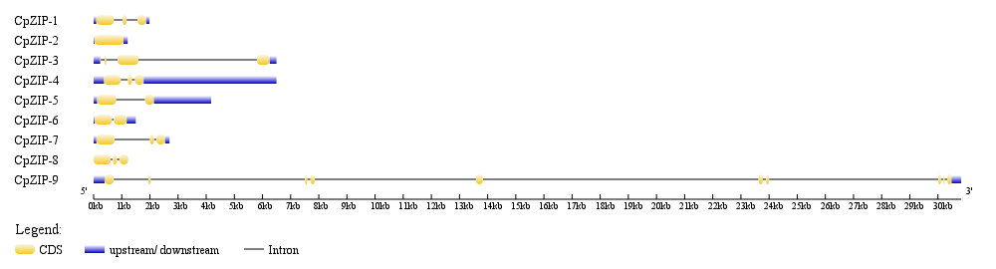

Fig. 3 Exon-intron organization of ZIP genes of Carica papaya analysed using GSDS tool. Exons are marked as yellow boxes, Introns are represented by black lines in between exons, upstream/ downstream sequences are shown in blue colour boxes.

Table 1. Sequence Characteristic of Papaya ZIP genes
Name | No of amino acid | Molecular  Weight | pI | GRAVY | TM  Domains | Signal  Peptide  Cleavage  Sites | Subcellular  localization | Instability  index
CpZIP1 | 360 | 38344.61 | 6.69 | 0.454 | 8 | 26 and 27 | Plasma  Membrane | 42.77
CpZIP2 | 343 | 363812.05 | 5.29 | 0.693 | 9 | 31 and 32 | Plasma  Membrane | 29.72
CpZIP3 | 422 | 45200.7 | 6.06 | 0.259 | 6 | 28 and 29 | Plasma  Membrane | 40.00
CpZIP4 | 350 | 37069.42 | 6.85 | 0.569 | 7 | 22 and 23 | Plasma  Membrane | 28.42
CpZIP5 | 330 | 35410.96 | 6.59 | 0.680 | 8 | 30 and 31 | Plasma  Membrane | 32.45
CpZIP6 | 354 | 37791.19 | 6.21 | 0.595 | 7 | 25 and 26 | Plasma  Membrane | 33.38
CpZIP7 | 367 | 39342.34 | 7.06 | 0.550 | 7 | 30 and 31 | Plasma  Membrane | 38.43
CpZIP8 | 353 | 38384.22 | 7.21 | 0.422 | 8 | 30 and 31 | Plasma  Membrane | 44.16
CpZIP9 | 486 | 53098.9 | 6.32 | -0.189 | 6 | 23 and 24 | Nuclear and  Plasma  Membrane | 32.17

The isoelectric points of the ZIP genes were observed between 5.29 to 7.21and predicted molecular weight was between 36.38 kDa to 53.09 kDa. The predicted instability index shows that seven out of nine ZIP proteins are stable in nature (Table 1). Subcellular localization prediction shows that all the ZIP proteins were located in the plasma membrane. The presence of these proteins in the plasma membrane indicates that they play a crucial role in transportation- related activity. The signal peptides prediction shows 77% of CpZIP sequences were predicted to contain signal peptides.

3.4 Functional annotation of ZIP genes
The Papaya ZIP proteins were found to participate in 18 biological processes. The biological process involved are metal ion transport, localization, TM transport, zinc ion transport, divalent inorganic cation transport (Fig. 4A). This indicates the association of CpZIP proteins in Fe and Zn transportation activity. The biological process analysis also shows that 82% of the ZIP sequences are involved in localization and transportation, whereas 18% of the sequences are associated with the metabolic processes. The molecular function analysis shows 80% sequences are involved in transportation activity, whereas 20% sequences are having catalytic activity. The molecular function are associated with the GO terms as cation transmembrane transporter activity, metal ion transporter activity, divalent cation transmembrane transporter activity, zinc ion transmembrane transporter activities (Fig.4B). The catalytic activity includes oxidoreductase activity, alkenal reductase activity. The cellular component prediction shows that 88.89% of ZIP sequences are associated with integral component of membrane, an intrinsic component of membrane, and plasma membrane. The above finding is also supported by the report of Li et al. (2013).

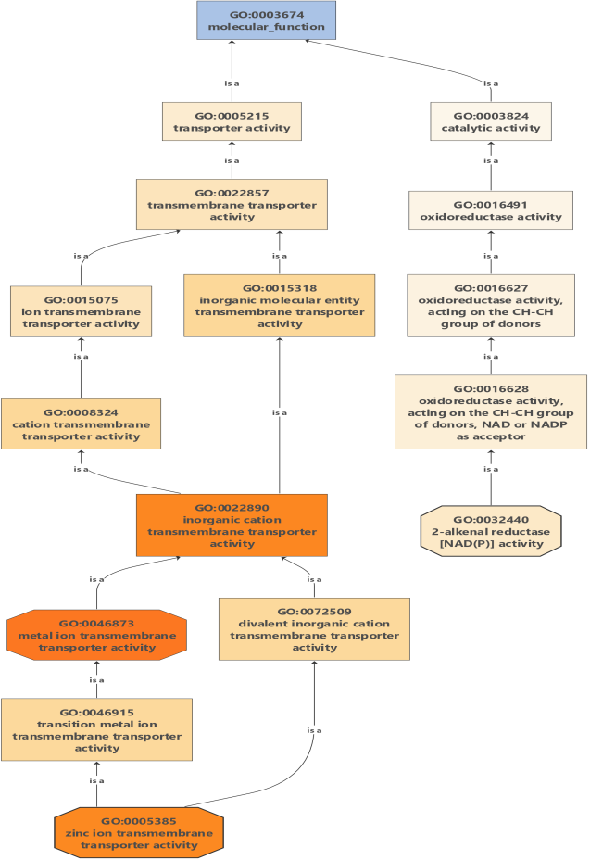
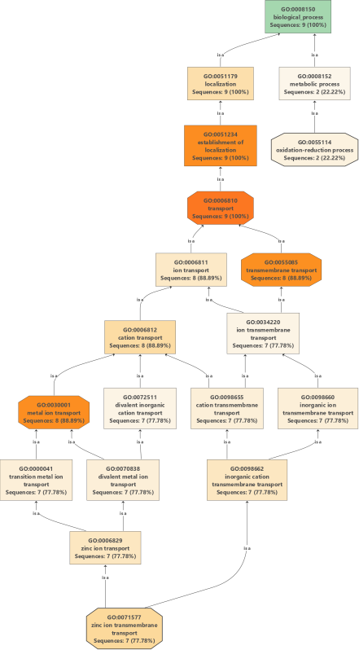
B
A
Fig. 4 Graphical representation of Gene Ontology (GO) and functional classification of papaya ZIP genes using the BLAST2GO tool. The histogram represents the sequence annotated to specific (A) Biological processes GO categories (B) molecular function of GO categories

3.5 Homology modeling of Papaya ZIP proteins
All the proteins were noticed to be diverse in terms of the composition of alpha-helix and transmembrane helix (Table 2). The percentage of residues modeled in each protein was varied within 54 to 75%. The number of residues and the aminoacid making the binding site for each CpZIP member was seen to be varying.

The number of ligands that lie within 0.8 angstroms, varies between 1 to 5 which are in contact with the residues. The average distance of residues from all the ligands that lie within 0.8 angstroms varies from 0 to 0.75 angstroms. The Jensen Shannon divergence score (JS score) is calculated for each protein considering the minimum score is 0 and the maximum score is 1. The conserved amino acids which are essential for maintaining the structure and function of the protein were determined and represented diagrammatically (Fig. 5).

Table 2.- Characteristics of candidate CpZIP proteins chosen for homology modeling

Name of ZIP Protein | % of residues modeled with 100% confidence | Characteristic features
CpZIP1 | 64% | Alpha helix (69%), TM helix  (48%),
CpZIP2 | 66% | Alpha helix (72%), TM helix  (47%)
CpZIP3 | 54% | Alpha helix (59%), TM helix  (39%)
CpZIP4 | 65% | Alpha helix (70%), TM helix  (48%)
CpZIP5 | 68% | Alpha helix (68%), TM helix  (49%)
CpZIP6 | 75% | Alpha helix (71%), TM helix  (48%)
CpZIP7 | 62% | Alpha helix (68%), TM helix  (46%)
CpZIP8 | 64% | Alpha helix (71%), TM helix  (46%)
CpZIP9 | 46% | Alpha helix (57%), TM helix  (36%)

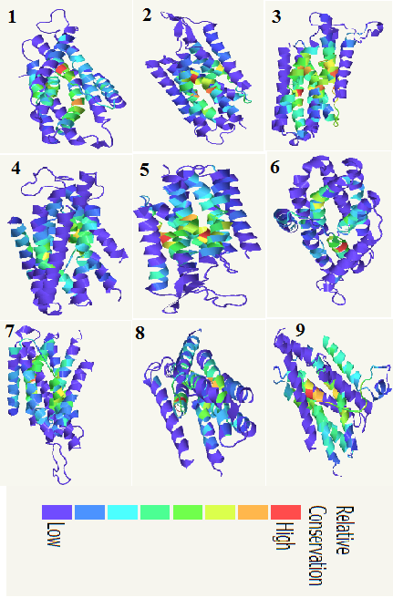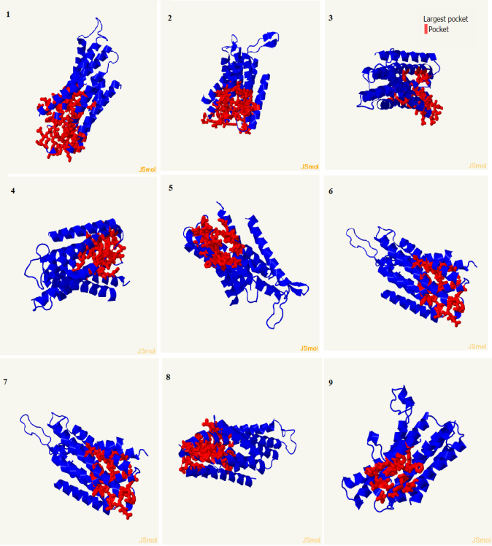
Fig. 5 Analysis of relative conservation of amino acid residues among Papaya ZIP sequences. The number 1-9 represents CpZIP1-CpZIP9 respectively
Fig. 6 Largest ligand binding site (pocket) prediction in Papaya ZIP genes. Pockets are colored in red. The number 1-9 represents CpZIP1-CpZIP9 respectively.

It was observed that amino acids like isoleucine, histidine, leucine, glycine, valine and tyrosine are highly conserved among CpZIP. The largest pocket (cavity) for each ZIP protein was detected and colored red in wireframe mode (Fig. 6).

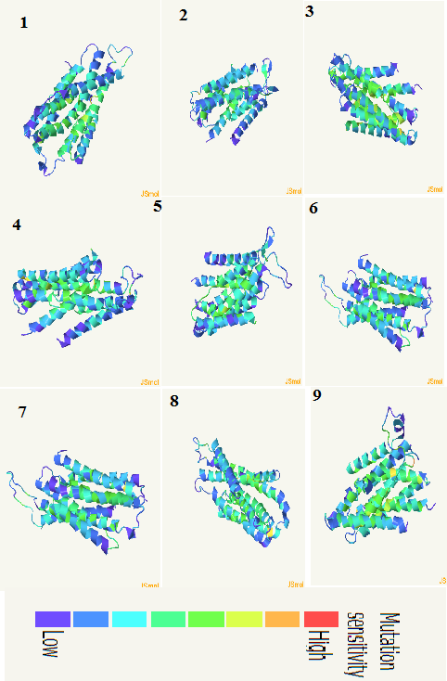

Fig. 7 Mutation sensitivity analysis in papaya ZIP genes by SuSPect tool. The number 1-9 represents CpZIP1-CpZIP9 respectively.

Mutational sensitivity assay was carried out to detect the mis-sense mutation in the ZIP proteins. The mutation analysis data shows that no ZIP proteins are highly sensitive to mutation which also indicates the stable nature of papaya ZIP proteins (Fig. 7).
3.6 Expression pattern of papaya ZIP genes
The Papaya ZIP genes were observed to be expressed at varying label in two different stages of the study. The ZIP genes CpZIP1, CpZIP3, CpZIP4, CpZIP6, and CpZIP9 exhibited high label of expression during the fruiting stage of the plant. The higher expression of the above genes indicates they may be actively involved in Zn and Fe transport during the fruiting stage. The high label expression of these genes also indicates the involvement of Zn in a similar manner like magnesium in other enzymatic reactions during fruiting or fruit ripening. The Zn is known to act as an essential micronutrient and cofactor during several enzymatic reactions (Marschner 1986). The foliar application of Zn is reported to increase the number of fruits, pulp weight, beta carotene content in litchi, and mango (Suman et al. 2017). Evidence based reported also shows the application of ZnSo₄ increases the number of mango fruit, pulp weight, increase in sugar content, and weight of mango fruit (Singh and Rajput 1976). These findings are evidenced by the heightened expression of Papaya ZIP genes in the fruiting tree as observed in our study. In another research with Peach cultivar grown on Fe deficient soil resulted in reduced chlorophyll concentrations, fruit numbers, total fresh weight of fruit by 42-59%, 66-71%, and 70-79% (Álvarez Fernández et al. 2003). We also noticed the maximum number of CpZIP genes with a high level of expression during the fruiting stage as compared to the young plants. However, CpZIP8 showed low expression label at both stages. The low level expression of this particular gene might be tissue-specific or modulated at a different time point which needs to be investigated further. Furthermore, we noticed that CpZIP2, CpZIP5, and CpZIP7 showed moderate expression at both stages. The current finding indicates these three genes may be part of a common regulatory network involved in Zn and iron uptake. The moderate expression of these genes might be to maintain the required Zn and Fe level in the plant for normal metabolic process. Two to six fold increase in fruit yield, Two to four fold increase in fruit number and, 15% to 34% increase in fruit size due to iron sulfate implant in peach plant was reported by Larbi (2003). This indicates the iron plays crucial role during the fruiting stage in plants and supports our current finding that most of the ZIP genes shows high-level expression during the fruiting stage.

- CONCLUSION
The present study provides an insight in to the phylogenetic relationship, functional divergence of the CpZIP genes in papaya for the first time. Nine ZIP transporters were identified across C. Papaya genome. The CpZIP could serve as potential gene for biofortification of Zn and Fe. The characterization of ZIP proteins will enrich the knowledge and deepens the understanding of the Zn and Fe homeostasis and divergence of ZIP family genes in other fruiting plants. As papaya is a highly nutritious fruit the functional characterization of each Papaya ZIP genes will add to the development of novel agronomic traits and contribute towards finding the solution for nourishment.

References:
- Alvarez-Fernández, A., Paniagua, P., Abadía, J., & Abadía, A. (2003). Effects of Fe Deficiency Chlorosis on Yield and Fruit Quality in Peach (Prunus persica L. Batsch). Journal of Agricultural and Food Chemistry, 51, 5738-5744. https://doi.org/10.1021/jf034402c
- Berardini, T. Z., Reiser, L., Li, D., Mezheritsky, Y., Muller, R., Strait, E., & Huala, E. (2015). The Arabidopsis information resource: Making and mining the "gold standard" annotated reference plant genome. Genesis. https://doi.org/10.1002/dvg.22877
- Chai, W., Si, W., Ji, W., Qin, Q., Zhao, M., & Jiang, H. (2018). Genome-Wide Investigation and Expression Profiling of HD-Zip Transcription Factors in Foxtail Millet (Setaria italica L.). BioMed Research International. https://doi.org/10.1155/2018/8457614
- Ciarbelli, A. R., Ciolfi, A., Salvucci, S., Ruzza, V., Possenti, M., Carabelli, M., Fruscalzo, A., Sessa, G., Morelli, G., & Ruberti, I. (2008). The Arabidopsis homeodomain-leucine zipper II gene family: diversity and redundancy. Plant Molecular Biology, 68(4-5), 465–478. https://doi.org/10.1007/s11103-008-9383-8
- Dezar, C. A., Giacomelli, J. I., Manavella, P. A., Ré, D. A., Alves-Ferreira, M., Baldwin, I. T., Bonaventure, G., & Chan, R. L. (2011). HAHB10, a sunflower HD-Zip II transcription factor, participates in the induction of flowering and in the control of phytohormone-mediated responses to biotic stress. Journal of Experimental Botany, 62(3), 1061–1076. https://doi.org/10.1093/jxb/erq339
- Fu, X. Z., Zhou, X., Xing, F., Ling, L. L., Chun, C. P., Cao, L., Aarts, M., & Peng, L. Z. (2017). Genome-Wide Identification, Cloning and Functional Analysis of the Zinc/Iron-Regulated Transporter-Like Protein (ZIP) Gene Family in Trifoliate Orange (Poncirus trifoliata L. Raf.). Frontiers in Plant Science, 8, 588. https://doi.org/10.3389/fpls.2017.00588
- Hu, B., Jin, J. P., Guo, A. Y., Zhang, H., Luo, J., & Gao, G. (2015). GSDS 2.0: An upgraded gene feature visualization server. Bioinformatics, 31(8), 1296–1297. https://doi.org/10.1093/bioinformatics/btu817
- Hu, R., Chi, X., Chai, G., Kong, Y., He, G., Wang, X., Shi, D., Zhang D., Zhou, G., et al. (2012). Genome-wide identification, evolutionary expansion, and expression profile of homeodomain-leucine zipper gene family in poplar (Populus trichocarpa). PLOS ONE, 7(2), e31149. https://doi.org/10.1371/journal.pone.0031149
- Javelle, M., Klein-Cosson, C., Vernoud, V., Boltz, V., Maher, C., Timmermans, M., Depège-Fargeix, N., & Rogowsky, P. M. (2011). Genome-wide characterization of the HD-ZIP IV transcription factor family in maize: Preferential expression in the epidermis. Plant Physiology, 157(2), 790–803. https://doi.org/10.1104/pp.111.182147
- Kawahara, Y., de la Bastide, M., Hamilton, J., Kanamori, H., McCombie, R., Ouyang, S., et al. (2013). Improvement of the Oryza sativa Nipponbare reference genome using next generation sequence and optical map data. Rice, 6(1), 4. https://doi.org/10.1186/1939-8433-6-4
- Krishna, T. P. A., Maharajan, T., Roch, G. V., Ignacimuthu, S., & Ceasar, S. A. (2020). Structure, Function, Regulation and Phylogenetic Relationship of ZIP Family Transporters of Plants. Frontiers in Plant Science. https://doi.org/10.3389/fpls.2020.00662
- Kumar, S., Stecher, G., & Tamura, K. (2016). MEGA7: Molecular Evolutionary Genetics Analysis Version 7.0 for Bigger Datasets. Molecular Biology and Evolution, 33(7), 1870–1874. https://doi.org/10.1093/molbev/msw054
- Larbi, A., Morales, F., Abadía, J., & Abadía, A. (2003). Effects of branch solid Fe sulphate implants on xylem sap composition in field-grown peach and pear: changes in Fe, organic anions and pH. Journal of Plant Physiology, 160(12), 1473–1481. https://doi.org/10.1078/0176-1617-01010
- Letunic, I., Copley, R. R., Schmidt, S., Ciccarelli, F. D., Doerks, T., Schultz, J., Ponting, C. P., & Bork, P. (2004). SMART 4.0: towards genomic data integration. Nucleic Acids Research, 32(Database issue), D142–D144. https://doi.org/10.1093/nar/gkh088
- Lin, Y. F., Liang, H. M., Yang, S. Y., Boch, A., Clemens, S., & Chen, C. C. (2009). Arabidopsis IRT3 is a zinc-regulated and plasma membrane localized zinc/iron transporter. New Phytologist. https://doi.org/10.1111/j.1469-8137.2009.02766.x
- Li, S., Zhou, X., Huang, Y., Zhu, L., Zhang, S., Zhao, Y., et al. (2013). Identification and characterization of the zinc-regulated transporters, iron-regulated transporter-like protein (ZIP) gene family in maize. BMC Plant Biology https://doi.org/10.1186/1471-2229-13-114
- Ma, Y., Dai, X., Xu, Y., Luo, W., Zheng, X., Zeng, D., Pan, Y., Lin, X., Liu, H., Zhang, D., Xiao, J., Guo, X., Xu, S., Niu, Y., Jin, J., Zhang, H., Xu, X., Li, L., Wang, W., Qian, Q., Ge, S., & Chong, K. (2015). COLD1 confers chilling tolerance in rice. Cell, 160(6), 1209–1221. https://doi.org/10.1016/j.cell.2015.01.046
- Marschner, H. (1986). Functions of mineral nutrients: macronutrients. In H. Marschner, *Mineral Nutrition of Higher Plants* (pp. 195-267). Academic Press. https://www.elsevier.com/books/mineral-nutrition-of-higher-plants/marschner/978-0-12-473542-2
- Singh, R. R., & Rajput, C. B. S. (1977). Effect of various concentrations of zinc on vegetative growth characters, flowering, fruiting and physico-chemical composition of fruits in mango (Mangifera indica L.) cv. Chausa. Haryana Journal of Horticultural Sciences, 6, 10-14.
- Suman, M., Sangma, P. D., & Singh, D. (2017). Role of Micronutrients (Fe, Zn, B, Cu, Mg, Mn and Mo) in Fruit Crops. International Journal of Current Microbiology and Applied Sciences, 6(6), 3240–3250. https://doi.org/10.20546/ijcmas.2017.606.382
- Tina, R. R., Shan, X. R., Wang, Y., Guo, S. Y., Mao, B., Wang, W., Wu, H. Y., & Zhao, T. H. (2017). Response of antioxidant system to drought stress and re-watering in alfalfa during branching. IOP Conference Series: Earth and Environmental Science. https://doi.org/10.1088/1755-1315/94/1/012129
- Turchi, L., Carabelli, M., Ruzza, V., Possenti, M., Sassi, M., Penalosa, A., Sessa, G., Salvi, S., Forte, V., Morelli, G., Ruberti, I., et al. (2013). Arabidopsis HD-Zip II transcription factors control apical embryo development and meristem function. Development, 140, 2118–2129. https://doi.org/10.1242/dev.092833
- Zhang, Z., Chen, X., Guan, X., Liu, Y., Chen, H., Wang, T., Mouekouba, L. D. O., Li, J., & Wang, A. (2014). A genome-wide survey of homeodomain-leucine zipper genes and analysis of cold-responsive HD-Zip I members' expression in tomato. Bioscience, Biotechnology, and Biochemistry, 78(8), 1337-1349. https://doi.org/10.1080/09168451.2014.923292

