Morpho-Agronomic Diversity of Lathyrus sativus L. germplasm accessions

Abstract:
Lathyrus sativus is considered as an important economical source of high-quality proteins and adaptability to global climate change. This study is based on the agro-morphological characterization of the 48 grasspea germplasm including checks i.e. Mahateora and Prateek. The forty-eight grasspea germplasm accessions were classified for twenty one morphological characters according to the DUS descriptor of Lathyrus developed by International Plant Genetic Resources Institute, Rome, Italy (2000). Diversity shown by 14 characters out of total 21 qualitative characters. Monomorphic, Dimorphic and Trimorphic characters were seen in the germplasm under studied. No variation was observed in plant type, number of leaflets per leaf, pigmentation of leaf vein, leaf pubescence, number of pods per peduncle, seed shape and cotyledon colour. The characters that show medium diversity in the germplasm includes Anthocyanin pigmentation of leaf, leaf colour, leaflet shape, leaf petiole colour, leaf tendril, seed coat colour, seed size, seed coat surface and seed coat pattern were under dimorphic characters. Stem colour coating, stem wax coating, leaf colour, flower colour, pod shape and pod curvature are the characters in the germplasm showing high diversity. Phenotypic descriptors are crucial for plant breeders to discriminate specific parental germplasm for targeted phenotypes.
Key words: DUS descriptors, grass pea, agro-morphological characterization
Introduction:
The Lathyrus sativus L. (2n = 14) is an annual herb and an important pulse crop, rich in protein content (28%) next to soybean locally called as grass pea, khesari dal, peavine or chanamatra. It belongs to family Leguminosae, sub family Papilionoideae and genus Lathyrus with 130 species occurring all over the temperate region of Northern hemisphere and the higher altitude of tropical Africa. Widely cultivated in poor countries, they constitute a reliable resource in marginal low-input agricultural ecosystems (Vaz Patto et al., 2006). Grass pea (Lathyrus sativus L.) is one of the most cultivated species in the genus Lathyrus because of their economical source of high-quality proteins and adaptability to global climate change (Campbell et al., 1993). Grass pea has many qualities that make it an attractive crop during drought or in wet areas, with poor quality soil and prevailing extreme environmental conditions. The grass pea is characterized by a penetrating root system and can be cultivated on many soil types, including very poor soils (Sidorova et al., 2013). There is a growing interest in cultivation of this culture, dictated by the need to restore particularly eroded soils (Polignano et al., 2009). The differentiation of grasspea cultivars is essential for their safeguarding under Plant Variety Protection (PVP) legislation. This is due to the fact that distinctiveness, uniqueness and stability (DUS) assessment is the minimum prerequisite for conferring protection to novel plant germplasms under the Protection of Plant Varieties and Farmer's Right (PPV&FR) Act of 2001. Acknowledging the significance and merit of varietal taxonomy, the present investigation was conducted to categorize various lentil genotypes based on DUS characteristics, as specified by PPV & FRA, 2007. The current study has been carried out to classify the various lentil genotypes based on DUS descriptors as per PPV & FRA, 2007.
Materials and Methods:
Forty eight grass pea accessions were planted on the Research cum Instructional Farm of Indira Gandhi Krishi Vishwavidyalaya, Raipur, (C.G.) during Rabi 2022-23 in a Randomized Complete Block Design with three replications for DUS characterization. The forty-eight grasspea germplasm accessions were classified for twenty one morphological characters according to the DUS descriptor of Lathyrus developed by International Plant Genetic Resources Institute, Rome, Italy (2000). The germplasm used in the research work comprises of forty eight genotypes including two checks i.e. Mahateora and Prateek. The experimental material details of the germplasm used in the present study as given in Table 1.
Table 1: Details of the grasspea germplasm used in the present study
Genotype | Block | District | State | NAME
1 | ICARDA | Aleppo | Morocco | IFLA-1864
2 | ICARDA | Aleppo | Morocco | IFLA-1926
3 | ICARDA | Aleppo | Morocco | IFLA-1193
4 | Patan | Durg | Chhattisgarh | IC-142595
5 | Abhanpur | Raipur | Chhattisgarh | IC-142787
6 | Patan | Durg | Chhattisgarh | IC-142615
7 | Dharsiwa | Raipur | Chhattisgarh | RLK-158
8 | - | Raipur | Chhattisgarh | RLK-148
9 | Abhanpur | Raipur | Chhattisgarh | RLK-141
10 | Durg | Durg | Chhattisgarh | IC-142557
11 | Dharsiwa | Raipur | Chhattisgarh | IC-142840
12 | Mohala | Rajnandgaon | Chhattisgarh | IC-143410
13 | Mohala | Rajnandgaon | Chhattisgarh | IC-143420
14 | Mohala | Rajnandgaon | Chhattisgarh | IC-143430
15 | Mohala | Rajnandgaon | Chhattisgarh | IC-143440
16 | Chauki | Rajnandgaon | Chhattisgarh | IC-143529
17 | Kasdol | Raipur | Chhattisgarh | IC-143400
18 | - | Raipur | Chhattisgarh | IC-143770
19 | - | Raipur | Chhattisgarh | IC-146919
20 | ICARDA | Aleppo | Morocco | SEL-553
21 | ICARDA | Aleppo | Morocco | SEL-554
22 | Akola | Maharastra | Maharastra | IC-120449
23 | Chauki | Rajnandgaon | Chhattisgarh | IC- 143534
24 | Chauki | Rajnandgaon | Chhattisgarh | IC-143532
25 | Rajnandgaon | Rajnandgaon | Chhattisgarh | IC-143521
26 | Abhanpur | Raipur | Chhattisgarh | IC-142782
27 | Dharsiwa | Raipur | Chhattisgarh | RLK-161
28 | Dharsiwa | Raipur | Chhattisgarh | IC-142851
29 | Raipur | Raipur | Chhattisgarh | AKL-19
30 | IARI | New Delhi | New Delhi | BIOL-202
31 | Akola | Maharastra | Maharastra | JRL-41
32 | IIPR | Kanpur | Uttar Pradesh | IPLY-9
33 | ICARDA | Aleppo | Morocco | IFLA-2750
34 | Raipur | Raipur | Chhattisgarh | No. 2208
35 | ICARDA | Aleppo | Morocco | IFLA-1522
36 | ICARDA | Aleppo | Morocco | IFLA-1826
37 | - | - | Bangladesh | BANG-268
38 | - | - | West Bengal | BK-40-1
39 | ICARDA | Aleppo | Morocco | IFLA-276
40 | ICARDA | Aleppo | Morocco | IFLA-274
41 | ICARDA | Aleppo | Morocco | IFLA-275
42 | ICARDA | Aleppo | Morocco | IFLA-2441
43 | IGAU | Raipur | Chhattisgarh | RLS-2012-5
44 | IGAU | Raipur | Chhattisgarh | RLS-3006
45 | IGAU | Raipur | Chhattisgarh | RLS-2010-8
46 | IGAU | Raipur | Chhattisgarh | RLS-2010-4
47 | IGAU | Raipur | Chhattisgarh | MAHATEORA
48 | IGAU | Raipur | Chhattisgarh | PRATEEK

Result and Discussion:
According to Din et al., scientific classification of the plant still relies on morphological traits. Moreover, this technique is easier, cost effective, easy to score, requires less time and finally it does not need any technical knowledge. In this study, forty-eight grasspea germplasm accessions were classified for twenty one morphological characters. Diversity shown by 14 characters out of 21 characters. Table 2 summarises the statistics of the 21 quantitative morpho-agronomic traits for 48 grass pea collection.
Variability was noted in the stem colour, with 83.34% of genotypes being green, 8.33% being light green colour and 8.33% genotypes being purple green colour. In stem waxy coating, 54.16% genotypes had large waxy coating, 41.67% genotypes had medium waxy coating and 4.17% genotypes had no waxy coating. For leaf colour, 54.16% genotypes were under green, 41.67% genotypes were dark green and 4.17% genotypes were light green leaf colour. Flower color also displayed diversity of 87.5% genotypes had blue flowers, 6.25% genotypes had white flowers and 6.25% genotypes had pink flowers. 64.59% genotypes had straight type, 29.16% genotypes had slightly curved and 6.25% genotypes had curved type of pod curvature. Lassoued et al. (2023) got similar findings with pod curvature and flower colour. Pod shape in 66.66% genotypes had oblong elliptical shaped, 27.09% genotypes are of medium oblong elliptical shaped and 6.25% genotypes are of curved shape. Stem colour coating, stem wax coating, leaf colour, flower colour, pod shape and pod curvature were the characters showing three classes of relative frequency of phenotypic classes in the germplasm showing high diversity.
The characters that show medium diversity in the germplasm includes Anthocyanin pigmentation of leaf, leaf colour, leaflet shape, leaf petiole colour, leaf tendril, seed coat colour, seed size, seed coat surface and seed coat pattern i.e., two classes of relative frequency of phenotypic classes. Petrova (2023) got similar results with traits leaflet shape, seed coat colour and seed coat surface.
The qualitative characters include plant type, number of leaflets per leaf, pigmentation of leaf vein, leaf pubescence, number of pods per peduncle, seed shape and cotyledon colour were found monomorphic.
Table 2: Frequency distribution of lathyrus genotypes for various DUS characters
S.No | Characteristics | Class | Symbols | No. of genotypes recorded in a class | Frequency percentage (%)
1 | Plant type | Indeterminate | 1 | 48 | 100
2 | Stem colour | Light Green  Green  Purple Green | 1  2  3 | 4  40  4 | 8.33  83.34  8.33
3 | Stem waxy coating | No coating  Medium  Large | 0  5  7 | 2  20  26 | 4.17  41.67  54.16
4 | Anthocyanin pigmentation on leaf | Absent  Present | 0  1 | 15  33 | 31.25  68.75
5 | Number of leaflets/Leaf | One pair | 1 | 48 | 100
6 | Leaf colour | Light Green  Green  Dark Green | 1  2  3 | 2  26  20 | 4.17  54.16  41.67
7 | Pigmentation of leaf vein | No | 0 | 48 | 100
8 | Leaflet shape | Linear  Lanceolate | 1  2 | 20  28 | 41.67  58.33
9 | Leaf petiole colour | Green  Purple Green | 1  2 | 34  14 | 70.83  29.17
10 | Leaf tendrils | Small  Medium | 1  2 | 20  28 | 41.67  58.33
11 | Leaf pubescence | Absent | 0 | 48 | 100
12 | Flower colour | White  Blue  Pink | 1  3  7 | 3  42  3 | 6.25  87.5  6.25
13 | No. of pods per peduncle | One | 1 | 48 | 100
14 | Pod curvature | Straight  Slightly Curved  Curved | 1  2  3 | 31  14  3 | 64.59  29.16  6.25
15 | Pod shape | Oblong elliptical  Medium Oblong elliptical  Curved | 1  2  3 | 13  35  3 | 27.09  66.66  6.25
16 | Seed shape | Rhomboid | 3 | 48 | 100
17 | Seed coat colour | Grey White  Grey | 1  9 | 35  13 | 72.91  27.09
18 | Seed size | Medium  Large | 5  7 | 40  8 | 83.33  16.67
19 | Seed coat surface | Smooth  Tubercular | 1  2 | 10  38 | 20.83  79.17
20 | Seed coat pattern | Marbled  Dotted | 1  2 | 12  36 | 25  75
21 | Cotyledon colour | Yellow | 1 | 48 | 100

Plate-1 -ANTHOCYANIN PIGMENTATION Plate 2- LEAFLET SHAPE
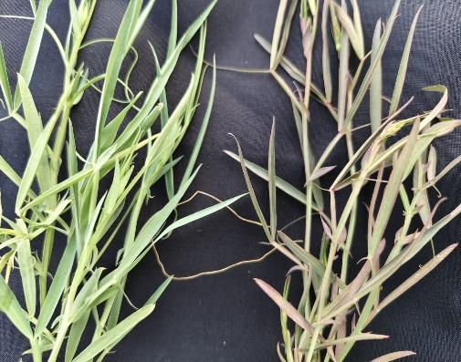 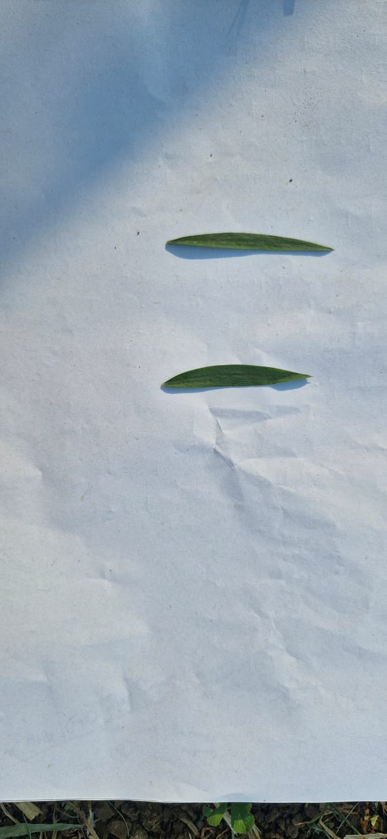 a. Absent b. Present
a. Linear b. Lanceolate
a b
Plate 3- LEAF PETIOLE COLOUR Plate 4- LEAF TENDRIL SIZE 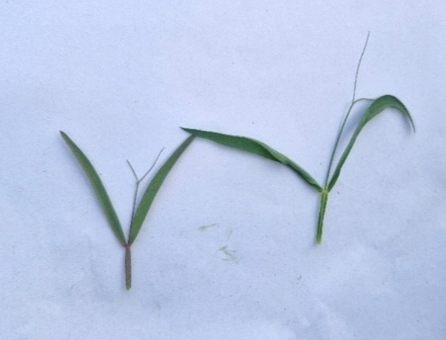 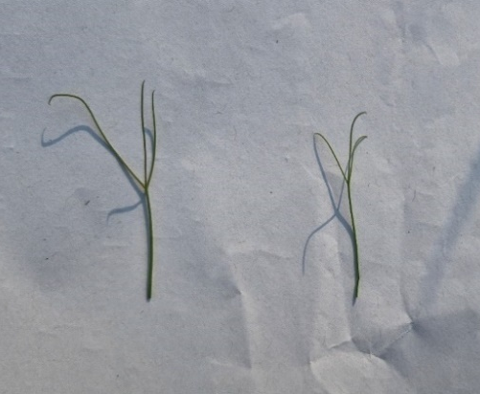
a b
a b
a. Medium b. Small
a. Purple green b. Green

plate 5- FLOWER COLOUR 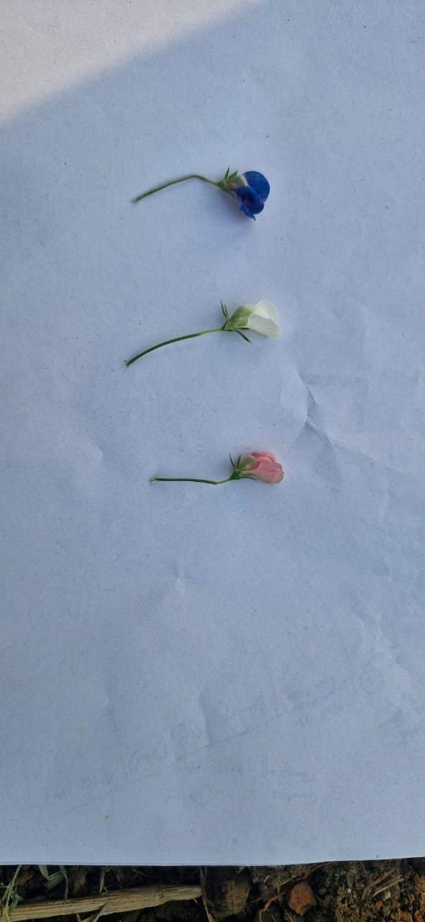
a b c
a. Blue b. White c. Pink

plate-6- NO. OF PODS/PEDUNCLE plate 7- POD CURVATURE 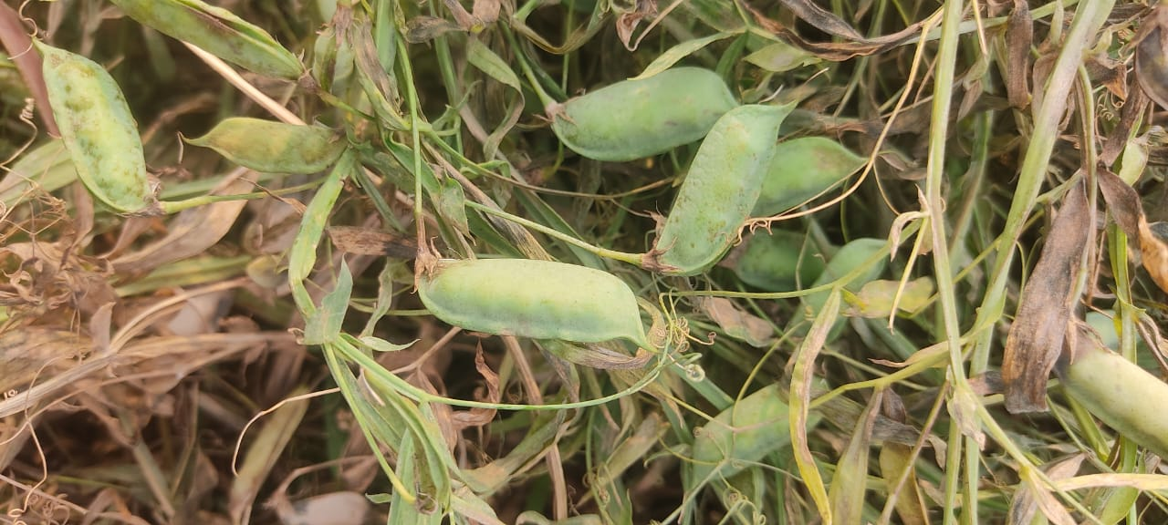 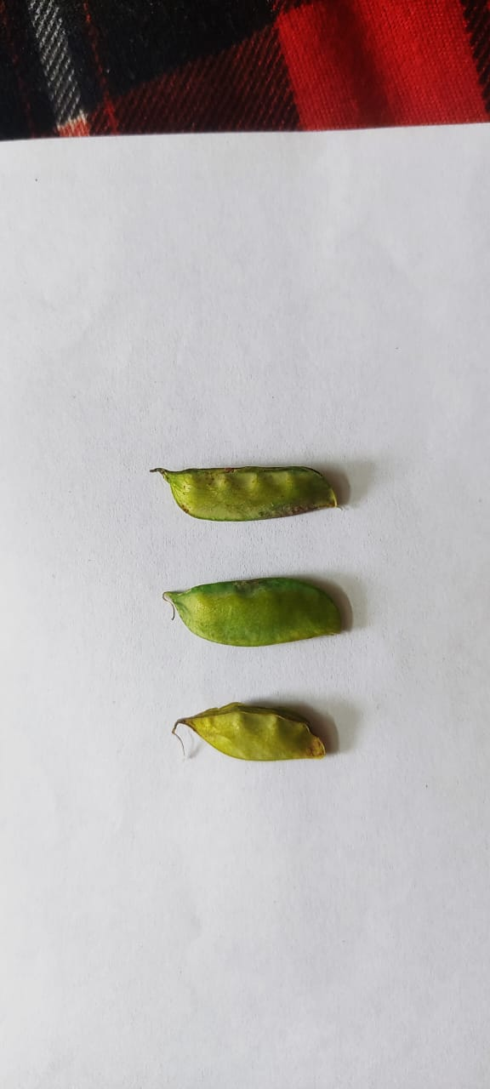
a b c
1 pod/peduncle a. Curved b. Slightly curved c. Straight

Plate 8- POD SHAPE plate 9- SEED SHAPE 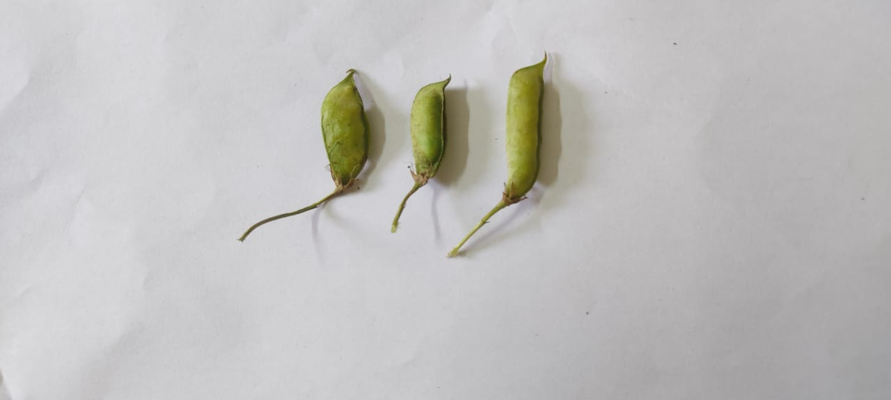 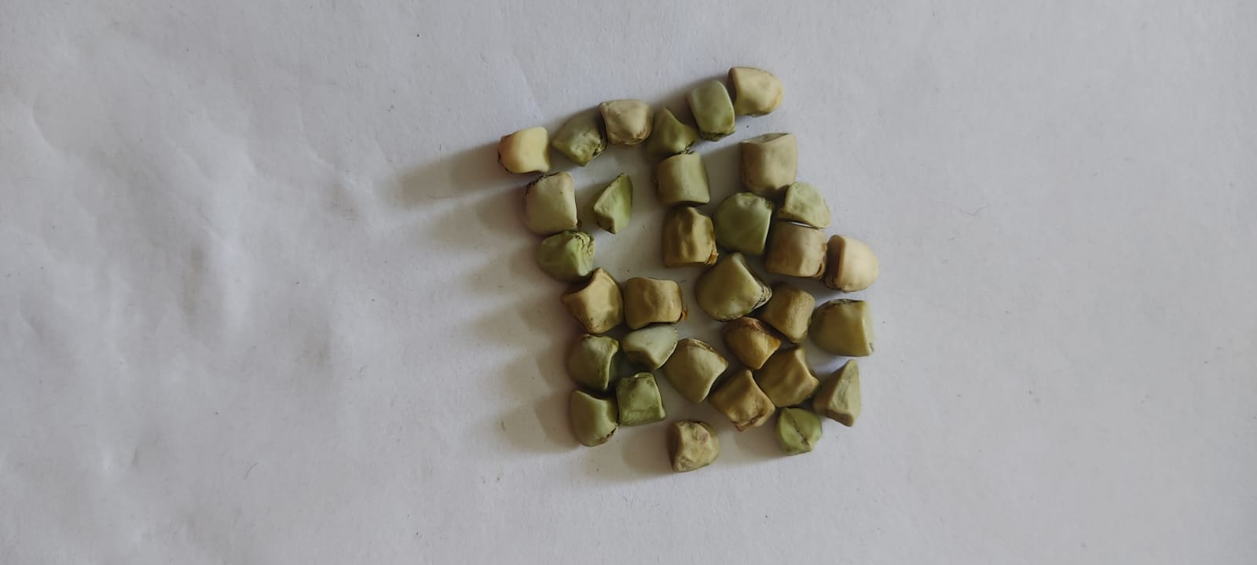
a b c
Rhomboid
a. Curved
b. Medium oblong elliptical
c. Oblong elliptical

Plate 10- SEED COAT COLOUR 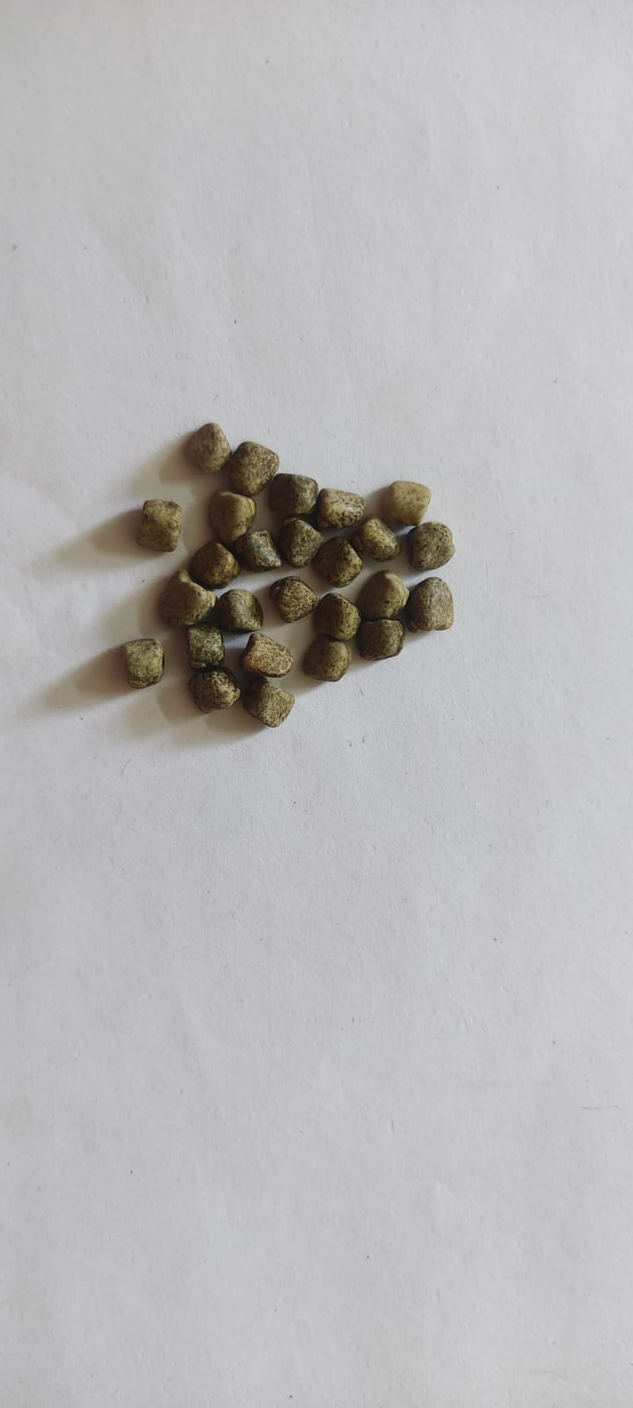 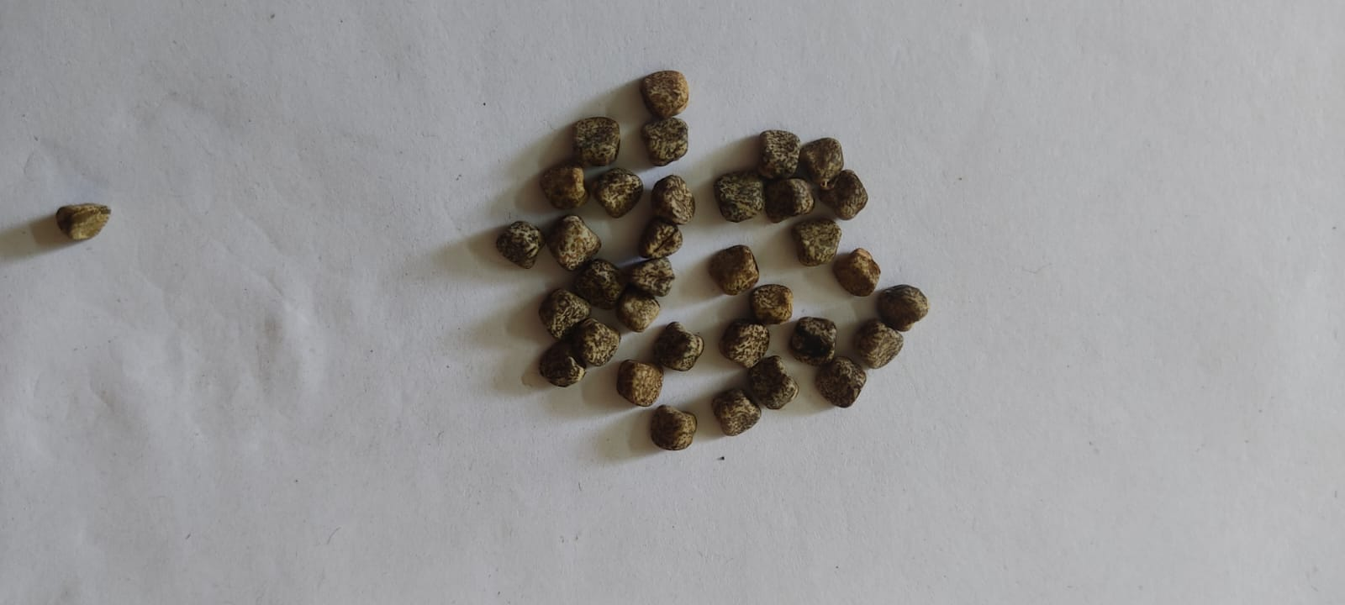
a. Grey white b. Grey

Plate 11- SEED SIZE
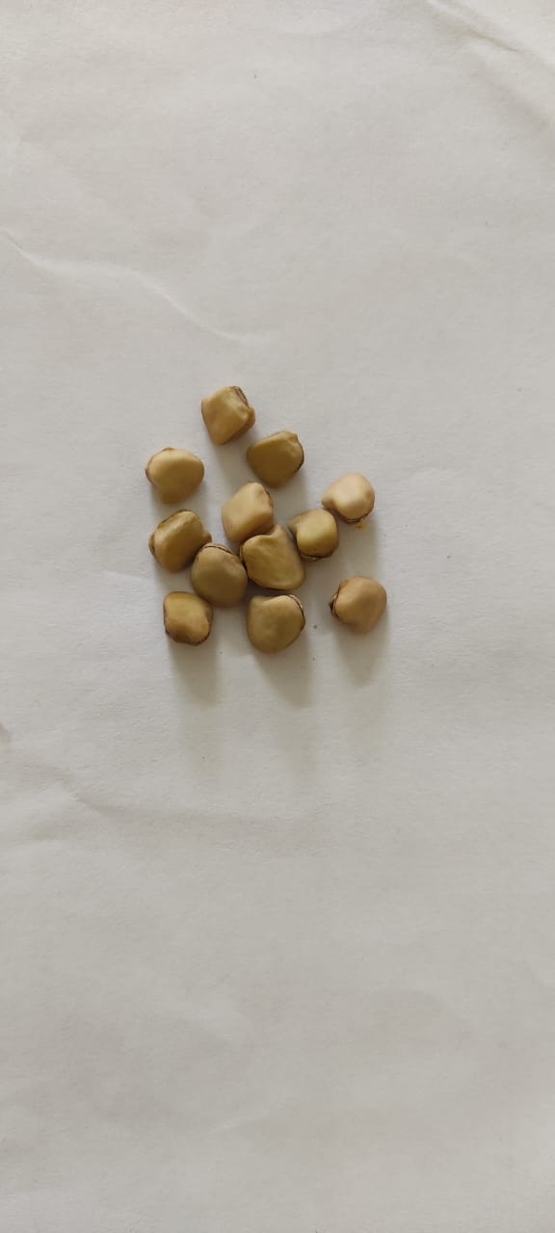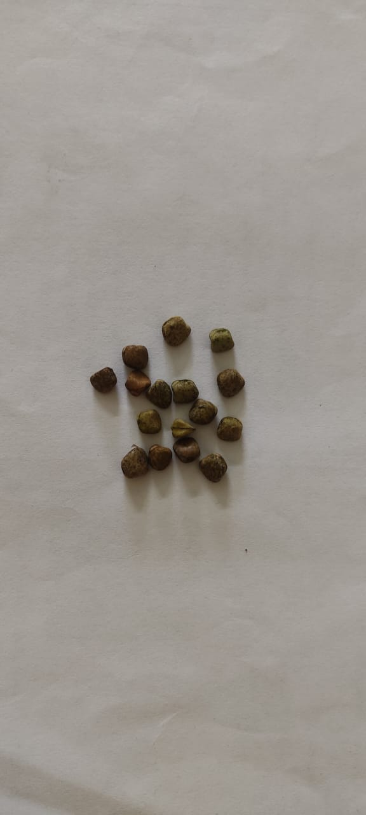

a. Big b. Small
Plate 12- SEED COAT PATTERN
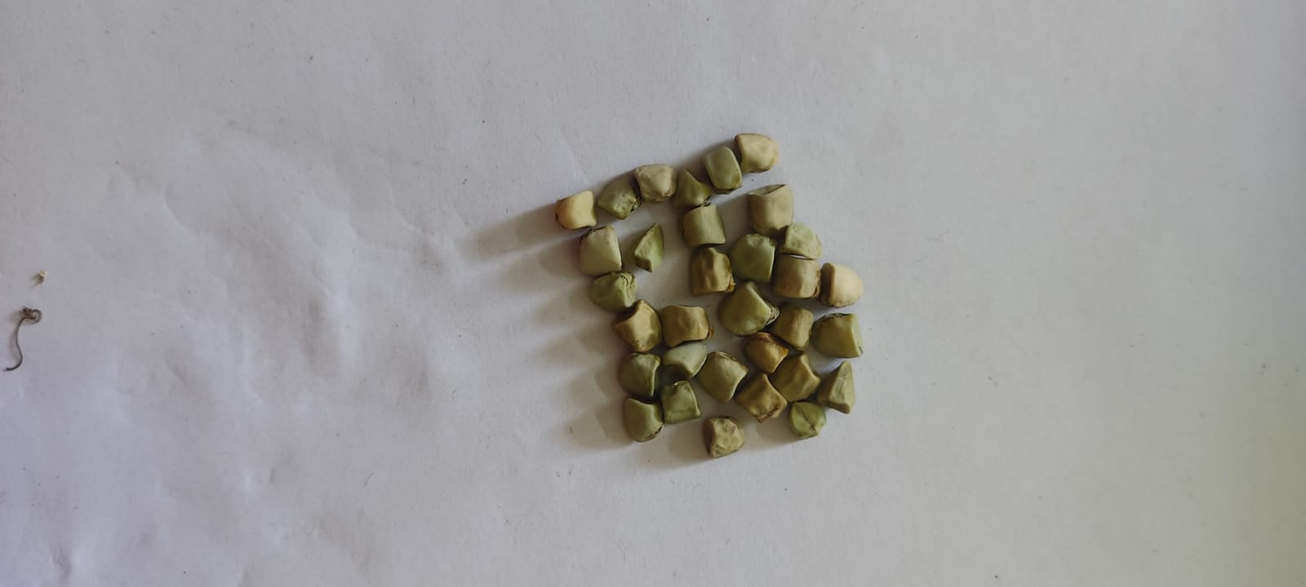
a.Dotted b.Marbled

Plate 13- COTYLEDON COLOUR
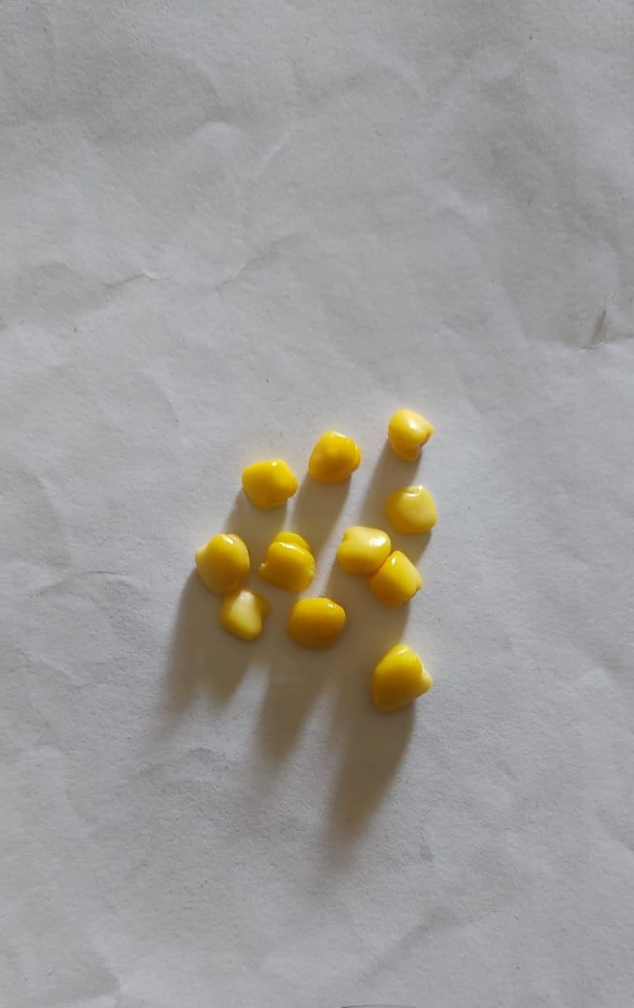
Yellow

Fig. 1: Frequency distribution of morphological traits in forty eight grass pea germplasm accessions:

Conclusion:
Morphological characteristics are often used for basic characterization, because this information is of high interest to users of the genetic diversity. They are valuable tools for characterizing and utilizing germplasm accessions and provide a foundation for understanding genetic diversity, identifying valuable germplasm, and making informed decisions about germplasm conservation and utilization. This investigation demonstrated significant heritable diversity for agronomic and morphological characters. In accordance with the Protection of Plant Varieties and Farmers' Rights (PPV & FR) Act of 2007, the generated data will facilitate cultivar registration and contribute to taxonomic categorization and genotypic grouping. The phenotypic characterization data of grasspea accessions provide a substantial repository for research and enable their application in selection strategies, marker-assisted breeding and gene discovery.

References:
Campbell C. G., Mehra, R. B., Agrawal, S. K., Chen, Y. Z., Abd El Moneim, A. M., Khawaja, H. I. T., Yadov, C. R., Tay, J. U. and Araya, W. A., 1993. Current status and future strategy in breeding grass pea (Lathyrus sativus). Euphytica., 73:167–175.
Lassoued, S., Giosafatto, C. V. L., Mariniello, L. 2023. Morphological characterization and in vitro digestibility of seven Lathyrus sativus (grass pea) accessions originating from Eurasia, Africa, and Canada. Eur. Food Res. Technol., 12: 2419–2432.
Petrova, S. 2023. Lathyrus diversity: resources with different origin with relevance to crop improvement. Bulgarian J. of Crop Sci., 60(6): 74-84.
Polignano, G. B., Bisignano, V., Tomaselli, V., Uggenti, P., Alba, V. and Gatta, C. D. (2009). Genotype × Environment Interaction in Grass Pea (Lathyrus sativus L.) Lines. International Journal of Agronomy., 2009: 1-8.
Sidorova, K. K., Levko, G.D. and Shumny, V.K. 2013. Investigation of nodulation and nitrogen fixation in annual species and varieties of vetchling, genus Lathyrus. Russian Journal of Genetics: Applied Research., 3(3): 197-202.
Vaz Patto, M. C., Fernandez-Aparicio, M., Moral, A., Rubiales, D. 2006. Characterization of resistance to powdery mildew (Erysiphe pisi) in a germplasm collection of Lathyrus sativus. Plant Breed., 125:308–310.

