Investigating the soil salt removal potentials of cocoyam (Colocasia esculenta), tropical spiderwort (Commelina benghalensis), and water mint (Mentha aquatica)

ABSTRACT
Salt-rich wastewater has a variety of adverse effects on the ecological environment but very difficult to treat than other industrial wastewater. The aim of this work is to monitor the growth performance of cocoyam plant, tropical spiderwort and water mint under salty conditions, then evaluate their efficiencies in the removal of the salt from the soil. The experiments were conducted using 3 liters buckets for each plant, filled with soil and placed in a shady area free from rain. Each plant had three buckets, one for each salt concentration used (300 mg/L, 1000 mg/L and 5000 mg/L). The growth performance of the plants were monitored for 4 weeks by checking the plants every after one week for new shoots as well as whether they withered or not. At the end of the 4th week (30 days) the plants were separated from the soil and the electrical conductivity (EC), total dissolved solids (TDS) and salinity of the wet soil determined, and the percentage salt removal by each plant was calculated. The results showed that, for the last week, it was observed that though water mint and tropical spiderwort had initially produced new shoots between week two and three at all the tested concentrations, they were all drying out in the fourth week. However, for the cocoyam, there were no new shoots on the fourth week but the plant was growing perfectly at all the tested concentrations. All the plants significantly reduced salt concentration with values reaching 99 % for cocoyam at 5000 mg/L compared to 32 % for spider wort, 47 % for water mint and 34 % in 30 days. These results show that cocoyam can be very effective in removing salt from the soil at all concentration ranges without affecting its growth performance.
Keywords: Desalination, phytoremediation, Colocasia esculenta, Commelina benghalensis, Mentha aquatica
1. INTRODUCTION
In many industrial processes such as the chemical coal industry, the processing of agricultural by-products, pharmacology, and papermaking, large amounts of high-salinity wastewater with complex components and large amounts of difficult-to-degrade pollutants are generated (Guo et al., 2023). If discharged directly, it will not only waste a large amount of potential salt resources, but it also cause environmental problems such as water mineralization, soil salinization, and water eutrophication (Gao et al., 2022). Salt-rich wastewater has a variety of adverse effects on the ecological environment. First, the inorganic salts in high-saline sewage leads to freshwater mineralization, in which the organic matter also leads to eutrophication, and the heavy metal elements accumulate within the food chain, which directly affects the safety of drinking water. Second, salt infiltration into the soil will alter soil structure and permeability, reducing soil water permeability and increasing the likelihood of flooding (Singh, 2015). In addition, the use of salt water for irrigation leads to irreversible soil salination, retards crop growth and development, significantly reduces agricultural productivity, and has a negative impact on social and economic development.
Wastewater with a high salt content is more difficult to treat than other industrial wastewater (Maharaja et al., 2020). Due to the complex and varied composition of saline wastewater, it is often necessary to choose a suitable pre-treatment solution according to the actual situation. Excessive inorganic salts in the water can be toxic to microorganisms and seriously impair the treatment efficiency, making it difficult to treat high-salinity wastewater with conventional biological technology. Traditional physical and chemical treatment methods are also difficult to generalize due to excessive chemical consumption, equipment corrosion and fouling, and high operating costs. In addition, it is still very difficult to purify the waste salt after desalination. High-salinity wastewater is complicated, and the national and local discharge standards are increasingly strict, which makes it more and more difficult to treat high-salinity wastewater (Guo et al., 2023)
Phytoremediation, however, is one of the environmentally friendly and low-cost methods of removing pollutants from water and soil (Ashraf et al., 2019; Dahaina et al., 2024). This treatment is a remediation method that uses various plants to reduce, extract, and hold excessive nutrients and pollutants from a contaminated medium (Poo et al., 2018). Phytoremediation methods can be categorized based on how the pollutants are removed from the environment, such as through degradation, extraction, containment or a combination of two or more techniques. Plant species considered to be ideal phytoremediation agents have a high biomass, a good root system, and are fast-growing and easy to grow (Dutta and Nath , 2018). The use of aquatic plants, also known as macrophytes, have been used for the filtration of contaminated water using natural processes involving wetland vegetation, soils, and their associated microbial assemblages. The aim of this work is to monitor the growth performance of three local aquatic plants; cocoyam plant, tropical spiderwort and water mint under salty conditions, then evaluate their efficiencies in the removal of the salt from the soil. Other studies have used other plants in the removal of salt from water and soil (Guo et al., 2023 Ali et al. 2013; Kafle e t al., 2022), but this is the first study to using cocoyam, tropical spiderwort and water mint for salt removal.

2. MATERIALS AND METHODS
2.1 Sampling and treatment of the plants
Cocoyam (Colocasia esculenta), Fig. 1a was harvested from a local farm while Tropical Spiderwort (Commelina benghalensis), Fig. 1b and Water Mint (Mentha aquatica), Fig. 1c) were harvested from a swampy area. The roots of each macrophyte were washed using running water from the tap to remove any soil that was in the roots. The synthetic salt solutions of 300 mg/L, 1000 mg/L and 5000 mg/L used in this study were prepared by dissolving appropriate amounts of sodium chloride in distilled water. These concentrations were chosen to represent low, moderate and high salinity conditions.

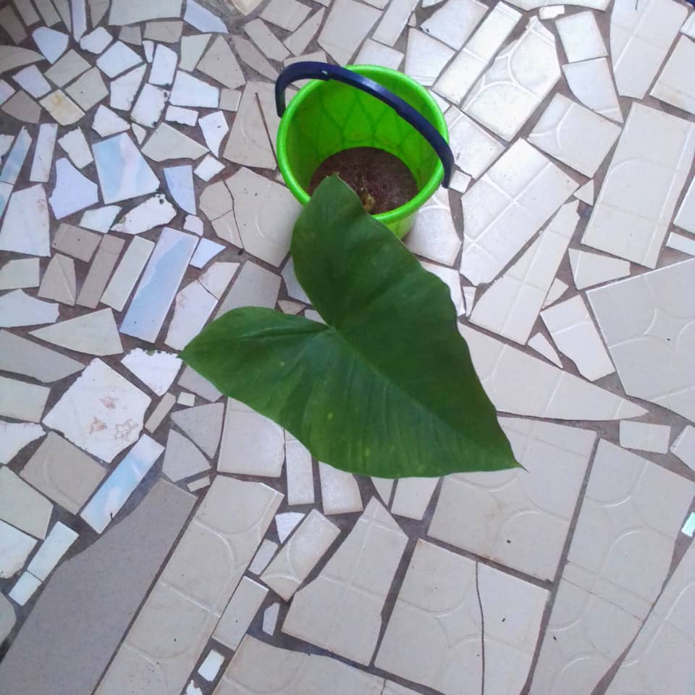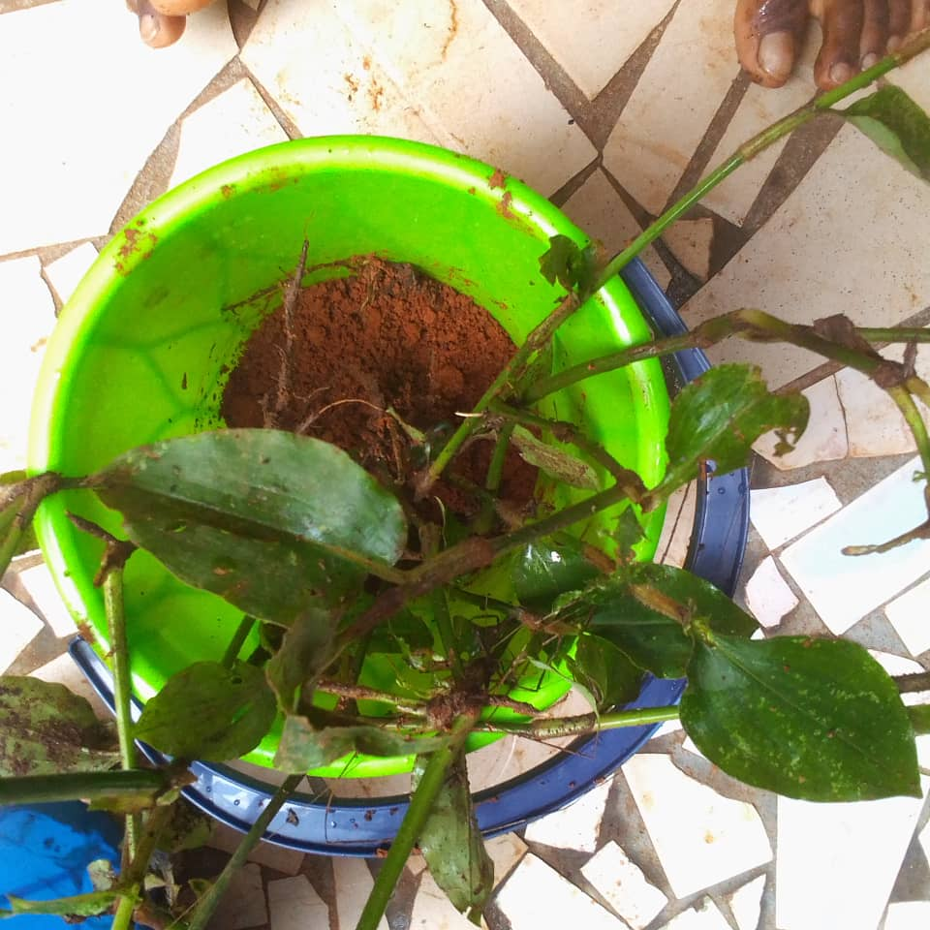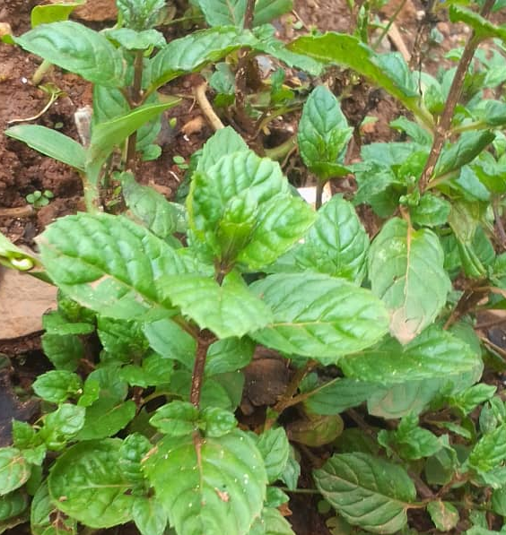
b
c
a
Fig. 1. The plants used a) cocoyam, b) tropical spider wort, c) water mint

2.2 Monitoring the desalination efficiency of the three plant
The experiments were conducted using 3 liters buckets and placed in a shady area free from rain (Fig. 2). Each plant has three buckets, one for each concentration used. Each bucket was filled with soil of mass 248.25g, contaminated with salt solution of desired concentrations and kept for 24 hours prior to planting of the plant to permit distribution of the salt throughout the soil. The growth performance of the plants were monitored for 4 weeks. The monitoring was done by checking the plants every after one week for new shoots as well as whether they withered or not. At the end of the 4th week (30 days) the plants were separated from the soil and the electrical conductivity (EC), total dissolved solids (TDS) and salinity of the wet soil determined using a PC60, PH/Cond/TDS/Sal/Tester. The percentage salt removal by each plant was calculated using following equation.

E = Cin – Cout/ Cin×100………………………. (1)
Where, Cin = initial parameter of saline water for each
Cout = final parameter of saline water (Bauer et al. 2021).

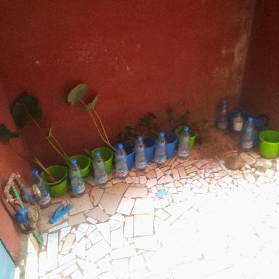
Fig. 2. Set-up to monitor the growth performance of each plant

3. RESULTS AND DISCUSSION
3.1 Monitoring shoot development and plant survival
After monitoring the plants for four weeks, the plants in the different concentrations were seen to have some changes. The plants were checked each week for shoot development as shown on Table 1, where it can be observed that some of the plants had new shoots in some of the concentrations while others in other concentrations showed not shooting. Those, which had new shoots, are represented with a 1 while those with no shoots are represented with a 0. While Tropical spiderwort and water mint had new shoots at all the tested concentrations, cocoyam did not have a shoot at lower concentration of 300 mg/L.

Table 1. Monitoring shoot development in each plant for the different concentrations tested
Plant type | Salt concentration | Weekly Observation (Shoot or no shoot (1or 0))  1 = new shoot; 0 = no shoot
 |  | Week 1 | Week 2 | Week 3 | Week 4
Cocoyam | 300 | 0 | 0 | 0 | 0
Cocoyam | 1000 | 1 | 0 | 1 | 0
Cocoyam | 5000 | 1 | 1 | 0 | 0
Tropical spiderwort | 300 | 1 | 1 | 0 | 0
Tropical spiderwort | 1000 | 1 | 1 | 0 | 0
Tropical spiderwort | 5000 | 0 | 1 | 0 | 0
Water mint | 300 | 0 | 1 | 0 | 1
Water mint | 1000 | 0 | 1 | 0 | 0
Water mint | 5000 | 0 | 0 | 1 | 0

Though water mint produced new shoots in the second week in nearly all the three concentrations, they started dying down (Fig. 3, a, b and c). As for the tropical spiderwort (week 1), in the bucket that was having the concentration 300 mg/L, there were new shoots while there were no shoots in the that which had 5000 mg/L, there were no shoots, instead, some leaves started drying off. The bucket which had 1000 mg/L had few new shoots not as many as the plant in the 300 mg/L bucket (Fig. 3 d, e and f). The cocoyam in the 300mg/L treatment was growing steadily with no new shoot, while that of 5000 mg/L had a new shoot with one of the first leaves drying up, but for that in the 1000 mg/L, there was also a new shoot with the first leave looking yellowish but didn’t wither (Fig. 3 g, h, I).
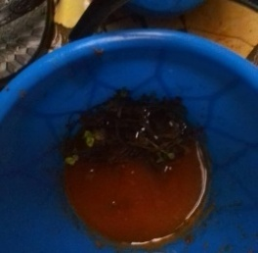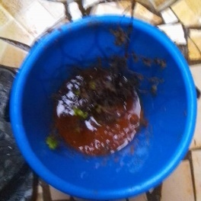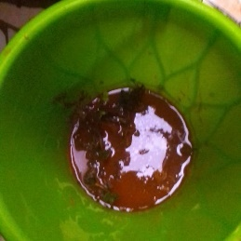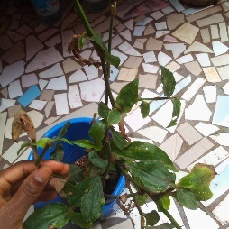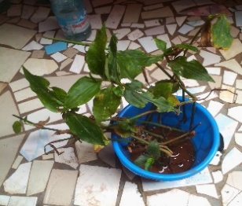
a
b
c
d
e
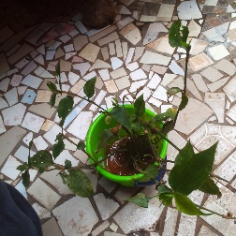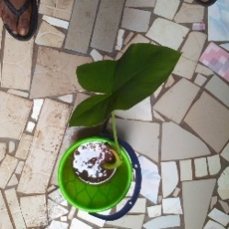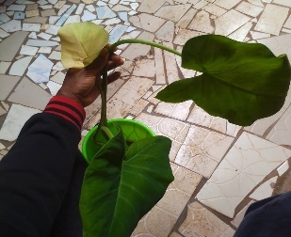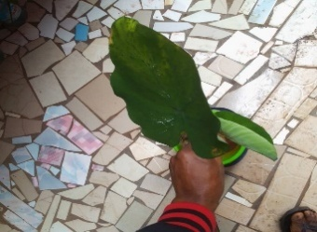
f
g
h
i
Fig. 3. Week one growth performance a) water mint at 300 mg/L b) water mint at 5000 mg/L c) water mint at 1000 mg/L, d) tropical spiderwort at 300mg/L e) tropical spiderwort at 5000 mg/L f) tropical spiderwort at 1000 mg/L g) cocoyam at 300 mg/L, h) cocoyam at 5000 mg/L i) cocoyam 1000 mg/L
Monitoring the plants after week two, it was discovered that water mint at 300 mg/L and that at 1000 mg/L had new shoots after the original leaves completely dried up while that at 5000 mg/L had no shoot and its original leaves had dried up (Fig. 4 a, b and c). For the tropical spiderwort, it was noticed that at 300 mg/L, 5000 mg/L and 1000 mg/L, there were still some new shoots (Fig.. d, e f). For the cocoyam, there was no shoot in the concentrations, 300 mg/L and 1000 mg/L, but there was a new shoot for that of 5000 mg/L (Fig. 4 g, h, i ).

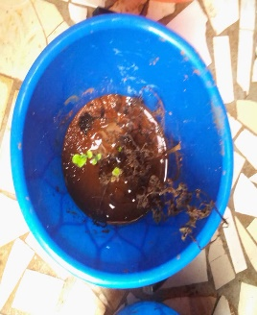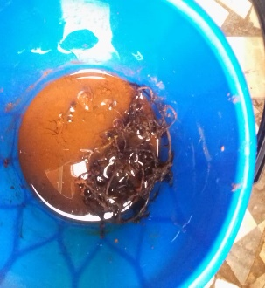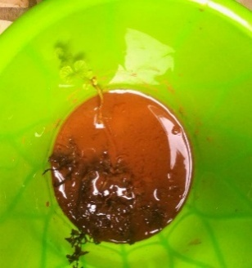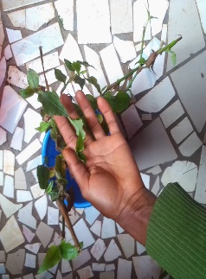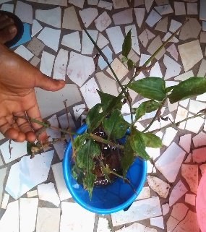
a
b
c
d
e
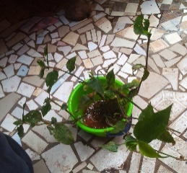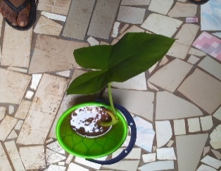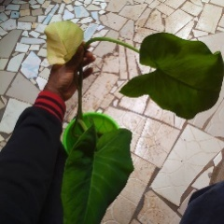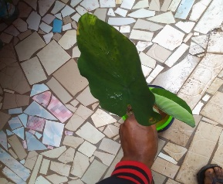
f
g
h
i
Fig. 5. Week two growth performance a) water mint at 300 mg/L b) water mint at 5000 mg/L c) water mint at 1000 mg/L, d) tropical spiderwort at 300 mg/L e) tropical spiderwort at 5000 mg/L f) tropical spiderwort at 1000 mg/L g) cocoyam at 300 mg/L h) cocoyam at 5000 mg/L i) cocoyam 1000 mg/L

After the third week, the water mint at concentration 300 mg/L and 1000mg/L had no new shoots but were steadily growing while that at 5000 mg/L had a new shoot (Fig. 6, a, b and c). For the plant tropical spiderwort, there was no shot for all the concentration, instead the leaves were dying up (Fig. 6 d, e and f). For the cocoyam, that in 300 mg/L and 5000mg/L had no new shoots while that in the 1000mg/L had a new shoot (Fig. 6 g, h, I).
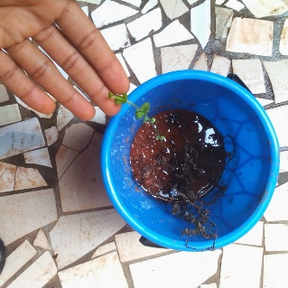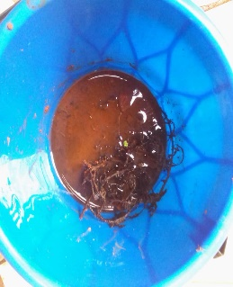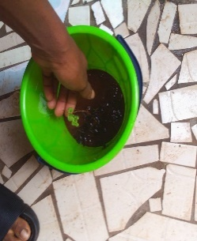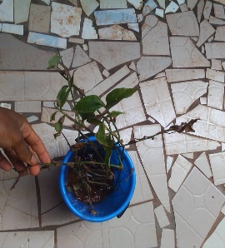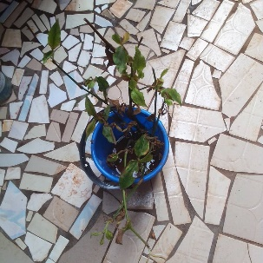
a
b
c
d
e
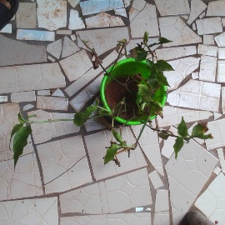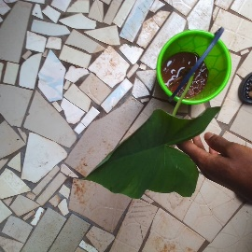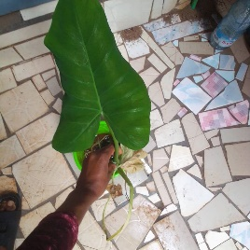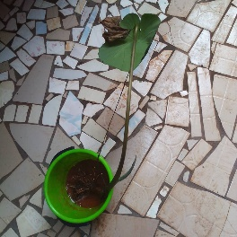
f
g
h
i
Fig. 6. week three growth performance a) water mint at 300 mg/L b) water mint at 5000 mg/L c) water mint at 1000 mg/L, d) tropical spiderwort at 300 mg/L e) tropical spiderwort at 5000 mg/L f) tropical spiderwort at 1000 mg/L g) cocoyam at 300 mg/L h) cocoyam at 5000mg/L I ) cocoyam 1000 mg/L

For the last week, which was week four, the water mint at 1000 mg/L and 5000 mg/L had no new shoots and the new shoot that came out at concentration 5000 mg/L on the third week was dying up while that at 300 mg/L had a new shoot after the previous shoot died off (Fig. 7.a, b and c). For tropical spiderwort, at concentrations, 1000mg/L and 5000mg/L, the plants died while that in 300mg/L was still having few green leaves but was dying too (Fig. 7 d, e and f). And for the cocoyam, there were no new shoots for any of the concentrations but the previous leaves were still surviving (Fig. 7 g, h, i).

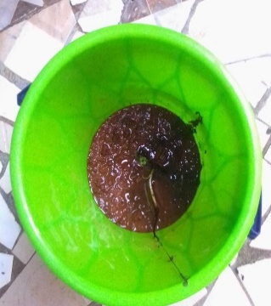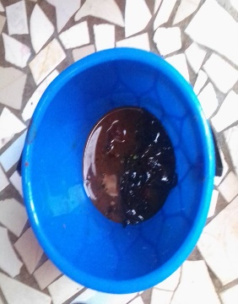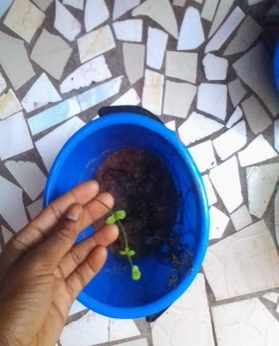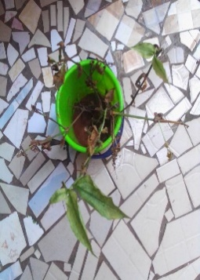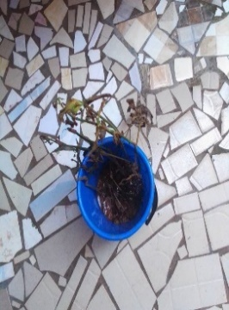
a
b
c
d
e
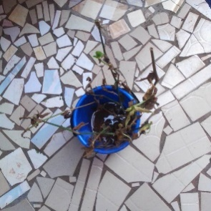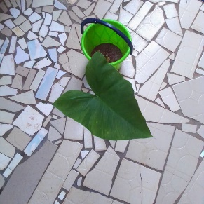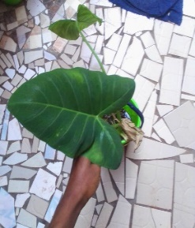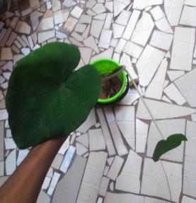
f
g
h
i
Fig. 7. week four growth performance a) water mint at 300 mg/L b) water mint at 5000 mg/L c) water mint at 1000 mg/L , d) tropical spiderwort at 300 mg/L e) tropical spiderwort at 5000 mg/L f) tropical spiderwort at 1000 mg/L g) cocoyam at 300mg/L h) cocoyam at 5000 mg/L i) cocoyam 1000 mg/L

3.2 Evaluating the efficiency of each plant in EC, TDS and salinity removal from the soil Results of the efficiency of each plant in improving the physico-chemical properties of the soil are presented in Fig. 8. At the end of the monitoring period (4 weeks), EC, TDS and salinity was measured. Fig. 8a present the results of EC, TDS and salinity removal efficiency by cocoyam, where it can observed that over 99 % of EC, TDS and salinity were removed at 5000 mg/L salt concentration. For 1000 mg/L concentration, removal efficiency was about 75 % for EC, TDS and salinity. Meanwhile for 300 mg/L salt concentration, about 70 % EC and TDS were removed compared to 68 % for salinity. Contrary to cocoyam, tropical spiderwort showed a reverse trend with over 91 % EC, TDS and salinity removal occurring at the lowest salt concentration of 300 mg/L and less than 40 % removal at 1000 and 5000 mg/L salt concentrations (Fig. 8b). However for water mint (Fig. 8c), over 89 % EC, TDS and salinity removal were recorded for 1000 mg/L salt concentration, about 72 % for 300 mg/L salt concentration and about 47 % for 5000 mg/L salt concentration. These results show cocoyam can remove salt from the soil and lower concentrations, tropical spiderwort only at lower concentrations, and water mint at lower and medium concentrations. This work demonstrates the suitability of cocoyam for soil desalination as it shows continuous growth at all the tested salt concentration, against tropical spiderwort and water mint that were drying off by week 4 (30 days).

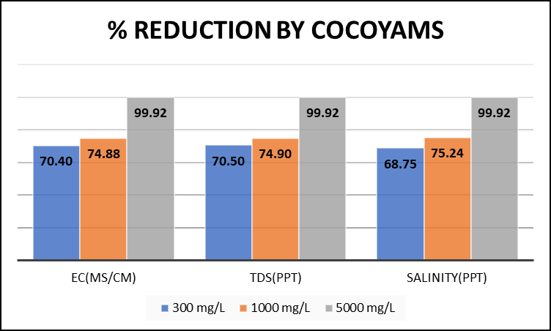
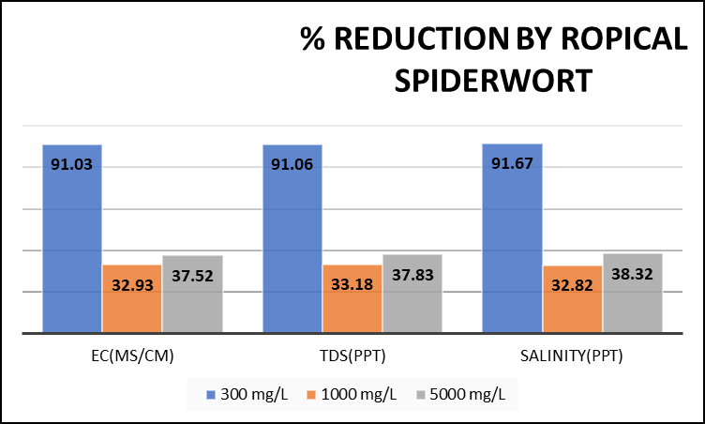
b
a
a
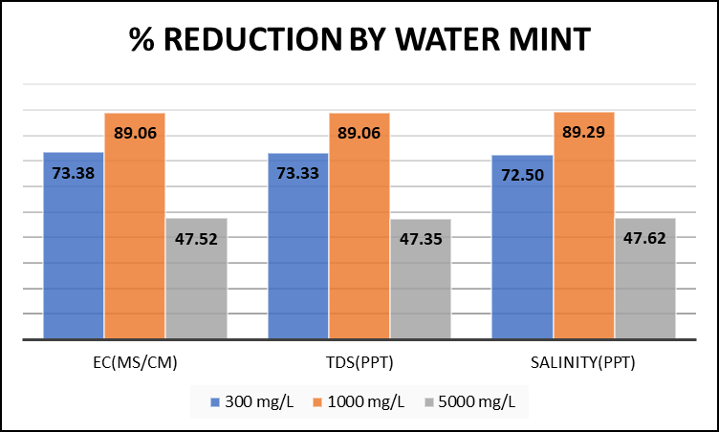
c

Fig. 8. Salt percentage reduction in 30 days a) cocoyam, b) tropical spiderwort c) water mint

4. CONCLUSION
This work investigated the growth performance of three local aquatic plants; cocoyam plant, tropical spiderwort and water mint under three soil salt concentrations of 300, 1000 and 5000 mg/L, then evaluate their efficiencies in the removal of the salt from the soil. The experiments were conducted for four weeks and while monitoring weekly for new shoots as well as whether they withered or not. At the end of the 4th week (30 days) the plants were separated from the soil and the electrical conductivity (EC), total dissolved solids (TDS) and salinity of the wet soil determined, and salt removal by each plant calculated. For the last week, it was observed that though water mint and tropical spiderwort had initially produced new shoots between week two and three at all the tested concentrations, they were all drying out in the fourth week. However, for the cocoyam, there were no new shoots on the fourth week but the plant was growing perfectly at all the tested concentrations. At the end of the monitoring period (4 weeks) also, the results of EC, TDS and salinity removal efficiency by cocoyam showed over 99 % of EC, TDS and salinity were removed at 5000 mg/L salt concentration. For 1000 mg/L concentration, removal efficiency was about 75 % for EC, TDS and salinity. Meanwhile for 300 mg/L salt concentration, about 70 % EC and TDS were removed compared to 68 % for salinity. Contrary to cocoyam, tropical spiderwort showed a reverse trend with over 91 % EC, TDS and salinity removal occurring at the lowest salt concentration of 300 mg/L and less than 40 % removal at 1000 and 5000 mg/L salt concentrations. However, for water mint, over 89 % EC, TDS and salinity removal were recorded for 1000 mg/L salt concentration, about 72 % for 300 mg/L salt concentration and about 47 % for 5000 mg/L salt concentration. These results show cocoyam can be very effective in removing salt from the soil at all concentration ranges without affecting its growth performance. However, tropical spiderwort can be effective only at lower concentrations, and water mint at lower and medium concentrations and they do not survive after the process. This work demonstrates the suitability of cocoyam for soil desalination as it shows continuous growth at all the tested salt concentration, against tropical spiderwort and water mint that were drying off by week 4 (30 days). The desalination efficiency is particularly important as it grows in a wide variety of conditions including paddies in wetland areas and in full sunlight or partial shade.

DISCLAIMER (ARTIFICIAL INTELLIGENCE)
Author(s) hereby declare that NO generative AI technologies and text-to-image generators have been used during writing or editing of this manuscript.

COMPETING INTERESTS
Authors declared that no competing or financial interests exist.

REFERENCES
Kafle, A., Timilsina, A., Gautam, A., Adhikari, K., Bhattarai, A., & Aryal, N. (2022). Phytoremediation: Mechanisms, plant selection and enhancement by natural and synthetic agents. Environmental Advances, 8, 100203. https://doi.org/10.1016/j.envadv.2022.100203
Singh, A. (2015). Soil salinization and waterlogging: A threat to environment and agricultural sustainability. Ecological Indicators, 57, 128–130. https://doi.org/10.1016/j.ecolind.2015.04.027
Dahaina, D. C., Mbaigane, J. C. D., Ouanmini, B., & Tsamo, C. (2024). Physico-Chemical Properties of Soils from Diguel and Koudalwa Tchad, and Phytoremediation Potentials of Acasia and Kinkeliba Plants in Removing Cr and Cu from These Soils. Journal of Environmental Science and Engineering A, 13, 165-177. https://doi.org/10.17265/2162-5298/2024.05.003
Dutta, D. P., & Nath, S. (2018). Low-cost synthesis of SiO2/C nanocomposite from corn cobs and its adsorption of uranium (VI), chromium (VI) and cationic dyes from wastewater. Journal of Molecular Liquids, 269, 140–151. https://doi.org/10.1016/j.molliq.2018.08.028
Ali, H., Khan, E., & Sajad, M. A. (2013). Phytoremediation of heavy metals—Concepts and applications. Chemosphere, 91(7), 869-881. https://doi.org/10.1016/j.chemosphere.2013.01.075
Poo, K.-M., Son, E.-B., Chang, J.-S., Ren, X., Choi, Y.-J., & Chae, K.-J. (2018). Biochars derived from wasted marine macro-algae (Saccharina japonica and Sargassum fusiforme) and their potential for heavy metal removal in aqueous solution. Journal of Environmental Management, 206, 364–372. https://doi.org/10.1016/j.jenvman.2017.10.056
Guo, L., Xie, Y., Sun, W., Xu, Y., & Sun, Y. (2023). Research Progress of High-Salinity Wastewater Treatment Technology. Water, 15(4), 684. https://doi.org/10.3390/w15040684
Maharaja, P., Boopathy, R., Anushree, V. V., Mahesh, M., Swarnalatha, S., Ravindran, B., Chang, S. W., & Sekaran, G. (2020). Bio removal of proteins, lipids and mucopolysaccharides in tannery hyper saline wastewater using halophilic bacteria. Journal of Water Process Engineering, 38, 101674. https://doi.org/10.1016/j.jwpe.2020.101674
Ashraf, S., Ali, Q., Zahir, Z.A., Ashraf, S., & Asghar, H.N. (2019). Phytoremediation: Environmentally Sustainable Way for Reclamation of Heavy Metal Polluted Soils. Ecotoxicology and Environmental Safety, 174, 714-727. https://doi.org/10.1016/j.ecoenv.2019.02.068
Gao, S., Liu, H., Wang, M., Xie, Y., Ding, J., & Wang, Y. (2022). Research progress in new treatment technology for high-salinity wastewater. Modern Chemical Industry, 42, 68–71.

