Chemical and Mineralogical Characterizations of Diatomite from Chad for their Valorization

.
ABSTRACT
Diatomite, a microporous siliceous rock, is mainly used in northern Chad for building houses due to its abundance and thermal insulation properties. However, the industrial potential of this valuable material is under-exploited due to a lack of comprehensive physical and chemical characterization. The objective of this study is to determine the chemical and mineralogical properties of Chadian diatomite deposits in order to assess their potential for more diversified industrial applications. Six samples of diatomite were collected around the town of Mao (Kanem region) and characterized using X-ray fluorescence (XRF) and X-ray diffraction (XRD). Chemical analyses show that the samples are mainly composed of silica (SiO₂), with contents ranging from 49.94 to 88.97%, with significant amounts of alumina (Al₂O₃, 3.48–5.62%) and iron oxide (Fe₂O₃, 1.32–3.37%). Two deposits (Koulola and Youlo) are distinguished by high calcium oxide (CaO: 13.08% and 5.46%) and magnesium (up to 4.38%) contents, suggesting limestone contamination. Mineralogical analyses (Rietveld method) confirm the dominance of quartz (30.05–83.89%) in most samples, as well as the presence of illite, plagioclase and hematite. Notably, the Koulola deposit is dominated by plagioclase (41.93%) rather than quartz. Comparison with industry specifications reveals that the Djoulou, Mobye, Motto and Tchidi deposits, with silica contents exceeding 78%, are particularly suitable for use in less demanding applications than filtration, such as mineral fillers, abrasives and thermal insulation. This study provides the first database for promoting the exploitation of these resources in Chad.

Keywords: Diatomite, Chad, Characterization, Chemical and Mineralogical properties, Valorization.
1. INTRODUCTION
Diatomite (SiO₂⋅nH₂O), also known as diatomaceous earth, are light, porous siliceous sedimentary rocks composed mainly of fossilized frustules of single-celled algae (diatoms) (Arik, 2003; Korunic Z., 1998; Paschen, 1986). Their unique structure gives these rocks high porosity (up to 90% voids) (Lemonas, 1997), low density and a large specific surface area. These characteristics make it a versatile material that is highly prized in many industrial applications, particularly as a filtration medium (beverages, chemicals), as an absorbent, as a filler for plastics and paints, or as a thermal insulator (Bakr & Elden, 2010; Jonas et al., 2023; Reka et al., 2014).
Although diatomite has a remarkable set of physical, chemical and mineralogical properties, its composition varies significantly depending on its geological origin and the degree of contamination by impurities such as clays, carbonates and iron oxides. Chad has significant deposits of diatomite, particularly in the Kanem region. Currently, exploitation of this resource is rudimentary and local, limited almost exclusively to the manufacture of bricks for housing construction in the north of the country (Jonas et al., 2023). This underutilization is due to the lack of precise characterization data, which is essential for its integration into more structured industrial sectors.
The characterization of diatomite is essential to determine their suitability for various industrial applications. It requires the accurate quantification of major oxides (particularly silica) and secondary mineral phases (clays, and carbonates) that act as impurities.
This research aims to address this lack of data by characterizing the chemical and mineralogical properties of six diatomite deposits sampled in the Mao region, in northwestern Chad. The results obtained will be compared with the specifications and operating ranges in force in producing countries in order to establish a local database and assess the industrial development potential of these natural resources.
2. material and methods
Raw diatomite samples were collected from six (6) separate quarries located approximately the town of Mao, in northwestern Chad, in the Kanem region. These sites are locally known for the artisanal exploitation of the material in the manufacture of building bricks. Representative composite samples (approximately each) were collected from each deposit. The six sampling sites and their geographical coordinates are listed in Table 1 and their locations are mapped in Figure 1.
Table 1: Geographical coordinates of six diatomite-sampling sites
Sampling sites | Site abbreviations | Geographical coordinates
Sampling sites | Site abbreviations | Latitudes | Longitudes
Diatomite from Djoulou | DD | 14.12418532 | 15.39092795
Diatomite from Koulola | DK | 14.09649670 | 15.32784601
Diatomite from Mobye | DM | 14.10834213 | 15.32317897
Diatomite from Motto | DMo | 14.11986662 | 15.30248061
Diatomite from Tchidi | DT | 14.09371776 | 15.31411060
Diatomite from Youlo | DY | 14.14272835 | 15.30461716
Figure 2 shows a map of diatomite extraction sites in the Mao region in northwestern Chad.
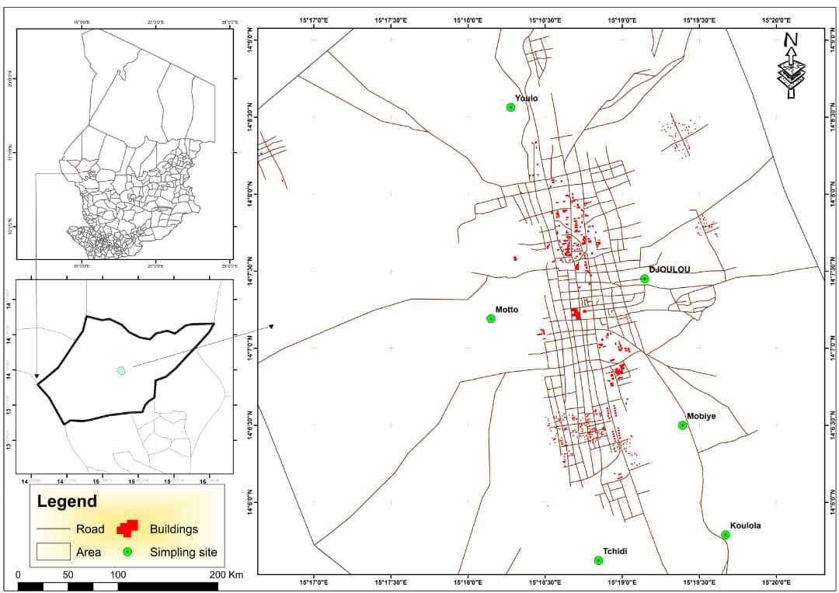
Fig.1: Map showing the locations of diatomite sample collection sites
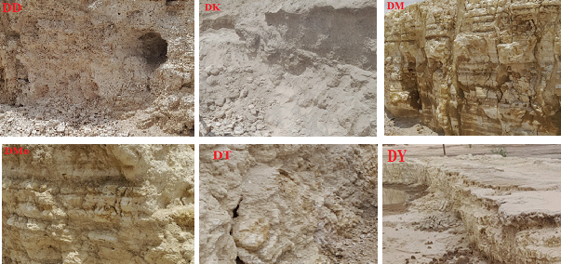
Fig. 2: Six diatomite deposits studied
The raw samples were dried in the open air, then crushed and finely ground using an agate mortar to obtain homogeneous powders. A fraction of each sample was dried at 105°C for 24 hours for chemical analysis.
2.1 Determination of chemical composition (XRF)
X-ray fluorescence (XRF) spectrometric analysis was performed on the dried samples to determine the concentration of major and minor oxides. The analyses were performed using a Philips Magix Pro spectrometer (PW-2440) at the Geoscience Laboratory of the University of Johannesburg (South Africa). The samples were prepared in the form of vitrified pellets to ensure matrix homogeneity.
The analysis made it possible to quantify the elemental composition (in mass percentage of oxides) and to determine the Loss on Ignition (LOI) by gravimetric after calcination at 1000∘C. Data relating to oxides and geochemical indices (in particular the chemical alteration index, CIA) are reported in section 3.1.
2.2 Determination of mineralogical composition (XRD)
The mineralogical composition of diatomite was determined by X-ray diffraction (XRD) on disoriented powders. The apparatus used was a Philips diffractometer (PW-1710 diffractometer applying Cu-radiation) equipped with a copper anti-cathode tube (CuKα; λ=1.5406 λ=1.5406 Å). The samples were scanned in the 2θ angular range from 5∘ to 80∘ with a step size of 0.0167 (2θ) and a counting time of 85.725 s.
The diffraction peaks were determined in accordance with Bragg's law: 2dSinθ = nλ, where d is the interplanar spacing, θ is the half-angle of deviation, n is the reflection order (usually n=1) and λ is the wavelength of the X-rays (Phillips & Das, 1997).
The mineral phases were identified by comparison with data from the Powder Diffraction File (PDF, formerly ASTM) database (Phillips & Das, 1997). Semi-quantitative mineral quantification was performed using the Rietveld method (Pillière, 2002), developed under the Maud programmer, which minimizes the error between the measured diffract gram and the calculated diffract gram.
3. results and discussion
3.1 Chemical analyses
Table 2 presents the geochemical compositions of the six Chadian diatomite samples, including loss on ignition (LOI) and relevant geochemical ratios, compared with bibliographic data. The six samples are mainly composed of silica (SiO₂), alumina (Al₂O₃) and iron oxide (Fe₂O₃), with traces of BaO, CaO, K₂O, MgO, MnO, Na₂O, P₂O₅ and TiO₂.
Table 2: Chemical data for diatomite samples collected and some references
Chemical composition (%) | Samples |  |  |  |  |  | (Al-Ghouti et al., 2007; Flores-Cano et al., 2013; Ibrahim & Selim, 2012; Safa et al., 2012; Yuan et al., 2004)
Chemical composition (%) | DD | DK | DM | DMo | DT | DY | China | Egypt | Algeria | Mexico | Morocco
Al2O3 | 5.62 | 3.70 | 3.48 | 5.08 | 3.93 | 3.52 | 5,75 | 4.24 | 5.3 | 13.52 | 7.3
BaO | - | 0.06 | - | - | - | - | - | - | - | - | -
CaO | 0.34 | 13.08 | 0.43 | 0.54 | 0.47 | 5.46 | 0.24 | 6.17 | 7.2 | 0.66 | 10
Fe2O3 | 2.80 | 3.37 | 2.20 | 1.97 | 1.32 | 2.42 | 1.41 | 1.07 | 3.8 | 3.37 | 4.3
K2O | 1.16 | 2.17 | 0.40 | 0.45 | 0.39 | 1.47 | 0.06 | - | 0.54 | 0.3 | 1.2
MgO | 0.37 | 4.38 | 0.20 | 0.20 | 0.16 | 1.74 | 0.21 | - | 2.6 | 0.42 | 1.0
MnO | - | 0.25 | - | - | - | 0.11 | - | - | - | - | -
Na2O | 0.90 | 3.09 | 0.08 | 0.07 | 0.24 | 1.29 | 0.06 | - | 0.65 | 0.17 | 1.8
P2O5 | 0.12 | 0.12 | - | - | - | 0.11 | - |  | - | - | -
SiO2 | 82.93 | 49.94 | 88.97 | 85.46 | 88.81 | 74.53 | 82.95 | 83.6 | 72.1 | 70.38 | 72.0
SO3 | 0.14 | 0.81 | - | 0.30 | 0.44 | 0.39 | - | - | - | - | -
TiO2 | 0.29 | 0.25 | 0.21 | 0.31 | 0.25 | 0.24 | 0.69 | - | 0.37 | - | -
LOI | 5.34 | 18.29 | 4.00 | 4.42 | 4.01 | 8.32 | 7.93 | 4.86 | 7.44 | 11.18 | 2.4
Sum | 100 | 99.50 | 100 | 98.81 | 100 | 98.2 | 99.3 | 99.94 | 100.0 | 100.0 | 100.0
$\frac{{SiO}_{2}}{{Al_{2}O}_{3}}$ | 14.75 | 13.49 | 25.5 | 16.82 | 22.59 | 21.2
$\frac{{SiO}_{2}}{{Al_{2}O}_{3}+{{Fe}_{2}O}_{3}}$ | 9.84 | 7.06 | 15.66 | 12.12 | 16.91 | 12.6
CIA | 69.46 | 16.78 | 79.27 | 82.73 | 78.13 | 29.9
3.2.1 Major oxide contents
In general, silica (SiO₂) content is dominant, ranging from 49.94% to 88.97%. The lowest content is observed in sample DK (49.94%), while the highest is in sample DM (88.97%). The DD, DM, DMo and DT deposits have SiO₂ contents above 78%. The alumina (Al₂O₃) and iron oxide (Fe₂O₃) contents are relatively low and homogeneous (3.48–5.62% and 1.32–3.37% respectively).
The DK sample has a unique composition, distinguished by very high levels of calcium oxide (CaO: 13.08%), magnesium oxide (MgO: 4.38%) and loss on ignition (LOI: 18.29%). These values strongly indicate the presence of carbonate phases (calcite, dolomite) or other calcium-magnesium minerals, which constitute significant impurities in relation to silica. The DY sample also has higher CaO (5.46%) and LOI (8.32%) contents than other siliceous diatomites.
3.2.2 Geochemical indices and recovery potential
Industrial recovery criteria are paramount. For high-purity filtration, the requirements are strict: SiO₂>90% and Fe₂O₃<1.3% (Delfau, 1979; Haddoum et al., 2014; Indira, 2011). None of the raw samples meets these criteria.
However, for use as mineral fillers or abrasives (less noble applications), the criteria are more flexible (Delfau, 1979; Indira, 2011; Meradi, 2015): SiO₂ between 70% and 90%, Al₂O₃ between 2% and 10% and Fe₂O₃ around 5% (max). DM, DMo, DT and DD deposits (with SiO2>78%) meet these specifications. These results are consistent with the compositions of diatomites marketed by other producing countries (Ipekoğlu & Mete, 1990; Meradi, 2015).
The SiO₂/Al₂O₃ ratios (greater than 13 for siliceous samples) indicate a marked enrichment in silica (Bhatia & Crook, 1986), confirming the nature of these materials. The chemical alteration index (CIA), calculated from the chemical composition, shows high values for DD (69.46), DM (78.27), DMo (82.73) and DT (78.13), indicating that these deposits have undergone prolonged and significant chemical alteration (Babechuk et al., 2014). Conversely, the low values for DK (16.78) and DY (29.98) reflect either a low degree of alteration or masking of this index by the incorporation of unaltered primary minerals, such as carbonates and plagioclase (confirmed by XRD).
3.2 Mineralogical analyses
X-ray diffract grams (Figures 3, 4 and 5) were used to identify the crystalline phases contained in the raw samples. The six diatomite are polyphasic, composed mainly of quartz (SiO₂), clay minerals (illite, kaolinite) and feldspars (plagioclase, K-feldspar). The presence of hematite (Fe2O3) and traces of other minerals confirms the heterogeneity of the samples.
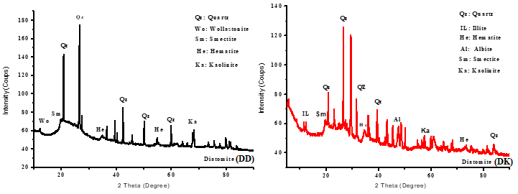
Fig. 3: X-ray diffraction patterns of raw diatomites (DD) and (DK)
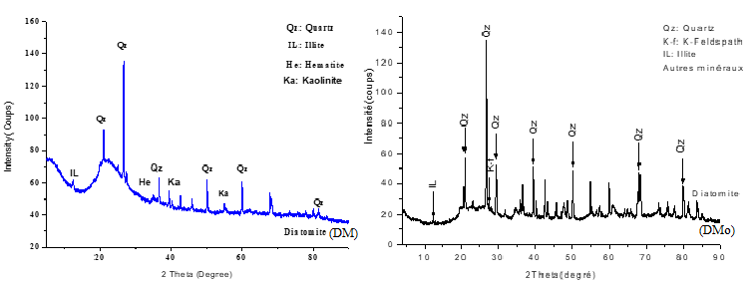
Fig. 4: X-ray diffraction patterns of raw diatomites (DM) and (DMo)
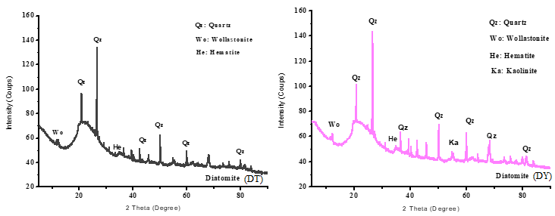
Fig. 5: X-ray diffraction patterns of raw diatomites (DT) and (DY)
Table 3 presents the semi-quantitative estimates of minerals obtained using the Rietveld method.
Table 3: Quantitative estimation of minerals in six samples
Samples | Illite % | K-feldspar % | Plagioclase  % | Kaolinite % | Quartz % | Hematite % | Other minerals %
DD | 10.05 | 6.87 | 1.69 | - | 73.36 | 5.75 | 2.28
DK | 11.79 | 9.06 | 41.93 | - | 30.05 | 5.82 | 1.53
DM | 3.46 | 2.37 | 2.13 | 2.43 | 83.85 | 4.51 | 1.27
DMo | 3.90 | 2.67 | 2.68 | 5.42 | 78.33 | 4.04 | 2.96
DT | 3.38 | 2.31 | 2.33 | 3.49 | 83.19 | 2.71 | 2.59
DY | 7.73 | 5.71 | 19.11 | - | 60.64 | 4.97 | 1.84
- Mineralogical estimation and chemical consistency
Quantitative estimation confirms the dominance of quartz in the DD, DM, DMo and DT samples, with contents ranging from 73.36% to 83.85%. Quartz, being the crystalline form of silica, is the key mineral sought in diatomite. The high quartz content is directly correlated with the high SiO₂ content observed by XRF for these four deposits.
The DK sample is the exception, where plagioclase (41.93%) is dominant, followed by quartz (30.05%). This predominance of plagioclase (a calcium-sodium mineral) is perfectly consistent with the high CaO and Na₂O levels measured in chemical analysis (Table 2), reinforcing the hypothesis of contamination by detrital minerals.
Other minerals identified, such as illite (3.38–11.79%) and feldspars, as well as hematite (iron oxide), are the main sources of impurities. Hematite (2.71–5.82%) is responsible for the Fe₂O₃ content and often influences the color of the rock.
In conclusion, mineralogical analyses confirm that the DD, DM, DMo and DT deposits are mainly siliceous diatomite, while the DK and DY samples are diatomite that are more contaminated with secondary mineral phases, which is crucial for any mining decision.
4. Conclusion
Diatomite is a multifaceted mineral resource, but its use in Chad is currently limited to local construction due to a lack of precise data on its properties. In response to this observation, six diatomite deposits in the Mao region underwent in-depth chemical and mineralogical characterization.
XRF analyses revealed that silica (SiO₂), alumina (Al₂O₃) and iron oxide (Fe₂O₃) are the major oxides in all samples. However, the DK (Koulola) and DY (Youlo) samples are distinguished by significantly higher percentages of calcium oxide and magnesium oxide, accompanied by high loss on ignition, indicating contamination by carbonate phases. The chemical alteration index (CIA) confirmed a more advanced degree of alteration for the Djoulou, Mobye, Motto and Tchidi deposits.
Mineralogical analyses by XRD identified and quantified the dominance of quartz in the DD, DM, DMo and DT deposits (quartz content >73%), in contrast to the DK sample, where plagioclase is the dominant mineral (41.93%).
Compared to industrial standards, the four deposits (DD, DM, DMo and DT) have silica and impurity contents that, although below the strict requirements for high-purity filtration, make them perfectly suitable for use in less demanding applications. They meet the specifications for use as fillers, abrasives or thermal insulation materials. The DK and DY deposits, due to their high limestone contaminant content, would require purification steps or would be directed towards applications specific to limestone diatomite.
The results of this study provide a solid scientific basis for promoting and guiding the industrial exploitation of Chadian diatomite.

References
Al-Ghouti, M. A., Khraisheh, M. A. M., Ahmad, M. N., & Allen, S. J. (2007). Microcolumn studies of dye adsorption onto manganese oxides modified diatomite. Journal of Hazardous Materials, 146(1-2), 316-327. https://doi.org/10.1016/j.jhazmat.2006.12.024
Babechuk, M. G., Widdowson, M., & Kamber, B. S. (2014). Quantifying chemical weathering intensity and trace element release from two contrasting basalt profiles, Deccan Traps, India. Chemical Geology, 363, 56-75. https://doi.org/10.1016/j.chemgeo.2013.10.027
Bakr, G. M. M., & Elden, H. (2010). Diatomite: Its Characterization, Modifications and Applications. Asian Journal of Materials Science, 2(3), 121-136. https://doi.org/10.3923/ajmskr.2010.121.136
Bhatia, M. R., & Crook, K. A. W. (1986). Trace element characteristics of graywackes and tectonic setting discrimination of sedimentary basins. Contributions to Mineralogy and Petrology, 92(2), 181-193. https://doi.org/10.1007/BF00375292
Delfau, M. (1979). Diatomite - Mémento substances utiles (matériaux de carrière). http://infoterre.brgm.fr/rapports/79-SGN-158-MTX.pdf
Flores-Cano, J. V., Ramos, R. L., Padilla-Ortega, E., & Mendoza-Barron, J. (2013). Adsorption of Heavy Metals on Diatomite: Mechanism and Effect of Operating Variables. Adsorption Science & Technology https://doi.org/10.1260/0263-6174.31.2-3.275
Haddoum, S., Selmi, E. H., & Chitour, C. E. (2014). Élaboration de catalyseurs à base de bentonite et de kieselguhr pour le craquage catalytique des coupes pétrolières. Comptes Rendus Chimie, 17(7-8), 746-751. https://doi.org/10.1016/j.crci.2014.03.017
Ibrahim, S. S., & Selim, A. Q. (2012). Heat treatment of natural diatomite. Physicochemical Problems of Mineral Processing https://doi.org/10.5277/ppmp120208
Indian Bureau of Mines. (2011). *Indian Minerals Yearbook, Part II, 50th Edition*. Ministry of Mines, Government of India. http://ibm.nic.in/index.php?c=pages&m=index&id=107
Ipekoğlu, U., & Mete, Z. (1990). Determination of the properties of various diatomite deposits within Aegean Region of Turkey. Geologija, 33(1), 447–459. https://doi.org/10.5474/geologija.1990.011
Jonas, T., Ngamsou, D. T., Samson, M., Soultan, M., Nanimina, A. M., Lamaï, N., & Querry, M. (2023). Influence of Diatomite on the Physico-Mechanical Properties of Compressed Earth Blocks. Physical Science International Journal, 27(3), 38-50. https://doi.org/10.9734/psij/2023/v27i37794
Lemons, J. F. (1997). Diatomite. *American Ceramic Society Bulletin*, *76*(6), 92.
Meradi, H. (2015). Contribution to characterization of the diatomite for industrialapplication. https://www.academia.edu/123298843/Contribution_to_characterization_of_the_diatomite_for_industrialapplication
Phillips, R. J., & Das, S. K. (1997). Improved a fax mould fluxes for high speed casting with emphasis on special requirements for thin slab casting. 51st ATM - 35th NMD of the Indian Institute of Metals at Jamshedpur.
Pillière, H. (2002). L’analyse par diffraction de RX, Mesures 746.
Reka, A. A., Anovski, T., Bogoevski, S., Pavlovski, B., & Boškovski, B. (2014). Physical-chemical and mineralogical-petrographic examinations of diatomite from deposit near village of Rožden, Republic of Macedonia. Geologica Macedonica, 28(2), 121–126. https://js.ugd.edu.mk/index.php/GEOLMAC/article/view/920
Safa, M., Larouci, M., Meddah, B., & Valemens, P. (2012). The sorption of lead, cadmium, copper and zinc ions from aqueous solutions on a raw diatomite from Algeria. Water Science and Technology: A Journal of the International Association on Water Pollution Research, 65(10), 1729–1737. https://doi.org/10.2166/wst.2012.183
Yuan, P., Wu, D., He, H., & Lin, Z. (2004). The hydroxyl species and acid sites on diatomite surface: A combined IR and Raman study. Applied Surface Science https://doi.org/10.1016/j.apsusc.2003.10.031

