AI-GUIDED DRUG REPURPOSING FOR NEURODEGENERATIVE AND NEUROINFLAMMATORY DISEASES

ABSTRACT:
The use of AI and ML has significantly updated how drugs are repurposed. Both AI and ML aid in faster drug repurposing than traditional methods and lower costs by analyzing both old and new drugs in a more data-driven approach than by random selection. The update of drug use through new therapeutic applications will be particularly beneficial to diseases that are both neurodegenerative (such as Alzheimer's and Parkinson's disease) and neuroinflammatory (such as multiple sclerosis and amyotrophic lateral sclerosis and others), because of their complexity and historical problems with traditional drug development. The integration of multi-omics datasets has allowed AI-based platforms to provide mechanisms for identifying novel drug-to-target-to-disease relationships. For example, platforms such as DeepDrug, COMIC, and DrugPipe use deep learning and knowledge graphs to create more advanced connections between drugs, targets, and diseases than possible through traditional methods. By using a systems biology approach and combining information across multiple omics (genomics, transcriptomics, proteomics, metabolomics, etc.), we gain a better understanding of the disease process at a mechanistic level and build computer models that can predict drug efficacy in treating diseases. Case studies highlight drug repurposing candidates such as aspirin and promethazine to reduce neuroinflammation and oxidative stress. While the use of AI to guide repurposing of drugs is rapidly evolving, there remain significant challenges in clinical validation, the ability to make sense of complex model outputs (interpretability), and the need to establish standard protocols for clinical validation. Recent advancements in explainable AI, federated learning, and network pharmacology offer a solution to these challenges and will support the continued adoption of AI-guided drug repurposing in the near future. AI-guided drug repurposing combined with Systems Biology is a new direction for drug discovery in Neuropharmacology that offers new opportunities for accelerating drug discovery and improving patient outcomes for neurodegenerative diseases and other debilitating disorders.
- INTRODUCTION:
The discovery of new treatments for many diseases is difficult and expensive, especially neurodegenerative and neuroinflammatory diseases like Alzheimer’s Disease, Parkinson’s Disease, Multiple Sclerosis, and Amyotrophic Lateral Sclerosis. The complicated causes and effects of these diseases and limited ways to treat them are extremely challenging to address using traditional drug discovery. Drug discovery has historically taken over a decade and cost millions, and has had very high failure rates in finding treatments that change the course of the disease [1]. The rise of drug repurposing, which finds new uses for already marketed drugs, has become a newer and more promising way to find new treatments for patients faster and at a lower cost . The use of artificial intelligence (AI) and machine learning (ML) in drug repurposing has transformed the way we think about drug development by providing computational tools for integrating multi-faceted biomedical data types (e.g., genomics, proteomics, EHRs, and published science) to find new ways to connect drugs, targets and diseases [2]. Through the use of AI technologies like deep neural networks, graph learning models and natural language processing (NLP), AI drug repurposing is able to model intricate biological systems and predict new drug-disease interactions [3, 4].
AI-driven frameworks, such as DeepDrug and COMIC, illustrate the new generation of multi-modal & explainable AI systems that facilitate the repurposing of drugs using AI analytics methodologies. For example, through an integration of prior knowledge of experts and the use of biomedical graphs, DeepDrug identifies novel synergistic combinations of drugs that are predicted to treat Alzheimer's Disease (AD) by targeting neuroinflammation, mitochondrial dysfunction, and glucose metabolism [5, 6]. In a similar fashion, COMIC employs contrastive masking combined with explainable AI processes to identify pathways associated with drugs and their relationships with diseases, resulting in improved clinical interpretability and trust in the predictions generated by AI-based systems [7]. AI has already shown immense potential for identifying drug candidates targeting multiple pathogenic mechanisms associated with neurodegenerative disorders (such as neuroinflammation and oxidative stress) through multi-omics data analysis, including anti-inflammatory drugs and anti-diabetic agents repositioning opportunities for Alzheimer's Disease (AD) and Parkinson's Disease (PD) [8]. AGATHA serves as an example of this type of capability by mining data from large biomedical literature databases to identify gene-disease-drug relationships related to treating dementia [9]. AI is also crucial for neuroinflammatory diseases, with the use of machine learning models being employed to combine transcriptomic data and clinical biomarkers to identify potential immunomodulatory agents for Multiple Sclerosis (MS) and similar disorders [10] . Explainable AI approaches, integrating knowledge graphs and ontologies, further enable transparency in the repurposing process by elucidating the underlying biological rationale of AI predictions [11].
AI-driven drug repurposing is currently in its infancy but is being aided by integrating multi-omic data, high-throughput screening, and graph neural networks (GNN). The advances that tools such as DrugPipe have made in facilitating the rapid identification of new ligands and in assisting with the prioritization of approved compounds for repurposing without the need for structural information create potential for drug repurposing in diseases with multiple mechanisms [12]. It is important to note that additional knowledge graph-based models, such as rd-Explainer [4, 11], have shown the ability to perform the same operations by creating verifiable and transparent hypotheses for drug repurposing in both rare and neuroinflammatory diseases. The challenges facing AI-driven drug repurposing are similar to those facing other AI systems, such as heterogeneity of data, lack of interpretability of models, and regulatory barriers to entry into the clinical environment. However, as the integration of AI-driven analytics with the increasing availability of biomedical databases and clinical validation takes place, there will no longer be any barriers to expanding the field of precision neuropharmacology and an opportunity for increasing the rate of discovery for new treatments for neurodegenerative and neuroinflammatory diseases [13, 14].
- OVERVIEW OF DRUG REPURPOSING
Repositioning drugs for new indications (drug repurposing) is the identification of new therapeutic uses for drugs that already exist, either approved or previously abandoned. The drug repurposing process allows a much faster and more affordable alternative to the traditional (de novo) drug discovery process, which typically takes approximately 10 years and costs about $2.6 billion to bring a drug to market [15]. Drug repurposing has significant advantages due to the ability to utilize existing pharmacokinetic, pharmacodynamic, and safety information, thus decreasing time and cost to develop new medicines while increasing the likelihood of successful clinical translation of drugs.
  - Evolution and Rationale of Drug Repurposing
To put it another way; the old way of developing drugs is facing challenges because there are so many drugs that never make it through the entire process. There has been an especially high failure rate seen in Drug Development for diseases of Neurodegeneration and Neuroinflammation where the complicated nature of the problem and the fact that these diseases have more than one cause makes it harder to find good targets [8]. One way around these difficulties has come from Drug Repurposing, which involves taking drugs that have already been approved for use and targeting them to work on different diseases. As an example, Baricitinib, a medication originally used for the treatment of rheumatoid arthritis that works on the JAK1/JAK2 (Janus Kinase) receptors, was recently found to be an effective treatment for COVID-19 as a result of developing new ways through computer modeling of how to use existing medications for new diseases [15].
  - Computational and AI-driven Approaches in Drug Repurposing
New technologies have created new ways to make the Drug Repurposing Process much easier through AI, ML and DL methods. AI is capable of examining very large amounts of data that includes not only genomic information but also transcriptomic information, proteomic information, and Clinical Data in order for AI to help make new associations between drugs and diseases [10]. One good example of this is a mechanism developed called DeepDrug that utilizes AI and uses Graph Neural Networks and Biomedical Knowledge Graphs to predict drugs that will work synergistically together on Alzheimer ’s disease. Another example of this type of technology is a pipeline called DrugPipe that uses AI and a generative model for virtual screening to search Drug Target Interactions, through Predicted Binding Pocket Structures and similarity based searches for Under Utilized Drug-Target Interactions [12] . Moreover, knowledge graph-based AI systems, such as Hetionet and rd-explainer, integrate biomedical ontologies to enhance interpretability and provide knowledge-infused explanations for AI predictions [4, 11]. These approaches allow the identification of biologically plausible drug-target mechanisms that can be experimentally validated, fostering trust and transparency in AI-driven discoveries.
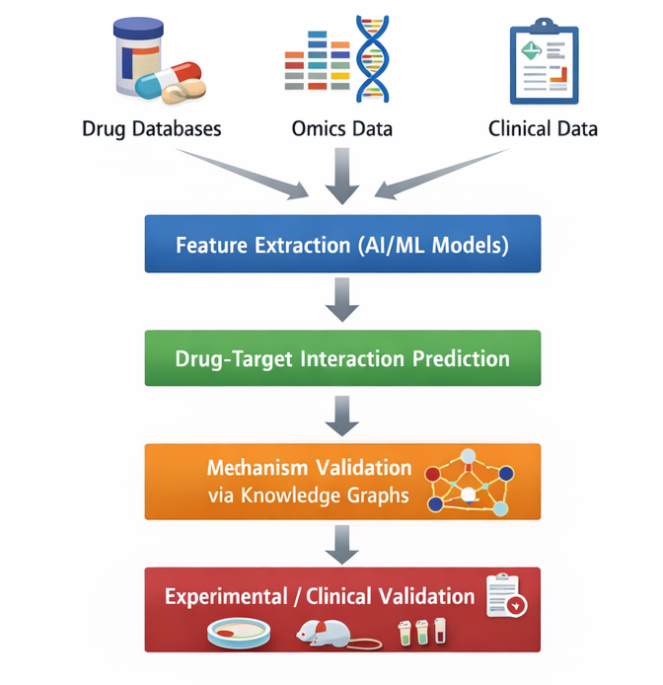
Figure 1 AI-Guided Drug Repurposing Workflow
  - Data-Driven Drug Repurposing Platforms
Numerous literature-mapping solutions exist that integrate multiple omics data and utilize automated Literature Mining Techniques (ALMT) through Artificial Intelligence (AI) such as AGATHA, which result in establishing Drug-Disease Relationships (DDR). In particular, through exhaustive exploration, the development of these tools has enabled the exploration and identification of novel drug-to-disease correlations in the area of neurodegenerative diseases [9]. One example of such an application is the ability of generative models together with natural language processing to identify correlations between therapeutic agents and potential indications [3]. The table below summarizes major computational methods used in modern AI-driven drug repurposing.
TABLE 1. Approaches used in AI-driven drug repurposing

Approach | Description | Example Tools/Models | Key Applications
Knowledge Graph AI | Integrates biomedical ontologies to predict drug-disease links | Hetionet, rd-explainer | Rare diseases, neurodegenerative disorders
Deep Learning (GNN) | Learns drug-target-pathway interactions using graph embeddings | DeepDrug | Alzheimer’s, Parkinson’s
Generative AI | Produces new molecular structures based on known scaffolds | DrugPipe | Virtual screening of new targets
NLP/Text Mining | Extracts associations from scientific literature | AGATHA | Dementia-related drug discovery
Hybrid Docking-AI | Combines molecular docking with AI predictions | Hybrid AI-MD frameworks | Alzheimer’s and general diseases (Zulhafiz et al., 2025)
- AI and Machine Learning in Drug Repurposing
Pharmaceutical research is increasingly being disrupted by AI (Artificial Intelligence) and ML (machine learning). One aspect of this involvement is the process of drug repurposing, which is the identification of existing drugs for new therapeutic uses. The utilization of AI-based models to support the discovery process for drug repurposing in the area of neurodegenerative and neuroinflammatory diseases is an excellent example of the evolution of the process from serendipity-driven to data-driven and hypothesis-driven [16].
  - Evolution of AI and ML in Drug Repurposing
Historically, the repurposing of medications was often guided by clinical experience or by conducting numerous tests until identifying the correct medication. With modern technology such as artificial intelligence (AI) and machine learning (ML), it is possible to predict clinical outcomes and identify connection between medications, targets and diseases through complex analysis of biomedical information. This can be achieved through the use of computational methods such as supervised learning (for predicting outcomes), unsupervised learning (for identifying patterns) and graph neural networks (GNNs) (for simulating complex relationships between medications, targets and diseases). For example, by using the analytical capabilities of AI to review multi-omics data from neurodegenerative diseases (e.g., Alzheimer’s and Parkinson’s) and integrate them with data from transcriptomic and proteomic analyses, it will be possible to explore potential disease pathways involving inflammatory processes, reactive oxidative species, protein misfolding, etc [16-18].
Table 2. AI and ML technologies used in drug repurposing span a broad range of computational paradigms
Methodology | Description | Applications in Drug Repurposing | Key References
Machine Learning (ML) | Algorithms trained on pharmacogenomic data to predict new indications | Identification of repositioned drugs for COVID-19 and CNS diseases | [19]
Deep Learning (DL) | Neural networks capture nonlinear drug-disease relationships | Protein binding prediction, image-based drug screening | [20]
Graph Neural Networks (GNNs) | Model biological networks and multi-target drug interactions | Alzheimer’s, Parkinson’s, and cancer | [21]
Natural Language Processing (NLP) | Text mining from biomedical literature | Identification of candidate drugs from PubMed and clinical data | [22]
Reinforcement Learning (RL) | Iterative optimization of drug-target binding | Adaptive generation of novel drug scaffolds | [23]
Ensemble Learning | Combines multiple algorithms for robust prediction | TCM-based repurposing via TCMBank | [24]
  - Integration of AI with Human Expertise
Although AI technologies can produce many predictions, human-interactivity is crucial for context confirmation and for achieving successful translation from the research lab to the clinic. Human experts help in providing biological context; providing human-readable, interpretable information; and determining the relative importance of predicted clinical candidate molecules for the experiments that need to be conducted. The successful combination of expert input and computational power has been especially valuable in addressing the challenges faced with rare diseases and nerve-degenerating diseases within the healthcare field [25].
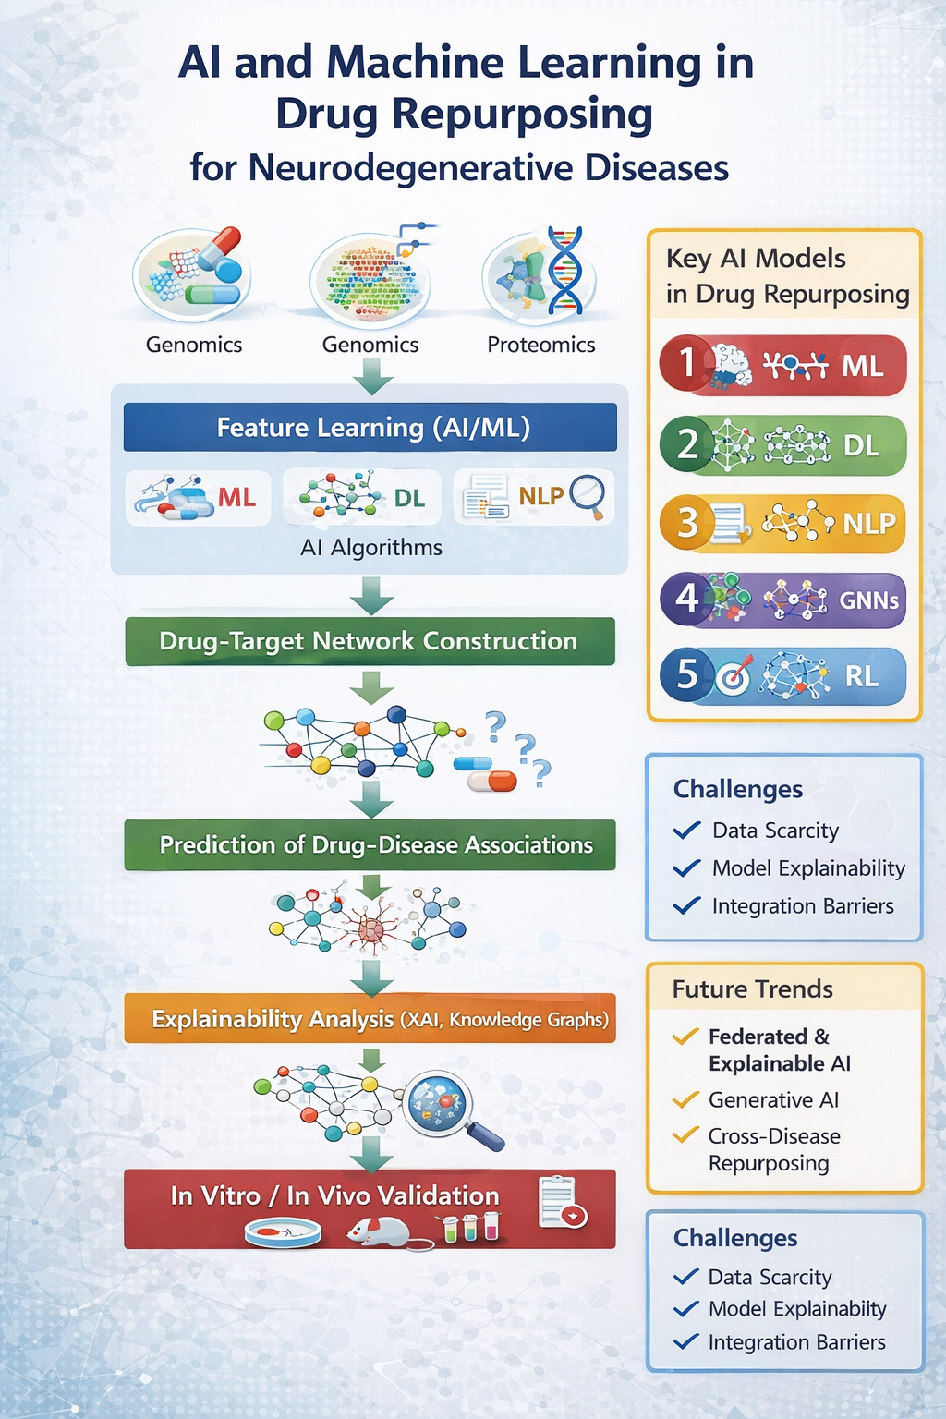
Figure 2 Framework of AI-Guided Drug Repurposing in Neurodegenerative Diseases
- AI-Guided Drug Repurposing in Neurodegenerative and Neuroinflammatory Diseases:
Neurodegenerative Diseases (NIDs) and Neuroinflammatory Diseases (NIDs) have drastically changed over the past several years due to the use of artificial intelligence (AI), machine learning (ML), as well as the many advantages that come from these technologies to increase efficiency and make available previously unavailable information about the mechanisms of NIDs and how they might play a role in finding new treatments. The traditional approach to drug development for NIDs such as Alzheimer's Disease (AD), Parkinson's Disease (PD), Multiple Sclerosis (MS), and Amyotrophic Lateral Sclerosis (ALS) involves long lead times and high costs associated with the complex nature of the diseases. AI-assisted drug repurposing allows researchers to conduct integrative analyses of genomic, transcriptomic, proteomic, and clinical data, enabling them to generate new indications for the repurposing of previously existing compounds without having to rely on a hypothesis-driven approach [26].
  - AI-Guided Drug Repurposing in Neurodegenerative Diseases
Neurodegenerative disorders cause gradual deterioration in brain functioning resulting in a wide range of neurological problems for individuals with these types of illnesses; thus, there is increased ongoing research using Artificial Intelligence (AI) models to help identify potential new therapies for these condition(s). For example, DeepDrug is an AI model using graph networks to develop new uses for FDA drugs that might provide treatment for Alzheimer's disease (AD). An analysis of five different existing drugs (Tofacitinib, Niraparib, Baricitinib, Empagliflozin, Doxercalciferol) reveals that together, they have the potential to treat AD by exploiting their synergistic effects on inflammation and metabolic problems caused by AD. Importantly, they can all be prescribed as monotherapy or in combination with other medications [6]. Similarly, Zileuton, a lipoxygenase inhibitor developed as a drug to treat asthma, has been studied using question-answer AI models to identify other neurodegenerative disorders due to its ability to decrease oxidative stress [27].
Artificial Intelligence (AI)-enhanced transcriptomic modeling of Parkinson’s disease cells has revealed novel therapeutic targets that could protect dopamine-producing neurons from death caused by mitochondrial dysfunction and help screen and prioritise therapeutic candidates for PD quickly [8]. Further, network pharmacology analyses using AI tools associated with Saroglitazar (dual PPAR-α/γ agonist used for treating type 2 diabetes) have identified this medication as a potential pharmacological modulator of neuroinflammation and insulin signaling within the context of neurodegenerative diseases [28].
  - AI-Guided Drug Repurposing in Neuroinflammatory Diseases
Some neuroinflammatory diseases, such as MS and autoimmune encephalopathies, involve a complex interplay between the immune system and the nervous system ('neuron'). In order to identify potential compounds to help modulate this interaction, AI can be used to correlate an individual’s immune signature with their gene expression and drug-target networks. A number of systems using knowledge graphs and XAI to generate links between drugs, genes, and symptoms are being developed. rd-explainer is an example of one of these systems, which focuses on generating easy-to-interpret mechanistic explanations to help identify drug candidates for both rare and neuroinflammatory diseases. AGATHA, another AI-based biomedical literature mining system, analyzes the gene-disease associations from over 20,000 datasets to identify shared inflammatory pathways and drug-able targets for diseases including Alzheimer’s, Parkinson’s, MS, and dementia [4]. Other generative AI-based systems like DrugPipe use both binding pocket prediction and similarity-based searching to help identify drugs for modulating neuroimmune signaling, even where there is no previous structural data on the target . The flexibility of these systems and the associated AI technologies provides opportunities for drug repurposing in rare or less-studied neuroinflammatory disorders. A rapidly growing field of research is using AI-driven alternative medicine frameworks like AIAltMed that utilize molecular similarity algorithms to identify bioactive compounds located in nature that may help modulate neuroimmune activity [9, 12, 29].
  - Integration of Multi-Omics and Systems Biology
AI has been successful in combining multiple omic databases (genomic, proteomic, transcriptomic and metabolomic) to identify therapeutic mechanisms that can be applied to multiple diseases simultaneously. For example, by employing this approach to study MS we were able to identify immunomodulatory pathways (e.g., JAK-STAT and NF-κB) that are shared with other types of neurodegenerative disorders. Further, this type of analysis has allowed us to develop predictive models of how drugs like Baricitinib and Tofacitinib originally developed as immunomodulators may also reduce neuroinflammation by restoring balance in glial activation [29]. The systems pharmacology approach enabled by AI has enabled us to identify convergent neurodegenerative/inflammation mechanisms and thus facilitate the rewiring of drugs across diseases [29].
- Integrative Multi-Omics and Systems Biology Approaches in AI-Guided Drug Repurposing
Integrating systems biology with different types of omics (multi-omics) has created a new method for repurposing drugs in many cases especially non-degenerative (ND) and neuroinflammatory diseases (NID). By analysing multiple areas of omics (genomic, transcriptomic, proteomic, metabolomic and epigenomic) together allows researchers to have a more comprehensive understanding for how a disease operates thus leading to the identification of new Drug-Target-Disease Relationships [30]. For example, a case study involving the application of multi-Omics technology on patients with Alzheimer’s Disease (AD) through the analysis of transcriptome-wide association studies (TWAS), GWAS and Drug Perturbation, resulted in identifying Aspirin to be a strong candidate to use in reversal of the Gene Signatures associated with AD [31]. Another application was made via the development of an interpretable machine learning-based tool known as PRISM-ML to perform a combined analysis of genomic, transcriptomic and Electronic Health Record (EHR) data which identified promethazine to be a candidate drug to reduce AD risk by 60% [32].
  - Systems Biology in Drug Repurposing
Systems biology integrates multiple levels of biological networks, thereby demonstrating how changes at the molecular level affect how changes at the molecular level affect how they are transmitted through pathways. The Predictive Evaluation of Therapeutic Simulations (PETS) framework illustrates this by allowing the simulation of these relationships at multiple scales through the use of dynamic protein-protein interaction networks. PETS also predicted successful repurposing of drugs with good accuracy and interpretability, outpacing the performance of previous computational methodologies, for the treatment of Alzheimer's Disease (AD) and Glioblastoma [33]. Workflows that combine network pharmacology and artificial intelligence (AI) with the methodologies of the various omic technologies provide insights into the mechanistic pathways of the action of multi-targeted drugs, for example, the application of network pharmacology and AI combinations has become an important aspect of the ability to use the principles of network pharmacology to scientifically justify the use of Traditional Chinese Medicine (TCM) [34].
  - AI-Driven Multi-Omics Integration
Using AI models to support multi-omics strategies provides improved predictions of the cross-disease effects of drugs. Machine learning is utilized to integrate transcriptomic and proteomic data to identify convergent pathways involved in Alzheimer's disease, Parkinson's disease, and multiple sclerosis [35]. Through this use of machine learning, shared mechanisms such as oxidative stress and mitochondrial dysfunction are identified as contributing factors in the drug repurposing prediction process.
  - Translational Pathway and Validation Challenges
While computational and AI-driven models accelerate candidate identification, validation bottlenecks remain a key challenge:
- Preclinical validation gaps: Many AI predicted drug–target interactions lack experimental corroboration, emphasizing the need for organoid, 3D bioprinting, and animal model studies [36].
- Clinical translation barriers: Patient heterogeneity, inconsistent omics datasets, and lack of multi site validation hinder reproducibility and regulatory approval [37].
- Ethical and data privacy issues: Integration of EHRs and omics data for personalized repurposing must navigate patient consent and data sharing frameworks [38].
Despite these hurdles, models such as scDisPreAI show promise for AI-driven integration of single-cell omics and disease staging, which can enhance biomarker-guided repurposing for NDs [38].
CONCLUSIONS:
Drug repurposing has gained significant traction in current drug development technology through Artificial Intelligence (AI). Examples include a wide array of Neurodegenerative Disease (ND) and Neuroinflammatory Disorder (NID) therapies currently available, as well as the many that are under development. In particular, the integration of AI with multi-omic and systems biology technologies is a game changer for accessing the full range of biological information in order to identify shared disease biology and develop new treatment strategies. The ability to collect and analyze genomic, transcriptomic, metabolomic, and proteomic data simultaneously with AI enables researchers to uncover patterns and identify numerous new potential drug targets based upon overlapping pathways and drug pathways. With machine learning (ML) and deep learning (DL), predictive analytics can allow for increasingly nuanced models of drug-target-pathway relationships. Additionally, utilizing GNNs (Graph Neural Networks) has significantly improved how researchers can accurately predict the potential use of known drugs for new indications for ND/NID diseases. AI-based platforms like DeepDrug, COMIC, and PETS have shown the ability to create accurate, interpretable, and actionably predictive models from the combination of their biomedical knowledge graphs with expert guidance. Additionally, multi-omic platforms like PRISM-ML and AGATHA utilize the power of combining literature mining, electronic health records, and omics level data in order to identify new approaches to repositioning known drugs, including aspirin and promethazine, as potential therapies for Alzheimer’s Disease. Systems biology frameworks provide a very strong basis to model drug interactions across an entire signaling network. These types of models allow the researcher to simulate the full effects of the multi-scale interactions between drugs and their targets on a molecular level and the drug’s effect at the cellular level. In a very real way, systems biology provides the researcher with the means to predict with high precision the multi-scale impact of drugs on a biological system.
A number of hurdles still exist in the application and validation of these new technologies, despite obvious leaps forward. The largest obstacle occurs when it comes to proving that AI predictions actually match reality, as there continues to be a very high level of uncertainty surrounding which AI predicted interactions are true and which ones aren't. Therefore, there is still a great deal of research that needs to be conducted in order to prove that these AI-identifying drug–target interactions are indeed valid. When attempting to carry out drug repurposing activities clinically there are significant challenges associated with utilizing data from multiple sites, as well as with forecasting how drugs may work within different systems or genres through the use of AI. Finally, there are significant ethical issues that exist when connecting patient-level multi-omics and electronic health record (EHR) data, and consequently, developers will need to establish a framework for ensuring data privacy and employing the use of explainable AI (XAI). Despite these hurdles, the outlook for AI-guided drug repurposing remains bright. The combined approach of merging multi-omic data with systems pharmacology and implementing XAI makes it possible for physicians to predict what the best treatment will be for an individual patient based upon their unique genetic and clinical profile. Furthermore, as additional technologies such as Federated learning, Quantum computing, and integrating Knowledge graph analytics evolve, it will become easier to move from the laboratory to the clinic when developing new therapies. Thus, AI will facilitate the rapid discovery and development of new therapies, while also decreasing overall costs associated with them, which should allow all patients suffering from neurodegenerative or neuroinflammatory diseases to receive personalized therapies.

References:

1. Selvaraj, G., et al., Application of Artificial Intelligence in Drug Repurposing: A mini-review1. Current Chinese Science, 2021. Current Chinese Science. https://doi.org/10.2174/2210298101666210204162006
2. Serrano, D., et al., Artificial Intelligence (AI) Applications in Drug Discovery and Drug Delivery: Revolutionizing Personalized Medicine. Pharmaceutics, 2024. 16: p. 1328. https://doi.org/10.3390/pharmaceutics16101328
3. Pham, P., et al., Generative AI-assisted Virtual Screening Pipeline for Generalizable and Efficient Drug Repurposing. bioRxiv, 2024.
4. Perdomo-Quinteiro, P., et al., Knowledge Graphs and Explainable AI for Drug Repurposing on Rare Diseases. bioRxiv, 2024. https://doi.org/10.1101/2024.10.17.618804
5. Li, V., et al., DeepDrug: An Expert-led Domain-specific AI-Driven Drug-Repurposing Mechanism for Selecting the Lead Combination of Drugs for Alzheimer's Disease. 2024. https://doi.org/10.1038/s41598-025-85947-7
6. Li, V., et al., DeepDrug as an expert guided and AI driven drug repurposing methodology for selecting the lead combination of drugs for Alzheimer’s disease. Scientific Reports, 2025. 15. https://doi.org/10.1038/s41598-025-85947-7
7. Aamer, N., M. Asim, and A. Dengel, COMIC: Explainable Drug Repurposing via Contrastive Masking for Interpretable Connections. bioRxiv, 2025. https://doi.org/10.1101/2025.03.26.645428
8. Qiu, Y. and F. Cheng, Artificial intelligence for drug discovery and development in Alzheimer's disease. Current opinion in structural biology, 2024. 85: p. 102776. https://doi.org/10.1101/2025.03.26.645428
9. Sikirzhytskaya, A., et al., AI-based mining of biomedical literature: Applications for drug repurposing for the treatment of dementia. Research Square, 2024. https://doi.org/10.1016/j.artmed.2025.103218
10. Singh, A., Artificial intelligence for drug repurposing against infectious diseases. Artificial Intelligence Chemistry, 2024. https://doi.org/10.1016/j.aichem.2024.100071
11. Nunes, S. and C. Pesquita, Drug Repurposing Hypothesis Validation with Knowledge-infused Explanations. 2024. https://ceur-ws.org/Vol-3833/
12. Pham, P., et al., DrugPipe: Generative artificial intelligence-assisted virtual screening pipeline for generalizable and efficient drug repurposing. Biology Methods & Protocols, 2025. 10. https://doi.org/10.1093/biomethods/bpaf038
13. Cortial, L., et al., Artificial intelligence in drug repurposing for rare diseases: a mini-review. Frontiers in Medicine, 2024. 11. https://doi.org/10.3389/fmed.2024.1404338
14. Rahane, N. and V. Abhang, Leveraging artificial intelligence for precision drug discovery: innovations in predictive modeling and drug repurposing. International Journal For Multidisciplinary Research, 2025. https://www.ijfmr.com/archive/volume-7-issue-2-march-april-2025/IJFMR250242349.pdf
15. Saito, R., et al., [Data-driven drug discovery for drug repurposing]. Nihon yakurigaku zasshi. Folia pharmacologica Japonica, 2023. 158 1: p. 10-14. https://doi.org/10.1254/fpj.22072
16. Anokian, E., et al., Machine Learning and Artificial Intelligence in Drug Repurposing—Challenges and Perspectives. Drug Repurposing, 2024. https://doi.org/10.58647/DRUGREPO.24.1.0004
17. Ferreira, F. and A. Carneiro, AI-Driven Drug Discovery: A Comprehensive Review. ACS Omega, 2025. 10: p. 23889-23903. https://doi.org/10.1021/acsomega.5c00549
18. Patwekar, M., et al., Harnessing artificial intelligence for enhanced Parkinson’s disease management: Pathways, treatment, and prospects. Trends in Immunotherapy, 2023. https://doi.org/10.24294/ti.v7.i2.2395
19. Yang, F., et al., Machine Learning Applications in Drug Repurposing. Interdisciplinary Sciences, Computational Life Sciences, 2022. 14: p. 15-21. https://doi.org/10.1007/s12539-021-00487-8
20. Gupta, R., et al., Artificial intelligence to deep learning: machine intelligence approach for drug discovery. Molecular Diversity, 2021. 25: p. 1315-1360. https://doi.org/10.1007/s11030-021-10217-3
21. Bittner, M. and S. Farajnia, AI in drug discovery: Applications, opportunities, and challenges. Patterns, 2022. 3. https://doi.org/10.1016/j.patter.2022.100529
22. Zheng, P., et al., Editorial: Artificial Intelligence in Bioinformatics and Drug Repurposing: Methods and Applications. Frontiers in Genetics, 2022. 13. https://doi.org/10.3389/fgene.2022.864012
23. Niazi, S. and Z. Mariam, Artificial intelligence in drug development: reshaping the therapeutic landscape. Therapeutic Advances in Drug Safety, 2025. 16. https://doi.org/10.1177/20420986251321704
24. Lv, Q., et al., TCMBank: bridges between the largest herbal medicines, chemical ingredients, target proteins, and associated diseases with intelligence text mining. Chemical Science, 2023. 14: p. 10684-10701. https://doi.org/10.1039/D3SC02139D
25. Challa, A., et al., Human and Machine Intelligence Together Drive Drug Repurposing in Rare Diseases. Frontiers in Genetics, 2021. 12. https://doi.org/10.3389/fgene.2021.707836
26. Khanam, H., et al., Artificial Intelligence in Clinical Practice: Unlocking New Horizons in Drug Repurposing for Disease Treatment. Nanotechnology Perceptions, 2024. https://www.nano-ntp.com/index.php/ntp/issue/view/100
27. Mickael, M.-E., et al., NRF2 drug repurposing using a question-answer artificial intelligence system. bioRxiv, 2019. https://doi.org/10.1101/594622
28. Kushawaha, S., et al., Repurposing Saroglitazar for neurodegenerative disorders: insight into molecular signalling pathways and neuroprotective modulations. Inflammopharmacology, 2025. https://doi.org/10.1007/s10787-025-01805-y
29. Bilokon, O., N. Bilokon, and P. Bilokon, AI-driven Alternative Medicine: A Novel Approach to Drug Discovery and Repurposing. 2024. https://doi.org/10.48550/arXiv.2407.02126
30. Mohammadi, E., et al., Applications of Genome-Wide Screening and Systems Biology Approaches in Drug Repositioning. Cancers, 2020. 12. https://doi.org/10.3390/cancers12092694
31. Grabowska, M., et al., Multi-omics analysis reveals aspirin is associated with reduced risk of Alzheimer's disease. medRxiv : the preprint server for health sciences, 2025. https://doi.org/10.1101/2025.04.07.25325038
32. Mottaqi, M., P. Zhang, and L. Xie, Integrating explainable AI with multiomics systems biology and EHR data mining for personalized drug repurposing in Alzheimer’s disease. bioRxiv, 2025. https://doi.org/10.1101/2025.03.24.644676
33. Song, K. and J. Chen, Integrative Multi-Scale Network Simulation for Precision Drug Repurposing with PETS. bioRxiv, 2025. https://doi.org/10.1101/2025.02.24.639994
34. Yang, L., et al., Network Pharmacology-Driven Sustainability: AI and Multi-Omics Synergy for Drug Discovery in Traditional Chinese Medicine. Pharmaceuticals, 2025. 18. https://doi.org/10.3390/ph18071074
35. Cardillo, M., K. Katam, and P. Suravajhala, Advancements in multi-omics research to address challenges in Alzheimer’s disease: a systems biology approach utilizing molecular biomarkers and innovative strategies. Frontiers in Aging Neuroscience, 2025. 17. https://doi.org/10.3389/fnagi.2025.1591796
36. Wu, Y., et al., Drug repurposing in traditional Chinese medicine: from empirical wisdom to modern therapeutic strategies. Frontiers in Pharmacology, 2025. 16. https://doi.org/10.3389/fphar.2025.1631727
37. Paranjpe, M., A. Taubes, and M. Sirota, Insights into Computational Drug Repurposing for Neurodegenerative Disease. Trends in pharmacological sciences, 2019. https://doi.org/10.1016/j.tips.2019.06.003
38. Ranganathan, Y., et al., Understanding integrative approach of translational bioinformatics on cardiovascular disease: Myocardial Ischemia. Egyptian Journal of Medical Human Genetics, 2024. 25. https://doi.org/10.1186/s43042-024-00622-2

