Physiological Correlation of Dopamine and Serotonin with Biochemical and Oxidative Stress Markers in Epilepsy Patients

Abstract
In general, epilepsy common neurological disorder affecting central nervous system, so it represents a significant public health and social burden. The primary cause of epileptic seizures is the excessive discharge of abnormal electrical charges from nerve cells. Epilepsy affects people in general, but is more common in elderly patients. The study included (35) patients with epilepsy (25) males and (10) females. Also, (35) control group (healthy) including (20) males and (15) females. The blood was taken by drawing blood from the vein after sterilizing the drawing area, using a 5 ml needle (syringe) of the type that is thrown away immediately after use (disposable syringe). The blood is then placed in tubes containing a gelatinous substance, in order to separate the clotted part from the serum when placed in a centrifuge at a speed of (3500) for (10) minutes, then the serum is withdrawn, placed in dry plastic tubes and stored at temperatures of 4 until it is used in the bio-endurance scale specified in the research, which included: Dopamine, serotonin, uric acid, creatinine, vitamin C, vitamin E, glutathione, peroxynitrite. In conclusion epilepsy patients showed clear raise in neurotransmitter, biochemical indicators, vitamin C, and peroxynitrite levels. In contrast, significant reductions in vitamin E and GSH levels in epilepsy patients compared to the control group.

Keywords: Blood samples, Dopamine, Serotonin, Vitamins.

1. Introduction
Epilepsy is a chronic brain disease that is usually characterized by continuous and discrete loss attacks. It is a common disorder of the central nervous system that affects both sexes and all ages, and is more common in children and the elderly The incidence of epilepsy in males is slightly higher than in females, and the highest incidence rate is in the elderly (Beydoun et al., 2020; Kurisu et al., 2024). Generalized epileptic seizures affect brain cells on both sides as a result of neurological injuries, deficits, or brain abnormalities. Focal epileptic seizures occur on one side of brain. Epileptic seizures arise from abnormalities, synchronization, or excessive neural activity in the brain, which causes a temporary disturbance in the way the brain works and controlled (Hesdorffer et al., 2009).

Epilepsy occurs as a result of neurological injuries, disability, or brain abnormalities, including head or skull injuries, or it occurs due to infection or tumors. Genetic factors play an important and effective role in the occurrence of the disease, as etiology of this condition still unknown (Roger et al., 2010).
Epileptic seizures are usually preceded by signs that indicate the onset of an epileptic seizure, which depend mainly on the location of the electrical discharge in the lobes of the brain. These signs appear in the form of feelings of hunger, nausea, and auditory hallucinations, such as hearing strange sounds or hearing speech from the surroundings without there being a person near him, or blurred vision, and feeling visual hallucinations such as seeing strange things or seeing people without their presence (Brody, 2016).
An epileptic seizure is usually caused by the normal electrical activity in the brain through the passage of millions of simple electrical charges in the nerve cells in the brain and then spreading to the rest of the body. This normal form of electrical activity may be disturbed by the release of abnormal charges that have a greater electrical effect than the effect of normal charges, which have an effect on the consciousness, movement and sensations of the human body for a shortly. The higher the percentage of abnormal electrical charges in the brain, the more it leads to the formation of convulsions in the limbs of the human body and thus the symptoms of epilepsy (Rishe et al., 2015).
Biochemical analyses are essential indicators for detecting and confirming pathological conditions (Al-Hayali, 2023; Ghareeb & Ali, 2023) and physiological disorders, especially in vital organs of the body (Saad et al., 2024; Taher & Ghareeb, 2022). Uric acid and creatinine are indicators of kidney function, and any abnormality indicates kidney dysfunction due to harmful factors (Ahmed, 2017).
Diagnosing epilepsy is extremely important for selecting the appropriate treatment for the disease, as the diagnosis is usually made after a second unexplained seizure occurs (Pellinen et al., 2024). The diagnosis depends on information obtained from the patient's family about his medical history and whether there is any triggering or risk factors that lead to epilepsy. A detailed description of the clinical manifestations or signs observed by the patient's family during an epileptic seizure is very important and necessary for a true diagnosis of the seizure type (Katyal, 2025). It's worth noting that clinical blood tests are representing first key in diagnosing most conditions and disorders in the body (Ali et al., 2022; Ghareeb, 2023).
Dopamine (DA) is a neurotransmitter produced by specific cells, located mainly in the ventral part of the brain. It is involved in most of the physiological functions that occur in the central nervous system, and it also contributes to maintaining internal balance (Lauretani et al., 2024). The primary function of dopamine is to regulate brain functions, including motor control, cognition, feeding, emotion, and endocrine functions, Therefore, any disorder that occurs in the nervous system will lead to neurological, mental and physical disorders, such as parkinson's disease, epilepsy, schizophrenia, drug addiction, learning and memory disabilities, autism, attention deficit hyperactivity disorder and lack of communication between him and others (Yi et al., 2024).
Serotonin is a neurotransmitter produced by the body and is a chemical that transmits nerve signals between the brain and nerves. Therefore, it is a potential target for drug therapy and neurological diseases that affect the brain. In addition, pharmacological data have shown that serotonin may be linked to anxiety disorders. However, study results have not proven a link between serotonin and schizophrenia, the most severe mental disorder after epilepsy. The relationship between addiction and the serotonergic system may be complex, as the direction of its effects remains unclear. Currently, there is insufficient evidence to support a link between serotonin and ADHD. However, some studies suggest that altered serotonin activity may be a cause of neurological diseases affecting the brain (Lin et al., 2014).
The accumulation of free radicals is responsible for appearance of different human illnesses such as atherosclerotic problems and plaque progress (Matkovics, 2003). Antioxidants have an important and effective role in scavenging free radicals and stopping the occurrence of inflammation in the body, especially in its early stages, and increasing the body’s immunity, modifying gene expression, activating motor proteins, and distinguishing between infected cancer cells and normal cells (Zeidan et al., 2022; Rahman & Panichayupakaranant, 2025). They also have a role in reducing the incidence of neurological diseases, especially brain diseases such as epilepsy and autism (Firdous et al., 2025). In addition, epilepsy is related with an excess of oxidative stress, as persistent epileptic seizures cause excessive generation of oxidants, which may be the primary cause of neuronal cell death. It has been found that some antiepileptic drugs, such as Lamotrigin and Levetiracetam, can reduce neuronal oxidative stress. While the use of diazepam may contribute to neuronal damage and increase oxidative stress (Kośmider et al., 2023), through the increase in dopamine and serotonin levels, the study aimed to evaluate the relationship between the neurotransmitter’s dopamine and serotonin and some biochemical indicators in epilepsy patients.

2. Patients and methods
This cross-sectional study conducted on (35) patients with epilepsy, (25) males and (10) females. Also, (35) control group (healthy) from the same age group. The number of healthy males was (20) and the number of healthy females was (15) after ensuring that they were free from all diseases. This study was conducted in Baquba Teaching Hospital / Consulting Clinic (Neurology and Psychiatry Unit) with the help of private clinics in Diyala Governorate for the period from 15/1/2025 to 15/5/2025.

Blood samples were collected by drawing blood from the vein after sterilizing the drawing area, using a 5 ml needle (syringe) of the type that is thrown away immediately after use (disposable syringe). The blood is then placed in tubes containing a gelatinous substance, in order to separate the clotted part from the serum when placed in a centrifuge at a speed of (3500) for (10) minutes, then the serum is withdrawn, placed in dry plastic tubes and stored at temperatures of 4 until it is used in the bio-endurance scale specified in the research, which included: (Dopamine, Serotonin, Uric acid, Creatinine, Vitamin C, Vitamin E, Glutathione, Peroxynitrite).

2.1 Estimation of neurotransmitter and vitamin concentrations
Immunomodulatory parameters including neurotransmitter and vitamins were measured using an enzyme-linked immunosorbent assay (ELISA) method for both patients and healthy controls, according to a specific protocol. The ELISA plate contains 96 wells coated with antibodies. Antibodies to dopamine, serotonin, vit C, and vit E were detected. Enzyme-labeled antibodies and antigens present in serum are used. The resulting interaction occurs between antigens and antibodies, and is a non-competitive interaction, forming a sandwich-like complex. During the incubation period, the immune complex aggregates in the titration tubes through the high-affinity interaction between streptavidin and the biotinylated antibody. After equilibrium and binding occur, the bound antibody parts separate from the unbound antigens in the washing process, and the enzyme’s activity in the bound antibody parts is directly proportional to the concentration of the antigens. It is stimulated by HRP and after addition the holes appear blue then the stop solution is added to each hole and the color changes from blue to yellow. The optical density (OD) is measured at a wavelength of (450) nm with each analysis repeated several times to obtain accurate results.

2.2 Estimation of uric acid levels
Serum uric acid concentrations were estimated for both groups using an enzyme-based method using a ready-made analysis kit supplied by Randox UK.

2.3 Creatinine level estimation
Serum creatinine concentrations were estimated for both groups using an enzyme-based method using a ready-made analysis kit supplied by the Spanish company Bio System.

2.4 Estimation of Glutathione levels
Glutathione was estimated for the samples under study using the modified method by Burtis & Ashwood, 1999, as this method uses Ellman's reagent, which is a yellow compound, as this compound reduces the sulfhydryl group of glutathione at a wavelength of 412 nanometers. This compound is read.

2.5 Estimation of peroxynitrite levels
The concentration of peroxynitrite radical was estimated using the modified method of (Al-Zamely et al. 2001), as the peroxynitrite radical nitrates phenol to nitrophenol at a wavelength of 412 nanometers, and the presence of nitrophenol in blood serum reflects the level of peroxynitrite radical resulting from this process.

2.6 Statistical Interpretation
The data were interpreted by Statistical Package for the Social Sciences (SPSS) statistical analysis program and the completely randomized design method. The t-test was used to analyze the variation between the studied groups at a probability level of (P≤0.05).

3. Results
3.1 Estimation of neurotransmitters concentration and biochemical indicators
The results of the current study showed significant differences in the serum levels of epilepsy patients and the control group (Dopamine, Serotonin, Uric acid, Creatinine, Vitamin C, Vitamin E, Glutathione, and Peroxynitrite) at a probability level of P ≤ 0.05, as shown in t Table (1) and figures (1-2).

Table 1; Serological levels of neurotransmitters and biochemical indicators
P-Value | Mean ± SD |  | Indicatores
P-Value | EPI  N=35 | Control  N = 35 | Indicatores
P ≤ 0.05 | 2.11±20.16 | 1.92 ±6.96 | Dopamine (ng/ml)
P ≤ 0.05 | 1.58±0.62 | 0.93±0.31 | Sreotonin (ng/ml)
P ≤ 0.05 | 2.92 ±1.66 | 1.52±0.46 | Uric acid (mg/dl)
P ≤ 0.05 | 0.47±0.33 | 0.31±0.22 | Ceratinine (mmol/L)
P ≤ 0.05 | 50.32±18.98 | 20.54±3.85 | Vit C (U/L)
P ≤ 0.05 | 4.21±2.46 | 9.92±6.86 | Vit E (µmol/L)
P ≤ 0.05 | 42.11±9.83 | 39.01±11.63 | Glutathione (µmol/L)
P ≤ 0.05 | 20.01 ± 10.71 | 8.19 ± 2.81 | Peroxy nitrite (mol/L)

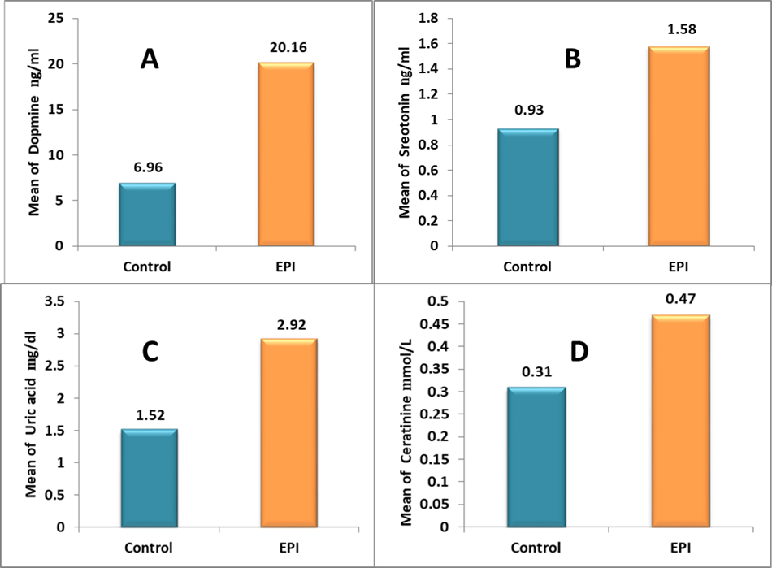
Fig.1. a. Dopamine concentration in the studied group; b. Serotonin; c. Uric acid concentration in the studied group; d. Creatinine concentration in the studied group concentration in the studied group

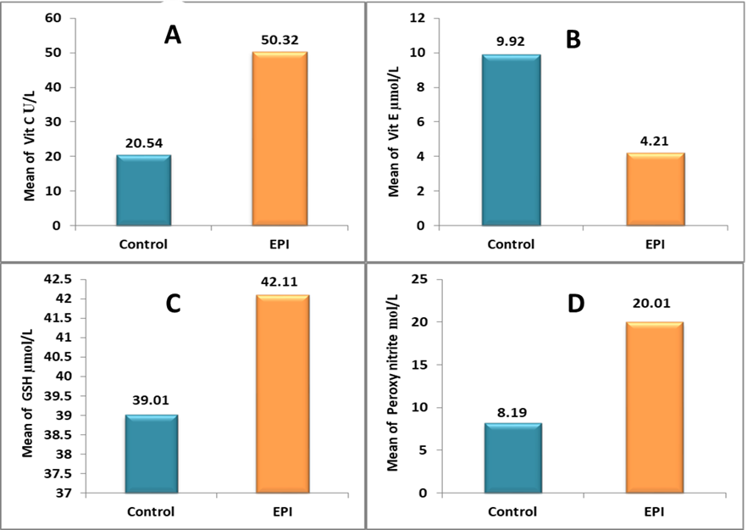
Fig. 2. a. Vitamin C concentration in the studied group; b. Vitamin E concentration in the studied group; c. Glutathione concentration in the studied group; d. Peroxynitrite concentration in the studied group

4. Discussion

The biological benefits of dopamine agonists in the treatment of epilepsy go back hundreds of years. Dopamine agonists were first shown to be a side effect 40 years ago. Epidemiologists noted a discrepant relationship between the so-called dopamine hyperactivity syndrome in schizophrenia and epilepsy, which is a state of dopamine deficiency. Non-selective drugs were used to evaluate early pharmacological studies for epilepsy. The effect of dopamine in treating epilepsy has not been clearly demonstrated, and the reason for this is due to the chemical composition of dopamine, which has not yielded largely conclusive results in treating epilepsy (Starr, 1996). The reason for the high concentration of dopamine in epilepsy patients is due to the effective participation of neurotransmitters in the mechanism of action of drugs that treat epileptic seizures (Palucha & Pilc, 2002). The mechanism of dopamine action is critical during epileptic seizures and in controlling neural excitability and cognition (Bozzi & Borrelli, 2013). It has been reported that activation of dopamine receptors can increase the seizure threshold, while seizures can be enhanced by drugs that inhibit dopamine levels, such as antipsychotics and antidepressants (Jain, 2021).

The neurotransmitter serotonin has a crucial role in regulating the complex neural networks involved in the susceptibility to epileptic seizures, respiratory mechanisms, and arousal, which may contribute to sudden unexpected death in patients with epilepsy and depression. In addition, serotonergic drugs inhibit epileptic seizures, but their biochemical effectiveness in humans is less effective, with the exception of some specific types of epilepsy, such as Dravet syndrome (Gilliam et al., 2021). The result of increased serotonin concentration in epilepsy patients was consistent with the results of (Bonnycastle et al., 1957; Chadwick et al., 1977), and the reason for the increase in serotonin levels is due to the excess amounts of serotonin levels present in the serum of patients, which in turn enhances its anti-epileptic effect (Zimmerman et al., 2008). In addition, serotonin plays a role in regulating mood, as it is a neurotransmitter that has an effective impact on this. It also reduces the occurrence of epileptic seizures by reducing nervous excitation (Barker-Haliski & White, 2015). In addition, uric acid has been shown to significantly increase in epilepsy patients, and this increase may enhance epileptic seizures, in addition to increasing oxidative stress, which in turn increases the risk of epileptic seizures (Song & Zhao, 2018). Because high concentrations of uric acid play a role in the easy formation of sodium glutamate crystals, which may lead to inflammatory reactions, thus leading to increased nervous excitability in patients with epileptic seizures (Thyrion et al., 2016; Terrone et al., 2017). The result of high uric acid was consistent with the result of (Wang et al. 2019) because the breakdown of internal muscle protein in patients with recurrent epileptic seizures leads to increased production of uric acid (Warren et al., 1975).

The result of the insignificant decrease in creatinine concentration was consistent with the result of (Jalava & Sillanpää, 1997) because external creatine supplements can protect against epileptic seizures caused by amino acids that have the ability to reduce lactate produce with oxidative damage, indicating the effective anti-convulsant and anti-oxidant ability of creatinine in metabolic processes that appear in the form of phenotypes of epileptic seizures (Magni et al., 2007; Royes et al., 2003). Despite the crucial potential of creatinine, there are contraindications that must be considered, including oral bioavailability and blood-brain barrier permeability, as externally administered creatine must first be absorbed into the bloodstream and then pass through the intestinal wall to be stored and subsequently used by various body tissues (Jomura et al., 2022).

The difference in vitamin levels, including vit C and vit E, in the epileptic seizure group is due to the fact that vitamin C is a powerful antioxidant that provides electrons that accumulate in the nervous system and are transmitted through blood-brain barrier. Because it is an electron donor and a powerful reducing agent, it can participate with other antioxidants that can reduce the damage to neurons during epileptic patients, Alows, vit.C can protect nerve cells by integrating cell membranes and reducing the peroxidation of absorbed lipids (Sawicka-Glazer & Czuczwar, 2014). Furthermore, induction of reactive oxygen species can be linked to a several disorders, as epileptic seizures (Nazıroğlu, 2009).

The difference in vitamin E levels between the studied groups is due to its antioxidant properties, as it prevents the oxidation of polyunsaturated fatty acids (PUFAS), as well as it prevents formation of free radicals, and unactivation of the lipoxygenase enzyme pathway (Lebold & Traber 2014). In general, this vitamin can reduce the activity of epileptic seizures, as it can reduce oxidation effects in brain tissue (Söderfeldt et al., 1983).

The reason for the difference in the level of concentration of antioxidants, including glutathione, is due to the effective role that glutathione plays as an antioxidant, as it prevents cell damage and removes toxins from chemicals inside the liver (Saeed et al., 2018). In addition, glutathione is an essential element that defends the body against the danger of free radicals, and its deficiency inducing oxidative stress in the body and thus causing many diseases, including an increase in epileptic seizures (Ahmad et al., 2014).

The reason for the increase oxidative stress concentration (peroxynitrite) is due to the generation of free radicals, which oxidize fats in cell membranes, as acids and the unnecessary continuity of cell membranes are part most exposed to free radical reactions due to they have double bonds that represent key target of free radicals, increasing the level of oxidative stress (Al-Hasani, 2004). Peroxynitrite results from oxidative stress in the body's various tissues, causing collisions, tissue necrosis, and cell death, which is a cause of the spread of some diseases, especially miscarriage, in addition to its ability to destroy many of the body's cells and the proportions of metabolic disorders and causing new mutations in reducing the concentrations of internal antioxidants (Ferdinandy, 2006).

5. Conclusion

The current study concluded that epilepsy patients showed considerable augmentation in neurotransmitter (dopamine and serotonin), kidney function indicators (uric acid, creatinine), vitamin C, and peroxynitrite levels. In contrast, clear reductions in vitamin E and GSH concentrations were observed in epilepsy patients versus healthy ones.

CONSENT (WHERE EVER APPLICABLE)
No patient data, clinical records, or personal information were used in this study; therefore, consent is not applicable.

ETHICAL APPROVAL (WHERE EVER APPLICABLE)
This study did not involve human participants, animals, or personal data. Therefore, ethical approval was not required.

References

- Beydoun A., DuPont S., Zhou D., Matta M., Nagire V., Lagae L. Current role of carbamazepine and oxcarbazepine in the management of epilepsy. 2020: 83: 251-263. Doi: 10.1016/j.seizure.2020.10.018 .
- Kurisu A., Sugiyama A., Akita T., Takumi I., Yamamoto H., Iida K., Tanaka J. Incidence and Prevalence of Epilepsy in Japan: A Retrospective Analysis of Insurance Claims Data of 9,864,278 Insured Persons. Journal of Epidemiology. 2024; 34 (2): 70-75. Doi: 10.2188/jea.JE20220316.
- Hesdorffer D. C., Benn E. K. T., Cascino G. D., Hauser W. A. Is a first acute symptomatic seizure epilepsy? Mortality and risk for recurrent seizure. Epilepsia. 2009; 50 (5): 1102-1108. Doi: 10.1111/j.1528-1167.2008.01945. x.
- Roger J., Bureau M., Dravet C. H., Genton P., Tassinari C.A., Wolf P. (Editors) Les Syndromes Epileptiques De L'Enfant Et De L'Adolescent. 1st ed. John Libbey Eurotext. 2010. pp: 17-21.
- Brody A. K. A brief overview of epilepsy, its causes, types, and treatment methods. Ph.D. Thesis. Faculty of Medicine and Pharmacy of Fez, Sidi Mohamed Ben Abdellah University, Morocco. 2016.
- Rishe W., Seifu M. F., Gelaw B. K., Gunasekaran T., Gebremariam E. T., Mohammed M. A. DRUG USE EVALUATION OF ANTIEPILEPTIC DRUGS IN OUTPATIENT EPILEPSY CLINIC OF BISHOFT GENERAL HOSPITAL, EAST SHOA, ETHIOPIA. Indo American Journal of Pharmaceutical Research. 2015; 4 (3): 1516-1528.
- Al-Hayali H. Biochemical Effects After Thyroidectomy. NTU Journal of Pure Sciences. 2023; 2 (2): 30-36.‏ Doi.org/10.56286/ntujps. v2i2.423.
- Ghareeb O. A. and Ali Q. Pathotoxic Impact of Zinc Oxide Nanoparticles on Liver Function and Protective Role of Silymarin. Current Innovations in Disease and Health Research. 2023; 3: 153-161.‏ Doi.org/10.9734/bpi/cidhr/v3/10703F.
- Saad N., Al-Kadhi N. A., and Noraldeen M. A. Association of H. pylori IgG and CagA-IgG with Some Immunological and Biochemical Parameters in Diabetic Patients. NTU Journal of Pure Sceinces. 2024; 3 (1): 10-17. Doi.org/10.56286/ntujps. v3i1.511.
- Taher G. N., and Ghareeb O. K. Assessment of Hepatic Biochemical Indices in Patients with Acute Cholecystitis. Eurasian Medical Research Periodical. 2022; 13: 53-60.‏
- Ahmed F. F. The effects of energy drinks, drugs and hormones that taken by the bodybuilding sportsmen on some liver and kidneys functions in Kirkuk city. Tikrit Journal of Pure Science. 2017; 22 (11): 19-22.‏
- Pellinen J., Foster E. C., Wilmshurst J. M., Zuberi S. M., French J. The Lancet, Neurology. 2024; 23 (5): 511-521. Doi: 10.1016/S1474-4422(24)00079-6.
- Katyal R. Classification and Diagnosis of Epilepsy. Continuum (Minneap Minn). 2025; 1 (1):14-37. Doi: 10.1212/cont.0000000000001519.
- Ali A., Ahmed F. F., Abdullah S. I., Abbas K. S. The protective effect of zinc and its relationship with some hematological, biochemical, and histological parameters in adult male rats. Archivos Venezolanos de Farmacologia y Terapeutica.2022; 41 (6):400-405. Doi: 10.5281/zenodo.7221850.
- Ghareeb O. A. Hematotoxicity Induced by Copper Oxide Nanoparticles and the Attenuating Role of Giloy In Vivo. Cureus, 2023;15 (10): e46577. Doi: 10.7759/cureus.46577. ‏
- Lauretani F., Giallauria F., Testa C., Zinni c., Lorenzi B., Zucchini I., Salvi M., Napoli R., Maggio M. G. Dopamine Pharmacodynamics: New Insights. International Journal of molecular Sciences. 2024; 25 (10): 5293. Doi: 10.3390/ijms25105293.
- Yi L. X., Tan E. K., Zhou Z. D. Tyrosine Hydroxylase Inhibitors and Dopamine Receptor Agonists Combination Therapy for Parkinson's Disease. International Journal of molecular Sciences. 2024; 25 (9): 4643. Doi: 10.3390/ijms25094643.
- Lin S.-H., Lee L.-T., Yang Y. K. Serotonin and mental disorders: a concise review on molecular neuroimaging evidence. Clinical Psychpharmacology and neuroscience. 2014; 12 (3): 196-202. Doi: 10.9758/cpn.2014.12.3.196.
- Matkovics A. An overview of free radical research. Acta Biologica Szegediensis. 2003; 47 (1-4): 93-97. Doi.org/10.53730/ijhs. v6nS6.9836.
- Zeidan M. M., Ahmed F. F. and Rija F. F. Comparative study of oxidative status and some biochemical parameters in subjects suffered of intermediate and major Thalassemia. International Journal of Health Sciences. 2022; 6 (S6): 328–335. Doi.org/10.53730/ijhs. v6nS6.9836.
- Rahman A. U. and Panichayupakaranant P. Antioxidants in Cancer Prevention. In: Antioxidants: Nature's Defense Against Disease. Sindhu R. K., Singh I. and Babu M. A. (Editors). 10th ed. Scrivener Publishing LLC. 2025; pp: 21-82.‏
- Firdous S. M., Mallik S. and Paria B. Antioxidant Effects of Medicinal Plants for the Treatment of Epilepsy. In: Antioxidants: Nature's Defense Against Disease. Sindhu R. K., Singh I. and Babu M. A. (Editors). 10th ed. Scrivener Publishing LLC. 2025; pp: 441-490.‏
- Kośmider K., Kamieniak M., Czuczwar S. J. and Miziak B. Second Generation of Antiepileptic Drugs and Oxidative Stress. Internation Journal of Molecular Sciences. 2023; 24 (4): 3873. Doi: 10.3390/ijms24043873.
- Burtis C. A. and Ashwood E. R. (Editors). Tietz Textbook of Clinical Chemistry. 3rd ed. W. B. Saunders Company.1999; pp: 29-150.
- Al-Zamely O. M., Al-Nimer M. S. and Muslih R. K. Detection the level of peroxynitrite and related with antioxidants status in the serum of patient with acute myocardial infraction. Iraqi National Journal of Chemistry. 2001; 4: 625-637.
- Starr M. S. The role of dopamine in epilepsy. Synapse. 1996; 22 (2): 159-94. Doi: 10.1002/(SICI)1098-2396(199602)22:2<159: AID-SYN8>3.0.CO;2-C.
- Pałucha A. and Pilc A. On the role of metabotropic glutamate receptors in the mechanisms of action of antidepressants. Polish Journal of Pharmacology. 2002; 54 (6): 581-586.
28. Bozzi Y. and Borrelli E. The role of dopamine signaling in epileptogenesis. Frontiers in Cellular Neuroscience. 2013: 7: 157. Doi: 10.3389/fncel.2013.00157.
29. Jain K. K. (Editor). Drug-induced Neurological Disorders. 4th ed. Springer. 2021; pp: 133-144.
30. Gilliam F. G., Hecimovic H., Gentry M. S. Serotonergic therapy in epilepsy. Current opinion in Neurology. 2021; 34 (2): 206-212. Doi: 10.1097/WCO.0000000000000901.
31. Bonnycastle D. D., Giarman N. J., Paasonen M. K. Anticonvulsant compounds and 5-hydroxytryptamine in rat brain. British Journal of Pharmacology and Chemotherapy. 1957;12 (2): 228–231. Doi: 10.1111/j.1476-5381. 1957.tb00125. x.
32. Chadwick D., Jenner P., Reynolds E. H. Serotonin metabolism in human epilepsy: the influence of anticonvulsant drugs. Annals of Neurology. 1977; 1 (3): 218-24. Doi: 10.1002/ana.410010304.
- Zimmerman G., Njunting M., Ivens S., Tolner E. A., Behrens C. j., Gross M., Soreq H., Heinemann U. and Friedman A. Acetylcholine-induced seizure-like activity and modified cholinergic gene expression in chronically epileptic rats. The European Journal of neuroscience. 2008; 27 (4): 965-75. Doi: 10.1111/j.1460-9568.2008.06070. x .
- Barker-Haliski M. and White H. S. Glutamatergic Mechanisms Associated with Seizures and Epilepsy. Cold Spring Harbour Perspectives in Medicine. 2015; 5 (8): a022863. Doi: 10.1101/cshperspect. a022863.
- Song C. and Zhao X. Uric acid promotes oxidative stress and enhances vascular endothelial cell apoptosis in rats with middle cerebral artery occlusion. Bioscience Reports. 2018; 38 (3): BSR20170939. Doi: 10.1042/BSR20170939.
- Thyrion L., Raedt R., Portelli J., Loo P. V., Wadman W. J., Glorieux G., Lambrecht B. N., Janssens S., Vonck K., Boon P. Uric acid is released in the brain during seizure activity and increases severity of seizures in a mouse model for acute limbic seizures.Experimental Neurology. 2016: 277:244-251. Doi: 10.1016/j.expneurol.2016.01.001.
- Terrone G., Salamone A., Vezzani A. Inflammation and Epilepsy: Preclinical Findings and Potential Clinical Translation. Current Pharmaceutical Design. 2017; 23 (37): 5569-5576. Doi: 10.2174/1381612823666170926113754.
- Wang D., Hu B., Dai Y., Sun J., Liu X., Feng Y., Cheng F., Zhang X. Serum Uric Acid Is Highly Associated with Epilepsy Secondary to Cerebral Infarction. Neurotoxicity Research. 2019; 35 (1): 63-70. Doi: 10.1007/s12640-018-9930-2.
- Warren D. J., Leitch a. G., Leggett R. J. Hyperuricaemic acute renal failure after epileptic seizures. Lancet. 1975; 2 (7931): 385-7. Doi: 10.1016/s0140-6736(75)92897-4.
- Jalava M. and Sillanpää M. Physical activity, heath‐related fitness, and health experience in adults with childhood‐onset epilepsy: a controlled study. Epilepsia. 1997; 38 (4): 424-9. Doi: 10.1111/j.1528-1157.1997. tb01731. x.
- Magni D. V., Oliveira M. S., Furian A. E., Fiorenza N. G., Fighera M. R., Ferreira J., Mello C. F., Royes L. F. F. Creatine decreases convulsions and neurochemical alterations induced by glutaric acid in rats. Brain Research. 2007 Dec 14:1185:336-45. Doi: 10.1016/j.brainres.2007.09.023.
- Royes I. F. F., Fighera M. R., Furian A. F., Oliveira M. S., da Silva I. G. M., Malfatti C. R. M., Schneider P. H., Braga A. L., Wajner M., Mello C. F. Creatine protects against the convulsive behavior and lactate production elicited by the intrastriatal injection of methylmalonate. Neuroscience. 2003;118 (4): 1079-90. Doi: 10.1016/s0306-4522(02)00978-8.
- Jomura R., Akanuma S.-I., Tachikawa M., Hosoya K - I. SLC6A and SLC16A family of transporters: Contribution to transport of creatine and creatine precursors in creatine biosynthesis and distribution. Biochimica et Biophysica Acta – Biomembranes. 2022; 1864 (3):183840. Doi: 10.1016/j.bbamem.2021.183840.
- Sawicka-Glazer E. and Czuczwar S. J. Vitamin C: a new auxiliary treatment of epilepsy?. Pharmacological Reports. 2014; 66 (4): 529-33. Doi: 10.1016/j.pharep.2014.02.016.
- Nazıroğlu, M. Role of selenium on calcium signaling and oxidative stress-induced molecular pathways in epilepsy. Neurochemical Research. 2009; 34 (12): 2181-91. Doi: 10.1007/s11064-009-0015-8.
- Lebold K. M. and Traber M. G. Interactions between α- tocopherol, polyunsaturated fatty acids, and lipoxygenases during embryogenesis. Free Radical Biology and Medicine. 2014:13-9. Doi: 10.1016/j.freeradbiomed.2013.07.039.
- Söderfeldt B., Blennow G., Kalimo H., Olsson Y., Siesjö B. K. Influence of systemic factors on experimental epileptic brain injury. Structural changes accompanying bicuculline-induced seizures in rats following manipulations of tissue oxygenation or alpha-tocopherol levels. Acta Neuropathologica. 1983; 60 (1-2): 81-91. Doi: 10.1007/BF00685351.
- Saeed M., Imran M., Baig M. H., Kausar M. A., Shahid S., Ahmad I. Virtual screening of natural anti-filarial compounds against glutathione-S-transferase of Brugia malayi and Wuchereria bancrofti. Cellular and molecular Biology. 2018; 64 (13): 69-73.
- Ahmad P., Jamsheed S., Hameed A, Rasool S., Sharma I., Azooz M. M. and Hasanuzzaman M. Drought Stress Induced Oxidative Damage and Antioxidants in Plants. In: Oxidative Damage to Plants: Antioxidant Networks and Signaling. Ahmad P. (Editor). 14th ed. Elsevier Inc. 2014; pp: 345-368.
- Al-Hasani O. M. H. The Effect of Infection with a Number of Cancerous Tumors on Lipid Peroxidation, Glutathione Levels, and Several Blood Component Variables. M.Sc. Thesis, College of Science, University of Mosul, Iraq. 2004.
- Ferdinandy P. Peroxynitrite: just an oxidative/nitrosative stressor or a physiological regulator as well?. British Journal of Pharmacology. 2006; 148 (1): 1-3. Doi: 10.1038/sj.bjp.0706693.

