Case Report
A Case Report of Acute Severe Encephalomyelitis and Literature Review

Abstract
Objective: To explore the clinical features, diagnostic approach, and treatment strategies for a child with acute encephalomyelitis combined with anti-NMDAR encephalitis, aiming to provide references for the early identification and personalized treatment of similar cases.
Methods: This report details the diagnosis and treatment process of an 11-year-9-month-old male child, including his clinical manifestations, laboratory findings (such as cerebrospinal fluid analysis and anti-NMDAR antibody testing), imaging results (MRI showing diffuse abnormal signals in the brain and spinal cord), and treatment response. Combined with a literature review, the characteristics and diagnostic/therapeutic experience of the disease are summarized.
Results: The child had an acute onset with symptoms of fever, headache, and vomiting, which rapidly progressed to impaired consciousness, convulsions, and limb paralysis. A complication of deep vein thrombosis (DVT) in the right lower limb occurred later. Key ancillary tests showed: significantly elevated CSF protein (3187 mg/L, reference range 150-450 mg/L) with a predominance of mononuclear cells (96%), and a positive anti-NMDAR antibody test. MRI confirmed extensive involvement of the brain and spinal cord. Treatment involved early high-dose glucocorticoids combined with intravenous immunoglobulin (IVIG). During treatment, the child developed respiratory failure and was transferred to the ICU, receiving comprehensive management including endotracheal intubation with respiratory support, anti-infective therapy, and placement of nasogastric and urinary catheters. Relying on multidisciplinary collaboration (critical care medicine, neurology, infectious diseases, and rehabilitation), complications were actively managed, and rehabilitation therapy was intensified. After 6 weeks of treatment, the child achieved complete recovery, with muscle strength returning to normal (Grade V). Currently, the patient has a good quality of life, with no sequelae in motor function, and can participate unrestricted in high-intensity physical activities including playing basketball, running, and jumping (including rapid changes of direction).
Conclusion: Acute encephalomyelitis combined with anti-NMDAR encephalitis is a severe condition. Early immunotherapy and multi-system monitoring are crucial for improving prognosis. The strong neuroplasticity in children, coupled with timely intervention, can significantly promote functional recovery. This case highlights the importance of screening for autoimmune mechanisms and implementing personalized treatment, providing practical evidence for the comprehensive management of severe neuroimmune diseases.
Keywords: Acute Encephalomyelitis; Anti-NMDAR Encephalitis; Children; Immunotherapy; Case Report

Background: Acute Encephalomyelitis (AEM) is an acute inflammatory disease involving the brain and spinal cord, which can be triggered by post-infectious immune responses or autoimmune mechanisms (such as anti-NMDAR encephalitis). Its clinical features include fever, headache, impaired consciousness, and motor/sensory abnormalities; severe cases may present with respiratory failure. Due to the less developed blood-brain barrier in children, the disease progression is often more rapid than in adults. Without timely intervention, permanent neurological damage may occur. Anti-NMDAR encephalitis is an autoimmune encephalitis that has garnered significant attention in recent years, more common in adolescents and children, typically presenting with psychiatric abnormalities, seizures, and autonomic dysfunction. When combined with myelitis, diagnosis and treatment become more challenging. Early immunotherapy (e.g., glucocorticoids, intravenous immunoglobulin [3]) can significantly improve prognosis but requires individualized assessment of disease severity and complication risks. We report a case of an 11-year-9-month-old male child presenting with acute encephalomyelitis and positive anti-NMDAR antibodies, aiming to explore the clinical characteristics, diagnostic approach, and treatment strategies for such diseases.

Case Introduction: A male child, aged 11 years and 9 months, was brought to our hospital's pediatric outpatient department on February 11, 2025, at 15:00, due to fever for 4 days and headache/vomiting for 2 days. Upon admission, there were no other symptoms or relevant clinical signs, and no significant past medical history.
Four days prior to admission, the child developed a fever (up to 39.0°C) without an obvious cause. Two days prior, he experienced paroxysmal headaches, primarily in the forehead and occipital region, accompanied by projectile vomiting (vomitus being gastric contents), fatigue, extremely poor mental state, and poor appetite. Physical examination: T: 38.4°C, P: 88 beats/min, R: 22 breaths/min, W: 37 kg. He was conscious but in extremely poor spirits, with neck stiffness, pharyngeal redness, clear lung sounds without rales, and no abnormalities in heart or abdomen. Muscle strength assessment was uncooperative, but limbs were movable. Kernig's sign and Brudzinski's sign were positive; bilateral Babinski signs were negative.
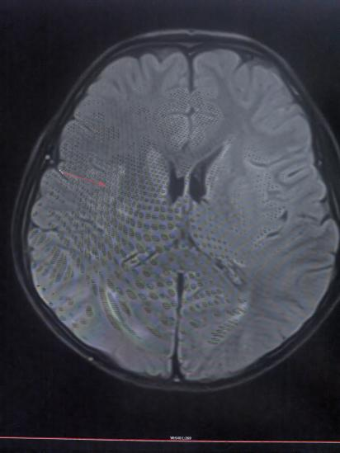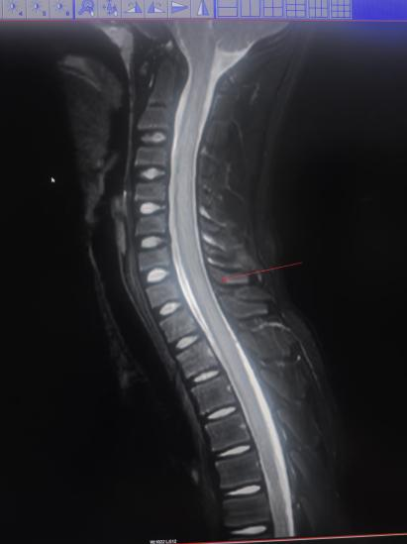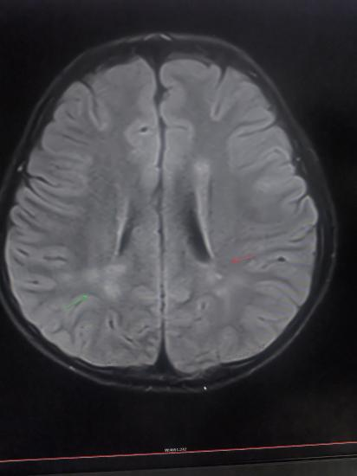

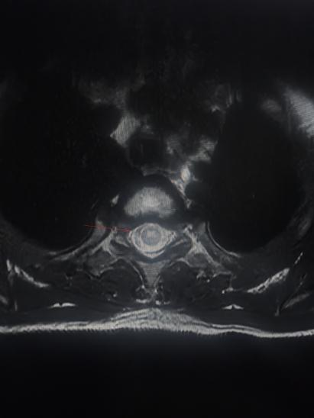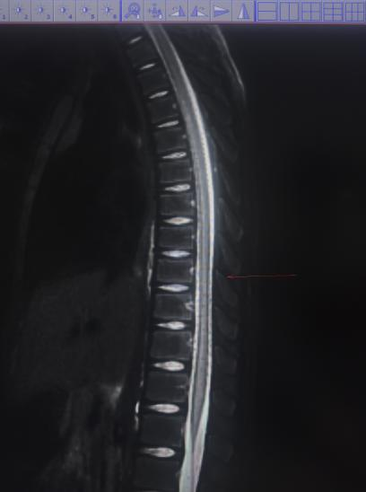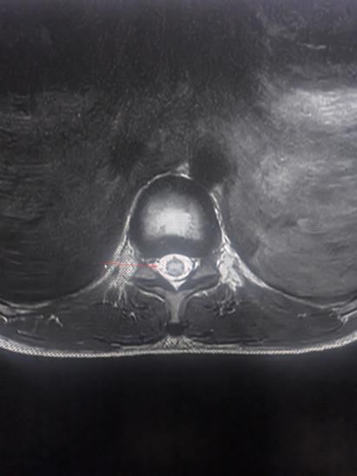
Fig 1: Spinal cord and cranial MRI at admission

After admission, treatment included ceftizoxime sodium for anti-infection, methylprednisolone (5 mg/kg/d) for anti-inflammatory therapy, intracranial pressure reduction, and supportive care. The child's temperature fluctuated recurrently around 38-39°C, with severe headaches. Auxiliary tests: high-sensitivity C-reactive protein 1.45 mg/L, white blood cell count 6.41x10^9/L, lymphocyte percentage 24.30%, monocyte percentage 14.00% (elevated), neutrophil percentage 57.50%, platelet count 207x10^9/L. Tests for influenza A/B virus nucleic acid, human rhinovirus, respiratory adenovirus, respiratory syncytial virus nucleic acid, and Mycoplasma pneumoniae nucleic acid were all negative. CSF pressure was 200 mmH₂O. CSF routine: colorless, no clot, Pandy's qualitative test 2+, nucleated cell count 175x10^6/L, differential: mononuclear 96%, polymorphonuclear 4%. Biochemistry: CSF glucose 2.4 mmol/L, chloride 120 mmol/L, CSF protein 3187.00 mg/L. On day 2 post-admission, the child experienced a generalized tonic-clonic seizure lasting about 2 minutes, followed by a drowsy state and subsequent brief staring spells lasting 1-2 seconds, along with difficulty urinating. After obtaining informed parental consent, intravenous immunoglobulin (IVIG, 1g/kg) was administered immediately to block the immune response. On day 3, he was drowsy with impaired limb movement: lower limb muscle strength grade 0, upper limb grade III, sensation迟钝 (dulled), decreased bilateral tendon reflexes, absent superficial reflexes, and absent bilateral Babinski signs. MRI: 1. Abnormal signals in bilateral semioval centers, periventricular white matter adjacent to the posterior horns of the lateral ventricles, right frontal lobe, right basal ganglia region, and left occipital lobe. 2. Diffuse abnormal signal in the spinal cord, consistent with myelitis based on history. IVIG (1g/kg) and methylprednisolone (5 mg/kg/d) were continued.
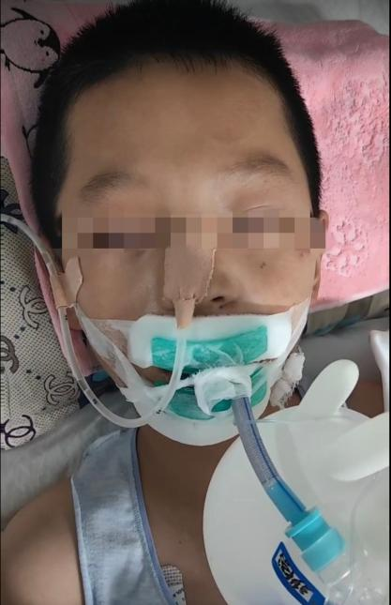
Fig 2: Initiation of Endotracheal intubation and mechanical ventilation
On day 4, the child developed dyspnea, increased sputum, increased lung markings, and scattered patchy opacities in the right lung and left lower lobe on imaging. Endotracheal intubation and mechanical ventilation were initiated. Due to pneumonia, antibiotic therapy was switched to meropenem to broaden the antimicrobial spectrum. IVIG (0.7g/kg) and methylprednisolone (5 mg/kg/d) were continued. After 5 days, methylprednisolone was tapered by 20 mg daily until reaching 60 mg, then switched to oral prednisone acetate tablet (1 mg/kg/d, tapered by 2.5 mg every 3 days until discontinuation). B vitamins and massage therapy were added. Two weeks later, repeat CSF analysis: nucleated cell count 90x10^6/L (elevated), mononuclear 86%, polymorphonuclear 14%; glucose 2.8 mmol/L, chloride 121 mmol/L, protein 774.00 mg/L. Muscle strength: bilateral upper limbs grade IV, lower limbs grade II. At three weeks, he could get out of bed; superficial sensation returned to normal; left lower limb grade II, right lower limb grade III. Rehabilitation and massage therapy were intensified.

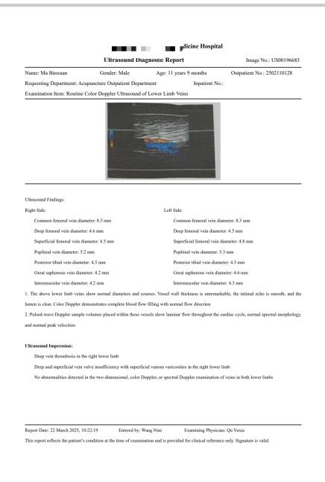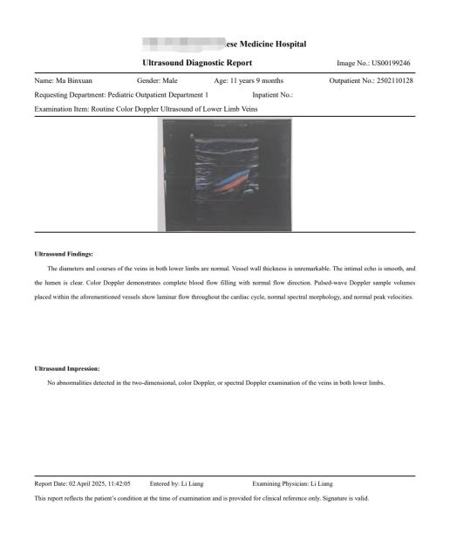
Fig 3: Dual lower extremity venous ultrasound

Follow-up ultrasound examination of both lower extremities after discharge

At four weeks, right lower limb DVT occurred, treated symptomatically with low molecular weight heparin. Urination was normal, superficial reflexes normal, muscle tone normal. Upper limb strength grade IV, lower limbs grade III. At 4.5 weeks, lower limb strength improved to grade IV, and the child was discharged. Half a month after discharge (6 weeks from illness onset), follow-up showed the child moved freely with muscle strength grade V. The patient's motor function recovery was ideal after systematic treatment and rehabilitation. He has fully regained activities of daily living (ADL) and can participate without hindrance in physically demanding sports like basketball, middle-distance running, and various jumping actions (including quick jumps and direction changes). His joint range of motion is completely normal, and muscle strength and endurance suffice for these activities, with balance and coordination fully restored.
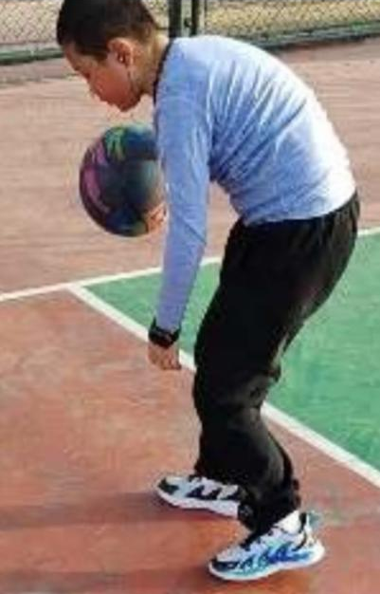
Fig 4: Boy’s Activities during the Recovery phase
Discussion: This case involves an 11-year-9-month-old boy presenting with acute fever, headache, and vomiting, rapidly progressing to impaired consciousness and neurological deficits. Combined with CSF findings, imaging characteristics, and positive anti-NMDAR antibody results, it aligns with the diagnosis of acute encephalomyelitis combined with anti-NMDAR encephalitis [10][12]. This case offers the following clinical insights:
Disease Evolution Characteristics: The course showed a typical three-stage progression: prodromal phase (fever, headache) -> acute neurological impairment phase (impaired consciousness, seizures, decreased muscle strength) -> recovery phase. Notably, the neurological damage was extensive, involving brain parenchyma (bilateral semioval centers, basal ganglia), meninges, and spinal cord. The diffuse white matter abnormalities on MRI and significantly elevated CSF protein (3187 mg/L) indicate severe blood-brain barrier disruption and neuroaxonal injury.
Autoimmune Mechanism Exploration: The positive anti-NMDAR antibody suggests a core role of autoimmune response. The uniqueness lies in the overlap of encephalomyelitis features with typical anti-NMDAR encephalitis manifestations. Literature reports approximately 5-10% of anti-NMDAR encephalitis patients may have concurrent spinal cord involvement, possibly related to antibody-mediated widespread damage to glutamatergic neurons. The CSF predominance of mononuclear cells (96%) supports T-cell-mediated immune involvement.
Implications for Differential Diagnosis: Key differentials include: ① Infectious encephalomyelitis (e.g., enterovirus, HSV): ruled out by negative CSF PCR and ineffective antiviral treatment; ② Neuromyelitis Optica Spectrum Disorder (NMOSD): not supported by negative AQP4 antibody and lack of optic nerve/chiasm lesions on imaging [21][25]; ③ Acute Disseminated Encephalomyelitis (ADEM): the monophasic course and response to immunotherapy are more consistent with ADEM, but the positive antibody suggests a specific autoimmune mechanism.
Treatment Strategy Analysis: The early use of high-dose glucocorticoids (methylprednisolone 5 mg/kg/d) combined with IVIG (2.7g/kg total) aligns with current guidelines. However, the disease fluctuation during immunotherapy suggests some patients might need more aggressive second-line treatments (e.g., rituximab or cyclophosphamide). The hospital-acquired pneumonia and type I respiratory failure highlight the synergistic risk of immunosuppression and invasive procedures (intubation), emphasizing the importance of respiratory management in intensive care. The development of right lower limb DVT was managed with early low molecular weight heparin, addressing the neurogenic hypercoagulable state.
Prognostic Factors: Despite severe initial neurological impairment (lower limb strength grade 0), complete functional recovery (grade V) was achieved, potentially due to: ① Strong neuroplasticity in children; ② Relatively timely initiation of immunotherapy (within 4 days of onset); ③ No associated malignancy (teratoma and other NMDAR-encephalitis related tumors were ruled out). The stepwise recovery of muscle strength (improving approximately one grade per week) suggests a biological process of axonal regeneration and remyelination.
This case indicates that for acute-onset widespread CNS injury, early screening for autoimmune antibodies and timely escalation of immunotherapy are essential. It also underscores the importance of high-quality nursing care, rehabilitation, and massage therapy in managing severe neuroimmune diseases. Balancing immunosuppression with infection prevention is key to improving outcomes.
Table 1: Course and Treatment Record
 | Day1 | Day2 |  | Day3 | Day4 | Day5 | Day6 | Day7 | Day8 | Day9 | Day10 | Day11 | Day12 | Day13 | Day15 | Day16 | Day19 | Day22 | Day25 | Day28
Clinical  Manifestation | Fever, headache, vomiting | Fever,headache,convulsions, dysuria |  | Methylprednisolone 200mg, Immunoglobulin 1g/kg, Cefotaxime Sodium | Fever, headache, occasional binocular staring, dysuria, limbmovement disorders | Low-grade fever, mild headache, occasional binocularstaring,dysuria,limbmovement,disorders,tachypnea,excessivesputum,decreasedbloodoxygen saturation | Normalbodytemperature,mildheadache,occasional,binocularstaring,dysuria,limbmovementdisorders,tachypnea, excessivesputum, decreasedbloodoxygensaturation | Normalbodytemperature,mild headache,occasional binocular staring, dysuria, limb movement disorders | Normal body temperature, mild headache, occasional binocular staring, dysuria, limb movement disorders | Normalbodytemperature,noconvulsions,mildheadache,dysuria,limbmovement disorders | Normal body temperature, mild headache, dysuria, limb movement disorders | Normalbody temperature, noheadache, dysuria,limbmovementdisorders | Normal body temperature, no headache, dysuria,limb movement disorders | Same as previous | Same as previous | Same as previous
Examination Results | Hypersensitive C-reactive protein (hs-CRP): 1.45 ng/L; White blood cell (WBC) count: 6.41×10⁹/L; Lymphocyte percentage: 24.30%; Monocyte percentage: 14.00%; Neutrophil percentage: 51.50%; Platelet count: 207×10⁹/L. Nucleic acid tests for influenza A virus, influenza B virus, human rhinovirus, respiratory adenovirus, respiratory syncytial virus, and Mycoplasma pneumoniae were all negative. Cerebrospinal fluid (CSF) pressure: 200 mmH₂O. Routine CSF examination: Color: colorless; Clot: none; Pandy's protein qualitative test: 2+; Nucleated cell count: 175×10⁶/L; Nucleated cell classification: Mononuclear cells 96%, Polymorphonuclear cells 4%. Biochemical examination: CSF glucose: 2.4 mmol/L; Chloride: 120 mmol/L; CSF protein: 3187.00 mg/L. |  |  |  | Magnetic Resonance Imaging (MRI): 1. Abnormal signals in the bilateral centrum semiovale, periventricular white matter of the posterior horn of the lateral ventricles, right frontal lobe, right basal ganglia region, and left inferior occipital lobe. 2. Diffuse abnormal signals in the spinal cord, considering myelitis in combination with the medical history. | Chest CT: Increased bronchovascular markings in both lungs;scattered flocculent hyperdense shadows in the right lung and left lower lobe |  |  |  |  |  | Cerebrospinal Fluid(CSF):Nucleated cell count 90X10⁶/L, mononuclear cells86%, polymorphonuclearcells14%; glucose2.8mmol/L; cerebrospinal fluid chloride 121 mmol/L;cerebrospinal fluid [item missing]774.00 ng/L | Anti-NMDAR antibody IgG positive |  |  |  |  |  |  | B-ultrasound: Deep venous thrombosis of the right lower extremity
Treatment | Methylprednisolone 200mg; Cefotaxime Sodium | Methylprednisolone200mg, Immunoglobulin 1g/kg, Cefotaxime Sodium |  | Methylprednisolone 200mg, Immunoglobulin 1g/kg, Cefotaxime Sodium | Methylprednisolone 200mg; Immunoglobulin 0.7g/kg; Cefotaxime Sodium | Methylprednisolone 200mg; Meropenem; Ventilator-assisted ventilation | Methylprednisolone 180mg; Meropenem; Ventilator-assisted ventilation | Methylprednisolone 160mg; Meropenem; Ventilator-assisted ventilation | Methylprednisolone 140mg; Meropenem; Ventilator-assisted ventilation | Methylprednisolone120mg;Meropenem;Ventilator-assistedventilation(ventilatordiscontinued) | Methylprednisolone 100mg; Meropenem; Massage | Methylprednisolone 80mg; Meropenem; Massage | Methylprednisolone 60mg; Meropenem; Massage | Prednisolone Tablets 30mg; Cefotaxime Sodium; Massage | Prednisolone Tablets 30mg; Cefotaxime Sodium; Massage | Prednisolone Tablets 27.5mg; Tuina Massage | Prednisolone Tablets 25mg; Tuina Massage | Prednisolone Tablets 22.5mg; Tuina Massage | Prednisolone Tablets 20mg; Tuina Massage | PrednisoloneTablets17.5mg;Tuina Massage; Low-molecular-weight heparin 3.75mg/day for anticoagulant therapy
(Note: The original table content appears fragmented/erroneous. A simplified translation is provided based on discernible headers.)

References:
[1] Zhao Guozhen, Wang Xuan. Clinical Analysis of 82 Cases of Acute Disseminated Encephalomyelitis in Children [J]. Journal of Jiangsu University (Medical Edition), 2023, 33(04): 348-351.
[2] Wang Yulin. Comparison of the Efficacy of Different Doses of Methylprednisolone in Treating Acute Myelitis [J]. China Medical Guide, 2025, 23(14): 73-75.
[3] Li Ruina, Lyu Xiaohan, Chen Xingyu, et al. Treatment of Acute Myelitis with High-Dose Methylprednisolone Combined with Gamma Globulin: A Case Report and Literature Review [J]. Clinical Rational Drug Use, 2024, 17(17): 171-173+177.
[4] Paolilo, R. B., Deiva, K., Neuteboom, R., Rostásy, K., & Lim, M. (2020). Acute Disseminated Encephalomyelitis: Current Perspectives. Children: Basel, 7(11), 210. https://doi.org/10.3390/children7110210.
[5] Liu Yuming. Cerebrospinal Fluid Nucleic Acid Detection and Clinical Analysis of 164 Children with Central Nervous System Infections in Northwest Yunnan [D]. Dali University, 2023.
[6] Wang Yang, Zhao Hui, Li Hui. Analysis of Cerebrospinal Fluid PCR Results and Clinical Features in Patients with Suspected Central Nervous System Infection [J]. International Journal of Laboratory Medicine, 2025, 46(06): 704-708.
[7] Zhu Yimin, Liu Jing, Liu Lili, et al. Study on Etiological Characteristics of Cerebrospinal Fluid in 26 Children with Viral Encephalitis (Meningitis) [J]. Virologica Sinica, 2021, 37(03): 583-590.
[8] Zhang Mengning. Effect of Rehabilitation Massage Combined with Functional Exercise on Limb Motor Function and Muscle Strength Recovery in Post-Stroke Hemiplegic Patients [J]. Chinese and Foreign Medical Research, 2019, 17(24): 171-172.
[9] Otallah, S. (2021). Acute disseminated encephalomyelitis in children and adults: A focused review emphasizing new developments. Multiple Sclerosis Journal, 27(8), 1153-1160. https://doi.org/10.1177/1352458520929627.
[10Wu, S., Shen, S., Sun, W., et al. (2025). FOXP3+ Macrophage-Derived Amphiregulin Promotes White Matter Repair of Experimental Autoimmune Encephalomyelitis. The FASEB Journal, 39(11), e70719. https://doi.org/10.1096/fj.202500075RR.
[11] Du Liqing. A Report on Personalized Rehabilitation Nursing Based on Multidisciplinary Collaboration for a Patient with Acute Myelitis [J]. Chinese and Foreign Medicine Research, 2025, 4(03): 123-125.
[12] Wu, S., Shen, S., Sun, W., et al. (2025). FOXP3+ Macrophage-Derived Amphiregulin Promotes White Matter Repair of Experimental Autoimmune Encephalomyelitis. The FASEB Journal, 39(11), e70719. https://doi.org/10.1096/fj.202500075RR
[13] Liu Jing, Jin Mei, Wang Yonggang, et al. Analysis of Neuroelectrophysiological Characteristics in Children with Acute Disseminated Encephalomyelitis [J]. Chinese Journal of Clinical Neurosciences, 2025, 33(01): 50-56.
[14] Wei Xiaoyu, Liang Chaoying, Wei Jianhua. Observation on the Clinical Efficacy of Ganglioside Combined with Methylprednisolone in the Treatment of Acute Myelitis [J]. Practical Journal of Clinical Medicine, 2023, 20(03): 75-78.
[15] Edlow, B. L., Claassen, J., Schiff, N. D., & Greer, D. M. (2021). Recovery from disorders of consciousness: mechanisms, prognosis and emerging therapies. Nat Rev Neurol, 17(3), 135-156. https://doi.org/10.1038/s41582-020-00428-x.
[16] Cao Fangzheng, Jin Tianyu, Wang Yiqi, et al. Role of T Lymphocyte Subsets in the Acute Phase of Neuromyelitis Optica Spectrum Disorder [J]. Journal of Apoplexy and Nervous Diseases, 2022, 39(10): 939-941.
[17] Zhong Lele, He Shengxue, Zhang Ronggui, et al. A Case of Tentorial Dural Arteriovenous Fistula Misdiagnosed as Acute Myelitis [J]. Journal of Clinical Neurology, 2022, 35(05): 399-400.
[18] Zhou Shengjuan, Zhang Xiaoyang, Qi Ruimin. Effect of Proprioceptive Neuromuscular Facilitation on Lower Limb Muscle Strength, Bladder, and Bowel Function Recovery in Patients with Acute Transverse Myelitis [J]. Journal of Aerospace Medicine, 2024, 35(04): 425-428.
[19] Lu Nannan, Wang Huixian, Pan Jinmeng. Effect of Lower Limb Functional Training on Lower Limb Muscle Strength in Patients with Acute Myelitis [J]. Qilu Journal of Nursing, 2022, 28(14): 146-148.
[20] Li Gang, Zhang Zhiqiang, Zhang Lixin, et al. Curative Effect Observation of Isokinetic Muscle Strength Training on Lower Limb Motor Function Rehabilitation in Stroke Patients with Hemiplegia [J]. Chinese Journal of Rehabilitation Medicine, 2019, 34(5): 588-590.
[21] Cao Danyang, Li Jiao, Xiao Shuang, et al. Effect of Psychological Support Combined with Rehabilitation Exercise on Living Ability and Lower Limb Muscle Strength in Patients with Acute Myelitis [J]. Modern Journal of Integrated Traditional Chinese and Western Medicine, 2019, 28(25): 2835-2838.
[22] Wei Shaoshaonong. Prediction of MOGAD in Acute Disseminated Encephalomyelitis Based on Multimodal MRI Features [D]. Hangzhou Dianzi University, 2023.
[23] Koelman, D. L. H., & Mateen, F. J. (2015). Acute disseminated encephalomyelitis: Current controversies in diagnosis and outcome. Journal of Neurology, 262(9), 2013-2024. https://doi.org/10.1007/s00415-015-7694-7.
[24] Wang Yamin, Liu Dawei. Research Progress on the Causal Relationship between Vaccination and Acute Disseminated Encephalomyelitis [J]. Chinese Journal of Vaccines and Immunization, 2012, 18(03): 261-267.
[25Baumann, M., Sahin, K., Lechner, C., Hennes, E. M., Schanda, K., Mader, S., Karenfort, M., Selch, C., Häusler, M., Eisenkölbl, A., Salandin, M., Gruber-Sedlmayr, U., Blaschek, A., Kraus, V., Leiz, S., Finsterwalder, J., Gotwald, T., Kuchukhidze, G., Berger, T., Reindl, M., & Rostásy, K. (2015). Clinical and neuroradiological differences of paediatric acute disseminating encephalomyelitis with and without antibodies to the myelin oligodendrocyte glycoprotein. Journal of Neurology, Neurosurgery & Psychiatry, 86(3), 265-272. https://doi.org/10.1136/jnnp-2014-308346.
[26] Zhang, M., Shen, J., Zhou, S., Du, X., Li, W., Yu, L., Zhang, Y., Wang, Y., & Zhang, L. (2020). Clinical and Neuroimaging Characteristics of Pediatric Acute Disseminating Encephalomyelitis With and Without Antibodies to Myelin Oligodendrocyte Glycoprotein. Frontiers in Neurology, 11, 593287. https://doi.org/10.3389/fneur.2020.593287
[27] Jin Bo, Zhao Yuting. Application Value of Comprehensive Nursing in Children with Severe Acute Disseminated Encephalomyelitis [J]. Chinese Community Doctors, 2022, 38(17): 97-99.
[28] Xie Zhaomin, Ling Xiaohui. Nursing Care for a Patient with Acute Disseminated Encephalomyelitis Complicated by Lower Limb Scald and Deep Vein Thrombosis [J]. Chinese Journal of Medical Care, 2014, 26(16): 118-119.
[29] Wang Xiaoyan. Nursing Care for Severe Acute Disseminated Encephalomyelitis [J]. Chinese General Practice Nursing, 2016, 14(24): 2557-2558.
[30] Jin Bo, Zhao Yuting. Application Value of Comprehensive Nursing in Children with Severe Acute Disseminated Encephalomyelitis [J]. Chinese Community Doctors, 2022, 38(17): 97-99. (Note: Duplicate entry [27] in original)

