Identification, Incidence and Prevalence of Sorghum Foliar Diseases in the fields of producers in the commune of Tanout

ABSTRACT
Sorghum plays an important role in the rural economy of Niger. However, the production of this cereal is hampered by multiple pressures, including fungal diseases. One hundred (100) fields belonging to sorghum producers in 20 villages of the commune were surveyed, with five (5) fields per village. In each field, five (5) elementary plots, each composed of twelve (12) planting holes, were marked out for the identification and assessment of the prevalence and incidence of sorghum foliar diseases. Six (6) foliar diseases were identified: anthracnose, leaf blight, oval spot, grey spot, zoned spot, and sand grain disease. Out of a total of 6,000 sorghum hills examined, 3,839 hills showed symptoms of anthracnose, representing an average incidence of 63.98%; 3,088 hills showed symptoms of oval spot, representing 51.47%; 2,039 hills showed symptoms of leaf blight, representing an average incidence of 33.98%; and only 94 hills showed symptoms of zoned spot, representing an average incidence of 1.57% in the commune of Tanout. The prevalence of these diseases fluctuates in line with their incidence. The prevalence is respectively 97.6% for anthracnose, 87.2% for oval spots, 82.6% for leaf blight and 13.4% for zoned spot. Anthracnose was the most widespread sorghum disease in the commune of Tanout, followed by oval spots, leaf burn, grey spots, sand grains and finally zoned spot.
Keywords: Sorghum, disease, incidence, prevalence, Tanout
1. INTRODUCTION
Sorghum (Sorghum bicolor L. Moench) is a major cereal crop cultivated in many tropical regions of the world. Along with millet, it is one of the main food sources in the arid and semi-arid zones of Africa and Asia, where millions of people depend on it for their livelihoods (Abdou et al., 2014; Karimou et al., 2023). Sorghum is cultivated primarily for its grain, which is used in human food in various forms (porridge, flatbreads, couscous, traditional beverages, etc.). The stalks and culms are also valued as animal fodder, fuel for household use, or building material (Karimou et al., 2023; Upadhyaya et al., 2017). In Niger, sorghum plays a significant role in the rural economy. In 2023, national production was estimated at 1,646,000 tonnes from an area of ​​3,700,000 hectares, with a yield of 581 kg/ha, making it the second most cultivated cereal after millet (FAOSTAT, 2024). In 2022, sorghum production in the Tanout department reached 118,276 tonnes from an area of ​​211,586 ha, with a yield of 559 kg/ha (INS/DR, 2024). This yield is low compared to the national average. This low productivity is explained by several constraints, including unfavourable climatic conditions, the use of low-performing local varieties, reduced use of agricultural inputs, but also and especially attacks by pests and diseases (Kadi Kadi et al., 2005; Louis et al., 2020). Some fungal diseases, when they affect susceptible lines, can cause yield losses of up to 100%, thus compromising the food security of rural populations dependent on this crop (Prom et al., 2011; Cuevas et al., 2016). Controlling these diseases requires precise knowledge of their frequency, extent, and severity in the field. The objective of this study is to identify foliar diseases of sorghum in the fields of producers in the commune of Tanout, and to determine the incidence and prevalence of these diseases.
2. MATERIALS AND METHODS
2.1. Study Area
The commune of Tanout is located in the far north of the Zinder Region, between 14°5’ and 17°30’ North latitude and between 7°20’ and 9°37’ East longitude. It covers an area of ​​6,780 km², representing 22.42% of the total area of ​​the Tanout Department, estimated at 30,247 km² (Kailou et al., 2022). The commune of Tanout is bordered to the east by the communes of Tenhya and Allakos (Gouré Department), to the west by the commune of Gangara, to the north by the communes of Aderbissanatt (Agadez Region) and Tenhya, and to the south by the communes of Olléléwa, Alakoss (Gouré Department), and Kangna Wamé (Mirriah Department). The climate is sub-desert Sahel-Saharan with rainfall ranging from 200 mm to 400 mm. Agriculture is the main activity of the population of the Tanout department. It is practiced primarily during the rainy season on the dune lands and during the dry season around a few existing ponds (PDC, 2025). Cultivated areas amount to 1,942,800 ha, representing 58.57% of the department's total area. The main crops are millet, sorghum, and cowpeas.
2.2. Methods
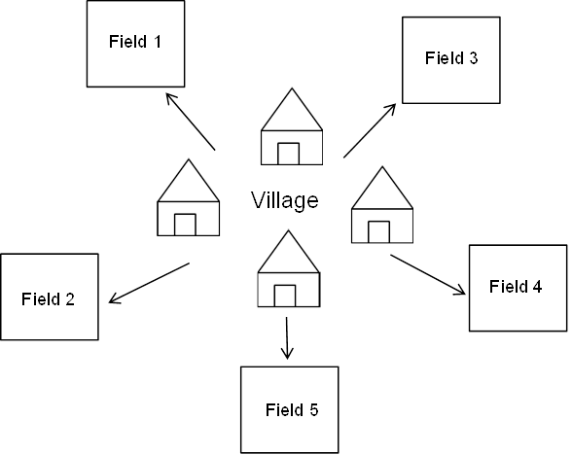
Surveys of sorghum farmers' fields in the commune of Tanout were conducted. A total of 100 randomly selected fields within the agricultural zone were surveyed at the physiological maturity stage in 20 administrative villages. Five (5) farmers' fields were surveyed in each village (Figure 1).

Figure 1: Layout of the fields at the village level
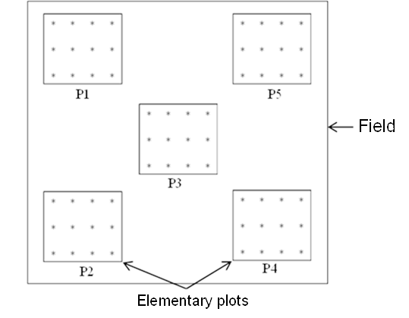
Five (5) elementary plots are materialized using a W-shaped pattern in each field (Louis et al., 2020). The elementary plots consist of 12 pockets each (Figure 2).

Figure 2: Layout of elementary plots in the fields
In each plot, sorghum foliar diseases are identified using the guide to the identification of major sorghum diseases in Niger (Haougui et al., 2025). The number of hills showing symptoms of each disease is counted to determine the incidence and prevalence of these diseases. Incidence is the proportion or percentage of infected hills in the plot. It is determined by the formula below:
$$Incidence \left(\%\right)=\frac{Number of infected spots}{Total number of spots} x 100$$
Prevalence is the percentage of individual plots in a field (or fields in a village) that have at least one sorghum plant (or field) affected by the disease. It expresses the geographical extent of the disease in a given area (field, village, municipality, department, etc.). It is calculated using the formula below:
$$Prevalence \left(\%\right)=\frac{Number of infected plots (or fields)}{Total number of plots (or fields) surveyed} x 100$$
3. RESULTS AND DISCUSSION
3.1. Results
3.1.1. Village Locations
Table 1 presents the geographic coordinates of the villages whose fields were surveyed. Analysis of this table shows that the study covers a large part of the Tanout municipality, with villages located between 14.53° and 15.01° North latitude and 8.72° and 9.18° East longitude. This spatial distribution of the sites indicates good geographic representation of the survey, encompassing both the northern and southern areas of the municipality.
Table 1: Geographic coordinates of the villages whose fields are being surveyed
Villages | Altitude | Longitude
TCHIMBORAGAN | N14°46’47,06’’ | E8°50’55,53’’
DALLI | N14°51’14,74’’ | E8°52’52,89’’
DALLI HAOUSSAWA | N14°50’21,80’’ | E8°52’18,40’’
ALBOURDATAN | N14°48’46,55’’ | E8°51’53,67’’
BAKATCHIRABA | N14°56’04,52’’ | E8°49’53,74’’
GAMDOU | N14°54’03,86’’ | E8°47’16,48’’
ABAGA | N14°52’45,78’’ | E8°47’26,16’’
ZABEWA | N14°49’26,28’’ | E8°47’40,31’’
MAIDIGA | N14°49’29,96’’ | E8°43’17,83’’
GOGUINE KASSOULA | N14°54’43,57’’ | E8°53’48,82’’
GOGUINE GWOM-GWOM | N14°52’23,07’’ | E8°53’25,69’’
OUMARADI | N14°49’12,77’’ | E8°53’37,36’’
AFOUNORI | N14°40’29,86’’ | E9°00’49,95’’
GARGADA | N14°32’19,01’’ | E9°10’46,06’’
BABOUL-YACHI | N14°49’35,23’’ | E9°03’29,62’’
GARIN MARMA | N15°00’45,36’’ | E8°57’50,40’’
MARMARI | N14°46’07,77’’ | E8°52’51,51’’
CHIRWA | N14°44’33,82’’ | E8°54’51,65’’
TANOUT | N14°58’10,83’’ | E8°53’26,97’’
DAN YARI | N14°58’38,31’’ | E8°52’31,06’’
Diseases encountered A total of six (6) foliar diseases of sorghum were identified in the fields of producers in the commune of Tanout (Figure 3, Table 2).

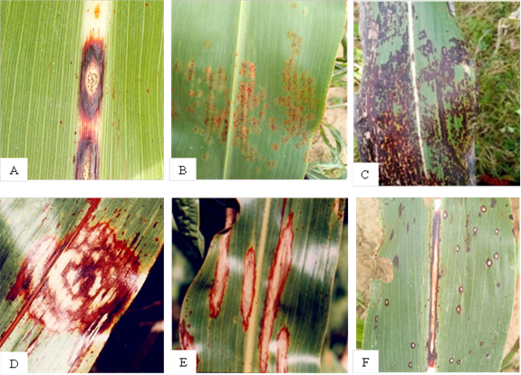
Figure 3: Symptoms of diseases identified in the commune of Tanout:
A = Anthracnose, B = Sand grains, C = Grey spots, D = Zoned spot,
E = Leaf burn, F = Oval spots

Table 2: Foliar diseases identified in the fields of producers in the commune of Tanout
Diseases | Causal agent | Symptoms
Anthracnose | Colletotrichum sublineola | - Small, elliptical leaf spots with the appearance of an eye staring at you in the center, on the upper surface of the leaves.  - Elliptical spots on the midrib.
Leaf burn | Exserohilum / Helminthosporium turcicum | - Elongated, elliptical lesions with reddish margins (depending on the variety) and a bronze center.  - The center of the lesions may have a powdery or black appearance in high humidity.
Grey spots | Cercospora sorghi | - Small, dark, moist spots surrounded by a yellowish border on the leaves.  - Over time, the lesions elongate parallel to the veins and become pale brown to grey, rectangular in shape with a diffuse outline (without a precise border).
Sand grains | Ascochyta sorghi | - Small reddish spots with initially whitish centers.  - As the lesions spread across the upper surface of the leaves, small black bodies appear in the centers of the spots, giving them a rough appearance.
Zoned spot | Gloeocercospora sorghi | - Small lesions on the lower leaves,  - These lesions become circular on the leaf blade and semi-circular on the edges of the leaf.
Oval spots | Ramulispora sorghicola | - Spots a few millimeters wide and generally oval in shape,  - Lesions arranged parallel to the veins, which limits their lateral expansion.  - They are straw-colored, surrounded by a purplish or reddish border
3.1.2. Prevalence of Foliar Diseases
Table 3 illustrates the prevalence of foliar diseases by village whose fields were surveyed. All identified diseases were present in all surveyed fields except for stripe leaf spot, which was absent from the fields in the villages of Goguine Gwom-Gwom and Oumaradi. Anthracnose stood out as the most widespread disease, with prevalence ranging from 80% to 100%. It was followed by leaf blight, with a prevalence varying from 64% to 100%. Gray leaf spot showed significant variability, ranging from 28% to 92%. Stripe leaf spot was the least frequent disease in the majority of villages, with overall low infestation levels of 0% to 28%. Sandy leaf spot showed a moderate but heterogeneous prevalence (4% to 64%), while oval leaf spot was characterized by high variability (20% to 100%). Some villages, such as Dalli, Dalli Haoussawa, Baboul-Yachi, Goguine Kassoula, Goguine Gwon-Gwon and Tanout, have recorded particularly high levels of infestation for several diseases, making them areas at high phytosanitary risk.
Table 3: Prevalence of sorghum foliar diseases by village
Villages | Prevalence of diseases (%)
Villages | Anth | LB | GS | ZS | SG | OS
TCHIMBORAGAN | 96 | 80 | 44 | 28 | 20 | 80
DALLI | 100 | 96 | 88 | 28 | 8 | 100
DALLI HAOUSSAWA | 100 | 96 | 92 | 16 | 4 | 96
ALBOURDATAN | 100 | 84 | 72 | 12 | 40 | 84
BAKATCHIRABA | 100 | 80 | 52 | 8 | 48 | 100
GAMDOU | 100 | 76 | 32 | 20 | 64 | 100
ABAGA | 100 | 80 | 36 | 4 | 60 | 72
ZABEWA | 96 | 84 | 68 | 16 | 48 | 92
MAIDIGA | 80 | 72 | 28 | 4 | 40 | 100
GOGUINE KASSOULA | 96 | 96 | 40 | 16 | 56 | 100
GOGUINE GWOM-GWOM | 92 | 92 | 28 | 0 | 36 | 100
OUMARADI | 96 | 92 | 28 | 0 | 36 | 96
AFOUNORI | 100 | 84 | 28 | 4 | 20 | 100
GARGADA | 100 | 68 | 60 | 12 | 52 | 52
BABOUL-YACHI | 100 | 100 | 84 | 44 | 24 | 100
GARIN MARMA | 100 | 84 | 40 | 16 | 52 | 100
MARMARI | 100 | 64 | 68 | 4 | 42 | 64
CHIRWA | 96 | 84 | 64 | 20 | 48 | 88
TANOUT | 100 | 76 | 48 | 12 | 48 | 100
DAN YARI | 100 | 64 | 80 | 4 | 12 | 20
Anth : Anthracnose ; LB : Leaf burn; GS : Grey spots; ZS : Zoned spot; SG : Sand grains ; OS : Oval spots
3.1.3. Incidence of Foliar Diseases
Anthracnose and oval leaf spot are the most common diseases, with incidence rates ranging from 0% in the Maidiga and Goguine Gwom-Gwom fields to 100% in the Zabewa and Goguine Gwom-Gwom fields for anthracnose, and from 0% in the Gargada and Dan Yachi fields to 100% in the Goguine Gwom-Gwom and Oumaradi fields for oval leaf spot. Leaf blight is the third most prevalent disease, with incidence rates reaching 81% in the Dalli and Abaga fields. Zoned spot disease had no incidence in more than 50% of the surveyed fields, with the highest incidence of 8.33% recorded in the Tchimboragan fields. Other diseases, namely gray spot and sand grain disease, had incidences ranging from 0% in 11% of fields to 81% in the Dalli Haoussawa fields for gray spot, and from 0% in 27% of the surveyed fields to 61.67% in the Gargada fields. The incidence of each disease was determined on 60 field samples. Table 4 shows the percentage of fields per disease according to incidence. For anthracnose, four percent (4%) of the surveyed fields had an incidence of 20% or less, thirty percent (30%) had a moderate incidence between 21% and 50%, and twenty-nine percent (29%) had an incidence greater than 80%. The surveyed fields were almost evenly distributed according to the incidence ranges for oval spots. Thus, nineteen percent (19%) of the fields had an incidence of 20% or less, thirty-one percent (31%) had a moderate incidence between 21% and 50%, and twenty percent (20%) had an incidence greater than 80%. One hundred percent (100%) of the fields recorded an incidence of less than 20% for Zoned Spot disease, and ninety-one (91%) of the fields had an incidence of gray spot less than 20%.
Table 4: Percentage of fields surveyed per disease according to incidence
Disease | Disease incidence (%)
Disease | [0 to 20] | [21 to 50] | [51 to 80] | [81 to 100]
Anthracnose | 4 | 30 | 37 | 29
Leaf burn | 26 | 55 | 17 | 2
Grey spots | 75 | 12 | 11 | 2
Zoned spot | 100 | 0 | 0 | 0
Sand grains | 91 | 8 | 1 | 0
Oval spots | 19 | 31 | 30 | 20
3.1.4. Incidence of Sorghum Foliar Diseases by Village
Figure 4 shows the incidence of sorghum foliar diseases identified in surveyed fields from 20 villages in the commune of Tanout. Anthracnose and oval leaf spot are the most frequent diseases, with incidence peaks sometimes exceeding 80% in the villages of Bakatchiraba (80.67%), Dan Yari (83.67%), and Afunori (87.67%) for anthracnose, and Oumaradi (78%), Goguine Gwom-Gwom (79.67%), and Tanout (80.67%) for oval leaf spot. Leaf blight ranks third after anthracnose and oval leaf spot, with incidence rates ranging from 73.33% in Dalli to 16% in Gargada. Zoned spot disease and sand grains have the lowest incidence rates, ranging from 0% in Goguine Gwom-Gwom and Oumaradi, to 4.33% in Baboul-Yachi for zoned spot and from 0.33% in Dalli Haoussawa, to 23.33% in Gargada.
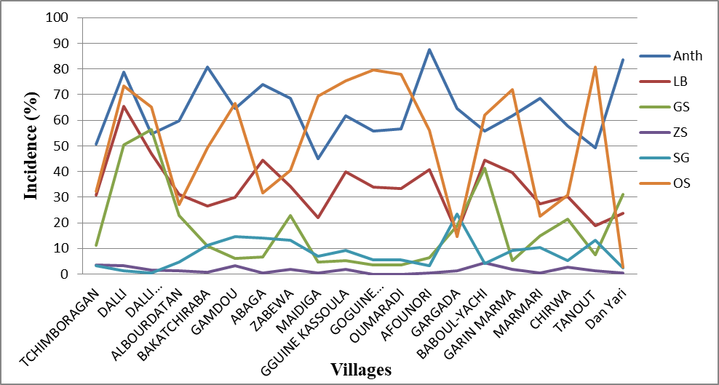
Figure 4: Incidence of sorghum foliar diseases by village: Anth = Anthracnose,
LB = Leaf blight, GS = Gray spots, ZS = Zoned spots, SG = Sand grains, OS= Oval spots

3.1.5. Incidence and Prevalence of Foliar Diseases in the Commune of Tanout
The average incidence and prevalence of foliar diseases found in the commune of Tanout are illustrated in Figure 5. Out of a total of 6,000 sorghum hills examined, 3,839 hills showed symptoms of anthracnose, representing an average incidence of 63.98%; 3,088 hills showed symptoms of oval spot, representing 51.47%; 2,039 hills showed symptoms of leaf blight, representing an average incidence of 33.98%; and only 94 hills showed symptoms of banded spot, representing an average incidence of 1.57% for the commune of Tanout. The variation in the prevalence of these diseases in the commune of Tanout follows the same pattern as that of their incidence. Thus, the prevalence in the commune is 97.6% for anthracnose, 87.2% for oval spot, 82.6% for leaf blight, and 13.4% for zoned spot. Overall, these results reveal that the phytosanitary pressure on sorghum in Tanout is dominated by a few major diseases, the control of which is essential to improve production.

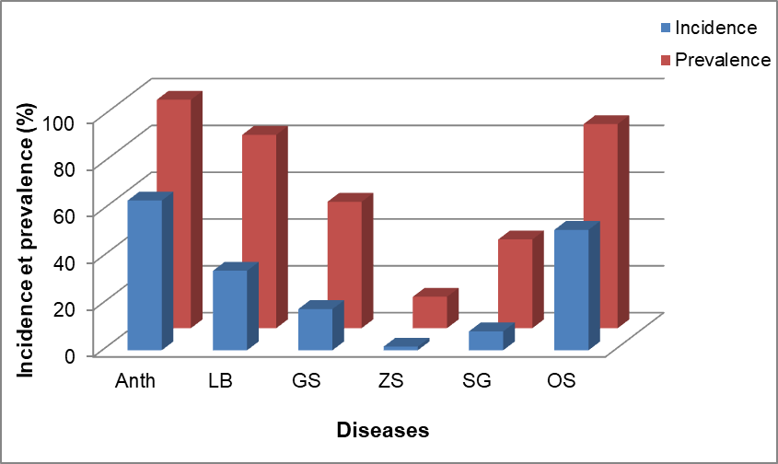
Figure 5: Incidence and prevalence of sorghum foliar diseases
in the commune of Tanout: Anth = Anthracnose, LB = Leaf blight,
GS = Gray spots, ZS = Zoned spots, SG = Sand grains, OS = Oval spot

3.2. DISCUSSION
The study on the incidence and prevalence of sorghum foliar diseases in farmers' fields in the commune of Tanout revealed the presence of six (6) diseases: anthracnose, oval spot, leaf blight, gray spot, zoned spot, and sand grain disease. These results are similar to those found by Louis et al. (2020) in a survey on the prevalence and incidence of foliar and panicle diseases in sorghum production areas in Niger. This study shows that anthracnose, oval spot, and leaf blight are the main foliar diseases of sorghum in the commune of Tanout. Their prevalence varies from 80% to 100% in producers' fields with an average of 97.6% for anthracnose, from 20% to 100% and an average of 87.2% for oval spots and from 64% to 80% for leaf burn with an average of 82.6% for the municipality (Table 3 and Figure 5). Surveys conducted in Niger also indicate that anthracnose, oval spot, and leaf blight are among the most prevalent diseases in the main sorghum-producing areas of Niger (Louis et al., 2020; Louis et al., 2023; Haougui et al., 2025). In western Kenya, anthracnose, leaf blight, gray spot, and zoned leaf spot were found to be the most frequently observed diseases in farmers' fields (Ngugi et al., 2002). In southern Tigray, Ethiopia, Teklay and Muruts (2015) reported that anthracnose, leaf blight, downy mildew, and smut are among the destructive diseases of sorghum. Authors have reported, each in their respective study areas, that anthracnose and leaf blight are the most common sorghum leaf diseases in farmers' fields, with prevalence ranging from 84% to 99% (Louis et al., 2020; Prom et al., 2021; Louis et al., 2023; Teklay and Muruts, 2015; Tsedaley et al., 2016; Chala et al., 2010; Beshir et al., 2015; Koima et al., 2022). Similar to this work, oval leaf spot has also been found to be one of the predominant sorghum diseases in four major climatic growing zones in Nigeria (Pande et al., 1993). However, a survey conducted in three climatic zones of the main sorghum-growing regions of Ghana revealed a low incidence of leaf blight (Nutsugah et al., 2008). In contrast, zoned leaf spot, gray spot, and sand spots are less prevalent in the fields of farmers in the commune of Tanout. Haougui et al. (2025) reported that zoned leaf spot is observed only in a few sorghum-producing regions of Niger. During this study, the incidence of foliar diseases varied from one disease to another, from one field to another, and from one village to another. For example, of the one hundred (100) fields surveyed, only four (4) had an anthracnose incidence ranging from 0 to 20%, thirty (30) fields had an incidence ranging from 21 to 50%, and twenty-nine fields had an anthracnose incidence exceeding 80%. However, for the zoned patch, all one hundred (100) fields surveyed have an incidence between 0 and 20% (Table 4). The incidence of anthracnose varies from 50.67% in Tchimboragan to 87.67% in Afounori, with an average of 63.98% for the commune. The incidence of oval spot ranges from 2.67% in Dan Yari to 80.67% in Tanout, with an average of 51.47% for the commune (Figures 4 and 5). Similarly, Eshte et al. (2015) recorded an anthracnose incidence of 100% in three districts in the southern Omo and Segen areas of Ethiopia. The observed differences between fields and between villages reveal a diversity of disease pressure, highlighting the need to adapt phytosanitary interventions locally according to the dominant disease and its intensity in each village. Similar to this work, surveys conducted on the incidence and prevalence in 2019, and on the incidence, prevalence and severity of sorghum diseases in 2022 in production areas in Niger, showed that foliar disease pressure varied from area to area and from field to field. Thus, of the 121 fields surveyed in 2019, twenty (20) had an anthracnose incidence greater than 95%, including four in the Tillabéri region, seven in the Dosso region, six in the Tahoua region, and three in the Maradi region (Louis et al., 2020). In 2022, the highest average incidence of leaf blight (95%) was recorded in the Tahoua and Zinder regions, while the highest average incidences of oval spot (80%), anthracnose (56%), and gray spot were observed in the Maradi region (Louis et al., 2023). Teklay and Muruts, (2015) report that the average incidence of anthracnose, which was 100% in 27 plots of the seven farmers' associations in the two districts in southern Tigray, Ethiopia, varied between 10% and 84.6% for eight other farmers' associations.
4. CONCLUSION
Sorghum is a strategic crop for food security in Tanout, but its productivity is compromised by various fungal diseases that affect both the panicles and the leaves. The combined effect of these complex diseases can lead to considerable yield losses for sorghum producers. This study identified six (6) foliar diseases of sorghum and determined their incidence and distribution in the commune of Tanout. Anthracnose was the most widespread sorghum disease in the commune of Tanout, followed by oval spot, leaf blight, gray spot, sand grain disease, and finally, zoned spot. The results of this work constitute a database for agricultural planning and phytosanitary research in Niger in general and in the commune of Tanout in particular, and can serve as a guide to researchers, including phytopathologists, funding bodies, as well as producers on the incidence, prevalence and importance of foliar diseases of sorghum in the production areas of this cereal.
REFERENCES
Abdou, M.M., Alzouma, M.Z., Dan Lamso, N., Elhadji Seybou, D., & Jean-Marie, K.A. (2014). Productivity of sorghum cultivation (Sorghum bicolor) in an agroforestry system based on Acacia senegal (L.) Willd. in Niger. J.Appl. Biosci., 82, 7339-7346.
Beshir, M.M., Ahmed, N.E., Abdelbagi, M.A., Ibrahim HB, Patrick R, & Patrick O. (2015). Prevalence and severity of sorghum leaf blight in the sorghum growing areas of central Sudan. Wudpecker J. Agric. Res., 4(4), 054 – 060.
Chala, A., Alemu, T., Prom, L. K., & Tronsmo, A. M. (2010). Effect of Host Genotypes and Weather Variables on the Severity and Temporal Dynamics of Sorghum Anthracnose in Ethiopia. Plant Pathol. J., 9(1), 39-46. doi:10.3923/ppj.2010.39.46
Cuevas, H. E., Prom, L. K., Isakeit, T., & Radwan, G. (2016). Assessment of sorghum germplasm from Burkina Faso and South Africa to identify new sources of resistance to grain mold and anthracnose. Crop Protect., 79, 43-50.
Eshte, Y., Mitiku, M., & Shiferaw, W. (2015). Assessment of Important Plant Disease of Major Crops (Sorghum, Maize, Common Bean, Coffee, Mung Bean, Cowpea) in South Omo and Segen People Zone of Ethiopia. Curr. Agric. Res. J., 3, 75-79. DOI: 10.12944/carj.3.1.10
FAO. (2024). FAOSTAT database. Food and Agriculture Organization, Rome, Italy. http://www.fao.org/faostat/en/#data/QC/visualize
Haougui, A., Issa, K., Basso, A., Ali, O.B., Bori, H., Kadri, A.A., & Halilou, O.O. (2025). Guide to identifying the main sorghum diseases in Niger. National Institute of Agronomic Research of Niger. 23p.
INS/DR. (2024). Regional statistical yearbook 2018-2022. 253p
Kadi Kadi, H. A., Kapran, I., & Pendleton, B. B. (2005). Identification of sorghum genotypes resistant to sorghum midge in Niger. Int. Sorghum Millets Newslet, 46, 57-59.
Kailou, D.A., Adamou, A., & Abdou, H. (2022). Planning of Water and Electricity Network Services in the Town of Tanout in Niger. Urban and Regional Planning, 7(4), 141-149. DOI: 10.11648/j.urp.20220704.11
Karimou, I., Halilou, H., & Issa, M.L. (2023). Occurrence And Distribution of Sorghum Smuts in the Field’s Producer in the South-Eastern Regions of Niger. Int. J.Sci. Eng. Applied Sci. (IJSEAS), 9(7), 1-7
Koima, I.N., Kilalo, D.C., Orek, C.O., Wagacha, J.M., & Nyaboga, E.N. (2022). Survey of fungal foliar and panicle diseases in smallholder sorghum cropping systems in different agro-ecologies of lower Eastern Kenya. Microbiology Research, 13, 765-787. DOI: 10.3390/microbiolres13040055
Louis, K.P., Haougui, A., Ali, O.B., Karimou, I., Abdoulaye, A.A., Oumarou, H.O., Basso, A., Coumba, F., & Clint, M. (2023). Incidence, Severity, and Prevalence of Sorghum Diseases in the Major production regions in Niger. Journal of Plant Studies, 12(1), 48-59. DOI:10.5539/jps.v12n1p48
Louis, K.P., Haougui, A., Adamou, I., Abdoulaye, A.A., Karimou, I., Ali, O.B., & Clint, M. (2020). Survey of the prevalence and incidence of foliar and panicle diseases of sorghum across production fields in Niger. Plant Pathol. J., 19, 106-113. DOI: 10.3923/ppj.2020.106.113
Ngugi, H.K., King, S.B., Abayo, G.O., & Reddy, Y.V.R. (2002). Prevalence, incidence and severity of sorghum diseases in Western Kenya. Plant Dis., 86(1), 65-70. DOI: 10.1094/pdis.2002.86.1.65
Nutsugah, S. K., Atokple, I. D. K., & Leth, V. (2008). Sorghum Diseases Prevalent in Ghana. Ghana J. Agric. Sci., 40, 119-126. DOI:10.4314/gjas.v40i2.2161
Pande, S., Harikrishnan, R., Alegbejo, M. D., Mughogho, L. K., Karunakar, R. I., & Ajayi, O. (1993). Prevalence of sorghum diseases in Nigeria. Int. J. Pest Manage, 39(3), 297-303.
PDC. (2025). Communal Development Plan of the Urban Commune of Tanout, developed with the financial support of PIDUREM and the technical assistance of the OGN AIDD_Cabinet_consult group. 100p.
Prom, L.K., Sarr, M.P., Diatta, C., Ngom, A., Aïdara, O., Cisse, N., & Magill, C. (2021). The occurrence and distribution of sorghum diseases in major production regions of Senegal, West Africa. Plant Pathol. J., 20, 1-10. DOI: 10.3923/ppj.2021.1.10

Prom, L. K., Thomas, I., Perumal, R., Erpelding, J. E., Rooney, W., & Magill, C. W. (2011). Evaluation of the Ugandan sorghum accessions for grain mold and anthracnose resistance. Crop Prot, 30, 566-571.
Teklay, A. T., & Muruts, L. W. (2015). Prevalence and Intensity of Economically Important Fungal Diseases of Sorghum in South Tigray, Ethiopia. Journal of Plant Sciences. 3(2), 92-98. doi: 10.11648/j.jps.20150302.18
Tsedaley, B., Adugna, G., & Lemessa, F. (2016). Distribution and Importance of Sorghum Anthracnose (Colletotrichum sublineolum) in Southwestern and Western Ethiopia. Plant Pathol. J., 15, 75-85.
Upadhyaya, H. D., Narsimha Reddy, K., Vetriventhan, M., Irshad Ahmed, M., Gumma, M. K,, Thimma Reddy, M., & Singh, S. K. (2017). Sorghum germplasm from West and Central Africa maintained in the ICRISAT genebank: Status, gaps, and diversity. The Crop Journal, 5 (6), 518-532.

