Original Research Article

Determining the Genetic divergence for Biometrical attributes in Cluster bean (Cyamopsis tetragonoloba (L.) Taub. accessions through Mahanalobis D² statistics

.
ABSTRACT

Aims: Genetic divergence plays a crucial part in determining the selection of genotypes for any breeding programme in order to generate superior segregants. Assessing the local or related genotypes for divergence, imposses a necessity to conduct experiments on specific agro-ecological situations to breed specific varieties suitable for vegetable and gum purpose.
Study design: Randomized Block Design
Place and Duration of Study: An elaborate study was performed in January to April 2022 at the field in Poothurai village of Villupuram District, Tamil Nadu to evaluate and screen the cluster bean germplasms.
Methodology: A total of 102 genotypes (including Pusa Navbahar - a check variety) procured from various regions of the country were utilized. Observations were recorded for growth attributes (plant height; number of branches per plant; days to maturity), flowering and pod characters (days to 50 % flowering; number of clusters per plant; number of pods per cluster; pod length; pod girth), yield parameters (pod weight; number of pods per plant; total pod yield per plant), seed characters (number of seeds per pod; hundred seed weight; total seed yield per plant) and physiological components (guar gum; protein and fibre) on five randomly selected plants.
Results: It divulged a paramount of diversity with the genotypes being grouped into 14 clusters based on 17 parameters. Seven clusters had more than 2 genotypes, and the remaining were solitary. Yield parameters such as total per plant yield (22.20%), pods per cluster (15.30%), and clusters per plant (14.80%) contributed to the highest percentage diversity. The distance between intra clusters ranges from 0.00 to 2031.87. The maximum distance between clusters observed is between cluster V and cluster IX (15980.81).
Conclusion: Of the 102 genotypes, Cluster XIV having the sole member Pusa Navbahar performed better for six out of seventeen parameters observed for the mean of clusters. With respect to the above results obtained and per se performance of the landraces, selection can be made to obtain superior cluster bean recombinants.

Keywords: Cluster bean, Multivariate statistic, Genetic Diversity, Mahalanobis D², Yield attributes.

1. INTRODUCTION

Cluster bean, an underexploited leguminous vegetable belonging to Leguminaceae family is highly drought tolerant, well adapted to poor and erratic climatic conditions ⁽¹⁾. It is a potential vegetable grown for its tender pods that are nutritionally affluent containing good sources of energy, protein, fats, carbohydrates, vitamins, calcium and iron ⁽²⁾. It has also gained attention for its fine endospermic gum, making it a potential cash crop for both industrial and pharmaceutical purposes ⁽³⁾. India holds a superlative share of 80 % of total gum production in the world. Owing to its multi-purpose nature, it is used as a forage crop and for fixing the atmospheric nitrogen thereby improving soil fertility⁽⁴⁾. According⁽⁵⁾, Adak guar, which is produced primarily for its gum content and as fodder in the arid regions of North Western India, has been found to act as a bridge between the wild and domesticated ones. The cluster bean under cultivation shows typical signs of domestication syndrome, including dense growing habit, indehiscent edible pods, seed dormancy loss, cylindrical and large seeds.
Assessing the local or related genotypes for divergence, imposes a necessity to conduct experiments on specific agro-ecological situations to breed specific varieties suitable for vegetable and gum purpose. It is vital to breed for deviations that are suited to specific agro-ecological environments for seed and gum purposes in order to assess local or related genotypes and figure out divergence. With very low divergence, only modest results can be achieved. The breeder will need to increase germplasm enrichment or may have to resort to increased divergence through mutations, polyploidy breeding and hybridization programmes⁽⁶⁾. Genetic diversity of elite germplasm opens up an array of possibilities in determining better parents and generating superior hybrids. While planning the breeding goals, having an understanding of the genetic divergence of different parameters, especially those that impact quantitative and qualitative traits, would be significant. Mahalanobis statistics indicates a scale of magnitude for the divergence between the two genotypes that are being assessed⁽⁷⁾. Hence an analysis was done out to determine the degree of genetic diversity between 102 accessions for 17 biometric traits.

2. material and methods
An elaborate study was performed in January to April 2022 at the field in Poothurai village of Villupuram District, Tamil Nadu to evaluate and screen the cluster bean germplasms. The experimental plot is situated at 11.9667° N and 79.7596° E with 23 MSL altitude. A total of 102 genotypes (including Pusa Navbahar - a check variety) procured from various regions of the country were utilized. The accessions were evaluated under Randomized Block Design (RBD) planted at a spacing of 45 cm between the ridges and 15 cm between the plants. The genotypes were planted in individual rows of 5 m length. Optimum management practices as given by Tamil Nadu Agricultural University were followed during its entire growing period.
Observations were recorded for growth attributes (plant height; number of branches per plant; days to maturity), flowering and pod characters (days to 50 % flowering; number of clusters per plant; number of pods per cluster; pod length; pod girth), yield parameters (pod weight; number of pods per plant; total pod yield per plant), seed characters (number of seeds per pod; hundred seed weight; total seed yield per plant) and physiological components (guar gum; protein and fibre) on five randomly selected plants. The multivariate tool, Mahanalobis D² statistic⁽⁸⁾ was implemented to estimate genetic divergence in cluster bean landraces.

3. results and discussion

Diversity at genetic level provides greater scope for exploiting the variation among the genotypes making it a pre-requisite in any breeding studies. D² analysis is a widely used multivariate statistic to measure genetic diversity across a set of genotypes. The evaluation of 102 genotypes including the check variety showed significant variations for growth, flowering, yield and physiological parameters. Analysis of variance (ANOVA) exhibited highly positive significant differences in all genotypes for all parameters studied both at 1 % and 5% level of significance, suggesting substantial amount of diversity among the genotypes.

3.1 Group Constellations of cluster bean accessions:
With respect to the relative magnitude of genetic distance, the genotypes were clustered into 14 groups (Table 1) indicating vast amount of variation among the genotypes. This large grouping was also reported by Manivannan and Anandakumar, 2013. Out of fourteen clusters, cluster I was the largest (54) followed by cluster II (13) and cluster VI (8) genotypes. Cluster III, cluster IV, Cluster V and Cluster VII had 4, 7, 6 and 3 accessions respectively. The remaining seven clusters from Cluster VIII to Cluster XIV were solitary. Cluster VII comprising of 7 genotypes are those that are highly recommended for vegetable purpose. Cluster XIV had only one genotype, Pusa Navbahar, a high yielding vegetable genotype. Results complementary to this was reported by⁽¹⁷⁾. Formation of solitary clusters may be a result of extreme selection or prevention in gene flow⁽⁶⁾ making them extraordinary contributors of one or more characters⁽²⁾. The results also revealed that agro-morphological grouping of genotypes is not necessarily correlated with their geographic origin. This was in accordance with that of⁽⁹⁾. Through application of clustering technique, it is feasible to compare all population pairs that could possibly exist inside a given group precisely, leading to authentic crosses⁽¹⁰⁾.

3.2 Inter and Intra Cluster distances:
The D² values obtained after grouping the genotypes into fourteen clusters indicated the presence of appreciable amount of genetic diversity (Table 2). The distance among the clusters ranged from 0.00 to 2031.87. This was found to be maximum in Cluster I (2031.87) followed by Cluster VI (1697.01) and Cluster III (1600.01). The presence of wide intra cluster distance indicates tremendous scope in exchange of genetic materials among the accessions⁽¹¹⁾. Seven clusters which were single member groups had intra-cluster distance values as 0. The inter cluster distance revealed maximum distance between Cluster V and Cluster IX (15980.81), closely followed by Cluster XI and Cluster XII (15105.61), Cluster XII and Cluster IV (14953.97), Cluster III and Cluster XII (14375.62) and Cluster IX and Cluster XI (13869.07). The distance between Cluster II and Cluster X was found to be least with 2852.03. The larger the magnitude of distance between the clusters, the more the genetic diversity. The narrow distance values indicated that the genotypes of the particular cluster were close to the other cluster pair⁽¹²⁾. The fact that the distance between clusters is greater than the distance within clusters suggests that there is significant variation between the genotypes⁽¹³⁾. For obtaining pertinent segregants, genotypes from clusters demonstrating large inter-cluster distances must be selected. This indication helps in the development of heterotic hybrids. Similar records were also observed by ^{(14),(15)}.

Cluster | Genotype Code (CT) | Genotype Name
I (54) | 1 3 4 6 7 9 12 14 16 17 18  19 20 2127 28 29 30 32  34 37 39 43 45 47 48 51  52 54 57 58 59 60 61 62  63 64 66 67 68 69 70 71  77 78 79 81 82 85 87 88  93 95 96 | IC 28283, IC 34235, IC 34458, IC 39998, IC 40023, IC 40073 IC 40188, IC 102825, IC 102867, IC 116531, IC 116532, IC II6535, IC 116535, IC 116537, IC 116543, IC 116571, IC 116572, IC 116574IC 116576, IC 116601 IC 116607, IC 116614, IC 116625, IC 116643, IC 116687IC 116723, IC 116724, RGC 1002, RGC 1038, RGC 471, RGC 1017, RGC 986, RGC 1053, RGC 1003, RGC 197, HGS 898, HG 75, HGS 16, HGS 894, HGS 182, HGS 885, HG 258, HG 365, HG 832,GAUG 980, GAUG 14, GAUG 005, Kandan Bahar, NS 662, NCB Nandhini, Desi Guar, Naveen, Guar Kranti, Karnataka Local, Indore local
II (13) | 2 5 8 10 11 13 15 22 23  26 46 84 92 | IC 33704, IC 39993, IC 40040, IC 40161, IC 40182, IC 4050BIC 102825, IC 102828, IC 116547, IC II6554, IC 116570,  IC 116700, IC Anjali, Goma Manjari
III (4) | 33 55 56 97 | IC 116605, RGC 1066, RGC 936, Telangana Local
IV (7) | 86 90 94 98 99 100 101 | Yanam Local, Sivapuri Local, MDU 1, Thiruvanamalai Local, Chegalpattu Local, Pusa Sadabahar, Orthanad Local
V (6) | 35 36 40 41 44 49 | IC 116609, IC116612, IC 116626, IC 116630, IC 116645, IC 116758
VI (8) | 42 53 65 72 73 76 83 89 | IC 116642, RGC 1055, HGS 100, HG 884, HG 870, GAUG 13, Selection 51, Ankur Rani
VII (3) | 74 75 80 | GAUG 982, GAUG 003, GAUG 004
VIII | 24 | IC 116559
IX | 25 | IC 116568
X | 31 | IC II6580
XI | 38 | IC 116620
XII | 50 | IC 116883
XIII | 91 | Lakshmi
XIV | 102 | Pusa Navbahar

Table 1: Cluster bean accessions being grouped into different clusters
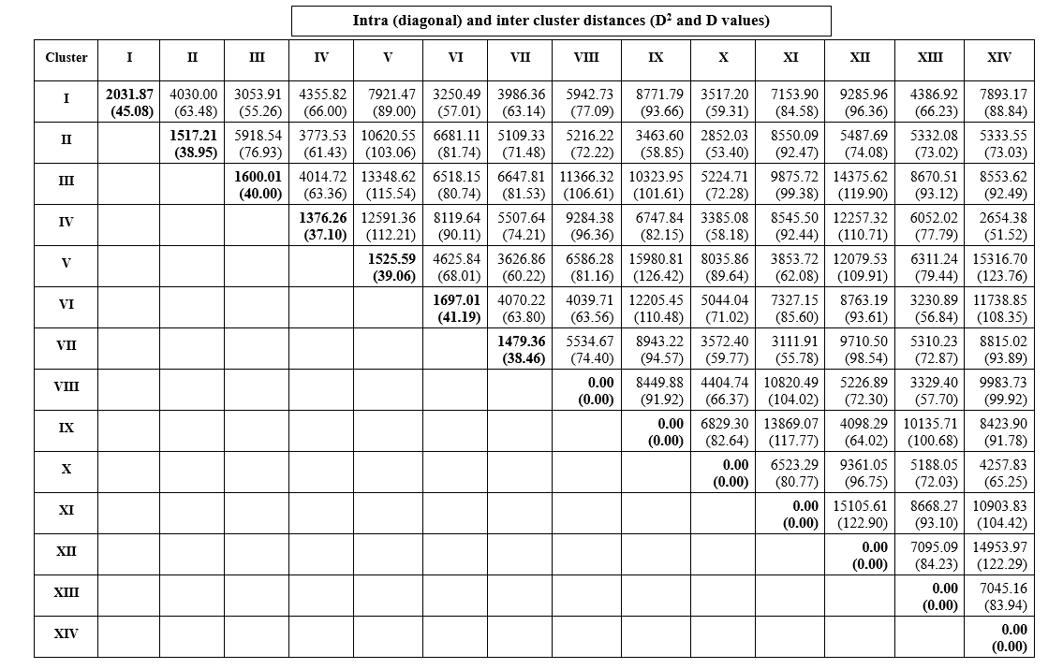
PH: Plant Height; NOB: Number of branches per plant; DUR: Duration; DFPF: Days to 50% flowering; NCPP: Number of clusters per plant; NPPC: Number of pods per cluster; PL: Pod length: PG: Pod girth; PW: Pod weight; NPPP: Number of pods per plant; TPYPP: Total pod yield per plant; NSPP: Number of seeds per plant; HSW: Hundred seed weight; TSYPP: Total seed yield per plant; GG: Guar Gum; PR: Protein; FB: Fibre.

Table 2: Intra-cluster (diagonal) and Inter-cluster distances among the fourteen clusters

3.3 Cluster means of biometrical traits:
In accordance with the clustering pattern, the mean parameters were calculated and presented in Table (3). Height of the plant recorded highest values in cluster XIV (131.01) and the lowest in cluster XI (77.62). In case of number of primary branches, the top value was recorded in cluster XII (10.25), whereas cluster III, IV and XIV attributed to zero. The earliest group to have completed its duration belonged to cluster VI (95.96), whereas cluster XIV had the longest duration of 122.57 days. Cluster III (39.49) was the earliest to produce 50 % of its flowers, while cluster VIII required 48.26 days. Cluster XI had the highest cluster mean of 57.25 clusters per plant, while cluster XII had the lowest cluster mean of 10.80 clusters per plant. With respect to the number of pods per cluster, the maximum mean values were observed in cluster IX (12.35) and the minimum being in cluster XI (2.14). The cluster mean value from cluster XIV (13.60) conformed superlative for pod length and cluster XII (4.39) were the smallest. Pod girth documented maximum and minimum values at cluster XI (7.40) and cluster IX (5.20) respectively. The pod weight was highest in cluster XIV (2.86) and lowest in cluster XII (0.92). Cluster IX (136.20) adhered to maximal number of pods per plant, whereas the minimal values were evident in cluster III (44.63). The total pod yield per plant was documented to be superlative in cluster XIV (256.32) and minimum in cluster III (51.36).

PH: Plant Height; NOB: Number of branches per plant; DUR: Duration; DFPF: Days to 50% flowering: NCPP: Number of clusters per plant; NPPC: Number of pods per cluster; PL: Pod length: PG: Pod girth; PW: Pod weight; NPPP: Number of pods per plant; TPYPP: Total pod yield per plant; NSPP: Number of seeds per plant; HSW: Hundred seed weight; TSYPP: Total seed yield per plant, GG: Guar Gum; PR: Protein; FB: Fibre

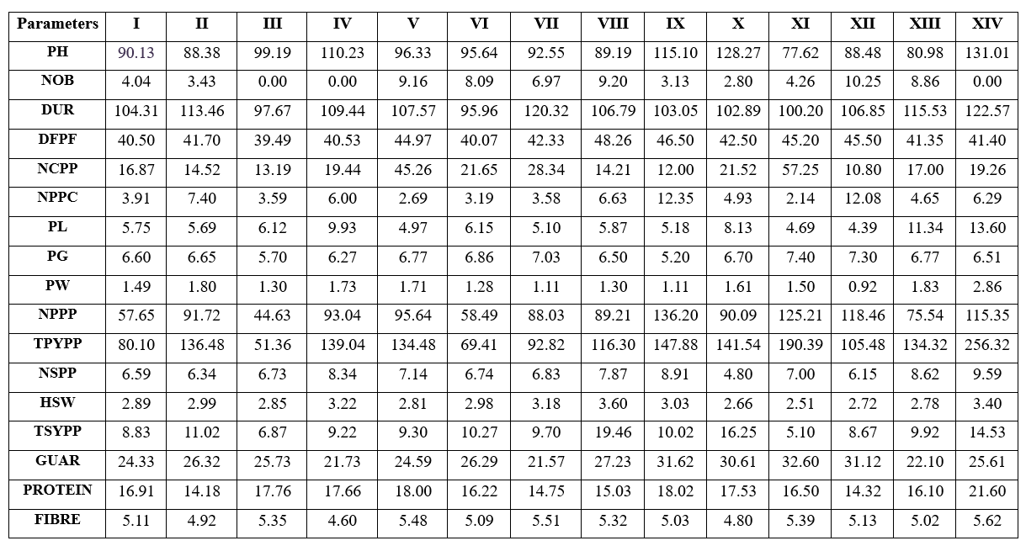

Table 3: Cluster means for seventeen characters of 102 cluster bean accessions

Similarly, the number of seeds per pods were highest in cluster XIV (9.59) and recorded lowest in cluster X (4.80). For hundred seed weight and total seed yield per plot, it was evident from table (3) the maximum values were recorded in cluster VIII (3.60 and 19.46) and least values in cluster XI (2.51 and 5.10) respectively.
The values for physiological parameters were recorded for guar gum, protein and fibre. The highest value for guar gum was recorded in cluster XI (32.60) and the lowest from cluster VII (21.57). In case of protein, cluster XIV showed superlative values with 21.60 % and the least being in cluster II (14.18). Minimal values being the positive aspect was recorded in cluster IV (4.60) and maximum value being in cluster XIV (5.62). Cluster XIV, comprising of the solitary member Pusa Navbahar, had maximum cluster mean values for six out of seventeen parameters which include plant height, pod length, pod weight, total pod yield per plant, number of seeds per pod and protein content showing its superiority over other clusters. The present findings are in accordance with those of^{(16,17 & 18).}

3.4 Percentage contribution of characters towards divergence:
In addition to genetic divergence, genotype and character performance with the greatest potential for divergence should be prioritised. The method employed by⁽¹⁹⁾ on ranking of genotypes by mean and critical difference for all traits, rather than their magnitude of contribution was found to be more effective. For the ranking of genotypes, this method depends on the contribution of characteristics to genetic diversity. Consequently, the combined ranking identifies superior genotypes for subsequent use as possible parents for a hybridization undertaking⁽¹⁰⁾.

PH: Plant Height; NOB: Number of branches per plant; DUR: Duration; DFPF: Days to 50% flowering: NCPP: Number of clusters per plant; NPPC: Number of pods per cluster; PL: Pod length: PG: Pod girth; PW: Pod weight; NPPP: Number of pods per plant; TPYPP: Total pod yield per plant; NSPP: Number of seeds per plant; HSW: Hundred seed weight; TSYPP: Total seed yield per plant, GG: Guar Gum; PR: Protein; FB: Fibre

Figure 1: Percentage contribution of biometrical parameters towards divergence

The contribution of characters towards divergence is presented in Figure (1). Total pod yield per plant contributed to maximum divergence with 22.20 %, followed by number of pods per cluster (15.30 %), number of clusters per plant (14.80 %), number of primary branches (11.30 %) and number of pods per plant (9.10 %). Similar findings on maximum contribution from pod yield was also observed by^{(4,2)}. ⁽¹⁹⁾reported on number of pods per cluster being a major contributor of divergence. The characters viz., total pod yield per plant, number of pods per cluster, number of clusters per plant, number of primary branches and number of pods per plant were major contributors of divergence owing to 72.7 % of total divergence. Importance should be given for these characters while selecting genetically diverse genotypes.

4. Conclusion

The investigation put forth the paramount availability of genetic divergence in cluster bean accessions collected from various regions of the country. During any selection process, further emphasis must be given to those characters that contribute to maximum divergence. Most divergent clusters having high D² values in cross combination proves to provide greater manifestation of heterosis. Genotypes for suitable characters can be selected based on their cluster mean values i.e lowest cluster mean values for duration and days to 50% flowering and higher mean values for yield aspects. In the event that the desired traits are not available, the implementation of a hybridisation programme to take advantage of the hybrid vigour potential in cluster beans helps to bridge this gap, which in turn also helps to expand the genetic diversity of cluster bean production.

COMPETING INTERESTS DISCLAIMER:
Authors have declared that they have no known competing financial interests OR non-financial interests OR personal relationships that could have appeared to influence the work reported in this paper.

References
- Santhosha, G. R., Shashikanth, E., Gasti, V. D., Prabhuling, G., Rathod, V. D., & Mulge, R. (2017). Genetic variability studies in cluster bean [Cyamopsis tetragonaloba (L.) Taub.] for growth, yield and quality parameters. Legume Research-An International Journal, 40(2), 232-236. https://doi.org/10.18805/lr.v0i0.7296
- Choyal, P., Bahadur, V., Dewangan, R., Xaxa, S., & Gupta, M. (2017). Genetic divergence studies in cluster bean [Cyamopsis tetragonoloba (L.) Taub]. International Journal of Current Microbiology and Applied Sciences, 6(8), 1099-1107.
- Kgasudi, B. K., Rekha, G. K., Jyothi, K. U., & Sasikala, K. (2020). Studies on genetic diversity for yield, quality and yield attributing traits in cluster bean [Cyamopsis tetragonoloba (L.) Taub.] genotypes. Electronic Journal of Plant Breeding, 11(1), 322-327. https://doi.org/10.37992/2020.1101.058
- Remzeena, A., Anitha, P., & Muhamed, S. (2021). Genetic divergence analysis in cluster bean [Cyamopsis tetragonoloba (L.) Taub.]. Legume Research-An International Journal, 44(3), 292-294. https://doi.org/10.18805/LR-4087
- Gopala Krishnan, S., Dwivedi, N. K., & Singh, J. P. (2011). Primitive weedy forms of guar, adak guar: possible missing link in the domestication of guar [Cyamopsis tetragonoloba (L.) Taub.]. Genetic Resources and Crop Evolution, 58, 961-966. https://doi.org/10.1007/s10722-011-9728-z
- Wankhade, R. S., Kale, V. S., Nagre, P. K., & Patil, R. K. (2017). Genetic divergence studies in cluster bean genotypes. Legume Research, 40(5), 811-817. https://doi.org/10.18805/lr.v0i0.7292
- Mahalanobis, P. C. (1936). On the generalized distance in statistics. *Proceedings of the National Institute of Science, India*. https://www.scienceopen.com/document?vid=11111111-1111-1111-1111-111111111111
- Rao, C. R. (1952). Advanced Statistical Methods in Biometric Research. John Wiley & Sons. https://books.google.com/books/about/Advanced_Statistical_Methods_in_Biometri.html?id=1_4_AAAAIAAJ
- Sultan, M., Rabbani, M. A., Shinwari, Z. K., & Masood, M. S. (2012). Phenotypic divergence in Guar (Cyamopsis tetragonoloba) landrace genotypes of Pakistan. Pakistan Journal of Botany, 44, 203–210. https://www.pakbs.org/pjbot/archives.php
- Muthuselvi, R and Shanthi, A. (2013). Genetic diversity in cluster bean [Cyamopsis tetragonoloba (L.) Taub]. Asian Journal of Horticulture, 8(2), 592-595.
- Mishra, S., Aghora, T. S & Venugopalan, R. (2019). Divergence studies in Indian cluster bean (Cyamopsis tetragonoloba L. Taub.) For developing variety for vegetable purpose. https://jpds.in/2019/03/03/divergence-studies-in-indian-cluster-bean-cyamopsis-tetragonoloba-l-taub-for-developing-variety-for-vegetable-purpose/

- Vishnoi, G., Sharma, A. K., Kumar, P., & Kumar, M. (2017). Genetic diversity for yield and its component traits in cluster bean (Cyamopsis tetragonoloba (L.) Taub.). Journal of Pharmacognosy and Phytochemistry. https://www.akinik.com/journals/journal-of-pharmacognosy-and-phytochemistry/

- Mehta, K. B., Patel, P. J., Patel, P. C & Manish Sharma. (2022). Genetic divergence studies in clusterbean [Cyamopsis tetragonoloba (L.) Taub.]. Biological Forum – An International Journal, 14(3), 1068-1073
- Pathak, R., Singh, S. K., Singh, M., & Henry, A. (2010). Molecular assessment of genetic diversity in cluster bean (Cyamopsis tetragonoloba) genotypes. Journal of Genetics, 89(2), 243-246. https://doi.org/10.1007/s12041-010-0033-y
- Rai, S., & Dharmatti, P. R. (2013). Genetic divergence studies in clusterbean (Cyamopsis tetragonoloba (L.) Taub.). Global Journal of Science Frontier Research D. Agriculture & Veterinary, 13(5). https://globaljournals.org/GJSFR_Volume13/5-Genetic-Divergence-Studies.pdf
- Girish, M. H., Gasti, V. D., Mastinoli, A. B., Thammaiah, N., Shantappa, T., Mulge, R & Kerutagi, M. (2012). Genetic divergence studies in cluster bean genotypes (Cyamopsis tetragonoloba (L.) Taub.) Karnataka Journal of Agricultural Sciences, 25(2), 245-247.
- Kumar, V., Ram, R. B. & Yadav, R. K. (2014). Genetic diversity in cluster bean [Cyamopsis tetragonoloba (L.) Taub.]. Journal of Science and Technology, 7(8), 1144-1148.
- Manivannan, A., & Anandakumar, C. R. (2013). Genetic Divergence Studies in Clusterbean [Cyamopsis tetragonoloba (L.) Taub.] Genotypes. Indian Journal of Science and Technology, 6(10), 5337-5341. https://doi.org/10.17485/ijst/2013/v6i10.11
- Nadarajan, N., & Gunasekaran, M. (2012). Quantitative genetics and biometrical techniques in plant breeding. Kalyani Publishers.
- Gipson, A & Balakrishnan, R. (1992). Genetic diversity in cluster bean. Indian Journal of Horticulture, 49, 70-74.

