Review Article

Soil Landscape Rehabilitation with Microbial and Remote Sensing Insights for Yield and Carbon Recovery

.
ABSTRACT

Soil degradation is quietly eroding the productive and climate-regulating capacity of agricultural landscapes. On many farms, eroded hilltops and shoulders are left shallow, compacted, and carbon-poor, while lower slope positions collect sediment and nutrients in uneven ways. The result is a patchwork of yield potential and a steady decline in soil organic carbon (SOC) stocks at the very moment when agriculture is being asked to produce more food and help mitigate climate change.
Soil landscape rehabilitation offers a way to actively rebuild these damaged systems rather than simply slowing further loss. Practices such as top-soil replacement, landscape reshaping, organic amendments, and diversified crop rotations can restore soil depth, improve structure, and create conditions that favor carbon accumulation. At the same time, soil microbial communities are now recognized as key drivers of recovery: they build aggregates, cycle nutrients, suppress diseases, and control how much carbon is stored or lost. Diversified crop sequences and organic inputs tend to foster richer, more resilient microbial communities that support both yield and carbon gains.
Remote sensing and Earth observation add a third, crucial dimension. By tracking vegetation vigor, surface soil properties, moisture status, and structural changes from above, they make it possible to monitor rehabilitation outcomes from individual fields to entire regions.
This review brings these strands together. It synthesizes field-based approaches to soil landscape rehabilitation, explains the microbial mechanisms that underpin lasting yield and carbon recovery, and explores how remote sensing can be used to track and guide rehabilitation efforts. The paper concludes with a practical framework and research agenda for integrating management, biology, and technology in climate-smart soil restoration.

Keywords: Soil health; Carbon storage; Microbial activity; Soil landscape rehabilitation; Remote sensing

1. INTRODUCTION

Agricultural landscapes worldwide are expected to deliver high and stable yields while also contributing to climate mitigation through carbon storage and reduced greenhouse gas emissions (IPCC, 2022). At the same time, many sloping, conventionally tilled systems are already degraded, with long-term tillage, uncontrolled traffic, and unbalanced nutrient management accelerating erosion, compaction, and soil organic carbon (SOC) loss (Lal, 2015). Where soil is thin and compacted, crops are more vulnerable to both drought and waterlogging, and yields become highly variable from year to year (Govers et al., 2017).
Conservation practices such as reduced tillage, residue retention, contour farming, and cover crops can slow further degradation and improve surface soil condition (Blanco-Canqui et al., 2015). However, they are often insufficient to fully recover function on soils that have already lost significant depth, structure, and SOC (Lal, 2015). In severely eroded summit and shoulder positions, simply “protecting what is left” does not restore rooting volume, pore connectivity, or the buffering capacity needed for climate-resilient production (Pennock & Veldkamp, 2019).
Soil landscape rehabilitation addresses this gap by explicitly targeting the spatial patterns of degradation within fields and watersheds (Pennock & Veldkamp, 2019; Jinger et al., 2023). Rather than treating soil health as uniform, it recognizes that slope position, parent material, and historical management interact to produce distinct soil conditions and constraints across landscapes (Govers et al., 2017). Rehabilitation efforts combine structural interventions, organic amendments, and diversified plant cover to rebuild soil depth and function where it has been most compromised, while also managing nutrient accumulation and hydrological risks in depositional areas (Lal, 2015).
Microbial communities and remote sensing both play critical roles in this emerging approach. Microbes mediate aggregation, nutrient cycling, disease suppression, and the stabilization of new carbon inputs, and they respond sensitively to changes in structure, moisture, and organic matter (Lehmann & Kleber, 2015; D. V. R. T. Amulothu et al., 2023). Remote sensing provides repeated, spatially explicit observations of vegetation vigor, moisture proxies, and surface characteristics (Mulder et al., 2013; Beatty et al., 2021; Ambaru et al., 2025). When combined with field measurements and soil biological indicators, these observations offer a way to guide and monitor rehabilitation at scales from individual fields to regions (Mahajan et al., 2021).
This review integrates three strands field-based management, microbiology, and remote sensing into a single framework for soil landscape rehabilitation. It first describes the patterns and drivers of degradation across landscape positions, then synthesizes structural and biological strategies for rebuilding soil function. Subsequent sections examine microbial mechanisms and remote sensing tools, before outlining opportunities for integrated monitoring and future research priorities.

2. Soil Landscape Degradation and Its Impacts

2.1 Patterns and drivers across landscape positions
Soil degradation in sloping agricultural landscapes is strongly structured by topography (Pennock & Veldkamp, 2019). Summit and upper-slope positions are prone to soil loss through water and wind erosion, especially under intensive tillage and limited ground cover (Govers et al., 2017). Over time, these areas often develop shallow profiles with reduced A-horizon thickness, elevated bulk density, and restricted rooting depth (Batey, 2009). In contrast, midslope positions function as transfer zones, while lower slopes and toe slopes tend to accumulate eroded sediments, nutrients, and organic material (Govers et al., 2017).
This redistribution of soil and nutrients alters hydrology as well as fertility. On eroded summits, reduced infiltration and limited storage capacity increase runoff and drought stress, while compacted layers further restrict rooting and water movement (Batey, 2009). On toe slopes, thicker profiles and finer textures can support higher water-holding capacity and biomass production but may also increase the risk of waterlogging, denitrification, and nutrient leaching when nutrients concentrate downslope (Pennock & Veldkamp, 2019). Machinery traffic, drainage modifications, and historical land use can create additional zones of severe compaction or altered hydrological connectivity within this topographic template (Tullberg et al., 2018).
A conceptual overview of how soil depth, compaction, organic carbon, and hydrological behavior vary along summit, midslope, and toe-slope positions is presented in Figure 1. This diagram highlights how erosion and deposition processes interact with management to create distinct functional zones within a single field.
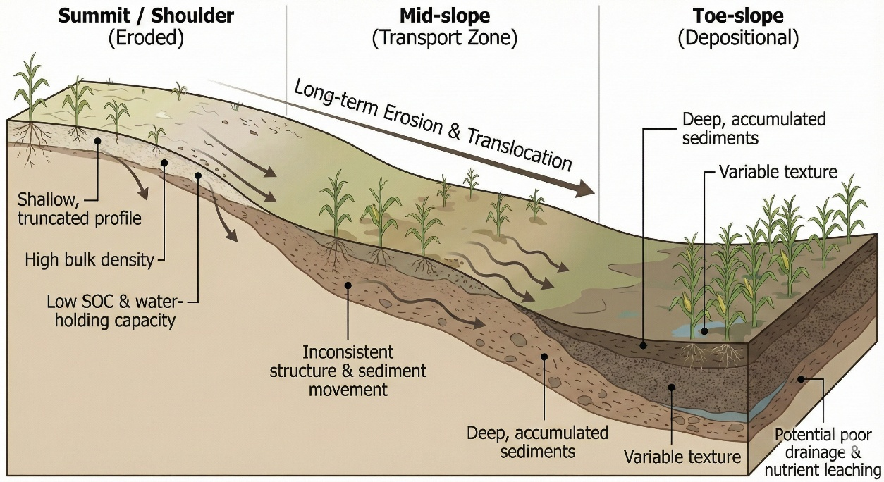
Figure 1. Conceptual diagram of soil depth, compaction, organic carbon, and hydrological behavior across summit, midslope, and toe-slope landscape positions in a degraded agricultural field.

Climate change amplifies these dynamics by increasing the frequency of intense rainfall events that drive erosion and sediment transport, particularly where protective cover is intermittent or where soil structure has been weakened (IPCC, 2022). Longer dry periods place additional stress on shallow, low-SOC soils that already have limited water storage (Lal, 2015). As a result, landscape position, management history, and climate interact to create mosaics of soil quality and production potential within single fields (Pennock & Veldkamp, 2019).
Recognizing these patterns is a prerequisite for effective rehabilitation. Rather than applying uniform management, farmers and advisers need tools to identify where soil depth, structure, and organic matter have been most severely reduced, and where sediment and nutrients have accumulated (Pennock & Veldkamp, 2019). This spatial understanding underpins targeted interventions that rebuild function in source areas and manage risks in depositional zones (Mulder et al., 2011).

2.2 Yield and carbon consequences and limits of conservation-only approaches
The spatially uneven nature of degradation translates directly into yield and carbon outcomes. Eroded summit and shoulder positions typically produce lower and more variable yields than mid-slope or toe-slope areas because of restricted rooting depth, poor structure, and limited water availability (Govers et al., 2017). SOC losses in these positions further weaken aggregate stability and reduce cation exchange capacity, compounding the decline in productivity (Lal, 2015). At the same time, depositional toe slopes may show high biomass production but also elevated risks of nitrate leaching, phosphorus runoff, and episodic anoxia due to nutrient and water accumulation (Pennock & Veldkamp, 2019).
From a carbon perspective, degradation represents both a loss of existing SOC and a reduced capacity to store additional carbon (Lehmann & Kleber, 2015). Shallow, compacted soils with limited root growth and rapid turnover of surface residues are less able to accumulate stable carbon fractions, particularly mineral-associated organic matter (Six et al., 2004). Even when cover crops or reduced tillage are introduced, the gains in SOC may be modest if the underlying structural and depth constraints remain (Blanco-Canqui et al., 2015). In other words, conservation practices alone can slow further losses but may not be sufficient to reverse decades of degradation in the most affected positions (Lal, 2015).
Typical differences in soil depth, bulk density, SOC, and water-holding capacity across summit, midslope, and toe-slope positions in degraded fields are summarized in Table 1. These contrasts illustrate how much physical and carbon-related potential has been lost from eroded uplands relative to depositional areas.

Table 1. Typical soil property differences across summit, midslope, and toe-slope positions in a degraded agricultural landscape (depth, bulk density, SOC, and water-holding capacity).
Landscape Position | Soil Depth | Bulk Density | SOC (%) | Water-Holding Capacity | Key Constraints
Summit / Shoulder (Eroded) | Shallow, truncated | High | Low | Low | Root restriction, water stress, low fertility
Mid-slope (Transport Zone) | Moderate | Variable | Moderate | Moderate | Inconsistent structure, active sediment movement
Toe-slope (Depositional) | Deep, accumulated sediments | Low–Moderate | Variable | High | Poor drainage, nutrient leaching, denitrification pockets

This limitation is particularly important in the context of climate-smart agriculture and carbon crediting schemes. If rehabilitation efforts focus only on surface residue management without addressing deeper structural and hydrological constraints, the potential for durable carbon storage and yield stabilization will remain constrained (Six et al., 2004). Spatial heterogeneity in soil condition also challenges assumptions of uniform treatment effects across fields and can complicate monitoring, reporting, and verification (Pennock & Veldkamp, 2019).
Soil landscape rehabilitation responds to these challenges by explicitly aiming to change the trajectory of degraded soils (Lal, 2015). Structural measures such as strategic subsoiling, controlled traffic, re-grading, terraces, or grassed waterways can increase effective rooting depth, disrupt compacted layers, and slow runoff (Tullberg et al., 2018). When combined with organic amendments, residue retention, and diversified plant cover, these interventions create the physical and biological conditions needed for SOC recovery and improved yield resilience (Blanco-Canqui et al., 2015). Microbial communities then help translate these improved conditions into stable structure, nutrient cycling, and long-term carbon stabilization (Mendes et al., 2011).

3. FIELD-BASED STRATEGIES FOR SOIL LANDSCAPE REHABILITATION

Soil landscape rehabilitation combines physical, chemical, and biological interventions to rebuild soil depth, structure, and carbon in positions that have experienced the greatest degradation. The patterns of soil depth, bulk density, SOC, and water-holding capacity described above, and summarized in Table 1, provide a template for targeting these strategies to summit, midslope, and toe-slope positions. The following subsections synthesize key field practices that collectively support yield stability and carbon recovery in degraded landscapes.

3.1 Structural and physical interventions
Structural and physical interventions form the foundation of rehabilitation because they directly modify soil depth, compaction, porosity, and hydrological behavior (Batey, 2009). Strategic subsoiling or ripping is often used to disrupt dense layers created by long-term tillage or traffic, improving vertical root penetration and water infiltration. These operations are most effective when targeted to compacted summit and shoulder positions, rather than applied uniformly, and when timed under soil moisture conditions that avoid smearing or further compaction.
Controlled traffic farming (CTF) confines machinery-induced compaction to permanent traffic lanes, protecting most of the field from repeated wheel loads (Tullberg et al., 2018). In rehabilitation settings, CTF is particularly valuable on upland positions where soil depth is already limited, and further compaction would sharply reduce effective rooting volume. Combining CTF with gentle slope reshaping, contour alignment, and grassed waterways can slow runoff, reduce rill formation, and stabilize midslope and toe-slope areas that receive eroded sediment.
On toe slopes and poorly drained depressions, structural interventions may need to focus on drainage and water-table management. Shallow surface drains, subsurface tile, or controlled drainage structures can reduce the duration of waterlogging and associated denitrification, while still retaining sufficient water to buffer crops against dry periods (Pennock & Veldkamp, 2019). By rebalancing water distribution along the slope, such measures help align physical conditions with the biological and chemical strategies described below.

3.2 Organic amendments, residues, and composts
Structural rehabilitation is more durable when accompanied by increased and diversified organic inputs. Organic amendments including composts, manures, and biosolids supply carbon and nutrients while also stimulating microbial activity and aggregation (Blanco-Canqui et al., 2015). On eroded summit soils with low SOC, moderate rates of compost or manure can rebuild carbon soil pools, improve aggregate stability, and enhance water-holding capacity. Placement in the upper 10–20 cm, combined with reduced disturbance, helps protect new organic matter from rapid decomposition.
Residue management is equally important. Retaining crop residues on the surface reduces raindrop impact, slows runoff, and moderates soil temperature, all of which support aggregate formation and pore connectivity (Six et al., 2004). In midslope positions prone to sediment transport, residue cover helps trap moving particles and gradually rebuilds the surface layer, especially when coupled with contour-aligned planting. On toe slopes, where nutrients may already be high, organic amendments should be applied cautiously or avoided, with residue strategies emphasizing erosion control rather than additional nutrient loading.
The characteristics of the amendments themselves influence rehabilitation outcomes. High-lignin, structurally complex materials tend to decompose more slowly and contribute more to stable SOC fractions, whereas low-lignin materials are more rapidly mineralized and may primarily support short-term nutrient cycling (Lehmann & Kleber, 2015). Blending different materials and matching amendment type and rate to landscape position can therefore improve both carbon efficiency and environmental performance.

3.3 Crop diversification, biological rehabilitation, and example scenarios
Crop diversification acts as a biological counterpart to physical and chemical interventions by modifying root architecture, residue quality, and microbial habitats over time. Deep-rooted crops such as sorghum, millet, or certain forage species penetrate compacted layers, create biopores, and redistribute water and nutrients within the profile (VandenBygaart et al., 2012). When these crops are rotated with shallow-rooted species, they leave behind channels that subsequent crops can exploit, effectively extending functional rooting depth on previously shallow soils.
Cover crops further enhance rehabilitation outcomes by providing continuous cover and living roots during otherwise fallow periods. They reduce erosion, increase infiltration, and supply a steady stream of root exudates that fuel microbial activity and aggregation (Blanco-Canqui et al., 2015). Mixtures that combine grasses, legumes, and brassicas can simultaneously deliver structural benefits, nitrogen inputs, and bio-drilling effects, particularly when residues are left on the surface. In rehabilitated landscapes, cover crops are especially valuable on summit and midslope positions where protecting emerging structure is critical.
In practice, landscape rehabilitation often relies on integrated strategies tailored to specific slope positions rather than isolated practices. For example:
- Summit positions may receive a sequence of subsoiling, controlled traffic implementation, and moderate compost or manure applications, followed by deep-rooted cover crops to extend rooting depth and stabilize new structure.
- Midslope positions can emphasize residue retention, contour-aligned cover crop strips, and moderate organic inputs to stabilize aggregates, reduce sediment transport, and maintain infiltration.
- Toe-slope positions may prioritize drainage improvements, careful nutrient management, and rotations that avoid continuous high-residue or high-nutrient crops, thereby reducing waterlogging and nutrient accumulation risks.
These examples illustrate how structural interventions, organic inputs, and diversified cropping systems can be combined into position-specific rehabilitation packages. Subsequent sections explore how microbial communities respond to these changes and how remote sensing can be used to monitor rehabilitation progress across the landscape.

4. SOIL MICROBIAL COMMUNITIES AS ENGINES OF RECOVERY

Soil microbial communities are central to the success of soil landscape rehabilitation because they translate improved physical conditions and organic inputs into stable structure, nutrient availability, and long-term carbon storage. Bacteria, fungi, archaea, and microfauna collectively mediate decomposition, mineralization, aggregation, and disease suppression, and they respond sensitively to changes in moisture, aeration, and organic matter (Schloter et al., 2018). Rehabilitation strategies that rebuild porosity, reduce compaction, and supply diverse organic substrates therefore have strong potential to re-activate beneficial microbial processes on degraded slopes.

4.1 Microbial control of structure, nutrient cycling, and carbon stabilization
Microbes contribute directly to soil structure through the production of extracellular polymeric substances, fungal hyphae, and plant–microbe interactions that bind mineral particles into stable aggregates (Six et al., 2004). These aggregates protect organic matter from rapid decomposition, maintain pore networks, and improve resistance to erosion, particularly on previously compacted summit soils. In this way, microbial activity both benefits from and reinforces the physical improvements created by structural interventions and residue management.
Nutrient cycling is equally dependent on microbial processes. Decomposer communities regulate the release of nitrogen, phosphorus, and sulfur from residues and organic amendments, influencing the timing and spatial distribution of nutrient availability along the slope (Lehmann & Kleber, 2015). In rehabilitated landscapes, this regulation can help match nutrient supply to crop demand, reducing losses from summit positions and excessive accumulation at toe slopes. Microbial immobilization also buffers the system against short-term surpluses, providing a temporary nutrient reservoir that can be re-released under favorable conditions.
Microbial communities play a key role in SOC stabilization by transforming labile plant inputs into more persistent forms and by facilitating the association of organic compounds with mineral surfaces, and this sequence—from fresh residues through microbial biomass and particulate organic matter to mineral-associated organic carbon—is shown in Figure 2 (Lehmann & Kleber, 2015). These pathways are especially important in landscapes where past erosion and tillage have depleted stable carbon pools and reduced the capacity of soils to buffer climate and management shocks.
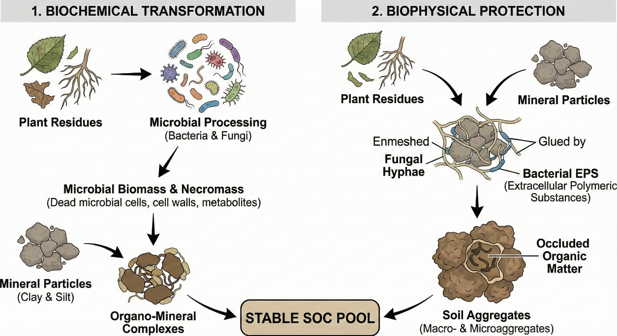
Figure 2. Conceptual diagram of microbial pathways for soil organic carbon stabilization in rehabilitated soils, highlighting the transformation of fresh plant inputs into microbial biomass, particulate organic matter, and mineral-associated organic carbon under improved physical and chemical conditions.

4.2 Microbial responses to restored physical conditions and organic inputs
Rehabilitation measures that improve aeration, water-holding capacity, and temperature buffering tend to increase microbial biomass and activity on degraded soils (Schloter et al., 2018). On compacted summit positions, subsoiling and controlled traffic create new pore space, allowing oxygen diffusion and root growth that support more diverse and active microbial communities. As these communities recover, they further enhance aggregation and pore continuity, creating a positive feedback between physical structure and biological function.
Organic amendments and residue retention provide the substrates needed for microbial growth and community differentiation. Composts and manures supply a mixture of readily decomposable compounds and more recalcitrant fractions, supporting both fast-growing copiotrophic microorganisms and slower-growing taxa associated with long-term carbon storage (Lehmann & Kleber, 2015). In contrast, low-input or residue-removed systems often favor stress-tolerant microbial communities with limited capacity to build stable aggregates or SOC.
Moisture dynamics strongly modulate these responses across the landscape. On summit soils, increased water-holding capacity and improved infiltration reduce drought stress on microbial communities, allowing more continuous activity during dry periods. On toe slopes, better drainage and reduced waterlogging prevent prolonged anaerobic conditions that can suppress beneficial microbes and favor denitrification or pathogenic organisms (Pennock & Veldkamp, 2019). Thus, the same physical interventions that enhance plant performance also create more favorable, spatially differentiated microbial habitats.

4.3 Crop rotations, cover crops, disease suppression, and plant resilience
Diverse crop rotations and cover crop mixtures shape microbial communities through differences in root architecture, exudate composition, and residue quality (Mendes et al., 2011). Deep-rooted species promote microbial activity at greater depths, extending biologically active zones into subsoil layers that were previously compacted or low in carbon. Legumes contribute nitrogen-rich residues and exudates that stimulate microbial growth and may help rebuild nutrient cycling capacity on eroded summit positions.
Cover crops provide continuous living roots and rhizodeposition during periods when main crops are absent, supporting microbial communities year-round (Blanco-Canqui et al., 2015). Mixtures that combine grasses, legumes, and brassicas can create a mosaic of microbial niches—some associated with fibrous root systems and gradual residue breakdown, others with rapid N release or biofumigation effects. In rehabilitation contexts, this diversity can accelerate the recovery of functional groups responsible for decomposition, aggregation, and disease suppression.
Microbial-mediated disease suppression is another important pathway through which rehabilitation influences yield stability. Healthy, diverse microbial communities can suppress soil-borne pathogens through competition, predation, and the production of antagonistic compounds (Mendes et al., 2011). Structural improvements, organic inputs, and diverse plant cover work together to reduce chronic stress on crops and to favor beneficial microbial consortia, thereby lowering the risk of yield losses from root diseases and nematodes.
Across the slope, these biological processes interact with physical and chemical changes to influence plant resilience. On rehabilitated summit positions, deeper rooting, improved aggregation, and active microbial communities help crops maintain function during dry spells. On midslope and toe-slope positions, improved drainage, moderated nutrient levels, and biologically active root zones reduce the frequency and severity of stress events. Together, these microbial contributions make soil landscape rehabilitation not only a physical and chemical restoration effort, but also a biological re-building process that underpins long-term productivity and carbon storage.

5. REMOTE SENSING CONTRIBUTIONS TO MONITORING SOIL REHABILITATION

Remote sensing provides a way to observe rehabilitation outcomes across entire fields and landscapes, complementing plot-level soil and microbial measurements. Satellite and drone imagery capture spatial patterns in vegetation vigor, surface moisture, and soil exposure that reflect underlying differences in soil structure, water availability, and management history (Mulder et al., 2011). When rehabilitation practices are applied selectively to summit, midslope, and toe-slope positions, remote sensing can help track where conditions are improving and where constraints persist.

5.1 What remote sensing detects in agroecosystems
Most remote sensing approaches used in agriculture are based on reflected solar radiation in the visible to shortwave infrared range (Mulder et al., 2011). Differences in canopy color, density, and water content alter the reflectance signal, allowing indices derived from red, near infrared, and shortwave infrared bands to serve as proxies for plant health and soil moisture. Bare soil and sparsely vegetated areas exhibit distinct spectral signatures that can indicate erosion, compaction, or poor establishment, particularly on degraded summit positions.
At finer spatial scales, drone-based imagery can detect within-field variability in crop height, canopy closure, and early-season emergence that is difficult to capture with ground-based sampling alone. These patterns often align with slope breaks, former erosion channels, machinery tracks, and other features that influence soil depth and structure. By overlaying remote sensing products with topographic and management information, practitioners can map zones of persistent stress and evaluate whether rehabilitation measures are reducing those stress patterns over time.

5.2 Vegetation, moisture, and surface-conditioning indices
Vegetation indices such as the normalized difference vegetation index (NDVI) and enhanced vegetation index (EVI) are widely used to summarize canopy greenness and density from multispectral imagery (Mahajan et al., 2021). In rehabilitated landscapes, increases in NDVI or EVI on previously degraded summits and midslope positions can indicate improved plant growth due to better rooting conditions, higher water-holding capacity, and more balanced nutrient supply. Conversely, persistently low values may signal areas where structural or biological constraints remain.
Indices sensitive to moisture and bare soil also contribute to rehabilitation monitoring. Shortwave infrared–based indices and thermal information can highlight zones of rapid drying, crusting, or waterlogging, revealing hydrological imbalances that structural interventions aim to correct (Mulder et al., 2011). Fractional cover and bare-soil indices derived from visible and near-infrared data help track the extent of residue and living cover, which are important for erosion control and microbial habitat. Together, these metrics provide a set of remotely sensed indicators that can be interpreted alongside field data on bulk density, SOC, and microbial activity.

5.3 Emerging links between reflectance, roughness, and soil biodiversity
Recent work has explored more direct links between spectral signatures, soil surface roughness, and subsurface soil properties relevant to rehabilitation, including biological attributes. Hyperspectral and imaging spectroscopy approaches can distinguish subtle differences in mineralogy, organic matter content, and moisture that are not captured by broadband indices alone (Demattê et al., 2019). These finer-scale spectral features can be related to SOC concentration, clay content, and even proxies for microbial habitat quality.
Surface roughness and microtopography, derived from high-resolution digital elevation models and radar backscatter, provide additional information on soil structure and management impacts (Mulder et al., 2011). Rough, cloddy surfaces or persistent rill networks may indicate recent tillage or ongoing erosion, whereas smoother, well-covered surfaces often reflect stabilized aggregates and effective residue management. As relationships between spectral data, roughness metrics, and soil biodiversity become better understood, remote sensing has the potential to serve as an indirect indicator of the biological recovery processes described in the previous section (Laliberté et al., 2020).

5.4 Using remote sensing to plan and verify rehabilitation
In practice, remote sensing can support rehabilitation in three main ways: diagnosing problems, guiding interventions, and verifying outcomes. Historical imagery and topographic data can be used to identify zones of recurring low productivity, frequent bare soil, or high erosion risk, helping to prioritize where structural and biological measures should be applied first (Mulder et al., 2011). During implementation, repeated acquisitions allow managers to assess whether changes in traffic patterns, residue management, or cover crop establishment are visible at the landscape scale.
Over multiple seasons, trends in vegetation indices, bare-soil cover, and moisture-related metrics provide evidence of whether summit and midslope positions are converging toward the performance of less degraded areas. These remote sensing trends can be paired with periodic soil sampling and microbial assessments to build a more complete picture of rehabilitation progress. An integrated framework that combines field observations, microbial indicators, and remotely sensed metrics is developed in the next section, where the relationships between management actions, soil processes, and spectral signals are summarized and linked, as shown in Figure 3.

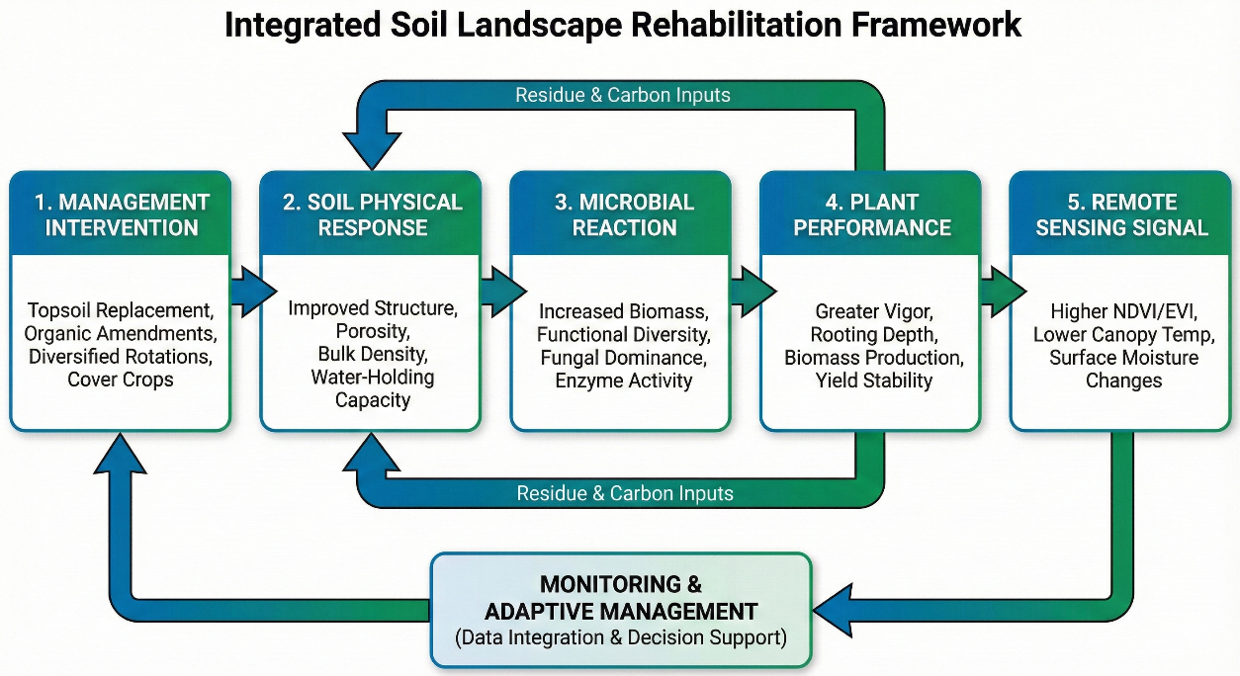
Figure 3. Integrated framework linking field management practices, soil physical and chemical changes, microbial processes, plant responses, and remote sensing indicators used to monitor soil landscape rehabilitation.

6. TOWARDS INTEGRATED MONITORING AND DECISION SUPPORT

Effective soil landscape rehabilitation requires a systems-level view that connects field practices, soil processes, biological recovery, and remotely sensed indicators. Rather than treating management, microbiology, and remote sensing as separate domains, an integrated framework links them in a sequence from practice → process → signal, which can then be used for monitoring and adaptive decision-making.

6.1 From practice to process to signal
Rehabilitation interventions initiate a cascade of changes that reshape soil function through five interconnected stages. First, management interventions including structural measures, organic amendments, and diversified crop rotations alter soil disturbance regimes, residue cover, and carbon inputs at specific slope positions. Second, these changes drive a soil physical and chemical response, modifying bulk density, porosity, aggregate stability, infiltration, water-holding capacity, SOC, and nutrient distribution (Batey, 2009).
Third, improved structure and organic resources trigger a microbial reaction, as microbial biomass, diversity, and activity increase in response to more favorable aeration, moisture, and substrate supply (Schloter et al., 2018). These communities further stabilize aggregates, regulate nutrient cycling, and contribute to long-term SOC formation. Fourth, healthier soils and microbial communities support enhanced plant performance, expressed as deeper rooting, better water and nutrient uptake, and more stable yields under variable weather.
Finally, these plant and surface changes generate a remote sensing signal detectable by satellite and drone platforms. Shifts in canopy greenness, cover, thermal behavior, and surface roughness are captured by vegetation, moisture, and bare-soil indices (Mulder et al., 2011). Together, these five stages form a mechanistic pathway that links rehabilitation practices to observable indicators at the landscape scale, as shown in Figure 3.

6.2 Building an indicator set for monitoring rehabilitation
Because soil systems are complex, no single metric can capture rehabilitation progress. Instead, a practical monitoring framework combines a small set of physical, chemical, biological, and remote sensing indicators that are both sensitive to change and feasible to measure.
Physical indicators such as bulk density, total porosity, aggregate stability, infiltration rate, and water-holding capacity quantify structural recovery and the capacity of soils to store and transmit water and air (Batey, 2009). Chemical indicators including SOC concentration, pH, cation exchange capacity, and key nutrient balances reflect long-term fertility and carbon sequestration potential (Lal, 2015). Biological indicators—such as microbial biomass carbon, fungal-to-bacterial ratios, and selected enzyme activities—capture the functional capacity of the microbial community to drive nutrient cycling and carbon stabilization (Schloter et al., 2018).
These ground-based measurements are complemented by remote sensing indicators derived from satellite or drone data. Vegetation indices (NDVI, EVI, LAI), fractional cover, bare-soil indices, and moisture-related metrics provide repeated, spatially continuous information about plant response and surface condition across summit, midslope, and toe-slope positions (Mahajan et al., 2021). When measured at appropriate intervals, this combined indicator set can show whether structural, biological, and plant-level improvements are occurring in the locations where rehabilitation efforts are focused.

6.3 Data integration and decision support in rehabilitation programs
The growing availability of geospatial tools, cloud-based platforms, and statistical and machine-learning methods makes it increasingly feasible to integrate these indicators into practical decision-support systems (Laliberté et al., 2020). High-resolution drone imagery can be merged with satellite time series, digital elevation models, and soil sampling layers to map degradation hotspots, track changes in vegetation and bare soil, and identify priority areas for structural or biological interventions (Mulder et al., 2011).
Predictive models trained on soil measurements, microbial profiles, and remote sensing data can forecast the likely trajectory of recovery under different management scenarios. Such models can highlight where additional interventions are needed, where current practices are sufficient, and where early gains may be at risk of reversal. Interactive dashboards and farm-level advisory tools can then translate these multiscale indicators into practical recommendations, such as where to concentrate organic amendments, how to adjust rotation sequences, or which positions require renewed structural work.
At broader scales, standardized indicators and harmonized remote sensing products enable comparison of rehabilitation outcomes across farms, watersheds, or regions. This supports program-level monitoring, carbon accounting, and landscape-scale restoration planning, while maintaining a clear connection back to the field-level processes and microbial mechanisms that underpin long-term recovery.

7. KNOWLEDGE GAPS AND FUTURE DIRECTIONS

7.1 Remaining knowledge gaps
Despite increasing interest in soil landscape rehabilitation, several key uncertainties limit the design and scaling of effective interventions. One major gap concerns how physical, chemical, and biological processes interact along full toposequences through time. Many studies describe erosion, compaction, and SOC loss on individual slope positions, but fewer follow the long-term trajectories of summit, midslope, and toe-slope soils under contrasting rehabilitation strategies (Pennock & Veldkamp, 2019).
Microbial dynamics in depth-limited, structurally degraded soils also remain incompletely understood. While there is strong evidence that microbial communities contribute to aggregation and SOC stabilization, the specific taxa and functions that drive durable carbon storage under repeated drying–wetting cycles and variable residue inputs are less well resolved (Schloter et al., 2018). The balance between particulate and mineral-associated organic carbon formation, and its sensitivity to different amendment types and rotation designs, requires more focused investigation (Lehmann & Kleber, 2015).
Another gap lies in linking rehabilitation practices explicitly to yield stability and risk reduction under climate extremes. Many studies report improvements in soil properties or average yields, but fewer quantify how rehabilitation affects yield variability, probability of crop failure, or resilience to compound stress events such as heatwaves followed by intense rainfall (IPCC, 2022). This limits the ability of farmers and policy-makers to weigh rehabilitation against other adaptation options.
At larger scales, the integration of remote sensing with soil and microbial data is still emerging. Relationships between vegetation indices, bare-soil metrics, moisture proxies, and ground-based indicators of structure, SOC, and biological activity are often context-specific (Mahajan et al., 2021). Calibration datasets that span multiple soil types, management histories, and climatic zones are scarce, which complicates transfer of models beyond the sites where they were developed (Laliberté et al., 2020).
Finally, socio-economic and institutional dimensions of rehabilitation are understudied. Costs, labor demands, risk perceptions, and access to information strongly influence whether farmers adopt targeted structural interventions, diversified rotations, and monitoring tools (Lal, 2015). Without better understanding of these constraints and incentives, technically sound rehabilitation frameworks may see limited uptake.

8. CONCLUSION

Soil landscape rehabilitation shifts the focus from uniform “soil health” management to spatially targeted restoration of degraded summit, midslope, and toe-slope positions. By recognizing how erosion, compaction, and SOC loss are structured by topography, rehabilitation strategies aim not only to conserve what remains but to rebuild functional soil profiles where constraints are most severe.
Field-based practices structural interventions, organic amendments, residue management, and diversified rotations provide the primary levers for change. When applied in position-specific combinations, these measures improve soil depth, porosity, infiltration, water-holding capacity, and nutrient distribution, particularly on eroded uplands. Microbial communities then act as engines of recovery, converting improved physical conditions and organic inputs into aggregate stability, nutrient cycling, disease suppression, and long-term SOC stabilization.
Remote sensing adds a complementary, landscape-scale perspective by capturing patterns in vegetation vigor, cover, moisture, and surface condition that reflect underlying soil and management differences. When combined with targeted soil and microbial measurements, these spectral indicators support diagnosis of degradation hotspots, tracking of rehabilitation progress, and verification of outcomes for climate and restoration programs.
An integrated framework that links management practices, soil physical and chemical changes, microbial processes, plant responses, and remote sensing signals provides a practical basis for monitoring and decision support. Within this framework, small, well-chosen indicator sets can guide adaptive management at the field scale while also feeding into larger-scale reporting and policy processes.
Looking ahead, advancing soil landscape rehabilitation will depend on long-term, landscape-scale experiments, standardized indicator suites, and decision-support tools that connect biophysical outcomes with economic and risk metrics. Aligning these technical advances with farmers’ capacities, incentives, and institutional support will be essential. If these elements come together, soil landscape rehabilitation can become a cornerstone of climate-resilient agriculture, simultaneously improving yield stability, enhancing carbon storage, and restoring the ecological functions of degraded landscapes.

7.2 Future research and practical priorities
Priority areas for future work can be grouped around process understanding, monitoring design, and implementation pathways.
One priority is to establish long-term, landscape-scale experiments that explicitly compare rehabilitation strategies across summit, midslope, and toe-slope positions. Such experiments should integrate measurements of soil physics, chemistry, microbial processes, and crop performance, allowing researchers to track how interventions alter whole-field carbon budgets, water dynamics, and yield stability over time (Pennock & Veldkamp, 2019). Embedding these studies within existing production systems would improve their relevance and facilitate farmer co-learning.
A second priority is to refine and standardize indicator sets and monitoring protocols. Co-developed indicator suites that combine a small number of core physical, chemical, biological, and remotely sensed variables could provide a practical basis for comparing rehabilitation outcomes across farms and regions (Laliberté et al., 2020). Harmonized sampling depths, timing, and data processing methods would improve the comparability and reproducibility of results, while still allowing flexibility for local adaptation.
A third priority is the development of models and decision-support tools that link rehabilitation practices to both biophysical outcomes and economic performance. Integrating process-based soil and crop models with remote sensing time series and simple economic modules would enable scenario analysis of alternative rehabilitation strategies under different climate and market conditions (Mahajan et al., 2021). User-friendly interfaces, co-designed with farmers and advisers, could translate these models into recommendations about where to focus structural interventions, how to sequence rotations, and how to allocate limited organic resources across the landscape.
A final priority is to connect rehabilitation monitoring with emerging climate and restoration finance mechanisms. Robust, spatially explicit evidence of SOC gains, erosion reduction, and yield resilience is increasingly required for participation in carbon markets and public incentive programs (Lal, 2015). Designing rehabilitation projects from the outset with verification in mind using integrated field measurements and remote sensing, as outlined in this review could help align farm-level management goals with broader climate and restoration agendas.
Together, advancing these research and practical priorities will help transform soil landscape rehabilitation from a set of promising case studies into a mature, scalable approach that supports both farm livelihoods and climate mitigation.

COMPETING INTERESTS
The authors declare that they have no competing interests.

ETHICAL APPROVAL
Not applicable. This article does not contain any studies with human participants or animals performed by any of the authors.

COMPETING INTERESTS DISCLAIMER:
Authors have declared that they have no known competing financial interests OR non-financial interests OR personal relationships that could have appeared to influence the work reported in this paper.

REFERENCES

Batey, T. (2009). Soil compaction and soil management. Soil Use and Management, 25(4), 335–345. https://doi.org/10.1111/j.1475-2743.2009.00236.x
Blanco-Canqui, H., Shaver, T. M., Lindquist, J. L., Shapiro, C. A., Elmore, R. W., Francis, C. A., & Hergert, G. W. (2015). Cover crops and ecosystem services: Insights from studies in temperate soils. Agronomy Journal, 107(6), 2449–2474. https://doi.org/10.2134/agronj15.0086
Govers, G., Merckx, R., van Wesemael, B., & Van Oost, K. (2017). Soil conservation in the 21st century: Why we need smart agricultural intensification. SOIL, 3(1), 45–59. https://doi.org/10.5194/soil-3-45-2017
Intergovernmental Panel on Climate Change (IPCC). (2022). Climate Change 2022: Impacts, Adaptation and Vulnerability. Working Group II Contribution to the Sixth Assessment Report of the Intergovernmental Panel on Climate Change. Cambridge University Press. https://doi.org/10.1017/9781009325844
Jha, A., & Mukherjee, R. (2021). GIS and remote sensing for soil erosion assessment in agricultural landscapes of India. Ecological Indicators, 125, 107314.
Lal, R. (2015). Restoring soil quality to mitigate soil degradation. Sustainability, 7(5), 5875–5895. https://doi.org/10.3390/su7055875
Laliberté, E., Schweiger, A. K., & Legendre, P. (2020). Partitioning plant spectral diversity into alpha and beta components. Ecology Letters, 23(2), 370–380. https://doi.org/10.1111/ele.13429
Lehmann, J., & Kleber, M. (2015). The contentious nature of soil organic matter. Nature, 528, 60–68. https://doi.org/10.1038/nature16069
Mendes, R., Garbeva, P., & Raaijmakers, J. M. (2013). The rhizosphere microbiome: Significance of plant beneficial, plant pathogenic, and human pathogenic microorganisms. FEMS Microbiology Reviews, 37(5), 634–663. https://doi.org/10.1111/1574-6976.12028
Mulder, V. L., de Bruin, S., Schaepman, M. E., & Mayr, T. R. (2011). The use of remote sensing in soil and terrain mapping: A review. Geoderma, 162(1–2), 1–19. https://doi.org/10.1016/j.geoderma.2010.12.018
Pennock, D. J., & Veldkamp, A. (2006). Advances in landscape-scale soil research. Geoderma, 133(1–2), 1–5. https://doi.org/10.1016/j.geoderma.2006.03.032
Poppiel, R. R., Lacerda, M. P. C., Safanelli, J. L., Rizzo, R., Oliveira Júnior, M. P., Novais, J. J., & Demattê, J. A. M. (2019). Mapping at 30 m resolution of soil attributes at multiple depths in Midwest Brazil. Remote Sensing, 11(24), 2905. https://doi.org/10.3390/rs11242905
Schloter, M., Nannipieri, P., Sørensen, S. J., & van Elsas, J. D. (2018). Microbial indicators for soil quality. Biology and Fertility of Soils, 54(1), 1–10. https://doi.org/10.1007/s00374-017-1248-3
Singh, R., & Mahajan, P. (2021). Soil health monitoring using remote sensing and GIS: A review of methodologies and challenges in Indian agriculture. Indian Journal of Soil Conservation. [Add volume and page numbers from your copy of the article.] https://www.indianjournals.com/index.php/ijsc/issue/view/10
Six, J., Bossuyt, H., Degryze, S., & Denef, K. (2004). A history of research on the link between (micro)aggregates, soil biota, and soil organic matter dynamics. Soil and Tillage Research, 79(1), 7–31. https://doi.org/10.1016/j.still.2004.03.008
VandenBygaart, A. J., Kroetsch, D., Gregorich, E. G., & Lobb, D. (2012). Soil C erosion and burial in cropland. Global Change Biology, 18(4), 1441–1452. https://doi.org/10.1111/j.1365-2486.2011.02604.x
Jinger, D., Kaushal, R., Kumar, R., Paramesh, V., Verma, A., Shukla, M., Chavan, S. B., Kakade, V., Dobhal, S., Uthappa, A. R., Roy, T., Singhal, V., Madegowda, M., Kumar, D., Khatri, P., Dinesh, D., Singh, G., Singh, A. K., Nath, A. J., Joshi, N., Joshi, E., & Kumawat, S. (2023). Degraded land rehabilitation through agroforestry in India: Achievements, current understanding, and future prospectives. Frontiers in Ecology and Evolution, 11, 1088796. https://doi.org/10.3389/fevo.2023.1088796
Ambaru, B., Manvitha, R., & Madas, R. (2024). Synergistic integration of remote sensing and soil metagenomics data: Advancing precision agriculture through interdisciplinary approaches. Frontiers in Sustainable Food Systems, 8, 1499973. https://doi.org/10.3389/fsufs.2024.1499973
Beatty, D. S., Aoki, L. R., Graham, O. J., & Yang, B. (2021). The future is big—and small: Remote sensing enables cross-scale comparisons of microbiome dynamics and ecological consequences. mSystems, 6(6), e01106-21 https://doi.org/10.1128/mSystems.01106-21
Amulothu, D. V. R. T., Kumar, J., Pal, A., Mondal, K., Rai, S., Maurya, C. L., Yadav, R., & Singh, B. V. (2023). Microbial responses to carbon sequestration soil amendment and productivity. International Journal of Environment and Climate Change, 13(10), 3587–3597. https://doi.org/10.9734/ijecc/2023/v13i103029

