Original Research Article

Parasitic contamination of Fresh vegetables sold in Local markets of Akure, Ondo State, Nigeria

ABSTRACT
Aim: Vegetables are important part of the human diet, but they can also serve as carriers of intestinal parasites, especially when grown, handled, or sold under poor sanitary conditions. This study evaluated parasitic contaminations on fresh vegetables across major local markets in Akure Ondo State, Nigeria.
Study design: Using standard parasitological techniques, samples of commonly consumed household vegetables were randomly collected from different vendors across several major market locations in Akure, Nigeria
Place and Duration of Study: The study was carried out in Akure Ondo State between July and September, 2025
Methodology: Eighty samples of four varieties of commonly consumed household vegetables were collected from different vendors across several major market locations. Vegetables comprising spinach (Amaranthus hybridus), waterleaf (Talinum triangulare), fluted pumpkin (Telfairia occidentalis), and jute mallow (Corchorus olitorius) were examined using standard parasitological techniques.
Results: 66.25% of vegetables were contaminated with at least one intestinal parasite specie. By intensity, 203 counts of eight (8) intestinal parasites were identified, where Strongyloides stercoralis (49.3%), hookworm larvae (22.7%) and Entamoeba coli (13.8%) were predominant
Waterleaf had the highest contamination rate (90%), followed by spinach (70%), jute mallow (60%), and fluted pumpkin (45%). By intensity, 203 counts of eight (8) intestinal parasites were identified, where Strongyloides stercoralis (49.3%) was found to be the most common, followed by hookworm larvae (22.7%) and Entamoeba coli (13.8%) respectively. Intestinal parasites contamination on vegetable samples were statistically significant (P=0.023, P<0.05). Mean parasite count per vegetable was significant (P=0.001, P<0.05), indicating potential public health risk on every vegetable not properly washed or cooked before consumption.
Conclusion: This study highlights the high level of parasitic contamination of vegetables sold in local markets of Akure which could pose potential public health risk to consumers. This study calls for proper awareness and intensified health education programs for local farmers, retailers, market vendors and consumers about the importance of hygiene, good irrigation practices and improved farming etiquettes; handling practices and regular monitoring of vegetables pre and post-harvest stages as these are crucial and recommended to reduce the risk of transmission and food borne infection.

Keywords: Intestinal parasites, food borne infection, transmission, pre and post-harvest storage, public health risks

1. INTRODUCTION

Nigeria is among the sub-Saharan African nations where intestinal parasitic infections are highly prevalent (Akyala et al., 2013; Simon-oke et al., 2014). Infections by such parasites have the potential to cause serious disease, such as malnutrition and stunted growth, particularly in the elderly, children, and immunocompromised individuals. In developing nations, such infections contribute to approximately 300 million cases of major disease and 200,000 annual deaths (Mohamed et al., 2016; Luz et al., 2017; Obebe et al., 2020). The most prevailing method of transmission of such parasites is direct contact with soiled hands or ingesting or drinking contaminated water and food (Alemu et al., 2020; Hajare et al., 2021). Most of the diseases caused by intestinal parasites, such as helminths and protozoa, are Neglected Tropical Diseases (NTDs) in most poor nations, such as Ethiopia, and present a serious public health hazard (Hotez et al., 2009).
Freshly consumed vegetables are a significant source of essential nutrients such as vitamins (including B, C, A, and K) and minerals (like calcium, magnesium, potassium, iron, and beta-carotene), along with dietary fiber. These nutrients help protect the body against viral diseases and function as phytochemicals that act as antioxidants and anti-inflammatory agents, reducing the risk of cardiovascular diseases, stroke, and certain cancers (Slavin et al., 2012; Poiroux-Gonord et al., 2010). They also aid in preventing conditions like constipation, hemorrhoids, and rectal fissures. Globally, green leafy vegetables are widely consumed due to their rich content of antioxidants, metabolites, and minerals (Shakya et al., 2013). In its 2021 annual report, the World Health Organization (WHO) emphasized the importance of consuming safe and high-quality meals for overall health (WHO, 2021). In many parts of Nigeria, green leafy vegetables are commonly incorporated into daily meals, used in soups and stews, or featured in specific cuisines. However, harmful farming techniques like the management of untreated manure, polluted irrigation water, and dirty storage, potentially increase infection risks, becoming vegetables potential vectors of transmitting protozoan cysts, helminth eggs, and larvae (Bekele et al., 2017; Bishop and Yohanna, 2018). For this reason, helminth eggs, larvae, oocysts, and cysts of protozoan parasites can spread throughout the nation predominantly via fruits and vegetables (Li et al., 2020). These infections can cause various symptoms such as abdominal pain, myositis, constipation, anemia, anorexia, B12 deficiency, rectal hemorrhage, blindness, hematochezia, hemoptysis, dysuria, central nervous system impairment, chest pain, chills, chronic fatigue, colitis, coughing, diarrhea, digestive disturbances, dizziness, fever, organ enlargement, headaches, vaginitis, jaundice, joint pain, weight loss due to malnutrition, weakness, immunodeficiency, nausea, vomiting, facial swelling, sleeplessness, skin ulcers, rectal prolapse, memory loss, and night sweats (Braseth et al., 2021). Proper washing with clean water or thorough cooking is crucial for reducing these risks (Yahaya et al., 2023). Soil-transmitted helminth (STH) infections are primarily caused by the oral intake of infectious eggs and/or oocysts from various sources such as dust, soil, hands, fingers, nails, water, and vegetables. As these are consumed daily, vegetables are considered the main source of STH infection (Funmilayo et al., 2017).
People can easily get infected with parasite through consumption of vegetables, particularly when they are eaten raw or without peeling (Yusof et al., 2017). Research on various fruit and vegetable samples has shown that Ascaris lumbricoides, Cryptosporidium spp., Entamoeba histolytica, Enterobius vermicularis, Fasciola spp., Giardia lamblia, hookworms, Hymenolepis spp., Taenia spp., Trichuris trichiura, Cyclospora spp., and Toxocara spp. are able to infect individuals eating fruits and vegetables that are infested with them without proper cooking or prolonged washing (Hajare et al., 2021). In Akure, like many places in Nigeria vegetables are often eaten raw or only slightly cooked, which makes it easier for people to get infected. Hence, the aim of this study is to identify and evaluate intestinal parasites on vegetables sold in local markets of Akure, Ondo state,
Nigeria.

2. material and methods

  - Study Area
Akure is the biggest city in Ondo state, bordered by Edo and Delta States to the east, Ogun and Osun States to the west, Ekiti and Kogi States to the north, and by the Atlantic Ocean and the Bight of Benin to the south (Funmilayo et al., 2017); with a population of 803,000. The research was carried out in five (5) major local markets: Shasha Market, Odo-Petu Market, Isolo Market, Oja Oba and Federal University of Technology, Akure (FUTA) environs. Akure is located on latitude 7.2899ºN and longitude 5.1483ºE

2.2 Sample Size and Collection
A total of 80 samples of four (4) kinds of vegetables were sourced randomly from four (4) vendors of major market location in the city. The vegetables included in the study were water leaf (Talinum triangulare), Spinach (Amaranthus hybridus), ewedu (Corchorus olitorius), and ugu (Telfairia occidentalis). Sellers were chosen using a systematic random sampling approach. From each market, one of the same vegetables were gotten from four (4) different vendors and replicated, making a total of sixteen (16) of the same vegetables per market. Vegetables were purchased within the early hours of 7am and 9 am, collected, placed in plastic bags and labelled appropriately.

2.3 Field work checklist for vegetable sample collection
A structured fieldwork checklist was used to evaluate environmental sanitation, vendor hygiene, handling practices, and the condition of vegetables prior to purchase in the selected locations. Observation was scored using a rating scale (1=very poor, 5=excellent) and supplemented with comment to ensure comprehensive evaluation.

2.4. Vegetable Sample Analysis
Sample preparation process was previously described by Yahia et al. (2023) and modified. Each 200g of vegetable sample was soaked in 1 L of physiological saline for 45 minutes. The solution was manually agitated by hand for 5mins. Vegetable was removed and the washed water was filtered through a sterile sieve of 400 micrometer holes to remove unwanted debris. The filtrate was allowed to sediment for 24 hours after which the supernatant was carefully decanted to obtain the sediment which was transferred into clean sample holder and centrifuged at 2000rpm for 10 minutes. Supernatant was discarded and the resulting sediment was examined under 10X and 40X magnification of LCD microscope for parasite eggs, larvae and cyst.

2.5 Parasitological Examination
A portion of the sediment was first used to prepare direct wet mount without stain. Another portion was then prepared and stained with Lugol’s iodine. Both sets of slides were examined under a LCD microscope at 10X and 40X magnification to detect and identify parasitic ova and larvae. Colored parasitological atlases were consulted as reference for identification.

2.6 Data analysis
The dataset prepared in Microsoft Excel was exported to SPSS Statistics version 24 for analysis. Differences in parasitic contamination among vegetable types and markets, as well as the predominant parasite type in each vegetable, were assessed using Pearson’s chi-square test (χ²) and one-way ANOVA. Statistical significance was set at p < 0.05.

3. results and discussion

3.1 Overall prevalence of Intestinal parasites on Vegetables
Prevalence of Intestinal parasitic contamination on vegetables is 66.25% (Fig.1). 53 (66.25%) out of 80 vegetable samples were positive for at least one intestinal parasite (Table 1). Waterleaf had the highest (Fig. 3) parasitic load (90%), followed by spinach (70%), jute mallow (60%), and fluted pumpkin (45%) respectively. Parasitic contamination on vegetables is statistically significant (P=0.023, P<0.05).

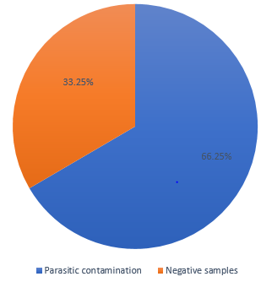
Fig. 1: Overall intestinal parasitic contamination on vegetables sold in the local market of Akure, Ondo state (P=0.023, P<0.05).
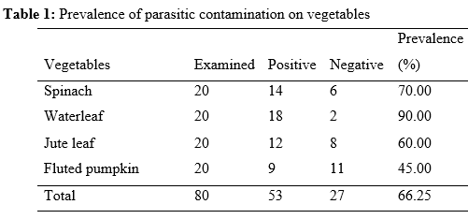
3.2. Parasite intensity and distribution by location
Eight (8) types of intestinal parasites amounting to 203 parasites counts, were detected from all sampled vegetables, sourced from five major markets in Akure: FUTA, Shasha, Odo-petu, Isolo, and Oja-Oba. The most common parasite was Strongyloides stercoralis larvae (49.3%), followed by hookworm larvae (22.7%), Entamoeba coli (13.8%), Entamoeba histolytica (4.9%), Ascaris lumbricoides (4.4%). Hookworm eggs (3.0%), Trichuris trichiura (1.0%) and Giardia lamblia (1.0%) were the least frequent (Fig. 2).
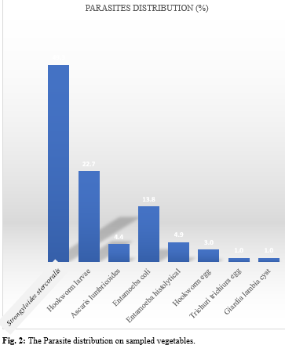
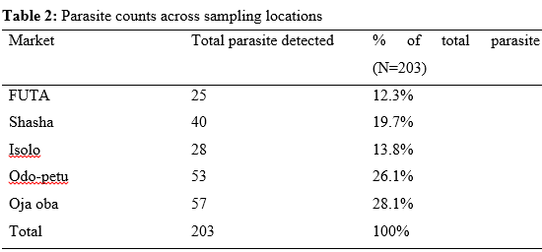
Vegetable Samples from Oja oba market (Table 2) recorded the highest parasite contamination, (n = 57, 28.1%), followed by Odo-petu (n = 53, 26.1%), Shasha (n = 40, 19.7%), Isolo (n = 28, 13.8%) and FUTA respectively (n = 25, 12.3%). In all markets, Strongyloides stercoralis larvae was the predominant parasite, accounting for 36.8%–67.9% of total parasites identified. Chi-square analysis showed no significant association between parasite type and market location (χ² = 29.33, df = 28, P= 0.396). Similarly, one-way ANOVA indicated no significant difference in mean parasite counts between markets (F = 1.16, P>0.05).

3.3. Prevalence and parasite distribution by Vegetable type
From the four vegetable types understudied (Table 3, Fig. 3), overall parasitic contamination on waterleaf was highest (34%; mean=5.91), when compared with spinach (26.4%; mean=4.53), followed by jute mallow leaf (22.6%; mean=2.69) and fluted pumpkin (17%; mean=3.65) respectively. Strongyloides stercoralis larvae (mean = 6.36 parasites/sample) occurred more frequently on all sampled vegetables than other parasite discovered, while Trichuris trichiura and Giardia lamblia were least frequent. Chi-square analysis showed no significant association between vegetable and parasite type (χ² = 21.36, df = 21, P= 0.437). However, one-way ANOVA revealed a significant difference in mean parasite counts among vegetables (F = 13.07, P < 0.05). Furthermore, parasitic contamination by intensity and parasite prevalence on all vegetable type is statistically significant (P< 0.05, P=0.001).
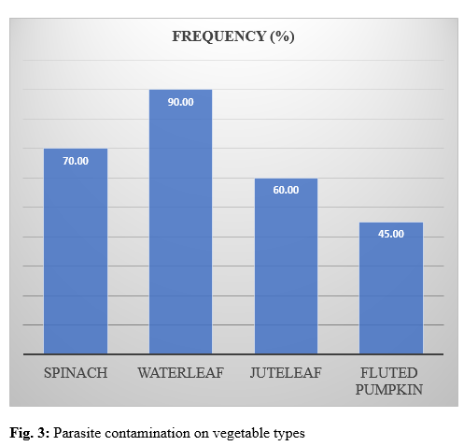

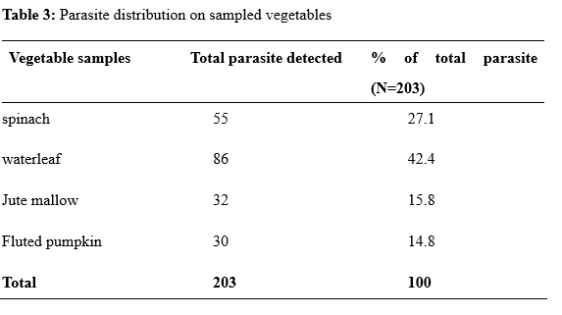

3.4. Checklist Assessment for Market hygiene and Parasitic contamination
The fieldwork checklist showed variation in market hygiene and sanitary condition across the five market locations (Table 4) in respect to parasitic is significant (P=0.0231). Shasha and Odo-petu had the poorest sanitary conditions (mean hygiene rating =1.6) while Oja Oba was slightly fair (1.92). Isolo and FUTA market recorded better hygiene rating (3.25). Although, vegetables from Odo-petu was more contaminated than Shasha market, despite having equal hygiene rating. Hence, market hygiene and environmental condition is not only the determinant of parasitic contamination on vegetables (fig. 4).
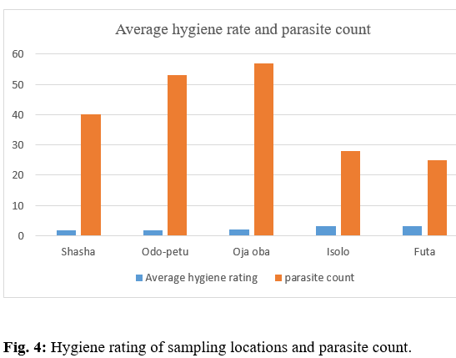

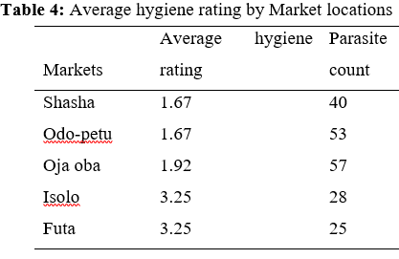
3.5 Parasite types and identification
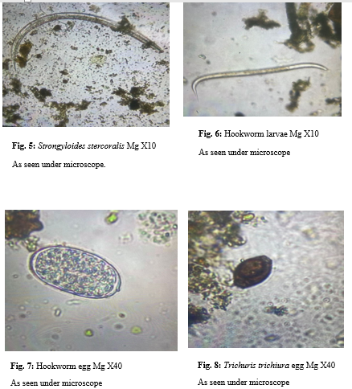
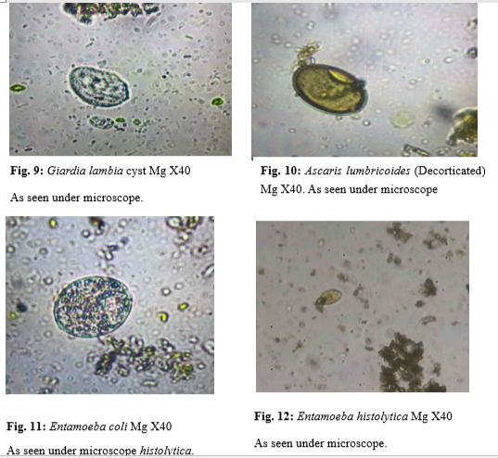

Overall parasitic contamination of 66.25% discovered on vegetables from this study is an indication that raw leafy vegetables are sources of intestinal parasites when undercooked or eaten raw and could cause serious public health risk for households, community and globally. The extent of intestinal parasitic contamination on Waterleaf (Talinum triangulare) was highest among other edible vegetables understudied. Leafy vegetables tend to have more surface area and more crevices where parasite eggs or cysts can hide, they are also more likely to be contaminated through irrigation water or poor handling practices; this may make sense if waterleaf had the highest contamination. In Jos Nigeria, a higher prevalence of 75.9% was reported with African spinach (Amaranthus hybridus) being the mostly contaminated (Nadabo et al., 2022). The dominance of Strongyloides stercoralis larvae as the most common parasite aligns with findings from several studies (Yahaya and Bishop, 2022). This also aligns with the report of Animaw et al. (2024) in Ethiopia on vegetables where S. stercoralis is found. Similarly, Kudah et al. (2018) also reported S. stercoralis as the most common parasite found in a research in Ghana on vegetables. This frequent occurrence may be associated with poor sanitation and irrigation water polluted by human feaces; and this is implicated as a causal agent for diarrhoea (Obebe et al., 2020). This human pathogenic parasitic roundworm causes strongyloidiasis, responsible for chronic infections that leads to serious lungs and digestive problems (WHO, 2014). Moreover, report of soil-transmitted helminthes- hookworms are also frequent contaminants. In a more recent report in Thailand (Laoraksawong et al., 2025), majority of the parasites discovered on vegetables were S. stercoralis, hookworm larve and Ascaris spp. Other parasites like Entamoeba histolytica, Giardia lamblia and oocyst of cryptosporidium are also commonly found (Alemu et al., 2019; Egbom et al., 2025). The presence of these parasites in fresh vegetables highlights the need for improved food safety measures and proper hygiene practice in cultivation, harvest and storage. Vegetables sourced from Odo-petu was more contaminated than Shasha market, despite having equal hygiene rating. This suggests that market hygiene and environmental condition is not only the determinant of parasitic contamination on vegetables; but sources of contamination, like soil quality, irrigation water, and how vendors handle the vegetables are also implicated as risk factors. In other words, poor hygiene alone does not fully account for differences in parasite load, other factors such as storage, transport condition, exposure time and water sources may contribute significantly. Hence visible hygiene condition at the point of sales does not solely determine parasitic contamination or intensity.

4. Conclusion
This research highlights that contamination is multi-factorial, rising not only from market sanitation but also from pre-harvest practices, handling and storage condition. Parasite count did not always correspond directly with market hygiene, indicating that other factors such as irrigation water, pre-harvest contamination, and vendor handling practices are major players in vegetable contamination. Farmers are encouraged to use clean irrigation water and discourage the use of untreated wastewater in vegetable farming. Moreover, vendors should be trained on safe postharvest handling practices, including thorough washing before sale. Furthermore, consumers are strongly advised to wash vegetables thoroughly and properly cook before consumption; and if applicable use disinfection method such as saltwater, vinegar, or mild disinfectants. In addition, local authorities should establish and enforce guidelines for irrigation water quality and vegetable handling; and ensure regular monitoring and surveillance of vegetables for parasitic contamination as parts of food safety programs. Overall, this study informs on the strong need to improve hygiene in markets, practice better handling habits in order to reduce infection risk of intestinal parasites on vegetables in Akure, Nigeria and by extension, global transmission due to migration of people across continents.

References

Akyala, I. A., Ishakeku, D., & Agwale, S. (2013). Prevalence of parasitic contamination of some edible vegetables sold at alhamis market in Lafia Metropolis. Scholarly Journals of Biotechnology, 2(2), 26-29.
Simon-Oke, I. A., Afolabi, O. J., & Obasola, O. P. (2014). Parasitic contamination of fruits and vegetables sold at Akure Metropolis, Ondo State, Nigeria. Researcher, 6(12), 30-35.
Mohamed, M. A., Siddig, E. E., Elaagip, A. H., Edris, A. M. M., & Nasr, A. A. (2016). Parasitic contamination of fresh vegetables sold at central markets in Khartoum state, Sudan. Annals of clinical microbiology and antimicrobials, 15, 1-7.
Luz, J. G. G., Barbosa, M. V., Carvalho, A. G. D., Resende, S. D., Dias, J. V. L., & Martins, H. R. (2017). Contamination by intestinal parasites in vegetables marketed in an area of Jequitinhonha Valley, Minas Gerais, Brazil. Revista de nutrição, 30, 127-136.
Obebe, O. O., Aluko, O. O., Falohun, O. O., Akinlabi, K. B., & Onyiche, T. E. (2020). Parasitic contamination and public health risk of commonly consumed vegetables in Ibadan-Nigeria. Pan African Medical Journal, 36(1).
Alemu, G., Mama, M., Misker, D. and Haftu, D. (2019) Parasitic contamination of vegetables marketed in Arba Minch town, southern Ethiopia. BMC Infect Dis 19,410(2019). https://doi.org/10.1186/s12879-019-4020-5
Hajare, S. T., Gobena, R. K., Chauhan, N. M., & Eriso, F. (2021). Prevalence of intestinal parasite infections and their associated factors among food handlers working in selected catering establishments from Bule Hora, Ethiopia. BioMed Research International, 2021(1), 6669742.
Hotez, P. J., Fenwick, A., Savioli, L., & Molyneux, D. H. (2009). Rescuing the bottom billion through control of neglected tropical diseases. The Lancet, 373(9674), 1570-1575.
Slavin, J. L., & Lloyd, B. (2012). Health benefits of fruits and vegetables. Advances in nutrition, 3(4), 506-516.
Poiroux-Gonord, F., Bidel, L. P., Fanciullino, A. L., Gautier, H., Lauri-Lopez, F., & Urban, L. (2010). Health benefits of vitamins and secondary metabolites of fruits and vegetables and prospects to increase their concentrations by agronomic approaches. Journal of Agricultural and Food Chemistry, 58(23), 12065-12082.
Shakya, Pawan Raj, and Neena Malla Khwaounjoo. "Heavy metal contamination in green leafy vegetables collected from different market sites of Kathmandu and their associated health risks." Scientific world 11.11 (2013): 37-42
World Health Organization, WHO urges governments to promote healthy food in public facilities, Pridobljeno 19 (1) (2021)
Bekele, F., Tefera, T., Biresaw, G., & Yohannes, T. (2017). Parasitic contamination of raw vegetables and fruits collected from selected local markets in Arba Minch town, Southern Ethiopia. Infectious diseases of poverty, 6, 1-7
Bishop, H. G., & Yohanna, A. Z. (2018). Contamination of vegetables with geohelminths: Prevalence, intensity and roles of hygiene practices in Samaru-Zaria, Nigeria (geohelminthic contamination of vegetables). Int J Acad Appl Res, 2, 8-13.
Li, J., Wang, Z., Karim, R.M. and Zhang, L. (2020). Detection of human intestinal protozoan parasites in vegetables and fruits: a review. Parasite and vectors 13, 380 (2020). https://doi.org/10.1186/s13071-020-04255-3
Braseth, A.L., Elliot, D.E. and Ince, M.N. (2021) Parasitic infection of the gastrointestinal track and liver. Gastroenterol Clin North Am 2021: 50(2):361-381. Doi:10.1016/j.gtc.2021.02.011
Yahaya, O., Bishop, H. G., Umar, I. O., Enoch, A. C., & Markus, D. A. (2023). Distribution dynamics of intestinal parasites on vegetables sold in Egah Market, Kogi State, Nigeria. Science World Journal, 18(1), 71-74.
Fumilayo, A. J., Buru, A. S., Kayode, A. I., & Adedokun, A. R. (2017). Isolation of intestinal parasites in vegetables sold in major markets in Akure, Ondo State, Nigeria. International Journal of Health Sciences and Research, 7(6), 78-83.
Yusof, A. M., Mohammad, M., Abdullahi, M. A., Mohamed, Z., Zakaria, R., & Wahab, R. A. (2017). Occurrence of intestinal parasitic contamination in select consumed local raw vegetables and fruits in Kuantan, Pahang. Tropical life sciences research, 28(1), 23.
Yahia, S. H., Etewa, S. E., Abd Allah, A. A. H., Arafa, S. Z., Saleh, N. S., Sarhan, M. H., Rashad, S. I., & Hassan, S. S. (2023). Investigating the Occurrence of Soil‐Transmitted Parasites Contaminating Soil, Vegetables, and Green Fodder in the East of Nile Delta, Egypt. Journal of Parasitology Research, 2023(1), 6300563
Nadabo, C., Ramyil, S. C., Bello, C. S., Adeola, O. A., Ike, R., Ogundeko, T. O., ... & Adu, P. (2022). Parasitic contamination of commonly consumed and locally cultivated leafy vegetables in Jos, north-central Nigeria. Journal of Human Environment and Health Promotion, 8(1), 1-9.
Yahaya, O. and Bishop, H.G. (2022) Parasitic contamination of fresh vegetables sold in some major markets and farms in Zaria. Science world journal vol 17(No1) 2022 ISSN: 1597-6343
Animaw, Z., Melese, A., Bedane, D., Tadesse, B., Degarege, D., Admasu, F., ... & Emmanuel, B. (2024). Prevalence, pattern and predictors of clinically important parasites contaminating raw vegetables and fruits in Ethiopia: a systematic review and meta-analysis. BMC Infectious Diseases, 24(1), 1146.
Kudah, C., Sovoe, S. and Baiden, F. (2018) Parasitic contamination of commonly consumed vegetables in two markets in Ghana. Ghana Med Journal 2018:52(2):88-93.doi:10.4314/gmj.v52i2.5
World Health Organization (2014). Control of Neglected tropical disease- Strongloides stercoralis: a plea for action. Doi:10.1371/journal.pntd.0002214
Laoraksawong, P., Bunkasem, U. and Pradidthaprecha, A (2025) Prevalence of intestinal parasitic contamination in fresh vegetables in Bangkok, Thailand and surrounding areas: A cross-sectional survey. Parasite epidemiology and control. https://doi.org/10.1016/j.parepi.2025.e00416
Egbom, S.E., Nwoko, R., Ihejirika, O.C., Ezenwaka, C.O., Opara, M.C., Anyanwu, E.O and et al. (2025) Parasitic contamination of vegetables consumed raw in parts of south east Nigeria: A challenge to NTDs elimination. International journal of health science and research 15(1). Doi:https://doi.org/10.52403/ijhsr.20250109

