Case report

Bilateral Asymmetric Best Vitelliform Macular Dystrophy in Adulthood: Insights from Multimodal Imaging

Abstract
Purpose:
To describe a rare presentation of bilateral asymmetric Best vitelliform macular dystrophy (BVMD) in adulthood and to highlight the role of multimodal imaging in disease characterization.
Methods:
A 34-year-old male with long-standing decreased central visual acuity underwent comprehensive ophthalmic evaluation including best-corrected visual acuity, slit-lamp examination, fundus photography, fundus autofluorescence (FAF), and fluorescein angiography (FA). Findings were documented and compared to standard BVMD staging criteria.
Results:
Fundus examination revealed asymmetric macular lesions: the right eye demonstrated a Stage IV (vitelliruptive) lesion, and the left eye showed a Stage III (pseudohypopyon) lesion. FAF highlighted central hypoautofluorescence with scattered hyperautofluorescent areas in the right eye and a heterogeneous semi-lunar pattern in the left eye. FA confirmed semi-lunar staining without leakage in both eyes. Multimodal imaging enabled precise staging and detection of early retinal pigment epithelium dysfunction.
Conclusion:
This case illustrates adult-onset asymmetric BVMD and underscores the value of multimodal imaging, particularly FAF and FA, for staging disease and identifying early structural changes. Recognition of these imaging markers is critical for appropriate follow-up and timely detection of complications such as choroidal neovascularization.

Keywords: Best vitelliform macular dystrophy, adult-onset, multimodal imaging, fundus autofluorescence, choroidal neovascularization

Introduction
Best vitelliform macular dystrophy (BVMD), also known as Best disease, is an autosomal dominant macular disorder classically presenting in childhood with a yolk-like yellow-orange lesion in the macula [1,2]. Lipofuscin accumulation occurs within the retinal pigment epithelium (RPE), leading to progressive photoreceptor degeneration. While pediatric presentations are well-described, adult-onset and asymmetric forms are rare, and can present diagnostic challenges [3,4].
Multimodal imaging, including fundus autofluorescence (FAF), near-infrared FAF (NIR-FAF), optical coherence tomography (OCT), and OCT angiography (OCTA), provides essential structural, functional, and vascular information. FAF, in particular, can detect early RPE dysfunction even in subclinical stages, as demonstrated in prior studies showing characteristic hypo- and hyperautofluorescent patterns before overt visual impairment [5–7]. These imaging modalities have become increasingly important for accurate staging, monitoring progression, and detecting complications such as choroidal neovascularization (CNV) [8,9].
Here, we report a rare case of bilateral asymmetric adult-onset BVMD and illustrate the utility of multimodal imaging in disease characterization.

Case Report
A 34-year-old male presented with long-standing decreased central vision in both eyes. Best-corrected visual acuity was 20/40 in the right eye (OD) and 20/30 in the left eye (OS). Anterior segment examination was unremarkable. Peripheral retina was normal in both eyes.
Fundus Examination
- Right eye (OD): Stage IV (vitelliruptive) lesion with breakup of vitelliform material, giving a “scrambled egg” appearance (Figure 1A).
- Left eye (OS): Stage III (pseudohypopyon) lesion with semi-lunar configuration (Figure 1B).
Fundus Autofluorescence (FAF)
- Right eye (OD): Central hypoautofluorescence with scattered punctiform hyperautofluorescent areas (Figure 2A).
- Left eye (OS): Heterogeneous semi-lunar hyperautofluorescence with peripheral hypoautofluorescent areas (Figure 2B).
Fluorescein Angiography (FA)
- Right eye (OD): Early phase and late phase showing semi-lunar staining without leakage and bordered by a thin hyperfluorescent rim (Figure 3A–B).
- Left eye (OS): Early phase and late phase showing semi-lunar hyperfluorescent staining with irregular contours without leakage (Figure 3C–D).
The patient was advised to undergo regular follow-up for early detection of potential complications, including choroidal neovascularization (CNV).

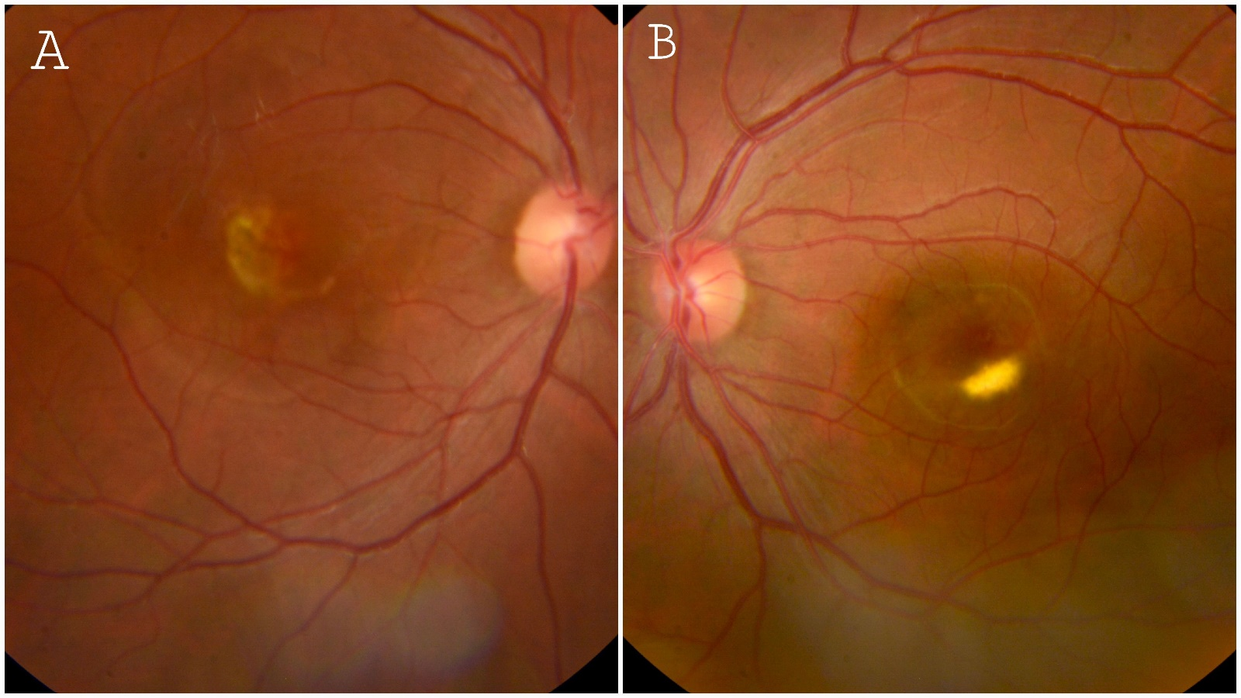
Figure 1. Color Fundus Photography
- (A) Right eye: Stage IV vitelliruptive lesion (“scrambled egg” appearance).
- (B) Left eye: Stage III pseudohypopyon lesion with semi-lunar configuration.

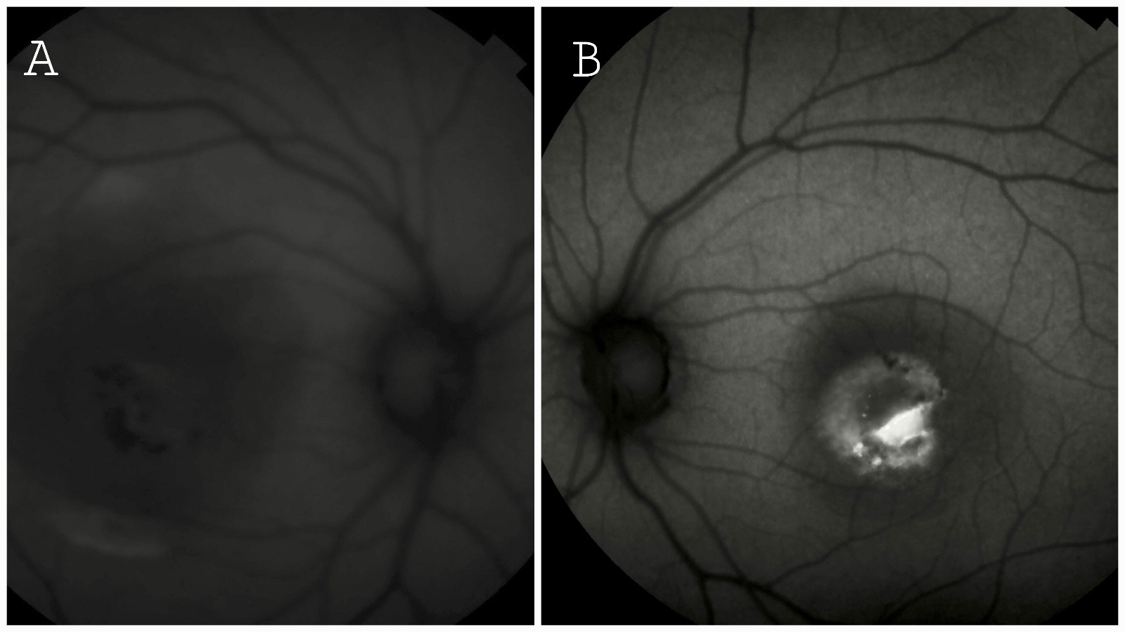
Figure 2. Fundus Autofluorescence (FAF)
- (A) Right eye: Central hypoautofluorescence with scattered hyperautofluorescent spots.
- (B) Left eye: Heterogeneous semi-lunar hyperautofluorescence with peripheral hypoautofluorescent areas.
Figure 3. Fluorescein Angiography (FA)
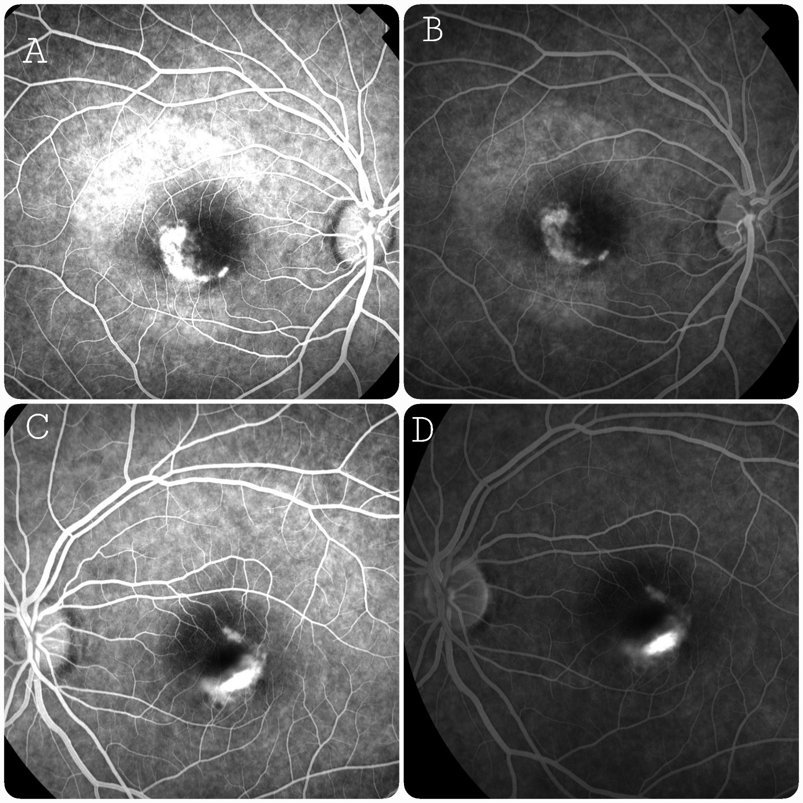
- (A) Right eye, early phase: Semi-lunar staining without leakage.
- (B) Right eye, late phase: Persistent semi-lunar staining with thin hyperfluorescent rim.
- (C) Left eye, early phase: Semi-lunar hyperfluorescent staining with irregular contours, no leakage.
- (D) Left eye, late phase: Persistent semi-lunar hyperfluorescent staining, no leakage.

Discussion
Best vitelliform macular dystrophy (BVMD) is classically described as an autosomal dominant macular disorder presenting in childhood, characterized by yellow-orange vitelliform lesions resulting from lipofuscin accumulation within the retinal pigment epithelium (RPE) [1,2]. However, adult-onset and asymmetric presentations are rare and can pose diagnostic challenges [3,4]. Epidemiologically, BVMD affects approximately 1 in 10,000 individuals, with adult-onset and asymmetric forms being particularly uncommon [3,5]. Our report of bilateral asymmetric BVMD in a 34-year-old patient underscores these atypical manifestations and highlights the importance of multimodal imaging in disease characterization.
Color fundus photography remains a useful tool for documenting lesion morphology, but advanced imaging modalities, such as fundus autofluorescence (FAF), near-infrared FAF (NIR-FAF), optical coherence tomography (OCT), and OCT angiography (OCTA), provide essential structural, functional, and vascular information [3–7]. FAF can detect early RPE dysfunction even in subclinical or atypical cases. Querques et al. demonstrated that NIR-FAF reveals central hypoautofluorescence surrounded by hyperautofluorescent zones in eyes with clinically inapparent BVMD, highlighting its sensitivity for early disease detection [5]. Similarly, Schönbach and Scholl described a subclinical case in which FAF identified discrete hyperautofluorescent foci despite normal visual acuity and unremarkable OCT and microperimetry [6].
Correlation between FAF patterns and retinal function has been further emphasized in several studies. Battaglia Parodi et al. reported that hyperautofluorescent, hypoautofluorescent, and patchy patterns are associated with varying degrees of RPE and photoreceptor dysfunction, with patchy patterns often corresponding to reduced central retinal sensitivity [3,7]. Quantitative multimodal imaging, including OCT, can detect outer retinal changes such as thinning of the outer nuclear layer and disruption of the ellipsoid zone, which correlate with decreased visual function [4,6]. OCTA has also revealed the presence of non-exudative choroidal neovascularization (CNV), particularly in later stages, emphasizing the value of detailed vascular assessment for long-term surveillance [8].
The pathophysiology of BVMD involves mutations in the BEST1 gene encoding bestrophin, which disrupts RPE function and contributes to vitelliform material accumulation. Recent insights suggest that lipofuscin deposition may result from impaired photoreceptor-RPE apposition rather than primary metabolic defects, leading to progressive accumulation of shed outer segments [9]. Bianco et al. highlighted that multimodal imaging, including FAF, OCT, adaptive optics, and OCTA, provides a comprehensive assessment of lesion composition and disease evolution, enabling precise staging and monitoring, especially in adult-onset or asymmetric cases [9].
In the present patient, asymmetric macular lesions were observed: a Stage IV vitelliruptive lesion in the right eye and a Stage III pseudohypopyon lesion in the left eye. FAF revealed central hypoautofluorescence with scattered hyperautofluorescent areas in the right eye, and a heterogeneous semi-lunar pattern in the left eye. These observations correspond with previously reported FAF patterns and their correlation with disease stage and functional impairment [3,5,7]. Fluorescein angiography showed semi-lunar staining without leakage, further supporting the utility of multimodal imaging in precise staging and early detection of RPE dysfunction.
Clinical and Practical Implications:
This case illustrates that adult-onset BVMD can present asymmetrically and progress subtly, emphasizing the need for detailed multimodal evaluation, even when visual acuity is relatively preserved. Recognizing imaging biomarkers through FAF, NIR-FAF, OCT, and OCTA not only aids diagnosis but also facilitates early detection of complications, such as CNV, and guides appropriate follow-up.
Practical recommendations for ophthalmologists include:
- Perform baseline multimodal imaging in all suspected BVMD cases, including FAF, OCT, and FA/OCTA if available.
- Document lesion stage, symmetry, and FAF pattern to guide follow-up and prognosis.
- Schedule periodic monitoring (every 6–12 months depending on lesion stage, patient age, and symptoms).
- Educate patients on early warning signs of CNV (sudden distortion, scotoma) and the need for urgent assessment.
- Consider genetic counseling, particularly for adult-onset cases or family planning.
These insights underscore that multimodal imaging is essential for optimal management of BVMD, particularly in atypical adult presentations, and highlight the value of a structured long-term surveillance strategy to preserve vision and detect complications promptly.

Consent
Written informed consent for publication of this case report and accompanying images was obtained from all patients.

Ethical Approval
As this is a retrospective descriptive case series involving anonymized clinical data, formal ethical approval was not required.

Disclaimer (artificial intelligence)The author(s) hereby declare that no generative AI technologies, including Large Language Models (e.g., ChatGPT, Copilot) or text-to-image generators, have been used in the writing or editing of this manuscript

References
- Pinckers, A., Cuypers, M. H., & Aandekerk, A. L. (1996). The EOG in Best's disease and dominant cystoid macular dystrophy (DCMD). Ophthalmic Genetics, 17(3), 103–108. https://doi.org/10.3109/13816819609057112
- Weingeist, T. A., Kobrin, J. L., & Watzke, R. C. (1982). Histopathology of Best's macular dystrophy. Archives of Ophthalmology, 100(7), 1108–1114. https://doi.org/10.1001/archopht.1982.01030040086016
- Battaglia Parodi, M., Arrigo, A., Calamuneri, A., Aragona, E., & Bandello, F. (2022). Multimodal imaging in subclinical best vitelliform macular dystrophy. British Journal of Ophthalmology, 106(4), 564–567. https://doi.org/10.1136/bjophthalmol-2020-317635
- Bianco, L., Arrigo, A., Antropoli, A., & Battaglia Parodi, M. (2024). Multimodal imaging in Best Vitelliform Macular Dystrophy: Literature review and novel insights. European Journal of Ophthalmology. https://doi.org/10.1177/11206721231166434
- Querques G, Bux AV, Carnevali A, et al. Near-infrared fundus autofluorescence imaging in Best vitelliform macular dystrophy: characteristic patterns in subclinical cases. Retina. 2014;34(1):120–128. PMID: 25174897.
- Schönbach, E. M., & Scholl, H. P. (2017). Fundus Autofluorescence in a Subclinical Case of Best Disease. Retinal Cases and Brief Reports. https://doi.org/10.1097/ICB.0000000000000390
- Battaglia Parodi, M., Arrigo, A., Calamuneri, A., Iacono, P., Del Turco, C., & Bandello, F. (2015). Functional Assessment of the Fundus Autofluorescence Pattern in Best Vitelliform Macular Dystrophy. Retina, 35(4), 737–744. https://doi.org/10.1007/s00417-015-3194-9
- Karaca Adiyeke, S., & Ture, G. (2022). Choroidal Neovascularization Associated with Best Vitelliform Macular Dystrophy. Beyoglu Eye Journal, 7(2), 103–108. https://doi.org/10.14744/bej.2022.54376
- Bianco, L., Arrigo, A., Antropoli, A., Berni, A., Saladino, A., Vilela, M. A. P., Mansour, A. M., Bandello, F., & Battaglia Parodi, M. (2024). Multimodal imaging in Best Vitelliform Macular Dystrophy: Literature review and novel insights. European Journal of Ophthalmology, 34(1), 39–51. https://doi.org/10.1177/11206721231166434

