Case report

Scleral Dellen : A Rare Complication Following Pterygium Surgery Case Series and Literature Review

.
ABSTRACT

Scleral dellen is a rare, non-infectious complication following pterygium excision, arising from focal scleral dehydration and tear film instability.

We report four male patients (38–65 years) who developed scleral dellen within 5–16 days after conjunctival autograft surgery performed without mitomycin c. All presented localized scleral thinning without systemic disease. Three cases resolved with intensive topical therapy : preservative-free lubricants, antibiotics, autologous serum (30%), and eye patching ; while one required amniotic membrane transplantation. Complete recovery occurred within four weeks.

Early recognition, meticulous graft coverage, cautious cautery, and prompt postoperative lubrication are key to preventing this rare complication.

Keywords: Scleral dellen, Pterygium surgery, Ocular surface complications, Conjunctival autograft, Amniotic membrane transplantation, Autologous serum eye drops.

1. INTRODUCTION :

Pterygium is a common fibrovascular proliferation of the conjunctiva extending onto the cornea, often associated with ultraviolet exposure and chronic ocular irritation. Surgical excision with conjunctival autograft remains the preferred technique to minimize recurrence, and alternatives such as amniotic membrane transplantation or multilayer grafting have been described [1,2].
While most postoperative complications are mild, rare but potentially serious events such as scleral dellen may occur. This entity, characterized by focal scleral thinning due to localized dehydration and tear film instability, typically develops in the early postoperative period and has been reported following various ocular surface procedures [3,4].
We present four cases of scleral dellen following primary pterygium surgery, emphasizing risk factors, management strategies, and preventive considerations.

2. Presentation of cases :

2.1 Case 1:
A 56-year-old man with no significant medical history underwent pterygium excision of the left eye. The conjunctival autograft was sutured with 7-0 Vicryl, leaving a 2 mm bare scleral area. No mitomycin C or cautery was used. Postoperatively, the patient received topical dexamethasone 0.1%–tobramycin 0.3% eight times daily with tapering. The first two postoperative weeks were uneventful. On day 15, slit-lamp examination revealed a brownish nasal scleral thinning surrounded by edematous conjunctiva (Figure 1).

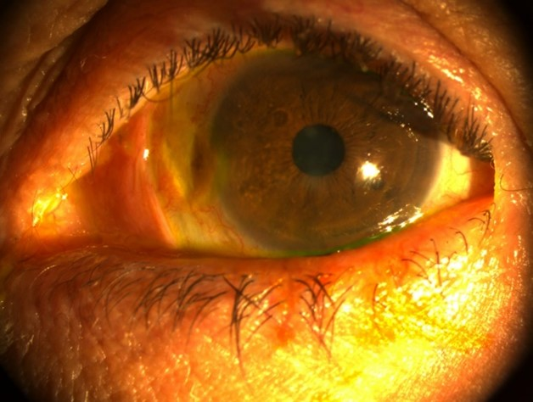

Figure 1 : Scleral dellen with focal scleral thinning and brown discoloration at postoperative day 15 (Case 1).

A second autograft with smaller bare sclera was attempted but dislodged on day 3. Conservative management was pursued with preservative-free artificial tears (hourly), topical tobramycin 0.3%, autologous serum 30%, cicatrizing ointment (vitamin A - carbomer gel), and occlusion. Progressive improvement occurred, and complete healing was achieved within four weeks (Figure 2).

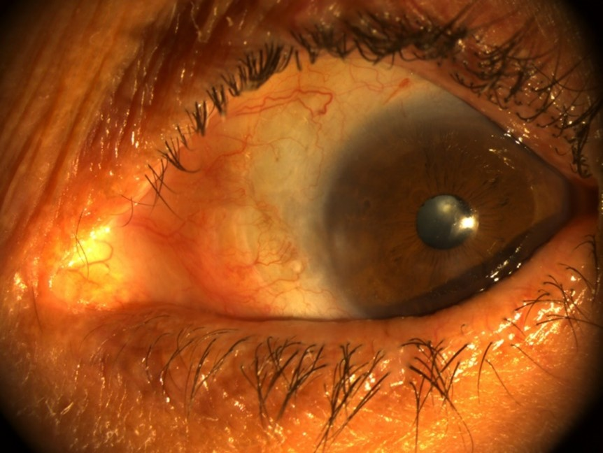

Figure 2 : Progressive healing after intensive topical therapy (Case 1, week 3).

Systemic work-up : including complete blood count, inflammatory and autoimmune screening, and infectious serologies, was unremarkable.

2.2 Case 2:
A 38-year-old man underwent uncomplicated primary pterygium excision with a conjunctival autograft sutured by 7-0 Vicryl, without mitomycin C or cautery. On day 16, he reported ocular pain and noted a dark nasal spot. Examination revealed scleral thinning with visible ciliary body and surrounding conjunctival edema; sutures had loosened. Intensive lubrication, topical antibiotics, and patching were prescribed. Epithelial recovery was noted within one week, and subsequent systemic evaluation was normal.

2.3 Case 3:
A 52-year-old man presented with stinging and redness in the left eye after pterygium surgery that included four perilimbal cauterization points. Postoperative therapy consisted of topical dexamethasone 0.1%–tobramycin 0.3%, unpreserved artificial tears, and healing ointment (vitamin A - carbomer gel),. By day 11, the conjunctival graft had melted, revealing a 4 × 3 mm corneoscleral dellen (Figure 3).

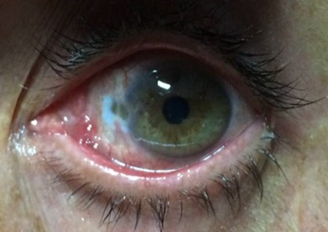

Figure 3 : Corneoscleral dellen with necrotic conjunctival graft (Case 3, day 11).

Necrotic tissue was debrided, and steroids were discontinued. Intensive lubrication and antibiotic therapy were maintained. Because of slow epithelial recovery, 30% autologous serum was initiated hourly on day 15, resulting in rapid healing within one week. The serum was tapered over one month. At six-month follow-up, a mild pterygium recurrence was observed.

2.4 Case 4:
A 65-year-old man underwent grade II nasal pterygium excision under local anesthesia with lidocaine–adrenaline. A conjunctival autograft was secured with 7-0 Vicryl; no cautery or mitomycin C was used. Standard postoperative care included topical tobramycin–dexamethasone, unpreserved lubricants, healing ointment, and patching. On day 5, a 2 × 2.5 mm scleral dellen with visible uveal tissue developed. Despite five days of intensive medical therapy with autologous serum 30%, no improvement occurred. Surgical repair using cryopreserved amniotic membrane transplantation (AMT) was performed. The membrane was sutured with 7-0 Vicryl at conjunctival edges, providing complete coverage of the defect. AMT acted as a biologic dressing and source of epitheliotrophic factors. Complete epithelial and stromal healing occurred within four weeks (Figure 4), with full graft integration and no recurrence during follow-up.

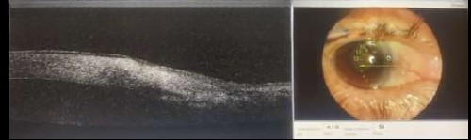

Figure 4 : Healed scleral defect following amniotic membrane transplantation (Case 4, postoperative day 10).

All four patients presented localized scleral thinning without infection or inflammation. Three responded to conservative management; one required AMT. Complete recovery occurred in all within four weeks, with no residual thinning or recurrence of scleral defects.

3. discussion :

Scleral dellen represents a localized area of stromal thinning secondary to focal dehydration and tear film instability over an avascular scleral surface [3,4]. Although rare, it constitutes a potentially serious complication of pterygium surgery if not promptly recognized. The pathogenesis is primarily mechanical, but surgical and pharmacologic factors can exacerbate tissue breakdown. Early onset—usually within days to two weeks after surgery—has been described in several reports [2–5].
Predisposing factors include bare sclera exposure, graft dehiscence, and excessive cautery, all of which may impair local perfusion and epithelial regeneration; similar risk patterns have been highlighted in recent studies [5,6]. Topical corticosteroids, while useful for inflammation control, can retard epithelial healing and fibroblastic activity and have been implicated experimentally in delayed wound closure [7].
Conservative therapy remains the first-line approach and is effective in most cases. Intensive lubrication, antibiotic prophylaxis, cicatrizing ointments, and temporary occlusion promote rehydration and epithelial migration. Autologous serum supplies growth factors and anti-inflammatory mediators that accelerate recovery and is supported by clinical evidence for persistent epithelial defects [8,9].
When medical therapy fails or when deep stromal thinning with uveal show is present, surgical coverage such as amniotic membrane transplantation (AMT) is indicated. AMT provides a biological scaffold and epitheliotrophic factors that facilitate re-epithelialization and stromal repair [1,2].
Preventive measures include avoiding bare sclera techniques, minimizing cautery near the limbus, ensuring secure graft fixation, initiating early lubrication, and tapering steroids judiciously [5,10]. Early recognition and a stepwise management algorithm ensure favorable outcomes and prevent progression to scleral necrosis or perforation.

4. Conclusion

Scleral dellen is an uncommon but potentially serious early complication of pterygium surgery. Early recognition, intensive ocular surface therapy, and timely surgical intervention when required ensure excellent recovery. Preventive strategies : complete graft coverage, minimal cautery, adequate lubrication, and prudent steroid use, are key to reducing postoperative risk.

Consent (where ever applicable)

The authors certify that they have obtained all appropriate patient consent forms. In the form, the patient(s) has/have given his/their consent for his/their images and other clinical information to be reported in the journal. The patients understand that their names and initials will not be published and due efforts will be made to conceal their identity, but anonymity cannot be guaranteed.

Ethical approval (where ever applicable)

The authors certify that the study was conducted in accordance with ethical standards and was reviewed and approved by the appropriate Institutional Ethics Committee/Institutional Review Board (IRB). The study was performed in compliance with the ethical principles outlined in the Declaration of Helsinki (1964) and its later amendments. All necessary permissions were obtained prior to the commencement of the study.

References

- Sridhar, M. S., Bansal, A. K., & Rao, G. N. (2002). Multilayered amniotic membrane transplantation for partial thickness scleral thinning following pterygium surgery. Eye, 16(5), 639–642. https://doi.org/10.1038/sj.eye.6700123
- Kim JS, Kim JC, Na BK, Jeong JM, Song CY. Amniotic membrane transplantation in the treatment of conjunctival defects. Korean J Ophthalmol. 2001;15(4):228–237.
- İmamoğlu S, Can İ, Üstündağ K, et al. Scleral dellen: an early complication of pterygium surgery. Turk J Ophthalmol. 2015;45(6):281–283.
- Elshazly LH, Ali H, Torky MA. Dellen and corneal perforation after bilateral pterygium excision with conjunctival autograft. Clin Ophthalmol. 2012;6:1649–1651.
- Solmaz N, Yağcı A. Scleral dellen after pterygium surgery: Risk factors and treatment approaches. J Curr Ophthalmol. 2022;34(4):479–484.
- Accorinti M, Abdulaziz AA, Pirraglia MP. Severe scleral dellen as an early complication of pterygium excision with simple conjunctival closure: Case report and review of the literature. Arq Bras Oftalmol. 2014;77(3):182–184.
- Najpure S, Rao VA, Jha R. Autologous serum treatment for corneoscleral dellen following pterygium surgery. J Glaucoma-Cataract. 2016;11(2):65–68.
- Mahdy MA, Grima JT, Edwards M. Effects of topical steroids on corneal epithelial wound healing in rabbits. Eye Contact Lens. 2007;33(6):274–278.
- Tsubota, K., Goto, E., Shimmura, S., & Shimazaki, J. (1999). Treatment of persistent corneal epithelial defect by autologous serum application. Ophthalmology, 106(10), 1984–1989. https://doi.org/10.1016/S0161-6420(99)90412-8
- Singh G, Mehta P, Arora V, et al. Scleral dellen as a complication of pterygium surgery: A case series and review. Indian J Ophthalmol. 2022;70(2):345–350.

