Case report

LEFT ATRIAL MYXOMA EXCISION WITH COMBINED CABG - A CASE REPORT

.
ABSTRACT
Left atrial myxoma is the most common benign primary cardiac tumor, typically originating in the left atrium attached to the interatrial septum. It is associated with nonspecific systemic, embolic, and obstructive symptoms, making timely diagnosis and intervention crucial. Once physicians detect it, early surgical management is performed in most cases. We report a case of a 60-year-old female who presented with fever, progressive dyspnea over 8–10 days, and a transient episode of right-sided weakness lasting 5–10 minutes. Echocardiography revealed a mobile left atrial mass attached to the interatrial septum, suggestive of myxoma. The tumor was surgically excised under cardiopulmonary bypass, and histopathology confirmed the diagnosis of myxoma. Postoperative recovery was significant, with complete resolution of symptoms and no recurrence on follow-up.

Keywords: [Left atrial myxoma, Echocardiography, Cardiopulmonary bypass, Cardiac myxoma }

1. INTRODUCTION
[Cardiac myxoma is a rare disease; however, the exact prevalence is unknown. The reported prevalence is 0.03% in the general population [1]. The annual incidence of cardiac Myxoma 0.5 to 1 case per million individuals. [2,3]
Cardiac myxomas are rare benign and slowly proliferating neoplasms of uncertain histogenesis with heterogeneous histomorphology and variable and sometimes clinically quite malignant pathological manifestations.[4] Cardiac myxomas are common primary neoplasms of the heart. They are biologically benign but “functionally malignant” because of the potential for embolization. They arise most commonly from the left atrium.[5]
It is located in the left atrium and typically arises from the foramen ovale in approximately 75% of the general patient population, in the right atrium in 23%, and in the ventricles in only 2%.[6] The most frequent initial manifestations of myxomas include dyspnoea and symptoms of congestive heart failure by cardiac obstruction, palpitations, chest pain, signs of embolism and systemic rheumatism, depending on the localization, size and humoral activity of the tumor.[7] Medical history, conducting a physical examination, and performing necessary diagnostic tests such as echocardiography particularly transthoracic echocardiography, computed tomography scan, coronary angiography, cardiac MRI, or biopsy are crucial for an accurate diagnosis of cardiac myxoma .[8] Surgical resection of the myxoma is the treatment of choice, surgery being safe with low morbidity and mortality.[9] However, incomplete resection, multifocal tumors, and embolism caused by tumors are important factors in its recurrence and complications.[10]
2. CASE PRESENTATION

A 60-year-old female presented to the Cardiothoracic and Vascular Surgery (CTVS) outpatient department with complaints of Fever: Low-grade, persistent over 8–10 days. Breathing Difficulty: Progressive dyspnea. and a history of sudden episode of right-sided weakness that resolved spontaneously within 5–10 minutes. The patient had type 2 diabetes mellitus, managed with oral hypoglycemics including tablet metformin 500mg and tablet glimepiride 1mg daily in the morning. She also had a history of coronary artery disease, and hypertension but reports were not available. Echocardiography performed by the physician revealed LA mass attached to the inter-atrial septum (1.5cm x1.5cm).
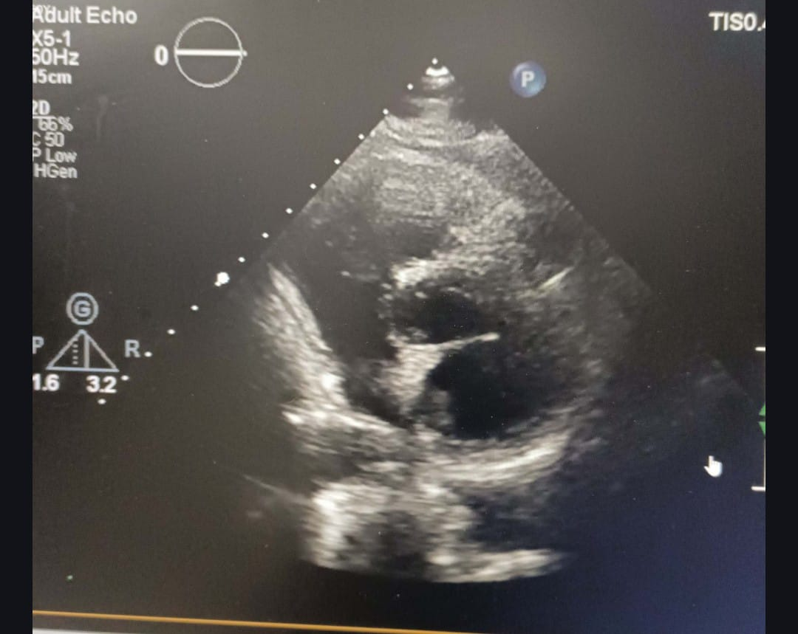
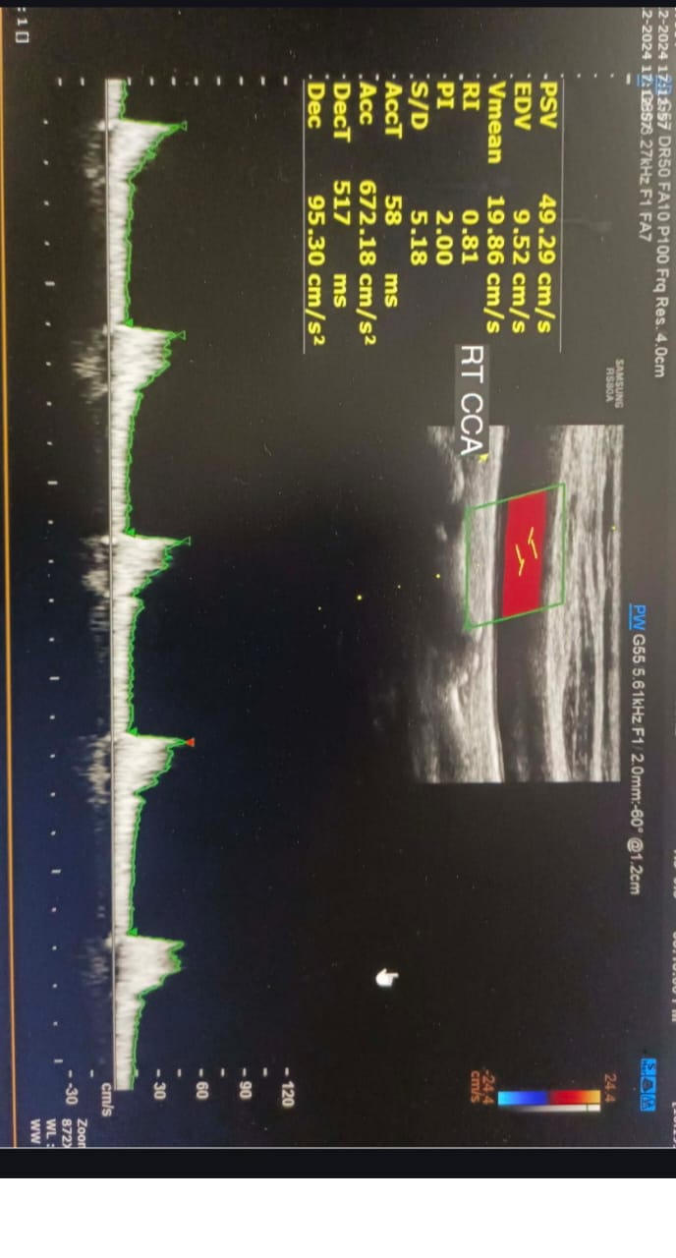
The patient was admitted on 10 December 2024 for further management. On physical examination, basal crepitations and the use of accessory muscles for breathing were noted. A coronary angiogram performed on the same day revealed single-vessel coronary artery disease, while Doppler ultrasonography indicated atherosclerotic changes in the bilateral lower limb arteries and increased bilateral carotid artery intima-media thickness (Fig-1). Echocardiography showed a left atrial myxoma measuring 14x12 mm, attached to the interatrial septum (IAS), with no mitral inflow obstruction (Fig-2). Cardiac MRI confirmed a well-defined, altered signal intensity, solitary, broad-based pedunculated mass lesion attached to the interatrial septum, just above the mitral leaflet, consistent with a left atrial myxoma. (Fig-3) Chest radiography revealed pleural effusion. Laboratory results showed a glycated hemoglobin (HbA1c) of 6.7% and a random blood glucose level of 190 mg/dL.The Cardiothoracic and Vascular Surgery (CTVS) team consulted and recommended surgery along with preoperative care. The patient was treated with anticoagulation (injection heparin 2000 IU STAT), antihypertensive medications (Tab cilnidipine 5 mg BD, Tab nebivolol 2.5 mg BD), antidiabetic treatment (Human actrapid insulin according to GRBS), and nebulization (levosalbutamol 0.63 mg, budesonide 0.5 mg).

FIG-1 Doppler ultrasonography indicated atherosclerotic changes in the bilateral lower limb arteries and increased bilateral carotid artery intima-media thickness
FIG-2 Echocardiography showed a left atrial myxoma measuring 14x12 mm, attached to the interatrial septum (IAS), with no mitral inflow obstruction

On 12 December 2024, the patient underwent surgery, which included left atrial myxoma excision and coronary artery bypass grafting. A saphenous vein graft (SVG) was used to bypass the obstruction in the third diagonal branch (D3) of the left anterior descending artery. (Fig-3) Histopathological examination confirmed the presence of a benign tumor, composed of lepidic cells within myxoid stroma, with a gelatinous mass appearance (Fig-4). Postoperatively, the patient was managed in the CTVS ICU with ventilator support. IV antibiotics (Inj cefuroxime sodium 1.5 gm BD) were administered initially, and on postoperative day 2, the IV antibiotics were switched to oral cefuroxime 500 mg BD. On postoperative day 1, the patient developed a cough, and a chest X-ray revealed pleural effusion and consolidation .

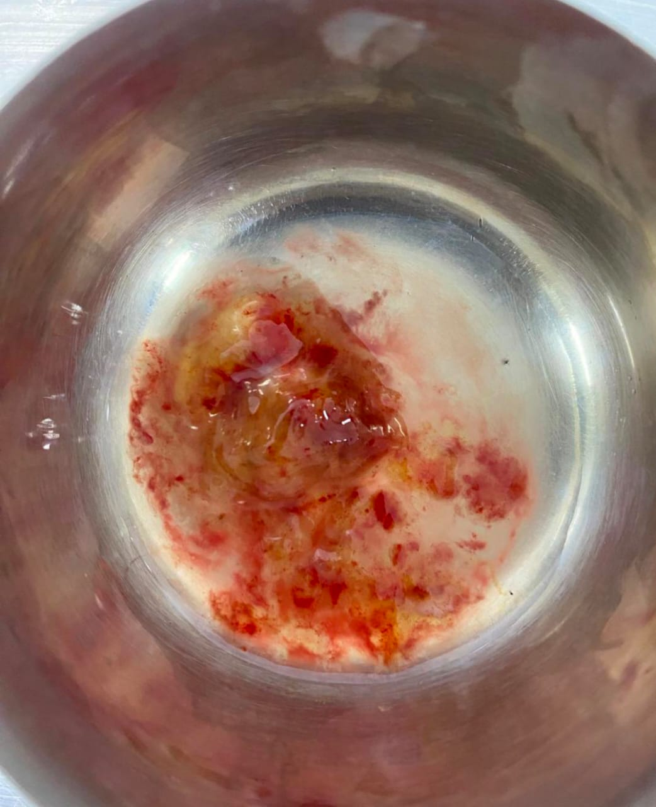
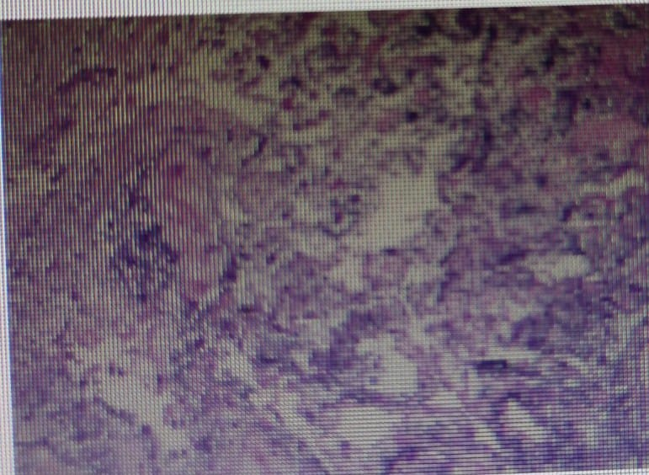

Fig-3 surgical findings; A saphenous vein graft (SVG) was used to bypass the obstruction in the third diagonal branch (D3) of the left anterior descending artery
Fig-4 Histopathological findings; Histopathological examination confirmed the presence of a benign tumor, composed of lepidic cells within myxoid stroma, with a gelatinous mass appearance.

A pulmonology consultation recommended nebulization (acetylcysteine BD, budesonide 0.5 mg) and chest physiotherapy. For coronary artery disease, the patient was started on clopidogrel and aspirin 75/100 mg OD, rosuvastatin 40 mg OD, diuretics (frusemide and spironolactone 20/50 mg), antihypertensive therapy (Metoprolol succinate 25 mg OD), and insulin (human act rapid insulin as per GRBS). Additional supportive therapies included analgesics, potassium chloride, and calcium supplements. On postoperative day 3, the patient was transferred to a semi-private ward
She recovered successfully and was discharged on postoperative day 8 with the following medications: oral antibiotics (cefuroxime 500 mg BD for 5 days), cough suppressant and nebulization (levosalbutamol 0.63 mg TID, foracort 0.5 mg BD, montelukast-fexofenadine OD, lupituss 10 mL BD), proton pump inhibitor (esomeprazole 40 mg OD), diuretics (lasilactone 20/50 mg OD for 15 days), analgesics (paracetamol 650 mg TID for 5 days), iron supplements (ferrous ascorbate-folic acid for 1 month), cardiac medications (aspirin 75 mg OD, nebivolol 2.5 mg BD, rosuvastatin 2 mg OD), and oral antidiabetic medications Note: Review paper may have different types of subsections.

3. discussion

Cardiac myxomas are rare benign and slowly proliferating neoplasms of uncertain histogenesis with heterogeneous histomorphology and variable and sometimes clinically quite malignant pathological manifestations.[1]. The growth rate of LA myxomas was first described in 1987 [11, 12] and has been reported in several studies since then. The median value and range of growth rate were 3.5 mm/ month and 0–28.3 mm/month, respectively. Walpot et al.[13] .In our case, although there were no significant change in the growth rate of the left myxoma within 15 days. The most frequent initial manifestations of myxomas include dyspnoea and symptoms of congestive heart failure by cardiac obstruction, palpitations, chest pain, signs of embolism and systemic rheumatism, depending on the localization, size and humoral activity of the tumor .[7] Our patient was a 60 years female patient was presented with a complains of fever and difficulty on breathing since 8-10 days and history of right sided weakness- sudden onset and disappeared within 5-10 mins . Echocardiography performed by physician revealed LA mass attached to the inter- atrial septum(1.5cm x1.5cm) .surgical resection of the myxoma is the treatment of choice, surgery being safe with low morbidity and mortality.[9].In our case surgery was performed which included LA myxoma excision and coronary artery bypass grafting.
However, incomplete resection, multifocal tumors and embolism caused by tumors are important factors in its recurrence and complications.[10]. our patient developed respiratory complication inhomogeneous opacification of the left mid and lower zone obscuring left CP angle, dome of diaphragm suggestive of pleural effusion, and haziness noted underlying lung field suggestive of consolidation of lungs. Anticipating such complications and timely interventions accordingly is needed in such instances.

4. Conclusion

Cardiac myxoma is a rare heart disease observed in a small proportion of the general population Combining echocardiography and clinical manifestations may help make an accurate diagnosis. Early diagnosis through non-invasive imaging, such as transthoracic or transesophageal echocardiography, is critical to prevent serious complications like stroke or sudden cardiac death. Surgical excision remains the definitive treatment, offering excellent outcomes and symptom resolution. Regular postoperative follow-up with echocardiographic examination is required to evaluate for the recurrence of myxoma. This case highlights the importance of early recognition and management of left atrial myxoma to prevent embolic and obstructive complications.

References

1. Yoon, D. H., & Roberts, W. (2002). Sex distribution in cardiac myxomas. American Journal of Cardiology, 90(5), 563-565. https://doi.org/10.1016/s0002-9149(02)02540-7
2. Keeling, I. M., Oberwalder, P., Anelli-Monti, M., Schuchlenz, H., Demel, U., Tilz, G. P., Rehak, P., & Rigler, B. (2002). Cardiac myxomas: 24 years of experience in 49 patients. European Journal of Cardio-Thoracic Surgery, 22(6), 971-977. https://doi.org/10.1016/s1010-7940(02)00592-4
3. Gošev, I., Paić, F., Đurić, Ž., Gošev, M., Ivčević, S., Jakuš, F. B., & Biočina, B. (2013). Cardiac myxoma the great imitators: comprehensive histopathological and molecular approach. International Journal of Cardiology, 164(1), 7-20. https://doi.org/10.1016/j.ijcard.2011.12.052
4. Islam, A. K. M. M. (2022). Cardiac myxomas: A narrative review. World Journal of Cardiology, 14(4), 206-219. https://doi.org/10.4330/wjc.v14.i4.206
5. Grebenc, M. L., Rosado de Christenson, M. L., Burke, A. P., Green, C. E., & Galvin, J. R. (2000). Primary cardiac and pericardial neoplasms: radiologic-pathologic correlation. *Radiographics*, *20*(4), 1073–103. https://doi.org/10.1148/radiographics.20.4.g00jl081073
6. Samanidis, G., Khoury, M., Balanika, M., & Perrea, D. N. (2020). Current challenges in the diagnosis and treatment of cardiac myxoma. Kardiologia Polska (Polish Heart Journal), 78(4), 269-277. https://doi.org/10.33963/KP.15254
7. Knepper, L. E., Biller, J., Adams, H. P., Jr., & Bruno, A. (1988). Neurologic manifestations of atrial myxoma. A 12-year experience and review. Stroke, 19(11), 1435-1440. https://doi.org/10.1161/01.str.19.11.1435

8. Rabiee Rad, M., Ghasempour Dabaghi, G., Darouei, B., Amani-Beni, R., Zare, M. M., Shirin, F., & Jamalian, M. (2024). Clinical and laboratory manifestations, ECG findings, and outcomes of right atrial myxoma: a systematic review of cases reported worldwide. The Egyptian Heart Journal, 76(1), 125. https://doi.org/10.1186/s43044-024-00550-x .
9. Lone, R. A., Ahanger, A. G., Singh, S., Mehmood, W., Shah, S., Lone, G. N., Dar, A. M., Bhat, M. A., Sharma, M. L., & Lateef, W. (2008). Atrial myxoma: Trends in management. International Journal of Health Sciences, 2(2), 141-151. https://ijhs.qu.edu.sa/index.php/journal/article/view/59
10. Chojdak-Łukasiewicz, J., Budrewicz, S., & Waliszewska-Prosół, M. (2022). Cerebral Aneurysms Caused by Atrial Myxoma—A Systematic Review of the Literature. Journal of Personalized Medicine, 13(1), 8. https://doi.org/10.3390/jpm13010008 .
11. Marinissen, K. I., Essed, C., de Groot, C., Schelling, A., & Hagemeijer, F. (1987). Growth rate of left atrial myxoma. Development of a symptomatic left atrial myxoma less than two years after coronary artery bypass grafting. Chest, 92(5), 941–2. https://doi.org/10.1378/chest.92.5.941
12. Roudaut, R., Gosse, P., & Dallocchio, M. (1987). Rapid growth of a left atrial myxoma shown by echocardiography. British Heart Journal, 58(4), 413–416. https://doi.org/10.1136/hrt.58.4.413
13. Walpot, J., Shivalkar, B., Rodrigus, I., Pasteuning, W. H., & Hokken, R. (2010). Atrial myxomas grow faster than we think. Echocardiography, 27(10), E128-E131. https://doi.org/10.1111/j.1540-8175.2010.01186.x

