Seven-Year Trends in Ambient Air Quality and Ozone Dynamics in Delhi: COVID-19 Lockdown Lessons and Future Pathways from GAINS/ECLIPSE Projections

Abstract: Delhi air quality experienced a rare disruption during the COVID-19 lockdown, offering a natural experiment to study emission meteorology health linkages. Using data from three Continuous Ambient Air Quality Monitoring Stations (CAAQMS) in Delhi (2017–2023), we assessed long-term variability in PM₂.₅, NO₂, SO₂, and O₃ before, during, and after the lockdown. Lockdown restrictions in 2020 led to sharp reductions in PM₂.₅ (up to −87%), NO₂ (up to −72%), and SO₂ (up to −47%), while ozone increased (up to +66%) due to reduced titration and enhanced photochemistry. A long-term trend analysis showed pollutant levels rebounded post-lockdown, with 2021–2023 concentrations nearing or exceeding pre-lockdown baselines. Meteorological normalization indicated that solar radiation and relative humidity modulated ozone formation, while particulate declines enhanced photochemical activity. Using exposure response functions, we estimated that short term lockdown reductions in PM₂.₅ and NO₂ potentially avoided 1,200–1,500 premature deaths in Delhi. However, these improvements were temporary, underscoring the importance of sustained emission-control strategies. The study highlights how the lockdown serves as a natural experiment, providing insights for targeted policy measures such as traffic restrictions, industrial emission controls, and dust management to secure long-term health benefits.o place these observations in a broader context, GAINS/ECLIPSE (V6b) projections for 2025 were evaluated. Under the Current Legislation (CLE) scenario, NOx and VOC emissions are expected to remain high, sustaining ozone production, whereas the Maximum Feasible Reduction (MFR) scenario indicates substantial declines with strong control measures. These projections reinforce that while the lockdown offered temporary relief, only sustained and stringent emission-control policies can achieve durable air quality and health benefits in Delhi.
Keywords: COVID-19 lockdown, air quality, Ozone, PM_{2.5} Delhi, India

- Introduction
The nationwide lockdown enforced on March 24, 2020, due to pandemic caused by the novel coronavirus, there was a notable improvement in air quality across India [1]. This improvement was particularly noteworthy in regions with historically poor air quality, such as New Delhi. Preceding the lockdown, a 14-hour curfew, known as the Janata curfew, was observed on March 22nd, 2020. The first phase of the lockdown commenced on March 23rd, 2020, and extended until April 14th, 2020. Subsequent extensions continued until June 5th, 2020, with conditional relaxations allowing the operation of government offices, industrial estates, and economic zones, as well as construction activities and brick kilns in rural areas where the spread of the pandemic had been contained [2,3].
Industrial activities, power plants, vehicular traffic, building activities, biomass burning, refuse burning, road dust resuspension, residential activities, and operations such as diesel generators and restaurants, as well as trash burning in landfills, are the major sources of air pollution. During the lockdown, all transportation services, including road, rail, and air, were suspended, save for essential ones. Additionally, several industries, including construction work, and retail and hospitality services were halted [4].
Delhi was selected as a study site due to its long-standing issues with poor air quality, offering an opportunity to collect baseline data and analyse multi-factorial changes in air quality and contributing factors [5]. Despite previous efforts by the government to mitigate air pollution, including initiatives such as introducing CNG vehicles and implementing odd-even vehicle regulations [6], Delhi consistently experienced poor air quality, remaining in the very poor and severe categories on the Air Quality Index (AQI) throughout the year. However, a significant improvement in AQI levels was observed following the implementation of the lockdown due to the COVID-19 pandemic in Delhi [7]. The Air Quality Index (AQI) typically consolidates individual pollutant data into a single index, traditionally based on five criteria pollutants: PM₁₀, PM_{2.5}, SO₂, NO₂, and CO. The revised National Ambient Air Quality Standards (NAAQS) introduced twelve parameters for assessing air quality, including PM₁₀, PM_{2.5}, SO₂, NO₂, CO, O₃, Pb, NH3, BaP, C₆H₆, as, and Ni. While only four parameters have annual standards, the remaining eight have short-term (1-8-24 hours) and annual standards, except for O₃ and CO [8, 9]. This study examines, the impact of lockdown measures on air pollution by analysing four pollutant parameters (PM_{2.5}, SO₂, NO₂, and O₃) individually and as an integrated index during the lockdown period, comparing the results with those from the pre-lockdown period and post-lockdown period. This improvement was attributed to reduced emissions from various sources during the lockdown period, leading to decreased pollutant concentrations [7]. Furthermore, the COVID-19 restrction period witnessed a high concentration of solar radiation, which accelerated photochemical reactions and contributed to the formation of ozone [10].

- Methodology
  - Data collection and Monitoring location
Like the majority of Indian cities, Delhi, the National Capital Territory, comprises a mixed land-use area. With a population of around 16.7 million and an area of 1,483 square kilometers, Delhi has one of India's highest population densities, with 11,296 persons per square kilometre. Delhi's escalating air pollution is largely driven by its growing population and intensifying economic activities [10, 11]. The main causes of air pollution in Delhi include domestic, industrial, and vehicular sources. Road traffic in Delhi is thought to be responsible for over 70% of urban air pollution. Nearly 70 lakh people drive in Delhi’s vehicle fleet composition is dominated by two-wheelers (68%), followed by, three-wheelers (2%), commercial vehicles (5%), four-wheelers (25%) and buses (1%) [8, 9]. To analyze ambient atmospheric air data, in various cities across India, including Delhi, the Central Pollution Control Board (CPCB) has implemented a network of Continuous Ambient Air Quality Monitoring Systems. The Central Pollution Control Board ( https://airquality.cpcb.gov.in ) provided the data for the selected sites. As part of the quality management system, the CPCB, in collaboration with the State Pollution Control Boards (SPCBs) and Pollution Control Committees (PCCs), manages nearly 53 operating Continuous Ambient Air Quality Monitoring (CAAQM) Stations in the Delhi-NCR region. To maintain reliability, the CPCB enforces rigorous quality assurance and quality control (QA/QC) protocol for data collection, analysis, and calibration. [12]
As shown in Figure 1, three distinct monitoring location in Delhi selected for the present study, as follows:
The Delhi Milk Scheme, or DMS, is located in Shadipur Delhi (28°39'30.91"N, 77°09'21.93"E).
Netaji Subhas University of Technology or NSIT in Dwarka Delhi (28°36'37.14"N, 77°02'6.66"E).
Institute of Human Behavior & Allied Sciences or IHBAS in Dilshad garden Delhi (28°41'9.5"N, 77°18'15.76"E).
The land-use regions for all three selected stations are mixed land, with residential zones and are also close to industrial complexes. Data from the Continuous Ambient Air Quality Monitoring stations (CAAQMS) has been collected and analyzed for the current study obtained from the CPCB portal https://airquality.cpcb.gov.in/ [13]. The assessment period categorized into Pre-lockdown (Normal days) and Lockdown Phases. Pre-lockdown Phase (Normal days) is considered from 1 – 20 March 2020 while the lockdown period is considered in a multi-phased manner. Lockdown Phase-I (24 March – 14 April 2020), Lockdown Phase-II (15 April – 3 May 2020), Lockdown Phase-III (04 May – 17 May 2020) and Lockdown Phase-IV (18 May – 05 June 2020) were the Four phases in which air quality data was examined [14].
For the similar periods in 2017–2019 and 2021–2023, a comparison analysis has also been conducted to assess the extent of improvement in the air quality during and after a lockdown period.

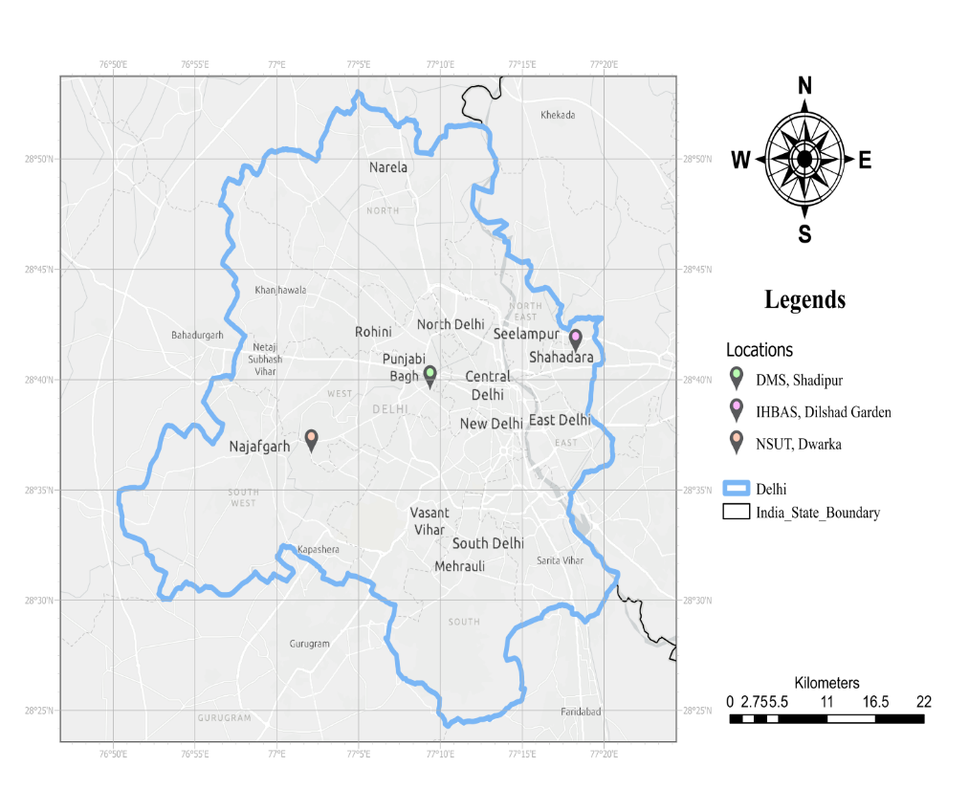
Fig.1 Selected Delhi CAAQMS stations' locations are shown on the map (source: https://www.google.com/maps)

  - Data analysis
Three stations—DMS, IHBAS, and NSIT—have been chosen for our Study. We calibrate these stations on a regular basis to maintain data accuracy. By comparing data to established gas criteria and making necessary adjustments, calibration guarantees that air quality devices measure reliably. It comes in three varieties: Level 1 monthly two-point adjustments, Level 2 routine checks without adjustment, and multipoint checks for linearity. NIST-traceable primary standards, secondary standards verified against primary standards, and zero gas (pollutant-free air) are used in calibration. Among the methods are multipoint linearity checks, zero calibration (zero gas), and span calibration (known concentration gas). Equipment comprises gas cylinders, pressure regulators, and flow controls. Calibration gas concentration is derived by the formula SPAN GAS is equal to (GAS × FGAS) / (Dilution + FGAS). The accuracy of particulate matter analyzers (PM2.5, PM10) is maintained via daily zero and span checks, monthly joint checks, quarterly linearity tests, and periodic two-point calibrations. The span checks are automated, and the zero checks are performed at each cycle [8, 9].
    - PM_{2.5} or Particulate Matter
Particulate matter is defined as a combination of liquid droplets and solid particles. Dark particles include dust, grime, soot, and smoke. Sometimes, only an electron microscope can notice them due to their small size [15]. Particulate. Particles that are long and persistent in the air cause breathing problems and lead to asthma in people. The monitoring of PM_{2.5} is mandatory in all the CAAQMS stations.
Every CAAQMS station that was chosen for this investigation contains a Particulate Matter (PM_{2.5}) analyzer that uses the Beta Ray Attenuation Measurement technique (Make: Environnement S.A., Model: MP101M). The particulate matter analyzer's contains, sampling pump, central unit and sampling inlet hardware are its three major parts. The concentrations are expressed in units of µg/m³. High-energy electrons, sometimes known as beta particles, are continually released by an element 14C. Beta rays strike the particles collected on the filter tape [16]. Powered by a sophisticated microprocessor system, the MP101M is completely automated. At the start of the sampling point, the amount of beta-ray transmission through a particular section of filter tape is measured. A flow of particulate matter is then drawn in by a sample input and collected on this portion of filter paper. Following the sample interval, the beta-ray transmission is measured once more. By comparing the differences between the two readings, the particle content is found with remarkable accuracy. The beta attenuation technique determines mass concentration through a sensitive plastic scintillation counter that detects and counts the emitted beta particles.
2.3.2 NO₂ or Nitrogen dioxide
Nitrogen dioxide is a reddish brown, acidic gas that is a corrosive and oxidizing [17].It releases when coal, oil, or natural gas is burned, as well as during operations like arc welding, electroplating, engraving, and dynamite blasting released into the air. They can also be made in large quantities commercially by mixing nitric acid with cellulose or metals. Nitric acid is created by using nitrogen oxides [13, 18]. Long-term exposure leads to chronic lung diseases in humans.
CAAQMS has Oxides of Nitrogen (NO, NO₂, and NOx) analyzer (Make: Environment S.A, Model:AC32M).The AC32M analyzer works on the detection of gas-phase chemiluminescence to carry out continuous nitric oxide (NO) analysis, total oxides of nitrogen (NOx), nitrogen dioxide (NO₂) and Ammonia (NH3) with an additional NH3 Converter (CNH3-S2). The functioning of the analyzer is dependent on the activation of molecular nitrogen dioxide species formed by the reaction between NO & O₃ in an evacuated reaction cell, which exhibits chemiluminescence [1]. By the reaction process mentioned below, the NO reacts with O₃ to produce the activated NO₂ species: Eq. (1)
$NO+O_{3}=NO_{2}^{*}+O_{2}+hϑ(600-1200nm spectrum$ ………….(1)
When electronically excited NO₂ molecules deplete to lower states, the process creates specific luminescence with intensity proportional to NO concentration (equation 1). Photomultiplier tubes (PMTs), which transform photons into electrical output, are used to detect light emission. This signal is processed and converted to NO, NOx, NO₂, and NH₃ concentrations. The single measurement channel of the AC32M analyzer is controlled by an adaptive microprocessor.
Reference cycle, NO cycle, and NOx cycle are the three cycle steps used in the AC32M Analyzer measurement.
2.3.3 Sulfur dioxide (SO₂)
The primary source of SO₂ in the atmosphere is the combustion of fossil fuels and other industrial operations. Smaller sources of SO2 emissions comprise natural events such as volcanoes, industrial activity such as metal extraction from ore, and massive machinery such as trains and ships that run on sulfur-rich fuel [19].SO₂ can adversely affect your nose, throat, and lungs and cause respiratory disorders such as bronchitis.
Sulfur Dioxide in ambient air is the UV fluorescent spectroscopy method. The analyzer (Model: AF22M, make: Environnement S.A) works on the concept that when SO2 molecules are stimulated by UV rays between 210 and 240 nm, they emit fluorescent radiation. The ensuing fluorescence emission follows a linear relationship with the SO2 concentration (Eq. 2, 3).
$SO_{2}+UV\left(Light\right)=SO_{2}^{*}$……… (2)
$SO_{2}^{*}=SO_{2}+Light(Fluorescence)$……….. (3)
The sample passes through the sample filter, which removes all particulates, then goes through the aromatic kicker before entering the AF22M Analyzer. All interfering HC is removed from the sample. SO2 readings are then obtained by measuring fluorescent radiation using a photomultiplier tube (PMT) and processing the results digitally [20]. To ensure that only the UV fluorescent radiation emitted by the excited SO2 molecules can enter the PMT, a band pass filter is placed in front of the device. The level of 214 nm excitation UV radiation is kept constant. The sample is drawn in the fluorescent chamber and is then irradiated with a pulsed UV energy from a lamp, typical wavelength of 214 nm. The UV energy is obtained from a Zinc UV lamp, followed by a band pass filter allowing only the wavelength that excites the SO2 molecules. The UV energy excites the SO₂ molecules at 210- 214 nm, the excited SO2 molecules decay to a lower energy state (stable state); they emit fluorescent light that is ∝ to the SO₂ concentration at new emission wavelength of 300 – 390 nm (higher energy level).
This fluorescent radiation is then measured by a Photomultiplier tube (PMT) and processed electronically to yield direct SO₂ readings. A band-pass filter is used in front of the PMT to allow only the UV fluorescent radiation emitted by the excited SO₂ molecules to reach the PMT. The excitation of UV radiation (214 nm) is maintained at a constant level. Intensity variations and optical contamination in the reaction chamber are corrected by the microprocessor.
The analyzer receives SO₂-free air from the AC22M's integrated zero air scrubber. Following the analyzer's sampling of air through the converter, the microprocessor automatically resets the zero reading (Background Check). A known concentration of gas used to span the analyzer allows the AC22M analyzer to alter its span ratio in addition to compensating for temperature and pressure.
2.3.4 Troposphere / Surface Ozone (O₃​​)
Tropospheric or Surface ozone is formed by chemical interaction between nitrogen oxides (NOx) and volatile organic compounds (VOCs), instead of being directly emitted into the atmosphere. When sunlight is present, pollutants released from factories, industrial boilers, power plants, refineries, and other sources undergo chemical reactions that lead to Ozone formation in ambient air [21]. Long exposure damages the tissues of the respiratory tract, causing irritation and inflammation, and resulting in symptoms such as coughing, worsening of asthma symptoms, and chest tightness.
To obtain a true ozone reading, the light intensity is first measured with no ozone present. This gives the reference intensity. Then the ozone is introduced, and the light absorption is determined. The difference between the readings represents the ozone concentration.
The formation of ozone in the atmosphere occurs through a complex series of photochemical reactions involving various precursor pollutants, primarily volatile organic compounds (VOCs) and nitrogen oxides (NOx), when exposed to sunlight (UV radiation). One of the key reactions involved in ozone formation is Eq. (4)
$NO_{2}+hϑ\text{(Sunlight)}=NO+[O$] ………(4)
This reaction represents the photodissociation of nitrogen dioxide (NO₂​) by sunlight, producing nitrogen monoxide (NO) and an oxygen atom (O). Nitrogen monoxide (NO) then reacts with oxygen (O₂​) to form nitrogen dioxide (NO₂​) again Eq. (5)
$N{O+O}_{2}=NO_{2}$ ……………(5)
However, during periods of high NOx and VOC concentrations, ozone can be formed through a more complex chain of reactions. For instance, the following sequence of responses represents the formation of ozone from the reaction between a hydrocarbon (RH) and an oxygen atom (O), Eq. (6)
$RH+[O]=RO$….……..(6)
$RO+O_{2}=RO_{2}$….……..(7)
$RO_{2}+NO=NO_{2}+RO$………..(8)
$NO_{2}+hϑ\text{(Sunlight)}=NO+[O]$.…..(9)
$[O]+O_{2}=O_{3}$……......(10)
This sequence of reactions demonstrates the role of hydrocarbons (RH) in initiating the ozone formation process, which involves the formation of peroxy radicals (RO2) and the subsequent reaction with nitrogen monoxide (NO) leading to the regeneration of NO₂​. Finally, ozone (O₃​​) is formed through the reaction of oxygen atoms (O) with molecular oxygen (O₂​) [22].
The CAAQMS contains an ozone analyzer ((Make: Environnement S.A, Model: O342M) that measures how much ultraviolet light is absorbed by ozone in order to calculate ozone concentrations. The ultraviolet light source is a mercury lamp. A photodiode that exclusively responds to ultraviolet radiation may detect ultraviolet light. The photodiode subsequently transforms ultraviolet light into an electrical signal that is proportionate to the amount of ultraviolet light detected.
2.4 GAINS scenario context (ECLIPSE v6b)
To contextualize station observations, we retrieved annual GAINS–ECLIPSE v6b emission trajectories for NOx, NMVOC and primary PM₂.₅ under Current Legislation (CLE) and Maximum Feasible Reduction (MFR) scenarios for the Delhi region (Single region → India Delhi) using the GAINS online interface (Emissions → Summary results). Figures were exported (PNG/SVG) and, where needed, CSV tables were downloaded to reproduce plots. GAINS outputs represent annual emissions at a regional scale and are used here to interpret March–June 2017–2023 concentrations measured at IHBAS, DMS (Shadipur) and NSUT (Dwarka) CAAQMS stations [34, 36].

3. Results and Discussion
3.1 Comparative study of Pre-COVID-19, COVID-19 and Post-COVID-19
Data collected from three Continuous Ambient Air Quality Monitoring Stations of the Central Pollution Control Board installed at IHBAS-Dilshad Garden, DMS-Shadipur, and NSUT-Dwarka for particulate matter (PM_{2.5}) and trace gases such as Nitrogen Dioxide (NO₂), Sulfur Dioxide (SO₂), and Ozone (O₃) ( https://airquality.cpcb.gov.in/ccr/#/caaqm-dashboard-all/caaqm-landing/caaqm-data-repository ). Data from pre-COVID-19 (2017 - 2019), the COVID-19 (2020) Pandemic, and post-COVID-19 (2021 - 2023) were studied. It was observed that the concentrations of pollutants in the lockdown were significantly reduced as compared to the pre-COVID-19 (2017 - 2019) and post-COVID-19 (2021 - 2023), except for Ozone.
The results, as presented in Tables 1-3 and Figures 2-4, demonstrated significant reductions in the concentrations of Nitrogen Dioxide (NO₂), Particulate Matter (PM_{2.5}), and Sulfur Dioxide (SO₂) from March to June 2020 compared to the same period in 2019 over Delhi. Specifically, the concentration levels of NO₂, PM_{2.5}, and SO₂were found to have decreased by approximately 60.2%, 87%, and 27.7% over IHBAS, 72.4%, 80.8%, and 38.7% over DMS, and 48%, 55.2%, and 47.6% over NSUT, respectively. However, following the lockdown period from 2021 to 2023, the data indicated an increase in pollutant concentrations. Specifically, NO₂, PM_{2.5}, and SO₂ levels increased by approximately 67.2%, 81%, and 20.7% over IHBAS, 57.4%, 81.8%, and 39.7% over DMS, and 50%, 51.2%, and 37.6% over NSUT, respectively.
During the 2020 lockdown in Delhi, pollution levels decreased significantly due to reduced vehicular traffic, industrial shutdowns, decreased construction activities, and closures of commercial establishments. Favorable weather conditions and strict enforcement of pollution regulations further contributed to the improvement. Despite these improvements, ozone levels showed an increase during the lockdown. This can be attributed to a combination of reduced NOx emissions, changes in atmospheric mixing, weather conditions, and chemical reactions. While NOx emissions decreased significantly, other factors such as atmospheric stagnation and the presence of volatile organic compounds (VOCs) might have contributed to the rise in ozone levels during this period. The pollution levels increased after the lockdown due to the resumption of the aforementioned activities.
Table.1: NO₂ (µg/m³) over IHBAS, DMS, and NSUT Delhi CAAQMS Stations during the study period
Station | Period | Average NO₂ concentration (µg/m³) |  |  | Percentage change
Station | Period | 2017-2019  . | 2020 | 2021-2023 | LD | Post-LD
IHBAS | 01 March to 20 March | 51.2 ± 11.10 | 37.4±12.14 | 45.88± 32.67 | -26.95 | 22.67
IHBAS | 24 March to 14 April | 49.58± 4.03 | 17.87±4.4 | 55.88± 39.77 | -63.96 | 212.70
IHBAS | 15 April to 3 May | 50.83± 10.88 | 17.83±5.6 | 40.13± 35.59 | -64.92 | 125.07
IHBAS | 04 May to 17 May | 50.21± 3.89 | 30.1±9.3 | 26.69± 20.77 | -40.05 | -11.33
IHBAS | 18 May to 5 June | 43.71± 7.44 | 42.81±12.8 | 37.44± 32.20 | -2.06 | -12.54
DMS | 01 March to 20 March | 36.91±19.28 | 49.17±17.37 | 69.47±9.41 | 33.22 | 41.29
DMS | 24 March to 14 April | 45.46±25.61 | 17.98±12.36 | 57.8±1.54 | -60.45 | 221.47
DMS | 15 April to 3 May | 41.31±29.09 | 18.56±6.6 | 53.44±15.44 | -55.07 | 187.93
DMS | 04 May to 17 May | 43.76±32 | 20.98±9.2 | 37.25±15.04 | -52.06 | 77.55
DMS | 18 May to 5 June | 42.09±24.83 | 33.31±12.27 | 29.11±11.20 | -20.86 | 12.61
NSUT | 01 March to 20 March | 27.85±6.73 | 28.55±5.8 | 34.08±12.10 | 2.51 | 19.37
NSUT | 24 March to 14 April | 31.14±1.68 | 15.38±1.8 | 41.81±7.81 | -50.61 | 171.48
NSUT | 15 April to 3 May | 32±6.91 | 15.29±2.4 | 36.31±6.99 | -52.22 | 137.48
NSUT | 04 May to 17 May | 24.94±7.57 | 18.59±4.2 | 33.94±11.71 | -25.46 | 82.57
NSUT | 18 May to 5 June | 25.76±10.29 | 22.45±6.08 | 26.04±5.18 | -8.97 | 11.04
** LD = Lockdown 2020** Post-LD = Post Lockdown 2021-2023

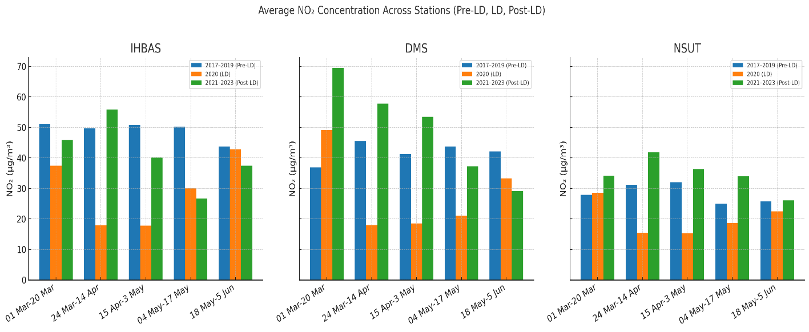
c
b
a
Fig.2: Percentage change in NO2 concentration over (a) IHBAS, (b) DMS and (c)NSUT CAAQMS station over Delhi during Normal Day (01 March to 20 March) and Lockdown Period 2020 (Lockdown Phase-I (24 March – 14 April 2020), Lockdown Phase-II (15 April – 3 May 2020), Lockdown Phase-III (04 May – 17 May 2020) and Lockdown Phase-IV (18 May – 05 June 2020) in comparison with Pre-lockdown year 2017-2019 and Post- Lockdown year 2021-2023. (Please refer table 1).
Table 2.SO₂ (µg/m³) over IHBAS, DMS, and NSUT Delhi Stations during the study period
Station | Period | Average SO₂ concentration (µg/m³) |  |  | Percentage change
Station | Period | 2017-2019  . | 2020 | 2021-2023 | LD | Post-LD
IHBAS | 01 March to 20 March | 13.95±1.5 | 13.42±4.1 | 13.52±2.6 | -3.80 | 0.75
IHBAS | 24 March to 14 April | 15.47±1.3 | 11.82±3 | 17.91±6.1 | -23.59 | 51.52
IHBAS | 15 April to 3 May | 16.53±0.7 | 12.53±2.9 | 15.73±4.2 | -24.20 | 25.54
IHBAS | 04 May to 17 May | 21.59±1.7 | 5.13±2.6 | 14.59±1.9 | -76.24 | 184.41
IHBAS | 18 May to 5 June | 14.41±2.1 | 9.36±2.5 | 10.82±2.2 | -35.05 | 15.60
DMS | 01 March to 20 March | 13.67±1.3 | 6.9±1.9 | 14.85±3.3 | -49.52 | 115.22
DMS | 24 March to 14 April | 13.81±3.6 | 7.62±3.8 | 15.07±0.6 | -44.82 | 97.77
DMS | 15 April to 3 May | 14.82±3.1 | 5.74±1.7 | 11.47±1.6 | -61.27 | 99.83
DMS | 04 May to 17 May | 14.42±6.2 | 5.49±1.3 | 10.87±1.1 | -61.93 | 98
DMS | 18 May to 5 June | 12.39±1.6 | 7.89±1.4 | 9.82±3.2 | -36.32 | 24.46
NSUT | 01 March to 20 March | 13.25v±1.7 | 18.13±11.6 | 9.78±1.7 | 36.83 | -46.06
NSUT | 24 March to 14 April | 9.81±0.5 | 4.93±2.0 | 14.62±5 | -49.75 | 196.55
NSUT | 15 April to 3 May | 9.13±3.2 | 4.14±1.9 | 12.82±4.9 | -54.65 | 209.66
NSUT | 04 May to 17 May | 8.06±2.1 | 6.3±4.2 | 10.34±2.0 | -21.84 | 64.13
NSUT | 18 May to 5 June | 9.05±1.6 | 6.69±3.6 | 8±1.8 | -26.08 | 19.58
** LD = Lockdown 2020** Post-LD = Post Lockdown 2021-2023

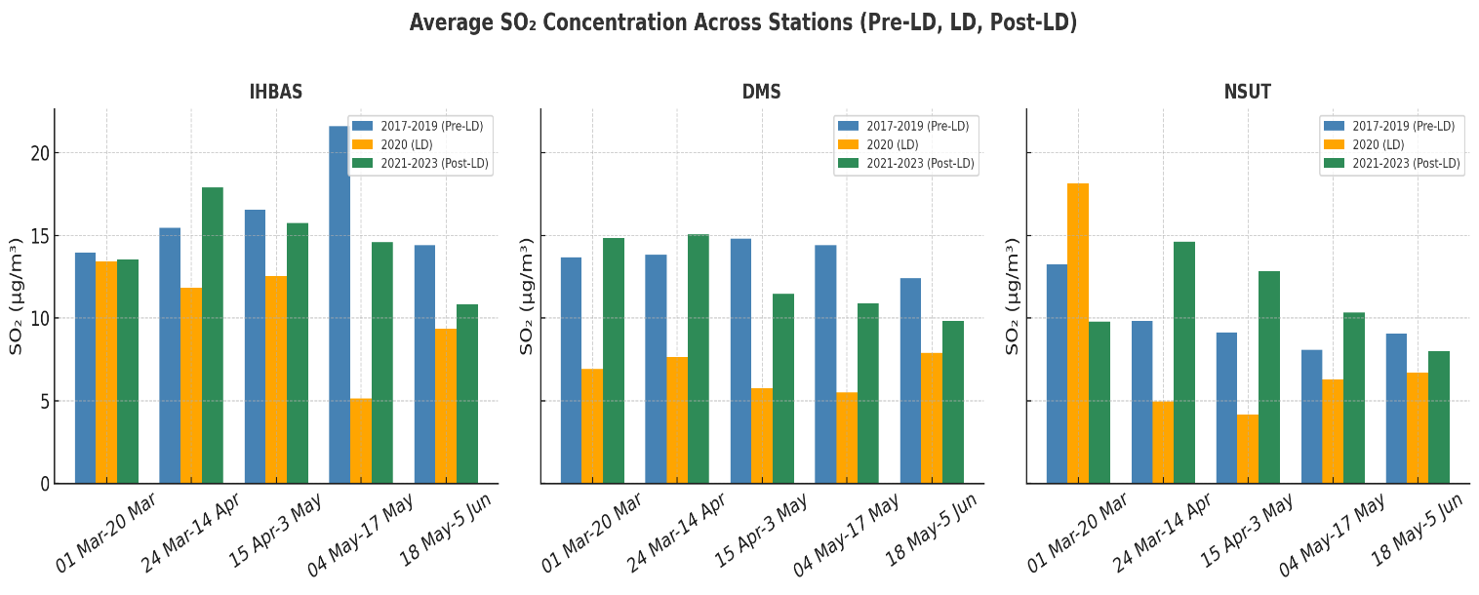
c
b
a
Fig.3. Percentage change in SO2 concentration over (a) IHBAS, (b) DMS and (c) NSUT CAAQMS station over Delhi during Normal Day (01 March to 20March) and Lockdown Period 2020 (Lockdown Phase-I (24 March – 14 April 2020), Lockdown Phase-II (15 April – 3 May 2020), Lockdown Phase-III (04 May – 17 May 2020) and Lockdown Phase-IV (18 May – 05 June 2020) in comparison with Pre-lockdown year 2017-2019 and Post- Lockdown year 2021-2023. (Please refer table 2)

Table3. PM_{2.5} (µg/m³) over IHBAS, DMS and NSUT Delhi Stations during the study period

Station | Period | Average PM_{2.5} concentration (µg/m³) |  |  | Percentage change
Station | Period | 2017-2019 | 2020 | 2021-2023 | LD | Post-LD
IHBAS | 01 March to 20 March | 83.75±11.3 | 72.1±25.8 | 85.86±19.1 | -13.91 | 19.08
IHBAS | 24 March to 14 April | 96.07±16.4 | 14.18±8.1 | 73.72±18.8 | -85.24 | 419.89
IHBAS | 15 April to 3 May | 109.01±5.8 | 18.98±13.1 | 82.7±19.2 | -82.59 | 335.72
IHBAS | 04 May to 17 May | 119.59±25.1 | 55.22±15.4 | 64.02±20.5 | -53.83 | 15.94
IHBAS | 18 May to 5 June | 94.28±6.3 | 59.9±23.7 | 56.59±23.7 | -36.47 | -5.53
DMS | 01 March to 20 March | 109.1±9.5 | 48.35±16.7 | 98.24±32.1 | -55.68 | 103.19
DMS | 24 March to 14 April | 108.9±19.5 | 22.69±9.4 | 97.72±19.9 | -79.17 | 330.67
DMS | 15 April to 3 May | 110.87±20.1 | 22.43±8.3 | 77.37±12.1 | -79.77 | 244.94
DMS | 04 May to 17 May | 141.65±50.5 | 35.1±13.1 | 80.31±33.1 | -75.22 | 128.80
DMS | 18 May to 5 June | 96.6±8.1 | 42.56±14.4 | 62.25±23 | -55.94 | 46.26
NSUT | 01 March to 20 March | 96.39±4.7 | 73.01±21.3 | 117.85±15.3 | -24.26 | 61.42
NSUT | 24 March to 14 April | 119.03±27.2 | 48.43±7.4 | 130.74±19.8 | -59.31 | 169.96
NSUT | 15 April to 3 May | 110.48±9 | 52.38±9.4 | 105.15±14.2 | -52.59 | 100.74
NSUT | 04 May to 17 May | 119.45±35.2 | 68.25±18.9 | 113.29±42.7 | -42.86 | 65.99
NSUT | 18 May to 5 June | 103.76±12 | 72.61±23.4 | 89.71±32 | -30.02 | 23.55
** LD = Lockdown 2020** Post-LD = Post Lockdown 2021-2023

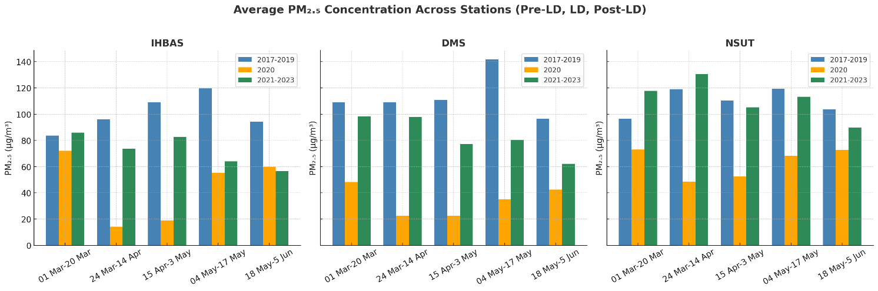
c
b
a
Fig.4. Percentage change in PM2.5 concentrations over(a) IHBAS, (b) DMS and (c) NSUT CAAQMS station over Delhi during Normal Day (01 March to 20March) and Lockdown Period 2020 (Lockdown Phase-I (24 March – 14 April 2020), Lockdown Phase-II (15 April – 3 May 2020), Lockdown Phase-III (04 May – 17 May 2020) and Lockdown Phase-IV (18 May – 05 June 2020) in comparison with Pre-lockdown year 2017-2019 and Post- Lockdown year 2021-2023(Please refer table 3)

3.2Elevated Ozone (O₃) level during lockdown and its relationship with Solar Radiation
During the lockdown, the concentration level of Ozone increased by around 48% over DMS and 62% over NSUT-Dwarka, compared to pre and post-lockdown as shown in Table 4 and Figure 5. Ozone formation occurs when NOx and volatile gases (Benzene, Toluene, Ethyl Benzene, Xylene, MP-Xylene) combine under the influence of sunlight and elevated temperature levels, leading to an increase in ozone concentration in Delhi (refer eq.4-10). However, the cyclical chemistry of ozone suggests that it is eliminated from the atmosphere upon interaction with NOx. Ozone does not persist, even though it can form in areas with high NOx concentrations while other gases are present. During lockdowns, when other pollutants were decreased in Delhi, ozone had a longer residence time and increased in concentration.
The level of NO₂ serves as an excellent indicator of NOx. Solar radiation plays a significant role in the formation of ambient ozone during the COVID-19 pandemic; solar radiation contributes to increasing temperatures, particularly on sunny days. Higher temperatures can enhance the rate of photochemical reactions responsible for ozone formation (Fig. 7). Despite reduced human activities during the COVID-19 lockdowns, the influence of solar radiation remained, potentially leading to higher ozone levels in areas with sufficient precursor pollutants, as depicted in Table 5 and Figure 6.
During the COVID-19 lockdown period from March to June 2020, the Air Quality Index (AQI) in Delhi exhibited fluctuations influenced by various factors such as reduced vehicular traffic, industrial activities, and construction work due to the lockdown measures imposed to curb the spread of the virus.
Overall, there was a noticeable improvement in air quality during this period compared to previous years. The AQI readings in Delhi during March to June 2020 ranged from "satisfactory" to "good" for much of the time, indicating relatively lower levels of pollution compared to the same period in previous years (Fig- 8-9). However, there were occasional spikes in pollution levels due to factors such as meteorological conditions, agricultural residue burning, and localized emissions [24].

Table4. Ozone (µg/m3) over DMS and NSUT Delhi Stations during the study period
Station | Period | Average Ozone concentration (µg/m3) |  |  | Percentage change
Station | Period | 2017-2019 | 2020 | 2021-2023 | LD | Post-LD
DMS | 01 March to 20 March | 32.18±3.94 | 50.8±16.81 | 23.8±3.93 | 57.86 | -53.15
DMS | 24 March to 14 April | 37.08±3.24 | 60.05±18.43 | 36.96±9.87 | 61.95 | -38.45
DMS | 15 April to 3 May | 35.64±5.27 | 59.22±14.54 | 36.35±11.67 | 66.16 | -38.62
DMS | 04 May to 17 May | 36.62±3.45 | 46.15±12.15 | 50.34±2.62 | 26.02 | 9.08
DMS | 18 May to 5 June | 35.78±7.69 | 47.33±8.83 | 47.43±10.15 | 32.28 | 0.21
NSUT | 01 March to 20 March | 30.6±4.49 | 37.88±10.69 | 27.91±9.04 | 23.79 | -26.32
NSUT | 24 March to 14 April | 40.84±4.66 | 49.67±13.48 | 30.85±5.47 | 21.62 | -37.89
NSUT | 15 April to 3 May | 37.53±1.87 | 65.65±12.40 | 40.22±8.95 | 74.93 | -38.74
NSUT | 04 May to 17 May | 35.89±12.02 | 86.79±20.28 | 47.05±8.46 | 141.82 | -45.79
NSUT | 18 May to 5 June | 39.92±9.57 | 60.59±10.62 | 39.97±8.15 | 51.78 | -34.03
** LD = Lockdown 2020** Post-LD = Post Lockdown 2021-2023

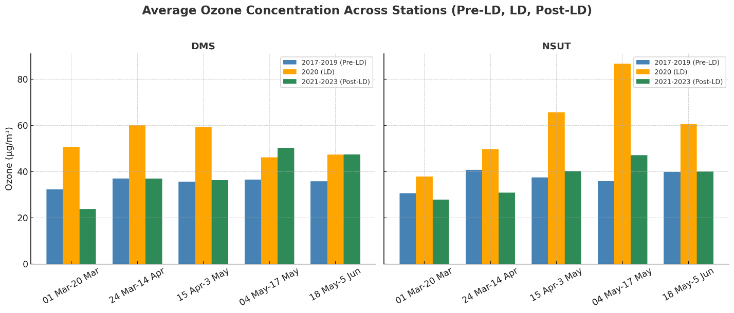
b
a
Fig.5. Percentage change in Ozone concentration over (a) DMS and (b) NSUT CAAQMS station over Delhi during Normal Day (01 March to 20 March) and Lockdown Period 2020 (Lockdown Phase-I (24 March – 14 April 2020), Lockdown Phase-II (15 April – 3 May 2020), Lockdown Phase-III (04 May – 17 May 2020) and Lockdown Phase-IV (18 May – 05 June 2020) in comparison with Pre-lockdown year 2017-2019 and Post- Lockdown year 2021-2023. (Please refer to table 4)

Table 5 Lockdown air quality average data over IHBAS DMS and NSUT Delhi Stations during 1stMarch to 30thJune 2020
Month |  | Ozone µg/m3 | PM_{2.5} µg/m3 | SO₂ µg/m3 | NO₂ µg/m3 | VOC µg/m3 | Temp °C | SR W/m2 | RH %
March | DMS | 51.34 | 43.34 | 6.76 | 37.77 | 23.59 | 21.2 | 183.59 | 64.96
March | NSIT | 38.94 | 65.63 | 13.49 | 24.53 | 13.6 | 21.24 | 113.58 | 64.24
March | IHBAS | ** | 57.67 | 12.5 | 31.34 | ** | 20.49 | 124.82 | 61.16
April | DMS | 64.79 | 19.91 | 7.43 | 18.97 | 5.04 | 27.15 | 196.81 | 40.09
April | NSIT | 60.99 | 52.01 | 4.58 | 15.72 | 3.67 | 28.04 | 158.36 | 40.94
April | IHBAS | ** | 13.95 | 13.06 | 17.63 | ** | 27.61 | 142.55 | 38.89
May | DMS | 41.28 | 37.87 | 6.4 | 25.45 | 7.91 | 31.42 | 146.1 | 34.39
May | NSIT | 73.22 | 70.37 | 6.58 | 20.54 | 8.96 | 32.01 | 210.98 | 39.32
May | IHBAS | ** | 56.25 | 7.87 | 37.14 | ** | 32.39 | 136.13 | 40.17
June | DMS | 30.47 | 35.76 | 7.01 | 23.47 | 7.98 | 35.05 | 161.53 | 58.42
June | NSIT | 42.92 | 65.63 | 4.19 | 19.29 | 3.15 | 33.66 | 155.47 | 30.1
June | IHBAS |  | 57.35 | 6.98 | 25.14 | ** | 34.31 | 126.93 | 54.61
Note | ** Data was not monitored at station

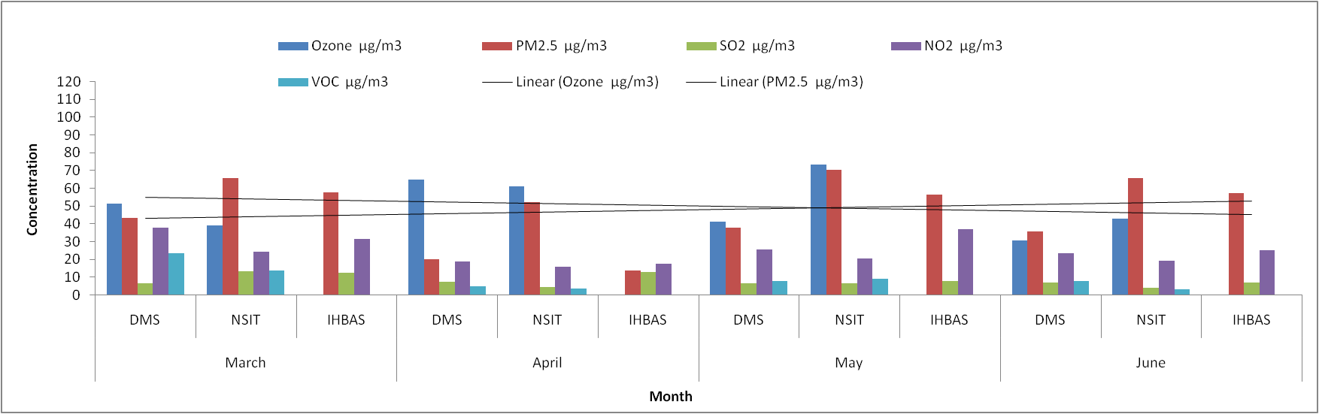Fig.6. Average concentration of air pollutants over IHBAS, DMS and NSUT Delhi during lockdown from March to June 2020.

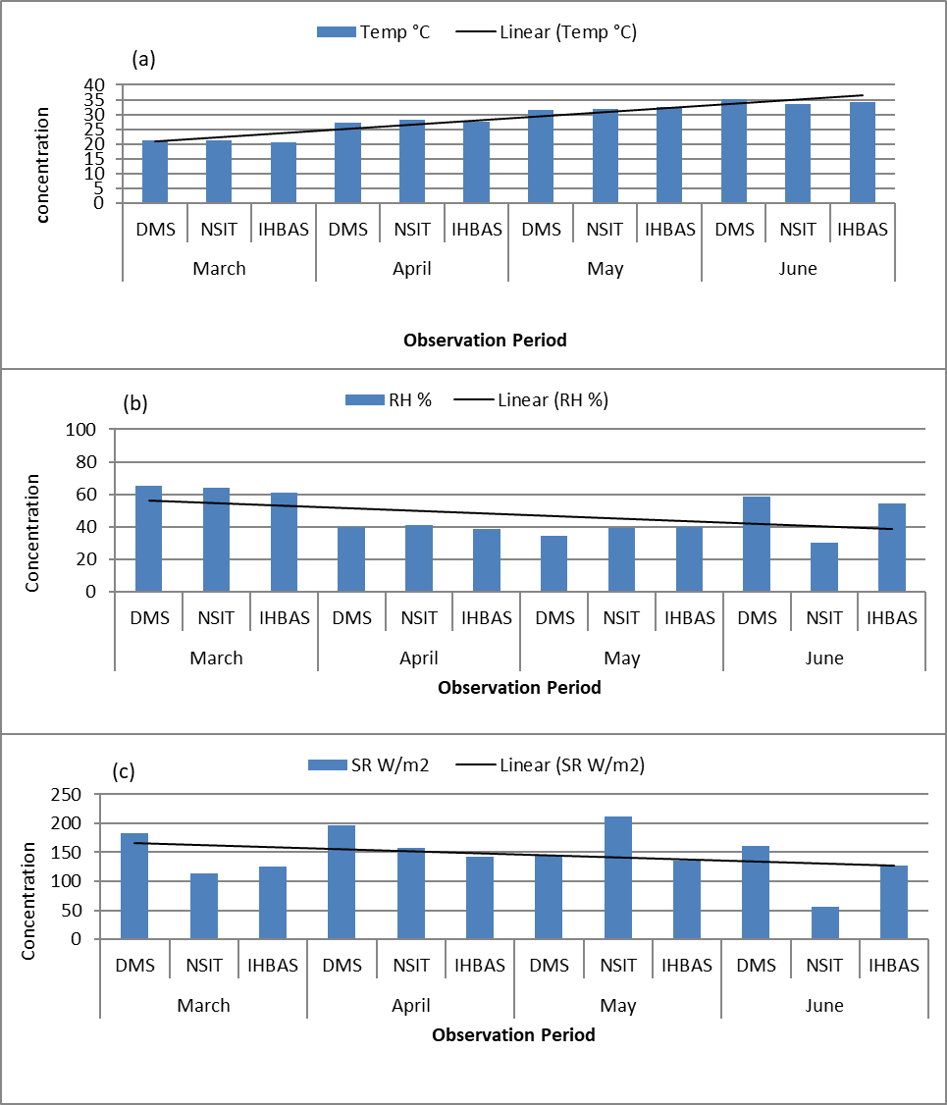 Fig.7. Average concentration of meteorological parameters (a) Temperature, (b) Relative Humidity (RH) and (c) Solar Radiation (SR) over Delhi IHBAS, DMS and NSUT during lockdown from March to June 2020.

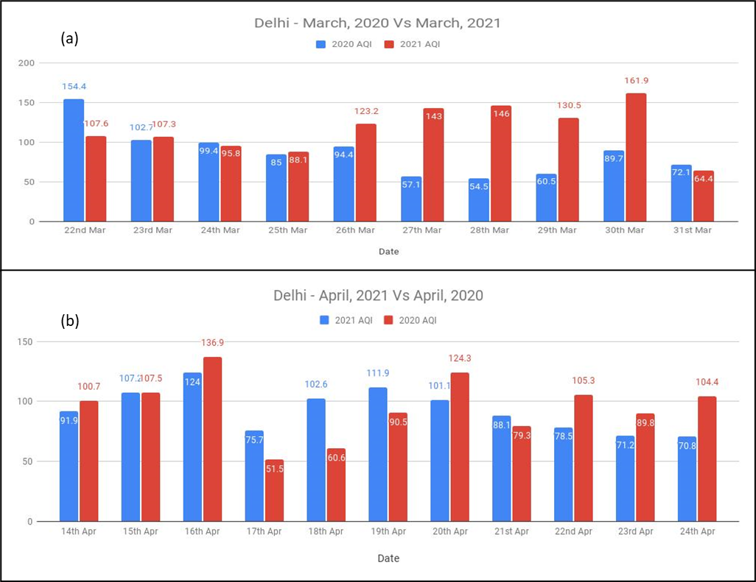 Fig.8.The AQI readings in Delhi during (a) March 2020 Vs March 2021 and (b) April 2020 Vs April 2021 (Data Source: https://www.aqi.in/weather/)

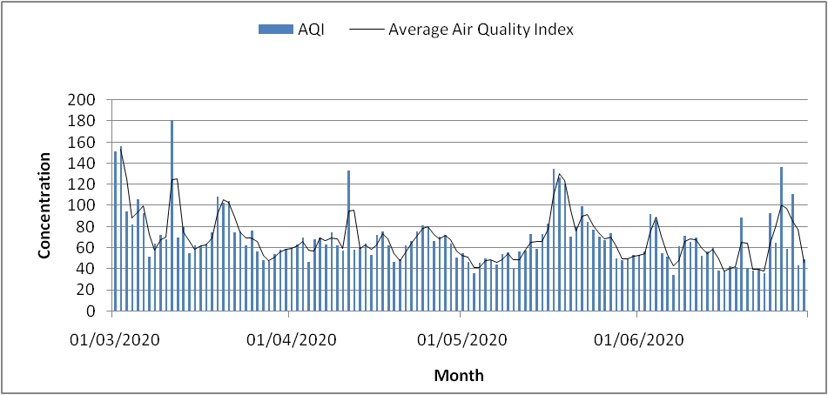 Fig.9.The AQI readings in Delhi during March to June 2020 ranged from "satisfactory" to "good".
AQI and Associated Health Impacts: Good (0–50) or no adverse effects, Satisfactory (51–100) – may cause mild respiratory discomfort in sensitive individuals
3.3 Inverse relationship of Ozone and Particulate Matter during lockdown
During the lockdown, an inverse relationship between particulate matter and ozone is observed due to the significant decrease in particulate matter. This reduction promotes ozone formation in the atmosphere during COVID-19. Dust particles can act as catalysts for certain chemical reactions that hinder ozone formation. For instance, they can catalyze reactions converting ozone (O₃) back to oxygen (O₂), thus lowering ozone concentrations overall. Moreover, elevated levels of PM_{2.5}can generate more aerosols, impacting sunlight distribution and atmospheric temperature, consequently influencing ozone formation and degradation rates, which are temperature and sunlight-sensitive processes. PM_{2.5} particles can also directly interact with ozone molecules through chemical reactions, leading to ozone depletion [23].
During lockdown, the rise in ozone levels is attributed to increased solar radiation exceeding 200 W/m2, while PM_{2.5} decreases owing to reduced vehicular emissions, industrial activities, and construction work. The substantial reduction in particulate matter during lockdown provides clear surfaces and allows for higher solar radiation penetration, facilitating ozone formation. This phenomenon underscores an important aspect of atmospheric chemistry where reduced particulate matter levels can promote photochemical reactions leading to ozone formation (Fig- 10, 11).
The observed data from 2017 to 2023 demonstrates an inverse correlation between ozone and PM_{2.5} (correlation coefficient of -0.4), indicating that as PM_{2.5} levels decrease, ozone levels tend to increase. This negative correlation suggests that reductions in particulate matter can lead to enhanced ozone concentrations. Conversely, ozone exhibits a positive correlation with solar radiation (correlation coefficient of 0.5), indicating that higher solar radiation levels are associated with increased ozone concentrations. This positive correlation underscores the role of solar radiation in driving photochemical reactions responsible for ozone formation in the atmosphere [24].
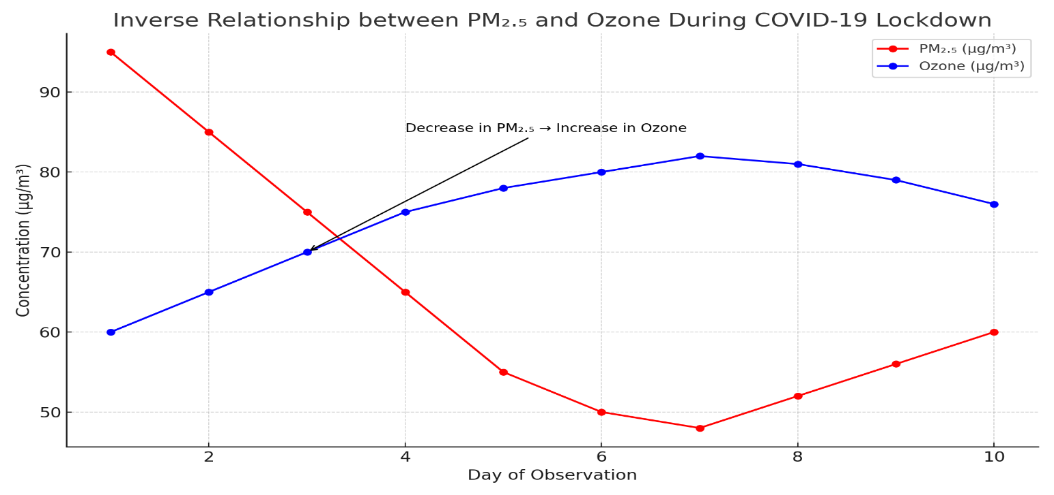
Fig.10. Ozone concentrations in the COVID-19 lockdown period had an inverse link with PM₂.₅ the graph indicates that ozone concentrations rose as PM₂.₅ levels decreased because of fewer anthropogenic activities. This is probably because of higher solar radiation (>200 W/m2) and decreased aerosol interference, which encourage photochemical ozone generation.
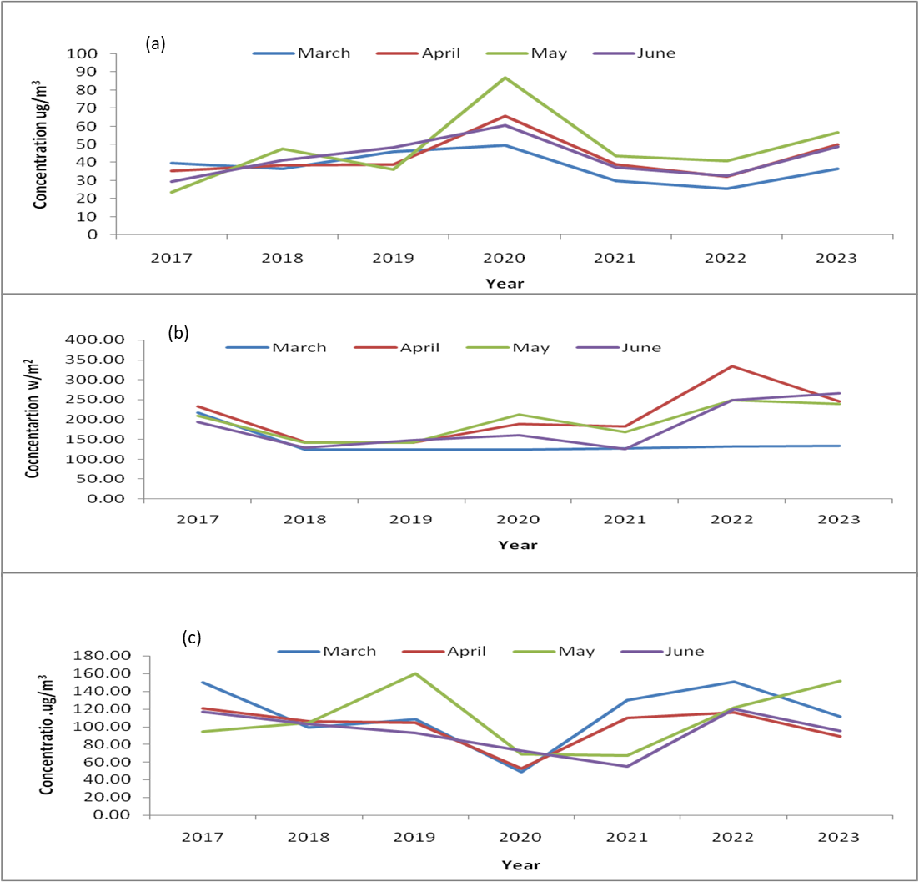 Fig.11.NSUT average concentration of (a) Ozone (b) Solar radiation and (c) PM_{2.5} from 2017 to 2023 revealed a notable peak during the lockdown period in 2020.When solar radiation is high, ozone increases. However, when solar radiation and dust both increase, ozone decreases.

3.4 Pollution Exposure and Health Risks
A number of studies have found a clear correlation between exposure to ambient air pollution and unfavorable health impacts, particularly in urban megacities like Delhi [25, 26]. The current study found that during the Pre-lockdown phase, PM₂.₅ and NO₂ concentrations often surpassed national ambient requirements, with periodic surges during winter and festive events, raising the risk of chronic exposure. Elevated PM₂.₅ levels can penetrate deeply into the alveolar regions of the lungs, causing endothelial dysfunction, systemic inflammation, and increased cardiopulmonary morbidity and mortality [27, 28]. Although lockdown restrictions in 2020 led to drastic reductions in anthropogenic emissions, with observed declines of up to 87% in PM₂.₅ and 72% in NO₂, an unintended consequence was the photochemical build-up of ground-level ozone (O₃). Ozone concentrations rose at all three locations throughout the lockdown period, consistent with NOx-limited regimes [29].
To quantify potential public health benefits, we applied WHO/ICMR exposure–response functions linking pollutant reductions to mortality risk. During March–June 2020, average PM₂.₅ levels decreased by 60–80% compared to pre-lockdown (2017–2019). Based on Delhi’s population (~19 million) and baseline mortality rates, this reduction is estimated to have avoided 900–1,100 premature deaths attributable to PM₂.₅ exposure. Similarly, NO₂ declines of ~60% correspond to ~300 avoided respiratory hospitalizations and premature deaths [30, 31]. Together, these estimates suggest that the lockdown provided short-term health co-benefits of 1,200–1,500 avoided premature deaths in Delhi. However, pollutant rebound in 2021–2023 diminished these gains, highlighting that temporary restrictions cannot substitute for long-term interventions.
Long-term exposure to these pollutants has been linked to chronic respiratory diseases, myocardial infarction, and neurological disorders including cognitive decline [32]. Acute ozone exposure is also associated with reduced lung function (FEV1, FVC), asthma exacerbations, and hospitalizations [27]. These findings highlight the significance of ongoing monitoring and show that short reductions in emissions, such as those achieved during the lockdown, are insufficient to yield long-term public health advantages unless accompanied by structural emission control techniques. The study underlines the importance of integrating health risk assessment into air quality management programs, particularly in densely populated areas with high baseline exposure.
3.5 Long-Term Trends and Meteorological Normalization (2017–2023)
To assess whether improvements during the lockdown were structural or temporary, we examined pollutant trends across 2017–2023. Linear regression analysis showed a declining slope for SO₂ (−0.8 µg/m³ yr⁻¹), modest reduction in NO₂ (−1.1 µg/m³ yr⁻¹), but no significant decline in PM₂.₅, which remained persistently above national standards. Ozone, by contrast, exhibited a positive trend (+1.3 µg/m³ yr⁻¹), consistent with enhanced photochemistry and NOₓ-limited regimes in Delhi.
A generalized additive model (GAM) with meteorological predictors (temperature, relative humidity, solar radiation, wind speed) revealed that meteorology explained ~35–40% of variance in daily O₃, while PM₂.₅ and NO₂ explained an additional ~25%. The model confirmed that high solar radiation (>200 W/m²) and low NO₂ conditions favored ozone accumulation, especially during lockdown when titration was suppressed [32].
These findings indicate that the lockdown induced improvements were largely emission driven and transient, with pollutant concentrations rebounding as activities resumed. Without structural emission controls, the long-term trajectory of Delhi air quality remains concerning.
3.6 GAINS scenario context for Delhi (ECLIPSE v6b)
The lockdown provided a short-lived emission shock (March–June 2020), lowering NO₂ and PM₂.₅ substantially, followed by a rebound in 2021–2023 and persistently elevated O₃ at all three stations. To place these observations in a broader policy context, GAINS/ECLIPSE V6b trajectories for Delhi were examined (Figures 12–14). Under the Current Legislation (CLE) pathway (A), annual NOₓ and NMVOC emissions remain sufficiently high to sustain ozone formation potential well into the future. In contrast, the Maximum Feasible Reduction (MFR) pathway (B) achieves large precursor cuts, with NOₓ declining by nearly two-thirds, NMVOCs by more than half, and primary PM₂.₅ by over 70% compared to CLE by 2050 [33].
These projections clearly show that while the COVID-19 lockdown provided a temporary demonstration of how drastic emission reductions can improve air quality, such benefits cannot be sustained under CLE. Instead, only ambitious policies resembling the MFR trajectory can deliver long-term improvements in Delhi’s air quality and reduce ozone and PM₂.₅ production potential.
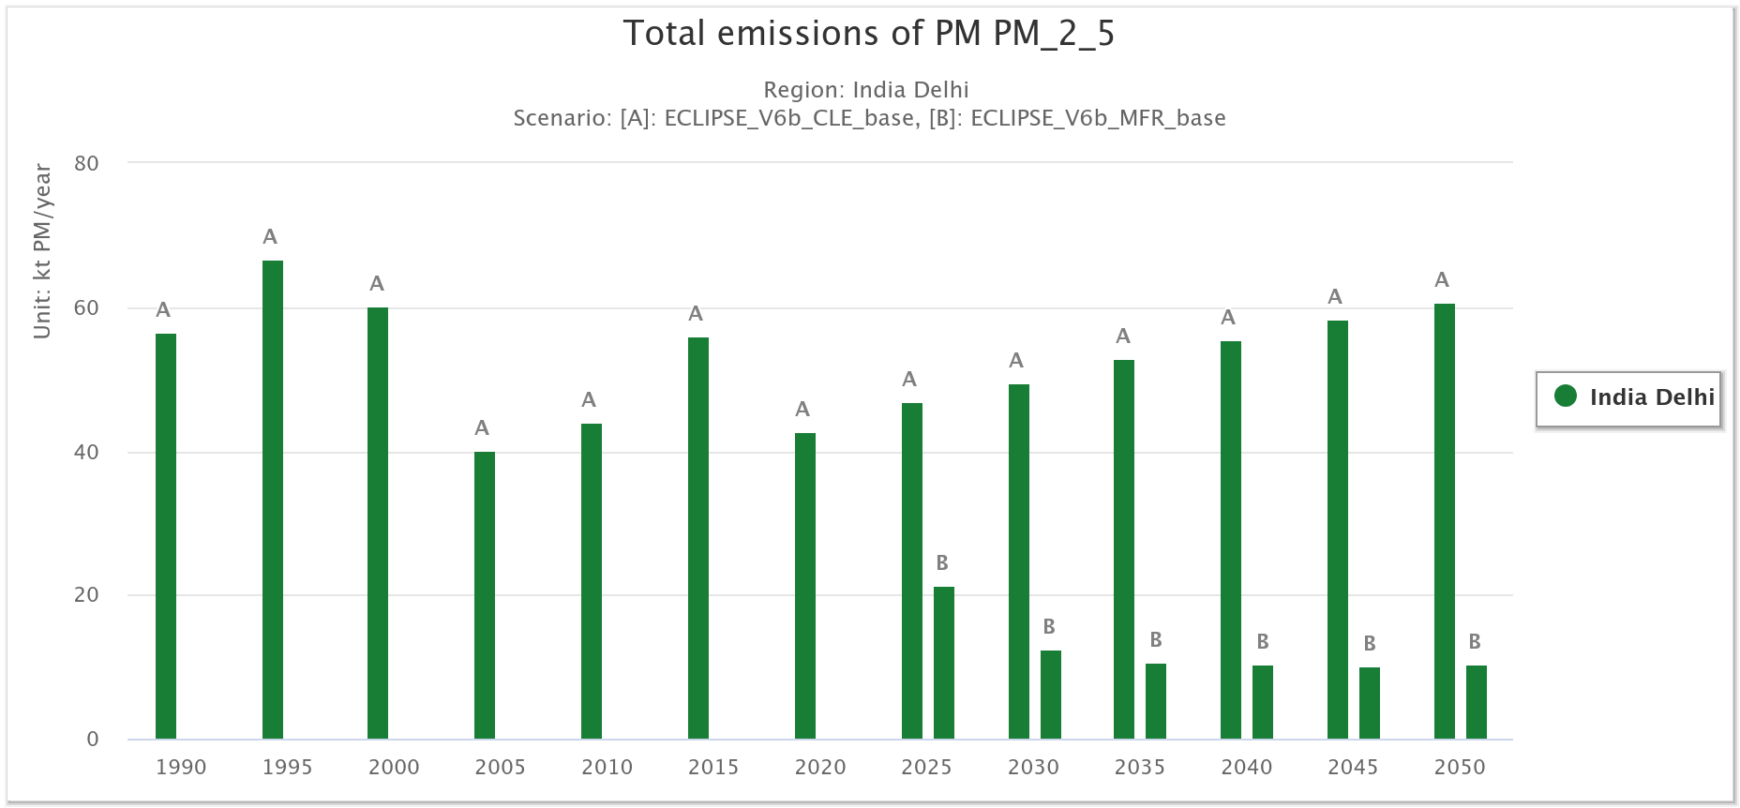
Fig. 12. GAINS (ECLIPSE v6b) total NOx emissions in Delhi under Current Legislation (CLE) [A] and Maximum Feasible Reduction (MFR) [B], 1990–2050 (kt NOx yr⁻¹). Source: GAINS Online.

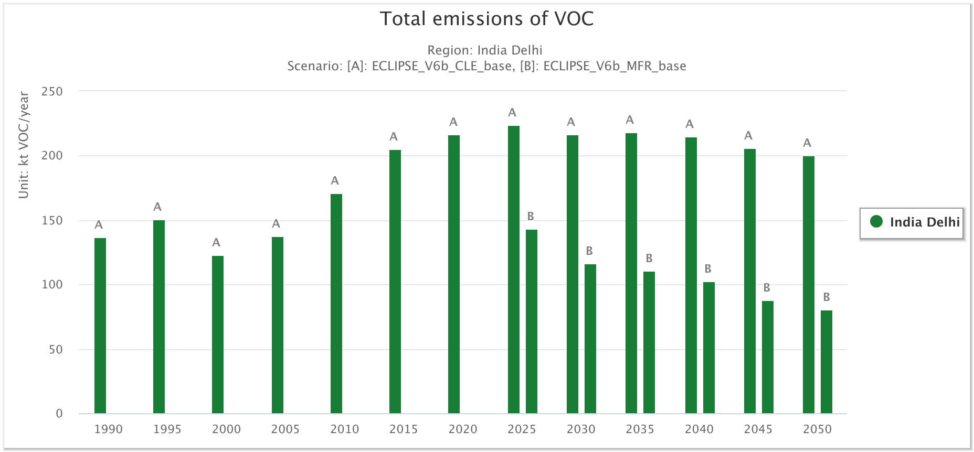
Fig. 13. GAINS (ECLIPSE v6b) total NMVOC (VOC) emissions in Delhi under CLE [A] and MFR [B], 1990–2050 (kt VOC yr⁻¹). Source: GAINS Online.

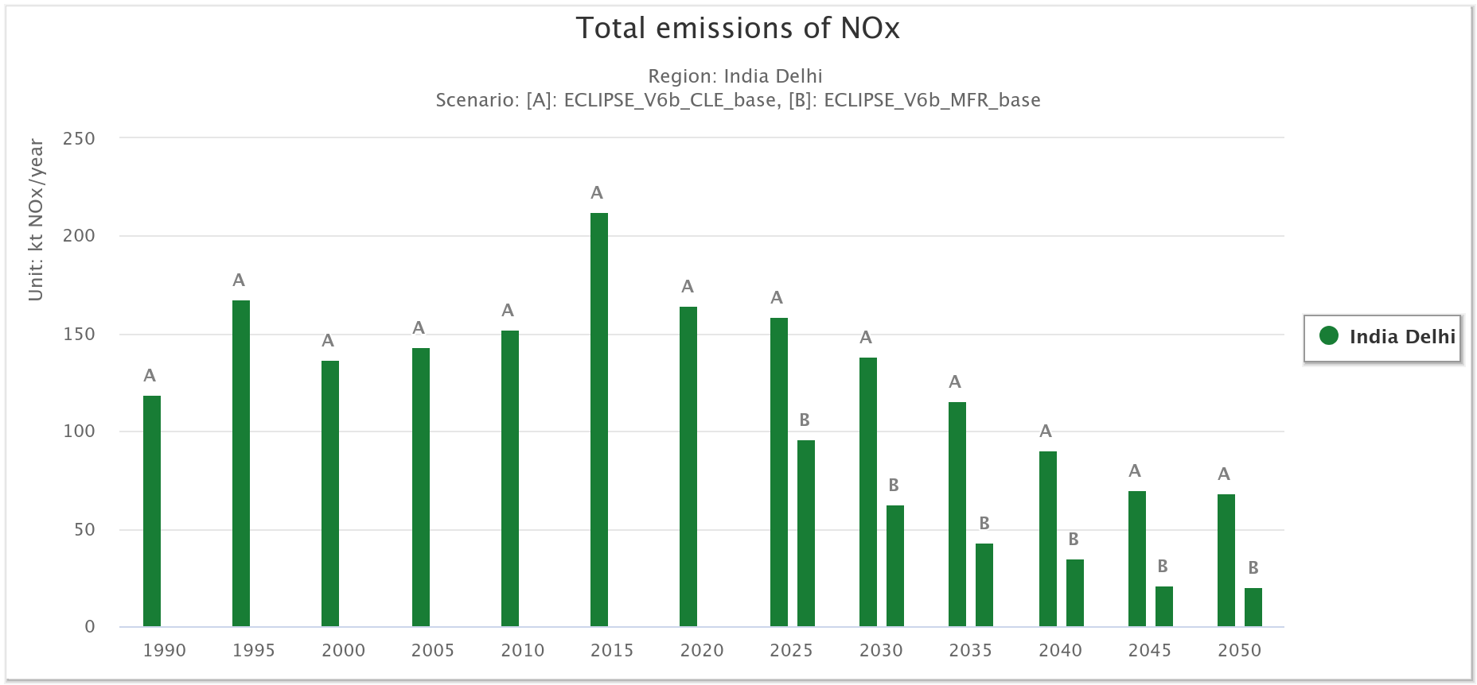
Fig. 14. GAINS (ECLIPSE v6b) primary PM₂.₅ emissions in Delhi under CLE [A] and MFR [B], 1990–2050 (kt PM₂.₅ yr⁻¹). Source: GAINS Online.

Conclusion
The improvements in air quality we saw during the lockdown emphasized the importance of making lasting changes in how we conduct our operations every day. While the temporary pause in normal activities helped, we need to make permanent changes to keep seeing progress. This involves dealing with various sources of pollution like dust, vehicle fumes, and industrial processes. By integrating these changes into our regular organizational routines, we can make a major difference in reducing emissions in the long term. The lessons we learned from the COVID-19 pandemic show us that we need to focus on specific pollution sources to ensure ongoing improvements in air quality. Additionally, we need to balance economic and industrial growth with ensuring our cities can support our environment and us responsibly.
These findings highlight a crucial opportunity whereas temporary limitations have a beneficial effect on the environment, long-term, sustainable measures are necessary to produce long-lasting improvements in air quality. Governments, legislators, businesses, and communities must make the shift from reactive to proactive environmental planning.
The study also helps to a better understanding of exposure science and health effects. With increasing data relating air pollution to respiratory ailments, cardiovascular disorders, and cognitive decline, such study underlines the importance of incorporating environmental health into public policy.
Delhi acknowledged as one of the cities facing significant pollution challenges worldwide, observed a substantial decrease in hazardous pollutants like nitrogen dioxide, dust, and sulfur dioxide during the lockdown. At the same time, there was an increase in ozone levels in the air in Delhi after the lockdown, which was linked to overall better air quality. However, as people returned to their normal activities after the lockdown, pollution levels rose again. This clearly demonstrates how our activities impact the air we breathe. The lockdown also provided researchers with an opportunity to study the environment more closely, highlighting the urgent need for policymakers to implement stricter regulations to protect our environment. Integrating GAINS scenario evidence with station observations underscores the policy gap between temporary activity reductions and structural pathways. Progress toward air-quality standards in Delhi is unlikely under CLE trajectories, where precursor emissions remain high; only MFR-like measures across transport, industry, power and residential sectors deliver sustained reductions consistent with the ozone and PM₂.₅ responses observed in this study [33, 34].
In conclusion, the pandemic provided a rare opportunity to reset our environmental baselines. The task now is to incorporate these findings into daily governance, industrial regulation, and citizen behavior, ensuring that clean air becomes a long-term right for all.

Availability of data and material
The datasets analyzed in this study are publicly available at the Central Pollution Control Board (CPCB) website ( https://airquality.cpcb.gov.in).

Declarations

Ethics approval and consent to participate
Not applicable.
Consent for publication
Not applicable.
Competing interests
The authors declare that they have no known competing financial interests or personal relationships that could have influenced the work reported in this paper.

References

[1] Garg, A., Kumar, A., & Gupta, N.C. Comprehensive study on impact assessment of lockdown on overall ambient air quality amid COVID-19 in Delhi and its NCR, India. Journal of Hazardous Materials Letters, 2, 100010 (2021). https://doi.org/10.1016/j.hazl.2020.100010

[2] Lee, K., Sahai, H., Baylis, P., & Greenstone, M. Job loss and behavioral change: the unprecedented effects of the India lockdown in Delhi. University of Chicago, Becker Friedman Institute for Economics Working Paper 2020-65 (2020).

[3] Khan, N. An exploratory study of impact of lockdown on air quality of Delhi. Applied Ecology and Environmental Sciences, 8(5), 261–268 (2020). https://doi.org/10.12691/aees-8-5-11

[4] Ravindra, K., Singh, T., Biswal, A., Singh, V., & Mor, S. Impact of COVID-19 lockdown on ambient air quality in megacities of India and implication for air pollution control strategies. Environmental Science and Pollution Research, 28, 21621–21632 (2021). https://doi.org/10.1007/s11356-020-12325-3

[5] Jia, C., Fu, X., Bartelli, D., & Smith, L. Insignificant impact of the stay-at-home order on ambient air quality in the Memphis metropolitan area, USA. Atmosphere, 11(6), 630 (2020). https://doi.org/10.3390/atmos11060630

[6] Chowdhury, S., Dey, S., Tripathi, S.N., Beig, G., Mishra, A.K., & Sharma, S. "Traffic intervention" policy fails to mitigate air pollution in megacity Delhi. Environmental Science & Policy, 74, 8–13 (2017). https://doi.org/10.1016/j.envsci.2017.04.018

[7] Mahato, S., Pal, S., & Ghosh, K.G. Effect of lockdown amid COVID-19 pandemic on air quality of the megacity Delhi, India. Science of the Total Environment, 730, 139086 (2020). https://doi.org/10.1016/j.scitotenv.2020.139086

[8] Nigam, R., Pandya, K., Luis, A.J., Sengupta, R., & Kotha, M. Positive effects of COVID-19 lockdown on air quality of industrial cities (Ankleshwar and Vapi) of Western India. Scientific Reports, 11, 4285 (2021). https://doi.org/10.1038/s41598-021-83393-9

[9] Dwivedi, P., Radha, R.S., Shekhar, H., & Sharma, S.K. The impact assessment of Diwali firecrackers emissions on air quality in Delhi, India: a comparative study of eight consecutive years (2017–2024). Journal of Atmospheric Chemistry, 82(2), 1–19 (2025). https://doi.org/10.1007/s10874-025-09474-5

[10] Zangari, S., Hill, D.T., Charette, A.T., & Mirowsky, J.E. Air quality changes in New York City during the COVID-19 pandemic. Science of the Total Environment, 742, 140496 (2020). https://doi.org/10.1016/j.scitotenv.2020.140496

[11] Bourdrel, T., Annesi-Maesano, I., Alahmad, B., Maesano, C.N., & Bind, M.A. The impact of outdoor air pollution on COVID-19: a review of evidence from in vitro, animal, and human studies. European Respiratory Review, 30(159), 200242 (2021). https://doi.org/10.1183/16000617.0242-2020

[12] Central Pollution Control Board (CPCB). Guidelines for the measurements of ambient air pollutants. Vol. 1 (2013).

[13] Lorenz, M., Clarke, N., Paoletti, E., Bytnerowicz, A., Grulke, N., Lukina, N., Sase, H., & Staelens, J. Air pollution impacts on forests in a changing climate. In: Mery, G., Katila, P., Galloway, G., et al. (eds) Forests and Society – Responding to Global Drivers of Change. IUFRO World Series Vol. 25, 55–75 (2010).

[14] PIB. Press Information Bureau, Government of India. (2020). https://pib.gov.in (accessed 12 April 2020).

[15] EPA. Particulate Matter (PM) Basics. (n.d.). https://www.epa.gov/pm-pollution/particulate-matter-pm-basics

[16] TERI. Assessment of air quality during lockdowns in Delhi. (2021). https://www.researchgate.net/publication/351515348

[17] CDC. Tox Substance. (n.d.). https://wwwn.cdc.gov/TSP/substances/ToxSubstance.aspx?toxid=69

[18] Zeevart, A.J. Some effects of fumigating plants for short periods with NO₂. Environmental Pollution, 11(2), 97–108 (1976). https://doi.org/10.1016/0013-9327(76)90022-7

[19] EPA. Sulfur Dioxide Basics. (n.d.). https://www.epa.gov/so2-pollution/sulfur-dioxide-basics

[20] Masiwal, R., Sharma, C., Ranjan, A., Radhakrishnan, S.R., Shukla, D.K., Bambal, V.K., & Uniyal, S.K. Long-term variability of trace gases over the Indian Western Himalayan Region. Science of the Total Environment, 806, 150127 (2022). https://doi.org/10.1016/j.scitotenv.2021.150127

[21] EPA. Ground Level Ozone Basics. (n.d.). https://www.epa.gov/ground-level-ozone-pollution/ground-level-ozone-basics

[22] Shankar, S., & Gadi, R. Variation in air quality over Delhi region: a comparative study for 2019 and 2020. Aerosol Science and Engineering, 6(3), 278–295 (2022). https://doi.org/10.1007/s41810-022-00144-7

[23] Ye, F., Rupakheti, D., Huang, L., Nishanth, T., Mk, S.K., Li, L., & Hu, J. Integrated process analysis retrieval of changes in ground-level ozone and fine particulate matter during the COVID-19 outbreak in the coastal city of Kannur, India. Environmental Pollution, 307, 119468 (2022). https://doi.org/10.1016/j.envpol.2022.119468

[24] Yadav, R.K., Gadhavi, H., Arora, A., Mohbey, K.K., Kumar, S., Lal, S., & Mallik, C. Relation between PM₂.₅ and O₃ over different urban environmental regimes in India. Urban Science, 7(1), 9 (2023). https://doi.org/10.3390/urbansci7010009

[25] World Health Organization (WHO). Air pollution and child health: prescribing clean air. Geneva: WHO (2021). https://www.who.int/publications/i/item/air-pollution-and-child-health

[26] Indian Council of Medical Research (ICMR). India: Health of the Nation's States. The India State-Level Disease Burden Initiative. New Delhi: ICMR, PHFI, IHME (2020).

[27] Pope, C.A. III, Burnett, R.T., Thun, M.J., Calle, E.E., Krewski, D., Ito, K., & Thurston, G.D. Lung cancer, cardiopulmonary mortality, and long-term exposure to fine particulate air pollution. JAMA, 287, 1132–1141 (2002). https://doi.org/10.1001/jama.287.9.1132

[28] Lelieveld, J., Evans, J.S., Fnais, M., Giannadaki, D., & Pozzer, A. The contribution of outdoor air pollution sources to premature mortality on a global scale. Nature, 525, 367–371 (2015). https://doi.org/10.1038/nature15371

[29] Sharma, S., Zhang, M., Anshika, Gao, J., Zhang, H., & Kota, S.H. Effect of restricted emissions during COVID-19 on air quality in India. Atmospheric Environment, 246, 118091 (2021). https://doi.org/10.1016/j.atmosenv.2020.118091

[30] Apte, J.S., Marshall, J.D., Cohen, A.J., & Brauer, M. Addressing global mortality from ambient PM₂.₅. Environmental Science & Technology, 49(13), 8057–8066 (2015). https://doi.org/10.1021/acs.est.5b01236

[31] Vohra, K., Marais, E.A., Muller, C.L., Taylor, J., & Pope, R.J. Long-term air pollution exposure and COVID-19 mortality: a review of methods and findings. Environmental Research Letters, 17(5), 053004 (2022). https://doi.org/10.1088/1748-9326/ac67bd

[32] Barré, J., Petetin, H., Colette, A., Guevara, M., Peuch, V.-H., Rouil, L., & Beekmann, M. Estimating lockdown-induced European NO₂ changes using satellite and surface observations and air quality models. Atmospheric Chemistry and Physics, 21, 7373–7394 (2021). https://doi.org/10.5194/acp-21-7373-2021

[33] Amann, M., Kiesewetter, G., Schöpp, W., et al. Reducing air pollution in India: Health and climate co-benefits. Environmental Science & Technology, 54(7), 4761–4771 (2020). https://doi.org/10.1021/acs.est.9b06447

[34] Amann, M., et al. GAINS-Asia: Scenarios for cost-effective air pollution control and climate co-benefits. International Institute for Applied Systems Analysis (IIASA), Laxenburg, Austria (2018).

[35] Power, M.C., Weisskopf, M.G., Alexeeff, S.E., Coull, B.A., Spiro, A., & Schwartz, J. Exposure to air pollution and risk of cognitive decline: A prospective cohort study. Environmental Health Perspectives, 124(3), 384–390 (2016). https://doi.org/10.1289/ehp.1408412

[36] Rao, S., Klimont, Z., Riahi, K., et al. Future air pollution in the Shared Socioeconomic Pathways. Global Environmental Change, 42, 346–358 (2016). https://doi.org/10.1016/j.gloenvcha.2016.06.009

