Original Research Article

Long-Term variability in Onset of Effective Monsoon and Rainy Days in Ken basin and Betwa basin

Abstract
This study examined the Number of Rainy Days (NRD) and the Onset of Effective Monsoon (OEM) in Ken basin and Betwa basin, where agricultural activities depend mainly on monsoonal rainfall. The long-term daily rainfall data for 49 years were used for this analysis. The OEM and NRD were determined using Ashok Raj's approach, which defines agriculturally effective monsoon onset in terms of rainfall adequacy and continuity. The result indicated that monsoon variation has changed noticeably in both basins. The onset of the effective monsoon exhibited a mixed pattern in Ken Basin with total change ranging from 17 to -4 days, whereas in Betwa Basin, the onset is generally delayed with total change ranging from 17 to -32 days. The number of rainy days showed a predominantly decreasing trend in both basins. In Ken Basin, the total change in rainy days ranges from 8 to -12 days, while in Betwa Basin, the decreased is more significant with total change ranging from 11 to -16 days. The decreased in rainy days along with a delay in monsoon onset indicating extended dry spells and lower early-season soil moisture availability. This study provides useful insights for farmers, planners and policymakers in developing climate-resilient agricultural practices to enhanced soil moisture conservation and basin-scale adaptation strategies.
Keywords: Number of Rainy Days, Onset of Effective Monsoon, Ken basin, Betwa basin
- Introduction
Global warming has increased the frequency of extreme weather events in various climatic regions including those dominated by monsoons and arid areas. Climate change not only raises the frequency and severity of extremes but also alters the way natural processes occur, amplifying their effects in relation to specific regional climatic and physiographic factors (Ülker et al., 2018; Uzun and Ustaoğlu, 2022; Lunagaria et al., 2022). The changing climate affects critical environmental factors that have a direct impact on agricultural systems including the availability of soil moisture, rates of evapotranspiration, frequency of droughts, and overall crop yield (Kay and Davies, 2008; Secci et al., 2021; Pulido-Velazquez et al., 2022; Abraham and Muluneh, 2022). As a result, it is anticipated that the climate variability of the future will provide considerable difficulties for the planning and management of water resources in numerous areas worldwide (IPCC, 2022).
In India, rainfall is the most critical climatic factor influencing agriculture productivity, particularly for Kharif (summer) crops that are highly dependent on the southwest monsoon (June to September). Out of the nearly 140 million hectares (mha) of agricultural land in the country, approximately 48.8% is irrigated, while 51.2% relies on rainfed sources, thereby emphasizing a significant dependence on monsoonal rainfall. Moreover, according to Census, 2011, around 54.6% of India's total workforce is engaged in agriculture and related activities (Indian Institute of Public Administration, 2022). Nearly 80% annual rainfall of India is attributed to the south-west monsoon as it is important for maintaining agricultural production and freshwater resources. The spatial and temporal variability of monsoon rainfall frequently leads to droughts, dry spells, and excessive rainfall, affecting crop yields and production stability (Lal, 2011). Among these factors, the onset of monsoon is particularly crucial as it determines sowing schedules in rainfed agricultural systems. The delays or irregularities in the onset of monsoon can disrupt timely planting leading to substantial yield losses and potentially affecting subsequent cropping cycles which can have broader implications for farm income and food security (Bhagat et al., 2020).Therefore, it is essential to forecast the onset of effective monsoon to assist farmers in making informed sowing decisions and minimizing risks associated with climate variability (Jain, 2015).
According to recent studies (Pai et al., 2015; Guhathakurta et al., 2015; Guhathakurta et al., 2016; Rozy et al., 2017; Krishnan et al., 2020; Mishra et al., 2021; Chakra et al, 2023), there have been significant changes in monsoon rainfall characteristics throughout India including changes in rainfall frequency, increased intermittency, and regional variability in monsoon behaviour. Even in situations where overall seasonal rainfall exhibits weak or mixed trends, a number of studies showed a decrease in the number of rainy days across various parts of India, indicating an increase in rainfall concentration and prolonged dry spells during the monsoon season (Kumar, 2022). These results indicate that when evaluating agricultural and hydrological consequences, timing and frequency of rainfall are more important than total rainfall.
The Ken and Betwa basin, which spans parts of Madhya Pradesh and Uttar Pradesh, is an essential agricultural region where 80 percent of cultivated land depends on monsoonal rainfall (State action plan on climate change, UP, 2014). The onset of the southwest monsoon marks the beginning of Kharif crop sowing, making it crucial to determine the effective rainfall onset for optimal agricultural planning. Given the unpredictable nature of rainfall in this region, farmers often struggle with early or delayed sowing affecting crop productivity. Therefore, understanding rainfall variability and monsoon onset is essential for improving crop management, water resource planning, and reducing agricultural risks. The present study analyse the onset of effective rainfall and number of rainy days in Ken Basin and Betwa Basin.
2. Materials and Methods
2.1 Description of the study area
The Ken River basin lies between 23°12′ N and 25°54′ N latitudes and 78°30′ E and 80°40′ E longitudes covering an area of 28709.89 km², in the states of Madhya Pradesh and Uttar Pradesh. The Ken river originates at the Ahirgawan village on the north west slops of Kaimur hills in Katni district of Madhya Pradesh. It has an elevation of about 550 m and after traversing for about 427 km in the States of Madhya Pradesh and Uttar Pradesh, it finally joins the river Yamuna near village Chilla in Banda district of Uttar Pradesh at an elevation of about 95 m. The average annual rainfall ranges from approximately 800 mm to 1,250 mm with an average rainfall of 1,165 mm. The daily mean temperature ranges from a minimum 6.7 °C to a maximum 44.2 °C.
The Betwa River basin lies between 77°10ʹ E and 80°20ʹ E longitude and 22° 54' to 26° 05'N latitude covering an area of43500.59 km² in the central part of India. The Betwa River flows in a north-easterly direction through Madhya Pradesh (MP) and enters Uttar Pradesh (UP) near village Bangawan of Jhansi district. The elevation of the basin ranges between 18 to 705 meters above mean sea level. The Betwa River originates near Barkhera village in the Raisen district of Madhya Pradesh and flows into the Yamuna River near Hamirpur in Uttar Pradesh. The total length of Betwa River from its source to its confluence is 590 kilometers, with 232 kilometers in Madhya Pradesh and the remaining 358 kilometers in Uttar Pradesh. The average annual rainfall varies from 700 to 1,200 mm with an average annual rainfall of 1,138 mm. The daily mean temperature ranges from a minimum of 8.1°C to a maximum of 42.3°C.
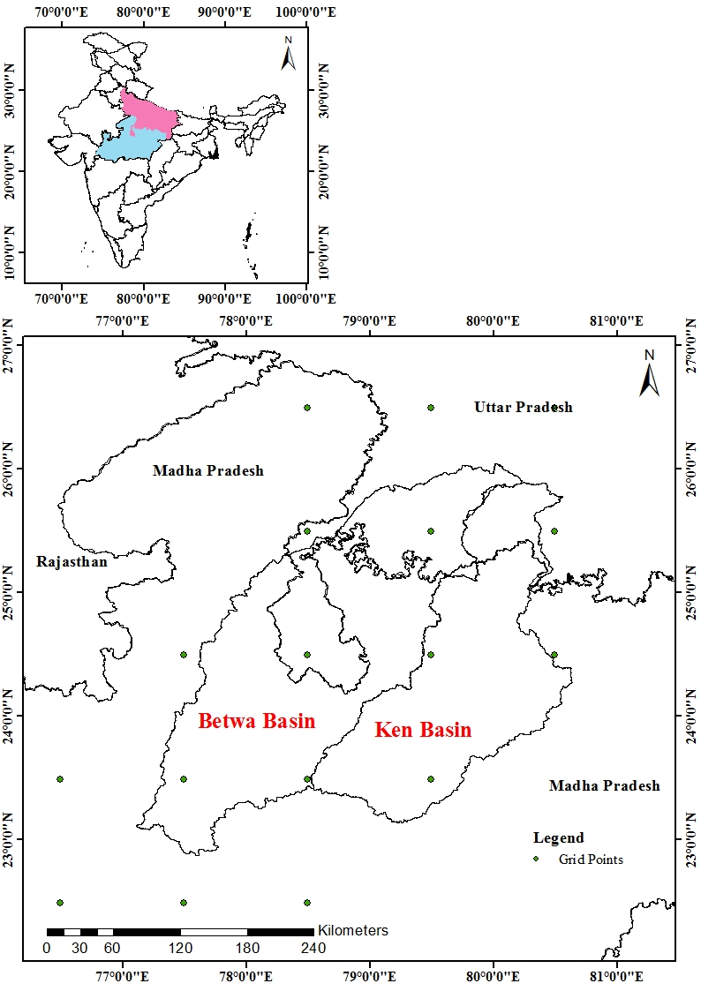
Figure 1 Location maps of Ken basin and Betwa basin
2.2 Metrological data
The metrological data for 49 years was procured from India Meteorological Department (IMD), Pune. The daily rainfall data was used to compute rainy days and OEM, which are available for 6 grid points for Ken basin and 15 grid points for Betwa basin from 1971 to 2019.

2.3 Onset of Effective Monsoon (OEM)
The Effective Monsoon (EM) refers to the amount of rainfall that meets or exceeds the evaporation requirement over a seven-day period ensuring adequate soil moisture for beginning crop development. The onset of effective monsoon (OEM) is an essential agroclimatic variable for Kharif crop planning. According to Ashok Raj (1979), the following criteria should be satisfied for the evaluation of the OEM: (i) The first day of a seven-day spell should exceed evaporation; (ii) a day with more than 3 mm of rainfall is considered a rainy day; (iii) total rainfall during the seven-day spell exceeds (3× PET + 10) mm; and (iv) at least four out of seven days are rainy. These conditions aim to predict the onset of agriculturally important monsoon rainfall ensuring adequate moisture availability for the beginning of sowing activities and early crop establishment.

2.4 Mann Kendall Test
The Mann-Kendall (MK) test is a non-parametric statistical method used to identify trends in a time-series dataset without requiring the data to conform to a particular distribution. In this approach, a dataset with ‘n’ observations is analyzed by comparing each data point with subsequent ones, forming two subsets: Ti​ and Tj​, where i=1 to n−1 and j=i+1 to n. If a later observation Tj​ is greater than an earlier one Ti​, the statistic S is increased by 1. If the later value is smaller, S is decreased by 1. The overall test statistic S is the sum of these comparisons, reflecting the cumulative trend in the data (Drapela and Drapelova, 2011).
The Mann-Kendall S Statistic is computed as

(3.1)
(3.2)
In the context of the Mann-Kendall test, the observations for distinct time intervals, represented as yj and yi, where j > i, hold significant importance. For small sample sizes (n < 10), the absolute value of SSS is compared directly to the critical values from the Mann-Kendall distribution. If ∣S∣ exceeds the critical threshold Sα/2​, the null hypothesis H₀​ (no trend) is rejected in favor of the alternative hypothesis Ha​ (presence of a trend). A positive S value suggests an increasing trend, while a negative S indicates a decreasing trend (Luo et al., 2008; Salmi et al., 2002).
When the dataset includes 10 or more observations, the test statistic S is approximated by a normal distribution with:
E(S) =0
(3.3)
Here, ti denotes the number of tied ranks. Tied values identical observations are accounted for in the variance calculation, as they can influence the outcome of the trend analysis. The standardized test statistic Zs​is then derived as follows:
(3.4)
The significance of the trend is determined by comparing ∣Zs​∣ to the critical value Zα/2​, which corresponds to the selected significance level. If ∣Zs​∣ exceeds this value, the trend is considered statistically significant (Motiee et al., 2009).
2.5 Sen’s Slope Estimator
To quantify the magnitude of a linear trend, Sen’s Slope Estimator is employed. This robust, non-parametric method is used to determine the true slope of a time series. It is based on the median of all pairwise slopes, ensures a more accurate assessment of the trend, particularly for climatic datasets that tend to exhibit high variability (Hirsch et al, 1982).
The slope (β) is computed as:
$β=Median \left[\frac{X_{j}-X_{i}}{j-i}\right] For all i<j$ (3.5)
Where, X_{j} and X_{i} represent the observed values of the variable at time steps j and i, respectively.
2.6 Relative Change
The relative change in various climatic variables was calculated to quantify the overall variation during the study period using the approach (Some’e et al., 2012). The relative change (RC) is defined as:
$RC=\frac{n*β}{|x|}*100$ (3.6)
Where, n denotes the duration of the trend period in years, β represents the trend magnitude estimated using Sen’s slope method, and ∣x∣ is the absolute mean value of the corresponding time series.
3. Results and Discussion
This study examined the long-term variability in the Number of Rainy Days (NRD) and Onset of Effective Monsoon (OEM) for Ken and Betwa basin from 1971 to 2019.
3.1 Number of Rainy Days (NRD)
The number of rainy days in Ken basin exhibits mainly decreasing pattern. The total change ranging from 8 days to -12 days and most grid points exhibit no statistically significant trend. While some grid points in the center and northern regions exhibited considerably more decreases and some showed slightly increases. The basin exhibited a gradual decrease in the number of rainy days, even though the change is not statistically significant at most grid points. In Betwa basin, the NRD trend is significantly decreasing. The total change ranging from 11 days to -16 days with some parts of the basin showing negative change. The grid points exhibited statistically significant decreasing trends at different significance levels (1%, 5%, and 10%) indicating a more consistent and predictable decrease. A few grid points exhibited no trend and increasing NRD. This could indicate that there are less rainy day in the Betwa basin over time.
Overall, the rainy days are decreasing in both Ken basin and Betwa basin, with the Betwa basin experiencing a more severe and statistically significant decrease. Although total rainfall amounts might not have changed considerably but the decrease in NRD indicates that rainfall is occurring on a lesser number of days. This trend indicates that rainfall has been divided into fewer, more intense events, which increases the probability of rapid flow rather than moderate soil infiltration. The longer dry spells during the monsoon season are also caused by the reduced number of rainy days. These dry spells have the ability to hamper crop growth, reduce soil moisture availability, and increase the risk of agricultural drought .
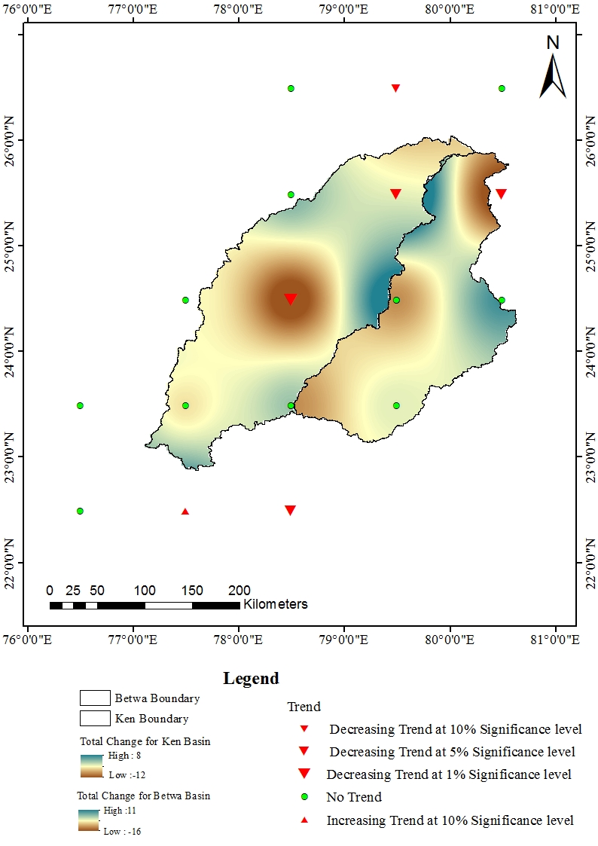
Figure 2: Spatial trend of Number of Rainy Days in Ken and Betwa basin
3.2 Onset of Effective Monsoon (OEM)
The Onset of Effective Monsoon (OEM) in the Ken basin exhibited a mixed pattern with total changes ranging from 17 to -4 days. Most parts of the basin experience a delay in OEM , particularly across the central and northern areas where the shift is more pronounced. Overall, most grid points exhibited no trend indicating that long-term changes are not uniform across the basin. In Betwa basin, the Onset of Effective Monsoon has also been significantly delayed. The total change ranges from 17 to -32 days resulting in significant delays in certain central and lower basins. It indicates that rainfall events must be consistently delayed in order to exceed the effective threshold as a few grid points showed statistically decreasing trends at the 1% and 10% significance levels. The grid points showing no trend indicates that rather than occurring throughout the basin, changes occur in particular regions.
Overall, Ken basin and Betwa basin exhibited a tendency toward delay. The observed delay in OEM indicates that the initial significant rainfall that might increase agricultural activity or soil moisture recharge is arriving later than in previous decades. A delayed effective monsoon has severe agrohydrological consequences. When the initial significant rainfall occurs more than expected, the moisture available during the early stages of crop growth, germination, root establishment, and vegetative development is reduced. Longer early-season dry spells might cause farmers to utilize additional irrigation or postpone planting dates, affecting crop calendars and increasing susceptibility to mid-season dryness.
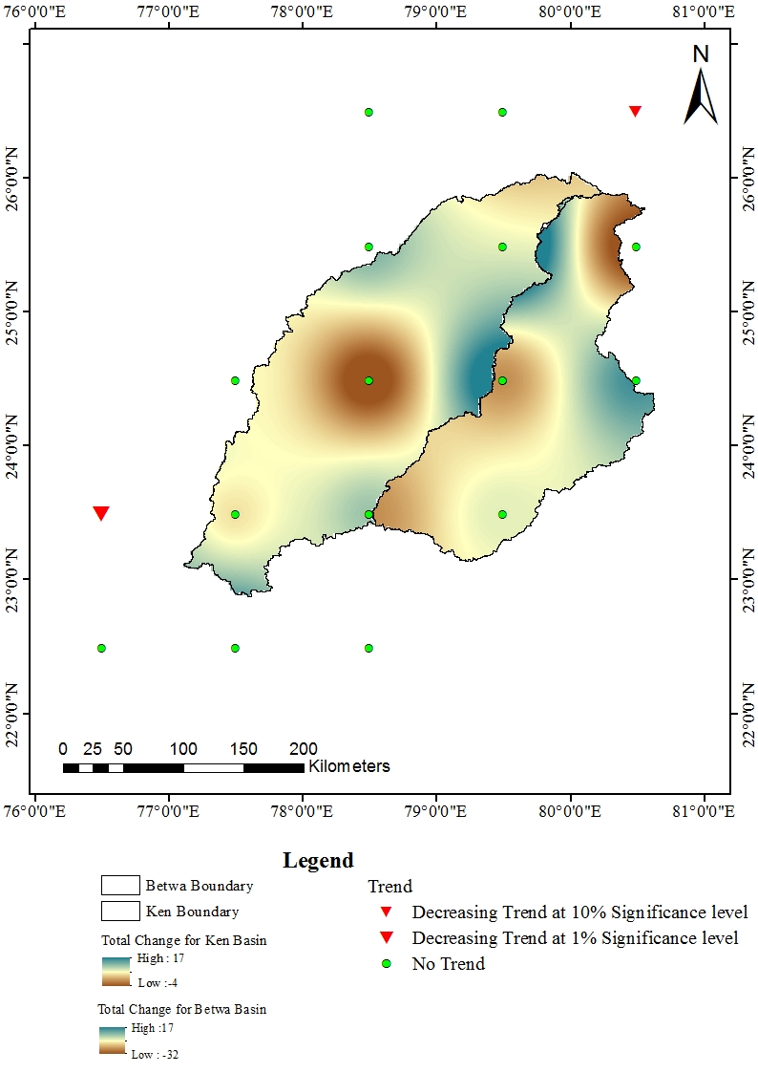
Figure 3: Spatial trend of Onset of Effective Rainfall in Ken and Betwa basin
- Conclusion
This study assessed the Number of Rainy Days (NRD) and Onset Effective Rainfall (OEM) in Ken basin and Betwa basin. The Ken and Betwa basin showed an overall decrease in NRD with the Betwa Basin showing a more pronounced and statistically significant decrease. Rainfall has become more heavy and intense, as shown by a decrease in rainy days. This pattern causes longer dry spells, reduces soil infiltration, and promotes rapid runoff during the monsoon season. Especially during critical crop growth stages, these changes increase the risk of agricultural drought, temporary water stress, and reduced soil moisture availability. The OEM analysis indicated an increased tendency for a delayed monsoon onset in both basins. In comparison to Ken Basin, there are more pronounced delays in Betwa Basin. A delayed effective monsoon reduces early-season soil moisture recharge, leading farmers to either delay seeding or rely on additional irrigation during crop establishment and early vegetative growth. These disruptions make crop calendars more vulnerable to mid-season rainfall fluctuation, which also affects agricultural stability.
Overall, rainfall irregularity is increasing in both basins due to a simultaneous decrease in number of rainy days and delay in onset of effective monsoon. These changes have significant agro-hydrological consequences, including increased irrigation demand, reduced water availability at the initial phase of the cropping season, and increased susceptibility to seasonal drought. The results emphasize the necessity for farmers, planners and policymakers to support climate-resilient agricultural practices to enhanced soil moisture conservation and basin-scale adaptation strategies.
References
Abraham, T. and Muluneh, A., 2022. Quantifying impacts of future climate on the crop water requirement, growth period, and drought on the agricultural watershed, in Ethiopia. Air, Soil and Water Research, 15, p.11786221221135151.
Ashok Raj, P.C., 1979. Onset of effective monsoon and critical dry spells. Research bulletin (Indian Agricultural Research Institute).
Bhagat, A.D., Gorantiwar, S.D., Malunjkar, V.S., Kohakade, S. and Gholkar, M., 2023. Comparison of Onset And Withdrawal of Monsoon using TSMOM (Triggering Soil Moisture For Onset Of Monsoon) and Conventional Method. Journal of Agriculture Research and Technology, 48(1), p.132.
Chakra, S., Ganguly, A., Oza, H., Padhya, V., Pandey, A. and Deshpande, R.D., 2023. Multidecadal summer monsoon rainfall trend reversals in South Peninsular India: a new approach to examining long-term rainfall dataset. Journal of Hydrology, 624, p.129975.
Drapela, K., Drapelova, I., 2011. Application of Mann-Kendall test and the Sen’s slope estimates for trend detection in deposition data from Bílý Kříž (Beskydy Mts., the Czech Republic) 1997–2010. Beskdy Mendel University in Brno 4 (2), 133–146.
Guhathakurta, P. and Revadekar, J., 2016. Observed variability and long-term trends of rainfall over India. In Observed climate variability and change over the Indian region (pp. 1-15). Singapore: Springer Singapore.
Guhathakurta, P., Rajeevan, M., Sikka, D.R. and Tyagi, A., 2015. Observed changes in southwest monsoon rainfall over India during 1901–2011. Int. J. Climatol, 35(8), pp.1881-1898.
Hirsch, R.M., Slack, J.R., and Smith, R.A. (1982). Techniques of trend analysis for monthly water quality data, Water Resources Research, 18 (1): 107-121.

Indian Institute of Public Administration, 2022. Agriculture(Chapter-1)
https://www.iipa.org.in/upload/agriculture.pdf
Jain, M., Naeem, S., Orlove, B., Modi, V. and DeFries, R.S., 2015. Understanding the causes and consequences of differential decision-making in adaptation research: adapting to a delayed monsoon onset in Gujarat, India. Global Environmental Change, 31, pp.98-109.
Kay, A.L. and Davies, H.N., 2008. Calculating potential evaporation from climate model data: A source of uncertainty for hydrological climate change impacts. Journal of Hydrology, 358(3-4), pp.221-239.
Kikstra, J.S., Nicholls, Z.R., Smith, C.J., Lewis, J., Lamboll, R.D., Byers, E., Sandstad, M., Meinshausen, M., Gidden, M.J., Rogelj, J. and Kriegler, E., 2022. The IPCC Sixth Assessment Report WGIII climate assessment of mitigation pathways: from emissions to global temperatures. Geoscientific Model Development, 15(24), pp.9075-9109.
Krishnan, R., Gnanaseelan, C., Sanjay, J., Swapna, P., Dhara, C., Sabin, T.P., Jadhav, J., Sandeep, N., Choudhury, A.D., Singh, M. and Mujumdar, M., 2020. Introduction to climate change over the Indian region. In Assessment of climate change over the Indian region: A report of the Ministry of Earth Sciences (MoES), Government of India (pp. 1-20). Singapore: Springer Singapore.
Kumar, S., 2022. Analysis of Uniformity in Rainfall Distribution over North-east India (Doctoral dissertation, BANARAS HINDU UNIVERSITY VARANASI).
Lal, M., 2011. Implications of climate change in sustained agricultural productivity in South Asia. Regional environmental change, 11(Suppl 1), pp.79-94.
Luo, W., Taylor, M.C., Parker, S.R. 2008. A comparison of spatial interpolation methods to estimate continuous wind speed surfaces using irregularly distributed data from England and Wales. Int J. Climatol 28:947–959.
Lunagaria, M., Vijayakumar, P., Chaudhari, N.J. and Bal, S.K., 2022. Onset, cessation, and seasonality of rainfall during monsoon in Gujarat state of India. International Journal of Environment and Geoinformatics, 9(3), pp.65-72.
Mishra, V., Aadhar, S. and Mahto, S.S., 2021. Anthropogenic warming and intraseasonal summer monsoon variability amplify the risk of future flash droughts in India. Npj Climate and Atmospheric Science, 4(1), pp.1.
Motiee, H. and McBean, E., 2009. An assessment of long-term trends in hydrologic components and implications for water levels in Lake Superior. Hydrology Research, 40(6), pp.564-579.

Pai, D.S., Sridhar, L., Badwaik, M.R. and Rajeevan, M., 2015. Analysis of the daily rainfall events over India using a new long period (1901–2010) high resolution (0.25× 0.25) gridded rainfall data set. Climate dynamics, 45(3), pp.755-776.
Pulido-Velazquez, D., Collados-Lara, A.J. and Fernandez-Chacon, F., 2022. The impact of climate change scenarios on droughts and their propagation in an arid Mediterranean basin. A useful approach for planning adaptation strategies. Science of the total environment, 820, p.153128.
Roxy, M.K., Ghosh, S., Pathak, A., Athulya, R., Mujumdar, M., Murtugudde, R., Terray, P. and Rajeevan, M., 2017. A threefold rise in widespread extreme rain events over central India. Nature communications, 8(1), p.708.
Salmi, T., Maata, A., Antilla, P., Ruoho Airola, T. and Amnell, T., 2002. Detecting trends of annual values of atmospheric pollutants by the Mann–Kendall test and Sen’s slope. Finnish Meteorological Institute, Helsinki. Report code: FMI-AQ-31, 36.
Secci, D., Tanda, M.G., D'Oria, M., Todaro, V. and Fagandini, C., 2021. Impacts of climate change on groundwater droughts by means of standardized indices and regional climate models. Journal of Hydrology, 603, p.127154.
State action plan on climate change, 2014 https://moef.gov.in/uploads/2017/09/SAPCC_UP_final_version_0.pdf
Some'e, B. S., Ezani, A. and Tabari, H. (2012). Spatiotemporal trends and change point of precipitation in Iran, Atmospheric Research, 113:1–12.

Ülker, D., Ergüven, O. and Gazioğlu, C., 2018. Socio-economic impacts in a changing climate: Case study Syria. International Journal of Environment and Geoinformatics, 5(1), pp.84-93.
Uzun, A. and Ustaoğlu, B., 2022. The effects of atmospheric oscillations on crop (olive, grape and cotton) yield in the eastern part of the Mediterranean region, Turkey. International Journal of Environment and Geoinformatics, 9(1), pp.147-161.

