Original Research Article

Study of spatial variation of soil moisture availability in Akola district using geoinformatics

ABSTRACT
The soils of Akola district are medium to deep black soil. Monsoon break for 7-10 days may not be a serious concern but more than 15 days duration especially at critical growth stages leads to soil moisture stress reduction in crop yield. Drought due to break in monsoon adversely affect the crops in shallow soils as compared deep soils. Soil moisture plays an important role in determining the amount of runoff that occurs and the chances of droughts and floods that may affect an area. The spatial variation of soil moisture availability in the study area was estimated using GIS tools based on spatial variation of soil types and digital elevation mode land region specific pedo-transfer functions. The point data on textural composition were converted into hydraulic data using pedo-transfer functions recommended by Patil et al. (2010, 2012, and 2013) to estimate field capacity, permanent wilting point and bulk density of the soils. These estimates were then applied to the identical textural classes to generate soil moisture data. The spatial variation of available water holding capacity of soil in different talukas of Akola district indicated that the soil moisture availability is more in the Akola, Akot, Telhara and Balapur talukas as compared to the Murtizapur, Barshitakli and Patur taluka.
Key words: Soil moisture, water holding capacity, Vidarbha region
Introduction
Rainfall is the principal source of water for agricultural production, particularly in rain-fed systems where irrigation is limited. Under such conditions, crop success or failure is strongly influenced by the timing, amount, and distribution of rainfall during the growing season. The Indian Summer Monsoon (ISM), a key component of the Asian monsoon system, exhibits substantial variability across multiple time scales — daily, intra-seasonal, inter-annual, and longer-term trends. During the core monsoon months of June to September, a significant portion of this variability arises from intra-seasonal oscillations characterized by alternating active phases with abundant rainfall and break phases with reduced or negligible rainfall. Recent studies indicate that the frequency and duration of these active and break spells vary considerably between wet and drought years, with prolonged breaks contributing to seasonal rainfall deficits and increasing the risk of drought (Ramesh & Kumar, 2023).
Prolonged dry spells during critical crop growth periods can lead to water stress, reduced soil moisture, and substantial reductions in crop yield, particularly in rain-fed regions. Therefore, understanding the intra-seasonal behavior of the monsoon, including the occurrence, duration, and intensity of breaks, is essential for agricultural planning, drought early warning, and sustainable water resource management (Ramesh & Kumar, 2023).
The soils of Akola district are medium to deep black soil. Monsoon break for 7-10 days may not be a serious concern but more than 15 days duration especially at critical growth stages leads to soil moisture stress reduction in crop yield. Drought due to break in monsoon adversely affect the crops in shallow soils as compared deep soils. Soil moisture controls interactions between the land surface and the atmosphere, as changes in soil moisture affect both energy and water cycles. Soil moisture plays an important role in determining the amount of runoff that occurs and the chances of droughts and floods that may affect an area.
Now a days, remote sensing technology has become an integral part of ever growing Information Technology, which acquires modern remote sensing means information about earth’s land and water surfaces by using reflected or emitted electromagnetic energy. Remote sensing provides solution to facilitate sustainable development of the natural resources and conservation of environment at varying scales. The technical capabilities of remote sensing and GIS are found useful to study the different scenario with the help of historical satellite imageries. It is easy to generate combinations of spatio-temporal themes of various resources. Satellite imageries are useful in the study of spatial variations of available soil moisture during dry spells.

Materials and methods
Computation of Soil Moisture Using GIS Techniques
The spatial variation of soil moisture availability in the study area was estimated using GIS tools based on spatial variation of soil types and digital elevation mode land region specific pedo-transfer functions. The point data on textural composition were converted into hydraulic data using pedo-transfer functions recommended by Patil et al. (2010, 2012, and 2013) to estimate field capacity, permanent wilting point and bulk density of the soils. These estimates were then applied to the identical textural classes to generate soil moisture data.
The overlay operation was performed in GIS environment to identify the vivid combinations of soil texture, depth and slope along with derived properties such as bulk density, actual water holding capacity and permanent wilting points. The flow chart of methodology adopted for soil moisture estimation is depicted in Fig. No. 1
Integration of different layers of soil properties with weather database facilitated generation of different combinations of soil moisture allowing the viewer synoptic visualization of soil moisture distribution. The extrapolation technique was found useful to identify the status of soil moisture for remote locations/area.

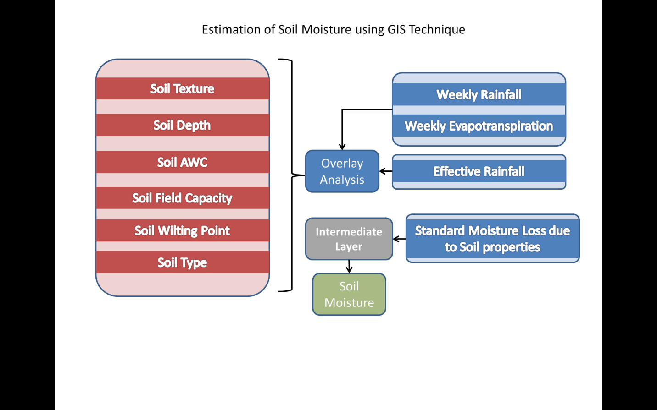

Fig. 1 Flow Chart for Soil Moisture Estimation in GIS Environment

Available Water Holding Capacity
The difference in the moisture content of the soil between field capacity and the permanent wilting point is called the available moisture. The available water holding capacity of soil for its depth can be determined by using following relationship between soil moisture constants (field capacity and wilting point), bulk density of soil and soil depth.

$$d=\frac{(Mf-Mw)}{100}×As×D$$

In which,
d = Available water holding capacity, cm/ m
M_{f} = Field capacity moisture content of the soil, percent
M_{w} = Wilting point moisture content of the soil, percent
As = Bulk density of the soil
D = Depth of soil, cm

Results and Discussion
Spatial Variation of Soil Moisture Availability
The spatial variation of soil moisture availability in different taluka places of Akola district was studied with the information on variation in soil texture, soil depth, soil slope using remote sensing imageries and geographical information system (GIS) tools. The results so obtained are discussed as below.
1. Soil texture map
The soils of Akola district are classified into eight distinct textural classes: clayey, clay loam, gravelly clay, gravelly clay loam, gravelly sandy clay loam, gravelly sandy loam, sandy clay loam, and silty loam. Spatial distribution maps indicate that clayey soils dominate most of the district, suggesting high water-holding capacity and nutrient retention, although these soils may require management to improve aeration and root penetration (Deshmukh, Patil, & Sharma, 2024; Raju & Kumar, 2025).
2. Soil depth map
Soil depth in the district varies considerably, classified into five groups: very shallow (<10 cm), shallow (10–25 cm), moderately deep (25–50 cm), deep (50–100 cm), and very deep (>100 cm). Most of the district is covered by deep to very deep soils, favoring agricultural productivity, whereas the northern and southern extremes with hilly terrain have shallow to moderately deep soils, which are more susceptible to erosion and require conservation measures (Moharana, Singh, & Verma, 2024).
3. Soil slope map
The land slope also shows notable variation, ranging from 1–3% up to 35–50%. Gentle slopes (1–3%) are prevalent in Akola, Balapur, Akot, Telhara, Murtizapur, and Patur talukas, providing favorable conditions for soil accumulation and agriculture. Slightly steeper slopes (3–5%) occur primarily in Barshitakli and parts of Patur taluka. The relationship between slope and soil properties highlights the influence of terrain on soil depth, texture, and overall land capability, with steeper areas tending to have shallower soils due to erosion (Sharma & Joshi, 2024; Raju & Kumar, 2025).
Overall, the spatial variability of soil texture, depth, and slope in Akola district has significant implications for land management and agricultural planning. Deep, clayey soils in gentle terrain are suitable for a wide range of crops, while shallow soils on steeper slopes require soil conservation strategies to maintain productivity and reduce erosion risks.

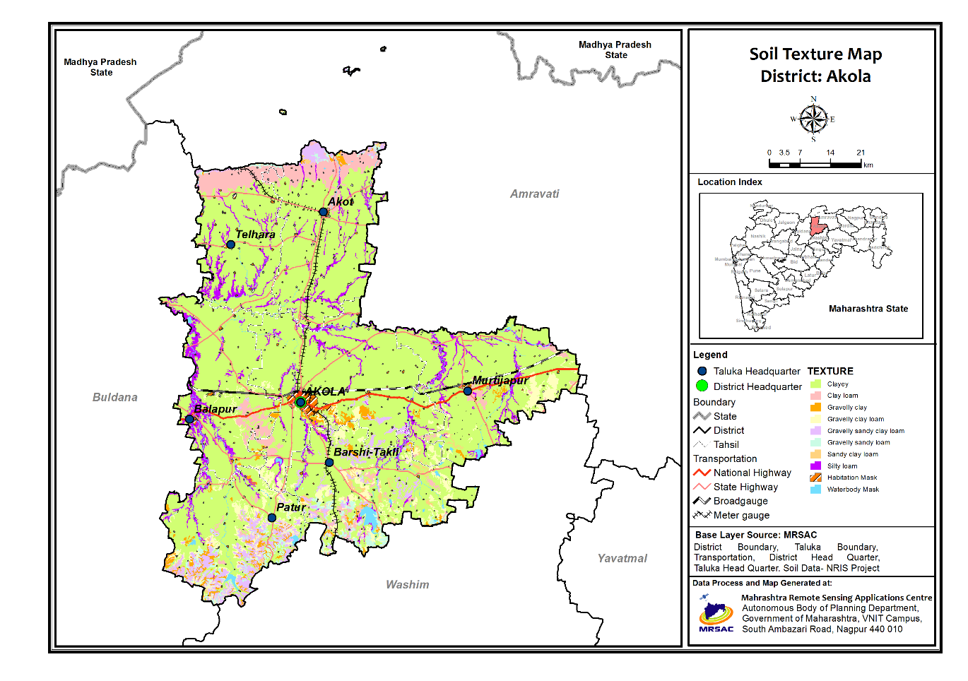
Fig. 2 Distribution of soil texture in different talukas of Akola district
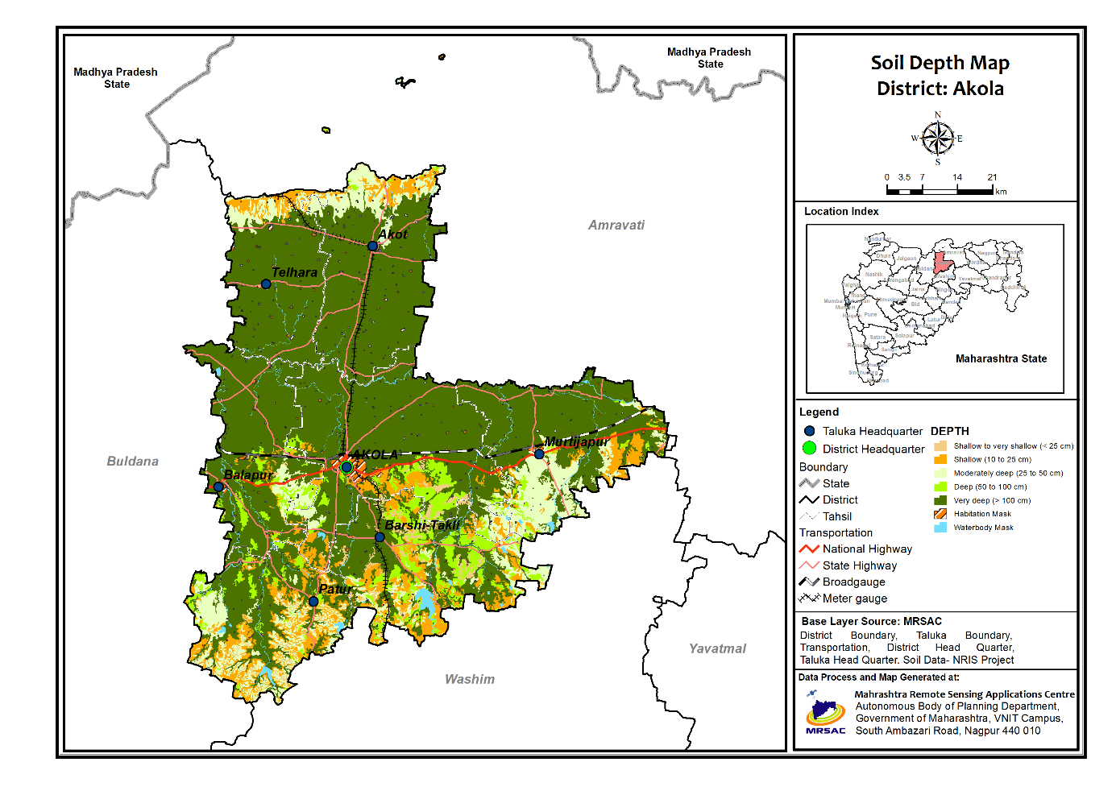
Fig. 3 Distribution of soil depth in different talukas of Akola district
4. Available water holding capacity
The spatial variation of soil available water holding capacity in Akola district was analyzed using maps of soil depth, texture, and slope (Fig. 5). The available water holding capacity of soils across the district varied from less than 5 cm to more than 25 cm per meter of soil depth, indicating substantial heterogeneity in the soil’s capacity to store plant-available water.
A detailed examination of Fig. 5 reveals that high available water holding capacity (>25 cm m⁻¹) is observed predominantly in Akola, Akot, Telhara, and Balapur talukas, as well as in parts of Murtizapur, Barshitakli, and Patur talukas, covering the major portion of the district. These areas possess deeper soils with finer textures and gentler slopes, which enhance water retention and reduce runoff. Conversely, low available water holding capacity (<5 cm m⁻¹) occurs in limited areas of Akola and Barshitakli talukas and the northern regions of Akot and Telhara talukas, primarily corresponding to shallow soils, coarser textures, and sloping terrains that facilitate rapid drainage. Intermediate available water holding capacity values (5–25 cm m⁻¹) are scattered throughout the district, reflecting local variability in soil properties.
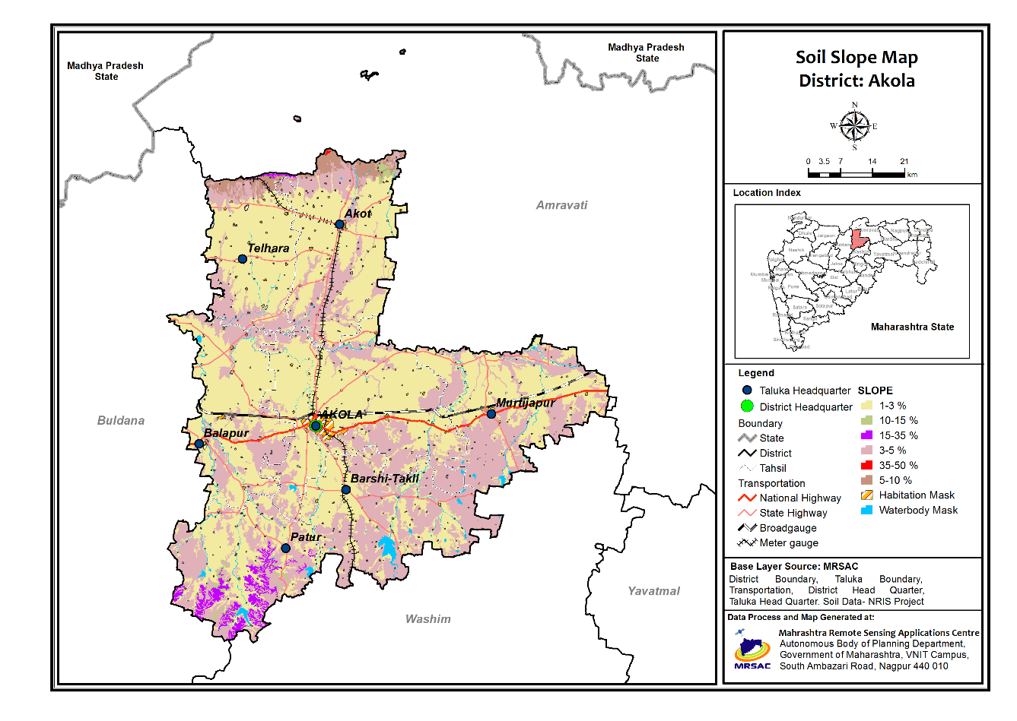
Fig. 4 Distribution of soil slope in different talukas of Akola district
The spatial variability of available water holding capacity has direct implications for agricultural planning. Talukas with higher available water holding capacity, such as Akola, Akot, Telhara, and Balapur, have greater soil moisture availability, which supports crop growth and reduces dependence on supplemental irrigation. Areas with lower available water holding capacity require careful management to mitigate water stress, particularly during dry spells or delayed monsoon onset. This information is crucial for selecting suitable crops and varieties, determining appropriate package of practices, and implementing contingency measures to ensure sustainable agricultural productivity.
These findings align with recent research emphasizing the importance of spatially mapping soil water holding capacity for optimized water management. For example, Ramachandran et al. (2024) demonstrated that geostatistical assessment of soil available water holding capacity in semi-arid regions can guide irrigation planning and enhance water use efficiency, supporting precision agriculture strategies in areas with heterogeneous soils.
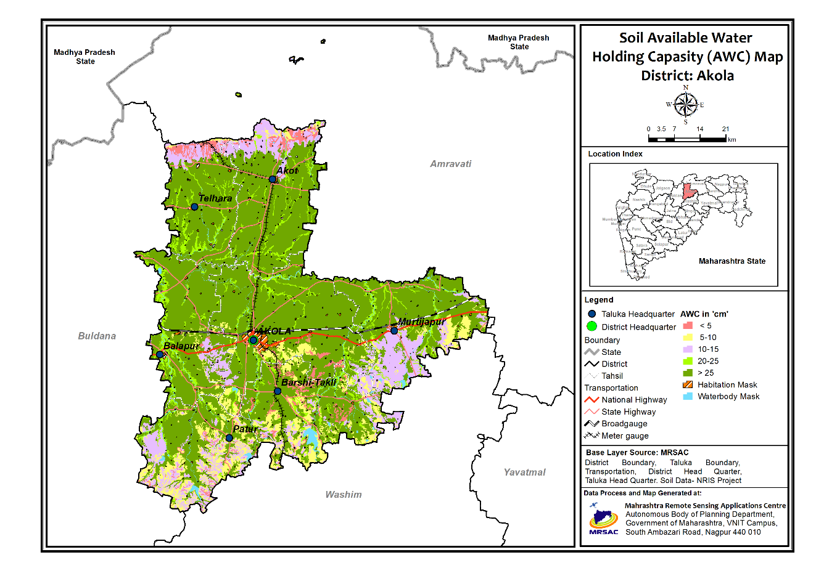
Fig. 5 Distribution of soil available water holding capacity in different talukas of Akola district
Conclusion
The spatial variation of soil moisture availability in Akola district was carried out using geoinformatics. The spatial variation of available water holding capacity of different soil types in Akola district was developed by using the information compiled in spatial maps of soil depth, soil texture and soil slope of study area using data from remote sensing imageries and GIS tools. The spatial variation of available water holding capacity of soil in different talukas of Akola district indicated that the soil moisture availability is more in the Akola, Akot, Telhara and Balapur talukas as compared to the Murtizapur, Barshitakli and Patur taluka. This information on spatial variability of available water holding capacity of soil in different taluka places can be very much useful for planners and development agencies for proper selection of crops and their varieties and deciding different package of practices.
Competing interests
Authors have declared that no competing interests exist.
References:
- Ramesh, S., & Kumar, P. (2023). Intra-seasonal variability of Indian summer monsoon and its impact on rainfall and agriculture. EGU General Assembly 2023. https://meetingorganizer.copernicus.org/EGU25/EGU25-6038.html
- Patil N. G., G. S. Rajput, R. K. Nema and R. B. Singh (2010). Calibration and evaluation of pedotransfer functions to estimate available water capacity of seasonally impounded shrink-swell soils of central India, Archives of Agronomy and Soil Science, 56:5, 525-538, DOI: 10.1080/03650340903161187
- Patil, N., D. Pal, C. Mandal and D. Mandal (2012). Soil Water Retention Characteristics of Vertisols and Pedotransfer Functions Based on Nearest Neighbor and Neural Networks Approaches to Estimate AWC. J. Irrig. Drain Eng., 10.1061/(ASCE)IR.1943-4774.0000375, 177-184.
- Patil, N., P. Tiwary, D. Pal, T. Bhattacharyya, D. Sarkar, C. Mandal, D. Mandal, P. Chandran, S. Ray, J. Prasad, M. Lokhande and V. Dongre. (2013). Soil Water Retention Characteristics of Black Soils of India and Pedotransfer Functions Using Different Approaches. J. Irrig. Drain Eng., 10.1061/(ASCE)IR.1943-4774.0000527, 313-324.
- Deshmukh, P., Patil, R., & Sharma, S. (2024). Mapping the distribution of micro-nutrients in soils of Akola district: A spatial analysis. Biochemical Journal of Soil Science, 8(11), 2895–2908. https://www.biochemjournal.com/archives/2024.v8.i11.G.2895/mapping-the-distribution-of-micro-nutrients-in-soils-of-akola-district-a-spatial-analysis
- Moharana, K., Singh, A., & Verma, P. (2024). Modeling and prediction of soil depth variation using remote sensing and machine learning techniques in central India. Journal of Indian Society of Soil Science, 72(2), 135–148. https://epubs.icar.org.in/index.php/JISSS/article/view/153273
- Raju, B., & Kumar, V. (2025). Geospatial analysis of soil texture and terrain attributes: Implications for land management. Environmental Earth Sciences, 84(4), 219. https://link.springer.com/article/10.1007/s12665-025-12530-8
- Sharma, D., & Joshi, R. (2024). Terrain slope influence on soil properties and agricultural potential in Vidarbha region. International Journal of Environmental Research and Public Health, 15(9), 1903. https://www.mdpi.com/1660-4601/15/9/1903
- Ramachandran, J., Lalitha, R., Kannan, S. V., & Sivasubramanian, K. (2024). Geo-statistical assessment of spatial variability of soil water-holding capacity for optimal irrigation under semi-arid vertisols in South India. Journal of Agriculture and Ecology, 19, 103–119
- Blanka-Végi, V., Tobak, Z., Sipos, G., Barta, K., & van Leeuwen, B. (2025). Estimation of the spatiotemporal variability of surface soil moisture using machine learning methods integrating satellite and ground-based soil moisture and environmental data. Water Resources Management, 39, 2317–2334. https://doi.org/10.1007/s11269-024-04069-3
- Kumar, S., Prasad, R., Sharma, J., & Prajapati, B. S. (2025). High-resolution soil moisture mapping using MSAVI-LST based triangle method. ISPRS Annals of the Photogrammetry, Remote Sensing and Spatial Information Sciences, X-5/W2, 357–364. https://doi.org/10.5194/isprs-annals-X-5-W2-2025-357-2025
- Abhishek C., M.V. R. Seshasai, C. S. Murthy and S.V. C. K. Rao, (2012). Assessing early season drought condition using AMSR-E soil moisture product, Geomatics, Natural Hazards and Risk, Vol. 4, No. 2, Page no.:164-186.
- Bouma, J. (1989). Using soil survey data for quantitative land evaluation. Adv Soil Sci. 9: 177-213.
- Ladda K. C., G. R. Maruthi Sankar, S. K. Sharma, S. N. Soddani and P. K. Mishra (2010). Modeling effects of rainfall and soil moisture on productivity of maize and black gram in semi-arid vertisols,Journal of Agrometeorology,12 (1): 27-32.
- Leeuwen B. V. (2015). GIS workflow for continuous soil moisture estimation based on medium resolution satellite data, AGILE 2015 – Lisbon, June 9-12, 2015.
- Mondal, S.S. (1991). Moisture availability and its application in evaluating agriculture potential in semi-arid region. Mausam 42(1): 65-70.
- Nandagiri, L. and R. Prasad. (1997). Relative performance of textural models in estimating soil moisture characteristic. J. Irrig Drain. Div., Am. Soc. Civ. Eng. 1997: 211-214.
- Pachepsky, Ya. A., and Rawls W. J. (1999). Accuracy and reliability of pedotransfer functions as affected by grouping soils. Soil. Sci. Soc. Am. J. 63: 1748-1756.
- Singh R. P., D. R. Mishra, A. K. Sahoo and S. Dey, (2004). Spatial and temporal variability of soil moisture over India using IRS P4 MSMR data, International Journal of Remote Sensing, Vol. 26, No. 10, 20,ISSN 2241–2247.
- Thanunathan, K.; M. Thiruppathi and V. Imayavaramban (2006). Rainfall climatology and cropping system for tail-end Veeranam ayacut command area of Tamilnadu. Research on crops. 7(2): 571-574.

