Estimation of Irrigation Water Requirements for Existing and High-Value Crops in the Appapuram Channel Command Using the AquaCrop Model.

Abstract
The present study was carried out to estimate irrigation water requirements and crop yields for existing and high-value crops cultivated in the Appapuram Channel Command of the Krishna Western Delta (KWD). The command area, covering about 10,000 ha, primarily grows rice, cotton, maize, chilli, black gram, green gram, and sugarcane during Kharif and Rabi seasons. In the KWD system, canal water is supplied continuously until nearly 10 days before harvest, and water is required for land preparation, field saturation, crop establishment, and subsequent crop growth stages. Components such as saturation requirement, effective rainfall, evapotranspiration, and seepage–percolation losses were considered in estimating crop water requirements. The FAO AquaCrop model was applied to estimate irrigation water requirements and yields of major crops using long-term meteorological data (2000–2015). Effective rainfall was computed using the CROPWAT model following the USDA–SCS method. The results indicated total irrigation water requirements of 1010 mm for paddy, 656.0 mm for maize, 573.3 mm for black gram, 816.2 mm for chilli, 672.2 mm for cotton, and 552.2 mm for green gram across Kharif and Rabi seasons. The study revealed misutilization of canal water and underutilization of groundwater resources, resulting in cultivated area being lower than the actual irrigation potential. The findings demonstrate the usefulness of AquaCrop for irrigation planning and efficient water management in canal command areas.
Key words: AquaCrop Model, CROPWAT, Irrigation water requirement, Crop yield

INTRODUCTION

Globally, it is well debated fact that the water productivity in agriculture needs to be raised in order to meet the increasing demand for food, which will double by 2050. Thus, on one hand, failure to develop and implement the technologies to enhance water productivity will result in use of more water in future to sustain the present level of agricultural production and on the other hand, use of water in excess of that required for crop growth will have a significant negative impact on ecosystem and livelihood of the region (FAO, 2006). Keeping view of the above, it is imperative to enhance the water productivity in agriculture. To accomplish this, there are broadly two options such as a) to improve productivity at the farm level through better management and use of improved varieties having drought resistance and higher yield potential and b) to optimize the use of land resources, irrigation and rainfed farming technologies and judicious management of surface and ground water resources. All this can be achieved by using appropriate tools to predict water productivity under different irrigation regimes or deficit irrigation approaches for different crops (Sarangi, 2010).

MATERIALS AND METHODS
The command area of Appapuram channel, which branches form Commamuru branch canal (Krishna Western main canal) near Sangam Jagarlamudi lock is selected as the study area. Field visits were made to study the actual cropping pattern existing in the command. Interaction meetings and interviews with the farmers, WUA members were conducted to collect the information to the nearest possibility to the ground truth. It spreader over 10000 ha and is on an average 6 m above the mean sea level. The Appapuram channel has nine branches hydraulic particulars of Appapuram main channel and its distributaries.
Though the crops like paddy, cotton, maize, chillies, black gram, and green gram and sugarcane are commonly grown in the area, for the past three years, farmers were growing paddy, in kharif and maize, blackgram in rabi seasons respectively. The model CROPWAT was run to calculate the effective rainfall which is an important parameter for calculating crop irrigation requirement. The canal water release data for 10 years (2005-2015) were collected from Irrigation & Command Area Development (I & CAD) Department at Bapatla and analyzed for further investigation. The details of crops grown in the command, climate, soil data etc. collected are used to assess the net irrigation requirement in the distributary using Aqua Crop 4.0 Model.
The effective precipitation is one of the water inputs to the soil root zone. For irrigation purpose the effective rainfall is defined as the part of total precipitation during the crop growing period that is available to meet the evapotranspiration needs of that crop. USDA Soil Conservation Service Method (USDA-SCS Method) is used by the crop model for calculating the effective rainfall. The net irrigation requirement for crops grown in the distributory is computed by the Aqua Crop 4.0 Model.
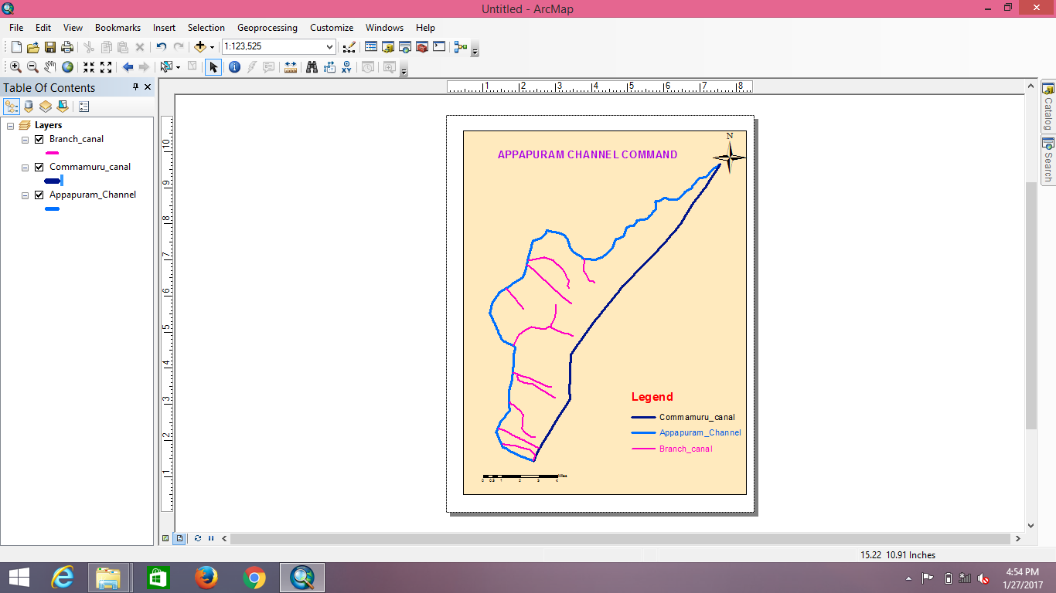 | 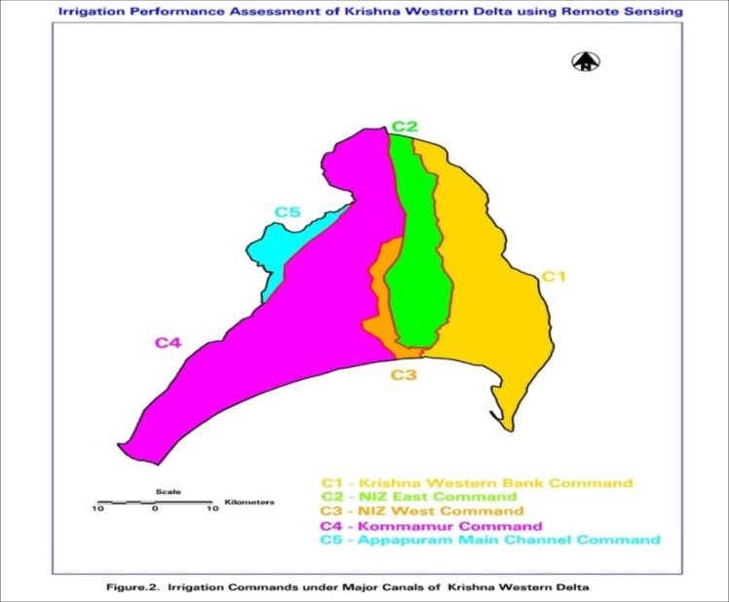
Fig. 1 Map Showing Appapuram Channel Command area
Aqua Crop 4.0 is a crop water productivity model developed and modified by the Land and Water Division of FAO (2012) to simulate yield response to water. Aqua Crop is a general model, as it is widely used for a wide range of herbaceous crops, including forage, vegetable, grain, fruit, oil, and root and tuber crops. It simulates yield response to water of herbaceous crops and is particularly suited to address conditions where water is a key limiting factor in crop production. Aqua Crop attempts to balance accuracy, simplicity and robustness. It uses a relatively small number of explicit and mostly-intuitive parameters and input variables requiring simple methods for their determination. Its main applications include assessing water-limited, attainable crop yields at a given geographical location, assessing rain fed crop production on the long term and developing irrigation schedules for maximum production and for different climate scenarios and for optimizing a limited amount of water available.

Fig. 2 Main menu of Aqua Crop 4.0 model
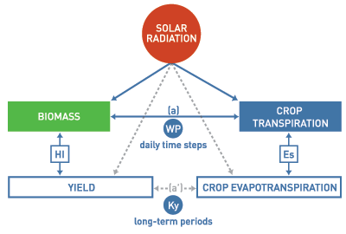
Fig. 3 Schematic representation Aqua Crop 4.0 model
Aqua Crop uses a relatively small number of explicit parameters and largely intuitive input variables, either widely used or requiring simple methods for their determination. Input consists of five components such as weather data, crop and soil characteristics, and field and irrigation management practices that define the environment in which the crop will develop.
RESULTS AND DISCUSSION
The model estimated the effective rainfall on a monthly basis using the average monthly rainfall data of the study area. The weather inputs provided to the model, including rainfall and other climatic parameters, were used to compute the soil water balance and reference evapotranspiration. While estimating effective rainfall, the model deducted various losses such as evapotranspiration occurring immediately after rainfall, infiltration beyond the effective root zone, and deep percolation losses when rainfall exceeded the soil’s water-holding capacity. These losses were influenced by soil characteristics, crop root depth, and prevailing climatic conditions. Thus, the effective rainfall for each month represented only the portion of total rainfall that was actually available for crop use within the root zone. The computed monthly effective rainfall values were subsequently used for estimating crop water requirements and irrigation demand in the study area.

Fig. 4 Annual rainfall in Appapuram channel command (2000-2015)
The total annual rainfall of the study area for 15 years (2000–2015), shown in Fig. 4, was analyzed using rainfall data collected from RARS, Lam, Guntur district. The annual rainfall exhibits noticeable inter-annual variability, reflecting fluctuations in monsoon behavior and its impact on water availability. The season-wise rainfall distribution for the same period is presented in Fig. 5, which indicates that a major portion of the rainfall occurs during the Kharif season, while Rabi and Summer seasons receive comparatively low and irregular rainfall. This uneven seasonal distribution highlights the importance of Kharif rainfall in meeting crop water requirements and emphasizes the need for supplemental irrigation during Rabi and Summer seasons for effective agricultural water management.

Fig.5 Seasonal rainfall in Appapuram channel command (2000-2015)
From the above figure, it is clearly observed that the Kharif season receives significantly higher rainfall compared to the Rabi and Summer seasons throughout the study period (2000–2015). The rainfall during Kharif shows considerable inter-annual variation, with pronounced peaks in certain years, reflecting the dominant influence of the southwest monsoon. This higher and relatively dependable rainfall during Kharif substantially contributes to meeting the crop water requirements, thereby reducing the dependence on irrigation during this season. In contrast, the Rabi and Summer seasons receive comparatively low and erratic rainfall, which is inadequate to satisfy crop water demands and necessitates supplemental irrigation from surface and groundwater sources. The clear seasonal disparity in rainfall distribution highlights the critical role of Kharif rainfall in agricultural water availability and groundwater recharge. This information was effectively utilized in estimating the irrigation water requirements of different crops and was further incorporated in formulating the constraints for irrigation planning and water allocation models, ensuring realistic and season-specific representation of water availability in the analysis.

Fig. 6 Monthly and effective rainfall in the study area
Effective rainfall is a crucial component of the water balance in the crop root zone, as it directly contributes to meeting the evapotranspiration requirements of crops and thereby reduces the need for supplemental irrigation. In the present study, effective rainfall was estimated using the FAO CROPWAT model by incorporating long-term rainfall data along with other relevant meteorological parameters such as temperature, relative humidity, wind speed, and sunshine hours on a mean monthly basis. The model simulations were carried out for multiple crops grown in the study area and for multiple crop periods covering the years 2000 to 2015, in order to capture the temporal variability in rainfall and its effectiveness. The USDA Soil Conservation Service (SCS) method, which is widely accepted for estimating effective rainfall, was adopted within the CROPWAT model to compute daily effective rainfall values, and the results are presented in Fig. 6. This method accounts for rainfall losses due to surface runoff and deep percolation, thus providing a realistic estimate of the portion of rainfall that is actually available to crops. The estimated effective rainfall values were subsequently used as key input data in the AquaCrop model for simulating crop growth and predicting yield levels of different crops in the study area, thereby ensuring a consistent and integrated approach to water requirement assessment and crop yield estimation.
Table.1 Estimated monthly irrigation water requirement of different crops
S.  No. | Month | Paddy  (mm) | Maize  (mm) | Blackgram  (mm) | Chilli  (mm) | Cotton  (mm) | Green gram  (mm)
1 | January | 0.0 | 107.5 | 0.0 | 103.0 | 103.0 | 0.0
2 | February | 0.0 | 114.9 | 0.0 | 110.1 | 110.1 | 0.0
3 | March | 0.0 | 150.3 | 131.5 | 144.0 | 0.0 | 131.5
4 | April | 0.0 | 171.7 | 150.3 | 0.0 | 0.0 | 150.3
5 | May | 0.0 | 0.0 | 161.4 | 0.0 | 0.0 | 161.4
6 | June | 0.0 | 0.0 | 130.1 | 0.0 | 0.0 | 109.0
7 | July | 250 | 0.0 | 0.0 | 0.0 | 0.0 | 0.0
8 | August | 220 | 0.0 | 0.0 | 0.0 | 0.0 | 0.0
9 | September | 210 | 0.0 | 0.0 | 120.4 | 120.4 | 0.0
10 | October | 180 | 0.0 | 0.0 | 113.7 | 113.7 | 0.0
11 | November | 150 | 0.0 | 0.0 | 118.0 | 118.0 | 0.0
12 | December | 0.0 | 111.6 | 0.0 | 107.0 | 107.0 | 0.0
 |  | 1010 | 656.0 | 573.3 | 816.2 | 672.2 | 552.2

The computer-based crop simulation model AquaCrop was employed in the present study to estimate both crop water requirements and yield levels of major crops grown in the study area, namely rice, cotton, chilli, maize, green gram, and black gram, during the Kharif and Rabi seasons. The model simulations were carried out using long-term decennial meteorological data for the period 2000–2015, which included rainfall, temperature, reference evapotranspiration, and other climatic variables influencing crop growth. AquaCrop integrates crop, soil, climate, and management practices to realistically simulate crop response to water availability. The results of the simulation indicated that the total irrigation water requirements were approximately 1010 mm for paddy, 656.0 mm for maize, 573.3 mm for black gram, 816.2 mm for chilli, 672.2 mm for cotton, and 552.2 mm for green gram during the Kharif and Rabi seasons, reflecting significant variation in water demand among different crops. Yield estimation was carried out by calibrating and validating the model using the last three years of yield records obtained from the Agriculture Department and field-level information collected from farmers. Based on this validation, the simulated yields were found to be in close agreement with observed values, with average yields of about 5.5 t/ha for rice, 1.5 t/ha for cotton, 4.1 t/ha for maize, 4.0 t/ha for chilli, and around 1.0 t/ha each for green gram and black gram during the Kharif and Rabi seasons. The results demonstrate the applicability of the AquaCrop model for assessing crop water requirements and predicting yields under varying climatic and water availability conditions, thereby providing a reliable tool for irrigation planning and crop management in the study area.
Table.2 Average yield of different crops in command area
S.No. | Crop | Yield(t/ha)
1 | Rice | 5.5
2 | Cotton | 1.5
3 | Chilli | 4.1
4 | Maize | 4.0
5 | Greengram | 1.0
6 | Blackgram | 1.0

CONCLUSIONS
The computer simulation model AquaCrop was used in this study to estimate crop water requirements and yields of major crops such as rice, cotton, chilli, maize, green gram, and black gram grown during Kharif and Rabi seasons. The model predicts crop yield by simulating key physiological processes including canopy development, biomass production, transpiration, and harvest index under varying water availability conditions. AquaCrop effectively evaluates crop performance under both irrigated and rainfed situations and has been widely calibrated and validated for several field crops, demonstrating its reliability under different agro-climatic conditions. Although the salinity module is under development, the model shows potential for assessing crop response under saline environments. Overall, AquaCrop is a useful tool for developing efficient irrigation strategies, particularly under water deficit conditions, and supports effective irrigation planning and water management.
REFERENCES
Akol, A.M., Hassan, D.F., Mohammed, R.J., AlJanaby, Z.A.A., Abed, M.A.K., Hussain, S., Nassif, N., Jaddoa, K.A. and Razzaq, H.K., 2024. Optimizing wheat yield and water use efficiency using AquaCrop model calibration and validation in various irrigation and tillage systems under climate change. Soil Science Annual, 75(3), pp.1-12. https://doi.org/10.37501/soilsa/195823

Amiri, E. & Abedinpour, M. (2020) Simulating maize yield responseto depletion of available soil water and nitrogen management1066 AMIRI ET AL. under drip irrigation with the FAO AquaCrop model. RussianAgricultural Sciences, 46(6), 602–608. https://doi.org/10.3103/S1068367420060038

Araya, A., Habtub, S., Hadgu, K.M., Kebede, A., Dejene, T. 2010.Test of Aqua Crop model in simulating biomass and yield of water deficient and irrigated barley (Hordeum vulgare). Agricultural Water Management. 97: 1838-1846. https://doi.org/10.1016/j.agwat.2010.06.021

Ahmadi, S.H., Elnaz, M., Kamgar-Haghighi, A.A and Sepaskhah, A.R. 2015. Modeling Maize Yield and Soil Water Content with AquaCrop Under Full and Deficit Irrigation Managements. Water Resources Management.1-17. https://doi.org/10.1007/s11269-015-0973-3

Bhandarkar, D. M., S.S. Dhakad , K.S Reddy and R. Singh. 2004. Estimation of crop water requirement for important field and vegetable crops in Bhopal region. Proceedings of XXXVI ISAE Annual Convention & Simposium Dr. BSKKV, Dapoli, 16-18 January 2004:61.

Bitri, M., Grazhdani, S and Ahmeti, A. 2014. Validation of the AquaCrop Model for Full and Deficit Irrigated Potato Production in Environmental Condition of Korça Zone, South-eastern Albania. International Journal of Innovative Research in Science, Engineering and Technology. 3(5):12013-12020. https://www.ijirset.com/upload/2014/may/2_Validation.pdf

Maucieri, Carmelo, Maurizio Borin, Francesco Morbidini, Tjaša Pogačar, Marko Flajšman, Graziano Ghinassi, Leonardo Verdi, Anna Dalla Marta, and Roberto Ferrise. "Projecting the impacts of climate change on soybean production and water requirements using AquaCrop model." European Journal of Agronomy 165 (2025): 127538. https://doi.org/10.1016/j.eja.2025.127538

Sarangi, A. 2010. Crop Yield Simulation Using Aquacrop Model Under Rainfed and Irrigated Conditions,Water Technology Centre, Indian Agricultural Research Institute Library Avenue, New Delhi.MIV51:1-11.

Salemi, H., Soom, M.A.M., Teang, S.L., Sayed, F.M.,Arman, G and Mohd, K.Y. 2011. Application of AquaCrop model in deficit irrigationmanagement of Winter wheat in arid region. African Journal of Agricultural Research. 610: 2204-2215. https://doi.org/10.5897/AJAR10.1009

Shaw, S. K., Sharma, A., Khatua, K. K., & Oliveto, G. (2023). An integrated approach to evaluating crop water requirements and irrigation schedule for optimizing furrow irrigation design parameters in Kurnool District, India. Water, 15(10), 1801. https://doi.org/10.3390/w15101801

Shengli, Q., Willardson, L, S., Deng, W., Jum li, X and Jiang liu, C. 2004. Crop water deficit estimation and irrigation scheduling in Western Jilin province, Northeast China. Agricultural water management. 71: 47-60. https://doi.org/10.1016/j.agwat.2004.07.016

Srinivasulu, A., Satyanarayana, T.V., Ravi Kumar, M. and Sai Sudha, J.L.N. 2003. Crop water requirement in comparison to actual applied in some canal commands of Krishna Western Delta. Journal of Agricultural Engineering, 40(4): 43-50. https://epubs.icar.org.in/index.php/JAE/article/view/14175

Yuan, B. Z., Nishiyama, S. & Kang, Y.2003 Effects of different irrigation regimes on the growth and yield of drip-irrigated potato. Agric. Water Manag. 63(3), 153–167. https://doi.org/10.1016/S0378-3774(03)00174-4

Zhiming, F., L. Dengwei and Y. Zang. 2007. Water requirements and irrigation scheduling of spring maize using GIS and Crop Water model in Beijing-Tianjin-Hebei region. Chinese Geographical Science, 17: 56-63. https://doi.org/10.1007/s11769-007-0056-3

