Original Research Article

Climate Change Impacts on Community Livelihoods and Vegetation Dynamics Across Elevational Gradients in the Central Himalaya, India

Abstract
This study examines the impacts of climate change on local communities and alpine vegetation across Himalayan elevation gradients using household surveys (n = 175) and a 21-year NDVI (2004–2024) analysis. Community perceptions revealed rising temperatures (91%), altered seasonal timing (89%), reduced snowfall (91%), shorter winters (82%), and shifts in agriculture, horticulture, and species phenology. Reported impacts included early flowering, reduced medicinal plant productivity, crop infestations, and increased wildlife–human interactions. NDVI trends showed stable high values at low elevations (max 0.7 in 2024), moderate but fluctuating peaks at mid elevations, and gradual greening at high elevations (peaks of 0.5 in 2022–23). Early NDVI peaks indicated advancing phenology linked to warmer springs and early snowmelt. Together, perception and remote sensing evidence reveal significant climatic alterations affecting seasonal cycles, agro-pastoral practices, and vegetation productivity, highlighting the need for sustainable adaptation strategies in Himalayan ecosystems.
Keywords: Climate change, Community, NDVI, Vegetation, Alpine, Phenology, Biodiversity

Introduction
Climate change refers to long-term alterations in temperature, precipitation patterns, and other climate variables driven primarily by anthropogenic greenhouse gas emissions. Since the industrial revolution, global mean surface temperature has risen by approximately 1.1 °C above pre-industrial levels, with the past decade being the warmest on record (IPCC, 2021). This warming is causing widespread impacts, including glacier retreat, sea-level rise, shifts in precipitation regimes, and increased frequency of extreme events such as heatwaves, droughts, and intense storms (NASA, 2023). Beyond physical systems, climate change affects biodiversity, ecosystem functioning and human livelihoods particularly in climate-sensitive regions like alpine and polar ecosystems (Parmesan & Yohe, 2003). Projections suggest that without substantial mitigation, global temperatures may rise by 2 to 4 °C by the end of the century, driving profound ecological, social, and economic consequences (IPCC, 2021).
Climate change is profoundly influencing vegetation patterns and dynamics worldwide, driving shifts in species composition, productivity, and biome distributions. Rising global temperatures, altered precipitation regimes, and increased frequency of extreme events are changing plant phenology, advancing flowering and leaf-out times, and lengthening growing seasons in many temperate and boreal regions (Piao et al., 2019). These shifts are causing poleward and upward migration of plant species, with evidence of biome-scale transformations, such as shrub encroachment into tundra and tree line advancement in alpine ecosystems (Peñuelas & Filella, 2009; Gottfried et al., 2012). At the same time, drought stress and heat extremes are increasing vegetation mortality and causing forest diebacks, particularly in semi-arid regions and tropical rainforests (Phillips et al., 2009; Allen et al., 2010). Moreover, elevated CO₂ concentrations are enhancing photosynthetic activity and biomass in some ecosystems, yet these gains are often offset by water and nutrient limitations (Zhu et al., 2016). Collectively, these patterns indicate that climate change is reshaping global vegetation structure and function, with implications for biodiversity, carbon cycling, and ecosystem services. Remote sensing is reliable source to intercept biodiversity loss and real time monitoring at global because of close correlation with normalised difference vegetation index (NDVI) values (-1 to 1), high NDVI more than 0.6 for dense, green vegetation and Low NDVI 0.1-0.5 for sparse vegetation cover included grasslands, which is derived from reflectance of Red and NIR spectral band.
Alpine meadows are among the most climate-sensitive ecosystems due to their reliance on narrow temperature and moisture ranges. Rising temperatures accelerate soil carbon loss by enhancing microbial decomposition and thawing permafrost, potentially converting alpine meadows from carbon sinks to carbon sources (Schmidt et al., 2021; Wang et al., 2021). On the Tibetan Plateau, warming has driven long-term increases in carbon sequestration under warmer and wetter conditions, although some sites have shifted towards weak carbon sources when ecosystem respiration exceeded primary productivity (Zhou et al., 2023; Xu et al., 2023). Nutrient dynamics are similarly affected; warming reduces soil organic matter, nitrogen, phosphorus, and moisture content, resulting in altered plant productivity and soil stability (Liu et al., 2024). Plant communities also exhibit thermophilization, with cold-adapted species declining and warm-adapted shrubs and bryophytes expanding in alpine meadows across Europe and the Himalaya (Gottfried et al., 2012; Bjorkman et al., 2018). Reduced snowpack duration, earlier snowmelt, and changes in hydrology further disrupt plant phenology and habitat conditions, threatening biodiversity and ecosystem functioning (Hülber et al., 2016; NPS, 2023). Collectively, these shifts highlight how climate change is reshaping alpine meadows through intertwined impacts on carbon cycling, nutrient availability, and species composition, putting their ecological stability at risk.
Alpine meadows of the Indian Himalayas, locally known as bugyals, are highly sensitive ecosystems experiencing significant alterations due to climate change. Rising temperatures and shifting precipitation patterns have led to treeline advancement by 300 - 600 meters, shrinking alpine meadow habitats and altering vegetation composition (Negi et al., 2020; Rawal et al., 2024).
The Himalayan region is severely data-deficient in terms of observations of climate change impacts on ecosystem and biodiversity (IPCC 2007). There is a serious lack of systematic studies and empirical observations about species-level impacts of climate change in the Himalayas (Gautam et al. 2013). A recent study reports a decline in apple yields in some parts of Himachal Pradesh because of the chilling requirements during flowering and fruiting (Raina 2009). Alpine grasslands, mainly distributed at high altitude regions, are particularly sensitive to the effects of global change. Climate change effects on community structure and composition are dependent on species identity, the number of functional groups and community types, and geographical distributions (Sheldon et al., 2011; Yang et al., 2011; Frenette-Dussault et al., 2013). Thus, the aim of present study was to analyse the change in vegetation dynamics and community livelihood at high altitude area of central Himalaya.
Material and Methods
Study area
The Study was conducted in High-Altitude Alpine Meadows of the Byans valley and is located between 30°10´ and 30°20´ N latitude and 80° 20´and 80°50´ E longitude between 3200-3500m elevation in Central Himalaya, India. The Byans valley is the last valley of the Indian Himalayan region before the bordering with Tibet. It runs along a North West to South East axis, formed by the Kuti yankti river, which is one of the headwaters of the Kali River that forms the boundary between India and Nepal (Fig.1). The study area was selected considering various geographical attributes along with environmental coordinates such as latitude, longitude, altitude, and slope using a global positioning system (Garmin model 2000).
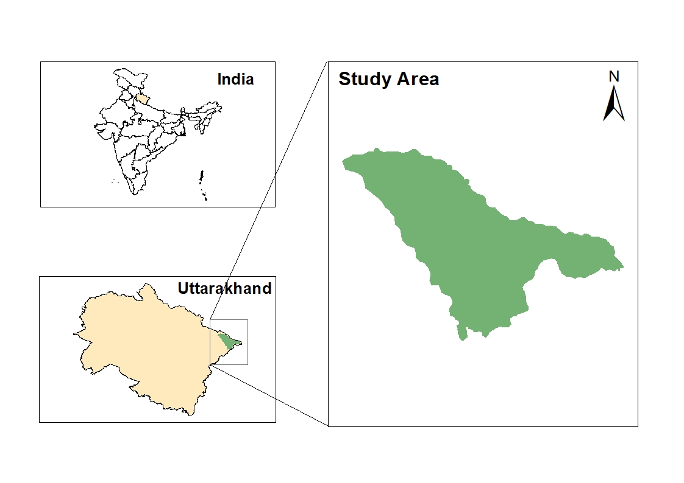
Fig. 1 Sketch map of the Study area

Climate
The area covered with snow during early winter season to late spring (November-April). The climatic data were collected from tehsil Dharchula, nearest climatic station, the mean maximum temperature was 13.9°C and mean minimum temperature was -2.3°C. The rainy season (summer monsoon) extends from mid-June to September, and maximum rainfall (about one third of the annual) occurs during this period (1520mm) (Fig. 2). The snowfall, begins from November and continue until the first week of April. Snow melt begins around mid-April which provide sufficient moisture to the growth of herbaceous vegetation. Geologically the study area situated in greater Himalayan region. The alpine region has a wide range of edaphic conditions due to the diversity of geological formations and highly undulating topography (Valdiya 1980). The weathering of the bed rocks of the Greater Himalaya, particularly at higher elevations, produces a vast amount of loose material in the form of scree, which creates talus slopes that result in coarse and muddy soil. The soils of the area have diverse nature and showed close relationship with vegetation pattern. Texture of soil is sandy loam and clay loam varies in depth across the altitudinal gradients and slightly reddish in colour (Rawat 2012).

Fig. 2 Monthly variation in rainfall (mm) and temperature (°C) in the study area

The area is situated at high elevation where climatic conditions do not favour the growth of tree vegetation and shows the presence of small-structured woody vegetation, grasses, and herbs. The plant communities exhibit a diverse distribution, because of their extremely modest spatial extents, many of these communities can be seen in small patches (<1 to 2 m²) at a single place (Ram et al. 1988). The dominant plant species are Danthonia cachemyriana, Potentilla argyrophylla, Primula macrophylla, etc (Ram et al, 1989; Rawat 2012).
Methodology
For assessing the impact of climate change in alpine meadows, a socio-economic study was conducted to understand local perspectives regarding the phenomenon. Participatory Rural Appraisal (PRA) tools such as seasonal calendars, group discussions, and historical information were used for impact assessment. The collected data, both quantitative and qualitative, was analysed using Excel 2019, and SPSS version 16.0.
The Normalized Difference Vegetation Index (NDVI) was used to analyse the impact of climate change through decadal variation across the study site. The study area was divided into three elevation zones using Shuttle Radar Topography Mission (SRTM) 30 m DEM data. In this study, MODIS MOD13Q1 V6.1 NDVI data (250 m, 16-day composites) from January 2004 to December 2024 were used to analyse long-term vegetation trends (Rao et al., 2015). The annual NDVI cycle was characterized using a double logistic function to improve estimates in high-altitude environments affected by snow cover, short growing seasons, and low radiation. All spatial and statistical analyses, including time series evaluation for each elevation zone, were conducted in Google Earth Engine (GEE) (Kumari et al., 2022). All the information on impacts was further utilized for developing mitigation measures and conservation strategies for biodiversity in high-altitude alpine meadows (Ram et al 1988; Ram, 2005; Nagi et al., 2017). Field visit will be done in the growing season (May-August). NDVI threshold value ( -1 to 1) are capable to identify the health of vegetation (Fig. 3). NDVI Calculated using the formula:
$$NDVI=\frac{NIR-RED}{NIR+RED}$$
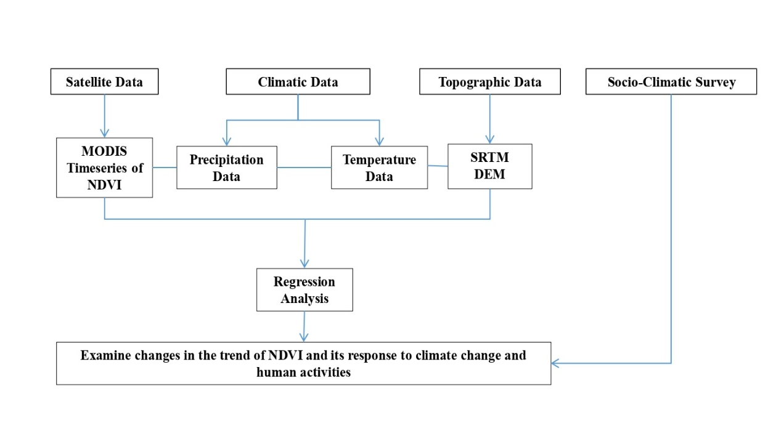
Fig. 03 Flow chart for NDVI data

Data analysis: The collected data, both quantitative, was analysed using Excel 2019, and SPSS version 16.0.
Results
Across the 21-year period in low elevation, vegetation consistently showed a peak NDVI between May and August (Day of Year 129–241), aligning with the summer growing season in alpine ecosystems. Among all the years, 2024 recorded the highest NDVI value of 0.7 on DOY 225, indicating exceptionally lush and dense vegetation cover, possibly due to favourable climatic conditions like adequate precipitation or warmer temperatures. In contrast, the earlier peak NDVI occurred in 2009, 2010, 2020 with a value of 0.6 reached as early as DOY 177 (around late June), suggesting an early onset of the growing season. This early peak may reflect an early snowmelt or unusually warm spring temperatures, which are common indicators of climate variability in this region. Over the years, the data shows noticeable interannual variation in vegetation health and productivity. In early decade (2004–2010), the NDVI values generally show strong seasonal peaks with relatively stable maximum values, indicating a consistent and healthy growing season. However, in the mid-decade period (2011–2016), there is some fluctuation and a few years (e.g., 2013, 2015) show dips in mid-season NDVI values, potentially reflecting environmental stress such as drought, temperature extremes, or land-use changes. A notable decline is observed in 2015 where the NDVI remained lower across many time steps. In recent years (2017–2024), the data indicates a trend of gradual recovery and even enhancement in peak NDVI values. For instance, 2023 and 2024 show a strong increase in mid-season vegetation greenness. This may suggest improved vegetation health due to shifting climatic conditions such as increased summer rainfall or warming temperatures enhancing plant growth at higher elevations. The extension or early onset of the growing season observed in some years (e.g., 2009, 2020) further suggests that alpine vegetation is responding to climate change through phenological shifts (Fig. 4 and 5).
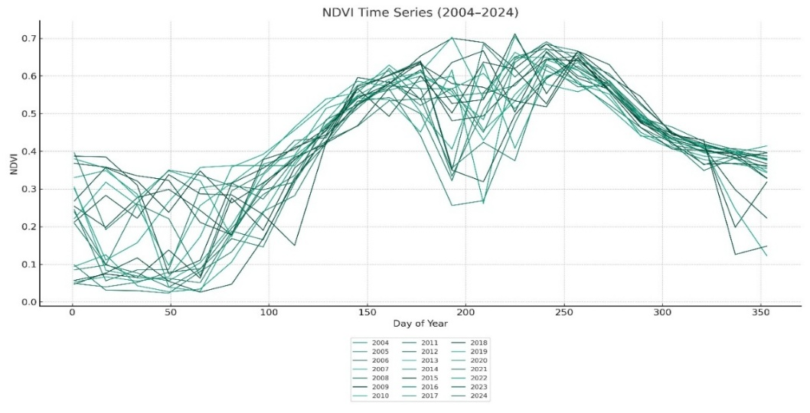
Fig. 4 NDVI time series analysis at low elevation
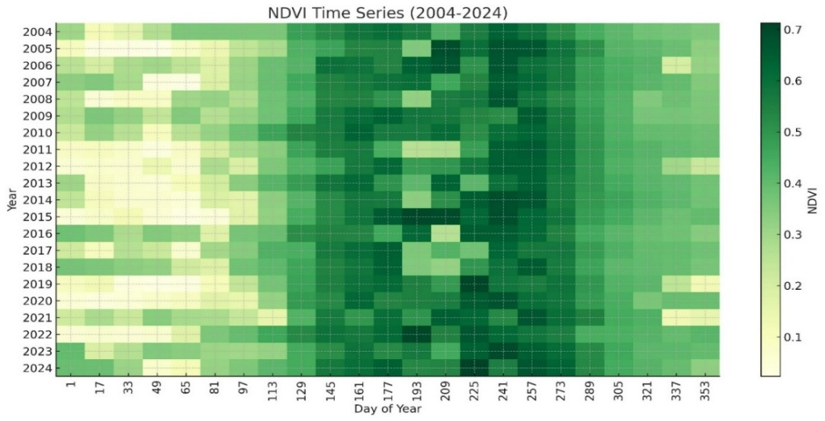
Fig. 5 Heat map low elevation

In mid elevation the NDVI values was low during the early (DOY 1–81) and late parts (DOY 321–353) of the growing season, reflecting snow cover or winter dormancy, and its rise in values from around DOY 97 onwards as the vegetation begins to grow. The peak growing season consistently falls between DOY 161 and 241, where NDVI values reach their highest levels (0.7), indicating maximum plant productivity and greenness. Notably, certain years exhibited early NDVI peaks, suggesting a shift in vegetation phenology likely influenced by climatic changes. Among these, 2010 stands out earliest peak, where a high NDVI of 0.5 was recorded at DOY 161, indicating vegetation reached its peak growth. Similarly, in 2009, the NDVI peaked to 0.5 at DOY 177, reinforcing the trend of early season green-up during this period. In terms of overall productivity, year 2022 recorded the highest NDVI (0.6 at DOY 193), followed by 2024, which reached NDVI 0.6 at DOY 225. Overall, the data suggests a clear ecological response of vegetation to climate variability, with a shift toward earlier and more productive growing seasons in recent years, which could have profound implications for species composition, plant phenology, and ecosystem functioning in high-altitude landscapes (Fig. 6 and 7).
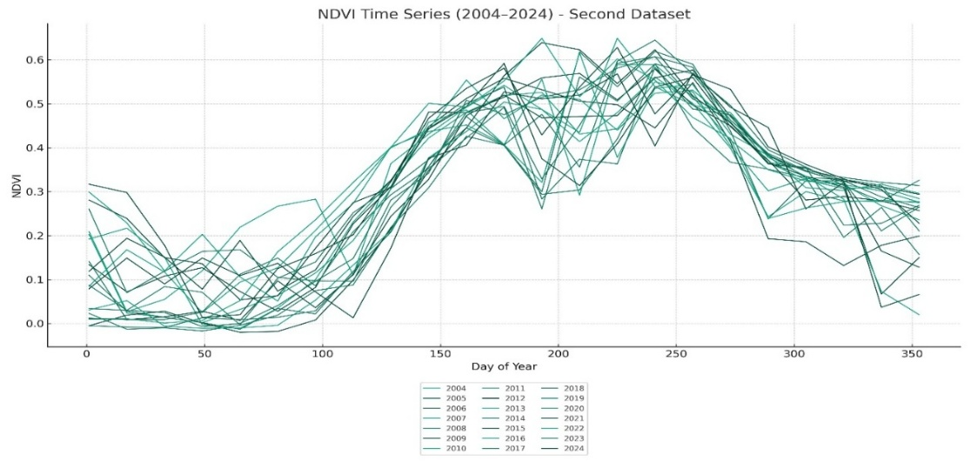
Fig. 6 NDVI time series analysis at mid elevation

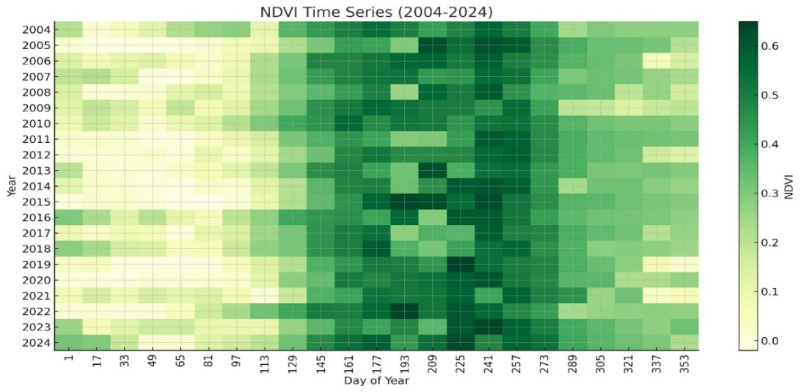
Fig. 7 Heat map mid elevation
In high elevation over the two-decade period, a noticeable fluctuation in NDVI values was observed. Earlier years (2004–2010) show moderate to low NDVI values during peak season compared to recent years, which may be attributed to less favourable climatic conditions, delayed snowmelt, or shorter growing periods. From 2011 onwards, a gradual increase in NDVI values was observed during both early and late growing season, suggesting improvements in vegetation health and growing conditions. This trend may be linked to climatic warming, leading to longer growing seasons and increased photosynthetic activity in alpine environments. However, certain years such as 2015 and 2020 exhibit dips in early season NDVI but high values later in the season, indicating delayed greening or possibly altered precipitation patterns. Additionally, years like 2009 and 2011 show very low NDVI values in the early season, reflecting late snow cover melt or colder early spring temperatures. Notably, in years like 2006, 2010, 2016, and 2022, NDVI values around day 129 were significantly high (e.g., 0.1 in 2006, 0.2 in 2010, 0.2 in 2016, and 0.2 in 2022), indicating early onset of vegetative activity and possibly an early peak season in these years. The year 2022 recorded the highest NDVI value at day 193 (0.5), which reflects the peak of vegetation productivity and biomass accumulation, suggesting favourable climatic and environmental conditions that year. Close to this, other years like 2015 (0.4) and 2023 (0.5) also showed high peak values, indicating years of vigorous vegetation growth. These peak values usually occur around days 193 to 241 (mid to late July and August), which aligns with the known peak growing season in high-altitude alpine regions (Fig. 8,9).
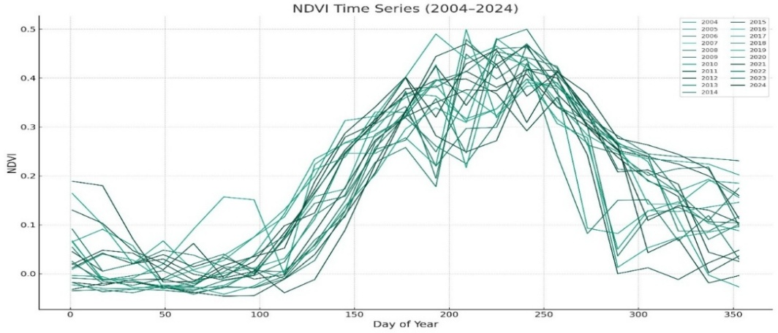
Fig. 8 NDVI time series analysis at high elevation

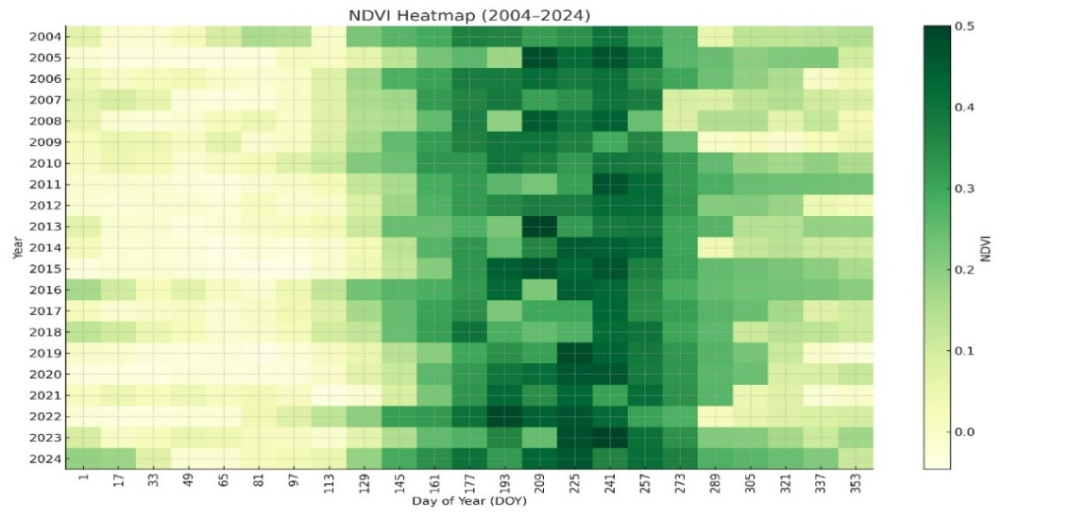
Fig. 9 Heat map high elevation
The temporal analysis of NDVI across low, mid, and high elevation gradients reveals distinct patterns of vegetation dynamics shaped by altitude. At the low elevation, NDVI values showed noticeable interannual variability, with a moderate peak occurring in 2016, and the highest NDVI observed in 2024. Notably, early peak values appeared in 2004, suggesting an earlier onset of vegetation growth in some years. Despite fluctuations, vegetation activity remained relatively stable over the years, indicating resilience at lower altitudes, possibly due to favourable growing conditions like warmer temperature and longer growing season. In contrast, mid-elevation displayed slightly lower NDVI values compared to low elevation, reflecting a shift in vegetation composition or delayed green-up due to declined temperatures. The highest NDVI year at mid elevation was 2022, indicating improved vegetation conditions in recent years, while 2004 again marks an early peak, possibly influenced by climatic anomalies. The high elevation exhibited the lowest NDVI values, as expected due to harsher environmental conditions and shorter growing seasons. Vegetation activity remained suppressed across many years, with negative or near-zero NDVI values dominating the early and late parts of the growing season. Interestingly, the highest NDVI year was also 2024, indicating a possible response to recent warming trends or reduced snow cover allowing longer growing periods.
The community perceptions indicated that 91% of the respondents agreed a rise in temperature and a noticeable change in the seasonal patterns of summer and winter. Previously, people used to migrate to the valley between the last week of April and the first week of May but in recent years, this migration has shifted to the first week of March and returned from last week of September and the first week of October. These shifts in migration patterns reflect broader climatic changes. Moreover, the cultivation patterns of both agricultural and horticultural crops have also changed. Crops that were once limited to lower elevations, such as rajma (kidney beans) and aaloo (potatoes), mattor (pea) now cultivated at higher altitudes, indicating a significant shift in agro-climatic conditions. 89% of the respondents agreed that there have been noticeable changes in the timing of seasons, fluctuations in rainfall patterns, delayed snowfall, prolonged summers, and shorter winters. These climatic changes have significantly influenced vegetation growth in the region and have adversely impacted agricultural production. 86% of the respondents agreed that there has been a decline in the productivity of certain medicinal plant species in the wild, as well as in cultivated areas. Additionally, some native species have been replaced by other species typically found at lower elevations. 91% of the respondents agreed that snowfall has decreased compared to previous years. 82% of respondents agreed that shorter winters as compare to previous years. 80 percent of the respondents observed changes in the population and behaviour of wild animals and others in the forest around their villages. It is also reported that the wild animals have lately shed their natural fear of humans and started to come very close to the habitations and agricultural fields. 74 percent of the respondents agreed that the timing of flowering and fruiting of plants has changed. Early flowering in almost all agricultural, horticultural, and wild species is reported to be a common observation, particularly so in Rubus sp., apples (Malus domestica) and rhododendron (Rhododendron arboreum). This change is attributed to increase in temperature, shortened and less harsh winters and early onset of summer in lower elevation villages of the valley. 57% of the respondents agreed that the increased crop infestations in recent days as compare to previous days. 51% of the respondents agreed that agricultural land is being left barren due to a decline in cultivation activities, as some farmers have ceased farming while others have permanently migrated in search of income and livelihood opportunities. 86% of the respondents agreed that there has been a change in agricultural patterns in recent years, with lower-elevation crops now growing more easily in higher-elevation villages. 49% of the respondents agreed that the increased vulnerability to hazards in recent few years. 74% of the respondents agreed that the decrease in fuel, fodder, medicinal plants, and other forest resources in recent few years. 66% of the respondents agreed that the irregularity in rainfall as compare to previous year. 69% of the respondents agreed that the fluctuations in water availability in recent few years (Table.1).
Table.1 Community perception about climate change
Community’s perception of climate change | Yes | No | Do not know
Rise in temperature | 160 (91%) | 10 (6%) | 5 (3%)
Change in timing of seasons | 155 (89%) | 15 (9%) | 4 (2%)
Decreased in productivity | 150 (86%) | 19 (11%) | 6 (3%)
Less Snowfall | 160 (91%) | 11 (6%) | 4 (2%)
Shorter Winters | 144 (82%) | 18 (10%) | 12 (7%)
Changes in the population and behaviour of wild animal | 140 (80%) | 15 (9%) | 20 (11%)
Changes in flowering ad fruiting time | 130 (74%) | 25 (14%) | 20 (11%)
Increased crop infestations | 100 (57%) | 25 (14%) | 50 (29%)
Agricultural land being left barren | 90 (51%) | 50 (29%) | 35 (20%)
Change in Agriculture pattern | 150 (86%) | 15 (9%) | 10 (6%)
Increased vulnerability to hazards | 85 (49%) | 50 (29%) | 40 (23%)
Decrease in fuel, fodder, medicinal plants, and other forest resources | 130 (74%) | 20 (11%) | 25 (14%)
Irregular rainfall patterns | 115 (66%) | 20 (11%) | 40 (23%)
Fluctuations in water availability | 120 (69%) | 45 (26%) | 10 (6%)

Discussion
Climate change has significant and far-reaching impacts on alpine meadows, which are among the most sensitive ecosystems due to their high elevation and specialized plant communities. Rising temperatures have led to noticeable shifts in species composition, with thermophilic (warm-adapted) species migrating upward and outcompeting native cold-adapted flora. This encroachment poses a threat to endemic alpine species, many of which have limited dispersal ability and narrow ecological niches (Pauli et al., 2012). Additionally, climate change alters phenological patterns such as flowering time and leaf emergence. Early snowmelt and warmer spring temperatures can trigger earlier growth, which may lead to mismatches between plants and their pollinators, ultimately reducing reproductive success (Wipf et al., 2009). Biodiversity in alpine meadows is also declining, as habitat fragmentation and the loss of specialist species reduce ecological resilience (Gottfried et al., 2012). While some areas may experience a temporary increase in biomass due to longer growing seasons and elevated CO₂ levels, this benefit is often counterbalanced by increased drought stress and extreme weather events that hinder plant growth and survival (Klein et al., 2014). Furthermore, changes in plant communities affect key ecosystem processes such as nutrient cycling, soil microbial activity, and carbon storage, leading to broader consequences for ecosystem functioning and climate feedbacks (Díaz et al., 2023). Overall, climate change is transforming alpine meadows in ways that challenge their ecological integrity and long-term sustainability (Körner, 2007). Phenological changes, such as earlier flowering and leaf budding by several weeks, have been observed in high-altitude sites like Gaumukh, Uttarakhand, with cascading effects on plant–pollinator interactions (Kumar et al., 2020). Vegetation monitoring in the northwestern Himalaya shows increasing species richness at lower elevations, while cold-adapted species are declining at higher elevations, indicating thermophilization trends (Bhat et al., 2024). Additionally, glacier retreat and earlier snowmelt are altering soil moisture regimes and lengthening the growing season, further affecting alpine ecosystem dynamics (ICIMOD, 2019; Wester et al., 2019). These changes threaten endemic biodiversity, ecosystem services, and traditional pastoral livelihoods that depend on meadow productivity, underscoring the urgent need for adaptive conservation strategies (Kala, 2017; Sharma et al., 2022).
Search of food is perceived to drive wild animals towards habitations. Climate change is put forth as one of the reasons for random movement of Himalayan black bear towards habitations. Acorns and nuts of the previous year are the main food of this species and when availability of these decreases due to unusual weather events they are reported to wander around for other food items. Many other animals might also be victim of such phenomenon. It is also reported that wild animals have lately shed fear of human presence. This is qualified by increased instances of wild animals being sighted close to habitations and agriculture fields. Incidences of bear and leopard killing animals even in cattle sheds are reportedly rising. The cold climate in these areas is responsible for soil temperature, soil moisture and soil properties which directly regulate plant growth (Hudson et al., 2022).
Overall, NDVI trends suggest that vegetation productivity is highest at low elevations and lowest at high elevations, consistent with altitudinal gradients in temperature, soil depth, and growing season length. The shared pattern of peak NDVI in 2024 across all elevations could reflect a regional climatic influence such as increased summer warmth or favourable precipitation, enhancing alpine vegetation growth. However, the earlier NDVI peaks in 2004 across all elevations may point to unusually early growing seasons possibly driven by anomalous climatic conditions that year. Over the 21-year period, vegetation at higher elevations shows signs of gradual increase, potentially hinting at alpine greening due to climate change, while lower elevations appear more stable but still responsive to interannual variation. Over the two-decade period, the data reveals significant changes in vegetation growth patterns, reflecting both natural variability and long-term environmental shifts. From 2004 to around 2010, NDVI values followed a stable seasonal rhythm, with moderate peaks and gradual transitions. However, from 2010 onwards, several years began to show earlier and stronger NDVI peaks, suggesting the influence of rising temperatures and shifting precipitation patterns. The period from 2015 to 2024 reveals a trend of higher mid-season NDVI values, with multiple years showing strong vegetation growth, extended peak periods, and in some cases, earlier green-up. This indicates a possible lengthening of the growing season and improved vegetation productivity in response to changing climatic conditions such as early snowmelt, warmer springs, and favourable moisture availability. At the same time, some fluctuations, such as in 2005 and 2006, show reduced NDVI levels, possibly due to climatic stress or localized environmental disturbances.
In low elevation relationship between NDVI and temperature showed positive relation (Fig. 10).

Fig. 10 Relationship between NDVI and temperature °C

In low elevation relationship between NDVI and precipitation showed negative relation (Fig. 11). In mid elevation relationship between NDVI and precipitation showed negative relation (Fig. 12). Relationship between NDVI and temperature showed negative relation (Fig.13). In high elevation relationship between NDVI and temperature showed negative relation (Fig.14). In high elevation relationship between NDVI and precipitation showed negative relation (Fig. 15).

Fig. 11 Relationship between NDVI and precipitation

Fig.12 Relationship between NDVI and precipitation

Fig.13 Relationship between NDVI and temperature °C

Fig.14 Relationship between NDVI and temperature °C

Fig.15 Relationship between NDVI and precipitation
Conclusion
This study provides integrated evidence of climate change impacts on Himalayan ecosystems by combining long-term remote sensing analysis with local community perceptions across elevation gradients. The convergence of household survey responses and 21-year NDVI trends clearly demonstrates that rising temperatures, altered seasonal timing, and declining snowfall are reshaping both ecological processes and livelihood systems in alpine regions. Community-reported observations of earlier flowering, reduced medicinal plant productivity, increased pest outbreaks, and changing agricultural practices are strongly supported by NDVI-derived vegetation dynamics. Stable greenness at lower elevations suggests relative resilience under current climatic conditions, whereas increased variability at mid elevations reflects heightened sensitivity to climatic fluctuations. In contrast, gradual greening at higher elevations, along with earlier NDVI peaks, indicates advancing phenology likely driven by warmer springs and earlier snowmelt. While this greening may initially suggest enhanced productivity, it may also signal long-term ecological shifts with potential consequences for species composition, forage availability, and ecosystem stability.

Ethics approval
The study titled “Climate Change Impacts on Community Livelihoods and Vegetation Dynamics Across Elevational Gradients in the Central Himalaya, India” was conducted following the ethical guidelines of Kumaun University. Ethical approval for the field surveys and interviews was obtained from the Institutional Ethics Committee. Prior to participation, all respondents were informed about the purpose and objectives of the research, and their participation was entirely voluntary. Informed verbal consent was obtained from all participants before conducting interviews and household surveys. No personal identifying information was collected, and data confidentiality was strictly maintained.

Consent for Publication
All participants were informed about the purpose of the study and agreed that the anonymized data could be used for publication in scientific journals. As no personal identifying information or images of participants are included in this manuscript, specific written consent for publication was not required.
Competing Interests
The authors declare that they have no competing interests.
Availability of Data and Materials
The data supporting the findings of this study are not publicly available to maintain the confidentiality of participants but are available from the corresponding author on reasonable request.
References
Allen, C. D., Macalady, A. K., Chenchouni, H., Bachelet, D., McDowell, N., Vennetier, M., Kitzberger, T., Rigling, A., Breshears, D. D., Hogg, E. H., Gonzalez, P., Fensham, R., Zhang, Z., Castro, J., Demidova, N., Lim, J. H., Allard, G., Running, S. W., Semerci, A., & Cobb, N. (2010). A global overview of drought and heat-induced tree mortality reveals emerging climate change risks for forests. Forest Ecology and Management, 259(4), 660-684. https://doi.org/10.1016/j.foreco.2009.09.001.
Bhat, A. A., Gupta, S. K., Singh, S. K., Meraj, G., Kumar, P., Kanga, S., Singh, S., & Sajan, B. (2024). Simulating climatic patterns and their impacts on the food security stability system in Jammu, Kashmir and Adjoining Regions, India. Climate, 12(7), 99. https://doi.org/10.3390/cli12070099.
Díaz-Álvarez, E. A., Martínez-Zavaleta, J. P., López-Santiz, E. E., De La Barrera, E., Larsen, J., & Del-Val, E. (2023). Climate change can trigger fall armyworm outbreaks: A developmental response experiment with two Mexican maize landraces. International Journal of Pest Management, 69(2), 184-192. https://doi.org/10.1080/09670874.2020.1869347.
Frenette‐Dussault, C., Shipley, B., Meziane, D., & Hingrat, Y. (2013). Trait‐based climate change predictions of plant community structure in arid steppes. Journal of ecology, 101(2), 484-492. https://doi.org/10.1111/1365-2745.12040.
Gautam, M. R., Timilsina, G. R., & Acharya, K. (2013). Climate change in the Himalayas: Current state of knowledge (Policy Research Working Paper No. 6516). The World Bank. https://doi.org/10.1596/1813-9450-6516.
Gottfried, M., Pauli, H., Futschik, A., Akhalkatsi, M., Barancok, P., Benito Alonso, J. L., Coldea, G., Dick, J. M., Erschbamer, B., Fernández Calzado, M. R., Kazakis, G., Krajci, J., Larsson, P., Mallaun, M., Michelsen, O., Moiseev, D., Moiseev, P. A., Molau, U., Merzouki, A., Nagy, L., Nakhutsrishvili, G. S., Pedersen, B., Pelino, G., Puscas, M., Rossi, G., Stanisci, A., Theurillat, J.-P., Tomaselli, M., Villar, L., Vittoz, P., Vogiatzakis, I. N., & Grabherr, G. (2012). Continent-wide response of mountain vegetation to climate change. Nature Climate Change, 2(2), 111-115. https://doi.org/10.1038/nclimate1329.
Hudson, A. R., Peters, D. P. C., Blair, J. M., Childers, D. L., Doran, P. T., Geil, K., Gooseff, M., Gross, K. L., Haddad, N. M., Pastore, M. A., Rudgers, J. A., Sala, O., Seabloom, E. W., & Shaver, G. (2022). Cross-site comparisons of dryland ecosystem response to climate change in the US Long-Term Ecological Research Network. BioScience, 72(9), 889-907. https://doi.org/10.1093/biosci/biab134
Hülber, K., Wessely, J., Gattringer, A., Moser, D., Kuttner, M., Essl, F., Leitner, M., Winkler, M., Ertl, S., Willner, W., Kleinbauer, I., Sauberer, N., Mang, T., Zimmermann, N. E., & Dullinger, S. (2016). Uncertainty in predicting range dynamics of endemic alpine plants under climate warming. Global Change Biology, 22(7), 2608-2619. https://doi.org/10.1111/gcb.13232
Masson-Delmotte, V., Zhai, P., Pirani, A., Connors, S. L., Péan, C., Berger, S., Caud, N., Chen, Y., Goldfarb, L., Gomis, M. I., Huang, M., Leitzell, K., Lonnoy, E., Matthews, J. B. R., Maycock, T. K., Waterfield, T., Yelekçi, O., Yu, R., & Zhou, B. (Eds.). (2021). Climate Change 2021: The Physical Science Basis. Contribution of Working Group I to the Sixth Assessment Report of the Intergovernmental Panel on Climate Change. Cambridge University Press. https://doi.org/10.1017/9781009157896
Kala, N. (2017). Learning, adaptation, and climate uncertainty: Evidence from Indian agriculture. https://ceepr.mit.edu/publication/learning-adaptation-and-climate-uncertainty-evidence-from-indian-agriculture/
Klein, T., Yakir, D., Buchmann, N., & Grünzweig, J. M. (2014). Towards an advanced assessment of the hydrological vulnerability of forests to climate change‐induced drought. New Phytologist, 201(3), 712-716. https://doi.org/10.1111/nph.12548
Körner, C. (2007). Climatic treelines: conventions, global patterns, causes. Erdkunde, 61(4), 316–324. https://doi.org/10.3112/erdkunde.2007.04.02
Körner, C., & Paulsen, J. (2004). A world‐wide study of high-altitude treeline temperatures. Journal of Biogeography, 31(5), 713-732. https://doi.org/10.1111/j.1365-2699.2003.01043.x
Kumar, S., Chanda, K., & Pasupuleti, S. (2020). Spatiotemporal analysis of extreme indices derived from daily precipitation and temperature for climate change detection over India. Theoretical and Applied Climatology, 140(1), 343-357. https://doi.org/10.1007/s00704-020-03088-5
Kumari, P., Jaiswal, R. K., & Singh, H. P. (2024). Assessing climate change impacts on irrigation water requirements in the Lower Mahanadi Basin: A CMIP6-based spatiotemporal analysis and future projections. Journal of Water and Climate Change, 15(7), 3328-3345. https://doi.org/10.2166/wcc.2024.152
Liu, W., Mo, X., Liu, S., & Lu, C. (2024). Impacts of climate change on grassland fractional vegetation cover variation on the Tibetan Plateau. Science of the Total Environment, 939, 173320. https://doi.org/10.1016/j.scitotenv.2024.173320
McCluney, K. E., Belnap, J., Collins, S. L., González, A. L., Hagen, E. M., Holland, J. N., Kotler, B. P., Maestre, F. T., Smith, S. D., & Wolf, B. O. (2012). Shifting species interactions in terrestrial dryland ecosystems under altered water availability and climate change. Biological Reviews, 87(3), 563-582. https://doi.org/10.1111/j.1469-185X.2011.00209.x
NASA (National Aeronautics and Space Administration). (2023). What Is Climate Change. https://climate.nasa.gov/what-is-climate-change/
Negi, G. C. S., & Mukherjee, S. (2020). Climate change impacts in the Himalayan Mountain ecosystems. In Encyclopedia of the World’s Biomes (pp. 349-354). https://doi.org/10.1016/b978-0-12-409548-9.12056-1
Negi, V. S., Maikhuri, R. K., Pharswan, D., Thakur, S., & Dhyani, P. P. (2017). Climate change impact in the Western Himalaya: people’s perception and adaptive strategies. Journal of Mountain Science, 14(2), 403-416. https://doi.org/10.1007/s11629-015-3814-1
Parmesan, C., & Yohe, G. (2003). A globally coherent fingerprint of climate change impacts across natural systems. Nature. https://doi.org/10.1038/nature01286
Pauli, H., Gottfried, M., Dullinger, S., Abdaladze, O., Akhalkatsi, M., Alonso, J. L. B., Coldea, G., Dick, J., Erschbamer, B., Fernández Calzado, R., Ghosn, D., Holten, J. I., Kanka, R., Kazakis, G., Kollár, J., Larsson, P., Moiseev, P., Moiseev, D., Molau, U., Molero Mesa, J., Nagy, L., Pelino, G., Puşcaş, M., Rossi, G., Stanisci, A., Syverhuset, A. O., Theurillat, J. P., Tomaselli, M., Unterluggauer, P., Villar, L., Vittoz, P., & Grabherr, G. (2012). Recent plant diversity changes on Europe's mountain summits. Science, 336(6079), 353-355. https://doi.org/10.1126/science.1219033
Peñuelas, J., Rutishauser, T., & Filella, I. (2009). Phenology feedbacks on climate change. Science, 324(5929), 887-888. https://doi.org/10.1126/science.1173004
Phillips, S. J., Dudík, M., Elith, J., Graham, C. H., Lehmann, A., Leathwick, J., & Ferrier, S. (2009). Sample selection bias and presence‐only distribution models: implications for background and pseudo‐absence data. Ecological applications, 19(1), 181-197. https://doi.org/10.1890/07-2153.1
Piao, S., Liu, Q., Chen, A., Janssens, I. A., Fu, Y., Dai, J., Liu, L., Lian, X., Shen, M., & Zhu, X. (2019). Plant phenology and global climate change: Current progresses and challenges. Global Change Biology, 25(6), 1922-1940. https://doi.org/10.1111/gcb.14619
Polley, H. W., Derner, J. D., Jackson, R. B., Wilsey, B. J., & Fay, P. A. (2014). Impacts of climate change drivers on C4 grassland productivity: scaling driver effects through the plant community. Journal of Experimental Botany, 65(13), 3415-3424. https://doi.org/10.1093/jxb/eru009
Raina, V. K. (2009). Himalayan glaciers: a state-of-art review of glacial studies, glacial retreat and climate change. http://moef.nic.in/downloads/public-information/MoEF%20Discussion%20Paper%20_him.pdf
Ram, (2005). Biodiversity and conservation of high-altitude meadows of Uttaranchal Himalaya. Bulletin of the National Institute of Ecology, 15, 11-17.
Ram, R. (1988). Additional evidence on causality between government revenue and government expenditure. Southern Economic Journal, 763-769.
Rao, C. S., Lal, R., Prasad, J. V. N. S., Gopinath, K. A., Singh, R., Jakkula, V. S., Sahrawat, K. L., Venkateswarlu, B., Sikka, A. K., & Virmani, S. M. (2015). Potential and challenges of rainfed farming in India. In D. L. Sparks (Ed.), Advances in agronomy (Vol. 133, pp. 113-181). https://doi.org/10.1016/bs.agron.2015.05.004
Rawal, R., Negi, V. S., Bhatt, I. D., & Tiwari, L. M. (2024). Rarities pattern of vascular plants in the high-altitude forests of Indian western Himalaya: Conservation implications. Journal for Nature Conservation. https://doi.org/10.1016/j.jnc.2024.126588
Rawat, P. K. (2012). Impacts of climate change and hydrological hazards on monsoon crop patterns in the Lesser Himalaya: A watershed based study. International Journal of Disaster Risk Science, 3(2), 98-112. https://doi.org/10.1007/s13753-012-0010-6
Schmidt, T., Klemis, V., Schub, D., Mihm, J., Hielscher, F., Marx, S., Abu-Omar, A., Ziegler, L., Guckelmus, C., Urschel, R., Schneitler, S., Becker, S. L., Gärtner, B. C., Sester, U., & Sester, M. (2021). Immunogenicity and reactogenicity of heterologous ChAdOx1 nCoV-19/mRNA vaccination. Nature medicine, 27(9), 1530-1535. https://doi.org/10.1038/s41591-021-01464-w
Sharma, A. K., Sharma, A. K., Sharma, M., & Sharma, M. (2022). Assessment of land use change and climate change impact on biodiversity and environment. In K. D. Bahukhandi, N. Kamboj, & V. Kamboj (Eds.), Environmental Pollution and Natural Resource Management (pp. 73-89). Springer International Publishing. https://doi.org/10.1007/978-3-031-05335-1_5
Sheldon, K. S., Yang, S., & Tewksbury, J. J. (2011). Climate change and community disassembly: impacts of warming on tropical and temperate montane community structure. Ecology Letters. https://doi.org/10.1111/j.1461-0248.2011.01689.x.
Valdiya, K. S. (1980). Geology of the Kumaun Lesser Himalaya. Wadia Institute of Himalayan Geology. https://search.library.wisc.edu/catalog/9910000000002121
Wang, C., Wang, Z., Wang, G., Lau, J. Y. N., Zhang, K., & Li, W. (2021). COVID-19 in early 2021: current status and looking forward. Signal Transduction and Targeted Therapy, 6(1), 114. https://doi.org/10.1038/s41392-021-00527-1
Wester, P., Mishra, A., Mukherji, A., & Shrestha, A. B. (2019). The Hindu Kush Himalaya assessment: Mountains, climate change, sustainability and people. Springer Nature. https://doi.org/10.1007/978-3-319-92288-1
Wipf, S., Stoeckli, V., & Bebi, P. (2009). Winter climate change in alpine tundra: plant responses to changes in snow depth and snowmelt timing. Climatic Change, 94(1), 105-121. https://doi.org/10.1007/s10584-009-9546-x
Xu, L., Gao, G., Wang, X., & Fu, B. (2023). Distinguishing the effects of climate change and vegetation greening on soil moisture variability along aridity gradient in the drylands of northern China. Agricultural and Forest Meteorology, 343, 109786.
Yang, H., & Yang, D. (2011). Derivation of climate elasticity of runoff to assess the effects of climate change on annual runoff. Water Resources Research, 47(7) https://doi.org/10.1029/2010WR009287
Zhou, S., Yu, B., & Zhang, Y. (2023). Global concurrent climate extremes exacerbated by anthropogenic climate change. Science Advances. https://doi.org/10.1126/sciadv.abo1638
Zhu, J.-K. (2016). Abiotic stress signaling and responses in plants. Cell, 167(2), 313-324. https://doi.org/10.1016/j.cell.2016.08.029

