Biodiversity and its importance for Environmental Sustainability-A Case of ICAR-NAARM, Hyderabad, India

ABSTRACT

The biodiversity refers to the all types of life found on the earth. The present paper is deals with an innovative work as biodiversity park in an area of three acres of land at ICAR-National Academy of Agricultural Research Management, Hyderabad by conserving the existing native trees and other plant species. The total area of ICAR-NAARM campus is 125 acres out of which 4 acres of existing land was brought under the biodiversity park in the past five years. The main aim to develop this park is to conserve local flora and fauna consisting of native tree/plant species, reptiles, birds, butterflies and several insects. It is focused on theme-based plantations which have ecological and aesthetic values in mind and several existing tree species were conserved and many more are added by planting. While planting, an importance was given to the fragrant flowering creepers/plants which helped to increase the population of butterflies and various insects. Variety of turf grasses were also considered for plantation to attract the several insects for the survival of birds and to maintain the ecological balance. Regarding the plantation of various local species viz., flame of the forest (Butea monosperma L.), Bael (Aegle marmelos L.), Wood apple (Aurantioideae L.), Bamboo spp. (Bambusoideae L.) and medicinal/herbal plant varieties were included for their conservation as well to make awareness among the commuters and visitors about the local flora and fauna. This area is naturally sloppy from western part towards the east side which was also helped us to develop a water harvesting pond. This park serves as a show window for the Academy for the flora and fauna. The important birds, reptiles and butterflies are found in the campus which includes peacock, sparrow, kingfisher, quail, crane, rabbit, mongoose and many more in the list.

Keywords: Biodiversity, conservation, birds, flora and fauna, environment and sustainability.

Introduction

Biodiversity is the concept to have a balance between nature and mankind (A K Singh, 2017). It includes genetic differences within species, the availability of a variety of species in a particular area their habitat in the landscape. The quality of the environment is deteriorating worldwide, with declining, frequent occurrence of pandemics and threats to the natural ecosystems. In this situation of global scenario, bringing back nature close to humans has prime importance. Bringing back depleted soils to normal good healthy soils by opting for natural farming practices is one of the best examples. Biodiversity helps to protect homeless wild animals, reduces global warming, and controls floods and soil erosion, biodiversity also helps to save wild/rare species of birds. Trees are helpful in producing oxygen and inhaling the carbon dioxide which maintains the balance in the environment. By saving the trees global temperature can be reduced which is again helpful for the mankind for the cultivation of various crops for better harvest.

The main cause of biodiversity loss is due to changes in natural habitats (Newbold, 2018). It happens due to the fragmentation of tropical forests and the reduction in the area (Alroy, 2017, Haddad et. al., 2015). These type of changes in the natural habitats, modifications, and climate changes are the challenges to the biodiversity (Scarano & Ceotto, 2015). Due to human activities, there are changes in climate and it causes in reduction of shift of species distributions (Lyra et al., 2017; Parmesan & Yohe, 2003). Hence, it is an important task to balance between habitat loss, fragmentation, and climate change for the conservation of natural habitats (Tilman et al., 2017).

Benefits of biodiversity: There are many advantages of biodiversity such as the conservation of the natural heritage of a particular area, and enhancement of the urban environment, biodiversity connects people, and it also helps to create a hub for education, cultural and conservation activities.
It serves as a hub for education, cultural, and conservation activities. Biodiversity also promotes eco-tourism and provides livelihood opportunities to the local communities. Biodiversity functions as a living lab to understand the ecology and its functions. Biodiversity also checks on weather and carbon dioxide and helps to reduce pollution as well as serves as climate change adaptation. It prevents the endemic plant and animal species. Considering these important facts of the biodiversity ICAR-NAARM has taken the initiative to develop a biodiversity park in its campus at Hyderabad.

The ICAR-National Academy of Agricultural Research Management is an apex institute of Indian Council of Agricultural Research (ICAR) which was established in 1976 to address the training at the national level to the newly appointed agricultural scientists through the Agricultural Research Service of ICAR. Later on, the Academy’s role was expanded and its involved in research and capacity building of senior professionals at national and international levels. The 125 acres of the campus of the Academy is covered with a fruit plantation, avenue plantation, floriculture crops, lawns, gardens, nursery, and ABD park as a demonstration farm. Out of 125 acres of campus, 60 acres of land is covered with roads, hostels, guest houses, and other official buildings and the remaining area is under plantation.

Considering the importance of biodiversity worldwide and safeguarding the environment the present study was planned and started the area to be conserved and to develop as a biodiversity park at the Academy. Biodiversity for today and future is an important aspect for ecosystems population and species for their uniqueness and conservation and it is also helpful for the human population. In the past we have lost many species of plants/animals and microorganisms and many more are declared as endangered species. To avoid this situation, it is important to safeguard the present biodiversity for the benefit of society and for the entire generations to come.

The main objectives to develop this biodiversity park is to conserve biodiversity of a particular area for genetic importance and its stock availability. While developing the biodiversity park, the main focus was given to the conservation of rare plants/endangered species as well as to protect the existing native trees. It was also focused on having some ornamental plants in the biodiversity park to attract commuters to visit. This park will also be helpful to the researchers/educationists as well to the public to understand the biodiversity of the local ecosystem and will have a great impact on saving the environment.

Survey

The concept of developing a biodiversity park at ICAR-NAARM, Hyderabad was worked out with the officials of the All India Network Project (AINP) on Vertebrate Pest Management (VPM) of PJTSAU, Hyderabad and the committee members of biodiversity development constituted at NAARM based on the recommendations of the Research Advisory Committee of the Academy. After having several talks and meetings with external and internal experts the following themes were considered to be included in the biodiversity park by protecting the existing tree and plant species.

Natural resources management: In this theme, the existing slope from the western side of the area towards the eastern part of the biodiversity was managed by digging a channel connected to a watershed pond in the area. The watershed pond was developed in the lowest part of the area where the natural rainwater runoff was stopped and water is collected which helped in groundwater recharge in the area sufficient water is also the tube wells of that area and the same water is used for irrigation purpose presently.

Conserve moisture and stop soil erosion: As a part of soil conservation and to maintain the moisture in this particular area grass plantation was taken up along with the channel as well as the side walls of the water shed pond which is ultimate helped to top the soil erosion, ground water recharged and natural water moisture is also maintained.

Conservation of tropical tree/plant species and medicinal plants: The area was surveyed by the experts and many native/tropical plant species, medicinal and herbal plants were identified, conserved and some of the tropical tree species as well as medicinal plants were considered for the plantation. Based on the suggestions of the committee many medicinal and herbal plants were planted considering their importance in human health.

Focus on groundwater recharge: Improvement in groundwater is one of the most important expected benefits from soil which was achieved in this area by developing the natural watershed pond which was connected by a sloppy channel available in the area that passes through the campus which is a good source to harvest the water during rainy season.

Execution of work and results

The execution of biodiversity park work was taken up in 2017 by identifying the area within the campus. The ICAR-NAARM is located at 17°18'49"N latitude and 78°24'42" East longitude in Hyderabad. The Academy is spread over 125 acres consisting of roads, buildings, residential quarters, guest houses, and agricultural demonstration farm out of which around 4 acres’ area were earmarked specially to be brought under the biodiversity park. The expert advice from Professor Jayashankar Telangana Agricultural University sought for identification of native tree/plant species.

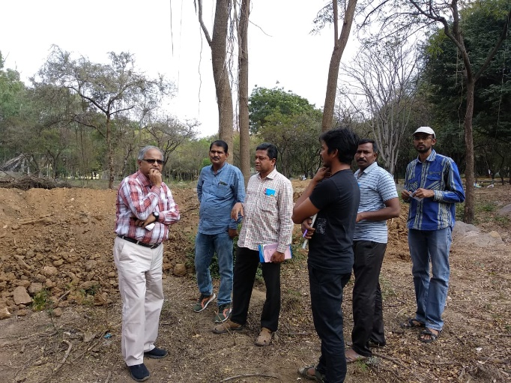 | 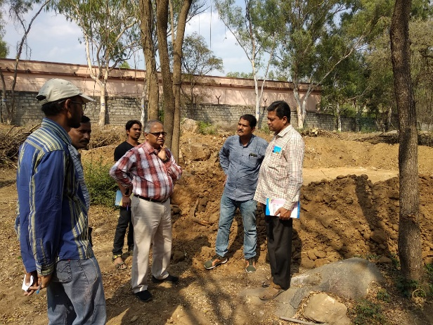
Fig 1-Experts from the All India Network Project (AINP) on Vertebrate Pest Management (VPM) of PJTSAU, Hyderabad

While identification, importance was given to the local native and tropical tree/plant species as well as herbal and medicinal plants for conservation based on their medicinal properties. During the execution of the work, existing trees/plants were trained by pruning without disturbing the natural vegetation except for the unwanted bushes, grasses, and other weeds which were removed, and various turf grasses were planted to avoid soil erosion and to attract the insects, birds and reptiles for their natural habitat.

The plantation of various tree/plant species following major components were considered as forest trees/Native trees, flowering bushes, Flowering creepers and climbers, Cactus and succulents, Colourful ornamental plants, Aromatic plant species, various grasses, Fruit plants etc.

Native trees: Naturally grown native trees such as Azadiracta indica (Neem tree), Tamarindus indicum (Tamarind), Butea monosperma (Flame of the forest), Bambusa vulgaris (Bamboo), Mellingtonia hortensis (Tree jasmine), Delonix regia (Gulmohor), Peltophorum pterocarpum (Peltoforum ), Santalum album (Sandal wood) and Zizipus Zujube (Ber) were trained for their proper shape and development.

Forest / avenue tree (New plantation): To bring aesthetic value and awareness about various tree species and their importance among the visitors the new plants were include in this area such as Ficus benghalensis (Banyan), Neolamarckia cadamba (Kadamba), Filicium decipiens (Japanese fern tree), Tabebuea argentia (Golden bell), Tabebuea avellanidaeae (Pink tabebuea), Tabebuea rosea (Rosy trumpet tree), Jacaranda mimosifolia (Blue Jacaranda), Spathodea campanulata (Spathodia), Bauhinea purpurea (Orchid tree), Mimusops elengi (Bakula tree), Albizzia lebbeck (Siris), Cassia marginata (Red shower), Cassia javanica (Pink shower), Cassia fistula (Golden shower), Ficus krishnae (Krishna fig), Lagerstroemia flos-reginae (Pride of India), Callistimon citrinus (Bottle brush), Plumeria rubra (Temple tree), Strelitzia reginae (Bird of paradise) and Ravenala madagascariensis (Travellers palm).

Flowering bushes/plants: To add a flavor in the beauty of the campus, to attract the butterflies and honey bees several flowering bushes and other annual flowering plants are planted viz., Hibiscus rosa-sinensis (Rose mallow), Jasminum (Jasmine), Felicia amelloides (Daisy), Solidago nemoralis (Golden rod), Euphoria mili (Crown of thorns), Ixora coccinea (West Indian jasmine), Centaurea cineraria (Dusty miller or silver dust), Cestrum nocturnum (Night queen), Cestrum diurnum (Day king), Nycanthes arbor-tristis (Parijat), Artabotrys hexapetalus (Madan mast) etc.

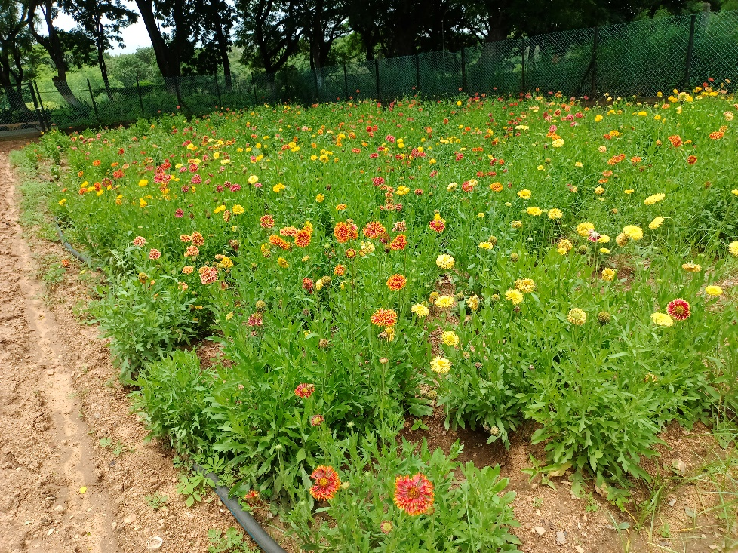
Fig 2-Galardia in flowering at ICAR-NAARM

Flowering Creepers and climbers: As part of the beautification and to bring the glory of the area as well as to attract the butterflies several flowering creepers and climbers are planted in this area namely., Bignonia purpurea (Purple funnel vine), Combratum indicum (Rangoon creeper or Madhumalati), Allamanda cathartica (Allamanda), Ficus pumila (Creeping fig), Mansoa allicea (Garlic creeper), Passiflora edulis (Passion fruit), Pentalinon luteum (Allamanda yellow flower), Bougainvillea, Clerodendrum thomsoniae (bleeding glory-bower), Pyrostegia venusta (Flame vine), Ipomoea indica (Blue morning glory) and Thunbergia grandiflora (Bengal clockvine).

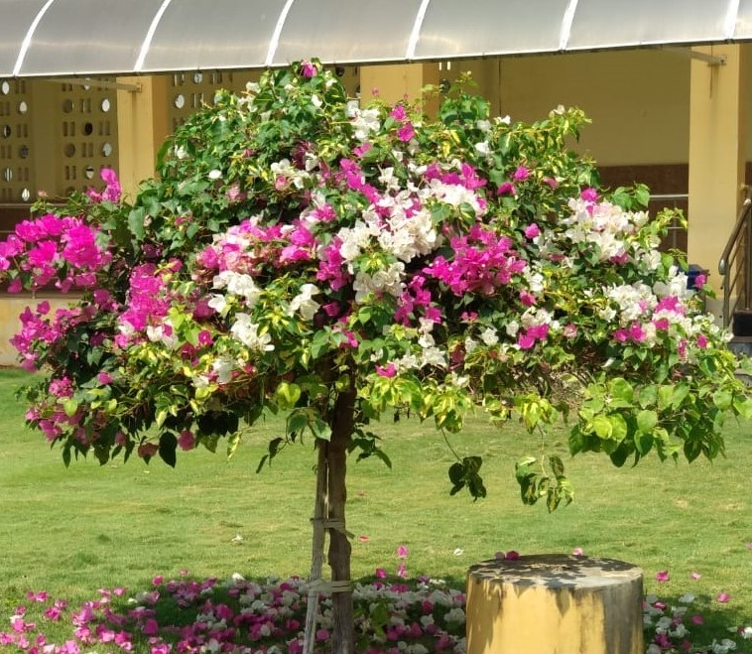
Fig 3-Bougainvillea plant in full bloom at ICAR-NAARM, Hyderabad

Ground covers and grasses: Importance was given to covering the soil to add beauty in the area, to avoid the growth of wild bushes/weeds, to stop soil erosion and to attract insects as well as butterflies several ground covers were planted such as Sphagneticola trilobata (trailing daisy-yellow flower), Stenotaphrum secundatum (Saint Augustine shade grass), Paspalum vaginatum (Paspalum shade grass) and Cenchurus setaceus (Red fountain grass). Due to these ground covers there are plenty of insects available for the birds to eat and a number of butterflies are also seen in this area.

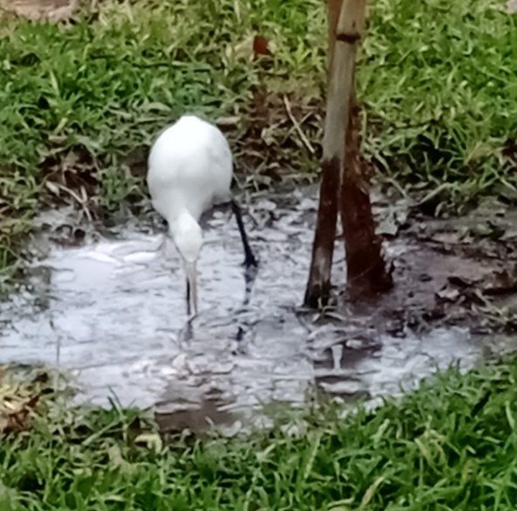  Fig 4-Paspalum vaginatum turf grass plantation | 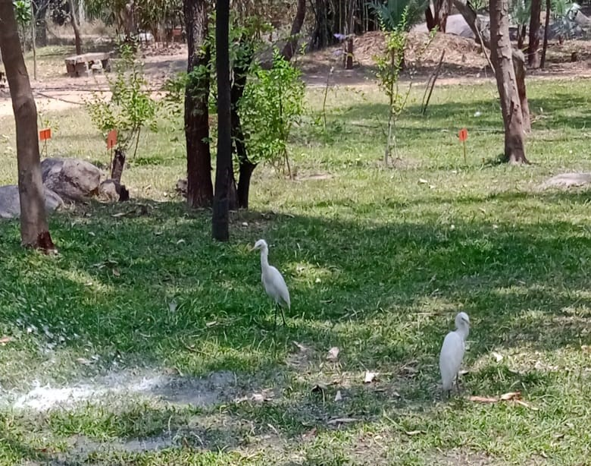  Fig 5-Stenotaphrum secundatum (St. Augastine) turf grass attracted the birds Birds attracted for their survival

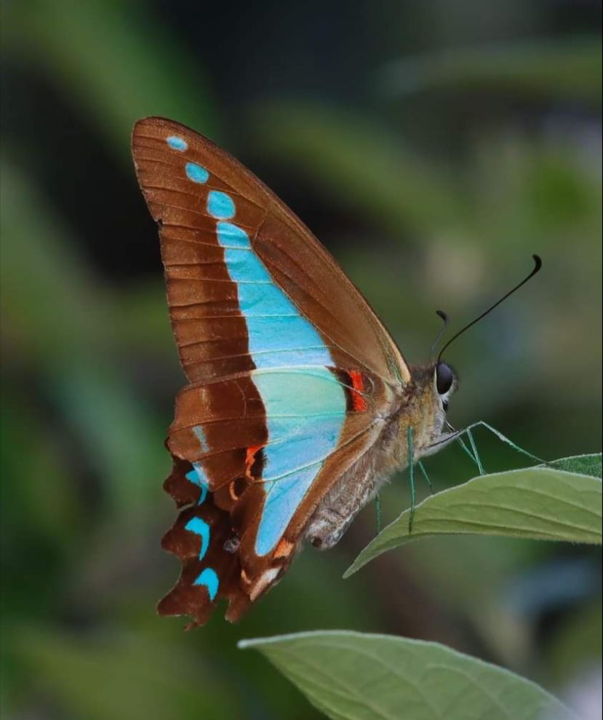 | 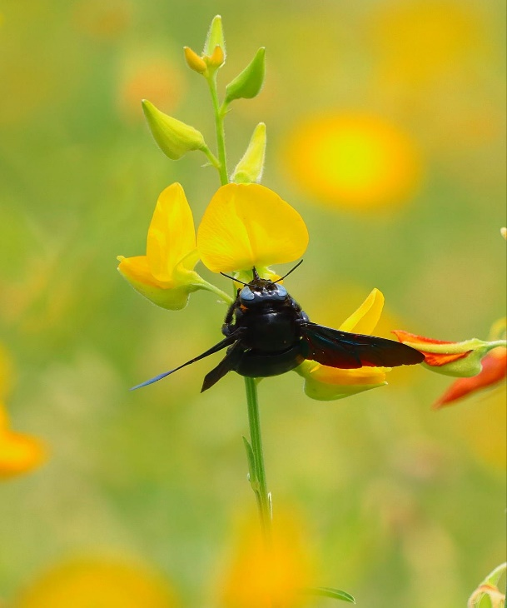

Fig 6- Biodiversity of butterfly
Cactus and succulent desert plants: The biodiversity park area is naturally covered with rocks, stones, and boulders. To bring back the natural beauty of this area for its beautification and attraction several hardy, desert plants were planted which includes Sansveria (Devil's tongue), Sedum confusum, Huernia species (Cactus plant), Kalonchoe pumila (flower dust plant), Pepromia obtusifolia, and Kalanchoe species.
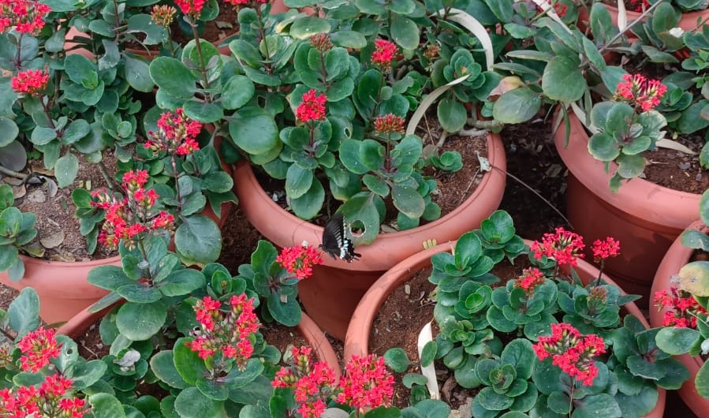
Fig 7-Kalonchoe pumila (flower dust plant)

Ornamental flowering / colourful foliage plants: The biodiversity park is also planted with several varieties of ornamental flowering and colouful plants such as several eranthimum species (Eranthimum black magic, Pseuderanthemum maculatum, Bi-colour eranthimum Graptophyllum, Eranthimum multi-colour), Acalipha species, Palm Varieties, Ornamental bamboo species and many more ornamental plants are included in the area as the Academy receives more than 6000 visitors annually which includes the students, teachers from State Agricultural Universities, trainee participants of various training programmes.

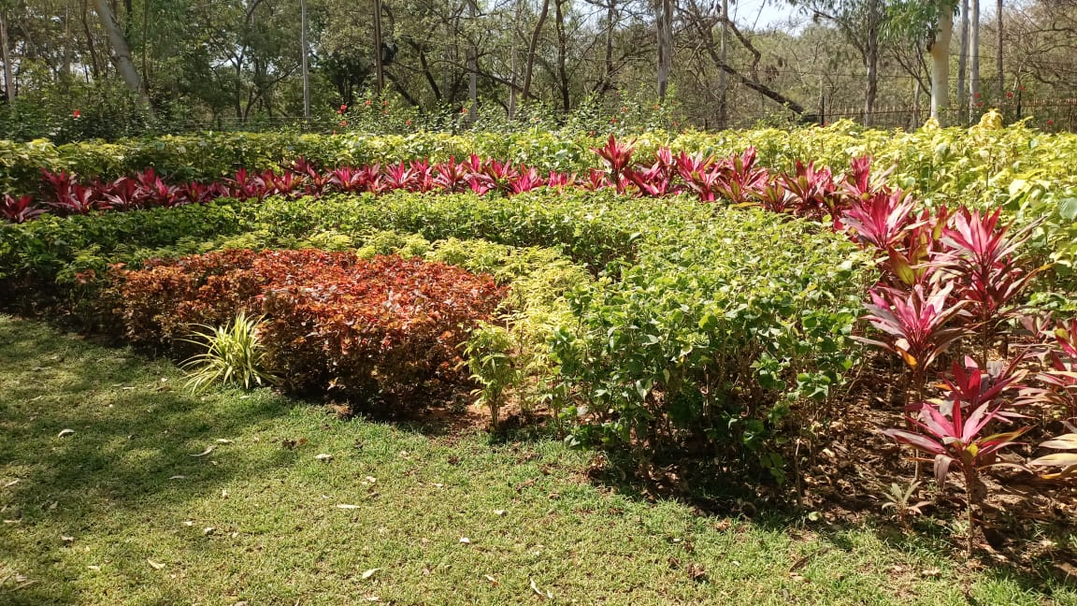
Fig 8-Plant rainbow at biodiversity Park ICAR-NAARM
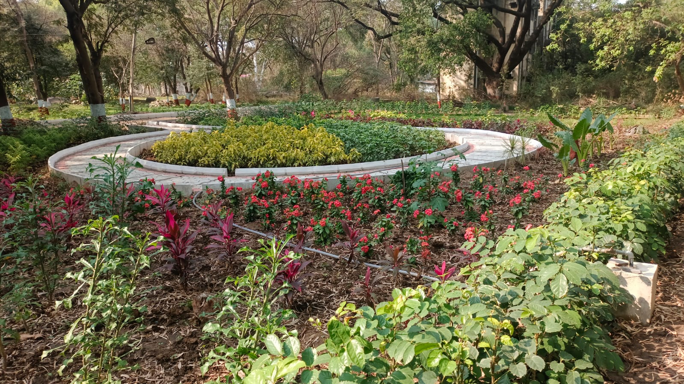
Fig 9-Colourful foliage / flowering plants at biodiversity Park ICAR-NAARM

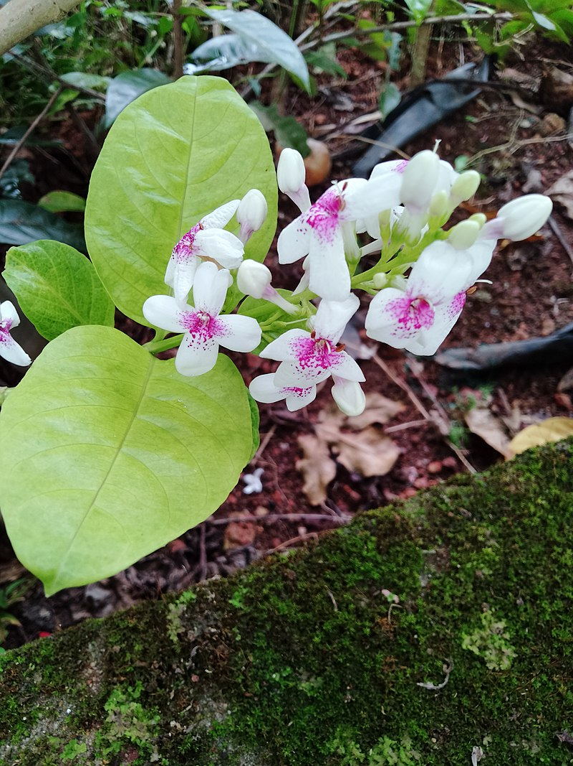  Fig 10-Pseuderanthemum maculatum | 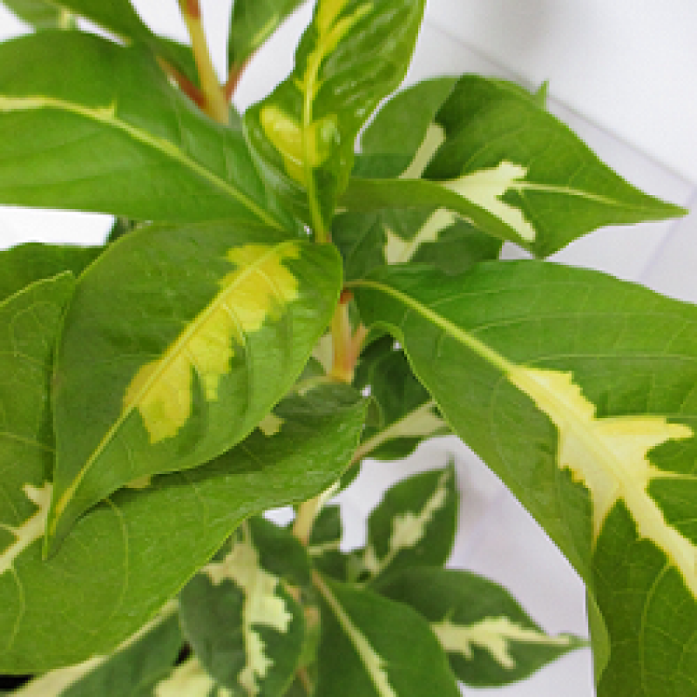  Fig 11-Graptophyllum Plant (Bi-colour eranthimum)
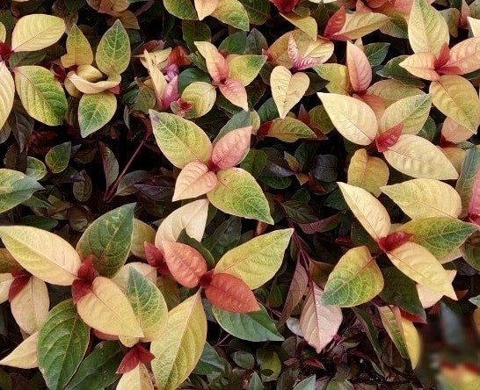  Fig 12-Eranthemum Variegated | 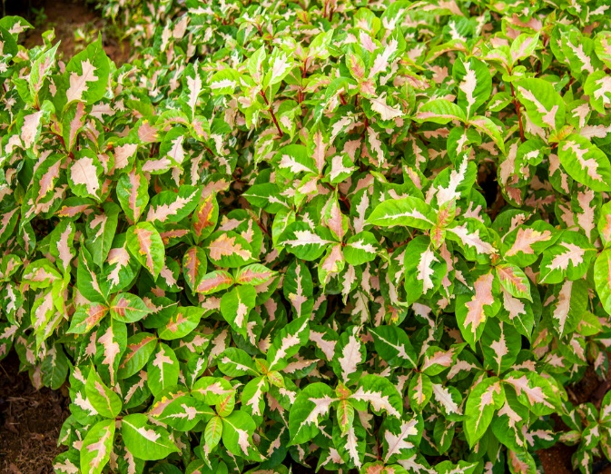  Fig 13-Eranthimum multicolour

Plantation of Herbal, Medicinal, and Aromatic Plants: The Academy receives around 12000-15000 visitors on campus consisting of students, farmers, researchers, scientists, enthusiast, and many more as the Academy also serves on educational aspects. Considering the importance and variety of visitors around 50 herbals, medicinal, and aromatic plants were planted to make awareness among the visitors about the plants and their use in human health. The plants which are included in the herbal garden are citronela, lemon grass, vettiver, khus grass, multivitamin, insulin, erithrina indica, Arjuna tree, Arrow root, Thippa tiga (Giloy), Gymnema silvester, thorn apple and many more are planted in the garden with display of self-explanatory boards consisting of Scientific and local name, use of plant, part of plant used.

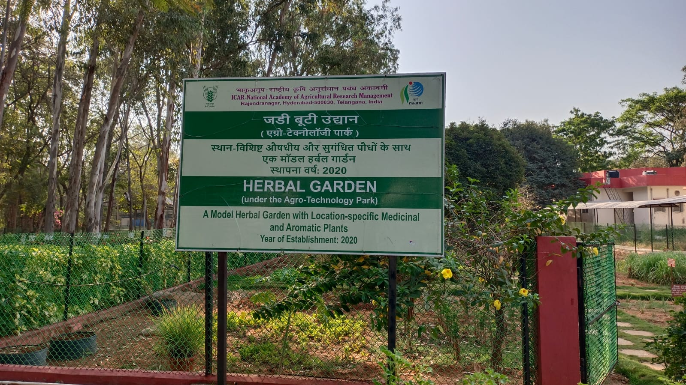
Fig 14-Herbal Garden developed at ICAr-NAARM, Hyderabad

Fruit orchard plantation: As a part of demonstration of fruit orchards the Academy has planted Mango, Guava, Sapota, Sweetlime, Custard apple (Annona squamosa) Aamla (Emblica officinalis) and many other soft fruit orchards are also developed. Other than that while developing biodiversity park for the survival of birds like Peacock, Parrot, Indian roller (Coracias benghalensis), Sparrow, Quail and many more in the list.

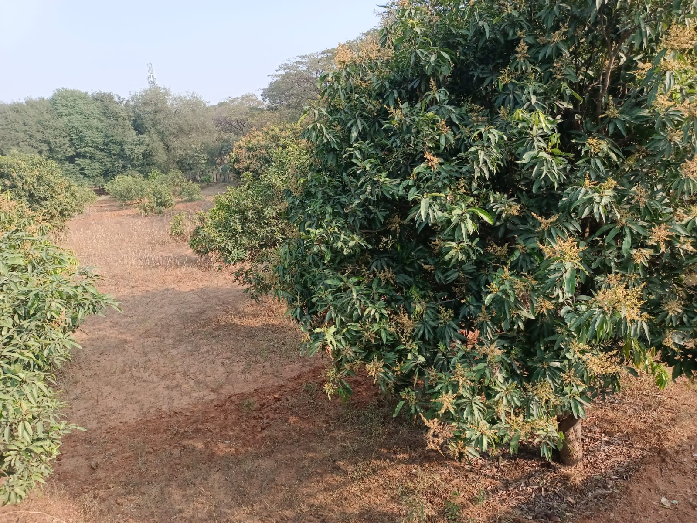
Fig 15-Mango orchard developed at ICAR-NAARM

Safeguarding / Conservation of Peacock, Reptiles, Butterflies other birds: The NAARM campus covered with a lot of tree species, lawns, gardens, orchards, water bodies (Lake & Watershed ponds), plant nurseries, herbal gardens, and many technologies-related to agriculture are displayed in the campus. Due to these plantations as the green campus, many birds are finding their safest shelter in the campus. Therefore, to maintain the ecological balance, initiative has been taken to safeguard the birds such as peacocks, white cranes, myna, squirrels, mongoose, and other reptiles. These reptiles and birds find their feed naturally on various fruits such as Mango, Guava, Sapota, Phalsa, Aamla, Custard apple, Star berries, Fig, Pomegranate, and Sweet lime which are already planted in the campus as agro-technological demonstration blocks. To safeguard these birds and reptiles spraying of insecticides is mostly avoided and natural/botanical pesticides are used for controlling the pest problem in the orchards. These practices are helpful to us to maintaining the ecological balance for the conservation of birds/reptiles to remain sustainable for a healthy environment.

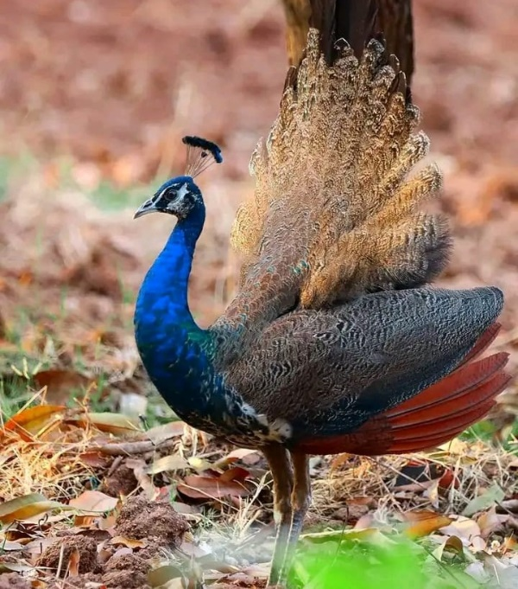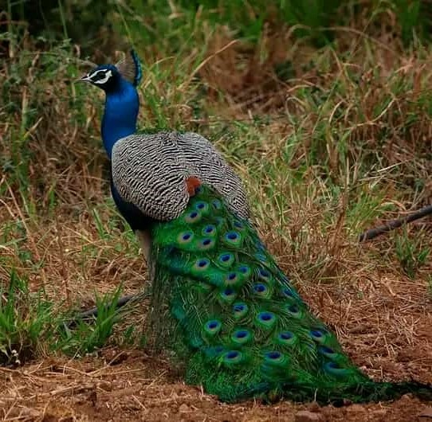
Fig 16-Pea hen and peacock in the Biodiversity park area at ICAR-NAARM Campus

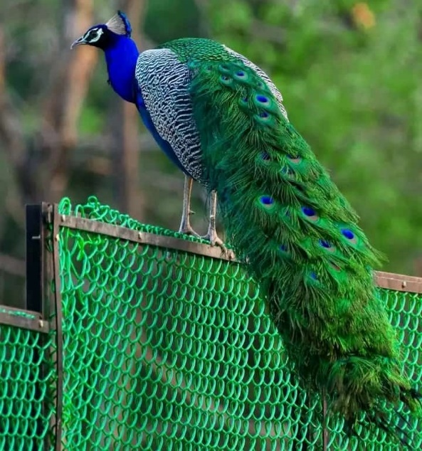  Fig 17-Peacock on orchard fence | 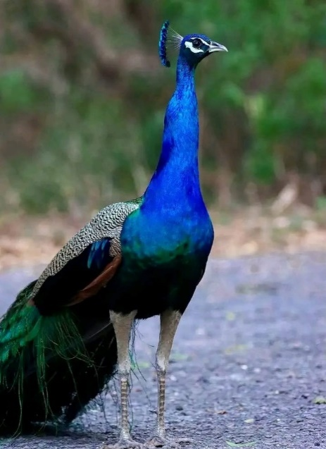  Fig 18-Peacock while taking walk on the road in campus

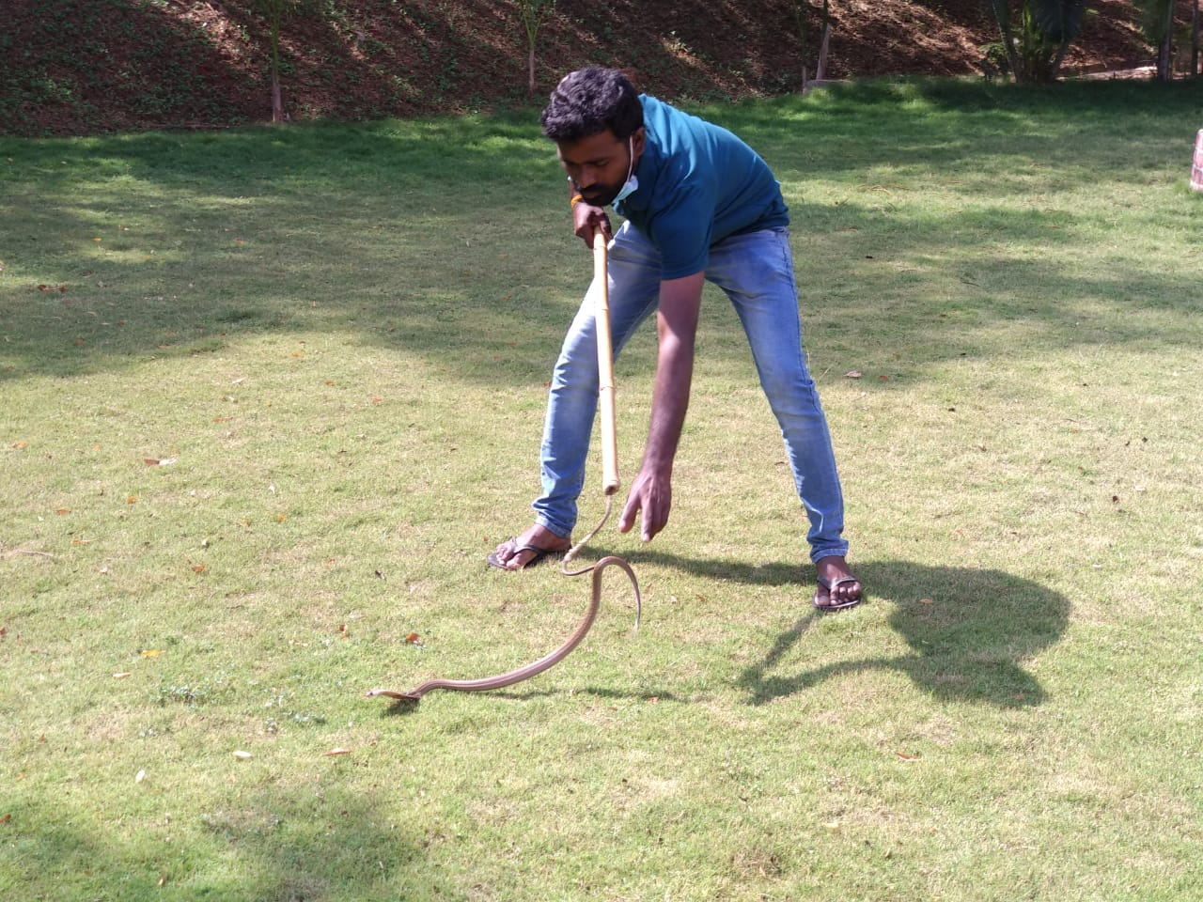
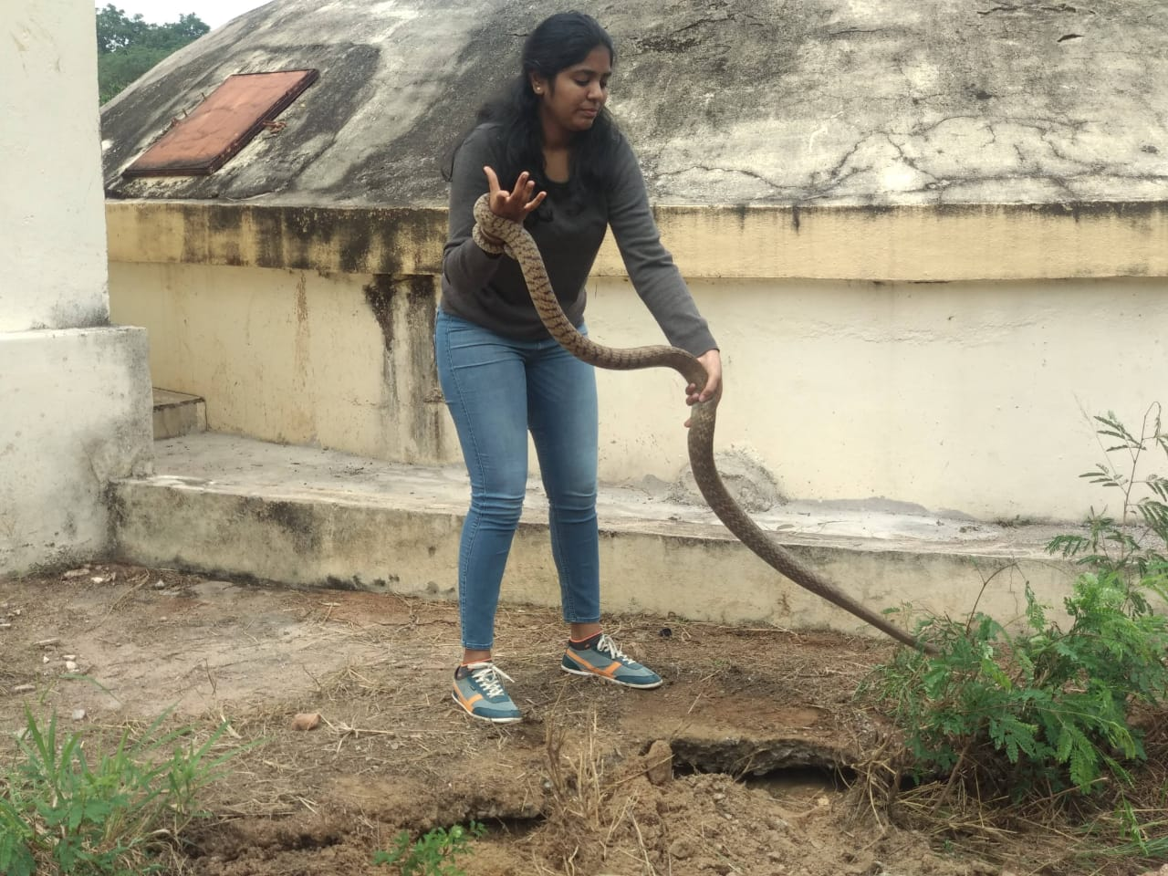
Fig 19-Safeguarding of reptile in campus are captured with the help of trained Sarp Mitras and released tie to time in the safe areas in campus.

Wealth creation out of waste: As a part of the sustainability the leaf litter and other waste generated from the area is converted into vermi-compost or compost. The visitors were also exposed on the activities taken up at the biodiversity park by collecting the farm waste or leaf litter which is collected and used for vermi-compost preparation. Even the grasses planted at this area is also used in compost making. Ultimately the entire waste generated in this area is used for compost making and used in plants for self-sustainability and also helps to reduce the maintenance cost of plants. Shed grasses planted in the biodiversity park were trimmed regularly and it is used for compost making. Regular sweeping work in the biodiversity park was taken up for collection of leaf litter and the collected litter will be converted as vermicompost.

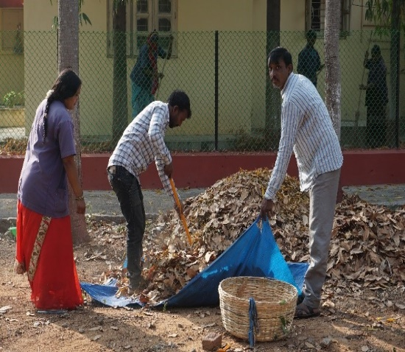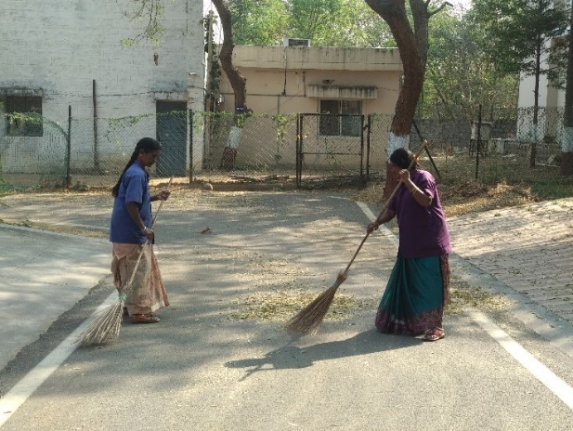
Fig 20-Collection of leaf litter by sweeping of roads and surrounding areas of the buildings for compost preparation

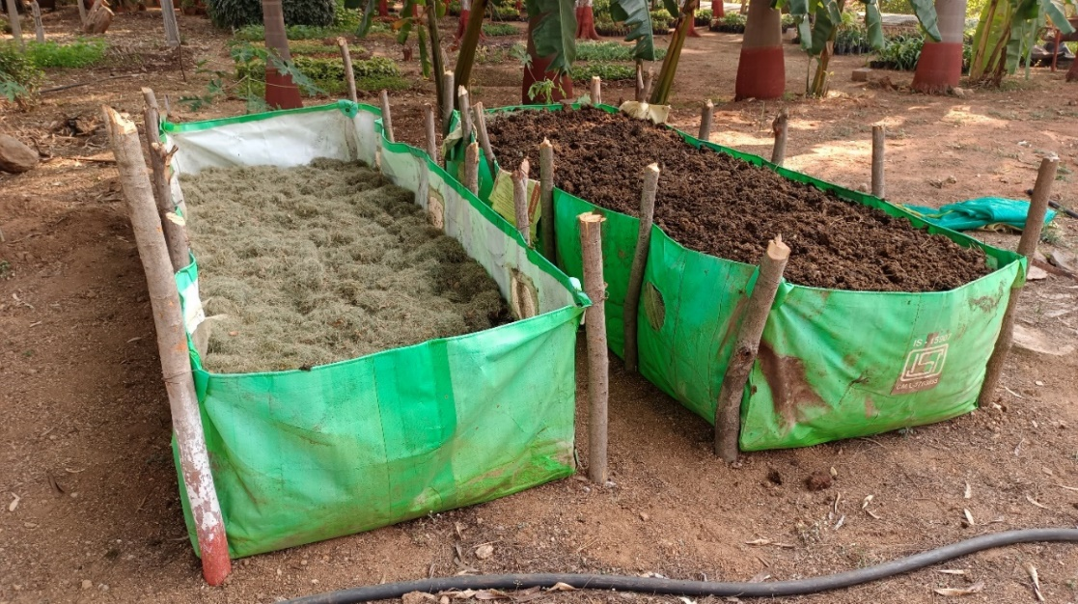
Fig 21-HDPE Mobile vermicompost beds

Awareness creation among the trainee participants/visitors: The Union Government has given a lot of importance to Swachhta activities, hence we at the Academy have taken the initiative to make awareness among the commuters for disposal of waste in the safest manner and value creation from the waste. The above photographs were taken during the visit of newly recruited FOCARS trainees at the biodiversity park and they were explained the value creation from farm waste and the importance of the biodiversity for conservation of endangered species of plants/animals and the sustainability of the environment.

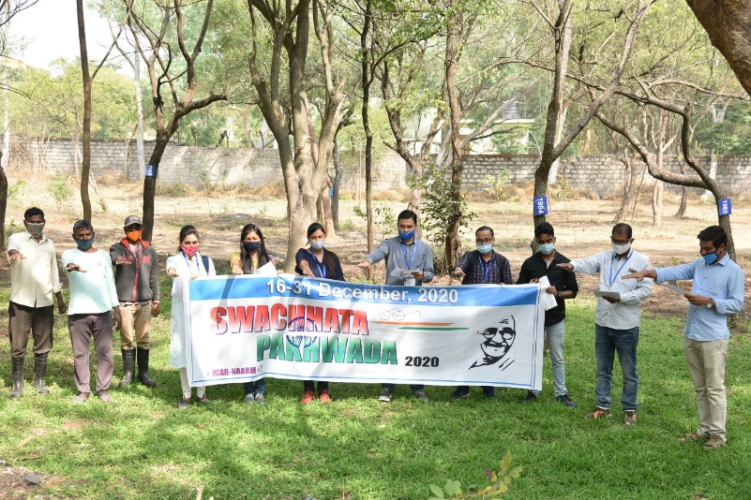
Fig 22-Swatchhta Pledge taken by visitors at Biodiversity Park ICAR-NAARM

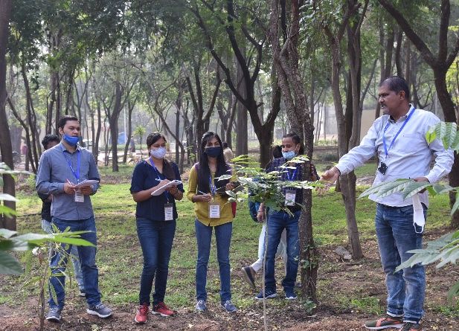 | 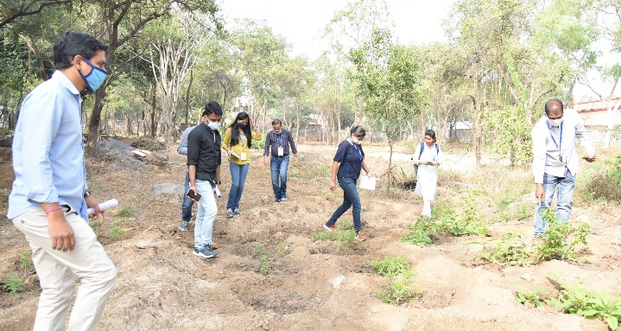
Fig 23-Visitors at Biodiversity Park-ICAR-NAARM

Conclusion: The National Academy of Agricultural is an important institute of the Indian Council of Agricultural Research which imparts training for entry-level scientists recruited through the Agricultural Scientists Recruitment Board and it’s an apex institute for Capacity building of all categories of employees of NARES such as Scientific, Technical, Administrative staff and skilled support staff and also receives a 6000 plus trainee participants, visitors, students and farmers for various purposes of the clienteles. To serve the needs of these clients the biodiversity park will create awareness among the clients about the heritage of tree/plant species, the natural environment, and its importance, it also brings the natural aesthetic value to the campus and will also have an educational impact.

References:

A.K. Singh (2017). Biodiversity Park: An Innovative Approach for Green Environment, Rai Journal of Technology Research & Innovation, Vol.5. No.1. Pp.9-11.
Alroy, J. (2017). Effects of habitat disturbance on tropical forest biodiversity. Proceedings of the National Academy of Sciences of the United States of America, 114(23), 6056–6061. https://doi.org/10.1073/pnas.1611855114
C.R.Babu (2012). “Biodiversity Parks : An Innovative approach for conservation of natural heritage and enhancement of quality of urban environment”. Centre for environmental management of degraded ecosystem.
Cardinale, B. J. (2011). Biodiversity improves water quality through niche partitioning. Nature. https://doi.org/10.1038/nature09904
Champion, H. G. and Seth, S. K. (1968). Revised forest types of India, Govt. of India Publication, and New Delhi.
Chaudhury, K. (2008). Diversity and Phytosociological Analyses of North Andaman Forests with Special Reference to RS and GIS, Ph. D thesis submitted to University of Calcutta.
Haddad, N. M., Brudvig, L. A., Clobert, J., Davies, K. F., Gonzalez, A., Holt, R. D., Lovejoy, T. E., Sexton, J. O., Austin, M. P., Collins, C. D., Cook, W. M., Damschen, E. I., Ewers, R. M., Foster, B. L., Jenkins, C. N., King, A. J., Laurance, W. F., Levey, D. J., Margules, C. R., Melbourne, B. A., Nicholls, A. O., Orrock, J. L., Song, D.-X., & Townshend, J. R. (2015). Habitat fragmentation and its lasting impact on Earth’s ecosystems. Science Advances, 1(2), e1500052. https://doi.org/10.1126/sciadv.1500052
Scarano, F. R., & Ceotto, P. (2015). Brazilian Atlantic forest: impact, vulnerability, and adaptation to climate change. Biodiversity and Conservation. https://doi.org/10.1007/s10531-015-0972-y.
Lyra, A., Imbach, P., Rodriguez, D., Chou, S. C., Georgiou, S., & Garofolo, L. (2017). Projections of climate change impacts on central America tropical rainforest. Climatic Change, 141(1), 93–105. https://doi.org/10.1007/s10584-016-1790-2.
Newbold, T. (2018). Future effects of climate and land-use change on terrestrial vertebrate community diversity under different scenarios. Proceedings of the Royal Society B: Biological Sciences, 285(1881). https://doi.org/10.1098/rspb.2018.0792).
Parmesan, C., & Yohe, G. (2003). A globally coherent fingerprint of climate change impacts across natural systems. Nature, 421, 37–42. https://doi.org/10.1038/nature01286.
R.K. Sahu (1992). Mega Biodiversity of India.
Scarano, F. R., & Ceotto, P. (2015). Brazilian Atlantic forest: impact, vulnerability, and adaptation to climate change. Biodiversity and Conservation, 24(9), 2319–2331. https://doi.org/10.1007/s10531-015-0972-y.

Tilman, D., Clark, M., Williams, D. R., Kimmel, K., Polasky, S., & Packer, C. (2017). Future threats to biodiversity and pathways to their prevention. Nature, 546(7656), 73–81. https://doi.org/10.1038/nature22900.

www.thefarminghouse.com/2021/10/Reforestation-and-deforestation.html. Global Reforestation and impact of heavy Deforestation and ICT.

