Antioxidant and Anti-Inflammatory Potential of Beta vulgaris Ethanol Extract in H₂O₂-Induced Oxidative Stress in HepG2 Cells

Abstract
This study evaluated the phytochemical composition, antioxidant, and anti-inflammatory activities of ethanol extracts of Beta vulgaris, complemented by in silico molecular docking studies. Phytochemical screening revealed significant levels of tannins (67.02 ppm), flavonoids (67.97 ppm), saponins (46.99 ppm), steroids (14.98 ppm), terpenoids (17.77 ppm), and alkaloids (61.13 ppm), with Dauricine, Daidzein, Tangeretin, Dinosterol, Alpha-Tomatine, and Citronellol identified as the predominant compounds. The extract demonstrated dose-dependent antioxidant activity, restoring peroxiredoxin levels in H₂O₂-induced HepG2 oxidative stress, and modulated pro-inflammatory markers TNF-α and IL-1β, particularly at higher concentrations. ADMET and physicochemical analyses indicated that Daidzein, Tangeretin, Citronellol, and Dinosterol possess favorable drug-like properties suitable for molecular docking studies. Cavity-guided docking using CB-Dock2 revealed strong binding affinities of Dauricine and Silibinin with Peroxiredoxin, TNF-α, and IL-1β, mediated by hydrogen bonding and hydrophobic interactions across key residues, whereas other ligands displayed moderate to weak interactions. From the study, it can be deduced that Beta vulgaris ethanol extract is a promising source of bioactive compounds with hepatoprotective and anti-inflammatory potential, supporting further experimental and computational exploration for therapeutic applications.
Keywords: Antioxidants, Anti-inflammatory, Molecular Docking, Pharmacokinetics, Hepatoprotective, Beta vulgaris

1.0 Introduction
Oxidative stress and inflammation are interconnected biological processes that underlie the pathogenesis of many chronic human diseases including liver diseases (Allameh et al., 2023). Although synthetic antioxidants and anti-inflammatory agents exist, their therapeutic limitations have spurred growing interest in natural products. Natural products, including vegetables like beetroot (Beta vulgaris), which are rich in bioactive compounds are recognized for their antioxidant, hepatoprotective, and anti-inflammatory properties (Liguori et al., 2018; Kujala et al., 2002). Beta vulgaris L., belonging to the family Amaranthaceae, is commonly known as beetroot, chard, or sugar beet. Various parts of the plant including roots, leaves, seeds, and juice have been traditionally used in ethnomedicine for their therapeutic properties (Stoica et al., 2025). The plant has been employed to potentially improve clinical outcomes such as anemia, fatigue, cardiovascular diseases hypertension, liver disorders, and as a general tonic, serving as anti-inflammatory and diuretic agents supporting kidney and bladder health (Mirmiran et al., 2020; Bonilla Ocampo et al., 2018; Gheith & El-Mahmoudy, 2018; Babarykin et al., 2019). Beta vulgaris is rich in phytochemical composition, notably betalains, flavonoids, phenolic acids, vitamins (A, C, folate), and minerals such as iron and potassium (Thilagavathi et al., 2023). These phytochemicals have been reported to modulate redox balance, enhance endogenous antioxidant defense, and mitigate liver injury (Direito et al., 2024; Das et al., 2025). The aim of the study is to investigate the phytochemical composition, antioxidant and anti-inflammatory activities of ethanol extracts of Beta vulgaris in a hydrogen peroxide-induced HepG2 oxidative stress model, complemented by in silico studies.

2.0 Materials and Methods
2.1 Collection and Identification of Plant Sample Materials
The Beta vulgaris (Beetroot) plant was purchased from Fruit Garden market in Port Harcourt, Rivers State and identified at the Plant Science and Biotechnology Department, Rivers State University, Nigeria.
2.2 Preparation and Extraction of Plant Sample Materials
The plant sample was air-dried for 14 days before being pulverized with a laboratory blender and stored at room temperature until further use. The blended plant samples were macerated and extracted with 70% ethanol (1:5 w/v) for 72hours with intermittent shaking at room temperature. The mixture was filtered (using muslin cloth) and the filtrate evaporated to dryness using water bath at 45℃. The dried crude extract was stored at 4℃ in the refrigerator until further use.
2.3 Determination of Phytochemical Composition
A 0.2 g portion of the ethanol extract was mixed with 15 mL ethanol and 10 mL 50% w/v potassium hydroxide and heated at 60°C for 3 minutes. The mixture was transferred to a separatory funnel and sequentially washed with ethanol, water, and hexane to recover both polar and non-polar phytochemicals. The combined extracts were washed with 10% aqueous ethanol, evaporated, and the residue dissolved in pyridine, with 200 µL used for GC-MS analysis. Separation was performed on an Agilent 6890 GC equipped with a RESTEK MXT-1 column and FID detector; helium served as the carrier gas, and the oven was programmed from 200°C to 330°C at 30°C min⁻¹. Phytochemicals were identified via spectral libraries and quantified relative to an internal standard, expressed in ppm.
2.4 Determination of Total Antioxidant Capacity (TAC) of Plant Extracts
The total antioxidant capacity (TAC) of the plant extracts was determined according to the phosphomolybdate method described by Prieto et al. (1999) with minor modifications. Briefly, plant extracts were dissolved in methanol or distilled water to prepare working concentrations ranging from 100–500 μg/mL. An aliquot of 0.1 mL of each extract was mixed with 1.0 mL of freshly prepared phosphomolybdate reagent (0.6 M sulfuric acid, 28 mM sodium phosphate, 4 mM ammonium molybdate) in capped test tubes. The reaction mixtures were incubated in a water bath at 95 °C for 90 min. After cooling to room temperature, the absorbance of the resulting green complex was measured at 695 nm against a reagent blank using a UV–Vis spectrophotometer. A calibration curve was constructed using ascorbic acid at concentrations of 50–200 μg/mL. The TAC of each plant extract was calculated from the standard curve and expressed as μg ascorbic acid equivalents per mL of extract (μg AAE/mL) equation (1).
TAC (AAE) = $\frac{(Absorbance of Standard-Abstance of sanple)}{Slope of Standard curve}$ ----------- (1)

2.5 Cell Culture and Establishment of Oxidative Stress Model
HepG2 (human hepatocellular carcinoma) cell lines were obtained from the National Centre for Cell Sciences (NCCS, Pune, India). The cells were maintained as monolayers in Dulbecco’s Modified Eagle’s Medium (DMEM) supplemented with 10% fetal bovine serum (FBS) and 100 μg/mL penicillin. To provide additional buffering capacity during experimental manipulations outside the CO₂ incubator, the culture medium was supplemented with 10 mM HEPES (pH 7.2) and sterilized by filtration. Cells were grown at 37 °C in a humidified atmosphere until reaching 70–80% confluency. At this stage, cells were passaged using trypsin–EDTA, harvested by centrifugation, and resuspended in fresh medium. Subcultures were seeded at a 1:16 split ratio, and the medium was replaced every 2–3 days to maintain optimal growth. To establish the oxidative stress model, cells were treated with hydrogen peroxide (H₂O₂, 30%) at 1000 μM for 1-24 h to induce cytotoxicity. For hepatoprotective assays, cells were pre-treated with the test compounds for 24 h, followed by exposure to H₂O₂ under the same conditions. After treatment, cells were harvested for assessment of intracellular antioxidant enzyme activity and anti-inflammatory markers summarized in Table 1.
Table 1: Treatment Protocol for the Cells.

S/No. | Groups | ID | Treatment Protocol
1 | Normal control | Untreated Control | 1ml of Hep G2 cells + 1ml of buffer
2 | Hydrogen Peroxide (H₂O₂) only | Negative Control | 1ml of HepG2 cells + 5ml of H₂0₂ (30%)
3 | Test 1(H₂O₂+ 200mg/ml) | HH200 | 1ml of HepG2 cells + 2ml of plant extract + 5ml of H₂0₂ (30%)
4 | Test 2 (H₂O₂+ 400mg/ml) | HH400 | 1ml of HepG2 cells + 4ml of plant extract + 5ml of H₂0₂ (30%)
5 | Test 3 (H₂O₂+ 600mg/ml) | HH600 | 1ml of HepG2 cells + 6ml of plant extract+ 5ml of H₂0₂ (30%)
6 | Test 4(H₂O₂+ 800mg/ml) | HH800 | 1ml of HepG2 cells + 8ml of plant extract+ 5ml of H₂0₂ (30%)
7 | Test 5 (H₂O₂+ 1000mg/ml) | HH1000 | 1ml of Hep G2 cells + 10ml of plant extract + 5ml of H₂0₂ (30%)
8 | Positive control (H₂O₂+ 150mg/ml) silymarin | Positive control | 1ml of Hep G2 cells + 150ml of Silymarin + 5ml of H₂0₂ (30%)
2.6 Peroxiredoxin (Prx) Activity
Peroxiredoxin activity was measured using a thioredoxin-dependent assay. Briefly, cell lysates were incubated with H₂O₂ in the presence of thioredoxin, thioredoxin reductase, and NADPH. The rate of NADPH consumption was monitored spectrophotometrically at 340 nm, and enzyme activity was expressed as nmol NADPH oxidized per min per mg protein.

2.7 Tumor Necrosis Factor-Alpha (TNF-α) Quantification
TNF-α levels in cell culture supernatants were determined using a commercial sandwich ELISA kit according to the manufacturer’s instructions. Standards and samples were added to anti-TNF-α antibody-coated wells, followed by a biotinylated detection antibody and streptavidin-HRP. Color development was achieved using 3, 3’, 5, 5’-tetramethylbenzidine (TMB) substrate and terminated with 1 M H₂SO₄. Absorbance was measured at 450 nm, and TNF-α concentrations were calculated from the standard curve and expressed in pg/ml.
2.8 Interleukin-1 (IL-1) Quantification
IL-1 levels were measured using a similar ELISA-based approach. Samples and standards were incubated in antibody-coated wells, followed by an HRP-conjugated detection antibody. The colorimetric reaction with TMB was read at 450 nm, and cytokine concentrations were determined from the standard curve and expressed in pg/ml.
2.9 ADMET Analysis
The canonical simplified molecular-input line-entry system (SMILES) names of the bioactive compounds were retrieved from PubChem (https://pubchem.ncbi.nlm.nih.gov/) and used to test for absorption, distribution, metabolism, excretion and toxicity (ADME/T) profile using a freely accessible web servers, the SwissADME (http://www.swissadme.ch/) and the pkCSM (https://biosig.lab.uq.edu.au/pkcsm/prediction) respectively.
2.10 Target Protein Structures for In Silico Studies
Peroxiredoxin (PRx, PDB ID: 1HD2) are antioxidant enzymes that reduce hydrogen peroxide and other peroxides, playing a key role in cellular redox regulation. Tumor Necrosis Factor-α (TNF-α, PDB ID: 5MU8) is a pro-inflammatory cytokine involved in immune regulation, apoptosis, and inflammation. Overexpression is associated with inflammatory diseases. The primary function of Interleukin-1 beta (IL-1β, PDB ID 8C3U) is as a pro-inflammatory cytokine. It plays a key role in immune and inflammatory response. The structures of these target proteins were obtained from the protein data bank (https://www.rcsb.org/).

2.11 Molecular Docking of Ligands (Phytocompounds) from Beta vulgaris
The molecular interactions between selected phytocompounds from Beta vulgaris and target proteins were investigated using CB-Dock2 (cavity-detection-guided blind docking) online platform (https://cadd.labshare.cn/cb-dock2/index.php) as described by Liu et al. (2022). CB-Dock2 identifies potential protein binding pockets, calculates cavity center coordinates and dimensions using curvature-based detection algorithm, and performs docking simulations through integration with AutoDock Vina. The platform provides interactive 3D visualization of docking results and protein cavity scanning, making it a valuable tool for identifying unrecognized or unexpected binding modes. Docking poses were ranked according to Vina binding scores, with binding energies interpreted as follows: > −5.0 kcal/mol indicates weak or negligible interaction, −5.1 to −6.9 kcal/mol indicates moderate binding, and < −7.0 kcal/mol suggests strong binding affinity with potential biological relevance. The 3D protein structures were prepared using Biovia Discovery Studio 2024 Client by removing water molecules and ligands, adding polar hydrogens, and converting to PDB format. Compounds from the Beta vulgaris were selected for docking studies based on their higher percentage compositions, comparative overview of hepatoprotective activity. The structures of these ligands were obtained from the PubChem data base (https://pubchem.ncbi.nlm.nih.gov) in the SDF format. Ligands corresponding to the selected phytocompounds were obtained in SDF format, imported into PyRx software using the Open Babel tool, and energy-minimized using the Merck Molecular Force Field (MMFF94). Finally, ligands were converted to AutoDock ligand format (PDBQT) for docking simulations.

2.12 Statistical Analysis of Data
All experiments were performed in triplicate and data were expressed as mean ± standard Error of the Mean (mean ± S.E.M). Differences among extract concentrations were analyzed using one-way analysis of variance (ANOVA) followed by Tukey’s post hoc test to determine statistically significant differences between groups. A p-value < 0.05 was considered statistically significant. Graphical representation and statistical analyses were performed using Excel. Calibration curves for total antioxidant capacity was constructed using linear regression analysis, and the coefficient of determination (R²) was reported.
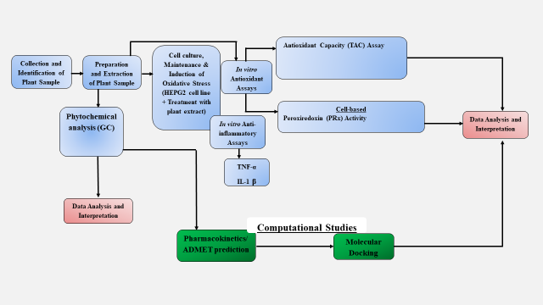
Figure 1: Flow Chart of the Methodology
3.0 Results
The result of the plant (Beta vulgaris) sample analyzed for phytochemicals is presented in Figures 1 to 6 and Tables 2 to 7. The result showed significant amounts of tannins (67.02ppm), flavonoids (67.97ppm), saponins (46.99 ppm), steroids (14.98ppm), terpenoids (17.77ppm), and alkaloids (61.13 ppm) present in the sample. The developed chromatogram for each class of phytochemical showed that Dauricine (37.79ppm, 624.77g/mol), Dinosterol (3.22ppm, 428.74g/mol), Alpha-Tomatine (8.49ppm, 1039.19g/ml), Tangeretine (19.80ppm, 372.37g/mol), Daidzein (21.51ppm, 254g/mol) and citronellol (3.24ppm, 186.26g/mol) were highest in concentration in the alkaloids, steroids, saponins, flavonoids, tannins and terpenoids respectively.

Figure 2: Total Composition of Bioactive Components in Each Class of Phytochemicals in Beetroot (Beta Vulgaris)
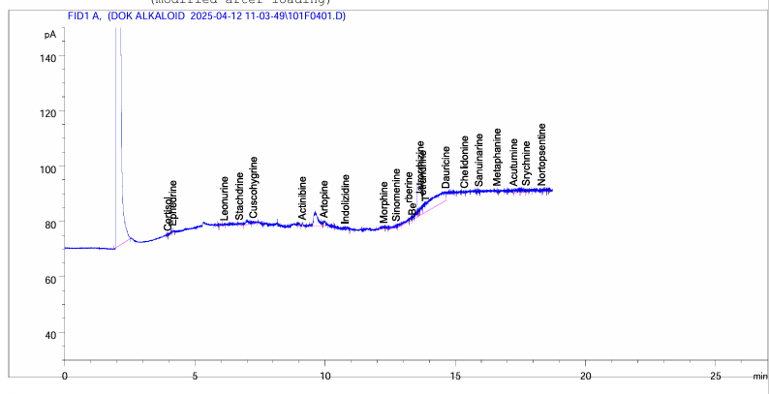
Figure 3: Chromatogram Developed for Alkaloids
Table 2: Results for the Bioactive Compounds in the Alkaloids
S/No. | Compound | Retention Time | Concentration  (ppm)
1. | Cortisol | 3.96 | 0.23
2. | Ephedrine | 4.15 | 0.51
3. | Leonurine | 6.12 | 0.42
4. | Stachydrine | 6.70 | 0.84
5. | Cuscohygrine | 7.24 | 0.76
6. | Actinidine | 9.13 | 0.73
7. | Atropine | 9.97 | 2.03
8. | Indolizidine | 10.79 | 1.36
9. | Morphine | 12.26 | 1.98
10. | Sinomenine | 12.72 | 1.59
11. | Berberine | 13.20 | 3.38
12. | Jatrorrhizine | 13.52 | 2.59
13. | Tetrandrine | 13.75 | 4.05
14. | Dauricine | 14.65 | 37.79
15. | Chelidonine | 15.36 | 0.59
16. | Sanguinarine | 15.92 | 0.32
17. | Metaphanine | 16.61 | 0.44
18. | Acutumine | 17.24 | 0.97
19. | Strychnine | 17.72 | 0.33
20. | Nortopsentine | 18.31 | 0.23

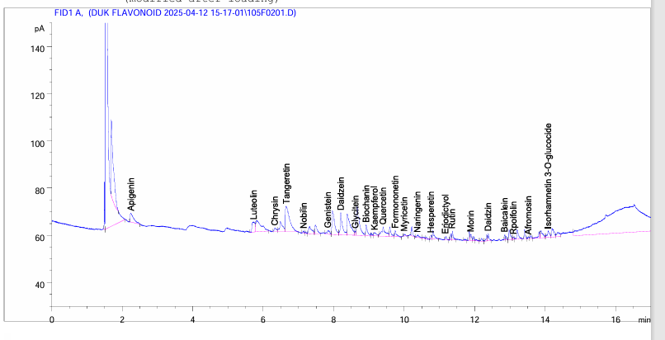
Figure 4: Chromatogram Developed for Flavonoids
Table 3: Results for the Bioactive Compounds in the Flavonoids
S/No. | Compound | Retention Time | Concentration (ppm)
1. | Apigenin | 2.25 | 5.41
2. | Luteolin | 5.73 | 5.29
3. | Chrysin | 6.34 | 1.49
4. | Tangeretin | 6.66 | 19.80
5. | Nobilin | 7.14 | 0.36
6. | Genistein | 7.84 | 1.84
7. | Daidzein | 8.21 | 8.58
8. | Glycitein | 8.62 | 0.57
9. | Biochanin | 8.92 | 3.39
10. | Kaempferol | 9.16 | 1.75
11. | Quercetin | 9.41 | 6.05
12. | Formononetin | 9.75 | 1.76
13. | Myricetin | 10.01 | 0.52
14. | Naringenin | 10.38 | 0.92
15. | Hesperetin | 10.76 | 0.64
16. | Eriodictyol | 11.18 | 0.80
17. | Rutin | 11.36 | 1.89
18. | Morin | 11.89 | 1.27
19. | Daidzin | 12.38 | 1.42
20. | Baicalein | 12.85 | 0.70
21. | Rhoifolin | 13.10 | 0.61
22. | Afromosin | 13.52 | 0.26
23. | Isorhamnetin 3-O-glucoside | 14.08 | 2.60

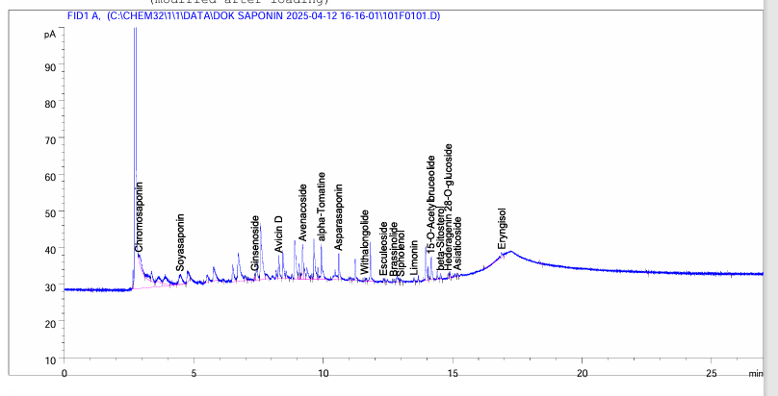
Figure 5: Chromatogram Developed for Saponins
Table 4: Results for the Bioactive Compounds in the Saponins
S/No. | Compound | Retention Time | Concentration  (ppm)
1. | Chromosaponin | 2.89 | 4.85
2. | Avenacin | 3.77 | 0.22
3. | Soyasaponin | 4.48 | 5.68
4. | Glycyrrhizin | 5.35 | 5.68
5. | Ginsenoside | 7.35 | 0.88
6. | Avicin | 8.27 | 4.90
7. | Avenacoside | 9.20 | 7.32
8. | alpha-Tomatine | 9.92 | 8.49
9. | Asparasaponin | 10.60 | 4.48
10. | Withalongolide | 11.61 | 0.55
11. | Esculeoside | 12.33 | 0.37
12. | Brassinolide | 12.72 | 0.44
13. | Sipholenol | 13.01 | 0.62
14. | Limonin | 13.50 | 0.57
15. | 15-O-Acetylbruceolide | 14.17 | 4.31
16. | Beta-Sitosterol | 14.54 | 0.95
17. | Hederagenin-28-O glycoside | 14.87 | 0.54
18. | Asiaticoside | 15.19 | 0.42
19. | Erngisol | 16.90 | 1.63

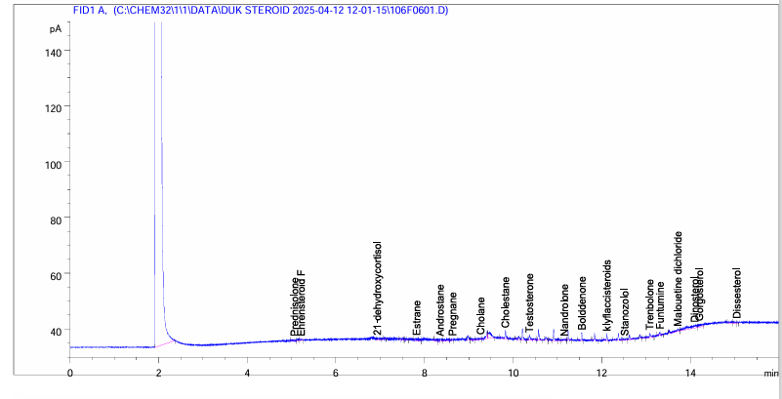Figure 6: Chromatogram Developed for Steroids
Table 5: Results for the Bioactive Compounds in the Steroid Family
S/No. | Compound | Retention Time | Concentration  (ppm)
1. | Prednisolone | 5.06 | 0.24
2. | Ehrensteroid F | 5.22 | 0.28
3. | Estrane | 7.83 | 0.81
4. | Androstane | 8.36 | 0.71
5. | Pregnane | 8.65 | 0.31
6. | Cholane | 9.27 | 0.40
7. | Cholestane | 9.83 | 1.24
8. | Testosterone | 10.38 | 1.08
9. | Nandrolone | 11.16 | 0.38
10. | Boldenone | 11.55 | 0.81
11. | Klyflaccisteroids | 12.12 | 0.76
12. | Stanozolol | 12.53 | 0.42
13. | Trenbolone | 13.09 | 1.06
14. | Funtumine | 13.32 | 0.22
15. | Malouetine dichloride | 13.72 | 0.97
16. | Dinosterol | 14.11 | 3.22
17. | Gorgosterol | 14.21 | 1.24

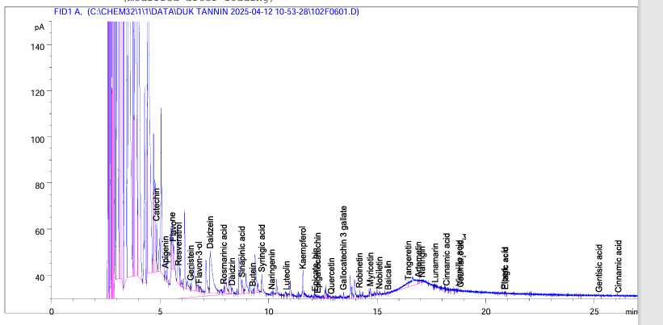Figure 7: Chromatogram Developed for Tannins
Table 6: Results for the Bioactive Compounds in the Tanins Family
S/No. | Compound | Retention Time | Concentration  (ppm) | Molecular Weight  (g/mol)
1. | Catechin | 4.84 | 6.81 | 290.27
2. | Apigenin | 5.26 | 1.35 | 270.24
3. | Flavone | 5.62 | 3.72 | 222.24
4. | Resveratrol | 5.92 | 2.26 | 228.24
5. | Genistein | 6.40 | 0.89 | 270.24
6. | Flavon-3-ol | 6.80 | 1.03 | 238.24
7. | Daidzein | 7.30 | 21.51 | 254.24
8. | Rosmarinic acid | 7.94 | 1.13 | 360.31
9. | Daidzin | 8.31 | 1.25 | 416.38
10. | Sinapinic acid | 8.78 | 2.93 | 224.21
11. | Butein | 9.27 | 0.51 | 272.25
12. | Syringic acid | 9.68 | 3.51 | 198.17
13. | Naringenin | 10.14 | 0.53 | 272.25
14. | Luteolin | 10.82 | 0.40 | 286.23
15. | Kaempferol | 11.58 | 3.90 | 286.23
16. | Epicatechin | 12.16 | 0.61 | 290.27
17. | Epigallocatechin | 12.26 | 0.78 | 306.27
18. | Quercetin | 12.88 | 0.19 | 302.23
19. | Gallocatechin-3- gallate | 13.45 | 0.61 | 458.37
20. | Robinetin | 14.19 | 0.79 | 302.23
21. | Myricetin | 14.67 | 1.34 | 318.23
22. | Nobiletin | 15.10 | 0.46 | 402.39
23. | Baicalin | 15.50 | 0.34 | 446.36
24. | Tangeretin | 16.44 | 6.38 | 372.37
25. | Artemetin | 16.89 | 0.93 | 388.37
26. | Naringin | 17.06 | 1.03 | 580.53
27. | Lunamarin | 17.67 | 0.26 | 309.32
28. | Cinnamic acid | 18.19 | 0.40 | 148.16
29. | Coumaric acid | 18.83 | 0.19 | 164.16
30. | Piperic acid | 20.86 | 0.27 | 218.20
31. | Ellagic acid | 20.90 | 0.19 | 302.19
32. | Gentisic acid | 25.21 | 0.14 | 154.12

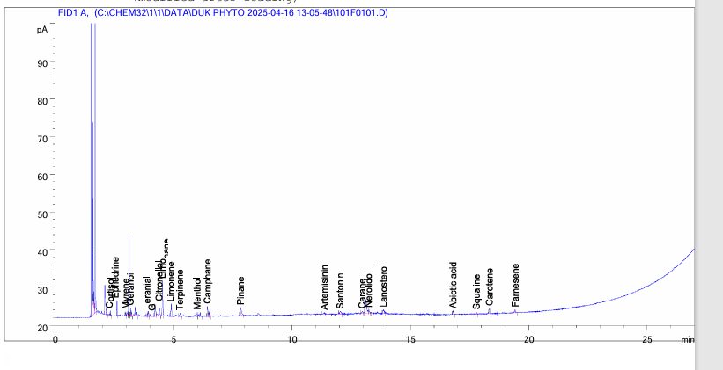Figure 8: Chromatogram Developed for Terpenoids
Table 7: Results for the Bioactive Compounds in the Terpenoids
S/No. | Compound | Retention Time | Concentration  (ppm) | Molecular Weight  (g/mol)
1. | Cortisol | 2.34 | 0.25 | 362.46
2. | Ephedrine | 2.60 | 2.00 | 165.23
3. | Geranial | 3.88 | 0.35 | 152.23
4.  5. | Citronellol  Limonene | 4.20  4.90 | 3.24  2.74 | 156.26
 |  |  |  | 136.23
6. | Terpinene | 5.27 | 0.66 | 456.84
7. | Menthol | 5.99 | 0.35 | 156.26
8. | Camphane | 6.42 | 1.07 | 138.25
9. | Pinane | 7.83 | 2.41 | 138.25
10. | Artemisinin | 11.37 | 0.38 | 282.33
11. | Santonin | 12.04 | 0.70 | 246.30
12. | Carane | 12.96 | 0.29 | 138.25
13. | Nerolidol | 13.24 | 0.55 | 222.37
14. | Lanosterol | 13.85 | 0.80 | 426.72
15. | Abietic acid | 16.80 | 0.49 | 302.45
16. | Squalene | 17.79 | 0.22 | 410.73
17. | Carotene | 18.34 | 0.72 | 536.88
18. | Farnesene | 19.42 | 0.55 | 204.35

The Total Antioxidant Capacity (TAC) assay result showed an increase in a concentration-dependent manner, indicating that as the concentration of the Beta vulgaris ethanol extract increased, the more the reducing potential and higher total antioxidant capacity as seen in Figures 9 and 10. A plateau was observed at higher concentrations, between 500–600 µg/mL, as TAC levels rise only slightly (14.11 to 14.81 AAE/mg of extracts) suggesting saturation of antioxidant activity. This is as a result of reacting components approaching saturation after a point, typical of natural extracts, due to limited active compounds. This indicates that the extract possesses appreciable reducing power comparable to standard antioxidants.

Figure 9: Standard Curve of Ascorbic Acid for the Determination of Total Antioxidant Status

Figure 10: Total Antioxidant Activity of Plant Extract Using Phosphomolybdate Method
Hydrogen peroxide (H₂O₂) caused a sharp decrease in peroxiredoxin (Prx) in the HepG2 cells (37.30 vs. 85.53 baseline) nmol/mg protein, confirming oxidative stress. Treatment with the Beta vulgaris ethanol extract restored Prx levels, with higher doses (HH800–HH1000) significantly (p<0.05) higher than the base line concentration of the untreated, and matching the positive control (Silymarin, 91.00nmol/mg protein). This indicates the Beta vulgaris ethanol extract has strong antioxidant and hepatoprotective effects against H₂O₂-induced oxidative damage (Figure 11).

Figure 11: Concentration of Peroxiredoxin (Prx) in the Cells.
Values are represented as (Mean±S.E.M) Means with different superscript (a-e) are significantly different (Tukey hsd, p<0.05).
The result observed for the pro-inflammatory markers (TNF-alpha and IL-1) were presented in Table 8. The result showed that hydrogen peroxide (H₂O₂) induced approximately a 4.35-fold increase in TNF-α (1102.76 vs 253.24) pg/mg protein in the untreated, showing strong oxidative stress–mediated inflammation. Treatment with varying concentrations of the plant extract showed modulation, but not strictly linear. Low dose (HH200) reduces TNF-α substantially (504.67pg/mg protein), about 54% reduction from negative control. The Moderate doses (HH400–HH600) show partial reduction or slight rebound (854.19pg/mg protein and HH400 620.86pg/mg protein at HH600). Higher doses (HH800–HH1000) reduce TNF-α further (504.83 to 395.14) pg/mg protein, approaching the untreated baseline. Positive control (Silymarin) reduces TNF-α effectively (243.60) pg/mg protein, slightly below untreated levels. IL-1 follows a similar trend as TNF-α. Hydrogen peroxide (H₂O₂) induces ~4.85-fold increase (1066.57 vs 219.90) pg/mg protein. Plant extract reduced IL-1 levels significantly (p<0.05) in a dose-dependently at higher concentrations. At HH600to HH1000, there was significant (p<0.05) reduction comparable to the baseline (HH1000 = 404.67pg/mg protein). The result obtained for the positive control (Silymarin) was not significantly (p>0.05) different from the untreated control (314.20pg/mg protein).
Table 8: Concentration of Pro-inflammatory Markers in the Cell

S/No. | Groups | ID | TNF-α (pg/mg protein) | IL-1(pg/mg protein)
1 | Untreated control | Untreated Control | 253.24±11.34ª | 219.91±5.67 ª
2 | Negative control (H₂O₂) only | Negative Control | 1162.76 ±15.11 ^{b} | 1099.57±13.66 ^{b}
3 | Test 1(H₂O₂+ 200mg/ml) | HH200 | 504.67±10.98 ^{c} | 747.52±14.89 ^{c}
4 | Test 2 (H₂O₂+ 400mg/ml) | HH400 | 884.20±17.56 ^{d} | 818.93±12.97 ^{c}
5 | Test 3 (H₂O₂+ 600mg/ml) | HH600 | 620.86±12.33 ^{c} | 599.90±10.76 ^{d}
6 | Test 4(H₂O₂+ 800mg/ml) | HH800 | 304.67±9.09 e | 552.30±12.03 ^{d}
7 | Test 5 (H₂O₂+ 1000mg/ml) | HH1000 | 395.14±7.45 e | 404.67±9.01 e
8 | Positive control (H₂O₂+ 150mg/ml) silymarin | Positive control | 247.52±5.87 ª | 314.19±7.89 ª
Values are represented as (Mean ± S.E.M.) Means with different superscript (a-e) are significantly different (Tukey hsd, p<0.05) down the cloumn.
Compounds from the Beta vulgaris were selected for docking studies based on their higher percentage compositions, comparative overview of hepatoprotective activity (Table 9) and Figure 12. The structures of these ligands were obtained from the PubChem data base (https://pubchem.ncbi.nlm.nih.gov) in the SDF format. The six candidate compounds Dauricine, α-Tomatine, Tangeretine, Dinosterol, Daidzein, and Citronellol exhibited diverse physicochemical properties and pharmacokinetic profiles (Table 12). Molecular weights ranged from 156.27 g/mol (Citronellol) to 1034.16 g/mol (α-Tomatine), with Dauricine (624.77 g/mol) and Alpha-Tomatine exceeding the 500 g/mol threshold commonly associated with reduced oral bioavailability. Aromaticity was high in Dauricine, α-Tomatine, Tangeretin, and Dinosterol, whereas Daidzein and Citronellol were predominantly aliphatic, reflecting greater three-dimensional flexibility as indicated by their higher Fsp³ values (0.92 and 0.93, respectively). Rotatable bond counts varied from 1 (Dinosterol) to 10 (Dauricine), indicating differences in molecular flexibility that may influence binding affinity and bioavailability. Hydrogen bond donor and acceptor counts were highest in Alpha-Tomatine (6/14), consistent with its elevated topological polar surface area (TPSA = 230.12 Å²), which may limit passive membrane permeability. In contrast, Tangeretin and Citronellol exhibited low TPSA values (40.23 Å² and 20.23 Å², respectively), suggesting favorable permeability profiles. The Consensus Log P values ranged from 2.49 (Daidzein) to 5.54 (Dauricine), with higher lipophilicity potentially contributing to reduced solubility, as reflected in the ESOL predictions. Dauricine and α-Tomatine displayed poor aqueous solubility (1.36 × 10⁻⁵ mg/ml and 0.002 mg/ml, respectively), whereas Daidzein and Citronellol demonstrated relatively higher solubility (0.179 mg/ml and 0.180 mg/ml, respectively), indicative of improved oral absorption potential. Predicted gastrointestinal (GI) absorption was high for most compounds, although BBB permeability varied, with Dauricine unable to cross the blood-brain barrier, whereas α-Tomatine, Dinosterol, Daidzein, and Citronellol were predicted to permeate the CNS. In terms of interactions with metabolic enzymes, α-Tomatine was identified as a CYP3A4 inhibitor, and Dinosterol inhibited CYP2C9 and CYP2D6, indicating potential drug-drug interaction risks. Dauricine, Alpha-Tomatine, and Dinosterol were also predicted to inhibit hERG II channels, suggesting possible cardiotoxicity, while only α-Tomatine exhibited hepatotoxic potential. Skin sensitization was predicted exclusively for Citronellol. Toxicity parameters, including LD50 and LOAEL. Dauricine and Dinosterol displayed relatively safer acute toxicity profiles, whereas Citronellol and Daidzein had lower LD50 values. Synthetic accessibility scores indicated moderate to high complexity for Dauricine and Tangeretin (5.18 and 6.09), while Daidzein and Dinosterol were comparatively easier to synthesize. Analysis of drug-likeness revealed that Dauricine and α-Tomatine violated multiple Lipinski and Ghose rules, suggesting potential limitations in oral bioavailability, whereas Tangeretine, Dinosterol, Daidzein, and Citronellol largely conformed to these criteria. Daidzein, Citronellol, and Dinosterol exhibited the most favorable combination of solubility, permeability, low toxicity, and drug-likeness, highlighting their suitability as lead compounds. In contrast, Dauricine and α-Tomatine, despite certain pharmacological advantages, may require structural optimization or alternative delivery strategies to mitigate limitations associated with high molecular weight, poor solubility, and potential toxicity.

Table 9: The canonical SMILES strings along with PubChem CIDs for the six compounds and reference drug
Compound | PubChem CID | Canonical SMILES
Dauricine | 73400 | CN1CCC2=CC(=C(C=C2[C@H]1CC3=CC=C(C=C3)  OC4=C(C=CC(=C4)C[C@@H]5C6=CC  (=C(C=C6CCN5C)OC)OC)O)OC)OC
α-Tomatine | 28523 | CC1CCC2(C(C3C(O2)CC4C3(CCC5C4CCC6C5  (CCC(C6)OC7C(C(C(C(O7)CO)OC8C(C(C(C(O8)  CO)O)OC9C(C(C(CO9)O)O)O)OC2C(C(C(C  (O2)CO)O)O)O)O)O)C)C)C)NC1
Tangeretin | 68077 | COC1=CC=C(C=C1)C2=CC(=O)C3=C  (O2)C(=C(C(=C3OC)OC)OC)OC
Dinosterol | 6441076 | C[C@H]1[C@@H]2CC[C@H]3[  C@@H]4CC[C@@H]([C@]  4(CC[C@@H]3[C@]2(CC[C@@H]1O)C)  C)[C@H](C)/C=C(\C)C(C)C(C)C
Daidzein | 5281708 | O=C1C2=CC(=C(C=C2O1)C3=  CC=C(C=C3)O)O
Citronellol | 8842 | CC(CCC=C(C)C)CCO
Silymarin | 5213 | COC1=C(C=CC(=C1)C2C  (OC3=C(O2)C=C(C=C3)  C4C(C(=O)C5=C(C=C  (C=C5O4)O)O)O)CO)O

Table 10: ADME/T Analysis of Selected Bioactive Components
Property | Dauricine) | α-Tomatine | Tangeretin | Dinosterol | Daidzein | Citronellol
MW (g/mol) | 624.77 | 1034.16 | 402.50 | 414.71 | 254.24 | 156.27
Aromaticity | High | High | High | High | Low | Low
Fsp³ | 0.12 | 0.35 | 0.76 | 0.0 | 0.92 | 0.93
Rotatable bonds | 10 | 7 | 6 | 1 | 4 | 5
H-bond donors / acceptors | 1 / 8 | 6 / 14 | 1 / 3 | 2 / 4 | 2 / 4 | 1 / 1
TPSA (Å²) | 73.21 | 230.12 | 40.23 | 50.35 | 57.23 | 20.23
Log P (Consensus) | 5.54 | 2.81 | 4.12 | 3.42 | 2.49 | 2.81
ESOL Solubility (mg/ml) | 1.36 × 10⁻⁵ | 0.002 | 3.21 × 10⁻³ | 0.075 | 0.179 | 0.180
GI Absorption | High | High | Low | High | High | High
BBB Permeability | No | Yes | No | Yes | Yes | Yes
Pgp Substrate | No | No | No | No | No | No
CYP Inhibition | None | CYP3A4 | None | CYP2C9, CYP2D6 | None | None
Skin Permeability (log Kp) | −3.41 | −5.62 | −2.34 | −4.21 | −2.12 | −1.89
AMES Toxicity | No | No | No | No | No | No
Hepatotoxicity | No | Yes | No | No | No | No
hERG II Inhibition | Yes | Yes | No | Yes | No | No
LD50 (mol/kg) | 2.741 | 2.556 | 2.102 | 2.935 | 1.912 | 1.669
LOAEL (log mg/kg_bw/day) | 2.527 | 2.198 | 1.732 | 0.899 | 2.032 | 1.556
Skin Sensitisation | No | No | No | No | No | Yes
Synthetic Accessibility | 5.18 | 4.92 | 6.09 | 2.79 | 2.61 | 3.12
Drug-Likeness Violations | Lipinski: 1, Ghose: 3 | Lipinski: 1, Ghose: 2 | Lipinski: 0, Ghose: 1 | Lipinski: 0, Ghose: 0 | Lipinski: 0, Ghose: 0 | Lipinski: 0, Ghose: 0

Based on the evaluation of physicochemical and pharmacokinetic properties, Daidzein and Tangeretin emerged as the most suitable candidates for molecular docking with Peroxiredoxin (PRx), TNF-α, and interleukin targets. Daidzein, with a low molecular weight (254.24 g/mol), moderate TPSA (57.23 Å²), and four rotatable bonds, combines structural flexibility with favorable hydrogen bonding capacity, allowing efficient accommodation within protein binding pockets. Tangeretin (MW 402.50 g/mol; TPSA 40.23 Å²; six rotatable bonds) exhibits a balanced size and moderate flexibility, supporting effective docking interactions, particularly in hydrophobic regions of the target proteins. Citronellol, although small (MW 156.27 g/mol) and highly flexible, may engage fewer interactions due to its limited functional groups. Conversely, Dauricine and Dinosterol are moderately suitable; Dauricine’s high molecular weight (624.77 g/mol) and hERG inhibition risk could limit its pharmacological applicability despite its flexibility, while Dinosterol’s rigidity (single rotatable bond) may reduce binding adaptability. Alpha-Tomatine is considered unsuitable for docking studies due to its excessive molecular weight (1034.16 g/mol), high TPSA (230.12 Å²), and predicted hepatotoxicity, which together suggest poor binding efficiency and safety concerns. The physicochemical and ADMET profiles support the prioritization of Daidzein, Tangeretin, citronellol and Dinosterol as lead compounds in in silico studies and experimental evaluation against PRx, TNF-α, and interleukin targets (Tables 11 and 12).
Table 11: Ranking the six compounds for docking suitability with PRx, TNF-α, and IL-1β
Compound | MW (g/mol) | TPSA (Å²) | Rotatable Bonds | Log P | Hepato-  toxicity | hERG II | Docking Suitability
Daidzein | 254.24 | 57.23 | 4 | 2.49 | No | No | Excellent
Tangeretin | 402.50 | 40.23 | 6 | 4.12 | No | No | Good
Citronellol | 156.27 | 20.23 | 5 | 2.81 | No | No | Moderate
Dauricine | 624.77 | 73.21 | 10 | 5.54 | No | Yes | Moderate
Dinosterol | 414.71 | 50.35 | 1 | 3.42 | No | Yes | Low
α-Tomatine | 1034.16 | 230.12 | 7 | 2.81 | Yes | Yes | Poor

Criteria for docking suitability.

Excellent: Highly favorable physicochemical and ADME/T profile; likely efficient docking. Good: Suitable for docking; minor limitations. Moderate: Can dock, but structural or toxicity concerns may affect results. Low: Limited suitability due to rigidity, size, or toxicity. Poor: Unsuitable for docking due to MW, TPSA, or predicted toxicity.

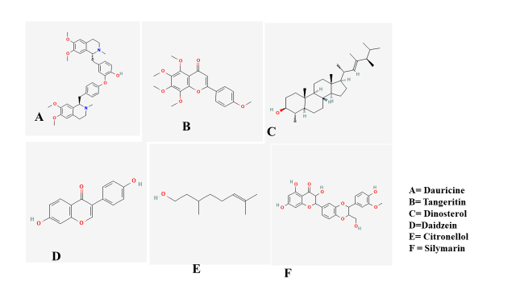
Figure 12: The 2D Structures of the Preferred Ligands

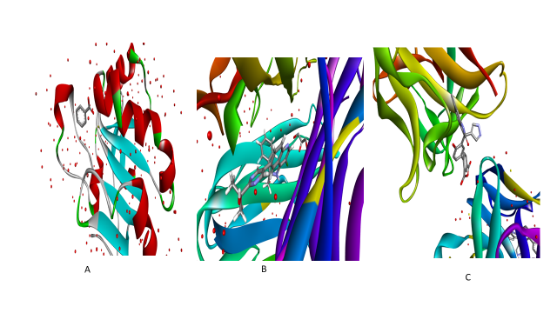Figure 13: A= (1HD2) Crystal Structure of Human Peroxiredoxin 5, a Novel Type of Mammalian Peroxiredoxin in complex with Benzene. B= (7JRA) HUMAN TNF-ALPHA IN COMPLEX WITH 2-[5-(3-chloro-4-{[(1R)-1-(2-fluorophenyl) ethyl]amino}quinolin-6-yl)pyrimidin-2-yl]propan-2-ol. C=() Crystal Structure of human IL-1beta in complex with a low molecular weight antagonist, (S)-4'-hydroxy-3'-(6-methyl-2-oxo-3-(1H-pyrazol-4-yl)indolin-3-yl)-[1,1'-biphenyl]-2,4-dicarboxylic acid.
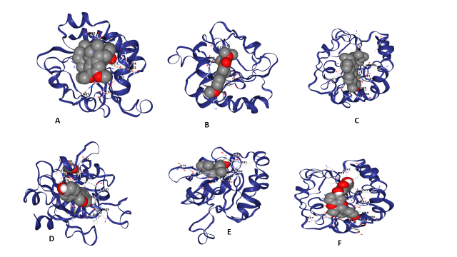
Figure 14: Post Docking View of Ligands with 1HD2
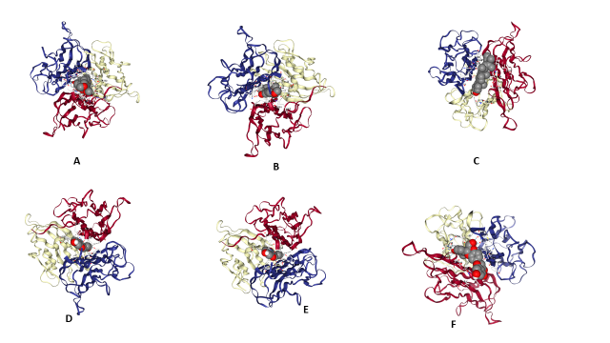
Figure 15: Post Docking View of Ligands with 7JRA

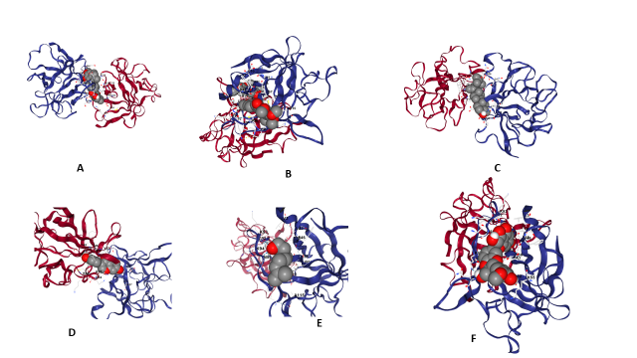
Figure 16: Post Docking View of Ligands with 8C3U
Table 12: Comparative Molecular Docking Results of the Selected Ligands against the Target Protein Peroxiridoxin, Prx (PDB: 1HD2) (CB-Dock2 Output)
Compound | Best Pocket (ID) | Vina Score (kcal/mol) | Cavity Volume (Å³) | Pocket Center (x, y, z) | Docking Size (Å) | Interacting  Residues
Silymarin | C1 | –7.9 | 343 | 18, 40, 15 | 26 × 26 × 26 | GLU16, GLU18, LYS22, GLU27, TRP84, ARG86, GLU91, LYS93, ARG95, LEU96
Dauricine | C1 | –7.8 | 343 | 18, 40, 15 | 24 × 24 × 24 | GLU16, ASN21, LYS22, GLU27, LYS63, TRP84, ARG86, GLU91, LYS93, VAL94
Daidzein | C1 | –6.9 | 343 | 18, 40, 15 | 21 × 21 × 21 | GLU16, TRP84, ARG86, HIS88, GLU91, LYS93, VAL94, LEU96
Dinosterol | C1 | –6.7 | 343 | 18, 40, 15 | 25 × 25 × 25 | GLU16, VAL23, GLU27, TRP84, ARG86, GLU91, VAL94, LEU96
Tangeretine | C1 | –5.8 | 343 | 18, 40, 15 | 22 × 22 × 22 | GLU16, LYS22, GLU27, ARG86, GLU91, LYS93, LEU96
Citronellol | C1 | –4.3 | 343 | 18, 40, 15 | 19 × 19 × 19 | PHE15, GLU16, ARG86, LYS89, GLU91, LYS93, VAL94, LEU96

Cavity-guided molecular docking analysis using the CB-Dock2 platform identified five potential binding sites on for the ligands on target proteins (Tables 11-14 and Figures 12-16). On the Peroxiredoxin antioxidant enzyme, all ligands exhibited a clear preference for the primary cavity (C1, volume ≈343 Å³). Predicted Vina binding affinities ranged from –4.3 to –7.9 kcal·mol⁻¹, reflecting differential interaction strengths among the tested compounds. Silymarin (–7.9 kcal·mol⁻¹) and Dauricine (–7.8 kcal·mol⁻¹) demonstrated the strongest binding potentials, forming multiple stabilizing hydrogen bonds and hydrophobic interactions with key residues, including Glu16, Lys22, Arg86, Glu91, Lys93, and Val94. Daidzein (–6.9 kcal·mol⁻¹) and Dinosterol (–6.7 kcal·mol⁻¹) exhibited moderate affinities, whereas Tangeretine (–5.8 kcal·mol⁻¹) and Citronellol (–4.3 kcal·mol⁻¹) showed comparatively weaker interactions, likely due to limited hydrogen bonding and reduced surface complementarity. The pronounced binding of Silymarin and Dauricine highlights their potential as lead compounds capable of modulating hepatoprotective and anti-inflammatory pathways through peroxiredoxin regulation. Docking of the ligand panel into TNF-α and IL-1β revealed two primary binding regions: a large hydrophobic pocket (C1) and a smaller polar pocket (C2), with cavity volumes of ~4394–4450 Å³ and ~202–1364 Å³, respectively. Several ligands preferentially occupied C2 with high predicted affinities, including Tangeretine (–12.1 kcal·mol⁻¹) and Dauricine (–10.6 kcal·mol⁻¹), whereas Silymarin displayed its strongest interactions at C2 (–8.3 kcal·mol⁻¹) through hydrogen bonding with polar and charged residues such as ASN53, ASP54, LYS55, GLU96, ARG98, ASN102, and GLN116. Dinosterol showed moderate binding across both cavities, and Citronellol had the weakest affinity (–5.1 kcal·mol⁻¹). Across TNF-α and IL-1β, Dauricine and Silymarin emerged as the most promising modulators, stabilized by a combination of hydrophobic packing and polar contacts across chain interfaces, while the remaining ligands may provide moderate or supportive inhibitory effects. The overall binding-energy ranking was: Dauricine > Silymarin > Daidzein ≈ Dinosterol > Tangeretine > Citronellol, supporting their potential as lead candidates for targeting inflammatory and hepatoprotective pathways in this study.
Table 13: Comparative Molecular Docking Results of the Selected Ligands against the Target Protein the TNF-α (PDB: 7JRA) (CB-Dock2 Output)
Ligand | Best Pocket (ID) | Best Vina score (kcal·mol⁻¹) | Pocket Cavity Volume (Å³) | Pocket center (x,y,z) | Docking box size (Å) | Interacting  Residues
Dauricine | C2 | –10.6 | 1364 | –16, –3, –25 | 24 × 24 × 24 | Chain A: THR83, PRO84, SER85, ASP86, LYS87, VAL89, LEU133, TYR135, TYR195, VAL199, ILE231, ALA232, LEU233
Tangeretine | C2 | –12.1 | 1364 | –16, –3, –25 | 22 × 22 × 22 | Chain A/B/C overlaps: LYS87, LEU133, TYR135, TYR195, VAL199, ILE231, ALA232, LEU233
Dinosterol | C1 | -8.4 | 4450 | 4, 3, -39 | 35x25x25 | Chain A: LEU151 ALA172 ILE173 LYS174 SER175 PRO176 GLN178 ARG179 TYR191 GLU192 PRO193
Diadzein | C2 | –9.5 | 1364 | –16, –3, –25 | 21 × 21 × 21 | Chain A/B/C residues: SER85, LYS87, LEU133, TYR195, VAL199, ILE231, ALA232, LEU233 (various chain overlaps)
Citronellol | C2 | –6.7 | 1364 | –16, –3, –25 | 26 × 19 × 19 | Chain A/B/C: LEU133, TYR135, TYR195, VAL199, ILE231, LEU233 (hydrophobic-rich)
Silymarin | C2 | –9.5 | 1364 | –16, –3, –25 | 21 × 21 × 21 | Chain A/B/C: SER85, LYS87, LEU133, TYR195, VAL199, ILE231, ALA232, LEU233
Table 14: Comparative Molecular Docking Results of the Selected Ligands against the Target Protein the Il-β (PDB: 8C3U) (CB-Dock2 Output)
Ligand | Best pocket (ID) | Best Vina score (kcal·mol⁻¹) | Cavity volume (Å³) | Center  (x, y, z) | Docking box (Å) | Interacting residues
Dauricine | C1 | –9.0 | 4394 | –13, –11, –40 | 24×24×24 | Chain A: PHE46, VAL47, LYS55, PRO57, VAL58, ALA59, CYS71, VAL72, LEU73, MET95, GLU96, ARG98, VAL100, SER114, GLN116, PRO118 Chain B: ASN7, MET20, SER21, LEU29, GLU37, PHE42, LEU62, LYS63, GLU64
Tangeretine | C1 | –6.7 | 4394 | –13, –11, –40 | 28×29×22 | Chain A: SER45, VAL47, PRO57, VAL58, ALA59, LEU73, ASP76, LYS92–97, VAL100, GLN116, PRO118, TRP120 Chain B: MET20, GLU25, GLU37–39, PHE42, LEU62–65
Dinosterol | C1 | –7.6 | 4394 | –13, –11, –40 | 25×25×25 | Chain A: VAL47, PRO57, VAL58, ALA59, CYS71, VAL72, LEU73, MET95, VAL100, GLN116, PRO118 Chain B: MET20, SER21–23, LYS27, GLU37–43, LEU62–65
Daidzein | C1 | –7.8 | 4394 | –13, –11, –40 | 28×29×21 | Chain A: VAL3, SER45–47, PRO57–59, LYS92–97, VAL100, GLN116, PRO118 Chain B: MET20–25, LYS27, GLU37–39, LEU62–65
Citronellol | C2 | –5.1 | 202 | 4, –16, –23 | 19×19×19 | Chain B: VAL3, SER45–47, GLU50, PRO57–59, PRO91–97, VAL100, ASN102, ALA115
Silymarin | C2 | –8.3 | 202 | 4, –16, –23 | 26×26×26 | Chain B: PRO2–5, PHE46–47, GLU50, ASN53–54, LYS55, ILE56–59, PRO87–98, VAL100–118

4.0 Discussion
The result presented from this study demonstrated that phytochemicals of Beta vulgaris (beetroot) contains antioxidant and anti‐inflammatory bioactivities both in vitro and via in silico modelling. The high levels of tannins (67.02 ppm), flavonoids (67.97 ppm), saponins (46.99 ppm), steroids (14.98 ppm), terpenoids (17.77 ppm) and alkaloids (61.13 ppm) align closely with prior literature, which reports that beetroot is a robust source of polyphenols and other bioactive compounds with health‐promoting features (Mirmiran et al., 2020). The peak individual constituent of Dauricine (37.79 ppm), Tangeretin (19.80 ppm), Daidzein (21.51 ppm) reflect the presence of chemically diverse moieties with potential for multifaceted biological interactions. The concentration‐dependent increase in total antioxidant capacity (TAC) from 3.38 to 14.81 AAE/mg of extract, with saturation above ~500–600 µg/ml, confirms that these constituents confer appreciable reducing power (radical‐quenching capacity) before reaching a plateau typical of complex natural extracts with finite active compound pools. The cellular oxidative stress model with H₂O₂‐induced HepG2 cells provides functional validation of the extract’s bioactivity. Oxidative stress reduced peroxiredoxin (Prx) levels from 85.53 to 37.30 nmol/mg protein, and treatment with the extract restored Prx levels (up to 91.00 nmol/mg protein with the positive control silymarin). This suggests effective hepatoprotection and redox‐homeostasis restoration by the plant’s ethanol extract consistent with the notion that beetroot extract activate endogenous defense systems (Rhee et al., 2012; Clifford et al., 2015). Furthermore, the modulation of inflammatory biomarkers (TNF-α and IL-1) by H₂O₂ induction, 4.35 to 4.85‐fold increase, was reduced significantly by the higher Beta vulgaris ethanol extract concentration (p<0.05) toward baseline confirming the anti‐inflammatory potential of the extract via attenuation of oxidative‐stress‐driven cytokine induction. In silico ADMET and docking components deepen the mechanistic interpretation by linking chemical composition and predicted bioavailability with ligand- protein interaction potential. In this study, Daidzein and Tangeretin emerged as the most suitable docking candidates based on favourable molecular weights (254.24 g/mol and 402.50 g/mol, respectively), moderate TPSA values, and drug‐likeness metrics. By contrast, high molecular‐weight compounds such as α-Tomatine (1034 g/mol) and Dauricine (624.77 g/mol) although showing high in vitro binding potential may face poor bioavailability or toxicity liabilities (e.g., hERG inhibition). This methodology aligns with the current trend of integrating phytochemical profiling, in vitro bioassays and in silico modelling for lead‐compound prioritization (Lipinski et al., 2001; Daina et al., 2017; Sanguinetti & Tristani-Firouzi, 2006; ). These results support a workflow from phytochemical quantification functional assay to computational rationale, and position beetroot ethanol extract and its major constituents as promising modulators in hepatoprotection, redox biology and inflammation.

5.0 Conclusion
The ethanol extract of Beta vulgaris shoed that there was significant amount of phytochemical components including tannins, flavonoids, saponins, steroids, terpenoids, and alkaloids, with notable concentrations of Dauricine, Daidzein, Tangeretin, Dinosterol, Alpha-Tomatine, and Citronellol. The extract exhibited strong antioxidant activity from the TAC assay and restoring peroxiredoxin levels in H₂O₂-induced HepG2 oxidative stress and down-regulating pro-inflammatory markers TNF-α and IL-1β effectively. In silico analysis further revealed that these phytocompounds possess favorable physicochemical and ADMET profiles, with Daidzein, Tangeretin, Citronellol, and Dinosterol emerging as lead candidates for molecular docking. Cavity-guided docking highlighted Dauricine and Silymarin as the most potent modulators of Peroxiredoxin, TNF-α, and IL-1β, supported by strong hydrophobic and hydrogen-bonding interactions across key protein residues. The integration of in vitro antioxidant and anti-inflammatory assays with in silico molecular docking clearly highlights the therapeutic potential of Beta vulgaris phytochemicals in hepatoprotection and inflammation regulation.

DISCLAIMER (ARTIFICIAL INTELLIGENCE)
Author(s) hereby declare that no generative AI technologies such as Large Language Models (ChatGPT, COPILOT, etc) and text-to-image generators have been used during writing or editing of this manuscript.
COMPETING INTERESTS
Authors have declared that no competing interests exist.

References
Allameh, A., Niayesh-Mehr, R., Aliarab, A., Sebastiani, G., & Pantopoulos, K. (2023). Oxidative stress in liver pathophysiology and disease. Antioxidants, 12(9), 1653. https://doi.org/10.3390/antiox12091653
Babarykin, D., Smirnova, G., Pundinsh, I., Vasiljeva, S., Krumina, G., & Agejchenko, V. (2019). Red beet (Beta vulgaris) impact on human health. Journal of Biosciences and Medicines, 7(3). https://doi.org/10.4236/jbm.2019.73007
Bonilla Ocampo, D. A., Paipilla, A. F., Marín, E., Vargas-Molina, S., Petro, J. L., & Pérez-Idárraga, A. (2018). Dietary nitrate from beetroot juice for hypertension: A systematic review. Biomolecules, 8(4), 134. https://doi.org/10.3390/biom8040134
Clifford, T., Howatson, G., West, D. J., & Stevenson, E. J. (2015). The potential benefits of red beetroot supplementation in health and disease. Nutrients, 7(4), 2801–2822. https://doi.org/10.3390/nu7042801
Das, S., Deb, T., Mottola, F., Madhu, N. R., Revanaiah, Y., Rosas, I. M., Ray, S. D., & Roychoudhury, S. (2025). Phytochemical screening, pharmacognostic characterization, antioxidant activity, and hepatoprotective effects of Abroma augustum (L.) L.f. on human hepatocellular carcinoma (HepG2) cells and goat liver homogenate. Antioxidants, 14(4), 472. https://doi.org/10.3390/antiox14040472
Daina, A., Michielin, O., & Zoete, V. (2017). SwissADME: A free web tool to evaluate pharmacokinetics, drug-likeness and medicinal chemistry friendliness of small molecules. Scientific Reports, 7, 42717.
Direito, R., Barbalho, S. M., Sepodes, B., & Figueira, M. E. (2024). Plant-derived Bioactive compounds: Exploring Neuroprotective, metabolic, and Hepatoprotective effects for health promotion and disease prevention. Pharmaceutics, 16(5), 577. https://doi.org/10.3390/pharmaceutics16050577
Gheith, I., & El-Mahmoudy, A. (2018). Laboratory evidence for the hematopoietic potential of Beta vulgaris leaf and stalk extract in a phenylhydrazine model of anemia. Brazilian Journal of Medical and Biological Research, 51(11), e7722. https://doi.org/10.1590/1414-431X20187722
Kujala, T. S., Vienola, M. S., Klika, K. D., Loponen, J. M., & Pihlaja, K. (2002). Betalain and phenolic compositions of four beetroot (Beta vulgaris) cultivars. European Food Research and Technology, 214(6), 505–510. https://doi.org/10.1007/s00217-002-0607-9
Liguori, I., Russo, G., Curcio, F., Bulli, G., Aran, L., Della-Morte, D., Gargiulo, G., Testa, G., Cacciatore, F., Bonaduce, D., & Abete, P. (2018). Oxidative stress, aging, and diseases. Clinical Interventions in Aging, 13, 757–772. https://doi.org/10.2147/CIA.S158513
Lipinski, C. A., Lombardo, F., Dominy, B. W., & Feeney, P. J. (2001). Experimental and computational approaches to estimate solubility and permeability in drug discovery and development settings. Advanced Drug Delivery Reviews, 46(1–3), 3–26. https://doi.org/10.1016/s0169-409x(00)00129-0
Liu, Y., Yang, X., Gan, J., Chen, S., Xiao, Z. X., & Cao, Y. (2022). CB-Dock2: Improved protein–ligand blind docking by integrating cavity detection, docking and homologous template fitting. Nucleic Acids Research, 50(W1), W159–W164. https://doi.org/10.1093/nar/gkac394
Mirmiran, P., Houshialsadat, Z., Gaeini, Z., Bahadoran, Z., & Azizi, F. (2020). Functional properties of beetroot (Beta vulgaris) in management of cardio-metabolic diseases. Nutrition & Metabolism, 17(1). https://doi.org/10.1186/s12986-019-0421-0
Prieto, P., Pineda, M., & Aguilar, M. (1999). Spectrophotometric quantitation of antioxidant capacity through the formation of a phosphomolybdenum complex: Specific application to the determination of vitamin E. Analytical Biochemistry, 269(2), 337–341. https://doi.org/10.1006/abio.1999.4019
Rhee, S. G., Woo, H. A., Kil, I. S., & Bae, S. H. (2012). Peroxiredoxin functions as a peroxidase and a regulator and sensor of local peroxides. Journal of Biological Chemistry, 287(7), 4403–4410. https://doi.org/10.1074/jbc.R111.283432
Sanguinetti, M. C., & Tristani-Firouzi, M. (2006). hERG potassium channels and cardiac arrhythmia. Nature, 440(7083), 463–469. https://doi.org/10.1038/nature04710
Stoica, F., Râpeanu, G., Rațu, R. N., Nicoleta Stănciuc, & Jităreanu, G. (2025). Red Beetroot and Its By- Products: A Comprehensive Review of Phytochemicals, Extraction Methods, Health Benefits, and Applications. Agriculture, 15(3), 270. https://doi.org/10.3390/agriculture15030270.
Thilagavathi, R., Begum, S. S., Varatharaj, S. D., Balasubramaniam, A. K., George, J. S., & Selvam, C. (2023). Recent insights into the hepatoprotective potential of medicinal plants and plant‐derived compounds. Phytotherapy Research, 37(5), 2102-2118. https://doi.org/10.1002/ptr.7821
Veber, D. F., Johnson, S. R., Cheng, H-Y., Smith, B. R., Ward, K. W., & Kopple, K. D. (2002). Molecular properties that influence the oral bioavailability of drug candidates. Journal of Medicinal Chemistry, 45(12), 2615–2623. https://doi.org/10.1021/jm020017n

