Case report
Renal Spectrum of Sjögren’s Syndrome: A Case of Secondary Membranous Nephropathy

Abstract

Sjögren’s syndrome (SS) is a systemic autoimmune disease primarily affecting exocrine glands, but with potential multisystem involvement. Renal manifestations are uncommon and most frequently present as tubulointerstitial nephritis, while glomerular disease is rare. We report a case of a 19-year-old female with primary Sjögren’s syndrome who presented with nephrotic-range proteinuria, anasarca, and acute kidney injury severe enough to require renal replacement therapy. She also had classical sicca symptoms, arthralgia, and serological positivity for anti-SSA and anti-SSB antibodies. Renal biopsy demonstrated membranous nephropathy with diffuse capillary wall thickening and granular IgG1/IgG4 deposition. Immunohistochemistry and serology were negative for known membranous nephropathy antigens, including PLA2R, THSD7A, NELL-1, and EXT1, supporting a diagnosis of secondary membranous nephropathy associated with Sjögren’s syndrome. Treatment with corticosteroids and mycophenolate mofetil resulted in significant improvement in renal function and proteinuria, with the patient becoming dialysis-independent. This case highlights an unusual renal manifestation of Sjögren’s syndrome in a young patient and underscores the importance of renal biopsy for accurate diagnosis, even when systemic disease activity appears modest. It also raises the possibility of yet unidentified antigenic targets in Sjögren’s syndrome–associated membranous nephropathy.

Keywords : Sjögren’s syndrome, Renal involvement, Nephrotic syndrome, Membranous nephropathy

Introduction :
Sjögren’s syndrome (SS) is an autoimmune exocrinopathy marked by lymphocytic infiltration of salivary and lacrimal glands, giving rise to xerostomia and keratoconjunctivitis sicca .SS is associated with remarkable B-cell hyperactivity manifested as hypergammaglobulinemia and the presence of serum autoantibodies like antinuclear antibodies, rheumatoid factor, cryoprecipitable immunoglobulins and antibodies against two ribonucleoprotein complexes named Ro/SSA and La/SSB which are the hallmarks of the disease. Although Sjogren’s syndrome predominantly affects the exocrine glands, presenting with xerostomia and keratoconjunctivitis sicca, it is a systemic autoimmune disease with potential involvement of virtually any organ system. Renal involvement is relatively uncommon, affecting about 5 % of SS patients, and typically manifests as tubulointerstitial nephritis (TIN)¹. Membranous nephropathy in SS is rarely reported but carries important prognostic implications. Herein, we present a case of secondary membranous nephropathy in a patient with primary SS.

Case Report
A 19-year-old nulliparous female who is non hypertensive non diabetic presented with generalized oedema, nephrotic-range proteinuria (urine ACR 8,200 mg/g) and oliguria. Eight months prior to her current admission she had similar complaints of anasarca and was hospitalized and managed with intravenous albumin and diuretics. A renal biopsy performed at that time was inadequate, as only light microscopy was available, and was empirically interpreted as a non-proliferative glomerulopathy. She was started on corticosteroids and tacrolimus, along with diuretics for oedema control, with partial improvement in swelling. However, she was lost to follow-up after two months of therapy. Six months later, she presented again with generalized oedema (anasarca) and oliguria, accompanied by fatigue, arthralgia, ocular grittiness and dryness in both eyes, xerostomia requiring frequent sips of water, and vaginal dryness with dyspareunia. There was no history suggestive of other systemic connective tissue disease. On examination, she was normotensive with marked peripheral oedema, ascites and pleural effusion. Ophthalmologic evaluation confirmed keratoconjunctivitis sicca (tear film breakup time: 9 s right eye, 8 s left eye) and a positive Schirmer’s test (both eyes-3 mm/5minutes). Patient was considered for renal replacement therapy (hemodialysis). Despite a modest EULAR Sjögren's syndrome disease activity index (ESSDAI) score of 3², the severity of renal involvement prompted a repeat renal biopsy.
Laboratory investigations revealed hemoglobin 9.8 g/dL, leukocyte count 10,533/µL, serum creatinine 3.0 mg/dL, blood urea 83 mg/dL, sodium 135 mEq/L, potassium 3.22 mEq/L, measured calcium 7.4 mg/dL (corrected 9.2 mg/dL), 4+ proteinuria, and urine ACR 6,637 mg/g, with no hematuria. Immunology showed ANA positivity (titer 1:100, homogeneous + speckled with centromere cells), positive anti-SSA and anti-SSB, and negative ANCA. Work-up for secondary causes of membranous nephropathy was negative, including viral serologies (HBsAg, anti-HBc, anti-HCV, HIV), malignancy screening (chest X-ray, abdominal/pelvic imaging), and drug history. Serum C3 and C4 levels were normal. Ultrasound revealed normal-sized kidneys with gross ascites. According to 2016 ACR/EULAR classification criteria for Sjögren’s syndrome³, our patient had a score of 4 and after ruling out other secondary causes of Sjogren’s syndrome as classified clinically into primary Sjogren syndrome. Repeat renal biopsy (Fig 1) demonstrated enlarged glomeruli with thickened capillary walls (membranous changes) and patchy acute tubular injury. Direct immunofluorescence showed granular capillary wall IgG (predominantly IgG1 and IgG4). Immunohistochemistry was negative for PLA2R, NELL-1, THSD7A, and EXT-1, and serum PLA2R antibody levels were also negative, supporting a secondary rather than primary etiology. Taken together with the clinical context, the findings confirmed secondary membranous nephropathy associated with Sjögren’s syndrome. The patient was treated with corticosteroids and mycophenolate mofetil, resulting in a reduction of urine ACR from 6,637 to 449 mg/g and improvement in serum creatinine from 3.0 to 1.89 mg/dL after four weeks, indicating a favourable early response.

Discussion
Sjögren’s syndrome (SS) is a multisystem autoimmune disease classically described in middle-aged women with sicca symptoms (includes keratoconjunctivitis sicca, xerostomia ,xerosis, pharyngeal and laryngeal dryness, xerotrachea, vaginal dryness) but its spectrum extends to cutaneous (raynaud’s phenomena, cutaneous vasculitis), musculoskeletal (jaccoud’s arthropathy), neurological (polyneuropathy), renal, and pulmonary manifestations (interstial pneumonitis) , and it also carries a long-term risk of lymphoma¹. Our case is remarkable because of the strikingly young age at presentation, where sicca features and arthralgia coexisted with nephrotic syndrome and acute kidney injury severe enough to require RRT.
Renal involvement in SS is relatively uncommon, affecting about 5% of patients with primary SS (pSS)⁴. In pSS, renal involvement most commonly manifests as plasma cell–predominant tubulointerstitial nephritis (TIN) accounts for nearly 85% of renal lesions, that mirrors the lymphoplasmacytic infiltration of the salivary glands and frequently leads to tubular dysfunction with electrolyte abnormalities; in contrast, glomerular disease is uncommon , reported in only 10–15% of cases^{5,6}. In our patient, the development of nephrotic-range proteinuria and anasarca clearly suggested a glomerular process. Historically, membranoproliferative glomerulonephritis (MPGN), often associated with cryoglobulinemia, was regarded as the predominant glomerular lesion in SS. Maripuri et al. reported MPGN as the most frequent finding, while membranous nephropathy (MN) accounted for only 4⁵. Other lesions reported include IgA nephropathy ⁷and focal segmental glomerulosclerosis (FSGS) is described in up to 38% of biopsy-proven glomerular cases⁹.
More recent evidence, however, suggests a changing spectrum of glomerular involvement. Qiu et al. observed MN in 44% of patients, FSGS in 38%, and proliferative GN in 18%⁸ . Ramponi et al. also emphasized MN as an increasingly recognized lesion in SS¹⁰.
Idiopathic membranous nephropathy is an autoimmune glomerular disease characterized by subepithelial immune complex deposition leading to diffuse thickening of the glomerular capillary walls and represents a leading cause of nephrotic syndrome in older adults; although antibodies against the M-type phospholipase A2 receptor (PLA2R) are detected in approximately 70–80% of cases of primary MN, additional target antigens—including thrombospondin type-1 domain–containing 7A (THSD7A), neural epidermal growth factor–like 1 protein (NELL-1), semaphorin3B ¹¹. Although PLA2R is the antigen primarily involved in primary MN ,there are cases in which PLA2R positivity is associated with secondary forms of membranous nephropathy such as lupus nephritis, hepatitis B virus–associated disease, malignancy-associated MN, and Sjogren’s syndrome. Chen et al. in his study further stratified MN cases into PLA₂R-positive patients, resembling idiopathic MN, and PLA₂R-negative cases often associated with mesangial proliferation and hypocomplementemia, consistent with autoimmune-mediated MN¹².
Renal biopsy is the gold standard test to identify the cause of nephrotic syndrome in the background of autoimmunity. So we performed renal biopsy in our patient that demonstrated enlarged glomeruli with diffuse thickened capillaries; features suggestive of MN with granular IgG1/IgG4 deposits and tested negative for all currently recognized antigens (PLA₂R, NELL-1, THSD7A, and EXT1) and serum PLA₂R antibody levels were also negative, representing a completely antigen-negative profile. Our case of Sjogren’s syndrome is one with negative staining for all the antigen testing available. To our knowledge, such an antigen-negative MN in the context of SS has not been reported previously and may indicate the existence of as yet unidentified antigenic targets.
The patient was commenced on haemodialysis session in view of oliguria. She was administered antibiotics, intravenous fluids. We started our patient on corticosteroids at the dose 0.5 mg/kg and mycophenolate mofetil (MMS) at the dose of 1.5 mg BD which remains the cornerstone of therapy for SS-associated renal disease¹³. Ocular dryness was managed with lubricants hydroxypropyl methylcellulose, while systemic secretagogues such as pilocarpine was given to salivary flow rates. Our patient showed a favourable early response to this regimen, with marked improvement in both renal function and proteinuria. She became dialysis free within 14 days and was discharged with adequate urine output and stable RFT’s. This case underscores an unusual but clinically important manifestation—secondary MN in a young patient with SS —and highlights the importance of pursuing renal biopsy even when systemic disease activity scores ESSDAI appear low.

References
- André, F., & Böckle, B. C. (2022). Sjögren's syndrome. J Dtsch Dermatol Ges, 20(7), 980-1002. https://doi.org/10.1111/ddg.14823
- Seror R, Bowman SJ, Brito-Zeron P, Theander E, Bootsma H, Tzioufas A, et al. EULAR Sjögren's syndrome disease activity index (ESSDAI): a user guide. RMD Open. 2015 Feb 20;1(1):e000022.DOI: 10.1136/rmdopen-2015-000022
- Ramos-Casals, M., Solans, R., Rosas, J., Camps, M. T., Gil, A., Del Pino-Montes, J., Calvo-Alen, J., Jiménez-Alonso, J., Micó, M. L., Beltrán, J., Belenguer, R., & Pallarés, L. (2008). Primary Sjögren syndrome in Spain: clinical and immunologic expression in 1010 patients. *Medicine (Baltimore)*, *87*(4), 210–219. https://doi.org/10.1097/MD.0b013e318181e6af
- Shiboski CH, Shiboski SC, Seror R, Criswell LA, Labetoulle M, Lietman TM, Rasmussen A, Scofield H, Vitali C, Bowman SJ, Mariette X; International Sjögren's Syndrome Criteria Working Group. 2016 American College of Rheumatology/European League Against Rheumatism classification criteria for primary Sjögren's syndrome: A consensus and data-driven methodology involving three international patient cohorts. Ann Rheum Dis. 2017 Jan;76(1):9-16.DOI:10.1136/annrheumdis-2016-210492
- Maripuri, S., Grande, J. P., Osborn, T. G., Fervenza, F. C., Matteson, E. L., Donadio, J. V., et al. (2009). Renal involvement in primary Sjögren's syndrome: A clinicopathologic study. Clinical Journal of the American Society of Nephrology, 4(9), 1423-1431. https://doi.org/10.2215/CJN.00980209
- Aiyegbusi, O., McGregor, L., McGeoch, L., Kipgen, D., Geddes, C. C., & Stevens, K. I. (2021). Renal Disease in Primary Sjögren's Syndrome. Rheumatology and Therapy. https://doi.org/10.1007/s40744-020-00264-x
- Chen, Y., Zhao, X., Tang, D., Xu, C., Sun, L., Sun, L., Wu, J., & Mei, C. (2010). IgA nephropathy in two patients with Sjögren's syndrome: one with concomitant autoimmune hepatitis. Internal Medicine, 49(1), 37-43. https://doi.org/10.2169/internalmedicine.49.2722
- Qiu, L., Luo, H., Wei, H., Ding, J., Chen, X., Chen, Y., et al. (2025). The spectrum and prognosis of Sjögren’s syndrome with membranous nephropathy: a multicenter retrospective study. *Clinical Kidney Journal*, *18*(2), sfae384. https://doi.org/10.1093/ckj/sfae384
- Kurihara H, Oka H, Hara S, Takeda Y, Hori Y, Yamagata K. Nephrotic syndrome due to focal segmental glomerulosclerosis in a patient with primary Sjögren’s syndrome. CEN Case Rep. 2019 Aug;8(3):175-80.DOI:10.1007/s13730-019-00388-7
- Ramponi, G., Folci, M., Badalamenti, S., Angelini, C., & Brunetta, E. (2020). Biomarkers and Diagnostic Testing for Renal Disease in Sjogren's Syndrome. Frontiers in Immunology. https://doi.org/10.3389/fimmu.2020.562101
- Avasare, R., Andeen, N., & Beck, L. (2024). Novel Antigens and Clinical Updates in Membranous Nephropathy. Annual Review of Medicine. https://doi.org/10.1146/annurev-med-050522-034537
- Chen Y, Zhao MH, Wang HY. Sjögren’s syndrome complicated with membranous nephropathy, a cause or coincidence? Clin Exp Rheumatol. 2021 Jul-Aug;39 Suppl 133(4):113-21.DOI: 10.55563/clinexprheumatol/m3133e
- Chiarenza A, Rosato E, Priori R. Treatment strategies in primary Sjögren’s syndrome: current perspectives and future directions. J Clin Med. 2024;13(9):2465.DOI: 10.3390/jcm13092465

Table1: Laboratory investigations of the patients
Category | Parameter | Result
Hematology | Hemoglobin | 9.8 g/dL
 | Total Leukocyte Count | 10,533/µL
Renal Function Tests | Serum Creatinine | 3.0 mg/dL
 | Blood Urea | 83 mg/dL
Electrolytes | Sodium | 135 mEq/L
 | Potassium | 3.22 mEq/L
 | Calcium (measured) | 7.4 mg/dL
 | Corrected Calcium | 9.2 mg/dL
Urinalysis | Proteinuria | 4+ (nephrotic range)
 | Hematuria | Absent
 | Urine Albumin–Creatinine Ratio (ACR) | 6637 mg/g
Immunological Tests | ANA (IFA) | Positive, titer 1:100, homogeneous + speckled pattern, centromere cells
 | C-ANCA | Negative
 | P-ANCA | Negative
 | Anti-SSA Antibody | Detected
 | Anti-SSB Antibody | Detected
Imaging (Ultrasound) | Right Kidney | 94 × 39 mm (normal size)
 | Left Kidney | 92 × 36 mm (normal size)
 | Additional Finding | Gross ascites

Renal biopsy –
Figure1- light microscopy image of a glomerulus showing diffusely thickened capillaries with membrane alterations
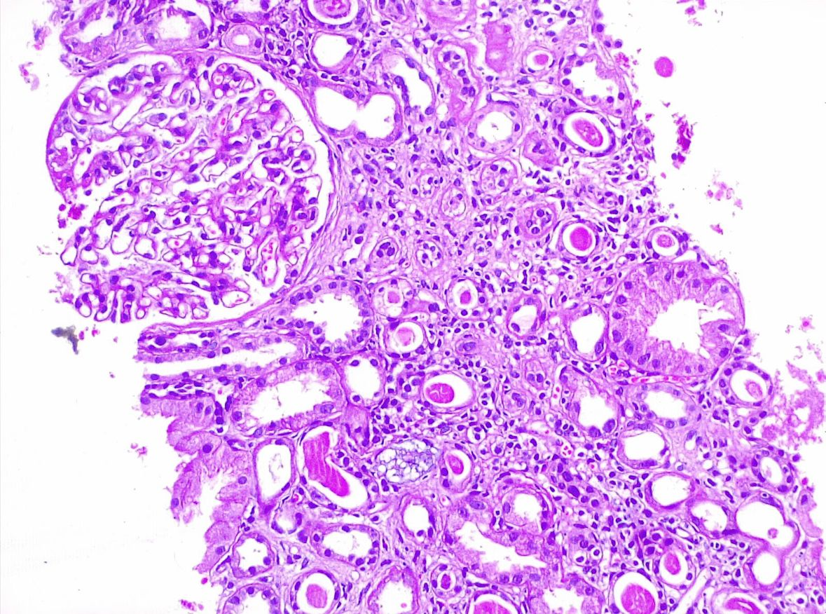

Figure 2- Immunofluorescence microscopy of renal biopsy demonstrating coarse granular IgG staining along the glomerular capillary walls

