Case report
C1q-Associated Nephropathy in a Patient with Prior Acute Interstitial Nephritis and Treated Hepatitis C Infection.

Abstract
C1q nephropathy (C1qN) is an uncommon glomerular disorder defined by dominant mesangial deposition of complement component C1q on immunofluorescence in the absence of clinical or serological evidence of systemic lupus erythematosus (SLE). It classically presents with nephrotic syndrome and shows variable light microscopic appearances that may mimic minimal change disease (MCD) or focal segmental glomerulosclerosis (FSGS). We report a 48-year-old male farmer with a history of biopsy-proven acute interstitial nephritis (AIN) and previously treated hepatitis C virus (HCV) infection who presented with nephrotic-range proteinuria, severe hypoalbuminemia, and marked dyslipidemia. Renal biopsy demonstrated dominant mesangial C1q positivity with trace IgG, C3 and light chains, and electron microscopy revealed electron-dense deposits confined exclusively to the mesangium. The patient was started on high-dose corticosteroids (prednisolone 1 mg/kg/day) as per KDIGO adult nephrotic syndrome recommendations, achieved complete remission by four weeks, and is currently maintained on a six-month tapering schedule. This case highlights the diagnostic utility of renal biopsy, the importance of differentiating C1qN from lupus nephritis, and the potential association of antecedent immune insults or viral exposure with mesangial immune complex disease.

Introduction
C1q nephropathy was first characterized in 1985 and remains a subject of clinical and pathological debate owing to its heterogenous presentation and uncertain pathogenesis. The defining diagnostic criterion is dominant or co-dominant mesangial C1q deposition on immunofluorescence in individuals without systemic lupus erythematosus. The clinicopathologic spectrum ranges from relatively benign proteinuria to full nephrotic syndrome with progressive kidney dysfunction. Histologically, C1qN may show MCD-like changes, mesangial proliferative features, or FSGS, and the prognosis varies with the light microscopic pattern and response to therapy. Immune complex formation with activation of the classical complement pathway is implicated, and viral infections such as hepatitis C and HIV have been reported in association with mesangial immune deposits; however, causality is not firmly established. Clinicians must carefully distinguish C1qN from lupus nephritis because management strategies and long-term monitoring differ substantially. We present a case that illustrates the diagnostic pathway and favorable steroid responsiveness of a mesangial C1q-dominant nephropathy in an adult with prior interstitial nephritis and successfully treated HCV infection.

Case Details
A 48-year-old male farmer presented to our nephrology clinic with a two-year history of intermittent bilateral lower limb swelling that had become progressively persistent and was now accompanied by increasing abdominal distension and persistently frothy urine. He reported generalized fatigue and decreased exercise tolerance but denied fever, gross hematuria, oliguria, skin rash, photosensitivity, arthralgia, oral ulcers or breathlessness. He had not taken any over-the-counter nephrotoxic drugs or herbal medicines in the recent past. His past medical history included biopsy-proven acute interstitial nephritis three years earlier, which had responded to a short course of corticosteroids with apparent full recovery of renal function. He also had a history of hepatitis C virus infection which had been treated with direct-acting antiviral agents, and follow-up testing had shown negative HCV RNA. There was no history of diabetes mellitus, long-standing hypertension, tuberculosis, autoimmune disease, or a family history of chronic kidney disease.
On physical examination, the patient was afebrile and hemodynamically stable with a blood pressure of 118/74 mmHg and a pulse of 84/min. He had bilateral pitting pedal edema extending to the mid-calf and mild ascites on abdominal examination. Cardiorespiratory and cardiovascular examinations were unremarkable. There were no cutaneous stigmata of systemic autoimmune disease, no synovitis, and no lymphadenopathy.
Laboratory evaluation showed severe hypoalbuminemia (serum albumin 0.9 g/dL) and pronounced dyslipidemia: total cholesterol 376 mg/dL, LDL cholesterol 309 mg/dL and triglycerides 208 mg/dL. Urine analysis revealed nephrotic-range proteinuria with an albumin-to-creatinine ratio (ACR) of 13,372 mg/g. Serum creatinine was 0.9 mg/dL and electrolytes were within normal limits. Complement levels (C3, C4) were in the reference range and serologies for ANA, anti-double-stranded DNA, HIV, hepatitis B surface antigen and hepatitis C antibody were negative at presentation. Abdominal ultrasound demonstrated normal-sized kidneys with preserved corticomedullary differentiation, grade I fatty liver and mild splenomegaly without obstructive uropathy.
Given the severity of proteinuria, profound hypoalbuminemia and the absence of extrarenal features of systemic autoimmune disease, a percutaneous renal biopsy was performed. Light microscopy revealed nine glomeruli, two of which were globally sclerosed. The viable glomeruli showed mild mesangial matrix expansion without significant hypercellularity, endocapillary proliferation, crescents or necrotizing lesions. There was no segmental sclerosis identified on the sampled tissue. Tubulointerstitial evaluation showed mild chronic interstitial fibrosis and tubular atrophy. Immunofluorescence microscopy demonstrated dominant mesangial C1q staining (1+) with only trace granular staining for IgG, C3 and both kappa and lambda light chains; there was no “full-house” pattern suggestive of lupus nephritis and no significant capillary wall staining. Electron microscopy confirmed the presence of electron-dense deposits confined exclusively to the mesangium with no detectable subendothelial or subepithelial deposits and showed approximately 50–60% effacement of podocyte foot processes. These combined features were most consistent with C1q-associated mesangial immune complex nephropathy.
In line with KDIGO 2021 recommendations for adult nephrotic syndrome and considering the MCD-like clinical behavior and preserved renal function, the patient was started on high-dose oral prednisolone at 1 mg/kg/day (60 mg/day). Supportive measures included angiotensin-converting enzyme inhibitor therapy for antiproteinuric effect, loop diuretics for symptomatic edema control, dietary sodium restriction, and initiation of statin therapy to address severe dyslipidemia. The patient was monitored closely for steroid-related adverse effects and infection risk. Within four weeks of initiating therapy the patient experienced dramatic clinical improvement: edema resolved, serum albumin rose to 3.7 g/dL and ACR decreased to below 300 mg/g, meeting criteria for complete remission of nephrotic syndrome. Given this favorable response, a structured steroid taper over six months was planned and he remains in clinical and biochemical remission on follow-up.

Discussion
C1q nephropathy is an unusual and underrecognized glomerular disease with variable clinical manifestations and prognosis. Its defining pathological hallmark — dominant mesangial deposition of C1q — implicates activation of the classical complement pathway, but whether these deposits represent pathogenic immune complexes, trapped circulating immune reactants, or aberrant local complement handling is unresolved. Associations with viral infections (including hepatitis C), prior immune-mediated renal injury and other triggers have been reported, suggesting that chronic antigenic stimulation may predispose to mesangial immune complex formation. In our patient, antecedent HCV infection (successfully treated) and prior AIN could plausibly have contributed to persistent or episodic immune activation and subsequent mesangial deposition, though direct causation cannot be proven retrospectively.
Clinically, C1qN most often presents with nephrotic syndrome in children and young adults; however, adult presentations can be heterogeneous. Important clinical differentials include MCD, idiopathic FSGS and lupus nephritis. Distinguishing C1qN from lupus nephritis is essential because lupus typically demonstrates a “full-house” immunofluorescence pattern with peripheral capillary wall deposits on electron microscopy, serologic autoantibodies, and systemic features. In contrast, C1qN shows mesangial-dominant C1q without serologic markers of SLE and lacks peripheral deposits, as seen in our case. The histologic pattern (MCD-like vs FSGS-like) is important prognostically; MCD-like lesions generally show corticosteroid responsiveness while FSGS-like variants are more likely to be steroid-resistant and have progressive loss of renal function.
Therapeutically, management follows established nephrotic syndrome protocols. High-dose corticosteroids remain the first-line therapy for steroid-sensitive presentations, while calcineurin inhibitors (cyclosporine, tacrolimus) or mycophenolate mofetil can be considered in steroid-resistant or frequently relapsing disease. Our patient’s rapid and complete remission following high-dose steroid therapy is consistent with a steroid-sensitive phenotype and predicts a favorable renal outcome; nevertheless, relapse remains possible and long-term monitoring is warranted. Adjunctive therapies targeting proteinuria and cardiovascular risk (RAAS blockade, statins) are essential components of comprehensive care.
Prognostic determinants in C1qN include baseline renal function, the extent of chronicity on biopsy (glomerulosclerosis, tubulointerstitial fibrosis), presence of FSGS lesions, and responsiveness to immunosuppression. Large cohort data are limited, and reported outcomes vary, with some patients maintaining prolonged remission and others progressing to chronic kidney disease over time. This variability highlights the need for individualized management and close follow-up.

Conclusion
C1q-associated mesangial immune complex nephropathy should be considered in adults presenting with nephrotic syndrome, particularly when serologic testing for SLE is negative and renal biopsy shows mesangial-dominant C1q deposits with mesangial electron-dense deposits on EM. Early renal biopsy with combined light microscopy, immunofluorescence and electron microscopy is critical for accurate diagnosis and to guide therapy. High-dose corticosteroid therapy, as applied in this case according to KDIGO adult nephrotic syndrome guidance, may induce rapid remission in steroid-sensitive presentations. Continued surveillance during steroid taper and long-term follow-up are necessary to detect relapse and manage complications.

References
- Devasahayam, J., Erode-Singaravelu, G., Bhat, Z., Oliver, T., Chandran, A., & Zeng, X. (2015). C1q Nephropathy: The Unique Underrecognized Pathological Entity. Analytical Cellular Pathology (Amsterdam). https://doi.org/10.1155/2015/490413
- Kanodia, K. V., Vanikar, A. V., Patel, R. D., Suthar, K. S., Patel, H. V., Gumber, M. A., Shah, P. R., & Trivedi, H. L. (2015). C1q nephropathy in India: A single-center study. *Saudi Journal of Kidney Diseases and Transplantation*, *26*(2), 398–403. https://doi.org/10.4103/1319-2442.152562
- Jennette, J. C., & Hipp, C. G. (1985). C1q nephropathy: a distinct pathologic entity usually causing nephrotic syndrome. American Journal of Kidney Diseases, 6(2), 103–110. https://doi.org/10.1016/s0272-6386(85)80150-5
- Sharman, A., Furness, P., & Feehally, J. (2004). Distinguishing C1q nephropathy from lupus nephritis. Nephrology Dialysis Transplantation, 19(6), 1420–1426. https://doi.org/10.1093/ndt/gfh139
- Markowitz, G. S., Schwimmer, J. A., Stokes, M. B., Nasr, S., Seigle, R. L., Valeri, A. M., & D'Agati, V. D. (2003). C1q nephropathy: A variant of focal segmental glomerulosclerosis. Kidney International, 64(4), 1232–1240. https://doi.org/10.1046/j.1523-1755.2003.00218.x
- Hisano, S., Fukuma, Y., Segawa, Y., Niimi, K., Kaku, Y., Hatae, K., Saitoh, T., Takeshita, M., & Iwasaki, H. (2008). Clinicopathologic correlation and outcome of C1q nephropathy. Clinical Journal of the American Society of Nephrology, 3(6), 1637–1643. https://doi.org/10.2215/CJN.00830208
- Yu, A. S. L., Chertow, G. M., Luyckx, V., Marsden, P. A., Skorecki, K., & Taal, M. W. (Eds.). (2019). *Brenner and Rector's The Kidney* (11th ed.). Elsevier. https://www.elsevier.com/books/brenner-and-rectors-the-kidney/yu/978-0-323-53265-5

Table 1 : Investigations
Parameter | Result | Reference Range | Notes
Hemoglobin | 10.3 g/dL | 13–17 g/dL | Mild anemia
WBC | 7.8 ×10⁹/L | 4–10 ×10⁹/L | Normal
Platelets | 140 ×10⁹/L | 150–400 ×10⁹/L | Mild thrombocytopenia
Serum Creatinine | 0.9 mg/dL | 0.6–1.2 mg/dL | Normal renal function
eGFR | 95 mL/min/1.73 m² | >90 mL/min/1.73 m² | Normal
Serum Albumin | 0.9 g/dL | 3.5–5.0 g/dL | Severe hypoalbuminemia
Total Protein | 4.0 g/dL | 6.0–8.0 g/dL | Low
Serum Calcium | 7.9 mg/dL | 8.5–10.2 mg/dL | Mild hypocalcemia
Cholesterol | 376 mg/dL | <200 mg/dL | Marked hypercholesterolemia
LDL | 309 mg/dL | <100 mg/dL | High
Triglycerides | 171 mg/dL | <150 mg/dL | Mildly elevated
Urine Protein | 4+ | Negative | Nephrotic-range
Urine ACR | 13,372 mg/g | <30 mg/g | Nephrotic-range
Urine RBC | 2–3 /HPF | 0–2 /HPF | Mild hematuria
Urine WBC | 0–2 /HPF | 0–5 /HPF | Normal
HIV, HBsAg, HCV | Negative | Negative | No active infection
ANA, dsDNA | Pending | Negative | To exclude lupus
Ultrasound Abdomen | Normal kidneys, grade 1 fatty liver, mild splenomegaly | N/A | No obstruction

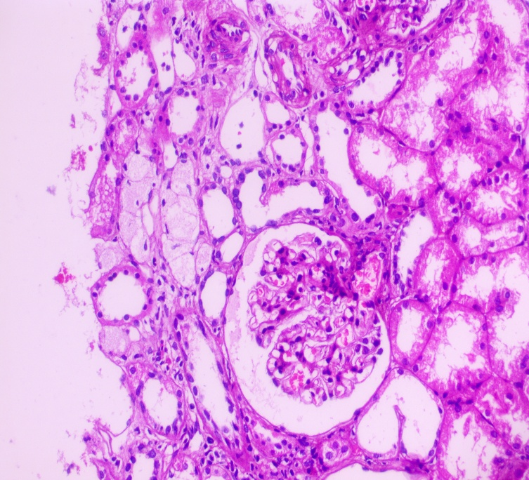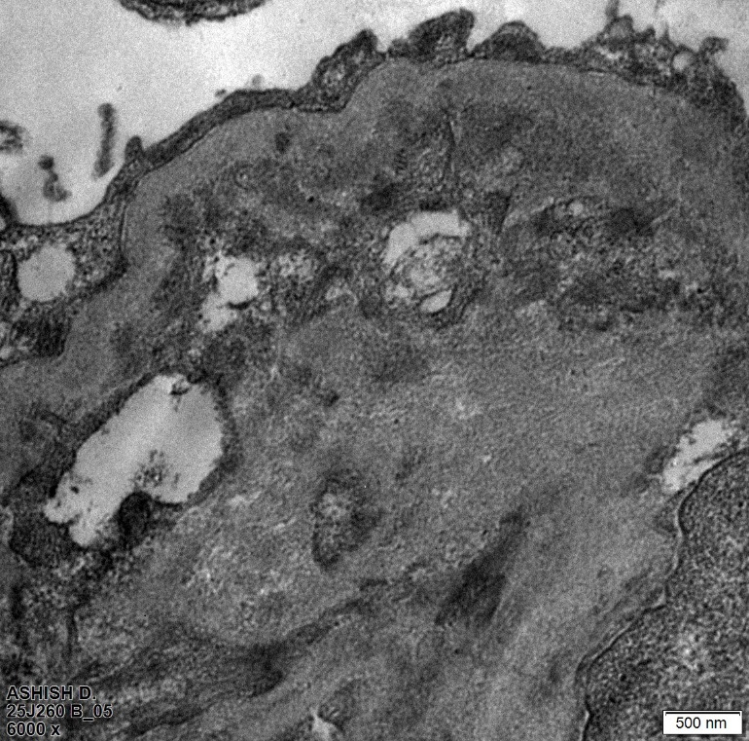
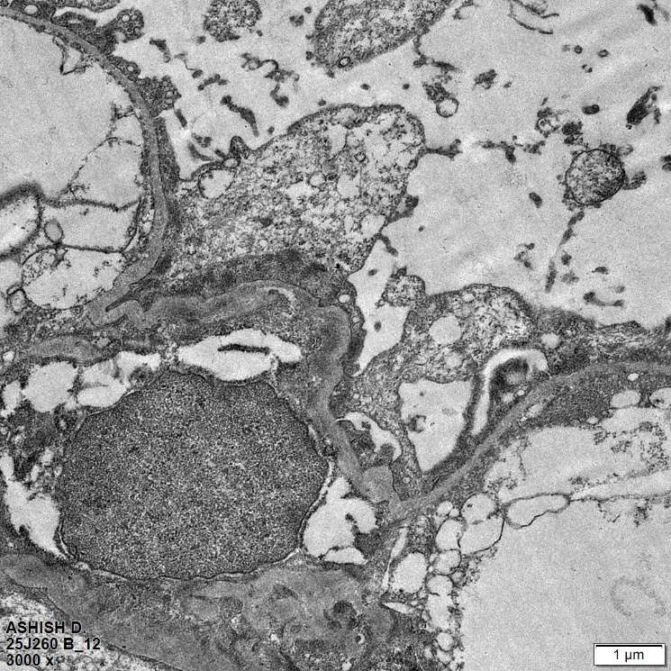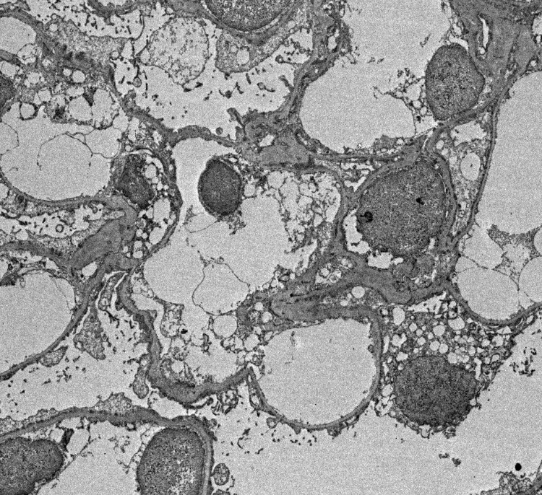
Fig 1 : Light microscopy showing focal dilatation and congestion of capillary lumina, no other proliferative or exudative activity

