Formulation and Characterization of Millet-Enriched Chocolate with an Enhanced Nutritional Profile

Abstract
This study focused on developing a nutritionally improved millet-enriched chocolate by incorporating three underutilised millets: finger millet (Eleusine coracana), foxtail millet (Setaria italica), and kodo millet (Paspalum scrobiculatum), along with nutrient-rich dry fruits. Four formulations (T1 to T4) were prepared with different millet ratios and evaluated for sensory characteristics, nutritional composition, microbiological safety, and economic feasibility. Each formulation contained 20 g of mixed millets, 60 g dark compound chocolate, and fixed levels of butter (10 g) and dry fruits (10 g) per 100 g batch. Based on a 9-point hedonic scale, T2 emerged as the optimised formulation, receiving significantly higher scores for taste (8.6 ± 0.29), texture (8.6 ± 0.28), and aroma (8.0 ± 0.26) (p < 0.05). Nutritional analysis of T2 showed 5.90 g of protein, 59.85 g of carbohydrates including 21.19 g of sugars, 29.48 g of fat, and 3.70 g of dietary fibre per 100 g. The micronutrient profile was also enhanced, containing 4.90 mg of iron and 110.24 mg of calcium. Microbiological testing recorded a total plate count of 750 cfu/g, while coliforms, yeast, and moulds were not detected (within the method detection limits), indicating satisfactory hygienic quality. A detailed cost analysis that considered raw materials, packaging, processing, and overheads estimated a maximum retail price (MRP) of ₹100.11 per 100 g. This price falls within the typical range of premium chocolates in the Indian market, suggesting strong commercial potential. Overall, the findings show that millet-enriched chocolate can offer better nutritional value while remaining sensorially acceptable and economically viable. This product also supports dietary diversification and aligns with the growing interest in functional foods.
Keywords: Millet-based chocolate, Foxtail millet, Kodo millet, Sensory analysis, Economic feasibility.
- Introduction
The global shift towards health-conscious consumption has catalysed the development of functional foods. These are products that not only fulfil basic nutritional needs but also provide additional physiological benefits. Among them, value-added confections with enhanced nutritional profiles are gaining popularity, especially when they align with clean-label and sustainability trends. Traditional millets, long overlooked in modern diets, are now being revisited for their rich nutritional attributes and environmental resilience. This makes them suitable candidates for ingredients in functional food matrices.
Millets such as finger millet (Eleusine coracana), foxtail millet (Setaria italica), and kodo millet (Paspalum scrobiculatum) are characterised by their high fibre, protein, and micronutrient contents, along with a low glycaemic index and various health-promoting properties. Finger millet, widely cultivated in South Asia and Africa, is particularly rich in complex carbohydrates (72-79.5%), dietary fibre, protein (7-12.7%), calcium (162-487 mg/100 g), and iron (3.61-5.42 mg/100 g), with noted antioxidant and bone-strengthening potential (Dida & Devos, 2006; Singh & Raghuvanshi, 2012; Shobana et al., 2013; Chandrasekara & Shahidi, 2011). Foxtail millet exhibits elevated protein (11.85-20.58 g/100 g), fat (2.82-4.47 g/100 g), and starch (65.59-74.12 g/100 g) contents, along with B-complex vitamins and antioxidant activity (Sharma & Niranjan, 2018). Kodo millet is similarly nutrient-dense, with 7-12% protein, 8-9% fibre, and a high polyphenol content. According to earlier studies, these components have been linked with favourable metabolic responses (Deshpande et al., 2015; Saleh et al., 2013).
Dark compound chocolate is a widely used confectionery base due to its processing stability, cost-effectiveness, and consumer acceptability. Cocoa solids in chocolate are a source of bioactive compounds, including polyphenols and flavanols, which are recognised for their antioxidant properties and have been linked to potential cardiometabolic and neurocognitive health benefits (Cooper et al., 2008; Patel et al., 2019). Consequently, dark compound chocolate can serve as an effective carrier matrix for incorporating functional ingredients such as millet flours and dry fruits. Almonds, cashews, and pistachios are nutritionally dense nuts, providing substantial amounts of healthy fats (predominantly unsaturated), high-quality plant protein, dietary fibre, vitamin E, and essential minerals (e.g., calcium, potassium) (Bulló et al., 2015; Bai et al., 2019; Gonçalves et al., 2023). These bioactive ingredients are known to support cardiovascular health, glycaemic regulation, and cognitive function (Gebauer et al., 2016). Despite individual recognition of these ingredients for their health benefits, limited research exists on their synergistic application in functional confectionery products. The integration of millets and dry fruits into a dark compound chocolate matrix offers a unique opportunity to bridge nutritional gaps while appealing to modern consumer preferences. Furthermore, the promotion of millets is supported by global initiatives such as the International Year of Millets (FAO, 2023), highlighting the relevance and timeliness of such innovations.
Therefore, the present study was undertaken to develop and evaluate a chocolate formulation enriched with millets and dry fruits. The objectives were to optimise the ingredient composition and assess the sensory attributes, nutritional profile, microbiological quality, and economic feasibility of the developed product.
- Methodology
  - Raw Materials
Finger millet (Eleusine coracana) and kodo millet (Paspalum scrobiculatum) were procured from local suppliers in Bharuch, Gujarat, while foxtail millet (Setaria italica) was sourced from Thane, Maharashtra. Dark compound chocolate (commercial grade), unsalted butter, and dry fruits (almonds, cashews, and pistachios) were purchased from local suppliers in Bharuch, Gujarat, India. All ingredients were used without further chemical modification.
  - Millet Enriched Chocolate Preparation
The millets were thoroughly washed with potable water, dried in a hot-air oven, and milled into fine flour using a laboratory-scale grinder, followed by sieving through a 100 μm mesh to obtain a uniform particle size. The flour was then dry roasted with butter at 80-90 °C for 5 to 7 minutes to reduce residual moisture and enhance flavour (as shown in Fig. 1). Butter was incorporated at a fixed level of 10 g per formulation during roasting of millet flour. Dry fruits were lightly roasted at 150 °C for 5 minutes and chopped into small, uniform pieces.
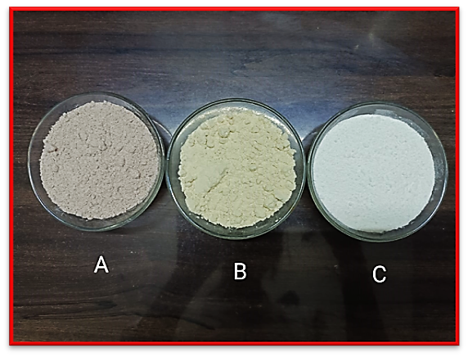
Fig. 1. Millet flours: (A) Finger Millet; (B) Foxtail Millet; (C) Kodo Millet
Dark compound chocolate was selected due to its improved processing stability, lower cost, and suitability for functional ingredient incorporation. Chocolate was melted using the double-boiling method at approximately 50 °C with continuous stirring at 150 rpm. Once fully liquefied, the roasted millet flour and chopped dry fruits were gradually incorporated under controlled stirring (150 rpm for 5-7 minutes) to ensure uniform dispersion of ingredients. The homogenised mixture was then poured into pre-lubricated food grade silicone moulds and allowed to set in a freezer at −18 °C for 2-3 h for solidification. The demoulded chocolates were individually wrapped in aluminium foil and subsequently stored under controlled conditions at 20 ± 2 °C for a maximum period of 48 h prior to sensory, nutritional, and microbiological analyses.
2.3 Formulation Design
Four experimental formulations (T1-T4) were developed by fixing the total millet content at 20 g per 100 g of product and systematically varying the proportions of finger millet, foxtail millet, and kodo millet. The quantity of dark compound chocolate was kept constant at 60 g, while butter and mixed dry fruits were incorporated at fixed levels of 10 g each across all formulations. This formulation strategy ensured a consistent product mass (100 g) while isolating the effect of millet type and ratio on sensory, nutritional, and functional characteristics. Similar observations have been reported in earlier studies, where the addition of plant-based or grain ingredients was shown to substantially affect chocolate rheology, melting characteristics, and consumer acceptability (Aidoo et al., 2013; Medina-Mendoza et al., 2021). To avoid these processing challenges and maintain desirable chocolate texture, the total millet content was restricted to 20 g per 100 g, and only the ratios of the three millets were systematically varied across treatments. This approach allowed the evaluation of sensory balance, flavour contribution, and nutritional enhancement without compromising structural integrity. In addition, millets are recognised as nutrient-dense grains rich in fibre, minerals, and bioactive components, making them suitable for functional food development (Rawat et al., 2023). Thus, the four formulations were designed to achieve a practical balance between technological feasibility, sensory appeal, and nutritional enrichment, while isolating the effect of different millet combinations on the final product.
Table 1. Ingredient composition of millet-enriched chocolate formulations (per 100 g)
Ingredient | T1 (g) | T2 (g) | T3 (g) | T4 (g)
Finger millet | 10 | 10 | 5 | 5
Foxtail millet | 3 | 5 | 5 | 10
Kodo millet | 7 | 5 | 10 | 5
Dark compound chocolate | 60 | 60 | 60 | 60
Butter | 10 | 10 | 10 | 10
Dry fruits (mixed) | 10 | 10 | 10 | 10
2.4 Sensory Evaluation
Sensory evaluation of the chocolate formulations (T1-T4) was conducted by a semi-trained panel comprising 45 participants, including faculty members, students, and food industry professionals. The sensory attributes evaluated were colour and appearance, aroma, taste, texture, and overall acceptability, using a 9-point hedonic scale (1 = dislike extremely, 9 = like extremely). Each panellist evaluated all four formulations in three independent sessions conducted on different days to minimise session-related bias and fatigue effects. Samples were served in a randomised order using three-digit blinding codes under controlled lighting and temperature conditions. Panellists were instructed to rinse their mouths with potable water between samples to avoid carry-over effects. For statistical analysis, scores obtained across the three sessions were averaged for each panellist and formulation, yielding a single representative value per sensory attribute. This approach ensured that the panellist, rather than individual sessions, was treated as the experimental unit. The evaluation protocol followed the guidelines outlined in ISO 8589:2007 for sensory analysis test conditions.
2.5 Proximate Nutritional Analysis
The proximate nutritional composition of the optimised formulation (T2) was determined in triplicate using standard analytical procedures. Moisture content of chocolate samples was determined by the hot-air oven method, wherein approximately 2.0 ± 0.1 g of sample was weighed into pre-dried, tared aluminium dishes and dried at 105 ± 2 °C to constant weight, as per the method described by Kreiser and Martin Jr. (1977) and Latimer (2016). Constant weight was confirmed when two successive weighings, after cooling in a desiccator, differed by less than 1 mg. Ash content was determined by incinerating 2.0 ± 0.1 g of chocolate sample in a pre-weighed crucible at 550 °C in a muffle furnace for 4-6 hours, until a light grey residue and constant weight were obtained, following the procedure described in Latimer (2016). Crude fat content was extracted using a Soxhlet apparatus with petroleum ether as the solvent. Protein content was determined via the Kjeldahl method, applying a nitrogen-to-protein conversion factor of 6.25. Carbohydrate content was calculated by difference using the formula: 100 minus the sum of moisture, protein, fat, and ash contents. Total sugars were estimated after acid inversion (hydrolysis of non-reducing sugars) followed by Fehling’s titration, and expressed as g per 100 g of sample. Dietary fibre was analysed by the enzymatic-gravimetric method in accordance with IS 11062:1984. Calcium concentration was determined through EDTA titration after ash digestion of the sample; Iron content was measured using a colorimetric method as described by Ranganna (1986). Additionally, vitamin E content was quantified by High-Performance Liquid Chromatography (HPLC), following AOAC Method 992.03 and reported as mg per 100 g.
2.6 Microbiological Analysis
To assess the microbiological safety of the optimised chocolate formulation (T2), total plate count (TPC), coliform count, and yeast and mould count were evaluated. TPC was performed by plating serial dilutions of the sample on nutrient agar using the pour plate method, followed by incubation at 37 °C for 48 h. Coliforms were enumerated using Violet Red Bile Agar (VRBA) by pour plating appropriate dilutions and incubating at 37 °C for 24 h; typical red/pink colonies with bile precipitation were counted and expressed as cfu/g. Yeast and mould counts were carried out by inoculating samples onto potato dextrose agar (PDA) and incubating them at 28 °C for 72 h. The results were expressed as colony-forming units per gram (cfu/g) of the sample. The limit of detection for plate counts was <10 cfu/g (based on the lowest countable dilution plated).
2.7 Statistical Analysis
Sensory data were expressed as mean ± standard deviation (SD). Statistical analysis was performed using one-way analysis of variance (ANOVA) with formulation (T1-T4) as the fixed factor. The panellist-averaged score for each formulation served as the experimental unit (n = 45). When significant differences were observed, Tukey’s Honestly Significant Difference (HSD) test was applied for post-hoc pairwise comparisons among means. Statistical significance was established at p < 0.05. All analyses were carried out using R software (version 4.5.1; R Foundation for Statistical Computing, Vienna, Austria) through the RStudio integrated development environment. Nutritional and microbiological analyses were performed in triplicate, and results are reported as mean values to ensure analytical reliability and reproducibility. Session-to-session variability was minimised by averaging repeated measurements prior to statistical analysis.
- Results and Discussion
3.1 Product Development and Formulation Strategy
T2 was identified as the optimised formulation owing to its superior performance across all sensory attributes, including colour and appearance, aroma, taste, texture, and overall acceptability, along with its enhanced nutritional profile, satisfactory microbiological quality, and favourable cost structure. This formulation demonstrated an optimal balance between consumer preference and functional enrichment, thereby emerging as the most commercially viable variant. A total of four formulations (T1-T4) were developed using a fixed total millet incorporation level of 20 g per 100 g of product, while systematically varying the relative proportions of finger millet, foxtail millet, and kodo millet. This formulation approach was designed to exploit the complementary nutritional and functional attributes of these traditional millets and associated dry fruits, as reported in earlier studies (Shobana et al., 2013; Azadmard-Damirchi et al., 2011; Saleh et al., 2013). The final chocolate product obtained from the optimised T2 formulation is presented in Fig. 2.

Fig. 2. Optimized millet-enriched chocolate products (T2 formulation)
3.2 Sensory Evaluation of Chocolate Formulations
The sensory attributes of the chocolate formulations (T1-T4) were evaluated using a 9-point hedonic scale for colour and appearance, aroma, taste, texture, and overall acceptability. Sensory scores were analysed using panellist-averaged data obtained from three independent evaluation sessions, ensuring that each panellist served as the experimental unit. Among the four formulations, T2 consistently received the highest mean scores across all evaluated sensory attributes, indicating superior overall acceptability (Fig. 3). The T2 formulation recorded mean scores of 8.7 ± 0.34 for appearance, 8.0 ± 0.26 for aroma, 8.6 ± 0.29 for taste, and 8.6 ± 0.28 for texture, reflecting strong consumer preference and favourable sensory perception. One-way analysis of variance (ANOVA) revealed that formulation type had a statistically significant effect (p < 0.05) on all sensory attributes evaluated. Post-hoc comparisons using Tukey’s Honestly Significant Difference (HSD) test confirmed that T2 scored significantly higher than the other formulations for appearance, taste, and texture (p < 0.05). For aroma, T2 exhibited significantly higher scores compared with T1 (p < 0.05), while differences with T3 and T4 were not statistically significant. Overall, the consistently higher mean scores and relatively low variability associated with the T2 formulation indicate strong agreement among panellists and confirm its sensory superiority over the other variants. The enhanced acceptability of T2 can be attributed to its optimised balance of millet composition and chocolate matrix, which contributed to favourable sensory characteristics across multiple attributes. These findings are consistent with earlier reports demonstrating improved palatability and consumer acceptance in millet-enriched chocolate and cocoa-based products (Arora et al., 2023).
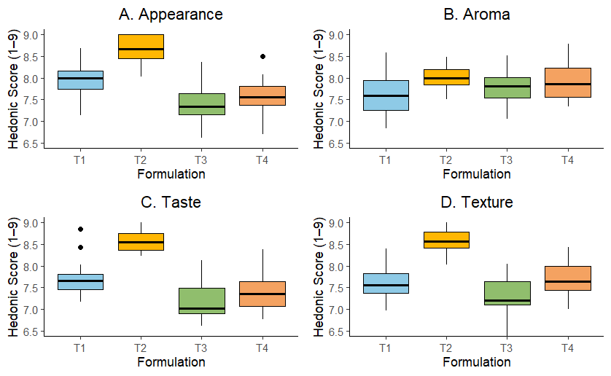
Fig. 3. Sensory evaluation of millet-enriched chocolate formulations (T1-T4)
3.3 Nutritional Composition of the Optimised Formulation (T2)
Nutritional values are expressed per 100 g of product for the optimised formulation containing 60 g dark compound chocolate, 10 g butter, 10 g dry fruits, and 20 g millets. Formulation T2 exhibited a well-balanced nutritional profile, providing 5.90 g protein, 59.85 g carbohydrates (including 21.19 g sugars), 29.48 g fat, and 3.70 g dietary fibre, along with 4.90 mg iron, 110.24 mg calcium, and 0.21 mg vitamin E per 100 g. The nutritional composition is presented in Table 2 and illustrated in Figs. 4 and 5. The low moisture content of the optimised formulation (2.11%) supports improved microbial stability, which is consistent with the inherently low water activity of chocolate-based matrices. The inclusion of underutilised millets and dry fruits contributed significantly to the enhancement of micronutrient density, particularly iron and calcium, which are nutrients of concern in typical Indian diets (Deshpande et al., 2015; Gupta et al., 2015; ICMR-NIN, 2020). The iron content observed in T2 (4.90 mg/100 g) exceeded values commonly reported for conventional cocoa-based confections (3.20 mg/100 g) (Kinder et al., 1942), highlighting the formulation’s improved nutritional value. The elevated calcium (110.24 mg/100 g) levels are largely attributable to kodo millet, which is recognised for its high mineral content (Bukar et al., 2021; Ramashia et al., 2019). Overall, the optimised formulation demonstrates how the integration of traditional millets and nutrient-dense dry fruits can enhance the nutritional profile of chocolate products, offering added value beyond taste.

Table 2. Nutritional composition of the optimised chocolate formulation (T2) per 100 g
Parameter | Value (per 100 g)
Moisture (%) | 2.11
Ash (%) | 1.87
Protein (g/100 g) | 5.90
Carbohydrates (g/100 g) | 59.85
Sugars (g/100 g) | 21.19
Fat (g/100 g) | 29.48
Dietary fibre (g/100 g) | 3.70
Iron (mg/100 g) | 4.90
Calcium (mg/100 g) | 110.24
Vitamin E (mg/100 g) | 0.21

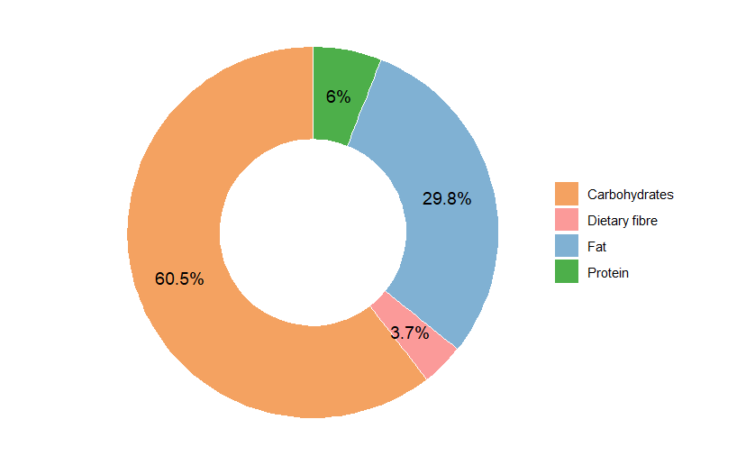
Fig. 4. Macronutrient distribution of T2 formulation (per 100 g)
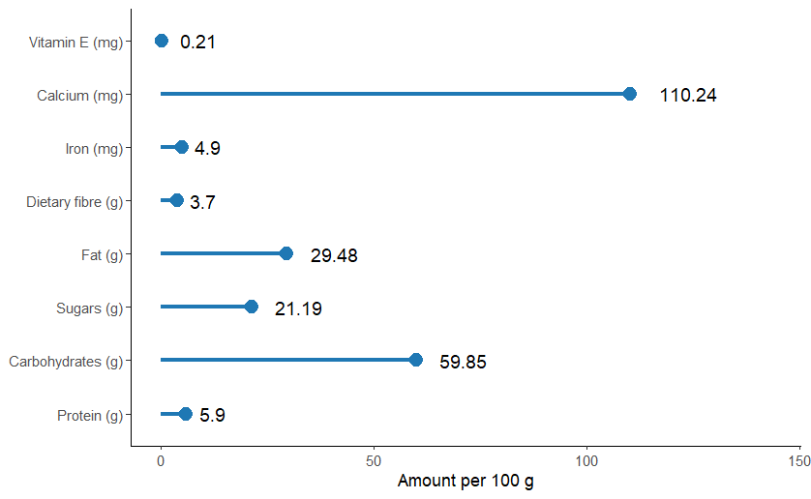
Fig. 5. Nutritional Composition of Optimised Chocolate (T2)
3.4 Microbiological Analysis
The microbiological assessment of the optimised formulation (T2) indicated satisfactory microbial quality. The total plate count (TPC) was 750 cfu/g, while coliforms and yeast/moulds were not detected (<10 cfu/g), indicating good hygienic quality. These results demonstrate that the product maintained acceptable hygiene standards during preparation and storage. The low microbial load can be primarily attributed to the low moisture content of the formulation, in combination with effective processing steps such as roasting and hygienic handling during production. Similar observations have been reported by Beckett et al. (2017), who emphasised that the inherently low water activity of chocolate, coupled with proper thermal processing, restricts microbial proliferation and extends shelf stability. Thus, the current findings are consistent with established knowledge on the microbiological safety of chocolate products.
3.5 Economic Feasibility and Cost Structure
The economic feasibility of the optimised millet-enriched chocolate formulation (T2) was evaluated by systematically accounting for all major cost components, including raw materials, packaging, processing-related overheads, profit margin, and statutory taxes. The formulation was standardised on a 100 g product basis, comprising 60 g dark compound chocolate, 10 g butter, 10 g mixed dry fruits, and 20 g millets, with a 2% processing loss incorporated to account for handling and processing inefficiencies. Based on prevailing market prices ₹700/kg for dark compound chocolate, ₹600/kg for butter, ₹900/kg for dry fruits, and ₹60/kg for millets the effective raw material cost was estimated at ₹59.36 per 100 g, representing the dominant cost contributor. Packaging inputs, including primary aluminium foil wrapping, secondary carton, labeling, and desiccant, added ₹6.10 per unit. Processing-related expenses covering direct labour, electricity and refrigeration, quality assurance and sanitation, logistics, and administrative/SG&A overheads were grouped under overheads, collectively contributing ₹11.67 per unit. After incorporating a 10% profit margin, the ex-factory price was calculated, and the application of Goods and Services Tax (GST) at 18% resulted in a final maximum retail price (MRP) of approximately ₹100.11 per 100 g. The cost distribution analysis (Fig. 6) showed that raw materials constituted the largest share of the MRP (59.3%), followed by GST (15.2%), overheads (11.6%), profit margin (7.7%), and packaging costs (6.1%). Although premium ingredients such as compound dark chocolate and dry fruits were the primary cost drivers, the inclusion of underutilised millets contributed only a small fraction of the overall cost while substantially improving the nutritional profile of the product. Importantly, the estimated retail price positions the developed millet-enriched chocolate well below luxury dark chocolate brands currently available in the Indian market (e.g., premium/luxury dark chocolate brands at approximately ₹325 per 100 g), demonstrating that the formulation achieves nutritional enhancement without significant cost escalation. These findings confirm the commercial viability and scalability of the optimised formulation for functional confectionery applications.
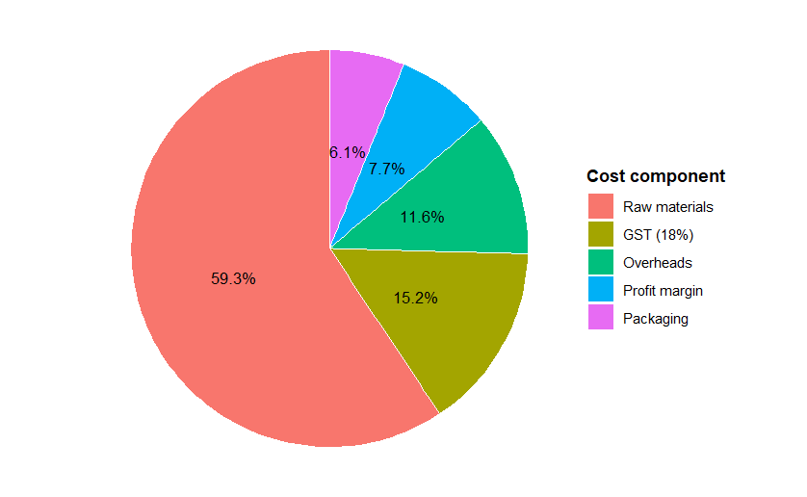
Fig. 6. Cost distribution of T2 formulation (per 100 g)
3.6 Integrated Evaluation and Commercial Relevance
The final integrated evaluation focuses on the sensory performance of the optimised chocolate formulation (T2), visually represented in Fig. 7. The radar plot compares the sensory scores of all four formulations (T1 to T4) across key attributes: appearance, aroma, taste, and texture. Among them, T2 consistently demonstrated superior scores, validating its selection as the most acceptable formulation based on overall sensory appeal. This sensory superiority, when considered alongside the previously discussed nutritional enrichment (Figure 4 and 5) and cost-effectiveness (Figure 6), reinforces the multifunctional potential of formulation T2. The product successfully combines consumer-preferred attributes, nutritional value, and economic feasibility. Such integration supports the development of clean-label, functional chocolate products aligned with the objectives of FAO’s International Year of Millets (2023) and global priorities for sustainable and health-promoting food innovations (Thagunna et al., 2022; Saleh et al., 2013).
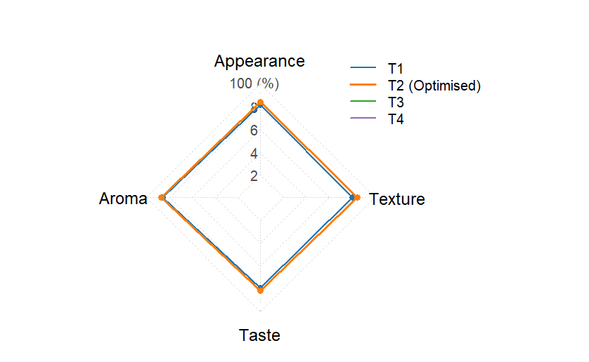
Fig. 7. Sensory Radar Plot of Chocolate Formulations (T1-T4)
4. Conclusion
This study successfully formulated a millet-enriched chocolate product using underutilised millets, namely finger millet, foxtail millet, and Kodo millet, along with nutrient-dense dry fruits. Among the four tested formulations, T2 was identified as the optimised variant, demonstrating superior performance in terms of sensory attributes, nutritional composition, microbiological safety, and economic feasibility. The incorporation of 20% millet flour blend significantly enhanced the protein, dietary fibre, iron, and calcium content, thereby improving the overall nutritional profile of the product in relation to conventional cocoa-based confections. The low microbial load and competitive cost structure further support its suitability for large-scale production. These findings emphasise the potential of traditional grains in the development of value-added food products, consistent with global initiatives such as the International Year of Millets. Importantly, the estimated retail price of the T2 formulation was found to be comparable to that of premium chocolates in the Indian market, highlighting its commercial viability alongside nutritional enhancement. Future research should include comprehensive shelf-life studies under varied storage conditions, large-scale consumer acceptability trials across diverse demographic segments, and scientific validation of health benefits through clinical or in vivo studies. Additionally, the development of product variants, such as low glycaemic index or high-protein formulations, may further extend the scope of millet-based confectionery innovations.
References
AOAC International. Official Methods of Analysis. 16th ed. Gaithersburg (MD): AOAC International; 1995.
Aidoo, R. P., Depypere, F., Afoakwa, E. O., & Dewettinck, K. (2013). Industrial manufacture of sugar-free chocolates–Applicability of alternative sweeteners and carbohydrate polymers as raw materials in product development. Trends in Food Science & Technology, 32(2), 84-96. https://doi.org/10.1016/j.tifs.2013.05.008
Arora, L., Aggarwal, R., Dhaliwal, I., Gupta, O. P., & Kaushik, P. (2023). Assessment of sensory and nutritional attributes of foxtail millet-based food products. Frontiers in Nutrition, 10, 1146545. https://doi.org/10.3389/fnut.2023.1146545
Azadmard-Damirchi, S., Emami, S. H., Hesari, J., Peighambardoust, S. H., & Nemati, M. (2011). Nuts composition and their health benefits. World Academy of Science, Engineering and Technology, 5(9), 544-548 https://doi.org/10.5281/zenodo.1329785 .
Bai, S. H., Brooks, P., Gama, R., Nevenimo, T., Hannet, G., Hannet, D., Randall, B., Walton, D., Grant, E., & Wallace, H. M. (2019). Nutritional quality of almond, canarium, cashew and pistachio and their oil photooxidative stability. Journal of food science and technology, 56(2), 792-798. https://doi.org/10.1007/s13197-018-3539-6
Beckett, S. T., Fowler, M. S., & Ziegler, G. R. (Eds.). (2017). Beckett's industrial chocolate manufacture and use. John Wiley & Sons. https://doi.org/10.1002/9781118923597
Bulló, M., Juanola-Falgarona, M., Hernández-Alonso, P., & Salas-Salvadó, J. (2015). Nutrition attributes and health effects of pistachio nuts. British Journal of Nutrition, 113(S2), S79-S93. https://doi.org/10.1017/S0007114514003250
Bureau of Indian Standards. IS 11062:1984 – Methods for determination of dietary fibre in food. New Delhi: BIS; 1984.
Bunkar, D. S., Goyal, S. K., Meena, K. K., & Kamalvanshi, V. (2021). Nutritional, functional role of kodo millet and its processing: a review. International Journal of Current Microbiology and Applied Sciences, 10(01), 1972-1985. https://doi.org/10.20546/ijcmas.2021.1001.229
Carvalho, M. J. B., & Fidalgo, L. (2021). Practical handbook sensory analysis. Escola Superior Agrária, Instituto Politécnico de Beja.
Chandrasekara, A., & Shahidi, F. (2011). Bioactivities and antiradical properties of millet grains and hulls. Journal of Agricultural and Food Chemistry, 59(17), 9563-9571. https://doi.org/10.1021/jf201849d
Cooper, K. A., Donovan, J. L., Waterhouse, A. L., & Williamson, G. (2008). Cocoa and health: a decade of research. British Journal of Nutrition, 99(1), 1-11. https://doi.org/10.1017/S0007114507795296
Deshpande, S. S., Mohapatra, D., Tripathi, M. K., & Sadvatha, R. H. (2015). Kodo millet-nutritional value and utilization in Indian foods. Journal of grain processing and storage, 2(2), 16-23.
Dida, M. M., & Devos, K. M. (2006). Finger millet. In Cereals and millets (pp. 333-343). Berlin, Heidelberg: Springer Berlin Heidelberg. https://doi.org/10.1007/978-3-540-34389-9_10
Food and Agriculture Organization of the United Nations. International Year of Millets 2023 [Internet]. Rome: FAO; 2023 [cited 2025 Aug 7]. Available from: https://www.fao.org/millets-2023
Food, C., & Kjeldahl, T. M. C. (2020). Changes in AOAC® official methods of analysis. J. AOAC Int, 79, 1060-3271. https://doi.org/10.1093/jaoac/79.1.363
Gebauer, S. K., Novotny, J. A., Bornhorst, G. M., & Baer, D. J. (2016). Food processing and structure impact the metabolizable energy of almonds. Food & function, 7(10), 4231-4238. https://doi.org/10.1039/C6FO01076H
Geetha, P., & Preethi, P. (2020). Development of kodo millet based functional milk beverage. IJCS, 8(6), 1034-1037. https://doi.org/10.22271/chemi.2020.v8.i6o.10900
Gonçalves, B., Pinto, T., Aires, A., Morais, M. C., Bacelar, E., Anjos, R., Ferreira-Cardoso, J., Oliveira, I., Vilela, A., & Cosme, F. (2023). Composition of nuts and their potential health benefits An overview. Foods, 12(5), 942. https://doi.org/10.3390/foods12050942
Gupta, R. K., Gangoliya, S. S., & Singh, N. K. (2015). Reduction of phytic acid and enhancement of bioavailable micronutrients in food grains. Journal of food science and technology, 52(2), 676-684. https://doi.org/10.1007/s13197-013-0978-y
Indian Council of Medical Research – National Institute of Nutrition. Nutrient Requirements for Indians – Recommended Dietary Allowances and Estimated Average Requirements. Hyderabad: ICMR-NIN; 2020.
Kinder, F., Mueller, W. S., & Mitchell, H. S. (1942). The availability of the iron of cocoa and of iron-fortified cocoa mixtures. https://doi.org/10.3168/jds.S0022-0302(42)95308-6
Kreiser, W. R., & Martin Jr, R. A. (1977). Comparison of Accuracy, Precision, and Speed of Three Methods for Determining Moisture in Milk Chocolate. Journal of the Association of Official Analytical Chemists, 60(2), 302-306. https://doi.org/10.1093/jaoac/60.2.302
Latimer, G. W. (Ed.). (2016). *Official methods of analysis of AOAC International* (20th ed.). AOAC International. https://www.aoac.org/official-methods-of-analysis/
Medina-Mendoza, M., Rodriguez-Pérez, R. J., Rojas-Ocampo, E., Torrejón-Valqui, L., Fernández-Jeri, A. B., Idrogo-Vásquez, G., Cayo-Colca, I.S., & Castro-Alayo, E. M. (2021). Rheological, bioactive properties and sensory preferences of dark chocolates with partial incorporation of Sacha Inchi (Plukenetia volubilis L.) oil. Heliyon, 7(2). https://doi.org/10.1016/j.heliyon.2021.e06154
Patel, N., Jayswal, S., & Maitreya, B. B. (2019). Dark chocolate: Consumption for human health. Journal of Pharmacognosy and Phytochemistry, 8(3), 2887-2890. https://www.phytojournal.com/archives/2019/vol8issue3/PartAO/8-2-565-157.pdf
R Core Team. (2022). R: A language and environment for statistical computing. R Foundation for Statistical Computing. https://www.R-project.org/
Ramashia, S. E., Anyasi, T. A., Gwata, E. T., Meddows-Taylor, S., & Jideani, A. I. O. (2019). Processing, nutritional composition and health benefits of finger millet in sub-saharan Africa. Food Science and Technology, 39, 253-266. https://doi.org/10.1590/fst.25017
Ranganna, S. (1986). Handbook of analysis and quality control for fruit and vegetable products. Tata McGraw-Hill Education.
Rawat, M., Varshney, A., Rai, M., Chikara, A., Pohty, A. L., Joshi, A., Binjola, A., Singh, C.P., Rawat, K., Rather, M.A., & Gupta, A. K. (2023). A comprehensive review on nutraceutical potential of underutilized cereals and cereal-based products. Journal of Agriculture and Food Research, 12, 100619. https://doi.org/10.1016/j.jafr.2023.100619
RStudio: Integrated Development Environment for R. Posit Software, PBC, Boston, MA, USA. https://www.posit.co/
Saleh, A. S., Zhang, Q., Chen, J., & Shen, Q. (2013). Millet grains: nutritional quality, processing, and potential health benefits. Comprehensive reviews in food science and food safety, 12(3), 281-295. https://doi.org/10.1111/1541-4337.12012
Sharma, N., & Niranjan, K. (2018). Foxtail millet: Properties, processing, health benefits, and uses. Food reviews international, 34(4), 329-363. https://doi.org/10.1080/87559129.2017.1290103
Shobana, S., Krishnaswamy, K., Sudha, V., Malleshi, N. G., Anjana, R. M., Palaniappan, L., & Mohan, V. (2013). Finger millet (Ragi, Eleusine coracana L.): a review of its nutritional properties, processing, and plausible health benefits. Advances in food and nutrition research, 69, 1-39. https://doi.org/10.1016/B978-0-12-410540-9.00001-6
Singh, P., & Raghuvanshi, R. S. (2012). Finger millet for food and nutritional security. African Journal of Food Science, 6(4), 77-84. https://doi.org/10.5897/AJFSX10.010
Sohan, S. Z., Kumari, B. A., Suneetha, W. J., & Gayatri, B. (2020). Development and Organoleptic Evaluation of Foxtail and Proso Flakes Incorporated Energy Dense Snack Bar. Current Journal of Applied Science and Technology, 39(20), 1-5. https://doi.org/10.9734/cjast/2020/v39i2030802
Thagunna, B., Rimal, A., Kaur, J., Dhakal, Y., & Paudel, B. (2022). Finger millet: a powerhouse of nutrients its amino acid, micronutrient profile, bioactive compounds, health benefits, and value-added products. Journal of Research in Agriculture and Animal Science. https://questjournals.org/jraas/archive.html

