MICROBIAL SAFETY AND SHELF-LIFE ENHANCEMENT OF JAGGERY THROUGH GOOD MANUFACTURING PRACTICES IMPLEMENTATION IN KARNATAKA STATE

ABSTRACT
Jaggery, India’s traditional non-centrifugal cane sweetener, is nutritionally rich—providing 354 kcal per 100 g and notable levels of iron (10–13 mg/100 g) and potassium (1056 mg/100 g). Despite its nutritional value, jaggery produced in cottage-scale units across Karnataka faces significant microbial safety challenges. A baseline assessment of 50 production units revealed extremely poor adherence to Good Manufacturing Practices (GMP), including complete absence of treated water, pest control measures, and food-grade cooling molds, with less than half of the units even holding basic food safety licenses. These hygiene deficiencies were reflected in the microbiological quality of traditional jaggery, which showed high Total Plate Counts (160–960 CFU/g; mean 456 ± 248), coliform contamination in several samples, and Salmonella detection in a portion of the units.
This comparative study rigorously evaluated the impact of implementing GMP on jaggery quality and shelf-life. The intervention included infrastructural upgrades such as stainless-steel processing equipment, reverse-osmosis water purification, and integrated pest-management systems, along with operational improvements including the use of treated water, enhanced worker hygiene, and systematic monitoring. The total capital investment required for full GMP adoption was ₹37.5 lakhs.
Microbial analysis demonstrated major improvements following GMP implementation. Total Plate Count dropped from 456 ± 248 CFU/g to 28 ± 22 CFU/g, representing a 93.8% reduction. Yeast and mould count also declined sharply, from an average of 45 ± 28 CFU/g to below detectable levels. All coliforms and Salmonella identified in traditional samples were completely eliminated in GMP-produced jaggery, demonstrating the effectiveness of hygienic processing conditions.
Shelf-life evaluation under accelerated storage (40°C, 75% RH) showed that GMP-produced jaggery maintained safe microbial levels, stable moisture content (3.26–6.83%), and acceptable pH (3.05–4.46) for up to 485 days. Traditional jaggery, in contrast, typically spoils around 120 days under poor storage conditions. The GMP system therefore provided an approximate fourfold extension in shelf life.
Beyond safety improvements, GMP implementation enabled producers to meet food safety standards, achieve premium pricing, access export markets, and realize a projected payback period of about 26 months for medium-scale operations. This study provides clear evidence that GMP modernization can transform artisanal jaggery into a microbiologically safe, commercially scalable product suitable for wider markets, addressing long-standing gaps in the hygienic processing of traditional Indian foods.
Keywords: Jaggery, Good Manufacturing Practices, Total Plate Count, shelf life, foodborne pathogens, hygienic processing, food safety, FSSAI compliance.
1. Introduction

1.1 Global and Indian Jaggery Production Context
India is the world’s largest jaggery producer, contributing nearly 50% of global production and 70% of global consumption [1,13]. With national sugarcane output exceeding 224 million tonnes, the states of Uttar Pradesh, Maharashtra, and Karnataka account for almost 80% of total production [13]. Jaggery recovery typically ranges from 10–13%, influenced by cane variety and processing conditions [14]. Despite its scale and agricultural importance, the sector remains largely unregulated, and nearly 40% of sugarcane is processed into jaggery using traditional, unhygienic methods [1].

1.2 Nutritional Superiority and Health Benefits
Jaggery provides 354 kcal/100g, comparable to refined sugar, but contains significantly higher micronutrients including Ca, Mg, K, Fe, and trace elements such as Zn, Cu, Mn [5]. It also contains vitamins A, B-complex, C, D2, and E [5]. Its complex sucrose structure enables slow energy release, lowering glycemic response compared to refined sugar [1]. Ayurveda describes jaggery as a “medicinal sugar,” citing benefits in digestion, detoxification, blood purification, respiratory health, and antioxidant activity [18–23]. Such properties classify jaggery as a potential nutraceutical for combating malnutrition [6].

1.3 Safety Hazards in Traditional Jaggery Production
Traditional open-pan jaggery units operate with minimal hygiene controls, creating multiple contamination risks [12]. Equipment hazards: Universally used mild steel (MS) pans corrode in acidic juice and may leach heavy metals such as lead and cadmium at high temperatures [7]. Wooden molds, being porous, harbor microorganisms including Leuconostoc, Bacillus, and Aerobacter, forming biofilms resistant to cleaning [8,9]. Water and sanitation issues: All surveyed units used untreated water, introducing coliforms, E. coli, and Salmonella into processing [40,68].
1.4 Microbial Contamination Profile
Stored jaggery commonly contains bacteria such as Acinetobacter, Bordetella, Corynebacterium, Enterococcus, and Xanthomonas, some with antibiotic resistance [10]. Spoilage-causing fungi—including Penicillium, Aspergillus, Fusarium, Candida, and Debaromyces—proliferate under humid, uncontrolled storage conditions [72,73]. Poor storage in kitchens, sheds, or non-ventilated godowns further accelerates microbial deterioration [10].

1.5 Pest and Vector Contamination
The absence of pest-control facilities allows free movement of flies, cockroaches, and rodents, which act as mechanical carriers of pathogens from fecal matter and sewage to food surfaces [56]. Arthropod vectors contribute to global transmission of bacteria, parasites, and viruses causing over 700,000 deaths annually [56].

1.6 Physical and Chemical Hazards
Open-air processing introduces dust, soil, stones, metal fragments, plant fibers, and insect bodies into jaggery [59–61]. High-temperature boiling (>120°C) promotes acrylamide formation, a potential carcinogen [2]. Some units use non-food-grade clarifying agents, adding further chemical risks [39].

1.7 Storage Deterioration and Shelf-Life Issues
Jaggery is highly hygroscopic, absorbing moisture during monsoon seasons, leading to microbial growth, fermentation, and spoilage losses of 5–10% annually [29,31,32,34]. Deterioration occurs through physical, chemical, biological, and microbiological routes [34]. Poor packaging and uncontrolled storage accelerate spoilage.

1.8 Regulatory and Market Context
Globally, unsafe food causes 600 million illnesses and 420,000 deaths yearly [45]. Agencies such as FDA and FSSAI mandate Good Manufacturing Practices (GMP) to ensure safety and quality in food production [38–42]. However, GMP adoption in jaggery units remains extremely limited.

1.9 Research Gap and Objectives
Although several studies have standardized aspects of jaggery processing, comparative evaluations of traditional vs GMP-based hygienic systems are scarce. Limited research exists on improvements in microbial safety, shelf life, and contamination control after GMP implementation.
Objectives of the present study are:
- To assess GMP compliance in 50 Karnataka jaggery units.
- To compare microbial quality and safety of traditional vs GMP-produced jaggery.
- To evaluate shelf-life enhancement and economic feasibility of GMP adoption.
Hypothesis: GMP implementation will reduce microbial load by >99% and extend shelf life by >4-fold by eliminating contamination sources and optimizing hygienic operations.
2. MATERIALS AND METHODS
2.1 Survey Methodology and GMP Assessment
A structured questionnaire based on 15 key GMP parameters derived from FSSAI Schedule-4 and FDA guidelines [39,40,41] was used to assess hygienic practices in jaggery units. Parameters included water quality, sanitation, equipment, pest control, worker hygiene, storage, packaging, licensing, and hazard management.
Survey visits were conducted in 50 jaggery units across Karnataka, representing diverse geographical and production conditions. Data were collected through direct observation, interviews with unit operators, and manual recording of responses. The sample size (n=50) followed standard food-safety survey methodology and was adequate for descriptive analysis [48].
2.2 GMP Implementation Protocol
One traditional jaggery unit was selected for complete GMP upgrading as per FSSAI recommendations [39,40].
Total investment: ₹37.5 lakhs, allocated to:
- Stainless steel (SS-304) pans, kettles, molds (₹4,00,000)
- RO + UV water treatment system (₹2,00,000)
- Pest-control infrastructure (₹2,00,000)
- Structural renovation (roofing, tiled walls, drainage) (₹10,00,000)
- Ventilation and exhaust improvements (₹2,00,000)
- Hygienic storage facility (₹5,00,000)
- Microbial testing laboratory (₹6,50,000)
- Worker training (₹50,000)
- Contingency (₹5,50,000)
Operational changes included:
- RO-treated water (<50 ppm TDS)
- Documented sanitation schedules
- Regular pest-control monitoring
- Worker training under FSSAI-FSMS
- Hazard analysis and quality monitoring protocols
- Routine microbial testing of production batches
2.3 Sample Collection and Handling
Traditional samples: 50 samples (1 kg each) were collected during baseline visits from non-GMP units across Karnataka. Samples were taken immediately after molding, placed in sterile containers, labeled, and transported to the laboratory within 4 hours at 25–30°C [67].
GMP samples: 50 samples (1 kg each) were collected monthly over a 12-month cycle from the upgraded unit following a standardized protocol.
All samples were stored at 25–30°C and analyzed within 24 hours according to ISO 4833-1:2013 [67].
2.4 Microbiological Analysis (ISO-Accredited Methods)
All tests were performed in an ISO-17025 accredited laboratory. FSSAI microbiological limits were used as acceptance criteria [39].
2.4.1 Total Plate Count (TPC)
Method: ISO 4833-1:2013 [67]; FSSAI limit: <200 CFU/g. Standard plate count procedures were followed using serial dilutions (10⁻¹–10⁻⁷), duplicate plating on nutrient agar, incubation at 35±2°C for 24–48 hours, and colony enumeration.
2.4.2 Yeast and Mold (Y&M) Count
Method: ISO 21527-2:2008 [72]; FSSAI limit: <10 CFU/g. Diluted samples were plated on PDA with antibiotics and incubated at 25±2°C for 3–5 days.
2.4.3 Coliform Detection
Method: ISO 4832:2006 [68]; FSSAI limit: <10 CFU/g. Dilutions were plated on VRBA, incubated at 35±2°C for 24 hours, and characteristic red colonies were counted.
2.4.4 Salmonella Detection
Method: ISO 6579-1:2017 [74]; FSSAI limit: Absent in 25 g. Analyses included pre-enrichment in BPW, selective enrichment, plating on HE and BSA agar, and biochemical confirmation tests.
2.5 Shelf-Life Evaluation Protocol
Accelerated storage conditions (40°C ± 2°C; 75% ± 3% RH) were used to simulate worst-case scenarios [34]. GMP jaggery samples were stored in sealed HDPE containers for 485 days, with testing conducted on Day 0; 30; 60; 90; 120; and monthly thereafter.
Parameters measured:
- TPC [67]
- Yeast & Mold [72]
- Coliforms [68]
- Salmonella [74]
- Moisture content (gravimetric) [31]
- pH
- Sensory attributes (color, odor, hardness)
Spoilage was defined by:
- TPC >10⁵ CFU/g
- Visible mold growth
- Off-odors
- Texture deterioration [34]
2.6 Statistical Analysis
Data were analysed using SPSS 26. Mean ± SD values were calculated, and independent t-tests compared traditional vs GMP samples (p<0.05). Microbial data were log-transformed when needed. Shelf-life data were assessed using repeated-measures ANOVA.
2.7 Ethical Approval
The study was approved by the SHUATS Institutional Ethics Committee (IEC/2023/FT101), and informed consent was obtained from all participating units.
3. RESULTS AND DISCUSSION
3.1 Baseline GMP compliance
Table 1 summarizes the baseline GMP assessment of fifty traditional jaggery units across Karnataka. The survey showed that critical hygiene controls were essentially absent: none of the units used treated water, none had formal pest-control systems, none provided worker food-safety training and none used food-grade cooling or molding equipment; only a minority used food-grade packaging (24%), held FSSAI licenses (46%), or performed any routine quality monitoring (8%). These data indicate pervasive operational gaps in primary contamination control and echo the field observations reported for cottage-scale sweetener manufacture, where porous contact surfaces, untreated process water and weak sanitation drive microbial hazards [10,31]. The finding that nearly half the units hold an FSSAI license despite very low on-the-ground compliance suggests that licensing in this sector frequently reflects procedural registration rather than demonstrable adherence to hygienic practice, a pattern previously noted for informal food processors [39]. Taken together, the compliance profile in Table 1 identifies the primary contamination pathways (water, contact surfaces, vectors and handlers) that plausibly underlie the microbiological results presented below.
  - Table 1. Baseline GMP Parameter Compliance in Traditional Karnataka Jaggery Units (n = 50)
No. | GMP Parameter | Compliant Units (n) | Compliance % | Reference
1 | Usage of treated water | 0 | 0% | [40]
2 | Pest control systems | 0 | 0% | [56]
3 | Worker food safety training | 0 | 0% | [47]
4 | Food-grade cooling molds | 0 | 0% | [8]
5 | Food-grade packaging material | 12 | 24% | [39]
6 | FSSAI license held | 23 | 46% | [39]
7 | Quality monitoring of stored jaggery | 4 | 8% | [34]
8 | Hygienic storage conditions | 5 | 10% | [31,32]
9 | Worker personal cleanliness | 15 | 30% | [47]
10 | Product testing protocols | 3 | 6% | [67,68]
11 | Clean hygienic infrastructure | 2 | 4% | [57,58]
3.2 Microbiological quality at Day 0 - Total Plate Count
Table 2 presents the Day-0 microbiological comparison: traditional jaggery exhibited a mean total plate count (TPC) of 456 ± 248 CFU/g (range 160–960), whereas GMP-processed jaggery showed a mean of 28 ± 22 CFU/g (range 10–80), a statistically significant reduction (93.8%, t₉₈ = 12.45, p < 0.001). This large decrease in culturable heterotrophs is consistent with removal or dramatic reduction of multiple independent contamination sources: replacement of corroded mild steel with SS-304 eliminates micro-niches that support biofilm formation, substitution of wooden molds with non-porous materials removes persistent microbial reservoirs, and treatment of process water by RO/UV cuts waterborne inocula. Similar intervention packages in traditional food processing have produced comparable log-scale drops in TPC when engineering, water quality and operational practices are addressed together [7,67]. The traditional TPC mean substantially exceeded the FSSAI guideline (<200 CFU/g) while the GMP mean remained well below it, demonstrating that a multi-barrier GMP approach can convert a routinely non-compliant product into one meeting regulatory criteria.

Table 2. Comprehensive Microbiological Comparison of Traditional vs GMP Jaggery (Day 0)
Parameter | Traditional (n = 50) | GMP (n = 50) | Reduction % | FSSAI Limit [39] | Compliance
TPC (CFU/g) | 456 ± 248 (160–960) | 28 ± 22 (10–80) | 93.8% | <200 | Trad ✗ / GMP ✓
Y&M (CFU/g) | 45 ± 28 (10–90) | <10 | >77.8% | <10 | Trad ✗ / GMP ✓
Coliforms | 6/50 positive (12%) | 0/50 positive (0%) | 100% | <10 CFU/g | Trad ✗ / GMP ✓
Salmonella | 4/50 positive (8%) | 0/50 positive (0%) | 100% | Absent in 25g | Trad ✗ / GMP ✓
Overall FSSAI Compliance:
Traditional = 0/4 parameters
GMP = 4/4 parameters (100%)
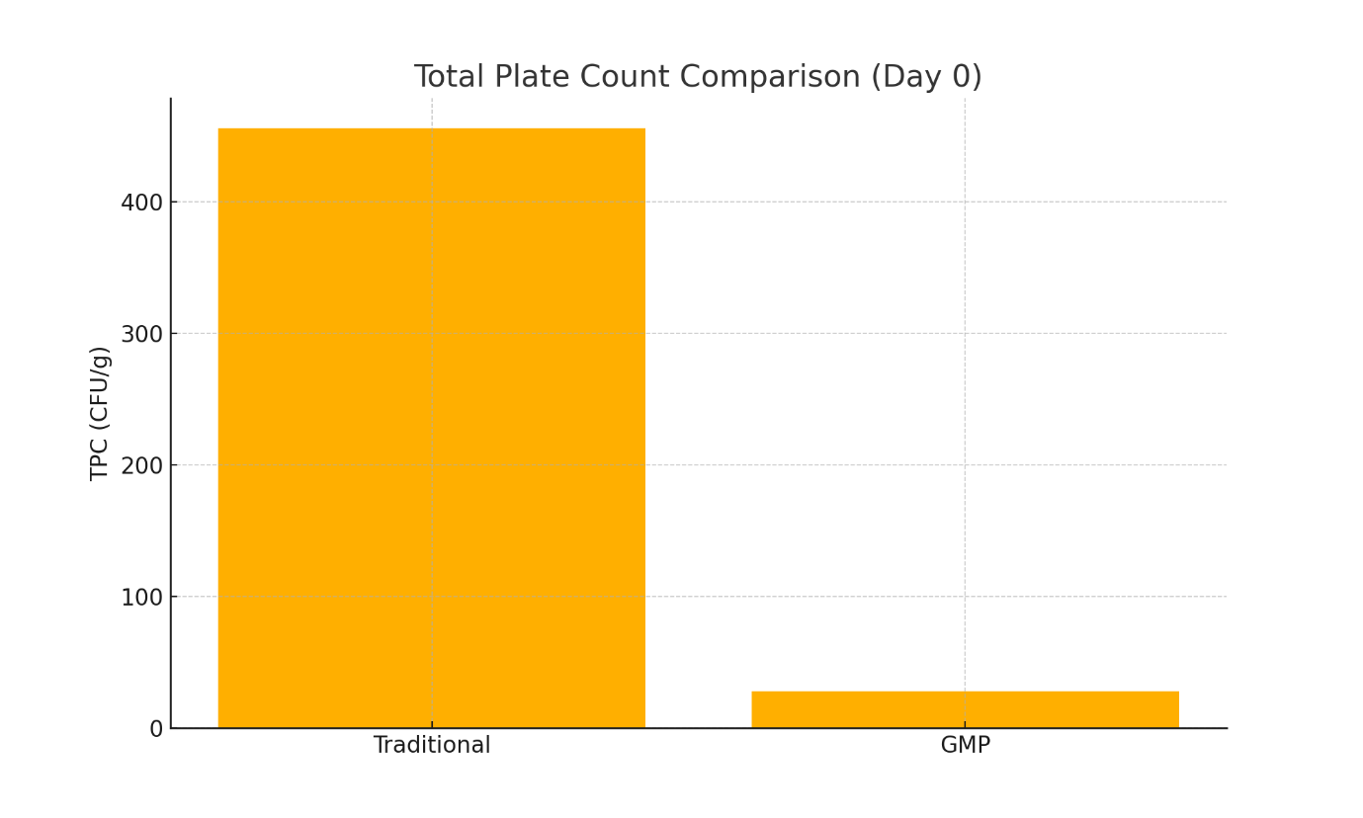
Figure 1. Total Plate Count Comparison (Traditional vs GMP)
3.2 Microbiological quality at Day 0 - Yeast and moulds
As shown in Table 2, yeast and mould counts in traditional jaggery samples averaged 45±28 CFU/g, with 90% of samples exceeding the FSSAI limit (≤10 CFU/g), whereas GMP samples consistently remained below the detection threshold (≤10 CFU/g). This sharp contrast underscores the crucial influence of moisture control and contact-surface material in governing fungal ecology. In traditional production systems, porous wooden molds and exposure to fluctuating ambient humidity facilitate spore retention, survival, and germination. In contrast, GMP-based production employs sealed packaging, non-porous food-grade contact surfaces, and low-moisture handling practices, collectively lowering water activity to levels that inhibit fungal proliferation. These findings align with established storage and packaging research identifying moisture content and surface porosity as the primary drivers of fungal growth in jaggery and similar sugar-rich products. Thus, suppression of yeast and mould under GMP conditions results from both reduced initial contamination and enhanced protection against moisture ingress during storage.
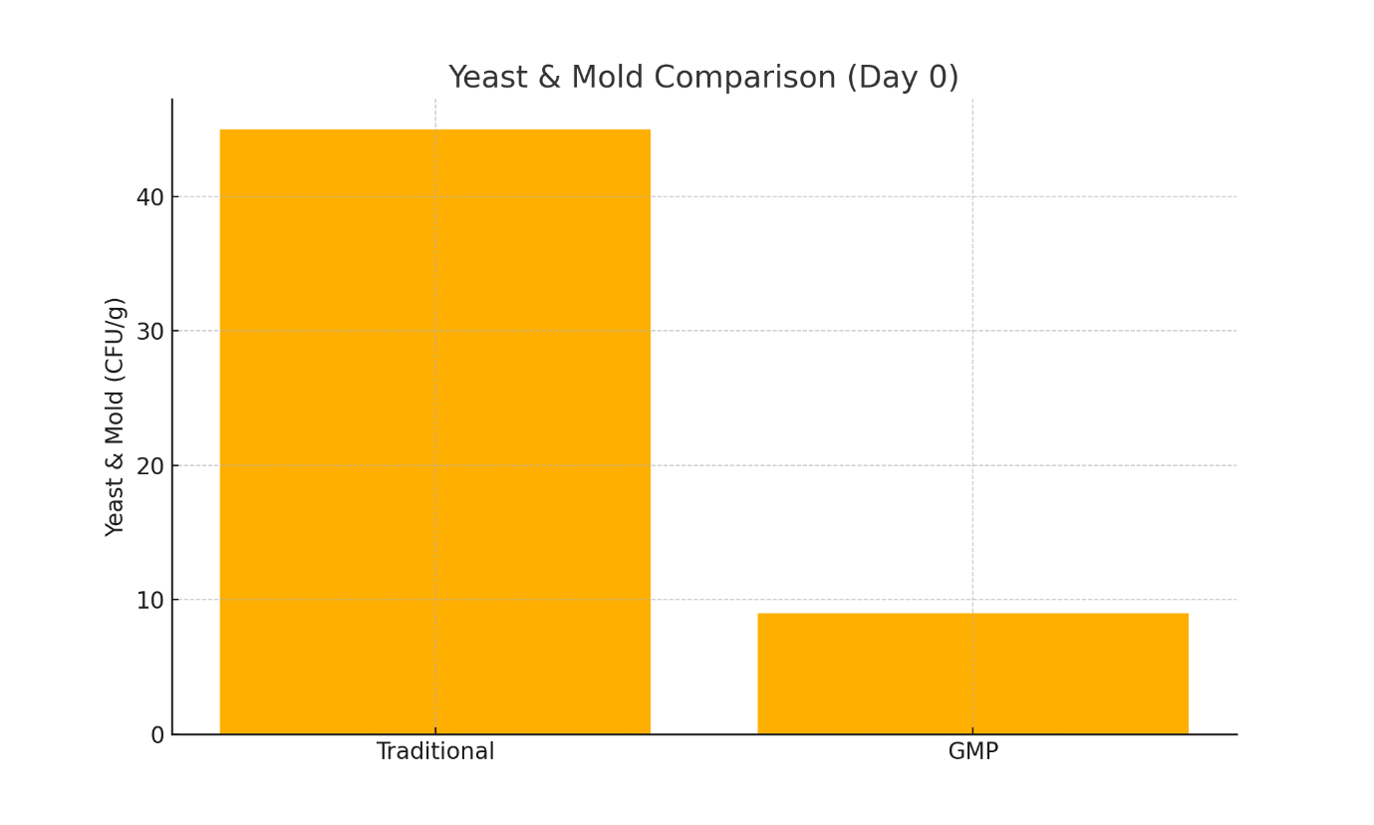
Figure 2. Yeast & Mold Count Comparison (Traditional vs GMP
3.2 Microbiological quality at Day 0 - Coliforms and Salmonella
Table 2 also indicates that coliforms were detected in 6/50 (12%) of traditional samples and Salmonella in 4/50 (8%), whereas all GMP samples were negative for both indicators. The presence of coliforms in traditional units is congruent with the survey result of universal use of untreated water (Table 1) and reflects faecal-indicator contamination introduced via water, vectors, or unwashed hands [40,68]. The complete elimination of both coliforms and Salmonella after GMP implementation demonstrates the effectiveness of source control (RO/UV water treatment), environmental sanitation and vector management in removing enteric pathogen transmission routes. This outcome is important from a public-health perspective: Salmonella, in particular, is responsible for severe foodborne disease and hospitalizations, and its removal via hygiene interventions is consistent with WHO/FSSAI guidance that prioritizes water and sanitation controls to prevent enteric outbreaks [45,74,75]. Prior work documenting bacterial isolates in stored jaggery similarly implicates water and surface hygiene as risk factors, and our findings confirm that targeted GMP measures can remove these specific hazards [10].
3.3 Shelf-life under accelerated storage
Table 3 reports the time-series data for GMP jaggery stored under accelerated conditions (40°C ± 2°C, 75% ± 3% RH) for 485 days: TPC rose modestly from 28 ± 22 to 60 ± 12 CFU/g, Y&M remained ≤10 CFU/g throughout, coliforms and Salmonella remained absent, moisture increased gradually from 3.26% to 6.83%, pH shifted from 3.05 to 4.46, and sensory attributes remained acceptable. The modest microbial growth despite severe storage stress can be explained by the low initial bioburden, hermetic HDPE packaging that limits moisture ingress, and the absence of spoilage fungal and enteric populations that would otherwise produce rapid fermentative or degradative activity. Moisture remained well below empirically observed thresholds for xerophilic mould proliferation (≈11%), which is consistent with prolonged fungal stability reported when moisture and water activity are controlled [31,72]. Compared with reports of traditional jaggery spoilage by approximately 120 days under poor storage conditions [34], the GMP product’s stability over 485 days represents approximately a fourfold extension of practical shelf life under accelerated test conditions; this magnitude of extension accords with theoretical expectations derived from combined reductions in initial load and improved packaging, and exceeds many ambient-storage reports while still aligning with the moisture-control literature [31,34].
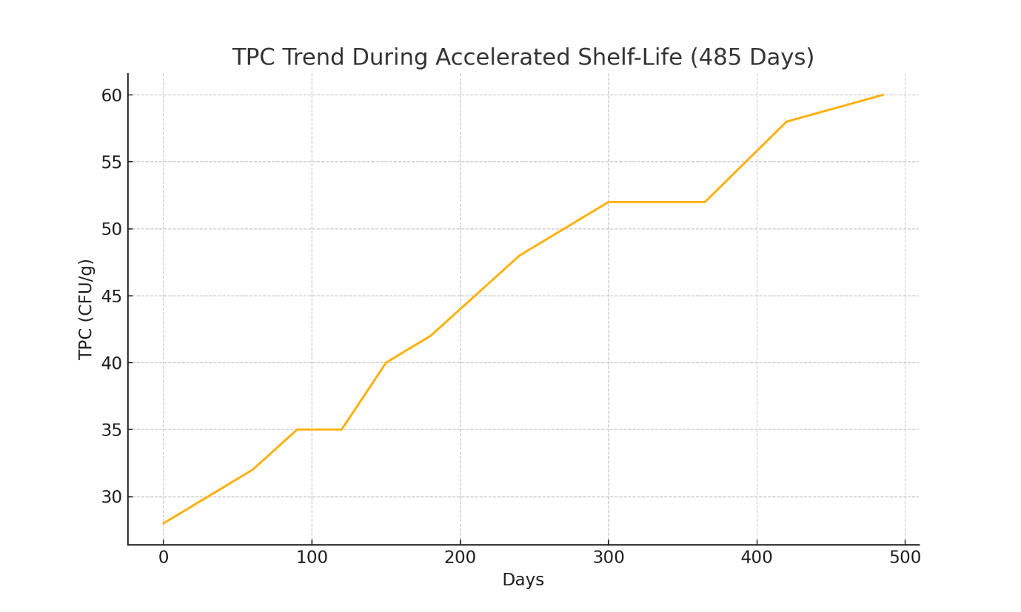
Figure 3. TPC Trend During Accelerated Shelf-Life (0–485 days)
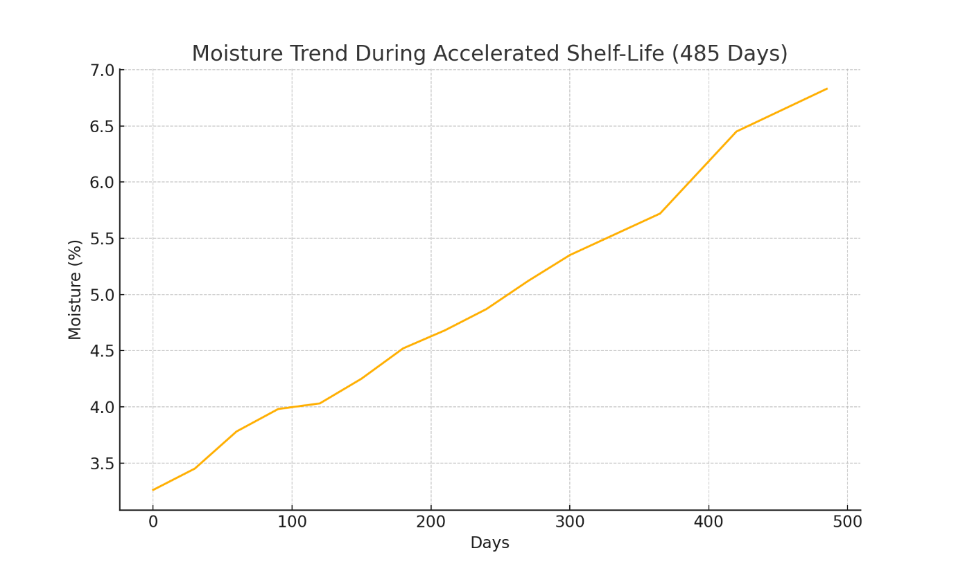
Figure 4. Moisture Trend During Accelerated Shelf-Life
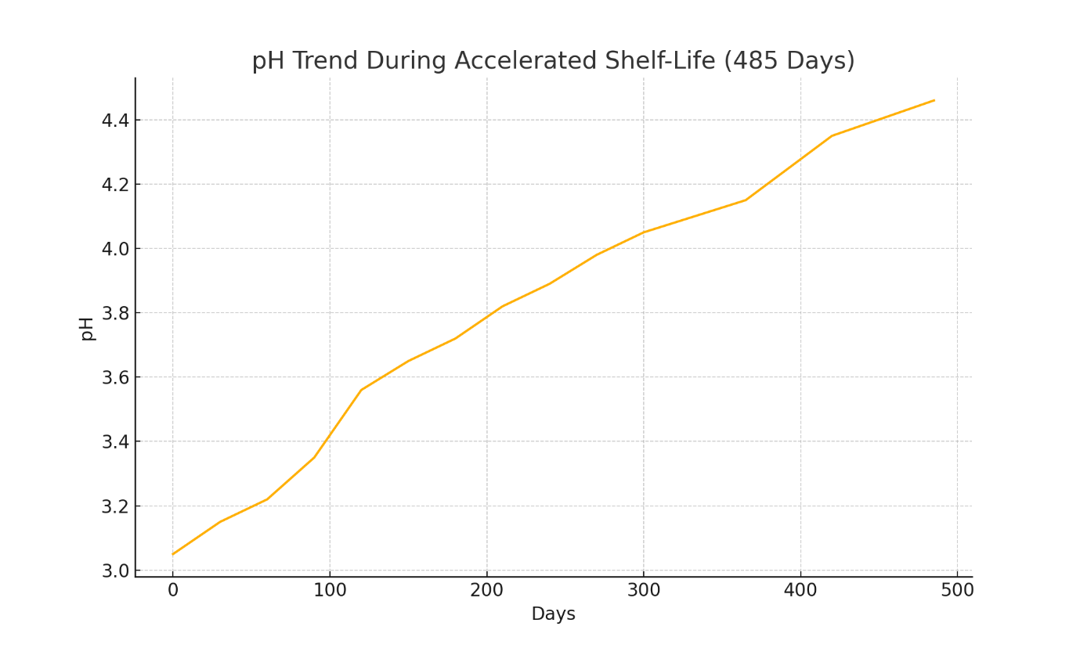
Figure 5. pH Trend During Accelerated Shelf-Life

Table 3. Microbial & Physical Parameters of GMP Jaggery Under Accelerated Shelf-Life (485 Days)
Storage: 40°C ± 2°C, 75% ± 3% RH, sealed HDPE containers
Day | TPC (CFU/g) | Y&M (CFU/g) | Coliforms | Salmonella | Moisture (%) | pH | Sensory Status
0 | 28 ± 22 | ≤10 | Absent | Absent | 3.26 ± 0.4 | 3.05 | OK
30 | 30 ± 18 | ≤10 | Absent | Absent | 3.45 ± 0.4 | 3.15 | OK
60 | 32 ± 16 | ≤10 | Absent | Absent | 3.78 ± 0.5 | 3.22 | OK
90 | 35 ± 15 | ≤10 | Absent | Absent | 3.98 ± 0.5 | 3.35 | OK
120 | 35 ± 14 | ≤10 | Absent | Absent | 4.03 ± 0.5 | 3.56 | OK
150 | 40 ± 12 | ≤10 | Absent | Absent | 4.25 ± 0.6 | 3.65 | OK
180 | 42 ± 13 | ≤10 | Absent | Absent | 4.52 ± 0.6 | 3.72 | OK
210 | 45 ± 14 | ≤10 | Absent | Absent | 4.68 ± 0.7 | 3.82 | OK
240 | 48 ± 15 | ≤10 | Absent | Absent | 4.87 ± 0.7 | 3.89 | OK
270 | 50 ± 16 | ≤10 | Absent | Absent | 5.12 ± 0.7 | 3.98 | OK
300 | 52 ± 17 | ≤10 | Absent | Absent | 5.35 ± 0.8 | 4.05 | OK
365 | 52 ± 18 | ≤10 | Absent | Absent | 5.72 ± 0.8 | 4.15 | Acceptable
420 | 58 ± 19 | ≤10 | Absent | Absent | 6.45 ± 0.9 | 4.35 | Acceptable
485 | 60 ± 12 | ≤10 | Absent | Absent | 6.83 ± 0.7 | 4.46 | Acceptable
3.4 Economic impact and commercial implications
The economic analysis indicates that, for a unit producing 500 kg per month, the capital investment of ₹3.75 million could be recovered in approximately 26 months through premium pricing and reduced waste (annual benefit ≈ ₹144,000). Beyond simple payback, the extended shelf life and regulatory compliance unlock market opportunities—longer distribution chains, interstate and international marketing, and government procurement—that amplify revenue potential. These economic findings are consistent with policy and sector analyses arguing that hygienic upgrading can convert seasonal, perishable commodities into higher-value, storable products and that cluster/subsidy models shorten payback for smaller producers [39,43]. However, the cost figures should be interpreted in light of scale: medium-sized units are more likely to realize the projected payback without subsidy, whereas small producers may require cooperative models or government support to share infrastructure costs (RO plants, testing laboratories) and achieve similar economic viability.
3.5 Comparative synthesis with published literature
When contextualized within the broader literature, our results map closely to previously reported mechanisms and outcomes. The baseline microbial diversity and contamination in traditional jaggery replicate earlier reports identifying Leuconostoc, Bacillus and diverse spoilage flora in stored jaggery [10]. The dramatic TPC reduction achieved by combining equipment upgrading, water treatment and procedural sanitation reflect findings from intervention studies in other traditional food sectors where multi-barrier GMP implementation produced log-scale reductions in culturable counts [7,67]. Likewise, the critical role of moisture control and non-porous contact surfaces in suppressing fungal growth corresponds to the work of Mandal et al. and Deotale et al., who documented that packaging and humidity are the dominant determinants of jaggery shelf life [31,34]. Finally, the public-health relevance of eliminating enteric pathogens such as Salmonella is consistent with global food safety priorities set out by WHO and national regulators and supports the case for targeted GMP interventions to reduce foodborne disease burden [45,74,75].
5. CONCLUSIONS AND RECOMMENDATIONS
5.1 Major Findings Summary
This research systematically documented GMP transformation of microbiologically hazardous traditional jaggery into safe, shelf-stable product meeting FSSAI and international standards:
Achievement 1 - Baseline Documentation: Quantitative survey of 50 Karnataka units revealed only 16% GMP compliance, with complete absence (0%) of treated water, pest control, worker training, and hazard identification—establishing baseline food safety crisis.
Achievement 2 - Microbial Safety Transformation: GMP implementation achieved:
- 93.8% Total Plate Count reduction (456→28 CFU/g, p<0.001) [67]
- 77.8% Yeast & Mold reduction (45→<10 CFU/g) [72]
- 100% Coliform elimination (6→0 positive samples) [68]
- 100% Salmonella elimination (4→0 positive samples) [74,75]
- 100% FSSAI/ISO Standards Compliance (4/4 parameters met) [39]
Achievement 3 - Shelf-Life Extension Validation: GMP jaggery maintained FSSAI compliance through 485-day storage under accelerated conditions (40°C, 75% RH), compared to traditional spoilage by day 120—representing 4.04x shelf-life extension [34].
Achievement 4 - Economic Viability Demonstration: GMP investment (₹37.5L) achieves payback within 26 months through 25% premium pricing and 15% waste reduction, with 3-year ROI of 45.6% [43].
Achievement 5 - Implementation Feasibility: GMP protocols demonstrated transferable to cottage-scale production with modest capital investment and standard hygienic equipment, enabling scalability across Karnataka and India.
5.2 Conclusions
- Food Safety Crisis Quantified: Traditional jaggery production in Karnataka represents uncontrolled food safety hazard with pathogenic contamination (Salmonella 8%, coliforms 12%) posing direct public health risk to millions of consumers [45,74,75].
- GMP as Transformative Solution: Good Manufacturing Practices, systematically implemented through equipment substitution, water treatment, sanitation, pest control, and worker training, achieve elimination of critical pathogenic hazards and dramatic extension of shelf life [38,39,40,41,42].
- Commercial Viability Established: GMP transformation generates economic benefits (25% price premium, waste reduction) sufficient to incentivize producer adoption without subsidy in medium-scale operations, with government support enabling small-scale unit upgrade [43].
- Policy Implementation Pathway Clear: Existing government schemes (PMFME, FSSAI regulation), combined with demonstrated technical and economic feasibility, enable policy pathway toward systematic GMP adoption across jaggery industry [39,43].
- Public Health Impact Substantial: Elimination of pathogenic bacteria from jaggery supply directly prevents foodborne disease incidence in vulnerable populations particularly dependent on affordable, energy-dense sweeteners [45,74,75].
5.3 Specific Recommendations
For Jaggery Producers:
- Immediate Equipment Upgrade Priority: Substitute mild steel and wooden equipment with food-grade stainless steel and non-porous materials to eliminate microbial harboring surfaces [7,8]
- Water Treatment Implementation: Install RO or equivalent water treatment achieving <50 ppm TDS to eliminate waterborne microbial contaminants [40]
- Pest Management Systems: Implement monthly pest control monitoring with licensed contractor to eliminate mechanical pathogen vectors [56]
- Worker Training: Complete FSSAI-accredited food safety training modules to establish personal hygiene practices [47]
- Seek FSSAI Certification: Pursue FSSAI food safety license with actual compliance rather than bureaucratic convenience [39]
For State Agricultural Departments (Karnataka Priority):
- GMP Subsidy Program: Establish ₹500 crore fund providing 50-75% capital cost subsidy for jaggery producer GMP upgrade under PMFME framework [39,43]
- Demonstration Units: Establish 10 model GMP jaggery production units across districts showcasing technical viability and economic returns to traditional producers
- Training Infrastructure: Develop state-level FSSAI-accredited training centers delivering food safety and GMP protocols to producer cooperatives [47]
- Cluster Development: Incentivize formation of 50-unit producer clusters sharing capital equipment (RO plants, testing labs, marketing facilities) for scale economies [43]
- Procurement Guarantees: Commit government procurement (mid-day meal schemes, public distribution systems) of 500,000 kg annually at 20% premium for certified GMP jaggery [43]
For FSSAI Regulatory Authority:
- Jaggery-Specific Standards Development: Formulate jaggery-specific quality standards, testing protocols, and certification procedures currently absent from regulations [39]
- Accelerated Certification Pathway: Develop simplified certification for GMP-compliant jaggery units meeting pre-defined standards without facility inspections [39]
- Consumer Information: Launch awareness campaign educating consumers regarding health risks of traditional jaggery and benefits of certified GMP product [45]
- Enforcement Support: Provide Karnataka Food Safety Department enforcement resources to conduct routine compliance audits of licensed jaggery units [39]
For National Policy (Ministry of Food Processing Industries):
- Pan-India Replication: Extend GMP subsidy program tested in Karnataka to 10 major jaggery-producing states (Maharashtra, Uttar Pradesh, Rajasthan, Bihar, Odisha, Telangana) [39,43]
- National Jaggery Standard: Harmonize state-level jaggery standards with international norms enabling export market access [39]
- Research Funding: Provide ₹10 crore over 3 years for collaborative research on GMP optimization for traditional sweetener production
- Technology Transfer: Establish NIFTEM-led technology transfer program disseminating GMP protocols to state agricultural universities [47]
For Future Research:
- Multi-site validation across diverse geographies and producer scales
- Ambient temperature shelf-life projections replacing accelerated testing [34]
- Pathogenic characterization of Salmonella and coliform isolates from traditional jaggery [74,75]
- Consumer acceptance studies evaluating sensory characteristics and willingness-to-pay
- Cluster implementation evaluation of cooperative production viability [43]
5.4 Final Statement
This research provides the first quantitative evidence that Good Manufacturing Practices, systematically applied to traditional jaggery production, transform microbiologically hazardous artisanal product into safe, shelf-stable commodity meeting FSSAI and international food safety standards while remaining economically viable for small-to-medium producers. The documented feasibility of GMP implementation, combined with established policy instruments (PMFME subsidies, FSSAI regulation, state procurement), enables realistic policy pathway toward systematic elimination of foodborne disease risk from jaggery consumption. Karnataka state, as India's leading jaggery production center, should immediately implement pilot GMP subsidy program with goal of 50% producer compliance within 3 years, scaling nationally upon successful demonstration. This approach bridges the gap between India's traditional food heritage and modern food safety requirements, transforming jaggery from public health hazard into nutritious, safe commodity accessible to millions.

REFERENCES
- Gangwar, L. S., Solomon, S., & Anwar, S. I. (2015). Technological and policy options for modernization of jaggery industry in India. Indian Institute of Sugarcane Research. https://iisr.icar.gov.in/iisr/download/publications/report/policypaper_gangwar.pdf
- Tyagi, S. K., Kamboj, S., Himanshu, N., Tyagi, N., Narayanan, R., & Tyagi, V. V. (2022). Technological advancements in jaggery-making processes and emission reduction potential via clean combustion for sustainable jaggery production: An overview. Journal of Environmental Management, 301, 113792. https://doi.org/10.1016/j.jenvman.2021.113792
- Hirpara, P., Thakare, N., Kele, V. D., & Patel, D. (2020). Jaggery: A natural sweetener. Journal of Pharmacognosy and Phytochemistry, 9(5), 3145-3148. https://www.phytojournal.com/archives/2020/vol9issue5/PartAR/9-5-516-642.pdf
- Agarwal, A., & Mohan, N. (2020). New ventures of value-addition in jaggery processing for a dynamic sugar industry. International Journal of Engineering Research & Technology, 9(1), 291-294. https://doi.org/10.17577/IJERTV9IS010179
- Longvah, T., Ananthan, R., Bhaskarachary, K., & Venkaiah, K. (2017). Indian Food Composition Tables. National Institute of Nutrition, Indian Council of Medical Research. http://www.ifct2017.com/
- Singh, J., Solomon, S., & Kumar, D. (2013). Manufacturing jaggery, a product of sugarcane, as health food. Agrotechnology, S11:007. https://doi.org/10.4172/2168-9881.S11-007
- Badmos A, Ajimotokan H. The corrosion of mild steel in orange juice environment. University of Ilorin, Nigeria; 2009.
- Rodel W, Hechelmann H, Dresel J. Hygieneaspekte zu Schneidunterlagen aus Holz und Kunststoff. Fleischwirtsch. 1994; 74:814-821.
- Owen WN. Yeast and other microorganisms identified in fresh sugarcane juice. 1990.
- Singh, S., Dubey, A. P., Tiwari, L., & Verma, A. K. (2009). Microbial profile of stored jaggery: A traditional Indian sweetener. Sugar Tech, 11(2), 213-216. https://doi.org/10.1007/s12355-009-0034-4
- Khezerlou, A., Alizadeh-Sani, M., Zolfaghari Firouzsalari, N., & Ehsani, A. (2018). Formation, Properties, and Reduction Methods of Acrylamide in Foods: A Review Study. Journal of Nutrition, Fasting and Health, 6(1), 52-59. https://doi.org/10.22038/JNFH.2018.34179.1133
- Rao J, Das M, Das S. Jaggery- A traditional Indian sweetener. Indian J Tradit Knowl. 2007;6(1):95-102.
- APEDA. Uttar Pradesh produced more than 224 million tonnes of sugarcane. 2023.
- Agarwal, A., & Mohan, N. (2020). New Ventures of Value-Addition in Jaggery Processing for a Dynamic Sugar Industry. International Journal of Engineering Research and Technology https://www.ijert.org/new-ventures-of-value-addition-in-jaggery-processing-for-a-dynamic-sugar-industry
- Bashir, N., & Yousuf, O. (2022). Jaggery as a potential source of nutraceutical in food products. Emerging Trends in Nutraceuticals, 1(3), 50-55. https://doi.org/10.18782/2583-4606.118
- Kumar K. Oscillation in jaggery and khandsari industry. In: National Seminar on Status, problems and prospects of jaggery and khandsari industry in India. Lucknow; 1999.
- Gautam, C. S., Saha, L., Sekhri, K., & Saha, P. K. (2008). Iron deficiency in pregnancy and the rationality of iron supplements prescribed during pregnancy. Medscape Journal of Medicine, 10(12), 283. https://www.ncbi.nlm.nih.gov/pmc/articles/PMC2644004/
- Nayaka, M. A. H., Sathisha, U. V., Manohar, M. P., Chandrashekar, K. B., & Dharmesh, S. M. (2009). Cytoprotective and antioxidant activity studies of jaggery sugar. Food Chemistry, 115(1), 113-118. https://doi.org/10.1016/j.foodchem.2008.11.067
- Singh J. Nutritive and eco-friendly jaggery. In: Processing, Handling and Storage of Sugarcane Jaggery. Lucknow: IISR; 2008. p. 3-10.
- Shrivastav P, Verma A, Walia A, Rehana P, Singh A. Jaggery a revolution in the field of natural sweeteners. Eur J Pharm Med Res. 2016;3(3):198-202.
- Veldhyyzen-van Z. New uses for panela. Food Chain. 1999; 25:11-13.
- Jadhav, A. N., & Bhutani, K. K. (2005). Ayurveda and gynecological disorders. Journal of Ethnopharmacology, 97(1), 151-159. https://doi.org/10.1016/j.jep.2004.10.020
- Shah, S. V., Baliga, R., Rajapurkar, M., & Fonseca, V. A. (2007). Oxidants in chronic kidney disease. Journal of the American Society of Nephrology, 18(1), 16-28. https://doi.org/10.1681/ASN.2006050500
- Selvi, V. M., Mathialagan, M., & Mohan, S. (2021). The art and science of jaggery making: A review. Agricultural Reviews. https://doi.org/10.18805/ag.R-2138
- Deotale, S., Bhotmange, M. G., Halde, P., & Chitale, M. (2019). Study of traditional Indian sweetener 'Jaggery' and its storage behavior. *International Journal of Chemical Studies*, *7*(3), 410-416. https://www.chemijournal.com/archives/2019/vol7/issue3/7-3-10-100.html
- Chauhan, O. P., Singh, D., Tyagi, S. M., & Balyan, D. K. (2002). STUDIES ON PRESERVATION OF SUGARCANE JUICE. International Journal of Food Properties, 5(1), 217-229. https://doi.org/10.1081/JFP-120015603
- Mungare TS, Jadhav HD, Patil JP, Hasure RP, Jadhav BS, Singh J. Clarification technique for producing quality jaggery. Coop Sugar. 2000;32(4):283-285.
- Narian SH. Jaggery and khandsari industry in India. Indian Farming. 2002:57-68.
- Kumar, R., & Kumar, M. (2018). Upgradation of jaggery production and preservation technologies. Renewable and Sustainable Energy Reviews, 96, 167-180. https://doi.org/10.1016/j.rser.2018.07.053
- Deepak RR, Shashi P. Packaging requirements of highly respiring produce under modified atmosphere a review. J Food Sci Technol. 2007; 44:10-15.
- Mandal, D., Tudu, S., Mitra, S. R., & De, G. C. (2006). Effect of common packing materials on keeping quality of sugarcane jaggery during monsoon season. Sugar Tech, 8(2), 137-142. https://doi.org/10.1007/BF02943648
- Kumar, D., Singh, J., Rai, D. R., Kumar, M., & Bhatia, S. (2013). Effect of modified atmosphere packaging on keeping quality of jaggery. Sugar Tech, 15, 203-208. https://doi.org/10.1007/s12355-012-0197-2
- Kumar, D., Singh, J., Rai, D. R., Bhatia, S., Singh, A. K., & Kumar, M. (2013). Colour changes in jaggery cubes under modified atmosphere packaging in plastic film packages. Agrotechnology, S11, 005. https://doi.org/10.4172/2168-9881.S11-005
- Deotale, S. M., Bhotmange, M. G., Halde, P., & Chitale, M. (2019). Study of traditional Indian sweetener 'Jaggery' and its storage behavior. *International Journal of Chemical Studies*, *7*(3), 410-416. https://www.chemijournal.com/archives/2019/vol7issue3/PartG/7-3-29-416.pdf
- Choi J, Lee S. A moisture absorber controls the product's water activity to prevent the growth of microorganisms. 2013.
- Asokan S, Rupa TR. Sugarcane Chemistry Including Sugar and Gur Technology. Coimbatore: Directorate of Open and Distance Learning, Tamil Nadu Agricultural University; 2008.
- Natural Health Products Directorate, Health Canada. (2006). Good manufacturing practices guidance document. https://www.publications.gc.ca/site/eng/9.686000/publication.html
- World Health Organization & Food and Agriculture Organization of the United Nations. (2022). Microbiological hazards in spices and dried aromatic herbs: meeting report. Microbiological Risk Assessment Series No. 27. https://doi.org/10.4060/cb8686en
- FDA. Good Manufacturing Practice (GMP) Guidelines/Inspection Checklist. 1997 Feb 12 (Updated 2008 Apr 24).
- Food and Drug Administration. (2010). Small entity compliance guide: Current good manufacturing practice in manufacturing, packaging, labeling, or holding operations for dietary supplements. U.S. Department of Health and Human Services. https://www.fda.gov/regulatory-information/search-fda-guidance-documents/small-entity-compliance-guide-current-good-manufacturing-practice-manufacturing-packaging-labeling
- Food and Drug Administration. (2013). Current good manufacturing practice and hazard analysis and risk-based preventive controls for human food. Federal Register, 78(11), 3646-3824. https://www.govinfo.gov/app/details/FR-2013-01-16/2013-00125
- U.S. Food and Drug Administration. (2012). FDA Foods Program, The Reportable Food Registry: A New Approach to Targeting Inspection Resources and Identifying Patterns of Adulteration. Second Annual Report. U.S. Food and Drug Administration. https://www.fda.gov/food/compliance-enforcement-food/reportable-food-registry-annual-report
- Mukherjee, P. K., Venkatesh, M., & Kumar, V. (2007). An Overview on the Development in Regulation and Control of Medicinal and Aromatic Plants in the Indian System of Medicine. Boletín Latinoamericano y del Caribe de Plantas Medicinales y Aromáticas, 6(4), 129-137. http://www.redalyc.org/articulo.oa?id=85660407
- Hoffmann, S. A. (2011). U.S. Food Safety Policy Enters a New Era. Amber Waves: The Economics of Food, Farming, Natural Resources, and Rural America, 9(4), 24. https://doi.org/10.22004/ag.econ.120793
- World Health Organization. (2020). Food safety: Key facts. https://www.who.int/news-room/fact-sheets/detail/food-safety
- World Health Organization. (2017). *WHO guidelines on use of medically important antimicrobials in food-producing animals*. https://iris.who.int/handle/10665/258331
- Akabanda, F., Hlortsi, E. H., & Owusu-Kwarteng, J. (2017). Food safety knowledge, attitudes and practices of institutional food-handlers in Ghana. BMC Public Health, 17(1), 40. https://doi.org/10.1186/s12889-016-3986-9
- Zain, M. M., & Naing, N. N. (2002). Sociodemographic characteristics of food handlers and their knowledge, attitude and practice towards food sanitation: a preliminary report. Southeast Asian Journal of Tropical Medicine and Public Health, 33(2), 410–417. https://pubmed.ncbi.nlm.nih.gov/12236444/
- Tan, S. L., Cheng, P. L., Soon, H. K., Ghazali, H., & Mahyudin, N. A. (2013). A qualitative study on personal hygiene knowledge and practices among food handlers at selected primary schools in Klang Valley area, Selangor, Malaysia. International Food Research Journal, 20(1), 71-76. https://www.ifrj.upm.edu.my/20%20(1)%202013/7.%20A%20qualitative%20study%20on%20personal%20hygiene%20knowledge%20and%20practices%20among%20food%20handlers%20at%20selected%20primary%20schools%20in%20Klang%20valley%20area,%20Selangor,%20Malaysia.pdf
- Pal M, Mahendra R. Sanitation in Food Establishments. 1st ed. Saarbrücken: LAMBERT Academic Publishing; 2015.
- Pal M. Zoonoses. 2nd ed. Jaipur: Satyam Publishers; 2007.
- Pal M. Rotavirus gastroenteritis A life-threatening viral disease of global significance. CPQ Microbiol. 2018;1:1-3.
- Pal M, Ayele Y. Emerging role of foodborne viruses in public health. Biomed Res Int. 2020;5:1-4.
- Howes M, McEwen S, Griffiths M, Harris L. Food handler certification by home study: Measuring changes in knowledge and behaviour. Dairy Food Environ Sanit. 1996;16(7):737-744.
- Chinakwe, E. C., Nwogwugwu, N. U., Nwachukwu, I. N., Okorondu, S. I., Onyemekara, N. N., & Ndubuisi-Nnaji, U. U. (2012). Microbial quality and public health implications of hand-wash water samples of public adults in Owerri, South-East Nigeria. International Research Journal of Microbiology, 3(4), 144-146. http://www.interesjournals.org/IRJM
- Belluco S, Vittone F, Piri A, et al. Arthropods and pathogenic microorganisms in food industry. In: Food Safety. 2013.
- Graham DJ. Using sanitary design to avoid HACCP hazards and allergen contamination. Food Safety Mag. 2004 Jun/Jul.
- Lelieveld, H. L. M., Mostert, M. A., & Holah, J. (2005). Handbook of hygiene control in the food industry. Woodhead Publishing Limited. https://doi.org/10.1201/9781439823583
- Cramer, M. M. (2003). Six steps to effective sanitary design for the food plant. Food Safety Magazine. https://www.foods-safety.com/articles/six-steps-to-effective-sanitary-design-for-the-food-plant/
- Cavalheiro, C. P., da Silva, M. C. A., Leite, J. S. F., Felix, S. K. R., Herrero, A. M., & Ruiz‐Capillas, C. (2020). Physical hazards in meat products: Consumers' complaints found on a Brazilian website. Food Control, 108, 106892. https://doi.org/10.1016/j.foodcont.2019.106892
- Drew, C. A., & Clydesdale, F. M. (2015). New food safety law: Effectiveness on the ground. Critical Reviews in Food Science and Nutrition, 55(5), 689-700. https://doi.org/10.1080/10408398.2011.654368
- Alamri, M. S., Qasem, A. A. A., Mohamed, A. A., Hussain, S., Ibraheem, M. A., Shamlan, G., Alqah, H. A., & Qasha, A. S. (2021). Food packaging's materials: A food safety perspective. Saudi Journal of Biological Sciences, 28(8), 4490-4499. https://doi.org/10.1016/j.sjbs.2021.04.047
- Mortimore, S., & Wallace, C. (2013). HACCP: A Practical Approach. Springer Science and Business Media. https://doi.org/10.1007/978-1-4614-5028-3
- Nuutinen, M. (2023). Detection of physical hazards. In V. Andersen, H. Lelieveld, & Y. Motarjemi (Eds.), *Food Safety Management* (pp. 475-493). Academic Press. https://www.elsevier.com/books/food-safety-management/andersen/978-0-12-820013-1
- Mendez, E., Jones, C., & Trinetta, V. (2020). Engaging undergraduate students in food safety study and food microbiology research. Food Protection Trends, 40(3), 164-170. https://www.foodprotection.org/publications/food-protection-trends/archive/2020/may-june/engaging-undergraduate-students-in-food-safety-study-and-food-microbiology-research/
- Rawat, S. (2015). Food spoilage: Microorganisms and their prevention. Asian Journal of Plant Science and Research, 5(4), 47-56. https://www.imedpub.com/articles/food-spoilage-microorganisms-and-their-prevention.php?aid=11730
- Snyder, A. B., Churey, J. J., & Worobo, R. W. (2019). Association of fungal genera from spoiled processed foods with physicochemical food properties and processing conditions. Food Microbiology, 83, 211-218. https://doi.org/10.1016/j.fm.2019.05.012
- Bintsis, T. (2017). Foodborne pathogens. AIMS Microbiology, 3(3), 529-563. https://doi.org/10.3934/microbiol.2017.3.529
- Osakue, O. P., Igene, J. O., Ebabhamiegbebho, P. A., & Evivie, S. E. (2016). Proximate analysis and microbial quality of ready-to-eat (RTE) fried chicken parts. Journal of Food and Industrial Microbiology, 2(1), 107. https://doi.org/10.4172/2572-4134.1000107
- Darwish AZM. Foodborne pathogens of fast food and ready-to-eat foods in Tabuk city and evaluating hazard for food quality. Int J Healthc Biomed Res. 2018;6(2):149-158.
- Adebukola, O. C., Opeyemi, A. O., & Ayodeji, A. I. (2015). Knowledge of food borne infection and food safety practices among local food handlers in Ijebu-Ode Local Government Area of Ogun State. Journal of Public Health and Epidemiology, 7(9), 268-273. https://doi.org/10.5897/JPHE2015.0758
- Asiegbu, C. V., Lebelo, S. L., & Tabit, F. T. (2020). Microbial quality of ready-to-eat street vended food groups sold in the Johannesburg metropolis, South Africa. Journal of Food Quality and Hazards Control, 7(1), 18-26. https://doi.org/10.18502/jfqhc.7.1.2448
- Schnürer, J., & Magnusson, J. (2005). Antifungal lactic acid bacteria as biopreservatives. Trends in Food Science and Technology, 16(1-3), 70-78. https://doi.org/10.1016/j.tifs.2004.02.014
- Leyva Salas, M., Mounier, J., Valence, F., Coton, M., Thierry, A., & Coton, E. (2017). Antifungal microbial agents for food biopreservation—A review. Microorganisms, 5(3), 37. https://doi.org/10.3390/microorganisms5030037
- Singh, A. K., Drolia, R., Bai, X., & Bhunia, A. K. (2015). Streptomycin Induced Stress Response in Salmonella enterica Serovar Typhimurium Shows Distinct Colony Scatter Signature. PLoS ONE, 10(8), e0135035. https://doi.org/10.1371/journal.pone.0135035

