Leaf Morphoanatomical Analysis to Authenticate Some Selected Species Belong to Solanaceae Family Used in Traditional Medicine

Abstract
The accurate authentication of medicinal plants is critical for ensuring the safety and efficacy of herbal products. This study provides a comprehensive morphoanatomical characterization of six medicinally important Solanaceae species from Sudan: Datura innoxia, Physalis angulata, Solanum dubium, Solanum incanum, Solanum nigrum, and Withania somnifera. Fresh leaf samples were collected from their natural habitats in Khartoum and eastern Sudan. Transverse sections and epidermal peels were examined using light microscopy with digital imaging. Distinct anatomical markers were identified, including epidermal cell wall patterns, stomatal types (anisocytic, paracytic, anomocytic), trichome morphology (glandular, non-glandular, stellate), calcium oxalate crystal forms (druses, crystal sand), and mesophyll organization. A diagnostic dichotomous key was developed based on these micromorphological traits. Notably, P.angulata displayed undifferentiated mesophyll with sinuous anticlinal walls, while W.somnifera exhibited stellate trichomes and two types of calcium oxalate crystals. S. nigrum showed paracytic stomata and unicellular trichomes, whereas D. innoxia presented glandular trichomes and druse crystals. These findings provide reliable, microscopy-based tools for authenticating fragmented or powdered herbal material, combating adulteration in the traditional medicine trade. The study bridges a significant gap in the botanical documentation of Sudanese medicinal flora and supports quality control in pharmacognosy, conservation planning, and ethnobotanical research.
Keywords: Solanaceae, medicinal plants, authentication, leaf anatomy, microscopy, trichomes, calcium oxalate, Sudan, traditional medicine.

1. Introduction
Medicinal plants continue to play a vital role in global healthcare systems, with approximately 80% of the world's population relying on botanical remedies for primary healthcare needs (WHO, 2019). The increasing demand for herbal products has expanded commercial markets but also raised concerns regarding quality, safety, and authenticity (Heinrich et al., 2017). Adulteration and misidentification of raw materials pose significant risks to consumer health and undermine the credibility of traditional medicine (Rocha et al., 2021).
The Solanaceae family encompasses numerous species with well-documented ethnopharmacological uses, including antimicrobial, anti-inflammatory, and neuroprotective properties (Chowański et al., 2016). In Sudan, wild Solanaceae species are widely utilized in traditional healing practices for treating infections, gastrointestinal disorders, and inflammatory conditions (Karar and Kuhnert, 2017). However, accurate identification of these plants remains challenging due to morphological similarities and the prevalence of dried or processed materials in trade.
Macroscopic and microscopic authentication methods are fundamental to pharmacognostic evaluation, offering rapid, cost-effective, and reliable means of verifying plant identity (Anand et al., 2019). Leaf anatomical features such as epidermal cell patterns, stomatal complexes, trichome types, and crystal inclusions provide taxonomically informative markers that are consistent within species and less influenced by environmental variability (Metcalfe and Chalk, 1979; Al-Turki et al., 2020).
Despite their medicinal importance, comprehensive anatomical data for Sudanese Solanaceae species are scarce. This study aims to fill this gap by conducting a detailed leaf morphoanatomical analysis of six selected species belong to solanaceae family. The objectives are to: (1) characterize and compare leaf anatomical structures, (2) identify diagnostic markers for species discrimination, and (3) develop a dichotomous key to facilitate accurate identification. The findings will enhance the scientific basis for quality assurance in herbal medicine and contribute to the conservation of Sudan’s medicinal plant heritage.
2. Materials and Methods
2.1. Plant Material and Collection Sites
Fresh, mature leaves from six Solanaceae species were collected during the flowering stage (Table 1). Voucher specimens were deposited at the Herbarium of Botany Department, University of Khartoum (Voucher numbers: DI-001, PA-002, SD-003, SI-004, SN-005, WS-006). Geographic coordinates were recorded using a Garmin GPS Map 62s.

Table 1: Collection details of the studied Solanaceae species.
Species | Collection Site | Coordinates | Habitat Type
Datura innoxia Mill | Tutti Island, Khartoum | 15°37′0″N, 32°31′0″E | Riverside, disturbed area
Physalis angulata L. | Tutti Island, Khartoum | 15°37′0″N, 32°31′0″E | Agricultural margins
Solanum dubiumFresen | Tutti Island, Khartoum | 15°37′0″N, 32°31′0″E | Open grassland
Solanum incanum L. | Tutti Island, Khartoum | 15°37′0″N, 32°31′0″E | Semi-arid scrubland
Solanum nigrum L. | Tutti Island, Khartoum | 15°37′0″N, 32°31′0″E | Cultivated fields
Withania somnifera(L.) Dunal | Arkawet Area, Eastern Sudan | 14°42′52″N, 33°18′8″E | Dry rocky slopes

2.2. Anatomical Preparation and Microscopy
Transverse sections (TS) of leaf lamina and midrib were hand-cut using a razor blade. Epidermal peels were obtained from both adaxial and abaxial surfaces without chemical treatment. Samples were stained with 1% safranin in ethanol for 1 min, rinsed with distilled water, and mounted in 50% glycerol.
Observations were made using a Leica DM 750 light microscope equipped with a Leica ICC50 HD digital camera. Images were captured and measured using Leica Application Suite (LAS) software. For each species, 10 replicates were examined per anatomical feature.
2.3. Character Documentation
- The following anatomical traits were recorded:
- Epidermal cell shape and anticlinal wall pattern
- Stomatal type, density, and distribution
- Trichome type, morphology, and distribution
- Mesophyll differentiation (palisade/spongy ratio)
- Crystal type and location (druses, crystal sand)
- Vascular bundle arrangement in midrib
2.4. Data Analysis and Key Development
Qualitative data were summarized descriptively. Diagnostic characters were used to construct a dichotomous key for species identification. Comparative analysis was performed to evaluate interspecific variation.
3. Results
3.1. General Leaf Anatomical Organization
All studied species exhibited dorsiventral (bifacial) leaf structure with distinct palisade and spongy mesophyll layers, except P.angulata, which showed undifferentiated mesophyll. Epidermal cells were predominantly irregular with sinuous to sinuous-wavy anticlinal walls. Stomata were present on both surfaces (amphistomatic) with higher density on the abaxial side.
3.2. Species-Specific Anatomical Profiles
3.2.1. Datura innoxia
The transverse section of the lamina of D.innoxia is presented in Figure (1). Epidermal cells on the adaxial surface are irregular with sinuous anticlinal walls. The epidermis is composed of a single layer of cells. Amonotetracytic and anisocytic stomata complex types were occurred in the adaxial and abaxial surface of D. innoxia. Trichomes are unicellular with gland. Mesophyll tissue consists of upper layer of palisade mesophyll parenchyma cells and 3-4 layers of lower spongy mesophyll parenchyma cells. The mesophyll of D. innoxia is bifacial. The crystal of calcium oxalate is present in the spongy mesophyll in druse type. The parenchyma cells occupy the most region of the mid-rib. The vascular bundle in mid-rib is bicollateral type.

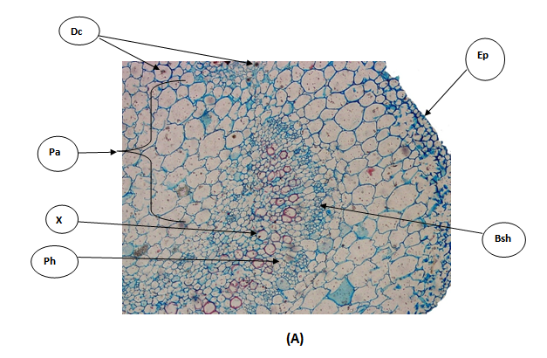
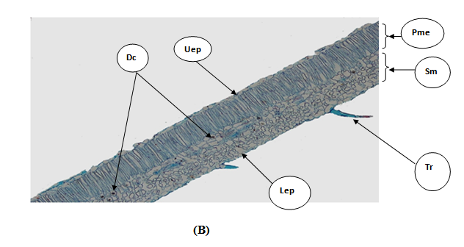
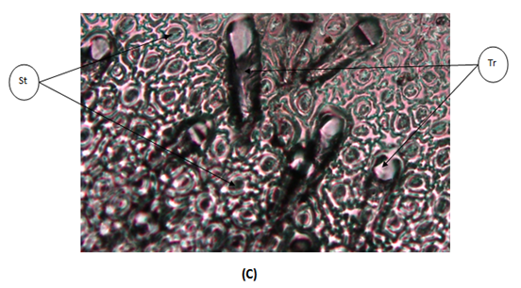
Figure1: Transfer section (T.S.) of the lamina of D. innoxia; (A) T.S. through the mid-rib region:Bsh= Bundle sheath; Dc= Druse crystal; Ep= epidermis; Ph= phloem; Xy= xylem; Pa= parenchyma cells. (B) T.S. through the lamina: Dc= Druse crystal; Uep= Upper epidermis; Lep=Lower epidermis;Pme=Palisade mesophyll;Sme=Spongy mesophyll. (C) T. S. through the peel: St= stomat; Tr= trichome.

3.2.2. Physalis angulata
The transverse section of the lamina of P.angulata is presented in Figure (2). Epidermal cells on the adaxial surface are irregular with sinuous anticlinal walls. Epidermis layer is composed of one single layer of cells. Anisocytic, paracytic and anomocytic stomata type are characterized the adaxial and abaxial surface of P.angulata. The mesophyll tissue is differentiated into palisade mesophyll parenchyma cells and spongy mesophyll parenchyma cells. Both of them are composed of one layer. The mesophyll in P.angulata is classified as bifacial. The crystal of calcium oxalate is found in the mid-rib region and spongy mesophyll in druse type. The parenchyma cells occupy the most region of the mid- rib. The vascular bundles in the mid-rib region are bicollateral.

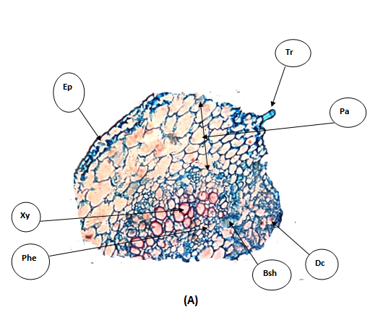

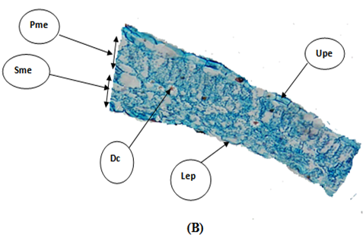

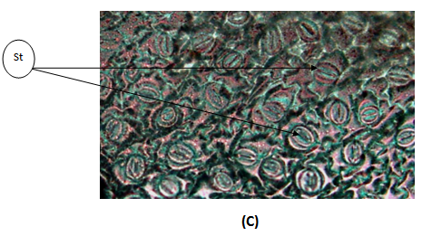

Figure 2: Transfer section (T.S.) of the lamina of P.angulata; (A) T.S. throuth The mid-rib region: Bsh= Bundle sheath; Ep=Epidermis; Ph= Pholem; Xy=Xylem; Pa= Parenchyma cells. (B) T.S. through the lamina: Druse crystal; Uep= Upper epedermis; Lep=Lower epidermis;Pme=Palisade mesophyll;Sme=Spongy mesophyll, (C) T.S through the peel: St= stomata.

3.2.3. Solanum dubium
The transverse section of the lamina of S.dubium is presented in Figure 3. Epidermal cells on the adaxial surface are irregular with sinuous walls. The epidermis is composed of a single layer of cells. Trichomes are unicellular with multicellular stalk and non-glandular. The mesophyll tisse is bifacial; it composed of palisade mesophyll and spongy mesophyll. It is noted that the palisade mesophyll cells is compacted and smaller in size than spongy mesophyll cells. The calcium oxalate is present in the form of crystal sand. A uni-cellular tricomes with 2-4 celled stalks is present in the mesophyll tissue and in the mid-rib region. The bulk region of the mid -rib is occupied by parenchyma cells. The vascular bundle is bicollateral.

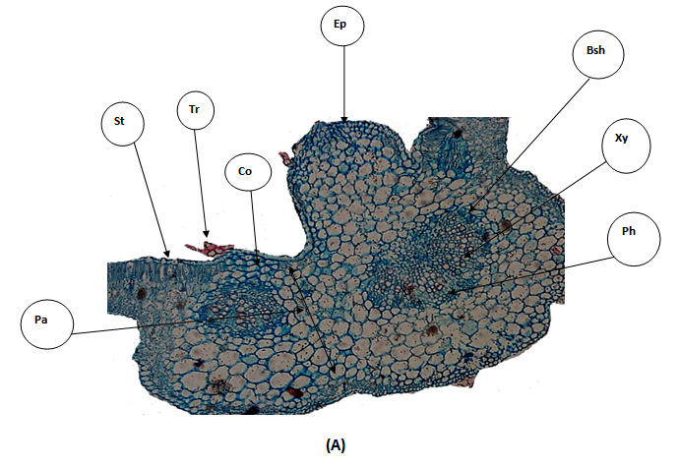
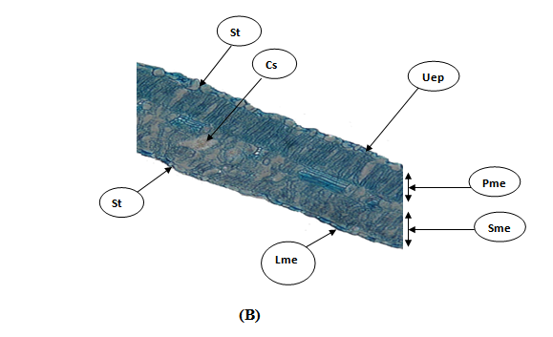

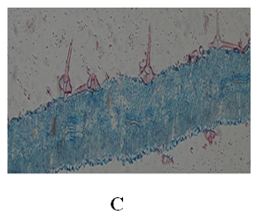
Figure 3: Transfer section (T.S.) of the lamina of S.dubium: (A) T.S. throuth The mid-rib region: Bsh= Bundle sheath;Co=Collenhyma cells; Pa=Parenchyma cells; Ep=Epidermis ; Ph= Pholem and Xy=Xylem; Me=Mesohyll; St=Stomata; Tr=Tricome. (B) T.S. through the lamina: Cs=Crystal sand; Uep= Upper epedermis;Lep=Lower epidermis;Pme=Palisademesophyll;Sme=Spongy mesophyll; St= Stomata, (C)Trichome.

3.2.4. Solanum incanum
The transverse section of the lamina of S.incanum is presented in Figure 4. Epidermal cells on the adaxial surface are irregular with sinuous wavy anticlinal walls. Anatomical investigation showed that a polygonal –shaped or irregular epidermal cells in the epidermis layer. The stomata were anisocytic and sometimes anomocytic type. Trichomes are unicellular with multicellular stalk and non-glandular. The upper epidermis layer of S.incanum was characterized by a single layer of thick cuticle. The mesophyll tissue is bifacial and differentiated into palisade mesophyll parenchyma and spongy mesophyll parenchyma. The palisade mesophyll is larger than spongy mesophyll. The crystal sand is present. The vascular bundles in the mid-rib region are bicollateral and surround by sheath. The bulk region of the mid- rib is stuff by parenchyma cells.
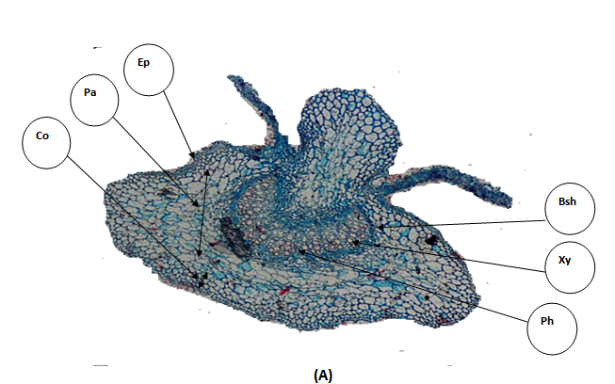

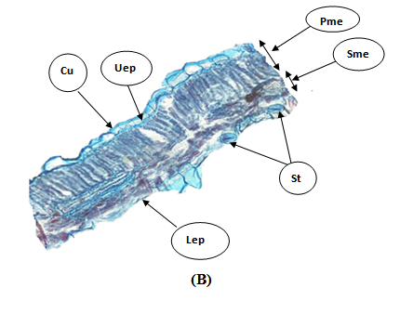

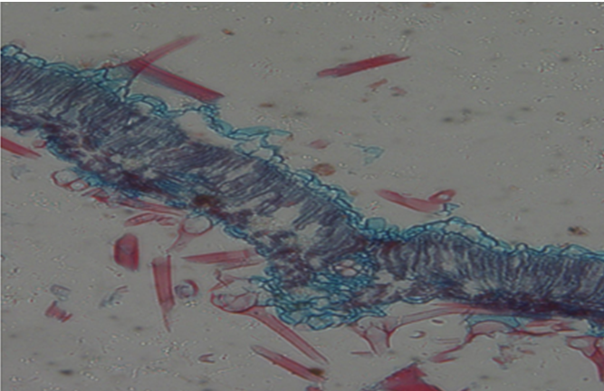
Figure 4: Transfer section (T.S.) of the lamina of S.incanum (A) T.S. throuth The mid-rib region: Bsh= Bundle sheath;Co=Collenhyma cells; Pa=Parenchyma cells; Ep=Epidermis ; Ph= Pholem and Xy=Xylem (B) T.S. through the lamina: Cu=Cuticle; Uep= Upperepedermis ;Lep=Lower epidermis;Pme=Palisade mesophyll;Sme=Spongy mesophyll; St= Stomata.(C)Trichome.

3.2.5. Solanum nigrum
The transverse section of the lamina of S.nigrum is presented in Figure 5. Epidermal cells on the adaxial surface are irregular with sinuous walls. The stomata were mostly anisocytic, sometimes anomocytic type. Glandular trichomes and non-trichomes are present with unicellulartype .The spongy mesophyll was made of cells which were round or irregular in shape. Large intercellular spaces occurred among these cells. The palisade mesophyll and spongy mesophyll are equally in thickness. The crystal of calcium oxalate is in Druse type. The glandular and non-glandular trichomes are present. The bulk region of mid-rib is occupied by large rounded intercellular parenchyma cells. The vascular bundle is bicollateral and surrounded by sheath.

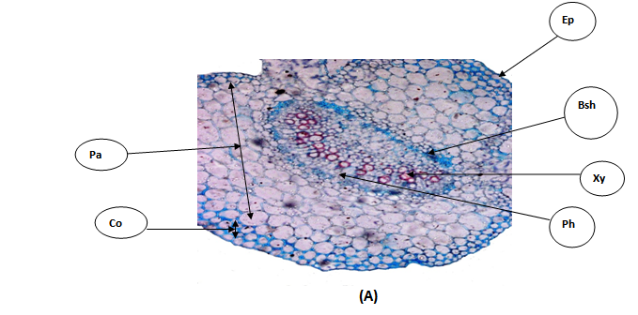

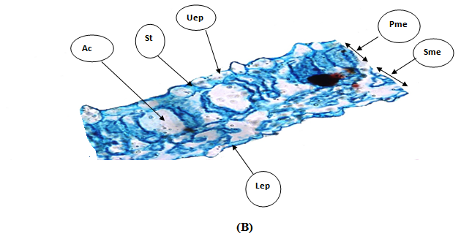
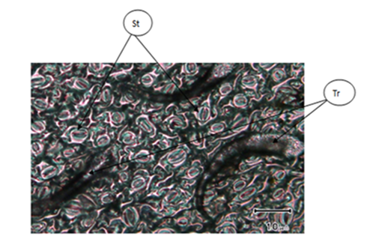
Figure 5: Transfer section (T.S.) of the lamina of S.nigrum;(A) T.S. throuth The mid-rib region: Bsh= Bundle sheath; Bsh= Bundle sheath;Co=Collenchyma cells; Ep=Epidermis ;Pa=Parenchem cells; Ph= Pholem and Xy=Xylem. (B) T.S. through the lamina: Ac=Air cavity; Uep= Upper epedermis;Lep=Lower epidermis;Pme=Palisademesophyll;Sme=Spongy mesophyll; St= Stomata,(C) T.S througth the pell: St= stomata; Tr= Trichome.
Lep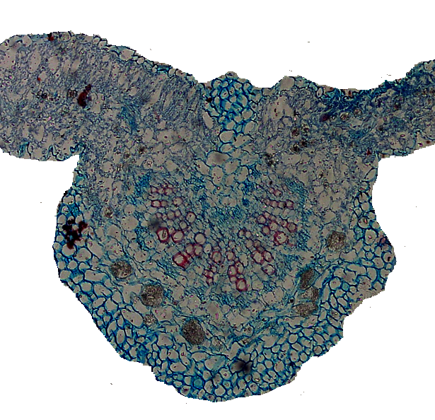

3.2.6. Withania somnifera
The transverse section of the lamina of W.somnifera is presented in Figure 6. Epidermal cells on the adaxial surface are irregular with sinuous anticlinal walls. The epidermis layer is composed of upper epidermis layer with thin cuticle and lower epidermis layer. anisocytic, paracytic and anomocytic stomata type are characterized the adaxial and abaxial surface of W.somnifera. stellate trichomes are present, also multicellular tricomes with non-gland is present. The mesophyll tissue is bifacial composed of palisade mesophyll with intercellular parenchyma cells and spongy mesophyll parenchyma cells. The spongy mesophyll layer is larger than palisade mesophyll layer. The crystal of calcium oxalate is present in druse type. It is noticed the glandular unicellular satellite tricomes are present. The mid-rib region is larger and most of its area is occupied by parenchyma cells. The vascular bundle is large and bicollateral type.

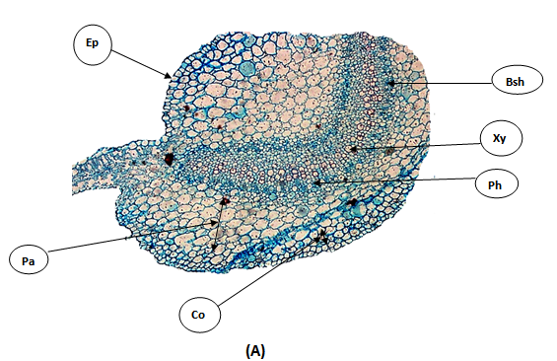

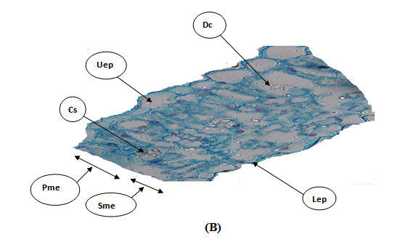
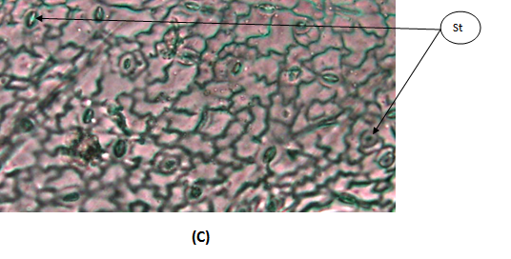
Figure 6: T.S. of W.somnifera(A) T.S. throuth The mid-rib region: Bsh= Bundle sheath;Co=Collenhyma cells; Pa=Parenchyma cells; Ep=Epidermis ; Ph= Pholem and Xy=Xylem. (B) T.S. through the lamina: Cs=Crystal sand;Dc=Druse crystal; Uep= Upper epedermis ;Lep=Lower epidermis ;Pme=Palisade mesophyll;Sme=Spongy mesophyll; St= Stomata, (C) Leaf epidermis: st=stomata.
Cs
Lep

3.3. Diagnostic Dichotomous Key
1a. Mesophyll undifferentiated; spongy throughout ………………………………………………………. Physalis angulata
1b. Mesophyll differentiated into palisade and spongy layers ………………………………………..……………………….. 2
2a. Stellate trichomes present ……………………………………………………………….…………………….Withania somnifera
2b. Stellate trichomes absent ………………………………………………………………………………………..………………………… 3
3a. Calcium oxalate exclusively as druses ………………………………………………………………………………………………… 4
3b. Calcium oxalate as crystal sand or both forms …………………………………………………………………………………… 5
4a. Glandular unicellular trichomes present; stomata anisocytic/anomocytic ……………………..Datura innoxia
4b. Both glandular and non-glandular trichomes; stomata paracytic ……………………………….. Solanum nigrum
5a. Crystal sand only; thick cuticle on adaxial epidermis ……………………………………………….…Solanum incanum
5b. Crystal sand only; thin cuticle ……………………………………………………………………………………..Solanum dubium

4. Discussion
Global population still relies on botanical drugs and there is speculation that more than two billion people may be heavily reliant on medicinal plants. The safe use of herbal medicines requires prior authentication of the raw herbal materials used to make them. Thus, the rapid and accurate identification of herbal medical plants is highly necessary to ensure their safety and efficacy. Because of the increasing demand for herbal remedies and for authentication of the source material, it is vital to provide a single database containing information about authentic plant materials and their potential adulterants.
Plant anatomy plays a crucial role in authenticating medicinal plants by providing distinct physical characteristics that can be used to differentiate genuine specimens from adulterants or substitutes. This authentication method is vital for ensuring the safety and efficacy of herbal medicines. Analyzing cellular structures such as stomata types, trichomes (hairs), crystal morphology (e.g., calcium oxalate crystals), and the presence of specific cell types can provide unique identifiers for a particular species.
The foliar epidermis is one of the important taxonomic characters from the systematic point of view. Different plant species possess unique anatomical features, often consistent within a species and distinct from closely related or adulterant species. The taxonomic studies of a number of families and genera have been made on the basis of leaf epidermis (Adedeji and Illo, 2004; Adedeji et al., 2007; Adedeji and Jewoola, 2008).
This study elucidates the leaf anatomical diversity of six Sudanese Solanaceae species, revealing taxonomically informative traits that can serve as reliable authentication markers. The observed variation in epidermal patterns, stomatal complexes, trichome types, and crystal forms aligns with previous reports on the family’s anatomical plasticity (Metcalfe and Chalk, 1979; Al-Turki et al., 2020).
The sinuous to sinuous-wavy anticlinal walls of epidermal cells are consistent with findings in other Solanaceae genera, likely representing an adaptive trait to reduce water loss in arid environments (Bacelar et al., 2007). Anomocytic type of stomata was common in various members of the studied species which is followed by anisocytic type of stomata. These results are consistent with the study conducted by (Krstić et al., 2002 ; Awan and Murtaza, 2016; Hameed and Hussain, 2011; Wahua and Edwin-Wosu, 2016; Bello et al., 2017) who investigated the anatomical stomata of solanaceae.. However, the presence of paracytic stomata in P. angulata and S. nigrum suggests phylogenetic or ecological differentiation ( Liu et al., 2018; Wang et al., 2019) . Trichome anatomy is a crucial and stable diagnostic tool for authenticating medicinal plants, even when the material is fragmented or powdered. The unique and consistent micromorphological features of trichomes act as botanical markers that allow for species-level identification and help in detecting adulterants. Trichome morphology in the current study emerged as a key diagnostic feature. The glandular trichomes of D. innoxia and S. nigrum may secrete secondary metabolites with ecological or medicinal roles (Glas et al., 2012). The stellate trichomes of W. somnifera are particularly distinctive and have been linked to drought resistance (Mir et al., 2015).
Type and location of calcium crystals are often used in plant taxonomic classification (Hsieh and Huang, 1974; Genua and Hillson, 1985). The calcium crystals may occur in different plant organs and in various shapes, e.g. druses, prismatic crystals, raphides, styloides, and crystal sands. However, calcium carbonate crystals are found only in a few families such as Moraceae, Urticaceae, and Acanthaceae (Wu and Kuo-Huang ,1997). Gómez-Nucamendi et al., (2016) reported that druse crystal was mainly found in the leaves of Datura species. Satıl et al., (2015) investigated five specis of genus Hyoscyamus which belongs to solanaceae family. In the Druse crystals are recorded only in mesophyll of Hyoscyamus albus. Also, Mhinana et al., (2010) reported that the leaves of N. glauca were characterized by the presence of solitary crystals and crystal-sand. In the current study, Calcium oxalate crystal forms showed clear interspecific variation. Druses were predominant in D. innoxia, P. angulata, S. nigrum, and W. somnifera, while crystal sand characterized S. dubium and S. incanum. These crystals may function in calcium regulation, herbivore deterrence, or light reflection (Franceschi and Nakata, 2005). Their consistent occurrence in specific tissues supports their utility as identification markers.
The microscopic evaluation of mesophyll is a recommended parameter by the World Health Organization (WHO) for the characterization of medicinal plants. The undifferentiated mesophyll of P. angulata is unusual for Solanaceae and may reflect adaptation to shaded or humid microhabitats (Vogel, 2009). In contrast, the well-developed palisade layers in S. incanum and S. dubium suggest adaptation to high-light environments.
Anatomical and microscopic evaluation provides a rapid and cost-effective method to verify the botanical identity of herbal material and detect adulterations or substitutions. From an applied perspective, these anatomical markers offer practical tools for authenticating herbal materials, especially when morphological features are lost during processing. These microscopic features are often taxon-specific and are a cornerstone of pharmacopoeial standards for quality control. Regulatory agencies and traditional healers can use the provided dichotomous key to verify species identity, reducing the risk of adulteration with toxic or ineffective substitutes.

5. Conclusion
This study provides the first comprehensive leaf anatomical characterization of six medicinal Solanaceae species from Sudan, identifying reliable micromorphological markers for their authentication. The developed dichotomous key enables accurate species discrimination based on accessible microscopic features. These findings strengthen the scientific foundation of traditional medicine by supporting quality control in herbal product preparation and distribution. Future research should integrate anatomical data with molecular and phytochemical analyses to establish holistic authentication protocols. Conservation initiatives should prioritize these species given their medicinal value and susceptibility to habitat loss.

7. References
Adedeji, O., Ajuwon, O.Y., & Babawale, O.O. (2007). Foliar Epidermal Studies, Organographic Distribution and Taxonomic Importance of Trichomes in the Family Solanaceae. International Journal of Botany. https://doi.org/10.3923/ijb.2007.276.282
Adedeji, O., and Illoh, H. C. (2004). Comparative Foliar Anatomy of Ten Species in the Genus Hibiscus Linn. in Nigeria.
Adedeji, O., & Jewoola, O. A. (2008). Importance of Leaf Epidermal Characters in the Asteraceae Family. Notulae Botanicae Horti Agrobotanici Cluj-Napoca, 36(2), 7–16. https://doi.org/10.15835/nbha.36.2.243
Gaber, A., Hassan, M. M., Boland, C., Alsuhaibany, A., Babbington, J., Pereira, J., Budd, J., & Shobrak, M. (2020). Molecular identification of Todiramphus chloris subspecies on the Arabian Peninsula using three mitochondrial barcoding genes and ISSR markers. Saudi Journal of Biological Sciences. https://doi.org/10.1016/j.sjbs.2019.11.014
Anand, U., Tudu, C.K., Nandy, S. (2019). Botanical description, phytochemical constituents and pharmacological properties ofWithaniasomnifera: A review. Journal of Pharmacy and Pharmacology, 71(8), 1295–1314.
Awan, A. A., & Murtaza, G. (2016). Anatomical studies on stomata of Solanaceae from Muzaffarabad Division Azad Jammu and Kashmir, Pakistan. Science International (Lahore), 28(5), 4701–4706. http://www.sci-int.com/pdf/15849010701%20a%204701-4706%20Ashfaq%20Ahmad%20Awan%20-Bot.--AJK--21-9-16--TR.pdf
Bacelar, E. A., Moutinho-Pereira, J. M., Gonçalves, B., Ferreira, H., & Correia, C. M. (2007). Changes in growth, gas exchange, xylem hydraulic properties and water use efficiency of three olive cultivars under contrasting water availability regimes. Environmental and Experimental Botany, 60(2), 183–192. https://doi.org/10.1016/j.envexpbot.2006.10.003
Bello, A. O., Oladipo, O. T., and Saheed, S. A. (2017). Leaf epidermal studies of some Solanum (Solanaceae) species in Nigeria. Phytologia balcanica, 23(1), 55-63.
Chowański, S., Adamski, Z., Marciniak, P., Rosiński, G., Büyükgüzel, E., Büyükgüzel, K., Falabella, P., Scrano, L., Ventrella, E., Lelario, F., & Bufo, S. A. (2016). A review of bioinsecticidal activity of Solanaceae alkaloids. Toxins, 8(3), 60. https://doi.org/10.3390/toxins8030060
Franceschi, V. R., & Nakata, P. A. (2005). Calcium oxalate in plants: formation and function. Annual Review of Plant Biology, 56, 41–71. https://doi.org/10.1146/annurev.arplant.56.032604.144106
Genua, J. M., & Hillson, C. J. (1985). The occurrence, type and location of calcium oxalate crystals in the leaves of fourteen species of Araceae. Annals of Botany, 56(3), 351–361. https://doi.org/10.1093/oxfordjournals.aob.a087021
Glas, J. J., Schimmel, B. C. J., Alba, J. M., Escobar-Bravo, R., Schuurink, R. C., & Kant, M. R. (2012). Plant Glandular Trichomes as Targets for Breeding or Engineering of Resistance to Herbivores. International Journal of Molecular Sciences, 13(12), 17077–17103. https://doi.org/10.3390/ijms131217077
Gómez-Nucamendi, O. L., Hernández-Sandoval, L., Figueroa-Cabañas, M., and Martínez, M.(2016). Leaf anatomy of four species and one variety of Datura (Solanoidea, Solanaceae).
Hameed, I., & Hussain, F. (2011). Stomatal studies of some selected medicinal plants of family solanaceae. Journal of Medicinal Plants Research, 5(18), 4525-4529. https://doi.org/10.5897/JMPR.9001150
Heinrich, M., Lardos, A., Leonti, M., Weckerle, C., & Willcox, M. (2017). Best practice in research: Consensus Statement on Ethnopharmacological Field Studies – ConSEFS. Journal of Ethnopharmacology, 211, 329–339. https://doi.org/10.1016/j.jep.2017.08.015
Hsieh, C. F., & Huang, T. C. (1974). The acanthaceous plants of Taiwan. Taiwania, 19(1), 19-57. https://doi.org/10.6165/tai.1974.19.19
Karar, M. G. E., & Kuhnert, N. (2017). Herbal drugs from Sudan: Traditional uses and phytoconstituents. Pharmacognosy Reviews, 11(22), 83–103. https://doi.org/10.4103/phrev.phrev_15_15
Krstić, L. N., Merkulov, L. S., & Boža, P. P. (2002). The variability of leaf anatomical characteristics of Solanum nigrum L. (Solana-les, Solanaceae) from different habitats. Zbornik Matice srpske za prirodne nauke, (102), 59-70. https://doi.org/10.2298/ZMSPN0201059K
Liu, C., He, N., Zhang, J., Li, Y., Wang, Q., Sack, L., & Yu, G. (2018). Variation of stomatal traits from cold temperate to tropical forests and association with water use efficiency. Functional Ecology, 32(1), 20-28. https://doi.org/10.1111/1365-2435.12973
Metcalfe, C. R., & Chalk, L. (1979). Anatomy of the Dicotyledons (2nd ed.). Clarendon Press. https://global.oup.com/academic/product/anatomy-of-the-dicotyledons-9780198543831
Mir, B.A., Koul, S., & Kumar, A. (2015). Structural and functional adaptation to salinity in Withaniasomnifera. Journal of Plant Interactions, 10(1), 136–146.
Rocha, L.G., Almeida, J.R.G.S., Macedo, R.O., et al. (2021). A review on the adulteration of commercial medicinal plants: Current status and challenges. Brazilian Journal of Pharmacognosy, 31(1), 1–13.
Vogel, S. (2009). Leaves in the lowest and highest winds: Temperature, force and shape. New Phytologist, 183(1), 13–26. https://doi.org/10.1111/j.1469-8137.2009.02854.x
Satıl, F., Aslan, M., Erdoğan, E., Polat, R., & Selvi, S. (2015). Comparative anatomical studies on some species of Hyoscyamus L. (Solanaceae) growing in Turkey. Bangladesh Journal of Botany, 44(1), 37–43. https://doi.org/10.3329/bjb.v44i1.22721
Wahua, C., & Edwin-Wosu, N. L. (2016). Morphological characters, occurrence and distribution among members of the family Solanaceae in parts of the Niger Delta Ecological Zone. Journal of Applied Sciences and Environmental Management, 20(3), 583-590. https://doi.org/10.4314/jasem.v20i3.12
Wang, M. H., Wang, J. R., Zhang, X. W., Zhang, A. P., Sun, S., & Zhao, C. M. (2019). Phenotypic plasticity of stomatal and photosynthetic features of four Picea species in two contrasting common gardens. AoB Plants, 11(4), plz034. https://doi.org/10.1093/aobpla/plz034
World Health Organization. (2019). WHO global report on traditional and complementary medicine 2019. https://www.who.int/publications/i/item/9789241515436
Wu, C. C., & Kuo-Huang, L. L. (1997). Calcium crystals in the leaves of some species of Moraceae. Botanical Bulletin of Academia Sinica, 38(2), 97-104. https://ejournal.sinica.edu.tw/bbas/content/1997/2/bot382-05.html .

