Original Research Article
Rutin Isolated from Heliotropium indicum Induces Mitochondria-Mediated Apoptosis and Cytotoxicity in HepG2 and LNCaP Cancer Cells

.
ABSTRACT

Aims: Locally, Heliotropium indicum L. is used as a leukemic, asthmatic, and antipyretic medica tion. In traditional medicine, it is frequently employed to treat open wounds. Heliotrope species have a long history of usage as useful medicinal and culinary plants
Study design: It is an in vitro cell culture–based experimental study with mechanistic evaluation and was carried out at the Tissue Culture Laboratory, Nigerian Institute of Medical Research.
Methodology: In the present study, Hepatocellular carcinoma cells (HepG2) and Prostate carcinoma cells (LNCaP) were used to test the cytotoxicity of rutin purified from methanol extract of whole plant Heliotropium indicum L. Utilizing WST assay (lactate dehydrogenase (LDH) leakage), mitochondrial membrane potential (MMP) assay, ELISA (caspases 9/3, Bcl-2, Bax and Cytochrome c), microscopy, and fluorometry to measure apoptosis, the extracts' cytotoxicity and anti-proliferative properties were assessed in vitro via spectrophotometry
Results: The results indicated that rutin significantly inhibited the proliferation of HepG2 and LNCaP cells at 0.1 - 1000 µg/ml in a concentration-dependent manner. In vitro, the cytotoxic effect of rutin on LNCaP was higher than on HepG2 cells. The significant increase in LDH leakage and decline in MMP further demonstrated the cytotoxic effects of rutin on these cells. Furthermore, upregulation of Caspases 9/3, Bax, cytochrome C and downregulation of Bcl-2 in HepG2 and LNCaP cells showed that the apoptosis signal route involved the mitochondrial pathway.
Conclusion: In summary, Rutin isolated from Heliotropium indicum L. demonstrates cytotoxic and apoptotic effects on HepG2 and LNCaP cells by releasing lactate dehydrogenase from the cell membrane and inducing apoptosis through a caspases-dependent mechanism. This suggests that Heliotropium indicum L. may be able to treat hepatocarcinoma and prostate cancers.

Keywords: Heliotropium indicum L., LNCaP, HepG2, Cell proliferation, Rutin

1. INTRODUCTION

Over half of the projected increase in global population between 2015 and 2050 is estimated to reside in Africa, underscoring the significance of addressing population health in the continent for enhancing public health internationally [1]. Given that cancer is currently the fifth greatest cause of death in Africa, greater research regarding the prevalence of cancer across the continent is necessary [2]. Cancer is a diseased condition marked by the uncontrolled growth and division of aberrant cells [3]. When compared to other geographical regions, Africa is expected to experience the largest increase in cancer incidence and mortality between 2020 and 2040. According to projections, there would be 2.1 million new cases of cancer and 1.4 million fatalities in Africa by 2040, up from 1.1 million cases and 711,429 deaths in 2020. By 2040, it is anticipated that the burden of the five major cancer types (breast, cervical, prostate, colorectal, and liver) will have doubled. Twelve neoplasms are anticipated to have more than 50,000 cases annually by 2040, while nine neoplasms are anticipated to have 50,000 or more cancer deaths by that year in Africa. The most frequent primary liver cancer is hepatocellular carcinoma (HCC), which is also the main cause of cancer-related death globally. HCC is the ninth most common cancer-related cause of death in the US [4]. Incidence and death are still increasing despite improvements in screening methods, prevention strategies, and new technologies for both diagnosis and treatment. Regardless of the etiology, cirrhosis continues to be the predominant risk factor for the development of HCC. Prostate cancer (PC) was the leading cancer group in African males with 93,173 [83,906 – 103,463] cases and 47,249 [41,941 – 53,228] deaths [2,5]. Today, prostate cancer is a major public health issue. The most significant malignancy that disproportionately affects males of African origin is prostate cancer. Prostate cancer is the most common cancer among Nigerian males, accounting for 6.1%–19.5% of all cancer diagnoses in the country. With an average frequency of 11%, prostate cancer is becoming more common in men [6]. The high mortality rate among cancer patients is a sign of the existing treatments' ineffectiveness [7,8]. Chemotherapy remains the mainstay of cancer treatment, despite improvements in the creation of new therapeutic modalities. However, natural chemicals obtained from food sources or medicinal plants have been viewed as prospective resources to identify novel chemotherapeutic treatments due to the highly damaging side effects of synthetic compounds to normal cells [9]. An African herb known as Heliotropium indicum Linn. is known to have antipyretic, wound healing, antileukemic, anti-asthmatic, anti-tumor, antioxidant, and antibacterial properties [10]. Heliotropium indicum L. is a common plant known as "Ogbe Ori Akuko" or “Heliotrope” (Family: Heliotropiaceae, Subfamily: Boraginaceae), that grows like a weed and is found around the world. In addition to being native to South America, the plant has also been naturalized in North America, Africa, Asia, and Australia. Given its importance in ethnomedicine, it is used all over the world. The herb is also used as a diuretic, an antifertility remedy, and uterine stimulant, among many other folk applications. The plant is known to have a variety of pharmacological properties, including anti-microbial, antinociceptive, anti-ulcer, anti-glaucoma, anti-tuberculosis, anti-plasmodial, and wound healing [11]. Antioxidant and anti-inflammatory properties of Heliotropium indicum L. extract are widely established. Consumption of foods and beverages containing flavonoids has repeatedly been linked to a decreased risk of acquiring a variety of malignancies, including prostate, lung, stomach, and breast cancers. Our previous research finding showed that Chloroform Fraction of Heliotropium indicum L. is the most potent of all the tested fractions in inducing mitochondrial-mediated apoptosis and therefore was suggested to contain the potent agents [10]. Therefore, the purpose of this study was to ascertain Heliotropium indicum's L. in vitro anticancer activity on HepG2 (hepatocarcinoma) and LNCaP (prostate cancer) cells.

2. material and methods
2.1 Collection of Heliotropium indicum L. whole plant
Fresh whole plant of Heliotropium indicum L. was collected at a farmland in Moor plantation, Apata. Identification of the plant was done at the herbarium, University of Ibadan; with a voucher number: UIH-22509 was assigned to the plant and deposited at the herbarium.

2.2 Extraction of Heliotropium indicum L.
The procedures for gathering, certifying, and processing the plant's methanol extract have all been documented in an earlier study [10], The Heliotropium indicum L. was gathered, allowed to dry naturally, ground into a fine powder (6.25 kg), and then allowed to soak in enough methanol for 72 hours. Afterwards, the mixture was decanted, filtered, and concentrated using a rotary evaporator at 40 °C under reduced pressure (Stuart, United Kingdom). A constant weight of 72 g was achieved by further condensing the methanol extract to a crude extract devoid of solvents in a water bath (DK-420, China).
The obtained methanol extract was subjected to vacuum liquid chromatography to obtain chloroform fraction, after which the chloroform fraction (dissolved in 70-30; chloroform-methanol solvent) was loaded on the silica gel (60 g) and loaded on preparative thin layer chromatographic plate and eluted in 100-chloroform, 70-30 methanol-chloroform, 60-40 methanol-chloroform, 50-50 methanol-chloroform, 40-60 methanol-chloroform, 30-70 methanol-chloroform and 100-methanol solvent mixtures. The distinct bands were carefully scrapped and were identified using nuclear magnetic resonance technique. The identified fractions were labeled and kept for later examination at 4 °C.

2.3. Chemicals
Lactate dehydrogenase (LDH) assay kit and Cytotoxicity Accessory Reagents, Caspases 3 and 9, Bax, Bcl-2, Cytochrome c, TMRE Mitochondrial membrane potential ELISA Assay kits, QVD-Oph Standard Caspase inhibitor, PI/Rnase staining buffer, Penicillin/Streptomycin, Trypsin-EDTA (MyBioSource, USA). HyClone DMEM, DMSO, HEPES buffer, PBS (Thomas Scientific, USA).

2.4. Culture Medium and Cell lines
The cancer cell lines; HepG2 and LNCaP were procured from Cell line services (CLS, Germany) and cultivated in Dulbecco's Modified Eagle's medium (DMEM) (Gibco, USA) supplemented with 10% fetal bovine serum (FBS; Sigma) and 2 × 10⁻³ v/v penicillin–streptomycin (31 g/L penicillin and 50 g/L streptomycin). The cultures were maintained at 37 °C in a humidified environment with 5% CO₂.

2.5. Cell Cytotoxicity Assay
The cancer cells; HepG2 and LNCaP were grown in 96-well plates (1 × 10⁴ cells/100microL well) for a duration of 24 hours. Following an overnight growth period, the culture medium was changed. In the 96-wells different extract concentrations (0.01 µg/mL to 1000 µg/mL) were carefully pipetted in triplicate and incubated for a duration of 72 hours. Under 72 hours, there was colour development (yellow) in the well plates in varying degrees. Lactate dehydrogenase (LDH) release was measured to determine the extent of cell injury (Kumar et al., 2018). The enzyme reaction was carried out following the manufacturer's instructions (Lactate Dehydrogenase - LDH), Assay Kit, MyBioSource, USA).
In summary, LDH reaction mixture (50 µL) was added to each well, and incubated for 60 minutes at 37 °C in the dark. The reaction was stopped with the aid of stop solution (10 µL). The Galapagos Plate reader was used to measure the absorbance (for the colour development) at 450 nm.

2.6. Cell Membrane Potential Assay
Following a 24-hour culture period. Attached cells were treated for 72 hours with an extract at varying concentrations. Within three - four hours after the test substance was dispensed into the cells, depolarized wells were filled with 20 µL of 400 µM FCCP (for a 20 µM treatment). Thirty minutes prior to the end of the experiment, 400 µL of 200 nM TMRE dye was added to each well, and it was left to incubate at 37 °C for thirty minutes. Following the subculturing process, the medium was removed and the cells were rinsed twice with 400 µL of 1X assay buffer.
To acquire fluorescence readings, the assay buffer (200 µl) was dispensed into each well, where it was allowed to equilibrate (after the buffer was added, it was allowed to sit for about five – ten minutes to chemically reach its equilibrium). Subsequently, the wells were transferred to the microplate reader. Excitation wavelengths for the monomer and aggregate were set at 475 ± 20 nm, with emission wavelengths for the monomer species at 530 ± 15 nm and for the aggregate at 590 ± 15 nm. Plotting of the aggregate-to-monomer ratio was performed post subtraction of the background signal.

2.7. Caspases Assessment Assay
Following the dispensing of 100 µL of standard, sample, and blank into the appropriate wells, the wells were sealed and sub-cultured at 37⁰C for an hour. The solution was dispensed. Using a multichannel pipette and absorbent paper, the well technically drained after being washed three times with 350 µL of wash solution. Next, 100 µL of HRP-Conjugate Reagent was added to the wells, and the mixture was incubated for thirty minutes at 37⁰C.
Subsequently, wells underwent five consecutive rounds of washing before 90 µL of substrate solution (A, and then B) were dispensed into them and then subjected to a 20–30 minutes sub-culture at 37 °C. To instantly stop the reaction, 50 µL of stop solution was added to the well, and the abs was measured at 450 nm. These procedures were conducted for Caspases 3 and 9 according to the manufacturer’s manual.

2.8. Bcl2 family (Pro- and Anti-) Assay
Prior to commencing the experiment, reagents were equilibrated to room temperature. 100 μL of the standard solution were added to the assigned wells in triplicate. Furthermore, 100 μL of the samples were added to wells in triplicate. The plate was sealed and incubated at 37 ⁰C for ninety minutes. After incubation, the liquid was micro-pipetted from each well. Each well was immediately filled with 100 mL of the BTD-Ab combination, and then the plate sealer was placed over the wells. The plate was lightly stirred and tapped to ensure equal distribution of the added substrate in the wells. Then, it was sub-cultured for one hour at 37⁰C. Following the removal of the solution from the wells, 350 μL of the wash solution was poured into each well and allowed to stand for two minutes before being disposed. It was wiped on absorbent paper, and this washing process was done three times. After adding 100 μL of HRP-conjugate working solution, the wells were sealed. After 30 minutes at 37 ⁰C of incubation, the solution was thrown out. Subsequently, the wash process was repeated, and 90 μL of substrate reagent were poured into wells and sealed. After that, it was sub-cultured for fifteen minutes at 37 ⁰C. 50 mL of stop solution was added to each well, and the OD values of the wells were measured concurrently at 450 nm using a microplate reader. These procedures adhered to the guidelines outlined in the manufacturer’s manual.

2.9. Cytochrome c Assay
Upon equilibrating all components of the kit to room temperature, a 1:25 wash solution was prepared by diluting the wash solution concentrate with double-distilled water (i.e. 0.2ml of wash solution concentrate was dissolved in 4.8ml of double distilled water to achieve 5 ml of wash solution). The cytochrome c standard was prepared by reconstituting lyophilized cytochrome c with 1 mL of standard diluent and allowing it to stand for 30 minutes. To achieve a range of concentrations (0.156 – 10 ng/mL), a serial dilution was carried out into seven Eppendorf tubes. The standard and sample (Cell lysate) were dispensed in triplicates into Cytochrome c specific primary ATB pre-coated wells. The wells were sub-cultured for 90 minutes at 37⁰C.
Following three rinses with 350 µL of previously prepared washing solution, biotinylated human cytochrome c ATB was added to the wells, and sub-cultured for 60 minutes (37 ⁰C). The specified wells were filled with 100 µL of the enzyme conjugate liquid (strep-HRP conjugate) and incubated for 30 minutes at 37 ⁰C. After which the TMB substrate (100 µL) was added. The wells were then sub-cultured for 30 minutes at 37 ⁰C. After a 10-minute culturing period, 100 µL of stop solution was added to each well, and the absorbance at 450 nm was determined.

3. results and discussion
3.1 Effect of rutin on cell proliferation
The antiproliferative effect of the rutin isolated from Heliotropium indicum against the two cancer cell lines, hepatocarcinoma (HepG2) and prostate carcinoma (LNCaP), was assessed. Non-tumorous VERO cells were utilized as the control. The effects of LNCaP and HepG2 cancer cells on increasing rutin concentrations are shown in Figures 1 and 2, respectively. The outcomes demonstrated propensity of both cell lines to rapidly decline in number when exposed to doses of rutin, with the strength of the response tapering as the concentrations of the substance increased. After being incubated for 72 hours, rutin's IC₅₀ values on HepG2 and LNCaP were 1.692 μg/mL and 1.849 μg/mL, respectively. This suggests that rutin had a greater anti-proliferative effect on LNCaP cancer cells than HepG2 cancer cells. It can be shown from the higher IC₅₀ value for VERO cells (used as the control) that rutin is more toxic on cancer cells than it is to normal cells as seen in the selectivity index for VERO's IC₅₀ against LNCaP and HepG2 which is greater than 2. According to this, rutin isolated from Heliotropium indicum may have enormous promise as an anti-cancer medication. These results were consistent with those of Mainasara et al. [12] and Al-Nemari et al. [13], who showed that the rutin has anti-cancer properties. Using the trypan blue technique, the cells' viability was evaluated. Trypan blue is a dye that only labels dead cells, making it useful for quantifying live cells. This dye is unable to pass through live cells' intact cell membrane and into the cytoplasm because they lack this barrier. Trypan blue reaches the cytoplasm of a dead cell by piercing the permeable cell membrane. Through the trypan-blue exclusion dye assay, the proportion of the viable cells after exposure to HepG2 and LNCaP cells were determined. Table 1 shows that in a concentration-dependent manner, there was reduction in the proportion of viable cells exposed to HepG2 and LNCaP cells. This table shows that viability of both cells (at control) was higher than 88%, while for HepG2 cells, the viability from 91.15% reduced to 87.14, 78.66 and 55.18% respectively, the viability for LNCaP cells from 88.35% reduced to 69.73, 48.84 and 39.29% respectively. Reduction in the viability of cells with respect to the trypan blue assay shows the cytotoxic effect of rutin on HepG2 and LNCaP cancer cells. This indeed, is the first time rutin isolated from Heliotropium indicum will be reported to be cytotoxic against HepG2 and LNCaP cells. Various activities such as anti-inflammatory, anti-oxidative and antimicrobial have been reported about the plant [14,15,16,17]. However, reports from this study show that rutin isolated from this plant is more cytotoxic to cancer cell lines and milder on the normal cell (i.e. VERO cells).
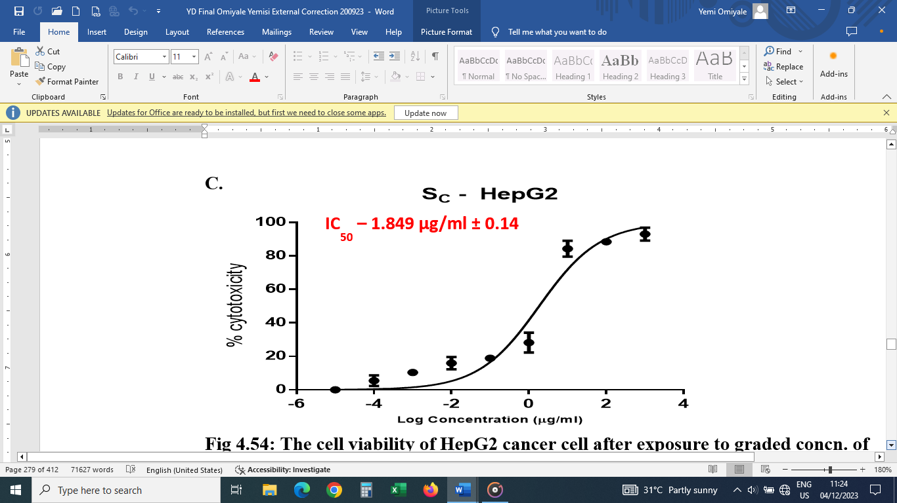
Fig 1: The cell viability of HepG2 cancer cell after exposure to graded concentration of rutin (S_{C}- Rutin, exposure) on HepG2 cells for 72 hrs

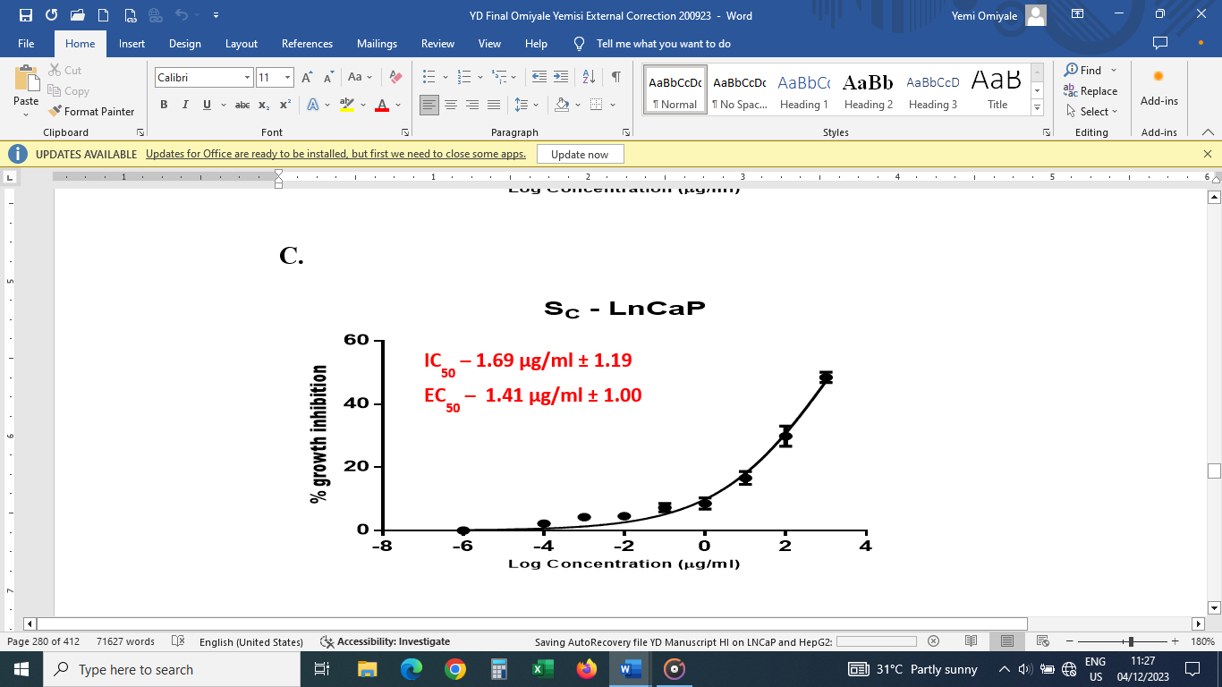
Fig 2: The cell viability of LNCaP cancer cell after exposure to graded concentration of rutin (S_{C}- Rutin, exposure) on LNCaP cells for 72 hrs

Table 1: Cell viability (Trypan -Blue) Assay
Groups | Viability Percentage  (HepG2 cells) | Viability Percentage  (LNCaP cells)
Control | 91.15 ± 2.44 | 88.35 ± 1.01
0.2% DMSO | 90.12 ± 0.91 | 87.93 ± 0.91
5 µg/mL Rutin | 87.14 ± 1.55* | 69.73 ± 2.65*
10 µg/mL Rutin | 78.66 ± 2.34* | 48.84 ± 2.55*
20 µg/mL Rutin | 55.18 ± 2.91* | 39.29 ± 4.11*
Presented Values are mean ± standard error of Five independent assays performed in triplicates. The significant differences between expos cells and controls groups are shown as (P = .05) (DMSO: dimethyl sulfoxide.)

Lactate dehydrogenase (LDH) is an important enzyme of the anaerobic metabolic pathway. It belongs to the class of oxidoreductases, with an enzyme commission number EC 1.1. 1.27. The function of the enzyme is to catalyze the reversible conversion of lactate to pyruvate with the reduction of NAD⁺ to NADH and vice versa [18]. By measuring the extracellular activity of lactate dehydrogenase (LDH) following disruption to the cell plasma membrane, the lactate dehydrogenase leakage assay serves as an indirect test for the loss of cell membrane integrity. The conversion of L-lactate to pyruvate is catalyzed by the stable cytosolic enzyme lactate dehydrogenase (LDH). LDH enzyme is released into the culture media when cells suffer membrane injury, indicating a loss of membrane integrity. Additionally, the finding that the graded concentration of rutin increased the amount of LDH in the cell as a percentage, demonstrates the cytotoxic effect, since increasing LDH levels signify cell damage to the plasma membrane [19]. Figure 3 shows the cytotoxic profile of HepG2 cells after its exposure to graded concentration of rutin for 72 h. Rutin increasingly caused an increase in LDH in the cell which were significantly noted at 0.01 – 1000 µg/ml at 18 – 74% in HepG2 cells. In Figure 4, the cytotoxic profile of LNCaP cells after its exposure to graded concentration of rutin for 72 h LNCaP cells was displayed. In a concentration-dependent manner, rutin caused the release of LDH by 21 – 82%. Across the experiment, rutin caused higher release of LDH in LNCaP higher than in HepG2 cells indicating that it is the most potent in causing a cytotoxic effect that led to the increasing release of LDH in the two cells tested by highest in LNCaP cells as measured by WST reagent. These results demonstrate the plausibility of pore opening induction, or intrinsic apoptosis, as a mechanism causing cell death.

Fig 3: The percentage cytotoxic effect of graded concentration of rutin (S_{C}- Rutin, exposure) on HepG2 cells
*, means values are statistically significant at (P = .05), relative to the control

Fig 4: The percentage cytotoxic effect of graded concentration of rutin (S_{C}- Rutin, exposure) on LNCaP cells
*, means values are statistically significant at (P = .05), relative to the control

Cancer, cardiovascular disease, diabetes, and neurodegenerative diseases have all been linked to mitochondrial dysfunction. The toxicity of substances can have an immediate or indirect consequence on mitochondrial function. Loads of these drugs inhibit mitochondrial membrane potential by disrupting a number of macromolecules in the mitochondria, these affects mitochondrial activities, and causes decrease in mitochondrial membrane potential leading to apoptosis [20]. By oxidising substrates, mitochondria generate a membrane potential seen as proton gradient across the mitochondrial inner membrane. Many functions with respect to mitochondria, including ATP production, reactive oxygen species, calcium ion sequestration, and protein import into the mitochondrion, are inextricably linked to mitochondrial membrane potential. As a result, pharmacological variations in mitochondrial membrane potential are linked to a variety of clinical conditions. Tetramethylrhodamine ethyl ester (TMRE) is used to mark active mitochondrial and it is a red-orange coloured cell permeant positively charged dye. The TMRE dye accrues in energised mitochondria and is used to assess the cell's mitochondrial membrane potential. The accumulation of TMRE in healthy cells appear as luminous clumps (emission at 590 nm) which is transformed to green fluorescent monomers (emission at 535 nm) and then stays in the cytosol when the mitochondrial membrane potential depolarizes and cells loses their integrity. In healthy mitochondria, TMRE staining is punctuate, whereas in cells with low ΔΨm, it is faint and diffuse. TMRE dye does not accumulate in cells whose mitochondria has shifted to a state of depolarization due to apoptosis (or other physiological state) Also, fluorescence microscopy can be used to observe the TMRE staining [21]. Our findings show that the percentage of HepG2 and LNCaP cells having the dye was high in FCCP-incubated cells, showing that the cells died. HepG2 and LNCaP cells treated with vehicle had a higher proportion of cells with TMRE masses. This shows that the cells' mitochondrial membranes were intact, as evidenced by the bright orange TMRE fluorescence.

However, when the cells were preincubated with rutin for 72 hours, the TMRE dye fluorescent intensity ratio revealed reduction in mitochondrial membrane potential. The remark that rutin caused a significant decline in mitochondrial membrane potential in LNCaP. Also, HepG2 cells pre-incubated with rutin dissipates mitochondrial membrane potential in these cells. This is consistent with the decrease in the ∆Ψm associated with early apoptosis mediated by pore opening.

- B.
Concentration

Fig 5: The percentage relative fluorescence signal of HepG2 cells treated with DMSO and FCCP (diluent control and coupler, respectively) and graded concentration of S_{c}
A: Exposure of DMSO and FCCP (as control) to HepG2 cells B: Exposure of S_{C}- Rutin to HepG2 cells
*, means values are statistically significant at (P = .05) relative to the control

- B.
Concentration

Fig 6: The percentage relative fluorescence signal of LNCaP cells treated with DMSO and FCCP (diluent control and coupler, respectively) and graded concentration of S_{C}- Rutin
A: Exposure of DMSO and FCCP (as control) to LNCaP cells B: Exposure of Sc to LNCaP cells
*, means values are statistically significant at (P= .05), relative to the control

Apoptosis is a cell death where intracellular components disintegrate while circumventing inflammation and mutilation to neighboring cells. Caspases are triggered in reaction to a variety of cell death events, and they eventually destroy the cell through limited proteolysis of approximately 400 cellular proteins, according to the most recent estimates. Other than their own precursors and the downstream effector caspases, the initiator caspases are extremely selective protease that cleave few proteins. Executioner caspases are stimulated by initiator caspases. Caspases 8, 9 and 3 are located at critical points in the apoptotic process. Caspase 9 promotes disassembly in reaction to substances or stressors that cause the cytochrome c from the mitochondria when complexed with APAF-1 and extra-mitochondrial cytochrome c. Caspase 3 appears to stimulate caspase 8 and 9 signals [22]. Our result demonstrates that there was concentration-dependent upsurge in caspases 9 and 3 in Cell lysate of HepG2 and LNCaP after exposure to graded concentration of rutin for 24 h, respectively. It is likely that the increase in the levels of these enzymes was as a result of increasing cytochrome c which is a point of no return for apoptotic process to kick-start. Also, the upsurge in caspases was interconnected with increase in the concentration of rutin and this is in tandem with observation made on the effect of chloroform fraction of Heliotropium indicum on caspases using the murine model, confirming the execution of apoptotic process [10].

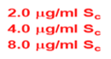
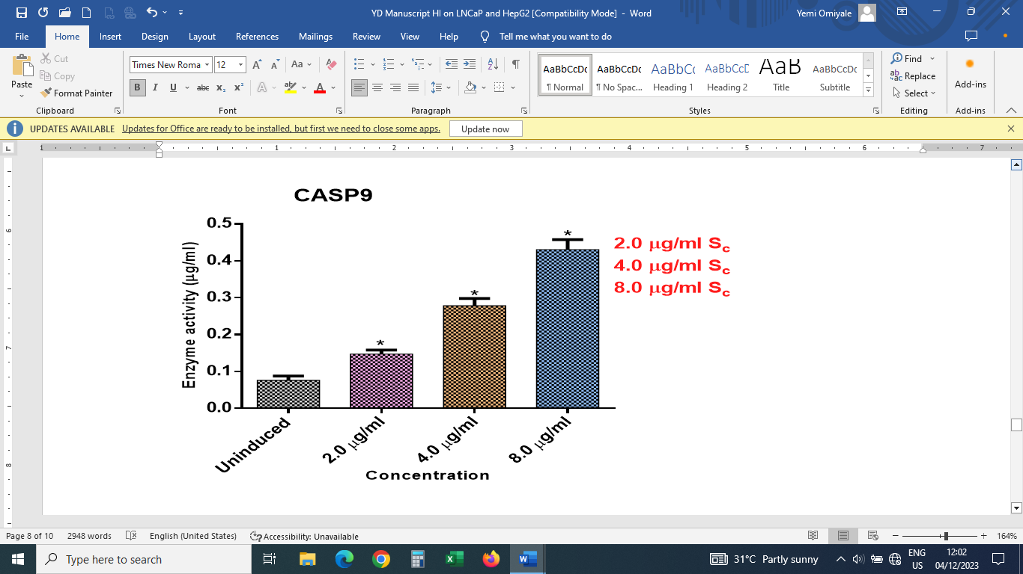

Fig 7: Caspase 9 in HepG2 Cell lysate after exposure to graded concentration of S_{C}- Rutin
*, means values are statistically significant at (P= .05), relative to the control

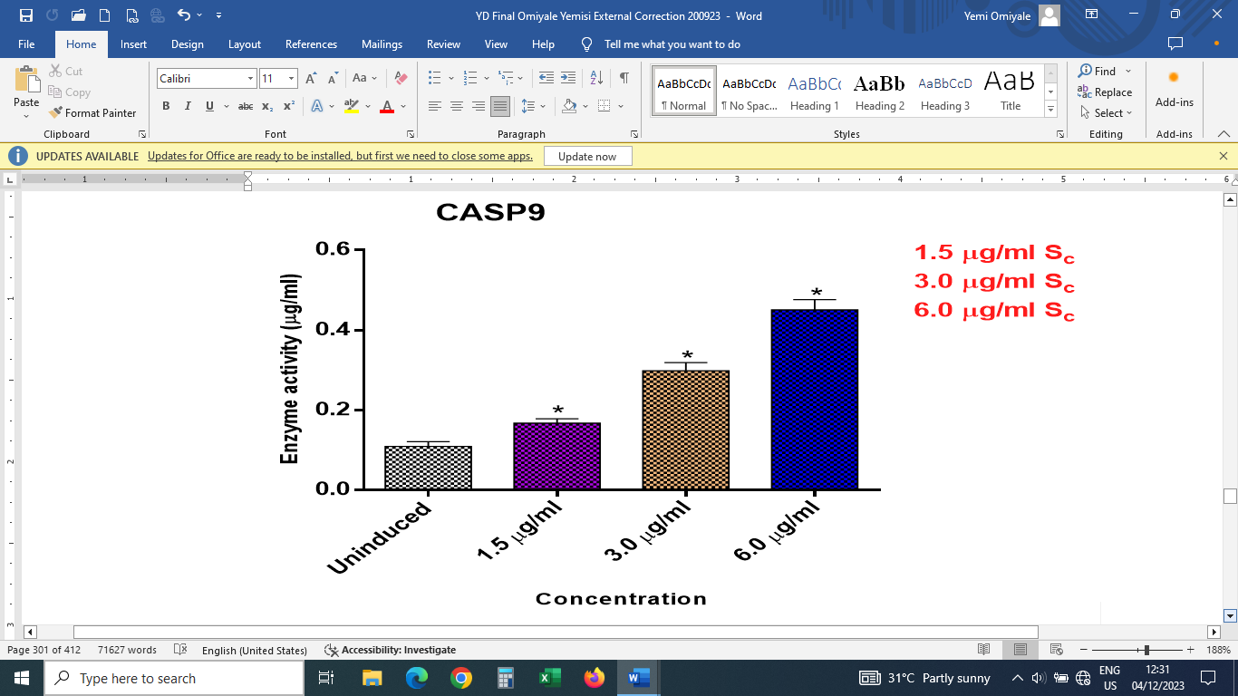
Fig 8: Caspase 9 in LNCaP Cell lysate after exposure to graded concentration of S_{C}- Rutin
*, means values are statistically significant at (P= .05), relative to the control
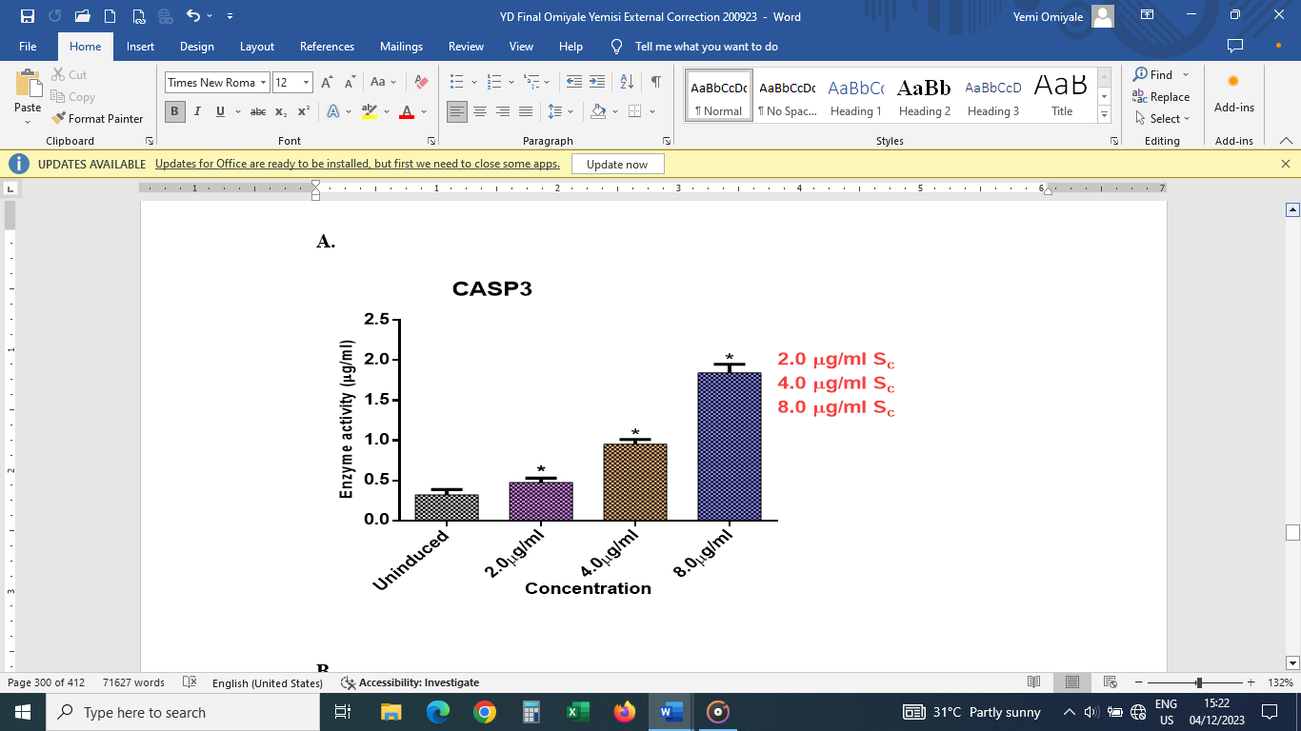
Fig 9: Caspase 3 in HepG2 Cell lysate after exposure to graded concentration of S_{C}- Rutin
*, means values are statistically significant at (P< 0.05*), relative to the control

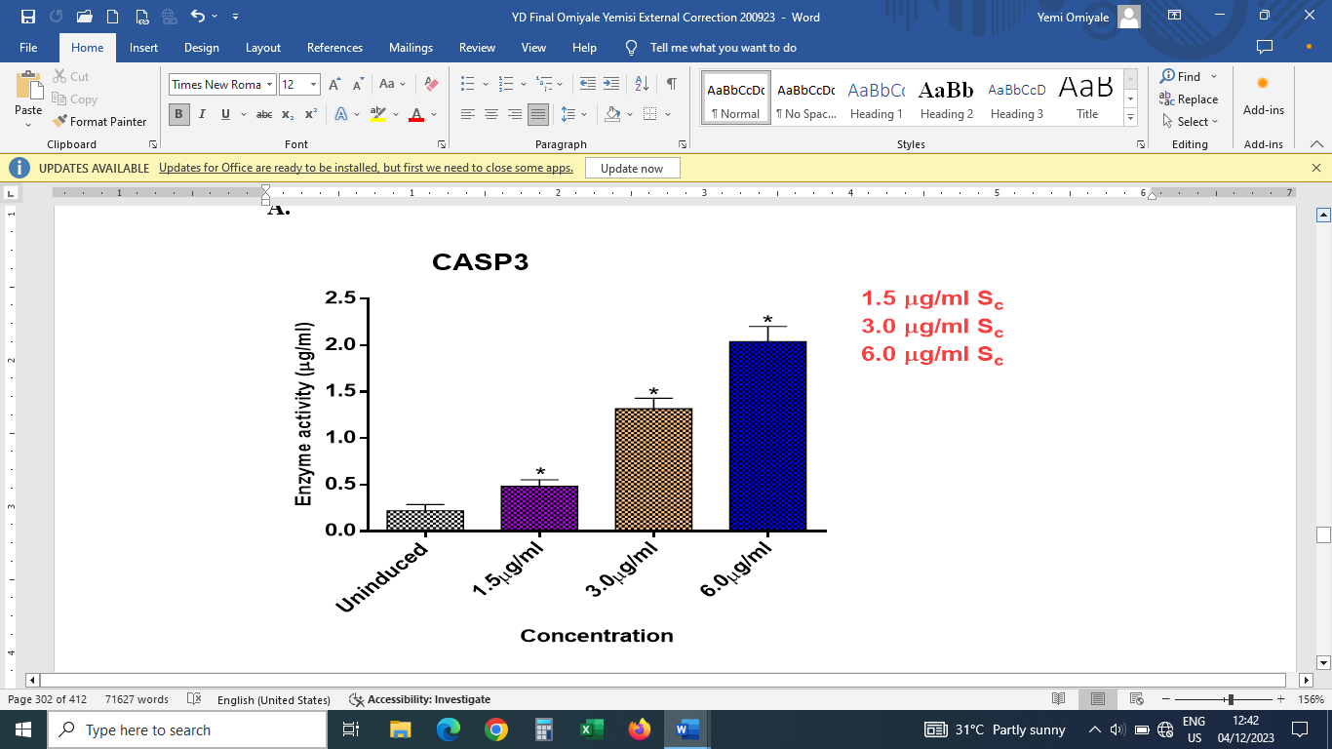
Fig 10: Caspase 3 in LNCaP Cell lysate after exposure to graded concentration of S_{C}- Rutin
*, means values are statistically significant at (P= .05), relative to the control

Pro-apoptotic Bax and Bak proteins are core controllers of the mitochondrial apoptosis process. This family of protein is characterized by four Bcl-2 homology domains (BH1-BH4). By hetero-dimerizing death antagonist and causing the release of apoptogenic substances into the cytoplasm via mitochondrial membrane permeability transition pore, Bax and Bak activate caspases. In relation to mitochondrial membrane permeability transition pore and cancer, pro-apoptotic proteins are highly up-regulated [23]. Pro-apoptotic proteins, are overly conveyed in graded cancers. Largely, increase in the components of the mitochondrial membrane permeability transition pore is offset by an almost equal increase in the negative regulators that are in the Bcl-2 proteins. Also, inactivation of the apoptotic enhancers are ways the cancer cells evade cell death [24]. As a result, the Bcl-2 (family) proteins serves as pivotal existence decision point in pathway of apoptosis. The ratio of pro-apoptotic to survival proteins in each cell, as well as binding between the three Bcl-2 subfamilies, determine whether or not a cell dies [25]. Our findings indicated that levels of Bax increased significantly up to 3.8 folds at 8 µg/mL for HepG2 cells and 4.6 folds at 6 µg/mL for LNCaP cells after 24 hours of rutin exposure, compared to normal. This proposes that rutin induced the translocation of Bax from cytosol to mitochondrion, probably facilitating Bax oligomerization required for mitochondrial membrane potential [26]. Furthermore, given that Bcl-2 proteins levels significantly decreased in HepG2 and LNCaP cell lysate after exposure to rutin for 24 h, respectively, shows that rutin downregulates the Bcl-2 (antiapoptotic) protein in both HepG2 and LNCaP cells.
These observations agree with the findings of Alkhatabi et al., (2022), who discovered that Navitoclax, a potent Bcl-2 protein inhibitor, downregulated Bcl-2 and thus caused apoptosis to occur in several model cancer cells. It is possible that lowering Bcl-2 levels will cause Bax or Bak to activate and migrate to the mitochondria, lowering membrane potential and cytochrome c release. As a result, a decrease in Bcl-2 contributes to rutin-induced apoptosis in HepG2 and LNCaP cells. Also, Bcl-2 downregulation by Sc could be caused by Bcl-2 displacement from Bax insertion. Furthermore, it demonstrates that the Bax and Bcl-2 proteins are vital to the control of rutin-induced cellular commitment to death via apoptosis.

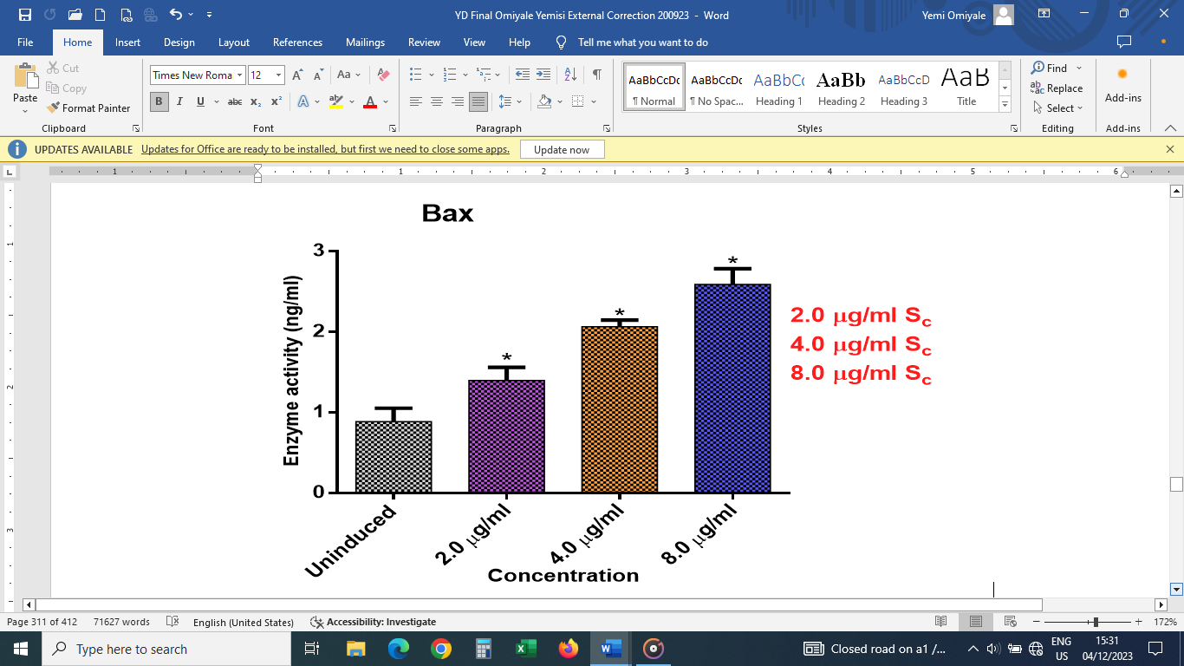
Fig 11: Expression of Bax in HepG2 Cell lysate after exposure to graded concentration of S_{C}- Rutin
*, means values are statistically significant at (P= .05), relative to the control

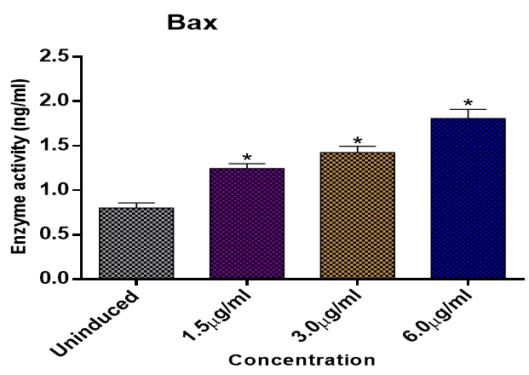

Fig 12: Expression of Bax in LNCaP Cell lysate after exposure to graded concentration of S_{C}- Rutin
*, means values are statistically significant at (P= .05), relative to the control
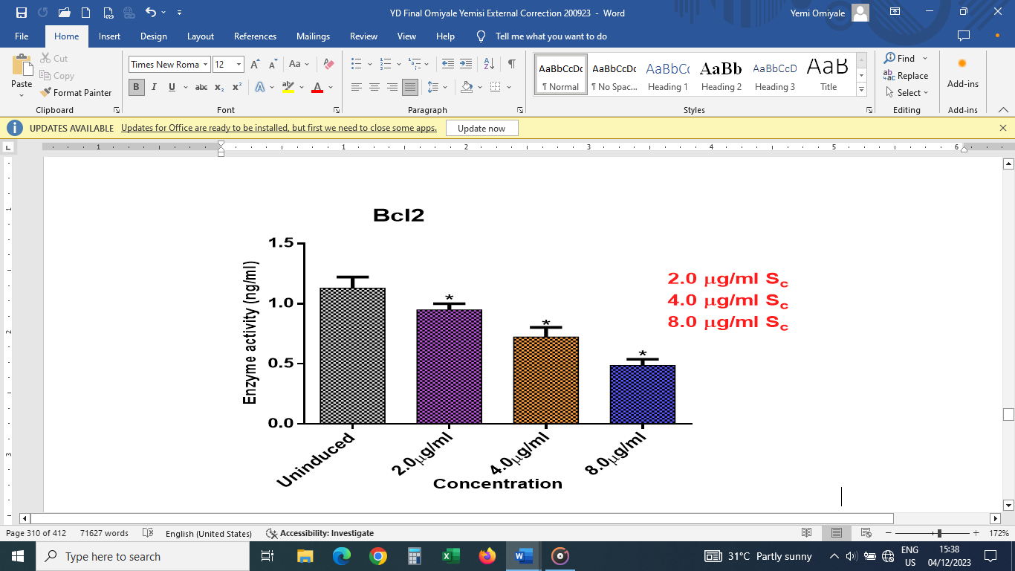
Fig 13: Expression of Bcl-2 in HepG2 Cell lysate after exposure to graded concentration of S_{C}- Rutin
*, means values are statistically significant at (P= .05), relative to the control
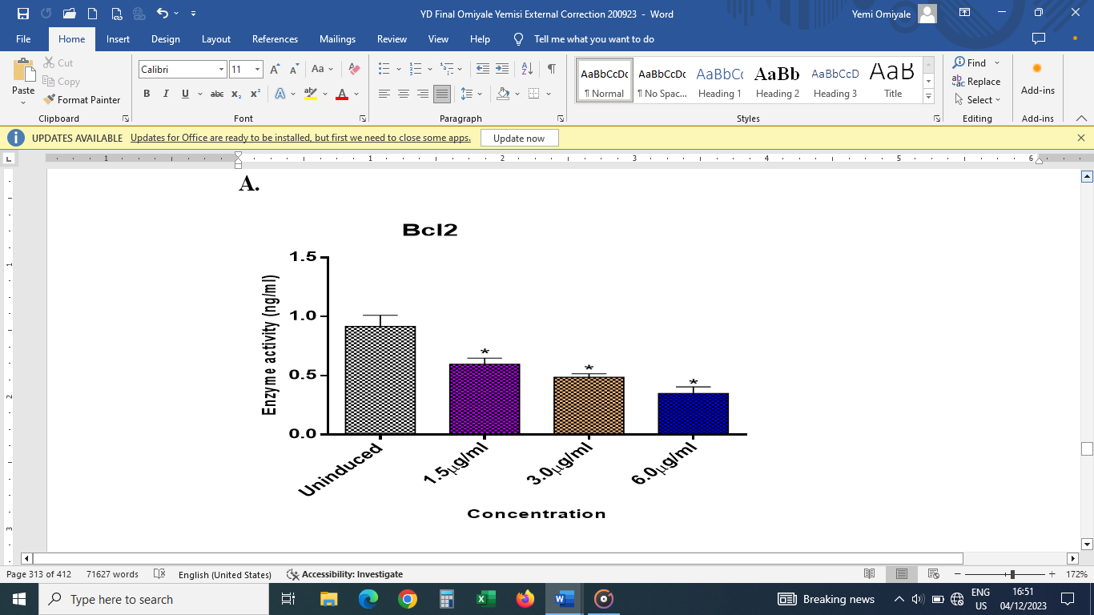
Fig 14: Expression of Bcl-2 in LNCaP Cell lysate after exposure to graded concentration of S_{C}- Rutin
*, means values are statistically significant at (P= .05), relative to the control

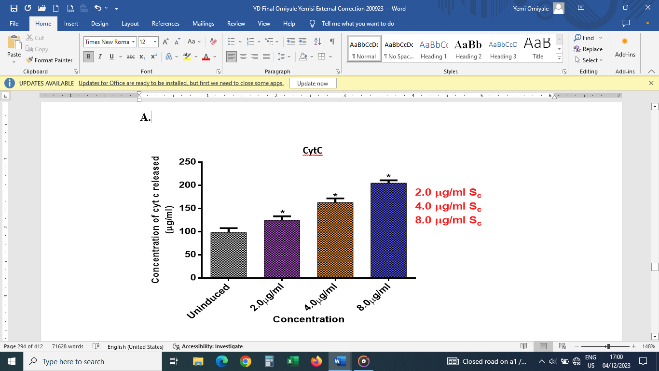
Fig 15: Levels of Cyt-c in HepG2 Cell lysate after exposure to graded concentration of S_{C}- Rutin
*, means values are statistically significant at (P= .05), relative to the control

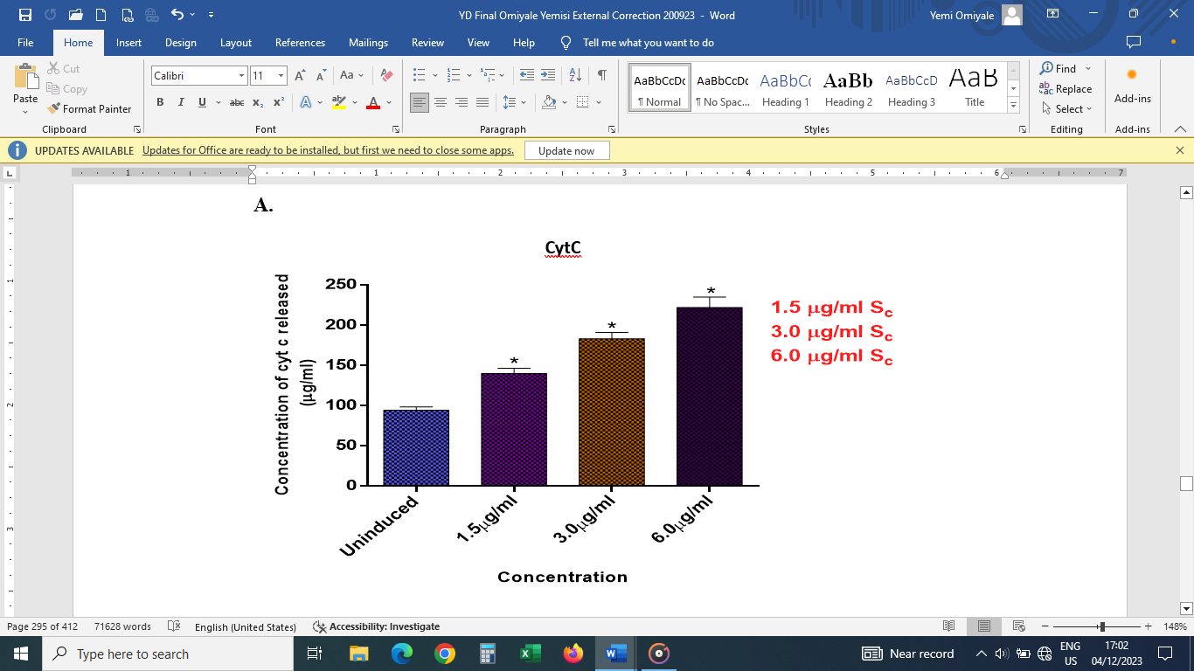
Fig 16: Levels of Cyt-c in LNCaP Cell lysate after exposure to graded concentration of S_{C}- Rutin
*, means values are statistically significant at (P= .05), relative to the control

The intrinsic path includes the cytochrome c release from mitochondria to cytosol, oligomerization of APAF-1 in the presence of dATP or ATP, resulting in the formation of an apoptosome, a heptameric wheel-like signaling platform. This attracts and triggers initiator caspase 9, which then cleaves and activates executioner caspases, caspase 3, caspase 6 and caspase 7. The executioners degrade hundreds of proteins, causing the cell to die (Qi et al., 2017). Further to that, cytochrome c release was studied to see if a collapse in mitochondrial membrane potential can lead to increase in the levels of cytochrome c. Results obtained show that there was significant upsurge in cytochrome c release in HepG2 and LNCaP cells exposed to rutin for 24 h. At 8 µg/mL of rutin there was 5.3 folds when compared to the control for HepG2 cells, while at 6 µg/mL of rutin there was 5.9 folds when compared to the control for LNCaP cells. The fact that cytochrome c levels increased with increasing rutin concentration in HepG2 and LNCaP cells suggests that changes in mitochondrial membrane potential caused by rutin is trailed by the discharge of apoptogenic proteins, cytochrome c. The activation of cysteine proteases known as caspases is critical to death-receptor apoptosis. They cleave substrates selectively, resulting in morphology and internucleosomal DNA disintegration. Caspases produce active signals that are involved in apoptosis and inflammation [27]. Caspases are thought to exist in sedentary precursor forms that are activated by dimerization before they can carry out most of their activities, one of which is cleaving their target proteins. Caspases promote cell death, so a decrease in caspase activity should promote tumour development [28].

4. Conclusion

With a focus on modifications to mitochondrial integrity, cytochrome c release, and lactate dehydrogenase, our data collectively shed light on the molecular link between changes in mitochondrial organization and function. In this work, the anticancer and anti-proliferative properties of rutin that was isolated from the whole Heliotropium indicum plant were demonstrated. To determine how specific this plant's action is in treating different types of cancer, more research is now being conducted.

Consent (where ever applicable)

Not Applicable

Ethical approval (where ever applicable)

"Principles of laboratory animal care" (NIH publication No. 85-23, revised 1985) were followed, as well as specific national laws where applicable. All experiments have been examined and approved by the appropriate ethics committee”

References

1. Vearey, J., Luginaah, I., Magitta, N. F., Shilla, D. J., & Oni, T. (2019). Urban health in Africa: a critical global public health priority. BMC Public Health, 19(1), 340. https://doi.org/10.1186/s12889-019-6674-8
2. Sharma, R., Aashima, N. M., Fronterre, C., Sewagudde, P., Ssentongo, A. E., Yenney, K., Arhin, N. D., Oh, J., Amponsah-Manu, F., & Ssentongo, P. (2022). Mapping Cancer in Africa: A Comprehensive and Comparable Characterization of 34 Cancer Types Using Estimates From GLOBOCAN 2020. Frontiers in Public Health, 10, 839835. https://doi.org/10.3389/fpubh.2022.839835
3. Sriharikrishnaa, S., Suresh, P. S., & Prasada, K. S. (2023). An introduction to fundamentals of cancer biology. In Optical Polarimetric Modalities for Biomedical Research (pp. 307-330). Cham: Springer International Publishing. https://doi.org/10.1007/978-3-031-31852-8_11
4. Balogh, J., Victor, D., III, Asham, E. H., Burroughs, S. G., Boktour, M., Saharia, A., Li, X., Ghobrial, R. M., & Monsour, H. P., Jr. (2016). Hepatocellular carcinoma: a review. Journal of Hepatocellular Carcinoma, 3, 41–53. https://doi.org/10.2147/JHC.S61146

5. Bengtsson, B., Widman, L., Wahlin, S., Stål, P., Björkström, N. K., & Hagström, H. (2022). The risk of hepatocellular carcinoma in cirrhosis differs by etiology, age and sex: A Swedish nationwide population-based cohort study. United European Gastroenterology Journal, 10(5), 465–476. https://doi.org/10.1002/ueg2.12238
6. Bassey, I. E., Emodi, B. A., Akpan, U. O., Iyakndue, I. F. A., Anakebe, E. A., Icha, B. E., Efobi, H. A., Ntinya, A. J., & Udoh, A. E. (2020). Impact of Androgen Deprivation on Oxidative Stress and Antioxidant Status in Nigerian Patients With Prostate Cancer Undergoing Androgen Deprivation Therapy. JCO Global Oncology, 6, 1481-1489. https://doi.org/10.1200/GO.20.00290
7. Kobo, O., Brown, S. A., Nafee, T., Mohamed, M. O., Sharma, K., Istanbuly, S., Roguin, A., Cheng, R. K., & Mamas, M. A. (2021). Impact of malignancy on In-hospital mortality, stratified by the cause of admission: An analysis of 67 million patients from the National Inpatient Sample. International journal of clinical practice, 75(11), e14758. https://doi.org/10.1111/ijcp.14758
8. Changalucha, M. J., Mushi, M. F., Kabangila, R., Silago, V., Likonda, B., & Mshana, S. E. (2020). Mortality among Cancer Patients within 90 Days of Therapy in a Tertiary Hospital, Tanzania: Is Our Pretherapy Screening Effective?. Journal of Cancer Epidemiology https://doi.org/10.1155/2020/4274682
9. Anand, U., Dey, A., Chandel, A. K. S., Sanyal, R., Mishra, A., Pandey, D. K., De Falco, V., Upadhyay, A., Kandimalla, R., Chaudhary, A., Dhanjal, J. K., Dewanjee, S., Vallamkondu, J., & Pérez de la Lastra, J. M. (2022). Cancer chemotherapy and beyond: Current status, drug candidates, associated risks and progress in targeted therapeutics. Genes and diseases, 10(4), 1367–1401. https://doi.org/10.1016/j.gendis.2022.02.007
10. Olowofolahan, A. O., Adeoye, Y. D., & Olorunsogo, O. O. (2017). Induction of Mitochondrial-Mediated Apoptosis by Solvent Fractions of Methanol Extract of Heliotropium indicum in Rat Liver Cells. Annual Research & Review in Biology, 17(2), 1–15. https://doi.org/10.9734/ARRB/2017/36334
11. Pahuja, S., Garg, M., Kumari, T., Bhatia, S., & Sarup, P. (2022). Compendious Review on Bioactive Constituents and Pharmacotherapeutic Profile of Heliotropium indicum Linn. *The Natural Products Journal*, *12*(1), 38–53. https://doi.org/10.2174/2210315510999201210143445
12. Mainasara, M. M., Abu-Bakar, M. F., Md Akim, A., Linatoc, A. C., Abu-Bakar, F. I., & Ranneh, Y. K. H. (2021). Secondary Metabolites, Antioxidant, and Antiproliferative Activities of Dioscorea bulbifera Leaf Collected from Endau Rompin, Johor, Malaysia. Evid Based Complement Alternat Med. https://doi.org/10.1155/2021/8826986 .
13. Rawan, A., Abir, B. B., Abdulrahman, A., Mikhlid, H. A., Maha, A., Hadel, A., Nael, A., & Abdelhabib, S. (2022). Cytotoxic effects of Annona squamosa leaves against breast cancer cells via apoptotic signaling proteins. Journal of King Saud University - Science. 34. 102013. 10.1016/j.jksus.2022.102013.
14. Chunthorng-Orn, J., Dechayont, B., Phuaklee, P., Prajuabjinda, O., Juckmeta, T., & Itharat, A. (2016). Cytotoxic, Anti-inflammatory and Antioxidant Activities of Heliotropium indicum Extracts. J Med Assoc Thai, 99(Suppl. 4), S102-S109. http://www.jmatonline.com/index.php/jmat/issue/archive
15. Appadurai, P., & Rathinasamy, K. (2014). Indicine N-oxide binds to tubulin at a distinct site and inhibits the assembly of microtubules: A mechanism for its cytotoxic activity. Toxicol. Lett. https://doi.org/10.1016/j.toxlet.2013.11.030
16. Dash, S. L., Mohapater, R., & Mishra, S. K. (2023). Anticancer Activity Study of Some Selected Indian Medicinal Plants used Traditionally, J Pharm Negative Results 2023;14(1):125-132.
17. Kamarul Zaman, M. A., & Mohamad Azzeme, A. M. (2019). Plant toxins: alkaloids and their toxicities. GSC Biological and Pharmaceutical Sciences, 6(2), 21-29. https://doi.org/10.30574/gscbps.2019.6.2.0003
18. Farhana, A., & Lappin, S. L. (2023). Biochemistry, Lactate Dehydrogenase. In *StatPearls*. StatPearls Publishing. https://www.ncbi.nlm.nih.gov/books/NBK557536/
19. Kumar, P., Nagarajan, A., & Uchil, P. D. (2018). Analysis of Cell Viability by the Lactate Dehydrogenase Assay. Cold Spring Harbor Protocols. https://doi.org/10.1101/pdb.prot095497
20. Chan, K., Truong, D., Shangari, N., & O’Brien, P. J. (2005). Drug-induced mitochondrial toxicity. Expert Opinion on Drug Metabolism & Toxicology, 1(4), 655-669. https://doi.org/10.1517/17425255.1.4.655
21. Zhang, Z., Liang, X., Fan, Y., Gao, Z., Bindoff, L. A., Costea, D. E., & Li, L. (2019). Fibroblasts rescue oral squamous cancer cell from metformin-induced apoptosis via alleviating metabolic disbalance and inhibiting AMPK pathway. Cell Cycle (Georgetown, Tex.), 18(9), 949–962. https://doi.org/10.1080/15384101.2019.1596900 .
22. Julien, O., & Wells, J. A. (2017). Caspases and their substrates. Cell Death & Differentiation. https://doi.org/10.1038/cdd.2017.44
23. Brown, L. M., Hanna, D. T., Khaw, S. L., & Ekert, P. G. (2017). Dysregulation of BCL-2 family proteins by leukemia fusion genes. The Journal of biological chemistry, 292(35), 14325–14333. https://doi.org/10.1074/jbc.R117.799056
24. Bonora, M., & Pinton, P. (2014). The mitochondrial permeability transition pore and cancer: molecular mechanisms involved in cell death. Frontiers in Oncology. https://doi.org/10.3389/fonc.2014.00302
25. Wang, Y., Yang, T., Han, Y., Ren, Z., Zou, J., Liu, J., & Xi, S. (2020). lncRNA OTUD6B-AS1 Exacerbates As2O3-Induced Oxidative Damage in Bladder Cancer via miR-6734-5p-Mediated Functional Inhibition of IDH2. Oxidative Medicine and Cellular Longevity. https://doi.org/10.1155/2020/3035624
26. Van Opdenbosch, N., & Lamkanfi, M. (2019). Caspases in cell death, inflammation, and disease. Immunity, 50(6), 1352–1364. https://doi.org/10.1016/j.immuni.2019.05.020
27. McIlwain, D. R., Berger, T., & Mak, T. W. (2015). Caspase functions in cell death and disease. Cold Spring Harbor Perspectives in Biology, 7(4), a026716. https://doi.org/10.1101/cshperspect.a026716
28. Avrutsky, M. I., & Troy, C. M. (2021). Caspase-9: A Multimodal Therapeutic Target With Diverse Cellular Expression in Human Disease. Frontiers in Pharmacology, 12, 701301. https://doi.org/10.3389/fphar.2021.701301

