Synthesis and characterization of ligands 4-bromo-2-{(1E)-1-[2-(1-phenylethenyl)hydrazinylidene]ethyl}phenol, N'-[(E)-(4-hydroxy-3-methoxyphenyl)methylidene]pyridine-3-carbohydrazide and their complexes- Antioxidant activities study

Abstract
Schiff bases have often been used as chelating ligands in the field of coordination chemistry, and their metal complexes have been extensively investigated due to their potential applications. It is known that reactions of N,N-donor Schiff bases ligands with transition metal ions have produced series of complexes with interesting structures and antioxidant properties. Two new ligand and their coplexes are prepared. Two coordinated water molecules complete the coordination sphere. The two ligands are structurally characterized by elemental analysis, infrared, UV-Vis spectroscopies and conductance. The ligand 4-bromo-2-{(1E)-1-[2-(1-phenylethenyl)hydrazinylidene]ethyl}phenol denoted (H₂L1) was synthesized as well as its corresponding complexes. The ligand N'-[(E)-(4-hydroxy-3-methoxyphenyl)methylidene]pyridine-3-carbohydrazide (H₂L2) was synthesized as well as its corresponding complexes. In this paper we will study the antioxidant activities of ligands.The ligand (H₂L2) crystallizes inthe monoclinic system in the space group P2₁/c with the unit cell parameters a = 7.9079(2) Å, b = 27.5162(6) Å, c = 6.9736(2) Å, α = 90°, β = 110.495(3)°, γ = 90°.

- Introduction
The foundations of coordination chemistry were born from the work of Alfred Werner [1] between approximately 1875 and 1915 under the constant criticism and suggestions of S. M. Jorgensen. A coordination compound, also called a coordination complex, is defined as being a chemical entity consisting of one or more metal ions called central element(s) around which one or more molecules containing electron-donating atoms called coordinates or ligands are fixed. The subdivisions of chemistry describing the formation, structure and reactivity of these complexes are organometallic chemistry (if the complex has metal-carbon bonds) and coordination chemistry (otherwise).
Coordination chemistry has seen its growth over the last two centuries thanks to the use of new Schiff-based ligands. Despite having been discovered a long time ago by Hugo Schiff, Schiff base ligands and their complexes with transition metals and lanthanides still have interesting but unexplored parts [2,3]. The use of these Schiff-based ligands in biology, medicine, magnetism, catalysis, etc., particularly in mineral biochemistry, which is an increasingly attractive field, has led us to become interested in the complexes of the elements of the first series of transition metals and lanthanides.
- Chemical context
Transition metal complexes of Schiff bases are being investigated more frequently now than ever before because of their potential properties. They have a pharmacological application such as in Gram positive bacteria in vitro [4].
Schiff bases are widely used in the field of coordination chemistry to prepare materials with particular properties. Compounds that can be used in catalysis, magnetism, luminescence or biological activity studies [5] have been synthesized and their properties extensively studied over the past decade.
The development of new molecules with drug activity and without dangerous side effects is one of the major challenges of science. The compounds having a hydrazone unit -C=N-NH-R are characterized by their use in the synthesis of compounds having therapeutic properties [6-9]. These metal transition coordination compounds obtained with hydrazone ligands are also studied because of their broad profile in the pharmacological field, with antitumor [10], antimicrobial [11,12] and anti-tuberculosis [13] potential. It has been shown that hydrazone ligands with biological properties can see their activity increased after complexation with metal ions. These ligands are largely used for the synthesis of complexes with biochemical and physical properties [14-17].
Metal complexes containing o-vanillin derivatives exhibit a variety of biological activities [18]. These complexes are particularly interesting in various fields such as magnetism, catalysis, in medicine [19], and luminescence.
The presence of phenolic moiety suggests that these complexes can be antioxidants as reported in the literature [20] but also as antibacterial agents. The physical and chemical properties of complexes are determined both by their geometry and by the nature of the electron density around the metal. Recently, we have been focusing on the synthesis of ligands and their complexes for biological applications such as antioxidant, antibacterial and antimicrobial activities [21].
- Experimental Part

1°) Starting materials and instrumentation
Elemental analyses of C, H and N were recorded on a VxRio EL Instrument. Infrared spectra were obtained on a FTIR Spectrum Two of Perkin Elmer spectrometer in the 4000-400 cm⁻¹ region. The molar conductance of 1×10⁻³ M in DMSO solution of the metal complex was measured at 25 °C using a WTW LF-330 conductivity meter with a WTW conductivity cell. The ¹H and ¹³C NMR spectra were recorded in DMSO-d₆ on a Bruker 500 MHz spectrometer at room temperature using TMS as an internal reference. Spectral analyzes of Nuclear Magnetic Resonance of the proton ¹H, of carbon ¹³C are carried out using DMSO-d₆ solutions.

2°) Synthesis of ligand H₂L1
In a 250 mL flask, introduce 6 mmol of 5-bromo-2-hydroxyacetophenone in 20 mL of ethanol. After dissolution add nicotinohydrazide previously dissolved in methanol. The mixture is heated to reflux for 3 hours. Upon cooling, the product obtained is collected, washed twice with 10 mL of ethanol and dried free.
Scheme 1 : Synthesis of HL ligand H₂L1
Yield : 85 %, Melting temperature : 260°
Anal. Calc. (%) for C₁₄H₁₂BrN₃O₂: C, 50.32, H, 3.62, N, 12.56, Br 23.91.
Found: C, 50.55, H, 3.16, N, 12.12, Br, 23.85.
NMR ¹H : (δ, ppm) : 3.835 (s, 3H, CH₃) ; 5.752-7.63 (m, 7H, Ar-H et Py-H) ; 10.80 (s, 1H, Ar-OH) ; 11.867 (s, 1H, NH).
NMR ¹³C : (δ, ppm) : 14.806 (CH₃–) ; 110.097-157.568 (C_{Ar}, C_{Py}) ; 158.350 (C=N) ; 163.603 (C=O).
3°) Synthesis of HL ligand H₂L2
Reaction scheme of N'-[(E)-(4-hydroxy-3-methoxyphenyl)methylidene]pyridine-3-carbohydrazide (H₂L2)

Scheme 2 : Synthesis of HL ligand H₂L2

Operating mode : 1.2 g (8 mmol) of paravalin are introduced into a flask containing 20 mL of ethanol. Then 1 g (7 mmol) and a few drops of glacial acetic acid are added to this solution. Then the mixture is brought to reflux for 3 hours. The reaction medium, which has become clear, is filtered while hot. A yellow precipitate appears in the filtra after cooling. This precipitate is recovered by filtration then washed with methanol to eliminate excess nicotinohydrazide. After two weeks of slow evaporation, yellow crystals diffractable by X-rays appear. The solid obtained is dried in the open air.
Yield : 70,42 %, Melting temperature : 170°
Anal. Calc. (%) for C₁₄H₁₃N₃O₃: C, 61.99, H, 4.83, N, 15.49.
Found: C, 61.46, H, 4.26, N, 14.39.
NMR ¹H : (δ, ppm) : 3.835 (s, 3H, CH₃) ; 6,86-8,251 (m, 7H, Ar-H et Py-H) ; 8.332 (s, 1H, HC=N) ; 9,55 (s, 1H, NH) ; 11.847 (s, 1H, Ar-OH).
NMR ¹³C : (δ, ppm) : 13.52 (CH₃–) ; 109.541-152.62 (C_{Ar}, C_{Py}) ; 135.859 (C=N) ; 161.913 (C=O).
- Infrared spectroscopy study of ligands
1°) Infrared spectroscopy study of ligand H₂L1
The infrared spectrum of this ligand (H₂L1) shows an intense band at 1641cm⁻¹ attributed to the valence vibration of the bond (C=O) [22]. The valence vibration of the imine function (C=N) is located at 1597 cm⁻¹. The intense band pointed at 1289 cm⁻¹ is attributed to the valence vibration of the C-O (phenolic) bond. The bands pointed at 1371 and 1023 cm⁻¹ are assigned to C-N and N-N valence bonds, respectively. The vibrations of the aromatic C=C bonds are located between 1557 and 1417 cm⁻¹. In the high frequency zone, we locate the vibration bands of the N-H and OH bonds at 3211 cm⁻¹. Towards low frequencies, the spectrum shows the deformation vibrations of aromatic C-H bonds between 815 and 620 cm⁻¹.

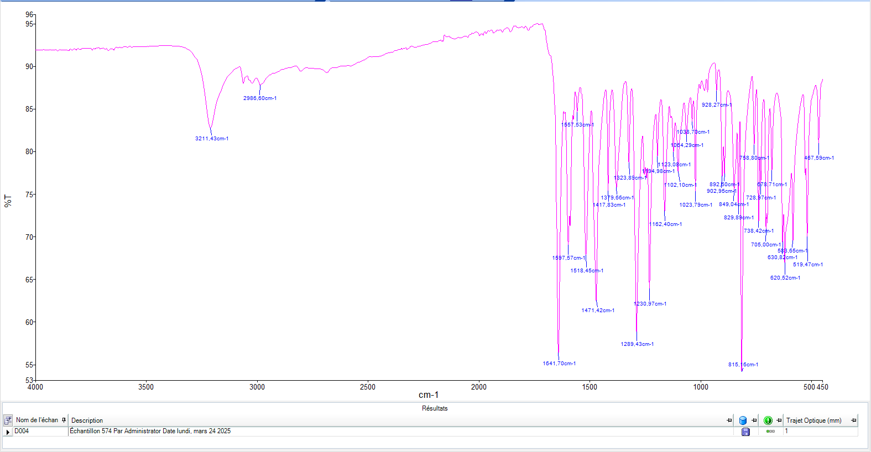
Figure 1: IR spectrum of the ligand H₂L1

2°) Infrared spectroscopy study of the ligand H₂L2
The infrared spectrum of the ligand indicates, towards high frequencies, vibration bands pointed at 3200 and 3019 cm⁻¹ which are attributed respectively to the valence vibrations of the free OH and N-H groups. The valence vibration of the carbonyl group (C=O) is pointed at 1646 cm⁻¹ and that of the imine function at 1595 cm⁻¹. The vibrations of the C=N and C=C bonds of the two pyridine and aromatic nuclei are located between 1557 and 1417 cm⁻¹ and those of the C-N and C-O bonds are noted respectively at 1290 cm⁻¹ and at 1273 cm⁻¹. The deformation vibrations of the aromatic C-H bonds are located towards low frequencies between 755 and 709 cm⁻¹.
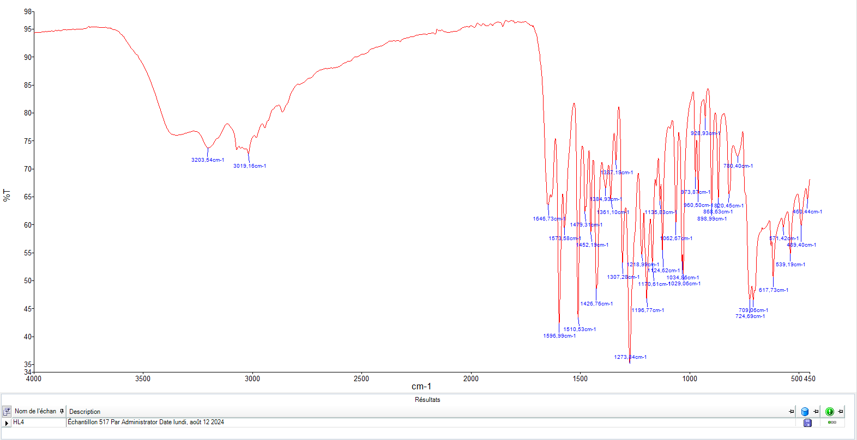
Figure 2: IR spectrum of the ligand H₂L2

3°) Infrared spectroscopy study of complexes of ligand H₂L1
- Study of the HL1Mn(NO₃).6H₂O complex
The infrared spectrum of the H₂L1 ligand presents bands at 1641, 1597, 1557 and 1289 cm⁻¹ attributed to carbonyl ν(C=O), ν(C=N) imine, ν(C=N) pyridine and phenolic ν(C-O) vibrations, respectively. On the spectrum of the manganese complex, we observe the ν(C=O), ν(C=N) imine, ν(C=N) pyridine and ν(C-O) phenolic bands respectively at 1639, 1585, 1513 and 1287 cm⁻¹. They show a shift towards low frequencies indicating the coordination to the metal of carbonyl and phenoyl oxygen atoms, iminic nitrogen and pyridine. In the high frequency region of the complex spectrum, broad bands are noted in the region (3197-3193) cm⁻¹ and are attributed to the ν(OH) vibration of the water molecule coordinated to the metal.

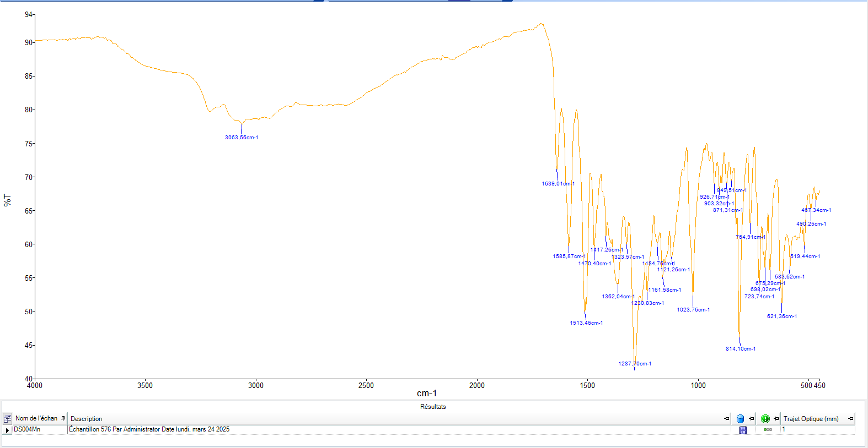
Figure 3: IR spectrum of the HL1Mn(NO₃).6H₂O complex

- Study of the HL1Fe(ClO₄)₃.6H₂O complex
The infrared spectrum of the ligand (H₂L1) presents bands at 1641, 1597, 1557 and 1289 cm⁻¹ attributed respectively to the ν(C=O) carbonyl, ν(C=N) imine, ν(C=N) pyridine and ν(C-O) phenolic vibrations, respectively. On the spectra of the iron complex, we observe the ν(C=O), ν(C=N) imine, ν(C=N) pyridine and ν(C-O) phenolic bands respectively at 1590, 1575, 1527 and 1296 cm⁻¹. They show a shift towards low frequencies indicating the coordination to the metal of carbonyl and phenoyl oxygen atoms, iminic nitrogen and pyridine. In the high frequency zone, we observe a broad band pointed at 3347 cm⁻¹ attributable to a coordinated water molecule.

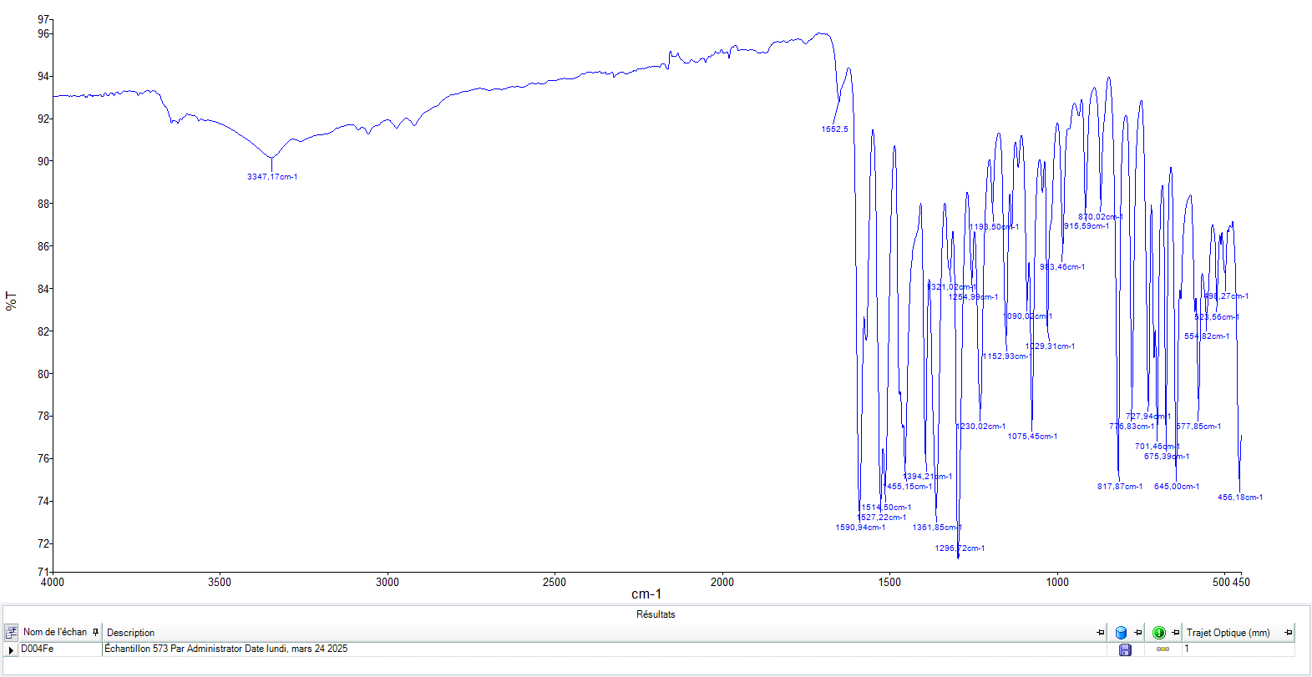
Figure 4: IR spectrum of the HL1Fe(ClO₄)₃.6H₂O complex

- Study of the HL1Co(NO₃)₃.6H₂O complex
The infrared spectrum of the ligand (H₂L1) presents bands at 1641, 1597, 1557 and 1289 cm⁻¹ attributed respectively to the ν(C=O) carbonyl, ν(C=N) imine, ν(C=N) pyridine and ν(C-O) phenolic vibrations, respectively. On the spectrum of the iron complex, we see a disappearance of the ν(C=O) band, this could be explained by the ennolization of the ligand during complexation. The ν(C=N) imine, ν(C=N) pyridine and ν(C-O) phenolic vibration bands are observed at 1575, 1554 and 1296 cm⁻¹, respectively. They show a shift towards low frequencies indicating the coordination to the metal of the oxygen atoms of phenoyl, iminic nitrogen and pyridine. In the high frequency zone, we observe a broad band pointed at 3094 cm⁻¹ attributable to a coordinated water molecule.
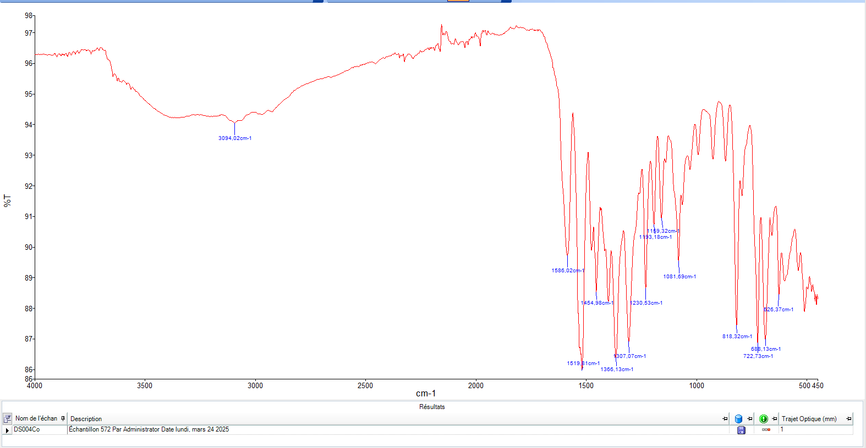
Figure 5: IR spectrum of the HL1Fe(ClO₄)_{3.}6H₂O complex

Table 1: IR data of ligand (HL1) complexes

Complexes and ligand | ν(OH) H₂O | ν(C=O) | ν(C=N)_{imine} | ν(C=N)_{pyridine} | ν(C-O)_{phénol}
(HL1) | - | 1641 | 1597 | 1557 | 1289
HL1Co(NO₃)₃.6H₂O | 3347 | 1590 | 1575 | 1527 | 1296
HL1Fe(ClO₄)₃.6H₂O | 3094 | - | 1575 | 1554 | 1296
HL1Mn(NO₃).6H₂O | 3197 | 1639 | 1585 | 1513 | 1287

4°) Infrared spectroscopy (IR) study of the complex with Mn(NO₃)₃.4H₂O
The infrared spectrum of the ligand presents vibration bands at 1646, 1596 and 1557 cm⁻¹ which are attributed to the vibrations of the bonds ν(C=O) of the carbonyl group, ν(C=N) of the imine group and ν(C=N) of the pyridine group. These bands are observed respectively at regions [1634-1596], [1525 -1503] and [1463 -1447] cm⁻¹ on the spectrum of the complex. This shift towards low frequencies results from the coordination of the carbonyl oxygen atoms, the imine nitrogen atom and the pyridine ring to the metal. In the high frequency range [3600-3200] cm⁻¹, we note the presence of a broad band of low intensity characterizing the valence vibrations of a water molecule on the spectrum of the complex. This band is accompanied by a characteristic deformation vibration band of a free water molecule ẟ(H₂O) in the region [1634-1516] cm⁻¹.

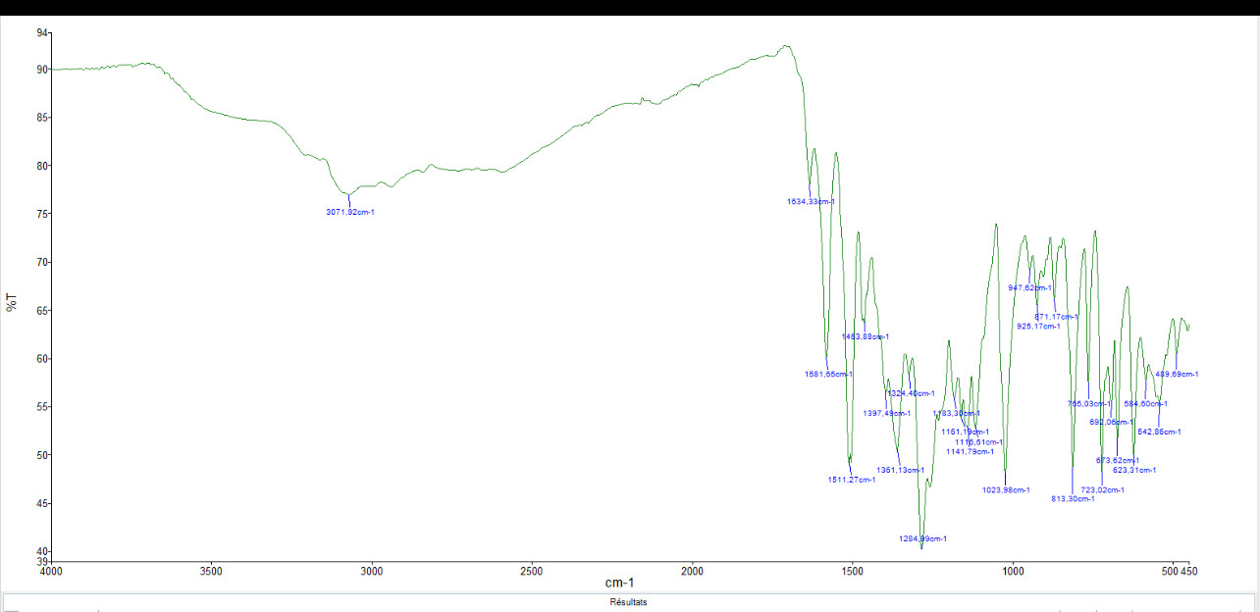
Figure 6: IR spectrum of the Mn(NO₃)₃.4H₂O complex

- Study by UV-visible spectrophotometry complexes
1°) Study by UV-visible spectrophotometry of H₂L1 complexes
- Study by UV-visible spectrophotometry of the HL1Mn(NO₃).6H₂O complex
The electronic spectrum of the complex reveals absorption bands at 259 and 349 nm. These bands are due to the π → π* and n → π* transitions within the ligand, respectively. The spectrum also presents an absorption band at 449 nm assigned to ligand → metal charge transfer.
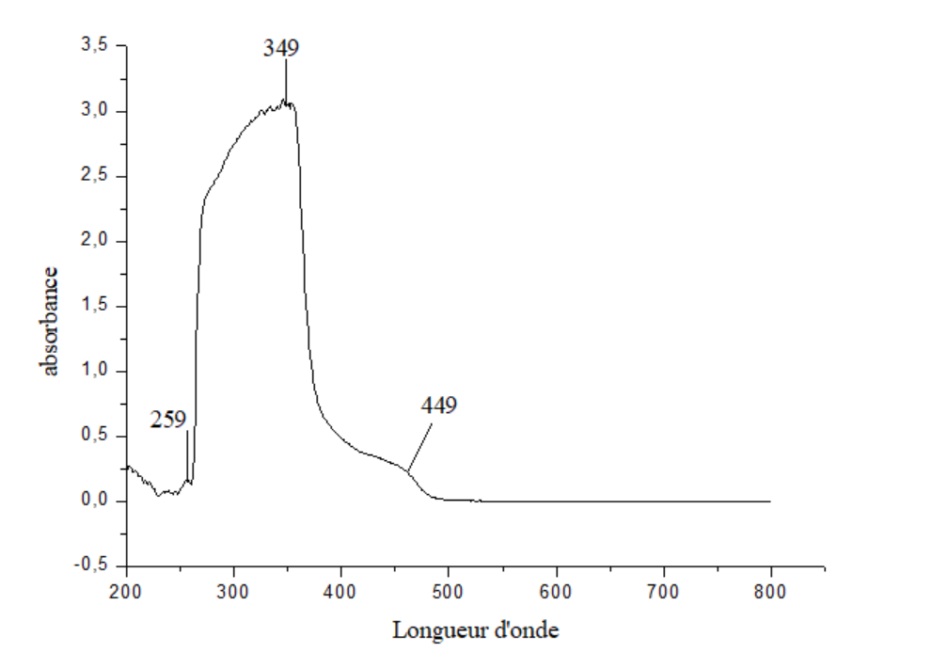
Figure 7: UV-visible spectrum of the HL1Mn(NO₃).6H₂O complex

- Study by UV-visible spectrophotometry of the HL1Fe(ClO₄)₃.6H₂O complex
The electronic spectrum of the complex reveals absorption bands at 256 and 354 nm. These bands are due to the π → π* and n → π* transitions within the ligand, respectively. The spectrum also presents an absorption band at 440 nm assigned to ligand → metal charge transfer.
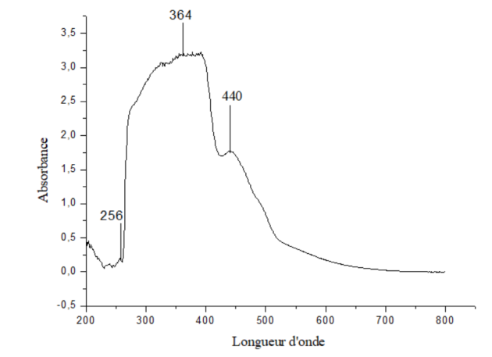
Figure 8: UV-visible spectrum of the HL1Fe(ClO₄)₃.6H₂O complex

- Study by UV-visible spectrophotometry of the HL1Co(NO₃)₃.6H₂O complex
The electronic spectrum of the complex reveals absorption bands at 269 and 361 nm. These bands are due to the π → π* and n → π* transitions within the ligand, respectively. The spectrum also presents an absorption band at 424 nm assigned to ligand → metal charge transfer.
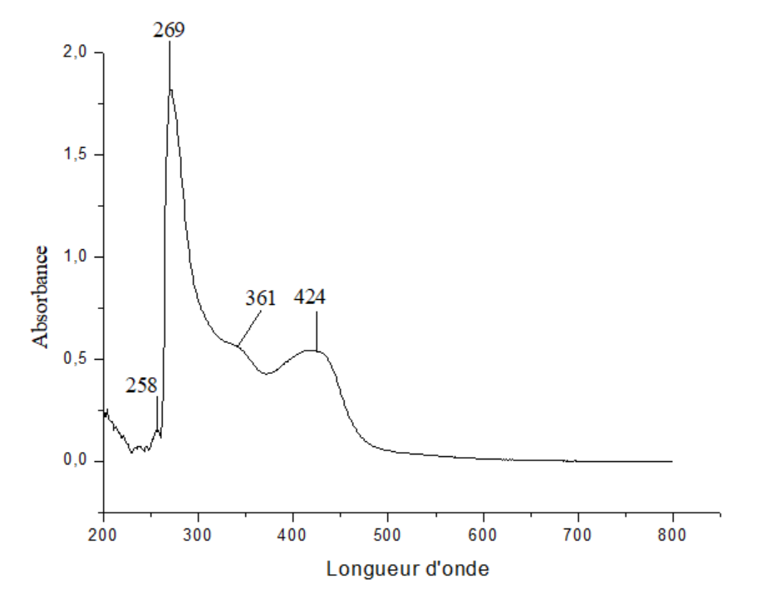
Figure 9: UV-visible spectrum of the HL1Co(NO₃)₃.6H₂O complex

- Study by UV-visible spectrophotometry of the HL1Mn(NO₃).6H₂O complex
The electronic spectrum of the complex reveals absorption bands at 259 and 349 nm. These bands are due to the π → π* and n → π* transitions within the ligand, respectively. The spectrum also presents an absorption band at 449 nm assigned to ligand → metal charge transfer.

Figure 10: UV-visible spectrum of the HL1Mn(NO₃).6H₂O complex

Table 2: UV-visible data of the ligand (H₂L1) complexes

complexes | UV-visible
complexes | λ (nm) | Attribution
HL1Co(NO₃)₃.6H₂O | 269, 361et 424 | π→ π*, n→ π*, TCLM
HL1Fe(ClO₄)₃.6H₂O | 256, 364, et 440 | π→ π*, n→ π*, TCLM
HL1Mn(NO₃).6H₂O | 259, 369 et 449 | π→ π*, n→ π*, TCLM

2°) Study by UV-visible spectroscopy of the HL2Mn(NO₃)₃.4H₂O complex
The electronic spectrum of the complex reveals absorption bands at 216 and 346 nm. These bands are due to the π → π* and n → π* transitions within the ligand, respectively. The spectrum also presents an absorption band at 408nm assigned to charge transfers ligand → metal.
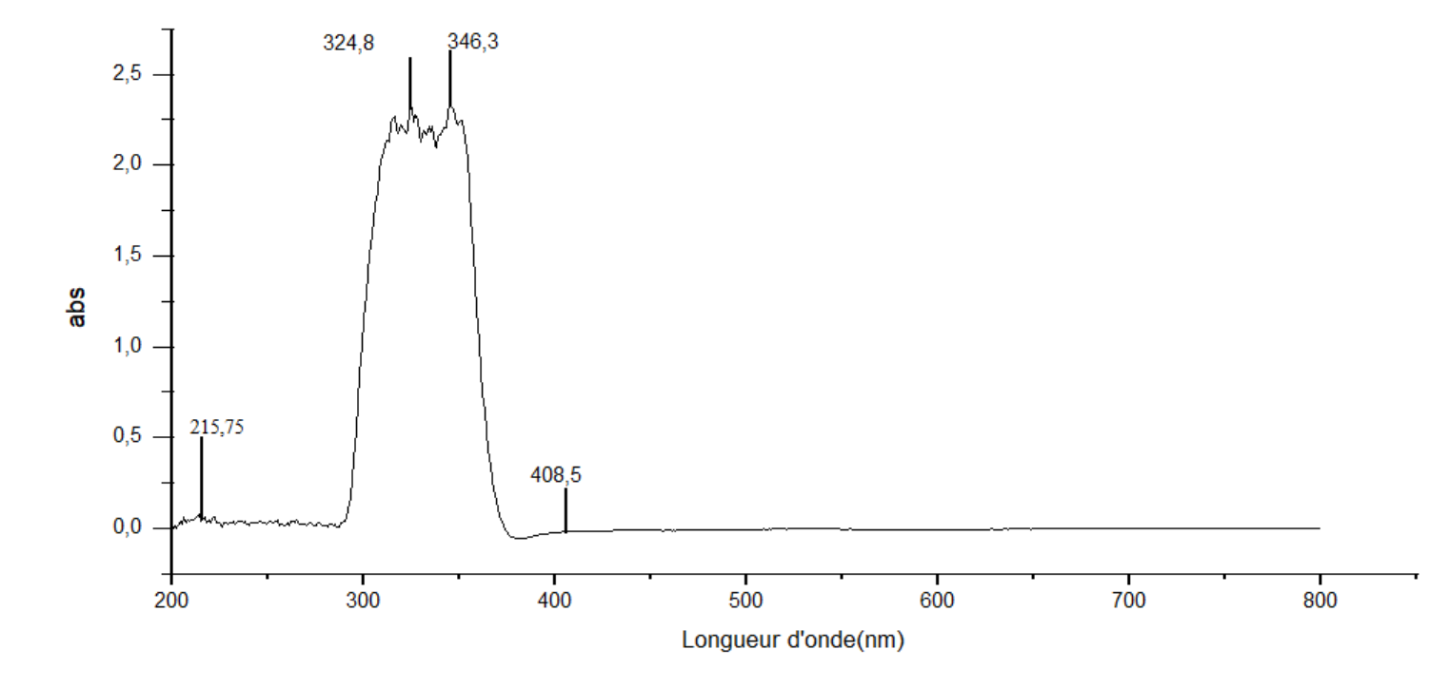
Figure 11 : UV-visible spectrum of the complex

- Study of the conductivity of the complexes
1°) Study of the conductivity of H₂L1 complexes
- Study of the conductivity of the HL1Co(ClO₄)₃.6H₂O complex
The molar conductivity measurements of the complex are carried out using a millimolar solution of DMF. The conductivity value obtained with the freshly prepared solution is observed at 20 Ω⁻¹cm².mol⁻¹. It has neutral electrolytes. After a week of storage, the conductivity value changes to 25 Ω⁻¹cm².mol⁻¹but remains neutral electrolyte. This result indicates the stability of the complex in solution [23].
- Study by the conductivity of the HL1Mn(NO₃).6H₂O complex
The molar conductivity measurements of the complex are carried out using a millimolar solution of DMF. The conductivity values ​​obtained with the freshly prepared solution are observed at 12 Ω⁻¹cm².mol⁻¹. They are neutral electrolytes. After a week of storage, the conductivity values ​​change between 14 Ω⁻¹cm².mol⁻¹ but remain neutral electrolyte. This result indicates the stability of the complex in solution.
- Study of the conductivity of the HL1Fe(ClO₄)₃.6H₂O complex
The molar conductivity measurements of the complex are carried out using a millimolar solution of DMF. The conductivity value obtained with the freshly prepared solution is observed at 22 Ω⁻¹cm².mol⁻¹. It has neutral electrolytes. After a week of storage, the conductivity value changes to 26 Ω⁻¹cm².mol⁻¹but remains neutral electrolyte. This result indicates the stability of the complex in solution.

Table 3: Conductimetric data of the ligand (H₂L1) complexes

Complexes | Fresh solutions  (t = 25°) |  | After 15 days  (t = 31°)
 | Λ | electrolyte | Λ | electrolyte
HL1Co(NO₃)₃.6H₂O | 20 | Neutre | 25 | Neutre
HL1Fe(ClO₄)₃.6H₂O | 22 | Neutre | 26 | Neutre
HL1Mn(NO₃).6H₂O | 12 | Neutre | 14 | Neutre

2)° Conductivity study of the HL2Mn(NO₃)₃.4H₂O complex
The molar conductivity measurements of the complex are carried out using a millimolar solution of DMF. The conductivity value obtained with the freshly prepared solution is observed at 52.72 Ω⁻¹cm².mol⁻¹. It has neutral electrolytes. After a week of storage, the conductivity value changes to 54.57 Ω⁻¹cm².mol⁻¹ but remains neutral electrolyte. This result indicates the stability of the complex in solution.
- X–ray crystallography study of the ligand H₂L2
Crystals suitable for X-diffraction, of the reported compound, were grown by slow evaporation of MeOH solution of the complex. Details of the X‐rays crystal structure solution and refinement are given in Table 1. A suitable crystal was selected and mounted on a Bruker APEX-II CCD diffractometer with graphite monochromatized MoKα radiation (λ = 0.71073 Å). All data were corrected for Lorentz and polarization effects. No absorption correction was applied. The hydrogen atoms of water molecules and NH groups were located in the Fourier difference maps and refined. Others H atoms were geometrically optimized and refined as riding model by AFIX instructions.

Table 4 : Crystal data and structures refinement for complex

Formula | C₁₄H₁₃N₃O₃, 2H₂O
System | Monoclinic
Space Group | P2₁/c
Cell Lengths | a = 7.9079(2)  b = 27.5162(6)  c = 6.9736(2)
Cell Angles | α = 90  β = 110.495(3)  γ = 90
Cell Volume | 1421.37

Table 5 : Symmetry codes:

Number | Symm. Op. | Description | Detail Description | Order | Type
1 | x,y,z | Identity | Identity | 1 | 1
2 | -x,1/2+y,1/2-z | Screw axix (2-fold) | 2-fold screw axix with direction (0,1,1) at 0,y,1/4 with screw component (0,1/2,0) | 2 | 2
3 | -x,-y,-z | Inversion centre | Inversion at (0,0,0) | 2 | -1
4 | x,1/2-y,1/2+z | Glide plane | Glide plane perpendicular to (0,1,0) with glide component (0,0,1/2) | 2 | -2

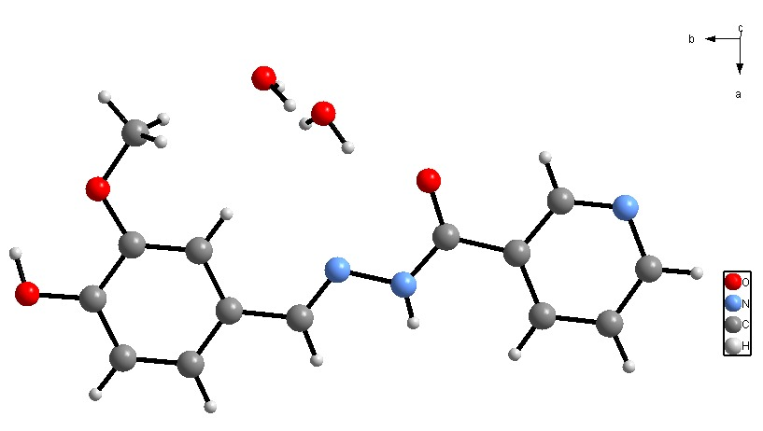
Figure 12 : Structure of HL ligand H₂L2

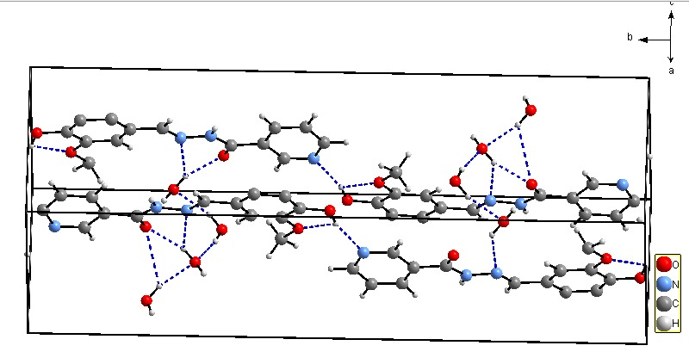
Figure 13 : The packing of the compound in the crystal structure

- Antioxidant activities study
Sensitivity test protocol : The diffusion method is one of the oldest approaches to determining the sensitivity of bacteria to antibiotics or natural or synthetic compounds and remains one of the most routinely used methods. It is suitable for the majority of pathogenic bacteria including slow-growing bacteria; it allows a variety in the choice of antibiotics and does not require any special equipment. Like most agar diffusion techniques, the EUCAST method is standardized, based on the principles defined in the report of the International Collaborative Study of Antimicrobial Susceptibility Testing (1972) but also on the experience of experts around the world.
Biology Antimicrobial test The antimicrobial activity of the synthesized compounds was studied in vitro using four reference bacterial strains such as two Gram (+): E. faecalis ATCC 29212 and S. aureus ATCC 38213; two Gram (_): E. coli ATCC 25921 and P. aeruginosa ATCC 27253; and one yeast C. albicans ATCC 24433. Erythromycin and tetracycline were used as reference compounds. Inoculum preparation. The microorganisms were first inoculated into the peptone medium and incubated at 37 .C for 24 h. After 24 h of incu-bation, all microbial strains had grown in their respective media. From the cultures obtained, a microbial suspension in salt solution was made until the inoculum was estimated at 1.5 ×108 CFU/mL based on a turbidity of 0.5 McFarland. Turbidity was measured using a densitometer.
Determination of minimum inhibitory concentrations.The minimum inhibitory concentration was defined as the lowest concentration of the compound that completely suppressed the growth of microorganisms [24]. A range of dilution for each compound was carried out to deter-mine the MIC for each strain. Dilutions were started by pipetting 100 ìL of compound into the first well of a 96-well plate containing 100 ìL of MH broth. Serial dilutions were carried out by cascade half dilutions to obtain a concentration range between 0.015 and 30 mg/mL. Then, 20 ìL of microorganism suspension cultures were added into each well. The plates were then incubated at 37 .C for 24 h. The tested microorganisms were exposed to broth without the alkaloid extract as a control.Anticancer activityCell viability was estimated using a colorimetric assay developed by Mosmann [25]. This method relies on the reduction by living cells of the tetrazolium salt, MTT, to form a blue formazan product [26].Cell lines.Anticancer activities were determined against breast (MCF-7), lung (Calu-3), pancreas (PANC-1) and prostate (PC-3) cancer cells. All cell lines were purchased from ATCC (American Type Culture Collec-tion/LGC Promochem, Molsheim, France). Telomerase-immortalized corneal fibroblasts (HTK) were used as normal cells [27]. Cells were grown and maintained in DMEM medium complemented with 10 % serum and antibiotics in a humidified incubator at 37 .C with 5 % CO₂.
MTT assay protocol.After trypsinization and counting, cells were seeded at 10 000 cells per well in a 96-well plate. 24h latter, the compounds were added at different concentrations ranging from 0.0005 to 10 ìg/ mL in sextuplicate and incubated for 72 h at 37 .C. DMSO was used as a negative control and carboplatin as a positive control [26]. MTT (0.5 mg/mL) was then added, and the plate was incubated for an additional hour. After washing, intracellular formazan crystals were dissolved in 100 µL of DMSO and absorbance was measured at 570 nm using a Multiskan® FC plate reader (Thermo Scientific). Cell viability was then estimated in percentage of control cells treated with DMSO alone. Re-sults are expressed as mean ±standard deviation (SD). Chi-square Test were performed using GraphPad Prism to determine differences. P value <0.05 was considered as statistically significant. IC50 was determined using the Quest Graph™ IC50 Calculator software [28].

1°) Media preparation
1.1. Preparation of MH medium
19 g of Muller Hinton Agar were weighed using a precision balance then suspended in 500 mL of distilled water and homogenized using a magnetic bar. The medium is then sterilized in an autoclave at 121°C for 15 minutes then cooled in a marri bath to 45°C. Then the medium was poured into the sterile square petri dishes to a uniform thickness of approximately 4 mm and the agar was allowed to settle at room temperature before putting them in the incubator at 37°C for 24 hours before use.
1.2. Preparation of Colombia agar
This medium was used to perform microbial culture.
20 g of Columbia powder were suspended in 500 mL of distilled water and then homogenized using a magnetic stirrer. The mixture is then placed in the autoclave at 121°C for 15 minutes then cooled in a water bath at 45°C. The medium was poured into round petri dishes under a hood and allowed to solidify at room temperature. These were stored in an oven at 37°C for 24 hours to test their sterility before use.
The boxes must not be dried out. If they must be used after 7 days, they must be stored at 4-8°C in a sealed plastic bag.
2°) Microbial culture and purification
The dial method was used to carry out strain purification.
20 µL of the microbial suspension was placed on the colombia agar medium, using a seeding loop the drop is scraped to the middle of the dish carefully to avoid scratching the agar. Using the ring of the handle, trace tight streaks on the 1st dial (in the most delicate way so as not to damage the agar). Then we turn the box towards the 2nd dial and we trace it in the same way as the first, we turn the box towards the 3rd dial, we seed it this time with loose but distant streaks which do not overlap the previous deposit. The plates were then incubated at 37°C at 5% CO2 for 24 h.
3°) Preparation of the inoculum
From a visible microbial culture carried out on Colombian agar medium, produce a bacterial suspension in saline solution (PBS) to achieve a turbidity equivalent to that of the 0.5 standard from the McFarland range. To do this, take several colonies of the same morphology (if possible) to avoid selecting an atypical variant using a seed loop, suspend these colonies in 10 mL of PBS.
The bacterial suspension is standardized using the 0.5 McFarland control. A heavy inoculum results in smaller diameters and vice versa. It is recommended to use a spectrophotometer to adjust the inoculum. This device must be calibrated against a standard from the McFarland range according to the manufacturer's recommendations. The turbidity of the bacterial suspension can also be compared with the naked eye to that of the 0.5 standard from the McFarland range. In this case, shake the turbidity standard vigorously on a VortexR before use (some commercial standards are gelled and should not be shaken; follow the manufacturer's recommendations).
4°) Inoculation of the agar and Deposition of the unimpregnated discs
The bacterial inoculum should ideally be used within 15 minutes of its preparation. Ten milliliters of inoculum are poured onto the surface of the poured and solidified culture medium (Muller Hinton). The surface is covered completely, the excess is removed and thrown into the bleach. The plates were incubated for 1 hour before placing the disks.
The standard antibiotic disks of Doripenem, erythromycin (10 µg/disc) and Ceftriaxone (30 µg/disc) with diameters of 6 mm were used as positive controls and DMSO to prepare the dilutions of the different extracts was used as a negative control.
The tests were carried out on unimpregnated discs with a diameter of 6 mm and the discs were impregnated with 40 µl of the solution to be evaluated with a concentration of 10 mg/mL).
The discs were firmly placed on the surface of the inoculated and dried agar. Contact with the surface should be close. The discs once deposited cannot be moved because the diffusion of antibiotics is very rapid. The number of discs placed per box is limited due to the overlapping of the inhibition zones and to limit interference between the compounds.
The boxes were turned over and incubated for 24 hours at 37°C at 5% CO2. The antibacterial activity was evaluated by measuring the inhibition zone.

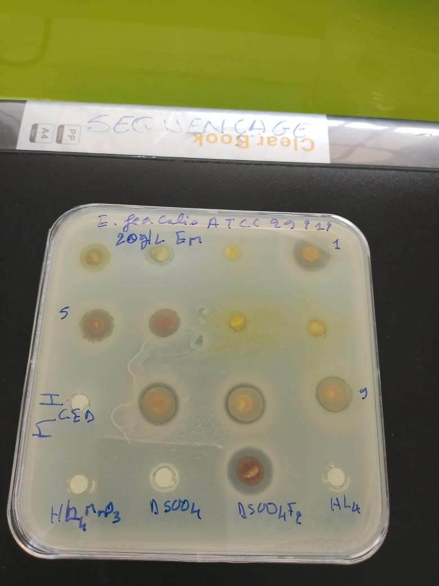
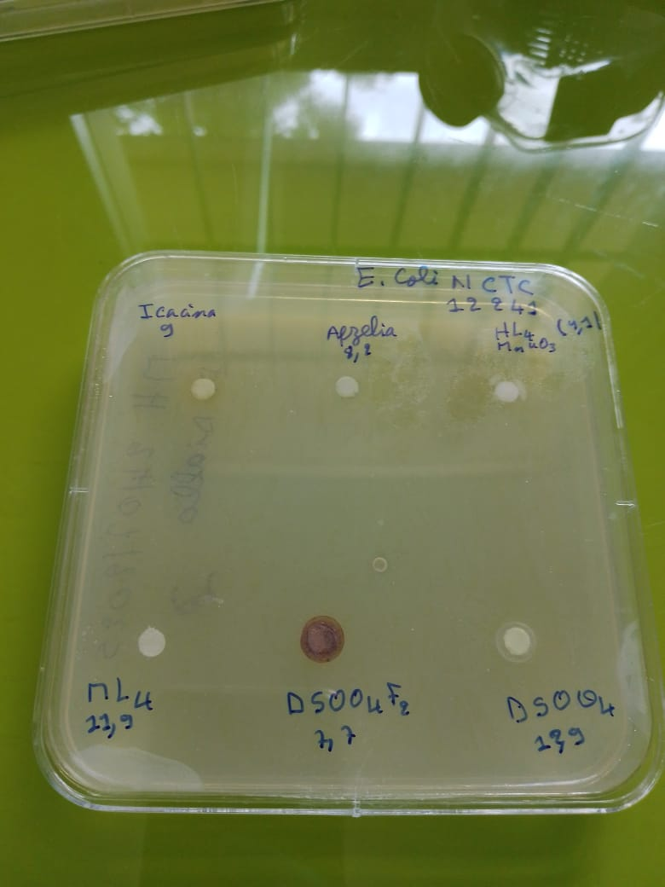
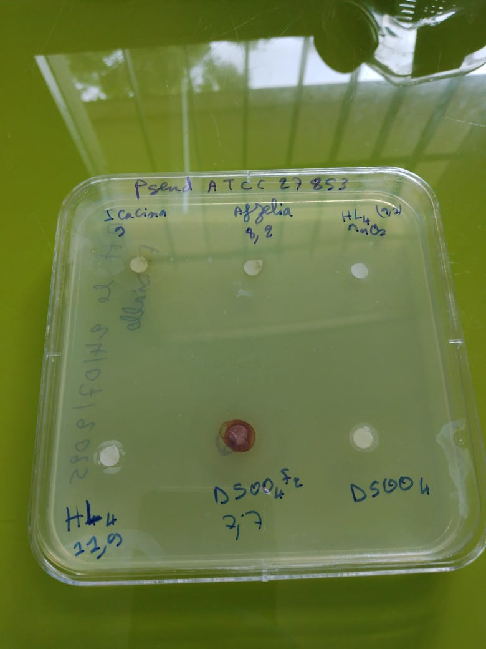
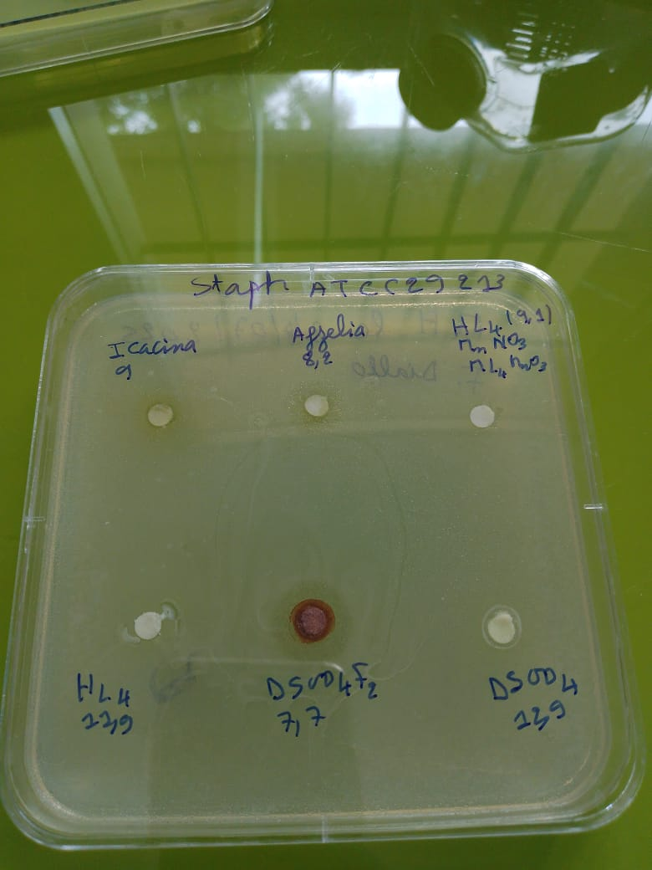

A b

Figure 14 : The antibacterial activity

Table 6 : Strains tested and Drugs tested

Strains tested | Drugs tested
Staphylococcus aureus ATCC 29213 (G+) (Staph aureus) | H₂L2
Escherichia Coli NCTC 12 241 (G-) (E. coli) | HL2MnO₃
Enterococcus faecalis ATCC 29212 (G+) (E. Faecalis) | HL1
Pseudomonas aeruginosa ATCC 27853 (G-) (P. aerus) | HL1Fe

Table 7: Inhibition diameters (mm)

Strains  Drugs (C : mg /mL) | Staph aureus  ATCC 29213 (G+) | E. coli  NCTC 12 241 (G-) | E. Faecalis  ATCC 29212 (G+) | P. aerus  ATCC 27853 (G-)
H₂L2 10 mg/mL | 7 | 6 | - | -
HL2MnO₃ 10 mg/mL | 8 | 10 | - | -
HL1 10 mg/mL | 10 | 10 | 7 | -
HL1Fe10 mg/mL | 15 | 10 | 16 | -
DMSO | - | - | - | -
Doripenem : 10 µg | 28 | 23 | 32 | 25
Ceftriaxone : 30 µg | - | 14 | 7 | -

No activity

Table 8 : Minimum inhibitory concentration MIC

Strains  Drugs (C : mg /mL) | Staph aureus  ATCC 29213 (G+) | E. coli  NCTC 12 241 (G-) | E. Faecalis  ATCC 29212 (G+) | P. aerus  ATCC 27853 (G-)
H₂L2 | ND | ND | ND | ND
HL2MnO₃ | 5 | 10 | ND | ND
HL1 | 5 | 10 | ND | ND
HL1Fe | ND | ND | ND | ND
DMSO | - | - | - | -
Doripenem : 10 µg | 28 | 23 | 32 | 25
Ceftriaxone : 30 µg | - | 14 | 7 | -

ND : Not Determined

The strains used for susceptibility testing are as follows
- Staphylococcus aureus ATCC 29213 (Gram positif)
- Escherichia coli NCTC 12241 (Gram négatif)
- Enterococcus faecalis ATCC 29212 (Gram positif)
- Pseudomonas aeruginosa ATCC 27853 (Gram négatif)
5°) Bibliographic study of strains used in sensitivity tests

5.1 Staphylococcus aureus ATCC 29213
Staphylococcus aureus is a Gram-positive cocci bacteria, a widely distributed opportunistic pathogen.
- Clinical interest: responsible for skin, pulmonary, osteo articular and septicemic infections
- Use in microbiology: strain ATCC 29213 is a reference strain frequently used for the evaluation of antibiotic sensitivity in agar diffusion tests and MICs. It serves in particular as quality control in the standardized CLSI and EUCAST protocols.
- Particularity: this strain is sensitive to many antibiotics, which makes it a good comparative model for testing new antimicrobial molecules.

5.2. Escherichia coli NCTC 12241
E. coli is a Gram-negative bacillus of the Entero bacteriaceae family, widely present in the human and animal intestinal microbiota.
- Clinical interest : certain commensal strains are harmless, but pathogenic strains are responsible for urinary, gastrointestinal, septicemic and meningeal infections.
- Use in microbiology : the NCTC 12241 strain is a reference strain used for quality control of sensitivity tests, in particular for antibiotics targeting Gram-negative bacteria.
- Special feature : this standardized strain makes it possible to compare the diffusion and effectiveness of antimicrobial compounds with international reproducibility.

5.3. Enterococcus faecalis ATCC 29212
faecalis is a Gram-positive cocci, often present in human intestinal flora.
- Clinical interest: it is involved in urinary infections, endocarditis and nosocomial infections.
- Use in microbiology: the ATCC 29212 strain is used as a standard control for determining the MIC of antibiotics. It is recommended by the CLSI for the validation of diffusion and dilution tests.
- Particularity: its relative tolerance to classic antibiotics makes it a reference strain for evaluating new molecules against resistant Gram-positive bacteria.

5.4. Pseudomonas aeruginosa ATCC 27853
P. aeruginosa is a non-fermentative Gram-negative bacillus, ubiquitous in humid environments.
- Clinical interest: major opportunistic pathogen, particularly feared in nosocomial infections (burns, pneumonia, septicemia). It has high natural resistance to many antibiotics.
- Use in microbiology: the ATCC 27853 strain is a reference strain used to evaluate the effectiveness of antimicrobial agents against non-fermentative Gram-negative bacilli. It is also a quality control for diffusion tests (CLSI, EUCAST).
- Special feature: it is a standardized sensitive strain, which allows the performance of antibiotics active on Pseudomonas to be compared.
This bibliography shows that the four strains chosen represent a relevant panel:
- Gram négatif (Escherichia, Pseudomonas)
- Quality control strains standardized by ATCC and NCTC, internationally recognized

6°) Results and discussions

6.1. Staphylococcus aureus ATCC 29213
- Role: Gram-positive reference strain, often used as quality control in antibiotic sensitivity tests, notably by the disk diffusion method (Kirby-Bauer) or MICs (CLSI, EUCAST).
- Quality: described as a low producer of β-lactamases, sensitive to standard antibiotics
- Normative use: frequently referenced in CLSI and EUCAST standards as a QC strain for validation of media (Mueller-Hinton) and diffusion tests

6.2. Escherichia coli NCTC 12241
- Role: Gram-negative strain, used as a control strain (wild-type) to validate sensitivity tests (disk diffusion in particular).
- Quality: sensitive to many common antibiotics (neomycin, colistin, kanamycin, gentamicin, chloramphenicol, cephalosporins, etc.)

6.3. Enterococcus faecalis ATCC 29212
- Role: Gram-positive control strain, sensitive to vancomycin, widely used as QC for antibiogram tests (diffusion, dilution, etc.)
- Characterization: sequenced genome (~3 Mb, G+C ≈ 37%), isolate initially collected from a human urine sample
- QC value: validated in multicenter studies for diffusion and microdilution tests. Established control zones (gentamicin 16–22 mm, streptomycin 14–19 mm)

6.4. Pseudomonas aeruginosa ATCC 27853
- Role: non-fermentative Gram-negative strain, reference for evaluating the effectiveness of antibiotics against this genus, particularly in diffusion tests.
- Normative reference: listed in CLSI standards for sensitivity testing, including media validation (Mueller-Hinton) and diffusion testing

6.5. Quote from a community testimony
As an illustration, here is a quote from the microbiological community, highlighting good practices for the use of the ATCC 29213 strain:
“According to the M07, 37° is ok, but on the high end of acceptable. The incubation range is 35° ± 2°.” Reddit
This reminds us of the importance of respecting the test conditions (temperature, inoculum, subculture passages) to guarantee reliable results.

7°) Interpretation of results
7.1. Analysis of Table 1 – Inhibition diameters (mm)
The diameter of the inhibition zone is an indicator of antibacterial activity
- Large diameter → high activity (sensitive bacteria)
- Small diameter or absence of zone → low or no activity (resistant bacteria)

- Staphylococcus aureus (ATCC 29213, G+)
- H₂L2 : low activity (7 mm)
- HL2MnO₃: modest activity (8 mm)
- HL1 good activity (10 mm)
- HL1Fe: most marked activity (15 mm)
Conclusion : HL1 derivatives, especially HL1Fe , are the most active against S. aureus.

- Escherichia coli (NCTC 12241, G–)
- H₂L2: very weak (6 mm)
- HL2MnO₃ and HL1 moderate (10 mm)
- HL1Fe : good activity (10 mm, identical but more regular)
Conclusion : E. coli is less sensitive overall, but HL1 and HL1Fe maintain correct effectiveness.

- Enterococcus faecalis (ATCC 29212, G+)
- Only HL1Fe shows activity (16 mm)
Conclusion: HL1Fe is the only active molecule against E. faecalis.

- Pseudomonas aeruginosa (ATCC 27853, G–)
- No compound shows activity.
Conclusion : P. aeruginosa remains fully resistant, which is expected because this bacteria is naturally multi-resistant.

- Comparison with controls (Doripenem & Ceftriaxone)
- Doripenem : wide zones (23–32 mm) → very high activity
- Ceftriaxone : low activity on E. coli and E. faecalis (7–14 mm), no activity on S. aureus and P. aeruginosa.
Conclusion: the new molecules tested present modest to moderate activity, much lower than Doripenem but sometimes higher than Ceftriaxone in certain cases (notably E. faecalis with HL1Fe).

7.2. Analysis of Table 2 – Minimum Inhibitory Concentrations (MIC, mg/mL)
La CMI est la plus faible concentration empêchant toute croissance bactérienne. The MIC is the lowest concentration preventing bacterial growth.
- Low MIC → powerful molecule
- High MIC or ND → ineffective molecule
- Staphylococcus aureus
- H₂L2MnO₃ CMI = 5 mg/mL (équivalente) equivalent
- HL1Fe : ND → not tested or not active
Conclusion: H₂L2MnO₃ and HL1 are effective on S. aureus at moderate concentrations.
- Escherichia coli
- H₂L2MnO₃: CMI = 10 mg/mL (low activity)
- HL1 : CMI = 10 mg/mL (low activity)
Conclusion: limited effectiveness against E. coli, requiring higher doses.
- Enterococcus faecalis
- All ND except control → no inhibition detected.
Conclusion: despite the activity observed with HL1Fe n Table 1, the MIC was not determined (perhaps linked to an experimental limit).
- Pseudomonas aeruginosa
- All ND → confirmation of the absence of activity.
7.3. Overall interpretation
- Best candidates
- HL1Fe active on S. aureus and especially E. faecalis (zone 16 mm).
- HL1: active on S. aureus and E. coli (MIC 5–10 mg/mL).
- Limited activity
- H₂L2 and HL2MnO₃ → low effectiveness, especially on Gram negative.
- No effectiveness
- All molecules against P. aeruginosa.
Conclusion
The ligand 4-bromo-2-{(1E)-1-[2-(1-phenylethenyl)hydrazinylidene]ethyl}phenol denoted (H₂L1) and the ligand N'-[(E)-(4-hydroxy-3-methoxyphenyl)methylidene]pyridine-3-carbohydrazide (H₂L2) was synthesized as well as its corresponding complexes.
The derivatives tested show selective antibacterial activity, mainly against Gram-positive bacteria (S. aureus, E. faecalis), with modest effectiveness against E. coli.
No effectiveness was observed on P. aeruginosa, which is consistent with its natural resistance.
The HL1Fe derivative appears to be the most promising, particularly against Enterococcus faecalis, which is often difficult to treat.

REFERENCES
[1] Werner A, « Zur Kennis des asymetrichen kobaltation X.I », Chem. Ber 1911 ; 44 :.1887.
[2] Diallo, A. S., Sarr, M., Gueye, M. N., Kama, A. B., Tamboura, F. B., Thiam, I. E., Dieng, M., & Gaye, M. (2024). Synthesis and characterization of a novel metal complex Cobalt (III) with a tetradentate N,N,O,O-donor ligand and 2,2'-{propane-1,2-diyl-bis[nitrilo(E)methylidene]}bis(6-methoxyphenol). Earthline Journal of Chemical Sciences, 11(2), 297-322. https://doi.org/10.34198/ejcs.11224.297322
[3] Silva CMD, Silva DLD, Modolo LV, Alves RB, Resende MAD, Martins CV and Fatima ÂD, « a short review of their antimicrobial activitie », journal of advanced research, 2010 ; p.2,
[4] Ponka, P., Borova, J., Neuwirt, J., Fuchs, O., & Necas, E. (1979). Mobilization of iron from reticulocytes. Identification of pyridoxal isonicotinoyl hydrazone as a new iron chelating agent. FEBS Letters, 97(2), 317–321. https://doi.org/10.1016/0014-5793(79)80111-8
[5] Yang, X.-B., Huang, Y., Zhang, J.-S., Yuan, S.-K., & Zeng, R.-Q. (2010). Synthesis, characterization and DNA interaction of copper (II) complexes with Schiff base ligands derived from 2-pyridinecarboxaldehyde and polyamines. Inorganic Chemistry Communications, 13(12), 1421-1424. https://doi.org/10.1016/j.inoche.2010.08.006
[6]. Koivusalo, L., Karvinen, J., Sorsa, E., Jönkkäri, I., Väliaho, J., Kallio, P., Ilmarinen, T., Miettinen, S., Skottman, H., & Kellomäki, M. (2018). Hydrazone crosslinked hyaluronan-based hydrogels for therapeutic delivery of adipose stem cells to treat corneal defects. Materials Science and Engineering C: Materials for Biological Applications, 85, 68–78. https://doi.org/10.1016/j.msec.2017.12.013
[7]. Uppal, G., Bala, S., Kamboj, S., & Saini, M. (2011). Therapeutic review exploring antimicrobial potential of hydrazones as promising lead. Der Pharma Chemica, 3(1), 250–268. https://www.scholarsresearchlibrary.com/articles/therapeutic-review-exploring-antimicrobial-potential-of-hydrazones-as-promising-lead.pdf
[8]. Cukierman, D. S., Pinheiro, A. B., Castiñeiras-Filho, S. L. P., da Silva, A. S. P., Miotto, M. C., de Falco, A., de Ribeiro, P. T., Maisonette, S., da Cunha, A. L. M. C., Hauser-Davis, R. A., Landeira Fernandez, J., Aucélio, R. Q., Outeiro, T. F., Pereira, M. D., Fernández, C. O., & Rey, N. A. (2017). A moderate metal-binding hydrazone meets the criteria for a bioinorganic approach towards Parkinson's disease: therapeutic potential, blood-brain barrier crossing evaluation and preliminary toxicological studies. Journal of Inorganic Biochemistry, 170, 160–168. https://doi.org/10.1016/j.jinorgbio.2017.02.020
[9]. Sanford, A. G., Schulze, T. T., Potluri, L. P., Watson, G. F., Darner, E. B., Zach, S. J., Hemsley, R. M., Wallick, A. I., Warner, R. C., Charman, S. A., Wang, X., Vennerstrom, J. L., & Davis, P. H. (2018). Derivatives of a benzoquinone acyl hydrazone with activity against Toxoplasma gondii. International Journal for Parasitology: Drugs and Drug Resistance, 8(3), 488–492. https://doi.org/10.1016/j.ijpddr.2018.11.001
[10]. Alagesan, M., Bhuvanesh, N. S. P., & Dharmaraj, N. (2013). Potentially cytotoxic new copper(II) hydrazone complexes: Synthesis, crystal structure and biological properties. Dalton Transactions, 42(19), 7210–7223. https://doi.org/10.1039/c3dt50371b
[11]. Cao, W., Liu, Y., Zhang, T., & Jia, J. (2018). Synthesis, characterization, theoretical and antimicrobial studies of tridentate hydrazone metal complexes of Zn (II), Cd (II), Cu (II) and Co (III). Polyhedron, 147, 62–68. https://doi.org/10.1016/j.poly.2018.03.012
[12]. Bhaskar, R. S., Ladole, C. A., Salunkhe, N. G., Barabde, J. M., & Aswar, A. S. (2020). Synthesis, characterization and antimicrobial studies of novel ONO donor hydrazone Schiff base complexes with some divalent metal (II) ions. Arabian Journal of Chemistry, 13(8), 6559–6567. https://doi.org/10.1016/j.arabjc.2020.06.012
[13]. Joshi, N., Gore, V., Tekale, S., Rajani, D., Bembalkar, S., & Pawar, R. (2021). Synthesis, characterization and biological activity of transition metal complexes of [1-(2-bromo, 5-methoxy benzylidene) hydrazine] ligand. Letters in Applied NanoBioScience, 10(2), 2056–2062. https://doi.org/10.33263/LIANBS102.20562062
[14] Kahwa, I. A., Selbin, J., O'Connor, C. J., Foise, J. W., & McPherson, G. L. (1988). Magnetic and luminescence characteristics of dinuclear complexes of lanthanides and a phenolic schiff base macrocyclic ligand. Inorganica Chimica Acta, 148(2), 265-272. https://doi.org/10.1016/s0020-1693(00)87513-1
[15] Kaczmarek, M. T., Zabiszak, M., Nowak, M., & Jastrzab, R. (2018). Lanthanides: Schiff base complexes, applications in cancer diagnosis, therapy, and antibacterial activity. Coordination Chemistry Reviews, 370, 42-54. https://doi.org/10.1016/j.ccr.2018.05.012
[16] Jastrzab, R., Kaczmarek, M. T., Nowak, M., Trojanowska, A., & Zabiszak, M. (2017). Complexes of polyamines and their derivatives as living system active compounds. Coordination Chemistry Reviews, 351, 32-44. https://doi.org/10.1016/j.ccr.2017.05.001
[17] Wu, S.-G., Peng, Y.-Y., Chen, Y.-C., Liu, J.-L., & Tong, M.-L. (2020). Magnetic dynamics of an open-ring tridysprosium complex employing mixed ligands. Dalton Transactions, 49, 14140-14147. https://doi.org/10.1039/D0DT02698K
[18] Li Q, Zhu X, Zhao Y, & Xie Y, The antifungal activity of o-vanillin against Aspergillus flavus via disrupting ergosterol biosynthesis and promoting oxidative stress, and an RNA-seq analysis thereof. LWT, 2022 ; 164 : 113635.
https://doi.org/10.1016/j.lwt.2022.113635
[19] Londoño-Mosquera, J.-D., Aragón-Muriel, A., & Cerón, D. P. (2018). Synthesis, antibacterial activity and DNA interactions of lanthanide(III) complexes of N(4)-substituted thiosemicarbazones. Universitas Scientiarum, 23(2), 141-169. https://doi.org/10.11144/Javeriana.SC23-2.saaa
[20] Haba, P. M., Tamboura, F. B., Diouf, O., Gaye, M., Sall, A. S., Baldé, C. A., & Slebodnick, C. (2006). Preparation, spectroscopic studies, and x-ray structure of homobinuclear lanthanide(III) complexes derived from 2,6-diformyl-4-chlorophénol-bis- (2’-hydroxy-benzoylhydrazone). Bulletin of the Chemical Society of Ethiopia, 20(1), 45-54. https://doi.org/10.4314/bcse.v20i1.21142
[21] Singh, Y. P., Patel, R. N., Singh, Y., Butcher, R. J., Vishakarma, P. K., & Singh, R. K. B. (2017). Structure and antioxidant superoxide dismutase activity of copper(II) hydrazone complexes. Polyhedron, 122, 1-15. https://doi.org/10.1016/j.poly.2016.11.013
[22] | E. I. Thiam, M. Diop, M. Gaye, A. S. Sall et A. H. Barry, Acta Cryst , vol. 64, p. 776, 2008.
[23] Geary, W. J. (1971). The use of conductivity measurements in organic solvents for the characterisation of coordination compounds. Coordination Chemistry Reviews, 7(1), 81–122. https://doi.org/10.1016/S0010-8545(00)80009-0
[24] Yu, Q., Yang, Y., Wan, J.-P., & Liu, Y. (2018). Copper-catalyzed C5–H sulfenylation of unprotected 8-aminoquinolines using sulfonyl hydrazides. The Journal of Organic Chemistry, 83(18), 11385–11391. https://doi.org/10.1021/acs.joc.8b01658
[25] Mosmann, T. (1983). Rapid colorimetric assay for cellular growth and survival: application to proliferation and cytotoxicity assays. Journal of Immunological Methods, 65(1-2), 55–63. https://doi.org/10.1016/0022-1759(83)90303-4
[26] Shaaban, S., Shabana, S. M., Al-Faiyz, Y. S., Manolikakes, G., & El-Senduny, F. F. (2021). Enhancing the chemosensitivity of HepG2 cells towards cisplatin by organoselenium pseudopeptides. Bioorganic Chemistry, 109, 104713. https://doi.org/10.1016/j.bioorg.2021.104713
[27] Huet, E., Vallée, B., Szul, D., Verrecchia, F., Mourah, S., Jester, J. V., Hoang-Xuan, T., Menashi, S., & Gabison, E. E. (2008). Extracellular matrix metalloproteinase inducer/CD147 promotes myofibroblast differentiation by inducing alpha-smooth muscle actin expression and collagen gel contraction: implications in tissue remodeling. FASEB Journal, 22(4), 1144–1154. https://doi.org/10.1096/fj.07-8748com
[28] AAT Bioquest, Inc. (2020). Quest Graph™ IC50 Calculator [Online calculator]. https://www.aatbio.com/tools/ic50-calculator

Annexes
Number Atom1 Atom2 Atom3 Angle
1 C00D O001 H001 111(1)
2 C009 O002 C00M 116.38(7)
3 N007 N006 C00J 114.78(8)
4 N006 N007 C00C 118.27(8)
5 N006 N007 H007 116(1)
6 C00C N007 H007 126(1)
7 C00K N008 C00L 116.92(8)
8 O002 C009 C00D 114.39(8)
9 O002 C009 C00E 124.90(8)
10 C00D C009 C00E 120.71(8)
11 C00E C00A C00G 119.31(8)
12 C00E C00A C00J 121.25(8)
13 C00G C00A C00J 119.43(8)
14 C00C C00B C00F 125.00(8)
15 C00C C00B C00K 116.85(8)
16 C00F C00B C00K 118.13(8)
17 O003 C00C N007 122.57(8)
18 O003 C00C C00B 119.83(8)
19 N007 C00C C00B 117.60(8)
20 O001 C00D C009 121.91(8)
21 O001 C00D C00H 119.24(8)
22 C009 C00D C00H 118.85(8)
23 C009 C00E C00A 120.02(8)
24 C009 C00E H00E 121.6(7)
25 C00A C00E H00E 118.4(7)
26 C00B C00F C00I 118.44(8)
27 C00B C00F H00F 122.2(8)
28 C00I C00F H00F 119.2(8)
29 C00A C00G C00H 120.51(9)
30 C00A C00G H00G 120.7(8)
31 C00H C00G H00G 118.8(8)
32 C00D C00H C00G 120.58(9)
33 C00D C00H H00H 117.6(8)
34 C00G C00H H00H 121.8(8)
35 C00F C00I C00L 119.03(8)
36 C00F C00I H00I 120.7(8)
37 C00L C00I H00I 120.2(8)
38 N006 C00J C00A 121.87(9)
39 N006 C00J H00J 121.8(9)
40 C00A C00J H00J 116.3(9)
41 N008 C00K C00B 123.86(8)
42 N008 C00K H00K 115.8(8)
43 C00B C00K H00K 120.3(8)
44 N008 C00L C00I 123.57(9)
45 N008 C00L H00L 116.0(9)
46 C00I C00L H00L 120.4(9)
47 O002 C00M H00A 110.0(8)
48 O002 C00M H00B 110.5(8)
49 O002 C00M H00C 107.3(8)
50 H00A C00M H00B 112(1)
51 H00A C00M H00C 111(1)
52 H00B C00M H00C 106(1)
53 H00D O004 H00M 96(2)
54 H00N O005 H00O 106(2)

Number Atom1 Atom2 Atom3 Atom4 Torsion
1 H001 O001 C00D C009 19(1)
2 H001 O001 C00D C00H -160(1)
3 C00M O002 C009 C00D -179.02(8)
4 C00M O002 C009 C00E 0.3(1)
5 C009 O002 C00M H00A -58.5(9)
6 C009 O002 C00M H00B 65.7(9)
7 C009 O002 C00M H00C -178.9(9)
8 C00J N006 N007 C00C 180.00(9)
9 C00J N006 N007 H007 1(1)
10 N007 N006 C00J C00A -179.16(8)
11 N007 N006 C00J H00J -1(1)
12 N006 N007 C00C O003 1.1(1)
13 N006 N007 C00C C00B -178.66(8)
14 H007 N007 C00C O003 -180(1)
15 H007 N007 C00C C00B 1(1)
16 C00L N008 C00K C00B -2.1(1)
17 C00L N008 C00K H00K 176.4(9)
18 C00K N008 C00L C00I 2.2(1)
19 C00K N008 C00L H00L -178(1)
20 O002 C009 C00D O001 0.6(1)
21 O002 C009 C00D C00H -179.75(8)
22 C00E C009 C00D O001 -178.75(8)
23 C00E C009 C00D C00H 0.9(1)
24 O002 C009 C00E C00A -179.65(8)
25 O002 C009 C00E H00E 0.3(9)
26 C00D C009 C00E C00A -0.3(1)
27 C00D C009 C00E H00E 179.6(9)
28 C00G C00A C00E C009 -0.4(1)
29 C00G C00A C00E H00E 179.6(8)
30 C00J C00A C00E C009 178.77(8)
31 C00J C00A C00E H00E -1.2(8)
32 C00E C00A C00G C00H 0.6(1)
33 C00E C00A C00G H00G -179(1)
34 C00J C00A C00G C00H -178.58(9)
35 C00J C00A C00G H00G 2(1)
36 C00E C00A C00J N006 -0.8(1)
37 C00E C00A C00J H00J -179(1)
38 C00G C00A C00J N006 178.36(9)
39 C00G C00A C00J H00J 0(1)
40 C00F C00B C00C O003 167.94(9)
41 C00F C00B C00C N007 -12.3(1)
42 C00K C00B C00C O003 -10.7(1)
43 C00K C00B C00C N007 169.06(8)
44 C00C C00B C00F C00I -177.15(8)
45 C00C C00B C00F H00F -2(1)
46 C00K C00B C00F C00I 1.4(1)
47 C00K C00B C00F H00F 176.3(9)
48 C00C C00B C00K N008 179.01(8)
49 C00C C00B C00K H00K 1(1)
50 C00F C00B C00K N008 0.3(1)
51 C00F C00B C00K H00K -178(1)
52 O001 C00D C00H C00G 178.97(8)
53 O001 C00D C00H H00H 1.0(9)
54 C009 C00D C00H C00G -0.7(1)
55 C009 C00D C00H H00H -178.6(9)
56 C00B C00F C00I C00L -1.4(1)
57 C00B C00F C00I H00I 176(1)
58 H00F C00F C00I C00L -176.4(9)
59 H00F C00F C00I H00I 0(1)
60 C00A C00G C00H C00D -0.1(1)
61 C00A C00G C00H H00H 178(1)
62 H00G C00G C00H C00D 180(1)
63 H00G C00G C00H H00H -2(1)
64 C00F C00I C00L N008 -0.5(1)
65 C00F C00I C00L H00L 180(1)
66 H00I C00I C00L N008 -177(1)
67 H00I C00I C00L H00L 3(1)

Number Label Charge SybylType Xfrac + ESD Yfrac + ESD Zfrac + ESD Symm. op.
1 O001 0 O.3 0.77430(9) 0.48868(2) 0.76686(11) x,y,z
2 O002 0 O.3 0.46900(8) 0.43550(2) 0.63828(11) x,y,z
3 O003 0 O.2 0.43469(9) 0.18862(2) 0.61492(12) x,y,z
4 N006 0 N.2 0.69235(11) 0.25682(3) 0.71311(12) x,y,z
5 N007 0 N.am 0.73302(11) 0.20765(3) 0.72890(12) x,y,z
6 N008 0 N.2 0.51990(11) 0.04246(3) 0.69504(12) x,y,z
7 C009 0 C.2 0.62726(11) 0.41023(3) 0.69595(13) x,y,z
8 C00A 0 C.2 0.81175(12) 0.33793(3) 0.75935(13) x,y,z
9 C00B 0 C.2 0.64167(11) 0.12307(3) 0.70021(12) x,y,z
10 C00C 0 C.2 0.59567(12) 0.17570(3) 0.67798(13) x,y,z
11 C00D 0 C.2 0.78385(12) 0.43964(3) 0.76128(13) x,y,z
12 C00E 0 C.2 0.64092(11) 0.36016(3) 0.69547(13) x,y,z
13 C00F 0 C.2 0.81265(12) 0.10389(3) 0.73347(14) x,y,z
14 C00G 0 C.2 0.96637(12) 0.36694(3) 0.82163(15) x,y,z
15 C00H 0 C.2 0.95212(12) 0.41735(3) 0.82254(15) x,y,z
16 C00I 0 C.2 0.83324(12) 0.05378(3) 0.74193(14) x,y,z
17 C00J 0 C.2 0.83044(13) 0.28518(3) 0.76436(14) x,y,z
18 C00K 0 C.2 0.50042(12) 0.09072(3) 0.68176(14) x,y,z
19 C00L 0 C.2 0.68467(12) 0.02478(3) 0.72150(14) x,y,z
20 C00M 0 C.3 0.30725(13) 0.40729(4) 0.57426(17) x,y,z
21 H00E 0 H 0.5346(17) 0.3395(4) 0.6518(18) x,y,z
22 H007 0 H 0.842(2) 0.2006(5) 0.771(2) x,y,z
23 H00I 0 H 0.9480(19) 0.0391(5) 0.755(2) x,y,z
24 H00K 0 H 0.3815(17) 0.1025(5) 0.655(2) x,y,z
25 H00F 0 H 0.9147(17) 0.1242(5) 0.7397(19) x,y,z
26 H001 0 H 0.669(2) 0.4979(6) 0.767(2) x,y,z
27 H00H 0 H 1.0583(18) 0.4382(5) 0.870(2) x,y,z
28 H00J 0 H 0.951(2) 0.2728(5) 0.812(2) x,y,z
29 H00L 0 H 0.696(2) -0.0109(6) 0.726(2) x,y,z
30 H00A 0 H 0.3028(18) 0.3867(5) 0.458(2) x,y,z
31 H00G 0 H 1.0871(19) 0.3522(5) 0.865(2) x,y,z
32 H00B 0 H 0.2979(18) 0.3881(5) 0.690(2) x,y,z
33 H00C 0 H 0.205(2) 0.4302(5) 0.535(2) x,y,z
34 O004 0 O.3 0.11082(10) 0.30919(3) 0.35507(13) x,y,z
35 H00D 0 H 0.163(3) 0.2996(6) 0.481(3) x,y,z
36 H00M 0 H 0.168(3) 0.2888(7) 0.300(3) x,y,z
37 O005 0 O.3 0.28984(10) 0.26917(3) 0.73321(13) x,y,z
38 H00N 0 H 0.346(3) 0.2839(7) 0.858(3) x,y,z
39 H00O 0 H 0.373(3) 0.2503(7) 0.711(3) x,y,z
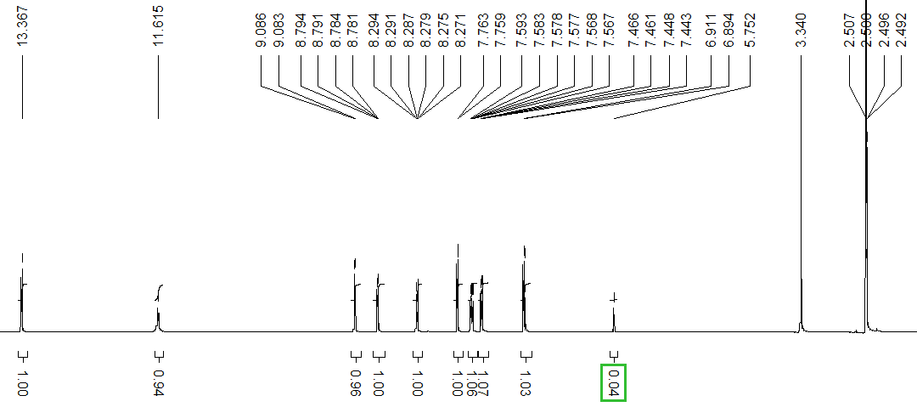Figure a : NMR spectrum of the ¹H of ligand H₂L1

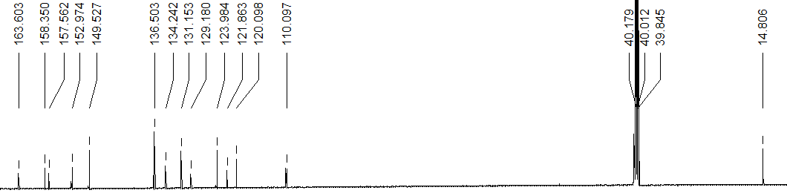
Figure b : NMR spectrum of the ¹³C of ligand H₂L1

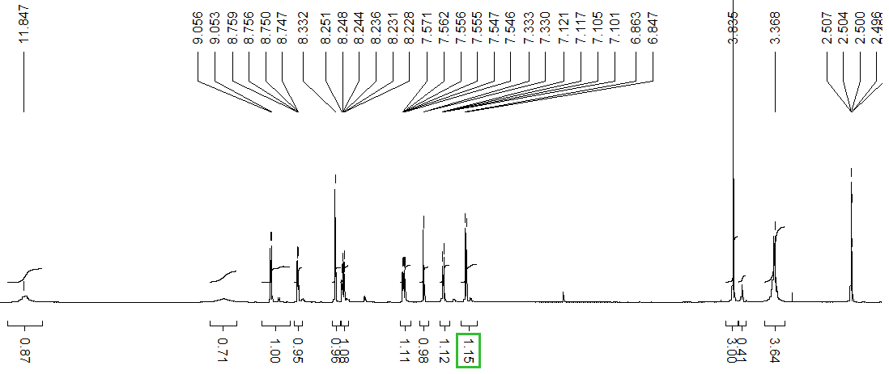
Figure c : NMR spectrum of the ¹H of ligand H₂L2

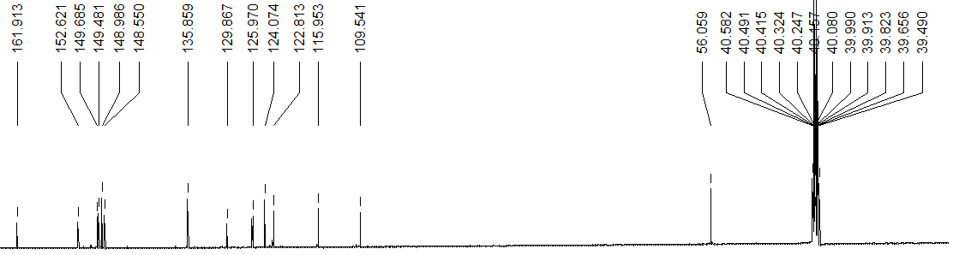
Figure d : NMR spectrum of the ¹³C of ligand H₂L2

