Original Research Article

Effects of Salinity on Biofortified Common Bean (Phaseolus vulgaris L.) Varieties for Seed Germination and Seed Vigour

ABSTRACT
Soil salinity threatens global food security, affecting over 800 million hectares of farmland, including approximately 2 million hectares in Tanzania. Common bean (Phaseolus vulgaris L.) is susceptible to salt stress during germination and early seedling development. The performance of recently released biofortified common bean varieties in Tanzania remains unexplored, raising concerns about potential trade-offs between enhanced nutrition and stress resilience. This study evaluated the effects of salinity on seed germination and seedling vigour in biofortified common bean varieties to identify those with superior salt tolerance for salt-affected areas. Seven varieties, six biofortified cultivars (SELIAN14, JESCA, TARIBEAN 2, TARIBEAN 4, TARIBEAN 5, TARIBEAN 6), and one non-biofortified control (TARIBEAN 1) were tested under four NaCl concentrations (0, 50, 100, and 150 mM) using a completely randomized factorial design with three replicates. Two-way ANOVA revealed that salinity significantly affected (p < 0.001) germination, shoot length, fresh and dry weight, and seedling vigour indices. Increasing salinity reduced cumulative germination from 98-100% to 59-67%, decreased shoot length by 25-35%, and lowered vigour index I by 50-60% at 150 mM NaCl. Significant varietal differences were observed for root length (p < 0.05), fresh weight (p < 0.001), dry weight (p < 0.001), and vigour index II (p < 0.01). SELIAN14, TARIBEAN 5, and TARIBEAN 6 demonstrated greater salt tolerance, maintaining higher biomass and vigour indices, while TARIBEAN 2 was more sensitive. These salt-tolerant, biofortified varieties are recommended for cultivation in salt-affected regions and as donor parents in breeding programs to develop climate-resilient, nutrient-rich common beans in sub-Saharan Africa.
Keywords: salinity stress; biofortification; Phaseolus vulgaris; seed vigour; genotypic variation; food security; climate resilience; micronutrient deficiency

1. INTRODUCTION
Common bean (Phaseolus vulgaris L.) is a vital crop for human nutrition and health, and it contributes to improved soil fertility [1]. Globally, it ranks as the third most important herbaceous annual grain legume and serves as a significant source of affordable protein (20-25%), complex carbohydrates, dietary fibre, and essential micronutrients such as iron and zinc, particularly among populations in sub-Saharan Africa. Africa has the highest global bean consumption, with annual per capita intake estimated at 50-60 kg [2]. Tanzania is a leading producer of beans with annual production of 1.2 million tons, making it the top producer in Africa and the seventh globally[3].
Beans are a critical food and livelihood source, supporting about 5.8 million rural households for daily nutrition [4]. National per capita consumption is approximately 19.3 kg per person per year [5]. Despite its importance, common bean production is constrained by both biotic and abiotic stresses, with salinity emerging as a significant climate-related challenge. Salinity reduces root and shoot dry-matter accumulation, even at low salinity levels [6]. High levels of soluble salts reduce the osmotic potential of the soil solution, thereby limiting root water uptake. Excess sodium (Na⁺) and chloride (Cl⁻) ions cause ionic and nutritional imbalances, disrupt membrane integrity and enzymatic activities, and induce oxidative damage, ultimately inhibiting photosynthesis [7].
These physiological disruptions negatively affect seed germination, seedling emergence, and early plant growth, thereby reducing yield and productivity. Soil salinity threatens global food security, affecting over 800 million hectares of agricultural land [8]. In Tanzania, about 2 million hectares are affected, especially in coastal regions, poorly drained inland areas, and zones with intensive irrigation [9]. Recent breeding initiatives by the Tanzania Agricultural Research Institute (TARI) and the Alliance of Bioversity International and CIAT (ABC) have developed biofortified common bean varieties enriched with iron and zinc to address widespread micronutrient deficiencies, known as "hidden hunger" [10]. These varieties target over 60 ppm Fe and 25 ppm Zn while maintaining yield potential. From 2018 to 2021, six new biofortified bean varieties were released in Tanzania through a collaboration between TARI and ABC, marking significant progress in nutritional security [11]. However, data on their performance under saline conditions are lacking. This gap is critical, given that Tanzania has approximately 1.2 million hectares of salt-affected soils, mainly in coastal and poorly drained areas [12]. Potential trade-offs between nutritional enhancement and stress tolerance have not been systematically assessed.
Climate change and expanded irrigation are expected to worsen soil salinisation [8]. Assessing the salinity tolerance of these biofortified varieties is essential for identifying those capable of maintaining viability under adverse environmental conditions, thereby supporting breeding, management, and deployment strategies in salt-affected regions of Tanzania and sub-Saharan Africa. This study aimed to quantify the effects of progressive salinity stress on biofortified standard bean germination and seedling vigour, and to establish relationships among germination, growth, and vigour parameters to inform efficient screening protocols for salt-tolerance breeding programs.
2. MATERIALS AND METHODS
2.1 Experimental site
The experiment took place in a controlled growth chamber at the Seed Health Centre Laboratory, Sokoine University of Agriculture (SUA), Morogoro, Tanzania, in April 2025. The facility is located in Morogoro Municipality at 6.85° S, 37.65° E, approximately 520 meters above sea level.

2.2 Experimental Materials
Seven common bean varieties were evaluated: six biofortified cultivars (TARIBEAN 2 (T2), TARIBEAN 4 (T4), TARIBEAN 5 (T5), TARIBEAN 6 (T6), JESCA, SELIAN 14 (S14)) and one non-biofortified control (TARIBEAN 1 (T1)). Seeds were obtained from the Tanzania Agricultural Research Institute (TARI) at the Maruku Centre (Kagera Region, northwestern Tanzania) in March 2025. Seeds from the 2024 harvest were stored at 4°C and 40% relative humidity. Uniform, healthy seeds free of mechanical injury, deformation, shrivelling, and discolouration were selected to minimize quality-related variability. About 1 kilogram of seeds per variety was manually sorted for uniform size, shape, and colour.
Table 1: Description of materials under study and their nutrient content
Variety name | Code | Nutrient content ratio
TARIBEAN 1 | RCB 593 | Non biofortified
TARIBEAN 2 | SMC 18 | Iron(Fe): 44.8-87.2 ppm, mg/kg  Zinc (Zn): 30.0-42.8 ppm, mg/kg
TARIBEAN 4 | COD MLB 033 | Iron(Fe): 55.5-78.3 ppm, mg/kg  Zinc (Zn): 31.4-40.4 ppm, mg/kg
TARIBEAN 5 | KAB06F2-8-36 | Iron(Fe): 55.5-76.0 ppm, mg/kg  Zinc (Zn): 31.4-39.0 ppm, mg/kg
TARIBEAN 6 | RWR2154 | Iron(Fe): 63.8-70.6 ppm, mg/kg  Zinc (Zn): 35.7- 40.8 ppm, mg/kg
JESCA | NA | Iron(Fe): 52-63 ppm, mg/kg  Zinc (Zn): 32-36 ppm, mg/kg
SELIAN 14 | MAC44 | Iron(Fe): 84 ppm, mg/kg  Zinc (Zn): 42 ppm, mg/kg
Source: TARI Variety Catalogue of Common Beans (Phaseolus Vulgaris) in Tanzania. TARI Research Publication No.1
2.3 Salinity Treatment Preparation
NaCl solutions were prepared by dissolving analytical-grade sodium chloride (≥99.5% purity, Sigma-Aldrich, USA) in deionized water (conductivity <5 μS cm−1). Solution electrical conductivity (EC) and pH were measured using a calibrated EC/pH meter (Hanna HI9814, Hanna Instruments, USA) and recorded as: 0 mM (EC: 0.2 dS m−1, pH 6.8), 50 mM (EC: 5.1 dS m−1, pH 6.6), 100 mM (EC: 9.8 dS m−1, pH 6.5), and 150 mM (EC: 14.2 dS m−1, pH 6.4) [13]. These concentrations represent non-saline (0 mM), moderately saline (50 mM), highly saline (100 mM), and severely saline (150 mM) conditions relevant to field scenarios in Tanzania's salt-affected regions.

2.4 Seed Treatment and Sowing
All seeds were surface-sterilised with 1% sodium hypochlorite (NaOCl) for five minutes to eliminate microbial contaminants, then rinsed with sterile distilled water. After sterilization, seeds were pre-soaked for 24 hours in saline solutions (0, 50, 100, and 150 mM NaCl) to equilibrate with the salt conditions [14]. Plastic containers were washed, sterilised, and moistened with distilled water. For each treatment, 100 seeds per container were sown at a depth of 2 cm and a spacing of 2 cm. Containers were placed in the growth chamber and irrigated with the respective saline solutions to maintain the target salinity. Irrigation was done every 48 hours to prevent waterlogging and maintain consistent moisture and salt concentration during germination.
2.5 Experimental Design
The experiment used a factorial layout within a Completely Randomized Design (CRD), with four salinity levels (0, 50, 100, and 150 mM NaCl) and seven common bean varieties. Each treatment was replicated three times, yielding 84 experimental units (7 varieties × 4 salinity levels × 3 replications). Each unit was a plastic container (25 cm × 18 cm × 8 cm) filled with sterilised sand as the germination medium. The growth chamber conditions were maintained throughout whereby temperature, relative humidity, and light intensity were monitored and kept at 25 ± 2°C (mean ± SD: 25.3 ± 1.1°C), 65-70% (mean: 67 ± 3%), and a 12-hour photoperiod (400 μmol m−2 s−1 photosynthetic photon flux density) using calibrated sensors [15].
2.6 Data Collection and Measurements
2.6.1 Germination Percentage (GP). Germination was monitored at three-day intervals until no additional germination occurred (10 days after sowing). A seed was considered germinated when radicle protrusion reached ≥2 mm, following the International Seed Testing Association (ISTA) standard germination criteria for Phaseolus species [16]. Germination percentage was calculated using: GP (%) = (Number of germinated seeds / Total number of seeds sown) × 100
2.6.2 Mean Germination Time (MGT). Mean germination time was calculated to assess the rate and uniformity of seed germination under different salinity treatments using the formula proposed by Ellis and Roberts (1981) [17]: MGT = Σ (n × d) / N, where n = number of seeds germinated on day d; d = time (days) from sowing to germination; N = total number of germinated seeds.
2.6.3 Shoot and Root Length. Ten days after sowing, ten seedlings from each treatment were randomly selected for measurement. Shoot length was measured from the hypocotyl-cotyledon junction to the apex of the primary leaf, and root length was measured from the hypocotyl base to the primary root tip using a standard ruler (±0.1 cm precision). Mean shoot and root lengths were calculated and expressed in centimetres.
2.6.4 Seedling Fresh Weight. Ten representative seedlings from each treatment were carefully uprooted, gently rinsed with distilled water to remove adhering substrate particles, and blotted with absorbent paper to remove excess surface moisture. Seedlings were weighed immediately on an analytical balance (±0.0001 g; Mettler Toledo ME204, Switzerland), and the mean fresh weight was expressed in grams.
2.6.5 Seedling Dry Biomass. Following fresh weight determination, seedlings were placed in labelled paper envelopes and oven-dried at 70°C for 48 hours, until a constant weight was achieved, using a forced-air drying oven (Memmert UF110, Germany). Samples were cooled in a desiccator to prevent reabsorption of moisture and then weighed on an analytical balance. Mean seedling dry biomass was expressed in grams.
2.6.6 Seedling Vigour Index I and II (SVI-I and SVI-II). Seedling vigor indices were calculated according to [18] to evaluate the combined effects of salinity stress on germination and early seedling growth performance: SVI-I = GP × (MSL + MRL), where GP = germination percentage (%), MSL = mean shoot length (cm), MRL = mean root length (cm); and SVI-II = GP × MSDW, where MSDW = mean seedling dry weight (g).
2.7 Statistical Analysis
A two-way analysis of Variance (ANOVA) was conducted to evaluate the effects of salinity levels and bean varieties using R statistical software version 4.3.2. The means were compared using Tukey's Honest Significant Difference (HSD) test at α < 0.05.

3. RESULTS
3.1 Effect of Salinity on Germination Parameters
The analysis of variance revealed that salinity stress had highly significant effects (p < 0.001) on germination parameters, including germination at Day 3 (F = 48.72), cumulative seed germination (F = 68.45), and the number of seeds not germinated (F = 68.45). The variety effect and variety-salinity interaction were not significant for most germination parameters (Table 1).
At the control condition (0 mM NaCl), all six biofortified and one non-biofortified common bean varieties (JESCA, SELIA 14, TARIBEAN 2, TARIBEAN 4, TARIBEAN 5, TARIBEAN 6, and TARIBEAN 1) respectively exhibited high germination percentages ranging from 98% to 100% at Day 3, with no significant differences among varieties. As salinity levels increased, germination on Day 3 declined progressively across all varieties. At 50 mM NaCl, germination dropped to approximately 44-54%; at 100 mM and 150 mM, it further decreased to 24-38% and 22-33%, respectively (Figure 1a). The study revealed distinct homogeneous groups, with control treatments (0 mM) forming group a ' and high salinity treatments (100-150 mM) forming groups 'def' and 'f'.
Germination time intervals at Day 5 and Day 7 showed no significant differences among treatments (Figures 1b and 1c), indicating that most germination occurred within the first three days under all conditions. Germination at Day 10 showed a significant salinity effect (F=3.42, p<0.05), indicating delayed germination under salt stress (Figure 1d).
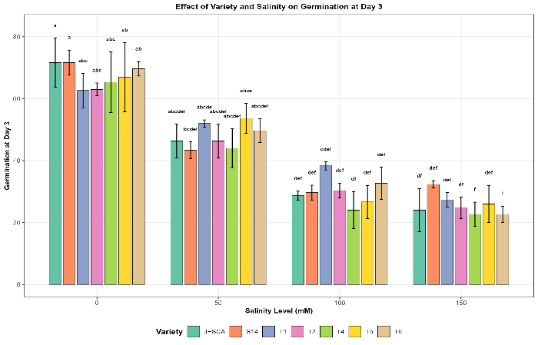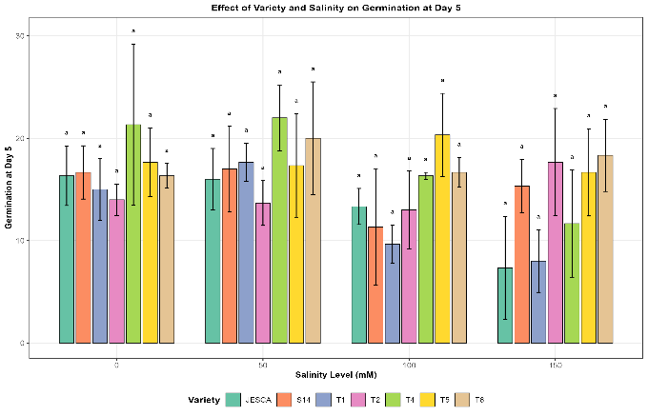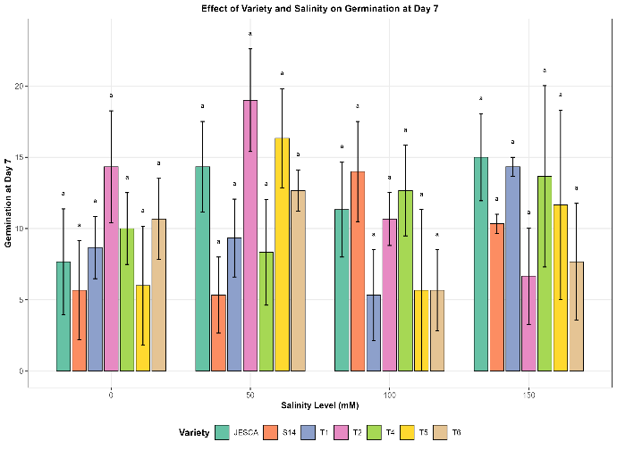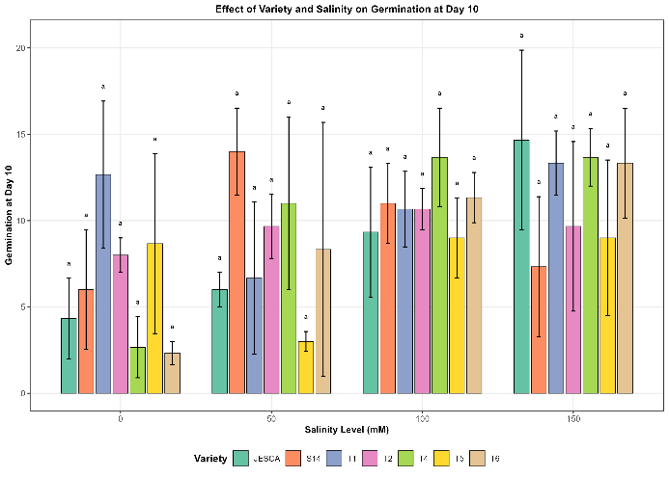
Figure 1. Effect of salinity stress on germination time intervals of six biofortified and one non-biofortified common bean (Phaseolus vulgaris L.) varieties. (a) Germination at Day 3, (b) Germination at Day 5, (c) Germination at Day 7, and (d) Germination at Day 10 indicate significant differences among treatment combinations according to Tukey's HSD test (p<0.05). Salinity levels: 0, 50, 100, and 150 mM NaCl. Varieties: JESCA, SELIAN 14, TARIBEAN 2, TARIBEAN 4, TARIBEAN 5, TARIBEAN 6, and TARIBEAN 1

Cumulative seed germination was dramatically affected by salinity (F=68.45, p<0.001). Under control conditions, cumulative germination approached 100% for all varieties. At 50 mM NaCl, cumulative germination ranged from 80-91%, decreasing to 62-67% at 100 mM and 59-67% at 150 mM (Figure 2a). The number of non-germinated seeds increased significantly with salinity, from near zero at 0 mM to approximately 33-41 seeds at 150 mM NaCl (Figure 2b).
Abnormal seed germination showed a significant but less pronounced salinity effect (F=3.78, p<0.05). The number of abnormally germinated seeds increased from 2-3 at 0 mM to 4-5 at 150 mM NaCl, although all treatment combinations were in the same statistical group according to post hoc analysis (Figure 2c).
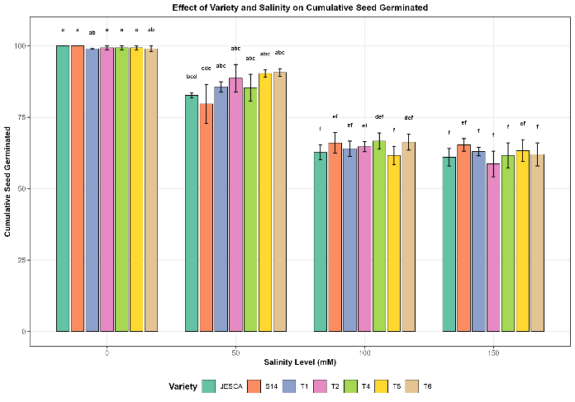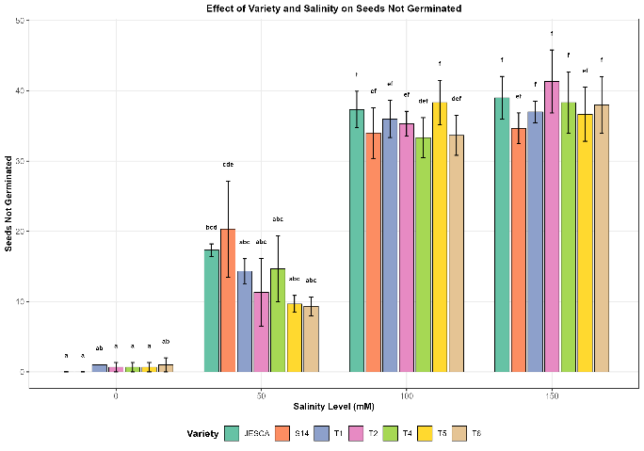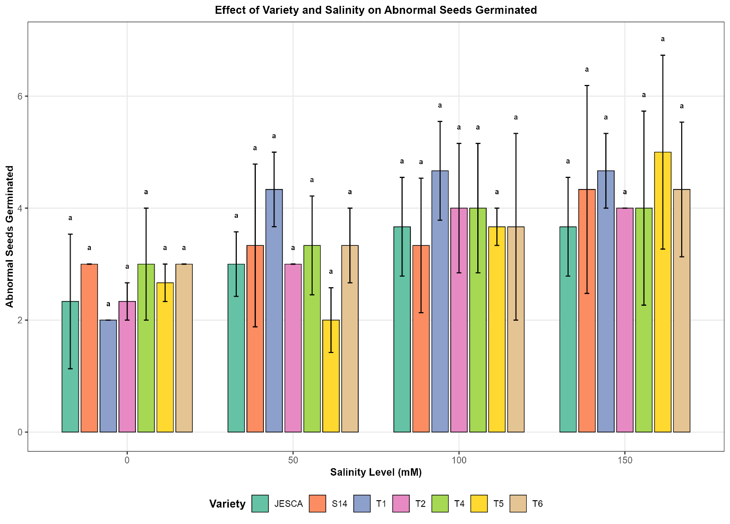 Figure 2. Effect of salinity stress on seed germination outcomes of six biofortified and one non-biofortified common bean (Phaseolus vulgaris L.) varieties. (a) Cumulative seed germination (%), (b) Number of seeds not germinated, and (c) Number of abnormally germinated seeds indicate significant differences among treatment combinations according to Tukey's HSD test (p<0.05), salinity levels: 0, 50, 100, and 150 mM NaCl
3.2 Effect of Salinity on Seedling Growth Parameters
Salinity stress significantly affected most seedling growth parameters. Shoot length was highly significantly affected by salinity (F=18.63, p<0.001), decreasing from 26-34 cm at 0 mM to 16-23 cm at 150 mM NaCl (Figure 3a). Variety TARIBEAN 5 showed the highest shoot length across all salinity levels, while JESCA exhibited the most significant reduction at high salinity (150 mM).
Root length showed a significant effect of variety (F = 2.89, p < 0.05). However, no significant effect of salinity, indicating that root development was primarily influenced by genetic factors rather than by salt stress (Figure 3b). JESCA produced the longest roots (8-9 cm) across all salinity treatments, while TARIBEAN 2 had the shortest roots (4-5 cm).
Seedling length, which combines root and shoot growth, was significantly reduced by salinity (F=12.54, p<0.001). At 0 mM, seedling length ranged from 30 to 42 cm across varieties, with TARIBEAN 5 and TARIBEAN 6 showing the highest values. At 150 mM NaCl, seedling length decreased to 24-31 cm, representing a reduction of approximately 25-35% (Figure 3c).
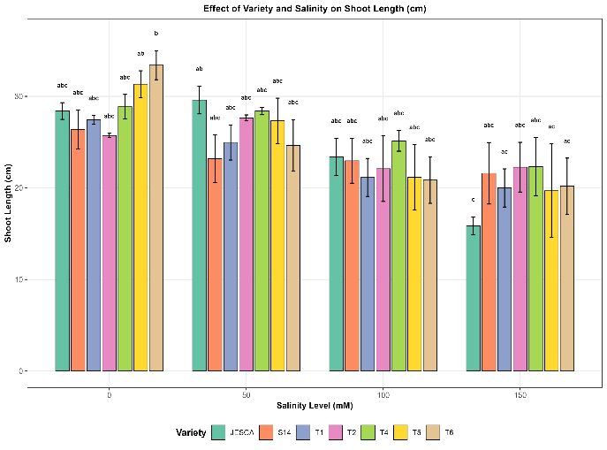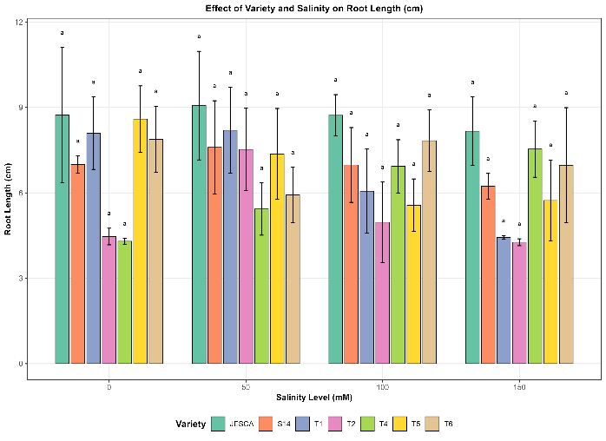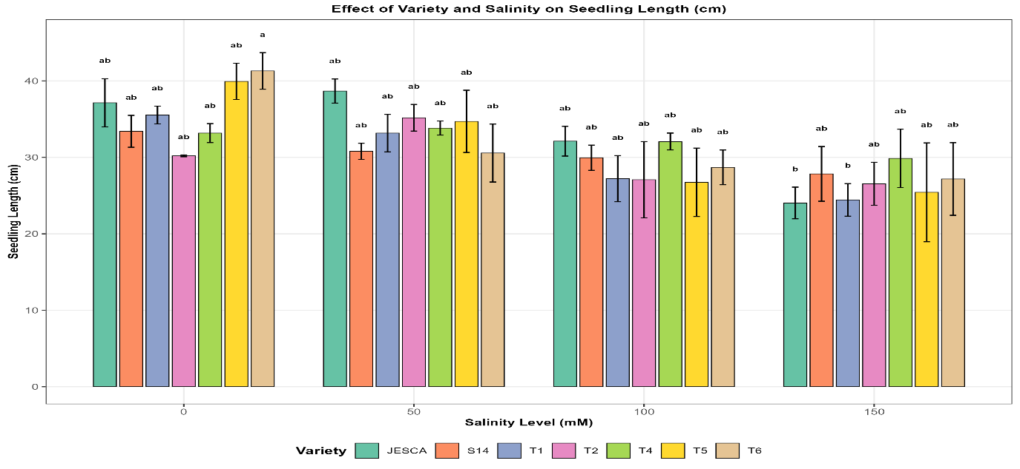 Figure 3. Effect of salinity stress on seedling length parameters of six biofortified and non-biofortified common bean (Phaseolus vulgaris L.) varieties. (a) Shoot length (cm), (b) Root length (cm), and (c) Total seedling length (cm indicate significant differences among treatment combinations according to Tukey's HSD test (p<0.05), salinity levels: 0, 50, 100, and 150 mM NaCl.
Fresh and dry weights showed significant variation and salinity effects (Figure 4). Fresh weight was highly significantly affected by both variety (F=12.45, p<0.001) and salinity (F=24.87, p<0.001). SELIAN 14 produced the highest fresh weight (14-17 g) across all treatments, while TARIBEAN 2 had the lowest values (3-7 g) (Figure 4a). Dry weight followed similar patterns, with significant effects of variety (F=4.82, p<0.001) and salinity (F=15.32, p<0.001) (Figure 4b). At high salinity (150 mM), fresh weight decreased by 40-65% compared to the control, depending on the variety.
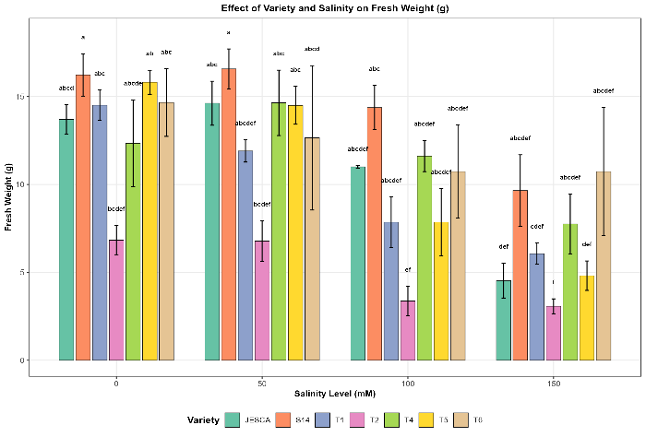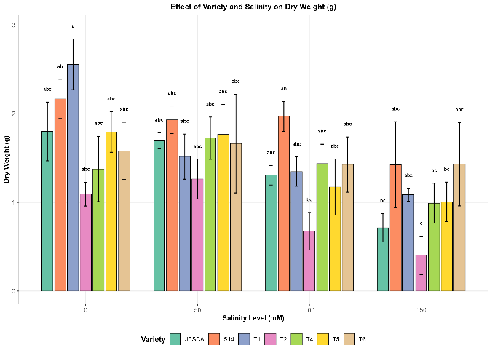 Figure 4. Effect of salinity stress on seedling biomass of six biofortified and non-biofortified common bean (Phaseolus vulgaris L.) varieties. (a) Fresh weight (g) and (b) Dry weight (g). indicate significant differences among treatment combinations using Tukey's HSD test (p < 0.05) at salinity levels of 0, 50, 100, and 150 mM NaCl.
3.3 Seedling Vigour Indices
Seedling vigour index I (SVI-I) was affected by salinity significantly (F=52.18, p<0.001). At 0 mM, SVI-I ranged from 2980 to 4100 across all tested varieties, with TARIBEAN 5 and TARIBEAN 6 showing the highest vigour. Salinity stress reduced SVI-I to 2450-3200 at 50 mM, 1620-2140 at 100 mM, and 1480-1850 at 150 mM NaCl (Figure 5a). This represents a 50-60% reduction in seedling vigour under severe salt stress.
Seedling vigour index II (SVI-II) showed significant effects of both variety (F=4.21, p<0.01) and salinity (F=32.67, p<0.001). TARIBEAN 1 exhibited the highest SVI-II at control conditions (270), while TARIBEAN 2 showed the lowest value across all treatments. At 150 mM NaCl, SVI-II decreased to 25-120, depending on variety, indicating that some varieties maintained better vigour under salt stress (Figure 5b).
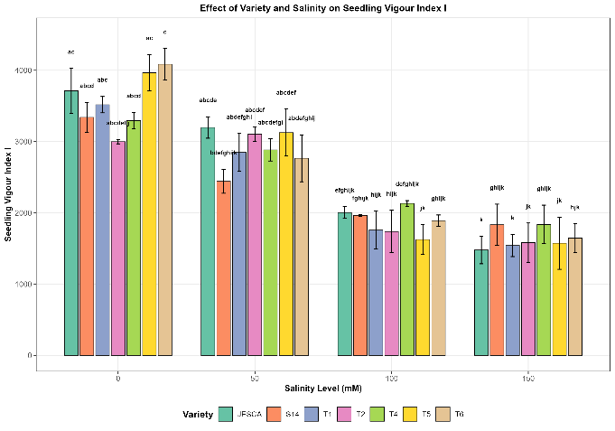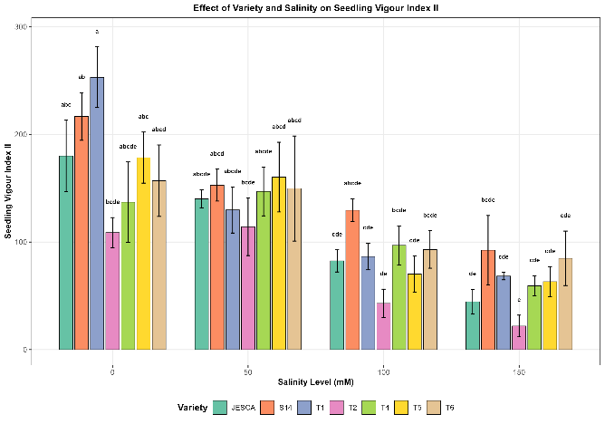
Figure 5. Effect of salinity stress on seedling vigour indices of six biofortified and non-biofortified common bean (Phaseolus vulgaris L.) varieties. (a) Seedling Vigour Index I (SVI-I = germination percentage × seedling length) and (b) Seedling Vigour Index II (SVI-II = germination percentage × dry weight) indicate significant differences among treatment combinations according to Tukey's HSD test (p<0.05), salinity levels: 0, 50, 100, and 150 mM NaCl.
3.4 Variety and Salinity Interaction
The salinity-by-variety interaction was not significant for any of the measured parameters (Table 2), indicating that all varieties responded similarly to increasing salinity stress. This suggests that the ranking of varieties remained consistent across salinity levels, and no variety exhibited specific adaptation to particular salinity conditions.

3.5 Overall Variety Performance
Among the six biofortified and one non-biofortified common bean varieties evaluated, SELIAN 14 and TARIBEAN 5 demonstrated superior performance under salt stress conditions. SELIAN 14 maintained relatively high fresh and dry weights across all salinity levels, while TARIBEAN 5 showed the highest seedling vigour indices. TARIBEAN 6 also performed well in terms of seedling length and vigour. In contrast, TARIBEAN 2 showed lower shoot and dry-weight parameters, suggesting greater sensitivity to salinity stress. JESCA demonstrated good root development but showed greater sensitivity in shoot growth parameters at high salinity levels. The coefficient of variation (CV) values ranged from 8.5% for cumulative germination to 45.2% for abnormal seed germination, indicating acceptable experimental precision for most parameters. The higher CV for abnormal germination reflects the inherent variability in this parameter.

Table 2. Analysis of variance for germination and seedling growth parameters of six biofortified and one non-biofortified common bean (Phaseolus vulgaris L.) varieties under different salinity levels (0, 50, 100, and 150 mM NaCl)
Source of variation | Df | Germ. Day3 | Germ. Day5 | Germ. Day7 | Germ. Day10 | Cum. germ. | Not germ. | Abnormal | Root length (cm) | Shoot length (cm) | Fresh wt. (g) | Dry wt. (g) | Seedling length (cm) | Vigour 1 | Vigour 2
Variety (A) | 6 | 0.68ns | 1.52ns | 0.73ns | 0.42ns | 0.36ns | 0.36ns | 0.19ns | 2.89* | 0.62ns | 12.45*** | 4.82*** | 0.68ns | 0.91ns | 4.21**
Salinity (B) | 3 | 48.72*** | 1.82ns | 1.32ns | 3.42* | 68.45*** | 68.45*** | 3.78* | 1.01ns | 18.63*** | 24.87*** | 15.32*** | 12.54*** | 52.18*** | 32.67***
A × B | 18 | 0.52ns | 0.48ns | 1.24ns | 0.92ns | 0.78ns | 0.78ns | 0.12ns | 0.98ns | 0.94ns | 1.02ns | 0.65ns | 0.96ns | 1.68ns | 0.97ns
Residual | 56 | — | — | — | — | — | — | — | — | — | — | — | — | — | —
CV (%) |  | 12.4 | 18.6 | 22.3 | 15.8 | 8.5 | 8.5 | 45.2 | 14.6 | 16.8 | 12.3 | 18.5 | 15.2 | 11.4 | 14.8
ns = not significant (P > 0.05); * = significant at P ≤ 0.05; ** = significant at P ≤ 0.01; *** = significant at P ≤ 0.001; Df = Degrees of freedom; CV = Coefficient of variation; Germ. = Germination; Cum. = Cumulative; wt. = weight. Means were compared using Tukey's honest significant difference (HSD) test at α<0.05.

4. DISCUSSION

4.1 Salinity Effects on Germination Parameters
Salt stress markedly reduced seed germination in all seven common bean varieties studied. The shift from nearly complete germination under control conditions to much lower rates at 150 mM NaCl highlights a critical threshold that threatens crop establishment in saline environments. This decrease emphasizes the vulnerability of biofortified common beans during this essential growth stage. The germination impairment suggests fundamental limitations that could challenge the adoption of these nutritionally enhanced varieties in salt-affected areas, where they are most needed.
Inhibition of germination is most severe during the early stages, when salinity effects are most potent. Statistical analysis revealed a highly significant effect of salinity on Day 3, indicating that osmotic and ionic stresses from salt rapidly impede seed hydration and metabolic processes. This early vulnerability is also seen in other legume species [19]; [20], suggesting a common response mechanism across the Fabaceae family. The physiological cause involves disrupted water absorption: osmotic stress from salt decreases the water potential gradient needed for imbibition, while ionic toxicity from Na⁺ and Cl⁻ hampers enzyme activities vital for mobilizing reserves and radicle emergence [21]; [22].
A key observation was the response difference between control and 50 mM NaCl treatments, where germination sharply declined from nearly 100% to approximately 44-54%. This sharp drop at moderate salinity suggests that common bean has limited osmotic adjustment capacity during germination, making it highly susceptible even at low to moderate soil salinity levels. The threshold effect marks the point where the seed's biochemical systems can no longer maintain the osmotic balance needed for normal germination. While osmotic stress primarily affects germination at lower salinity levels, ionic toxicity at higher salinities intensifies the stress, leading to a dual mechanism of growth inhibition [23]. This threshold is important for predicting field performance; soils with electrical conductivity above this level would greatly hinder stand establishment. In addition to reducing the final germination percentage, salinity also prolonged the germination time.
The significant delay observed on Day 10 indicates that salt stress not only inhibits germination in some seeds but also slows the germination process in those that do. Nonetheless, this delay was less significant than the overall reduction in germination, with most seeds sprouting within the first three days across all treatments. The ability of biofortified varieties to germinate quickly under stress suggests their innate vigor, which partially mitigates salt-related delays [24]. The key takeaway is that although salt stress reduces stand establishment, the germination period is likely only slightly extended, resulting in relatively synchronized seedling emergence even under moderate salinity.
Cumulative germination data revealed that salinity exerted the most decisive influence, with germination rates declining as salinity increased. This gradual response, rather than an abrupt threshold, suggests the presence of multiple mechanisms acting across the salinity spectrum. Even at 150 mM NaCl, some seeds still germinated, indicating that complete germination failure is avoided; however, the significant reduction poses challenges for crop establishment and future yields. Considering projections that climate change will increase soil salinization in arid and semi-arid regions, where common beans are a dietary staple [8];[25], these germination setbacks threaten food security for vulnerable populations.

4.2 Impact on Seedling Growth and Biomass Accumulation
Post-germination growth was affected by salinity, with shoot length decreasing significantly, especially at 150 mM NaCl. These morphological changes hinder early seedling establishment because limited shoot growth reduces photosynthesis and competitive ability during this sensitive stage. The extent of growth inhibition indicates that salt stress reduces seedling vigor, triggering a cascade from germination to vegetative growth. Notably, sensitivity differed between the shoot and root systems. While shoots were visibly impacted by salinity, root length remained unaffected. This suggests an adaptive mechanism: roots can sustain normal growth under salt stress, whereas shoots are heavily inhibited. The physiological basis involves the transpiration stream, which accumulates toxic ions in aerial tissues, whereas roots can partially exclude Na⁺ and Cl⁻ via selective membrane transport [23];[26]. Inhibition of shoot growth may serve as a protective response, reducing transpirational demand and limiting the transport of toxic ions to photosynthetic tissues.
The notable effects of variety on root development suggest that breeding for better root architecture could improve salt tolerance independently of shoot responses. The strong root performance of variety JESCA across all salinity levels indicates genuine genetic variation for this trait [27]. Biomass accumulation was most negatively affected by salt stress, with significant decreases in both fresh and dry weights across both varieties (p < 0.001) and salinity levels (p < 0.001). The reduction in fresh weight at 150 mM NaCl highlights a critical challenge to seedling vigor and future crop yields. These biomass declines stem from several interacting physiological mechanisms: decreased photosynthesis caused by stomatal closure and chlorophyll degradation; impaired nutrient uptake due to ion imbalances disrupting membrane transport; and metabolic disturbances caused by high Na⁺ and Cl⁻ levels, which hinder enzyme activity [20]; [28].
The combined influence of these factors explains why biomass reduction exceeds germination decline, as each physiological process contributes to overall stress. Variety SELIAN14 consistently showed higher biomass at all salinity levels, demonstrating stronger salt-tolerance mechanisms. This is likely due to improved osmotic adjustment, more efficient Na⁺ exclusion from shoots, and better tolerance of accumulated ions in tissues[29]. These specific responses suggest a potential for genetic enhancement of salt tolerance in biofortified common beans. Recent genome-wide association studies have identified candidate genes for salt tolerance in common bean, including ATP-binding cassette transporters and stress-related transcription factors [19]. The biomass retention of SELIAN14 may indicate favorable alleles at these gene loci, supporting marker-assisted breeding efforts.

4.3 Seedling Vigour Indices as Indicators of Salt Tolerance
Seedling vigor indices (SVI-I and SVI-II) are effective, comprehensive metrics for assessing salt stress tolerance, with reductions under high stress (150 mM NaCl). These combined parameters evaluate both germination and seedling development, providing a broader perspective on seed quality and stress resilience than individual measures. Their sensitivity to salinity makes them valuable for selecting tolerant varieties in breeding, as they reflect the impact of salt stress from germination through early growth stages. The significant differences in SVI-II among varieties indicate genetic variation in biomass preservation under salt stress, which is important for breeding. Varieties TARIBEAN 5 and TARIBEAN 6 consistently displayed higher SVI-I values at all salinity levels, highlighting genetic traits that promote germination and growth under saline conditions.
This variation indicates that salt tolerance during early development differs among biofortified varieties, and selecting for higher vigor indices could enhance both stress resilience and nutritional quality in breeding programs [21];[30]. A notable finding that questions common assumptions comes from comparing biofortified and non-biofortified varieties. TARIBEAN 1, the non-biofortified control, had the highest SVI-II under optimal conditions, but several biofortified varieties (SELIAN14, TARIBEAN 5, TARIBEAN 6) showed superior vigor under salt stress. This challenges the notion that improving nutritional traits necessarily compromises vegetative vigor or stress tolerance. Instead, it suggests that biofortification and salt tolerance can be improved together through careful genotype selection and targeted breeding. However, achieving micronutrient levels of 44 mg kg⁻¹ iron above local check varieties relies on sufficient plant growth and biomass, making the integration of these traits crucial in stress-prone environments.

4.4 Differential Variety Performance and Breeding Implications
The stability of variety rankings across salinity levels, as indicated by the absence of significant salinity-by-variety interactions, provides valuable guidance for breeding programs. This consistent ranking implies that varieties excelling under moderate stress are likely to perform similarly under harsher conditions. Such a finding has practical significance: breeding and screening can be reliably conducted under moderate salinity (50-100 mM NaCl), with confidence that the results will apply to more extreme field conditions. This uniformity streamlines breeding processes and reduces the need for extensive multi-environment testing across salinity levels [20]; [27].
Three varieties, SELIAN14, TARIBEAN 5, and TARIBEAN 6, demonstrated clear superiority in salt tolerance. SELIAN14's exceptional ability to maintain fresh and dry weights under stress, along with TARIBEAN 5's excellent seedling vigor indices, make these genotypes valuable for improvement programs. Their strong performance suggests that nutritional enhancement and stress tolerance can coexist. Additionally, genome-wide association studies have identified significant SNPs associated with salt tolerance traits in common bean, including seven associations with shoot dry weight under salt stress [19].
The salt-tolerant varieties identified here likely possess advantageous alleles at these loci, making them suitable for use in marginal environments or as donor parents in breeding programs targeting stress-prone regions of Africa and Latin America [10]. In contrast, TARIBEAN 2 exhibited the lowest performance across most measures, indicating greater salt sensitivity that could limit its use in saline conditions. This variety-level response highlights the considerable genetic variation in salt tolerance within the biofortified germplasm collection. Additionally, genetic correlation analyses in common bean have revealed trade-offs between certain agronomic traits and stress tolerance, especially a strong negative phenotypic correlation between Fe/Zn concentration and yield [31].
The generally superior performance of SELIAN14, TARIBEAN 5, and TARIBEAN 6 indicates that these trade-offs are not fixed. It is possible to enhance both nutritional quality and environmental stress tolerance concurrently through strategic breeding and careful genotype selection. The performance differences among varieties suggest that biofortified types naturally tolerate salt, offering helpful guidance for breeding programs. In particular, SELIAN14 and TARIBEAN 5 are valuable germplasm for marker-assisted selection targeting salt-tolerance genes. Candidate genes involved in salt tolerance in common bean include PvSOS1 (salt overly sensitive pathway), PvNHX1 (Na⁺/H⁺ antiporter for vacuolar sodium sequestration), and various transcription factors that regulate stress-response pathways [19]. These molecular tools, together with the phenotypic variation demonstrated here, provide a foundation for speeding up genetic improvements in breeding efforts focused on climate-resilient, nutrient-rich varieties.

4.5 Implications for Biofortification Under Climate Change Scenarios
Biofortified common bean varieties play a crucial role in combating micronutrient deficiencies affecting over 3 billion people worldwide, particularly iron and zinc deficiencies, which are significant public health concerns. However, this study underscores a significant challenge: salinity stress can impede germination and early development of these nutritionally enriched beans, potentially reducing their benefits in regions where they are most needed. Climate change projections indicate that soil salinization will intensify in arid and semi-arid regions where common beans are a staple food, affecting more than 800 million hectares of farmland globally [11].
The increasing salinity and nutritional demands among vulnerable groups highlight the urgent need for salt-tolerant, biofortified crop varieties. The decrease in fresh weight at high salinity levels directly hampers biofortification efforts. For instance, iron biofortification in common beans typically targets 44 mg kg⁻¹ above local varieties [10], but these targets depend on healthy plant growth and biomass accumulation. Salt stress that reduces growth, as shown here, could jeopardize nutritional outcomes by decreasing overall yields and altering micronutrient densities in edible parts. Although biofortified beans retain 77-91% of their iron after cooking [32], farmers can only provide nutritional benefits if enough yield is produced in salt-stressed areas.
A limitation of this research is the absence of direct measurement of micronutrient levels under stress, leaving unresolved whether salt stress influences Fe and Zn concentrations in seed tissues independently of yield effects. The identification of salt-tolerant, biofortified varieties such as SELIAN14, TARIBEAN 5, and TARIBEAN 6 offers a basis for breeding climate-resilient, nutritious crops adapted to marginalized farming environments. These findings demonstrate that salt tolerance and enhanced nutritional quality can coexist, refuting the notion that these traits are inherently mutually exclusive. Nonetheless, applying these laboratory findings to field performance requires validation under real-world conditions, including natural salinity variations, temperature changes, and multiple interacting stresses. Climate change impacts extend beyond salinity, encompassing drought, heat, and evolving pest and disease pressures [33], underscoring the need for breeding strategies that address multiple stressors simultaneously.
Future breeding efforts should aim to combine salt-tolerance genes with high-micronutrient traits, enabled by recent advances in molecular breeding. Quantitative trait loci (QTL) identified in Mesoamerican common bean populations increase Fe/Zn levels without sacrificing yield [31], providing valuable markers for marker-assisted selection. The consistent ranking of varieties across salinity levels in this study supports effective screening techniques: selecting under controlled, moderate-stress conditions (50-100 mM NaCl) can reliably predict performance in more severe field conditions, thereby facilitating faster improvement of complex traits such as salt tolerance [21]. Integrating phenotypic selection based on seedling vigor with marker-assisted selection for salt tolerance and micronutrient genes offers a quicker path to developing superior varieties.

4.6 Physiological Mechanisms Underlying Salinity Responses
Germination inhibition under salt stress occurs through both osmotic and ionic mechanisms that affect different concentration levels. At low to moderate salinity (50-100 mM NaCl), the osmotic effect predominates: increased external salt concentrations lower the water potential of the soil solution, thereby reducing the water potential gradient required for seed imbibition. This reduction in water uptake delays or stops the activation of metabolic processes essential for germination, including enzyme activation, reserve mobilization, and radicle emergence. The significant decline in germination between the control and 50 mM NaCl treatments highlights this crucial osmotic threshold [21];[23].
At higher concentrations (≥150 mM NaCl), ionic toxicity becomes more prominent. Na⁺ and Cl⁻ ions entering seed tissues disrupt enzyme activities, damage membrane integrity, and interfere with vital metabolic processes. These ionic effects add to osmotic stress, explaining the gradual decrease in germination across the salinity gradient. Salt stress also increases reactive oxygen species (ROS) production, leading to oxidative damage in cellular components like membranes, proteins, and nucleic acids [22]. The better performance of varieties SELIAN14 and TARIBEAN 5 may be linked to more effective antioxidant defense systems, possibly involving higher activities of catalase (CAT), peroxidase (POD), and superoxide dismutase (SOD) enzymes that neutralize ROS. Seed priming with compounds like salicylic acid has been shown to boost antioxidant defenses in common bean [34], suggesting a potential agronomic method to improve stress tolerance even in moderately sensitive varieties.
The increase in abnormal germination under salt stress, although statistically significant, was relatively modest compared to the effects on other parameters. This indicates that salinity mainly inhibits germination initiation rather than causing developmental abnormalities in germinating seeds. However, any occurrence of abnormal germination under stress indicates disruption in developmental regulation, possibly due to ion imbalances that interfere with hormonal signaling pathways responsible for radicle and plumule development. Some studies have shown that halopriming (pre-conditioning seeds with salt solutions) can improve subsequent germination, seedling establishment, and even fruit production by triggering adaptive physiological and biochemical changes [35].
The relatively low rate of abnormal germination observed in the biofortified varieties tested here may reflect inherent developmental stability that could be further enhanced through specific seed treatments. The tolerance differences among varieties likely involve ion balance and osmotic regulation. Salt-tolerant genotypes often restrict Na⁺ transport to shoots, maintaining higher K⁺/Na⁺ ratios in tissues critical for enzyme activity and metabolism [26]. Better shoot and root biomass maintenance in SELIAN14 suggests an enhanced ability to absorb ions and compartmentalize them selectively. Root-to-shoot ratio and antioxidant enzyme activities, especially SOD, have been linked to salt stress sensitivity in common bean seedlings, providing potential biochemical markers for early breeding selection [36].
The mechanisms underlying salt tolerance in SELIAN14 and TARIBEAN 5 likely involve coordinated regulation of multiple physiological processes at cellular, tissue, and whole-plant levels. At the molecular level, salt tolerance in common bean involves genes for ATP-binding cassette transporters (for ion compartmentalization), transcription factors (for coordinated stress gene expression), and proteins involved in signal transduction pathways that detect and respond to osmotic and ionic stresses [19]. Osmotic adjustment through the accumulation of compatible solutes (such as proline, glycine betaine, and sugars) helps maintain turgor pressure and cell expansion under salt stress. Simultaneously, the compartmentalization of Na⁺ and Cl⁻ into vacuoles prevents ionic toxicity in the cytoplasm. Enhanced expression of antioxidant enzymes defends against oxidative damage, while stress-responsive transcription factors regulate the expression of multiple genes involved in these protective mechanisms [29]. Understanding these integrated mechanisms provides a framework for developing breeding strategies that combine multiple tolerance traits to achieve robust, stable performance across diverse saline environments.
5. CONCLUSION AND RECOMMENDATION
This study shows salinity stress significantly impairs seed germination and seedling growth in both biofortified and non-biofortified common bean varieties, potentially reducing yields. The effects were dose-dependent, with notable decreases even at moderate salt levels (50 mM NaCl) and further at higher concentrations (100-150 mM NaCl). Of the seven varieties evaluated, three biofortified ones, SELIAN14 (S14), TARIBEAN 5, and TARIBEAN 6, showed greater salinity tolerance, maintaining higher germination, biomass, and seedling vigor.
SELIAN14 retained its fresh and dry biomass under saline conditions, while TARIBEAN 5 showed the highest seedling vigor indices. TARIBEAN 2 scored lowest on most parameters, indicating salt sensitivity. The absence of significant interactions between variety and salinity suggests performance rankings are stable across salt levels.
Based on this study, the salt-tolerant biofortified varieties SELIAN14, TARIBEAN 5, and TARIBEAN 6 are recommended for cultivation in moderately saline areas of Tanzania and similar regions in sub-Saharan Africa. These varieties offer improved nutritional quality and better salinity tolerance during establishment. To optimize productivity in salt-affected areas, supplemental agronomic practices, including soil, water, variety, and nutrient management, should be implemented. Seed priming with salicylic acid prior to planting is recommended to enhance antioxidant defenses and salt stress tolerance during germination. For breeding, variety rankings across salinity levels support the use of controlled-screening environments to select salt-tolerant genotypes efficiently. SELIAN14 and TARIBEAN 5 are recommended as donor parents for salt tolerance traits in breeding programs.
Future research should validate salt-tolerant varieties (SELIAN 14, TARIBEAN 5, 6) across multiple saline environments to corroborate laboratory results and assess yield stability. Studies should examine the molecular, biochemical, and physiological mechanisms underlying salt tolerance, including antioxidant activity, ion homeostasis, and osmotic adjustment. Nutritional assessments are needed to examine how salt stress affects seed iron and zinc levels to meet biofortification goals. Developing markers for salt-tolerance traits will aid marker-assisted breeding for climate-resilient, biofortified crops.
Finally, assessing how these varieties perform under combined stress conditions will provide insights into their resilience in real-world climate change scenarios. Combining genomic techniques with conventional breeding methods creates promising prospects for developing next-generation biofortified varieties that are better equipped to handle climate challenges.

CONSENT FOR PUBLICATION
This study did not involve human participants, human data, or human tissue. The research was conducted exclusively on plant materials; therefore, no consent for publication was required.

Ethical Approval
This study involved agricultural research on plant materials and did not require ethical approval as no human participants or animals were involved. All experiments were conducted in accordance with institutional guidelines and national regulations governing agricultural research in Tanzania.

COMPETING INTERESTS DISCLAIMER:
Authors have declared that they have no known competing financial interests OR non-financial interests OR personal relationships that could have appeared to influence the work reported in this paper.

References
Petry, N., Boy, E., Wirth, J. P., & Hurrell, R. F. (2015). Review: The potential of the common bean (Phaseolus vulgaris) as a vehicle for iron biofortification. Nutrients, 7(2), 1144–1173. https://doi.org/10.3390/nu7021144
Arumugam, P., Duku, C., Groot, A. M. E., Demissie, T., Nzoka, O., Wainaina, I., Mate, H., & Osumba, J. (2024). Common bean in Kenya: Climate Risk and Opportunities. SNV. https://edepot.wur.nl/696303
Siddiq, M., Uebersax, M. A., & Siddiq, F. (2022). Global production, trade, processing, and nutritional profile of dry beans and other pulses. In Dry beans and pulses: Production, processing, and nutrition (pp. 1–28). https://doi.org/10.1002/9781119776802.ch1
Birachi, E. A., Sperling, L., Kadege, E., Mdachi, M., Upendo, T., Radegunda, K., Mutua, M., Mbiu, J., Raya, N., Ndunguru, A., William, M., Maganga, R., Kalemera, S., Katungi, E., Mukankusi, C., Malle, S., Dey, B., Templer, N., Rubyogo, J. C., Onyango, P., & Buruchara, R. (2021). Analysis of the Yellow Bean Corridor in Tanzania. Feed the Future Global Supporting Seed Systems for Development activity. Catholic Relief Services. https://hdl.handle.net/10568/115720
5. Ndimbo, M., Shida, N., Mbiu, J., Kilango, M., Madata, C., Binagwa, P., and Kasuga, R. (2022). Variety catalogue of common beans (Phaseolus vulgaris) in Tanzania. TARI Research Publication, 1.
Mohamed, H. I., El-Sayed, A. A., Rady, M. M., Caruso, G., Sekara, A., & Abdelhamid, M. T. (2021). Coupling effects of phosphorus fertilization source and rate on growth and ion accumulation of common bean under salinity stress. PeerJ, 9, e11463. https://doi.org/10.7717/peerj.11463
Munns, R., James, R. A., Gilliham, M., Flowers, T. J., & Colmer, T. D. (2016). Tissue tolerance: an essential but elusive trait for salt-tolerant crops. Functional Plant Biology, 43(12), 1103–1113. https://doi.org/10.1071/FP16187
Negacz, K., Malek, Ž., de Vos, A., & Vellinga, P. (2022). Saline soils worldwide: Identifying the most promising areas for saline agriculture. Journal of Arid Environments, 203, 104775. https://doi.org/10.1016/j.jaridenv.2022.104775
Omar, M. M., Shitindi, M. J., Massawe, B. H. J., Fue, K. G., Meliyo, J. L., & Pedersen, O. (2023). Salt-affected soils in Tanzanian agricultural lands: Type of soils and extent of the problem. Sustainable Environment, 9(1), 2205731. https://doi.org/10.1080/27658511.2023.2205731
Beebe, S. (2020). Biofortification of common bean for higher iron concentration. Frontiers in Sustainable Food Systems, 4, 573449. https://doi.org/10.3389/fsufs.2020.573449
Huertas, R., Karpinska, B., Ngala, S., Mkandawire, B., Maling'a, J., Wajenkeche, E., Kimani, P. M., Boesch, C., Stewart, D., Hancock, R. D., & Foyer, C. H. (2023). Biofortification of common bean (Phaseolus vulgaris L.) with iron and zinc: Achievements and challenges. Food and Energy Security, 12(2), e406. https://doi.org/10.1002/fes3.406
Meliyo, J. L., Kashenge-Killenga, S., Victor, K. M., Mfupe, B., Hiza, S., Kihupi, A. L., Boman, B. J., & Dick, W. (2017). Evaluation of Salt Affected Soils for Rice (Oryza Sativa) Production in Ndungu Irrigation Scheme Same District, Tanzania. Sustainable Agriculture Research, 6(1), 24–38. https://doi.org/10.22004/ag.econ.265130
Cai, Y.-H. (2022). *Osmotic backwash for fouling control in solar energy-powered nanofiltration/reverse osmosis membrane systems* [Doctoral dissertation, Karlsruher Institut für Technologie (KIT)]. https://doi.org/10.5445/IR/1000146013
Semida, W. M., & Rady, M. M. (2014). Pre-soaking in 24-epibrassinolide or salicylic acid improves seed germination, seedling growth, and anti-oxidant capacity in Phaseolus vulgaris L. grown under NaCl stress. The Journal of Horticultural Science and Biotechnology, 89(3), 338–344. https://doi.org/10.1080/14620316.2014.11513088
Masud, U. S. M. R. (2018). Salinity effect on germination, growth and yield performance of mungbean (Vigna radiata L.). (Master's thesis, Sher-e-Bangla Agricultural University, Dhaka, Bangladesh) http://archive.saulibrary.edu.bd:8080/xmlui/handle/123456789/3122
International Seed Testing Association. (2024). *International Rules for Seed Testing*. International Seed Testing Association, Bassersdorf, Switzerland. https://www.seedtest.org/rules
Ellis, R. H., & Roberts, E. H. (1981). The quantification of ageing and survival in orthodox seeds. Seed Science and Technology, 9(2), 373–409. https://www.seedtest.org/en/seed-science-and-technology-_content---1--1084.html
Abdul-Baki, A. A., & Anderson, J. D. (1973). Vigor determination in soybean seed by multiple criteria. Crop Science, 13(6), 630–633. https://doi.org/10.2135/cropsci1973.0011183X001300060013x
Raggi, L., Caproni, L., Ciancaleoni, S., D'Amato, R., Businelli, D., & Negri, V. (2024). Investigating the genetic basis of salt-tolerance in common bean: a genome-wide association study at the early vegetative stage. Scientific Reports. https://doi.org/10.1038/s41598-024-55403-z
Ehtaiwesh, A., Sunoj, V. S. J., Djanaguiraman, M., & Prasad, P. V. V. (2024). Response of winter wheat genotypes to salinity stress under controlled environments. Frontiers in Plant Science. https://doi.org/10.3389/fpls.2024.1396498
21. Boudiar, R., Alshallash, K.S., Alharbi, K., Okasha, S.A., and Fenni, M. (2023). Differences in the physiological indicators of seed germination and seedling establishment of durum wheat (Triticum durum Desf.) cultivars subjected to salinity stress. Agronomy, 13(7), 1718. https://doi.org/10.3390/agronomy13071718
Hao, S., Wang, Y., Yan, Y., Liu, Y., Wang, J., & Chen, S. (2021). A review on plant responses to salt stress and their mechanisms of salt resistance. Horticulturae. https://doi.org/10.3390/horticulturae7060132
Shahid, M. A., Sarkhosh, A., Khan, N., Balal, R. M., Ali, S., Rossi, L., Gómez, C., Mattson, N., Nasim, W., & Garcia-Sanchez, F. (2020). Insights into the physiological and biochemical impacts of salt stress on plant growth and development. Agronomy, 10(7), 938. https://doi.org/10.3390/agronomy10070938
Meza, C., Valenzuela, F., Echeverría-Vega, A., Gomez, A., Sarkar, S., Cabeza, R. A., Arencibia, A. D., Quiroz, K., Carrasco, B., & Banerjee, A. (2022). Plant-growth-promoting bacteria from rhizosphere of Chilean common bean ecotype (Phaseolus vulgaris L.) supporting seed germination and growth against salinity stress. Frontiers in Plant Science, 13, 1052263. https://doi.org/10.3389/fpls.2022.1052263
El-Mageed, T. A. A., El-Mageed, S. A. A., Semida, W. M., & Rady, M. M. (2024). Investigating the influence of eco-friendly approaches on saline soil traits and growth of common bean plants (Phaseolus vulgaris L.). PeerJ, 12, e17828. https://doi.org/10.7717/peerj.17828
Jha, U. C., Bohra, A., Jha, R., & Parida, S. K. (2019). Salinity stress response and 'omics' approaches for improving salinity stress tolerance in major grain legumes. Plant Cell Reports, 38, 255–277. https://doi.org/10.1007/s00299-019-02374-5
Papathanasiou, F., Ninou, E., Mylonas, I., Baxevanos, D., Papadopoulou, F., Avdikos, I., Sistanis, I., Koskosidis, A., Vlachostergios, D. N., Stefanou, S., Tigka, E., & Kargiotidou, A. (2022). The evaluation of common bean (Phaseolus vulgaris L.) genotypes under water stress based on physiological and agronomic parameters. Plants, 11(18), 2432. https://doi.org/10.3390/plants11182432
Islam, M. S., Islam, M. R., Hasan, M. K., Hafeez, A. S. M. G., Chowdhury, M. K., Pramanik, M. H., Iqbal, M. A., Erman, M., Barutcular, C., Konuşkan, Ö., Dubey, A., Kumar, A., & El Sabagh, A. (2024). Salinity stress in maize: Consequences, tolerance mechanisms, and management strategies. OBM Genetics, 8(2), 232. https://doi.org/10.21926/obm.genet.2402232
Ragaey, M. M., Sadak, M. S., Dawood, M. F. A., Mousa, N. H. S., Hanafy, R. S., & Latef, A. A. H. A. (2022). Role of signaling molecules, sodium nitroprusside and arginine, in alleviating salt-induced oxidative stress in wheat. Plants, 11(14), 1786. https://doi.org/10.3390/plants11141786
Irik, H. A., & Bikmaz, G. (2024). Effect of different salinity on seed germination, growth parameters and biochemical contents of pumpkin (Cucurbita pepo L.) seeds cultivars. Scientific Reports. https://doi.org/10.1038/s41598-024-55325-w
Diaz, S., Polania, J., Ariza-Suarez, D., Cajiao, C., Grajales, M., Raatz, B., & Beebe, S. E. (2022). Genetic correlation between Fe and Zn biofortification and yield components in a common bean (Phaseolus vulgaris L.). Frontiers in Plant Science. https://doi.org/10.3389/fpls.2021.739033
32. Hummel, M., Talsma, E. F., Taleon, V., Londoño, L., Brychkova, G., Spillane, C., and McKeown, P. C. (2020). Iron, zinc, and phytic acid retention of biofortified, low phytic acid, and conventional bean varieties when preparing common household recipes. Nutrients, 12(3), 658. https://doi.org/10.3390/nu12030658
Hummel, M., Hallahan, B.F., Brychkova, G., Ramirez-Villegas, J., Guwela, V., Chataika, B., Curley, E., McKeown, P.C., Morrison, L., Talsma, E.F., Beebe, S., Jarvis, A., Chirwa, R., & Spillane, C. (2018). Reduction in nutritional quality and growing area suitability of common bean under climate change induced drought stress in Africa. Scientific Reports https://doi.org/10.1038/s41598-018-33952-4
Karimi, M. R., Sabokdast, M., Korang Beheshti, H., Abbasi, A. R., & Bihamta, M. R. (2025). Seed priming with salicylic acid enhances salt stress tolerance by boosting antioxidant defense in Phaseolus vulgaris genotypes. BMC Plant Biology, 25(1), 489. https://doi.org/10.1186/s12870-025-06376-2
Borromeo, I., Domenici, F., Giordani, C., Del Gallo, M., & Forni, C. (2024). Enhancing bean (Phaseolus vulgaris L.) resilience: Unveiling the role of halopriming against saltwater stress. Seeds, 3(2), 228-250. https://doi.org/10.3390/seeds3020018
García, M., García, G., Parola, R., Maddela, N.R., Pérez-Almeida, I., & Garcés-Fiallos, F.R. (2024). Root-shoot ratio and SOD activity are associated with the sensitivity of common bean seedlings to NaCl salinization. Rhizosphere, 29, 100848. https://doi.org/10.1016/j.rhisph.2024.100848

