Original Research Article

Probabilistic Topological Optimization of Rotational Friction Dampers for Seismic Retrofit of Shear Buildings

.
ABSTRACT

This research presents a probabilistic performance-based assessment regarding the topological optimization of Rotational Friction Dampers for the seismic retrofit of a 10-story benchmark shear building. To accurately capture the non-linear stick-slip behavior of the devices, the Non-Smooth Dynamics method was integrated into a Monte Carlo simulation framework. The study analyzed the sensitivity of the seismic response across a broad design space, evaluating randomized configurations subjected to five diverse seismic excitations. Statistical processing of the data concluded that the quantity and the slip load capacity are the governing design parameters. Results indicate that structural performance improves with increased damper quantity and higher resistance, converging towards high frictional moments (400–500 kNm). However, a distinct saturation point was identified at 7 dampers, beyond which the system exhibits diminishing returns. Furthermore, the topological analysis revealed a strict requirement for damper installation in the lower stories to control the soft-story mechanism, whereas the upper levels demonstrated topological flexibility. The study concludes that rather than searching for a singular "perfect" configuration, engineers should target "robust performance zones", which offer multiple optimal arrangements capable of accommodating seismic uncertainty.

Keywords: Rotational friction dampers, steel moment-resisting frames, nonlinear analysis, NSD method

1. INTRODUCTION

The seismic-resistant design of medium and high-rise structures necessitates structural systems capable of handling extreme demands. Passive control systems have emerged as an efficient alternative, dissipating energy to prevent significant plastic deformations in the main structure [1]. Among these, friction dampers, specifically Rotational Friction Dampers (RFD), stand out for their reliability, cost-effectiveness, and mechanical simplicity [2], [3].

Through an exhaustive review of the state of the art, it has been observed that their research has mainly focused on the optimization of their design parameters, such as their geometry and slip load, as well as their optimal location. In recent research(Namorado, Pinto Da Costa y Simões, 2022), it has been found that the optimal friction moment (M_{f}) can result in a relatively wide range, rather than a precise configuration, in addition to being relatively insensitive to variations in structural properties (+-20%)(Ampiah y Zhao, 2020). Such a contribution implies that the search for optimization must change the focus of the search from local performance optima to zones of optimal performance.

The problem addressed by this research arises from questioning if the exact value of the friction moment is not strictly a specific configuration, but a range, the location of optimal configuration presents the same property? Different investigations have addressed the search for an optimal configuration through complex optimization algorithms (Miguel, Miguel y Lopez, 2016; Ampiah y Zhao, 2020; Jarrahi, Asadi, Khatibinia y Etedali, 2020), but it is (Jarrahi, Asadi, Khatibinia, Etedali, et al., 2020), which studies optimization by varying the quantity and M_{f}, that exposes some tendencies about the preferable location, similarly, in (Ampiah y Zhao, 2020) concludes that there is a clear tendency to install dampers preferably in the lower zones of the structure, although a comprehensive analysis of the statistical reliability of these locations is lacking

This research aims to resolve this gap, focusing on a probabilistic performance-based approach. Using the Non-Smooth Dynamics (NSD) method (Namorado, Pinto Da Costa y Simões, 2022), to properly capture the non-linear behavior of RFD’s, this study also uses a Monte Carlo simulation framework to analyze a benchmark structure proposed by Wong in (Wong y Johnson, 2009). Different from other studies, this study analyzes the sensitivity of the seismic response as a function of the location and quantity

2. Methodology

This section details the numerical framework developed to evaluate the robust placement of friction dampers. It describes the benchmark structure, the mechanism of RFD, the use of NSD, the statistical Monte Carlo model used for this study, and finally the procedure used to obtain the results

2.1. Benchmark structural model

To evaluate the efficiency of the proposed optimization framework, a ten-story shear building model, originally introduced as a benchmark structure by Wong and Johnson [6], and illustrated in Fig. 1, is adopted. This structure is a medium rise building where, for simplification of the dynamic problem, the assumption of rigid floor diaphragms is applied, allowing a manageable number of degrees of freedom (DOF´S), compatible with NSD method.

The structural properties are characterized by a non-uniform distribution of stiffness along the height, but constant in mass, as it was defined in (Jarrahi, Asadi, Khatibinia, Etedali, et al., 2020). The mass of each floor is assumed to be 218.9 tons per floor. The lateral stiffness profile (k_{i}) varies along the height, which was calculated by applying a unitary load to each floor to match the dynamic characteristics of the benchmark reference. The inherent structural damping is modeled using the Rayleigh damping theory, calibrated to provide a damping ratio of 3% for the first two modes of vibration.

In order to conduct a validation of the use of NSD, the benchmark model seismic response was compared with the research (Jarrahi, Asadi, Khatibinia, Etedali, et al., 2020), resulting in the same lateral profile displacement. As can be seen in fig. 2 and fig 3. Also, a time history analysis was conducted on SAP2000 with the 1940 earthquake El Centro. The results, presented in Fig. 4, demonstrate that the proposed NSD algorithm produces an almost identical response to the commercial software, confirming the accuracy of the integration scheme.

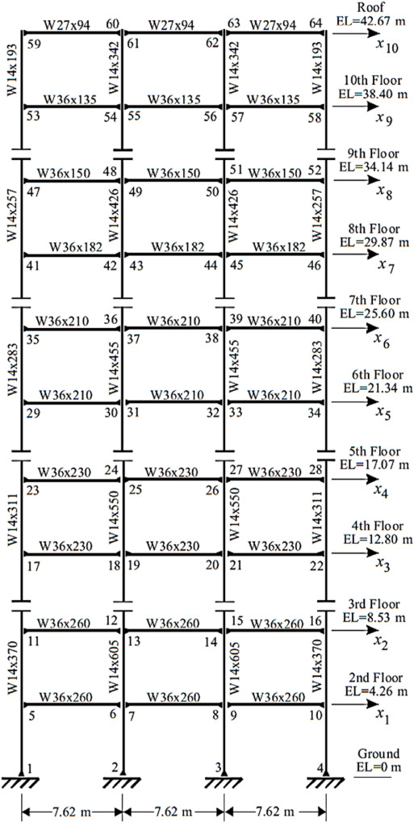

Fig. 1 Ten-story SMRF

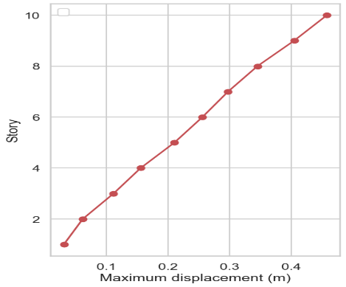  Fig. 2 Relative displacement profile of 10 story SMRF analyzed with NSD | 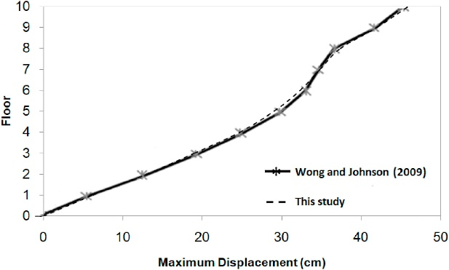  Fig. 3 Relative displacement profile of 10 story SMF subjected to Northridge (Jarrahi, Asadi, Khatibinia, Etedali, et al., 2020)

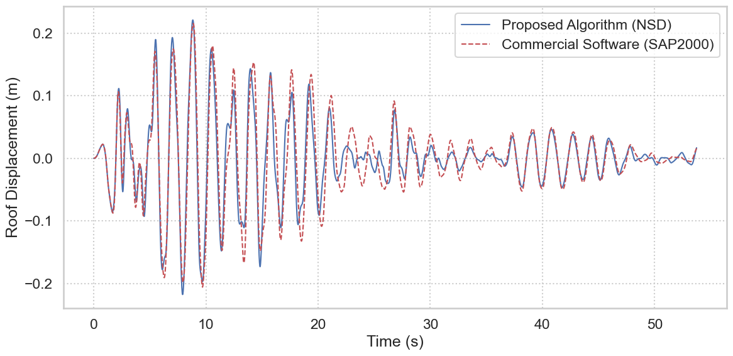
Fig. 4 Comparation of Time history analysis of El Centro Earthquake with NSD method and SAP2000,

2.2. Numerical modeling of rotational friction dampers

The rotational friction dampers (RFD), shown in are defined based on the ideal Coulomb friction law. Unlike viscous dampers, the behavior of an RFD is frequency-independent but highly non-linear due to the "stick-slip" phenomenon, as can be seen in Fig.5. The mechanism of this device results in a mathematical description of a backbone in Fig. 6. To properly capture this non-linear behavior, the non-smooth dynamics (NSD) method is employed, as developed and validated by Namorado et al. (Namorado, Pinto Da Costa y Simões, 2022).
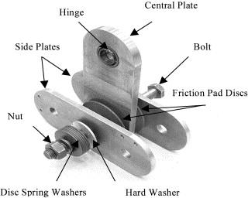Fig. 5 Rotational frictional damper | 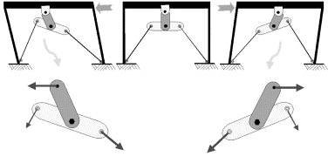Fig. 6 RFD Mechanism

Essentially, the resistive force, known as FRDF (t), generated from the damper installed at the i-th story is defined by the relative velocity between floors ($\dot{u_{j}}- \dot{u_{j-1} }$). This behavior can be described by the signum function inclusion in eq. 1:

$${\text{F}}_{\text{RFD,j }}\left(\text{t}\right)\text{∈ -}{\text{F}}_{\text{slip,j }}\text{ Sgn (}\dot{{\text{u}}_{\text{j}}}\text{- }\dot{{\text{u}}_{\text{j-1}} }\text{)}$$ | (1)

Where $F_{RFD,j }$is the slip force capacity, related to the frictional moment and the lever arm $h_{a}$, by the relationship ${\text{F}}_{\text{slip }}\text{=}\frac{{\text{M}}_{\text{f}}}{{\text{h}}_{\text{a}}}$. The state of the damper is determined at each time step: if the external force is lower than M_{f}, the damper remains in a "stick" state. If the force exceeds this condition, it enters a "slip" mode, dissipating energy through a rectangular hysteretic loop.

2.3. Probabilistic optimization framework

As the properties of study are the location and quantity, this study adopts a Monte Carlo simulation (MCS) framework to explore the global response space.
The simulation process was conducted as follows:

The topology of the RFD was defined as a binary 10-dimensional vector, where indicates the absence or presence of a damper at the i-th story.

The M_{f}´s were defined as discrete variables representing the friction moment, swept across a broad range from 25 KN-m to 500 KN-M to cover from under-damped to locked (rigid) scenarios.

A 280 sampling configurations were solved through the solution of the dynamic equation of motion (Eq.2), from 1024 topologically possible configurations; each configuration was evaluated using 5 different earthquake records and a wide range of M_{f}, using a custom high-performance Python routine optimized with Numba, allowing a rapid integration of a total of 30,000 nonlinear time history analyses This results in a comprehensive dataset covering the entire spectrum of possible quantities of RFD.
$$\text{M} \ddot{\text{u}}\text{ +C} \dot{\text{u}}\text{+K u =M}\ddot{{\text{u}}_{\text{g}}}$$ | (2)

2.4. Performance indices and earthquake ground motions

In order to establish a reference of the performance of the RFD, Mualla defines a criterion (Mualla y Belev, 2002), described as follows in eq. 3, 4, 5, 6 and 7.

$${\text{R}}_{\text{1}}\text{=}\frac{{\text{X}}_{\text{NfMax}}}{{\text{X}}_{\text{N}\text{0}\text{Max}}}$$ | (3)
$${\text{R}}_{\text{2}}\text{=}\frac{{\ddot{\text{X}}}_{\text{NfMax}}}{{\ddot{\text{X}}}_{\text{N}\text{0}\text{Max}}}$$ | (4)
$${\text{R}}_{\text{3}}\text{=}\frac{{\text{F}}_{\text{bf}}}{{\text{F}}_{\text{b}\text{0}}}$$ | (5)
$$\text{c}{\text{r}}_{\text{1}}\text{= }\sqrt{{\text{R}}_{\text{1}}^{\text{2}}\text{+}{\text{R}}_{\text{2}}^{\text{2}}}$$ | (6)
$$\text{c}{\text{r}}_{\text{2}}\text{= }\sqrt{{\text{R}}_{\text{1}}^{\text{2}}\text{+}{\text{R}}_{\text{2}}^{\text{2}}\text{+}{\text{R}}_{\text{3}}^{\text{2}}}$$ | (7)

Where R₁, R₂, and R₃ represent the weights of the maximum relative displacement, the maximum absolute acceleration, and the base shear of the frictionally damped case, respectively, with respect to the values of the undamped case.

It must be considered that minimizing drift often penalizes accelerations or base shear, two combined efficiency criteria CR₁ and CR₂ are proposed to identify equilibrated designs.

3. results and discussion

(Fig. 6 through 10) present the box-and-whisker plots correlating the number of friction dampers with the performance coefficient. Across all five graphs, a distinct trend of improved performance is evident as the number of devices increases. However, significant outliers are notably present, particularly in the range of 3 to 7 dampers. This variability suggests that factors beyond mere quantity—specifically the topological arrangement and the slip load play a critical role in the structural response, causing certain configurations to underperform despite having an adequate number of devices.
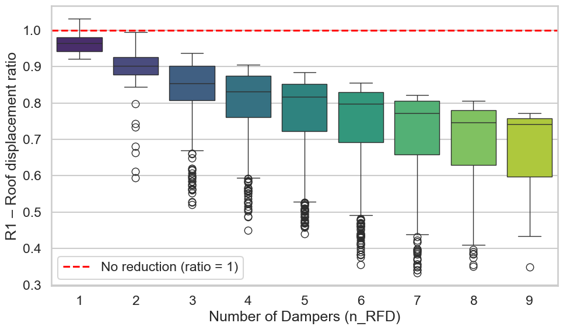
Fig. 7 Distribution of roof displacement reduction (R1) as a function of the number of dampers
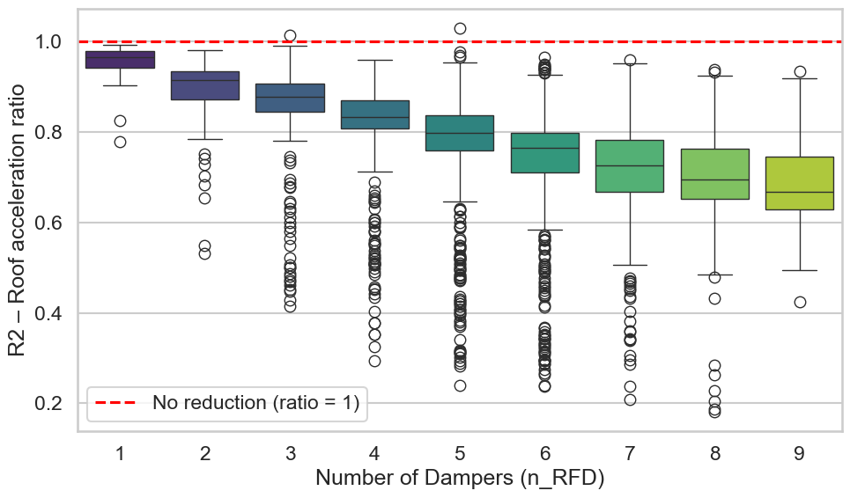
Fig. 8 Distribution of roof displacement reduction (R2) as a function of the number of dampers
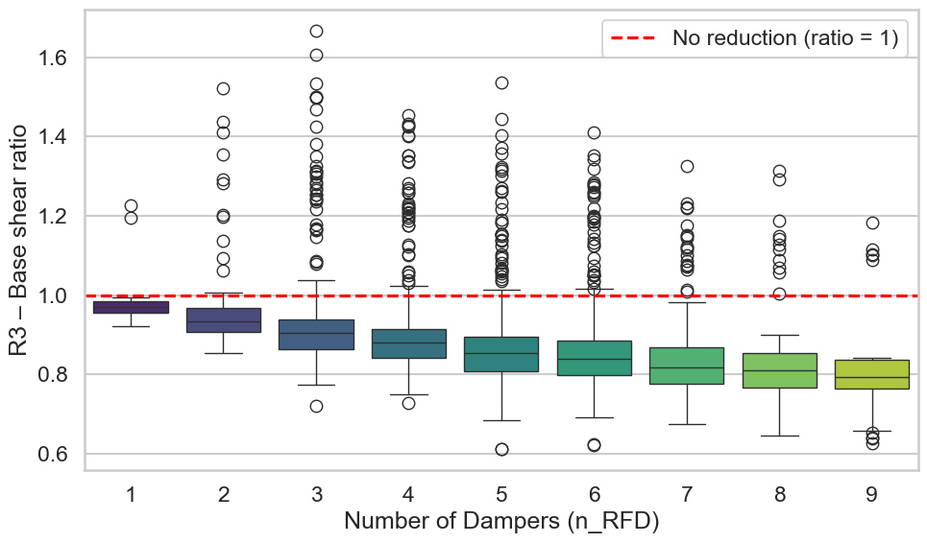
Fig. 9 Distribution of roof displacement reduction (R3) as a function of the number of dampers
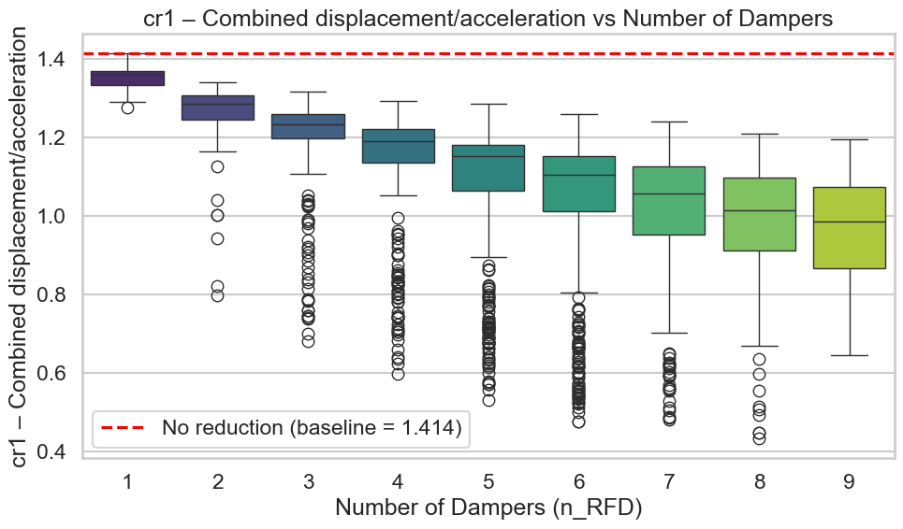
Fig. 10 Distribution of roof displacement reduction (CR1) as a function of the number of dampers

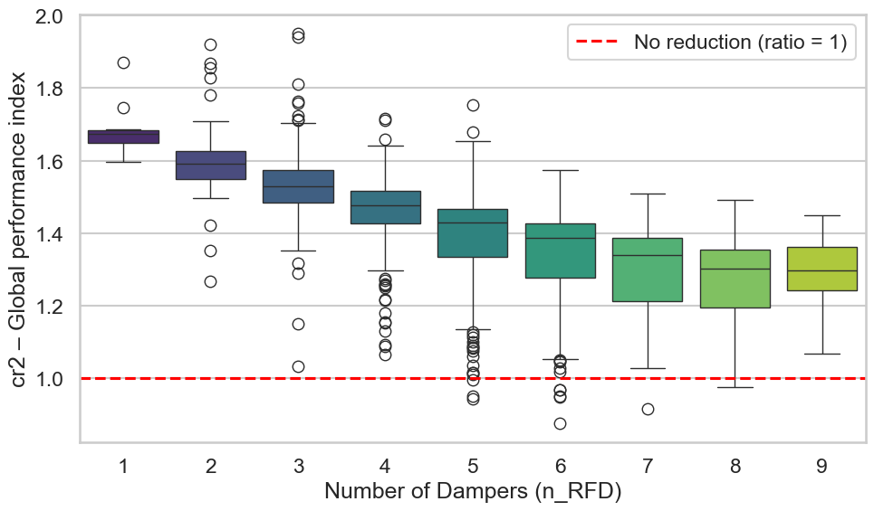
Fig. 11 Distribution of roof displacement reduction (CR2) as a function of the number of dampers

To verify if this trend persists under optimal conditions, the top 5% of results were isolated, as shown in (Fig. 8). This elite subset exhibits a similar trajectory of performance enhancement with increasing damper count, yet it stabilizes once the quantity reaches 7 units. This plateau implies that beyond this threshold (), the system becomes less sensitive to specific variations in placement and, achieving a state of robustness where the exact arrangement becomes less critical. Conversely, the analysis highlights a substantial risk associated with using sparse configurations (). These cases exhibit a wide performance range with extreme outliers, indicating a high dependency on precise placement to avoid ineffective designs.

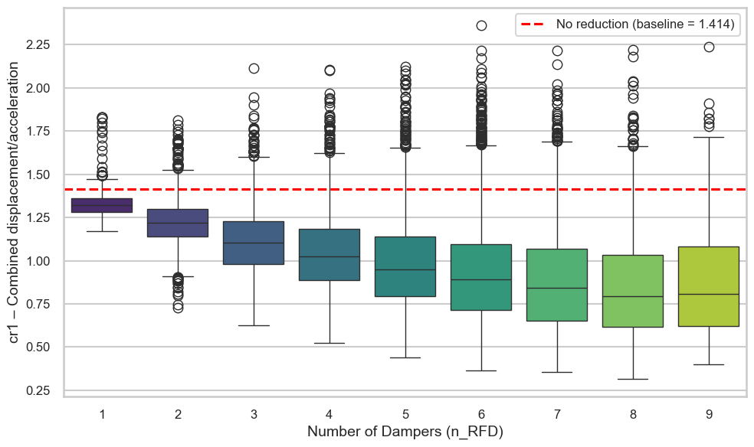Fig. 12 Distribution of roof displacement reduction (CR1) as a function of the number of dampers in top 5% topological configurations

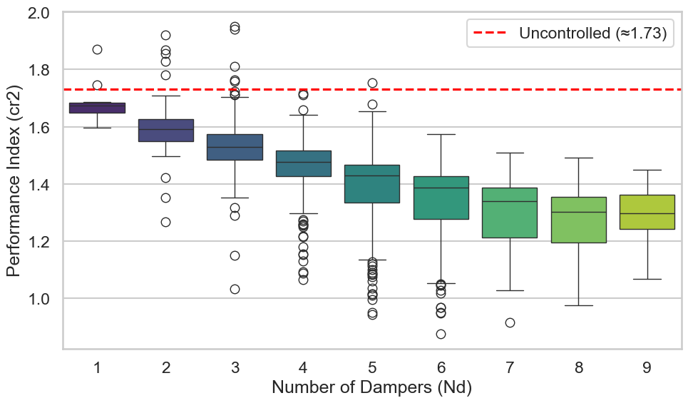 Fig. 13 Distribution of roof displacement reduction (CR2) as a function of the number of dampers in top 5% topological configurations

Regarding the specific influence of location, (Fig. 9 and 10) illustrate the Spearman correlation between damper presence at a specific story and the performance coefficients and, for both the global and elite datasets. A relatively homogeneous distribution is observed across the first six levels, contrasting sharply with the disparity found in the upper stories (7 through 10). While stories 2, 3, 5, and 6 appear as strong candidates for damper installation, the moderate correlation values suggest that these locations represent preferential tendencies rather than absolute design rules.

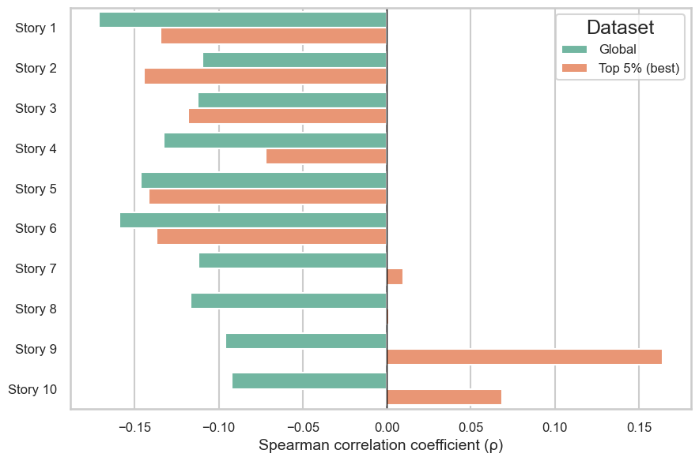
Fig. 14 Story-wise influence of damper placement on CR1: Spearman correlation for the global set and the Top 5% configurations

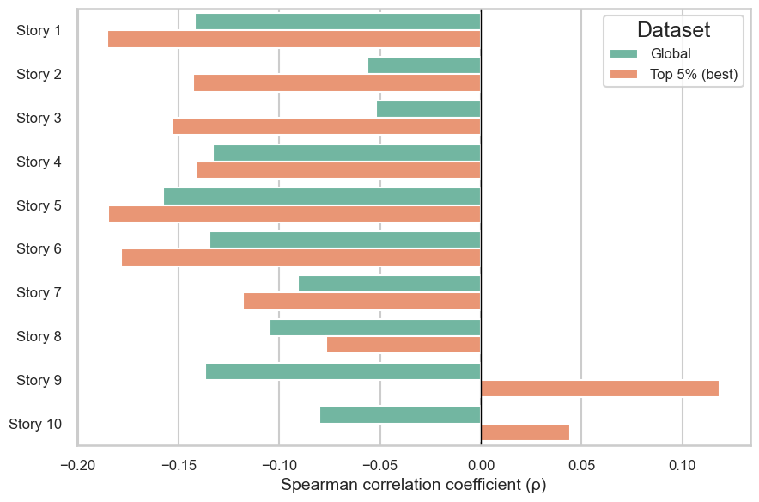
Fig. 15Story-wise influence of damper placement on CR2: Spearman correlation for the global set and the Top 5% configurations

In (Fig. 11 and 12) summarize the and performance relative to both quantity and slip load (). A "valley" of optimal performance is clearly distinguishable, concentrated around a configuration of 8 dampers with slip loads ranging from 350 to 450 kNm. This allows us to affirm that global optimization is defined by performance zones rather than a singular unique arrangement. This is further reinforced by the heatmaps in (Fig. 13 and 14), which analyze the preferred locations within the Top 5% subset relative to damper quantity. The average and values displayed at the top of these graphs confirm a relatively homogeneous distribution with optima centered on the use of 8 dampers, showing a clear preference for specific zones while generally excluding the extremes of the structure, with notable exceptions at stories 1 and 5.
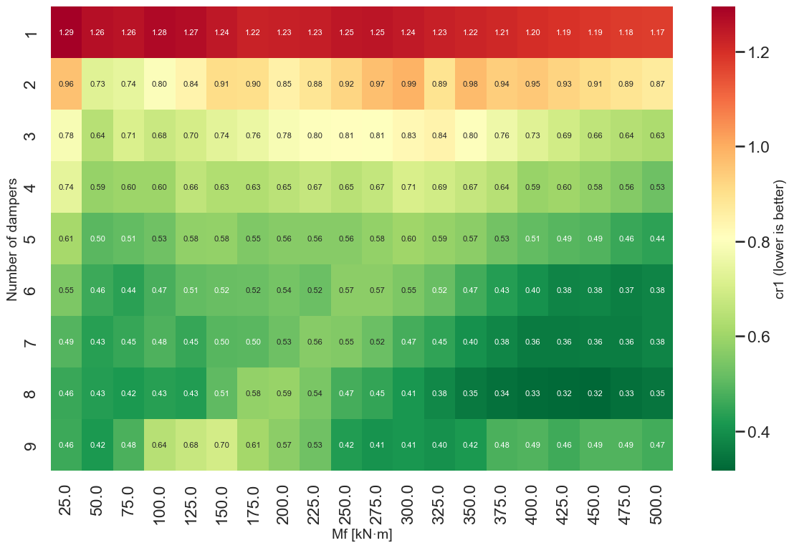
Fig. 16 Heatmap of CR1 versus Mf and number of dampers
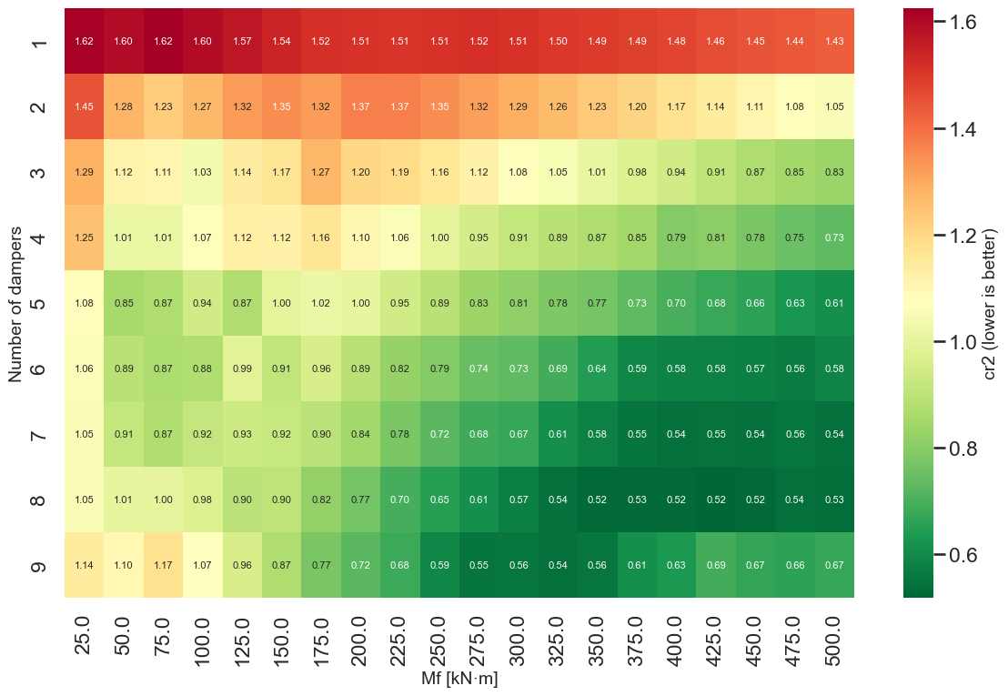
Fig. 17 Heatmap of CR2 versus Mf and number of dampers
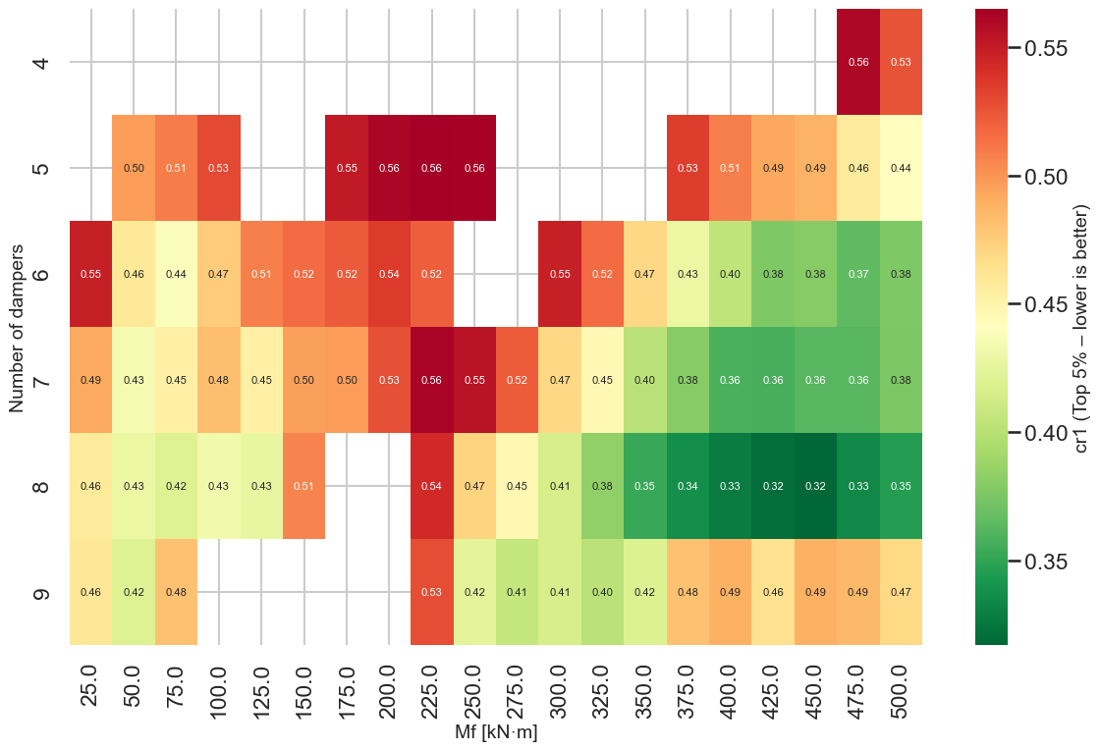
Fig. 18 Heatmap of CR1 versus Mf and number of dampers for top performance 5%
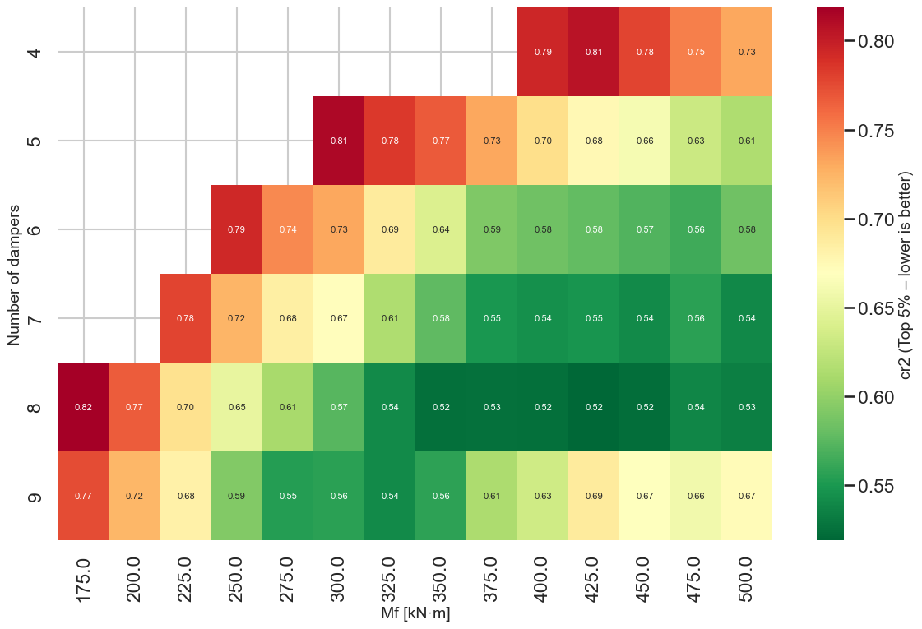
Fig. 19 Heatmap of CR2 versus Mf and number of dampers for top performance 5%

Finally, (Fig. 13 and 14) examine the tendency for preferred damper locations relative to the quantity of devices (), based on the top 5% elite subset. The average and values displayed at the top of the graphs corroborate that the global performance optimum is achieved with the use of 8 dampers. Regarding the spatial arrangement, a relatively homogeneous distribution is generally observed, suggesting topological flexibility for high-redundancy configurations. However, this uniformity is marked by distinct preferential tendencies at the 1st and 5th stories, indicating that these specific levels are critical for controlling the dynamic response, differentiating them from the general pattern observed in the rest of the structure.
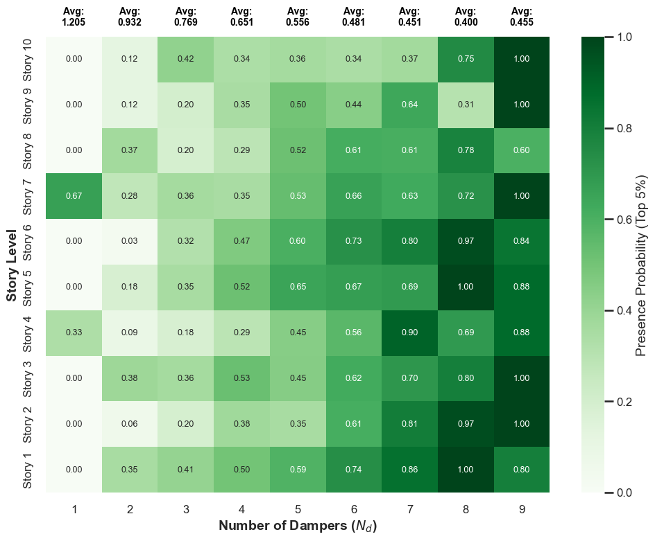
Fig. 20 Preferred damper locations in the Top 5% configurations: presence probability by story and number of dampers for CR1
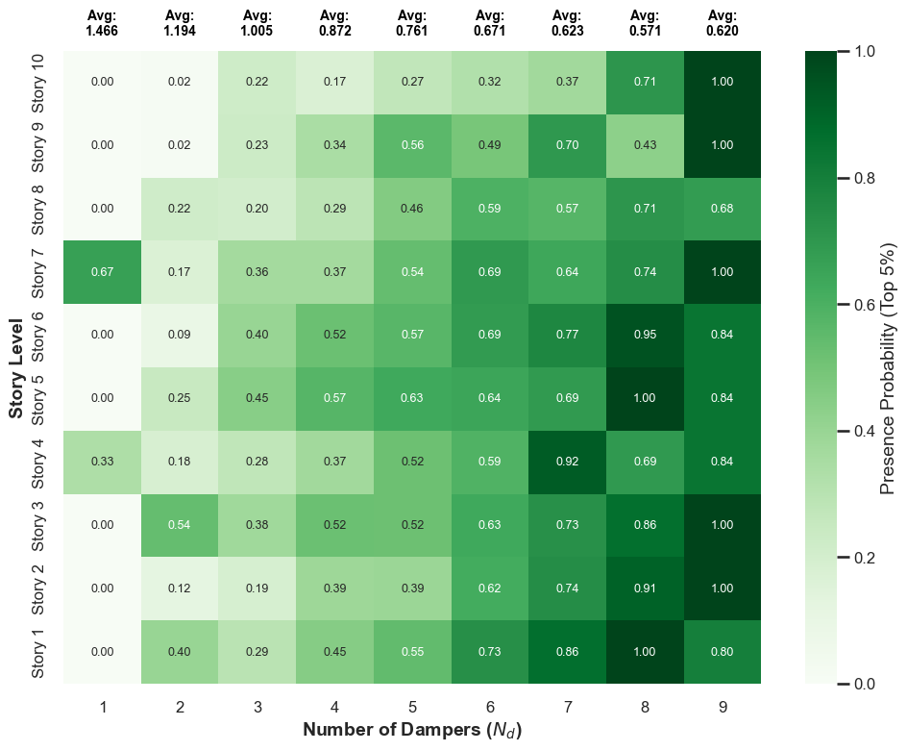
Fig. 21 Preferred damper locations in the Top 5% configurations: presence probability by story and number of dampers for CR2

4. Conclusion

This study presented a comprehensive probabilistic framework for optimizing the placement and capacity of Rotational Friction Dampers (RFD) in shear buildings. By integrating the Non-Smooth Dynamics (NSD) method with a Monte Carlo simulation covering the entire design space, the following conclusions are drawn regarding the sensitivity and robustness of the seismic retrofit:
- Dominance of Quantity and Saturation: The number of devices () is identified as a primary driver of performance, but it exhibits a clear behavior of diminishing returns. While increasing the quantity significantly reduces the response dispersion for , the performance gains plateau beyond 7 dampers. This suggests that structural saturation is reached, where additional devices provide negligible marginal benefits in terms of drift reduction.
- Topological Determinism at the Base: Contrary to the assumption that location is broadly permissible, the analysis of the "Elite" configurations (Top 5%) reveals a strict topological requirement: the installation of dampers in the first three stories is mandatory to achieve optimal performance. While the arrangement in the upper stories shows flexibility (homogeneity in the heatmaps), the control of the soft-story mechanism at the base is a prerequisite for the efficiency of the entire system.
- Preference for High Slip Loads: The optimization results challenge the conventional strategy of using low slip loads to encourage early activation. Instead, the optimal configurations consistently converged towards the upper bound of the frictional moment range (400–500 kNm). This indicates that for this structural typology, maximizing the energy dissipation per cycle (via larger hysteretic loops) provides superior protection compared to maximizing the frequency of sliding events with lower forces.
- Robustness of the Probabilistic Approach: The consistency of these findings across multiple seismic records validates the proposed probabilistic methodology. Unlike deterministic approaches that yield a single "perfect" solution sensitive to uncertainties, this framework successfully identified "zones of robust performance" (, concentrated base, high), providing engineers with flexible yet reliable design criteria.
- As recommendations for future research: finally, to validate the universality of these findings, it is recommended to extend this evaluation to diverse structural configurations. Future research should apply the proposed probabilistic framework to models with varying heights, stiffness distributions, or irregularity patterns to confirm if the identified topological rules are extrapolatable to a broader spectrum of structural systems.

COMPETING INTERESTS DISCLAIMER:
Authors have declared that they have no known competing financial interests OR non-financial interests OR personal relationships that could have appeared to influence the work reported in this paper.

References

Ampiah, A., & Zhao, X. (2020). Optimal Placement of Friction Dampers in High Rise Buildings Under Seismic Excitation. In H. Okada & S.N. Atluri (Eds.), Computational and Experimental Simulations in Engineering (pp. 547–556). Springer International Publishing. https://doi.org/10.1007/978-3-030-27053-7_47 .
Jarrahi, H., Asadi, A., Khatibinia, M., & Etedali, S. (2020). Optimal design of rotational friction dampers for improving seismic performance of inelastic structures. Journal of Building Engineering, 27, 100960. https://doi.org/10.1016/j.jobe.2019.100960
Jarrahi, H., Asadi, A., Khatibinia, M., Etedali, S., & Samadi, A. (2020). Simultaneous optimization of placement and parameters of rotational friction dampers for seismic-excited steel moment-resisting frames. Soil Dynamics and Earthquake Engineering, 136, 106193. https://doi.org/10.1016/j.soildyn.2020.106193.
Miguel, L. F. F., Fadel Miguel, L. F., & Lopez, R. H. (2016). Failure probability minimization of buildings through passive friction dampers. Structural Design of Tall and Special Buildings. https://doi.org/10.1002/tal.1287 .
Mualla, I. H., & Belev, B. (2002). Performance of steel frames with a new friction damper device under earthquake excitation. Engineering Structures, 24(3), 365–371. https://doi.org/10.1016/S0141-0296(01)00102-X
Namorado, B., Pinto da Costa, A., & Simões, F. M. F. (2022). Modelling rotational friction damping devices using the Non-Smooth Dynamics method. Engineering Structures. https://doi.org/10.1016/j.engstruct.2022.114118 .
Wong, K. K., & Johnson, J. (2009). Seismic Energy Dissipation of Inelastic Structures with Multiple Tuned Mass Dampers. Journal of Engineering Mechanics. https://doi.org/10.1061/(ASCE)0733-9399(2009)135:4(265)

