Original Research Article

Comparative Evaluation of the Thermal Performance of Ventilated Facades in Warm–Semi-Arid Climates: Effect of Cladding Material and Air Cavity Thickness

.
ABSTRACT

This study examines the high energy demand associated with cooling loads in buildings located in warm–semi-arid climates, focusing on ventilated facades as a passive strategy to reduce heat gain. Given the absence of clear design guidelines and the methodological inconsistency found in previous research for this specific climatic context, the study proposes a methodological framework to evaluate the thermal performance of different ventilated facade configurations.
The methodology was structured into three phases: (1) a review of specialized literature to identify critical variables influencing thermal behavior—primarily the properties of the exterior cladding and the geometry of the air cavity; (2) the development of an analytical matrix to refine and select key parameters; and (3) the construction of a comparative mathematical model. Based on this process, three cladding materials (Dekton, porcelain ceramic, and fiber cement) and two air cavity depths (6 cm and 10 cm) were selected, resulting in six configurations.
The thermal analysis was conducted using a one-dimensional series-resistance model applied to a case study consisting of a southwest-oriented classroom in the Biotechnology Building at the Universidad Autónoma de Querétaro, Mexico. A high heat-gain scenario was modeled, assuming an exterior temperature of 40 °C and an indoor temperature stabilized at 26 °C.
Results indicate that the heat flux toward the interior ranged from 7.91 to 8.32 W/m². The air cavity was identified as the primary moderator of thermal load, while the cladding material exhibited only marginal influence, as the system’s highest thermal resistance is provided by the insulation layer. It is concluded that, under the steady-state approach adopted, the selection of the exterior cladding material has a limited impact on reducing direct heat flux. This study provides a quantitative methodological basis to support decision-making in the design of ventilated facades for warm–semi-arid climates

Keywords: Thermal analysis, parametric design, passive strategies, energy efficiency

Fig. 1. Effect of external factors on facade behavior

1. INTRODUCTION

The building sector is one of the main global energy consumers, accounting for nearly 40% of total energy use, driven primarily by heating, cooling, and air-conditioning demands in warm regions (De Gracia et al., 2013).

This issue becomes more pronounced in hot semi-arid climates, where low humidity, high solar radiation, and elevated temperatures significantly increase cooling energy demand, as illustrated in Fig. 1 for a traditional facade. The pronounced thermal oscillation characteristic of this climate makes it an ideal context for studying the transient behavior of building envelopes.
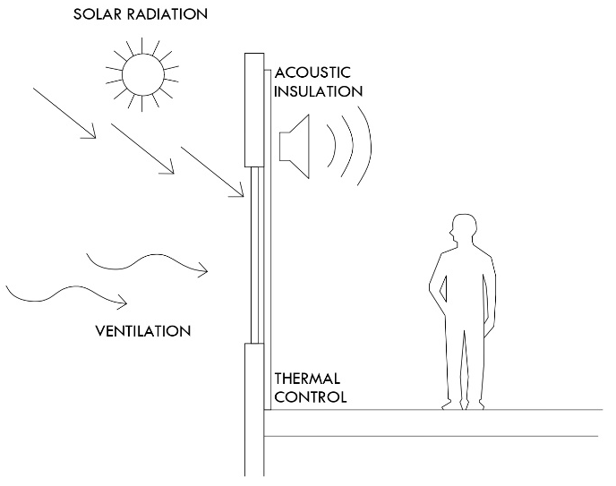
In response to this context, architecture and engineering have promoted the development of passive strategies aimed at improving the thermal performance of building envelopes. Among these, ventilated facades have emerged as a relevant solution due to their ability to reduce heat gains, induce natural ventilation through the stack effect, and decrease cooling loads (Schabowicz & Zawiślak, 2020).
Fig. 2. Components and configuration of a ventilated facade system
This multilayer system incorporates an external cladding, a structural support, and an air cavity positioned in front of the traditional facade, as shown in Fig. 2. This configuration facilitates the upward movement of heated air within the cavity, promoting its evacuation and allowing the entry of cooler air. Consequently, it helps mitigate solar loads and stabilize the interior surface temperature (Pizzatto et al., 2025).
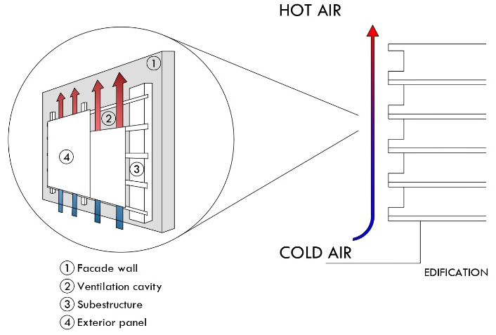
Ventilated facades have proven to be a high-performance strategy for both new construction and retrofitting, enhancing thermal resistance and reducing overheating (Colinart et al., 2019). However, their performance depends on the interaction among cladding properties, system geometry, and external climatic conditions (Aparicio-Fernández et al., 2014; El Dallal et al., 2024). This complexity has led to diverse results, limiting the extrapolation of useful conclusions for design.

Although previous studies consistently report clear benefits—such as validation of the stack effect and reductions in surface temperatures—significant methodological limitations persist: variability in critical parameters, differences in geometrical configurations, and a scarcity of research focused on warm semi-arid climates. This fragmentation poses challenges for establishing reliable design criteria in arid or semi-arid contexts.

In summary, the central issue identified is the lack of evidence-based guidelines that clearly indicate which ventilated facade configurations are most effective in warm semi-arid climates, a gap driven by the absence of comparative studies and methodological inconsistency across previous research.

To address these limitations, this article proposes the development of a conceptual framework—namely, a methodology that integrates modeling and the creation of a synthesis tool. The objective is to conduct a parametric analysis through dynamic modeling to evaluate the individual and combined effects of key variables—cladding material and cavity width—on thermal loads and airflow patterns in a classroom used as a case study, as illustrated in Fig. 3.

The scope of this study is limited to the thermal analysis of passive ventilated facades under representative warm semi-arid climatic conditions, relying exclusively on mathematical modeling and simulation, without incorporating in situ experimental validation.

This research aims to bridge the gap between advanced modeling and architectural practice, contributing to a more efficient and evidence-based adoption of ventilated facades in regions where passive strategies are essential for mitigating the energy demand associated with cooling.

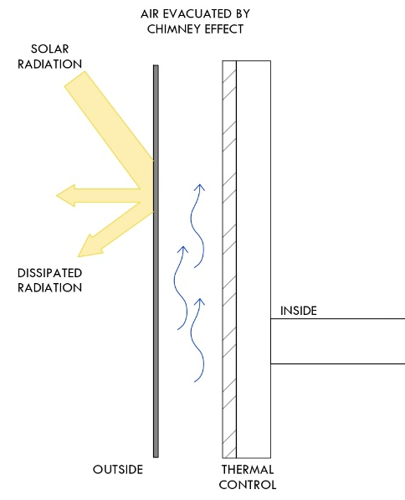
Fig. 3. Ventilation mechanism and heat transfer in a ventilated facade

2. material and methods

2.1 General Approach and Methodological Strategy
The methodology employed in this study was structured into three complementary stages. First, a review of specialized literature was conducted to identify the thermal variables that significantly influence the performance of ventilated facades. Based on this review, an analytical matrix was developed to organize the parameters reported in previous studies—thermal properties, geometric characteristics, and environmental conditions—thereby allowing the refinement and prioritization of the variables with the greatest impact on the system’s thermal behavior.

Finally, a comparative mathematical model was developed to evaluate the performance of different ventilated facade configurations under representative warm semi-arid conditions. This final stage enabled the analysis of both the individual and combined effects of the selected variables, providing a robust methodological foundation for assessing the thermal behavior of the system.

2.2 Selection Criteria and Matrix Development
The identification of the variables that govern the thermal behavior of ventilated facades was carried out through a literature review published between 2015 and 2025, with an emphasis on studies featuring experimental validation or highly rigorous dynamic thermal modeling.
This process enabled the systematic extraction of the most influential parameters, including air cavity depth, thermo-optical properties of the exterior cladding, the induced ventilation regime, and the system’s response under high solar radiation conditions.
A comparative analysis of these sources supported the development of table 1, which synthesizes the dominant variables reported across the literature. The findings reveal a consistent agreement that air cavities between 5 and 10 cm enhance natural ventilation potential in warm climates, while materials such as ceramic and fiber cement exhibit favorable performance due to their thermal stability and low emissivity.
Moreover, the review identified that next-generation ultracompact materials—such as Dekton—have been scarcely examined despite their potentially advantageous surface properties for ventilated facade applications, thus justifying their inclusion in the present study.

Table 1. Justification of the Parameters Selected for the Simulation Stage

Variable | Selected Values | Justification Based on Literature Review | References
Air cavity depth | 6 cm and 10 cm | Most frequently reported and efficient range for natural ventilation in warm climates (5–20 cm). The selection of 6 to 10 cm allows the evaluation of the transition zone where convective benefits stabilize and marginal returns decrease. | Andreeva et al., 2022; Cuce & Cuce, 2025; Pizzatto et al., 2025; Schabowicz & Zawiślak, 2020
Exterior cladding material | Exterior cladding material | Very low emissivity (0.1–0.2), high thermal inertia, and minimal solar absorption. Represents next-generation materials virtually absent from existing ventilated facade literature. | Cuce & Cuce, 2025; Fathi & Fakhriaemmanesh, 2025; Gelesz & Reith, 2015
Exterior cladding material | Ceramic / porcelain | Widely studied and with well-documented thermal behavior in warm and warm-humid climates. Excellent durability, low maintenance, and high reflectance. | Pizzatto et al., 2025; El Dallal et al., 2024; Luciani-Mejía et al., 2018; Ibañez-Puy et al., 2017
Exterior cladding material | Fiber cement | High reflectance, low cost, and reduced environmental impact. Commonly used in construction yet scarcely examined in combination with ventilated cavities in warm semi-arid climates. | Cuce & Cuce, 2025; Azkorra-Larrinaga et al., 2023; Piasecki et al., 2019

The matrix enabled the refinement of the broad set of parameters identified in the literature and allowed the selection of a reduced number of configurations suitable for analysis. As a result, three cladding materials—Dekton, ceramic porcelain, and fiber cement—and two cavity depths—6 cm and 10 cm—were selected, criteria supported both by their recurrent use in previous studies and by their relevance in hot and hot–semiarid climates.

Furthermore, the matrix facilitated the definition of the indicators guiding the mathematical analysis: the thermal conductivity of the exterior cladding, the transient response of the ventilated cavity, and the system’s capacity to reduce the inward thermal load. These parameters enable consistent comparison across configurations and provide an integrated evaluation of the thermal performance of each alternative.

2.3 Case Study
The case study was developed based on a real space located in the “Biotechnology Building” of the Facultad de Ingenieria at the Universidad Autónoma de Querétaro (UAQ). The southwest facade segment of the envelope was selected, as it represents the most critical orientation under hot–semiarid conditions: it receives direct solar radiation for most of the afternoon, concentrating the highest thermal loads and therefore maximizing the demand on the facade system.

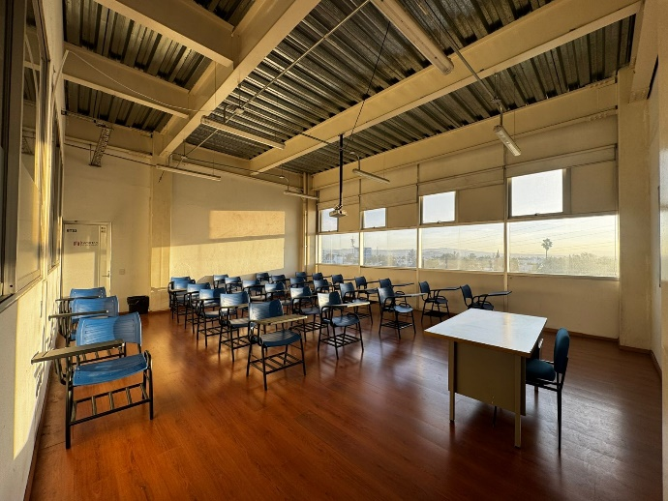
The analyzed classroom measures 8.00 m in length and 4.95 m in width, resulting in a floor area of approximately 39.6 m². With an interior height of 5.00 m, the total volume is 198.00 m³. This geometry, together with its orientation and local climatic conditions, makes it a representative case for evaluating the thermal behavior of different ventilated facade configurations in hot–semiarid regions (Fig. 4).

Fig. 4. Interior view of the reference classroom used as case study

The three-dimensional model was developed in Revit 2024.2, incorporating the exact location of the facade segment under study and accurately reproducing the physical composition of the wall. Each component—the exterior cladding, the air cavity, and the base wall—was defined using multilayer configurations to ensure proper geometric and material representation.

3. results and discussion

Ventilated Facade System Configuration
The geometric configuration of the ventilated facade included the explicit representation of the air cavity in two thicknesses—6 cm and 10 cm—as well as an interchangeable exterior cladding layer depending on the material analyzed: Dekton, porcelain ceramic, or fiber cement. These elements are described in table 2.

The objective of the modeling process was to enable a standardized comparison of the six resulting configurations (three materials × two cavity thicknesses). Figures 5, 6, and 7 illustrate the generated variants, which allowed for a consistent evaluation of the relative differences associated with each cladding material and air cavity geometry.

Table 2. Configurations of the ventilated facade system evaluated

Case | Cladding Material | Air Cavity Thickness
Case 1 | Dekton | 6 cm
Case 1 | Dekton | 10 cm
Case 2 | Ceramic | 6 cm
Case 2 | Ceramic | 10 cm
Case 3 | Fiber-cement | 6 cm
Case 3 | Fiber-cement | 10 cm

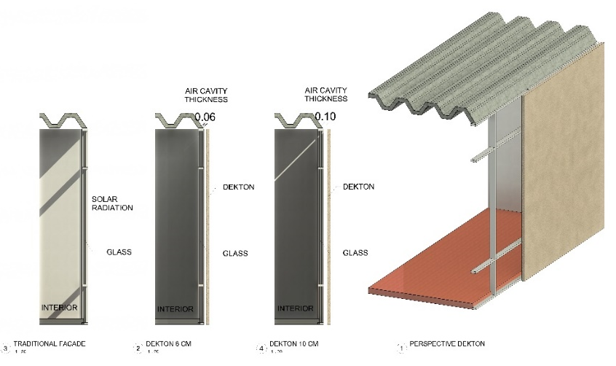
Each configuration was modeled as a multilayer system consisting of a tempered-glass base wall, a ventilated air cavity with variable thickness (6 cm or 10 cm), and an interchangeable exterior cladding layer depending on the material under analysis (Dekton, ceramic, or fiber-cement). This structure enabled a consistent comparison of the expected thermal behavior among the different ventilated facade variants, while keeping the geometric and construction parameters of the model constant.
Fig. 5. Facade configurations analyzed:(1) existing single-glazed facade (reference case), (2) ventilated facade with 6 cm air cavity and Dekton outer layer,(3) ventilated facade with 10 cm air cavity and Dekton outer layer, and (4) perspective view of the proposed ventilated facade with Dekton cladding
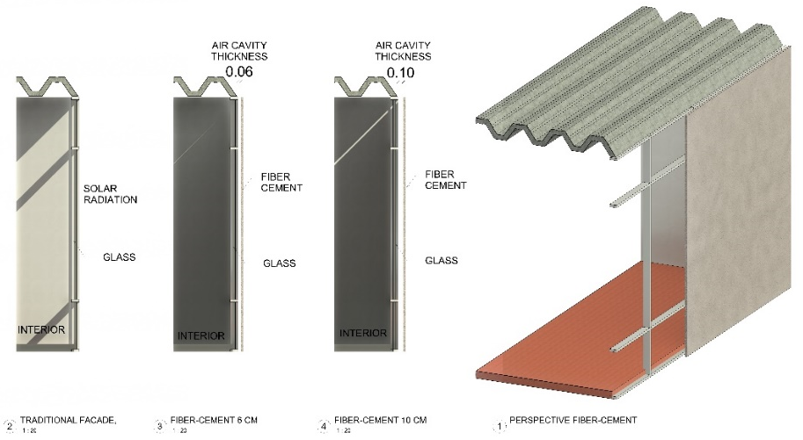
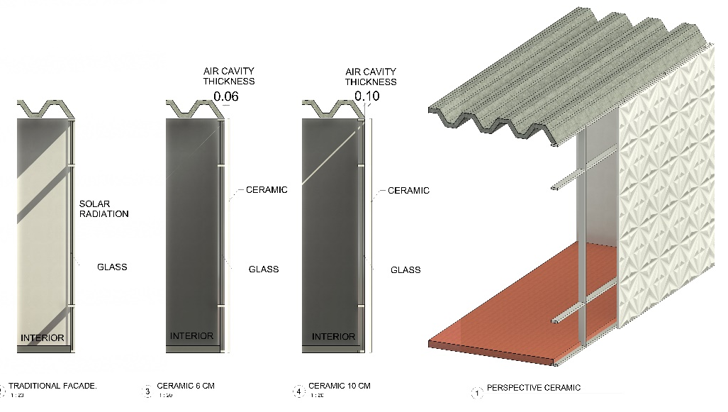
Fig. 6. Facade configurations analyzed:(1) existing single-glazed facade (reference case), (2) ventilated facade with 6 cm air cavity and Ceramic outer layer,(3) ventilated facade with 10 cm air cavity and ceramic outer layer, and (4) perspective view of the proposed ventilated facade with ceramic cladding.
Fig. 7. Facade configurations analyzed:(1) existing single-glazed facade (reference case), (2) ventilated facade with 6 cm air cavity and fiber-cement outer layer,(3) ventilated facade with 10 cm air cavity and fiber-cement outer layer, and (4) perspective view of the proposed ventilated facade with fiber-cement claddig.
2.6 Thermal calculation using a model
In this study, a simplified thermal modeling approach was adopted based on a one-dimensional series-resistance scheme, with the purpose of estimating the heat flux through the evaluated ventilated facade configurations.

To ensure the reproducibility of the procedure, the analysis was developed under a clearly defined set of assumptions: a unit area of 1.00 m², a temperature difference representative of a warm–semi-arid climate ($T_{ext}:40°C$ , $T_{int}:26°C$), typical convective coefficients for exterior $h_{ext}:15 W/m^{2}K$ and interior surfaces $h_{int}:8 W/m^{2}K$, a 6-mm tempered-glass base wall, a 50-mm mineral wool insulation layer (λ: 0.037 $W/mK$), and ventilated cavities of 6 cm and 10 cm, with assigned convective coefficients of $h_{cav}:5 W/m^{2}K$ and $h_{cav}:8 W/m^{2}K$ , respectively. These assumptions represent consistent extreme heat-gain conditions for the southwest facade of the building under study.

Heat transfer by conduction through the exterior cladding layer was calculated using the classical Fourier expression:
$R_{cond: }\frac{d}{k}$ (1)

Where 𝑑 is the material thickness and 𝑘 its thermal conductivity (Dekton, porcelain ceramic, or fiber-cement). Convection within the ventilated cavity and on the interior and exterior surfaces was modeled using:
$R_{conv: }\frac{1}{h}$ (2)

where ℎ is the corresponding convective heat-transfer coefficient. The total thermal resistance of the multilayer assembly was obtained as:
$R_{total: }\sum{R_{i}}$ (3)

and the heat flux entering the interior space was determined through the general one-dimensional expression:
$q=\frac{T_{ext}-T_{int}}{R_{total}}$ (4)

This procedure enabled a consistent comparison among the six configurations resulting from the combination of cladding materials and cavity depths.

Given the previous calculations, table 3 and 4 presents a consolidated summary of the thermal parameters obtained for each configuration, including conductive and convective resistances, total heat flux, and intermediate temperatures. This organization allows a clear evaluation of the influence of cladding materials and cavity depth on the thermal behavior, providing a consistent comparative basis across the six analyzed alternatives.

Table 3. Thermal performance of the ventilated facade configurations evaluated

Case | Cladding Material | Air Cavity Thickness | $$R_{clad}$$  (K/W) | $$R_{cav}$$  (K/W) | $$R_{tot}$$  (K/W) | $${ΔT}_{clad}$$  (K) | $${ΔT}_{cav}$$  (K) | $${ΔT}_{suf-Out}$$  (°C) | $${ΔT}_{aft-clad}$$  (°C) | $${ΔT}_{aft-cav}$$  (°C)
Case 1 | Dekton | 6 cm | 0.00909 | 0.200 | 1.75811 | 0.0724 | 1.5926 | 39.469 | 39.397 | 37.804
Case 1 | Dekton | 10 cm | 0.00909 | 0.125 | 1.68311 | 0.0756 | 1.0397 | 39.445 | 39.37 | 38.33
Case 2 | Ceramic | 6 cm | 0.01 | 0.200 | 1.75902 | 0.0796 | 1.5918 | 39.469 | 39.39 | 37.798
Case 2 | Ceramic | 10 cm | 0.01 | 0.125 | 1.68402 | 0.0831 | 1.0392 | 39.446 | 39.363 | 38.323
Case 3 | Fiber-Cement | 6 cm | 0.02 | 0.200 | 1.76902 | 0.1583 | 1.5828 | 39.472 | 39.314 | 37.731
Case 3 | Fiber-Cement | 10 cm | 0.02 | 0.125 | 1.69402 | 0.1653 | 1.033 | 39.449 | 39.284 | 38.251

Table 4. Heat flux through the facade for each ventilated facade configuration under design conditions.

Case | Cladding Material | Air Cavity Thickness | q ($W/m^{2}$) | Potencia  W
Case 1 | Dekton | 6 cm | 7.963 | 315.34
Case 1 | Dekton | 10 cm | 8.318 | 329.39
Case 2 | Ceramic | 6 cm | 7.959 | 315.18
Case 2 | Ceramic | 10 cm | 8.313 | 329.21
Case 3 | Fiber-Cement | 6 cm | 7.914 | 313.39
Case 3 | Fiber-Cement | 10 cm | 8.264 | 327.27

Where:
- $R_{clad}$ (K/W) : Thermal resistance by conduction through the exterior cladding, calculated using Fourier’s law
- $R_{cav}$ (K/W) : Thermal resistance associated with convection within the ventilated cavity.
- $R_{tot}$ (K/W) : Sum of all thermal resistances in the multilayer system.
- Potencia (W) : Total heat transfer through the entire facade panel under analysis.
- ${ΔT}_{clad}$ (K) : Temperature drop occurring exclusively across the exterior cladding.
- ${ΔT}_{cav}$ (K) : Temperature drop within the ventilated cavity.
- ${ΔT}_{suf-Out}$ (°C) : Temperature of the exterior surface of the cladding after accounting for external convection.
- ${ΔT}_{aft-Clad}$ (°C) : Temperature after passing through the exterior cladding, before entering the cavity.
- ${ΔT}_{aft-Cav}$ (°C) : Temperature after the ventilated cavity (before reaching the insulation and interior wall).

4. Conclusion

The simplified thermal analysis using the series‐resistance model enabled a consistent comparison of six ventilated facade configurations, derived from the combination of three cladding materials and two ventilated cavity depths under conditions representative of a warm–semi-arid climate.

The results indicate that the heat flux entering the interior remains within a narrow range of 7.91 to 8.32 W/m², with moderate variations primarily attributable to differences in convection within the cavity and, to a lesser extent, to the thermal properties of the exterior cladding.

The temperature drop across the cladding layer is minimal due to its small thickness, whereas the ventilated cavity contributes a more significant reduction, confirming its role as a passive element capable of partially attenuating the thermal load on the envelope. The dominance of the insulation layer in the total thermal resistance explains the similarity among configurations, indicating that—under a steady-state approach—the selection of the exterior skin material has a limited influence on the direct heat flux.

Overall, this study establishes a clear methodological basis for comparing preliminary design alternatives and provides quantitative insights to support decision-making in the design of ventilated facades in warm–semi-arid climates.

COMPETING INTERESTS DISCLAIMER:
Authors have declared that they have no known competing financial interests OR non-financial interests OR personal relationships that could have appeared to influence the work reported in this paper.
References

Andreeva, D., Nemova, D., & Kotov, E. (2022). Multi-skin adaptive ventilated facade: A review. Energies, 15(9), Article 3447. https://doi.org/10.3390/en15093447
Aparicio-Fernández, C., Vivancos, J.-L., Ferrer-Gisbert, P., & Royo-Pastor, R. (2014). Energy performance of a ventilated façade by simulation with experimental validation. Applied Thermal Engineering, 66(1–2), 563–570. https://doi.org/10.1016/j.applthermaleng.2014.02.041
Azkorra-Larrinaga, Z., Romero-Antón, N., Martín-Escudero, K., Lopez-Ruiz, G., & Giraldo-Soto, C. (2023). Evaluation of the thermal performance of two passive facade system solutions for sustainable development. Sustainability, 15(24), Article 16737. https://doi.org/10.3390/su152416737
Colinart, T., Bendouma, M., & Glouannec, P. (2019). Building renovation with prefabricated ventilated façade element: A case study. Energy and Buildings, 186, 221–235. https://doi.org/10.1016/j.enbuild.2019.01.033
Cuce, P. M., & Cuce, E. (2025). Ventilated facades for low-carbon buildings: A review. Processes, 13(7), Article 2275. https://doi.org/10.3390/pr13072275
De Gracia, A., Castell, A., Navarro, L., Oró, E., & Cabeza, L. F. (2013). Numerical modelling of ventilated facades: A review. Renewable and Sustainable Energy Reviews, 22, 539–549. https://doi.org/10.1016/j.rser.2013.02.029
El Dallal, I. S., Abdel-Maksoud, R. A., & Faragallah, R. N. (2024). Guidelines for Façade Techniques to Optimize Energy Efficiency in Educational Buildings. Port-Said Engineering Research Journal. https://doi.org/10.21608/pserj.2024.282378.1333
Fathi, S., & Fakhraeimanesh, S. (2025). Smart materials in building façades: A systematic review of applications and impacts on energy efficiency. Energy Reports, 14, 2123–2140. https://doi.org/10.1016/j.egyr.2025.08.042
Gelesz, A., & Reith, A. (2015). Climate-based performance evaluation of double skin facades by building energy modelling in Central Europe. Energy Procedia, 78, 555–560. https://doi.org/10.1016/j.egypro.2015.11.735
Ibañez-Puy, M., Vidaurre-Arbizu, M., Sacristán-Fernández, J. A., & Martín-Gómez, C. (2017). Opaque ventilated façades: Thermal and energy performance review. Renewable and Sustainable Energy Reviews, 79, 180–191. https://doi.org/10.1016/j.rser.2017.05.059
Luciani-Mejía, S., Velasco-Gómez, R., & Hudson, R. (2018). Ecoenvolventes: análisis del uso de fachadas ventiladas en clima cálido-húmedo. Revista de Arquitectura (Bogotá), 20(2), 62–77. https://doi.org/10.14718/RevArq.2018.20.2.1726
Piasecki, M., Fedorczak-Cisak, M., Furtak, M., & Biskupski, J. (2019). Experimental confirmation of the reliability of Fanger’s thermal comfort model—Case study of a near-zero energy building (NZEB) office building. Sustainability, 11(9), 2461. https://doi.org/10.3390/su11092461
Pizzatto, S. M. d. S., Pizzatto, F., Raupp-Pereira, F., Arcaro, S., Angioletto, E., & Montedo, O. R. K. (2025). Ventilated facade system: A review. Boletín de la Sociedad Española de Cerámica y Vidrio, 64, Article 100443. https://doi.org/10.1016/j.bsecv.2025.100443
Schabowicz, K., & Zawiślak, Ł. (2020). Numerical comparison of thermal behaviour between ventilated facades. Studia Geotechnica et Mechanica, 42(4), 297–305. https://doi.org/10.2478/sgem-2019-0044

