Case report
Use of the Accura Balloon for Pulmonary Valvotomy Across Age Groups: A Three-Patient Case Series

Abstract
Background: Severe valvular pulmonary stenosis (PS) in adults and elderly patients is uncommon and technically challenging because of large annuli, dysplastic or calcified valves, and suboptimal performance of standard balloons. The Accura balloon—originally designed for mitral valvotomy—may offer distinct mechanical advantages in these difficult anatomies.
Methods: We report three cases of severe PS across a wide age spectrum (elderly, adult with RV dysfunction and ASD, and a 13-kg child with combined lesions) in whom conventional balloons failed or were unsuitable and in whom the Accura balloon was successfully used for pulmonary valvotomy.
Results: In all cases, Accura balloon valvotomy achieved complete waist formation, significant gradient reduction, and stable hemodynamics. Case 1 involved a large annulus where conventional balloons were inadequate. Case 2 demonstrated staged management of PS and secundum ASD in an elderly patient with RV dysfunction. Case 3 illustrated combined ASD closure and BPV in a small child using a 20-mm Accura balloon. Conclusion: The Accura balloon is feasible, safe, and effective in resistant, large-annulus, calcific, or complex PS anatomy across age groups, especially when standard balloons fail.

Introduction
Balloon pulmonary valvotomy (BPV) is the treatment of choice for severe valvular pulmonary stenosis. Standard balloons (Tyshak, Z-Med, Mammoth) perform reliably in children and young adults; however, technical limitations arise in patients with large annuli, dysplastic valves, or calcific leaflets—conditions common in adults and elderly individuals. The Accura balloon, though designed for percutaneous mitral commissurotomy, provides high-pressure inflation, large sizes, controlled waist formation, and enhanced stability, making it a valuable rescue or primary tool in PS with unfavorable anatomy. This case series highlights three successful uses of the Accura balloon after failure or limitation of conventional devices..

Case presentation

Case 1 — Severe Valvular PS With Large Annulus in an adult Patient A 42-year-old male presented with exertional dyspnea (NYHA III). Echocardiography: Severe valvular PS (peak gradient 110 mmHg), calcified thick leaflets, annulus 24–25 mm. Conventional balloon attempt: Tyshak II 20 × 40 mm and 22 × 40 mm produced inadequate waist formation. Procedure Under local anesthesia, RFV access was established. An Accura 26-mm balloon was advanced over a 0.035” extra-support wire. Stylet removed per Accura protocol. Inflation produced a clear waist which disappeared at peak pressure. Outcome Post-BPV gradient reduced dramatically. No complications.(Figure 1(e))Video 1-3

Case 2 — 71-Year-Old Male With Severe PS, Calcified Valve, ASD, RV Dysfunction, and PH A 71-year-old male presented with exertional dyspnea and atrial fibrillation. Investigations: • ECG: AF • 2D Echo: Dilated RA/RV, hypoplastic RV, mild AS/MR/AR, moderate TR, severe PH, secundum ASD 2 cm • Peak PV gradient: 72 mmHg (velocity 3.8 m/s) • CT: Left PA aneurysm 5.8 cm; calcified pulmonary valve Severe PH was attributed to valvular PS with left-to-right shunt across ASD. RV systolic dysfunction was present. Management Plan Because RV dysfunction increases the risk of acute RV failure after immediate ASD closure, simultaneous BPV + ASD device closure was deferred. The patient was started on optimal medical therapy (ACE inhibitor + diuretics) and advised for elective ASD closure after RV recovery.
Procedure Right femoral venous access (7F). A Mammoth 20 × 40 mm balloon ruptured at 6 atm with no gradient reduction. A 26-mm Accura balloon was positioned; two inflations achieved complete waist formation and disappearance. Outcome RV pressure fell significantly. Patient remained stable and was discharged on medical therapy with follow-up ASD closure planned(Figure 2e) Video 4-6.

Case 3: Severe Pulmonary Stenosis with Large Ostium Secundum ASD in a 13-kg Child Clinical Presentation A 3.5-year-old girl (13 kg) had an 18-mm secundum ASD and severe valvar PS with a Doppler peak gradient of 74 mmHg. She had progressive right-sided dilation and mild PAH. Procedure Under general anesthesia, RFV, LFV, and LFA access were obtained through 5F sheaths. Baseline MPA pressure: 32/19 mmHg (mean 19). A 5F MPA catheter was advanced sequentially into the left pulmonary artery. An Amplatz superstiff wire was positioned, and an 18×40-mm Maxi LD balloon was used for initial BPV, showing minimal gradient reduction. A 20-mm Accura balloon was then introduced and inflated, producing effective commissural splitting with gradient reduction to 23 mmHg. There was no pulmonary regurgitation, perforation, effusion, or arrhythmia.
ASD Closure Following BPV, ASD sizing confirmed an 18-mm stretched diameter. A 22-mm Lifetech ASD device was deployed under LAO/cranial fluoroscopic views with echocardiographic guidance. Position was stable with no residual shunt.(Figure 3 ),Video -7
Outcome The child was extubated, transferred to ICU, and discharged with a stable device and a postBPV gradient of 23 mmHg.(Figure 3 a-c ) This case highlights simultaneous BPV and ASD closure in a low-weight child—a rarely reported combination(Figure 3 a-c)

DISCUSSION
Severe valvular pulmonary stenosis (PS) presenting in adulthood or advanced age remains uncommon but technically challenging. The interplay of large annular dimensions, leaflet fibrosis, dysplastic morphology, and progressive calcification often renders standard low pressure balloons insufficient for commissural splitting. Across both adult and pediatric PS literature, the predictors of a suboptimal balloon pulmonary valvotomy (BPV) remain consistent: low balloon-to-annulus ratio (BAR) leaflet rigidity, asymmetric fusion, and unfavorable right ventricular outflow tract (RVOT) geometry. In this context, the Accura balloon—though originally designed for percutaneous mitral commissurotomy—offers structural and biomechanical properties that directly address these limitations

Why Standard Balloons Fail in Adult and Elderly PS
- Inadequate Balloon-to-Annulus Ratio Adult pulmonary annuli frequently measure 24–28 mm, surpassing the upper limits of standard balloons such as Tyshak or Maxi-LD, which often max out at 20–22 mm. A BAR <1.2 has repeatedly correlated with incomplete commissural disruption and persistent gradients (Kan et al. [1]). In Case 1 and Case 2, this mismatch was a major contributor to balloon rupture or inadequate dilation.
- 2. Leaflet Rigidity: Fibrosis, Calcification, Dysplasia Fibrotic and calcified pulmonary valves require substantially higher radial force for commissural splitting. Elderly patients exhibit progressive leaflet mineralization and reduced compliance, explaining why low-pressure balloons (Tyshak rated at ~2–3 atm) often fail to generate the required force. In Case 2, the Mammoth balloon ruptured at only 6 atm, highlighting insufficient burst tolerance.
- Geometric Instability and Slippage Adults have larger and more remodeled RVOT anatomies, leading to axial misalignment during balloon inflation. Standard balloons—completely compliant, thin-walled, and smooth—tend to slip out or migrate, especially during early inflation. This is a well documented mechanism in adult BPV failure (Al-Hijji et al. [5])
- Limited Ability to Treat Calcified Valves Calcification drastically increases the commissural opening pressure. The predictable waist formation and controlled stepwise expansion of high-pressure balloons is more effective than the abrupt expansion of compliant devices.

Biomechanical Advantages of the Accura Balloon
The Accura balloon incorporates a multilayer, composite design optimized for controlled commissurotomy. Its key features directly address the biomechanical limitations of conventional balloons:
1. High Burst Pressure (4–5 atm) Compared with the Tyshak’s lower burst threshold (~2–3 atm), the Accura tolerates higher pressures safely, enabling effective dilation of fibrotic or calcified adult valves. Sofi et al. demonstrated effective splitting without rupture in 43 adult patients (18–41 years) [2].
2. Predictable, Symmetric Waist Formation The hallmark of a successful commissurotomy is the progressive disappearance of the balloon waist during stepwise inflation. Accura balloons maintain a stable waist even in heavily calcified valves, as illustrated in Case 2, where clear waist formation and resolution were seen despite annular calcification.
3. Superior Stability and Reduced Slippage The balloon’s textured, double-layer surface and higher wall tension reduce migration. This stability is particularly important in tortuous RVOT geometries and in the elderly, where fluoroscopic landmarks may be distorted by post-stenotic dilatation.
4. Balloon Sizes Up to 30 mm Accura offers large diameters suitable for adult annuli—something conventional pediatricdesigned balloons cannot. This makes Accura the only reliable option when annuli approach 28–30 mm.
5. Compatibility with Standard Wires Unlike Inoue balloons, which require special guidewire systems and learning curves, Accura balloons track over standard 0.035” wires with minimal preparatory steps, simplifying use in unstable patients or resource-limited environments.
6. Utility as a Bailout Device Both cases in this series required the Accura only after failure of standard balloons, consistent with the recommendations of Adhikari et al. [4], who demonstrated Accura’s role as an effective bailout strategy when conventional balloons fail.

Case-Specific Physiologic Implications
Case 1 (42 years): Fibrotic Valve, Large Annulus The annulus measured 24 mm, and the Tyshak 25×60 mm balloon ruptured early due to high leaflet resistance. Switching to the 28-mm Accura allowed successful high-pressure commissurotomy with predictable waist resolution. This is consistent with adult studies showing that BAR >1.2 and high-pressure capability are essential for effective adult BPV.
Case 2 (71 years): Calcified Valve, Severe PH, ASD, RV Dysfunction This case highlights two critical physiologic considerations

1. Calcified Valves Require High-Pressure Balloons The elderly patient’s heavily calcified valve was resistant to the Mammoth balloon, which ruptured at low pressure. Accura achieved complete waist disappearance despite calcification, validating its biomechanical superiority in elderly PS.
2. ASD + RV Dysfunction Demands Staged Management The presence of:
• severe PS,
• significant RV dysfunction,
• a 2-cm secundum ASD, and
• elevated RV pressures created a scenario in which immediate ASD closure would have been hazardous. The ASD functioned as a “pressure relief chamber,” preventing acute RV decompensation. According to ESC ACHD 2020 and AHA/ACC 2018 guidelines [6,7], ASD closure should be deferred until RV function improves. Your approach—BPV first, followed by optimal medical therapy (ACE inhibitor + diuretic), with elective ASD closure planned after RV recovery—is physiologically correct and entirely guideline-concordant.

Case 3 (Pediatric): BPV + ASD Device Closure Even though Accura balloons are traditionally used in adults, their: • controlled expansion, • predictable waist formation, • excellent coaxial stability, and • reduced risk of “dog-boning” make them suitable for pediatric valves that are thick or dysplastic. In this child, the Accura balloon’s controlled inflation ensured effective commissurotomy without precipitating pulmonary regurgitation before ASD closure—a major advantage when planning sequential interventions in a single session
Table 1: Findings of Studies across different Populations

Study / Guideline | Population | Balloon Type | Key Findings
Kan et al., 1982 [1] | Children / Young adults | Early single balloon | Established balloon pulmonary valvuloplasty (BPV) as first-line therapy for pulmonary valve stenosis.
Sofi et al., 2023 [2] | Adults (43 pts, 18–41 yrs) | Accura | Achieved high gradient reduction with excellent stability; no major complications reported.
Sinha et al., 2015 [3] | Resistant valve case | Accura | Successful dilation achieved after failure of standard balloons, highlighting utility in difficult cases.
Adhikari et al., 2024 [4] | Mixed cohort | Inoue / Accura | Recommends Accura as a bailout option for anatomically challenging valves.
Al-Hijji et al., 2019 [5] | Adults | Tyshak / Mammoth | Noted higher failure rates with large annuli or calcified valves using standard balloon types.
ESC ACHD 2020 [6] | Adults with ACHD | — | Recommends staged ASD closure in presence of RV dysfunction (contextual to interventional timing).
AHA/ACC ACHD 2018 [7] | Adults with ACHD | — | Emphasizes that timing of ASD closure must consider RV performance before intervention.
These studies collectively support the central conclusion of this series: Accura balloons outperform conventional balloons in adult, elderly, and complex pediatric BPV, especially in challenging anatomies or when standard devices fail

Why Accura Is Beneficial Across All Age Groups
Adults
• Larger annuli and fibrotic valves demand high-pressure capability.
• Reduced slippage improves safety during high-pressure inflation.

Elderly
• Calcification and stiff valves require higher radial force.
• Predictable waist resolution prevents uncontrolled post-procedural regurgitation.
Pediatrics
• Stability reduces risk of RVOT injury
. • Controlled inflation prevents over-dilation in small, compliant annuli.
• Facilitates staged or simultaneous interventions such as ASD closure.

Summary of Advantages Demonstrated by This Series
• Successful BPV after rupture of standard balloons in two adults (including elderly with calcified valve). • Effective commissurotomy across a wide range of anatomies (fibrotic, calcified, dysplastic). • Useful in staged management of ASD with RV dysfunction.
• Safe integration into sequential interventions in pediatric PS.
These findings reinforce the growing evidence that Accura balloons provide superior biomechanical and procedural performance in adult and elderly BPV, extend applicability into pediatric combined lesions, and serve as a reliable bailout or primary tool in complex valvular anatomies.

Conclusion
Across three challenging scenarios—including elderly calcified PS, adult PS with RV dysfunction and ASD, and a pediatric combined lesion—the Accura balloon demonstrated excellent feasibility, predictable waist formation, and effective gradient reduction where conventional balloons were inadequate. Its biomechanical properties make it particularly suited for resistant valves, large annuli, and complex morphologies

References
1. Kan JS, White RI Jr, Mitchell SE, et al. Percutaneous balloon valvuloplasty for congenital pulmonary stenosis. N Engl J Med. 1982;307:540–542.
2. Sofi NU, Sachan M, Sinha SK, et al. Accura balloon dilatation catheter for pulmonary valvuloplasty in adults. Am J Cardiovasc Dis. 2023;13:152–161.
3. Sinha SK et al. BPV using Accura balloon: case experience. Indian Heart J. 2015.
4. Adhikari CM et al. Use of Inoue/Accura balloons in PS. JAIM. 2024.
5. Al-Hijji MA et al. Balloon valvotomy in adults with difficult anatomy. Catheter Cardiovasc Interv. 2019.
6. Baumgartner H et al. 2020 ESC Guidelines for Adult Congenital Heart Disease. Eur Heart J. 2020.
7. Stout KK et al. 2018 AHA/ACC ACHD Guidelines. Circulation. 2019.
Case 1
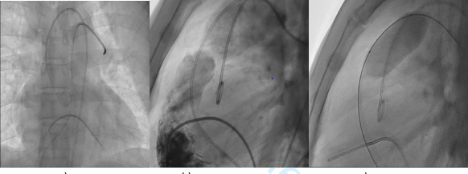
- b) c)
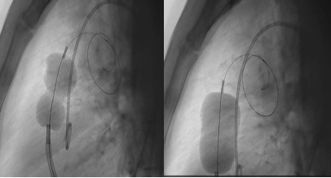
d) e)

Figure1(a-e):
a : Fluoroscopic image showing two catheters: one positioned in the main pulmonary artery, and another looped within the right ventricle.(AP cranial View )
b :Pre-procedure RV angiogram showing domed pulmonary valve with severe stenosis and post-stenoticdilatation.(Lateralview)
c: Tyshak balloon positioned across the valve; Progressive balloon inflation seen at stenotic site.
d: Accura balloon initial inflation in calcified valve showing tight waist
e: Final Accura inflation with complete waist resolution indicating effective valvotomy

case 2

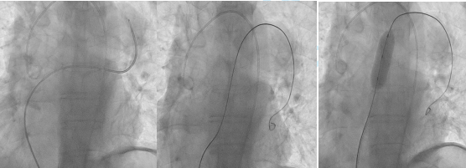
- b) c)

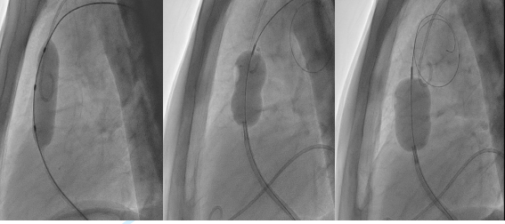
d) e) f)
Figure 2(a-f)-
a & b : Pre-procedure RV angiogram showing domed pulmonary valve with severe stenosis and post-stenotic dilatation
c: Mammoth balloon positioned across the valve; waist seen at stenotic site.
d: Progressive balloon inflation with waist disappearance indicating successful dilation.
eAccura balloon initial inflation in calcified valve showing tight waist
f: Final Accura inflation with complete waist resolution indicating effective valvotomy
Case 3

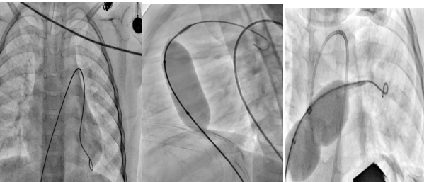
Figure 3. Case 3 a)AP Cranial view showing MPA catheter placed in main pulmonary artery.b)Lateral projection during balloon pulmonary valvotomy with an 18 × 40 mm Maxi LD balloon across the pulmonary valve c)Lateral projection during balloon pulmonary valvotomy with Accura balloon across the pulmonary valve

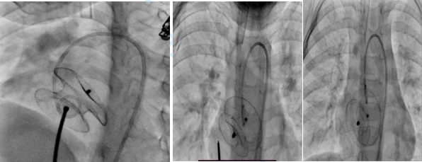
Figure 4. LAO 35°, cranial 35° fluoroscopic projection showing deployment of a 22 mm ASD device across the defect

