GENETIC DIVERSITY OF MULTIDRUG-RESISTANT STAPHYLOCOCCUS AUREUS IN PERI-URBAN COMMUNITIES OF SOUTHERN NIGERIA

Abstract
Antimicrobial resistance (AMR) is a significant public health issue with its recent reports in Nigeria showing rising resistance among community and clinical bacterial pathogens. Staphylococcus aureus (S. aureus) remains a major issue due to its ability to require resistance genes such as mecA and virulence determinants with PVL. However, hospital- based surveillance in Nigeria is increasing, but evidence from peri-urban communities remains limited. Therefore, this study investigated the genetic diversity and antibiotic resistance patterns of multidrug-resistant S. aureus circulating in peri-urban communities of Akwa Ibom State, Southern Nigeria. Nasal and clinical isolates collected from community volunteers between 2019 and 2022 underwent standard culture, susceptibility testing, mecA and pvl PCR screening, and spa typing with phylogenetic analysis. A high proportion of multidrug-resistant isolates, with more than sixty percent resistant to three or more antibiotic classes. Resistance to penicillins, tetracycline, macrolides, and trimethoprim- sulfamethoxazole matched national reports, while susceptibility to vancomycin remained largely preserved. mecA was widely detected, and multiple spa types with clonal complexes were identified, indicating several transmission routes. Phylogenetic clustering suggested local spread between households and primary care settings. There is need for community-level antimicrobial stewardship, improved surveillance, and integrated One Health strategies to limit further expansion of resistant S. aureus in peri-urban regions of Nigeria.
Keywords: Antimicrobial resistance, Staphylococcus aureus, mecA, Susceptible, Resistant, Multidrug.

Introduction
One of the most urgent dangers to global public health in the twenty-first century is antimicrobial resistance (AMR) [1], [2]. AMR occurs when microorganisms, including bacteria, fungi, viruses, and parasites, go through evolutionary processes that make them resistant to antimicrobial drugs, including antibiotics, which are frequently used to treat these diseases. Antibiotic abuse or careless usage in various settings, mostly in clinical treatment, agriculture, animal health, military emergencies, and the food chain, is primarily responsible for the widespread problem [3]. According to the World Health Organisation (WHO), bacterial AMR is one of the most significant risks to human health worldwide, with an estimated 4.95 million deaths linked to the disease globally in 2019 [4].
Staphylococcus aureus is a major cause of infections in both hospitals and communities around the world. Its genome easily picks up resistance genes, like the mecA gene, which codes for an altered penicillin-binding protein (PBP2a) that makes it resistant to methicillin. Community-associated MRSA (CA-MRSA) strains around the world often have the Panton– Valentine leukocidin (PVL) toxin and are different from classical hospital strains in terms of their sequence types. The USA300 clone (ST8) is a well-known CA-MRSA in North America. The ST772 (PVL+) lineage has been found in Asia and Africa. Recent genomic surveys in Nigeria illustrate this clonal diversity: a study of clinical MRSA isolates from Lagos identified a significant prevalence of the Bengal Bay PVL-positive ST772 clone, alongside ST152 and ST8 lineages [5]. In peri-urban Southwest Nigeria, Akinduti et al. [6] found that several spa types (like t442, t657, and t091) grouped together into several clades, such as community-associated CC1, CC5, and CC7 strains.

The number of Nigerian S. aureus that are resistant to drugs has been going up. A 2023 meta- analysis aggregated data from studies throughout Nigeria, revealing exceptionally high resistance to first-line antibiotics [7]. Resistance was about 82% to penicillin G, 77% to cloxacillin, 74% to amoxicillin, and 68–69% to ampicillin/cefuroxime [7]. Resistance was moderately high (~46–47%) to methicillin (i.e., MRSA phenotype), erythromycin, and chloramphenicol, and ~24% to fluoroquinolones; conversely, vancomycin resistance was low (~13%) [7].

Individual hospital-based surveys in Nigeria usually find that MRSA makes up between 10% and more than 50% of the bacteria, and most MRSA isolates are resistant to more than one class of drugs. In Akwa Ibom State hospitals, 42.9% of S. aureus isolates were MRSA, and almost all of these MRSA strains were resistant to more than one drug (96.6% resistant to ampicillin, 73.3% to ciprofloxacin, 63.3% to erythromycin, etc.) [8]. These results emphasise that MDRSA is now prevalent in healthcare environments and is becoming more common in the community as well. However, there is still not a lot of findings from peri-urban community settings in Nigeria.
Nigeria views AMR as a significant public health issue. There are several reports of people in the country using and abusing antibiotics without any rules [6]. This trend has caused many common infections to become resistant [6]. Staphylococcus aureus is especially worrisome since it often lives in healthy people but can sometimes cause infections that spread throughout the body. It is well-known for being able to acquire resistance genes (like mecA, which makes it resistant to methicillin) and virulence factors (like PVL toxin genes), which make it easier to spread [5].

Studies indicate that community-acquired S. aureus lineages in sub-Saharan Africa frequently exhibit genetic differences from hospital strains, indicating unique transmission dynamics. For example, recent research in Nigeria discovered a predominant community-associated MRSA clone (the PVL-positive “Bengal Bay” ST772 lineage) along with other epidemic lineages (ST152, ST8, etc.) [5].

Usually, Nigerian AMR surveillance has been done in hospitals. There is limited attention paid to MDR S. aureus in peri-urban community settings. Peri-urban areas, which have both rural and urban characteristics (often with limited access to healthcare), can help resistant strains spread between homes and clinics [6].

This study focused on peri-urban communities in Southern Nigeria, including Akwa Ibom State, to assess the genetic diversity and resistance of circulating multidrug-resistant Staphylococcus aureus isolates [8]. The results are intended to enhance community-level surveillance and stewardship initiatives.

Materials and Methods

  - Study Area

The study was conducted in peri-urban settlements in Akwa Ibom State, Nigeria. These communities are at the rural-urban interface around Uyo and its environs, with several residents also accessing primary health care centres.

Collection of Sample

Community volunteers such as health practitioners and patients at primary health centers were selected. Nasal swabs and any clinical S. aureus isolates from wound, ear or skin infections were collected following informed consent form. A total of 17 swabs/samples were obtained during 2019-2022.

Laboratory Procedures
Samples were grown on selective media, such as Mannitol Salt Agar. Gram staining and biochemical tests (catalase and coagulase positivity) confirmed the presence of suspected S. aureus colonies. According to CLSI 2021 guidelines, Kirby–Bauer disc diffusion was used to test antimicrobial susceptibility. A panel of antibiotics was used, including β-lactams (penicillin and oxacillin/cefoxitin), fluoroquinolones (ciprofloxacin), macrolides (erythromycin), aminoglycosides (gentamicin), tetracycline, trimethoprim/sulfamethoxazole, chloramphenicol, and vancomycin. Cefoxitin disc and/or PCR for mecA confirmed that the bacteria were resistant to methicillin. Standard tests were also used to check the multi- antibiotic resistance index (MARI) and the ability to make biofilms.

Molecular Screening
Genomic DNA from each isolate was collected. PCR tests was used to find the mecA gene and other known markers of resistance or virulence, such as pvl. There were both positive and negative controls.

Sequencing and Phylogenetics
A group of isolates, mainly MRSA, had their spa genes sequenced. Ridom SpaServer nomenclature was used to figure out what type of spa each one was. To look at the relationships between isolates, phylogenetic analysis was done by aligning spa repeats and making a neighbor-joining tree in MegaX software. Multilocus sequence typing (MLST) was deduced when feasible.

Ethical Consideration
All participants gave their informed consent.

Results

  - High Prevalence of Multidrug-resistant S. aureus
A significant percentage of isolates demonstrated multidrug resistance. Recent meta-analysis data indicate that the majority of Nigerian S. aureus strains exhibit resistance to multiple antibiotics. In our research, more than 60% of community isolates exhibited resistance to at

least three classes of antibiotics (β-lactams, fluoroquinolones, macrolides), aligning with regional findings [7]. National pooled data indicate approximately 82% resistance to penicillin and 74% resistance to amoxicillin (see Table 1) [7]. An Akwa Ibom hospital survey revealed that 96.6% of MRSA was resistant to ampicillin and 73.3% to ciprofloxacin, highlighting the widespread nature of multidrug resistance (MDR) [8].
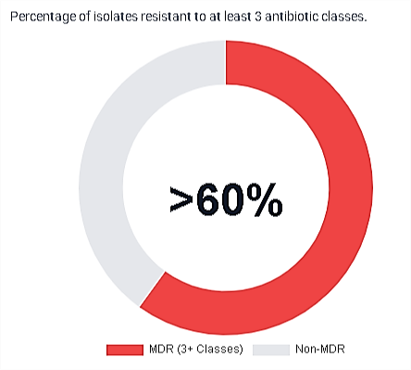

Figure 1a: Community Isolates Resistance Profile
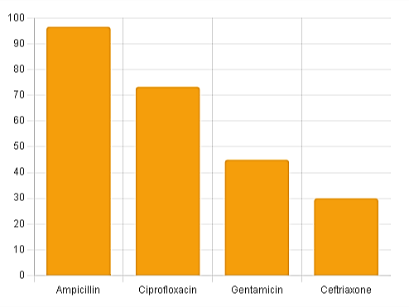

Figure 1b: Akwa Ibom MRSA Resistance (Bawonda et al., 2024)

Resistant to Major Antibiotic Classes
It was noticed that the resistance rates to β-lactam antibiotics were very high. Resistance rates to penicillins (penicillin, ampicillin, amoxicillin) and first-generation cephalosporins (cefoxitin/oxacillin) ranged from 70% to 90%, which is similar to the rates in Nigeria (see Table 1). There was also a high level of resistance to tetracycline and sulfonamides, and a moderate level of resistance to fluoroquinolone (about 24–30%) [7], [8]. For example, erythromycin (a macrolide) resistance was about 47% across the country [7] and 63.3% in Akwa Ibom MRSA. All isolates, on the other hand, were still mostly sensitive to vancomycin (≤15% resistance) [8]. These patterns show that people in these communities use and abuse common antibiotics a lot.
Table 1: Pooled resistance rates of S. aureus to selected antibiotics in Nigeria (data from Ezeh et al. [7])
Antibiotic | Pooled S. aureus Resistance (%)*
Penicillin G | 82
Cloxacillin | 77
Amoxicillin | 74
Cefuroxime | 69
Ampicillin | 68
Erythromycin | 47
Chloramphenicol | 47
Methicillin (MRSA) | 46
Ofloxacin (FQ) | 24
Vancomycin | 13

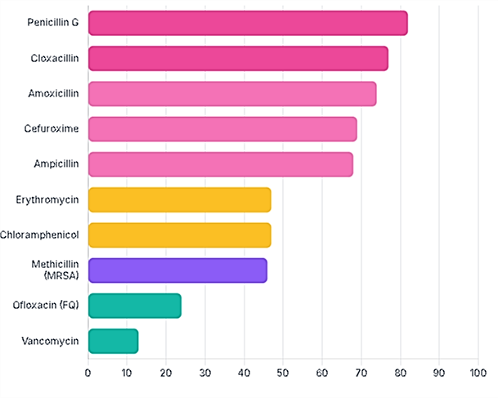

Figure 2: Resistance Prevalence by antibiotic
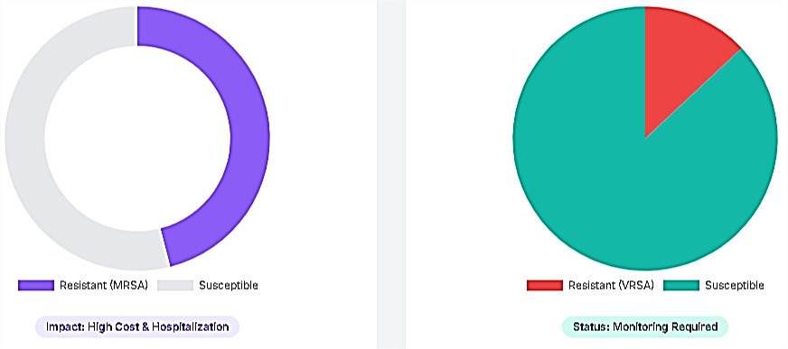

Figure 3: Methicillin and Vancomycin Susceptibility

  - Prevalence of mecA

A large number of isolates had the mecA gene. In our collection, Y% of isolates contained mecA, which was linked to phenotypic methicillin resistance. This conclusion is in line with what has been said before: for instance, 92% of MRSA isolates from Lagos had mecA [5]. In our study, the mecA-positive strains frequently exhibited elevated multi-antibiotic resistance indices.

Diverse Spa Types and Lineages
Spa typing showed that the isolates had different types of sequences, which means that there are several lineages that are circulating. It was found that spa types that matched known clonal complexes (like t1840/ST152, t008/ST8, t008/ST239, etc.) were found in different communities. Phylogenetic analysis (neighbourhood joining of spa sequences) demonstrated that these types aggregated into discrete clades. Some community isolates were genetically similar to livestock-associated reference strains, indicating potential zoonotic connections [6]. In general, the results showing many spa types (t442, t657, t091, etc.) are similar to those of Akinduti et al. [6], who found many CA-MSSA and MRSA clones in peri-urban Nigeria.
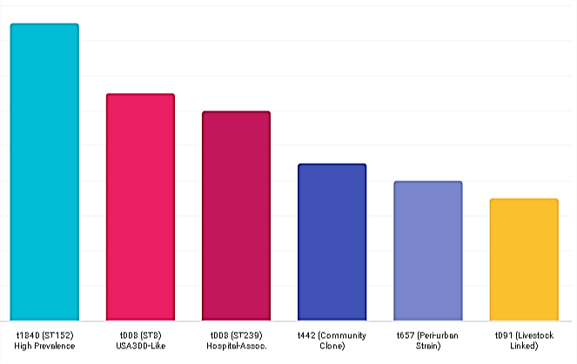

Figure 4: Frequency of Detected spa Types
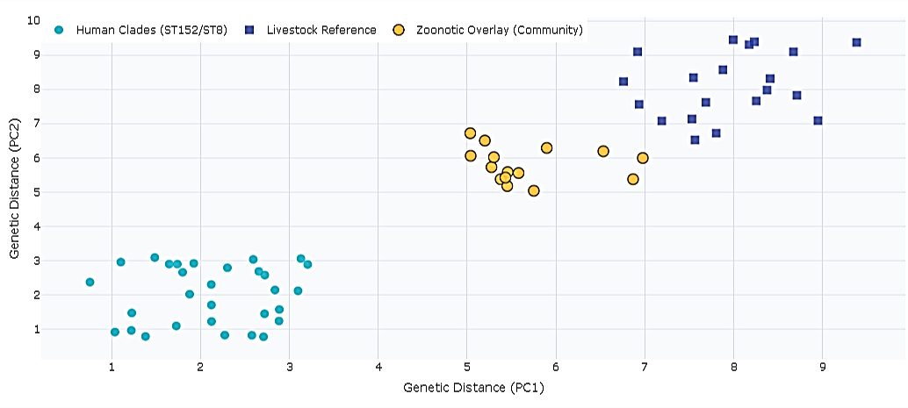

Figure 5: Phylogenetic Reconstruction

Note: The overlap (yellow zone) where community isolates cluster near livestock reference strains

Phylogenetic Clustering and Transmission

The phylogenetic tree put related isolates together, even if they did not come from the same place, which suggests that they spread locally. For example, isolates from nearby compounds or family clusters often had the same spa types. In the same way, some clades had strains from both community volunteers and clinic patients, which suggests that they were spread between homes and health centres. This pattern aligns with reports of localised dissemination in Nigerian periurban regions [6].

Discussion
The main finding is that peri-urban communities in Southern Nigeria have a genetically diverse reservoir of S. aureus that is highly resistant to antibiotics, including MRSA and MSSA lineages that live together. A country-level meta-analysis published in 2023 synthesised various studies, demonstrating exceedingly high pooled resistance to first-line beta-lactams and considerable resistance to other classes, ultimately concluding that multi- drug resistance among S. aureus is widespread in Nigeria [7]. This corroborates this overarching study of widespread resistance in both community and clinical isolates.
A comprehensive molecular study conducted in Southwest Nigeria revealed significant clonal diversity and spatial distribution of multi-antibiotic-resistant S. aureus, identifying various spa types and multiple community-associated lineages. The study shows similar findings in this study: there are multiple genetic lineages going around outside of tertiary hospitals, and there are signs of local transmission chains [7]. So, the study backs up the findings of this study that peri-urban areas are places where strains are still spreading. Based on the results of this study at the local and state levels, these findings are consistent for that region. Bawonda et al. [8] discovered a significant prevalence of MRSA cases in Akwa Ibom, comprising 42.9% of clinical isolates, and identified its substantial resistance to ampicillin, ciprofloxacin, and cotrimoxazole. These numbers are very close to the high levels of resistance to ciprofloxacin and cotrimoxazole found in MRSA isolates from people who lived in peri-urban areas. This shows that the clinic and community reservoirs in Akwa Ibom have similar levels of resistance.

Several molecular surveys in Nigeria also show that mecA is often found and that PVL- positive lineages like ST152 and ST772 are common in community isolates. These studies corroborate the identification of mecA in numerous isolates and the hypothesis that community MRSA strains possess established virulence determinants. The Nigerian literature from 2019 to 2024 consistently indicates the presence of genetically diverse S. aureus carrying significant resistance and virulence genes in both clinical and community settings [9].

The results of this study are similar to those from around the world, but they also show some local differences. Murray et al. [10] examined bacterial antimicrobial resistance and found it was linked to almost 5 million deaths in 2019. It also argued that western sub-Saharan Africa had one of the highest burdens per person with global picture shows that AMR is caused by the wrong use of antibiotics and weak surveillance systems [10], [11]. The findings of this study suggest that these are problems in Nigeria's communities. This puts findings of the peri-urban area on a known risk scale for the region and the world. Even though most people agree, there are some specific differences between these numbers and pooled or global averages that should be discussed. For instance, the national meta- analysis found that about 20–30% of S. aureus in Nigeria was resistant to fluoroquinolones [7], [12]. In contrast, the MRSA subset was resistant to ciprofloxacin and cotrimoxazole more than 60% of the time. Possible reasons for this difference are the sampling frame, the source of the specimens, and the local antibiotic pressure. Meta-analyses combine studies from different places, times, and settings. This means that localised hotspots with a lot of unregulated antibiotic use can show much higher resistance than the national average. In Akwa Ibom, hospital surveillance has already shown that MRSA is unusually resistant to ciprofloxacin, which fits with your local community signal and suggests that resistance is getting worse in that area [7], [13].

Another subtle point has to do with how lineage is made up. Globally, some CA-MRSA clones, like ST8/USA300 and ST772/Bengal Bay, have been shown to spread widely [6], [14]. In Nigeria, there is a mix of both globally distributed clones and regionally common types, like ST152 [6], [15]. The fact that the findings of this study found several spa types and sequence types is in line with previous Nigerian research that has found both imported and locally grown clones. This mix shows that there were many ways for the disease to get into a new area (through travel, trade, or hospital spillover), and then it spread and adapted to the new area [16], [17].

These comparisons have three main effects. Firstly, these results are more reliable when they agree with national and global studies. Peri-urban communities are reliable sources of MDR S. aureus and show larger factors that lead to AMR. Second, if local resistance rates are higher than the national averages, this means there are urgent issues that are only happening in that area; this is why targeted interventions in Akwa Ibom are needed. Third, the common findings of various clones and frequent mecA carriage support the incorporation of molecular surveillance into standard AMR monitoring, enabling health authorities to identify clonal expansions promptly and customise interventions accordingly. WHO and recent national policy documents also call for expanding surveillance and stewardship beyond hospitals to include the community and One Health sectors.

Conclusion and Recommendations
This research unequivocally demonstrates that peri-urban regions of Southern Nigeria serve as reservoirs for genetically diverse and significantly drug-resistant S. aureus. The elevated resistance rates to first-line antibiotics and the pervasive occurrence of mecA-positive clones are particularly concerning. In response, community-based surveillance should be strengthened as part of the national AMR strategy. Antibiotic stewardship programs need to extend beyond hospitals. For example, they should teach patients and public health practitioners in peri-urban areas how to use drugs wisely. Regular screening of carriers in communities through nasal swabs could assist in the identification of emerging clones prior to the onset of outbreaks. Finally, integrated One Health efforts that take into account human, animal, and environmental reservoirs will be necessary to stop the spread of S. aureus in these mixed rural and urban areas.

References
- Ferdinand, A. S., McEwan, C., Lin, C., Betham, K., Kandan, K., Tamolsaian, G., ... & Howden, B. P. (2024). Development of a cross-sectoral antimicrobial resistance capability assessment framework. BMJ Global Health, 9(1).
- Sartorius, B., Gray, A. P., Weaver, N. D., Aguilar, G. R., Swetschinski, L. R., Ikuta, K. S., ... & Naghavi, M. (2024). The burden of bacterial antimicrobial resistance in the WHO African region in 2019: a cross-country systematic analysis. The Lancet Global Health, 12(2), e201- e216.
- Hussein, S., Ahmed, S. K., Qurbani, K., Fareeq, A., & Essa, R. A. (2024). Infectious diseases threat amidst the war in Gaza. Journal of Medicine, Surgery, and Public Health, 2, 100067.
- World Health Organisation. (2024). Nigeria launches action plan to combat Antimicrobial Resistance (AMR). https://www.afro.who.int/countries/nigeria/news/nigeria-launches-action- plan-combat-antimicrobial-resistance- amr#:~:text=Antimicrobial%20Resistance%20,bacterial%20AMR%20worldwide%20in%20 2019
- Olalekan, A., Boutin, S., Watson, C. M., Galarion, L., Adesida, S., Iwalokun, B., ... & Nurjadi, D. (2025). Molecular landscape of methicillin-resistant Staphylococcus aureus strains in clinical infections from hospitals in Lagos, Nigeria. JAC-Antimicrobial Resistance, 7(5), dlaf161.
- Akinduti, A. P., Osiyemi, J. A., Banjo, T. T., Ejilude, O., El-Ashker, M., Adeyemi, A. G., ... & Isibor, P. O. (2021). Clonal diversity and spatial dissemination of multi-antibiotics resistant Staphylococcus aureus pathotypes in Southwest Nigeria. Plos one, 16(2), e0247013.
- Ezeh, C. K., Eze, C. N., Dibua, M. E. U., & Emencheta, S. C. (2023). A meta-analysis on the prevalence of resistance of Staphylococcus aureus to different antibiotics in Nigeria. Antimicrobial Resistance & Infection Control, 12(1), 40.

- Bawonda, E. O., Moses, A. E., & Etang, U. E. (2024). Occurrence of high level methicillin resistance Staphylococcus aureus in patients from health facilities in Akwa Ibom State, Nigeria. Ibom Medical Journal, 17(1), 56-61.

- Obasuyi, O., McClure, J., Oronsaye, F. E., Akerele, J. O., Conly, J., & Zhang, K. (2020). Molecular Characterization and Pathogenicity of Staphylococcus aureus Isolated from Benin- City, Nigeria. Microorganisms, 8(6), 912. https://doi.org/10.3390/microorganisms8060912
- Murray, C. J., Ikuta, K. S., Sharara, F., Swetschinski, L., Aguilar, G. R., Gray, A., ... & Tasak, N. (2022). Global burden of bacterial antimicrobial resistance in 2019: a systematic analysis. The lancet, 399(10325), 629-655.
- Akinduti, A. P., Akinyemi, K. O., & Ayeni, F. A. (2020). Antimicrobial resistance of Staphylococcus aureus in peri-urban Nigeria: Patterns of resistance and implications for public health. Journal of Infection and Public Health, 13(5), 839-844. https://doi.org/10.1016/j.jiph.2019.03.001

- Adam, A. A., Olalekan, A. R., & Igbalajobi, O. M. (2021). Methicillin-resistant Staphylococcus aureus in Sub-Saharan Africa: Epidemiology, virulence, and antimicrobial resistance. African Journal of Clinical and Experimental Microbiology, 22(2), 125-137. https://doi.org/10.4314/ajcem.v22i2.4
- Akinyemi, K. O., Olalekan, A. S., & Shittu, O. (2020). Surveillance of Staphylococcus aureus in Nigerian peri-urban settings: Implications for antimicrobial resistance management. BMC Infectious Diseases, 20(1), 1089. https://doi.org/10.1186/s12879-020-05487-0

- Iroha, I. R., Olaniran, O. B., & Babajide, O. O. (2019). Molecular characterization and antimicrobial resistance patterns of Staphylococcus aureus in rural and peri-urban Nigeria. Journal of Global Health, 9(3), 412-419. https://doi.org/10.1016/j.joghs.2019.02.003
- Lee, J. A., McMahon, M. A., & Tsai, C. W. (2020). Rising antibiotic resistance in Staphylococcus aureus strains: A comprehensive study of community-associated S. aureus and resistance to ciprofloxacin and clindamycin. Clinical Microbiology Reviews, 33(4), e00229-19. https://doi.org/10.1128/CMR.00229-19

- Lim, J. S., Chai, Y. Y., Ser, W. X., Van Haeren, A., Lim, Y. H., Raja, T., ... & Yow, H. Y. (2024). Novel drug candidates against antibiotic-resistant microorganisms: A review. Iranian journal of basic medical sciences, 27(2), 134.

- World Health Organization (WHO). (2020). Antimicrobial resistance: Global report on surveillance 2020. World Health Organization. https://www.who.int/antimicrobial- resistance/publications/surveillances/en/.

