MICROBIAL CONTAMINANTS IN THE CULTIVATION OF Pleurotus ostreatus

ABSTRACT
The evidence of a successful mushroom cultivation process is the production of high-quality fruit bodies, a process basically dependent on the quality of the spawns and substrates. Contamination at any stage of the cultivation process poses a significant challenge to productivity and yield. Aiming at producing high-quality Pleurotus ostreatus mushroom fruitbodies from wheat grain (Triticum aestivum) spawns and sawdust (SD) /rice (Oryza sativa) bran (RB) substrates, the bacterial and fungal contaminants associated with the spoilage of the spawns and substrates in the cultivation of Pleurotus ostreatus in the Mushroom unit of Biotechnology Advanced Research Centre (BARC), Sheda Science and Complex (SHESTCO) were isolated and identified using standard microbiological techniques. Contamination was initially detected phenotypically through discoloration, unpleasant odor and poor mycelia colonization. The spawns were grown on 100% wheat grains. The only microbial contaminant in the wheat spawns were identified as Bacillus substilis. The mean total bacterial count (TBC) for the spawns varied from 0 to 2.1 x 10⁶ CFU/g. The wheat spawns had no coliforms and no fungal growth. The spawns were inoculated on rice bran (RC) and sawdust (SD) substrates having different percentage ratios: RC (70%): SD (30%); SD (70%): RC (30%) and RC (50%): SD (50%), 100% sawdust and 100% rice bran. The mean TBC for contaminated substrates varied between 0 to 4.5 x 10⁶ CFU/g .They were isolated and identified as Bacillus substilis 5(25%), Pseudomonas aeruginosa 10(50%) and Staphylococcus aureus 5(25%) using morphological, cultural and biochemical techniques. The mean total fungal count for the contaminated substrate ranged from 0 to 3.5 x 10^{3.} CFU/g. The fungal isolates were Aspergillus niger and Candida albicans. The 50% rice bran and 50% sawdust combination formulation which had no contamination also had the best yield. Contaminated spawns and substrates along the cultivation line should be quickly removed and discarded aseptically to avoid cross contamination. Stringent sterilization and pasteurization techniques should be adopted to ensure uniformity in order to prevent future contamination. Future studies should focus on the molecular characterization of these contaminants and elucidate their specific inhibitory mechanisms at each cultivation point.
Keywords: Cultivation, Contaminants, Pleurotus ostreatus, Spawns, Substrates
1. INTRODUCTION
The art and science of mushroom cultivation is an indispensable part of global food security, biotechnology, and sustainable agriculture Among cultivated edible mushrooms, the oyster mushroom (Pleurotus ostreatus) is very popular due to its nutritional value, medicinal properties, adaptability to diverse substrates, and relatively short cultivation cycle (Sanchez, 2010; Kumar et al., 2021).
Pleurotus ostreatus, one of the most popularly cultivated edible mushroom belongs to the Kingdom Fungi, Division Basidiomycota, Class Agaricomycetes, Order Agaricales, Family Pleurotaceae and Genus Pleurotus (Oei., 2016; Deepalakshmi and Mirunalini., 2014). The proximate, mineral amino acid and vitamin content of Pleurotus mushrooms is well documented. (Ahmed et al., 2016).
In the wild, they are found as clusters on dead and decaying decidiuos and coniferous trees. They degrade lignocellulosic wastes, enabling it to grow easily on different types of agricultural wastes such as saw dust, rice bran, wheat straw, cassava peels, cottonseed hulls, corncob, sugarcane baggase, waste paper and leaves at wide temperature ranges (15℃ – 35℃) and extremely high relative humidity range of between 85% and 100% (Sanchez., 2010; Stamets., 2000). The knowledge, use and cultivation of oyster mushroom is increasing due to its ease of production, market value, medicine, nutritional benefit and environmental friendly production protocol (Banik and Nandi., 2004; Gregory et al., 2007). According to Kalac., (2013), China produces 90% of the oyster mushrooms produced wprldwide. It is the second most cultivated mushroom worldwide due to its high biological efficiency, shorter cultivation duration, affordable production, medicinal and nutritional values ( Chang and Miles., 2000; K’ues and Liu., 2000).
The success of mushroom cultivation, the growth, yield and nutritional composition of cultivated mushrooms is essentially based largely on the viability and quality of spawn (vegetative mycelia culture) and bulk substrate on which the fructification will occur (Bahl., 1984, El Sebaaly et al., 2019). The spawn grains and the substrates are both nutrient dense materials and encourage the growth of not only the macrofungi but a myriad of competing microorganisms, including bacteria, fungi and filamentous yeasts, In mushroom cultivation, there are beneficial microorganisms that are crucial in the conversion and adaptation of substrates, mycelial hyphal elongation mycelia and formation of fruit bodies.
Microbial contaminants negatively affect cultivation by competing with the mushroom for space and nutrients, consequently affecting the duration of mycelia colonization and fructification. The yield reduction as well as unpleasant odor, discoloration, slimy texture and other organoleptic properties of the mushroom are affected leading to losses. Daily monitoring of the cultivation process for early detection of contaminated mushrooms is key to preventing the proliferation and spread of contaminants. The isolation and identification of the contaminants involved will aid the formulation of prevention and control strategies.
Researchers have reported the detection of microbial contaminants on mushroom facilities, spawns and substrates (Biswas, 2014; Shin., 1987; Suarez et al., 2020). In Nigeria and other countries, the growing awareness on the importance of microbial contaminants in the cultivation cycle notwithstanding, there is still a paucity of documented information on this issue.
The aim of this research work is therefore to isolate and identify microbial contaminants associated with the spoilage of spawns and substrates in the cultivation of Pleurotus ostreatus

2. MATERIALS AND METHOD
2.1 Study location and Duration
This study was carried out in the Mushroom Unit of the Department of Food Science and Industrial Biotechnology, BARC, SHESTCO in Sheda, Kwali Area Council, Federal Capital Territory. Nigeria over a period of about four weeks.
2.1. 1 Source of Mushroom Culture and Spawn Production
Vigorously striving pure cultures of Pleurotus ostreatus were obtained from the mushroom culture collection of the BARC Mushroom Unit. The culture was maintained on sterile Potato Dextrose Agar (PDA) slants at 4°C and used as the mother spawn for spawn preparation.
2. 1.2 Preparation of Spawn
The spawn was prepared as described by Nnebechukwu et al., (2025) with modifications. Wheat grains (Triticum aestivum) were handpicked to remove stones and other debris. The grains were soaked in water for 12-18 hours, and then boiled for 40 minutes until they were soft but not bursting. Excess water was drained from the grains, surface-dried by spreading on a clean dry tray. Calcium carbonate (CaCO₃) was added at 2% w/w to buffer the pH. The grains were filled into glass jars of 500ml capacity, leaving one-third space to the cover. The jars were sealed with breathable lids (comprising a non-absorbent cotton wool plug and aluminum foil) and sterilized in an autoclave at 121°C (15 psi) for one hour, thirty minutes. They were cooled to room temperature (25±2°C) each of the jars was aseptically inoculated with five one centimeter agar plugs from the vigorously thriving Pleurotus ostreatus mother spawn on PDA. Inoculated jars were incubated in a darkroom at 27°C. The mycelia colonization was monitored daily. The jars of spawn that were fully colonized were identified by their thick white rhizomorphic mycelium covering all the wheat grains. This was used for substrate inoculation within 5-7 days of full colonization.
2.1.3 Preparation of Substrate
Different substrate formulation ratios were prepared using rice (Oryza sativa) bran (RB) and Sawdust (Gmelina arborea). (SD). Rice bran was obtained from a local rice mill.in Sheda village while the saw dusts were obtained from Timber shade, Bako in Kwali Area Council. The formulations were: 70% Rice Bran + 30% Sawdust, 50% Rice Bran + 50% Sawdust, 30% Rice Bran + 70% Sawdust, 100% Sawdust (Control I), 100% Rice Bran (Control 2).
The dry components of each formulation were thoroughly mixed and water was added gradually to achieve a final moisture content of 60-65% determined by the squeeze test. A handful of the wet substrate was squeezed to release only a few drops of water. The wet substrate was packed into polypropylene (mushroom) bags (approximately 1 kg wet weight per bag). Each of the bags was fitted with a firm plastic collar and a cotton-wool plug to allow for gas exchange while minimizing contaminant entry. The bags were then subjected to pasteurization by steaming in pasteurizing equipment (medium size metal drum) at 95-100°C for 10 hours, followed by a 12 hour cooling phase while still in the sealed drum.
2.1.4 Inoculation of Substrate Bags
The substrate bags were transferred to the inoculating chamber after pasteurization and cooling. Each of the substrate bags were aseptically inoculated with 5% (w/w) of the fully colonized wheat grain spawn. The bags were then moved to a dark incubation room maintained at 25°C. Complete mycelial colonization was achieved between twenty to twenty five days, the substrate bags were transferred to the growing room. Watering of the substrate bags was done regularly using a customized watering can to maintain the right humidity.
2.1.1 Sample Collection
The samples were collected by promptly removing Jars that showed signs of contamination (pungent smell, discoloration, wet spots or sparse mycelial colonization and removal of plastic collar) using hand gloves to prevent cross contamination and spread. One gram each of the contaminated spawns and substrates were aseptically collected using sterile spatulas into sterile containers. They were properly labeled and immediately taken to the Microbiology laboratory for microbiological analysis. A total of 6 contaminated spawn jars were analyzed. For the substrates, 10 contaminated bags were screened.
2.2 Isolation, Identification and Confirmation of Bacterial Isolates
Serial dilution of the contaminated samples was carried out as outlined by Cheesbrough (2006). One gram (1g) each of contaminated spawns and substrate samples were homogenized in nine (9.0) ml sterile distilled water to form a stock solution. One milliliter (1 ml) of the homogenate was dispensed serially into 9 ml sterile distilled water; the same procedure was repeated serially up to tube 10 ⁶ dilution factor. Spread plate technique in which 0.1ml aliquots from the 10⁴, 10⁵ and 10⁶ tubes were inoculated aseptically onto the dried surfaces of sterile plates of Nutrient Agar, Eosin Methylene Blue Agar, MacConkey agar, Mannitol Salt Agar, and Centrimide Agar in duplicates for isolation of bacteria and (All media were prepared according to manufacturer’s instructions). The plates were incubated at 37°C for 48 hours .
Mean colony counts were calculated and expressed as colony forming units per gram (CFU/g) of the sample analyzed.
Coliform Forming Unit/Gram was calculated as: Average number of colonies × Total dilution factor divided by volume plated (aliquot).

2.3.1 Purification of Bacterial Isolates
The pure cultures of the bacteria were obtained by repeated streaking aseptically on fresh nutrient agar plates. They were incubated for 24 hours at 37°C after which the isolates were inoculated on nutrient agar slants in bijoux bottles and stored in a laboratory refrigerator at 4°C for future use.
2.4 Isolation, Identification and Confirmation of Fungal Isolates
The total heterotrophic fungi count was done using Sabouraud Dextrose Agar (SDA) supplemented with 0.05g/l of Chloramphenicol to inhibit bacterial growth (Kpormon and Douglas, 2018). The spread plate technique employed (Prescott et al., 2011). An aliquot (0.1 ml) the serially diluted contaminated samples were inoculated in duplicates on the surface of SDA plate. Spreading was done evenly using a sterilized glass spreader. The inoculated SDA plates were incubated at 25 °C for 72 h after which the colonies were enumerated. The mean of the count was recorded (Douglas and Robinson, 2019).The Identification of fungal was carried out by picking the fungal spores with sterilized inoculating pin. They were placed on a clean glass slide, and gently spread with inoculating pin and a drop of Lactophenol Cotton Blue. They were covered with cover slips, and then, observed with a microscope. Their microscopic and cultural characteristics were used in the identification of the fungal isolates. These isolates were ascertained by comparison with a fungal atlas (Kidd et al., 2016). . Plates with distinct colonies were read as colony forming units per gram (CFU/g) of mushroom sample.

2.5 Determination of insect infestation
The contaminated samples were screened for the preesence of insects because contamination most often results in odor formation which attracts insects to the samples.

3 RESULT AND DISCUSSION

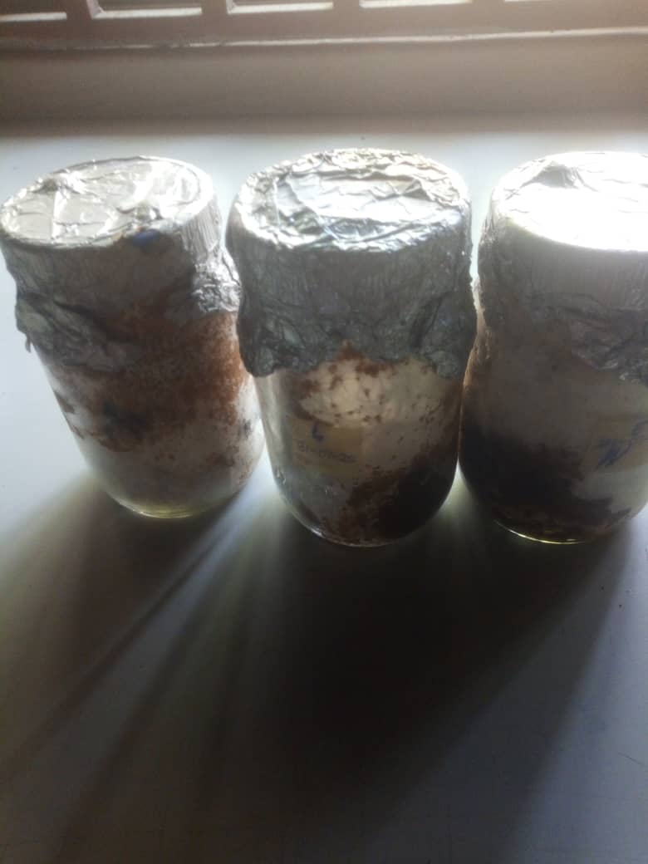
Figure 1: Representative samples of contaminated wheat spawns
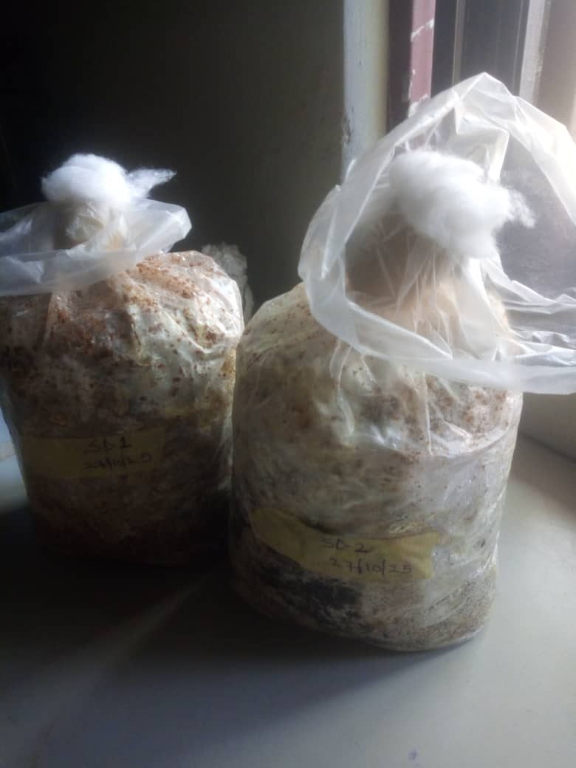
Figure 2: Representative samples of contaminated sawdust substrates

Table I: Mean Bioload for Contaminated Spawn

Contaminated Spawns | Total Bacteria Count CFU/g) | Total Coliform Count  CFU/g) | Total Fungal Count  CFU/g
Batch 1 | 1.6 X 10⁶ | 0 | 0
Batch 2 | 2.1 x 10⁶ | 0 | 0
Batch 3 | 0 | 0 | 0

Table 2: Mean Bioload for Contaminated Substrate (CFU/g)

Combination ratio | Total Bacteria Count CFU/g) | Total Coliform Count  CFU/g) | Total Fungal Count CFU/g
70RB:30SD | 1.8 x 10⁶ | 0 | 1.7 X 10⁶
50RB:50SD | 0 x 10⁶ | 0 | 0
30RB:70SD | 4.5 x 10⁶ | 0 | 3.5 X 10⁶
100 SD | 3.0 x 10⁶ | 0 | 2.3 X 10⁶
100 RB | 1.1 x 10⁶ | 0 | 1.0 X 10 ⁶

Key: 70RB:30SD =70% Rice bran and 30% Sawdust; 50RB:50SD = 50% Rice bran and 50% Sawdust; 30RB:70SD = 30% Rice bran and 70% Sawdust; 100 SD = 100% Sawdust; 100RB = 100% Rice bran.

Table 3. Cultural, Morphological and Biochemical Characteristics of Bacterial Isolates

 | Probable organism | Probable organism | Probable organism
 | Bacillus substilis | Staphylococcus aureus | Pseudomonas aeruginosa
Colony Edge | Irregular | Entire | Entire
Appearance on media | Creamy on nutrient agar | Golden yellow on Mannitol salt agar | Bluiesh green on nutrient agar
Shape | Rods | Cocci in clusters | Rods
Grain Stain | + | + | -
Indole | - | - | -
Catalase | + | + | +
Coaglulase | - | + | -
Oxidase | - | - | +
Methyl Red | - | + | -
Voges  Proskauer | - | - | +
Citrate | + | - | +
Glucose | + | - | -
Lactose | + | + | -
Fructose | - | + | +
Maltose | - | + | -
Sucrose | - | + | -

Table 4: Frequency of Occurrence of Bacterial Isolates from Contaminated Substrates

Isolate | Frequency | Percentage(%)
Staphylococcus aureus | 5 | 25
Bacillus substilis | 5 | 25
Pseudomonas aeruginosa | 10 | 50
Total | 20 | 100

Table 5: Frequency of Occurrence of Fungal Isolates from Contaminated Substrates

Isolate | Frequency | Percentage (%)
Aspergillus niger | 9 | 60
Candida albicans | 6 | 40
Total | 15 | 100

Table 6: Cultural Characteristics of Fungal isolates

Macroscopy | Microscopy | Probable organism
Cinnamon – brown colony, small,  filamentous mycelia on the surface,  grey on reverse | Compact Conidial heads, smooth and globose shaped conidiophores,  unbranched sporangiophores | Aspergillus niger
Moist, flat, smooth, cream and yeast-  like on surface, pink on reverse | Spherical | Candida albicans

Globally, and especially in a developing country like Nigeria, one of the most pressing developmental goal is food security. The successful cultivation of Pleurotus ostreatus is one of the ways by which this goal can be met. It involves favoring the growth and proliferation of a single beneficial fungus over other competitors.
Figure 1 is a representative sample of contaminated spawns. The Contaminated spawns were detected by discoloration with slimy patches and unpleasant odor as well as inhibition of complete mycelia colonization. As seen in figure 2, contaminated substrate bags were identified by the appearance of colored patches, loose caps and unpleasant odors.
Table 1 depicts the mean total bioload of contaminated spawns. The zero CFU/g total fungal count obtained in the spawn samples shows that the sterilization protocol (121°C for 90 minutes) and subsequent aseptic inoculation techniques were effective against mesophilic fungi. The bacterial load was evaluated in three batches: batch 1 had a bacterial load of 1.6 X 10⁶ CFU/g.; batch 2 had a bacterial load of 2.1 X 10⁶ CFU/g.; batch 3 had a bacterial load of 0 CFU/g. The Mean TBC for the spawn varied from 0 to 2.1 x 10⁶ CFU/g. A total of sixty spawn jars were examined. 6 (10%) were found to be contaminated before full colonization. The sole contaminant of the wheat grain spawn is Bacillus substilis. The Bacillus substilis colonies probably persisted as a result of the formation of spores. Contaminated spawns can serve as a vehicle for the introduction and transmission of competitors into the substrate. The substrates are so dense with nutrients that even a little contamination from the spawn can grow exponentially causing a lot of damage in the process. No coliforms were detected in the spawn samples. The spawns did not show any signs of insect infestation Therefore; the need to meticulously prepare the spawns cannot be overestimated.
Table 2 depicts the bioload for the contaminated substrate. The contamination was evaluated based on the different substrate formulations. A total of 100 bags, twenty bags each of the five different formulations were examined. The percentage occurrence of contamination per formulation were as follows: (70RB:30SD) = 2 (10%); (50RB:50SD) = 0%; (30RB:70SD) = 5(25%); (100 SD) = 2(10%) 100RB = 1(5%). There was a 10% contamination for the substrate bags. The mean total bacterial count for the substrates was 1.8 x10⁶, 0 x 10⁶, 4.5 x 10⁶, 30 x 10⁶ and 1.1 x 10⁶ CFU/g for 70% RB: 30%SD, 50%: 50%, 30%RB: 70%SD, 100%SD and 100% RB respectively. Table 2 also shows that the total fungal count for the substrate samples was 1.7 x 10⁶, 0 , 3.5 x x10⁶ , 2.3 x10⁶ , 1.0 x x10⁶ CFU/g for 70% RB: 30%SD, 50%: 50%, 30%RB: 70%SD, 100%SD and 100% RB respectively. Table 2 also depicts a zero coliform count for the contaminated substrates.
The result of the present study corroborates with the observation of Deveau et al., (2018) that wild and cultivated mushrooms interact with other microorganisms during their whole life cycle. According to Frey-Klett et al., (2011), interactions between mushrooms and microorganisms involve different combinations of physical contact and molecular communication via signaling molecules, chemotaxis, exchange and conversion of metabolites that influence the interacting organisms and their surrounding environment. In a similar experiment, Biswas (2014) observed that microbial contamination of oyster mushroom bed could serve as an obstacle to increased yield of Pleurotus spp.
Factors such as media used, presterilization technique as well as substrate mixture could be responsible for the difference in bacterial cell numbers. In the present study, a low bacterial count was observed in the spawns could be Attributed to the rigorous thermal reduction by cooking seeds in boiling water followed by sterilization in an autoclave.
Table 3 depicts the morphological, cultural and biochemical characteristics of the bacteria isolates isolated from contaminated substrates. The bacteria were: Staphylococcus aureus, Bacillus substilis and Pseudomonas aeruginosa. The organisms that were probably Staphylococcus aureus were Gram positive. Cocci in clusters. They were indole, oxidase, Voges proscauer, citrate negative. They were catalase and methyl red positive and utilized all the sugars in fermentation test.
Bacilus substilis reacted positively to Gram stain. They were found to be rod shaped. On nutrient agar, the bacteria were irregular, flat and white translucent colonies. The isolates were citrate positive, catalase negative and Voges proscauer positive. They were indole, oxidase and coagulase negative.
Pseudomonas aeruginosa colonies have an entire edge. They are blue green on nutrient agar. They are Gram negative rods. They are indole, coagulase, methyl red negative, citrate, Voges proscauer, catalase and citrate positive.
Table 4 depicts the frequency of occurrence of bacterial isolates in the contaminated substrates. Bacilus substilis 5(25%), Staphylococcus aureus 5(25%), Pseudomonas aeruginosa 10(50%). This result shows that most of the contaminants in this study were Bacillus substilis.. Pseudomonas aeruginosa is a common bacterium found occurring in the environment and grows very well in moist conditions. The detection of Staphylococcus aureus in the present study is not surprising because they are a major member of the normal flora of the human skin.Their presence suggests that there is a loophole in the hygiene of the human factor.Bacillus species are popular for their ability to resist heat.
Table 5 shows that the frequency of occurrence of fungal isolates in the contaminated substrates was as follows: Aspergillus niger 9(60%), and Candida albicans 6(40). Aspergillus niger: thrive in stored and moist environments. A common storage and environmental mold. Its rapid sporulation and is a concern to food safety. Candida albicans: are typically opportunistic human pathogens. The detection of Candida albicans indicates significant hygiene issues anD contamination of spraying.
Table 6 shows that on Sabouraud dextrose agar (SDA) supplemented with chloramphenicol, Aspergillus niger were white and rapidly turning black due to the dense production of their conidia. The microscopy showed characteristic radiating conidial heads with dark, rough conidia. The isolation of Aspergillus niger in this study is significant because it was mentioned by Biswas (2014) as one of the prominent contaminants in mushroom cultivation.
Candida albicans appeared as Creamy, smooth, yeast-like colonies on SDA supplemented with chloramphenicol. Microscopy revealed oval budding yeast cells and pseudohyphae. A positive germ tube test confirmed that they were Candida. albicans.
In the present study, it was observed that only uncontaminated samples progressed to full colonization and fructification. The 50% sawdust and 50% rice bran formulation had the best yield because it showed no signs of microbial contamination from the onset.
5. Conclusion
This investigation has successfully identified the microbial contaminants slowing down the cultivation of Pleurotus ostreatus. Bacillus subtilis was the most predominant contaminant as it was detected in both the contaminated spawns and substrates. It shows that substrate formulation is a critical determinant of contamination susceptibility and productivity. .The result highlights the importance of keeping the cultivation process free of contamination. The quality of the spawns and substrate should be ascertained before use. Contaminated spawns and substrates along the cultivation line should be quickly removed and discarded aseptically to avoid cross contamination. Stringent sterilization and pasteurization techniques should be adopted to ensure uniformity in order to prevent future contamination.
Future studies should focus on the molecular characterization of these contaminants and elucidate their specific inhibitory mechanisms at each cultivation point.

REFERENCES

Ahmed, M., Abdullah, N., & Nuruddin, N.N. (2016). Yield and nutritional composition of oyster mushrooms: an alternative nutritional source for rural people. Sains Malaysia, 45(11), 1609-1615. http://www.ukm.my/jsm/english_journals/vol45num11_2016/vol45num11_2016p1609-1615.htm
Bahl, N. (1984) Hand book of Mushroom. 3rd ed. Oxford and IBH Publishing Corporation. New Delhi, Bombay. 1984;345-52.
Banik, S., & Nandi, R. (2004). Effect of supplementation of rice straw with biogas residual slurry manure on the yield, protein and mineral contents of oyster mushroom. Industrial Crops and Products, 20, 311-319. https://doi.org/10.1016/j.indcrop.2003.11.003
Bhargav, P., Gupta, D., Jarial, R. S., Sharma, N., & Thakur, R. (2023). Fungal and Bacterial Contaminants Associated with the Spoilage of Mushroom Spawn. International Journal of Plant & Soil Science, 35(6), 85-93. https://doi.org/10.9734/ijpss/2023/v35i62842
Biswas, M.K (2014) Microbial Contaminants in Oyster Mushroom (Pleurotus ostreatus) Cultivation their Management and Role of Meteorological Factors. Proceedings of the 8 th International Conference on Mushroom Biology and Mushroom Products (ICMBMP8)
Chang, S. T., & Miles, P. G. (2004). Mushrooms: Cultivation, Nutritional Value, Medicinal Effect, and Environmental Impact. CRC Press. https://doi.org/10.1201/9780203492086
Cheesbrough, M. (2006). Biochemical Test to identify bacteria. In *District laboratory practice in tropical countries* (2nd ed., pp. 62-70). Cambridge University Press. https://doi.org/10.1017/CBO9780511543470
Deepalakshmi, K., & Mirunalini, S. (2014). Pleurotus ostreatus: an oyster mushroom with nutritional and medicinal properties. Journal of Biochemical Technology. https://doi.org/10.51847/wxxzf0n
Deveau, A., Bonito, G., Uehling, J., Paoletti, M., Becker, M., Bindschedler, S., Hacquard, S., Hervé, V., Labbé, J., Lastovetsky, O. A., Mieszkin, S., Millet, L. J., Vajna, B., Junier, P., Bonfante, P., Krom, B. P., Olsson, S., van Elsas, J. D., & Wick, L. Y. (2018). Bacterial–fungal interactions: ecology, mechanisms and challenges. FEMS Microbiology Reviews, 42(3), 335–352. https://doi.org/10.1093/femsre/fuy008
Douglas, S. I., & Robinson, V. K. (2019). Indoor microbiological air quality in some wards of a tertiary health institution in Port Harcourt, Nigeria. IOSR Journal of Pharmacy and Biological Sciences, 14, 44-50. https://doi.org/10.9790/3008-1401034450
El Sebaaly, Z., Assadi, F., Sassine, Y. N., & Shaban, N. (2019). SUBSTRATE TYPES EFFECT ON NUTRITIONAL COMPOSITION OF BUTTON MUSHROOM (AGARICUS BISPORUS). Agriculture and Forestry, 65(1), 73-80. https://doi.org/10.17707/AgricultForest.65.1.08
Frey-Klett, P., Burlinson, P., Deveau, A., Barret, M., Tarkka, M., & Sarniguet, A. (2011). Bacterial-fungal interactions: Hyphens between agricultural, clinical, environmental, and food microbiologists. Microbiology and Molecular Biology Reviews, 75(4), 583–609. https://doi.org/10.1128/MMBR.00020-11
Ghimire, A., Pandey, K. R., Joshi, Y. R., & Subedi, S. (2021). Major fungal contaminants of mushrooms and their management. International Journal of Applied Sciences and Biotechnology, 9(2), 80-93. https://doi.org/10.3126/ijasbt.v9i2.37513
Gregori, A., Švagelj, M., & Pohleven, J. (2007). Cultivation techniques and medicinal properties of Pleurotus spp. Food Technology and Biotechnology, 45(3), 238–249. https://hrcak.srce.hr/24172
Kalač, P. (2013). A review of chemical composition and nutritional value of wild-growing and cultivated mushrooms. Journal of the Science of Food and Agriculture, 93(2), 209-218. https://doi.org/10.1002/jsfa.5960
Kidd S., Halliday C., Alexiou H., Ellis D. (2016). Descriptions of medical fungi. 3rd edition. CutCut Digital, Paris.
Kpormon, L. B., & Douglas, S. I. (2018). Comparative ecotoxicological assay of e-waste (phone batteries) on some aquatic micro flora. Journal of Advances in Biology & Biotechnology, 17(2), 1-10. https://doi.org/10.9734/JABB/2018/40421
Kües, U., & Liu, Y. (2000). Fruiting body production in Basidiomycetes. Applied Microbiology and Biotechnology, 54(2), 141–152. https://doi.org/10.1007/s002530000396
Prajapati, S. K., Kumar, V., Rawat, D. K., Singh, S., Saroj, D. K., Ravikant, & Verma, S. (2023). Mushroom cultivation: A sustainable approach to future agriculture to ensure quality food and nutritional security of current population in India. International Journal of Multidisciplinary Research and Growth Evaluation, 4(4), 697-705. https://www.allmultidisciplinaryjournal.com/
Nnebechukwu, I. A., Godsave, Y. B., Nwadiaro, P. O., & Agaba, O. A. (2025). Cultivation of Oyster Mushroom (Pleurotus ostreatus) Using Ricebran, Sawdust and their Mixed Bed as Substrates. International Journal of Microbiology and Applied Sciences, 4(1), 65–72. https://ijmaas.com/publications/vol-4-issue-1-2025/
Oei, P. (2016). Mushroom Cultivation IV - Appropriate Technology for Mushroom Growers. ECO Consult Foundation. https://www.abebooks.com/9789082512908/Mushroom-Cultivation-IV-Appropriate-technologies-9082512904/plp
Willey, J. M., Sherwood, L. M., & Woolverton, C. J. (2011). Prescott's Microbiology, Eighth Edition. McGraw-Hill Higher Education. http://catalogs.mhhe.com/mhhe/home.do
Sánchez, C. (2010). Cultivation of Pleurotus ostreatus and other edible mushrooms. Applied Microbiology and Biotechnology, 85(5), 1321–1337. https://doi.org/10.1007/s00253-009-2343-7
Shin, G.C (1987). Harmful fungi associated with rice straw media for growing of oyster mushroom, Pleurotus ostreatus. Kor J .Mycol. 15: 92-98.
Stamets, P. (2000). Growing gourmet and medicinal mushrooms. Ten Speed Press. https://www.penguinrandomhouse.com/books/100000/growing-gourmet-and-medicinal-mushrooms-by-paul-stamets-9781580081757/
Suareza, C., Ratering, S.,Weigela, V.,Sacharowa, J., Bienhaus, J., Eberta, J., Hirz, A., Rühlb,M., Schnel,S l. Isolation of bacteria at different points of Pleurotus ostreatus cultivation and their influence in mycelial growth..Journal of Microbiological Reseaech. 234 :126393.

