Organoleptic characteristics of some traditional dishes made from a composite flour of wheat (Triticum aestivum) type 45 - taro corm (Colocasia esculenta) cultivars "Fouê" and "Yatan": the case of spring rolls, snowballs, and savory croquettes

ABSTRACT
Aims: This study aimed to investigate the influence of composite flour made from wheat and taro corms Colocasia esculenta varieties "Fouê" and "Yatan" on the physical characteristics of certain bakery products.
Study design: The wheat flour used in pastries in Côte d'Ivoire is exclusively imported, which fosters dependency on producing countries. Moreover, due to global population growth and malnutrition issues in African populations, it is essential to substitute or combine wheat flour with local flours to minimize the amount of imported wheat. Taro (Colocasia esculenta) is a plant that grows easily in tropical regions and holds great potential. This study, therefore, focused on using this tuber in combination with wheat flour type 45 to create bakery products.
Results: The final part of the work evaluated the acceptability of the prepared products through a sensory analysis. Lower acceptability was observed for products with 9% and 12% taro flour substitution. However, for substitutions at 1%, 3%, and 6%, the products were well appreciated by the panelists and demonstrated organoleptic characteristics close to the 100% wheat control.
Conclusion: Overall, the products had good acceptability, but those with 12% substitution showed less acceptable results and organoleptic characteristics that were not well received by the panelists.

Keywords: Composite flour, Organoleptic characteristics, Bakery products, Taro corms, Fouê, Yatan.

1. INTRODUCTION
1. Introduction
In recent years, food security has become a global concern due to climate change, which is one of the main factors contributing to the rise in international food prices [1]. Today, approximately 1.02 billion people are considered undernourished [2]. It is therefore evident that food production must increase significantly to meet the future demand of a growing population expected to reach 9 billion by 2050 [3]. The rapid urbanization of Africa and the emergence of a middle class are changing eating habits, boosting the consumption of bread and traditional dishes that need to be promoted [3]. Wheat flour is the main ingredient in bakery products, bread making, and some traditional dishes. Its widespread use is linked to its ability to retain gas, allowing the dough to expand during baking [4]. The cost of wheat and wheat-derived imports heavily impacts the trade balance of importing countries that do not produce wheat. In developing countries, particularly those in sub-Saharan Africa, research efforts are focused on partially substituting wheat flour with flours from available local products [5]. The goal is to reduce the expensive wheat imports and increase the use of local products [6]. Studies on composite flours combining wheat with other products show that their use in bread making, baking, and traditional dishes is relatively recent worldwide. Three main reasons for this development seem to emerge depending on the region: economic, social, and health reasons [5]. Research has therefore focused on producing composite flour from local crops to replace wheat. Several authors have worked on the development of composite flours in which part of the wheat flour is replaced by other starchy sources [7-8]. Trials have shown successful substitution of wheat flour with flour or powders from local carbohydrate-rich products such as cereals (maize, rice, sorghum, millet), tubers (cassava, taro, sweet potato, yam), and protein-rich sources (cowpea, soybean) [9-11]. These reports suggest that the product’s quality depends on the proportional composition of the composite flours and their properties [12]. Several studies have provided a physicochemical and nutritional understanding of taro powder [13-17]. Early research on taro showed that substitution up to 10% with raw taro powder does not significantly affect the dough’s rheological properties [15]. Certain physical characteristics of food products, such as appearance and surface color, are usually the first quality parameters evaluated by consumers and are essential in product acceptance [18]. Therefore, the objective of this study was to investigate the organoleptic characteristics of traditional foods made from composite flour of wheat (Triticum aestivum) type 45 and taro corm (Colocasia esculenta) cultivars "Fouê" and "Yatan," such as spring rolls, snowballs, and savory croquettes.
Specifically, the study aimed to:
-Formulate composite flours based on wheat flour and powders from each cultivar of taro ("Fouê" and "Yatan") in appropriate proportions,
-Prepare traditional pastry foods like African spring rolls, snowballs, and savory croquettes using these composite flours,
-Evaluate the acceptability of these new products through sensory analysis.

2. MATERIALS AND METHODS

2.1 Biological Material
The biological material used in this study consisted of wheat flour type 45 and corm powder from two taro species (Colocasia esculenta) cultivars "Fouê" and "Yatan." The wheat flour T45 was purchased from a supermarket in Abidjan. As for the taro tubers, they were specifically from purple-fleshed (Fig. 1) and white-fleshed (Fig. 2) cultivars, respectively called "Fouê" and "Yatan" in "Akyé," a dialect of the lagoon people of the Akan group in Côte d'Ivoire. These tubers were harvested at physiological maturity (after the leaves and stems had dried) in plantations in Afféry, a commune in the Akoupé department (Côte d'Ivoire), located in the southeast of the country. One hundred (100) kilograms of "Fouê" corm and eighty (80) kilograms of "Yatan" corm were then transported the day after harvest to the Laboratory of Biocatalysis and Bioprocesses of the Faculty of Food Science and Technology at Nangui Abrogoua University (Abidjan, Côte d'Ivoire) for studies.
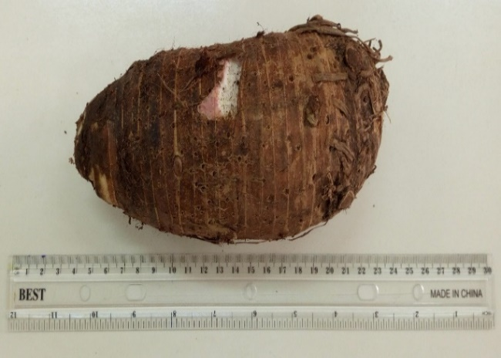
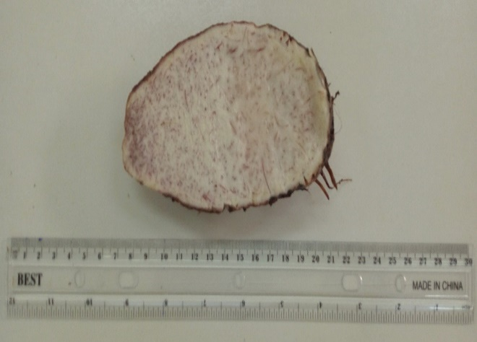
A
B

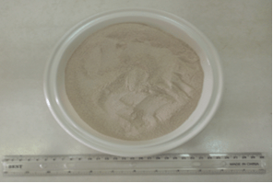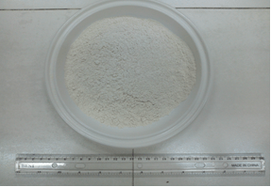
C
D
Fig. 1. Photography of the Corm and Powder of Taro Colocasia esculenta cv. "Fouê"
A: Whole corm; B: Longitudinal cut of the corm; C: Taro powder (cv. "Fouê"); D: Wheat flour T45
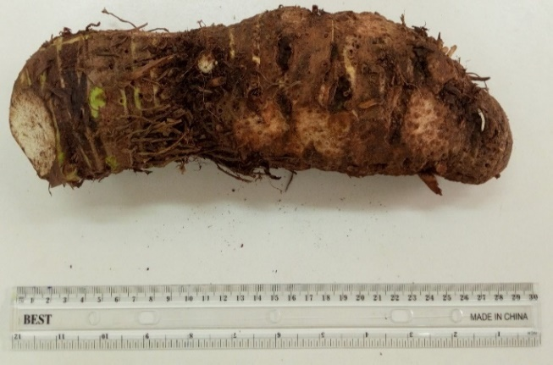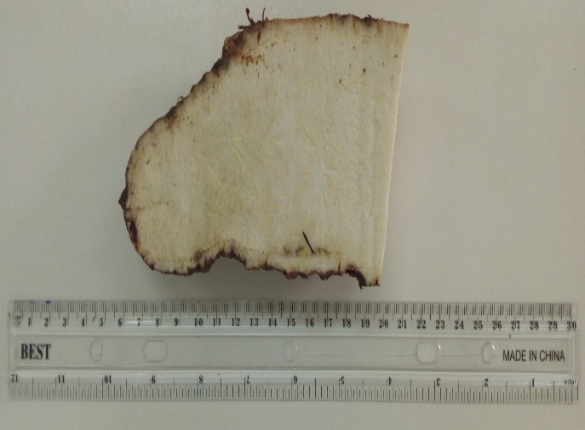
A
B
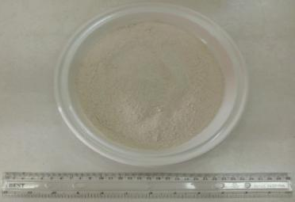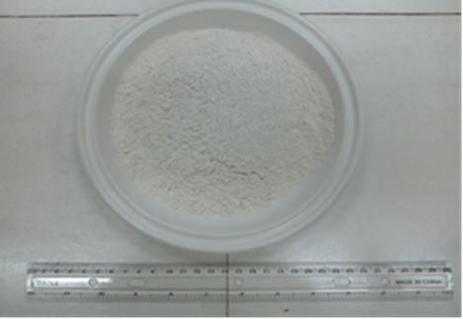
C
D
Fig. 2. Photography of the Corm and Powder of Taro Colocasia esculenta cv. "Yatan"
A: Whole corm; B: Longitudinal cut of the corm; C: Taro powder (cv. "Yatan"); D: Wheat flour T45

2.2 Technical Equipment
The technical equipment used for this work is the standard laboratory equipment for biochemical tasks. This includes, among others: a LE PROVENCAL AU SABOT 392355 stainless steel knife, a MOULINEX K1011014 grater, a MEMMERT 854 ventilated oven from Sewabach, Germany, a COOK WORKS SILVER GLASS BLENDER, a SMAUTOP B07TT5J3J2 electronic rotating porcelain mortar, a MATFER INOX 500 μm sieve, a MOULINEX ABM 11A30 electric whisk, an OXO 1126980 manual whisk, and a FAURE FCG510G1WA gas stove.

2.3 Other Food Ingredients
Salt (sodium chloride), yeast (Saccharomyces cerevisiae), sugar (sucrose), CALVE butter, PRINCESSE sweetened condensed milk, DINOR palm oil, fish, onions, garlic, and eggs were used as food ingredients in this work. They were purchased from a supermarket in Abidjan (Côte d'Ivoire).

2.2 Methods

2.2.1 Process for Obtaining Taro Flour
The taro tubers, cleaned with water, were peeled and then split in half. Subsequently, the pieces were grated to obtain chips. These chips were dried in an oven at 50°C for seventy-two hours (3 days). The dried chips were then ground using a blender and an electric rotating mortar. The resulting flours (Fig. 3) were sieved and stored in clean, airtight plastic containers. The taro powder was obtained according to the flowchart below.

Fresh taro corms
Washing with tap water
Fresh taro corms cleaned of impurities
Peel, cut and grate into small slices with a stainless-steel knife then rinse
Small slices of fresh corms
Dried taro corm chips
Grinding and sieving
Taro Powders
Open air display on plastic sheeting followed by drying for 72 hours at 45°C

Fig. 3. Process for obtaining powder from taro corms Colocasia esculenta

2.2.2 Wheat-Taro Composite Flours
The wheat-taro composite flours were formulated by partially substituting wheat flour with taro corm flour from Colocasia esculenta cv "Yatan" or "Fouê" in the following proportions: 1%, 3%, 6%, 9%, and 12%. In each case, 3 kg of composite flours were prepared, and the exact quantities of flour taken for each proportion are listed in Table I. The flours were thoroughly mixed manually. They were stored in designated containers for analysis and the preparation of spring rolls, savory croquettes, and snowballs. The composite flours made with partial substitution using taro powder from the "Yatan" cultivar were labeled as Yatan 1%, Yatan 3%, Yatan 6%, Yatan 9%, and Yatan 12%. The ones made with the "Fouê" cultivar were labeled as Fouê 1%, Fouê 3%, Fouê 6%, Fouê 9%, and Fouê 12%, while the control sample was designated as wheat flour T45 (100% wheat) (Table II).

Table I. Proportions of wheat flour substitution with taro corm powder from Colocasia esculenta cv "Yatan" or "Fouê"
Yatan ou Fouê | 1 % | 3 % | 6 % | 9 % | 12 % | Witness
Taro powder (g) | 30 | 90 | 180 | 270 | 360 | 0
T45 wheat flour (g) | 2970 | 2910 | 2820 | 2730 | 2640 | 3000
Composite flour  Wheat-taro (g) | 3000 | 3000 | 3000 | 3000 | 3000 | 3000

Table II. Identification of the different types of composite flours formed according to the proportions of added taro flours.
Type de farine | Identification
FBT 100% wheat witness | Control wheat flour (100% wheat)
FCF1 Fouê 1 % | Composite flour of 99% wheat flour and 1% taro cultivar powder ‘fouê’
FCF3 Fouê 3 % | Composite flour of 97% wheat flour and 3% taro cultivar powder ‘fouê’
FCF6 Fouê 6 % | Composite flour of 94% wheat flour and 6% taro cultivar powder ‘fouê’
FCF9 Fouê 9 % | Composite flour of 91% wheat flour and 9% taro cultivar powder ‘fouê’
FCF12 Fouê 12 % | Composite flour of 88% wheat flour and 12% taro cultivar powder ‘fouê’
FCY1 Yatan 1 % | Composite flour of 99% wheat flour and 1% taro powder cultivar ‘’yatan’’
FCY3 Yatan 3 % | Composite flour of 97% wheat flour and 3% taro powder cultivar ‘’yatan’’
FCY6 Yatan 6 % | Composite flour of 94% wheat flour and 6% taro powder cultivar ‘’yatan’’
FCY9 Yatan 9 % | Composite flour of 91% wheat flour and 9% taro powder cultivar ‘’yatan’’
FCY12 Yatan 12 % | Composite flour of 88% wheat flour and 12% taro powder cultivar ‘’yatan’’
FCF Fouê | Composite flour with powder of taro cultivar ‘fouê’
FCY Yatan | Composite flour with taro powder cultivar ‘’yatan’’

2.2.3 Pastry Products Preparation
The flours obtained are used to make some traditional pastries.

2.2.3.1 Preparation of Spring Rolls
First, the sauce is prepared. For this, the fish is deboned and crushed in a mortar along with onion, garlic, green onions, and cabbage. The mixture is blended to obtain the sauce. Next, the ingredients for the dough are added successively into an aluminum bowl and mixed by hand for 8 minutes. First, flour is added, followed by baker's yeast and water. The mixture is thoroughly combined manually for 3 minutes. Then, butter is added, and the dough is kneaded for 5 minutes to form a dough. Once the dough is formed, it is flattened on a board and cut into pieces with a knife. Each piece is filled with 0.5 g of sauce. The pieces are then rolled up and fried in oil for 7 minutes. The fried African spring rolls are placed in trays to cool to room temperature for 10 minutes before being labeled and packaged (Fig. 4). The same process was used for the formulations: 100% wheat T45, Yatan (1%, 3%, 6%, 9%, 12%), and Fouê (1%, 3%, 6%, 9%, 12%) (Table III).

Flour
Add the baker's yeast and water
Knead manually for 3 minutes
Add the butter
Knead manually for 5 minutes
Obtaining the dough
Fry in oil for 7 minutes
Spring rolls
Flatten on a board then cut into pieces and add 0.5 g of sauce before rolling up
Fish
Remove the stops then crush with the onion, cabbage, green onion and garlic
Sauce

Fig. 4. Process of Making Spring Rolls

Table III. Ingredients Used in the Production of Spring Rolls (Control and Tests)
Ingredients  Spring Rolls | Types of flour
 | Witness | Fouê tests | Yatan tests
100% wheat flour T45 | 200 g | 0 | 0
Composite flours | 0 | 200 g | 200 g
Fish | 50 g | 50 g | 50 g
Water | 100 mL | 100 mL | 100 mL
Butter | 60 g | 60 g | 60 g
Baker's yeast | 5,5 g | 5,5 g | 5,5 g
Onions | 1 | 1 | 1
Garlic | 1 gousse | 1 gousse | 1 gousse
Green onions | 5 g | 5 g | 5 g
Cabbage | 1,5 g | 1,5 g | 1,5 g

2.2.3.2 Preparation of Snowballs cakes
The ingredients for the dough are added successively into an aluminum bowl and mixed by hand for 8 minutes. First, composite flour is added, followed by baker's yeast, baking powder, nutmeg, milk, oil, and eggs. The mixture is manually combined for 8 minutes to form a dough. The dough is then shaped into balls by hand, which are then cooked in oil in an aluminum pan for 7 minutes. Finally, the cooked balls are cooled for 10 minutes at room temperature in trays before being labeled and packaged (Fig. 5). The same preparation method was applied for the formulations: 100% wheat T45, Yatan (1%, 3%, 6%, 9%, 12%), and Fouê (1%, 3%, 6%, 9%, 12%) (Table IV).

Flour
Add baker's yeast, baking powder, nutmeg, milk, oil and eggs
Knead manually for 8 minutes
Fry in oil for 7 minutes
Form balls manually with the dough
Obtaining the dough
Snowballs cakes

Fig. 5. Process of Making Snowballs cakes

Table IV. Ingredients Used in the Production of Snowballs cakes (Control and Tests)
Ingredients  Snowballs cakes | Types of flour
 | Witness | Fouê tests | Yatan tests
100% wheat flour T45 | 400 g | 0 | 0
Composite flours | 0 | 400 g | 400 g
Nutmeg | 0,56 g | 0,56 g | 0,56 g
Baking powder | 1 sachet | 1 sachet | 1 sachet
Baker's yeast | 1 sachet | 1 sachet | 1 sachet
Oil | 200 mL | 200 mL | 200 mL
Milk | 200 mL | 200 mL | 200 mL
Eggs | 03 | 03 | 03

2.2.3.3 Preparation of Savory Croquettes
Onion and garlic were crushed in a blender. Fifty (50) grams of the onion-garlic mixture were taken and added to each formulation. In a steel bowl, flour, water, oil, salt, and 50 g of the onion-garlic mixture were added. The mixture was kneaded by hand for 5 minutes to form a dough. The dough was then flattened and rolled out on a board, and cut into small dice with a knife. The dice were then cooked in oil for 5 minutes. The cooked savory croquettes were removed from the oil and placed in trays. The croquettes were allowed to cool to room temperature for 10 minutes before being labeled and packaged (Fig. 6). The same process was used for the formulations: 100% wheat T45, Yatan (1%, 3%, 6%, 9%, 12%), and Fouê (1%, 3%, 6%, 9%, 12%) (Table V).

Flour
Add water, oil, salt and 50 g of sauce
Knead manually for 5 minutes
Obtaining the dough
Fry in oil for 5 minutes
Salty croquettes
Flatten and spread out on a board then cut into small pieces in the form of cubes
Onion and garlic
Crush in a blender
Sauce
Fig. 6. Process of Making Savory Croquettes

Table V. Ingredients Used in the Production of Savory Croquettes (Control and Tests)
Ingredients  Savory Croquettes | Types of flour
 | Witness | Fouê tests | Yatan tests
100% wheat flour T45 | 200 g | 0 | 0
Composite flours | 0 | 200 g | 200 g
Garlic | ½ gousse | ½ gousse | ½ gousse
Onion | 1 | 1 | 1
Oil | 1,5 l | 1,5 l | 1,5 l
Water | 50 mL | 50 mL | 50 mL
Salt | 1,5 g | 1,5 g | 1,5 g

2.2.4 Sensory Analysis of Pastry Products

2.2.4.1 Tasting Test
The sensory analysis was carried out using the quantitative descriptive analysis method described by Watts et al. (1991). The samples, identified by a three-digit code, were presented in a random order to the tasters (Watts et al., 1991). The analysis involved evaluating and quantifying appropriate descriptors (crust color, crust and crumb texture, taste, flavor, acceptability) using an intensity scale. To achieve this, a panel of 15 individuals trained in the descriptive analysis of the organoleptic characteristics of these products was set up. A total of 15 panelists (both male and female) participated in the evaluation, which focused on general aspects (texture, color) of the crust (appearance, color, alveolation, regularity) of the crumb, taste, flavor, and acceptability. This method allowed the fifteen (15) trained and experienced panelists to assess the organoleptic parameters of the various products made with test and control flours. Each judge assigned a score based on a scale ranging from 0 to 10. The scores obtained were used to construct sensory profile curves of the different produced items. Finally, the study of acceptability allowed for the construction of general acceptability graphs of the evaluated traditional products.

2.2.4.2 Data Processing
The calculation of proportions and the construction of graphs for each product and each taro cultivar were performed using Microsoft Excel 2016.

3. RESULTS
Traditional products: spring rolls, snowballs, and savory croquettes were prepared with ten (10) composite flours added with powder from taro cv. "fouê" or taro cv. "yatan" formulations. The control was based on 100% wheat flour (T45).

3.1 Appearance and Characteristics of Different Taro-Wheat Composite Flours Obtained According to Taro Cultivars
100% wheat T45 flour is very white. When part of the wheat flour is substituted with taro powder from the "fouê" or "yatan" cultivars, the color of the mixture becomes brown. The composite flour made with the "fouê" cultivar has a darker red color compared to the composite flour made with the "yatan" cultivar. Additionally, as the percentage of substitution increases, the composite flour takes on a progressively darker shade (Fig. 7).

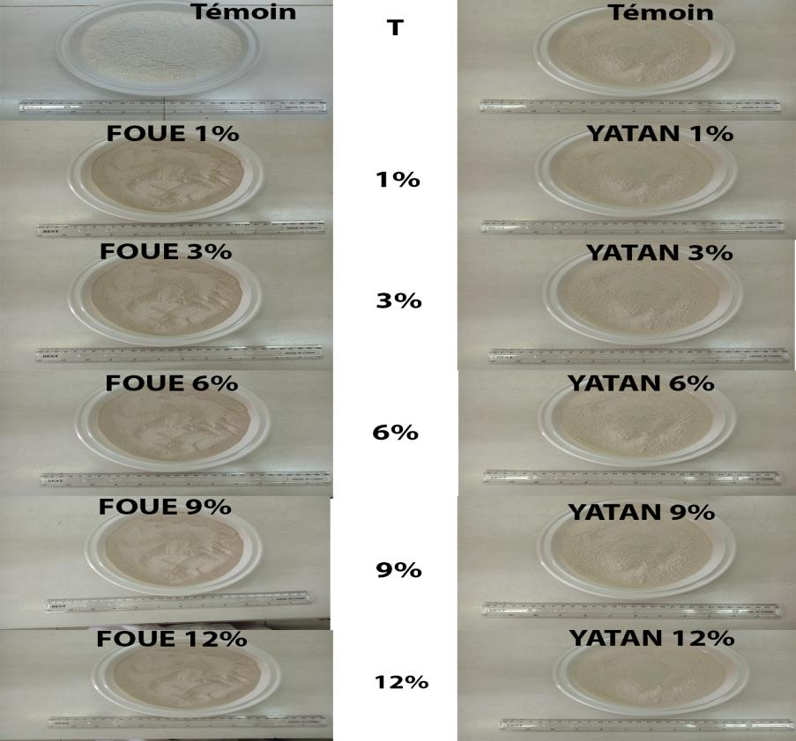
WITNESS
WITNESS
B
A

Fig. 7. Photos of Different Composite Flours (Taro-Wheat) Prepared
A) Wheat-Fouê; B) Wheat-Yatan; T: Incorporation Rate of Taro Flour or Control Flour

3.2 Production of Traditional Dishes

3.2.1 Spring Rolls
African spring rolls made with the control flour 100% wheat T45 have a light-yellow color and a very light appearance. When part of the wheat flour T45 is substituted with taro powder up to a substitution rate of 6%, the resulting spring rolls have a color and appearance similar to the control for both "fouê" and "yatan" cultivars. For substitution rates of 9% and 12%, the color becomes dark yellow and the appearance less light for both cultivars (Fig. 8).

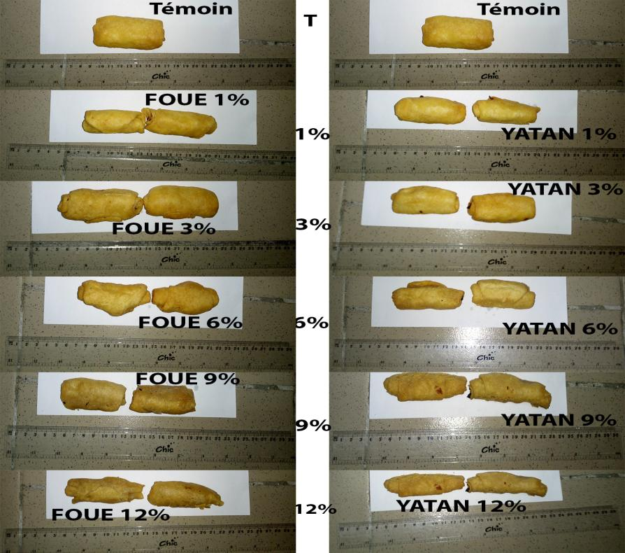
WITNESS
WITNESS
B
A

Fig. 8. Photos of Spring Rolls Made with Composite Flours Wheat-Fouê, Wheat-Yatan, and 100% Wheat T45 Flour
A) Wheat-Fouê; B) Wheat-Yatan; T: Incorporation Rate of Taro Flour or Control Flour

3.2.2 Snowballs cakes
Snowballs cakes made with the control flour 100% wheat T45 have a light-yellow color and a light appearance. When part of the wheat flour T45 is substituted with taro powder up to a substitution rate of 6%, the resulting snowballs cakes have a color and appearance similar to the control. For substitution rates of 9% and 12%, the color becomes dark yellow for the "yatan" cultivar. For the "fouê" cultivar, beyond a taro powder incorporation rate of 1%, the snowballs cakes take on a dark yellow color. This color darkens to red when the substitution reaches 12%. For both cultivars, as the incorporation rate increases, the appearance becomes less light (Fig. 9).
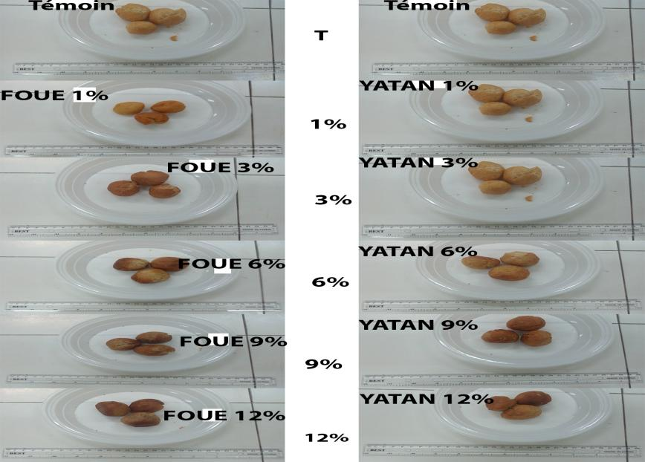
WITNESS
B
WITNESS
A

Fig. 9. Photos of Snowballs Made with Composite Flours Wheat-Fouê, Wheat-Yatan, and 100% Wheat T45 Flour
A) Wheat-Fouê; B) Wheat-Yatan; T: Incorporation Rate of Taro Flour or Control Flour

3.2.3 Savory Croquettes
Savory croquettes made with the control flour 100% wheat T45 have a light-yellow color and a light appearance. When part of the wheat flour T45 is substituted with taro powder up to a substitution rate of 6%, the resulting savory croquettes have a color and appearance similar to the control. For substitution rates of 9% and 12%, the color becomes dark yellow for the "fouê" cultivar. For the "yatan" cultivar, the light-yellow color is similar to the control up to a substitution rate of 12%. For both cultivars, as the incorporation rate increases, the appearance becomes less light (Fig. 10).
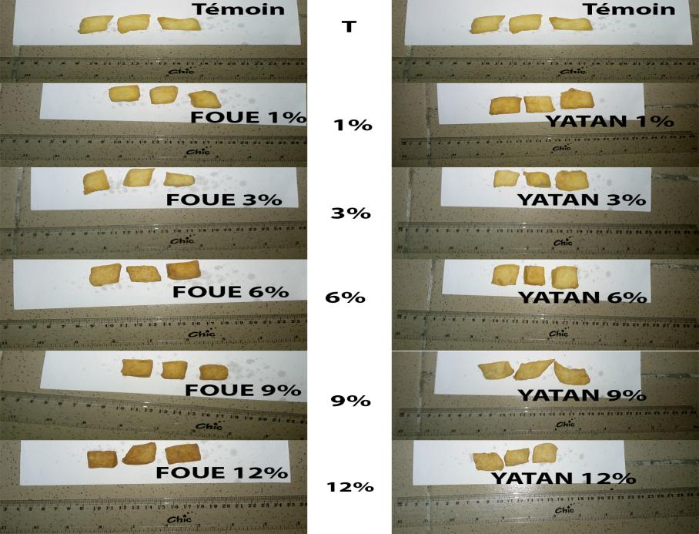
WITNESS
WITNESS
B
A

Fig. 10. Photos of Savory Croquettes Made with Composite Flours Wheat-Fouê, Wheat-Yatan, and 100% Wheat T45 Flour
A) Wheat-Fouê; B) Wheat-Yatan; T: Incorporation Rate of Taro Flour or Control Flour

3.3 Sensory Profiles of Traditional Products with Composite Flours Added with Taro Cultivars ‘Fouê’ and ‘Yatan’
The sensory profiles of traditional dishes were represented using radar charts based on the average scores (0 to 10) given to descriptors by panelists. Attributes such as color, aroma, texture, and taste were the most noticeable across all evaluated samples. When wheat flour T45 was substituted with taro powder up to 6%, the evaluated attributes were similar to those of the control (100% wheat T45). The most noticeable deviations from the control were found in the samples with ‘Fouê’ and ‘Yatan’ taro powders at 9% and 12% incorporation rates.

3.3.1 Spring Rolls
The sensory profiles of African spring rolls made with composite flours of wheat-Fouê (Fig. 11) and wheat-Yatan (Fig. 12) showed that the intensity of descriptors increased as the substitution rate of wheat flour with taro powder increased. Attributes such as aroma, taste, flavor, and color were more noticeable. With the addition of ‘Fouê’ and ‘Yatan’ taro powders, the results up to 6% substitution had sensory characteristics similar to those of the 100% wheat T45 control. Starting from 9%, the sensory characteristics became significantly different from the control, and the taste of taro became more pronounced. The colors of the crust and crumb also became darker as the substitution rate increased.

Fig. 11. Sensory characteristics of traditional spring rolls made with composite flour wheat-Fouê and 100% wheat T45 flour.

Fig. 12. Sensory characteristics of traditional spring rolls made with composite flour wheat-Yatan and 100% wheat T45 flour.

3.3.2 Snowballs cakes
The sensory profiles of snowballs cakes made with composite flours of wheat-Fouê and wheat-Yatan are illustrated respectively in Figs. 13 and 14. The intensity of responses was high when the substitution rate reached 9%. Attributes such as aroma, taste, and color were more noticeable from 9% substitution with ‘Fouê’ and ‘Yatan’ taro powders. With both taro cultivars ‘Fouê’ and ‘Yatan’, the results showed no significant differences in sensory parameters except for the taro taste and aroma, which were more pronounced as the substitution rate increased. Overall, the sensory parameters were not very different from the control, except for the flours with 9% and 12% substitution.

Fig. 13. Sensory characteristics of snowballs cakes made with composite flour wheat-Fouê and 100% wheat T45 flour.

Fig. 14. Sensory characteristics of snowballs cakes made with composite flour wheat-Yatan and 100% wheat T45 flour.

3.3.3 Savory Croquettes
The sensory profiles of savory croquettes made with composite flours of wheat-Fouê (Fig. 15) and wheat-Yatan (Fig. 16) showed that the intensity of responses was high when the substitution rate reached 9% and above. Attributes such as aroma, taste, flavor, and color were more noticeable. The results up to 6% substitution with ‘Fouê’ and ‘Yatan’ taro powders showed similar intensities. Starting from 9% and above, the sensory characteristics were strongly modified, with intense perceptions of taste and aroma. Substitutions of 9% and 12% of wheat flour T45 with ‘Fouê’ and ‘Yatan’ taro powders significantly altered the sensory properties of the products, especially in terms of aroma and taste.

Fig. 15. Sensory characteristics of savory croquettes made with composite flour wheat-Fouê and 100% wheat T45 flour.

Fig. 16. Sensory characteristics of savory croquettes made with composite flour wheat-Yatan and 100% wheat T45 flour.

3.4 General Acceptability of Traditional Products Made with Composite Flours of Taro Cultivars ‘Fouê’ and ‘Yatan’

3.4.1 Acceptability of Traditional Spring Rolls Made with Composite Flours Wheat-Fouê and Wheat-Yatan
The general acceptability on a three-point scale (Not acceptable, Less acceptable, Acceptable) was evaluated for spring rolls made with composite flours wheat-Yatan and wheat-Fouê. The spring rolls were well appreciated and accepted up to a substitution rate of 6%. The incorporation rate up to 6% with ‘Yatan’ taro flour (>80%) was higher compared to ‘Fouê’ taro flour (≈40%). However, from 9% incorporation, the traditional spring rolls became less acceptable and were not accepted at 12% (Figs. 17 and 18).

Fig. 17. General acceptability of spring rolls made with composite flour wheat-Fouê and 100% wheat T45 flour.

Fig. 18. General acceptability of spring rolls made with composite flour wheat-Yatan and 100% wheat T45 flour.

3.4.2 Acceptability of Snowballs cakes Made with Composite Flours Wheat-Fouê and Wheat-Yatan
The general acceptability on a three-point scale (Not acceptable, Less acceptable, Acceptable) was studied for snowballs cakes made with composite flours wheat-Fouê and wheat-Yatan (Figs. 19 and 20). Unlike the other two dishes, snowballs cakes were all well appreciated and accepted by most panelists (up to a substitution rate of 12%). However, the level of acceptability decreased as the substitution rate with ‘Fouê’ and ‘Yatan’ taro powders increased. The acceptability rates of snowballs cakes made with composite flours wheat-Fouê and wheat-Yatan were almost identical and did not show significant differences.

Fig. 19. General acceptability of snowballs cakes made with composite flour wheat-Fouê and 100% wheat T45 flour.

Fig. 20. General acceptability of snowballs cakes made with composite flour wheat-Yatan and 100% wheat T45 flour.

3.4.3 Acceptability of Savory Croquettes Made with Composite Flours Wheat-Fouê and Wheat-Yatan
The general acceptability on a three-point scale (Not acceptable, Less acceptable, Acceptable) was also conducted for savory croquettes made with composite flours wheat-Fouê and wheat-Yatan (Figs. 21 and 22). Savory croquettes were well appreciated and accepted up to a substitution rate of 6%. The acceptability of savory croquettes made with composite flour wheat-Yatan (1%, 3%, and 6%) was higher with respective percentages of 80%, 70%, and 65%. In contrast, savory croquettes with composite flours wheat-Fouê (1%, 3%, 6%) had acceptability rates of 60%, 65%, and 50%. Samples with substitution rates of 9% and 12% were not accepted by some panelists. Rejection was more pronounced (30%) with a 12% substitution rate using wheat-Yatan composite flour. The rejection rate with wheat-Fouê composite flour (12%) was approximately 15% of the panelists.

Fig. 21. General acceptability of savory croquettes made with composite flour wheat-Fouê and 100% wheat T45 flour.

Fig. 22. General acceptability of savory croquettes made with composite flour wheat-Yatan and 100% wheat T45 flour.

4. DISCUSSION
Regarding the sensory profiles of traditional dishes, sensory quality is an important dimension of food product quality. Sensory quality is perceived by human senses including sight, smell, taste, hearing, and touch [19]. From the sensory results obtained in this study, it is noteworthy that the variety of taro does not significantly influence the organoleptic qualities of the dishes prepared. To give a sensory identity to the different dish samples, their profiles were developed with various descriptors considering color, aroma, taste, and texture. The scores obtained for these dishes show that they were highly appreciated by the panelists. However, this appreciation decreased as the substitution levels increased (9% and 12%). This finding is consistent with results obtained by [20] for cakes made from composite wheat-plantain flour. The clarity of the dishes deteriorated as more wheat flour was substituted with taro powder, leading to darker colors. This can be explained by the fact that the incorporation of taro corm powder Colocasia esculenta cv "yatan" and "fouê" into wheat flour caused a significant reduction in clarity for our composite flour. This decrease in clarity could be attributed to the storage time of the composite flours and the clarity of the gel from taro corm powder Colocasia esculenta. Regarding the crust, [21] explained that the color of the crust of bread sticks made from composite wheat and taro corm flours could be attributed to the reddish-brown color of taro corm powders. This result aligns with findings by [22], who also worked on wheat/taro composite flours. Indeed, these authors noted that the darker crust color could be due to the reddish-brown color of the taro powder. This taro color becomes darker when the substitution level reaches 9% and 12%. [22] suggested that the crust color could be due to the Maillard reaction between reducing sugars and amino acids in proteins. Additionally, [23] observed that bread crust color shifted from creamy white to dull or dark brown. In this study, the color changed from light yellow to dark yellow or from white to dark white for the various prepared dishes. This could be justified by the amount of "fouê" and "yatan" cultivar powder incorporated into the wheat flour. Other factors such as the chemical composition of taro and wheat, drying temperature and duration, and cooking temperature and time may also affect crust color [24]. Regarding the crumb, dishes with 1%, 3%, and 6% incorporation proportions received good scores except for those with 9% and 12% proportions. This observation might be due to the high quantity of taro flour according to [25]. Dishes made from composite flours with 9% and 12% substitutions have a hard crust and crumb structure. Their appearance becomes less acceptable as the substitution rate of wheat flour with taro powder increases. Moreover, according to [26], fiber content generally weakens bread structure by reducing crumb volume and elasticity. This effect has been attributed to the interaction between fiber and gluten, leading to reduced gas retention capacity [27-28]. Furthermore, the crumb structure depends on the behavior of gas bubbles during production processes. Our results are consistent with those of [25]. These authors observed a color change in the crumb from creamy white to dull brown and a progressive hardening of crumb texture as the amount of soybean flour (high-fat and defatted) and barley increased. Regarding crust texture, almost all prepared dishes exhibited a good crispy texture. For the crumb appearance, a similarity was noted among the different dishes (except those made with composite flours with 9% and 12% proportions). In terms of cell structure, dishes made from composite flours with 1%, 3%, and 6% proportions had cells similar to those of the control dishes (100% wheat). Thus, dishes made from composite flours with substitution proportions of 1%, 3%, and 6% were the most appreciated by the panelists. These results are similar to those reported by [22] and [29], whose studies focused on wheat/plantain composite flours. [30] demonstrated in their work on wheat/cassava composite flours that a supplementation level of 10% to 20% does not affect bread taste. The dishes made from composite flours with 1%, 3%, and 6% proportions had aroma and flavor close to those of the control dishes. This observation could be due to the contribution of the taro flour amount. Based on the results of this study and compared to those of [22], the substitution level of wheat flour with taro powder up to 10% in the preparation of traditional dishes is acceptable. In general, panelists showed high acceptability rates for all dishes with descriptors except for those with substitution levels of 9% and 12%. It is clear from these studies that traditional dishes made with 9% and 12% proportions do not have sensory characteristics similar to those of control dishes and dishes with 1%, 3%, and 6% substitutions. Regarding the general acceptability of traditional dishes made, sensory tests conducted on dishes made from taro-wheat composite flour showed that these dishes received general acceptability scores at an acceptable level. The variety (fouê or yatan) does not impact the acceptability of the prepared dishes. Snowballs were all accepted by the panelists. On the other hand, African spring rolls and savory croquettes were accepted up to 6% incorporation with taro powder. Beyond (>6%), incorporation rates were not accepted by the panelists. General acceptability is significantly influenced by the substitution rate of wheat flour with taro flour. It was also found that general acceptability depends on odor, color, and texture, which is consistent with results obtained by [31], who studied the traditional dish "achu". The scores of the various dishes obtained show the specificity of dishes made from 100% wheat or substitution rates below 9% that are accepted by the panel, while other dishes are moderately accepted.

5. CONCLUSION
This study was conducted with the aim of valorizing taro tubers for the cultivars "fouê" and "yatan" by exploring their potential applicability in the agri-food industry, particularly in the prepared foods sector. The results showed that the substitution rate influences the organoleptic characteristics of the studied traditional dishes. The sensory analysis of traditional dishes made with different proportions of wheat-taro composite flour generally presented very high percentages for each descriptor. Traditional dishes with 1%, 3%, and 6% wheat flour composite – taro corm cultivars "fouê" and "yatan" were preferred by the panelists. The results regarding organoleptic properties revealed that dishes made from composite flours at proportions of 1%, 3%, and 6% had sensory characteristics similar to those of the 100% wheat control. This explains that taro corm powders Colocasia esculenta cv "fouê" and "yatan" can be incorporated up to 6% into wheat flour to obtain good traditional dishes (snowball, spring roll, and savory croquette). This study concludes that taro corm powders cv "fouê" and "yatan" are potential candidates for partial substitution of wheat flour in the production of modern pastry items. Future perspectives should include: examining the influence of varying physical production parameters of traditional dishes on the organoleptic quality of wheat-taro composite flour products; formulating bakery products with different composite flours and determining their acceptability; assessing the acceptability of wheat-taro composite flours with an untrained panel.

REFERENCES
1. Capone R, Bilali HE, Debs P, Bottalico F, Cardone G, Berjan S et al. Bread and bakery products waste in selected mediterranean arab countries. American Journal of Food and Nutrition. 2016;4(2):40-50. DOI:10.12691/ajfn-4-2-2
2. FAO. L’état de l’insécurité alimentaire dans le monde: Crises économiques - répercussions et enseignements. Organisation des Nations Unies pour l’Alimentation et l'Agriculture. 2009; 66 pp. French. Available : https://www.fao.org/4/i1683f/i1683f.pdf
3. Camel L. Etat des lieux et rapport. Définition des produits de boulangeries et de pâtisseries à développer et choix des matières premières (spéculations) à utiliser pour le CIPE-Agroalimentaire. 2018;1-8 p. French.
4. Gan Z, Ellist PR, Schofield D. Gas cell stabilisation and gas retention in wheat bread dough. Journal of Cereal Science. 1995;21:215-230. Available: https://d1wqtxts1xzle7.cloudfront.net/70661758/jcrs.1995.002520210929-24151-uhj812-libre.pdf?1636061775=&response-content-disposition=attachment%3B+filename%3DGas_Cell_Stabilisation_and_Gas_Retention.pdf&Expires=1726696035&Signature=OGjRxqSfxA5H8g5sVoCjRqPgr8rWUD97Plede1YB8582QXZRzM3u1ebrbM~cJoykomcgw0NR0Hb97dJzKYj1P5wR9~AGtDife~BMIDVeIqdA9IrNi5C16c1Jq8aGM7XQeJhXamdEPnMDQnAV7A~K2gtBv0BLqMF89sk1y81kJmUz0TKOHL0p0psbuIUboeeuYd-2FXv0zOj1rUdTXAYg1CN8gceF5e3jzahJ53De7u~obJfYFthvCXv6mIx7-z-iVkJ6OvMzkIC8eNYJ46C49GFb97m7GLJcbup5EUN0LMMxVQaH029Ybni5~l6VhlU5mXnWAcW1u0WYW9F0X9J01A__&Key-Pair-Id=APKAJLOHF5GGSLRBV4ZA
5. Shittu, Raji AO, Sanni LO. Bread from composite cassava-wheat flour: Effect of baking time and temperature on some physical properties of bread loaf. Food Res. Inter. 2007;40:280-290. DOI:10.1016/j.foodres.2006.10.012
6. Ikpeme, Emmanuel CA, Osuchukwu NC, Oshiele L. Functional and sensory properties of wheat (Aestium triticium) and taro flour (Colocasia esculenta) composite bread. African Journal of Food Science. 2010;4(5):248-253. Available: https://academicjournals.org/journal/AJFS/article-full-text-pdf/4AAAB0C23570
7. Berthelot J. La panification des céréales tropicales: mise au point de recettes de brioche à dominance de maïs ou de mil aisément transférables en Afrique noire. Rapport de fin de programme. Paris: Ministère de la coopération et du développement. 1990;64 p. French. DOI: 10.12691/jfnr-7-11-3
8. Defloor I. Factors governing the breadmaking potential of cassava (Manihot esculenta Crantz) flour. Ph. D.thesis, University of K.U. Leuven, Belgium. 1995;155 p.
9. Begum, Uddin MJ, Rahman MA, Islam MS. Comparative study on the development of maize flour based composite bread. J Bangladesh Agr Univ. 2013;11(1):133-139. DOI:10.3329/jbau.v11i1.18224
10. Bibiana, Grace N, Julius A. Quality evaluation of composite bread produced from wheat, maize and orange-fleshed sweet potato flours. American Journal of Food Science and Technology. 2014;2(4):109-115. DOI: 10.12691/ajfst-2-4-1
11. Trejo-González, Loyo-González AG, Munguía-Mazariegos MR. Evaluation of bread made from composite wheat-sweet potato flours, International Food Research Journal. 2014;21(4):1683-1688. Available: http://www.ifrj.upm.edu.my/21%20(04)%202014/58%20IFRJ%2021%20(04)%202014%20Marita%20735.pdf
12. Oladunmoye R, Akinoso AA, Olapade. Evaluation of some physical-chemical properties of wheat, cassava, maize and cowpea flours for bread making. Journal of Food Quality. 2010;33:693-708. Available: https://doi.org/10.1111/j.1745-4557.2010.00351.x
13. Njintang, YN, Parker ML, Moates GK, Mbofung CMF, Smith AC, Waldron KW. Rheology and microstructure of achu, food based on taro (Colocasia esculenta L. Schott) as affected by the method of preparation. Journal of Science Food Agriculture. 2006;86:902–907. Available: https://doi.org/10.1002/jsfa.2434
14. Njintang NY, Mbofung CM, Kesteloot R. Multivariate analysis of the effect of drying method and particle size of flour on the instrumental texture characteristics of paste made from two varieties of taro (Colocasia esculenta L. Schott) flour. Journal of Food Engineering. 2007;81(1):250–256. Available: https://d1wqtxts1xzle7.cloudfront.net/42115067/j.jfoodeng.2006.11.007-libre.pdf20160204-3411-1pp3osb?1454653663=&response-content-disposition=attachment%3B+filename%3DMultivariate_analysis_of_the_effect_of_d.pdf&Expires=1726696593&Signature=NgZzv2FQT8HS8-oFOb8BmhBxRUqn9~9UNh5EE4rxrU3KJzFilnNMgFIfmesDN1t4hTxmsFHpcQv-r810jdnKCkQEKdH2wQ4pl44krkaKuNCODA3EOKCmcquaVaRL~vqCg9PNWeP6UIApzt4e0B2LMlS6Ch30PK16yhA4WllPRV2NTFmUJel78EIh1iiSSkTY8je-1WoGjvweyghXQp~6C3uVQQm9x0Nkuydbv0dUARo7p4G~1VUZPi8T7XL2tgQUFd1RG8~238QdTNcJHZD7lk9-ikbMMQoLwSP3w-NBgUcbvG1vt5dUxVxt762GdI3kxjBSf~7iM6pLupjxjdE4Yw__&Key-Pair-Id=APKAJLOHF5GGSLRBV4ZA
15. Njintang YN, Mbofung CMF, Balaam F, Kitissou P, Scher J. Effect of taro (Colocasia esculenta) flour addition on the functional and alveographic properties of wheat flour and dough. Journal of science Food and Agriculture. 2008;88:273–279. Available: https://doi.org/10.1002/jsfa.3085
16. Aboubakar, Njintang NY, Scher J, Mbofung CMF. Texture, microstructure and physicochemical characteristics of taro (Colocasia esculenta L. Schott) as influenced by cooking conditions. Journel of food Engineering. 2009;91(3):373-379. DOI:10.1016/j.jfoodeng.2008.09.030
17. Aboubakar, Njintang NY, Nguimbou RM, Scher J, Mbofung CMF. Effect of storage on the physicochemical, functional and rheological properties of taro (Colocasia esculenta) flour and paste. Innovative Romanian Food Biotechnology. 2010;7:37-48. Available: https://www.gup.ugal.ro/ugaljournals/index.php/IFRB/article/view/3357/3028
18. Pedreschi F, León J, Mery D, Moyano P. Development of computer vision system to measure the color of potato chips. Food Research International. 2006;39(10):1092-1098. DOI:10.1016/j.foodres.2006.03.009
19. Meilgaard M, Civille GV, Carr BT. Sensory attributes and the way we perceive them, in: Sensory Evaluation Techniques, CRC Press, INC., Boca Raton, Florida. 1991b;8-22 p.
20. Yao AK, Koffi DM, Irié ZB, Niamké SL. Effet de la substitution partielle de la farine de blé par la purée de banane plantain (Musa AAB) bien mûre sur la qualité des produits de pâtisserie Journal of Applied Biosciences. ISSN 1997–5902. 2014;82:7436-7448. DOI:10.4314/jab.v82i1.12
21. Bello-Perez LA, Romero-Manilla R, Paredes-Lopez O. Preparation and properties of physically modiﬁed banana starchprepared by alcoholic alkaline treatment. Starch. 2000;52:154-159. DOI:10.1002/1521-379X(200006)52:53.0.CO;2-#
22. Mongi RJ, Ndabikunze BK, Chove BE, Mamiro P, Ruhembe CC, Ntwenya JG. Proximate composition, bread characteristics and sensory evaluation of cocoyam-wheat composite breads. African Journal of Food, Agriculture, Nutrition and Development. 2011;11(7):5586-5599. DOI: 10.18697/ajfand.48.11315
23. Raidi MA, Klein BP. Effect of soy or field pea flour substitution on physical and sensory characteristics of chemically leavened quick breads. Journal of Cereal Chemistry. 1983;60:367-370. Available: https://www.cerealsgrains.org/publications/cc/backissues/1983/Documents/Chem60_367.pdf
24. Ikpeme-Emmanuel CA, Okoi J, Osuchukwu NC. Functional, anti-nutritional and sensory acceptability of taro and soybean based weaning food. African Journal of Food Science. 2009;3(11):372-377. Available: https://doi.org/10.5897/AJFS.9000148
25. Dhighra S, Jood S. Effect of flour blending on functional, baking and organoleptic characteristics of bread. International Journal of Food Science and Technology. 2004;39(2):213-222. Available: https://doi.org/10.1046/j.0950-5423.2003.00766.x
26. Salmenkallio-Marttila M, Katina K, Autio K. Effect of bran fermentation on quality and microstructure of high-fibre wheat bread. Cereal Chemistry. 2001;78(4):429-435. Available: https://doi.org/10.1094/CCHEM.2001.78.4.429
27. Gomez M, Ronda F, Blanco CA, Caballero PA, Apesteguia A. Effect of dietary fibre on dough rheology and bread quality. European Food Research and Technology. 2003;216:51-56. DOI:10.1007/s00217-002-0632-9
28. Ishida PMG, Steel CJ. Physicochemical and sensory characteristics of pan bread samples available in the Brazilian market. Food Science and Technology, Campinas. 2014;34(4):746-754. Available: https://doi.org/10.1590/1678-457X.6453
29. Adeniji TA. Plantain, banana and wheat flour composites in bread making: prospects for industrial application. African Journal of Food, Agiculture, Nutrition and Development. 2015;15(4):10182-10197. DOI: 10.18697/ajfand.71.13330
30. Eddy NO, Udofia PG, Eyo D. Sensory evaluation of wheat/cassava composite bread and effect of label information on acceptance and preference. African Journal of Biotechnology. 2007;6(20):2415-2418. DOI: 10.5897/AJB2007.000-2379
31.. Aboubakar. Optimisation des paramètres de production et de conservation de la farine de taro (Colocasia esculenta). Thèse ENSAI/ Université de Ngaoundéré. 2009;211 p. French. Available: https://www.doc-developpement-durable.org/file/Culture/Culture-plantes-alimentaires/FICHES_PLANTES/taro/Optimisation%20des%20param%C3%A8tres%20de%20production%20et%20de%20conservation%20de%20la%20farine%20de%20taro.pdf

DEFINITIONS, ACRONYMS, ABBREVIATIONS
cv: cultivar
mL: mililiter
g: gram

APPENDIX
Annexe 1 : Fiche de notation pour les profils sensoriels de "Croquette salée, nem africain et boule de neige" (produit de pâtisserie) élaborés à partir de farine de composite taro-blé.

Séance N° : Date …………………
Dégustateur Nom : ............................ Prénoms :.............................................................
Tranche d’âge 12-17 ans 18-44 ans 45-64 ans > 65 ans
Instructions pour la notation
Dégustez les différents échantillons, cochez sur l’échelle de notation l’intensité de l’attribut indiqué.

Code échantillon

1. Couleur de la croûte

0
Clair
10
Sombre
  - Brune

2. Texture de la croûte
0
Faible
10
Faible
2.1. Croustillant

3. La mie
10
Fort
3.1. Aspect : légère
0
Faible

10
Fort
0
Faible
3.2. Couleur : brune

0
Faible
10
Fort
3.3. Alvéolage : grossier

0
Faible
10
Fort
3.4. Régularité

4. Goût
0
Faible
10
Fort
4.1. Arôme blé : perceptible

4.2. Arôme taro : perceptible
0
Faible
10
Fort

5. Saveur
10
Plus
0
Moins
5.1. Caractéristique blé : perceptible

Annexe 2 : Fiche d’évaluation de l’acceptabilité générale de "Croquette salée, nem africain et boule de neige" (produit de pâtisserie) élaborée à partir de farine de composite taro-blé.

Veuillez déguster le mets servi et cocher le numéro correspondant à votre impression pour chaque paramètre indiqué.
Puis donner les raisons de votre choix dans les cases en dessous.

Code échantillon

Acceptabilité générale

3. Acceptable

2. Moins acceptable

1. Pas acceptable

