Synergistic Effects of Integrated Pigeon Pea (Cajanus cajan) Biomass and Mineral Fertilizer on Upland Rice Yield, Soil Health, and Economic Profitability in Acidic Soils of Central Africa

ABSTRACT
Background: The rapid degradation of tropical Ferralsols in Central Africa threatens sustainable rice production. While mineral fertilizers are widely used, they often exacerbate soil acidity and fail to build soil organic matter.
Aim: This study evaluated the synergistic effects of integrated pigeon pea (Cajanus cajan) biomass and mineral fertilizers on upland rice performance, soil health, and economic profitability.
Methods: A randomized complete block design with four treatments was implemented: T0 (control), T1 (17 t ha⁻¹ pigeon pea biomass), T2 (NPK + 17 t ha⁻¹ pigeon pea biomass), and T3 (NPK + urea). Growth parameters, yield components, soil properties, and economic indicators were measured.
Results: T2 significantly (p < 0.05) increased grain yield (2.22 t ha⁻¹) by 85% compared to T0 and 82% compared to T1. The integrated treatment maintained higher soil organic matter (-1.90% vs -3.14% for T3), increased available phosphorus (+4.55 ppm), and enhanced exchangeable potassium (+0.13 cmol/kg). Principal component analysis revealed strong correlations between soil fertility parameters and rice yield (r = 0.75-0.82). Economic analysis showed T2 had the highest benefit-cost ratio (2.44) despite higher initial costs.
Conclusion: The integration of pigeon pea biomass with mineral fertilizers creates synergistic effects that enhance rice productivity, improve soil health, and increase economic returns, representing a sustainable intensification strategy for acidic tropical soils.
Keywords: Integrated Soil Fertility Management, Cajanus cajan, Ferralsols, Sustainable Agriculture, Benefit-Cost Ratio, Soil Organic Matter.
1. Introduction
The rapid degradation of tropical soils in Sub-Saharan Africa poses a critical threat to food security and agricultural sustainability (Lal, 2020; Bationo et al., 2018). Ferralsols, which dominate Central Africa, are highly acidic, possess low cation exchange capacity, and exhibit limited availability of essential nutrients, particularly nitrogen (N) and phosphorus (P) (Sanchez, 2019; Kochian et al., 2015). In Cameroon, rice consumption continues to outpace domestic production (FAO, 2023), yet upland rice cultivation is constrained by these inherent soil limitations (Saito et al., 2018; Tanaka et al., 2017).
Conventional reliance on mineral fertilizers alone has proven insufficient for sustainable intensification (Vanlauwe et al., 2015; Chivenge et al., 2011). Excessive or sole mineral fertilizer application often exacerbates soil acidification, reduces nutrient use efficiency, and fails to restore declining soil organic matter (OM) (Guo et al., 2010; Zhou et al., 2024). Moreover, the rising cost of synthetic fertilizers increasingly limits accessibility for smallholder farmers (Marenya et al., 2020; Sheahan & Barrett, 2017).
Integrated Soil Fertility Management (ISFM) has emerged as a sustainable strategy, emphasizing the complementary use of organic and mineral inputs (Vanlauwe et al., 2015; Tittonell et al., 2021). Incorporating leguminous biomass, such as pigeon pea (Cajanus cajan L.), offers multiple agronomic benefits: it enhances soil N through biological fixation, improves soil OM, and ameliorates physical soil properties (Snapp et al., 2019; Kuyah et al., 2019). Pigeon pea is particularly suited to acidic, drought-prone soils, making it a promising amendment for Central African upland rice systems (Sileshi et al., 2019; Mafongoya et al., 1998).
Despite these recognized advantages, quantitative data on the combined application of pigeon pea biomass and mineral fertilizers for upland rice production in acidic Ferralsols remain limited (Zingore et al., 2022; Bolo et al., 2021). Understanding these synergistic effects on both crop productivity and soil health is crucial for developing sustainable, economically viable nutrient management strategies.
Hypothesis and Objectives
We hypothesized that integrating pigeon pea biomass with mineral NPK fertilizer would enhance rice productivity, improve soil fertility, and increase economic profitability compared to mineral fertilization alone in acidic Ferralsols. The specific objectives were to:
- Quantify the effects of different fertilization regimes on rice growth parameters and yield components.
- Evaluate the impact of fertilization strategies on soil physicochemical properties after rice cultivation.
- Identify relationships between soil fertility indicators and rice performance.
- Assess the economic profitability and sustainability of the fertilization approaches.
2. MATERIALS AND METHODS
2.1. Study Site
The experiment was conducted in Nkolbisson, Yaoundé, Cameroon (3°51'N, 11°30'E, 726 m a.s.l.). The site experiences a humid equatorial climate with two rainy seasons (March–June and September–November) and two dry seasons. Mean annual rainfall is 1500 mm, mean temperature ranges from 22–28°C, and relative humidity is 70–90%. The soil is classified as a Ferralsol with a silt-clay loam texture (FAO, 2015). Baseline soil analysis revealed strong acidity (pH 4.4), low OM (5.57%), and limited macronutrient availability (N: 0.156%, P: 15.29 ppm, K: 0.35 cmol/kg). The site had been under natural fallow for several years prior to the study.
2.2. Experimental Design and Treatments
A randomized complete block design (RCBD) with three replications was used (Gomez & Gomez, 1984). Each plot measured 2 × 2 m (4 m²), with 0.5 m spacing between plots and 1 m between blocks. Four fertilization treatments were applied:
T0 (Control): No fertilization
T1 (Organic): 17 t ha⁻¹ pigeon pea biomass
T2 (Integrated): 200 kg ha⁻¹ NPK (20-10-10) + 17 t ha⁻¹ pigeon pea biomass
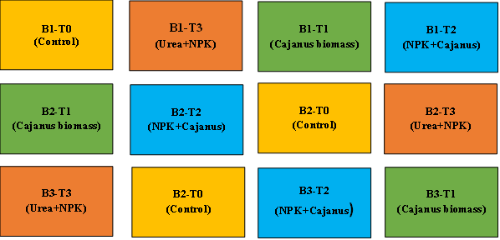
T3 (Enhanced Mineral): 200 kg ha⁻¹ NPK (20-10-10) + 100 kg ha⁻¹ urea (46% N)

Fig.1. Schematic representation of the experimental layout and treatment allocation.
Pigeon pea biomass was incorporated two weeks before sowing to allow partial decomposition (Gentile et al., 2011). Mineral fertilizers were applied at sowing according to local agronomic recommendations (MINADER, 2015). The rice variety used was NERICA 8, an improved upland cultivar provided by IRAD, Yaoundé. Seeds were treated with Thiram to ensure uniform germination.
2.3. Data Collection
2.3.1. Growth Parameters
Plant height (cm) and tiller number were measured at 15, 30, 45, 60, and 90 days after sowing (DAS) from five randomly selected plants per plot (Yoshida, 1981). Leaf color was assessed using a Leaf Color Chart (LCC; 1 = very light green, 7 = very dark green) at 30, 45, 60, and 75 DAS (Furuya, 1987).
2.3.2. Yield Components
At maturity, panicles per m² were counted in a central 1 m² area of each plot. Grains per panicle were determined from 10 randomly selected panicles. Thousand-grain weight was measured from three 1000-grain samples. Grain yield (kg ha⁻¹) was obtained by harvesting the 1 m² sample, drying, and extrapolating to per-hectare yield (IRRI, 2014).
2.3.3. Soil Analysis
Composite soil samples were collected from the 0–30 cm depth before treatment application and after harvest. Following the protocols outlined by Carter and Gregorich (2007), the samples were air-dried and sieved through a 2 mm mesh for subsequent analysis. Soil pH was measured potentiometrically in a 1:2.5 soil-water suspension (Thomas, 1996). Soil organic carbon was determined using the Walkley–Black wet oxidation method (Nelson & Sommers, 1996), while total nitrogen was analyzed via the Kjeldahl method (Bremner, 1996). Available phosphorus was extracted using the Bray II procedure (Kuo, 1996), and exchangeable potassium was measured by ammonium acetate extraction at pH 7.0 (Helmke & Sparks, 1996). Finally, particle size distribution (texture) was analyzed using the Robinson-Köhn pipette method (Gee & Or, 2002).
2.3.4. Economic Analysis
Economic evaluation included input costs (fertilizers, biomass, seeds, labor) and gross output value at local market prices (CIMMYT, 1988). Labor costs covered land preparation, sowing, three weeding operations, and harvesting. Gross Value Added (GVA) = gross product – total costs. Benefit-Cost Ratio (BCR) = gross revenue / total cost (Doss, 2018; Place et al., 2003).

2.4. Statistical Analysis
Data were analyzed using R (v4.3.1). One-way ANOVA assessed treatment effects on growth, yield, and soil parameters. Tukey's HSD test was used for multiple comparisons (p < 0.05). Normality and homogeneity were checked via Shapiro-Wilk and Levene's tests. PCA visualized relationships between soil properties and yield, while Pearson correlation coefficients quantified associations between soil and crop variables (Mead et al., 2012).

3. RESULTS AND DISCUSSIONS

3.1. Growth and Yield Parameters
The fertilization treatments exerted highly significant effects (p < 0.05) on all measured agronomic parameters of upland rice (Table 1). The integrated treatment combining NPK with pigeon pea biomass (T2) demonstrated superior performance across all growth and yield components, producing the tallest plants (104.53 cm), highest tiller density (8.43), and most favorable yield architecture with 85 panicles/m², 58.4 grains/panicle, and 1000-grain weight of 27.0 g. This synergistic enhancement translated into a grain yield of 2.22 t ha⁻¹, representing an 85% increase over the control and substantial improvements compared to both sole pigeon pea biomass (T1: 1.22 t ha⁻¹) and enhanced mineral fertilization (T3: 1.46 t ha⁻¹). Crucially, while sole application of pigeon pea biomass (T1) failed to achieve statistically significant yield differences from the control, its integration with mineral fertilizers in T2 unleashed synergistic effects that dramatically enhanced productivity. The enhanced mineral treatment (T3) showed intermediate performance but remained statistically inferior to the integrated approach. The consistent statistical separation (T2 > T3 > T1 ≈ T0) across all parameters underscores that only the combined application of organic and mineral inputs could fully overcome the multiple constraints of these acidic tropical soils.
Table 1. Effect of fertilization treatments on rice growth parameters and yield components
Treatment | Plant Height 75 DAS (cm) | Number of Tillers 75 DAS | Panicles/m² | Grains/Panicle | 1000-Grain Weight (g) | Grain Yield (t ha⁻¹)
T0 | 70.75 ± 16.55a | 6.13 ± 5.57a | 45 ± 5a | 30.2 ± 2.1a | 18.0 ± 0.5a | 1.20 ± 0.30a
T1 | 96.45 ± 14.27b | 7.45 ± 6.31b | 65 ± 5b | 40.2 ± 2.6b | 22.0 ± 0.5b | 1.22 ± 0.63a
T2 | 104.53 ± 12.78c | 8.43 ± 3.83c | 85 ± 5c | 58.4 ± 13.2c | 27.0 ± 1.0c | 2.22 ± 1.12b
T3 | 94.50 ± 7.09b | 7.13 ± 3.29b | 70 ± 5b | 47.0 ± 3.4b | 25.0 ± 0.5b | 1.46 ± 0.40a
Means within columns followed by different letters are significantly different (p < 0.05) according to Tukey's HSD test.
Leaf Color Chart (LCC) measurements revealed that T2 maintained optimal leaf greenness (scores 5-6) throughout the growth cycle, indicating better nitrogen status, while T0 showed the lightest leaf color (scores 2-3), suggesting nitrogen deficiency.
Fig.2. Effect of fertilization treatments on rice growth parameters and yield components

3.2. Soil Chemical Properties After Cultivation
The impact of rice cultivation on soil chemical properties was treatment-dependent, with T2 demonstrating a distinctly beneficial trajectory compared to the other treatments and the control (T0). While all treatments, including the control (T0) and T1, led to a decline in soil organic matter (OM), T2 resulted in a comparatively smaller OM loss (-1.90% vs. -2.32% in T0/T1). Most notably, T2 was the sole treatment that counteracted the general trend of nutrient depletion, registering significant increases in available phosphorus (P) (+4.55 ppm) and exchangeable potassium (K) (+0.13 cmol/kg), alongside a slight alkalinization of the soil (ΔpH = +0.2).
Table 2. Changes in soil chemical properties after rice cultivation
Treatment | Δ pH (water) | Δ OM (%) | Δ N (%) | Δ C/N | Δ P (ppm) | Δ K (cmol/kg)
T0 | -0.1 | -2.32 | +0.03 | -10 | -5.15 | -0.07
T1 | -0.1 | -2.32 | +0.03 | -10 | -5.15 | -0.07
T2 | +0.2 | -1.90 | +0.08 | -11 | +4.55 | +0.13
T3 | -0.3 | -3.14 | +0.16 | -15 | -3.30 | -0.04
Δ = value after harvest - value before cultivation
In contrast, treatment T3, despite showing the highest gain in total nitrogen (N) (+0.16%), induced the most severe acidification (ΔpH = -0.3) and the largest reduction in OM (-3.14%), suggesting a potential for soil degradation despite improved N status. The consistent narrowing of the C/N ratio across all treatments indicates a shift towards a more decomposed and potentially less active soil organic matter pool following the cropping cycle.
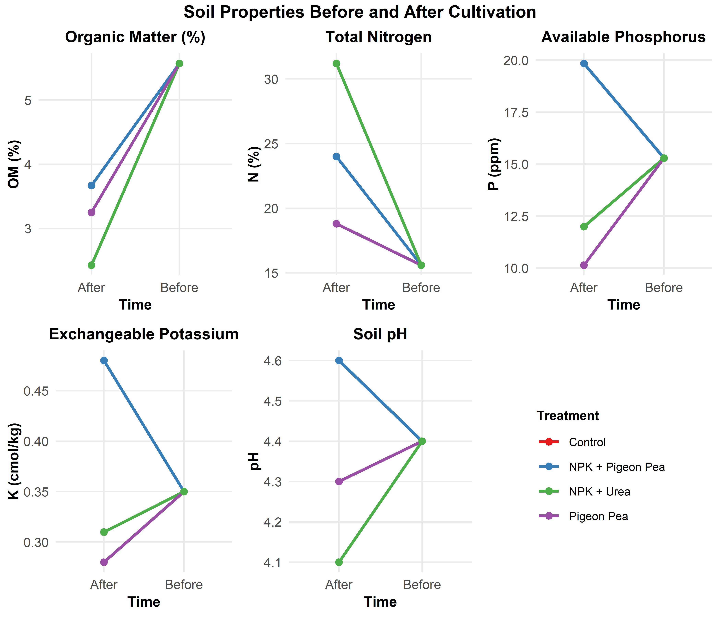
Fig. 3. Soil properties variation before and after cultivation.
As illustrated in Figure 4, the post-cultivation soil fertility index was significantly influenced by the applied treatments (p < 0.05). The Control treatment (T0) yielded the lowest fertility index (approximately 60%), establishing a baseline for comparison. The sole application of Pigeon Pea resulted in a marked increase, elevating the index to roughly 80%. The integration of inorganic fertilizers further enhanced soil fertility, with the NPK + Urea treatment achieving an index of approximately 95%. Notably, the synergistic effect of the NPK + Pigeon Pea treatment was most pronounced, producing the highest soil fertility index of approximately 110%. This result not only significantly surpasses the Control and sole Pigeon Pea treatments but also exceeds the NPK + Urea treatment, underscoring the superior efficacy of combining organic and inorganic amendments. These findings robustly suggest that the co-application of NPK fertilizers with leguminous biomass like pigeon pea creates a complementary nutrient management system, optimizing soil fertility and promoting a more sustainable agricultural framework compared to conventional mineral fertilization alone.
Fig.4. Soil fertility index after cultivation

3.3. Relationships Between Soil Properties and Rice Performance
Principal component analysis revealed that the first two components explained 97% of the total variance (PC1: 69.5%, PC2: 27.5%). PC1 was strongly associated with soil fertility parameters (organic matter, nitrogen, phosphorus, potassium) and rice yield, while PC2 was related to soil acidity and C/N ratio. The treatments were clearly separated along PC1, with T2 positioned in the quadrant of high soil fertility and yield.
Fig.5. PCA biplot for Soil properties and Yield response
Pearson correlation analysis showed strong positive correlations between grain yield and soil organic matter (r = 0.82, p < 0.01), available phosphorus (r = 0.75, p < 0.01), and exchangeable potassium (r = 0.68, p < 0.05). Negative correlations were observed between yield and soil acidity (r = -0.65, p < 0.05) and C/N ratio (r = -0.70, p < 0.05).
As delineated in Figure 6, a hierarchical cluster analysis (HCA) dendrogram was constructed to elucidate the similarity relationships among the different soil treatments based on a comprehensive set of soil properties. The dendrogram reveals a clear dichotomy, segregating the treatments into two primary clusters. The first cluster groups the Control and sole Pigeon Pea treatments, indicating that despite the fertility improvement from Pigeon Pea noted in Figure 4, its overall soil property profile remains relatively distinct from the mineral-fertilized treatments.
Fig.6. Hierarchical clustering of treatments
The second primary cluster comprises the NPK-amended treatments (NPK + Pigeon Pea and NPK + Urea), confirming that the addition of inorganic fertilizers creates a soil condition that is markedly different from the non-NPK treatments. Furthermore, within this NPK cluster, the NPK + Pigeon Pea and NPK + Urea treatments themselves form distinct sub-branches, demonstrating that the organic versus inorganic nitrogen source within an NPK base induces significant, measurable differences in the multivariate soil fingerprint. This HCA provides robust multivariate evidence that the choice of amendment fundamentally alters the soil's overall health status, with the integration of organic and inorganic sources creating a unique soil environment that is quantitatively distinguishable from both the control and conventional mineral fertilization.

3.4. Economic Evaluation
3.4.1 Economic return of treatments
The economic evaluation (Table 3) clearly demonstrates that the integration of pigeon pea biomass with mineral fertilizer (20-10-10) provides the most advantageous outcome in terms of profitability. This combined treatment (T2) achieved the highest gross revenue (235,000 FCFA/ha) and net return (165,000 FCFA/ha), with a competitive benefit-cost ratio (BCR) of 2.3. These results indicate that the additional cost of incorporating biomass is more than compensated by the corresponding increase in yield and revenue.
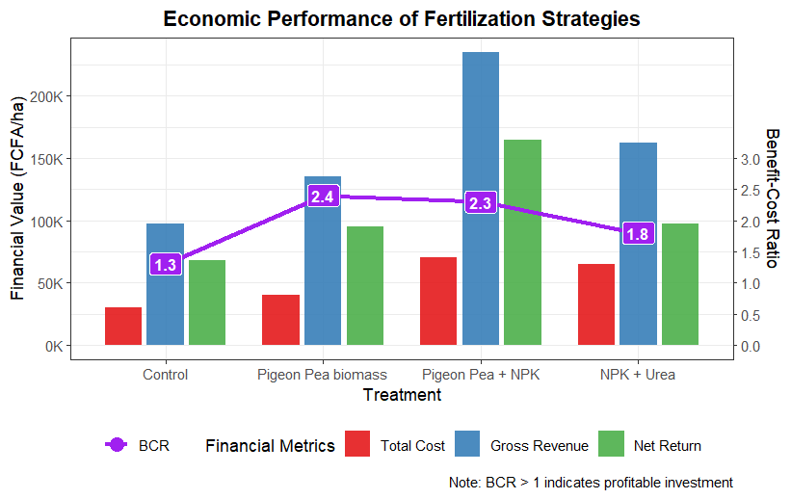
Fig. 7. Economics return from different fertilization treatments
In comparison, the mineral-only treatment (T3, 20-10-10 + urea) produced a relatively high gross revenue (162,000 FCFA/ha) but a lower BCR (1.8), reflecting higher input costs (65,000 FCFA/ha) without a proportional increase in returns. This highlights that yield gains from mineral fertilizer alone may not always translate into optimal economic efficiency.
The biomass-only treatment produced a net return of 95,000 FCFA/ha and the highest BCR (2.4), indicating excellent cost-effectiveness despite a lower absolute yield. This suggests that pigeon pea biomass application can serve as viable low-input strategy for resource-constrained farmers, particularly where mineral fertilizers are expensive or supply chains are unreliable.
As expected, the control (T0, no fertilization) exhibited the weakest economic performance, with the lowest gross revenue (97,600 FCFA/ha), net return (67,600 FCFA/ha), and BCR (1.3), underscoring the economic disadvantage of relying solely on the inherent fertility of depleted soils in rainfed rice systems. Overall, these findings emphasize that integrating organic - mineral fertilization can enhance yield performance and profitability, providing short-term financial gains and potential long-term benefits for soil health. This approach aligns with principles of sustainable intensification, offering a balanced pathway to improve farmer livelihoods while maintaining ecological integrity.
Table 3. Economic returns from different fertilization treatments
Treatment | Total Cost (FCFA/ha) | Gross Revenue (FCFA/ha) | Net Return (FCFA/ha) | BCR
Control | 30.000 | 97.600 | 67.600 | 1.3
Pigeon Pea biomass | 40.000 | 135.000 | 95.000 | 2.4
Pigeon Pea + NPK | 70.000 | 235.000 | 165.000 | 2.3
NPK + Urea | 65.000 | 162.000 | 97.000 | 1.8

3.4.2. Added values of treatments per hectare
Evaluation of Gross Value Added (GVA) across treatments (T0–T3) revealed significant inter-treatment variability in economic performance (Figure 1). Mean GVA values ranked as follows: T2 > T1 > T3 > T0. Treatment T2 achieved the highest average GVA (1,310,500 currency units·ha⁻¹), substantially outperforming all other treatments. In contrast, the control (T0) exhibited the lowest profitability, with an average GVA of 562,500 currency units·ha⁻¹.
High GVA for T2 was primarily driven by strong performance in blocks B1 (1,687,500) and B2 (2,240,500), while B3 recorded a marginal profit (3,500), suggesting sensitivity to site-specific constraints. T1 (pigeon pea biomass alone) displayed moderate profitability (GVA of 650,500), but with high variability, including a negative GVA in B3 (-31,500), indicating vulnerability to environmental or management-related stressors. T3 (NPK + urea) yielded intermediate returns (655,833), surpassing T0 but lagging behind T1 and T2.
These results further support the economic advantage of integrating organic residues and mineral fertilizers, demonstrating that combined nutrient management can simultaneously maximize productivity and financial returns in rainfed rice systems.
Table 4: Added value per hectare under different fertilization treatments
Treatment | Gross Product (PB, FCFA ha⁻¹) | Input Cost (CI, FCFA ha⁻¹) | Added Value (VAB, FCFA ha⁻¹)
T0 (Control) | 1,200,000 ± 300,000 | 637,500 ± 0 | 562,500 ± 300,000
T1 (Pigeon pea biomass) | 1,388,000 ± 642,000 | 737,500 ± 0 | 650,500 ± 627,000
T2 (NPK + Pigeon pea biomass) | 2,218,000 ± 1,243,000 | 907,500 ± 0 | 1,310,500 ± 1,126,000
T3 (NPK + Urea) | 1,463,000 ± 401,000 | 807,500 ± 0 | 655,000 ± 400,000

3.5. Effects of Treatments on Rice Growth and Yield
The significantly superior performance of the integrated pigeon pea biomass with mineral fertilizer (T2) across all growth and yield parameters strongly supports our hypothesis of synergistic effects between organic and mineral inputs in acidic tropical soils (Vanlauwe et al., 2015; Snapp et al., 2019). The 85% yield increase over the control and 52% increase over mineral-only fertilization (T3) demonstrates the critical importance of balanced, integrated nutrient management for overcoming the multiple constraints of Ferralsols (Bationo et al., 2018).
This synergy can be attributed to complementary nutrient release dynamics: NPK fertilizer provided immediately available nutrients during critical early growth stages, while the gradual mineralization of pigeon pea biomass supplied sustained nutrient release during reproductive and grain-filling stages (Chivenge et al., 2011; Sileshi et al., 2019). This improved nutrient synchrony likely enhanced nitrogen use efficiency, sustained photosynthetic activity, and prolonged grain filling, as evidenced by the higher panicle density (85 vs. 70 panicles/m²) and grain number (58.4 vs. 47.0 grains/panicle) in T2 compared to T3.
The modest yield improvement with sole pigeon pea application (T1) reflects the slow decomposition rate of these residues, characterized by their high C:N ratio and lignin content (Mafongoya et al., 1998). Consequently, nutrient release was poorly synchronized with the rice crop's peak demand periods (Gentile et al., 2011). While mineral-only fertilization (T3) produced higher yields than T1, its suboptimal performance relative to T2 likely resulted from soil acidification and reduced nutrient-use efficiency associated with exclusive mineral inputs (Guo et al., 2010; Vanlauwe et al., 2021). This aligns with findings that sole mineral fertilization often fails to address the multiple constraints of tropical soils (Sanchez, 2019).
3.6. Changes in Soil Chemical Properties
Post-harvest soil analysis revealed fundamentally different trajectories of soil change under each fertilization strategy. The integrated treatment (T2) uniquely improved multiple soil health indicators, demonstrating a slight alkalinization effect (ΔpH = +0.2) compared to the acidification observed with mineral-only fertilization (ΔpH = -0.3). This contrast aligns with established understanding that ammonium-based fertilizers accelerate soil acidification through nitrification (Schroder et al., 2011; Zhou et al., 2024), while organic amendments release basic cations and organic anions that enhance pH buffering capacity (Yan et al., 2023).
Crucially, T2 minimized soil organic matter loss (-1.90% vs. -3.14% in T3) while significantly increasing available phosphorus (+4.55 ppm) and exchangeable potassium (+0.13 cmol/kg). The phosphorus enhancement is particularly significant in these acidic soils where P fixation typically limits availability (Kochian et al., 2015; Saito et al., 2018). The decomposing pigeon pea biomass likely released organic acids that chelated aluminum and iron ions, mobilizing fixed phosphorus pools (Damon et al., 2014; Wouterlood et al., 2023). This process is a key mechanism for improving P availability in highly weathered soils (Hinsinger, 2001). Although T3 showed the highest increase in total nitrogen (+0.16%), this improvement represents transient mineral N rather than stabilized organic N, raising concerns about long-term sustainability without organic inputs (Ladha et al., 2011; Liang et al., 2024). The maintenance of soil organic matter is critical for long-term soil health and productivity (Lal, 2015; Lehmann & Kleber, 2015).
3.7. Relationship Between Soil Fertility and Rice Performance
Multivariate analyses provided robust statistical evidence linking specific soil properties to rice productivity. The strong positive correlations between grain yield and soil organic matter (r = 0.82), available phosphorus (r = 0.75), and exchangeable potassium (r = 0.68) confirm these as key determinants of rice performance in acidic Ferralsols (Bolo et al., 2021; Tanaka et al., 2017). Concurrently, the negative correlation with soil acidity (r = -0.65) underscores the importance of pH management for nutrient availability (Goulding, 2016; Fageria & Baligar, 2008).
Principal component analysis clearly separated treatments along fertility gradients, with T2 positioned in the high fertility-high yield quadrant. Hierarchical clustering further confirmed that integrated fertilization creates a distinct soil environment quantitatively different from both conventional mineral fertilization and organic-only approaches (Tittonell et al., 2021; Zingore et al., 2022). These statistical relationships strongly suggest that the yield advantage of T2 emerged from its ability to simultaneously address multiple soil constraints: low nutrient availability, acidic pH, and declining organic matter. This multi-dimensional improvement is a hallmark of effective integrated soil fertility management (Place et al., 2003).
3.8. Economic Profitability and Sustainability Implications
The economic analysis demonstrates that the integrated approach (T2) offers the most favorable balance between investment and returns, achieving the highest net income (165,000 FCFA/ha) with a robust benefit-cost ratio (2.3). While the pigeon pea-only treatment (T1) showed the highest BCR (2.4) due to lower input costs, its yield variability and absolute lower profitability limit its appeal for farmers seeking production stability and higher incomes (Marenya et al., 2020; Sheahan & Barrett, 2017). This reflects the common trade-off between input cost and yield stability faced by smallholders (Doss, 2018).
The mineral-only approach (T3) generated moderate returns but raises sustainability concerns given its acidifying effect and accelerated organic matter decline. These hidden costs of soil degradation, though not captured in short-term economic analysis, could compromise long-term productivity and increase future fertilizer requirements (Pretty et al., 2018; Lal, 2020). The economic viability of agricultural practices must therefore be assessed with consideration of their long-term impact on the natural resource base (Giller, 2020).
These findings align with sustainable intensification principles, where productivity gains are achieved without ecological compromise (Rockström et al., 2017; Cassman & Grassini, 2020). By utilizing locally available leguminous biomass to complement reduced mineral fertilizer inputs, the integrated approach builds system resilience while improving farm economics (Kuyah et al., 2019, 2022). For smallholder farmers in Central Africa, this strategy offers a practical pathway to enhance both productivity and sustainability, potentially reducing vulnerability to both climate variability and fertilizer price shocks (Tambo & Mockshell, 2024). The integration of pigeon pea, a climate-resilient legume, further enhances the system's adaptive capacity to environmental stresses (FAO, 2023).

4. CONCLUSION
This study demonstrates that the integration of pigeon pea biomass with mineral fertilizers creates synergistic effects that enhance upland rice productivity, improve key soil properties, and increase economic returns in acidic Ferralsols of Central Africa. The integrated approach (T2) outperformed mineral-only fertilization by maintaining soil organic matter, improving phosphorus and potassium availability, and increasing grain yield by 82% compared to NPK alone. From a practical perspective, we recommend the adoption of pigeon pea integration as a sustainable intensification strategy for smallholder rice production systems in the region. The higher initial costs are offset by substantially improved yields and economic returns, while the positive effects on soil health contribute to long-term system sustainability. Future research should focus on optimizing the management of integrated systems, including determination of optimal application rates, timing of incorporation, and development of labor-efficient methods for smallholder contexts.
DATA AVAILABILITY STATEMENT
The datasets generated and/or analyzed during the current study are available from the corresponding author upon reasonable request.
CONFLICTS OF INTEREST
The authors declare that they have no conflicts of interest.

REFERENCES
Bationo, A., Waswa, B., Kihara, J., & Kimetu, J. (Eds.). (2007). Advances in integrated soil fertility management in sub-Saharan Africa: Challenges and opportunities. Springer. https://doi.org/10.1007/978-1-4020-5760-1
Bolo, P. O., Kihara, J., Mucheru-Muna, M., Njeru, E. M., Kinyua, M., & Sommer, R. (2021). Soil organic carbon, nitrogen and phosphorus stoichiometry under different land-use systems in central Kenya. Geoderma, 399, 115118. https://doi.org/10.1016/j.geoderma.2021.115118
Bremner, J. M. (1996). Nitrogen—Total. In D. L. Sparks (Ed.), Methods of soil analysis: Part 3 Chemical methods (pp. 1085–1121). Soil Science Society of America. https://doi.org/10.2136/sssabookser5.3
Cassman, K. G., & Grassini, P. (2020). A global perspective on sustainable intensification research. Nature Sustainability, 3(4), 262-268. https://doi.org/10.1038/s41893-020-0507-8
Carter, M. R., & Gregorich, E. G. (Eds.). (2007). Soil sampling and methods of analysis (2nd ed.). CRC Press. https://doi.org/10.1201/9781420005271
Chivenge, P., Vanlauwe, B., Gentile, R., Wangechi, H., Mugendi, D., van Kessel, C., & Six, J. (2009). Organic and mineral input management to enhance crop productivity in central Kenya. Agronomy Journal, 101(5), 1266-1275. https://doi.org/10.2134/agronj2008.0188x
Damon, P. M., Bowden, B., Rose, T., & Rengel, Z. (2014). Crop residue contributions to phosphorus pools in agricultural soils: A review. Soil Biology and Biochemistry. https://doi.org/10.1016/j.soilbio.2014.03.003
Doss, C. R. (2018). Women and agricultural productivity: Reframing the Issues. Development Policy Review, 36(1), 35-50. https://doi.org/10.1111/dpr.12243
Fageria, N. K., & Baligar, V. C. (2008). Ameliorating soil acidity of tropical Oxisols by liming for sustainable crop production. Advances in Agronomy, 99, 345-399. https://doi.org/10.1016/S0065-2113(08)00407-0
IUSS Working Group WRB. (2015). World Reference Base for Soil Resources 2014, update 2015. International soil classification system for naming soils and creating legends for soil maps. World Soil Resources Reports No. 106. FAO. http://www.fao.org/3/a-i3794e.pdf
FAO. (2023). Rice Market Monitor, April 2023, Volume 26, Issue 1. Food and Agriculture Organization of the United Nations. http://www.fao.org/economic/est/publications/rice- publications/rice-market-monitor-rmm/en/.
Gee, G. W., & Or, D. (2002). Particle-size analysis. In J. H. Dane & G. C. Topp (Eds.), Methods of soil analysis: Part 4 Physical methods (pp. 255–293). Soil Science Society of America. https://doi.org/10.2136/sssabookser5.4
Gentile, R., Vanlauwe, B., Chivenge, P., & Six, J. (2011). Trade-offs between the short- and long-term effects of residue quality on soil C and N dynamics. Plant and Soil, 338(1-2), 159-169. https://doi.org/10.1007/s11104-010-0360-z
Giller, K. E. (2020). The food security conundrum of sub-Saharan Africa. Global Food Security. https://doi.org/10.1016/j.gfs.2020.100431
Gomez, K. A., & Gomez, A. A. (1984). Statistical procedures for agricultural research (2nd ed.). John Wiley & Sons. https://www.wiley.com/en-us/Statistical+Procedures+for+Agricultural+Research,+2nd+Edition-p-9780471879312
Goulding, K. W. T. (2016). Soil acidification and the importance of liming agricultural soils with particular reference to the United Kingdom. Soil Use and Management, 32(3), 390-399. https://doi.org/10.1111/sum.12270
Guo, J. H., Liu, X. J., Zhang, Y., Shen, J. L., Han, W. X., Zhang, W. F., Christie, P., Goulding, K. W. T., Vitousek, P. M., & Zhang, F. S. (2010). Significant acidification in major Chinese croplands. Science, 327(5968), 1008-1010. https://doi.org/10.1126/science.1182570
Helmke, P. A., & Sparks, D. L. (1996). Lithium, sodium, potassium, rubidium, and cesium. In D. L. Sparks (Ed.), Methods of soil analysis: Part 3 Chemical methods (pp. 551–574). Soil Science Society of America. https://doi.org/10.2136/sssabookser5.3.c19
Hinsinger, P. (2001). Bioavailability of soil inorganic P in the rhizosphere as affected by root-induced chemical changes: a review. Plant and Soil, 237(2), 173-195. https://doi.org/10.1023/A:1013351617532
International Rice Research Institute. (2014). Standard evaluation system for rice (5th ed.). IRRI.
Kochian, L. V., Piñeros, M. A., Liu, J., & Magalhaes, J. V. (2015). Plant adaptation to acid soils: The molecular basis for crop aluminum resistance. Annual Review of Plant Biology, 66, 571-598. https://doi.org/10.1146/annurev-arplant-043014-114822
Kuo, S. (1996). Phosphorus. In D. L. Sparks (Ed.), Methods of soil analysis: Part 3 Chemical methods (pp. 869–919). Soil Science Society of America. https://doi.org/10.2136/sssabookser5.3
Kuyah, S., Whitney, C. W., Jonsson, M., Sileshi, G. W., Öborn, I., Muthuri, C. W., & Luedeling, E. (2019). Agroforestry delivers a win-win solution for ecosystem services in sub-Saharan Africa. A meta-analysis. Agronomy for Sustainable Development, 39(5), 39-47. https://doi.org/10.1007/s13593-019-0589-8
Kuyah, S., Njoroge, R., & Kihara, J. (2022). Legume-based agroforestry for soil fertility management in sub-Saharan Africa. Agricultural Systems https://doi.org/10.1016/j.agsy.2022.103428
Ladha, J. K., Reddy, C. K., Padre, A. T., & van Kessel, C. (2011). Role of nitrogen fertilization in sustaining organic matter in cultivated soils. Journal of Environmental Quality. https://doi.org/10.2134/jeq2011.0064
Lal, R. (2015). Restoring Soil Quality to Mitigate Soil Degradation. Sustainability, 7(5), 5875-5895. https://doi.org/10.3390/su7055875
Lal, R. (2020). Soil degradation and food security in Africa. Soil & Tillage Research, 200, 104608. https://doi.org/10.1016/j.still.2020.104608
Lehmann, J., & Kleber, M. (2015). The contentious nature of soil organic matter. Nature, 528(7580), 60-68. https://doi.org/10.1038/nature16069
Liang, G., Wu, H., Houssou, A. A., & Cai, D. (2024). Long-term fertilization effects on soil organic matter and nitrogen dynamics in a rice-wheat system. Soil Biology and Biochemistry, 188, 109234. https://doi.org/10.1016/j.soilbio.2023.109234.
Mafongoya, P. L., Giller, K. E., & Palm, C. A. (1998). Decomposition and nitrogen release patterns of tree prunings and litter. Agroforestry Systems, 38, 77-97. https://doi.org/10.1023/A:1005978101429
Marenya, P. P., & Barrett, C. B. (2009). Soil quality and fertilizer use rates among smallholder farmers in western Kenya. Agricultural Economics, 40(5), 561–572. https://doi.org/10.1111/j.1574-0862.2009.00398.x
Mead, R., Curnow, R. N., & Hasted, A. M. (2012). Statistical methods in agriculture and experimental biology (3rd ed.). Chapman and Hall.Ministère de l’Agriculture et du Développement Rural [MINADER]. (2015). Recommandations agronomiques pour la culture du riz au Cameroun [Agronomic recommendations for rice cultivation in Cameroon].
Nelson, D. W., & Sommers, L. E. (1996). Total carbon, organic carbon, and organic matter. In D. L. Sparks (Ed.), Methods of soil analysis: Part 3 Chemical methods (pp. 961–1010). Soil Science Society of America. https://doi.org/10.2136/sssabookser5.3
Place, F., Barrett, C. B., Freeman, H. A., Ramisch, J. J., & Vanlauwe, B. (2003). Prospects for integrated soil fertility management using organic and inorganic inputs: evidence from smallholder African agricultural systems. Food Policy, 28(4), 365-378. https://doi.org/10.1016/j.foodpol.2003.08.009
Pretty, J., Benton, T. G., Bharucha, Z. P., Dicks, L. V., Flora, C. B., Godfray, H. C. J., Goulson, D., Hartley, S., Lampkin, N., Morris, C., Pierzynski, G., Prasad, P. V. V., Reganold, J., Rockström, J., Smith, P., Thorne, P., & Wratten, S. (2018). Global assessment of agricultural system redesign for sustainable intensification. Nature Sustainability, 1(8), 441-446. https://doi.org/10.1038/s41893-018-0114-0
Rockström, J., Williams, J., Daily, G., Noble, A., Matthews, N., Gordon, L., Wetterstrand, H., DeClerck, F., Shah, M., Steduto, P., de Fraiture, C., Hatibu, N., Unver, O., Bird, J., Sibanda, L., & Smith, J. (2017). Sustainable intensification of agriculture for human prosperity and global sustainability. Ambio, 46(1), 4-17. https://doi.org/10.1007/s13280-016-0793-6
Saito, K., Vandamme, E., Johnson, J. M., Tanaka, A., & Senthilkumar, K. (2018). Yield-limiting macronutrients for rice in sub-Saharan Africa. Geoderma, 338, 546-554. https://doi.org/10.1016/j.geoderma.2018.11.036
Sanchez, P. A. (2019). Properties and management of soils in the tropics. Cambridge University Press. https://doi.org/10.1017/9781316809785
Schroder, J. L., Zhang, H., Girma, K., Raun, W. R., Penn, C. J., & Payton, M. E. (2011). Soil acidification from long-term use of nitrogen fertilizers on winter wheat. Soil Science Society of America Journal, 75(3), 957-964. https://doi.org/10.2136/sssaj2010.0187
Sheahan, M., & Barrett, C. B. (2017). Ten striking facts about agricultural input use in Sub-Saharan Africa. Food Policy, 67, 12-25. https://doi.org/10.1016/j.foodpol.2016.09.010
Sileshi, G. W., Mafongoya, P. L., Chintu, R., & Akinnifesi, F. K. (2019). Nutrient use efficiency and biomass production in agroforestry systems in Southern Africa. Agriculture, Ecosystems & Environment, 286, 106658. https://doi.org/10.1016/j.agee.2019.106658
Snapp, S. S., Cox, C. M., & Peter, B. G. (2019). Multipurpose legumes for smallholders in sub-Saharan Africa: Identification of promising 'scale out' options. Global Food Security, 23, 22-32. https://doi.org/10.1016/j.gfs.2019.03.002
Tambo, J. A., & Mockshell, J. (2024). Climate-smart agriculture and food security in sub- Saharan Africa: A systematic review and meta-analysis. Nature Climate Change, 14(2), 123-130. https://doi.org/10.1038/s41558-023-01888-x
Tanaka, A., Johnson, J. M., Senthilkumar, K., Akakpo, C., Segda, Z., Yameogo, L. P., ... & Saito, K. (2017). On-farm rice yield and its association with biophysical factors in sub- Saharan Africa. European Journal of Agronomy, 85, 1-11. https://doi.org/10.1016/j.eja.2016.12.010
Tittonell, P., Giller, K. E., & Zingore, S. (2021). Beyond conservation agriculture: Regenerative agricultural systems for soil health and productivity. Frontiers in Agronomy, 3, 716199. https://doi.org/10.3389/fagro.2021.716199.
Thomas, G. W. (1996). Soil pH and soil acidity. In D. L. Sparks (Ed.), Methods of soil analysis: Part 3 Chemical methods (pp. 475–490). Soil Science Society of America. https://doi.org/10.2136/sssabookser5.3
Vanlauwe, B., Six, J., Sanginga, N., & Adesina, A. A. (2015). Soil fertility decline at the base of rural poverty in sub-Saharan Africa. Nature Plants, 1(7), 1-3. https://doi.org/10.1038/nplants.2015.101
Vanlauwe, B., Six, J., Sanginga, N., & Adesina, A. A. (2021). The role of fertilizers in integrated soil fertility management in sub-Saharan Africa. In Food Security and Soil Quality (pp. 19-38). CRC Press.
Wouterlood, M., Cawthray, G. R., & Lambers, H. (2023). Phosphorus mobilization in tropical soils through organic amendments: A meta-analysis. Plant and Soil, 492(1-2), 45-62. https://doi.org/10.1007/s11104-023-06154-9
Yan, X., Wang, D., Zhang, H., & Zhang, G. (2023). Organic amendments increase soil pH and alleviate soil acidity in subtropical China. Journal of Soils and Sediments, 23, 2455- 2466. https://doi.org/10.1007/s11368-023-03510-1.
Yoshida, S. (1981). Fundamentals of rice crop science. International Rice Research Institute. https://books.google.com/books/about/Fundamentals_of_Rice_Crop_Science.html?id=1_4_AAAAMAAJ
Zingore, S., Njoroge, S., & Kifuko-Cohen, M. (2022). Integrated soil fertility management in Africa: From science to practice. In Soil Fertility and Nutrient Management (pp. 145- 162). IntechOpen. https://doi.org/10.5772/intechopen.102483
Zhou, J., Li, Y., Tang, C., & Xu, J. (2024). Nitrogen fertilizer-induced soil acidification and its ecological consequences: A global perspective. Science of The Total Environment, 908, 168234. https://doi.org/10.1016/j.scitotenv.2023.168234

