CRANIAL APPENDAGES OF ARTIODACTYLS: A REVIEW

Abstract
The interest may actually pay off, as the study of ruminant headgear may enable important applications in the fields of veterinary and human medicine. Antler development, in particular, is seen as a key to understanding a suite of skin–bone interactions, including healing, regeneration and neural control of bone development. Horns consist of conical keratinous sheaths which enclose the horn core, arising from the frontal bone. They vary greatly in size, forms and curvatures. Unlike antlers, both the bony core and keratin covering are never shed naturally. Horns act as a shield which protects the animal during fight (Bighorn Sheep). Female bovids that are larger in size and live in an open habitat are more likely to have horns (African buffalo). Horns also act as a shock absorber. Antlers undergo periodic regeneration, with deer antlers being a model for studying bone growth and regeneration. Antler growth is energetically expensive and induced by testosterone. Ossicones, found in giraffes and okapis, are permanent and differ from horns and antlers. Pronghorns have a keratinous sheath that sheds annually and a forked appearance due to branching. Each type of cranial appendage has unique characteristics and functions, highlighting the diversity of these structures in herbivores.

Keywords: Ossicones, skin–bone interactions, horns, keratinous sheath

Introduction
All life on this planet has a single most important objective -survival, and of course, nature favours those who are most efficient at it. What began as an evolutionary arms race between predator and prey, has reached a stunning crescendo with diverse forms of horns and antlers growing and twisting into endless variety and ecstatic beauty.
Many questions abound on the evolution of ruminant headgear, and the most coherent and recent theories suggest that rudimentary bony projections may have arisen in ancestral ruminants 15 to 20 million years ago in the Middle Miocene with a mainly defensive function, which then was exaggerated to its current sizes and shapes due to the influence of sexual selection, i.e., females choosing to mate with the male presenting better headgear. Genetic evidence suggests that the evolution of horns, antlers, ossicones and pronghorns was not achieved independently, and that the traits have evolved from a common ancestor ^{[37]}.
Extreme examples of mammal headgear pepper the fossil record, including Megaloceros, the “Irish Elk,” whose enormous antlers could reach a 13-foot spread, and Ilingoceros, which had straight, spiral headgear that ended in forked tips. These megafauna captivated the human minds of the paleolithic era, inspiring art and sculpture, in which the headgear enjoyed a prominent spotlight in the portrayals. Perhaps the most poignant piece of art is a 15,000 year old carving, depicting a bison licking a wound in a candid, life-like pose, sculpted with tender precision in reindeer antler. Further commentary is not needed to highlight the fascination in which these creatures were held.
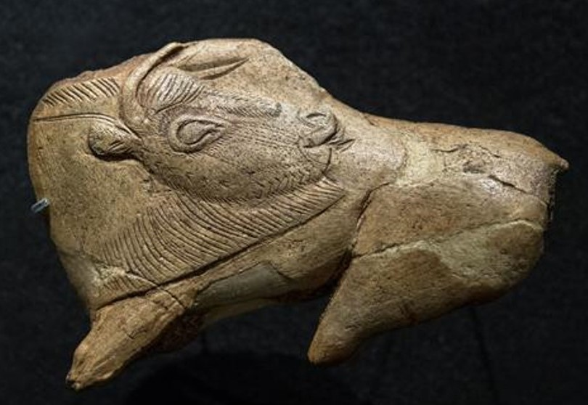
Fig :1 A 15,000 year old Paleolithic carving found at Dordogne, France, depicting a now extinct Steppe bison absorbed in a moment of self-care ^{[29]}.
This interest may actually pay off, as the study of ruminant headgear may enable important applications in the fields of veterinary and human medicine. Antler development, in particular, is seen as a key to understanding a suite of skin–bone interactions, including healing, regeneration and neural control of bone development. The possibilities for regenerative medicine have become a major line of inquiry, raising the possibility that antler regeneration could be co-opted for human medicine, with applications ranging from accelerating skin regeneration for burn victims to delaying the onset of osteoporosis.
Of the six extant families of artiodactyls, only four (Cervidae, Giraffidae, Bovidae, Antelocapridae) present cranial appendages, each with a different type; antlers, ossicones, horns, and pronghorns, respectively ^{[2]}.
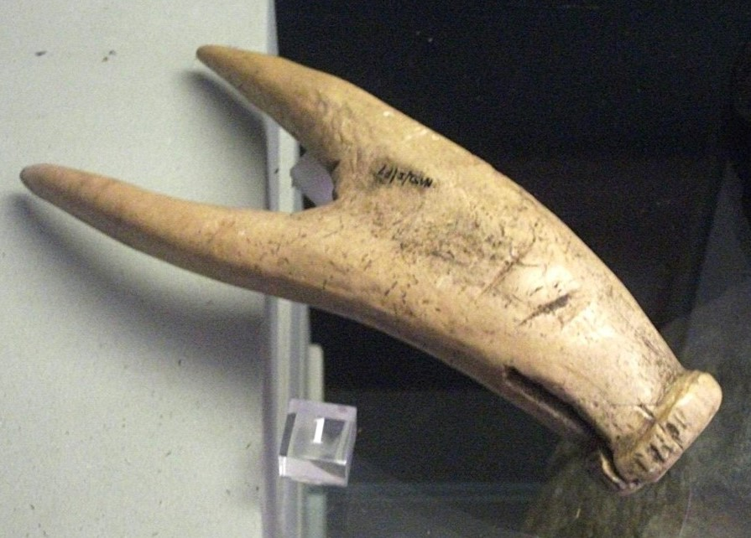
Fig 2: Blade of a double-pronged hoe made of deer antler, Iron Age ^{[28]}

- Horn (Bovidae)
Horns consist of conical keratinous sheaths which enclose the horn core, arising from the frontal bone. They vary greatly in size, forms and curvatures. Unlike antlers, both the bony core and keratin covering are never shed naturally.
True horns are one of the characteristics of ruminant artiodactyls, though a similar structure is seen in Jackson's horned chameleon (Triceros jacksonii), wherein the horn core is covered by an annulated keratin sheath ^{[36]}. They are considered analogues, not homologues. The horns are three in number and have a similar structure as that of the ruminant horn.
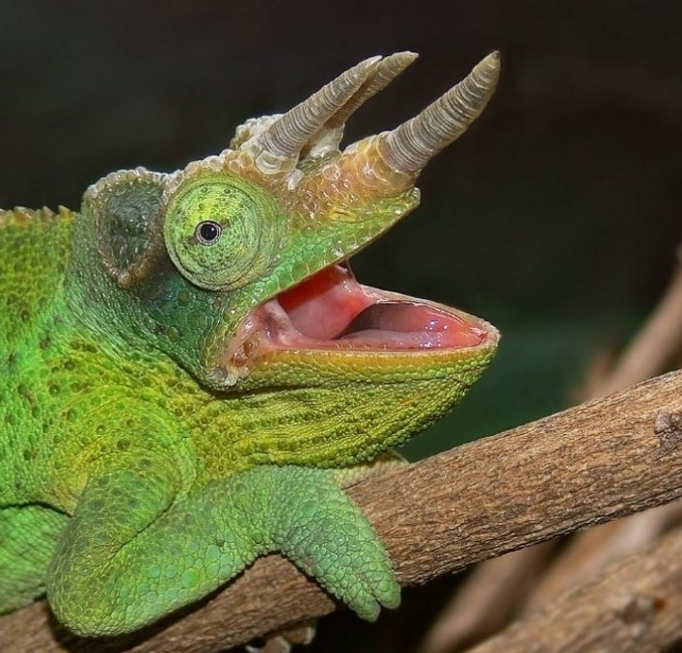
Fig 3: A Jackson's chameleon (Triceros jacksonii), Melbourne Zoo ^{[33]}. The annulated nature of the keratin covering can be seen.
Horns of bovids are remarkably diverse. Interspecific variation is so pronounced that most of the species are easily recognizable by the shape of horns.
Structure and Development
Horns arise from subcutaneous connective tissue and later fuse to the underlying frontal bone only after two months of age. In neonates the bony portion of the horn is very small with dermis and epidermal covering.
A typical horn consists of three parts ^{[26]}:
a. Innermost horn core (Os cornu): It is generally conical in form and develops as the cornual process of frontal bone. By 6 months of age the horn becomes hollow and the space within is continuous with the frontal sinus ^{[35]}.
b. Middle vascular connective tissue layer: this is continuous with that of skin surrounding the horn and provide nerve and blood supply.
c. Outermost keratinised layer (horn covering): It is ridged and porous and is with papillated dermis that is continuous with periosteum and epidermis, which is keratinised for protection.
The substance of horn is similar to that of hoof and is a mixture of tubules and intertubules. Horns grow from the base to the apex. Hormonal influence is significant in horn development; especially testosterone. Growth hormone also plays a role. It is noticed that in castrated animals horn growth recedes. True horns are simple, unbranched and never shed, though the keratin sheath is exfoliated once or twice during an animal’s life ^{[11]}. In domestic animals horns can be removed in an early stage (disbudding) or in adult stage (dehorning) for various reasons. But genetically hornless animals are termed as polled animals. Horn growth, when compared to antler, is less dynamic, owing to its permanence.
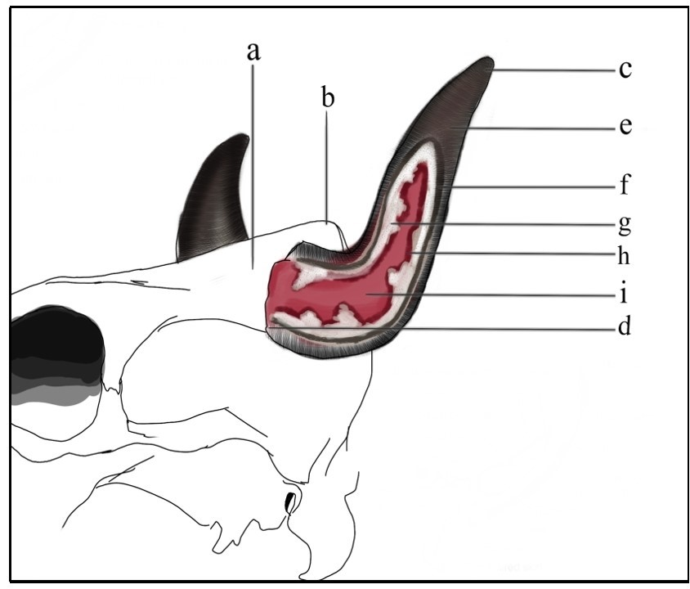
Fig 4: Skull of Bos taurus, side profile. (a), Frontal bone; (b), Frontal eminence; (c) Horn apex, (d), Horn base; (e), Horn sheath; (f), Cornual dermis; (g), Cornual periosteum; (h), Mucous membrane of frontal sinus; (i), Cornual diverticulum of frontal bone.
Functions
Horns are known to have diverse functions including defending territories and mates, protection, combat, displays of dominance, and so on. Darwin was the first to suggest that horns evolved in the context of sexual selection as a weapon of male –male competition ^{[23]}. Horns act as a shield which protects the animal during fight (Bighorn Sheep). Female bovids that are larger in size and live in an open habitat are more likely to have horns (African buffalo). Horns also act as a shock absorber ^{[24]}.
In goats and similar bovids in arid conditions, the horn helps to cool the blood flowing through the horn core to dissipate heat. As the ambient temperature increases, the blood flow through the horn dermis also increases which facilitates heat loss. Desert ruminants possess a highly vascularised horn core. Horn morphology differs by environment (tropical and temperate) which further justifies the thermoregulatory function; dehorned or polled domestic bovids tend to exhibit larger than typical ear pinna ^{[32]}.
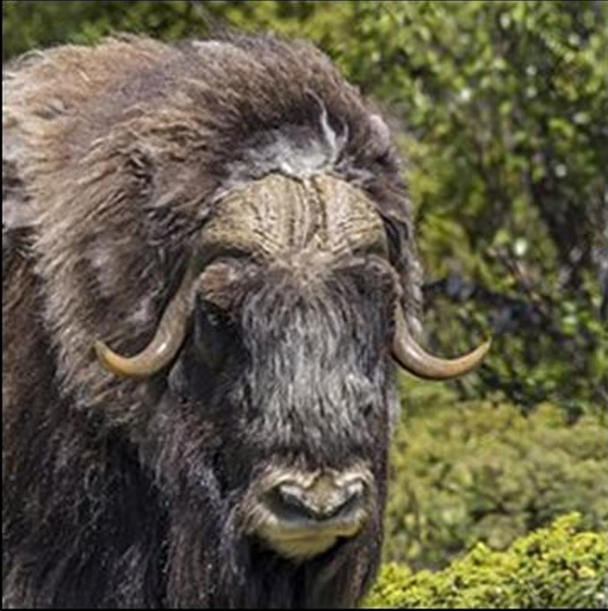
Fig 5: Muskox (Ovibos moschatus) male, Dovrefjell National Park, Norway ^{[22]}.
Musk oxen (Ovibos moschatus), in the arctic, present small, and ‘droopy’ horns, placed flat on the head, suggesting heat conservation.
Mechanical properties
Composite structure with vascularised bony core gives the horn an outstanding load bearing ability ^{[25]}. Mechanical properties of horn depend on the degree of hydration. Dry horn keratin may rupture at relatively lower strain level ^{[27]}.
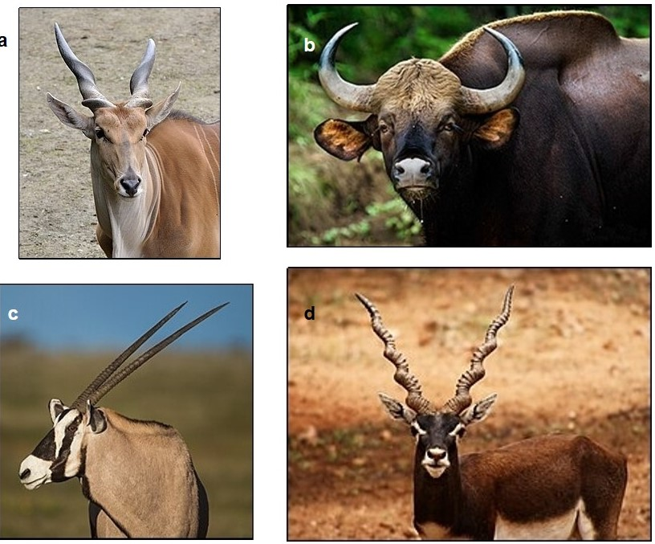
Fig 6: The various types of horns; in order, long spiral ( a, Common Eland; Taurotragus oryx ^{[19]}), cylindrical (b, Gemsbok; Oryx gazelle ^{[20]}), crescent (c, Gaur; Bos gaurus ^{[21]}), corkscrew spiral (d, Blackbuck; Antilope cervicapra ^{[22]}). Other shapes are also seen.

- Antler (Cervidae)
Antlers are deciduous, cranial, bony appendages in Cervidae, arising from subcutaneous connective tissues, fused to the frontal bone, similar to the horn. It undergoes periodic regeneration from the peduncles/pedicle, found on the frontal bone, which are permanent. The peduncles from which the antler grows develop adjacent to the fronto-parietal suture in the posterior region of the long, bony ridge that extends from the supraorbital in the posterior medial direction.
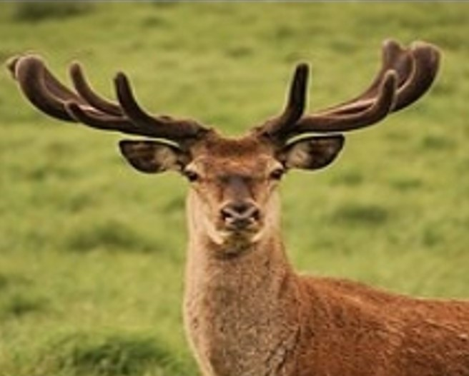
Fig 7: A male red deer (Cervus elaphus) in Munich, Bavaria, Germany; this buck shows immature, velvet antlers ^{[14]}.

Except in the Reindeer (Rangifer tarandus), generally, only bucks possess antlers. Antlers are developed in 36 out of 40 species of deer ^{[7]}. Chinese Water Deer (Hydropotes inermis) and species of Musk Deer (Moschus sp.) lack antlers. They constitute the secondary sexual characteristics in deer ^{[34]}. They develop from prominent peduncles, where growth is dependent on a specialized (antlerogenic) periosteum. Antlers are the fastest growing bones in any mammal, formed by endo-chondrial and perichondrial/ intra-membraneous ossification. Antlers are used for combat between males during rut and their bio-mechanical properties are adapted to that role ^{[31]}. It is a model for studying bone growth and mineralization, as well as epimorphic regeneration ^{[2] [31]}.
In growing antlers, the bone tissues start forming on a base of mineralized cartilage. This cartilaginous matrix is replaced by a loose, spongy network of bone with poorly arranged collagen fibers. Small cylindrical pores in the bone run along the length of the antler. Later, these pores are filled in by primary osteons after a layer of lamellar bone is added ^{[30]}.
Antlers have unique mechanical properties in comparison to other bone types. The mechanical properties vary from the base to the apex. This variation is the combined effect of bone microarchitecture and mineralization ^{[30]}. The gross comparison of antlers is similar to that of any other bone. It contains more organic matter and less mineral than other bones, as a consequence, it requires more energy to fracture an antler ^{[31]}. Antlers are the only example of complete regeneration of a large bony appendage in mammals.
Growth and development
Antlers are shed annually. As described, antlers are made entirely of bone, it has an epidermal covering during its development. Antlers become increasingly branched with age. Fully mature antlers are entirely bony structures, without any epidermal covering. Growth is triggered in the first year of life by a rise in circulating testosterone levels, produced by the developing testes, and can therefore, be inhibited by early castration in bucks ^{[7]}.
Antler growth cycle ^{[7]}
Secretion of testosterone induces antler growth at puberty. It controls the cyclical nature of antler growth in adulthood. The developing antler is primarily made of cartilage. New growth develops from the apex. This development is supported by a network of blood vessels and nerves that run on the periphery. Fine hair is present on the outer nourishing skin that is termed as ‘velvet’ owing to its fine texture. At this stage, the antler is tender and sensitive to touch and pain ^{[6]}.
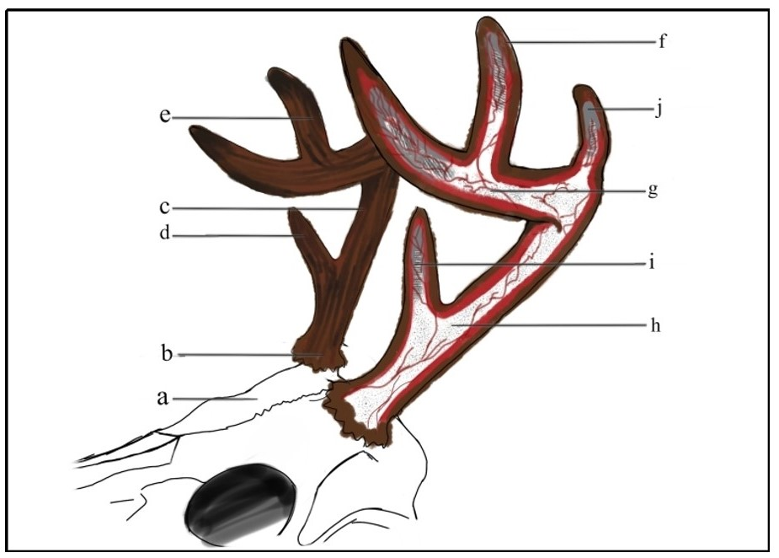
Fig 8: Skull of red deer with antlers intact, side profile. (a), Frontal bone; (b), Pedicle; (c), Main beam; (d), Brow tine; (e), Tines; (f), Velvet; (g), Blood vessels; (h), Compact bone; (i), Coarse spongy bone; (j), Cap of germinal
Physiology
Antlers are shed in the spring when the circulating levels of testosterone are low, at the start of the sexual cycle. It regenerates rapidly in the early summer through a modified wound healing mechanism. The low testosterone level aids in the growth of the antler beam and tines. When the hormone level increases, it stimulates the calcification of the then primarily cartilaginous antler. The overlaying layer of skin and fine hair – the velvet, is shed at this point, which is oftentimes consumed by the deer to reclaim spent energy.
Now, the antler is devoid of blood supply and any innervation. At this stage, the antler dies, producing an insensitive ossified structure. This hard antler is maintained throughout the autumn and winter, as long as the circulating testosterone level is maintained above basal values. The high testosterone level induces the final calcification and eventually, antler death. There is a gradual die-back at the junction between the antler and the living pedicle. The antler is shed when the circulating levels of testosterone declines. This initiates another cycle of antler regeneration.
Antler growth is energetically expensive, being the fastest growing mammalian bone, with growth rates up to about 2 cm per day ^{[9]}. Under light microscope, actively growing antler tissue is indistinguishable from a malignant bone neoplasm ^{[6]}. Various cellular mechanisms control this rapid cell growth, which are beyond the scope of this article. In short, antler growth is a type of controlled bone cancer. It is often referred to as a ‘physiological tumor’. In its social life, displaying a set of well-formed antlers signals the prime health status of the buck and highlights a good producer. Does prefer bucks with well-developed antlers. However, antlers can be damaged during combat with rival bucks, thus lowering a good producing buck’s status in the herd. As a result, there is a need to regenerate the antler annually, after each sexual cycle. Each cycle produces larger antlers, which begin to stabilize at 5-7 years of age, where the antler reaches the maximum size ^{[7]}. The drop in testosterone levels coincide with the end of the breeding season, thereby facilitating antler shedding, as antlers are no longer needed by the buck at this stage^{[7]}. High testosterone during rut suppresses osteoclasts at the antler-pedicle junction. However, at the end of the rutting season, lower levels of testosterone stimulates/activates osteoclasts, thereby dissolving the osteocytes at the junction. This leads to the formation of an abscission line, from which the antler is cast.
Effect of castration ^{[7] [9]}
As discussed above, testosterone plays a crucial role in the formation, maintenance, and the shedding of antlers. If the casting is prevented by the treatment with exogenous testosterone or oestradiol-17β, the die-back progresses down to the skull, and is fatal. This is because the normal cue for antler casting (low levels of testosterone) is blocked by the presence of exogenous testosterone. However, osteoclasts still remain active. Hence, bone demineralization continues and bone necrosis occurs.
Abnormal antler growth
Peruke antlers ^{[8]}: ‘Wig-like’, Seen mostly in Moose (Alces alces). This is caused due to lowering of testosterone levels in blood due to castration or testicular atrophy/damage, or damage to the pituitary.
Here, the antler never fully develops, the hormonal level is not high enough to fully calcify the antler. As a result, abnormal, coral-like antlers that never shed the velvet and are permanently retained. In Moose, this phenomenon is also known as “Devil antlers”. This condition is also described in Roe Deer (Capreolus capreolus) ^{[9]}. In female deer that are injected with testosterone, knob-like structures are formed, with a velvet-like covering, on the head where antlers would be seen in a buck. Older does after menopause develop similar knobs ^{[6]}.
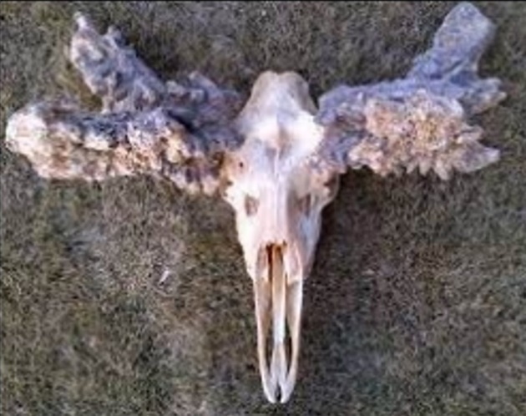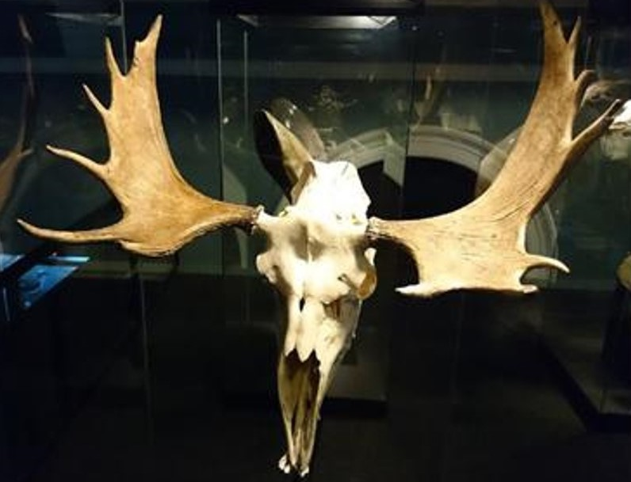
Fig 9: Comparison of moose skulls presenting peruke antlers (top) with that of normal, healthy antler growth. ^{[17][18]}

- Ossicone (Giraffidae)^{[3]}
Ossicones are found only in two modern-day genera; Giraffa, and Okapia. Ossicones are cranial protuberances of bone, dermis, and epidermis, which may be penetrated by extensions of the nasal, frontal, or parietal sinuses, usually seen at the fronto-parietal suture, and also on nasal, parietal, and supraoccipital bone in Giraffa. In Okapia, only the fronto-parietal pair is seen. These extensions of the skull are covered with skin and hair. They are permanent, unbranched, and more than a single pair is seen on male giraffes. In Okapia, only the males possess ossicones. Ossicones differ from horns in the fact that they do not possess an outer keratin covering. It differs from antlers due to their permanence and their unbranched nature. It is considered as the simplest cranial appendage in artiodactyla ^{[1]}. The main ossicones are usually paired and present on the fronto-parietal suture. Less developed median ossicones, often termed ‘Giraffacone ^{[5]}’ by certain authors, formed mostly of the frontals and anteriorly partly by the nasals ^{[4]}. Still less regular protuberances are seen on other positions of the skull ^{[3]}.
Giraffa (Giraffa camelopardalis)
Both sexes possess ossicones. It is often more robust in males than females. A median ossicone is seen in some sub-species. Certain sub-species have a supraoccipital pair in addition to the median ossicones, thereby presenting five ossicones in total.
Function
The ends of the ossicones in males appear ‘bald’ as a result of ‘necking’, a type of combat among rival bulls. The ossicones act as a club when the neck is swung towards the opponent. The increased number of ossicones in males perhaps aids in increasing damage on each impact. Females, however, retain the hair as they do not engage in necking to an extent. Ossicones also function as heat dissipating regions in the body, owing to their high vascularity.
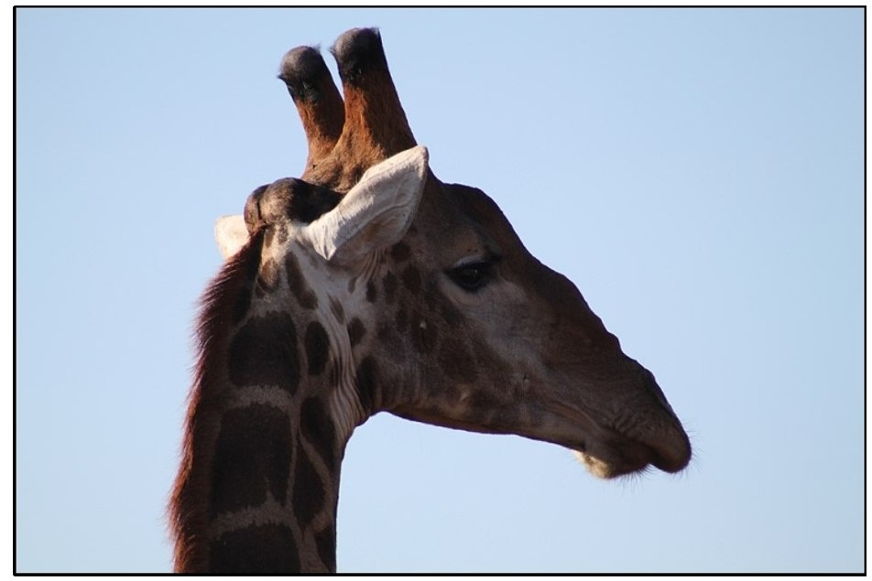
Fig 10: An adult giraffe showing nasal, parietal, and supraoccipital ossicones. The bald apices of the fronto-parietal pair is seen ^{[14]}.
Structure
Studies have shown that the ossicone is composed of three structures: an innermost large fronto-parietal boss base, the ossicones, and the outermost layers of secondary bone growth ^{[5]}. In the median ossicones, however, only two structures exists: the median fronto-nasal boss and overlaying layers of bone ^{[5]}.
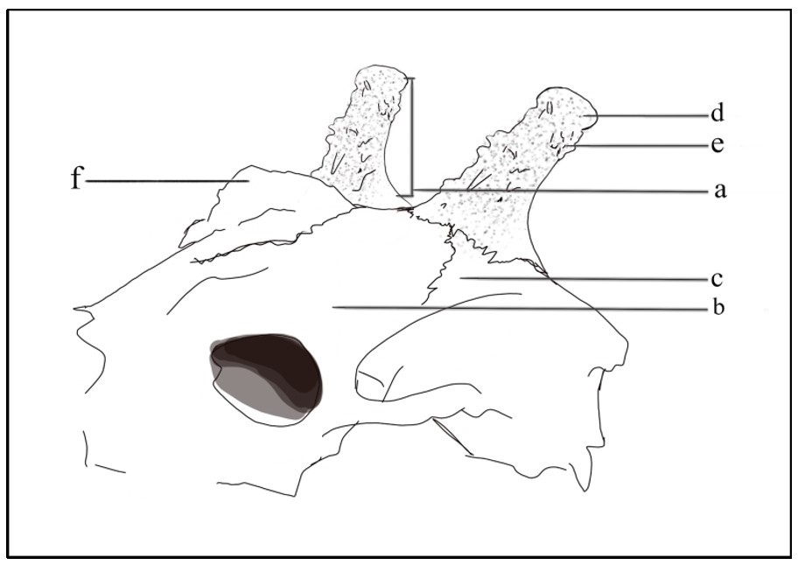
Fig 11: Skull of Giraffe, side profile. (a), Ossicone; (b), Frontal bone; (c), Parietal bone; (d), Apex of ossicone; (e), secondary bone growth; (f), Median ossicone.
The overlaying secondary layers of bone are a result of repeated clashes in older males; as a consequence the median ossicone consists of only the median boss in females ^{[5]}. Ossicones are formed in utero, unlike other mammalian cranial appendages ^{[5]}. The ossicones are not fused and lie flat on the skull of the foetus, to aid in the birthing process. ^{[4]}

Okapia (Okapia johnstoni)
As discussed above, only males possess ossicones. Unlike in Giraffa, ossicones are present only as a single pair. The ends are bare bone, often polished from use. Necrosis is often noticed at the site where the bone and skin meet. As in Giraffa, the ossicone is fused to the fronto-parietal suture. There are no instances of additional ossicones in Okapia. Only modest studies have been done on okapi, mostly owing to their elusive nature. Necking behavior is not well documented in Okapi.
The structure of ossicone in okapi remains more or less similar to that in the giraffe.
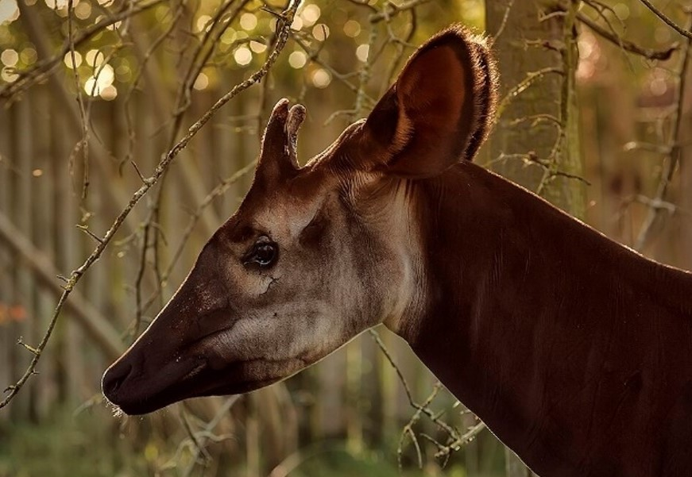
Fig 12: Male okapi with ossicones. The bare apices are noticeable upon close inspection ^{[16]}.

- Pronghorn (Antelocapridae)
The horn of the pronghorn antelope (Antelocapra americana) consists of a bony horn core and a branched keratinous sheath. It is similar to bovid in regards to the placement on the skull.
Structure
It differs greatly from the true horn in Bovidae due to the fact that the keratinous sheath is shed annually. Also, the sheath is branched, at about half-way, giving it a forked appearance. It differs from Cervid antlers in the structure of the horn, which consists of a branched keratinous sheath, which is covered by both keratin sheath and integument. However, the horn-core ontogeny in pronghorns is identical to that of the pedicle in Cervidae ^{[10]}.
Pronghorn core arises as an apophysis, as in cervid pedicle. As in both Cervidae and Bovidae, the pronghorn is situated on the frontals of the cranium. The pronghorn remains the only mammal to have deciduous horns ^{[11]}.
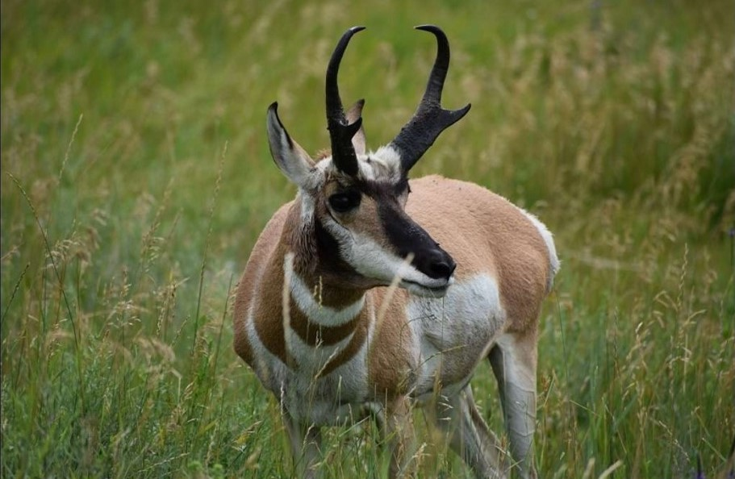
Fig 13: An adult male pronghorn grazes while watching for danger ^{[12]}; the forked appearance of the horn is seen.

Unlike the keratin sheath in Bovids, the pronghorn keratin sheaths do not cover the entire bony core. Also, the development of the pronghorn keratin sheath starts from the apex, then at the prong, and finally at the base, retaining the hairs embedded in it. This is reversal of the development of the Bovid keratin sheath. ^{[10] .} After old horn sheaths are cast off, the new horn consists of a bony core covered by a hairy integument at the base. Roots of hairs are embedded in the dermis under the basal portion of the horns and hair shafts traverse obliquely through the horns distally, except at the hooks and prongs ^{[11]}. The new horn develops while the old horn is still intact, pushing it off; the animal is never without the horns ^{[6]}. When the pronghorn matures, the skin proximal to and below the horn becomes hard horn ^{[11]}.
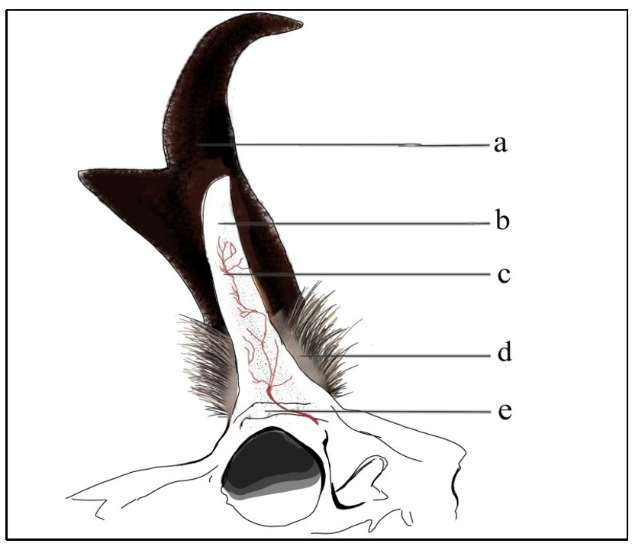
Fig 14: Skull of Pronghorn, side profile. (a), Forked keratin sheath; (b), Blade-like horn core; (c), Blood vessels; (d), Hairy integument; (e), Frontal bone.

Conclusion
Cranial appendages, such as horns and antlers, are vital for many herbivores' survival. These structures evolved from a common ancestor around 15-20 million years ago and are of four types: antlers, ossicones, horns, and pronghorns. Horns consist of keratinous sheaths enclosing a horn core, vary in size and form, and don't shed naturally. Antlers undergo periodic regeneration, with deer antlers being a model for studying bone growth and regeneration. Antler growth is energetically expensive and induced by testosterone. Ossicones, found in giraffes and okapis, are permanent and differ from horns and antlers. Pronghorns have a keratinous sheath that sheds annually and a forked appearance due to branching. Each type of cranial appendage has unique characteristics and functions, highlighting the diversity of these structures in herbivores.

References

- Cottingham, J T. (2020) “A literature review of horn and horn-like structures in vertebrates to correlate placement to function, behavior, and niche.” (2020). Biology Papers and Presentations. 2. https://scholarspace.jccc.edu/cgi/viewcontent.cgi?article=1001&context=biopapers
- Davis, E., Brakora, K. A., & Lee, A. H. (2011) Evolution of ruminant headgear: a review. Proceedings of the Royal Society B: Biological Sciences, 278(1270), 2857-2865. DOI: https://doi.org/10.1098/rspb.2011.0938
- Churcher, C. S. (1990). Cranial appendages of Giraffidae. In: Bubenik, G. A., Bubenik, A. B. (eds) Horns, Pronghorns, and Antlers. Springer, New York, NY. DOI: https://doi.org/10.1007/978-1-4613-8966-8_5
- Spinage, C. A. (1968). “Horns and Other Bony Structures of the Skull of the Giraffe, and their Functional Significance”. DOI: https://doi.org/10.1111/j.1365-2028.1968.tb00900.x
- Solounais, N. and Tang, N. (1990), The two types of cranial appendages in Giraffa camelopardalis (Mammalia, Artiodactyla). Journal of Zoology, 222: 293-302. DOI: https://doi.org/10.1111/j.1469-7998.1990.tb05678.x
- Modell, W. (1969). HORNS AND ANTLERS. Scientific American, 220(4), 114-123. http://www.jstor.org/stable/24926338
- Lincoln, G. A. (1992), Biology of Antlers. Journal of Zoology, 226: 517-528. DOI : https://doi.org/10.1111/j.1469-7998.1992.tb07495.x
- Alaska Department of Fish & Game, https://www.adfg.alaska.gov/static/species/disease/pdfs/peruke_antlers_poster.pdf
- Prince, J. S. and Allen, S. P. Exploring the mechanisms regulating regeneration of deer antlers. Philosophical Transactions of the Royal Society B: Biological Sciences, 359(1445), 809-822 DOI: https://doi.org/10.1098/rstb.2001.1471
- Solounias, N. (1988). Evidence from Horn Morphology on the Phylogenetic Relationships of the Pronghorn (Antilocapra americana). Journal of Mammology, 69(1), 140-143. DOI: https://doi.org/10.2307/1381760
- Bart W. O’Gara, Gary Matson, Growth and Casting of Horns by Pronghorns and Exfoliation of Horns by Bovids, Journal of Mammology, Volume 56, Issue 4, 18 November 1975, Pages 829-846. DOI: https://doi.org/10.2307/1379655
- An adult male pronghorn grazes while watching for danger. (2017). [Photograph]. https://garystockbridge617.getarchive.net/media/pronghorn-buck-grazing-b32b84 (Public domain photograph of wildlife, animals, wilderness, nature, free to use, no copyright restrictions image)
- Karl Moor. (2006, May 30). Male red deer (Cervus elaphus), Munich, Germany. [Photograph]. Wikimedia Commons. https://commons.wikimedia.org/wiki/File:Male_red_deer_(Cervus_elaphus),_Munich,_Germany_-_20060530.jpg
Licensed under CC BY-SA 2.0. https://creativecommons.org/licenses/by-sa/2.0, via Wikimedia Commons
- Flowcomm. (2014, May 4).giraffe. [Photograph]. Wikimedia Commons. https://commons.wikimedia.org/wiki/File:Giraffe_(13945064770).jpg Licencensed under CC BY 2.0 https://creativecommons.org/licenses/by/2.0, via Wikimedia Commons.
- Steve Wilson. (2010, November 15). The rare okapi. [Photohraph]. Wikimedia Commons. https://commons.wikimedia.org/wiki/File:The_Rare_Okapi_(10549264174).jpg. Licensed under CC BY 2.0 https://creativecommons.org/licenses/by/2.0, via Wikimedia Commons.
- Government of Alberta. (2016). Peruke antlers. [Photograph]. open.alberta.ca. https://open.alberta.ca/dataset/2a561211-3877-4852-99c1-37c8964bdf9a/resource/405508b6-c0b5-42d6-8787-712af785887d/download/factsheet-perukes-sep-2017.pdf. Licensed under the Open Government License – Alberta. https://open.alberta.ca/license.
- Nkansahrexford. (2014, July 16). Iziko Skull and Antlers of Moose. [Photograph]. Wikimedia Commons. https://commons.wikimedia.org/wiki/File:Iziko_Skull_and_Antlers_of_Moose.JPG Licensed under CC BY 4.0 https://creativecommons.org/licenses/by/4.0, via Wikimedia Commons.
- Quartl.(2011, August 23). Taurotragus oryx qtl2. [Photograph]. Wikimedia Commons. https://commons.wikimedia.org/wiki/File:Taurotragus_oryx_qtl2.jpg. Licensed under CC BY-SA 3.0 https://creativecommons.org/licenses/by-sa/3.0, via Wikimedia Commons.
- Yathin S Krishnappa. (2014, April 12). [Photograph]. Wikimedia Commons. https://commons.wikimedia.org/wiki/File:Oryx_gazella_-_Etosha_2014_square_crop.jpg. Licensed under CC BY-SA 3.0 https://creativecommons.org/licenses/by-sa/3.0, via Wikimedia Commons
- Wildnest Travel & Photography.(2015, March 31). Indian-gaur-tadoba. [Photograph]. Wikimedia Commons. https://upload.wikimedia.org/wikipedia/commons/8/89/Indian-gaur-tadoba.jpg. Licensed under CC BY 2.0. https://creativecommons.org/licenses/by/2.0, via Wikimedia Commons.
- { pranav }. (2009, June 28). Black buck in Hyderabad. [Photograph]. Wikimedia Commons. https://commons.wikimedia.org/wiki/File:Black_buck_in_Hyderabad.jpg. Licensed under CC BY 2.0. https://creativecommons.org/licenses/by/2.0, via Wikimedia Commons
- Charles J. Sharp. (2023, June 22). Muskox (Ovibos moschatus) male, Dovrefjell National Park, Norway. [Photograph]. Wikimedia Commons. https://upload.wikimedia.org/wikipedia/commons/6/6d/Muskox_%28Ovibos_moschatus%29_male_Dovrefjell_3.jpg. Licensed under CC BY SA-4.0 https://creativecommons.org/licenses/by-sa/4.0, via Wikimedia Commons.
- Lundrigan, B. (1996). Morphology of horns and fighting behavior in the family Bovidae. Journal of Mammalogy, 77(2), 462–475. DOI: https://doi.org/10.2307/1382822
- Geist, V. (1966). The Evolutionary Significance of Mountain Sheep Horns. Evolution, 20(4), 558–566. DOI: https://doi.org/10.2307/2406590
- Li, B.-W., Zhao, H.-P., & Feng, X.-Q. (2011). Static and dynamic mechanical properties of cattle horns. Materials Science and Engineering: C, 31(2), 179–183. DOI: https://doi.org/10.1016/j.msec.2010.08.016
- George, A. N. (1955). A note on the anatomy of the horns of sheep. British Veterinary Journal, 111(9), 391–393. DOI: https://doi.org/10.1016/S0007-1935(17)47056-4
- B. W. Li, H. P. Zhao, X. Q. Feng, W. W. Guo, S. C. Shan; Experimental study on the mechanical properties of the horn sheaths from cattle. J Exp Biol 1 February 2010; 213 (3): 479–486. DOI: https://doi.org/10.1242/jeb.035428
- Speed, S. (2010, September 16). Iron Age antler hoe head, Bedford Museum [Photograph]. Wikimedia Commons. https://commons.wikimedia.org/wiki/File:AntlerHoeBedfordMuseum.JPG. (Public domain).
- Parg, T. (2017, September 13). Abri de La Madeleine Bison [Photograph]. Wikimedia Commons. https://commons.wikimedia.org/wiki/File:Abri_de_La_Madeleine_Bison.jpg. Licensed under CC BY-SA 4.0 https://creativecommons.org/licenses/by-sa/4.0, via Wikimedia Commons.
- Picavet, P. P., & Balligand, M. (2016). Organic and mechanical properties of Cervidae antlers: A review. Veterinary Research Communications, 40(3–4), 141–147. DOI: https://doi.org/10.1007/s11259-016-9663-8
- Landete-Castillejos, T., Kierdorf, H., Gomez, S., Luña, S., García, A. J., Cappelli, J., Pérez-Serrano, M., Pérez-Barbería, F. J., Gallego, L., & Kierdorf, U. (2019). Antlers – Evolution, development, structure, composition, and biomechanics of an outstanding type of bone. Bone, 128, 115046. DOI: https://doi.org/10.1016/j.bone.2019.115046
- Picard K., Thomas D.W., Festa-Bianchet M., Belleville F., Laneville A. Differences in the Thermal Conductance of Tropical and Temperate Bovid Horns. Ecoscience. 1999; 6:148–158. DOI: https://doi.org/10.1080/11956860.1999.11682515.
- Benjamin444. (2007, October 27). A Jackson's chameleon (Chamaeleo jacksonii), Melbourne Zoo [Photograph]. Wikimedia Commons. https://commons.wikimedia.org/wiki/File:Jackson%27s_Chameleon444_(cropped).jpg. Licensed under CC BY-SA 3.0 http://creativecommons.org/licenses/by-sa/3.0/, via Wikimedia Commons.
- Malo, A. F., Roldan, E. R. S., Garde, J., Soler, A. J., Gomendio, M. (2005). "Antlers honestly advertise sperm production and quality". Proceedings of the Royal Society B: Biological Sciences. 272 (1559): 149–57. doi: https://doi.org/10.1098/rspb.2004.2933
- Menke, C. and Waiblinger, S. (2023). Animal welfare implications of dehorning and disbudding cattle—A review. Animals, 13(3), 500. DOI: https://doi.org/10.3390/ani13030500
- Tolley, K.A. and Herrel, A. (2014). The Biology of Chameleons (1st ed.). University of California Press. DOI: http://www.jstor.org/stable/10.1525/j.ctt5hjj1m
- Calamari, Z. T. and Flynn, J. J. (2024). Gene expression supports a single origin of horns and antlers in hoofed mammals. Communications Biology, 7, Article 509. DOI: https://doi.org/10.1038/s42003-024-06134-4

