Assessment of gastrointestinal metazoan parasites of Clarias anguillaris in three urban and two peri-urban reservoirs in Burkina Faso

Abstract :
Clarias anguillaris, one of the widely distributed freshwater fish in West African fisheries represents a potential host for many parasites. The present study assessed diversity, prevalence and intensity of gastrointestinal metazoan parasites of clarias anguillaris in three urban and two peri-urban reservoirs in Burkina Faso. A total of 188 fish individuals were examined between June 2023 and March 2024. A total of 243 gastrointestinal parasites were collected and two groups were identified : Cestoda (84.36%) and Nematoda (15.64%). Seven parasite species were identified, including four cestodes (Monobotrioides sp., Monobotrioides cunningtoni, Lytocestoides sp., Tetracampos ciliotheca) and three Nematoda (Paracamallanus cyatopharynx, Spirocamallanus spiralis, and Contracaecum sp.). The cestode Monobotrioides sp. was the most frequent and abundant species and showed a wide spatial distribution. The overall prevalence of infection was 19.15%. This prevalence showed significant spatial variation among sampling sites P=0.000<0.05). Fish from Naba Zana reservoir exhibited the highest prevalence, followed by those from Loumbila reservoir, whereas no infection was recorded in Boulmiougou reservoir and Tanghin reservoir n°2. These results indicate that peri-urban reservoirs support higher parasite diversity and prevalence, likely due to more favorable ecological conditions for intermediate hosts. In contrast, urban reservoirs appear to limit parasite transmission. This suggests the influence of local ecological conditions on the structure of parasite communities and points fish parasites as a potential candidate to consider for aquatic ecosystem monitoring.
Keywords : Clarias anguillaris, Burkina Faso, Cestoda; Nematoda, urban, peri-urban

- Introduction
Clarias anguillaris represents one of the widely distributed freshwater fish in sub-Saharan African countries (Paugy et al., 2003a,b; Froese and Pauly, 2025). This African catfish is consistently present in inland fisheries and aquaculture throughout West African countries (FAO, 2017; Froese and Pauly, 2025), where it holds pivotal socioeconomic importance due to its high acceptance among local consumers (FAO, 2017; Chukwu et al., 2023). In certain countries, such as Nigeria, it dominates fish production and is the most commonly consumed fish (Iheke and Nwagbara, 2014). In Burkina Faso, catfish are mostly consumed smoked (FAO, 2008). The country has larger fisheries such as Sourou, Samendeni, and Kompienga, where catfish smokers are working to satisfy demand. However, Burkina Faso still imports smoked fish from neighboring countries such as Mali, Sénégal and Côte-d'Ivoire to supplement local catches and meet the domestic high demand (FAO, 2008). To reduce the country high volume importation of fish, aquaculture is promoted to increase domestic fish production and animal protein supply and to develop stakeholders socio-economic situation (Hundscheid et al., 2020 ; Mapfumo, 2022). The Tilapia, Oreochromis niloticus and the catfish, Clarias anguillaris are both the main cultured species (Froese and Pauly, 2025). These species hold substantial socioeconomic importance due to their high market value, thanks to broad consumer acceptance. Moreover, their resilience to large variations in the ecological factors of the aquatic environment and their capacity to colonize extremely diverse habitats are assets for aquaculture (Chukwu et al., 2023 ; Melesse ; 2023). However, among these species, Clarias anguillaris is well suited for aquaculture due to its remarkable tolerance to low-oxygen conditions owing to its capacity to use air oxygen (Chukwu et al., 2023 ; Melesse ; 2023). As its farming is widely encouraged in Burkina Faso, it has become increasingly essential to understand the constraints affecting its production.
Gastrointestinal metazoan parasites represent a major challenge in freshwater fish population and widely reported to exert significant biological and economic impacts (Banyigyi et al., 2023 ; Verma and Kumari, 2023). These parasites consisting of cestodes, nematodes, acanthocephalans and digeneans can cause intestinal lesions and impair nutrient assimilation, thereby reducing growth performance and increasing vulnerability to secondary infections (Boungou et al., 2020). The knowledge of fish parasites is of particular interest in relation not only to fish health but also to understanding ecological problems in tropical Africa. Parasitic infection can lead to morbidity and mortality and negatively affect fish production and aquaculture sustainability (Kayis et al., 2009 ; Bichi and Yelwa, 2010). In Burkina Faso, more than 20 species of gastrointestinal metazoans including Cestoda, Nematoda and Trematoda have been described in Clarias anguillaris (Kabre, 1997 ; Boungou et al., 2020 ; Sinare et al., 2021; Sinare et al., 2023). Existing data relate to the diversity, prevalence, and temporal dynamics of gastrointestinal metazoan parasites in the rural aquatic environments of Burkina Faso. However, data from urban-impacted aquatic ecosystems remain scarce, resulting in critical gaps in the understanding of parasites associated with Clarias anguillaris. Therefore, the present study aims to investigate diversity, prevalence and intensity of gastrointestinal metazoan infecting clarias anguillaris in an urban-impacted and peri-urban aquatic ecosystems.

- Materials and Methods
2.1 study site
This study was conducted in five reservoirs; three urban reservoirs (Tanghin reservoirs n°2 and n°3 and Boulmiougou reservoir) and two peri-urban reservoirs (Loumbila reservoir and Naba Zana reservoir). Figure 1 shows the geographical location of the study sites. Data were collected from June 2023 to March 2024.
The Boulmiougou reservoir crosses the central and southwestern parts of the Ouagadougou, particularly districts 6, 7, and 3. It is created in 1971 and located at 12°20’11.8’’ N and 1°35’20.0’’ W. The reservoir supports multiple activities, including market gardening, dishwashing, laundry, intensive fishing, and swimming. Vegetable farming is practiced directly on the reservoir bed during dry season. The reservoir is also used as an informal dumping ground for animal carcasses and various types of waste.
Tanghin Reservoir N°2, located at 12°23’03.79’’ N and 01°30’03’’03.79’’ W. The reservoir is increasingly subjected to anthropogenic pressures. Vegetable farming is practiced along banks during floods and directly in the reservoir during dry seasons. The reservoir also receives wastewater from the city of Ouagadougou, with various types of pollutants (Sodji, 1999). Clothes, dishes and vehicles are washed in the reservoir. It also serves as informally dumping site for animal carcasses and all other solid waste. During rainy season, water is covered by water hyacinth. Fishing is practiced intensively throughout the year. All these activities contribute to the silting, pollution, and degradation of the reservoir.
Tanghin Reservoir N°3, located at 12°23’36.04’’ N and 01°33’17.48’’ W. It is also subject to intensive fishing year-round and represents a popular swimming area for children. The reservoir indirectly receives wastewater that flows through reservoir N°2 during the flood period. There is no market gardening observed around the reservoir, and animal carcasses are rarely found.
Loumbila reservoir is located about 20 km northeast of Ouagadougou, the capital of Burkina Faso, at 12°29'34" N and 0°24'05" W. This reservoir is constructed in 1947 and rehabilitated in 1970. Primarily it was designed to supply the capital with drinking water. The surrounding area is densely populated, and the dam provides opportunities for permanent hydro-agricultural activities. These activities negatively impact the water quality and the aquatic organisms that depend on it.
Naba-Zana reservoir is located in the Koubri department, in the Centre region, 15 km from Ouagadougou at 12°12’10’’ N and 01°21’17’’ W. It was created in the 1960s. Vegetable farming with the use of inputs and fishing are practiced around the reservoir all year round.
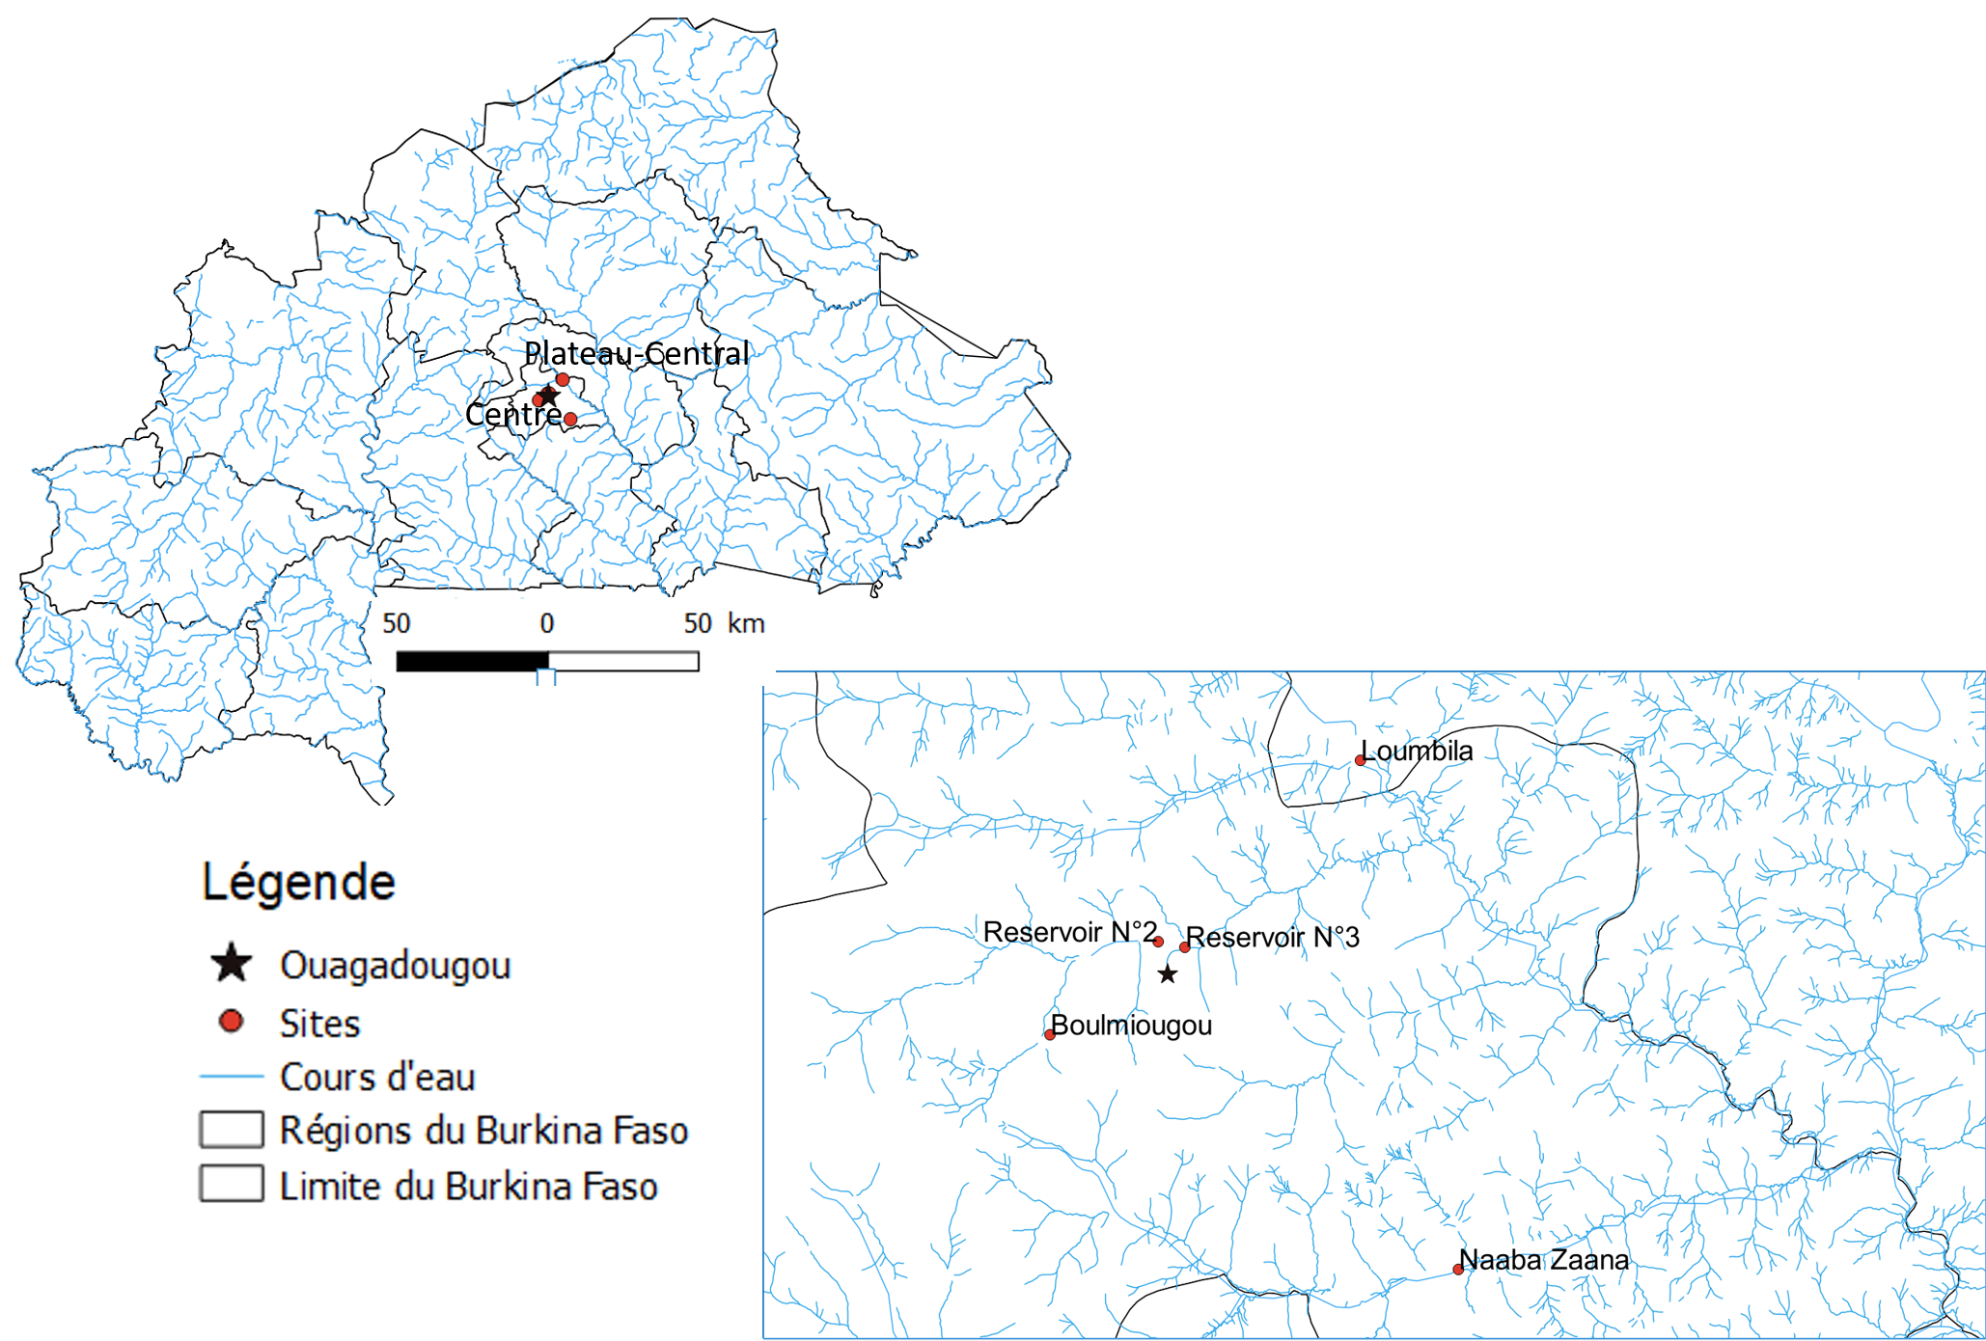
Figure 1 :Map of sampling sites (data source for map; IGB, 2012)
2.2 Sample collection
Host fish sampling
Fresh fish were purchased from fishermen at each sampling site, preserved in a cooler and transported to the Laboratory of Animal Biology and Ecology (LBEA) at Université Joseph KI-ZERBO. In the laboratory, each specimen was identified using the West African fish identification key (Paugy et al., 2003a, b).
Collection and preservation of parasites
Once in the laboratory, each specimen was dissected, and the different organs of the digestive tract (stomach and intestine) were removed and placed separately in Petri dishes containing saline solutions for parasite collection. Each section of the digestive tract was incised longitudinally under a binocular magnifier. Parasites found in each section were carefully detached and preserved separately. The abdominal cavity was observed, and the mesenteries examined. Any parasites found were collected. Parasites were first sorted according to major groups (phyla). While some specimens were mounted fresh under the microscope between a slide and coverslip for measurement and species identification, most specimens were preserved in Eppendorf tubes containing 70% alcohol and labeled for further processing.

Identification of parasites
Cestodes removed from 70% alcohol, were first washed in distilled water. They were then stained with Grenacher borax carmine and washed in hydrochloric acid (HCl). Finally, they were mounted between a slide and coverslip in a drop of Canada balsam, then observed under a microscope and identified.
Nematodes were placed in saline water. Then, they were observed fresh for measurement and identification.
Measurement is a critical process for parasite identification. Morphometric measurements of the collected parasites were taken using a ZEISS optical microscope equipped with an optical micrometer. Parasite identification was performed according to Gibbons (2010); Kuchta et al. (2012); and the species descriptions provided by Kabre (1997).

2.3 Data Processing and Statistical Analysis
The data obtained were entered into Microsoft Excel 2013 and analyzed using R4.4.1 (R Core Team, 2024). Species richness was defined as a compiled list of parasite species recorded for the all sample and within each sampling site, while abundance represented the sum of total parasite individuals. Parasitic infestation parameters defined according to Bush et al. (1997) were determined, namely prevalence (P), intensity (I). Tables and figures were used to illustrate the trends of these parameters according to sampling sites of host species, attachment sites of the parasites
Prevalence is defined as the number of hosts infected by one or more individuals of the parasite (N) divided by the number of hosts examined (H). It is calculated using the following formula:
P (%) = N* 100/H
Intensity (I) is the total number of parasites (A) found in host species divided by the number of parasitized hosts (N). It is calculated using the following formula:
I = A/N
Differences in prevalence according to sampling site were assessed using Fisher’s Exact Test, while differences in parasite intensity were evaluated using Median Test. The level of statistical significance for all analysis was set at 5%.
- Results
3.1 Parasite diversity and abundance
In total, 243 individuals of gastrointestinal parasites were collected from 188 examined fish hosts. These parasites were grouped into two (2) classes, such Cestoda and Nematoda. Cestoda was the most abundant, representing 84.36 % (205 individuals), compared to Nematoda with 15.64% (38 individuals) (Figure 2). Seven (7) species were identified. The Cestoda species reported were Monobotrioides sp., Monobotrioides cunningtoni, Lytocestoides sp., Tetracampos ciliotheca. The Nematode species recorded were Paracamallanus cyatopharynx, Spirocamallanus spiralis, Contracaecum sp. (Table 1).
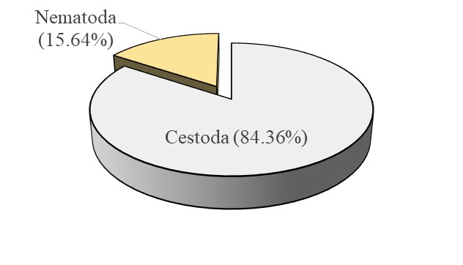
Figure 2: abundance of gastrointestinal parasites in Clarias anguillaris
Monobotrioides sp. was detected in three sample sites (Loumbila reservoir, Naba Zana reservoir, Tanghin reservoir n°3). Four (4) parasite species, namely, Monobotrioides cunningtoni, Lytocestoides sp., Paracamallanus cyatopharynx and Tetracampos ciliotheca were common to both Loumbila and Naba Zana reservoirs. In contrast, Contracaecum sp. was exclusively recorded in the Loumbila reservoir, whereas Spirocamallanus spiralis was exclusively identified in Naba Zana reservoir (Figure 3).
Regarding parasite distribution along the digestive tract, three species (Lytocestoides sp., Monobotrioides sp. and Tetracampos ciliotheca) were observed in both the stomach and intestine. Monobotrioides cunningtoni was recorded exclusively in the stomach, while Contracaecum sp., Paracamallanus cyatopharynx and Spirocamallanus spiralis were restricted to the intestine (Figure 4).
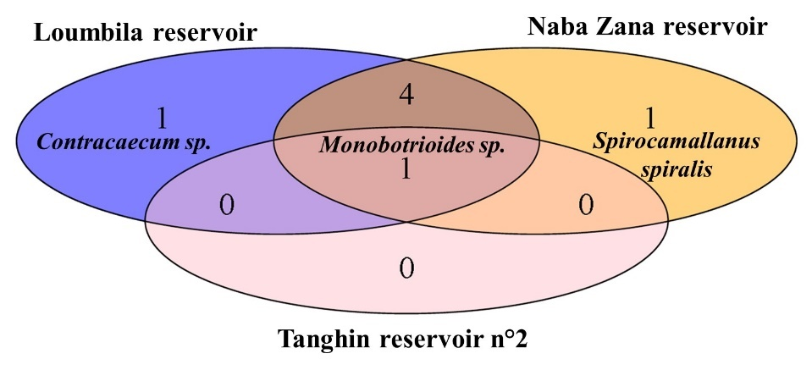
Figure 3: Gastrointestinal parasite taxa richness according to sample sites and the number of common and exclusive taxa between them
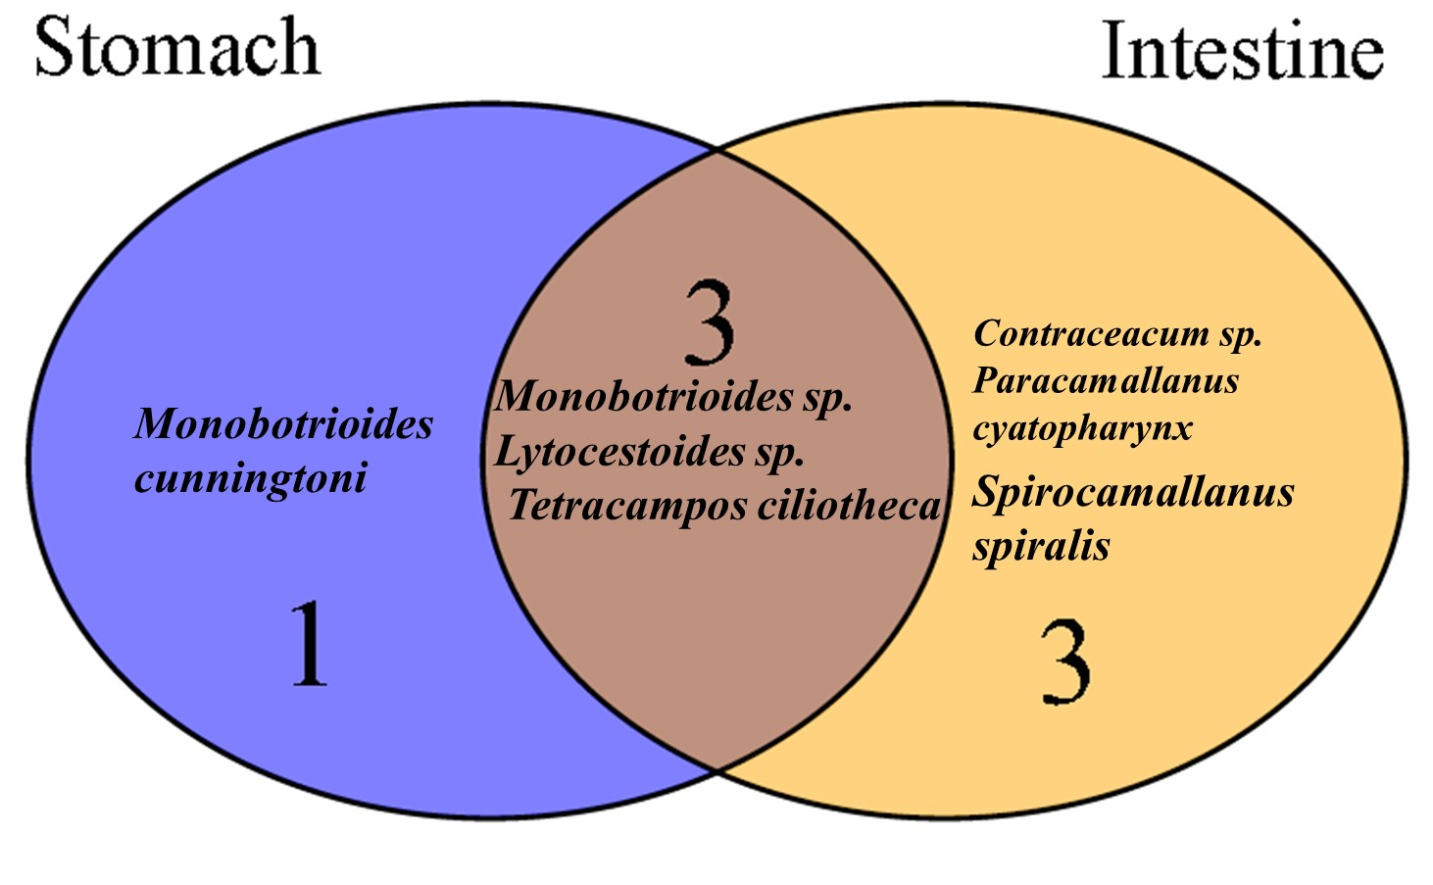
Figure 4: Gastrointestinal parasite distribution in the digestive tract
In total, the Cestoda Monobotrioides sp. was most frequently detected parasite (11.17%; 21/188); followed by Lytocestoides sp. (4.26%; 8/188), Tetracampos ciliotheca (4.26%; 8/188), Paracamallanus cyatopharynx (3.20%; 6/188). Lower frequencies were recorded for Monobotrioides cunningtoni (1.60%; 3/188), Spirocamallanus spiralis (1.06%; 2/188) and Contracaecum sp. (1.06%; 2/188).
Parasite frequencies of occurrence according to sampling sites are presented in Table 2. In Clarias anguillaris from Loumbila reservoir, all recorded parasites exhibited prevalences below 10% for each one. Monobotrioides sp. was most frequently detected (9.84%), followed by Tetracampos ciliotheca (4.10%), Paracallanus cyatopharynx (3.28%), Monobotrioides cunningtoni (1.64%), Lytocestoides sp. (1.64% and Contracaecum sp. (1.64%).
Similarly, Monobotrioides sp. was the most frequently detected gastrointestinal parasite in fish from Naba Zana reservoir (40%). It was followed by Lytocestoides sp. (30%), Tetracampos ciliotheca (15%), Paracallanus cyatopharynx and Spirocamallanus spiralis (10% each one), Monobotrioides cunningtoni (5%). In contrast, only Monobotrioides sp. was detected in Tanghin reservoir n°3.
Table 2 : Overview of gastrointestinal parasites frequency of occurrence according to sampling sites
Sampling sites | Parasite species | Frequency of Occurrence (%)
Loumbila Reservoir | Monobotrioides sp. | 9.84
Loumbila Reservoir | Monobotrioides cunningtoni | 1.64
Loumbila Reservoir | Lytocestoides sp. | 1.64
Loumbila Reservoir | Tetracampos ciliotheca | 4.10
Loumbila Reservoir | Paracamallanus cyatopharynx | 3.28
Loumbila Reservoir | Contracaecum sp | 1.64
Naba Zana reservoir | Monobotrioides sp. | 40.00
Naba Zana reservoir | Monobotrioides cunningtoni | 5.00
Naba Zana reservoir | Lytocestoides sp. | 30.00
Naba Zana reservoir | Tetracampos ciliotheca | 15.00
Naba Zana reservoir | Paracamallanus cyatopharynx | 10.00
Naba Zana reservoir | Spirocamallanus spiralis | 10.00
Tanghin reservoir n°3 | Monobotrioides sp. | 7.70

Out of the seven parasite species recorded in this study, Monobotrioides sp. exhibited the highest abundance, with 111 individuals (45.68%). It was followed by Tetracampos ciliotheca with (39 individuals (16.05%), Lytocestoides sp., with 31 (12.75%), Monobotrioides cunningtoni with 24 (9.87%), and Paracamallanus cyatopharynx with 24 (9.87%). Spirocamallanus spiralis was represented by 10 (4.11%), whereas Contracaecum sp. showed the lowest abundance, with only 4 individuals (1.64%) (Table 3; Figure 5).
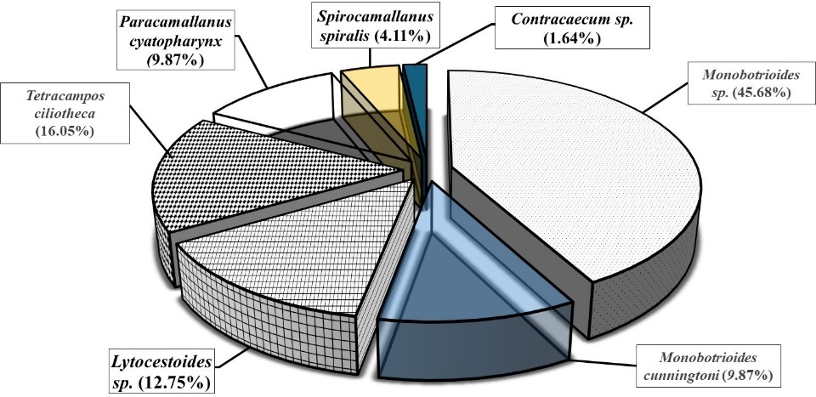
Figure 5 : Composition of species of Fish Parasites recorded in the study
Table 3: Overview of collected parasites and their abundances according to infected organs
Parasites |  | Abundance of parasites and site of infection
Classes | Species | Stomach | Intestine
Cestodes | Monobotrioides sp. | 25 | 86
Cestodes | Monobotrioides cunningtoni | 24 | 0
Cestodes | Lytocestoides sp. | 10 | 21
Cestodes | Tetracampos ciliotheca | 16 | 23
Nematoda | Paracamallanus cyatopharynx | 0 | 24
Nematoda | Spirocamallanus spiralis | 0 | 10
Nematoda | Contracaecum sp. | 0 | 4

3.2 Parasite Prevalence
A total of 188 individuals of Clarias anguillaris were examined for parasite infections, of which 36 (19.15%) were infected with at least one parasite species. The results revealed that the infection levels varied according to sampling sites: fish from the Naba Zana reservoir showed the highest prevalence of gastrointestinal parasites (50%), followed by those from the Loumbila reservoir (20.5%) and Tanghin reservoir n°3 (7.7%). During the study, no parasitic infection was recorded in fish collected from Boulmiougou reservoir or the Tanghin reservoir n°2 (Table 4).
Statistical analysis revealed significant differences in parasite prevalence among the five sampling sites (Fisher’s Exact Test, P=0.000<0.05). Pairwise comparisons using Fisher’s Exact Test showed that the prevalence in Naba Zana differed significantly from that in Loumbila reservoir, Tanghin reservoir n°2, Tanghin reservoir n°3 and Boulmiougou reservoir. The prevalence in Loumbila reservoir also differed significantly from Tanghin reservoir n°2. No significant differences were observed among the remaining site comparisons (Table 5).
Table 4 presents parasitic intensity values across sampling sites, which ranged from 0 to 12.4. The overall parasitic intensity was 6.75. No significant differences in parasitic intensity were observed among sampling sites (Median Test, p = 0.287 > 0.05).
Table 4: Prevalence of parasites and parasitic intensity according to sampling sites
Sites | examined fish | infected fish | Prevalence (%) | Parasitic intensity
Boulmiougou | 15 | 0 | 0 | 0
Loumbila | 122 | 25 | 20,5 | 4.68
Naba Zana | 20 | 10 | 50 | 12.4
Tanghin2 | 18 | 0 | 0 | 0
Tanghin3 | 13 | 1 | 7,7 | 2
Total | 188 | 36 | 19,15 | 6.75

Table 5: Results showing Pairwise Comparison between sampling sites
Comparison | P-Value | Significance | Interpretation
All sites | 0.000 | p<0.05 | Significant difference
Naba Zana vs Loumbila | 0.009 | p<0.05 | Significant difference
Naba Zana vs Tanghin3 | 0.022 | p<0.05 | Significant difference
Naba Zana vs Boulmiougou | 0.002 | p<0.05 | Significant difference
Naba Zana vs Tanghin2 | 0.000 | p<0.05 | Significant difference
Loumbila vs Tanghin3 | 0.462 | p˃0.05 | No significant difference
Loumbila vs Boulmiougou | 0.73 | p˃0.05 | No significant difference
Loumbila vs Tanghin2 | 0.043 | p<0.05 | Significant difference
Tanghin3 vs Boulmiougou | 0.464 | p˃0.05 | No significant difference
Tanghin3 vs Tanghin2 | 0.419 | p˃0.05 | No significant difference
Boulmiougou vs Tanghin2 | Not Applicable | --- | ----

- Discussion
The present study revealed a diverse gastrointestinal metazoan parasite faunal infecting the fish species Clarias anguillaris, with a total of 243 parasite individuals collected from 188 fish individuals. Cestoda were clearly the dominant taxa accounting for more 80% of the total collected parasite individuals. These finding are in line with previous studies (). The predominance of Cestoda may be attributed to the feeding habit of Clarias anguillaris. This species is an omnivorous with a preference for live prey such as insects, zooplankton, snails and small fish (Tesfahun, 2018 ; Dessie et al., 2024). However, the life cycle of Cestoda involves zooplankton (copepods) or other aquatic invertebrates as intermediate hosts (Khalil et al., 1994 ; Woo, 1995 ; Roberts et al., 2013). Consequently, the consumption of these intermediate hosts particularly the infected ones, enhances the transmission of Cestoda and facilitates their establishment within the gastrointestinal tract.
Among the collected cestoda parasites, the genus Monobotrioides ; Lytocestoides and Tetracampos are commonly reported for siluriform freshwater fish intestinal infections (Ash et al., 2011 ; Sinare et al., 2023). This fact may reflect a strong host specificity for those parasites.
Nematoda represented a smaller proportion of the collected parasite community. This lower abundance compare to Cestoda may be related to differences in transmission dynamics, survival rates or host immune response to parasite aggressions.
The detection of the zoonotic genus, Contacaecum whose live cycle involves piscivorous birds suggests ecological connectivity between fish and avian predators. The occurrence of this genus further poses a public heath concern and highlights the need for proper handling and cooking (Abdisa et al., 2023 ; particularly for fish from infected site.
The spatial distribution of gastrointestinal parasites across the three sampling sites highlighted heterogeneity in parasite assemblages. Likely, this fact may reflect differences of ecological conditions between sampling sites.
Monobotrioides sp. was detected in all three reservoirs even in Tanghin reservoir n°3, where no other parasite species were recorded and recorded high frequency. Similar wide distributions have been reported in African siluriform fish (Kalil et al., 1994 ; Aloo, 2002). This widespread occurrence suggests that Monobotrioides sp. exhibits broad ecological tolerance.
The similarity of parasite community characterized by the occurrence of five parasite species (Monobotrioides sp., Monobotrioides cunningtoni, Lytocestoides sp., Paracamallanus cyatopharynx and Tetracampos ciliotheca) between Loumbila and Naba Zana reservoirs suggests comparable ecological conditions in these water bodies. Such similarity likely reflects analogous trophic structures and the presence of common intermediate hosts which are critical for parasite propagation (Bush et al., 2001). Indeed, both réservoirs are located in peri-urban areas characterized by vegetable farming activities and may therefore be less polluted than the urban réservoirs. This relative less impacted condition could explain the higher parasite prevalence et intensity observed at these sites compared to other sampling sites. These findings are consistent with those of Madanire-Moyo and Barson (2010) who reported that parasite prevalences decrease as pollution increases.
The present study revealed that less than one quarter of the examined Clarias anguillaris individuals were infected by gastrointestinal parasites, with an overall prevalence of 19.15%. this prevalence is less than that reported by Sinare et al. (2023). Such a difference likely reflects the ecological conditions of sampling sites investigated in this study, which included urban-impacted sites. These findings are further supported by the results of spatial variation in parasite prevalence observed among sampling sites, which exhibited relatively low prevalence in fish from Tanghin reservoir n°3 (7.7%) and no infections in fish from Boulmiougou reservoir and Tanghin reservoir n°2. Reservoirs with higher nutrient levels may have greater invertebrate abundance and support more efficient parasite transmission (Bush et al., 2001), which may explain the high prevalence observed in Naba Zana reservoir since vegetable farming may increase nutrients in adjacent water bodies (Oates et al., 2025). The absence of detectable parasitic infections in Boulmiougou reservoir and Tanghin reservoir n°2 may indicate unfavorable conditions for parasite life cycles, such as limited availability of intermediate hosts due to pollution (Kabore et al., 2023).
The statistical analyses confirmed significant differences in parasite prevalence among the five sampling sites. Pairwise comparisons further demonstrated that Naba Zana reservoir differed significantly from all other sites, highlighting its distinct ecological profile.

- Conclusion
The present study revealed significant differences of parasite prevalence in Clarias anguillaris between sampling sites with the peri-urban sites being more infected which emphasizes the strong influence of local ecological conditions on parasite diversity and prevalence. These findings could support the use of fish parasite communities as indicators of ecosystem structure and trophic interactions, particularly in tropical freshwater systems.

References
Abdisa, T., Bula, B., Etana, M., & Getu, M. (2023). Epidemiology of Helminthes, Protozoans and Ectoparasites of Fishes: A Review. Journal of Veterinary Medicine and Animal Sciences, 6(1), 1126. http://meddocsonline.org/
Ash, A., Scholz, T., Oros, M., Levron, C., & Kar, P. K. (2011). Cestodes (Caryophyllidea) of the stinging catfish Heteropneustes fossilis (Siluriformes: Heteropneustidae) from Asia. Journal of Parasitology. https://doi.org/10.1645/GE-2661.1
Banyigyi, A. H., Ameh, S. M., & Isah, M. H. (2023). Incidence of gastrointestinal parasites of catfish (Clarias gariepinus) from River Nasarawa, Nigeria. FUDMA Journal of Sciences, 7(4), 90–94. https://doi.org/10.33003/fjs-2023-0704-1893
Bichi, A. H. & Yelwa, S. I. (2010). Incidence of piscine parasites on the gill and gastrointestinal tract of Clarias gariepinus (Teugels) at Bagauda fish farm, Kano. Bayero Journal of Pure and Applied Sciences, 3(1): 104-107
Boungou, M., Sinaré, Y., Mamonekene, V., Bagayan, M., & Kabré, G. B. (2020). Digenetic trematodes dependent on fish of Burkina Faso. International Journal of Biosciences, 16(3), 402-413. https://doi.org/10.12692/ijb/16.3.402-413
Abdisa, T., Bula, B., Etana, M., & Getu, M. (2023). Epidemiology of Helminthes, Protozoans and Ectoparasites of Fishes: A Review. Journal of Veterinary Medicine and Animal Sciences. http://meddocsonline.org/
Bush, A. O., Fernández, J. C., Esch, G. W., & Seed, J. R. (2001). Parasitism: The Diversity and Ecology of Animal Parasites. Cambridge University Press. https://www.cabidigitallibrary.org/doi/10.1079/9780851994821.0000
Bush, A. O., Lafferty, K. D., Lotz, J. M., & Shostak, A. W. (1997). Parasitology Meets Ecology on Its Own Terms: Margolis et al. Revisited. The Journal of Parasitology, 83(4), 575–583. https://doi.org/10.2307/3284227
Chukwu, G. U., Aga, T. A., Ulasi, G. F., Ezeh, E. O., & Gbande, S. H. (2023). Review on Status of African Catfish Aquaculture in Nigeria. International Journal of Latest Technology in Engineering, Management & Applied Science (IJLTEMAS), 12(08), 102–111. https://doi.org/10.51583/IJLTEMAS.2023.12811
Dessie, A., Mingist, M., Mequanent, D., & Aemro, D. (2024). Food and feeding habits of the African catfish Clarias gariepinus (Burchell, 1822) (Pisces: Clariidae) in the newly built Ribb Reservoir, north-west Ethiopia. Indian Journal of Fisheries, 71(2), 37-42. https://doi.org/10.21077/ijf.2024.71.2.134268-05
Food and Agriculture Organization of the United Nations. (2008). *Vue générale du secteur des pêches nationales, Burkina Faso*. Fishery and Aquaculture Country Profiles. https://www.fao.org/fishery/facp/BFA/fr
FAO. (2017). Fishery and Aquaculture Statistics. Global aquaculture production 1950-2015 (FishstatJ). FAO Fisheries and Aquaculture Department. http://www.fao.org/fishery/statistics/software/fishstatj/en
Froese, R., & Pauly, D. (Eds.). (2025). FishBase. World Wide Web electronic publication. https://www.fishbase.org
Gibbons, L. M. (2009). Keys to the nematode parasites of vertebrates: Supplementary volume. CABI. https://www.cabi.org/bookshop/book/9781845935719
Hundscheid, L., Sanon, V. P., & Ouedraogo, R. (2020). Aquaculture: History and Potential. In A. Melcher, R. Ouedraogo, A. Oueda, J. Somda, P. Toé, J. Sendzimir, G. Slezak, & C. Voigt (Eds.), SUSFISHBook -Sustainable Fisheries and Water Management. Transformation Pathways for Burkina Faso. SUSFISH+ Project Consortium. http://susfish.boku.ac.at/
Iheke, O. R., & Nwagbara, C. (2014). Profitability and viability of catfish enterprises in Abia State of Nigeria. Journal of Agriculture and Social Research, 14(1), 31–36. https://www.ajol.info/index.php/jasr/article/view/104909 .
Kabore, I., Bance, V., Ouedraogo, O., & Oueda, A. (2023). Utilisation des macroinvertébrés pour la caractérisation de l’état de santé biologique des réservoirs n°2 de la ville de Ouagadougou et de Ziga au Burkina Faso (Afrique de l’Ouest). International Journal of Development Research, 13(08), 63305-63310. https://doi.org/10.37118/ijdr.26864.08.2023 .
Kabre, B. G. (1997). Parasites des poissons du Burkina Faso: Faunistique, ultrastructure, biologie. Thèse d'Etat, Université de Ouagadougou, Burkina Faso 308p.
Kayis, S., Ozcelep, T., Capkin, E., & Altinok, I. (2009). Protozoan and metazoan parasites of cultured fish in Turkey and their applied treatments. Israeli Journal of Aquaculture— Bamidgeh, 61(2), 93–102. https://doi.org/10.46989/001c.20550
Khalil, L. F., Jones, A., & Bray, R. A. (1994). Keys to the cestode parasites of vertebrates. CAB International. https://www.cabi.org/bookshop/book/9780851988795/
Kuchta, R., Burianová, A., Jirků, M., de Chambrier, A., Oros, M., Brabec, J., & Scholz, T. (2012). Bothriocephalidean tapeworms (Cestoda) of freshwater fish in Africa, including erection of Kirstenella n. gen. and description of Tetracampos martinae n. sp. Zootaxa, 3309(1), 1–35. https://doi.org/10.11646/zootaxa.3309.1.1
Madanire-Moyo, G., & Barson, M. (2010). Diversity of metazoan parasites of the African catfish Clarias gariepinus (Burchell, 1822) as indicators of pollution in a subtropical African river system. Journal of Helminthology, 84, 216–227. https://doi.org/10.1017/S0022149X09990563
Mapfumo, B. (2022). Regional review on status and trends in aquaculture development in sub-Saharan Africa – 2020. FAO Fisheries and Aquaculture Circular N. 1232/4. Rome, FAO. https://doi.org/10.4060/cb7817en
Melesse, M. (2023). Dietary strategies for better production of African Catfish (Clarias gariepinus) in aquaculture: A review. International Scholars Journals.
Oates, C., Fajardo, H., Grieger, K., Obenour, D., Muenich, R. L., & Nelson, N. G. (2024). Effective Nutrient Management of Surface Waters in the United States Requires Expanded Water Quality Monitoring in Agriculturally Intensive Areas. ACS Environmental Au, 5(1), 1-11. https://doi.org/10.1021/acsenvironau.4c00060
Paugy, D., Lévêque; C., & Teugels, G. G. (2003a). Poissons d’Eaux Douces et Saumâtres de l’Afrique de l’Ouest, Tome 1, IRD : Paris.
Paugy, D., Lévêque, C., & Teugels, G. G. (Eds.). (2003). Faune des poissons d'eaux douces et saumâtres de l'Afrique de l'Ouest, Tome 2. IRD; Muséum national d'Histoire naturelle; Musée royal de l'Afrique centrale. https://horizon.documentation.ird.fr/exl-doc/pleins_textes/divers14-01/010034264.pdf
R Core Team. (2024). R: A language and environment for statistical computing. R Foundation for Statistical Computing, Vienna, Austria. https://www.R-project.org/
Sinare, Y., Boungou, M., Kangoye, N. M., & Kabre, B. G. (2021). Modèle de distribution des nématodes chez le poisson chat (Clarias anguillaris (Linnaeus, 1758)) dans deux réservoirs du Burkina Faso (Afrique de l’Ouest). Int. J. Biol. Chem. Sci., 15(3), 1015-1029. https://doi.org/10.4314/ijbcs.v15i3.14
Sinare, Y., Boungou, M., Gneme, A., & Oueda, A. (2023). Diversité et Dynamique des Cestodes chez Clarias Anguillaris au Burkina Faso. ESI Preprints. https://doi.org/10.19044/esipreprint.1.2023.p578
Sodji, A. (1999). La pollution à Ouagadougou (Burkina Faso). (Mémoire de Maîtrise). Université de Ouagadougou. https://beep.ird.fr/collect/ird/index/assoc/IRDT_1999_SOD_L.pdf
Tesfahun, A. (2018). Feeding biology of the African catfish Clarias gariepinus (Burchell) in some of Ethiopian Lakes: A review. International Journal of Fauna and Biological Studies, 5(1), 19-23. https://www.faunajournal.com/archives/2018/vol5issue1/parta/
Verma, D. K., & Kumari, V. (2023). Development and strategy fish health management in aquaculture. Biotica Research Today, 5(2), 207-211. https://www.researchgate.net/publication/375400000_Development_and_Strategy_Fish_Health_Management_in_Aquaculture
Woo, P. T. K. (1995). Fish Disease and Disorder: Protozoan and Metazoan Infection volume1. CABI international, walling ford, UK. pp: 45- 46.

