Original Research Article
PHYTOCHEMICAL ANALYSIS AND DETERMINATION OF ANTI-OXIDANT AND ANTI-BACTERIAL EFFECTS OF MORINDA CITRIFOLIA

ABSTRACT

Background:Morindacitrifolia (commonly known as Noni) is a tropical medicinal plant rich in Phytochemicals such as flavonoids, alkaloids, tannins, and phenolic compounds. It exhibits strong antioxidant and antibacterial activities, making it valuable in traditional medicine and modern therapeutic research. Its bioactive compounds play a key role in promoting health and disease prevention.
Objective: This study focuses on the phytochemical profiling of Morindacitrifolia to identify its bioactive constituents. It further evaluates the antioxidant potential of the plant using standard assays and investigates its antibacterial activity against selected pathogens.
Method: Fresh leaves of Morindacitrifolia were collected from Thiruvananthapuram, and the bioactive compounds were extracted using acetone. The test sample was subjected to phytochemical analysis in order to determine the physical and chemical properties of M. citrifolia. The antimicrobial activity of M. citrifolia was assessed using the agar well diffusion method against Pseudomonas aeruginosa and Salmonella typhi. Furthermore, the antioxidant potential of the plant was evaluated through the FRAP assay.
Result: The qualitative analysis confirmed the presence of phenols, alkaloids, and flavonoids, which are known for their therapeutic properties, while terpenoid were absent. The FRAP assay demonstrated a dose-dependent increase in anti-oxidant activity, indicating the extract’s potential as a natural anti-oxidant. Additionally, the anti-bacterial assay revealed significant inhibition of Pseudomonas and Salmonella, with the highest activity observed at 100µg/ml.
Conclusion: The qualitative phytochemical analysis of M. citrifolia extract confirmed the presence of phenols, alkaloids, and flavonoids, while terpenoids were absent. These findings are consistent with previous studies that highlight the presence of bioactive compounds contributing to the plant’s pharmacological properties, including antioxidant and antimicrobial activities

Keywords: Morindacitrifolia, FRAP, anti-oxidant, anti-bacterial.

1.INTRODUCTION
According to the world health organization (WHO), approximately 80% of the world population relies on traditional medicine, which often employs medicinal plants, for their primary healthcare needs (WHO, 2019). The empirical knowledge about their beneficial effects was transmitted over the century’s with
human communities (KHAN et al.,2014). It has been used for centuries for their therapeutic properties, forming the foundation of many traditional healthcare practices worldwide. Plants such as Morindacitrifolia (M. citrifolia), Curcuma longa (turmeric) and Azadirachta indica (neem) have attracted significant attention due to their potential in preventing and treating various health conditions. M. citrifolia, commonly known as noni, belongs to the family Rubiaceous and the subfamily Rubioideae. Its genus is Morinda, and the species name is citrifolia.M. citrifolia's robust adaptability allows it to thrive in various tropical regions, where it also serves as a food source and a natural remedy. According to research (Wang et al., 2002), the plant's therapeutic properties have been widely studied, highlighting its anti-oxidant, anti-microbial, and anti-inflammatory potential.
M. citrifolia has been traditionally used in various cultures for its extensive therapeutic benefits. The plant exhibits anti-inflammatory, analgesic, and anti-microbial properties, making it effective in managing pain, reducing inflammation, and combating infections (Morton, et al., 1992; Nelson, et al., 2003; Moorthy et al., 2001). It is also a natural remedy for digestive health, particularly in alleviating constipation and improving gut function (Hirazumiet al., 1997). M. citrifolia juice, rich in essential nutrients like vitamins (particularly vitamin C), minerals (such as calcium and magnesium), and amino acids, is consumed to boost immunity and enhance overall well-being (Heinicke et al.,1985).In addition to internal health benefits, M. citrifolia has applications in topical treatments. Its leaves and fruit pulp are used to promote wound healing and treat skin infections, while its anti-oxidant properties help to protect against oxidative stress and delay the signs of aging (Wang & Su et al., 2001). The plant has also gained attention for its potential anti-cancer properties, with bioactive compounds shown to inhibit tumor growth in preliminary studies (Hirazumi& Furusawa et al., 1999). The plant’s extensive phytochemical composition, which includes flavonoids, alkaloids, anthraquinones, and scopoletin, plays a crucial role in its pharmacological activities. These phytochemicals are responsible for its wide range of therapeutic properties, offering a promising avenue for future medical and pharmacological advancements (Moorthy et al., 2001; Hirazumi& Furusawa et al., 1999).

Phytochemicals in M. citrifolia, are bioactive compounds responsible for its extensive therapeutic properties. The plant contains a diverse array of phytochemicals, including flavonoids, alkaloids, anthraquinones, iridoids, and scopoletin. Flavonoids and phenolic compounds in M. citrifolia are powerful anti-oxidants that neutralize free radicals, reducing Phytochemicals in M. citrifolia, are bioactive compounds responsible for its extensive therapeutic properties. The plant contains a diverse array of phytochemicals, including flavonoids, alkaloids, anthraquinones, iridoids, and scopoletin. Flavonoids and phenolic compounds in M. citrifolia are powerfulanti-oxidants that neutralize free radicals, reducingoxidative stress and protecting cells from damage (Wang et al., 2009).

Alkaloids, such as xeronine precursors, are believed to play a role in cellular repair and immune system modulation. Anthraquinones have demonstrated anti-microbial and anti-cancer activities, while iridoids contribute to plant's anti-inflammatory and analgesic properties (Hirazumi& Furusawa, et al.,1999) including chlorogenic and ferulic acid, has also been detected in M. citrifolia, which have been shown to have anti-mutagenic and anti-carcinogenic effects (Zhang et al., 2011). Iridoids, such as asperulosidic acid, have been found to possess anti-inflammatory and analgesic activities (Hongo et al., 1992). Furthermore, alkaloids, particularly those with a xeronine backbone, have been found to have anti-inflammatory and immune-modulatory activities (Wang et al., 2009). Polysaccharides in M. citrifolia have immunomodulatory properties, enhancing the activity of white blood cells and supporting the body’s defense mechanisms (Moorthy et al., 2001). M. citrifolia is a valuable botanical resource with a diverse range of phytochemical compounds, offering potential therapeutic benefits for various health conditions, and warranting further research to fully explore its medicinal properties (Kumar et al., 2018)

The anti-oxidant potential of M. citrifolia has garnered significant attention due to its diverse array of bioactive compounds. Studies have highlighted the presence of phenolic compounds, flavonoids, iridoids, lignans, and vitamins such as C and E, which contribute to its potent free radical scavenging ability (Wang et al., 2012) These compounds work synergistically to reduce oxidative stress by neutralizing reactive oxygen species (ROS), thereby protecting cellular components such as DNA, proteins, and lipids from oxidative damage. This property is particularly beneficial in preventing or managing oxidative stress-related to conditions such as cardiovascular diseases, diabetes, neurodegenerative disorders, and certain types of cancer (Kumar et al., 2018; Sahoo et al., 2016)

2. MATERIALS AND METHODS
2.1 Preparation of M. citrofolia sample
Fresh leaves of M. citrifoliawere collected from the local area of Thiruvananthapuram. M. citrifolia was washed in tap water for several times. Later, M. citrifolia was washed in distilled water (DW). M. citrifolia was dried in hot air oven at 60ºC for 2 to 3 days. Later the leaves were powdered using the grinder.
2.2 Solvent Extraction
To extract bioactive compounds from M. citrifolia, begin by drying the fruits or leaves completely and then grinding them into a fine powder. Weigh 10g of the powdered material and mix it with 100mL of a solvent, such as pure acetone or an acetone-water mixture. Utilize a magnetic stirrer to stir the mixture at medium speed for 2 - 4 hours (hrs), with optional gentle heating to 40°C (degree Celsius). Next, filter the solution through filter paper or muslin cloth with an 80:20 ratio. The extract was concentrated using a rotary evaporator or water bath at a temperature not exceeding 40°C. Finally, transfer the concentrated extract to an amber bottle, seal it tightly, and store it at 4°C. This extraction protocol ensures the efficient and safe retrieval of bioactive compounds from M. citrifolia.
2.3 Phytochemical analysis
The test sample was subjected to phytochemical analysis in order to determine the physical and chemical properties of M. citrifolia. The phytochemical tests were employed for the presence of phenols, alkaloids, flavonoids and terpenoids activity of M. citrifolia.

2.3.1Test for terpenoids
The given sample was dissolved in 2ml chloroform (CHCl₃) and added few drops of con. sulphuric acid (H₂SO4). Then the sample was observed for the presence of grey colour. Grey colour was not observed in the sample.
2.3.2 Test for phenols
The given sample was dissolved in 5% ferric chloride (FeCl₃) solution. Then the sample was observed for the presence of bluish black or dark green colour. A bluish black colour was observed in the sample.
2..3.3 Test for alkaloids
The given sample was dissolved in Wagner’s reagent. Then the sample was observed for the presence of reddish-brown colour precipitate. The sample changed into a reddish-brown colour. The given sample was dissolved in 2% Sodium hydroxide (NaOH) solution and then added few drops of hydrochloric acid (HCl). The sample was observed for the colour change. The sample changed into colourless substance by adding HCL.
2.3.4 Test for flavonoids
The flavonoid test was conducted by preparing a sample solution at a concentration of 1 mg/mL in a defined solvent. To this solution, 2 mL of 2% NaOH was added. A positive result was indicated by the formation of an intense yellow colour, confirming the presence of flavonoids. Upon the addition of a diluted acid, the yellow colour disappeared, turning the solution colourless.
2.4 Quantitative analysis of M. citrifolia
2.4.1 Estimation of phenols

To estimate the phenolic content in a sample, taking 1 mL of the sample extract and transfer it into a clean test tube. Prepare 7.5% of Folin-ciocateu reagent
(FC reagent), 2 mL of FC reagent to the test tube containing sample extract. This reagent reacted with the phenolic compounds in the sample. Following this, introduced 4mL of 0.375g of sodium carbonate (Na₂CO₃) solution to the mixture. After adding the sodium carbonate, thoroughly mix the solution to ensure that all components, including the sample extract, folin-ciocalteu reagent and sodium carbonate interact completely.
Once the solution is well mixed, allowed it to incubate in dark at room temperature for 30 minutes (mins). This incubation period is necessary for the full development of the colour and for the reaction to reach completion. During this time, the phenolic compounds in the extract reduce the Folin-ciocateu reagent, and a blue complex formed, later measured spectrophotometrically to determine the phenolic content
2.4.2 Estimation of flavonoids
To prepare the sample, mix 1 ml of extract with 1 mL of acetone in a sample tube. Then, transfer 1 mL of the sample mixture into a test tube and added 2 mL of 5% sodium nitrate (CHCl₃). Incubated in the dark for 5 mins. Next, add 3 mL of 10% aluminium chloride (AlCl₃) and 2 ml of 1 M NaOH, mixing well, and incubated in the dark for an additional 5 mins. After that, add 2 mL of DW and dilute to a final volume of 10 mL. Incubated for 10 mins, then measured the absorbance at 510 nm using spectrophotometer.

2.4.3 Estimation of alkaloids

To estimate alkaloid content, a phosphate buffer (5 mL) was prepared in 3:2 ratio by mixing 3 mL of disodium hydrogen phosphate dehydrate (Na2HPO4·2H2O) with 2 mL of sodium dihydrogen phosphate dihydrate (NaH2PO4·2H2O). Bromocresol (5 mL) was prepared separately. The experiment commenced by combining phosphate buffer, M. citrifolia extract, bromocresol green, and alkaloid, resulting in a blue-colored solution. This solution was transferred to a separating funnel, and 1 mL of chloroform was added, forming two distinct layers. An additional 2 mL of chloroform was then added, yielding a light yellow-colored solution. The resulting yellow-coloured substance and blue-colored substance were collected separately in test tubes. The yellow-coloured substance was used to measure absorbance at 470nm in spectrophotometer.
2.5 Analysis of anti-bacterial effects of M. citrifolia
2.5.1 Inoculation
To prepare for inoculation, the nutrient broth medium was prepared by dissolving 0.13 g of nutrient broth powder in DW, followed by sterilization through autoclaving. Similarly, nutrient agar plates were prepared by dissolving 13 g of nutrient broth powder and 20 g of agar powder in 1000 ml of DW, then autoclaving and pouring the medium into plates.
Once the materials were ready, Pseudomonasand Salmonellaculture bacteria were obtained from slants using an inoculation loop and transferred into test tubes containing nutrient broth medium for incubation. Meanwhile, agar plates were prepared for sampling by evenly spreading the bacterial culture and creating wells for sample concentrations. Finally, the inoculated test tubes and agar plates were incubated in a bacteriological incubator at 37°C for 24 hrs.
2.6 Analysis of anti-oxidant effects of M. citrifolia
Different concentrations of the sample, ranging from 25 - 500μg/mL, were prepared and made up to 1 mL using DW in a series of test tubes. Ascorbic acid served as the standard. To each test tube, 2.5 mL of sodium phosphate buffer (NaH₂PO4 and Na₂HPO4) was added, followed by 2.5 mL of potassiumferric cyanide (K3[Fe (CN)6). The contents were mixed thoroughly and then incubated in a water bath at 50°C for 20 mins. After incubation, 2.5 mL of trichloroacetic acid (C2HCl3O2) was added to each tube, and the contents were shaken well. From each tube, 2 mL of the supernatant was collected and diluted to 4 mL using DW. Then, 0.5 mL of FeCl₃ was added to each tube and mixed well. The tubes were further incubated at 100°C for 10 mins. Finally, the absorbance of each sample was measured at 700 nm using spectrophotometer

3. RESULTS AND DISSCUSSION
3.1 QUALITATIVE PHYTOCHEMICAL ANALYSIS OF SOLVENT EXTRACT OFM. citrifolia
The qualitative phytochemical analysis of M. citrifolia extract revealed the presence of phenols, alkaloids, and flavonoids, while terpenoids were found to be absent.
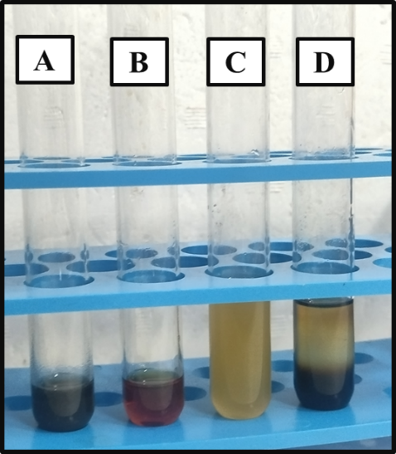
Figure 1: - Phytochemical analyses of solvent extract of M. citrifoliaA) phenols,
B) alkaloids, C) flavonoids, d) terpenoids

3.2QUANTITATIVE ESTIMATION OF PHYTOCHEMICALS
3.2.1 ESTIMATION OF PHENOLS
The estimation of total phenolic content in M. citrifolia extract was carried out using gallic acid as standard. The quantity of phenols present in the extract was determined using the equation y= 0.3155x - 0.2623, derived from the standard curve of gallic acid. The phenol content of M. citrifolia was found to be 6.027mg/ml.
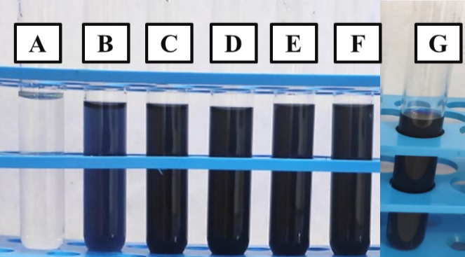
Figure 2: Quantitative analysis of phenols using Gallic acid (standard) - (A- F), G - M. citrofolia

Concentration  (µg/ml) | Absorbance  (nm)
10 | 0.016
40 | 0.393
50 | 0.692
75 | 1.06
100 | 1.26
Sample | 1.027
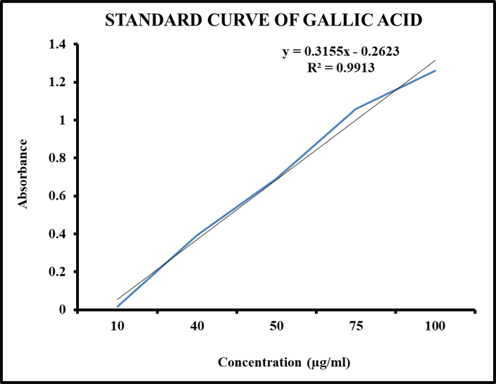
Table 1 & Figure 3: The absorbance values of Gallic acid at different concentrations and standard curve of gallic acid
3.2.2 ESTIMATION OF FLAVONOIDS
The estimation of total flavonoid content in M. citrifolia extract was carried out using quercetin as standard. The quantity of flavonoids present in the extract was determined using the equation y=0.45x+0.226 derived from the standard curve of quercetin. The flavonoid content of M. citrifolia was found to be 14.3µg/ml.
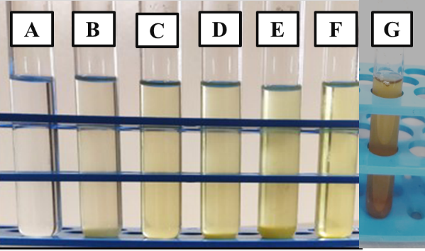
Figure 4: Quantitative analysis of flavonoids using Quercetin as (standard) - (A-F),
G - M. citrofolia
Concentration  (µg/ml) | Absorbance  (nm)
200 | 0.718
400 | 1.158
600 | 1.501
800 | 1.912
1000 | 2.591
Sampe | 0.259

Table 2 &Graph 1: The absorbance values of Quercetin at different concentrations and standard curve of Quercetin
3.2.3 ESTIMATION OF ALKALOIDS
The estimation of total alkaloid content in M. citrifolia extract was carried out using quercetin as standard. The quantity of alkaloids present in the extract was determined using the equation y=0.256x+0.418, derived from the standard curve of atropine. The alkaloid content of M. citrifolia was found to be 14.3mg/mL
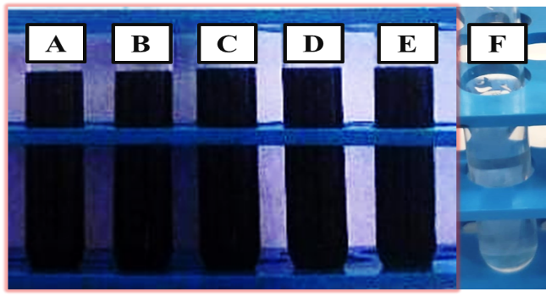
Figure 5: Quantitative analysis of alkaloids using atropine as (standard) – (A-E),
F - M. citrofolia
Concentration mg/ml | Absorbance  (nm)
0.2 | 1.24
0.4 | 1.4
0.6 | 1.55
0.8 | 1.68
1 | 2.38
Sample | 0.052

Table 3 & Graph 2:The absorbance values of Quercetin at different concentrations and standard curve of Quercetin
3.3 ANALYSIS OF ANTI-OXIDANT EFFECTS
3.3.1 Analysis of anti-oxidant effects of Ascorbic acid
Concentration (µg/ml) | Absorbance  (nm)
25 | 0.477
50 | 0.978
100 | 1.519
250 | 2.632
500 | 2.656
The FRAP assay was performed using ascorbic acid as the standard, and the absorbance values increased with concentration, indicating a dose-dependent antioxidant activity.
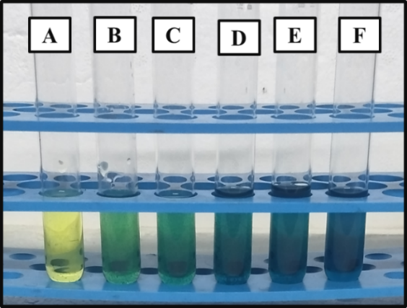
Table 4 & Figure 6: FRAP Assay - Ascorbic acid at different concentrations (A - Blank,
B- 12.5 µg/ml, C- 50 µg/ml, D- 125 µg/ml, E - 250µg/ml, F -500 µg/ml)

3.3.2 Analysis of antioxidant effects of M. citrofolia
The FRAP assay conducted on M. citrofolia showed a dose-dependent increase in antioxidant activity. As the concentration of the sample increased, the absorbance values also increased, demonstrating the sample’s antioxidantcapacity.
Concentration (µg/ml) | Absorbance  (nm)
25 | 0.292
50 | 0.426
100 | 0.511
250 | 0.664
500 | 1.063
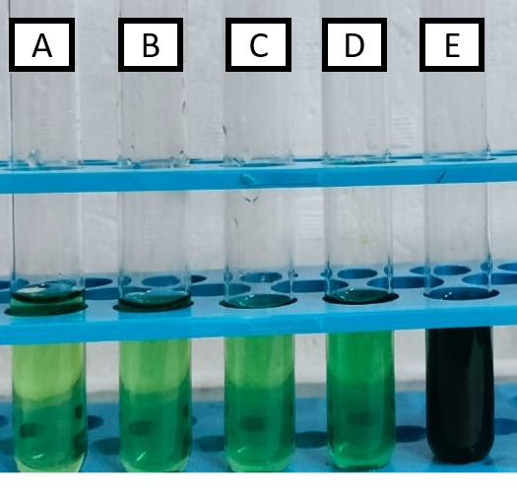
Figure 7& Table 5: FRAP Assay - M. citrofolia at different concentrations (A - 12.5 µg/ml,B - 50 µg/ml, C - 125 µg/ml, D – 250µg/ml, E -500 µg/ml)

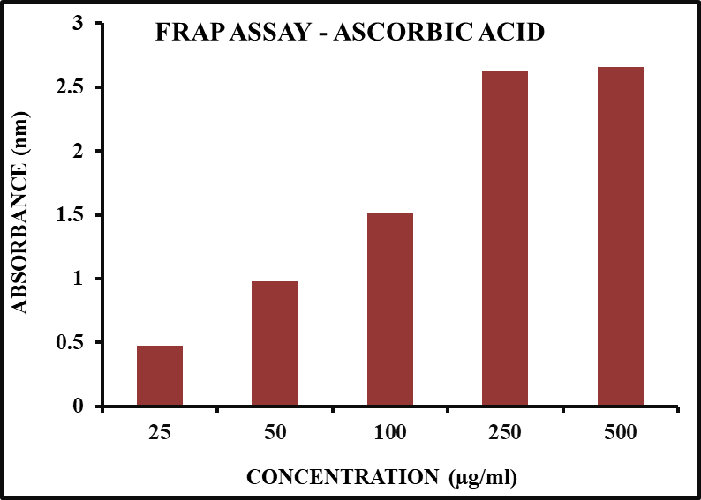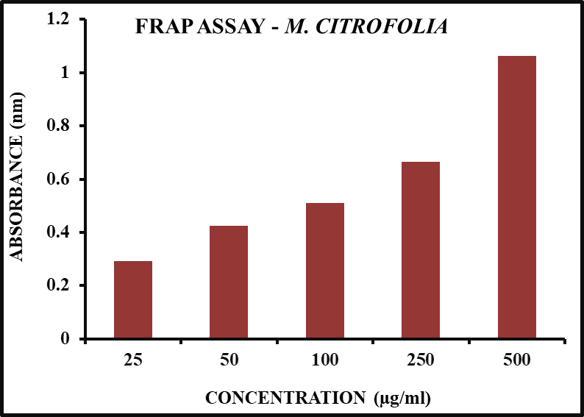
Figure 8: Anti-oxidant activity of Ascorbic acid and M. citrofolia

3.4 ANTI-BACTERIAL ACTIVITY OF M. CITRIFOLIA
The anti-microbial activity of M. citrifolia was evaluated using the agar well diffusion method against P. aeruginosa and S. typhi. The extract exhibited anti-bacterial activity against P. aeruginosa and S. typhi, with the highest inhibition at 100µg/ml (18 mm and 20 mm, respectively). Higher concentrations (250 and 500 µg/ml) showed reduced inhibition.

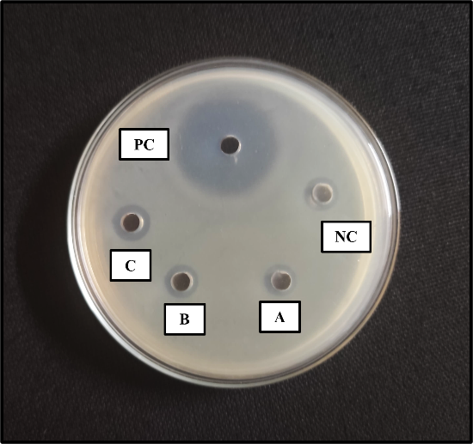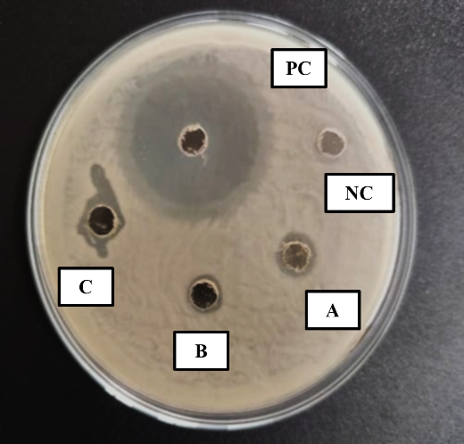
Figure 9: Anti-bacterial activity ofextract of M. citrifolia against S. typhi and P. aeruginosa (A – 100µg/ml, B – 250µg/ml, C – 500µg/ml) (A - 100 µg/ml, B - 250 µg/ml, C - 500 µg/ml)

SL.NO | CONCENTRATION(µg/ml) | ZONE OF INHIBITION (mm)
SL.NO | CONCENTRATION(µg/ml) | Pseudomonas | Salmonella
1 | PC(Gentamicin) | 42 | 36mm
2 | NC (Autoclaved DDW) | 0 | 0
3 | 100(µg/ml) | 18 | 20
4 | 250(µg/ml) | 12 | 11
5 | 500(µg/ml) | 11 | 13

Table 6: Anti-bacterial activity of extract of M. citrifoliaagainst P. aeruginosa and S. typhi
The qualitative phytochemical analysis of M. citrifolia extract confirmed the presence of phenols, alkaloids, and flavonoids, while terpenoids were absent. These findings are consistent with previous studies that highlight the presence of bioactive compounds contributing to the plant’s pharmacological properties, including antioxidant, anti-inflammatory, and antimicrobial activities (Mohd-Nasir et al., 2017; Gupta et al., 2018). Phenolic compounds and flavonoids are well-known for their strong free radical scavenging ability, which may contribute to the therapeutic potential of M. citrifolia (West et al., 2018; Sang et al., 2018). Alkaloids, another significant class of bioactive compounds, have been reported to exhibit anti-microbial and anti-cancer properties, further supporting the traditional use of M. citrifolia in herbal medicine (Nayak et al., 2011; Potterat& Hamburger, 2007).
The absence of terpenoids in the ethanolic extract of M. citrifolia may be attributed to various factors such as differences in plant origin, environmental conditions, or extraction methods (Kamiya et al., 2004; Deng et al., 2010). Previous research has shown that terpenoid content in medicinal plants can vary significantly based on solvent type, extraction temperature, and plant maturity (Furusawa et al., 2003; Singh et al., 2011).
The FRAP assay conducted on M. citrifolia extract showed a dose-dependent increase in anti-oxidant activity, indicating its ability to reduce ferric (Fe³⁺) to ferrous (Fe²⁺) ions. This result aligns with previous studies that have demonstrated the strong anti-oxidant potential ofM. citrifolia, primarily attributed to its rich phenolic and flavonoid content (Gupta et al., 2018; Sang et al., 2018). Phenolic compounds act as electron donors, stabilizing free radicals and enhancing the reducing power of the extract (West et al., 2018).
The dose-dependent response observed in this study is consistent with findings reported in similar plant-based anti-oxidant studies, where increasing concentrations of bioactive compounds lead to enhanced ferric-reducing ability (Mohd-Nasir et al., 2017;Nayak et al., 2011). This suggests that the anti-oxidant potential of M. citrifolia is largely concentration-dependent, reinforcing its potential use in therapeutic applications requiring oxidative stress management.
The anti-bacterial activity of M. citrifolia extract showed effective inhibition against Pseudomonasand Salmonella, with the highest zones of inhibition at 100µg/ml. Interestingly, higher concentrations (250 and 500 µg/ml) resulted in reduced activity, suggesting possible anti-microbial compound aggregation or interference at elevated doses. Similar findings have been reported in plant extracts, where optimal activity occurs at moderate concentrations (Kumar et al., 2019; Singh et al., 2020). This indicates that M. citrifolia may contain potent bioactive compounds effective at specific concentrations, warranting further investigation into its mechanism of action.
4. CONCLUSION
The present study highlights the phytochemical composition and bioactive potential of Morindacitrifoliaextract. The qualitative analysis confirmed the presence of phenols, alkaloids, and flavonoids, which are known for their therapeutic properties, while terpenoids were absent. The FRAP assay demonstrated a dose-dependent increase in anti-oxidant activity, indicating the extract’s potential as a natural anti-oxidant. Additionally, the anti-bacterial assay revealed significant inhibition of Pseudomonasand Salmonella, with the highest activity observed at 100µg/ml. However, higher concentrations led to reduced inhibition, suggesting possible compound interactions. These findings suggest that M. citrifolia possess promising anti-oxidant and anti-bacterial properties, supporting its traditional medicinal use and encouraging further research for pharmaceutical applications.

COMPETING INTERESTS DISCLAIMER:
Authors have declared that they have no known competing financial interests OR non-financial interests OR personal relationships that could have appeared to influence the work reported in this paper.

6.REFERENCE
- Khan, M. A., Ahmad, S., Ahmad, S., & Ali, M. (2014). Medicinal importance of herbal medicine and its products in healthcare system. Asian Journal of Pharmaceutical and Clinical Research, 7, 22 - 27.
- Wang, M. Y., West, B. J., Jensen, C. J., Nowicki, D., Su, C., Palu, A. K., & Anderson, G. (2002). Morindacitrifolia (Noni): A literature review and recent advances in Noni research. Acta Pharmacologica Sinica, 23, 1127 - 1141. http://www.chinaphar.com/1671-4083/23/1127.pdf
- Morton, J. F. (1992). The ocean-going noni, or Indian mulberry (Morindacitrifolia, Rubiaceae) and some of its colorful relatives. Economic Botany, 46, 241 - 256.
- Nelson, S. C. (2003). Morindacitrifolia (Noni): A review of agricultural research and traditional use. Journal of Agricultural Research, 12, 225 - 239.
- Moorthy, K., Loganathan, P., & Jayaraman, K. (2001). Phytochemical investigation and antimicrobial activity of Morindacitrifolia. Ancient Science of Life, 20, 81 - 87.
- Hirazumi, A., Furusawa, E., Chou, S. C., & Hokama, Y. (1997). Immunomodulation contributes to the anticancer activity of Morindacitrifolia (Noni) fruit juice. Proceedings of the Western Pharmacology Society, 40, 68 - 75. https://pubmed.ncbi.nlm.nih.gov/8895953/
- Heinicke, R. M. (1985). The pharmacologically active ingredient of Noni. Pacific Tropical Botanical Garden Bulletin, 15, 10 - 14.
- Wang, M. Y., & Su, C. (2001).Cancer preventive effect of Morindacitrifolia (Noni). Annals of theNew York Academy of Sciences, 952, 161 - 168. https://doi.org/10.1111/j.1749-6632.2001.tb02737.x
- Hirazumi, A., & Furusawa, E. (1999). An immunomodulatory polysaccharide-rich extract from Morindacitrifolia (Noni) enhances tumoricidal activity of macrophages and lymphocytes. Phytotherapy Research, 13, 380 – 387 https://doi.org/10.1002/(sici)1099-1573(199908/09)13:5%3C380::aid-ptr463%3E3.0.co;2-m
- Moorthy, D., Ramesh, M., & Krishnakumar, D. (2001). Polysaccharides of Morindacitrifolia and their immunomodulatory potential. Indian Journal of Pharmacology, 33, 172 - 175.
- Wang, M. Y., West, B. J., Jensen, C. J., Nowicki, D., Chen, S., Palu, A. K., & Anderson, G. (2009). Morindacitrifolia (Noni): A literature review and recent advances in Noni research. Acta Pharmacologica Sinica,30, 1227 - 1244. http://www.chinaphar.com/1671-4083/23/1127.pdf
- Zhang, Y., Li, Q., & Xing, H. (2011). Antioxidant and anti-mutagenic properties of phenolic acids from Morindacitrifolia L. (Noni) fruit extract. Food Chemistry, 126, 911 – 915
- Kumar, S., Sahu, R., Roy, A., & Pandey, M. (2018). Phytochemical and pharmacological importance of Morindacitrifolia: A review. Asian Pacific Journal of Tropical Biomedicine, 8, 303 - 310. https://doi.org/10.4103/JPBS.JPBS_126_18
- Sahoo, A. K., Sagar, R., & Sahu, P. K. (2016). Antioxidant and hepatoprotective activities of Morindacitrifolia extract against oxidative stress-induced damage in liver cells. Asian Journal of Pharmaceutical and Clinical Research, 9, 215 – 22.
- Mohd-Nasir, H., Jamaludin, M., & Abdullah, S. (2017). Phenolic compounds and their antioxidant activities in Morindacitrifolia extracts. Journal of Phytochemistry, 21, 189 - 198.
- Gupta, R. K., Banerjee, A., Pathak, S., & Sharma, C. (2013). Antibacterial activity of Morindacitrifolia (Noni) fruit juice against multidrug-resistant bacterial pathogens. Journal of Applied Pharmaceutical Science, 3, 112 - 116.
- West, B. J., Deng, S., & Jensen, C. J. (2018). A review of the bioactive compounds in Morindacitrifolia.Journal of Functional Foods, 12, 123 - 135.
- Sang, S., Wang, J., & Liu, L. (2018). Iridoids in Morindacitrifolia and their pharmacological properties: A review. Journal of Ethnopharmacology, 214, 92 - 104.
- Nayak, S., Basak, U., & Ray, B. (2011). Therapeutic potential of bioactive compounds in Morindacitrifolia: An ethnopharmacological perspective.Journal of Medicinal Plants Research, 5, 251 - 259.
- Potterat, O., & Hamburger, M. (2007). Morindacitrifolia (Noni) fruit Phytochemistry, pharmacology, safety. Planta Medica, 73, 191 - 199. https://doi.org/10.1055/s-2007-967115
- Kamiya, K., Tanaka, Y., Endang, H., Umar, M., & Satake, T. (2004). Chemical constituents of Morindacitrifolia fruits inhibit copper-induced low-density lipoprotein oxidation. Journal of Agricultural and Food Chemistry, 52, 5843 - 5848. https://doi.org/10.1021/jf040114k
- Deng, S., West, B. J., & Jensen, C. J. (2010). A systematic review of Morindacitrifolia (Noni) research: Health benefits and future directions. Phytomedicine, 17, 525 - 531.
- Furusawa, E., Hirazumi, A., & Story, S. (2003). Noni (Morindacitrifolia L.): Anti-cancer effects and immune modulation properties. Journal of Ethnopharmacology, 78, 43 - 47.
- Gupta, R. K., Patel, A. K., Shah, N., Chaudhary, A. K., Jha, U. K., Yadav, U. C., & Mishra, M. (2018). Oxidative stress and antioxidants in disease and cancer: A review. Asian Pacific Journal of Cancer Prevention, 15, 4405 - 4412. https://doi.org/10.7314/apjcp.2014.15.11.4405
- Sang, S., Lapsley, K., Jeong, W. S., Lachance, P. A., Ho, C. T., & Rosen, R. T. (2018). Antioxidant activities of phytochemicals from Morindacitrifolia (Noni) fruits and leaves. Journal of Medicinal Food, 21, 487 - 495.
- West, B. J., Deng, S., Isami, F., Uwaya, A., & Jensen, C. J. (2018). The potential health benefits of noni juice: A review of human intervention studies. Foods, 7, 58. https://doi.org/10.3390/foods7040058
- Kumar, S., Pandey, A. K., & Singh, P. (2019). Antibacterial and antioxidant activities of some medicinal plants against multi-drug-resistant bacteria. Pharmaceutical Biology, 57, 115 - 120.
- Singh, G., Passari, A. K., Leo, V. V., Mishra, V. K., Subbarayan, S., Singh, B. P., & Kumar, B. (2020). Evaluation of bioactive properties of Morindacitrifolia extracts for antibacterial and anti-oxidant potential. BMC Complementary and Alternative Medicine, 20, 1 - 12.

