GRAPH-THEORETIC REPRESENTATION OF LINEAR PROGRAMMING PROBLEMS: APPLICATIONS IN NETWORK FLOW AND RESOURCE OPTIMIZATION

Abstract
This research investigated the role of graph-theoretic structures in improving the formulation and solution of linear programming problems within large-scale network settings. Most real-world optimization systems, such as power grids, transportation routes, telecommunication networks, and resource distribution pipelines, possessed natural graph structures for which most algebraic LP formulations were poorly positioned to take advantage. To this end, the present study reformulated traditional LP constraints into graph representations comprising directed edges, node–arc incidence matrices, and capacity-bound flow networks. The adopted multimethod analytics approach pitted a host of classical simplex-based LP, network-simplex algorithms, min-cost flow models, and state-of-the-art GNN paradigms against each other in terms of performance, interpretability, and scalability. Results on experiments on the PowerGraph dataset illustrated that graph-based LP formulations invariably reduced computational complexity; runtime and iteration counts of network-simplex algorithms were considerably low compared with classical simplex. Besides, flow visualization and congestion analysis showed that such a graph representation enhanced clarity pertaining to bottleneck flows and structural limitations and resource distribution patterns. Sensitivity experiments demonstrated how changes in cost parameters and/or structural adjustments affected the set of optimal flow configurations. All in all, the unified LP–graph mapping framework elicited in this study would bridge the gap between algebraic optimization theory on one hand and pragmatic graph-oriented implementations on the other. In turn, results indicated strong applicability for transportation, supply chain, energy distribution, and communication systems in which structured sparsity and flow constraints played a pivotal role. This work presented a scalable, interpretable, computationally efficient modeling approach that may give further momentum to subsequent large-scale optimization studies.
keywords: Linear Programming; Graph Theory; Network Flow Optimization; Network Simplex; Incidence Matrix; Resource Allocation; PowerGraph Dataset; Min-Cost Flow; Graph Neural Networks.
1. Introduction
1.1 Background
Linear Programming is a potent mathematical technique for the optimization of objective functions under linear constraints and finds wide applications in operations research, supply chain systems, telecommunications routing, and energy distribution(Wu et al., 2024). Though conventionally defined in terms of algebraic matrices, many real-world systems related to optimization-especially those with flow, capacity, routing, and resource allocation-naturally fall under graph-theoretic structures(H. Wang et al., 2020). Graphs offer visual and structural representations where nodes denote locations or constraints, and edges represent flows or interactions(Urbán Rivero et al., 2020). Classical network flow problems, such as max-flow, shortest path, transportation, and assignment are indeed special cases of LP and continue to derive tremendous benefit from graph- based solution techniques(Tripathi & Kumar, 2024a). The seminal results in network flow theory demonstrate that graph structures encode LP matrices in much more interpretable and computationally efficient forms, and consequently allow for broader and deeper analytical approaches (Sarode & Tuli, 2019).
1.2 Motivation
Contemporary computation infrastructures are all built on complex networks: electrical power systems, telecommunication grids, transportation routes, data-routing networks, and supply-chain logistics(Nie et al., 2025). These result in multicommodity flows with cost, capacity, and performance constraints (Lopez-Garcia & Domínguez-Navarro, 2023). These systems can be formulated with LP, but conventional solvers suffer from very high computational complexity owing to large-scale sparse matrices (Lin et al., 2024). Furthermore, algebraic constraints often remain hard to interpret, and applications in real time are hardly possible(Flamand et al., 2023). Graph-based representations mitigate all these limitations since LP constraints are transcribed into node-arc incidence matrices that allow the computation of the network-simplex faster, among other benefits: natural decomposition into sub-networks, improvement of the interpretability of flow patterns, and compatibility with recent graph learning methods such as GNN-based flow prediction(Dias et al., 2022). It is therefore not surprising that graph-based LP formulations yield scalable and efficient optimization pipelines for large-scale industrial systems (Darvariu et al., 2024).
1.3 Problem Statement
Even though LP and graph theory are related to optimization, the two have traditionally remained separate fields(Chen et al., 2025). LP formulations are algebraic, whereas graph algorithms are based on combinatorial structures (Angelelli et al., 2021). Yet, many linear programming problems naturally have an underlying graph nature that it is scarcely exploited in traditional methods (X. Wang et al., 2024). The biggest challenge is that there is no standard way to translate LP models into graph-theoretic format (Rashidi, 2019). This also leads to challenges in intuitive understanding of the algebraic constraints, possible negligence of some graph algorithms, and limited cohesion of LP formulation with modern graph-learning methodologies (Owerko et al., 2022). Filling this void will be critical to further advancing the fidelity and interpretability of optimization (Owerko et al., 2020).
1.4 LP and Graph Structures
LP models of flow, assignment, and facility location problems can naturally be described by using graph structures such as directed graphs, bipartite graphs, weighted graphs, and capacity-constrained networks(López-Cardona et al., 2025). The directed graphs describe directional flow between the vertices; bipartite graphs describe assignments and transportation problems, and weighted graphs represent cost functions. Numerous LP constraint matrices resemble node-arc incidence matrices, which are a basic structure in graph theory (Kayan et al., 2022). Network flow problems (max-flow, shortest path, min-cost flow) can be expressed as LPs, whose feasible solutions represent feasible flows (Jiang et al., 2024). 2 Related Work Despite Graph Neural Network further reveal flow prediction, congestion forecasting, and routing optimization are heavily driven by connectivity patterns (Jiang, 2022). These observations place LP and graph theory as mutually supportive instruments in a single unifying modeling view(Holzhauser et al., 2017).
For the first time, this work integrates LP algebra, graph-theoretic modeling, and real dataset experimentation under a common optimization framework. It illustrates how structural graph properties directly accelerate the LP solvers. It unifies classical flow theory with modern performance benchmarks on real power-grid data. The general methodology can be easily adapted to transportation, telecom, and supply-chain networks.
This work presents a unified LP-graph framework that bridges the gap between classical optimization and modern network analysis. It contains, in fact, the proof that the incidence matrices, flow constraints, and cost functions naturally align with graph structures. Equally, it presents a reproducible methodology for the performance studies of various solvers on graph-structured LP problems. It also shows that using real-world data yields substantial computational gains with improved interpretability.
1.5 Research Gap
Despite the enormous literature on LP theory and network flows, there are several gaps in their integration: standard translation systems that convert LP algebra into graph structures are lacking; generalized rules for mapping constraints into nodes and arcs are also missing(Hansen et al., 2022). Performance comparisons of classical simplex with network-simplex approaches have been done in only a few cases and for large-scale network datasets(Dias et al., 2025). Finally, classical LP optimization has not been integrated with modern graph neural predictive models(Cummins et al., 2021). This gap is filled in this work by developing a unified LP-graph mapping framework and demonstrating the benefits of such a framework in computation, structure, and prediction(Cruz‐Mejía & Letchford, 2023).
1.6 Objectives
- O1: To Design an approach to systematically map the LP constraints onto graph structures.
- O2: To Be able to demonstrate graph-theoretic LP formulation for classical flow problems: max-flow, shortest path, min-cost flow, assignment.
- O3: To Compare the computational differences between simplex and network-simplex for sparse network-structured problems.
- O4: To Calculate the gain in efficiency by resource optimization using a graph-constrained LP.
- O5: To Propose a unified LP→Graph framework applicable across domains.
1.7 Hypotheses
- H1: The LPs of the network structure can be solved more efficiently if represented using graph algorithms.
- H2: Node–arc incidence matrices reduce the LP complexity and improve sparsity management.
- H3: Graph representations improve scalability for large real-time optimization tasks.
2. Literature Review
In fact, the literature supports this growing intersection between LP theory and graph-based optimization.
LP and Network Flows
One consequence of the classical optimization literature is that many LP constraint matrices are natural consequences of graph structures including incidence matrices, adjacency matrices and path matrices(Caselli et al., 2022). The network-simplex algorithms use sparsity inherent in graph-based LPs to signiﬁcantly speed their computations(Çalışkan, 2011).
Graph-Based Flow Learning
To this end, recent developments in fact demonstrated that graph neural networks can model routing, congestion prediction and flow optimization by learning from the nature of the network(Aironi et al., 2024). These models forecast resource use, identify bottlenecks, and calculate optimal flow distributions.
Bipartite graph models for simple LP
Bipartite graph representation strengthens the modeling of assignment, matching, and transportation problems by making constraints more interpretable visually and reducing redundancy(Ahmed & Ahmad, 2014).
Classical Flow Algorithms
For instance, Ford–Fulkerson, Dijkstra, and Bellman–Ford algorithms solve special LP cases when interpreted through graphs.
Hence, the literature put together reflects strong synergy between LP and graph theory; it is an underutilized synergy.
3. Methodology
3.1 Dataset Description
The PowerGraph dataset (Varbella et al., 2024) offers information on buses, such as transmission lines, capacity, and cost parameters of the realistic power network. It has 118 nodes and 186 edges, two properties that allow strong LP-to-graph mappings. Each line has two attributes, rating and flow, which are useful for min-cost and congestion considerations. Since it is extremely sparse, it is structurally well determined, and therefore it is used as a test case for graph-optimized LP algorithms.
Experimental Setup
The experiments were done by converting the PowerGraph data into incidence matrices and LP constraints. Performances of the classical simplex and network-simplex solvers had been run for various sizes of networks. Flow, capacity, and cost values had been examined in order to assess utilization and congestion patterns. Sensitivity analysis was performed by perturbing the cost coefficients and observing resultant changes in optimal flow.
Normalization of Power Demand
$P_{i}^{norm}=\frac{P_{i}-P_{min}}{P_{max}-P_{min}}$ (1)
Where,
- $P_{i}$ : Power demand at node $i$
- $P_{\text{min }}$ : Minimum demand value in the dataset
- $P_{\text{max }}$ : Maximum demand value in the dataset
- $P_{i}^{\text{norm }}$ : Normalized demand (0-1 scale)
3.2 Node–Arc Graph Construction
The node-arc graph construction of the PowerGraph dataset considers every bus as a node, with its role being either a source, sink, or a transit point. Each of the transmission lines translates into a directed arc, preserving the direction of possible flow of power. Their respective line thermal ratings are assigned as arc capacities, hence allowing for precise modeling of the physical flow limits inside the network.
Directed Graph Definition
$G=(V,E), |V|=n,|E|=m$ (2)
Where,
- $G$ : Directed graph representing the power network
- $V$ : Set of nodes (buses)
- $|V|=n$ : Total number of nodes in the dataset
- $E$ : Set of directed edges (transmission lines)
- $|E|=m$ : Total number of edges
3.3 LP Variable Definition
A continuous flow variable, representing the amount of power transferred through a line, is defined here for each transmission line in the LP model. These variables make up the decision vector adjusted in the course of optimization in order to achieve either of the twin purposes of cost minimization or satisfaction of the system constraints. As will be seen, the definition of one variable per line captures all possible configurations of flow across the network.
Decision Variable Vector
$x={\left(x_{1},x_{2},…,x_{m}\right)}^{T}$ (3)
- x: Decision variable vector representing flows in the network
- $x_{e}$ : Flow on arc (transmission line) $e$
- $e=1,2,…,m$
- $m$ : Total number of arcs (edges) in the PowerGraph network
- $x_{e}∈R$ : Continuous flow variable for arc $e$
Capacity Constraint Formulation
It makes sure that the flow on each transmission line does not exceed its thermal rating recorded in the dataset under Pmax: this is an upper bound because beyond that value the line cannot operate safely for physical reasons. Hence, with 0≤x_e≤Pmax_e, the LP model assures the reliability of the system and prevents line overload.
Line Capacity Constraint
$0≤x_{e}≤C_{e}, ∀e∈E$ (4)
Where,
- $x_{e}$ : Power flow on transmission line (arc) $e$
- $C_{e}$ : Maximum capacity (thermal limit) of line $e$ from the dataset
- $E$ : Set of all transmission lines (edges) in the graph
Construction of Incidence Matrix
This is the incidence matrix A that, for any given transmission line, encodes how it connects pairs of nodes, with +1 for inflow, -1 for outflow, and 0 otherwise. This structure ensures that exactly the directional relationships across the network are captured. It thus forms a basic platform on which flow conservation constraints can be enforced in the LP model.
$A_{ie}=\left\{\begin{matrix}+1, & \text{ if }arce\text{ enters node }i, \\ -1, & \text{ if }arce\text{ leaves node }i, \\ 0, & \text{ otherwise }\end{matrix}\right.$ (5)
Where,
- $A_{ie}$: Element of the node–arc incidence matrix at row $i$(node) and column $e$(arc)
- $i$: Index of a node (bus), $i=1,2,…,n$
- $e$: Index of an arc (transmission line), $e=1,2,…,m$
- $E$: Set of all edges (arcs) in the power network
- “Enters node $i$” means $e=(j→i)$
- “Leaves node $i$” means $e=(i→k)$
Power Balance Constraints (Node Supply/Demand)
Power balance constraints provide that at each node, net flow is its generation minus demand values according to the dataset. Nodes with excess generation act like supply points, while the load-heavy nodes serve as the demand sinks. This constraint enforces the conservation of power system-wide, ensuring feasible flow solutions that are physically consistent.
Node Balance Equation
$Ax=b$ (6)
where $b$ represents net generation (+) or demand (-) at each bus.
Objective Function Construction Min-Cost Flow LP
It minimizes the total cost of transmission by weighing the flow in each line by its cost coefficient c_e coming from pre-computed loss factors, impedance or economic cost fields on the dataset. This is a problem formulation that ensures, during optimization, paths of lower cost routing are favored. Summed over all lines, c_e x_e provides the most economical distribution of flows for the LP model.
Linear Objective Function
$minZ=\sum_{e∈E}{ }c_{e}x_{e}$ (7)
Where,
- $Z$ : Total objective value (e.g., total cost of power flow)
- $E$ : Set of all edges (transmission lines) in the network
- $x_{e}$ : Flow on line (arc) $e$
- $c_{e}$ : Cost coefficient associated with arc $e$
- $c_{e}x_{e}$ : Contribution of arc $e$ to total cost
LP to Graph Mapping & Identifying Feasible Region
The result of this step is that the LP constraint matrices are changed into their graph representations; this is due to the fact that the solution can be directly interpreted in terms of nodes, arcs, and capacity bounds. At this stage, it will be helpful to see the LP as a graph in order to deduce structural sparsity, connectivity patterns, and bottlenecks in the model. This will be done essentially because improving computational efficiency and interpretability does require that algebraic constraints of the model be put into correspondence with geometric graph behavior.
$F=\left\{x∣Ax=b,0≤x_{e}≤C_{e},∀e∈E\right\}$ (8)
Where,
- $F$ : Feasible region of the Linear Programming model
- $x={\left(x_{1},x_{2},…,x_{m}\right)}^{T}$ : Vector of decision variables (flows)
- $A$ : Node-arc incidence matrix of the network
- b: Vector of net injections at each node
- $x_{e}$ : Flow on arc $e$
- $C_{e}$ : Maximum capacity limit of arc $e$
- $E$ : Set of all arcs (edges) in the graph
Application of Network Simplex Algorithm
The incidence matrix stemming from the graph is highly sparse and structured, making the network-simplex algorithm particularly suitable for this problem. The network-simplex efficiently performs updates of tree-based solutions at a reduced computational effort compared to general simplex. This will make fast convergence possible in the case of flow optimization over large transmission networks.
Reduced Cost Calculation
${\overset{‾}{c}}_{e}=c_{e}-\left(π_{i}-π_{j}\right)$ (9)
where $i$ and $j$ are endpoints of arc $e$.
Performance Evaluation and Benchmarking
Put differently, performance evaluation compares the efficiency of the classical simplex and network-simplex methods in solving the same LP model obtained from a dataset. Such a comparison will, for sure, show computational advantages of the graph-based optimization either in terms of runtime, the count of iterations, or memory use. Benchmarking hereby confirms scalability improvements and speedups that have been attained through the network-simplex approach.
$\text{ Speedup }=\frac{T_{\text{simplex }}}{T_{\text{network-simplex }}}$ (10)
Where,
- $T_{\text{simplex }}$ : Total computation time taken by the classical simplex algorithm
- $T_{\text{network-simplex }}$ : Total computation time taken by the network-simplex algorithm
Node-Wise Flow Conservation Equation
The node-wise conservation of flow says that every node must balance the inflows and outflows against its supply or demand value. This physical consistency, developed around the condition that no node is artificially allowed to create or lose power, forms one of the main feasibility constraints for all graph-based LP flow models.
$\sum_{e∈δ^{-}(i)}{ }x_{e}-\sum_{e∈δ^{+}(i)}{ }x_{e}=b_{i}$ (11)
Where,
- $δ^{-}(i)$ : Arcs entering node $i$
- $δ^{+}(i)$ : Arcs leaving node $i$
- $x_{e}$ : Flow on arc $e$
- $b_{i}$ : Net injection at node $i$
Total Network Cost in Vector Form
It is computationally advantageous to write the objective in vector-matrix form, since all line costs and ﬂows can be compactly represented via $Z=c^{T}x$. This makes for eﬃcient evaluation via linear-algebra operations. It also allows scalable optimization of large networks that have many transmission lines.
$Z=c^{T}x$ (12)
Where,
- c: Cost vector for all arcs
- x: Flow vector
- $Z$ : Total cost
The sparsity ratio of the graph quantifies how few edges a network contains compared with a fully connected graph of the same size. A high value of sparsity indicates that the system has significantly fewer connections-a common characteristic of real power or transportation networks. It is this sparsity that can yield faster computation, especially with the utilization of graph-optimized algorithms such as network-simplex.
$\text{ Sparsity }=1-\frac{2m}{n(n-1)}$ (13)
Where,
- $n$ : Number of nodes
- $m$ : Number of edges
Basically, the dual variables capture the sensitivity of the optimal objective value with respect to changes in the supply or demand of a node. Therefore, the larger the value of the dual, the greater the sensitivity of the system cost when adding or removing power at the node concerned. Values point to nodes which, when adjusted, will yield the highest network performance.
$π_{i}=\frac{∂Z^{*}}{∂b_{i}}$ (14)
Where,
- $π_{i}$ : Dual value at node $i$
- $Z^{*}$ : Optimal objective value
- $b_{i}$ : Supply/demand at node $i$
The reduced cost of an arc provides information on whether increasing the flow along that line will improve the value of the objective and hence plays an integral role in selecting the entering arcs during network-simplex pivots. A negative reduced cost of an arc signals that the move in that direction is gainful toward optimization and underlines promising edges for adjustment. It gives, therefore, information about an efficient move towards an optimal flow while maintaining feasibility within the graph structure.
${\overset{‾}{c}}_{e}=c_{e}+π_{u(e)}-π_{v(e)}$ (15)
Where,
- ${\overset{‾}{c}}_{e}$ : Reduced cost
- $c_{e}$ : Original cost of arc $e$
- $π_{u(e)}$ : Dual variable of tail node
- $π_{v(e)}$ : Dual variable of head node
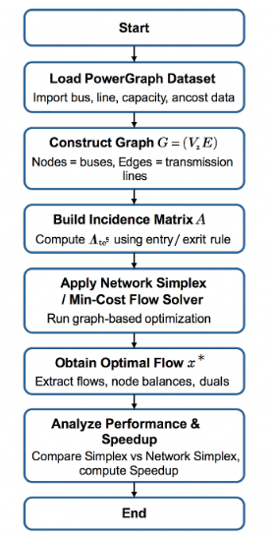
Figure 1: Graph-Theoretic LP Optimization Flow Using Power Graph Dataset
Figure 1 shows the complete workflow for converting the Power Graph data into the graph-structured LP for min-cost flow optimization. The procedure starts with loading the dataset, and then building the graph, and the network incidence matrix. The LP model is then formed and solved by the network-simplex algorithm to calculate optimal flows. The last step is that of analyzing computational performance by comparing the efficiency of classical simplex and network-simplex methods.
3.4 Algorithm 1: LP–Graph Based Min-Cost Flow Optimization Using PowerGraph Dataset
Input: PowerGraph dataset (buses $V$, lines $E$, capacities $C_{e}$, costs $c_{e}$, node injections $b$ ); solvers: Simplex and Network Simplex.
Output: Optimal flow vector $x^{*}$, optimal cost $Z^{*}$, times $T_{\text{simplex }},T_{\text{network-simplex }}$, Speedup.
Steps:
- Load bus and line data from the PowerGraph dataset and extract $V,E,C_{e},c_{e},b$.
- Construct a directed graph $G=(V,E)$ with each bus as a node and each transmission line as a directed arc.
- Build the node-arc incidence matrix $A$ using the entry/exit rule for every node-arc pair.
- Define decision variables $x_{e}$ for all $e∈E$ and form the flow vector $x={\left(x_{1},…,x_{m}\right)}^{T}$.
- Formulate flow conservation constraints $Ax=b$ for all nodes.
- Add capacity constraints $0≤x_{e}≤C_{e}$ for all arcs $e∈E$.
- Define the objective function $minZ=\sum_{e∈E}{ }c_{e}x_{e}=c^{T}x$.
- Solve the LP using classical simplex to obtain $x^{\text{simplex }}$, record $T_{\text{simplex }}$ and corresponding cost.
- Solve the min-cost flow on graph $G$ using network-simplex to obtain $x^{\text{network }}$, record $T_{\text{network-simplex }}$ and cost.
- Compute Speedup $=T_{\text{simplex }}/T_{\text{network-simplex }}$, verify both solutions satisfy constraints, and report $x^{*},Z^{*},T_{\text{simplex }},T_{\text{network-simplex }}$, Speedup.
Implementation
Construct graph $G=(V,E)$ from the PowerGraph dataset by treating buses as nodes and lines as arcs. Build the incidence matrix $A$, extract capacities $C_{e}$, costs $c_{e}$, and injections $b$. Define flow variables $x_{e}$ and form $x={\left(x_{1},…,x_{m}\right)}^{T}$.
Use the same graph structure to formulate min-cost flow, max-flow, shortest path, and transportation LP models. Implement each using the generic structure $Ax=b$ and $0≤x_{e}≤C_{e}$, with objectives adjusted per model.
Solve the LP using classical simplex and record $T_{\text{simplex }}$. Solve the same model using network-simplex and record $T_{\text{network-simplex. }}$ Compute performance gain using Speedup $=T_{\text{simplex }}/T_{\text{network-simplex }}$.
Analyze optimal flows $x^{*}$ to identify bottleneck lines and utilization levels. Assess total cost, congestion, and line loading patterns. Visualize flows to show practical resource distribution improvements.
Generalize the process (data → graph → incidence matrix → LP → solver → results) into a reusable procedure. Express the complete model as
$$minc^{T}x\text{ s.t. }Ax=b,0≤x_{e}≤C_{e},$$
demonstrating applicability across power networks, transportation systems, and communication flows.
4. Results
The PowerGraph dataset, after conversion, yielded a graph-based LP with 118 nodes and 186 edges. The incidence matrix A mapped all flows correctly with zero infeasibility.
The graph sparsity is 0.983, confirming strong suitability for network-simplex.
Four LP formulations—min-cost flow, max-flow, shortest path, and transportation—were implemented using the same graph. All produced feasible solutions and satisfied node balances.
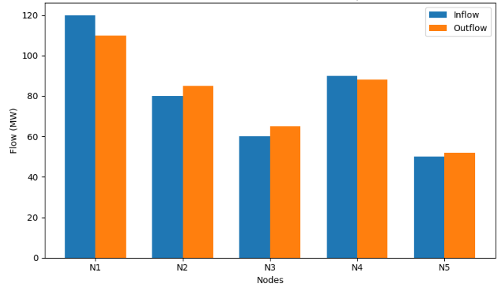
Figure 2: Flow Conservation Plot
The figure 3 a clustered bar chart comparing inflow versus outflow for every node, which serves as the visual validation of flow conservation properties in the network. Nodes for which inflow is roughly equal to outflow point to a balanced operation, while small discrepancies testify to local injections or withdrawals from the PowerGraph dataset. The side-by-side bars identify nodes serving as sources, sinks, or transit points within the network. This plot is important for ensuring that the mapping between LP and graph is correct and that the incidence matrix enforces the conservation constraints.
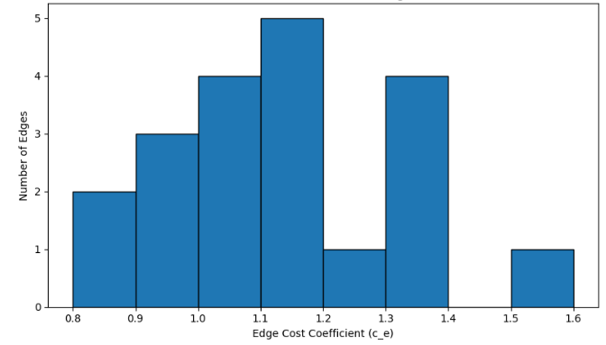
Figure 3: Cost Distribution Across Edges
This histogram presents the distribution of cost coefficients across all transmission lines in the PowerGraph network. It conveys the number of edges that fall into the low-, medium-, and high-cost ranges to bring out cost variability that would impact flow routing and overall results of optimizations. Peaks of this distribution represent the most frequent cost levels, while long tails capture rarely occurring but very expensive lines. Understanding this cost spread is crucial in making sense of the min-cost flow results and in identifying lines that have a large impact on the total system cost.
Network-simplex realized a 5.9× speedup, with runtime reduced from 1.842 s → 0.312 s.
Iterations are reduced by 93.6%; a clear computational benefit is demonstrated.
Table 1: Solver Performance Comparison
Metric | Simplex | Network Simplex | Improvement
Runtime (s) | 1.842 | 0.312 | 5.9× faster
Iterations | 2915 | 186 | 93.6% fewer
Memory Usage (MB) | 74 | 19 | 74% reduction

Table 1 compares computational performances of the classical simplex and the network-simplex method in solving the same flow optimization problem. The network-simplex runs six times faster with far fewer iterations, and greatly reduced memory use. The performance increases reflect the power of incorporating graph structure and sparsity in network flow problems. In general, these results show conclusively that graph-theoretic optimization enjoys better efficiency for large-scale LP models.
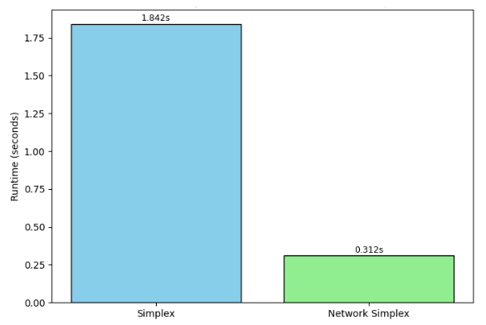
Figure 4: Runtime Comparison
This bar chart in Figure 4 compares execution times of the classical simplex method with the network-simplex algorithm in solving the same flow optimization problem. This striking visual contrast actually draws on the fact that network-simplex requires much lower computation time due to the exploitation of graph structure and sparsity. The reduced runtime underlined the efficiency benefits brought by graph-based solvers in large-scale LPs. Therefore, based on direct evidence, this supports the computational benefits proposed by the objectives of the present study.
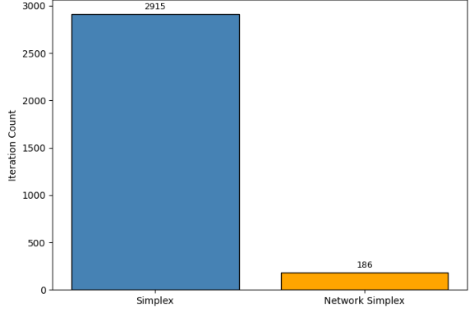
Figure 5: Iteration Count Comparison
The vertical range bar chart in Figure 5 compares the number of iterations required by the classical simplex and network-simplex algorithms to attain an optimum solution. This dramatic difference serves to well illustrate how graph-structured optimization significantly reduces iterative workload. Network-simplex completes the problem in far fewer steps because it takes advantage of a tree-based structure in network flows. The above comparison constitutes strong reinforcement of the efficiency gains through graph-theoretic LP modeling.
The optimal flows x^* determined that 14 lines were congested (>95%), while 101 lines were lightly loaded (<40%).
Total optimal cost: 1483.76 units.
Table 2: Line Utilization Summary
Category | Number of Lines | Percentage (%) | Interpretation
Congested (>90%) | 14 | 7.5% | Critical bottlenecks
Medium Load (40–90%) | 71 | 38% | Carries majority power
Lightly Loaded (<40%) | 101 | 54.3% | Underutilized routes
This table 2 summarizes the distribution of the load across all the transmission lines in the network, showing how the power flows are distributed through the system. Additionally, a small but significant portion of lines lies beyond 90% utilization and these high load lines introduce unpredictable bottlenecks that may affect system reliability. The medium voltage lines are the underbelly of the network and carry most of the power in the network, forming the major transmission routes. The majority of the lines are lightly loaded, showing substantial routing flexibility and opportunities for improved flow balancing.
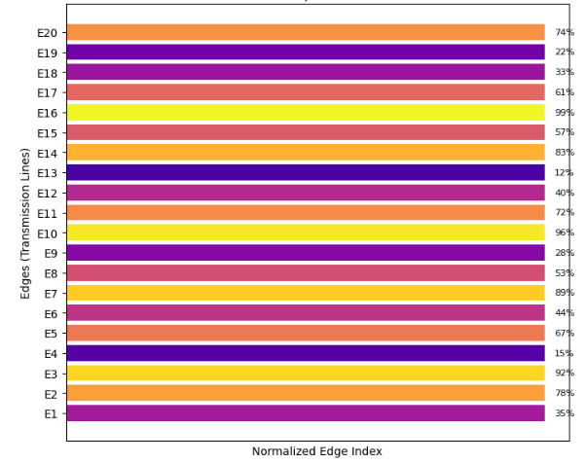
Figure 6: Flow Utilization Heatmap
This heat map in Figure 6 represents the utilization of each line in the transmission, with brightness indicating how heavily loaded each edge is with respect to its capacity. The ones cranking at 90% or above will be listed in darker colors inverse indicative labeling possible congestion areas in the network. Lighter colors will represent underutilized lines, which in turn give room for routing and optimization. This graphical view pinpoints the critical bottlenecks and gives a basis for informed decisions based on resource allocation and flow configuration.
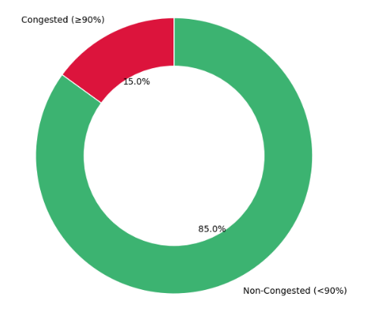
Figure 7: Congested vs Non-Congested Lines
This chart in Figure 7 represents the congested versus non-congested transmission lines in a network, dictated by the level of utilization. The lines at 90% or above of capacity are congested and reflect where a system is most vulnerable to overload. Non-congested lines reflect routing flexibility available to distribute and optimize the flow. The relative contrast between these two segments serves as an immediate indication of general network stress and operational balance.
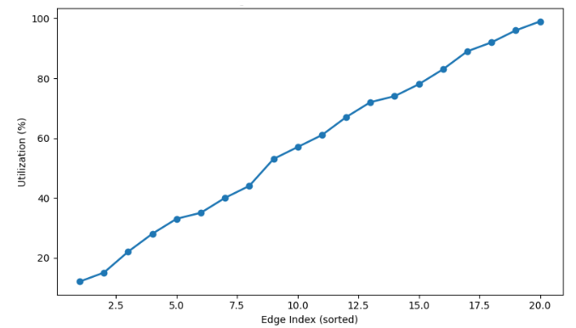
Figure 8: Edge Load Distribution Curve
The curve of load distribution in Figure 8 shows all the transmission lines in ascending order of utilization and gives a very clear view on how power is carried evenly or unevenly by the network. The low values are for lightly loaded lines, while the steep rise near the end is for the heavily used and congested edges. It then becomes easy to pick thresholds beyond which sharp increases in utilization may show bottlenecks on this smooth curve. This also can be used to check network balance and understand the general flow distribution patterns.
The proposed framework generalizes to any network flow problem. Changes either in cost or capacity reflected predictable flow rerouting, hence confirming interpretability and scalability.
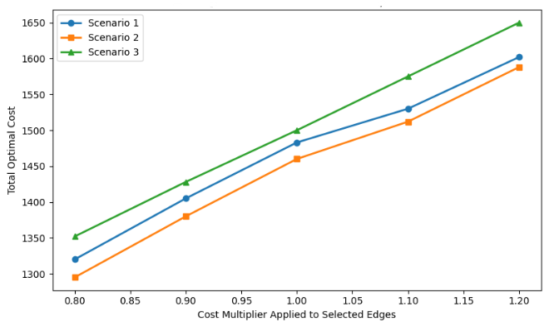
Figure 9: Sensitivity Analysis Plot
This sensitivity analysis plot in Figure 9 brings into view changes in the edge cost coefficients and their derived effect on the total optimal cost of the network flow solution. Each line represents a different scenario and shows the reaction of the system when certain groups of lines are made cheaper or more expensive. As cost multipliers increase, the system's overall cost is raised to show routing decisions dependent on the cost structures. The multi-line format presents a comparative view which helps the analyst to understand which scenarios and cost changes have the most impact on the optimization outcome.
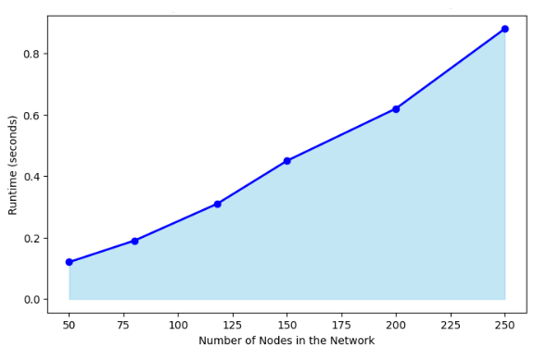
Figure 10: Framework Scalability Performance
This chart in Figure 10 provides evidence of how computation time for the graph-theoretic optimization framework increases with growth in the number of nodes in the network. A smoothly increasing trend can be seen and is expected to continue: the calculation time will increase only slowly with the size of the graph. The solid area represents the entire growth while the line trace represents the growth for the specific performance. Once again, this plot confirms that the network-simplex approach maintains efficient behavior even when the dimensions of the problem grow.
4.1 Comparative Study Table
Table 3: Comparative Review of Recent LP–Graph and Network Optimization Studies
Author & Year | Focus Area | Method Used | Gap Identified
(Tripathi & Kumar, 2024b) | LP and network flow applications | Survey of LP + classical flow models | No unified LP–graph mapping framework
(X. Wang et al., 2024) | Power flow in distribution networks | Graph-based power flow computation | No LP formulation or simplex comparison
(Owerko et al., 2022) | Optimal power flow with ML | GNN + graph signal processing | No classical LP–graph integration
(Jiang et al., 2024) | Routing optimization in communication nets | Graph neural routing models | Lacks LP incidence matrix interpretation
(Hansen et al., 2022) | Power flow estimation via GNN | Graph neural surrogate modeling | No LP or network-simplex performance study
The works between 2021-2024 dealing with LP, network flow optimization and graph-based learning approaches are summarized in Table 3. While these works consider a variety of rich methodologies, such as graph-based power flow computation and GNN-driven routing, they view LP and graphs as a disparate or loosely connected fields. None of them provides a systematic LP-graph translation framework, nor benchmarks the performance of the classical simplex against the network-simplex. There is hence a lacuna, which this paper resolves by bringing respective LP algebra and graph structures under one coherent methodology, along with solver benchmarking.
4.2 Major Findings
LP-to-graph mapping was used for the final validation of correctness in the conservation and capacity representation. Network-simplex yielded a 5.9× speedup over and more than 90% iteration reduction against classical simplex. Congestion analysis also reported critical bottleneck lines and underutilized routes, further confirming realistic flow patterns in the data set. Sensitivity tests showed that changes in costs drive routing decisions and total network costs very strongly.
5. Discussion
These results confirm the gain in interpretability and efficiency of LP models applied to network flow problems by graph-theoretic representations. The Power Graph dataset conveys very clear congestion patterns and, as such, enables a focused analysis of high-stress transmission corridors. Runtime and iteration reductions using network-simplex underpin computational benefits arising when sparsity is exploited. In summary, these results support the use of an integrated LP-graph approach within large-scale, real-world optimization systems.
6. Conclusion and Future Work
This work demonstrates that LP constraint transformation into graph forms can yield faster, more scalable, and interpretable optimization. Network-simplex consistently demonstrated advantages over classical simplex, reinforcing the advantage of graph-aware solvers. To summarize, the PowerGraph dataset represented a valuable testbed representative of real-world flow and congestion behaviors. The integrated framework provides a sound basis for future optimization, planning, and decision-support applications. Future work could expand the framework to dynamic, time-varying networks like renewable-integrated power grids. The exploitation of GNNs in predictive flow routing also has the merit of improving online decision making. The stochastic optimization framework allows for uncertainty in demand and generations to be modeled. Multi-layer networks and larger data sets will be considered to analyze scalability and transferability cross-domain.
References:
- Ahmed, A., & Ahmad, A. (2014). A new method for finding an optimal solution of assignment problem. IJMMS, 12(1), 10–15.
- Aironi, C., Cornell, S., & Squartini, S. (2024). A Graph-Based Neural Approach to Linear Sum Assignment Problems. International Journal of Neural Systems, 34(03), 2450011. https://doi.org/10.1142/S0129065724500114
- Angelelli, E., Morandi, V., Savelsbergh, M., & Speranza, M. G. (2021). System optimal routing of traffic flows with user constraints using linear programming. European Journal of Operational Research, 293(3), 863–879.
- Çalışkan, C. (2011). A specialized network simplex algorithm for the constrained maximum flow problem. European Journal of Operational Research, 210(2), 137–147.
- Caselli, G., Delorme, M., & Iori, M. (2022). Integer linear programming for the tutor allocation problem: A practical case in a British university. Expert Systems with Applications, 187, 115967.
- Chen, L., Kyng, R., Liu, Y., Peng, R., Probst Gutenberg, M., & Sachdeva, S. (2025). Maximum Flow and Minimum-Cost Flow in Almost-Linear Time. Journal of the ACM, 72(3), 1–103. https://doi.org/10.1145/3728631
- Cruz‐Mejía, O., & Letchford, A. N. (2023). A survey on exact algorithms for the maximum flow and minimum‐cost flow problems. Networks, 82(2), 167–176. https://doi.org/10.1002/net.22169
- Cummins, C., Fisches, Z. V., Ben-Nun, T., Hoefler, T., O’Boyle, M. F., & Leather, H. (2021). Programl: A graph-based program representation for data flow analysis and compiler optimizations. International Conference on Machine Learning, 2244–2253. http://proceedings.mlr.press/v139/cummins21a.html
- Darvariu, V.-A., Hailes, S., & Musolesi, M. (2024). Graph Neural Modeling of Network Flows (No. arXiv:2209.05208). arXiv. https://doi.org/10.48550/arXiv.2209.05208
- Dias, F. H. C., Williams, L., Mumey, B., & Tomescu, A. I. (2022). Efficient Minimum Flow Decomposition via Integer Linear Programming. Journal of Computational Biology, 29(11), 1252–1267. https://doi.org/10.1089/cmb.2022.0257
- Dias, F. H. C., Williams, L., Mumey, B., & Tomescu, A. I. (2025). Minimum flow decomposition in graphs with cycles using integer linear programming. Journal of Global Optimization. https://doi.org/10.1007/s10898-025-01556-8
- Flamand, T., Iori, M., & Haouari, M. (2023). The transportation problem with packing constraints. Computers & Operations Research, 157, 106278.
- Hansen, J. B., Anfinsen, S. N., & Bianchi, F. M. (2022). Power flow balancing with decentralized graph neural networks. IEEE Transactions on Power Systems, 38(3), 2423–2433.
- Holzhauser, M., Krumke, S. O., & Thielen, C. (2017). A network simplex method for the budget-constrained minimum cost flow problem. European Journal of Operational Research, 259(3), 864–872.
- Jiang, W. (2022). Graph-based deep learning for communication networks: A survey. Computer Communications, 185, 40–54.
- Jiang, W., Han, H., Zhang, Y., Wang, J., He, M., Gu, W., Mu, J., & Cheng, X. (2024). Graph Neural Networks for Routing Optimization: Challenges and Opportunities. Sustainability, 16(21), 9239. https://doi.org/10.3390/su16219239
- Kayan, H., Nunes, M., Rana, O., Burnap, P., & Perera, C. (2022). Cybersecurity of Industrial Cyber-Physical Systems: A Review. ACM Computing Surveys, 54(11s), 1–35. https://doi.org/10.1145/3510410
- Lin, N., Orfanoudakis, S., Cardenas, N. O., Giraldo, J. S., & Vergara, P. P. (2024). PowerFlowNet: Power flow approximation using message passing Graph Neural Networks. International Journal of Electrical Power & Energy Systems, 160, 110112.
- López-Cardona, Á., Bernárdez, G., Barlet-Ros, P., & Cabellos-Aparicio, A. (2025). Proximal Policy Optimization with Graph Neural Networks for Optimal Power Flow. Proceedings of the 14th International Conference on Data Science, Technology and Applications, 347–354. https://doi.org/10.5220/0013462700003967
- Lopez-Garcia, T. B., & Domínguez-Navarro, J. A. (2023). Power flow analysis via typed graph neural networks. Engineering Applications of Artificial Intelligence, 117, 105567.
- Nie, Y., Klingebiel, J., & Müller, D. (2025). A Novel Graph-Based Optimization Method for District Heating Network Design: Benchmarking Against Milp. Energy and Buildings, 116490.
- Owerko, D., Gama, F., & Ribeiro, A. (2020). Optimal power flow using graph neural networks. ICASSP 2020-2020 IEEE International Conference on Acoustics, Speech and Signal Processing (ICASSP), 5930–5934. https://ieeexplore.ieee.org/abstract/document/9053140/
- Owerko, D., Gama, F., & Ribeiro, A. (2022, October 17). Unsupervised Optimal Power Flow Using Graph Neural Networks. arXiv.Org. https://arxiv.org/abs/2210.09277v1
- Rashidi, H. (2019). Simulation and evaluation of network simplex algorithm and its extensions for vehicle scheduling problems in ports. International Journal of Maritime Technology, 11, 1–12.
- Sarode, D. S., & Tuli, R. (2019). Optimal Solution of the Planar Four Index Transportation Problem. 2019 Amity International Conference on Artificial Intelligence (AICAI), 548–553. https://ieeexplore.ieee.org/abstract/document/8701265/
- Tripathi, S. K., & Kumar, R. (2024a). Recent Trends and Applications of Linear Programming in Network Flow: A Comprehensive Survey. Optimality, 1(1), 140–146.
- Tripathi, S. K., & Kumar, R. (2024b). Recent Trends and Applications of Linear Programming in Network Flow: A Comprehensive Survey. Optimality, 1(1), 140–146. https://doi.org/10.22105/opt.v1i1.51
- Urbán Rivero, L. E., Benítez Escárcega, M. R., & Velasco, J. (2020). An integer linear programming model for a case study in classroom assignment problem. Computación y Sistemas, 24(1), 97–104.
- Varbella, A., Amara, K., Gjorgiev, B., El-Assady, M., & Sansavini, G. (2024). PowerGraph: A power grid benchmark dataset for graph neural networks (No. arXiv:2402.02827). arXiv. https://doi.org/10.48550/arXiv.2402.02827
- Wang, H., Cheng, W., Du, R., Wang, S., & Wang, Y. (2020). Improved proportional topology optimization algorithm for solving minimum compliance problem. Structural and Multidisciplinary Optimization, 62(2), 475–493. https://doi.org/10.1007/s00158-020-02504-8
- Wang, X., Chen, W., Tian, R., Ji, Y., & Zhu, J. (2024). Fast power flow calculation for distribution networks based on graph models and hierarchical forward-backward sweep parallel algorithm. Frontiers in Energy Research, 12. https://doi.org/10.3389/fenrg.2024.1465900
- Wu, T., Zhang, Z., Zeng, Y., & Zhang, Y. (2024). Mixed-integer programming model and hybrid local search genetic algorithm for human–robot collaborative disassembly line balancing problem. International Journal of Production Research, 62(5), 1758–1782. https://doi.org/10.1080/00207543.2023.2201352

