Case report
UNDIAGNOSED POST-TERM INTRA-ABDOMINAL PREGNANCY COMPLICATED BY INTRA-UTERINE FETAL DEMISE; AN UNCOMMON OCCURRENCE AT A TEACHING HOSPITAL IN SOUTHWEST NIGERIA

ABSTRACT
Abdominal ectopic pregnancy, AEP is a rare obstetric nightmare which complicates on the average 1 in 10000 to 1 in 30000 pregnancies. Its diagnosis is challenging because the presenting symptoms are non-specific and some do not present with symptoms. AEP is associated with enormous complications including fetal death, perinatal and maternal morbidity and mortality. We present a 38-years old G7P3+3(3A) with post-dated pregnancy and incidental finding of intra-abdominal pregnancy complicated by intra-uterine fetal death during Caesarean section, following failed induction of labour. She was delivered of a macerated female stillborn that weighed 1.5kg and her post-operative recovery was unremarkable.
Abdominal ectopic as a type of ectopic gestation is rare and associated with severe complications including maternal and fetal mortalities. Clinical symptoms, when present are non-specific, making diagnosis and management challenging. This case highlights the difficulty with the diagnosis of AEP and the need for improved diagnostic measures to forestall complications that can ensue.
Keywords: Abdominal ectopic pregnancy, Antepartum hemorrhage, Intra-uterine fetal death, Obstetric emergency, Perinatal/maternal morbidity and mortality, Studdiford’s criteria.

INTRODUCTION
Abdominal pregnancy is a form of ectopic gestation which is rare in occurrence and it is associated with increased fetal mortality, as well as maternal complications including maternal deaths from severe haemorrhage especially when the diagnosis is late or when not properly managed¹. Abdominal ectopic pregnancy (AEP) is defined as implantation of a gestational sac within the peritoneal cavity and implantation sites include omentum, uterine surface or abdominal organs such as intestine, liver or spleen^{2,3}. They account for about 1% of all ectopic pregnancies, are more common in the under-developed countries and when they occur, are usually associated with fetal growth restriction, congenital malformation and fetal demise¹. In AEPs the fetal mortality rates are very high, ranging from 40 to 95%, while the maternal mortality rates are lower, ranging from 1 to 18%⁴.
Abdominal pregnancy could be termed primary or secondary and most of the cases seen are secondary abdominal pregnancies^{5,6}. It is primary abdominal ectopic pregnancy when implantation is directly on intra-abdominal structures excluding the fallopian tubes and the ovaries and it is secondary abdominal ectopic gestation if there was an initial implantation in the uterus or fallopian tube followed by an extrusion into the peritoneal cavity^{1,2,5}.
Clinical symptoms and signs are non-specific; thus, the diagnosis is very challenging and easily missed. Some of the symptoms patients present with include vaginal bleeding in early pregnancy, abdominal pain, painful fetal movement and gastrointestinal manifestations, and on abdominal examination, the fetal parts are easily palpable^{1,3}.
This case presentation is a rare experience and it emphasizes the need for increased clinical awareness, enhanced diagnostic capabilities, and better institutional readiness in dealing with rare and complicated obstetric conditions in resource-constrained environments. Also, this case captions the pressing necessity for systemic advancements to lower complications and improve outcomes for high-risk pregnancies in Nigeria and other developing countries.
CASE REPORT
Mrs. S.T., a 38-years old G7P3+3(3A) at estimated gestational age of 43 weeks + 5 days who was referred from a general hospital on account of intra-uterine fetal death. She however, presented about 2 weeks following referral with complaints of inability to perceive fetal movement of a month duration. She also presented with an ultrasound scan report of intra-uterine fetal death at 20weeks + 4 days with background multiple uterine fibroids. Her pregnancy was said to have been booked at the referring centre at an estimated gestational age of 20 weeks with verbal report of normal booking parameters. She had 2 doses of intramuscular tetanus toxoid and 2 doses of intermittent preventive treatment for malaria. General physical examination was satisfactory with a pulse rate of 96bpm and blood pressure of 124/90mmHg. Abdominal examination revealed a symphysiofundal height of 36cm, fetal parts were not palpable and fetal heard sound was not heard while a digital vaginal examination showed a cervix which was not favourable for induction of labour. A repeat scan at presentation revealed a single fetus with intra-uterine fetal demise in transverse lie with Spalding sign.
The patient was counselled on the findings and was worked up for cervical ripening and induction of labour. Her bedside clotting time was 5 minutes. She had cervical ripening commenced (according to the departmental protocol) with combined trans-cervical extra-amniotic catheter, TCEAC and 25ug of misoprostol⁷. About 20 minutes following the procedure, attention was drawn to the patient on account of profuse bleeding per vaginum and a tentative diagnosis of antepartum hemorrhage cause unknown was made which necessitated an emergency surgery.
At surgery, a female macerated stillborn was found within the peritoneal cavity with a weight of 1.5kg, the placenta formed into a ball-shaped structure also found within the peritoneal cavity and the uterus intact and about 20 weeks size with grossly normal fallopian tubes and ovaries bilaterally. The patient’s recovery following the procedure was unremarkable and she was discharged to follow-up clinic 3 days post operation.
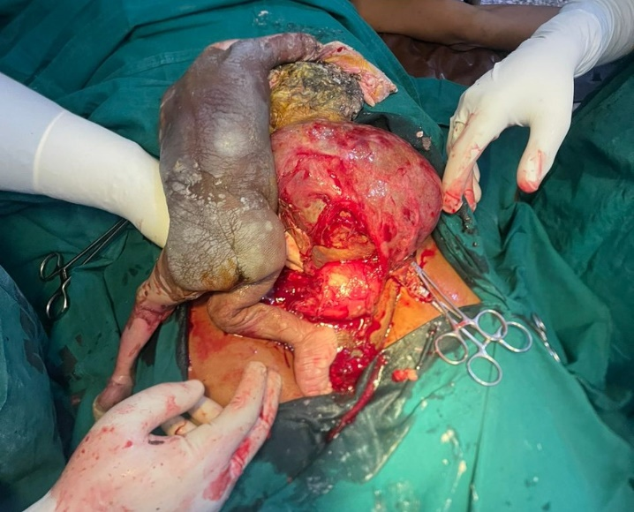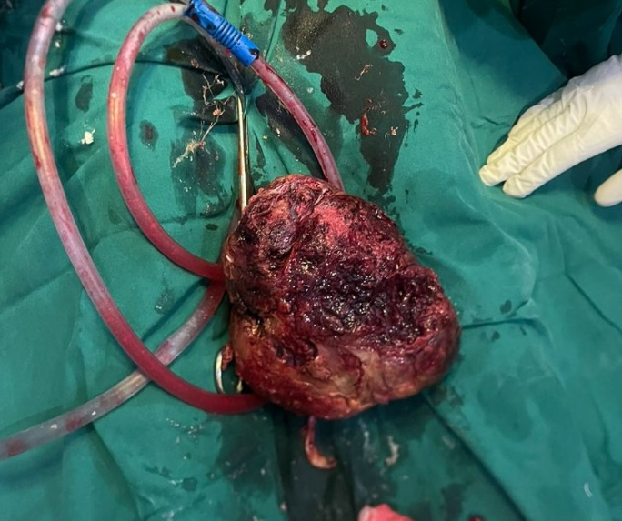
Figure 1: Macerated stillborn with intact uterus
Figure 2: Ball-shaped placenta

DISCUSSION
Abdominal ectopic pregnancy, AEP is rare with 1 in 654 and 1 in 1320 reported in Ibadan, Nigeria and Kumasi, Ghana respectively⁸. There are documented incidences ranging between 1 in 10,000 to 1 in 30,000 and aside its classification into primary or secondary abdominal pregnancy, it can also be classified into early or late depending on the gestational age at which the diagnosis was made. AEP is said to be early if diagnosed at ≤ 20 weeks gestational age and late when diagnosed at > 20 weeks gestational age^{4,6}. Abdominal pregnancy may progress to advanced stage and even to term especially in poorly developed climes where diagnosis may be missed⁴.
The diagnosis of AEP by relying on clinical presentation is very challenging and often missed because while some patients do not present with symptoms, those who present with symptoms have non-specific symptoms^{1,9}. The index patient only presented with inability to perceive fetal movement. It has been documented that the diagnosis of abdominal ectopic is difficult such that as high as 40 to 50% of known cases were discovered during surgical operations, despite of adequate antenatal reviews and ultrasound scans¹⁰. This exactly happened with Mrs. S.T., who booked for antennal care, went for her routine visits and had about 4 ultrasound scans ab initio and a fifth scan at presentation.
Studdiford in 1942 described a criteria that must be met before a diagnosis of primary abdominal pregnancy is made, which include – intact fallopian tubes and ovaries bilaterally, absent fistula connecting the uterus and the peritoneal cavity, pregnancy should be early enough to exclude the possibility of secondary implantation and must be exclusively related to the peritoneal surface^{1,11}. The diagnosis of AEP may be during an abdominal surgery as was found in our patient. This is a common finding in low-resource communities across board, wherein access to sophisticated imaging tools such as high resolution ultrasound scans and magnetic resonance imaging, MRI are lacking⁴.
The definitive treatment for AEP is dependent on some factors such as gestational age at diagnosis, fetal viability and the hemodynamic status of the patient. Options of management include medical treatment for early AEP, laparoscopy or laparotomy for early AEP and laparotomy for late AEP irrespective of fetal viability. Medical treatment involves using agents such as methotrexate, hyperosmolar glucose, mifepristone etc. and patients are kept under close surveillance for severe bleeding which will warrant a recourse to surgical intervention¹. Following delivery or evacuation of the fetus during laparotomy, the next challenge involves the removal of the placenta which may be attached to vital organs and large abdominal vessels. It is recommended that the placenta is left in-situ if there are no cleavage planes to ensure its safe removal. The downside to this is the possibility of aftermaths which include abdominal infections^{1,4}. The placenta in Mrs. S.T., had undergone some changes and formed into a ball-shaped structure, which made its delivery very easy.
CONCLUSION
The diagnosis of AEP is often missed as some patients do not present with symptoms, and those who do, present with symptoms that are non-specific. A sizable number of cases are discovered as rude shocks during abdominal surgeries, either elective caesarean section or caesarean section for failed induction of labour or other obstetrics reasons. This case highlights the complexity in the diagnosis of AEP in resource constrain regions and the need for improved diagnostic infrastructures in other to help avert complications that can occur from this obstetric nightmare through early diagnosis and timely intervention.

COMPETING INTERESTS DISCLAIMER:
Authors have declared that they have no known competing financial interests OR non-financial interests OR personal relationships that could have appeared to influence the work reported in this paper.

REFERENCES
1. Osegi N, Makinde OI, Eghaghe PO, Zawua Z, Ohaka BN. Abdominal pregnancy misdiagnosed as an intrauterine pregnancy: a cause of failed induction of labour for fetal death. Int J Reprod Contracept Obstet Gynecol. 2019;8(8):3382.
2. Dunphy L, Boyle S, Cassim N, Swaminathan A. Abdominal ectopic pregnancy. BMJ Case Rep CP. 2023;16(9):e252960.
3. Chen Y, Peng P, Li C, Teng L, Liu X, Liu J, et al. Abdominal pregnancy: a case report and review of 17 cases. Arch Gynecol Obstet. 2022 Apr 26;307(1):263–74.
4. Paluku JL, Kalole BK, Furaha CM, Kamabu EM, Mohilo GM, Kataliko BK, et al. Late abdominal pregnancy in a post-conflict context: case of a mistaken acute abdomen - a case report. BMC Pregnancy Childbirth. 2020 Apr 22;20(1):238.
5. Hajji A, Toumi D, Laakom O, Cherif O, Faleh R. Early primary abdominal pregnancy: diagnosis and management. A case report. Int J Surg Case Rep. 2020;73:303–6.
6. Ramphal S, Khaliq OP, Abel T, Moodley J. Expectant management of advanced abdominal pregnancies: Is it justifiable? Eur J Obstet Gynecol Reprod Biol. 2023;281:99–108.
7. Aduloju OP, Akintayo AA, Adanikin AI, Ade-Ojo IP. Combined Foley’s catheter with vaginal misoprostol for pre-induction cervical ripening: A randomised controlled trial. Aust N Z J Obstet Gynaecol. 2016 Dec;56(6):578–84.
8. Ayegbusi EO, Fadare OO, Fehintola AO, Ajiboye AD, Ubom AE. Undiagnosed advanced abdominal pregnancy: a case report. Intl J. 2021;7:590.
9. Mensah TA, Boateng AK, Doffour-Dapaah K, Erskine I, Oppong SA, Coleman J, et al. Advanced secondary abdominal pregnancy: a case report. Health Sci Investig J. 2023;4(2):572–6.
10. Siati A, Berrada T, Kharbach A. Abdominal pregnancy with a healthy newborn: a new case. Pan Afr Med J [Internet]. 2019 [cited 2025 Apr 17];34(1). Available from: https://www.ajol.info/index.php/pamj/article/view/208634
11. Talom AK, Ymele FF, Dingom MN, Fouedjio J. Abdominal Pregnancy: Epidemiological, Diagnostic, Therapeutic and Prognostic Aspects: A Case Report from the Yaounde Central Hospital (Cameroon). Open J Obstet Gynecol. 2021 Apr 12;11(4):381–90.

