Original Research Article

Ethnobotanical Study of Medicinal Plants Used in the Treatment of Diseases in the Kangu Grouping

Abstract

Aims: This study aimed to inventory medicinal plants used in the treatment of human diseases by traditional healers and herbal vendors in the Kangu groupement, to identify the main afflictions treated, the plant parts most frequently used, and the preferred modes of administration.

Study Design: A descriptive ethnobotanical survey.

Place and Duration of Study: Survey conducted in the groupement of Kangu, Democratic Republic of Congo, between January and June 2025.

Methodology: An ethnobotanical investigation was carried out with 30 respondents (traditional healers and herbal vendors). Data were collected using semi-structured interviews. Plant species were taxonomically identified, and their therapeutic uses were categorized. A total of 67 medicinal species were recorded, belonging to 81 genera and 38 families, including Angiosperms (Dicotyledons and Monocotyledons) and Pteridophytes. Frequencies of citation and usage of plant parts and preparation modes were analyzed descriptively.

Results: Respondents reported 67 medicinal plant species used to treat 40 afflictions grouped into 10 categories. The most cited conditions were malaria (26 citations), hemorrhoids and diarrhea (8 each), dysmenorrhea and sexual asthenia (7 each), pregnancy maintenance (6), and hydrocephalus (5). The most commonly used plant parts were leaves (57%), bark (26%), and roots (17%). Enemas (34%) were the predominant mode of administration, followed by oral intake (19%), body application (15%), and intimate baths (10%).

Conclusion: This study provides a baseline inventory of medicinal plants used in the Kangu groupement and highlights their potential value for future pharmacological and clinical investigations. Further scientific validation of the documented species is recommended to assess their therapeutic efficacy and safety.
Keywords: Traditional medicine, Medicinal plants, Kangu groupement

INTRODUCTION

Medicinal plants are an essential resource for healthcare worldwide, particularly in developing regions, where they are often used as an alternative to modern treatments (Srivastava et al., 2000; WHO, 2002).

The growing population, combined with the inaccessibility of modern medications in many developing countries, contributes to the increasing demand for plant-based remedies (Mohammadi et al., 2022).

As a result, the use of medicinal plants is experiencing a growing enthusiasm. More and more people are turning to natural products, and there is an increasing trend towards the use of cosmetics and cleaning products made from plants (Adossides, 2003). Furthermore, many populations continue to use plant-based remedies daily to meet their healthcare needs (El Hileh et al., 2016).

In this context, forests play a fundamental role, especially for communities that depend on this resource for their survival. Thus, sustainable management of forest ecosystems, actively involving these communities, is essential (Mavinga, 2020). In the Democratic Republic of the Congo, several studies indicate that local communities have been insufficiently involved in the reform process of the forestry sector, particularly during the drafting of the Forestry Code enacted in 2002. Although this legal framework constitutes a significant advancement and offers real opportunities for local governance of forest resources, its implementation remains limited. Specifically, the operationalization of community forestry management provisions is largely still at the planning stage, without true deployment on the ground (Sakata, 2009; Ndambo, 2014; Nlandu, 2020).The importance of traditional medicine in health systems and natural resource management is well established. Indeed, due to traditional knowledge, over 40% of current medical prescriptions worldwide are of natural origin (Maridass et al., 2012; Fabricant et al., 2001; Newman et al., 2003). Moreover, it is estimated that over 70% of African populations rely on traditional healers (Kayombo et al., 2012; Fakeye et al., 2009). In these countries, where access to Western medicine is often absent or too costly, dependence on remedies derived from native plants is particularly pronounced (Abdullahi, 2011; Ekor, 2014).

In the Kangu community group, the use of traditional medicine occupies a central position in the population’s healthcare practices. This strong reliance is largely attributable to the local abundance of medicinal plants, widely recognized for their therapeutic properties, as well as the financial accessibility of traditional treatments and the comparatively low incidence of reported side effects relative to modern medicine. Local ethnobotanical knowledge enables the treatment of a wide spectrum of ailments, including dermatological diseases, bacterial infections, and certain conditions requiring traditional physiotherapeutic practices. These pathologies predominantly affect the skin, mucous membranes, bones, and other target organs, thereby generating a substantial demand for plant resources.

However, the prominence of these practices raises concerns regarding the pressure exerted on forest resources in the Mayombe, which are already experiencing a trend toward depletion. In this context, it is essential to gain a deeper understanding of the population’s actual needs for medicinal plants in order to guide sustainable management strategies. The central problem of this study can therefore be formulated as follows: Which plant species are most frequently used in the treatment of diseases within the Kangu community group, and what information should be disseminated to local communities to ensure a sustainable supply of medicinal plants?

This study pursues the overall objective of establishing an inventory of the plants used by traditional healers and herbal vendors in the Kangu community group. More specifically, it aims to identify, through ethnobotanical surveys, the most commonly used species, the plant parts most frequently harvested, and the preferred modes of administration. This work contributes not only to the valorization of local therapeutic knowledge but also to the conservation of the natural heritage of the Mayombe. The expected outcomes should support ongoing efforts to promote sustainable management and encourage staggered harvesting practices, which are essential to preventing the gradual depletion of medicinal plant species.

2. material and Methods
2.1 Study Area
The Territory of Lukula is subdivided into five sectors and comprises a total of 60 community groups. The Fubu Sector consists of 12 community groups (Figure 1), namely: Kangu, Khoze, Kiniati, Kuimba-Lukula, Mbamba, Mbavu, Mboma-Tsundi, Nkuangila-Lukula, Phelele, Tsese-Ntinu, Vonde, and Vungu. The sector also includes an urban settlement known as Nsioni.
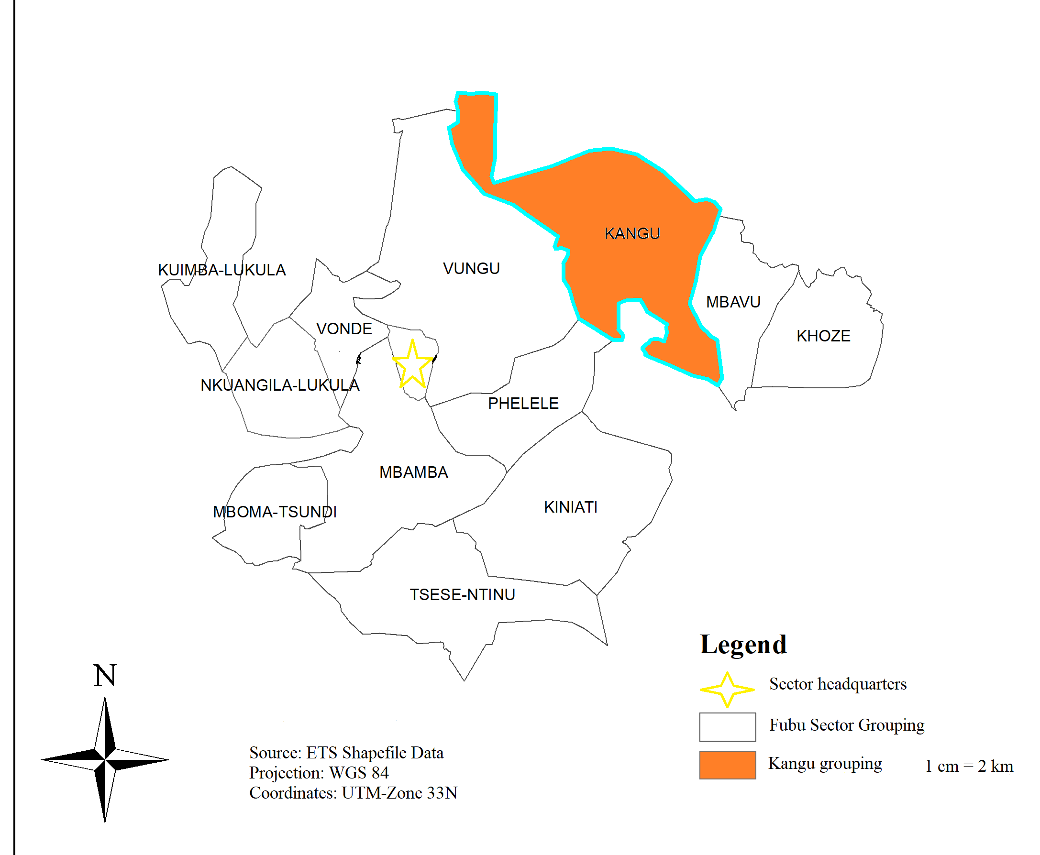
Figure.1. administrative subdivision of the Fubu Sector
Source : Khala Claude-Benoit, 2025

The Kangu community group consists of 36 villages (Table 1) and covers an area of 670 km², making it the largest community group within the Fubu Sector. However, some villages are gradually disappearing as a result of rural outmigration affecting the region. The local population increasingly prefers to migrate toward the town of Nsioni and other more developed urban centers, attracted by more favorable and modern living conditions.
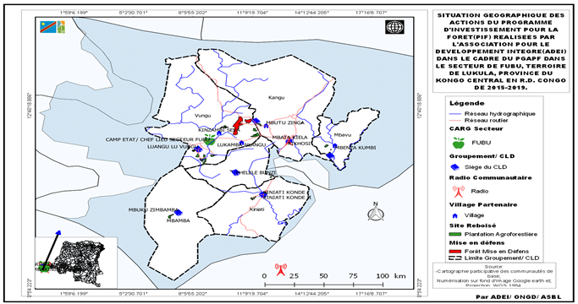
Figure.2. Ethnobotanical Sampling Site, PIF/PGAPF
Source: Reagan Mbumba, 2024

Table 1 Villages of the Kangu Community Group
Kangu Luvu | Kiyombo Kangu | Kiobo Ki Kangu | Kangu Keba
Kangu Mbunda | Ki Louis | Kiyenga Kangu | Kangu Mbenza
Kayi Kukangu | Kayi Kaka 1 | Kayi Nzambi | Kuimba Ntoto
Kayi Kaka 2 | Kuimba Nsole | Konde Kaka | Kayikumbi
Kayi Nzambi | Mbutu Zinga | Mbuku Zikangu | Mbuku Buete
Kayima Diambu | Mayenga Di Mbutu | Makangu Mombo | Kutilu Bela
Maniaka Mbumba | Kayikeba | Tsundi Loba | Mayenga Ma Kangu
Singa Phanda | Tsundi Kupika | Mbutu Thebukila, | Yema Di Kangu
Zeba Kikangu | Makayi Ku Kuimba | Mboma Bunzi

2.1.1 Climate

The climate of Kangu corresponds to a tropical savanna climate (Aw) according to the Köppen classification. It is characterized by a five-month dry season and a seven-month rainy season, with intense seasonal rainfall and an average annual temperature of approximately 25°C.

2.1.2 Relief

The Kangu community group is marked by significant topographic diversity, ranging from alluvial plains to steep summits. This altitudinal variation, highlighted by the Digital Elevation Model, strongly influences spatial organization, agricultural dynamics, and infrastructure accessibility. Low plateaus and moderate hills occupy a large portion of the area, whereas high plateaus and mountainous ridges delineate the peripheral zones.

2.1.3 Pedology

The entire Sector and the study area in particular, displays pedological conditions that are especially favorable for food crops such as cassava, maize, groundnut, and oil palm. The soil map reveals a predominance of rich, well-drained soils suited to the agronomic requirements of these species. However, certain zones, particularly in the southeast, show low suitability for mango cultivation due to specific edaphic constraints. This pedological diversity—shaped by relief and vegetation cover—allows for varied agricultural exploitation while underscoring the need for differentiated soil management. Spatial analysis of these suitability patterns helps guide strategies for sustainable rural development.

2.1.4 Hydrography

The hydrographic network is dominated by the Mungumungu River, which forms the central structure of local water dynamics. Around it are organized ten secondary streams—Manene, Bondi, Ntola, Mbata Kiela, Venir, Phangula, Cima, Phelele, Source, and Mont Nlaku—which ensure surface water drainage and contribute to soil moisture recharge. This hydrographic system plays a crucial role in water regulation, soil fertility, and ecosystem maintenance. Analysis of this configuration provides insight into the interactions among topography, water flow, and environmental dynamics within a region subject to climatic variability.

2.1.5 Vegetation

Vegetation in the Fubu Sector is characterized by marked ecological diversity influenced by local relief and climatic conditions. It is composed primarily of shrub savannas, acacia plantations, and gallery forests along waterways. This mosaic of vegetation plays a fundamental role in water regulation, soil protection, and the maintenance of biodiversity. Although fragmented, the wooded areas offer habitat for numerous species and contribute to the ecological resilience of the territory in the face of anthropogenic pressures and climatic uncertainties.

2.1.6 Fauna

The fauna of the Fubu Sector is generally dominated by surface bird nests and subterranean habitats of murine fauna, mainly within wooded areas. The limited presence of notable wild fauna is explained by anthropogenic pressure and forest fragmentation. Conversely, domestic fauna is well represented; goats, roosters, chickens, cattle, dogs, and cats coexist with local communities. Watercourses such as the Mungumungu River and adjacent streams also harbor fish species, contributing to local nutritional balance.

2.2 Methods
The ethnobotanical inventory of medicinal plants used in Kangu was conducted across the 36 villages of the community group from January to June 2025. In accordance with the principles set out in the Declaration of Helsinki, a stratified probabilistic sampling method was applied, as described in previous studies (Ngbolua et al., 2019; Masengo et al., 2023). This method consists of dividing the study area into different strata—represented here by markets and selling points—and assigning an equal number of respondents to each stratum.
As part of our research, a preliminary survey was carried out to identify key actors involved in medicinal Non-Timber Forest Products (NTFPs). A total of 30 participants were selected, including 21 traditional healers and 9 selling points associated with these products. These interviews provided valuable information regarding their practices, perceptions, and the challenges they encounter. The results of this exploratory phase are presented in Figure 2.
The Kangu community group was subdivided into 36 villages corresponding to the main markets where traditional healers and medicinal plant vendors operate. The study exclusively targeted these actors due to their expertise and the absence of previous ethnobotanical research in the area. Data were collected using a questionnaire administered in the Kiyombe language. The sample consisted of 30 respondents, selected from all the markets within the community group.
Ethnobotanical Survey
The study was structured around two complementary components. The first focused on inventorying the plant species traditionally used, conducted among traditional healers and medicinal plant vendors in the Kangu community group. The second component aimed to assess the level of knowledge and the modalities of use of these species, in order to understand their integration into local health practices and their contribution to treating common ailments.
Category of Traditional Plant Uses
The scope and content of ethnobotanical research depend on both the natural and human environment. According to community needs and study objectives, several domains of plant use may be defined (Prance et al., 1987). For the purposes of this study, we identified a single category of plant use: traditional pharmacopoeia, which encompasses the various plant species used in disease treatment by traditional healers and medicinal plant vendors within the Kangu community group.
Study Population, Sampling, and Inclusion/Exclusion Criteria
The study population consisted of traditional healers and vendors practicing traditional medicine within the study area, recognized for their role in transmitting ethnobotanical knowledge. Participants were required to be actively engaged in these activities, reside locally, and provide informed consent. Individuals who declined participation or relied on treatments other than medicinal plants were excluded. This selection ensured that the study focused on actors with relevant knowledge of local therapeutic practices.
Survey Questionnaire and Data Processing
Data were collected through standardized individual interviews using a structured questionnaire consisting of introductory notes, sociocultural information, ethnobotanical questions, and ethical considerations. The questionnaire addressed the identification of informants, the plant species cited, their therapeutic indications, the parts used, and preparation methods. The collected data were entered into Excel and subsequently transferred to Rstudio version 2025.09.2-418, for graphical analysis. Statistical analysis relied on descriptive methods, using means for quantitative variables and percentages for qualitative variables.

Results
The study population consisted of 30 informants, comprising traditional healers and medicinal plant vendors from the Kangu community group. The questionnaires were administered to individuals representing various sociocultural profiles within the community group.

1. Sociodemographic Characteristics of the Respondents
The sociocultural description of our respondents includes sex, age, marital status, level of education, and income derived from this activity.
Table 2 presents the sociocultural distribution of the study sample.

Table 2-Descriptive Statistics.
 | N | Minimum | Maximum | Mean | Standard deviation
Gender frequency | 3 | 9 | 30 | 20,00 | 10,536
% | 2 | 30 | 70 | 50,00 | 28,284
Age frequency | 5 | 0 | 30 | 12,00 | 12,865
% | 2 | 37 | 77 | 57,00 | 28,284
Marital status frequency | 5 | 0 | 30 | 12,00 | 15,540
% | 4 | 0 | 93 | 25,00 | 45,365
Education level frequency | 5 | 0 | 30 | 12,00 | 13,038
% | 2 | 33 | 67 | 50,00 | 24,042
Income frequency | 4 | 1 | 30 | 15,00 | 14,166
% | 3 | 4 | 80 | 33,67 | 40,649
Valid N (listwise) | 0

As shown in the results, the distribution of respondents by sex indicates that 70% of the traditional healers were male, while 30% were female, demonstrating a clear predominance of men in the practice of traditional medicine within the study area.
With regard to marital status, the vast majority of respondents were married (93%), representing the dominant group within the sample. In contrast, single individuals were not represented (0%), while divorced and widowed respondents accounted for only 4% and 3%, respectively. This finding suggests that traditional medical practice in the study area is largely carried out by individuals with established family responsibilities.
The age of the informants ranged from 37 to 77 years, with a mean age of 57 years. This age structure indicates that the study population is primarily composed of older adults, reflecting a high level of accumulated experience and extensive knowledge of traditional medical practices, which are typically acquired over long periods of practice and intergenerational transmission.
Regarding educational level and income, although these variables are not presented in detail in the dataset, the findings highlight the economic importance of traditional medical practice. Respondents expressed a strong preference for traditional medicine due to its associated economic benefits. Traditional healers reported earning an estimated USD 100 to 350 per semester, which constitutes a relatively substantial income for an informal economic activity in the local context.
3.1. Plant Species Used in Traditional Medicine

The survey focused on local and introduced plant species used in traditional medicine, regardless of their formally recognized medicinal status. A total of 67 specific taxa were recorded in the Kangu community group. These taxa include Angiosperms (both dicotyledons and monocotyledons) as well as Pteridophytes (spore-bearing plants), all of which possess medicinal properties and are utilized in the local traditional pharmacopoeia.
These species are distributed across 81 genera and 38 botanical families. The most represented families were Euphorbiaceae (11 species), followed by Fabaceae (7 species), Annonaceae (6 species), and Asteraceae (6 species).
The documented plant species are primarily used in the treatment of 40 different ailments, which were grouped into 10 major disease categories (Figure 3).

«Major Categories of Ailments and Their Relative Importance in Traditional Medicine in the Kangu Community Group.»
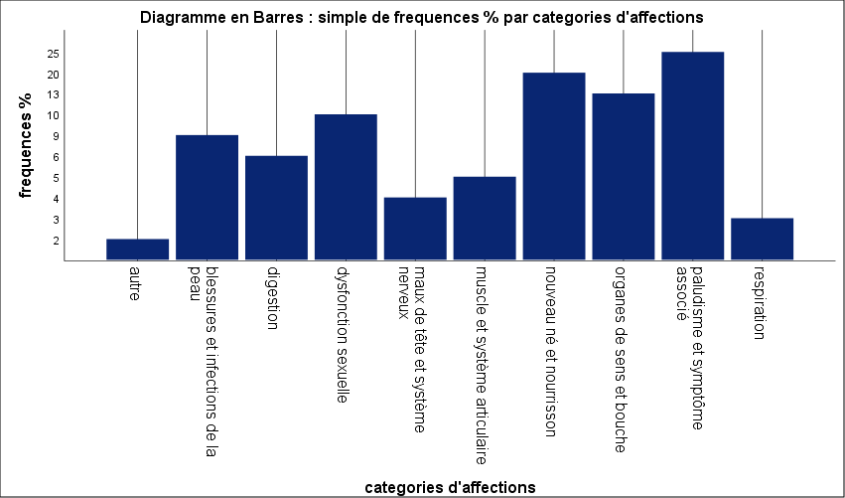

Figure.3. Categories of Ailments and Their Significance

3.2. Common Therapeutic Indications of Medicinal Plants
More specifically, the study demonstrates that, within the traditional medical practices of the Kangu community group, medicinal plants are used to treat a wide range of commonly encountered ailments. The most frequently cited therapeutic indications reported by traditional healers were malaria (26 citations); hemorrhoids and diarrhea (8 citations); dysmenorrhea and sexual asthenia (7 citations); pregnancy maintenance (6 citations); and hydrocephalus (5 citations).
Overall, a total of 119 use-reports (citations) were recorded for the various pathologies treated with medicinal plants in the study area.
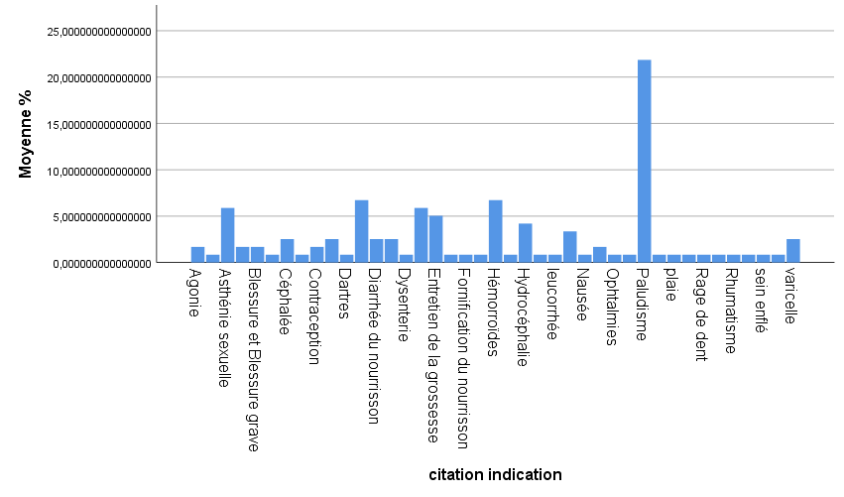
Figure.4. Most Frequent Mode of Indication

3.3. PARTS USED
Figure 5 below illustrates the plant parts most commonly used in traditional medicine in the Kangu groupement, according to the survey results. Regarding the most preferred parts of these plant species, the findings indicate the following patterns of use:
- Leaves (25%): Healers and vendors mainly favor the use of leaves due to their recognized therapeutic properties.
- Bark (20%): Bark ranks second, accounting for a substantial proportion of medicinal plant use in the treatment of various ailments.
- Roots (15%): Roots are also used, although less frequently than leaves and bark. This lower frequency of use is explained by the types of ailments for which this plant part is employed. Indeed, healers and vendors report that root-based treatments are mainly used for musculoskeletal and joint-related disorders, as well as for sexual dysfunctions—conditions that occur relatively infrequently over the course of the year.
- Other parts (40%): The remaining proportion corresponds to the use of other plant parts. However, these are generally of lesser significance in therapeutic applications.

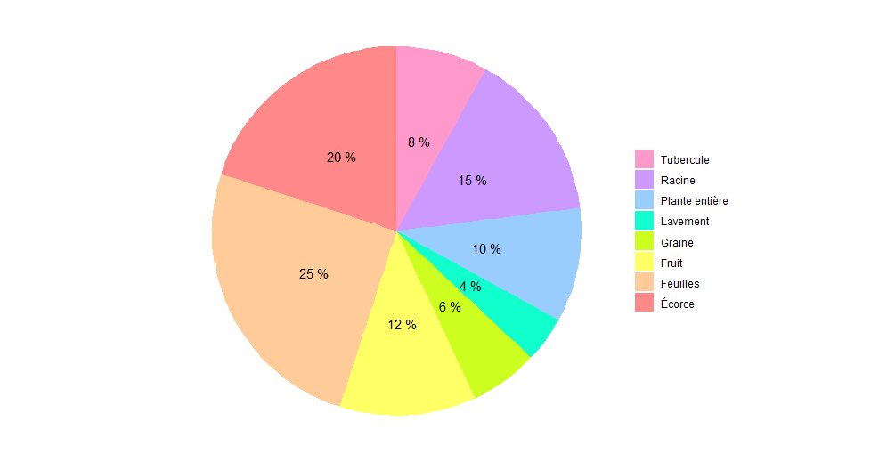
Figure 5.Parts used
3.4. Modes of Administration

Figure 6 illustrates the modes of use of medicinal plants and shows that, among the various methods recorded, enemas (34%) were the most frequently reported mode of administration, followed by oral administration (19%), topical application by rubbing or smearing (15%), and intimate bathing (10%).

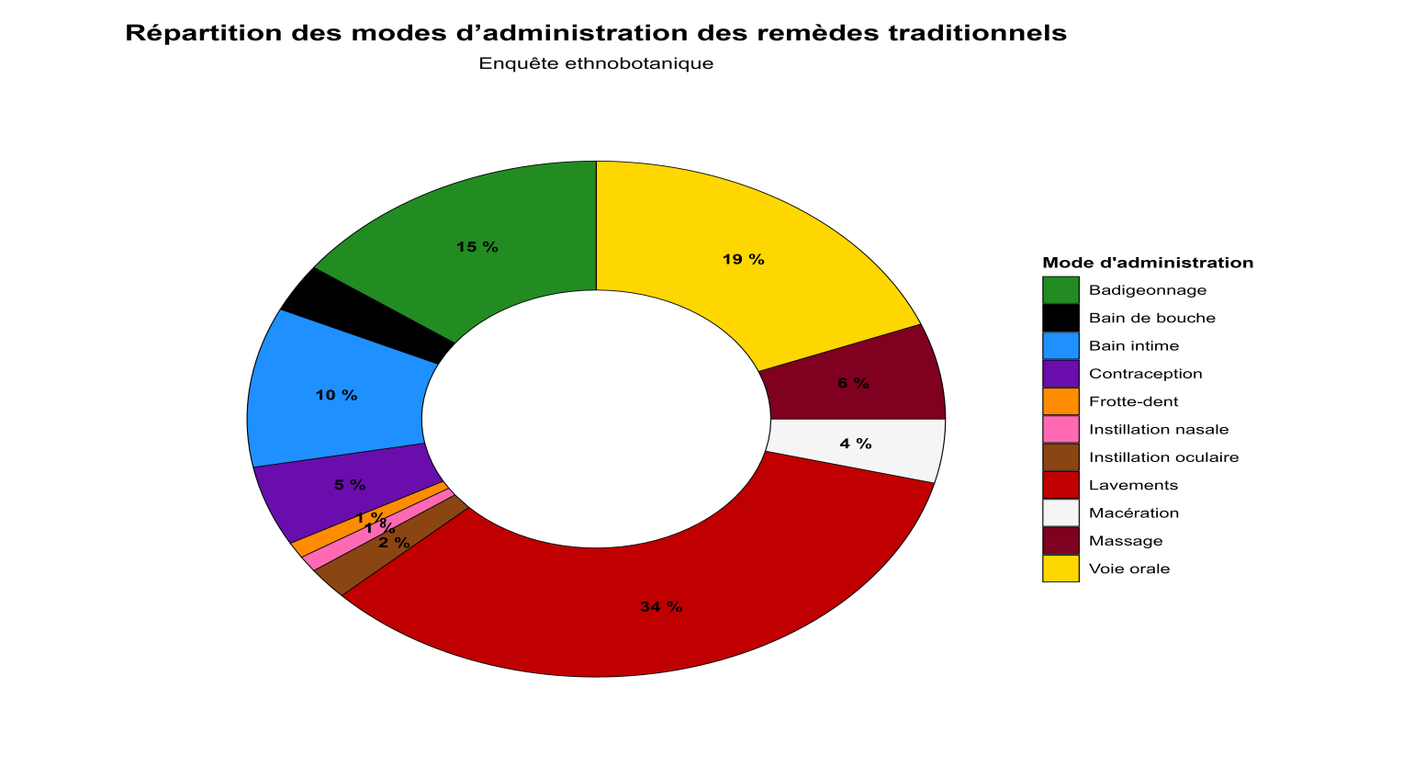
Figure.6. Mode of Use

3.5. ETHNOBOTANICAL INVENTORY

Table 3 presents the list of recorded plant species, their therapeutic indications, the parts used, and the modes of administration. It includes spontaneous species from the local flora as well as plants commonly sold and used by traditional healers.

Table.3. List of documented plant species.

Plante | Indication | Partie utilisée | Mode d’utilisation
Abrus precatorius | Intoxication ; palpitations | Leaf | oral route
Ageratum conyzoides | Headache (cephalgia) | Leaf | nasal instillations.
Alchornea cordifolia | vaginal discharge (Leucorrhea) | Leaf | Enema
Alstonia boonei | malaria | bark, Leave | Oral route, Enema,  Body painting
Alternanthera pungens | Convulsion ; Infant diarrhea | Leaf | Body painting, Enema
Anchomanes difformis | dysmenorrhea | Tuber | Enema
Anthocleista nobilis | Paludisme ; Rheumatism | bark, Root | Body painting
Azadirachta indica | Malaria | Leaf | Oral route, Enema, Body painting,
Bambusa vulgaris | malaria | Leaf | Oral route
Baphia nitida | Bad breath ; Bubo; Lower back pain | Root, Leaf | Tooth powder, Topical application
Bidens pilosa | Malaria, Hydrocephalus, Diarrhea | Leaf | Enema, Body painting
Bridelia micrantha | Malaria | Leaf | Bath, Enema
Caesalpinia bonduc | Malaria | Leaf | Enema
Cajanus cajan | Malaria | Leaf | Enema, Oral route, bain
Capsicum frutescens | Contraception, Agony | Fruit, Leaf | Contraception, Enema, Eye drops
Carica papaya | Malaria, Contraception | Leaf | Oral route, Enema
Carpolobia lutea | sexual asthenia | root | Oral route
Cassia alata | Malaria ; Eczema, Constipation | Leaf | Topical application, Body painting, Oral route
Cassia occidentalis | Constipation ; malaria ; headache (cephalgia) | Leaf | Oral route, Eye drops, nasal instillations.
Catharanthus roseus | Inguinal hernia | root | Enema
Cnestis ferruginea | Antenatal care ; Hydrocephalus | Leaf,root | Enema, Bath
Cocos nucifera | toothache | bark | Mouthwash
Cola lateritia var. maclaudi | Malaria | bark | Body painting
Cola nitida | Felon, Chickenpox | bark | Topical application
Digitaria horizontalis | Edema | whole plant | Body painting
Dioclea reflexa | infant fortification | seed | Bain
Eclipta prostrata | Malaria, Antenatal care Hydrocéphalus, Diarrhea, | Leaf | Enema, Bath,  Body painting
Erythrina senegalensis | Dysménorrhée, Rheumatism, Edema | bark | Enema, Topical application, Body painting
Eugenia whytei | Infant diarrhea, Bad breath Nausea | root, Leaf | Enema, Tooth powder, Oral route
Euphorbia hirta | Prenatal care, Measles, Diarrhea | whole plant | Enema
Ficus exasperata | Injury | root | Topical application
Flagellaria guineensis | Malaria, delayed motor functions, | Leaf | Bath
Garcinia kola | Bad breath , Sexual asthenia , Sexual weakness, Lung infection, Azoospermia, | root, fruit | Tooth powder, macération
Glyphaea brevis | prenatal care | Leaf | Enema
Gossypium spp | Dysménorrhea | Leaf | Enema
Harungana madagascariensis | Malaria | bark | Enema, bain, Oral route, Body painting
Heterotis rotundifolia | Diarrhea | Leaf | Enema
Hoslundia opposita | Convulsion (Seizure) | Leaf | Eye drops
Icacina mannii | Dysménorrhea, Sexual asthenia, Hemorrhoids | Tuber | Oral route
Jatropha curcas | abortion. | Leaf | Enema
Jatropha gossypiifolia | Dysménorrhea | Leaf | Enema
Khaya ivorensis | Sexual asthenia, Hemorrhoids | bark | Oral route, Enema
Kigelia africana | Swollen breasts, Sterility | Fruit, bark,  Leaf | Topical application , Enema, Oral route
Lophira alata | Bad breath | root | Tooth powder
Mangifera indica | Malaria , wound | bark | Oral route
Manihot esculenta | infant diarrhea | Fruit | Enema
Milicia excelsa | dysentery. | bark | Enema
Milicia regia | Hydrocephalea | bark | Bath, Body painting
Mitracarpus scaber | Eczema, Lower back pain | Leaf | Topical application, Enema
Momordica charantia | Malaria, Chickenpox. | Leaf | Bath, Oral route,  Body painting
Moringa oleifera | Malaria | Leaf | Oral route
Musa paradisiaca | Malaria, Ophtalmies | Leaf | Bath, Oral route, Enema
Ocimum gratissimum | prenatal care,  Infant diarrhea, ophthalmia, cephalea, Dysmenorrhea, Convulsion, malaria | Leaf | Enema, nasal instillations, Eye drops
Parinari excelsa | Hémorrhoids | bark | Enema
Paullinia pinnata | Malaria, gastritis, Hemorrhoids | Leaf | Bath, Body painting, Enema, Oral route
Pentaclethra macrophylla | Hydrocephalea | bark | Bath, Body painting
Phyllanthus amarus | Malaria, prenatal care ; Chickenpox | whole plant, Leaf | Oral route, Enema, Body painting
Psidium guajava | anal sores. | root | Enema
Pycnanthus angolensis | anemia, Hemorrhoids | bark | Oral route, Enema
Rauvolfia vomitoria | Malaria | root | Enema, Body painting
Ricinodendron heudelotii | sexual asthenia, Dysmenorrhea, Hémorrhoids | bark | Enema, Oral route
Ricinus communis | Lower back pain, Headache | Leaf | Massage, Topical application
Saccharum officinarum | Abortion | Leaf | Enema
Solanum lycopersicum | Contraception, Blessure grave, Agonie | Leaf | Enema, Topical application
Solanum nigrum | Malaria | Leaf | Bath, Enema, Body painting
Vernonia amygdalina | Malaria | Leaf | Bath, Body painting, Enema
Zanthoxylum gilletii | Malaria, sexual Asthénia, Hemorrhoids | bark | Oral route, Enema

DISCUSSION

This study on plant species used in the traditional pharmacopoeia of Kangu provides several key insights. In particular, it confirms that the therapeutic use of a given plant species is not universal, as the same species may be employed to treat different ailments depending on the geographical and cultural context. Thus, a plant considered effective against malaria in the Democratic Republic of Congo may be used elsewhere for entirely different indications, or may even exhibit a different perceived therapeutic efficacy.

This variability is largely explained by endogenous knowledge systems specific to each community, which are transmitted from generation to generation. The knowledge inherited from the earliest inhabitants of a given environment, their perception of the plant world, the cultural significance attributed to certain species, and the empirical experience accumulated over time in disease management all contribute to shaping local therapeutic practices. These elements highlight the importance of documenting and understanding ethnobotanical practices in order to fully appreciate the diversity of traditional healthcare systems.

As indicated by the inventory of medicinal flora in Kangu, Vernonia amygdalina is primarily used locally in the treatment of malaria. However, findings reported by Zabo et al. (2019) show that the same species is employed for the treatment of Buruli ulcer and as an antidiabetic remedy among the Ntandu people in the Lukaya district, Kongo Central Province. Similarly, plant species such as Alchornea cordifolia, Mangifera indica, Vernonia amygdalina, Carica papaya, and Ocimum gratissimum, which are used in Kangu for the management of various conditions including malaria, wounds, contraception, pregnancy maintenance, infantile diarrhea, gastritis, headaches, dysmenorrhea, convulsions, and leucorrhea, were also reported by Adrien Tuswisana et al. (2019) to be used by traditional healers in Kwango and Kinshasa in the treatment of diabetes.

This interregional variability in plant use highlights the ethnopharmacological plasticity of medicinal species and underscores the need to document local knowledge systems in order to better understand the therapeutic rationales underlying these practices.

A similar pattern is observed for species such as Carica papaya (malaria, contraception), Pentaclethra macrophylla (hydrocephalus), and Harungana madagascariensis (malaria), which were recorded in the medicinal flora of Kangu for the aforementioned indications. According to Engomba Mokekola et al. (2022), these same plant species are used by the Boginda and Bikoro communities in the Democratic Republic of Congo for the treatment of snake envenomation, once again illustrating the diversity of therapeutic applications across regions.

In Kinshasa, Fundiko et al. (2015) and Mola et al. (2021) evaluated in vitro the efficacy of several traditional medicinal formulations against four bacterial strains, including Escherichia coli, Staphylococcus aureus, and Salmonella typhi. Their studies demonstrated that species such as Millettia laurentii, Morinda morindoides, Ageratum conyzoides, along with nine others, are components of preparations exhibiting antibacterial properties and are used to treat various infectious diseases. This contrasts with the practices observed in the Kangu community group, where these same species are primarily employed in the treatment of headaches, diarrhea, low back pain, and sexual asthenia.

As previously discussed, these variations in use reflect the decisive role of endogenous knowledge shaped by cultural history, population adaptation to the environment, and the local availability of plant resources. They also highlight the capacity of traditional medical systems to evolve in response to accumulated empirical knowledge, while simultaneously reflecting the specific ecological contexts in which they are embedded.

LIMITATIONS OF THE STUDY
Several limitations of the present study should be acknowledged. First, although the ethnobotanical inventory is comprehensive, it does not systematically provide information on the relative abundance of each plant species or on their prevalence of use within the community, such as frequency of use or user preference.
Second, while modes of administration are described, dosage, duration of treatment, and potential contraindications are not consistently documented.
Third, for many of the species identified in this inventory, the transition from traditional use to scientific validation remains to be undertaken through phytochemical, pharmacological, and toxicological studies.
Finally, the sustainability dimension, including harvesting pressure and the regeneration capacity of plant resources, is not explicitly addressed in this study but represents an important complementary area for future research
CONCLUSION
Through the ethnobotanical surveys conducted in the Kangu community group, a substantial body of information was recorded regarding the use of medicinal plants in traditional phytotherapy.
A total of 67 medicinal plant species were identified and documented, all of which are used in the preparation of various medicinal recipes for the treatment of a wide range of ailments. The study population demonstrated a shared medicinal knowledge, with a predominance of adult practitioners aged 37 to 77 years, most of whom were married.
The findings indicate that many holders of endogenous medicinal knowledge have no formal education, yet successfully treat numerous diseases based on ancestral wisdom. This observation raises important questions regarding the limited engagement of formal scientific research with local traditional knowledge systems.
Leaves were identified as the most frequently used plant part, and the majority of the cited species are readily available within the study area. Respondents predominantly relied on species belonging to the families Euphorbiaceae, Fabaceae, Annonaceae, and Asteraceae, which are also among the most dominant families in the tropical flora of Kangu.
The most common preparation and administration methods involved the use of leaves and bark, mainly through enemas and oral administration. Malaria was the most frequently treated disease, followed by hemorrhoids, sexual disorders, and infant diarrhea.
Overall, these results constitute a valuable source of baseline information for future scientific research in phytochemistry and pharmacology, aimed at validating the therapeutic indications reported by traditional healers. Medicinal plants documented in this study may provide important responses to the complex challenges posed by common diseases.

PERSPECTIVES

- The issues addressed in this study are far from exhaustive and warrant further investigation. In the short term, the following research directions are proposed, in collaboration with other researchers:

- To investigate the ecology (distribution, availability, and conservation status) of the main medicinal plants used throughout the Fubu sector, with particular emphasis on species employed in gynecological, obstetric, pediatric, and cosmetic practices.

- To conduct an in-depth study, in collaboration with a sociologist, of the traditional religion of the Fubu sector and its conceptualization of floristic resource management.

- To assess the ethnobotanical potential of the Kangu community group in particular and the Fubu sector in general, with a view to developing ethnobotanical circuits. Such a study would also make it possible to identify and investigate selected species suitable for controlled harvesting, whose sustainable exploitation could provide tangible benefits to local communities.

CONﬂICTS OF INTEREST
The authors declare no conﬂict of interest.

RÉFÉRENCES
- Srivastava, J., Lambert, J., & Vietmeyer, N. (1996). Medicinal Plants: An Expanding Role in Development. The World Bank. http://documents.worldbank.org/curated/en/293821468766828964
- World Health Organization. (2002). *WHO Traditional Medicine Strategy 2002–2005* (WHO/EDM/TRM/2002.1). World Health Organization. http://whqlibdoc.who.int/hq/2002/WHO_EDM_TRM_2002.1.pdf
- Mohammadi, H., & Saghaian, S. H. (2022). Factors affecting consumption of different forms of medicinal plants: The case of licorice. Agriculture, 12(9). https://doi.org/10.3390/agriculture12091453
- Adossides, A. (2003) : Plantes aromatiques & médicinales. Projet « Assistance au Recensement Agricole », p. 69.
- El Hilah, F., Ben Akka, F., Bengueddour, R., Rochdi, A., & Zidane, L. (2016). Étude ethnobotanique des plantes médicinales utilisées dans le traitement des affections dermatologiques dans le plateau central marocain. Journal of Applied Biosciences, 98, 9252–9260. https://doi.org/10.4314/jab.v98i1.2
- Mavinga, M. S. (2020). Note de cours d'écologie (inédit, 97 pages). Université Simon Kimbangu.
- Sakata, G. (2009). La réforme du secteur des ressources naturelles : historique, enjeux et bilans. L'Afrique des Grands Lacs d'Afrique, Annuaire 2008-2009, 269-288. https://www.uantwerpen.be/en/research-groups/glac/publications/annuaire/
- Ndambo, M. N. (2014). Participation des communautés locales et gestion durable des forêts : cas de la Réserve de la biosphère de Luki en République Démocratique du Congo (Thèse de doctorat, Université Laval). http://hdl.handle.net/20.500.11794/25349
- Nlandu Mbele, W. (2020). Rapport de clôture du projet d'investissement pour la forêt (120 pages). [Manuscrit inédit].
- Maridass, M., & De Britto, A. J. (2008). Origins of plant derived medicines. Ethnobotanical Leaflets, 2008(1), 44.
- Fabricant, D. S., & Farnsworth, N. R. (2001). The value of plants used in traditional medicine for drug discovery. Environmental Health Perspectives, 109(Suppl 1), 69–75. https://doi.org/10.1289/ehp.01109s169
- Newman, D. J., Cragg, G. M., & Snader, K. M. (2003). Natural products as sources of new drugs over the period 1981–2002. Journal of Natural Products, 66(7), 1022–1037. https://doi.org/10.1021/np030096l
- Kayombo, E. J., Uiso, F. C., & Mahunnah, R. L. A. (2012). Experience on healthcare utilization in seven administrative regions of Tanzania. Journal of Ethnobiology and Ethnomedicine, 8(5), 1–8. https://doi.org/10.1186/1746-4269-8-5
- Fakeye, T. O., Adisa, R., & Musa, I. E. (2009). Attitude and use of herbal medicines among pregnant women in Nigeria. *BMC Complementary and Alternative Medicine*, *9*(1), 53. https://doi.org/10.1186/1472-6882-9-53
- Abdullahi, A. A. (2011). Trends and challenges of traditional medicine in Africa. African Journal of Traditional, Complementary and Alternative Medicines, 8(5 Suppl), 115–123. https://doi.org/10.4314/ajtcam.v8i5S.5
- Ekor, M. (2014). The growing use of herbal medicines: issues relating to adverse reactions and challenges in monitoring safety. Frontiers in Pharmacology, 4, 177. https://doi.org/10.3389/fphar.2013.00177
- Ngbolua, K.-T.-N., Inkoto, C.L., Mongo, N.L., Ashande, C.M., Masens, Y.D.-M., & Mpiana, P.T. (2019). Étude ethnobotanique et floristique de quelques plantes médicinales commercialisées à Kinshasa, République Démocratique du Congo. Revue Marocaine des Sciences Agronomiques et Vétérinaires, 7(1), 118-128. https://agrimaroc.org/index.php/Actes_IAVH2/article/view/705
- Masengo, C. A., Ngbolua, J.-P. K.-T.-N., Butoto, S. I. W. R., Gbolo, B. Z., Inkoto, C. L., & Mpiana, P. T. (2023). Ethno-botanical survey of medicinal plants species traditionally used for the treatment of diseases in Kasangulu Territory (Democratic Republic of Congo). Moroccan Journal of Agricultural Sciences, 4(2), 76–85. https://revues.imist.ma/index.php/MJAS/article/view/3090
- Prance, G. T., Balée, W., Boom, B. M., & Carneiro, R. L. (1987). Quantitative ethnobotany and the case for conservation in Amazonia. Conservation Biology, 1(4), 296–310. https://doi.org/10.1111/j.1523-1739.1987.tb00050.x
- Zabo, I. A., Tamasala, N., & Diakedika, L. (2019). Phytochemical study of medicinal plants used against Buruli ulcer by Ntandu people in Kongo Central, D.R. Congo. Tropical Plant Research, 6(1), 49–53. https://doi.org/10.22271/tpr.2019.v6.i1.009
- Tuwisana Masunda, A., Liyongo Inkoto, C., Ngiala Bongo, G., Oleko Wa Oloko, J. D., Ngbolua, K.-T.-N., Tshibangu, D. S. T., Tshilanda, D. D., & Mpiana, P. T. (2019). Ethnobotanical and ecological studies of plants used in the treatment of diabetes in Kwango, Kongo Central and Kinshasa in the Democratic Republic of the Congo. International Journal of Diabetes and Endocrinology, 4(1), 18-25. https://doi.org/10.11648/j.ijde.20190401.14
- Engomba Mokekola, B., Tamasala Ndombe, R., Mwange, R. K., Bulambo Mulonda, A., Biduaya, F., Kusamba Chifundera, Z., & Assumani Zabo, I. (2022). Ethnobotanical survey of medicinal plants against ophidian envenomations in the Bonginda/Bikoro group in D.R. Congo. World Journal of Advanced Pharmaceutical and Life Sciences, 2(2), 56–62. https://doi.org/10.53346/wjapls.2022.2.2.0024
- Fundiko, M. C. C., Mandango, M. A., Idrissa, A. Z., & Ludiongo, N. E. (2000). Activité antibactérienne de quelques recettes utilisées contre les maladies infectieuses à Kinshasa (R.D. Congo). Revue Pédagogique Appliquée (RPA), UPN, Kinshasa, XVI(2), 275–280.
- Mola, A. M., Idrissa, A. Z., Mwange, R. K., Mukeba, F. B., Cakupewa, M. F., Mangambu, J. D., & Balagizi, I. K. (2022). Ethnobotanical survey of plants used against erectile dysfunction in the commune of Ngaba in Kinshasa / DR Congo. World Journal of Advanced Research and Reviews, 13(03), 193–200. https://doi.org/10.30574/wjarr.2022.13.3.0193

